**Original Research Article**

UNDER PEER REVIEW

Effect of Alkaloid-rich fraction of *Dacryodes edulis* leaves on the cytoachitecture of the liver and blood glucose levels in streptozotocin-induced hyperglycemic rats

# ABSTRACT

**Introduction:** Diabetes mellitus is a chronic disease characterized by hyperglycemia due to insufficient insulin production or action. Numerous medicinal plants have been known for their anti-diabetic effects and *Dacryodes edulis* is one of them. Its extracts have been known for their medicinal qualities as it has been used to treat or manage many illnesses including diabetes. This is made possible due to the pharmacological properties of its bio-constituents constituents.

**Aims:** In this study, the ameliorative potential of an alkaloid-rich fraction of *Dacryodes edulis* leaves was investigated on the liver of hyperglycemic adult Wistar rats. The objectives were to determine its effects on liver histology and blood glucose level.

**Methods:** Thirty-seven (37) rats weighing between 140-190g were used for the research. Twelve (12) rats were used for its acute toxicity study, while twenty-five (25) rats were grouped into five. The groups were labelled A to E and contained five rats each. Group A (normal control) rats were given food pellets and distilled water only. Group B (diabetic control) rats were given 60mg/kg BW of streptozotocin. Group C rats were given 60mg/kg BW of streptozotocin + 500mg/kg BW of *Dacryodes edulis* extract, while Group D rats were given 60mg/kg BW of streptozotocin + 1,000mg/kg BW of *Dacryodes edulis* extract. Group E served as the metformin treated group and were given 60mg/kg BW of streptozotocin + 50mg/kg BW of metformin. The administration of streptozotocin and metformin were through the intraperitoneal route, while that of *Dacryodes edulis* extract was through the oral route with the aid of an oral gavage. The administration lasted for twenty-eight (28) days, after which the rats were made to fast overnight with access to only water. The rats were then weighed and then anaesthetized. Whole blood was collected through cardiac puncture and liver tissue obtained for histological analysis.

**Results:** The results showed degenerating liver histology with hepatocytes showing pyknotic nuclei, mild dilation of sinusoids, inflammatory cells and dilation of the central vein in the diabetic group as compared to the normal control group which showed a normal liver histology, with hepatocytes having abundant cytoplasm and prominent nuclei, well out-lined sinusoids and an intact central vein. The metformin group displayed mild degenerative changes compared to that of group B rats. The high dose extract group D showed a preserved cytoarchitecture of the liver, while the low dose extract group C displayed mild degenerative changes. A significant decrease (p<0.05) in the fasting blood glucose level was observed in the metformin and extract treated groups compared to the diabetic group (p<0.05). This

shows that *Dacryodes edulis* alkaloid extract possesses hepato-protective properties and a strong anti-diabetic potential, thereby making it useful in the management of diabetes mellitus and its complications.

UNDER PEER REVIEW

**Conclusion:** The alkaloid-rich fraction of *Dacryodes edulis* leaves can be considered as an alternative drug in the management of diabetes mellitus.

**Keywords:** *Dacryodes edulis*, alkaloid, diabetes mellitus, metformin, liver.

# INTRODUCTION

The liver is an organ of importance for many physiological processes including nutrient metabolism, blood volume regulation, immune system support lipid homeostasis and (1). It also plays a vital role in the regulation of plasma glucose levels being an important player during both fasting and postprandial conditions mainly through hepatic glucose production and glycogen storage and so plays a role in the development of metabolic diseases including diabetes mellitus (2). Diabetes mellitus is a chronic disease that occurs either when the pancreas does not produce enough insulin or when the body cannot effectively use the insulin it produces. Hyperglycemia is a common effect of uncontrolled diabetes and over time leads to serious damage to many of the body systems (3) including the liver (4). In diabetes, insulin resistance and hyperinsulinaemia can cause non-alcoholic fatty liver disease and progress to

non-alcoholic steatohepatitis “NASH” which manifests as inflammation and necrosis. Prolonged NASH will lead to liver fibrosis, hepatocellular carcinomas and end-stage liver disease (5). These traits are hypothesized to damage cell membrane which is as a result of elevated reactive oxygen species (ROS) that are generated during hyperglycemia (6). The production of oxygen species is needed in certain amounts for normal metabolic processes, but when it becomes too high, it leads to oxidative stress (7). Numerous studies have demonstrated the therapeutic effects of various medicinal plants, especially in ameliorating tissue toxicity or oxidative tissue damage caused by exposure to toxic substances (8,9,10,11,12). Medicinal plants are rich in antioxidants which are substances capable of counteracting the effects of reactive oxygen species associated with tissue toxicity and *Dacryodes edulis* is one of such plants (11). It is also known as African plum, African palm, native pear, bush butter tree, Eben or Ube (in Nigeria). The fruit is highly nutritious, comprising of lipids, proteins and provitamins. Pharmacologically active chemical constituents such as alkaloids, tanins, flavonoids and saponins are present in parts of the plant including its leaves. The bioconstituents obtained from its leaves are said to exhibit antioxidant, anti-diabetic, anti-sickle cell and antimicrobial activities (13,11). Pharmaceutically, metformin is considered to be the first choice agent for treatment of diabetes but it is said to produce undesirable side effects such as heart burn, nausea, weight loss, headache, anemia and hypoglycemia. There is therefore an advocacy for the use of medicinal plants because they have little or no side effects (4). The rich antioxidant and antiproperty of the *Dacryodes edulis* leaf makes it relevant to the study which involves its effect on the prefrontal cortex and neuro-behaviour in rats of Ketamine-induced neurotoxicity.

# MATERIALS AND METHODS

## Plant acquisition, identification and preparation of extract:

UNDER PEER REVIEW

Fresh leaves of *Dacryodes edulis* were obtained from a residence at Eastern highway, by Goldie market, Calabar, Cross River state, Nigeria. The leaves were then identified, authenticated and registered with a voucher number: Bot/Herb/CC/0189 in the department of botany, University of Calabar. The mature leaves were plucked and washed in running tap water and thereafter rinsed properly in distilled water. It was air dried, powdered with a grinder and stored in an air tight plastic container till required for analysis. Crude alkaloid from *Dacryodes edulis* leaves was extracted by heating the powdered sample (500g) for 4 hours at 55°C with 1200 ml of ethanol (20%). The extract was filtered and residue was re-extracted with 200 ml of ethanol (20%). The extract was concentrated on water bath till the volume reduced to 200 ml, which was mixed with 100 ml diethyl ether in a separating funnel. The mixture was vigorously shaken and then the separating funnel was fixed in a stand till the development of aqueous and diethyl layer. Aqueous portion was collected while the diethyl ether portion was discarded. To the aqueous layer n-butanol (80 ml) was added and properly mixed by vigorous shaking. The n-butanol extract was treated with 10 ml of 5% NaCl solution. The resultant solution was concentrated on a water bath and the crude alkaloid extract (14).

## Experimental design:

Thirty-seven (37) rats weighing between 140-190g were obtained from the College of Medical sciences animal house, University of Calabar. The rats were sheltered in optimal environmental conditions of humidity, temperature and daylight/dark cycle. They were fed with were given food pellets and distilled water only. They were kept in this environment for a period of three weeks to allow for acclimatization before the start of the experiment. Twelve (12) rats were used for acute toxicity test of the leaf extract, while 25 were divided into 5 groups and placed in properly ventilated plastic cages labelled A to E, with each cage containing five rats. Group A was designated as the normal control group and were given food pellets and distilled water only. Group B was the diabetic control group and were given 60mg/kg body weight “BW” of streptozotocin “STZ”. Group C rats were given 60mg/kg BW of streptozotocin + 500mg/kg BW of *Dacryodes edulis* extract, while Group D rats were given 60mg/kg BW of streptozotocin

+ 1,000mg/kg BW of *Dacryodes edulis* extract. Group E served as the metformin treated group and were given 60mg/kg BW of streptozotocin + 50mg/kg BW of metformin. The administration of streptozotocin and metformin were through the intraperitoneal route, while that of the *Dacryodes edulis* extract was through the oral route with the aid of an oral gavage. The administration lasted for twenty-eight (28) days, after which the rats were made to fast overnight with access to only water. The rats were then weighed and then anaesthetized. Whole blood was collected through cardiac puncture and liver tissue obtained for histological analysis. Pre and post-induction of STZ fasting blood sugar was assessed and these procedures were done daily throughout the course of the administration. The rats were then anaesthetized and whole blood collected through cardiac puncture and the serum used to assess blood glucose level. Liver tissue was obtained and processed for histological staining.

## Acute toxicity test:

12 rats were employed for the determination of the lethal dose “LD”50 of the alkaloid-rich fraction of *Dacryodes edulis* leaves using Lorke’s method (15). The rats were separated into four groups (3 rats each) for the first phase and received 500mg, 1000mg, 1500mg and 2000mg/kg BW respectively. They were observed for twenty-four hours. The second phase involved two groups of 2 rats each which were given 4000mg and 6,000mg/BW of the extract respectively. There was no death recorded and this agrees with

a study by Ononamadu which illustrated that its extract is non-lethal in any concentration (13). LD50 was therefore >5,000mg/kg so we decided to make use of 5,000mg/kg as the LD50. The doses of the extract were calculated as 10% and 20% of the established LD50. The extract was dissolved in distilled water and given via oral intubation using a gavage. The extract was then administered to the rats based on their weights.

UNDER PEER REVIEW

**Induction and confirmation of hyperglycemia:** Diabetes was induced in overnight fasted experimental rats by a single dose of STZ administered intraperitoneally. STZ was reconstituted in 0.5M Sodium citrate and administered at a dose of 60mg/kg.bw (16). Diabetes was confirmed 48 hours after the STZ administration using Accu-check glucometer with blood samples obtained from tails of the Wistar rats. The blood glucose levels (mg/dl) were checked before and after induction. It was also checked every three days during the administration of the metformin and plant extract to ascertain their hyperglycemic state. The rats with fasting blood glucose levels above 250mg/dl were deemed diabetic (17).

## Histological study with hematoxylin and eosin stain “H&E”:

The paraffin slides containing liver tissue underwent a dewaxing process involving two rounds of exposure to xylene for a duration of 5 minutes each. Subsequently, rehydration was performed by sequentially immersing the slides in decreasing concentrations of alcohol (100%, 95%, and 70%) and rinsing them under tap water. Following rehydration, the sections were subjected to a 15-minute staining procedure using hematoxylin, followed by a 5-minute rinse under tap water. To enhance visualization, the sections were then differentiated in acid alcohol for 1 minute and subsequently counter-stained with Eosin for another 1 minute. After a rinse in tap water, the sections underwent dehydration and clearing using xylene. Following this, the sections were allowed to air dry, and a few drops of dibutylphthalate polystyrene xylene “DPX” were applied to the slide surface before placing a coverslip on top. The resulting tissue units were then taken using a digital camera connected to a light microscope for further examination (18).

**Statistical analysis**: Data obtained from the experiment was analyzed statistically using one-way ANOVA and Duncan post hoc test using statistical package for social sciences (SPSS) software version 26.0 for Windows. The results were presented as mean±standard error of mean and considered statistically significant at p<0.05.

# RESULTS AND DISCUSSION

## Results:

Assessment of fasting blood glucose:

The changes in fasting blood glucose “FBG” were determined in this study over the course of the 28-day experimental period. The initial and final FBG levels are presented in figure 1. At day zero, the blood glucose levels in all experimental groups were considered normal ranging from about 70 mg/dl to 107

mg/dl. From the results, it can be observed that elevated blood glucose concentration was seen in all diabetic groups following the administration of 60mg/kg body weight of STZ. The elevated FBG level (Figure 1) of the diabetic control group only exhibited an increase (p<0.05) of 3.52±3.82 (gotten by subtracting the initial FBG level from the final FBG level after induction with diabetes mellitus), while that of extract treated groups (groups C and D) had significantly decreased FBG levels of -21.30±2.81 and

UNDER PEER REVIEW

-25.16±2.15mg/dl respectively (p<0.05). That of the metformin treated group E also showed significant decrease at -16.24±2.68mg/dl (p<0.05).

## Histomorphological examination of the liver:

The histological assessment of liver tissue sections across the experimental groups revealed a normal liver histology in group A rats (plate 1), detailing a central vein, well out-lined sinusoids and hepatocytes with abundant cytoplasm and prominent nuclei. In group B rats treated with 60mg/kg body weight of STZ (plate 2), hepatocytes with pyknotic nuclei were seen, along with mild dilation of sinusoids, inflammatory cells and moderate dilation of the central vein. These features are indicative of hepatotoxicity (19,20). For group C rats (plate 3) treated with 500mg/kg BW of the extract, normal hepatocytes were seen along with mild dilation of sinusoid, inflammatory cells and a central vein showing fatty infiltration. Group D rats (plate 4) treated with 1,000mg/kg BW of the extract displayed a preserved liver tissue with features similar to that of group A rats. These include well outlined sinusoids, central vein and hepatocytes having abundant cytoplasm, as well as prominent nuclei, although some inflammatory cells were seen. Group E rats (plate 5) showed an array of hepatocytes, sinusoids and a central vein with fatty infiltration.

## Discussion:

Diabetes mellitus has become a major public health issue that is approaching epidemic proportions globally. Complications from diabetes include coronary artery and peripheral vascular disease, stroke, diabetic neuropathy, amputations, renal failure and blindness (21). Studies have shown that diabetes mellitus is associated with a number of liver abnormalities such as acute liver disease, cirrhosis, fibrosis, abnormal glycogen deposition and abnormally elevated hepatic enzymes (22,23,24,25,26). In general, the liver plays many vital roles that help in the maintenance and performance of the body such as biosynthesis, detoxification, metabolism and storage (13). It is important in the modulation of plasma glucose levels through hepatic glucose production and glycogen storage, thereby playing a role in the development of metabolic diseases like diabetes mellitus (13). Streptozotocin is the most used diabetogenic chemical for creating rat models of type 1 and 2 diabetes as it has specific, rapid and irreversible cytotoxic actions on pancreatic islets β-cells (25).

The elevated serum FBS level observed in groups B, C, D and E rats that were induced with diabetes mellitus (by treatment with 60mg/kg BW of STZ) is due to the ability of STZ to induce hyperglycemia at a doses between 35mg/kg and 65mg/kg BW STZ administered intravenously or intraperitoneally (27). This agrees with many studies that have also reported successful induction of hyperglycemia with the STZ diabetic dose range in rats (12,24,27,28,29,30). Metformin qualifies as an oral anti-diabetic drug for the treatment of type 2 diabetes (31). It reduces serum glucose level by several mechanisms, notably through the suppression of hepatic glucose production (32). It activates the enzyme adenosine monophosphate kinase, resulting in the inhibition of key enzymes involved in gluconeogenesis and glycogen synthesis in the liver (31). In this study, administration of metformin was able to lower the serum FBG level in group E rats. This is in agreement with studies by Za’abi et al (33) and Horakova et al

(32) who illustrated this effect in diabetic rats. The alkaloid-rich fraction of *Dacryodes edulis* leaf extract was also able to lower serum FBG level in group C and D rats and this could be due to its wealth of antioxidants which possess many pharmacological properties, including anti-diabetic potential (13). This is in line with studies by Eru *et al* (34), Erukainure et al (35) Ononamadu et al (13) who illustrated the ameliorative effects *Dacryodes edulis* leaf extract on serum blood glucose. Alkaloids are nitrogen-containing heterocylic organic compounds of plant origin with many pharmacological activities including sedative, analgesic, antipyretic, anti-inflammatory, anti-tumour, antioxidant and anti-diabetic

UNDER PEER REVIEW

(36). Numerous studies have shown the antidiabetic effects of alkaloid-rich fractions of many leaves such as *Phyllanthus amarus* (37), *Andrographis paniculata* (37), *Catharanthus roseus*, *Ervatamia microphulla*, *Ziziphus oxyphylla* and *Murraya koenigii* (36). The possible mechanisms of the effect of the alkaloid extract on blood glucose in diabetic models can be attributed to the activation of enzymes in the liver which are associated with glycolysis, gluconeogenic and lipid metabolic process (36).

Hepatological observation of the rats in the diabetic control group displayed a distorted liver microstructure when compared to the normal control group A. The histopathological features observed agree with Riahi (19) and Al-Ani *et al* (20) about degenerative features in liver of diabetic rats. The Liver tissue structural anomaly was due to streptozotocin administration and other studies (4,38,39) involving STZ-induced diabetes have also reported degenerative features in the liver. The reaction is said to be provoked by the increased production of highly reactive intermediates of STZ which are normally detoxified by endogenous growth stimulating hormone “GSH” but when present in excess, can deplete GSH stores and affect liver tissue. The free radical generation plays a significant role in pathogenesis of diabetes mellitus (5,40). The liver tissue of the rats in group C (treated with low dose of extract) displayed degenerative changes while that of group D (treated with high dose of extract) showed typical healthy structural features as those in the normal control group but with minor degenerative changes. It has been postulated by Mohammed et al (40) and Jiang et al (5) that free radical generation resulted by glucose oxidation and protein glycation plays a vital role in pathogenesis of diabetes mellitus. It was proposed that the most important cause of liver damage in diabetic patients is hyperglycemia-induced oxidative stress and subsequent disturbance in carbohydrate, protein or lipid metabolisms (41). The Liver tissue section of diabetic rats treated with the extract (1,000mg/kg BW) exhibited features of tissue restoration. Thus, the alkaloid-rich fraction of *Dacryodes edulis* leaf was responsible for this this effect. A study (34) has demonstrated the tissue-restorative capacity of the alkaloid-rich fraction of *Dacryodes edulis* leaf and this was possibly due to its high antioxidant capacity (13). Many studies have also demonstrated tissue-restorative potentials of alkaloids (42,43,44,45) as they possess the ability to counteract excessive free radicals, thereby safeguarding cells and tissues against their toxic effects (36). The liver tissue of the rats in group E (treated with metformin) displayed mild degenerative changes compared to that of group B rats. This may be due to the fact that metformin is a known drug for the treatment of diabetes mellitus (31). The ameliorative effects were better in group D than that of group C rats and this may be due to the increased tissue-ameliorative action considering the administration of a higher dose of the extract.

# CONCLUSION

The present study illustrated that the administered dosage of STZ led to hyperglycemia in the rats, leading to distortion in liver cytoachitecture. The study also revealed ameliorative and anti-diabetic activities of the alkaloid-rich fraction of *Dacryodes edulis* leaves. The leaf extract therefore possesses

hepato-protective properties and a strong anti-diabetic potential, thereby making it useful in the management of diabetes mellitus and its complications.

UNDER PEER REVIEW

# ETHICAL Approval

All authors hereby declare that “Principles of laboratory animal care” (NIH publication No. 85-23, revised 1985) were followed as well as specific national laws where applicable. All experiments have been examined and approved by Faculty Animal Research Ethics committee, Faculty of Basic Medical Sciences, University of Calabar, Cross River state, Nigeria and given a registration number FAREC-FBMS 150-2/2023.

## Implication for health policy/practice/research/medical education

The administration of alkaloid-rich fraction of *Dacryodes edulis* leaves showed improved liver tissue structure and decreased blood glucose level when compared to the diabetic control group. This may be attributed to the antidiabetic and antioxidant capacities of the alkaloid component if the leaves. This makes it useful in the management of diabetes mellitus and its complications.

Disclaimer (Artificial intelligence)

Author(s) hereby declare that NO generative AI technologies such as Large Language Models (ChatGPT, COPILOT, etc.) and text-to-image generators have been used during the writing or editing of this manuscript.

REFERENCES

1. Trefts E, Gennon M, Wasserman DH. The liver. Current Biol. 2017;27 (21): 1147-1151.
2. Guerra S, Gastaldelli A. The role of the liver in the modulation of glucose and insulin in non-alcoholic fatty liver disease and type 2 diabetes. Current Opinion Pharmacol. 2020;55: 165-174.
3. World Health Organization. Diabetes. Accessed 15 April 2025; 2025. Available: <https://www.who.int/news-room/fact-sheets/details/diabetes>.
4. Akpaso MI, Bassey LE, Anani SE, Oku ME, Nnenna WA. et al. Ameliorative effect of *Curcuma longa* ethanolic extract on the histology, hepatic glycogen content and some biochemical parameters of the liver in streptozotocin-induced hyperglycemic rats. J Comp Altern Med Res, 2024;25 (11): 1-16.

UNDER PEER REVIEW

1. Mohamed J, Nafizah AHN, Zariyantey AH, Budin SB. Mechanisms of Diabetes-induced liver damage. Sultan Qaboos Univ Med J. 2016;16 (2); 132-141.
2. Jaganjac M, Tirosh O, Cohen G, Sasson S, Zarkovic N. Reactive aldehydes second messengers of free radicals in diabetes mellitus. Free Radic Res. 2013, 47 (1): 39–48.
3. Gomes EC, Silva AN, Oliveira MR. Oxidants, antioxidants and the beneficial roles of exercise-induced production of reactive species. Oxid Med Cell Longev. 2012, 2012: 12.
4. Eru EM, Gabriel UU, Ifiok FB, Kelechi CU, Samson OP, Michael EO. et al. Efficacy of aqueous extract of *Talinum triangulare* on the microanatomy of the hippocampus and short-term memory of scopolamine hydrobromide-induced Alzheimer’s type cognitive dysfunction rats. Nigerian Journal of Physiological Sciences. 2024;39 (1): 101-109.
5. Eru EM, Gabriel UU, Samson OP, Kelechi CU, Michael EO, Sadeyeng EA. et al. Restorative potentials of aqueous *Telfairia occidentalis* seeds extract on the hippocampal Nissl granules and short-term memory in scopolamine hydrobromide-induced Alzheimer’s type cognitive dysfunction rats. Trop J Nat Prod Res. 2021;5 (1): 182187.
6. Anani SE, Oku ME, Eru EM, Uruakpa KC, Bassey IF, Udo-affah GU et al. Neuroprotective effect of *Dacryodes edulis* ethanolic leaf extract on the prefrontal cortex and long-term learning and memory in Wistar rats of ketamine-induced neurotoxicity. Asian J Res Rep Neurol. 2024;7 (1): 86-97.
7. Anani SE, Nnenna WA, Eric AA, Nsikak MU, Bassey IF, Eru EM. et al. Neuroprotective effect of *Dacryodes edulis* ethanolic leaf extract on the hippocampus of rats of ketamine-induced neurotoxicity. Asian Journal of Research and Reports in Neurology. 2024; 7 (1): 130-145.
8. Oku ME, Akpaso MI, Odey PA, Eru EM, Anani SE, Umoh NM. Sterological studies on ameliorative role of ethanolic extracts of Verninia amygdalina and *Gongronema latifolium* against streptozotocin-induced diabetic splenic tissue damage in Wistar rats. Asian J Immunol. 2024;7 (1): 131-148.
9. Ononamadu CJ, Alhassan AJ, Ibrahim AJ, Imam AA, Igheboro AA et al. Methanol-extract factions of *Dacryodes edulis* leaves ameliorate hyperglycemia and associated oxidative stress in streptozotocin-induced diabetic rats. J Evid Based Integ Med. 2019, 24.
10. Zeb, H., Younas, A., Ahmed, I., & Ali, A. (2021). Self-care experiences of Pakistani patients with COPD and the role of family in selfcare: A phenomenological inquiry. Health & Social Care in the Community, 29(5), e174-e183.
11. Lorke D. A new approach to practical acute toxicity testing. Archiv Toxicol. 1983, 541: 275-287.
12. Ugochukwu NH, Cobourne MK. Modification of renal oxidative stress and lipid peroxidation in streptozotocin-induced diabetic rats treated with extracts from Gongronema latifolium leaves. Clin Chim Acta. 2003, 336 (1-2): 73-81.
13. Thiraphatthanavong P, Wattanathorn J, Muchimapura S, Thukham-mee W, Lertrat K, Suriharn B. The combined extract of purple waxy corn and ginger prevents cataractogenesis and retinopathy in streptozotocin-diabetic rats. Oxid Med Cell Longev. 2014: 789406.

[UNDER PE](https://www.researchgate.net/publication/315797013_Histochemistry_and_Tissue_Pathology)ER REVIEW

1. Avwioro OG. Histochemistry and tissue pathology, principles and techniques. 2010. Accessed 20 August 2020. Available: <https://www.researchgate.net/publication/315797013_Histochemistry_and_Tissue_Pathology>.
2. Riahi P. Passive hepatic congestion. Accessed 15 April 2025; 2025. Available: [https://www.radiopaedia.org/articles/passive-hepatic-congestion#:text=Passive](https://www.radiopaedia.org/articles/passive-hepatic-congestion#%3Atext%3DPassive) hepatic congestion%2C also known,or chronic right heart failure.
3. Al-Ani IM, Abired AN, Musafa BE, Wahab ENA, Azzubaidi MS. Effect of flaxseed extract on the liver histological structure in streptozotocin-inducesd diabetic rats. Intl Med J Malasia. 2017;16(1).
4. Tablish SA. Is Diabetes becoming the biggest epidemic of the twenty-first century?. Int J Health Sci. 2007;1(2): 5-8.
5. Karimabad MN, Khalili P, Ayoobi F, Esmailili-Nadimi A, Vecchia CL, Jamali Z. Serum liver enzymes and diabetes from the Rafsanjan cohurt study. BMC Endocr Disord. 2022, 22: 127.
6. Rodriguez V, Plavnik L, Talamoni NT. Naringin attenuates liver damage in streptozotocin-induced diabetic rats. Biomed Pharmacother. 2018, 105: 95-102.
7. Yazdi HB, Hojati V, Shiravi A, Hosseinian S, Vaezi G, Hadjzadeh M. Liver dysfunction and oxidative stress in streptozotocin-induced diabetic rats: protective role of Artemisia turanica. J Pharmacopuncture. 2019, 22 (2) 109-114.
8. Ghasemi A, Jeddi S. Streptozotocin as a tool for induction of rat models of diabetes: a practical guide. Excli J Expt Clin Sci. 2023, 22: 274-294.
9. Levinthal GN, Tavill AS. Liver disease and diabetes mellitus. Clin Diabet. 1999, 17: 73.
10. Su HC, Hung LM, Chen JK. Resveratrol, a red wine antioxidant, possesses an insulin-like effect in streptozotocin-induced diabetic rats. Am J Physiol Endocrinol Metab. 2006, 290: 1339-1346.
11. Srinivasan K, Viswanad B, Asrat L, Kaul CL, Ramarao P. Combination of high-fat diet-fed and low dose streptozotocin-treated rat: a model for type 2 diabetes and pharmacological screening. Pharmacol Res. 2005, 52: 313-320.
12. Essa R, Sadek AM, Baset ME, Rawash MA, Sami DG, Badawy MT et al. Effects of turmeric (Curcuma longa) extract in streptozocin-induced diabetic model. J Food Biochem. 2019, 43 (9): e12988.
13. Saleem M, Hussain A, Akhtar MF, Saleem A, Sadeeqa S, Naheed S. Ameliorating effect of Malva neglecta on hyperglycemia and hyperlipidemia in diabetic rats. Braz J Pharm. 2021, 2021: 57.
14. Nasri H, Rafieian-Kopaei M. Metformin: common knowledge. J Res Med Sci. 2014, 19 (7): 658-664.
15. Za’abi MA, Ali BH, Suleimani YA, Adham SA, Ali H, Manoj P. et al. The effect of diabetic and non-diabetic rats with experimentally-induced chronic kidney disease. Biomolecules. 2021, 11 (6): 814.
16. Iweala EJ, Uche ME, Dike ED, Etumnu LR, Dokunmu TM, Oluwapelumi AE et al. Curcuma longa (Turmeric): ethnomedical uses, phytochemistry, pharmacolodical activities and toxicity profiles-a review. Pharmacol Res Modern Chines Med. 2023, 6: 100222.

UNDER PEER REVIEW

1. Eru EM, Ekpenyong TI, Agbor CA, Fischer CE, Oku ME et al. Effect of alkaloid-rich fraction of *Dacryodes edulis* leaves on the microstructure of the hippocampus and blood glucose levels of STZ-induced diabetic Wistar rats. Intl NeuroPsy Dis J. 2025;22(3): 17-26.
2. Erukainure OL, Ijimone OM, Chukwuma CI, Xiao X, Salau VF et al. *Dacryodes edulis* (G. Don) H.J. Lam modulates glucose metabolism, cholinergic activities and Nrf2 expression while suppressing oxidative stress and dyslipidemia in diabetic rats. J Ethnopharmacol. 2020;255(2020): 112744.
3. Muhammad I, Rahman N, Nayab GE, Nishan U, Shah M. Antidiabetic activities of alkaloids isolated from medicinal plants. Braz J Pharm Sci. 2021;57(2021).
4. Adebayo BC, Ajiboye OM, Oyeleye IS, Ojo RO, Oboh, G. Effect of alkaloid extract from *Andrographis paniculata* and *Phyllanthus amarus* Schumach. & Thonn. on cognitive related biochemical in the brain of streptozotocin-induced diabetic rats. Pharmacol Res Mod Chinese Med. 2023;9(2023): 100314.
5. Manna P, Das J, Ghosh J, Sil PC. Contribution of type 1 diabetes to rat liver dysfunction and cellular damage via activation of NOS, PARP, IkappaBalpha/NF-kappaB, MAPKs, and mitochondria-dependent pathways: Prophylactic role of arjunolic acid. Free Radic Biol Med. 2010, 48: 1465–84.
6. Palsamy P, Sivakumar S, Subramanian S. Resveratrol attenuates hyperglycemia-mediated oxidative stress, proinflammatory cytokines and protects hepatocytes ultrastructure in streptozotocin-nicotinamide-induced experimental diabetic rats. Chem Biol Interact. 2010, 186: 200–10.
7. Jiang Z, Woollard A, Wolff SP. Hydrogen peroxide production during experimental protein glycation. Febs Letters. 1990, 268 (1): 69-71.
8. Yang Q, Cheng L, Zhang T, Yaron S, Jiang H, Sui Z et al. Phenol profiles, antioxidant and antiproliferative activities of turmeric (Curcuma longa). Industr Crops Prod. 2020, 152: 112561.
9. Rampogu S Balasubramaniyam T, Lee J. Phytotherapeutic applications of alkaloid in treating breast cancer. Biomed Pharmacother. 2022;155(2022): 113760.
10. Rui Y, Li S, Luan F, Li D, Lui R et al. Several alkaloids in Chinese herbal medicine exert protection in acute kidney injury: focus on mechanism and target analysis. Oxid Med Cell Longev. 2022;13(2022): 2427802.
11. Sun Q, Lian C, Chen Y, Ye J, Chen W et al. *Ramulus mori* (Sangzhi) alkaloids ameliorate obesity-linked adipose tissue metabolism and inflammation in mice. Nutrients. 2022;14(23): 5050.
12. Li H, Wang S. Steroidal alkaloids ameliorate cell proliferation, oxidative stress, inflammation and histology outcome in vitro and in vivo. Asian Pacif J Trop Med. 2018;11(3): 260-264.

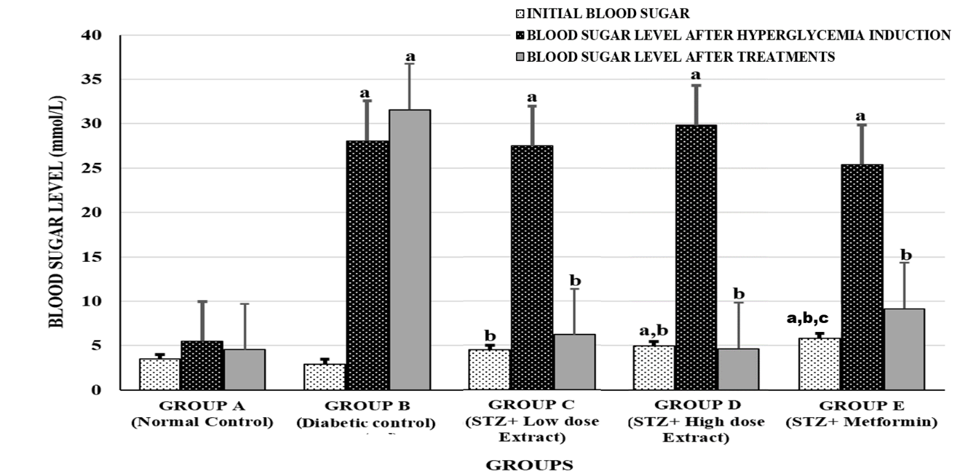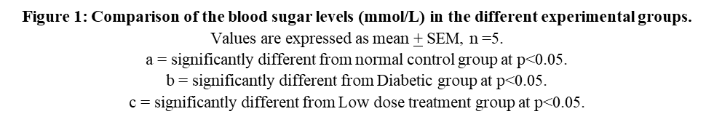

UNDER PEER REVIEW

UNDER PEER REVIEW

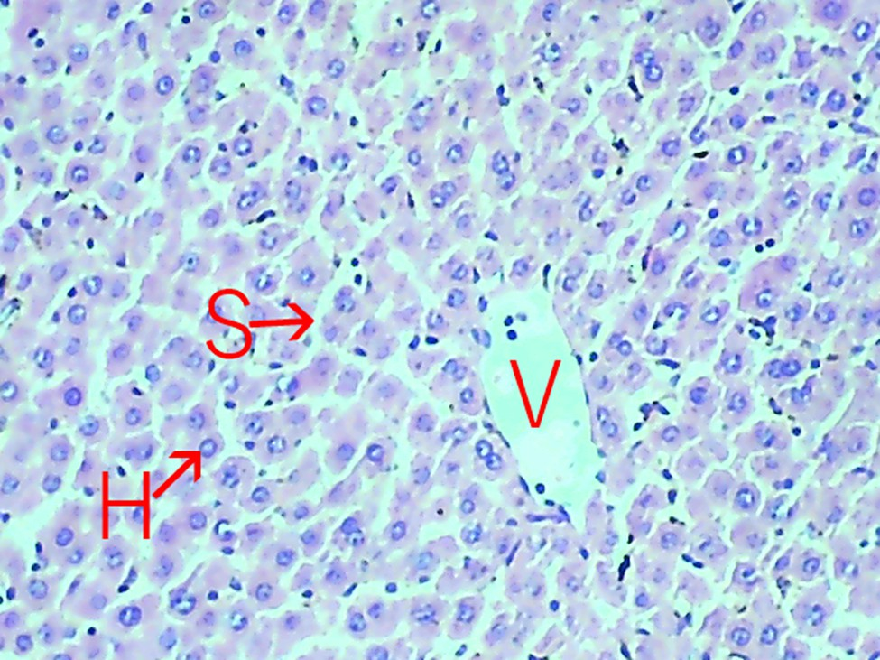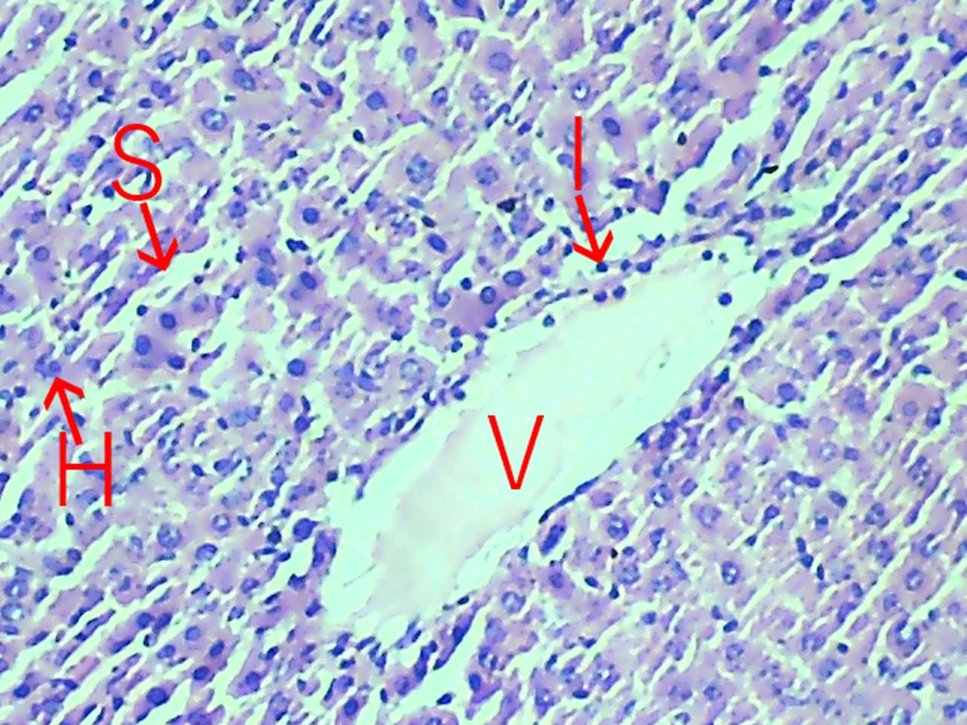**Plate 1**: Photomicrograph (X100) of a unit of liver tissue (H&E-stained section) of group A rats (normal control group) displaying normal architecture with arrays of hepatocytes (H), sinusoids (S) and a central vein (V).

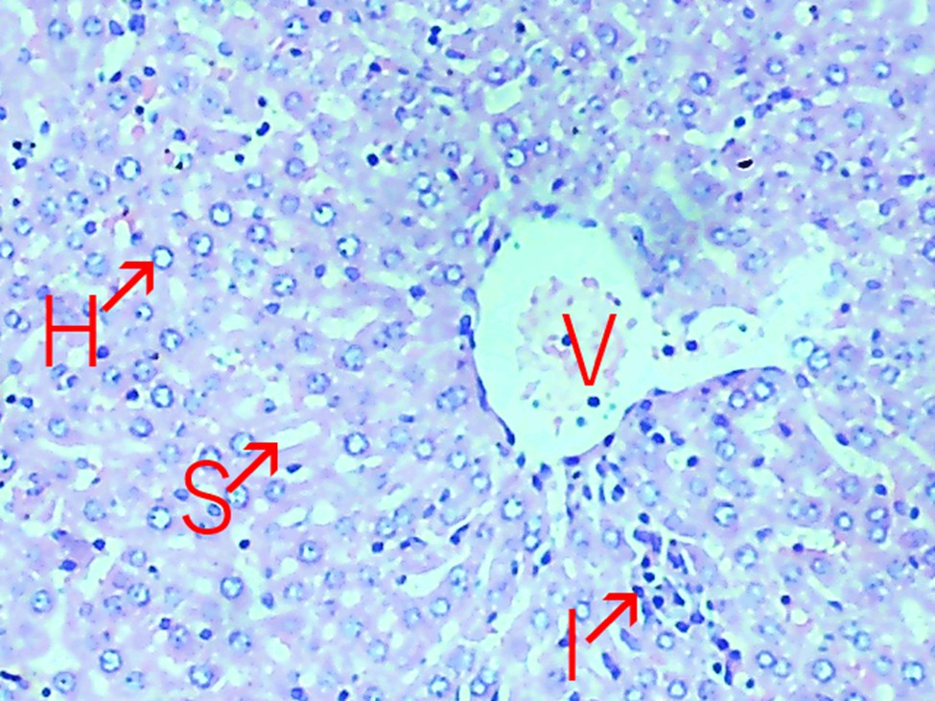**Plate 2**: Photomicrograph (X100) of a unit of liver tissue (H&E-stained section) of group B rats (diabetic control group) displaying hepatocytes (H) with pyknotic nuclei, along with mild dilation of sinusoid (S), inflammatory cells (I) and moderate dilation of the central vein.

UNDER PEER REVIEW

**Plate 3**: Photomicrograph (X100) of a unit of liver tissue (H&E-stained section) of group C rats (low dose extract group) displaying an array of hepatocytes (H), mild dilation of sinusoid (S), inflammatory cells (I) and central vein (V) showing fatty infiltration.

UNDER PEER REVIEW

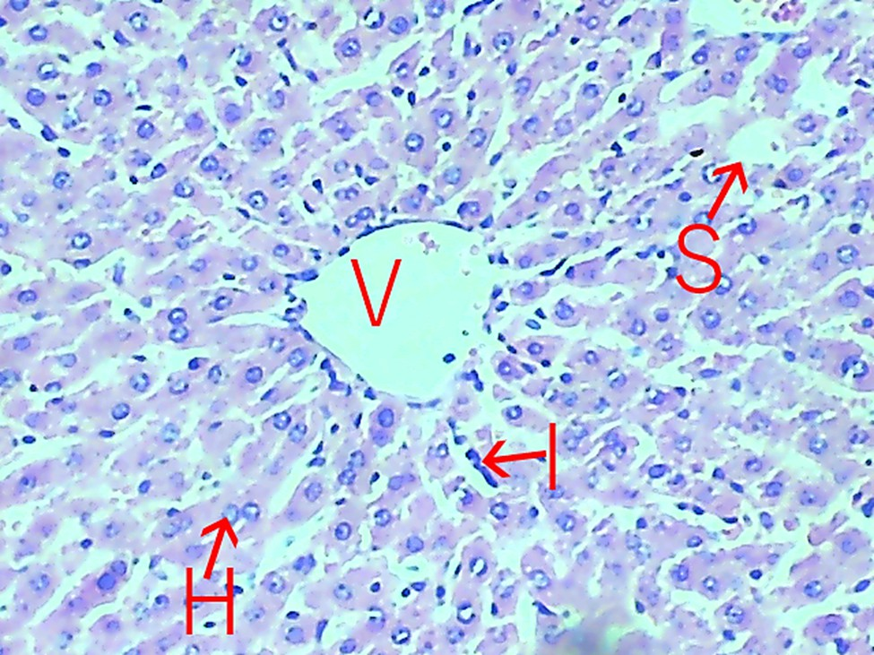**Plate 4**: Photomicrograph (X100) of a unit of liver tissue (H&E-stained section) of group D rats (high dose extract group) displaying an array of normal hepatocytes (H), sinusoids (S), inflammatory cells (I) and central vein (V). The section shows a preserved architecture of the liver.

UNDER PEER REVIEW

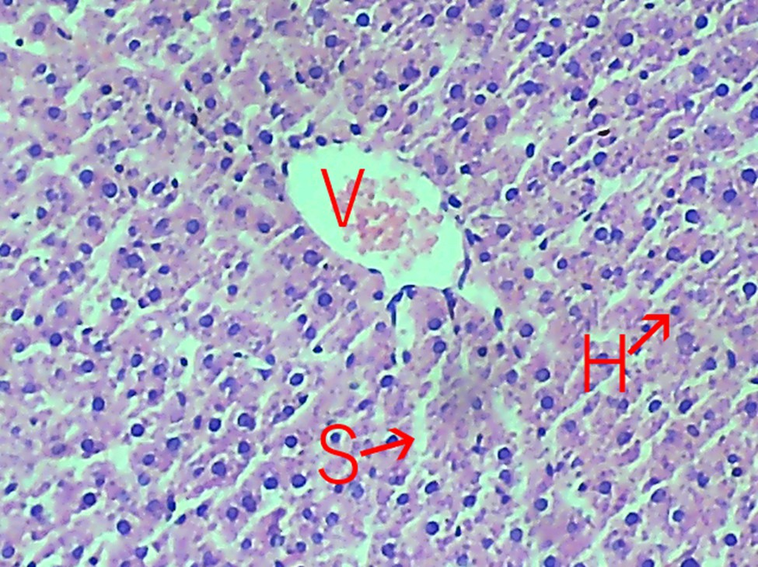**Plate 5**: Photomicrograph (X100) of a unit of liver tissue (H&E-stained section) of group E rats (metformin group) displaying hepatocytes (H), sinusoids (S) and central vein (V) showing fatty infiltration.