**Comparative Assessment of Liver Toxicity Induced by Sodium Benzoate, Ascorbic Acid, and their Co-administration in Albino Rats**

**ABSTRACT**

**Background:** The widespread use of preservatives such as sodium benzoate and ascorbic acid in food and beverages has raised concerns about potential health hazards, including the production of benzene, a known carcinogen. Therefore, this study aimed to evaluate the effects of sodium benzoate, ascorbic acid, and their combination on liver function parameters and histological integrity in albino rats.

**Methodology:** Thirty-six albino rats were randomly divided into six groups. Group I (control) received distilled water; Group II received 120 mg/kg of sodium benzoate alone; Group III received 240 mg/kg of sodium benzoate alone; Group IV received 100 mg/kg of ascorbic acid (vitamin C) alone; Group V received a combination of 120 mg/kg sodium benzoate with 100 mg/kg ascorbic acid; and Group VI received a combination of 240 mg/kg sodium benzoate with 100 mg/kg ascorbic acid. Treatments were administered orally once daily for 28 days. Liver function was assessed using biochemical markers, including total bilirubin, direct bilirubin, total protein, albumin, AST, ALT, ALP, and GGT. Liver histology was also examined.

**Results:** Group III (240 mg/kg sodium benzoate) exhibited significantly higher total bilirubin (5.25 ± 0.59 mmol/L) and direct bilirubin (7.56 ± 0.35 mmol/L) levels compared to Group VI (2.94 ± 0.73 mmol/L and 2.79 ± 0.67 mmol/L, respectively; p < 0.05). ALT levels were significantly elevated in Group VI (30.46 ± 6.31 U/L) compared to Group I (21.62 ± 0.97 U/L, p = 0.000), indicating severe hepatocyte injury. ALP levels were significantly higher in Group II (40.08 ± 3.47 U/L) compared to Group V (26.60 ± 8.48 U/L, p = 0.024), suggesting biliary dysfunction. Total protein and albumin levels did not differ significantly across groups (p = 0.555 and p = 0.451, respectively). Histological analysis revealed degenerating hepatocytes, sinusoidal congestion, and tissue distortion, particularly in Groups III and VI.

**Conclusion:** High dose of sodium benzoate (240 mg/kg) induce significant hepatotoxicity, and its combination with ascorbic acid exacerbates liver damage. These findings highlight the need for caution regarding the combined use of sodium benzoate and ascorbic acid in food products and emphasize the importance of further safety evaluations.

**Keywords:** Sodium Benzoate, Vitamin C, Liver Function, Benzene Formation, Histological Analysis, Biochemical Parameters, Preservatives

**Introduction**

The growing demand for food and beverage preservation to extend shelf life has resulted in the extensive use of preservatives. These compounds are crucial for controlling enzymatic reactions and microbial growth during packaging, storage, distribution, retail, and consumption, thereby preventing spoilage [1]. Preservatives are broadly classified into two categories: antioxidants and antimicrobials [2]. Antioxidants slow down oxidative degradation, preserving the food's quality and nutritional value, while antimicrobial agents inhibit the growth of spoilage microorganisms and pathogens, ensuring safety and longevity [3]. Sodium benzoate and ascorbic acid are two widely used examples of these preservatives.

Sodium benzoate (SB) is a commonly employed preservative known for its ability to inhibit microbial growth at low concentrations, earning it a reputation as an effective and safe food preservative [4]. Referred to as E211 in Europe, sodium benzoate is a tasteless, odorless, water-soluble compound with both antifungal and antibacterial properties [5]. It is FDA-approved and classified as generally recognized as safe (GRAS) at concentrations of up to 0.1%, and it is frequently added to carbonated beverages, sauces, and jams [6]. Ascorbic acid (vitamin C), on the other hand, is a natural antioxidant that prevents oxidative spoilage by inhibiting oxygen-related reactions in food, thus maintaining quality [7]. This compound extends shelf life by reducing harmful byproducts and is commonly used in the preservation of fruits, vegetables, and meats. Moreover, ascorbic acid supports collagen synthesis, immune function, and neutralizes reactive oxygen species (ROS), offering protection against oxidative stress [8].

The use of sodium benzoate in processed foods and beverages has raised concerns over potential adverse effects. Metabolically, sodium benzoate is converted into benzoic acid, which undergoes glycine conjugation in the liver to form hippuric acid, subsequently excreted via the kidneys. This metabolic process may place a significant burden on the liver, especially with chronic or excessive consumption, as these substances undergo first-pass metabolism upon reaching the hepatic system. Additionally, sodium benzoate has been linked to cancer and genotoxic effects [9], with these risks amplified when consumed in high doses or in conjunction with other substances.

Certain commercial foods and beverages contain both sodium benzoate and ascorbic acid as preservatives (illustrated in Figure 1), and their interaction has gained attention due to the potential formation of benzene, a known carcinogen, under conditions of light or high temperatures [10]. This reaction poses a risk of organ damage, particularly to the liver, which is responsible for metabolism and detoxification. Prolonged exposure to harmful compounds, including food additives and environmental toxins, could render the kidneys particularly susceptible to damage [11].

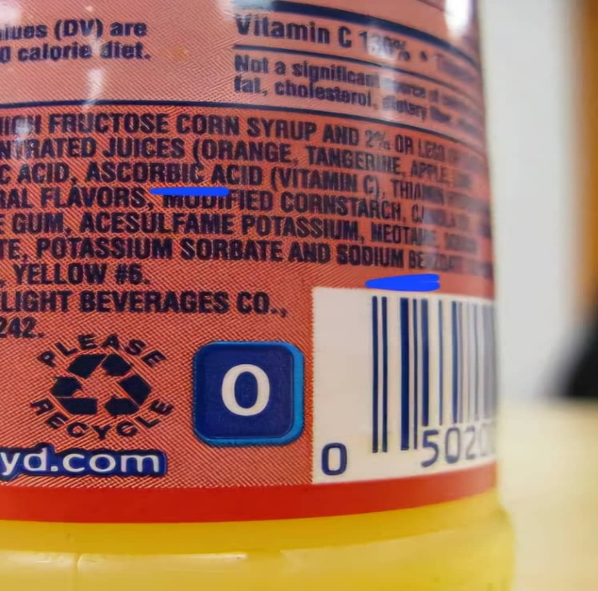 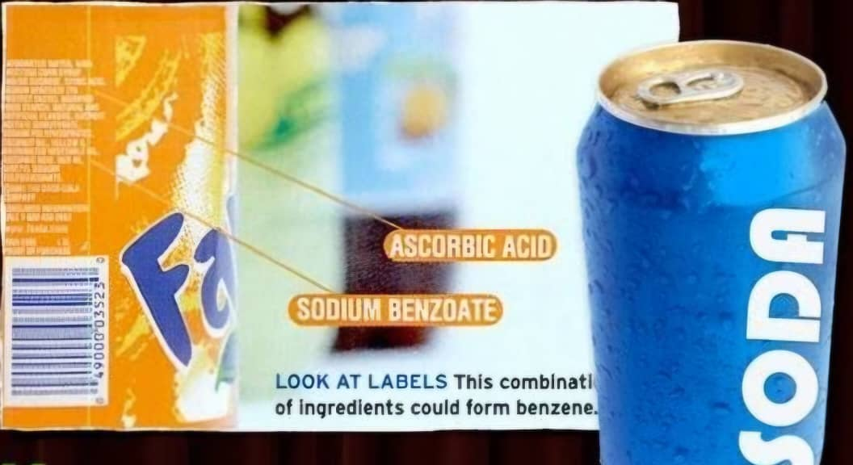

**A B**

**Figure 1A and 1B: Labels of Carbonated Drinks Indicating the Presence of Sodium Benzoate and Ascorbic Acid [12] [13]**

Research exploring the combined effects of sodium benzoate and ascorbic acid on liver remains limited but is essential, considering the extensive use of these compounds in the food industry. Although the antioxidant properties of vitamin C are thought to mitigate oxidative stress, its interaction with sodium benzoate may yield varying outcomes based on factors such as dosage, exposure duration, and existing physiological conditions. Therefore, this study was designed to assess the biochemical and histological effects of sodium benzoate, ascorbic acid, and their combined administration on liver function in albino rats.

**Materials and Methods**

**Procurement of Materials**

Sodium benzoate, sterile bottles, lithium heparin, plain bottles, and filter paper were procured from Nexidon Nigeria Limited reagent store, while syringes, hand gloves, and cotton wool were obtained from Lloyd’s Pharmacy in Port Harcourt.

**Ethical Considerations**

The internationally accepted National Institutes of Health (NIH) Guide for Care and Use of Laboratory Animals were observed.

**Experimental Animals**

Thirty-six (36) adult male and female albino rats, weighing between 140-250 g, were randomly selected for the study. The animals were sourced from the Department of Anatomy, College of Medical Sciences, Rivers State University. They were transported in a well-ventilated wire cage to the animal house at the Department of Animal and Environmental Sciences, Rivers State University, Port Harcourt. The rats were housed under a 12-hour light/dark cycle with free access to solid poultry chow and water. Prior to the study, they were acclimatized for two weeks under standard conditions before being divided into six groups.

**Acute Toxicity Study**

The Fixed Dose Procedure [12] was employed for the study, conducted in two phases. In the first phase, three rats were administered sodium benzoate at a dose of 700 mg/kg body weight via oral gavage and monitored for signs of toxicity over 14 days. In the second phase, another group of three rats received sodium benzoate at a lower dose of 300 mg/kg body weight via oral gavage, with observations for toxicity conducted over the same 14-day period.

**Dose Determination**

Following the results of the acute toxicity study, two doses of sodium benzoate were selected: a low dose (120 mg/kg) and a high dose (240 mg/kg). Both doses were below the threshold that caused observable acute toxicity.

***Low dose of sodium benzoate***

To determine the low dose of sodium benzoate, a dosage of 120 mg/kg body weight was calculated. For instance, for a rat weighing 234 g, the calculation proceeded as follows:

Since 120 mg of sodium benzoate is required for a 1 kg (1000 g) rat, the dose for a 234 g rat was calculated using the formula:

Dose = $\frac{120mg}{1000g}x 234g$ = **28.08 mg**

Following the OECD guidelines for volume selection [12], this 28.08 mg of sodium benzoate was dissolved in 2.34 ml of distilled water, ensuring accurate administration.

***High dose of sodium benzoate***

To determine the low dose of sodium benzoate, a dosage of 240 mg/kg body weight was calculated. For instance, for a rat weighing 234 g, the calculation proceeded as follows:

Dose = $\frac{240mg}{1000g}x 234g$ = **56.16 mg**

Following the OECD guidelines for volume selection [12], this 56.16 mg of sodium benzoate was dissolved in 2.34 ml of distilled water, ensuring accurate administration.

**Dose Calculation for Vitamin C**

The dosage of vitamin C used in this study was 100 mg/kg, as adopted from the methodology of Kumar et al. [13]. For a rat weighing 234 g, the dosage was calculated as follows:

Since 100 mg of vitamin C is required for a 1 kg (1000 g) rat, the dose for a 234 g rat was determined using the formula:

**Dose** = $\frac{100mg}{1000g}x 234g$ = **23.4 mg**

Following the OECD guidelines for volume selection [12], this 23.4 mg of vitamin C was dissolved in 2.34 ml of distilled water, ensuring accurate administration.

**Experimental Study Design**

After a 14-day acclimatization period, 36 rats were divided into six groups of six rats each based on their body weight. Group 1 served as the control and received food, water, and 1.8 ml of distilled water orally once daily for 28 days. Group 2 received sodium benzoate at a low dose of 120 mg/kg body weight through oral administration daily for 28 days, while Group 3 was given a high dose of sodium benzoate at 240 mg/kg body weight under the same conditions. Group 4 received vitamin C at a dose of 100 mg/kg body weight orally once daily for 28 days. Group 5 was administered a combination of the low dose of sodium benzoate (120 mg/kg) and vitamin C (100 mg/kg) daily for 28 days, while Group 6 was treated with the high dose of sodium benzoate (240 mg/kg) combined with vitamin C (100 mg/kg) following the same daily regimen.

**Specimen Collection and Preparation**

At the conclusion of the 28-day experimental period, the animals were fasted overnight and anesthetized in a jar containing chloroform-soaked cotton wool. Blood samples were then collected aseptically via cardiac puncture using 2 ml sterile syringes. A total of 2 ml of whole blood was drawn and transferred into lithium heparin bottles. The blood was centrifuged at 3000 rpm for 5 minutes to separate plasma, which was then transferred into plain bottles for kidney function analysis, including electrolytes (sodium, potassium, bicarbonate, and chloride ions), urea, and creatinine levels. Additionally, the kidneys were carefully excised and processed for histological examination.

**Sample Analysis**

The Spectrum and Biobase test kits were purchased and utilized for the analysis. The Spectrum test kit was employed for the measurement of sodium ion, potassium ion, chloride ion, urea, and creatinine, while the Biobase test kit was used for bicarbonate analysis. Additionally, the excised kidneys were prepared for histological examination using the hematoxylin and eosin (H & E) staining technique.

**Statistical Analysis**

The data generated from the analysis were expressed as Mean ± standard deviation, and analysed using the Statistical Package for Social Science (SPSS) version 24. Comparison of the mean and standard deviation values were made for the various parameters for the various groups using the one-way ANOVA and Tukey test. Results were considered statistically significant at 95% confidence interval (p≤0.05).

**Results**

**Acute Toxicity Study of Sodium Benzoate**

The acute toxicity study results for sodium benzoate are presented in Tables 1a and 1b. As shown in Table 1a, rats administered a dose of 700 mg/kg of sodium benzoate exhibited distinct clinical signs of toxicity. These included the development of open wounds and skin lesions, particularly around the limbs and flanks, as well as a noticeable reduction in physical activity. Affected animals appeared lethargic, with reduced responsiveness to external stimuli and minimal exploratory behaviour. Despite these observable toxic effects, there were no instances of mortality recorded during the study period. In contrast, Table 1 b reveals that treatment with 300 mg/kg of sodium benzoate showed no signs of toxicity or mortality in the rats.

**Table 1 a: Results of Acute Toxicity Study Phase I**

|  |  |
| --- | --- |
| **Dose (mg/kg)** | **Observation** |
| 700 | Presence of signs of toxicity such as wounds and lesions, and reduced activity. No mortality |

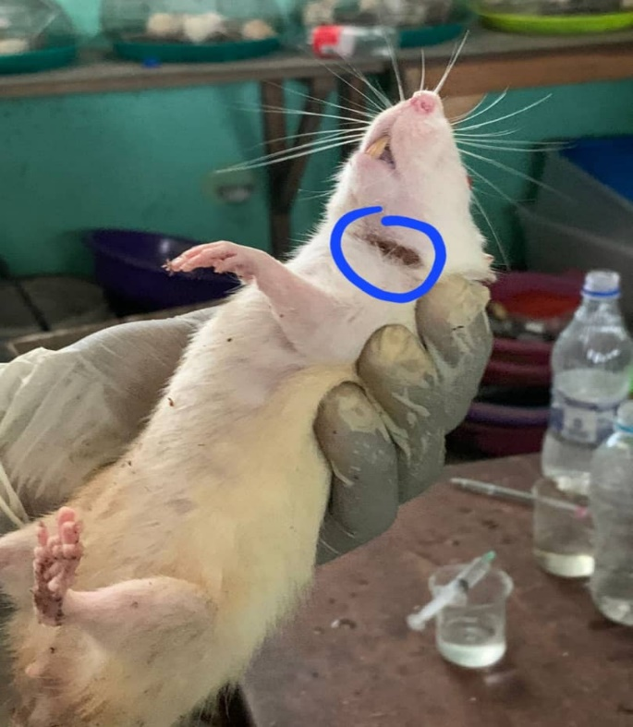 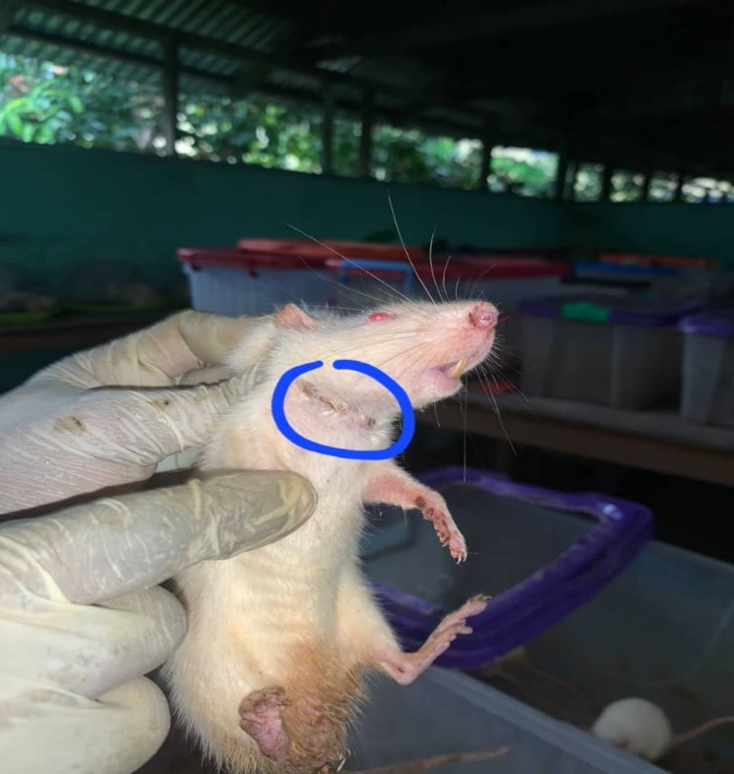

**Figure 2: Photographs Showing Wounds and Lesions on the Skin of Rats Administered 700 mg/kg of Sodium Benzoate During Phase I of the Acute Toxicity Study**

**Table 1 b: Results of Acute Toxicity Study**

|  |  |
| --- | --- |
| **Dose (mg/kg)** | **Observation** |
| 300 | No signs of toxicity. No mortality |

**Comparison of Serum Total Bilirubin, Direct Bilirubin, Total Protein, and Albumin in Control and Test Groups**

Table.2 compares total bilirubin, direct bilirubin, total protein, and albumin levels across six groups. Total bilirubin was highest in Group III (5.25 ± 0.59 mmol/L) and significantly higher than in Group VI (2.94 ± 0.73 mmol/L) with a p-value of 0.017. However, the total bilirubin levels in these groups did not significantly differ from the control group. Direct bilirubin levels were also highest in Group III (7.56 ± 0.35 mmol/L), significantly exceeding all other groups (p = 0.000). However, total protein and albumin levels showed no significant differences across the groups (p = 0.555 and p = 0.451, respectively).

**Table 2: Comparison of Serum Total Bilirubin, Direct Bilirubin, Total Protein, and Albumin Across Groups I, II, III, IV, V, and VI**

|  |  |  |  |  |
| --- | --- | --- | --- | --- |
|  | **Total Bilirubin (mmol/L)** | **Direct Bilirubin (mmol/L)** | **Total Protein (g/dL)** | **Albumin**  **(g/L)** |
| **GROUP I** | 4.02 ± 1.65 | 1.79 ± 0.85a | 57.88 ± 2.93 | 27.90 ± 5.12 |
| **GROUP II** | 4.24 ± 1.23 | 6.69 ± 0.82b | 59.78 ± 7.25 | 32.78 ± 5.93 |
| **GROUP III** | 5.25 ± 0.59a | 7.56 ± 0.35b | 60.88 ± 4.98 | 30.83 ± 5.16 |
| **GROUP IV** | 5.15 ± 1.08a | 5.27 ± 0.28c | 59.13 ± 3.31 | 33.53 ± 4.08 |
| **GROUP V** | 3.54 ± 0.88 | 5.04 ± 0.80c | 57.86 ± 3.38 | 33.36 ± 5.45 |
| **GROUP VI** | 2.94 ± 0.73b | 2.79 ± 0.67a | 55.73 ± 3.42 | 30.15 ± 3.90 |
| **F-value** | 3.469 | 54.982 | 0.808 | 0.979 |
| ***P*-value** | 0.017 | 0.000 | 0.555 | 0.451 |
| **Remark** | S | S | **NS** | **NS** |

***Key:*** *NS = not significant, S = significant. Values with different superscripts are significantly different (p<0.05)*

**Comparison of the Levels of Liver Enzymes of the Control and Test Groups**

Table 3shows the comparison of AST, ALT, ALP, and GGT levels across groups I to VI. AST levels did not differ significantly (p=0.089). ALT levels were significantly higher in Group VI (30.46 ± 6.31 U/L) compared to the other groups (p=0.000). ALP levels in Group II (40.08 ± 3.47 U/L) were significantly higher than in Group V (26.60 ± 8.48 U/L) and Group I (28.32 ± 8.22U/L) at a p-value of 0.024. However, GGT levels did not show significant differences across all the groups (p=0.185).

**Table 3: Comparison of AST, ALT, ALP, and GGT Across Groups I, II, III, IV, V, and VI**

|  |  |  |  |  |
| --- | --- | --- | --- | --- |
|  | **AST**  **(U/L)** | **ALT**  **(U/L)** | **ALP**  **(U/L)** | **GGT**  **(U/L)** |
| **GROUP I** | 14.20 ± 1.07 | 21.62 ± 0.97a | 28.32 ± 8.22b | 15.78 ± 2.59 |
| **GROUP II** | 13.95 ± 2.29 | 20.51 ± 1.69a | 40.08 ± 3.47a | 17.54 ± 3.85 |
| **GROUP III** | 11.42 ± 1.37 | 27.17 ± 2.71b | 33.18 ± 5.54 | 17.97 ± 2.41 |
| **GROUP IV** | 11.74 ± 1.93 | 22.32 ± 1.81 | 35.38 ± 5.77 | 18.90 ± 2.69 |
| **GROUP V** | 13.30 ± 0.95 | 22.46 ± 2.73 | 26.60 ± 8.48b | 20.22 ± 1.90 |
| **GROUP VI** | 12.98 ± 2.22 | 30.46 ± 6.31b | 35.53 ± 4.30 | 17.65 ± 1.40 |
| **F-value** | 2.187 | 7.276 | 3.202 | 1.650 |
| ***P*-value** | 0.089 | 0.000 | 0.024 | 0.185 |
| **Remark** | NS | **S** | **S** | **NS** |

***Key:*** *NS = not significant, S = significant, AST = Aspartate amino transferase, ALT = Alanine amino transferase, ALP = Alkaline phosphatase, GGT = Glutamyl transferase. Values with different superscripts are significantly different (p<0.05)*

**3.4 Histological Analysis Results of Liver Tissues from the Different Rat Groups**

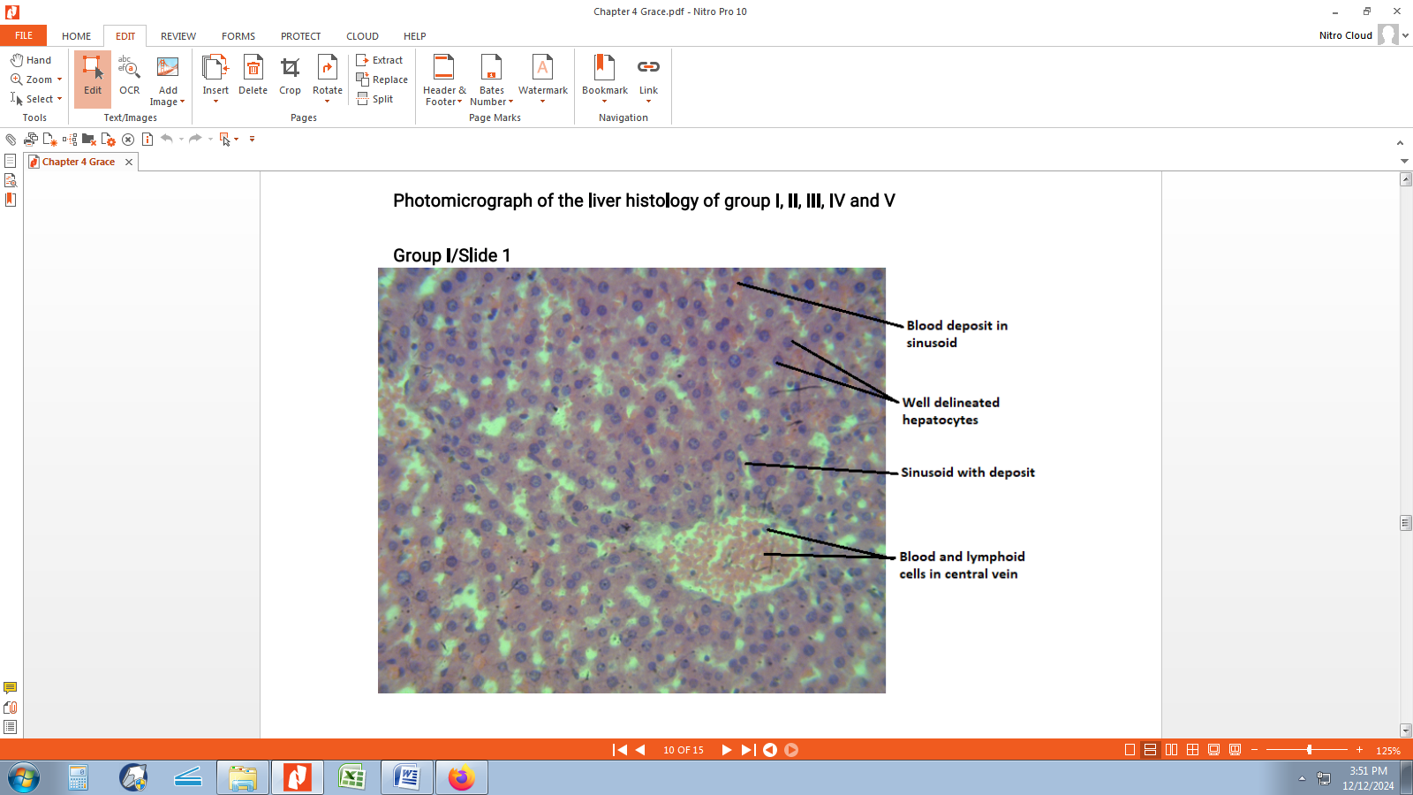

**Pic 1. Group I Photomicrograph of the liver tissue showing well delineated hepatocytes, sinusoid with deposit, and congested central vein. H & E; X400**

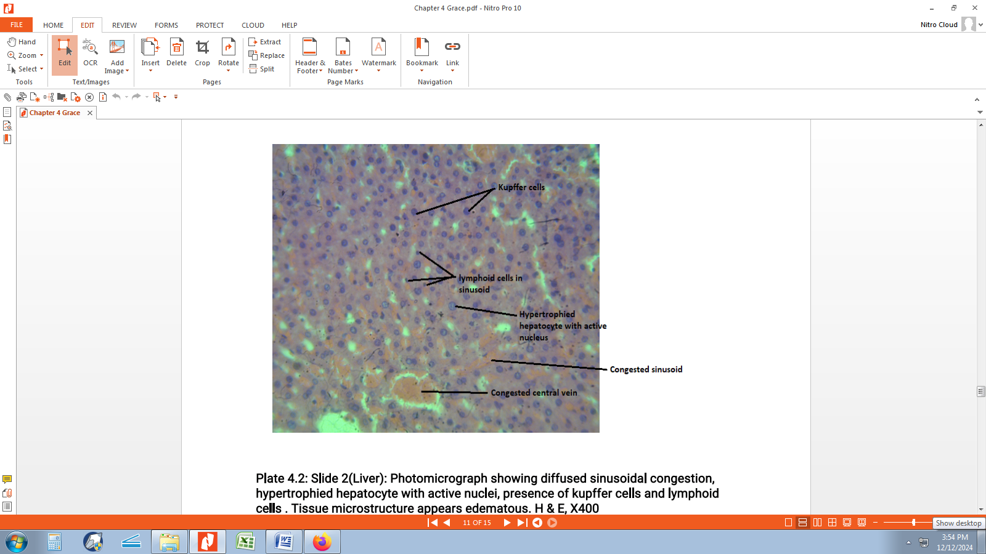

**Pic 2. Group II Photomicrograph showing diffused sinusoidal congestion, hypertrophied hepatocyte with active nuclei, presence of kupffer cells and lymphoid cells. Tissue microstructure appears edematous. H & E, X400**

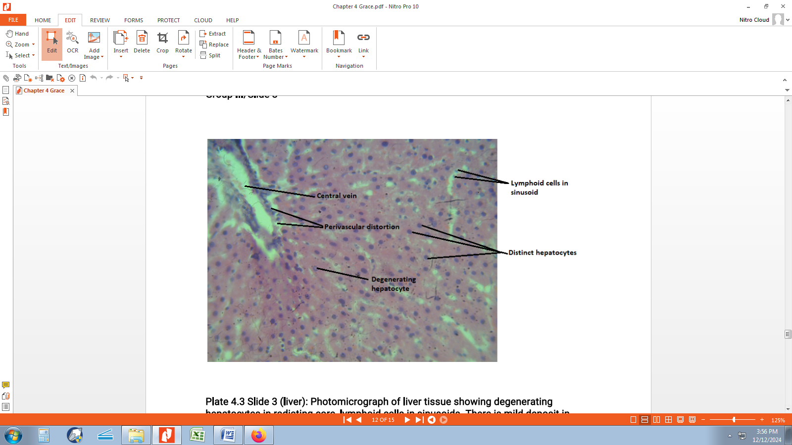

**Pic 3. Group III Photomicrograph of liver tissue showing degenerating hepatocytes in radiating core, lymphoid cells in sinusoids. There is mild deposit in central vein as well as perivascular distortion. Tissue shows distortion of microstructure. H & E, X400**

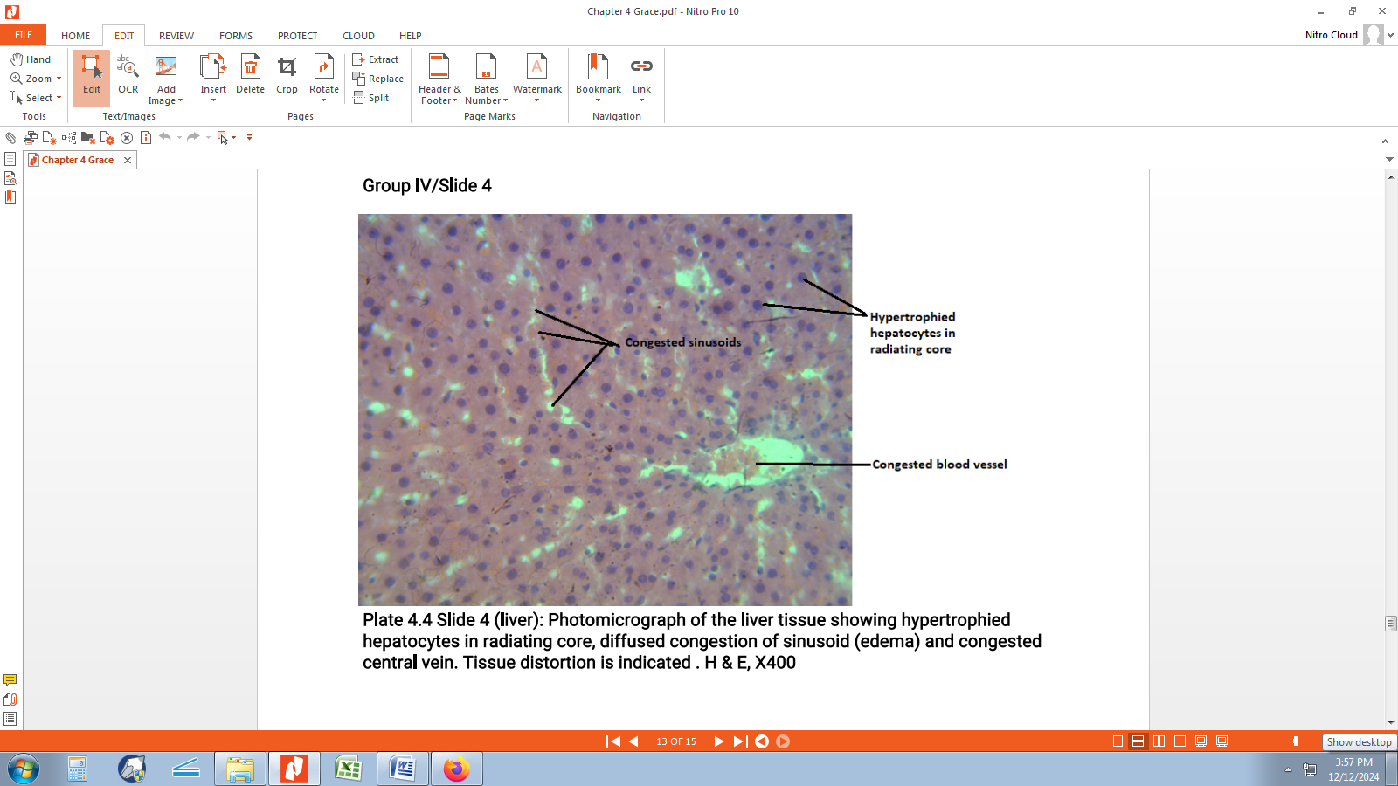

**Pic 4. Group IV Photomicrograph of the liver tissue showing hypertrophied hepatocytes in radiating core, diffused congestion of sinusoid (edema) and congested central vein. Tissue distortion is indicated. H & E, X400**

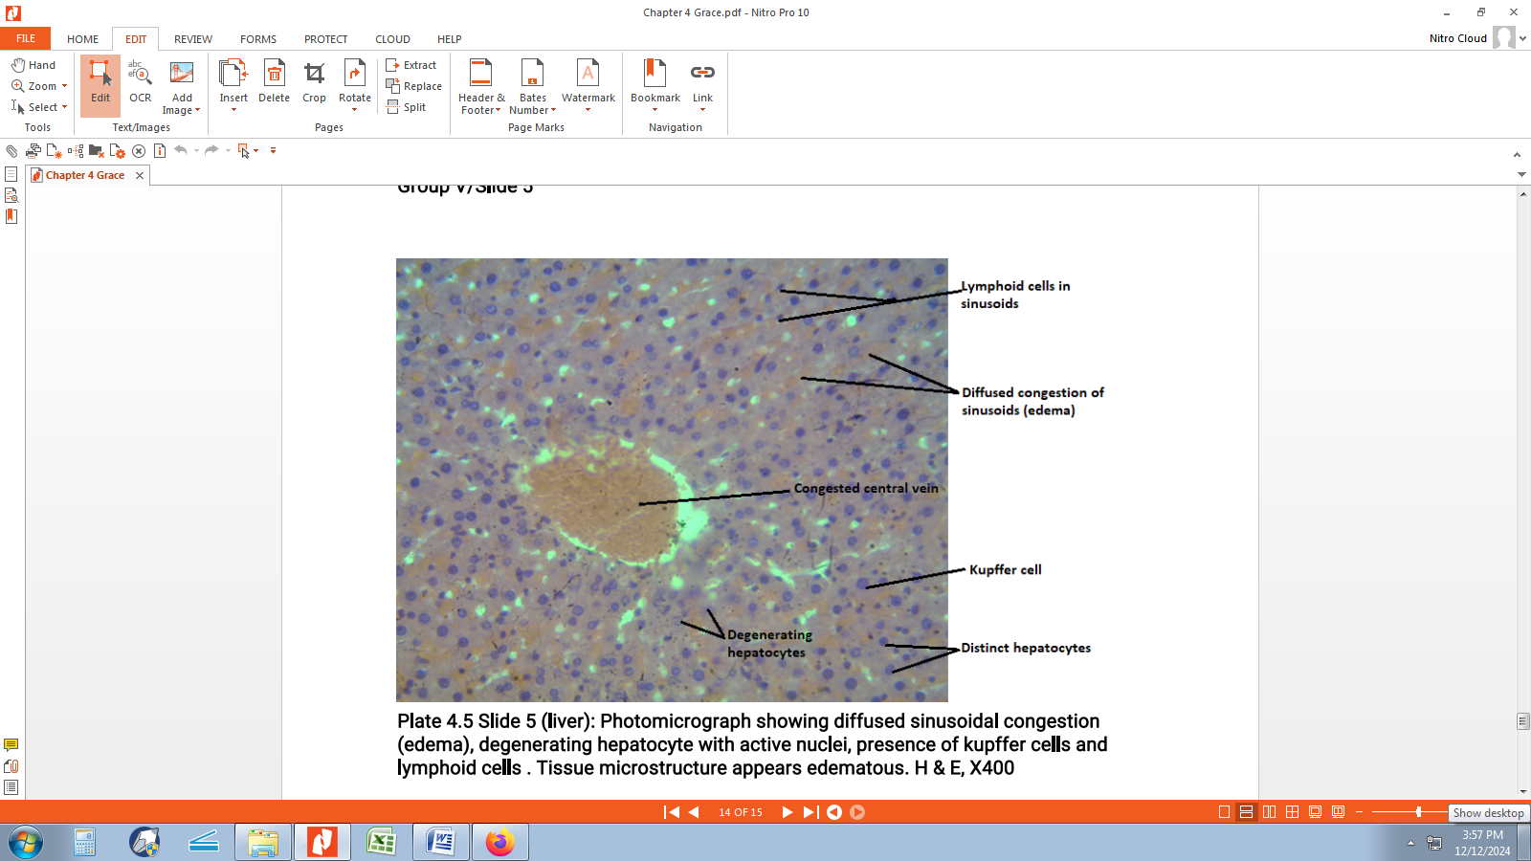

**Pic 5. Group V Photomicrograph showing diffused sinusoidal congestion (edema), degenerating hepatocyte with active nuclei, presence of kupffer cells and lymphoid cells. Tissue microstructure appears edematous. H & E, X400**

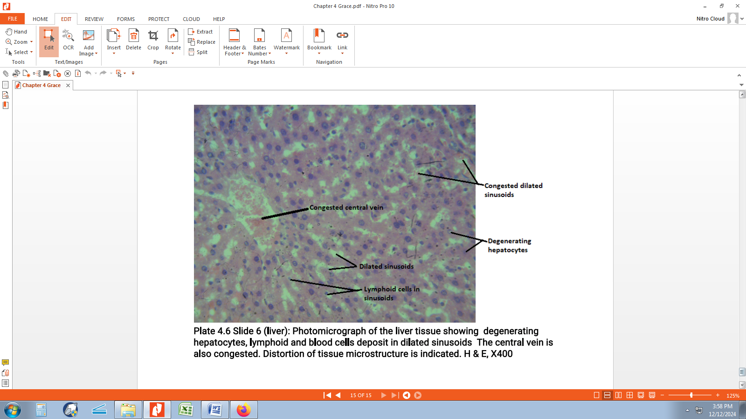

**Pic 6. Group VI: Photomicrograph of the liver tissue showing degenerating hepatocytes, lymphoid and blood cells deposit in dilated sinusoids. The central vein is also congested. Distortion of tissue microstructure is indicated. H & E, X400**

**Discussion**

This study aimed to investigate assessment of the hepatotoxic effects of sodium benzoate, ascorbic acid, and their combined administration in albino rats. The acute toxicity study results in this research reveal the effects of sodium benzoate on the health of albino rats at different doses. The administration of 700 mg/kg of sodium benzoate led to visible signs of toxicity, including wounds, lesions, and reduced activity in the rats, although no fatalities occurred. In contrast, a lower dose of 300 mg/kg did not result in any observable toxicity or mortality. The lesions and reduced activity observed in the higher dose group indicate that sodium benzoate may induce a stress response or organ-specific damage, such as skin and muscle toxicity, although the absence of fatalities suggests that the overall survival of the rats was not compromised at this dosage.

The total bilirubin level was highest in Group III (240 mg/kg sodium benzoate, high dose). This increase in bilirubin levels suggests possible hepatocellular injury or obstruction of bile flow, which is consistent with reports of liver toxicity caused by various substances [13]. Bilirubin is a byproduct of haemoglobin degradation, and elevated levels often indicate liver dysfunction or bile duct obstruction [14]. The histological findings from Group III, showing degenerating hepatocytes and distortion of tissue microstructure, support these biochemical results, as liver damage typically correlates with elevated bilirubin levels. These findings align with those of Asejeje et al. [15], who observed similar hepatotoxic effects from exposure to high doses of sodium benzoate.

Direct bilirubin levels were also highest in Group III, significantly higher than the values in all other groups. Direct bilirubin, which indicates conjugated bilirubin, is typically elevated in cases of obstructive or hepatocellular damage. The significant increase in direct bilirubin in Group III suggests that the hepatocytes in this group may have suffered from more severe injury, impairing their ability to process bilirubin effectively. The histopathological findings further confirm this, with Group III showing degenerating hepatocytes and perivascular distortion, which are signs of severe liver injury. These results are consistent with the study by Harb and Thomas [16], which demonstrated a direct correlation between hepatocellular damage and elevated direct bilirubin levels.

Interestingly, total protein and albumin levels did not show significant differences across the groups. These proteins are synthesized by the liver, and their levels often serve as indicators of liver function. The lack of significant changes suggests that while the liver was affected by the treatments, its ability to synthesize these proteins may not have been significantly impaired. This finding contrasts with some studies where liver dysfunction was accompanied by lower total protein and albumin levels [17]. The absence of significant changes in these proteins may also reflect the compensatory mechanisms of the liver, where it might still produce proteins despite the damage, as shown in the relatively mild histological changes in some groups, such as Group IV and Group II, which showed less severe distortion of liver microstructure.

Turning to liver enzymes, AST levels did not show significant differences among the groups, suggesting that these treatments did not significantly impact the general liver integrity, at least in terms of AST release. AST is often used as an indicator of liver damage, but its level can also be influenced by other tissues, such as muscle. This could explain why AST levels did not significantly vary across the groups. However, ALT levels in Group VI (240 mg/kg sodium benzoate with 100 mg/kg vitamin C) were significantly higher compared to the other groups, indicating substantial liver cell injury since ALT is more liver-specific compared to AST. Elevated ALT levels in Group VI correspond to the histological observations of severe hepatocyte degeneration and distortion in this group, as shown by the photomicrographs where hepatocytes appear degenerated with congestion in the central vein. This finding supports the view that Group VI underwent significant liver damage, consistent with studies by Brauner et al. [18], who reported elevated ALT levels in rats exposed to hepatotoxic substances.

ALP levels in Group II (120 mg/kg sodium benzoate, low dose) were significantly higher compared to Group V (120 mg/kg sodium benzoate with 100 mg/kg vitamin C). This suggests that Group II, exposed to the lower dose of sodium benzoate, may have experienced biliary tract or hepatobiliary dysfunction, as ALP is associated with bile duct activity. In contrast, the lower ALP levels in Group V may indicate less biliary involvement. The histological results from Group II, showing sinusoidal congestion, hypertrophied hepatocytes, and active nuclei, further suggest that liver damage in this group may be linked to cholestasis or bile duct obstruction, which often leads to an increase in ALP levels. These findings are consistent with research on bile duct-related hepatotoxicity [19].

Lastly, GGT levels did not differ significantly across the groups, suggesting that the treatments did not significantly impact liver function through mechanisms associated with GGT, which is primarily involved in the metabolism of glutathione and detoxification. The histological findings of sinusoidal congestion and hepatocyte degeneration in various groups, however, suggest that while GGT was not significantly altered, the liver cells may have still suffered from oxidative stress, which could affect glutathione metabolism indirectly.

**Conclusion**

The biochemical and histological results reveal varying degrees of liver damage across the treatment conditions. High-dose sodium benzoate alone caused the most significant changes in bilirubin levels and severe hepatocellular injury. A combination of vitamin C and high-dose sodium benzoate also led to significant liver damage, as indicated by elevated ALT levels and histopathological changes. In contrast, the low dose of sodium benzoate alone resulted in biliary dysfunction, while the combination of low-dose sodium benzoate and vitamin C showed less severe liver damage. These findings suggest that preservatives like sodium benzoate, particularly at high doses, may worsen liver damage when combined with antioxidants like vitamin C. However, the lack of significant changes in total protein, albumin, and GGT levels suggests that while liver injury occurred, the overall synthetic and detoxifying functions of the liver may not have been entirely compromised.

**COMPETING INTERESTS DISCLAIMER:**

Authors have declared that they have no known competing financial interests OR non-financial interests OR personal relationships that could have appeared to influence the work reported in this paper.

Disclaimer (Artificial intelligence)

Option 1:

Author(s) hereby declare that NO generative AI technologies such as Large Language Models (ChatGPT, COPILOT, etc.) and text-to-image generators have been used during the writing or editing of this manuscript.

Option 2:

Author(s) hereby declare that generative AI technologies such as Large Language Models, etc. have been used during the writing or editing of manuscripts. This explanation will include the name, version, model, and source of the generative AI technology and as well as all input prompts provided to the generative AI technology

Details of the AI usage are given below:

1.

2.

3.

**References**

1. Femi-Oloye OP, Olatunji-Ojo AM, Owoloye A, Adewumi B, Ibitoye O, Oloye FF, et al. Studies on the effects of carbonated soft drink additives and simultaneous consumption of carbonated soft drink with ascorbic acid on histological parameters of male mice. Int J Biochem Res Rev. 2019;1(1):1–9.
2. Himani N, Mahawer SK, Arya S, Kumar R, Prakash O. Essential oil: Source of antioxidants and role in food preservation. Switzerland: Springer Nature; 2022.
3. Bacak A. Acidity regulators, preservatives, and antioxidants. In: Advances in Dairy Products. New Jersey: Wiley; 2017. p. 117–31.
4. Heydaryinia A, Veissi M, Sadadi A. A comparative study of the effects of the two preservatives, sodium benzoate and potassium sorbate, on Aspergillus niger and Penicillium notatum. Jundishapur J Microbiol. 2011;4(4):301–7.
5. Davidson PM, Taylor TM, David JR. Antimicrobials in food. Florida: CRC Press; 2021.
6. Walczak-Nowicka ŁJ, Herbet M. Sodium benzoate—harmfulness and potential use in therapies for disorders related to the nervous system: a review. Nutrients. 2022;14(7):1497–500.
7. Franco R, Navarro G, Martínez-Pinilla E. Antioxidants versus food antioxidant additives and food preservatives. Antioxidants (Basel). 2019;8(11):1–13.
8. Yadav A, Kumar A, Das M, Tripathi A. Sodium benzoate, a food preservative, affects the functional and activation status of splenocytes at non-cytotoxic dose. Food Chem Toxicol. 2015;88:40–7.
9. Khan IS, Dar KB, Ganie SA, Ali MN. Toxicological impact of sodium benzoate on inflammatory cytokines, oxidative stress, and biochemical markers in male Wistar rats. Drug Chem Toxicol. 2020;45(3):1345–50.
10. Piper JD, Piper PW. Benzoate and sorbate salts: a systematic review of the potential hazards of these invaluable preservatives and the expanding spectrum of clinical uses for sodium benzoate. Compr Rev Food Sci Food Saf. 2017;16(1):868–80.
11. Pizzorno J. The kidney dysfunction epidemic, part 1: causes. Integr Med (Encinitas). 2015;14(6):8–13.
12. Ibama O, Korubo IF, Ogutu B. Assessment of the Comparative Effect of Sodium Benzoate, Ascorbic Acid, and their Combination on Glucose Levels, Lipid Profile, and Some Cardiovascular Risk Markers in Albino Rats. Asian J. Cardiol. Res. 2025;8(1):154-63.
13. Ibama O, Brisibe N, Lemoha FO. Assessment of the Nephrotoxic Effect of Sodium Benzoate, Ascorbic Acid, and their Combined Administration in Albino Rats. Int. J. Adv. Nephrol. Res. 2025;8(1):22-33.
14. Organisation for Economic Co-operation and Development (OECD) (2001). *OECD Guideline for Testing of Chemicals Acute Oral Toxicity – Acute Toxic Class Method*. Available from: <https://ntp.niehs.nih.gov/sites/default/files/iccvam/suppdocs/feddocs/oecd/oecd_gl423.pdf>
15. Ramírez-Mejía MM, Castillo-Castañeda SM, Pal SC, Qi X, Méndez-Sánchez N. The multifaceted role of bilirubin in liver disease: A literature review. J Clin Transl Hepatol. 2024;12(11):939-948.
16. Kalakonda A, Jenkins BA, John S. Physiology, bilirubin. In: StatPearls. Treasure Island (FL): StatPearls Publishing; 2022.
17. Asejeje FO, Akinola KD, Abiola MA. Sodium benzoate exacerbates hepatic oxidative stress and inflammation in lipopolysaccharide-induced liver injury in rats. Immunopharmacol Immunotoxicol. 2023;45(5):558-564.
18. Harb R, Thomas DW. Conjugated hyperbilirubinemia: Screening and treatment in older infants and children. Pediatr Rev. 2007;28(3):83-91.
19. Wen J, Chen X, Wei S, Ma X, Zhao Y. Research progress and treatment status of liver cirrhosis with hypoproteinemia. Evid Based Complement Alternat Med. 2022;2022:1-8.
20. Brauner C, Joveleviths D, Álvares-da-Silva MR, Marroni N, Bona S, Schemitt E, et al. Exposure to organic solvents and hepatotoxicity. J Environ Sci Health A Tox Hazard Subst Environ Eng. 2020;55(10):1173-1178.
21. Saran C, Brouwer KLR. Hepatic bile acid transporters and drug-induced hepatotoxicity. Toxicol Pathol. 2023;51(7-8):405-413.