***Case report***

**Management of medical fitness in idiopathic adulthood ductopenia in aviation medicine: a case report**

# ABSTRACT

**Aims:** The case raises important considerations regarding aeronautical fitness especially in managing chronic diseases, as Moroccan regulations and International Civil Aviation Organization (ICAO) standards necessitate strict health evaluations for air traffic controllers (ATC) as they play a crucial role in flight safety.

**Case presentation:** We present the case of a 26-year-old female Moroccan air traffic controller who was asymptomatic but presented with abnormal liver function tests during her periodic medical assessment. Comprehensive investigations, led to a diagnosis of idiopathic adulthood ductopenia (IAD)

**Discussion**: IAD is a rare cholestatic liver disease of unknown etiology, characterized by biopsy-confirmed ductopenia without an identifiable cause. It manifests in two forms: mild (Type 1), with limited bile duct loss and a favorable prognosis, and severe (Type 2), which often progresses to biliary cirrhosis. Ursodeoxycholic acid (UDCA) has shown efficacy in mild cases, although its long-term impact remains uncertain.

Moroccan aviation standards, in alignment with ICAO guidelines, generally deem serious gastrointestinal conditions disqualifying. However, exemptions may be granted based on medical stability, treatment response, and flight safety considerations. In this case, the mild nature of IAD, absence of complications, and positive response to UDCA warranted an exemption with regular monitoring.

**Conclusion:** This case emphasizes the importance of the systematic periodic medical assessment including liver function tests, for aircrew and by extension ATC. It also underscores the need for nuanced management of chronic conditions within the aviation field.

*Keywords: Idiopathic adulthood ductopenia, Aviation medicine, Medical fitness,*

# INTRODUCTION

In the demanding field of aeronautics, managing the health of aircrew, and by extension ATC, is critical for the safety of flights and passengers which is the ultimate purpose of aeronautical medicine. This case report examines a 26-year-old female air traffic controller, asymptomatic, who presented with abnormal liver function tests during her periodic medical assessment in February 2024. Extensive medical investigation, including imaging, serological tests and liver biopsy, led to a diagnosis of idiopathic adulthood ductopenia (IAD)—a rare chronic small duct cholestatic biliary disease of unknown origin characterized by the loss of interlobular bile ducts.

The report not only details her clinical journey, from initial assessment to diagnosis and treatment, but also explores the importance of systematic liver function tests (LFT) and the implications of IAD, as a progressive condition, on aeronautical fitness.

# CASE PRESENTATION

A 26-years-old Moroccan female ATC presented on her periodic medical assessment on February 2024, abnormal LFT with no symptoms. She had history of asymptomatic cholestasis attributed to use of paracetamol which was discovered during her last systematically conducted periodic medical assessment in 2022. The condition resolved after discontinuing the said treatment. She stated no other medical history on her declaration form. Physical examination showed no signs of chronic liver disease such as jaundice, hepatomegaly, or signs of cirrhosis. Her laboratory tests revealed hemoglobin 12.9 g/dL, white blood count 4500/mm3, platelets 184,000/mm3, alanine aminotransferase (ALT) 138 IU/L, aspartate aminotransferase (AST) 194 IU/L, alkaline phosphatase (ALP) 928 IU/L, γ-glutamyl transpeptidase (GGT) 539 IU/L, total bilirubin 1 mg/dL and total cholesterol of 353 mg/dL. In light of the detected abnormalities, a more thorough medical interview was conducted. Our ATC had history of prematurity birth but no history of neonatal or childhood jaundice, nor of liver disease or auto-immune disease. She denied any recent use of prescription medication, herbal medication, alcohol or illicit drugs. And there was no family history of recurrent cholestatic disorder or liver disease.

She was declared temporarily unfit for work and referred to a gastroenterologist for etiological assessment of the cholestasis.

The viral hepatitis panel for both hepatitis B and C was negative. Additional tests, including metabolic disease screening, revealed normal levels of copper in 24-hour urine, ceruloplasmin, alpha-1-antitrypsin, serum immunoglobulins, and protein electrophoresis. Autoimmune markers for anti-nuclear, anti-smooth muscle, anti-mitochondrial, anti-liver-kidney microsome, anti-liver cytosol, and anti-soluble liver antigen antibodies were all negative, effectively ruling out autoimmune diseases such as autoimmune hepatitis or primary biliary cholangitis (PBC).

Abdominal ultrasound showed no evidence of intra- or extrahepatic biliary dilation or cholelithiasis. Esophagogastroduodenoscopy and coloscopy did not show evidence of inflammatory bowel disease.

Considering the absence of an evident etiology, a liver biopsy was conducted and had demonstrated a lack of interlobular bile ducts with bile ducts present in three out of five portal tracts (absence of bile ducts in 40% of the portal tracts), as well as chronic hepatitis with mild activity and portal fibrosis (Metavir score: A1F2) associated with minimal hepatocyte cholestasis.

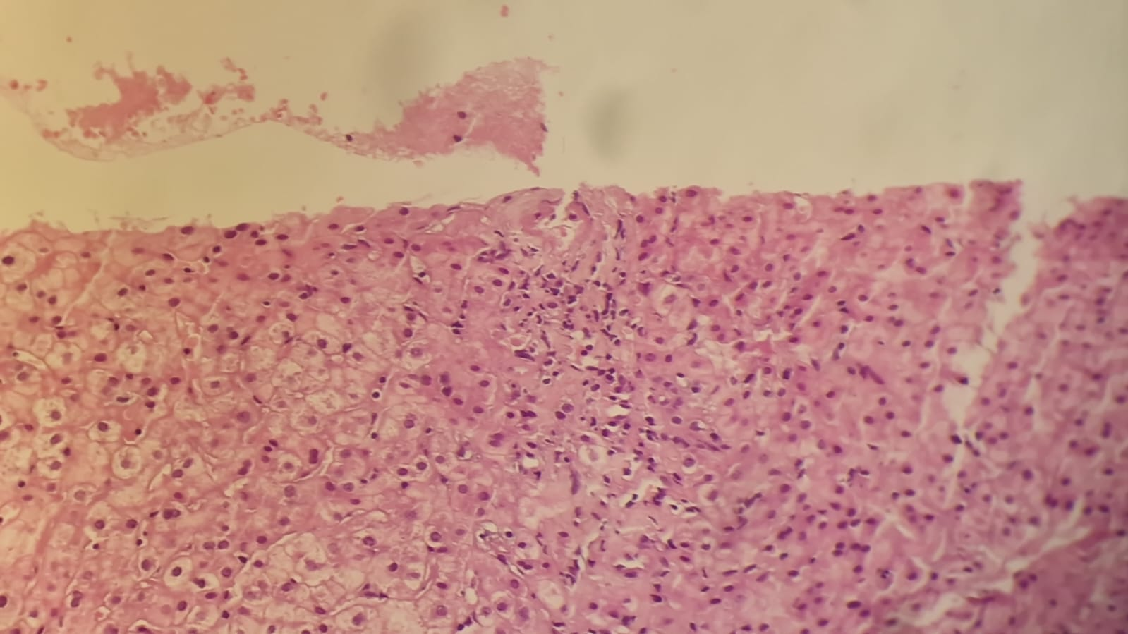

Figure 1: Histology findings of the liver biopsy specimen

Our ATC was diagnosed with IAD. Treatment was started with Ursodeoxycholic Acid (UDCA) at doses of 200mg thrice daily. After one month of treatment, the patient’s liver function tests showed significant improvement. The ALT dropped to 51 IU/L, AST to 81 IU/L, ALP to 766 IU/L, and GGT to 115 IU/L. Clinically, the patient remained asymptomatic.

Given the relatively favorable evolution of the biological parameters, the good tolerance of the treatment and the absence of any psychological impact, her file was presented to the committee of experts in aeronautical medicine, which granted her an aptitude by exemption with regular trimestral monitoring.

|  |  |  |
| --- | --- | --- |
|  | Before treatment | After one month of UDCA treatment |
| ALT | 138 IU/L | 51 IU/L |
| AST | 194 IU/L | 81 IU/L |
| ALP | 928 IU/L | 766 IU/L |
| GGT | 539 IU/L | 115 IU/L |

*Table 1: Improvement in laboratory results following one month of UDCA treatment*

# DISCUSSION

Perturbations in LFT, particularly cholestasis, are frequently encountered in aeronautical expertise. In most cases, the evaluation reveals a benign condition such as liver steatosis, which requires lifestyle and dietary modifications along with regular follow-up. However, the discovery of IAD in flying personnel remains an exceptional occurrence.

Idiopathic adulthood ductopenia is a rare small-duct biliary disease that was first described by Ludwig (2) in 1988. In a retrospective review of 2082 cases of small-duct biliary diseases, diagnosed between 1988 and 1994, IAD accounts for only 1.2%, while primary sclerosing cholangitis (PSC) and PBC constitute 93% (3).

Essentially, IAD constitutes a syndrome characterized by chronic cholestasis without inflammatory bowel disease, alongside biopsy-confirmed ductopenia, for which no discernible cause of bile duct loss can be ascertained through imaging, biopsy, or serology (4).

Although most cases are sporadic, which is the case of our ATC, familial cases do occur as reported by Zafrani (5) and Burak (6).

A literature review identified 39 reported cases of IAD. The median age at diagnosis was 27 years. Furthermore, there was an almost 2:1 ratio in favor of males compared to females (1).

As of now, the etiology is still unknown, nonetheless several causes have been suggested including late-onset non-syndromic paucity of intrahepatic bile ducts, small duct PSC without large duct involvement and without evidence of inflammatory bowel disease, non-suppurative viral cholangitis, and autoimmune disorders in the absence of the typical autoantibodies (1–3,7)

The current diagnostic criteria of IAD (2,3) include chronic biochemical cholestasis, indicated by elevated ALP values, along with biopsy findings of ductopenia, in the absence of PSC or inflammatory bowel disease. In the original description of the syndrome, ductopenia was histologically defined as the absence of interlobular bile ducts in at least 50% of small portal tracts. However, there is a spectrum of bile duct loss, and minimal or early ductopenia can be diagnosed when over 20% of portal tracts lack bile ducts, which is significantly lower than the normal value (8). Patients typically present in adulthood or during their teenage years, but beyond the typical age range for syndromic or non-syndromic paucity of intrahepatic bile ducts. Other cholestatic syndromes such as PBC, drug reactions, and viral infections must also be excluded before a diagnosis of IAD can be established. It is, therefore, a diagnosis of exclusion.

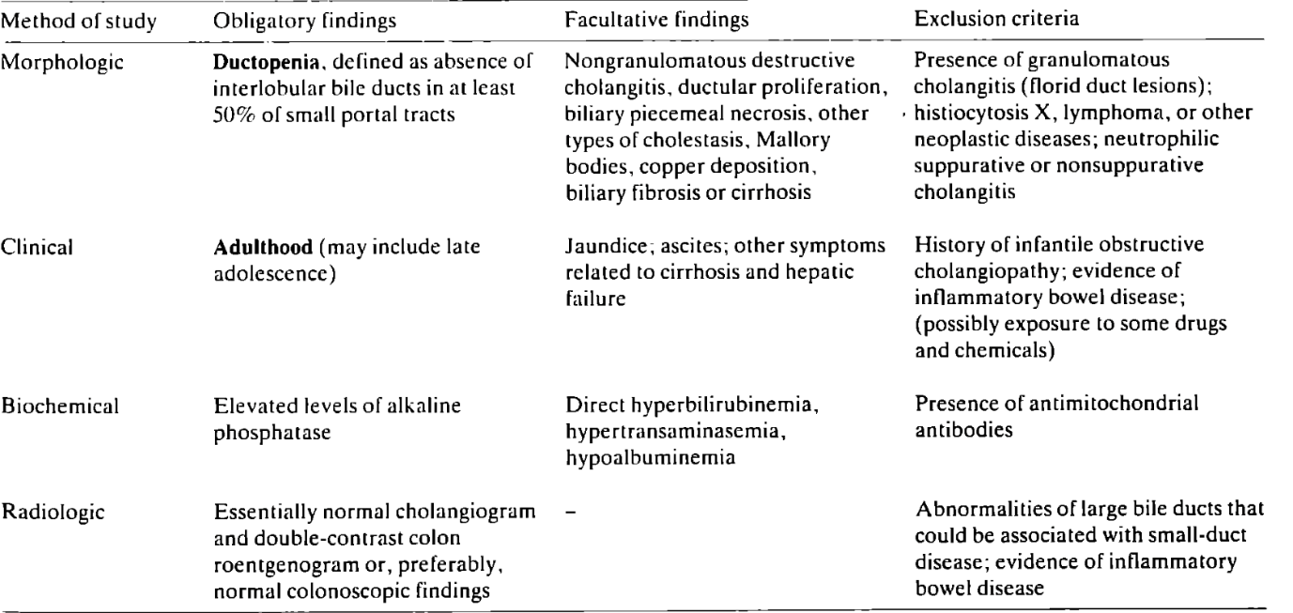

*Table 2: Diagnostic features of IAD*

Clinically, it presents with cholestatic pattern symptoms, including jaundice, pruritus, and fatigue; however, IAD has also been observed in patients without symptoms of liver disease (9). Laboratory findings demonstrate the cholestatic profiles; bilirubin levels could be up to 26mg/dL, the ALP and GGT values ranged from 3 to 16 and 14 times the normal upper limit respectively, and transaminase levels vary between normal and a 10-fold increases (1–3).

When assessing our flight crew member, she was asymptomatic but exhibited significantly elevated liver enzymes. ALP and GGT levels were 7 and 12 times the upper normal limit, respectively. AST and ALT levels were 6 and 4 times the upper normal limit, respectively.

Khanlou and al (10) have analyzed the data on IAD and concluded that two distinct courses of IAD are recognized which vary histologically and by prognosis.

Patients with Type 1 IAD also termed mild IAD have less than 50% loss of biliary ducts on liver biopsy specimens, have a more benign clinical course and better prognosis. Type 2 IAD’s patients have more widespread ductopenia and usually progress to decompensated biliary cirrhosis.

Although mild IAD does not meet the current diagnostic criteria for IAD as they have ductopenia involving less than 50% of the portal tracts, they appear to have features consistent with this diagnosis as demonstrated by Moreno and Dominguez. (9,11)

In mild IAD, UDCA has been proven to be efficient though its effect on the disease’s progression is still unknown (6,9,11,12), whereas patients with type 2 IAD will ultimately require liver transplantation (5,6,10,13). Although immunosuppressed states are associated with IAD, there have been anecdotal reports of improvement in IAD with immune suppression and controlled trials for immune modulation could be considered in the future. (4)

In this case, our ATC probably had mild IAD considering the age of the disease onset, the ductopenia that affected less than 50% of the portal ducts as well as the absence of any other probable cause. She was put on UDCA 600 mg daily which improved her liver function tests.

Overall, UDCA is a well-tolerated treatment; in fact, no serious adverse effects of its administration were reported in early controlled clinical trials including placebo-controlled trials in patients with cholestatic liver disease. Its adverse effects include gastrointestinal disorders mainly diarrhea, abdominal pain and nausea and vomiting, as well as the exacerbation of pruritus. (14)

Regarding aeromedical fitness, all aircrew, and by extension ATC, in aviation must meet medical fitness requirements, which are governed by regulatory standards. These standards vary according to the various categories of aircrew: civilian, military; and for civilians, they vary according to class. However, these standards all have the same objective: to guarantee the safety of flights and the people carried, as well as the accomplishment of missions. Every aircrew member must therefore be physically and mentally fit to accomplish all the tasks assigned to his or her job, and must not have any cause likely to render him or her incapable of performing his or her duties to the extent that flight safety could be jeopardized.

In Morocco, the aeronautical fitness standards are governed by the Ministerial Decree N°1209-09 in line with the standards set by the International Civil Aviation Organization (ICAO).

The ICAO manual (15) clearly specifies that applicants for medical assessments must be free from any abnormalities—whether congenital or acquired—or any active, latent, acute, or chronic disabilities. It also emphasizes that applicants must not have any injuries, surgical sequelae, or the side effects of prescribed or non-prescribed medications that could impair their ability to safely operate an aircraft or perform their duties.

Moreover, the Moroccan standards manual outlines the medical requirements for aircrew, including periodic liver function tests, which are initially conducted and repeated every two years. The manual also states that ATC candidates with significant gastrointestinal deficiencies or related conditions are considered unfit for duty.

This supports the conclusion that, any perturbation of liver function tests requires an etiological evaluation. If cholestasis results from a benign condition with no impact on flight safety, medical fitness may be granted with regular follow-up. However, if it stems from a progressive condition requiring long-term medication, unfitness is the rule.

That being said, filing for an appeal request is always possible. An exemption may be granted if certain conditions are met, depending on the medical condition, the tolerance of the treatment, the flying personnel’s specialty and their experience.

In the case of our patient, despite the diagnosis of a chronic liver condition, its mild nature, the absence of complications and psychological impact, and the good response to treatment allowed for the possibility of an exemption. This exemption includes trimestral medical assessments and monitoring of LFT.

# CONCLUSION

Idiopathic adulthood ductopenia is a rare disease with an unknown etiology. It is a chronic cholestatic liver condition that manifests in adulthood, characterized by the loss of bile ducts and remains a diagnosis of exclusion.

It is a condition that can be completely asymptomatic, highlighting the importance of systematic blood tests conducted by flight personnel. Given its progressive nature and the need for long term treatment, managing medical fitness becomes more complex. Ultimately, the goal is to ensure flight safety, which is the fundamental purpose of aeronautical medicine.

**Ethical Approval:**

As per international standards or university standards written ethical approval has been collected and preserved by the author(s).

# CONSENT

All authors declare that ‘written informed consent was obtained from the patient for publication of this case report and accompanying images.

Disclaimer (Artificial intelligence)

Th authors hereby declare that ChatGPT have been used during the writing or editing of manuscripts solely for grammar and rephrasing. The conceptualization, the research as well as the analysis are entirely the work of the authors.

Details of the AI usage are given below:

1. Grammar and rephrasing

# REFERENCES

1. Kim, W. R. (2000). Variant forms of cholestatic diseases involving small bile ducts in adults. *American Journal of Gastroenterology, 95*(5).
2. Ludwig, J., Wiesner, R. H., & LaRusso, N. F. (1988). Idiopathic adulthood ductopenia. *Journal of Hepatology, 7*(2), 193–199.
3. Ludwig, J. (1998). Idiopathic adulthood ductopenia: An update. *Mayo Clinic Proceedings, 73*(3), 285–291.
4. Reau, N. S., & Jensen, D. M. (2008). Vanishing bile duct syndrome. *Clinics in Liver Disease, 12*(1), 203–217.
5. Zafrani, E. S., Metreau, J. M., Douvin, C., Larrey, D., Massari, R., Reynes, M., et al. (1990). Idiopathic biliary ductopenia in adults: A report of five cases. *Gastroenterology, 99*(6), 1823–1828.
6. Burak, K. W., Pearson, D. C., Swain, M. G., Kelly, J., Urbanski, S. J., & Bridges, R. J. (2000). Familial idiopathic adulthood ductopenia: A report of five cases in three generations. *Journal of Hepatology, 32*(1), 159–163.
7. Dural, A. T., Genta, R. M., Goodman, Z. D., & Yoffe, B. (2002). Idiopathic adulthood ductopenia associated with hepatitis C virus. *Digestive Diseases and Sciences, 47*(7), 1625–1626.
8. Nakanuma, Y., & Ohta, G. (1979). Histometric and serial section observations of the intrahepatic bile ducts in primary biliary cirrhosis. *Gastroenterology, 76*(6), 1326–1332.
9. Moreno, A., Vicente Carreño, V., Cano, A., & González, C. (1997). Idiopathic biliary ductopenia in adults without symptoms of liver disease. *New England Journal of Medicine, 336*(12), 835–838.
10. Khanlou, H., Sass, D., Rothstein, K., Manzarbeitia, C., Reich, D., Jacobson, L., et al. (2000). Idiopathic adulthood ductopenia: Case report and review of the literature. *Archives of Internal Medicine, 160*(7), 1033.
11. Domínguez-Antonaya, M., Coba-Ceballos, J. M., Gómez-Rubio, M., De Cuenca, B., Ortega-Muñoz, P., & García, J. (2000). Idiopathic adulthood ductopenia: A diagnosis—Two clinicopathologic courses. *Journal of Clinical Gastroenterology, 30*(2), 210–212.
12. Müller, C., Ulrich, W., & Penner, E. (1995). Manifestation late in life of idiopathic adulthood ductopenia. *Liver, 15*(4), 213–218.
13. Rios, R., Herrero, J. I., Quiroga, J., Sangro, B., Sola, I., Pardo, F., et al. (2001). Idiopathic adulthood ductopenia: Long-term follow-up after liver transplantation. *Digestive Diseases and Sciences, 46*(7), 1420–1423.
14. Hempfling, W., Dilger, K., & Beuers, U. (2003). Systematic review: Ursodeoxycholic acid—Adverse effects and drug interactions. *Alimentary Pharmacology & Therapeutics, 17*(9), 897–906.
15. International Civil Aviation Organization (ICAO). (2012). *Manual of Civil Aviation Medicine* (3rd ed.). Montreal: ICAO.