Caroli’s disease presenting as Acute Cholangitis: A Case Report

Abstract

Caroli disease is a congenital disorder characterized by multifocal, segmental dilatation or ectasia of large intrahepatic bile ducts. The disease develops due to a remodeling defect, but its molecular pathogenesis is not fully understood. The absence of specific symptoms and signs in Caroli's disease complicates the diagnosis.
It is important to highlight this case and as many can be misdiagnosed by the gastro-enterologist and the surgeons.

Through the column of this article, we describe a 37 years old female to whom the clinical presentation, biological and the radiological findings were that of a Caroli’s disease misdiagnosed since 2012.

Keywords : Caroli’s disease, cholangitis, hydatid cyst, Biliary duct dilatation, Hepatobiliary disorder

Introduction

Caroli disease is a rare, congenital condition characterized by segmental dilation of large, intrahepatic bile ducts. [1] Caroli disease belongs to a group of congenital disorders known as fibropolycystic liver diseases, which originate from ductal plate malformations during embryological development and are associated with various liver cysts.[2][3]
The absence of specific symptoms and signs in Caroli's disease complicates the diagnosis. The magnetic resonance cholangiography is the most sensitive method in diagnosis. Prognosis depends on the degree of liver fibrosis and liver dysfunction and whether or not renal dysfunction is present.
The manuscript helps the practitioners to think beyond the common etiologies of acute cholangitis and to think of Caroli’s disease as a differential for Acute cholangitis which is rare. It also enforces that proper history taking guides us to investigate patients in a better way, so that nothing is missed. One should not shy away till a proper diagnosis is reached.

Below we present a case of a 37 years old patient presented with Caroli disease.

Case Presentation:

We report a history that goes back to 11/09/23 of a 37 years old woman, with medical history of surgery for hydatid cyst in 2012, 2015 and 2018, hospitalized twice for acute cholangitis.

For over a year the symptomatology started by the appearance of right hypochondrium pain without any other symptom, followed by the appearance of jaundice and nausea without vomiting of ​​progressive aggravation, which motivated a consultation in our structure.
Examination on admission shows a conscious patient, her blood pressure was at 110/80 mmHg and her heart rate was at HR 101 pulses per minute. Her respiratory rate at 24c /min and arterial oxygen saturation at 93% at room air with 38,7° C fever.

The abdominal exam showed the surgical scar and an important right hypochondrium sensibility without any other sign.
Abdominal CT (computed tomography) scan showed dysmorphic liver with multiple rounded lesions occupying all of hepatic segments, the largest measures 21mm *17 mm may be related to micro abscesses.
Dilation of intrahepatic bile ducts without detectable obstacles

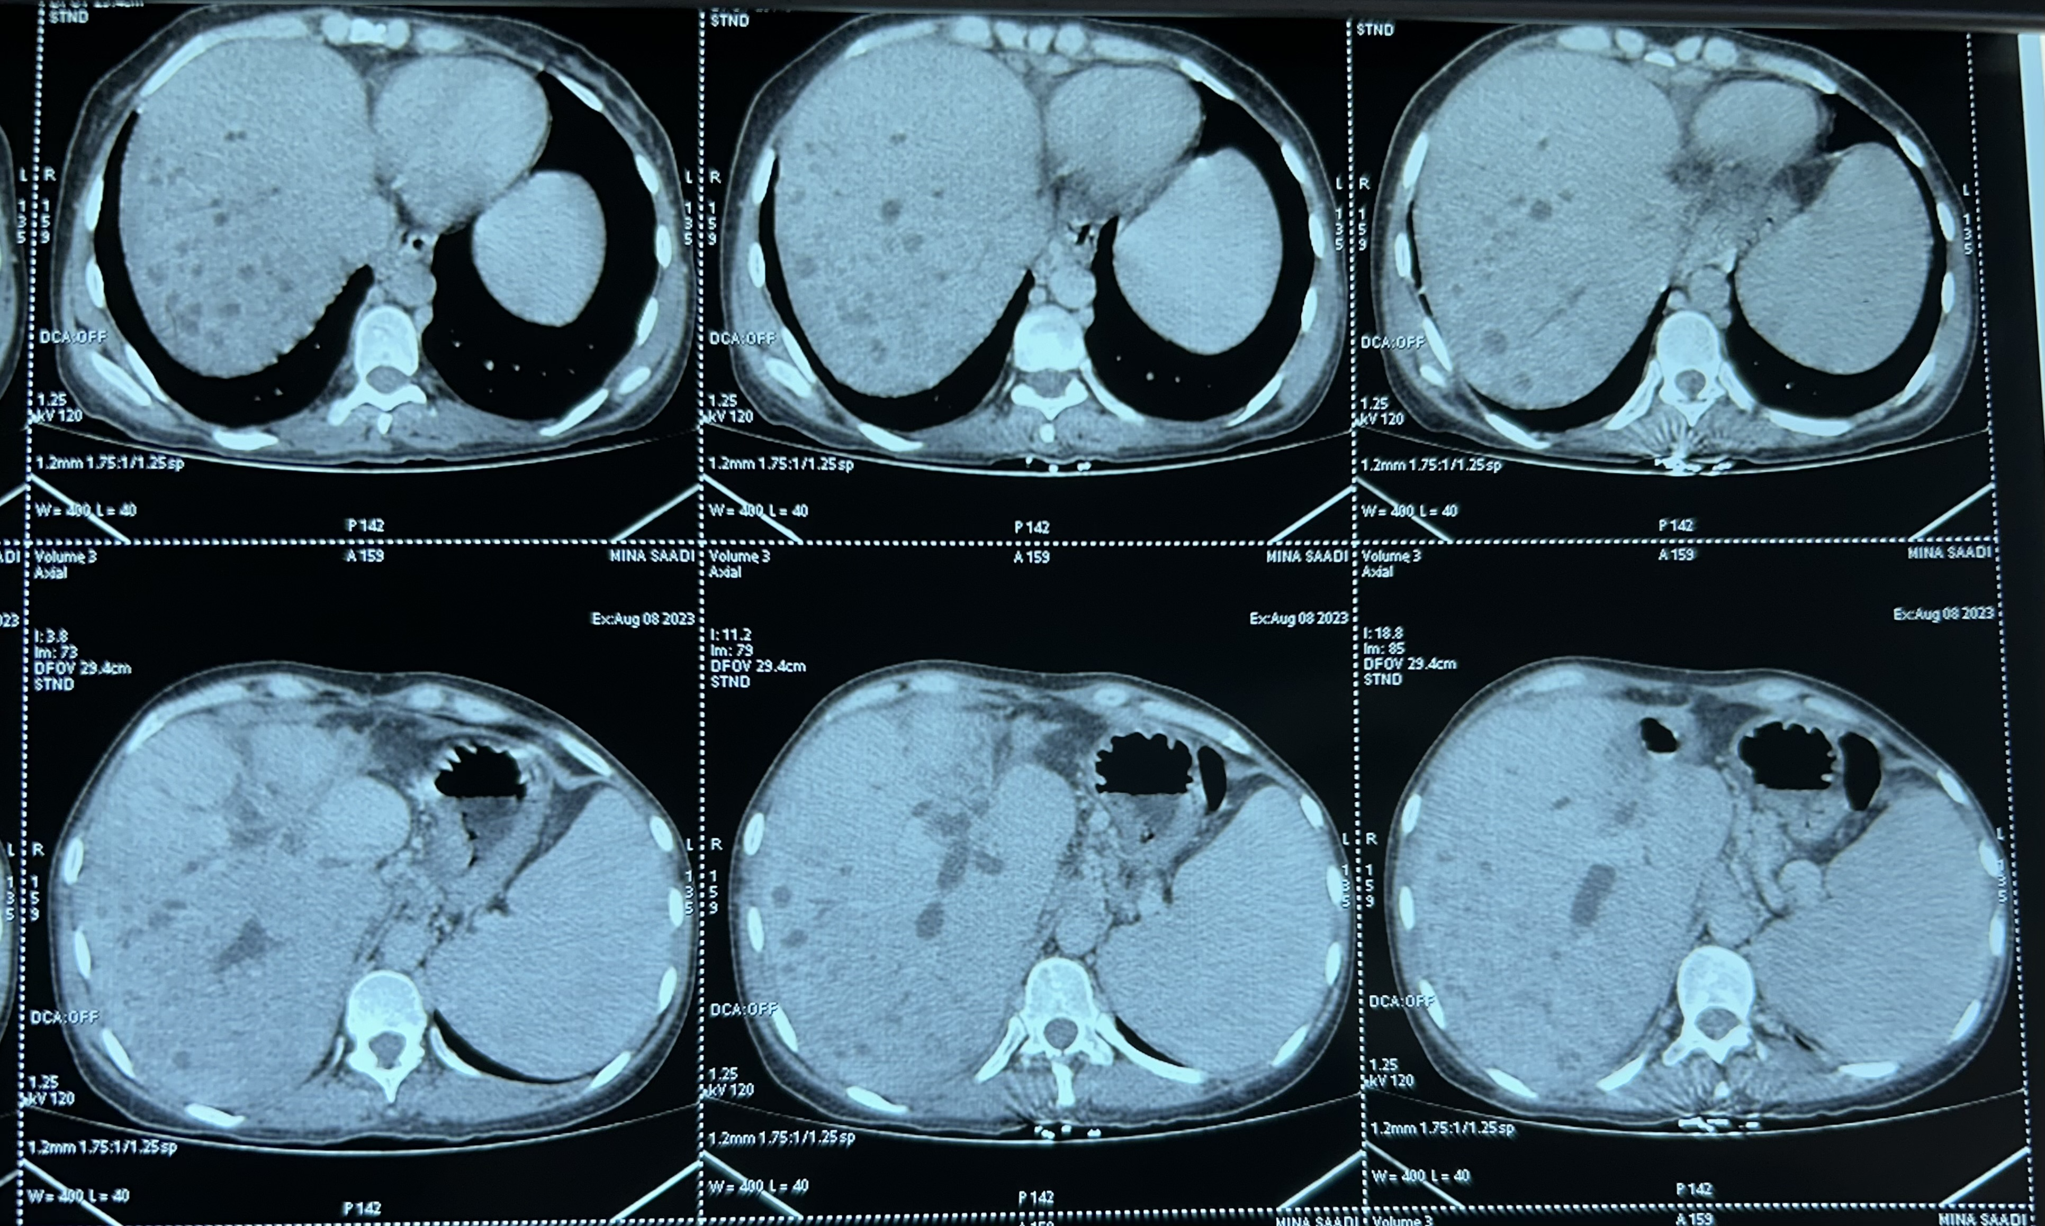

Figure 1: CT (computed tomography) scan showing multiple liver abscesses.

RMI (magnetic resonance imaging) that finds out one of its good indications showed multiple cystic formations of 6, 7 and 8 liver segments in hyposignal T2 wheighting and hypersignal T1 wheighting enhaced after gadolinium injection communicating with biliary tract that can be related to Caroli’s disease.
Dilation of the intra hepatic bile ducts.
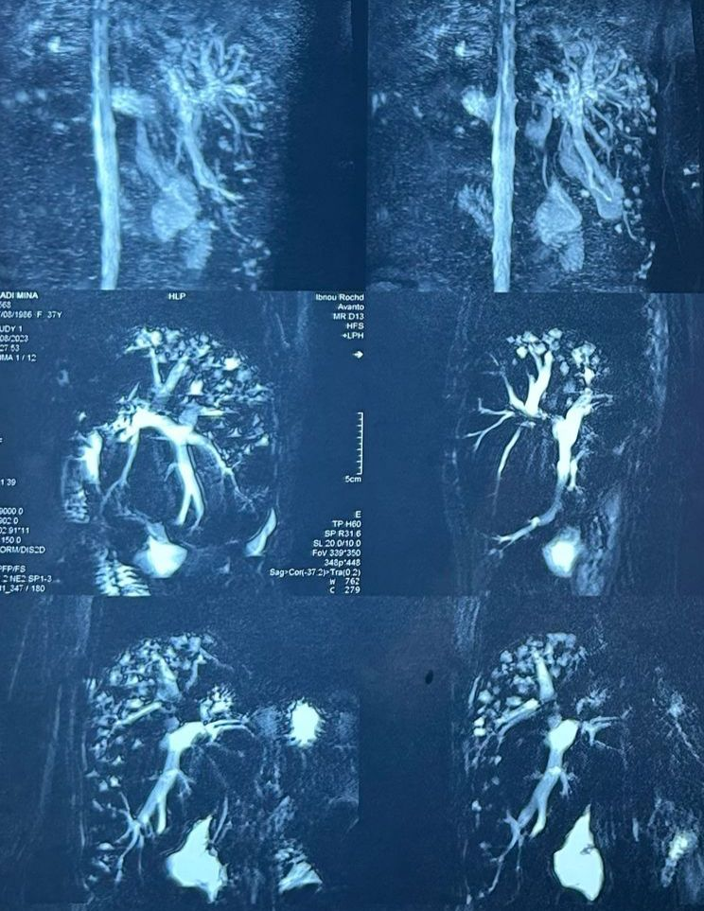

Figure 2: MRI (magnetic resonance imaging) compatible with Caroli’s disease with multiple liver abscesses.

Biological work up revealed:
ASAT: 20 IU / l and ALAT: 24 IU / l GGT=81 PAL=542
BT= 20 mg/L BC= 10mg/L BL= 10 mg/L GGT= 81UI/L PAL=542 UI/L
white blood cell number of 11,500 cells / mm 3 (Neutrophils 9580, lymphocytes 1100), anemia (hemoglobin 7.2 g /dl), thrombocytes at 400,000 cells /mm3. Prothrombin time and partial thromboplastin time were normal (TP at 70% and TCA at 26s for a witness of 23s), CRP: 87 mg/L, albumin 42.
Hydatid blood test: negative

Therapeutic management included oxygen therapy, medical pain treatment.
Antibioc therapy based on third generation cephalosporin and metronidazole with good evolution.

Discussion:

Caroli disease is a rare inherited affection, characterized by a localized or a diffuse cystic dilation of intra hepatic ducts due to a lack of involution of ductal plate [4]. Some genetic mutations about genes which regulate the formation of kidneys and bile ducts are responsible of embryonic malformations of ductal plate [5].

56% of patient with Caroli’s desease will be revealed by acute cholangitis as in our case it was revealed by acute cholangitis grade 1 of Tokyo classification [15].

Stasis of bile will favor infection syndromes which are the clinical manifestations of the disease. Like for our case, this typical clinical feature was described by different authors [6] [7].

The diagnostic of this affection is based on radiologic exams. [7]
Cystic dilations are generally diffuse like it was the case in for our patient. [8]
the “Dot sign” show as a cystic intra hepatic picture with a vascular lesion at his center at the CT-Scan sign the diagnosis. [9]
However, the liver biopsy punction is the key exam to found a peri portal diffuse fibrosis, associated with a proliferation of bile ducts.

According to the clinical presentation, the mainstay of therapy for patients with Caroli disease is supportive and individualized. Cholangitis resulting from biliary obstruction is treated with antibiotics covering gram-negative and anaerobic rod-shaped bacteria. Adequate biliary drainage may be achieved through biliary stent placement using ERCP [10] [11].

The prevalence of cholangiocarcinoma in Caroli disease has been reported as approximately 7%.[12][13]
Liver transplantation is currently the only definitive treatment for Caroli syndrome. Referral for liver transplantation is recommended for patients with Caroli disease or syndrome who are symptomatic with recurrent cholangitis and have either bilobar involvement or monolobar involvement with liver fibrosis or portal hypertension, especially when hepatectomy is not indicated. [14]

The prognosis of Caroli disease varies based on the extent of intrahepatic bile duct dilation and liver involvement. While the condition can often be managed conservatively, individuals with diffuse lobar involvement, recurrent cholangitis, and biliary cirrhosis are at increased risk of morbidity and mortality.

Conclusion:

To conclude Caroli’s disease is an inherited disorder which may cause severe life-threatening cholangitis or which may lead to hepatobiliary degeneration.
Caroli disease can be misdiagnosed due to the lack of experience, for this reason despite its rare incidence Caroli’s disease should not be forgotten as differential diagnosis of liver cyst.

Consent
As per international standards or university standards, patient(s) written consent has been collected and preserved by the author(s).

Authors’ contribution:

All the authors contributed equally in drafting of the manuscript. All the authors read and agreed to the final manuscript.

Disclaimer (Artificial intelligence)
Option 1:
Author(s) hereby declare that NO generative AI technologies such as Large Language Models (ChatGPT, COPILOT, etc.) and text-to-image generators have been used during the writing or editing of this manuscript.
Option 2:
Author(s) hereby declare that generative AI technologies such as Large Language Models, etc. have been used during the writing or editing of manuscripts. This explanation will include the name, version, model, and source of the generative AI technology and as well as all input prompts provided to the generative AI technology
Details of the AI usage are given below:
1.
2.
3.

References

1. Desmet VJ. Congenital diseases of intrahepatic bile ducts: variations on the theme "ductal plate malformation". Hepatology. 1992 Oct

- Veigel MC, Prescott-Focht J, Rodriguez MG, Zinati R, Shao L, Moore CA, Lowe LH. Fibropolycystic liver disease in children. Pediatr Radiol. 2009 Apr;39(4):317-27; quiz 420-1.

- Mirza H, Besse W, Somlo S, Weinreb J, Kenney B, Jain D. An update on ductal plate malformations and fibropolycystic diseases of the liver. Hum Pathol. 2023

- Bockhorn, M., Malago, M., Lang, H., Nadalin, S., Paul, A., Saner, F., et al. (2006) The Role of Surgery in Caroli’s Disease. Journal of the American College of Surgeons

- Levy, A.D., Rohrmann, J.R., Murakat, L.A., et al. (2002) Caroli’s Disease: Radiological Spectrum with Pathologic Correlation. American Journal of Roentgenology

- Iancu, C., Bodea, R., Muresan, T., Iancu, D., Boruah, P. and Al Hajjar, N. (2010) Diffuse Form of Caroli’s Disease: Therapeutical Approach in a Female Patient with Recurrent Cholangitis. The Journal of Gastrointestinal and Liver Diseases

- Yonem, O. and Bayraktar, Y. (2007) Clinical Characteristics of Caroli’s Disease . World Journal of Gastroenterology

- Giovanardi, R.O. (2003) Monolobar Caroli’s Disease in an Adult. Case Report. Hepatogastroenterology,

- Karim, A.S. (2004) Caroli’s Disease. Indian Pediatrics

- Yonem O, Bayraktar Y. Clinical characteristics of Caroli's syndrome. World J Gastroenterol. 2007

- European Association for the Study of the Liver. EASL Clinical Practice Guidelines on the management of cystic liver diseases. J Hepatol. 2022 Oct

- Dayton MT, Longmire WP, Tompkins RK. Caroli's Disease: a premalignant condition? Am J Surg. 1983

- Fahrner R, Dennler SG, Inderbitzin D. Risk of malignancy in Caroli disease and syndrome: A systematic review. World J Gastroenterol. 2020 Aug
- Lai Q, Lerut J. Proposal for an algorithm for liver transplantation in Caroli's disease and syndrome: putting an uncommon effort into a common task. Clin Transplant. 2016 Jan
- F. Fterich et al, Maladie de Carolie étude de cas la Tunisie médical 2012

