Transverse colon volvulus presenting as bowel obstruction: A rare case report

**Abstract**

Transverse colon volvulus (TVC) is an exceptionally rare cause of large bowel obstruction, accounting for only 2% of colonic volvulus cases [2]. While sigmoid and cecal volvulus are well-documented, TCV remains a diagnostic and therapeutic challenge due to its infrequency. If left untreated, it can result in catastrophic complications such as bowel ischemia, perforation, and peritonitis. Given its rarity, many gastroenterologists and surgeons may never encounter a case in their clinical practice.

We report the case of a 52-year-old male who presented with acute abdominal pain, progressive distension and nausea. Physical examination revealed a distended, tympanic abdomen. Abdominal imaging, including computed tomography (CT), confirmed a volvulized transverse colon with a classic "whirl sign" and significant bowel distension. The patient had a history of chronic constipation but no prior abdominal surgeries.

Given the suspicion of ischemic bowel, an emergency laparotomy was performed. Intraoperative findings revealed a gangrenous transverse colon volvulus.

The patient succumbed to refractory shock secondary to extensive bowel necrosis, despite maximal surgical and supportive interventions.

TCV is a rare but life-threatening cause of large bowel obstruction that requires prompt recognition and intervention. This case underscores the importance of maintaining a high index of suspicion for TCV in patients presenting with unexplained colonic obstruction. Early imaging, timely surgical intervention, and appropriate postoperative management are crucial in optimizing patient outcomes.

Keywords : Transverse colon, Volvulus, Ogilvie’s syndrome, laparotomy, refractory shock

**Introduction**

“Colonic volvulus is a rare but potentially life-threatening condition characterized by the axial twisting of a segment of the colon around its mesenteric attachment, leading to luminal obstruction, vascular compromise, and, if untreated, bowel ischemia and perforation” [1].

While volvulus most commonly affects the sigmoid colon (60–80%) and cecum (15–40%), the transverse colon and splenic flexure are rarely involved, accounting for only 2% and 1–2% of cases, respectively [2,3].

“To our knowledge, few reports have been published to date, and less than 100 patients were described with such a diagnosis” [2].

“Such an emergency can lead to infarction, peritonitis, and death” [3].

The manuscript is an important one as this case requires the attention of Gastroenterologists. The prognosis for colon volvulus depends on the timeline of diagnosis and treatment. If diagnosed and treated early, most patients can recover without long-term complications.

Here, we present a case of a 52-year-old patient diagnosed with acute transverse colon volvulus, emphasizing the diagnostic and therapeutic challenges associated with this uncommon condition.

**Case Presentation**

The study reports a case that goes back to 27/07/23 of a 52-year-old man with a one-year history of constipation; there was no other significant past medical history, particularly psychiatric disease or abdominal surgery, starting by the appearance of a sub-occlusive syndrome made of cessation of materials and gas his last bowel movement had been 3 days ago.

This was followed by the appearance of abdominal pain the leading cause of nausea without vomiting or ​​progressive aggravation, which motivated a consultation.

The admission examination revealed a conscious patient with a blood pressure of 120/80 mmHg and a heart rate of 88 beats per minute. His respiratory rate was at 23c /min and arterial oxygen saturation at 96% at room air without fever (body temperature at 36°.9C),

The abdominal exam revealed significant distension associated with a tympanitic abdomen on percussion without signs of peritonitis.

The digital rectal exam showed an empty rectal ampulla without any intraluminal mass.

The abdomen without preparation (ASP) that finds one of its good indications showed an aspect of bowel volvulus. The patient was admitted to our gastroenterology unit for further investigations.

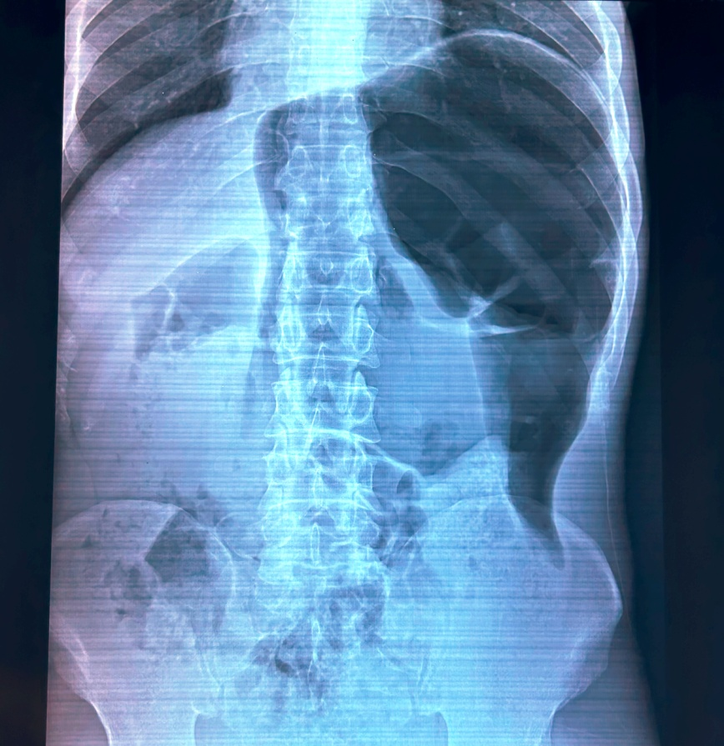

Figure 1: ASP revealing important bowel volvulus

Computed Tomography scan showed colon distention without obstacle concluding to probable Ogilvie syndrome.

The patient's biological assessment revealed a white blood cell count of 4,820 cells/mm³ (neutrophils 3,040, lymphocytes 1,200), a haemoglobin level of 12.2 g/dl, and a thrombocyte count of 190,000 cells/mm³. Prothrombin time and partial thromboplastin time were normal (TP at 70% and TCA at 26s for a witness of 23s).

Natremia:142 mmol / l, kalemia: 3.9mmol / l, correct liver and renal function (urea: 11.6 mmol/L and creatinine: 0.89 mg /dl,ASAT: 20 IU / L and ALT: 24 IU / L), fasting blood sugar at 1.03 g/l (5.72 mmol/L), C-reactive protein at 1mg/l, albumin 42 g/L

Therapeutic management included oxygen therapy and medical pain treatment.

A therapeutic colonoscopy was performed, revealing an enlarged colonic lumen without an obstructive cause, consistent with a dolichocolon.

On the second day, the symptomatology worsened by the aggravation of pain and abdominal distention leading to a surgical exploration.

The surgical exploration revealed a purulent peritoneal effusion and a dolichocolon with a necrotic transverse colon volvulus, resulting in two spire towers.

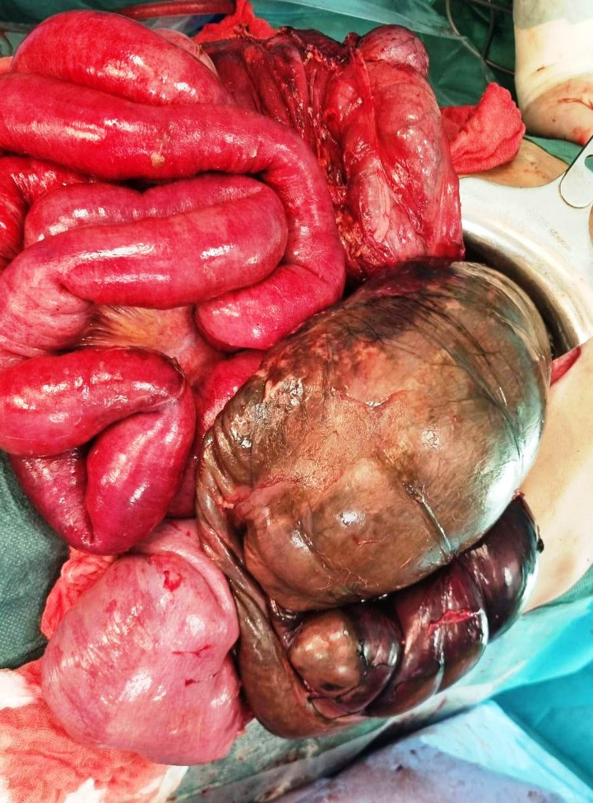

Figure 2: Image showing necrotic transverse colon volvulus

**Discussion:**

“Volvulus of the transverse colon case was first described in 1932 by the Finnish surgeon Kallio” [4].

“It is an abnormal twisting of bowel along its mesenteric axis leading to closed-loop obstruction. It stops venous return and compromises arterial supply leading to ischemia” [5].

Volvulus itself is an unusual cause of intestinal obstruction accounting for 5% of cases of gastrointestinal obstruction and 10-15% of large bowel obstruction.

“Moreover, chronic constipation appears to be associated with the occurrence of volvulus in the transverse colon, likely due to its excessive elongation” [6].

“Given the clinical picture and morphological transformations, acute volvulus form is characterized by the sudden severe abdominal pain, peritoneal signs, nausea, vomiting, and severe clinical state.

Inadequate implementation of effective treatment can lead to exacerbation and progression to a fulminating form” [7, 8].

“The diagnosis of this condition is usually made during laparotomy despite a thorough history, examination, and appropriate radiological investigations” [9].

“In the absence of clinical and radiological signs of necrosis or perforation, the initial management of volvulus involves colonoscopic derotation and decompression, followed by semi-elective resection and anastomosis after optimizing the patient” [10/11].

“According to the literature, in contrast to the volvulus of the sigmoid colon and caecum, an attempt at endoscopic decompression and drainage of the colon is not recommended mainly due to the high probability of necrosis in the case of volvulus of the transverse colon” [12], “the mortality rate is 33%, which is much higher than the mortality rate recorded for the volvulus of the sigmoid colon or cecum, which is 21% and 10% respectively” [13].

Our patient had an extensive right hemicolectomy with colostomy. His postoperative

the course was eventful; the symptomatology was worsened by hemodynamic instability; the patient was intubated and passed away within 24 hours after the surgery

**Conclusion:**

Transverse colon volvulus is a rare cause of bowel obstruction syndrome. Its diagnosis is challenging.

Prompt recognition and emergency intervention constitute the key to a successful outcome and prevent complications.

Ethical Approval:

As per international standards or university standards written ethical approval has been collected and preserved by the author(s).

**Consent**

**As per international standards or university standards, patient(s) written consent has been collected and preserved by the author(s).**

**Competing interests:**

The authors declare no competing interests.

**Authors’ contribution:**

All the authors contributed equally in drafting of the manuscript. All the authors read and agreed to the final manuscript

Disclaimer (Artificial intelligence)

Option 1:

Author(s) hereby declare that NO generative AI technologies such as Large Language Models (ChatGPT, COPILOT, etc.) and text-to-image generators have been used during the writing or editing of this manuscript.

Option 2:

Author(s) hereby declare that generative AI technologies such as Large Language Models, etc. have been used during the writing or editing of manuscripts. This explanation will include the name, version, model, and source of the generative AI technology and as well as all input prompts provided to the generative AI technology

Details of the AI usage are given below:

1.

2.

3.

**References**

1. Lianos G, Ignatiadou E, Lianou E, Anastasiadi Z, Fatouros M. Simultaneous volvulus of the transverse and sigmoid colon: case report. G Chir. 2012;33(10): 324-326.

2. *Ciraldo A, Thomas D, Schmidt S*: Case report: transverse colon volvulus associated with Chilaiditis Syndrome. *Internet J Gastroenterol* 2000; 1: 1.

3. Sana L, Ali G, Kallel H, Amine B, Ahmed S, Ali M, *et al*. Spontaneous transverse

colon volvulus. Pan African Med J. 2013;14:1937–8688.

4. Kallio KB. Uber volvulus transversii. Act Chir Scand. 1932;70:39–58

5. Sparks DA, Dawood MY, Chase DM, Thomas DJ. Ischemic volvulus of the transverse colon: a case report and review of literature. Cases J. 2008;1(1): 174.

6. *Casamayor Franco MC, Gracia Solanas JA, Artigas Marco C* et al.: Intestinal occlusion secondaryto transverse colon volvulus. *Rev Esp Enferm Dig* 2005; 97: 914-15.

7. *Sparks D, Dawood M, Chase D* et al.: Ischemic volvulus of the transverse colon: A case report and review of literature. *Cases J* 2008; 1: 174.

8. *Eisenstat TE, Raneri AJ, Mason GR*: Volvulus of the transverse colon. *Am J Surg* 1977; 134: 396.

9. Islam S, Hosein D, Bheem V, Dan D. Synchronous volvulus of the sigmoid colon and caecum, a very rare cause of large bowel obstruction. Case Reports. 2016; 2016: bcr2016217116.

10.Motsumi MJ, Tlhomelang O. Synchronous volvulus of the sigmoid and transverse colon in a 26-year-old male. J Surg Case Rep. 2018;2018(11): rjy295.

11. Chung YFA, Eu KW, Nyam DCNK, Leong AFPK, Ho YH, Seow-Choen F. Minimizing recurrence after sigmoid volvulus. British Journal of Surgery. 1999;86(2): 231-233.

12.*Echenique M, Amondaraín JA*: Colonic volvulus. *Rev Esp Enferm Dig* 2002; 94: 201-05.

13. *Ciraldo A, Thomas D, Schmidt S*: Case report: transverse colon volvulus associated with Chilaiditis Syndrome. *Internet J Gastroenterol* 2000; 1: 1