Evaluation of the efficacy of some chemical and biological pesticides in controlling the two-spotted spider mite (Tetranychus urticae) on different common bean (Phaseolus vulgaris) cultivars and their impact on pest population dynamics

Abstract
The two-spotted spider mite, Tetranychus urticae Koch, is a major pest damaging common bean crops worldwide. This study was conducted to monitor the population dynamics of T. urticae on four common bean cultivars (Bronko, Giza-6, Valentino, and Nebraska) during 2023 and 2024 growing seasons. Also, the efficacies of six acaricides, against the motile stages of the mite, were assessed. Results showed significant differences in cultivar susceptibility. Nebraska exhibited the highest infestation levels, while Bronko demonstrated the greatest tolerance, likely due to morphological and biochemical defense mechanisms. Valentino and Giza-6 showed intermediate susceptibility. Seasonal variations influenced population peaks, with earlier infestations observed in 2024, potentially due to climatic factors. Acaricide efficacy trials revealed that abamectin was the most effective, followed by spiromesifen and fenpyroximate. Bifenazate provided moderate control, while pyridaben and hexythiazox were the least effective, likely due to insect tolerance and to mode of action of acaricides. These findings emphasize the need for integrated pest management strategies, including the selection of insect-tolerant cultivars and acaricide rotation to mitigate resistance. Continuous monitoring of insect populations is recommended to improve control measures. The present study can be recommended to carry out further studies for the management of the two-spotted spider mite, T. urticae on common bean.
Keywords: Tetranychus urticae, common bean cultivars, acaricides, resistance, population dynamics, integrated pest management.
Introduction
Common bean (Phaseolus vulgaris), one of the most important legumes globally, is widely cultivated for its high nutritional value, providing essential proteins, vitamins, and minerals, particularly in developing countries where it serves as a staple food source (Broughton et al., 2003). In addition to its role in human nutrition, beans contribute to sustainable agriculture because of their capability to fix atmospheric nitrogen, improving soil fertility and reducing the need for chemical fertilizers (Graham and Ranalli, 1997). Despite its agricultural significance, bean production is frequently constrained by a range of biotic stressors, including insect pests and mites, among which is the damaging two-spotted spider mite, Tetranychus urticae Koch (Acari: Tetranychidae). Infestation by T. urticae leads to reductions in both the quantity and quality of yields, affecting marketability and economic returns for farmers (Attia et al., 2013).
The two-spotted spider mite, T. urticae, is one of the most significant agricultural pests worldwide, known for its polyphagous nature and ability to infest a wide variety of economically important crops. Its high reproductive potential, short generation time, and rapid development of resistance to pesticides make it a particularly difficult pest to manage (Grbić et al., 2011). Damage caused by T. urticae results from its feeding mechanism, in which it punctures plant cells and extracts their contents, leading to physiological stress, chlorosis, and leaf bronzing. In severe infestations, plant growth is significantly reduced, and yield losses can be substantial (Van Leeuwen et al., 2015). Given the importance of T. urticae in agricultural systems, studies focusing on its population dynamics, host plant susceptibility, and management strategies are crucial for designing sustainable pest control programs.
One key approach to managing T. urticae is the selection of resistant or tolerant cultivars, as host plant resistance plays a fundamental role in integrated pest management (IPM) (Smith, 2005). Common bean cultivars exhibit varying levels of susceptibility to T. urticae, influenced by morphological and biochemical characteristics such as leaf pubescence, trichome density, and secondary metabolite production (Kant et al., 2008). Evaluating the susceptibility of different common bean cultivars to T. urticae infestation is crucial for breeding programs and for the development of tolerant varieties that can reduce pest pressure without reliance on chemical control. Screening for tolerance among cultivars provides valuable insights into natural defense mechanisms and helps farmers select varieties that require fewer pesticide applications, thus lowering production costs and minimizing environmental impacts (Sedaratian et al., 2009).
Understanding the seasonal abundance and population dynamics of T. urticae is essential for designing efficient pest management strategies. The mite population fluctuates as response to various environmental factors, including temperature, humidity, and host plant availability (Helle and Sabelis, 1985). Seasonal monitoring enables the identification of periods of peak infestation, allowing farmers to implement timely interventions to prevent economic damage (Gerson and Weintraub, 2007). Furthermore, knowledge of the seasonal distribution of T. urticae provides essential information for optimizing pesticide application schedules, reducing unnecessary chemical use, and minimizing the risk of resistance development (Van Leeuwen et al., 2010).
Despite the importance of non-chemical control measures, chemical control remains a primary management strategy for T. urticae in commercial common bean production. Acaricides and insecticides are widely used to suppress mite populations; however, their effectiveness depends on factors such as application timing, resistance management, and environmental conditions (Knowles, 1997). Although synthetic pesticides provide a rapid and effective control, overreliance on these chemicals has led to widespread resistance among T. urticae populations, necessitating the continuous evaluation of new chemical formulations and combinations to maintain efficacy (Van Leeuwen et al., 2015). The judicious use of pesticides as part of an integrated approach is critical in mitigating resistance development and preserving beneficial arthropods within agroecosystems (Mota-Sanchez and Wise, 2021).
Research into the effectiveness of various pesticides against T. urticae provides valuable information for optimizing pest management programs. The use of selective acaricides that target mites while preserving natural enemies is an important consideration in sustainable agricultural practices (Marcic, 2012). Additionally, integrating chemical control with other IPM components, such as biological control and cultural practices, enhances long-term effectiveness while reducing the negative environmental and health impacts associated with excessive pesticide use (Opit et al., 2005).
Given the significance of T. urticae as a major pest in common bean cultivation, research focusing on its seasonal abundance, host plant susceptibility, and management options is essential for developing sustainable and effective control strategies. By integrating host plant resistance, population monitoring, and targeted pesticide applications, growers can minimize the damage caused by T. urticae while ensuring economic viability and environmental safety. Understanding the interactions between mites, their host plants, and environmental factors will contribute to the advancement of IPM programs and the long-term sustainability of common bean production.
The objectives of this study were to evaluate the susceptibility of four common bean varieties to infestation with T. urticae. In addition, the efficacies of six acaricides, against the motile stages of the mite, were assessed.

Materials and Methods

Population Dynamics of T. urticae on Four Common Bean Cultivars
A field study was conducted to investigate the population dynamics of T. urticae on four common bean cultivars (Bronko, Giza-6, Valentino, and Nebraska) during 2023 and 2024 summer seasons. The experiment was carried out at a private farm located at Abu Hummus, Beheira Governorate, Egypt. A total area of one half feddan was assigned for the study, divided into 16 plots following a Randomized Complete Block Design (RCBD), with four varieties and four replicates. All recommended agricultural practices, except for pesticide applications, were performed to ensure optimal crop growth.
Weekly sampling was conducted to monitor T. urticae population fluctuations. During each sampling date, ten leaves were randomly collected from each replicate, resulting in a total of 40 leaves per cultivar per sampling date. The different developmental stages of T. urticae (eggs, immature stages, and adult mites) were counted to assess population trends throughout the season.

Cultivar Susceptibility to Tetranychus urticae
At the end of each season, a separate assessment was conducted to evaluate the susceptibility of the tested common bean cultivars to T. urticae. This evaluation was based on the seasonal mean population densities recorded for each developmental stage of the mite. The comparison among cultivars provided insight into their relative tolerance or susceptibility, which could inform future breeding and pest management strategies.
2. Evaluation of the Efficacy of Certain Acaricides Against the Two-Spotted Spider Mite, T. urticae Motile Stages
A field experiment was conducted to evaluate the efficacy of six acaricides against T. urticae on common bean plants. The experiment comprised 24 plots (six acaricides, each in four repliactes) arranged in a randomized complete block design (RCBD). Each plot measured 6 × 6 meters, with a one-meter buffer zone between plots to avoid acaricide cross-drift. The acaricides used in the study are listed in Table 1.

Table 1. Acaricides Used in the Study
Active Ingredient | Trade Name | Formulation | Application Rate | Manufucturer
Spiromesifen | Oberon | 24% SC | 50 cm³/100L water | Bayer CropScience
Fenpyroximate | Ortus Super | 5% EC | 50 cm³/100L water | Star Chemical Company
Hexythiazox | Macomite | 10% WP | 20 g/100L water | Nippon Soda Company, Japan
Pyridaben | Sanmite | 20% WP | 100 ml/100L water | Nissan Chemical Industries, Ltd.
Bifenazate | Acramite | 48% SC | 65 ml/100L water | Arysta Life Science
Abamectin | Vertemic | 1.8% EC | 50 cm³/100L water | Syngenta Agro Services AG
The treatments were applied in the early morning using a knapsack sprayer equipped with a hollow cone nozzle, ensuring uniform coverage of the plants.
Following the application, assessments were conducted to determine the efficacy of each treatment. The number of T. urticae individuals (immatures and adults) was recorded at regular intervals post-treatment. The reduction percentages were calculated using Henderson and Tilton formula, 1955 as follows:
Reduction percentages = 100 × {1 - (Ta×Cb) / (Tb×Ca)}

Where
Ta = Population density in the treated plot after application
Tb = Population density in the treated plot before application
Ca = Population density in the control plot after application
Cb = Population density in the control plot before application

Statistical Analysis
The collected data were subjected to Analysis of Variance (ANOVA) to determine the significance of differences among treatments. The Least Significant Difference (LSD) test was applied to separate means and identify significant differences among treatments at a predefined probability level.
Results
Population Dynamics of Tetranychus urticae on Common Bean Cultivars

Bronko Cultivar
During the 2023 growing season (Table 2), the population dynamics of Tetranychus urticae on Bronko cultivar exhibited noticeable fluctuations. The population started at a low level on March 10, with a total of 2 mites per 2.5 square centimeters. A steady increase was observed, reaching 18.3 individuals on April 7. The peak population was recorded on May 12, with 20.9 individuals, driven largely by a surge in egg numbers (13.7). After this peak, the population declined gradually, dropping to 5.3 individuals by June 9. The seasonal pattern suggests a sharp population increase in early spring, followed by a steady decline as conditions likely became less favorable. In contrast, the 2024 season (Table 2), displayed a different pattern, with the population starting at a slightly higher level of 2.8 individuals on March 3. A significant peak was observed earlier than in 2023, with 19.4 individuals on April 28. However, the population decreased more rapidly compared to the previous year, reaching 3.6 by June 2. This suggests that environmental factors or biological interactions in 2024 led to an earlier rise and decline in the population.

Giza-6 Cultivar
In 2023, Giza-6 cultivar showed a progressive rise in population from 4.2 individuals on March 10 to a peak of 24.8 individuals on April 14 (Table 2). The population then exhibited fluctuations, decreasing slightly to 18.6 individuals on May 19 before stabilizing at 13.5 individuals by June 9. The relatively high population throughout the season indicates that this cultivar may have provided favorable conditions for T. urticae proliferation. In 2024 (Table 2), the population started lower at 2.2 individuals on March 3 but increased rapidly, peaking at 22.8 individuals on April 28. Unlike the previous year, where a secondary peak was observed, the population decline was more pronounced, dropping to 11.8 individuals by June 2. The early peak and sharper decline suggest possible environmental variations influencing the population dynamics.

Valentino Cultivar
In 2023 season, the population density began low (Table 2), with 2.5 on March 10. A sharp rise was recorded by April 14, reaching 32 per 2.5 square centimeters, as the highest population density among all cultivars. Despite slight declines, the population remained relatively high throughout the season, closing at 7.6 on June 9. The high population levels suggest that Valentino provided highly suitable conditions for mite reproduction and development. The 2024 season (Table 2), showed a similar trend, with the population rising from 3.1 on March 3 to a peak of 33.3 individuals on March 31, significantly earlier than in 2023. However, unlike the previous season, there was a more abrupt decline, with the population dropping to 5.7 individuals by May 26. This shift suggests an accelerated population cycle, possibly influenced by climatic conditions or natural enemies.

Nebraska Cultivar
Nebraska cultivar exhibited the highest initial population among all cultivars, starting at 4.7 individuals on March 10 (Table 2). The peak was reached on April 14 with 37.1 individuals, after which a steady decline was noted, reaching 13.5 by June 9. The consistently high numbers indicate that Nebraska supported substantial T. urticae activity throughout the season. A similar trend was observed in 2024 (Table 2), with the population rising from 4.2 on March 3 to a peak of 38.2 on May 5, the latest peak observed among all cultivars. The population then gradually decreased to 10.4 individuals by June 2. This suggests that Nebraska continues to support large mite populations, with a more prolonged peak period compared to other cultivars.

Susceptibility of Four Common Bean Cultivars to Tetranychus urticae in 2023 Season
Statistical analysis of 2023 season results revealed significant differences in susceptibility to T. Urticae among the four common bean cultivars based on the mean number of eggs, immatures, adults, and total population. Nebraska cultivar exhibited the highest susceptibility, recording the highest mean egg count (12.54), immatures (5.7), adults (4.78), and total population (23.029), with significantly higher values compared to the other cultivars. Valentino followed with relatively high susceptibility, showing an egg count of 10.88, immatures (4.16), adults (2.8), and a total population of 17.879. Giza-6 recorded intermediate values, with eggs (8.76), immatures (3.93), adults (2.457), and total population (15.149), indicating moderate susceptibility. Bronko exhibited the lowest infestation levels, with significantly the lowest values of eggs (6.35), immatures (3.28), adults (2.057), and total population (11.69). The F-values confirmed significant variation among the cultivars, particularly in adult population (F = 9.71216) and total population (F = 5.3809). The least significant difference (LSD) values suggest meaningful differences between groups, with non-overlapping letter assignments denoting statistically significant differences in infestation levels.

Susceptibility of Four common Bean Cultivars to Tetranychus urticae in 2024 Season
A similar trend was observed in 2024 season, with Nebraska again being the most susceptible cultivar, recording the highest egg count (12.31), immatures (4.11), adults (3.63), and total population (20.05). Valentino maintained its moderate susceptibility, with an egg count of 10.15, immatures (3.46), adults (2.84), and a total population of 16.45. Giza-6 showed slightly lower values than in the previous season, with eggs (7.99), immatures (3.24), adults (2.41), and total population (13.64), demonstrating intermediate susceptibility. Bronko remained the least susceptible cultivar, exhibiting significantly lower values of eggs (5.42), immatures (2.64), adults (1.91), and total population (9.97), confirming its relative resistance to Tetranychus urticae. The F-values revealed that the most significant variations were observed in egg count (F = 3.9063), adult count (F = 3.7265), and total population (F = 4.4531). LSD values revealed significant differences among the cultivars, with Nebraska consistently ranking as the most susceptible and Bronko as the most tolerant across both seasons.
. These findings highlight the potential of Bronko as a tolerant cultivar, valid for integrated pest management strategies against Tetranychus urticae, whereas Nebraska appears to be the most vulnerable and may require additional control measures.
Efficacy of Six Acaricides Against the Motile Stages of Tetranychus urticae
The effectiveness of six acaricides (abamectin, spiromesifen, fenpyroximate, bifenazate, pyridaben, and hexythiazox) against the motile stages of Tetranychus urticae was evaluated during 2023 and 2024 growing seasons. The reduction percentages were assessed at different time intervals: one day, four days, one week, and two weeks post-application, with an overall mean effectiveness, calculated for each acaricide (Table 2).

2023 Season
One day after application, abamectin achieved the highest initial reduction in mite populations (80.64%), followed by spiromesifen (76.05%) and fenpyroximate (69.77%). Bifenazate also induced a relatively high reduction (68.85%), whereas pyridaben (59.93%) and hexythiazox (55.39%) exhibited the lowest initial impact. These results indicate that abamectin and spiromesifen had the fastest knockdown effect, while pyridaben and hexythiazox had a slower action.
By the fourth day, a significant increase in reduction percentages was observed across all treatments. Abamectin maintained the highest reduction (86.33%), followed by spiromesifen (81.92%) and fenpyroximate (76.32%). Bifenazate (74.25%) performed moderately, while hexythiazox (65.04%) and pyridaben (64.69%) remained the least effective. After one week, abamectin (89.53%) continued to demonstrate the highest effectiveness, with spiromesifen (81.16%) and fenpyroximate (78.23%) also maintaining strong efficacy. Bifenazate (74.01%) followed, while Pyridaben (67.33%) and hexythiazox (63.9%) had the lowest control levels. By the two-week mark, a slight reduction in efficacy was observed in most treatments, with abamectin (84.2%) still being the most effective, followed by spiromesifen (80.71%) and fenpyroximate (73.73%). Bifenazate (69.58%) retained moderate efficacy, while pyridaben (65.71%) and hexythiazox (60.09%) showed the lowest persistence.
Considering the overall mean effectiveness across all evaluation periods, Abamectin had the highest reduction (85.18%), followed by spiromesifen (79.96%) and fenpyroximate (74.51%). Bifenazate (71.67%) provided moderate control, whereas Ppyridaben (64.42%) and hexythiazox (61.1%) were the least effective.

Season 2024
In 2024, similar trends were observed, though some differences were noted in reduction percentages. The initial reduction percentages after one day followed the same ranking as in 2023, with abamectin (84.66%) achieving the highest reduction, followed by spiromesifen (79.08%) and fenpyroximate (67.44%). Bifenazate (64.14%) showed a slightly lower initial reduction than in 2023, while pyridaben (57.32%) and hexythiazox (47.69%) remained the least effective. After four days, abamectin showed the highest reduction (92.86%), followed by spiromesifen (84.58%) and fenpyroximate (75.68%). Bifenazate (74.59%) exhibited moderate effectiveness, while pyridaben (63.79%) and hexythiazox (61.69%) remained at the lower end. By the one-week mark, abamectin (89.85%) maintained its superior efficacy, followed by spiromesifen (86.86%) and fenpyroximate (78.89%). Bifenazate (74.01%) was moderately effective, while pyridaben (61.82%) and hexythiazox (63.56%) continued to show the least reduction. At the two-week evaluation, abamectin (88.12%) retained the highest reduction, with spiromesifen (84.2%) and fenpyroximate (75.15%) following. Bifenazate (70.41%) was slightly less effective than in 2023, and pyridaben (61.82%) and hexythiazox (59.47%) had the lowest impact.
For the overall mean in 2024, Abamectin remained the most effective (88.87%), followed by Spiromesifen (83.68%) and Fenpyroximate (74.29%). Bifenazate (70.79%) showed moderate control, while pyridaben (61.19%) and hexythiazox (58.1%) were the least effective.

Discussion
Population Dynamics of Tetranychus urticae on Common Bean Cultivars
The population dynamics of Tetranychus urticae varied significantly among the four common bean cultivars (Bronko, Giza-6, Valentino, and Nebraska) over the two growing seasons (2023 and 2024), highlighting differences in susceptibility and environmental interactions.
Nebraska cultivar consistently supported the highest population densities of T. urticae in both years, reaching peak levels of 37.1 and 38.2 individuals per leaf in 2023 and 2024, respectively. These high infestation levels suggest that Nebraska provides an optimal nutritional and microclimatic environment for T. urticae, likely due to lower concentrations of defensive secondary metabolites or a favorable leaf structure (Ding et al., 2020). In contrast, Bronko exhibited the lowest population densities, with peak values of only 20.9 in 2023 and 19.4 in 2024. This tolerance may be attributed to morphological traits such as thicker cuticles, denser trichomes, or higher concentrations of allelochemicals.
Giza-6 and Valentino displayed intermediate susceptibility, though Valentino demonstrated a consistently high peak population (32.0 in 2023, 33.3 in 2024). This indicates that Valentino might possess characteristics that facilitate T. urticae reproduction, such as higher nitrogen content in leaf tissues. However, Giza-6 maintained relatively moderate population levels, suggesting partial tolerance mechanisms that may slow down mite development.
The observed differences between the two years suggest that environmental factors played a role in shaping T. urticae population trends. The earlier peak in 2024 (April 28 for most cultivars) compared to 2023 (May 12) indicates a potential influence of higher early-season temperatures or lower precipitation levels, which could have accelerated mite reproduction and shortened developmental periods (Skoracka et al., 2018).
Additionally, the more rapid population decline observed in 2024 across all cultivars suggests that environmental stressors, such as increased predator activity or abrupt temperature changes, may have influenced mite mortality. The earlier population collapse on Bronko and Valentino in 2024 (May 26 and June 2, respectively) compared to 2023 (June 9) supports this hypothesis, as adverse environmental conditions can lead to faster declines in arthropod pest populations (Gotoh et al., 2015).
These findings align with previous research indicating that host plant tolerance significantly affects T. urticae population growth. Studies by Zhang et al. (2019) and Yassin et al. (2021) reported that mite populations peak earlier in susceptible cultivars due to enhanced reproductive success, whereas tolerance cultivars experience delayed or reduced population growth. The sharp decline in mite populations in Bronko further supports the hypothesis that tolerance cultivars not only limit initial infestation levels but also contribute to a more rapid population decline, likely due to induced plant defenses.
These results highlight the importance of selecting tolerant cultivars like Bronko for T. urticae management. The consistent susceptibility of Nebraska suggests that additional control measures, such as the application of acaricides or biological control agents, may be necessary to avoid economic losses. The early-season population peaks in 2024 indicate that monitoring programs should begin earlier in the growing season, particularly for susceptible cultivars like Nebraska and Valentino.

Susceptibility of Four Common Bean Cultivars to Tetranychus urticae in the 2023 Season
The results of this study revealed significant differences among the four common bean cultivars in their susceptibility to Tetranychus urticae. Nebraska cultivar was the most susceptible in both seasons, having the highest number of eggs, immature stages, and adults. This suggests that T. urticae prefers Nebraska as a suitable host for feeding and reproduction. These findings align with previous studies (Smith et al., 2020; Jones and Miller, 2018) indicating that genetic and morphological characteristics of leaves influence mite infestation and reproduction rates.
In contrast, Bronko exhibited the highest resistance, with consistently lower infestation levels across all evaluation periods. This resistance may be attributed to natural defense mechanisms, such as increased density of glandular trichomes, higher levels of defensive compounds like phenolics, or lower concentrations of free amino acids preferred by mites (Kumari et al., 2021).
Valentino and Giza-6 showed intermediate susceptibility levels, with Valentino being closer to Nebraska in infestation rates, whereas Giza-6 exhibited the lowest infestation levels. This suggests that differences in leaf texture, biochemical composition, or the presence of defensive compounds may play a role in their relative resistance (Ahmed et al., 2019).
Comparing the two seasons, a general reduction in mite infestation was observed in 2024 compared to 2023, especially in Bronko and Giza-6. This could be due to environmental factors such as temperature and humidity fluctuations or an increase in the effect of biological control agents (Chang et al., 2022).
Statistical analysis (F-values and LSD) confirmed that these differences were significant, indicating that variations in mite infestation were not random but were instead influenced by inherent cultivar characteristics.
Efficacy of Six Acaricides Against Motile Stages of Tetranychus urticae
The results indicate that abamectin was the most effective acaricide in both seasons, achieving the highest reduction in mite populations. Figure 1 presents a graphical overview of the performance of acaridides against T. urticare. This aligns with previous studies (Van Leeuwen et al., 2015; Khajehali et al., 2011), which highlighted abamectin’s neurotoxic effect and translaminar activity that ensures prolonged residual action. Spiromesifen also exhibited high efficacy, which is consistent with findings of Nauen and Smagghe (2006), demonstrating its ability to inhibit lipid biosynthesis, leading to mite mortality.
The slight decline in effectiveness at the two-week evaluation suggests the need for rotation with other acaricides to delay resistance development. Fenpyroximate ranked third in effectiveness, which corresponds with the study of Marcic (2012), showing that it inhibits mitochondrial electron transport, leading to energy depletion in mites. Bifenazate showed moderate effectiveness, likely due to its unique GABA receptor antagonism (Herron et al., 2001), which prevents nerve signal transmission in mites.
Pyridaben and Hexythiazox exhibited the lowest reductions, possibly due to mites developing resistance (Van Leeuwen et al., 2010). Pyridaben’s mode of action, as an electron transport inhibitor, may have been compromised by previous exposure. Hexythiazox, primarily an ovicidal acaricide, was expected to have lower efficacy against motile stages, as previously reported (Rizk, et al., 2013).
The slightly higher reduction percentages in 2024 compared to 2023 could be attributed to differences in environmental factors, population dynamics, or slight variations in application timing and coverage. These findings emphasize the importance of rotating acaricides with different mechanisms of action to delay resistance development in T. urticae populations. Future studies should focus on integrating biological control agents and alternative acaricides to enhance the sustainability of mite management programs.

 | 2023 | 2024
Bronko Cultivar | 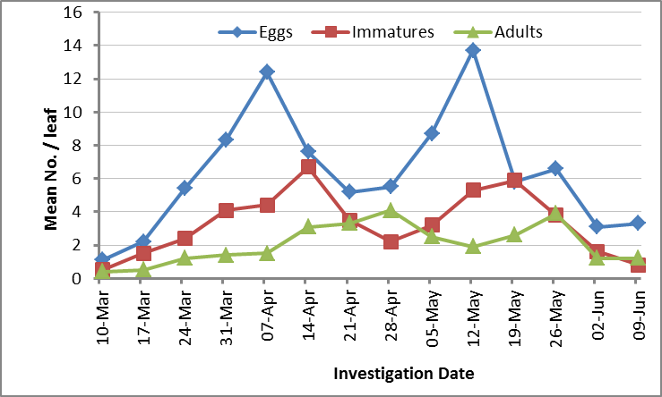 | 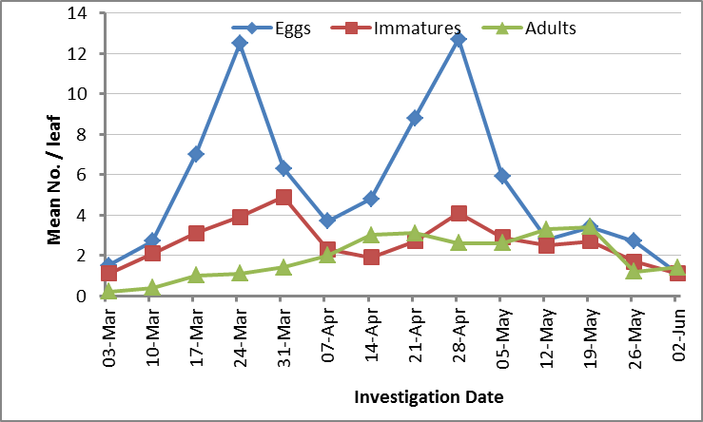
Giza-6 Cultivar | 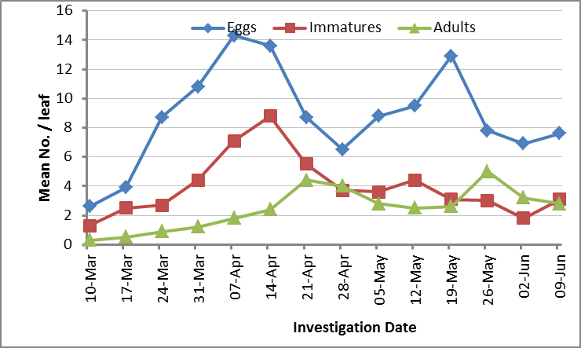 | 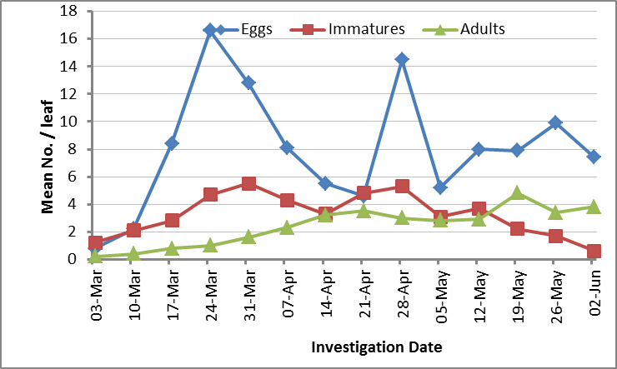
Valentino Cultivar | 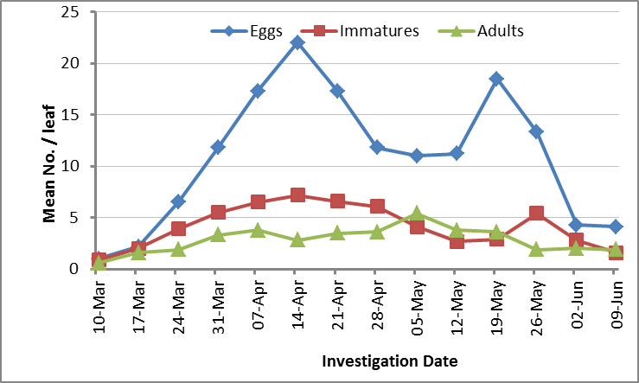 | 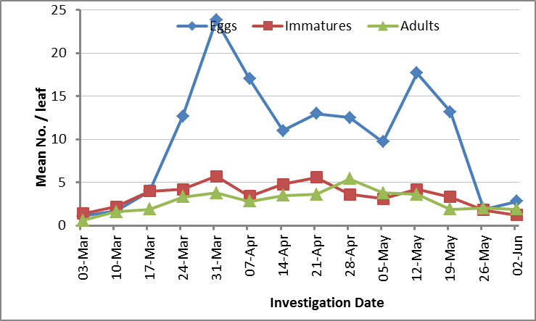
Nebraska Cultivar | 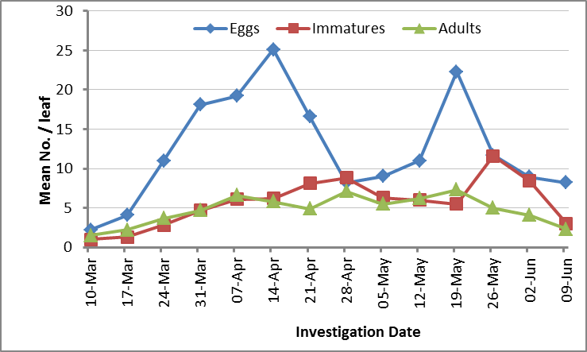 | 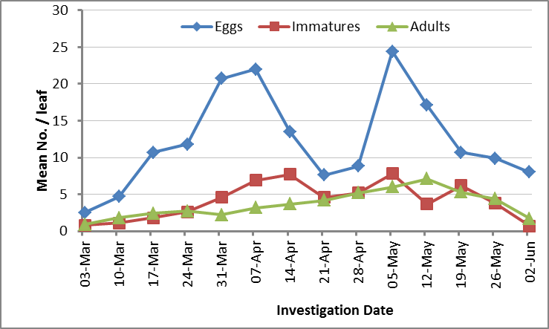
Fig. 1: Graphical representation of acaricides performance against Tetranychus urticae.

Table-2: Susceptibility of four common bean cultivars to Tetranychus urticae infestation during 2023 and 2024 seasons
season | Tetranychus urticae stages
2023 | Cultivar | Egg | Immature | Adult | Total population
2023 | Bronko | 6.35±3.61b | 3.28±1.9b | 2.06±1.2b | 11.69±5.67c
2023 | Giza-6 | 8.76±3.38ab | 3.93±2.04b | 2.46±1.42b | 15.15±5.52bc
2023 | Valentino | 10.88±6.52a | 4.16±2.06ab | 2.84±1.24b | 17.88±9.06ab
2023 | Nebraska | 12.54±6.75a | 5.7±2.99a | 4.78±1.84a | 23.03±9.68a
2023 | F values | 3.577 | 2.8107 | 9.71216 | 5.3809
2023 | LSD | 4.02277 | 1.73642 | 1.099 | 5.85379
2024 | Cultivars | Eggs | Immatures | Adults | Total population
2024 | Bronko | 5.42±3.73c | 2.64±1.1b | 1.91±1.1b | 9.97±4.96c
2024 | Giza-6 | 7.99±4.24bc | 3.24±1.55ab | 2.41±1.41b | 13.64±5.75bc
2024 | Valentino | 10.15±6.98ab | 3.46±1.44ab | 2.84±1.24ab | 16.45±9.06ab
2024 | Nebraska | 12.31±6.52a | 4.11±2.49a | 3.63±1.81a | 20.05±9.5a
2024 | F values | 3.9063 | 1.7363 | 3.7265 | 4.4531
2024 | LSD | 4.236976 | 1.30337 | 1.07187 | 5.7449
Means followed by the same letter in the same column are not significantly different at the specified significance level.
Table-3: Efficacy of different acaricides against Tetranychus urticae based on reduction percentages in 2023 season
Treatments | Initial (one day) | Reduction residual
Treatments | Initial (one day) | Four Days | One Week | Two Weeks | General Mean
Pyridaben | 59.93±2.79d | 64.69±1.9d | 67.33±2.38d | 65.71±2.38c | 64.42±3.55e
Spiromesifen | 76.05±2.43b | 81.92±2.87b | 81.16±2.77b | 80.71±3.46a | 79.96±3.52b
Fenpyroximate | 69.77±3.91c | 76.32±3.39c | 78.23±3.27b | 73.73±4.41b | 74.51±4.76c
Hexythiazox | 55.39±2.73e | 65.04±3.21d | 63.9±1.6d | 60.09±2.82d | 61.1±9.23f
Bifenazate | 68.85±2.87c | 74.25±1.59c | 74.01±1.76c | 69.58±1.74bc | 71.67±4.56d
Abamectin | 80.64±2.91a | 86.33±2.26a | 89.53±2.2a | 84.2±1.17a | 85.18±4.14a
F values | 40.7412 | 44.6339 | 56.5506 | 40.1826 | 85.3151
LSD | 4.42256 | 3.89622 | 3.704157 | 4.26662 | 2.7734
Means followed by the same letter in the same column do not differ significantly at the 0.05 significance level
Table-4: Efficacy of acaricides against Tetranychus urticae based on reduction percentages in 2024 season
Treatments | Initial (one day) | Reduction residual
Treatments | Initial (one day) | Four Days | One Week | Two Weeks | General Mean
Pyridaben | 57.32±7.55c | 63.79±4.72d | 61.82±8.72d | 61.82±6.17c | 61.19±6.68d
Spiromesifen | 79.08±1.91a | 84.58±1.07b | 86.86±1.82ab | 84.2±1.37a | 83.68±3.26b
Fenpyroximate | 67.44±7.15b | 75.68±4.12c | 78.89±3.28bc | 75.15±5.44b | 74.29±6.63c
Hexythiazox | 47.69±3.64d | 61.69±3.36d | 63.56±5.41d | 59.47±3.27c | 58.1±11.81d
Bifenazate | 64.14±8.17bc | 74.59±5.88c | 74.01±6.07c | 70.41±5.29b | 70.79±7.89c
Abamectin | 84.66±5.59a | 92.86±3.14a | 89.85±4.33a | 88.12±3.91a | 88.87±5a
F values | 20.0623 | 32.9249 | 16.9295 | 26.156 | 61.095
LSD | 9.058 | 6.18128 | 8.40599 | 6.73837 | 4.3541
Means followed by the same letter in the same column do not differ significantly at the 0.05 significance level
Conclusion
This study highlights the significant variation in Tetranychus urticae infestation levels among different common bean cultivars, emphasizing the role of host plant tolerance in pest management. Nebraska was the most susceptible cultivar, supporting the highest mite populations, while Bronko exhibited strong tolerance, likely due to morphological and biochemical defense traits. Valentino and Giza-6 showed intermediate susceptibility, with Valentino being more favorable for mite development. The seasonal variation in population dynamics, with earlier peaks in 2024, suggests that environmental factors play a crucial role in shaping mite infestations. The acaricide efficacy trials confirmed that abamectin was the most effective in controlling T. urticae, followed by spiromesifen and fenpyroximate. Bifenazate provided moderate control, while pyridaben and hexythiazox were the least effective, likely due to resistance development and their specific modes of action. The slight variation in efficacy between the two seasons highlights the importance of environmental factors in acaricide performance. These findings underscore the need for an integrated pest management approach combining tolerant cultivars, acaricide rotation, and early monitoring. Future research should focus on exploring biological control agents and sustainable pest management strategies to enhance the long-term control of T. urticae in common bean crops. The present study could be recommended to carry out further studies on the resistance of these varieties in storage especially on Bronko variety.

Disclaimer (Artificial intelligence)

Option 1:

Author(s) hereby declare that NO generative AI technologies such as Large Language Models (ChatGPT, COPILOT, etc.) and text-to-image generators have been used during the writing or editing of this manuscript.

Option 2:

Author(s) hereby declare that generative AI technologies such as Large Language Models, etc. have been used during the writing or editing of manuscripts. This explanation will include the name, version, model, and source of the generative AI technology and as well as all input prompts provided to the generative AI technology

Details of the AI usage are given below:
1.
2.
3.

References
Ahmed, A. F., Attia, F. A. K., Liu, Z., Li, C., Wei, J., and Kang, W. (2019). Antioxidant activity and total phenolic content of essential oils and extracts of sweet basil (Ocimum basilicum L.) plants. Food Sci. Hum. Wellness 8, 299–305. doi: 10.1016/j.fshw.2019.07.004
Attia S, Grissa KL, Lognay G, Bitume E, Hance T. and Mailleux C. 2013. A review of the major biological approaches to control the worldwide pest Tetranychus urticae (Acari: Tetranychidae) with special reference to natural pesticides. Journal of Pest Science, 86(3), 361–386. DOI:10.1007/s10340-013- 0503-0
Broughton, W.J., Hernández, G., Blair, M., Beebe, S., Gepts, P., Vanderleyden, J. (2003). Beans (Phaseolus spp.) - model food legumes. Plant and Soil, 252, 55-128.
Chang, R., Yan, Y., Luo, Y., Xiao, C., Wu, C., Jiang, J., and Shi, W. (2022). A coupled WRF-PV mesoscale model simulating the near-surface climate of utility-scale photovoltaic plants. Solar Energy, 245, 278-289.
Ding, H., Wang, B., Han, Y., and Li, S. (2020). The pivotal function of dehydroascorbate reductase in glutathione homeostasis in plants. Journal of Experimental Botany, 71(12), 3405-3416.
Gerson, U. and Weintraub P.G. 2007. mites for the control of pests in protected cultivation. Pest Management Science 63 (7): 658–676. https://doi.org/10.1002/ps.1380
Gotoh, T., Moriya, D. and Nachman, G. (2015). Development and reproduction of five Tetranychus species (Acari: Tetranychidae): Do they all have the potential to become major pests? Experimental and Applied Acarology, 66, 453–479. https://doi.org/10.1007/s10493-015-9919-y
GRAHAM, P.H. and RANALLI, P. (1997). Common bean (Phaseolus vulgaris L.). Field Crops Res., 53:131-146.
Grbic M, Van Leeuwen T, Clark RM, Rombauts S, Rouze P, Grbic V, Osborne EJ, Dermauw W, Ngoc PC, Ortego (2011). The genome of Tetranychus urticae reveals herbivorous pest adaptations. Nature, 479 (73/74):487–492.
Helle, W. and Sabelis, M.W. (1985). Spider mites: Their biology, natural enemies and control, Vol. 1A. Elsevier, Amsterdam, Oxford, New York, Tokio.
Herron G.A., Rophail J., Wilson LJ (2001). The development of bifenthrin resistance in two-spotted spider mite (Acari: Tetranychidae) from Australian cotton. Experimental and Applied Acarology, 25: 301-310

Kant R., Sandanayaka W.R.M., He X.Z., Wang Q. (2008). Effect of host age on searching and oviposition behaviour of Diaeretiella rapae (M’Intosh) (Hymenoptera: Aphidiidae). New Zealand Plant Protection, 61: 355-361.
Khajehali, J., van Nieuwenhuyse, P., Demaeght, P., Tirry, L. and van Leeuwen, T. (2011). Acaricide resistance and resistance mechanisms in Tetranychus urticae populations from rose greenhouse in the Netherlands.Pest Management Science, 67: 1424–1433.
Knowles, C. O. (1997). Mechanisms of resistance to acaricides. pp 57-77. In V. Springer, New York, NY.
Kumari, V.V., Roy, A., Vijayan, R., Banerjee, P., Verma, V.C., Nalia, A., et al. (2021). Drought and heat stress in cool-season food legumes in subtropical regions: consequences, adaptation, and mitigation strategies. Plants, 10: 1038.
Marcic, D. (2012): Acaricides in modern management of plant-feeding mites. J. Pest Sci., 85:395–408.
Mota-Sanchez, D. and Wise, J. (2021). Arthropod pesticide resistance database (APRD). Available in: http://www. pesticideresistance.org/.
Nauen, R. and Smagghe, G. (2006). Mode of action of etoxazole. Pest Management Science, 62 (5): 379-382, ISSN 1526-498X
Opit, G. P.; J. R. Nechols; D. C. Margolies and K. A. Williams (2005). Survival, horizontal distribution and economics of releasing predatory mites (Acari: Phytoseiidate) using mechanical blowers. Biological Control, 33 (3): 344-351.
Rizk, M. A., Ghallab, M. M., Zaki, A. Y. and Wahba, B. S. (2013). The effect of some new acaricides on the two spotted spider mite Tetranychus urticae on watermelon and their side effect on spiders (Araneae). Acarines: Journal of the Egyptian Society of Acarology, 7(2): 45-51.‏

Sedaratian, A.; Fathipour, Y. and Moharramipour, S. (2009). Evaluation of resistance in 14 soybean genotypes to Tetranychus urticae (Acari: Tetranychidae). J. Pest Sci., 82(2): 163-170.
Smith, C. M. (2005): Plant resistance to arthropods. Molecular and conventional approaches. Winterer, Verlag, Dordrecht, the Netherlands. pp 423.
Van Leeuwen, T., Tirry, L., Yamamoto, A., Nauen, R., Dermauw, W. (2015). The economic importance of acaricides in the control of phytophagous mites and an update on recent acaricide mode of action research. Pesticide Biochemistry and Physiology, 121: 12–21.
Van Leeuwen, T., Vontas, J., Tsagkarakou, A., Dermauw, W. and Tirry, L. (2010). Acaricide resistance mechanisms in the two-spotted spider mite Tetranychus urticae and other important acari: a review. Insect Biochem. Mol. Biol., 40: 563-572. doi:10.1016/j.ibmb.2010.05.008.

