Original Research Article
The Curative Role of the Main Primary Health Facility in Indonesia: Analyzing Patient Visits at a Single PUSKESMAS with a Focus on General and Maternal-Child Health Clinics

.

ABSTRACT

Aims: to analyze the curative role of a single PUSKESMAS based on the number of its patients visit with focus in its clinic which has the highest number of patient.
Methodology: simple descriptive cross sectional approach on data of patients in PUSKESMAS Bogor Timur from July 2019 until December 2024 Result: This PUSKESMAS has 10 clinics, with total number of patients registered from July, 1st, 2019 until December, 31st 2024 was 97,934 patients; 33,873 [34.68%] male and 64061 [65.41%] female. Mean age of male patients was 34.13 (SD=0.125) while in the female patient was 33.68 (SD=0.84). the top three clinics visited by the patients were the general clinic with 54,628 patients [55.8%], the maternal and child health clinic with 24,371 patients [24.9%] and the supportive clinic (PUSKESMAS PEMBANTU) with 13,190 patients [13.5%]. Further analysis of the patients in the general clinic revealed that it handles 55.8% from the whole PUSKESMAS service and the maternal and child health clinic handle 24.9% of the whole patients. In these two clinics, all showed an increase in number of patient and also in yearly trend line from 2019 until 2024. The numbers revealed its hidden potency to up grade its service, qualitatively and also quantitatively. Conclusion: PUSKESMAS is still the main backbone of Indonesia’s primary health facilities. The tendency to rise in number is very huge, and all stake holders must be aware of the positive and negative impact of the increment of patient population that come to the PUSKESMAS

Keywords: clinic, maternal-child health, potency, health service, capitation, incentives, universal health coverage

1. INTRODUCTION

Pusat Kesehatan Masyarakat (PUSKESMAS) as Indonesia’s primary health care facilities play a role in curative efforts through physical, mental, and dental health services [Hasanbasri, et al., 2024; Kusuma, 2022; Anita, et al., 2016]. Primary Health centers also play a role in health promotion and disease preventive efforts [ Fuadi, et al., 2024] to prevent hospitalization rates in a very vast and dynamic population [Caron et al., 2023]. The concept was initiated by Dr. Johannes Leimena in 1950. Then, PUSKESMAS began to be built in 1968 by the government, nationwide and since then it has colored the health life of the people of Indonesia with the ups and downs of its services [Astuti, et al., 2024; Soeroso, 2023].
The main task of PUSKESMAS, which aimed to be located equally in rural and urban areas of Indonesia, with all its limitation, e.g., geographical, sociodemographic etc. [Fanda, et al., 2024; Wulandari et al, 2023] is to provide basic and comprehensive health services [Werdhani, 2019] to the community in its working area [Hasanbasri, et al., 2024]. The Health Center also plays a fundamental role in implementing community health development, including social aspect [Indra P, et al, 2023].
Based on data from the Ministry of Health (Kemenkes), the number of PUSKESMAS in Indonesia in 2023 is 10,416 units, which at least held at village level. This number increased by 0.4% compared to 2022. Of this number, 41% or 4,238 community health centers have inpatient facilities, while 59% or 6,178 community health centers do not have inpatient facilities. Meanwhile, according to Sistem Informasi Sumber Daya Manusia Kesehatan (SISDMK)- Health Human Resources Information System, an application developed by the Ministry of Health to manage health worker data throughout Indonesia- data as of March 2024, 48% of the 10,217 community health centers in Indonesia have not been able to meet the availability of the nine types of health workers which desperately needed in order to complete full service of health to the community.
The national coverage of Community Health Center services actually directed to increase access, coverage, and financial protection for the community in obtaining health services. The aim of this study was to analyze the curative role of a single PUSKESMAS based on the number of its patients visit with focus in its clinic which has the highest number of patient.

2. METHODOLOGY

This simple cross sectional study analyzed data of patient of a PUSKESMAS Bogor Timur (google maps link https://g.co/kgs/Nv1aNQz). located in Bogor, west Java, Indonesia. All data obtained from the registration data compiled in Ms Excel which contain demographic data, medical financing and related data, short medical history that brough the patient seek treament, brief medical examination data, diagnosis, treatment, and data related to follow up of the patient . The data recorded since July 2019 to December 2024 with our focus on data regarding (1) the total number of the patient based on the clinic they attended, (2) the distribution of the patient wholly based on the year, (3) the distribution of the patients based on the two most visited clinic, namely general clinic and the maternal and child health clinic. The study conducted in January 2025, using SPSS to analyze data retrospectively using statistic programme to count for mean and standard deviation (SD). All phase of the study conducted in the faculty of Medicine, Universitas Kristen Indonesia, Jakarta-Indonesia.

3. results and discussion

PUSKESMAS Bogor timur (location in Google maps 6°36'23.7"S 106°48'39.9"E, or -6.606585725902566, 106.81108881899287) consisted of one primary/main PUSKESMAS with its two supportive PUSKESMAS namely PUSKESMAS PEMBANTU Bantar Kemang and Katulampa. Located in Bogor city, west Java. According to its official website (https://pkmbogortimur.kotabogor.go.id/welcome/profil) in 2022, there were four doctor, a dentist, and 38 non doctor health staffs.
This PUSKESMAS has 10 clinics, with total number of patients registered from July, 1st, 2019 until December, 31st 2024 were 97,934 patients which consisted of 33,873 [34.68%] male and 64061 [65.41%] female. Mean age of male patients was 34.13 (SD=0.125) while in the female patient was 33.68 (SD=0.84). Further the distribution of the patients according to the clinic they attended were as follows:
Table 1 revealed the top three clinics visited by the patients namely (1) general clinic with 54,628 patients [55.8%], (2) maternal and child health clinic with 24,371 patients [24.9%] and (3) supportive clinic (PUSKESMAS PEMBANTU) with 13,190 patients [13.5%]. Data from Open Data JABAR regarding outpatient just in the year 2019 in kabupaten Bogor were 4,569,769 [https://opendata.jabarprov.go.id/]. The number of patients visiting community health centers in Indonesia can indicate the level of utilization of health services in Indonesia {Rahman & Ruwiyah 2024; Astuti, et al., 2024]]. Unfortunately, the number of patient visits to health centers in Indonesia has not been reported properly, or at least not easily searchable through keyword approaches in common search engines, making it quite difficult to find comparative electronic data for this study.

Table 1. Distribution of patient based on the clinic
Clinic | Number of patient  (2019 – 2024) | Percentage
General | 54,628 | 55.8
Maternal and child health | 24,371 | 24.9
Mobile/Supportive (PUSKESMAS PEMBANTU) | 13,190 | 13.5
Infectious disease prevention | 3,327 | 3
Geriatric | 1,210 | 1.2
Voluntary Counselling Test (VCT) | 801 | 0.8
Non communicable disease prevention | 198 | 0.2
Dental | 126 | 0.12
Delivery room | 59 | 0.006
Nutrition | 24 | 0.0024
Total number of patient | 97,934 | 100

With various types of services (clinics) and the dynamics of patients and health workers, more efforts are needed to support primary care health facilities in providing optimal care to patients, especially those with high need, high cost (HNHC) subpopulations in order to reduce spending and to improve quality of care [Beckan et al., 2023].
We further analyzed the number of patients and divided them into new patients and repeat patients, with annual mean of number of patients per months.

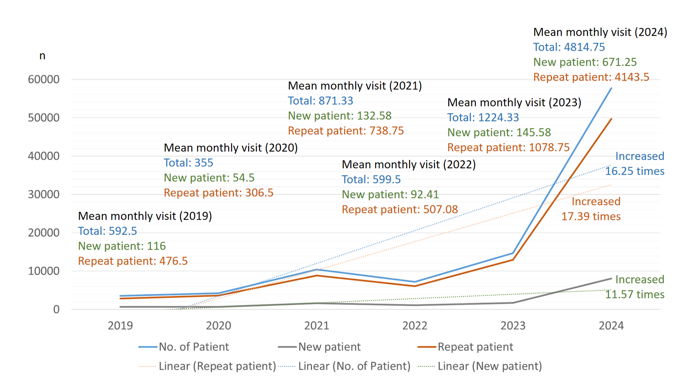
Fig. 1. Distribution of patients from June 2019 to December 2024. Solid line represent the number of the patient. Dotted line represent trend of the patient. Blue color represent the sum of the patient, orange color represent repeat patient, greeen color represent new patient.

Figure 1 showed us the dynamic of the number of patients, where each year there was a tendency to increase in number, except for the year of 2020 and 2022. During 2020, the implementation of the Large-Scale Social Restrictions (PSBB) policy reduce largely the number of patient, followed by a spike in number of patients the following year (2021). Unfortunately, in 2022 there was another decline in the number of visits for unknown reasons. Then in 2023, there was a significant spike which continued in 2024. Further annual analysis on the number of the patients revealed its distribution as follow: in 2019: 3,555 patients (3.6%) with mean monthly patient visit was 592.5 patients, in 2020: 4260 patients (4.3%) with mean 355 patients per month, in 2021: 10,456 patients (10.7%) with mean monthly patient visit was 871.33 patients, in 2022: 7,194 patients (7.3%) with mean 599.5 patients visit per month, in 2023: 14,692 patients (15%) with mean monthly patient visit was 1,244.33 patient and finally in 2024: 57,777 (59%) with mean 4,814.75 patient per month. These huge number only come from one PUSKESMAS only; it will be interesting to explore deeper in the next future study whether any variation in results based on the location or region of the PUSKESMAS, such as urban vs. rural areas. Beside that, regarding the trend, we realize that It is also difficult to gauge the importance of the trends without the context of some statistical comparisons or significance tests in the data analysis. Adding some statistical comparisons or significance tests would strengthen the findings which at the moment is our limitation, and will be interesting to analyze deeper in our next study. Regarding the COVID pandemic, studies on COVID-19's impact on healthcare, for example a study that analyzes how PUSKESMAS adapted or changed in response to the pandemic is still limited, and perhaps this will become an interesting topic to dig deeper in the future study.
The number of patients visiting a PUSKESMAS (Community Health Center) may increase due to a number of factors, including: (a) the implementation of a strict health care referral system may lead to more potential patients visiting a certain Puskesmas, (b) pro-active Government assistance which facilitate and give assistance to vulnerable patients, e.g., elderly, to visit a Puskesmas more often, and (c) improvement of Quality of care at a Puskesmas, e.g., due to ISO accreditation, (d) the proximity of the PUSKESMAS to patients' homes.
BPJS Kesehatan, the national health insurance provider in Indonesia, has an important role in ensuring that the community has access to quality health services. Quality services mean services that are fast, pleasant, error-free, and follow established processes and procedures [Bau & Kapitan, 2024]. Regarding the implementation of a strict health care referral system, pay-for-performance (P4P) schemes are commonly used to incentivize primary care providers, which is intended to improve the quality of healthcare they deliver. Commitment base capitation or Kapitasi Berbasis Komitmen (KBK) scheme for PUSKESMAS (community health centers) was implemented in province capitals between August 2015 and May 2016. Its main goal was to incentivize the substitution of secondary by primary care use. Concerns surge on how the scheme brings improvement to the patient’s quality of service [Sambodo et al., 2023]. Quality per definition is a dynamic condition that affects service products, people, processes and the environment that meet or exceed expectations. Further study needs to be done in order to explore the effect of increasing number of the patient against quality of service that the PUSKESMAS provide to its patients.
The huge increased in number of patients, actually bring negative impact which based on overcrowding [Sartini et al., 2022] due to delayed diagnosis and treatment [McCharty, et al., 2009], compromised nursing care which actually stressful for both the patient and the health staff [Arogyaswamy et al., 2022] and longer waiting times. The dynamic crowding throughout each patient's visit should be carefully screened in a real-time manner to prevent and avoid deleterious effect on the timeliness of care, even for high-acuity patients. According to Aprilia and Wella (2024) there are techniques, namely linear regression, single exponential smoothing, and autoregressive integrated moving average, are utilized to predict and ascertain the most precise forecasting accuracy; in order to avoid excessively long waiting times and in a more specific order is to improve the readiness of healthcare facilities in delivering patient care [Aprilia & Wella, 2024].
We further analyze the number of patient in two of the PUSKESMAS clinic which has the highest number of patient throughout 2019 to 2024, namely the General clinic and the Maternal and Child Health clinic.

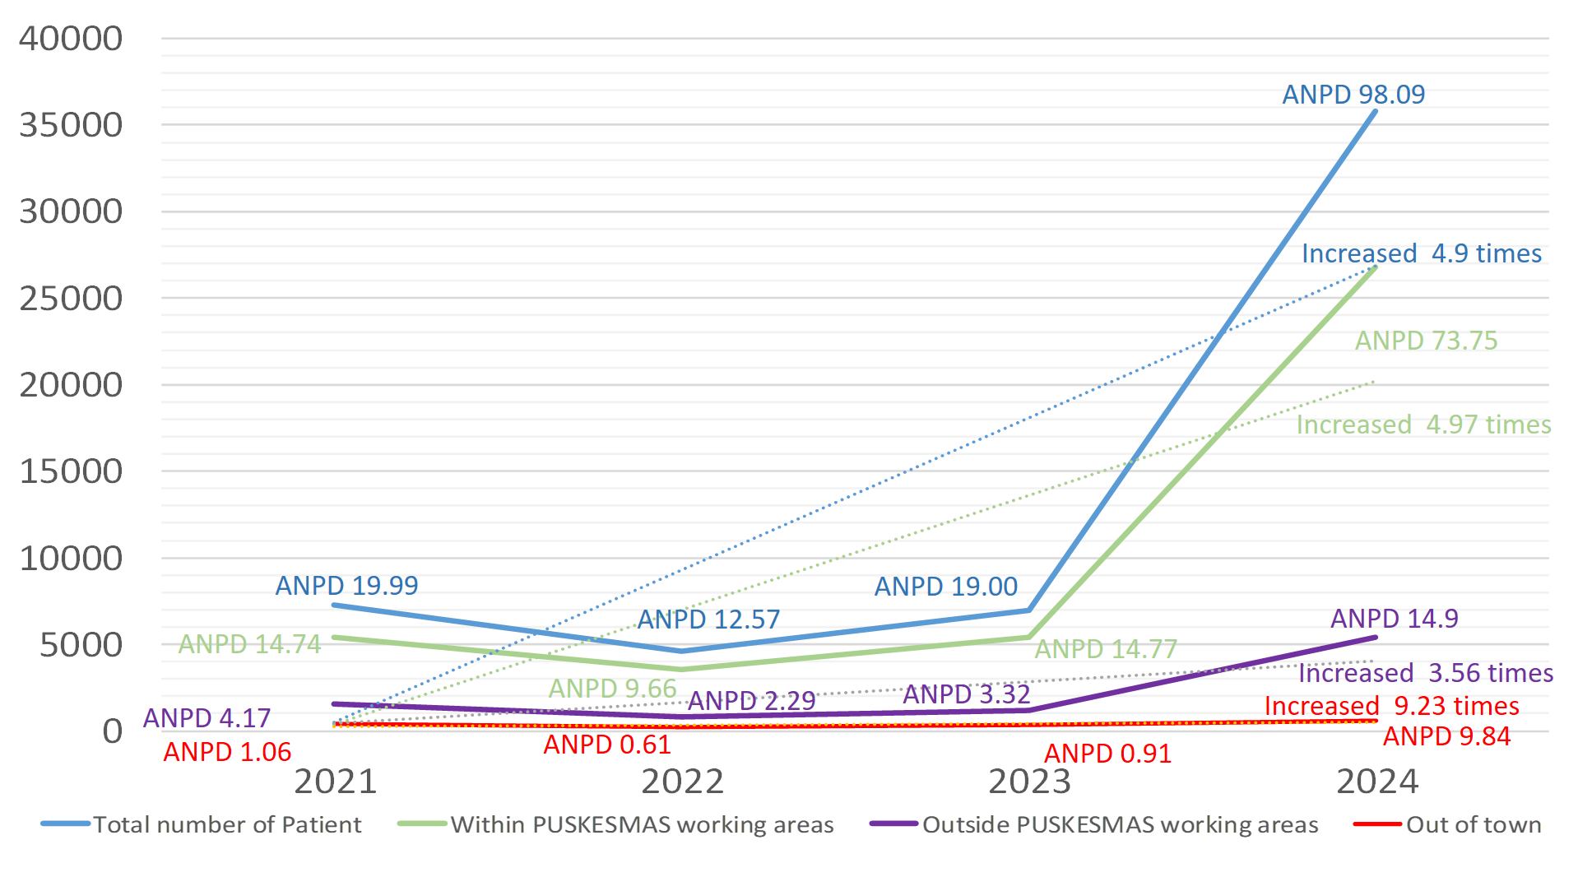
Fig. 2 Distribution of patients in General Clinic, 2021 – 2024. Blue represented total number of patients, green represented patients which houses were within the PUSKESMAS’s working areas, purple represented patients from outside the PUSKESMAS’s working areas and red represented patients who came from out of Bogor. ANPD= Average number of patients per day throughout the year, dotted line showed trends.

Figure 2 showed us, how the general clinic become the backbone of the PUSKESMAS which covers 55.8% from the whole PUSKESMAS service. In this clinic, there was 4.9 times increased in total number of patient from 2019 (7,279 patients) to 2024 (35,804 patients). Annual number of patient per day in 2021 were 19.99 patients and in 2024 were 98.09 patient. Based on the patient's origin (within the PUSKESMAS work area, from outside the work area but still in the same city and from outside the city) all showed the same increasing trend with the highest increased was from patient from outside of town (9.23 times increased, with ANPD in 2021 was 1.06 and in 2024 became 9.84 patients) and the lowest increased was patient that came from outside of PUSKESMAS working areas but still in the same city (Bogor) which was 3.56 times increased, with ANPD in 2021 were 4.17 and became 14.9 patients in 2024. The actual percentage of number of patient that came from the PUSKESMAS working areas were 76.34% (41,705 patients out of 54,628 total number of patient), the patients from outside of the PUSKESMAS working areas were 16.5% (n=9,014) and the patients from out of Bogor were 8.3% (n=4539). These numbers showed the hidden potency of PUSKESMAS to improve their coverage in quantity and also quality.
The number of patients treated by the PUSKESMAS in the of the National Health Insurance (JKN) is always increasing [Khoiriyah & Hidayat (2024)]. Our data showed us that >75% of the patients of the general clinic came from the scope of the PUSKESMAS work area and this number showed us the PUSKESMAS still focuses on its work area. Puskesmas are the most used primary health facility by the community and our data indicate that PUSKESMAS have a heavy workload, and are more focused on medical services, which also suggested by Budi et al [Budi et al., 2024]. Puskesmas are actually also responsible for providing disease prevention and health promotion through community health services, which actually much lower in budget compare to curative care [Fuady et al., 2024].
The huge increase in patient visit may actually due to the regulation where under the JKN, potential patients must first visit and be examined at primary healthcare facilities, including PUSKESMAS and they are forbidden to go directly to the hospital for treatment. Only certain diseases and severity will be referred to the hospital for further health care {Ekawati et al, 2017]. This statement supported by our findings where 76.04% (41,543 out of total 54,628) patients in general clinic were outpatient. As much as 22.23% patients (n=12,145) referred to secondary health facility for further management and only 1.72% (n=940) referred to another polyclinic in the same health center (data not shown).
If the patients do not follow this procedure, patients will have to pay for all medical expenses with their own money. At the health facility level, health care facilities’ spending is also crucial [Asante et al., 2023] to ensure the health facilities provide not only cost-effective healthcare for their patients [Hanson et al., 2022] but also able to motivate health workers [Kitsios & Kamariotou, 2021] to ensure the service quality.
Primary healthcare facilities in Indonesia are paid with capitation, just as some countries in the world [Sambodo et al., 2023]. Receiving service payment through capitation system means primary healthcare facilities receive a predetermined amount of money per patient monthly even before the physician deliver health care services. Primary healthcare facilities must serve the patients with specific services, including number of patient visit [Nursolihah et al., 2023], listed in the contract between health facilities and BPJS Kesehatan as payers. Health facilities could not ask for more money outside the capitation fund when agreeing to be paid with capitation. As a result, when primary healthcare facilities want to improve their profitability under capitation, their practices must become more cost-efficient. Theoretically, it should simply urge primary healthcare staffs take care of the population they serve in a much better way, with their focus more in a health promotion and disease prevention approach, rather than curative. But unfortunately, sometime there are pending Claim of BPJS Kesehatan patient due to incompatibility or even error coding [Supriadi & Putri, 2022]. Latest evaluation of the National Health Insurance, especially on how JKN (Jaminan Kesehatan Nasional) is currently performing and what improvements have been observed post-pandemic could be an interesting topic to explore deeper.

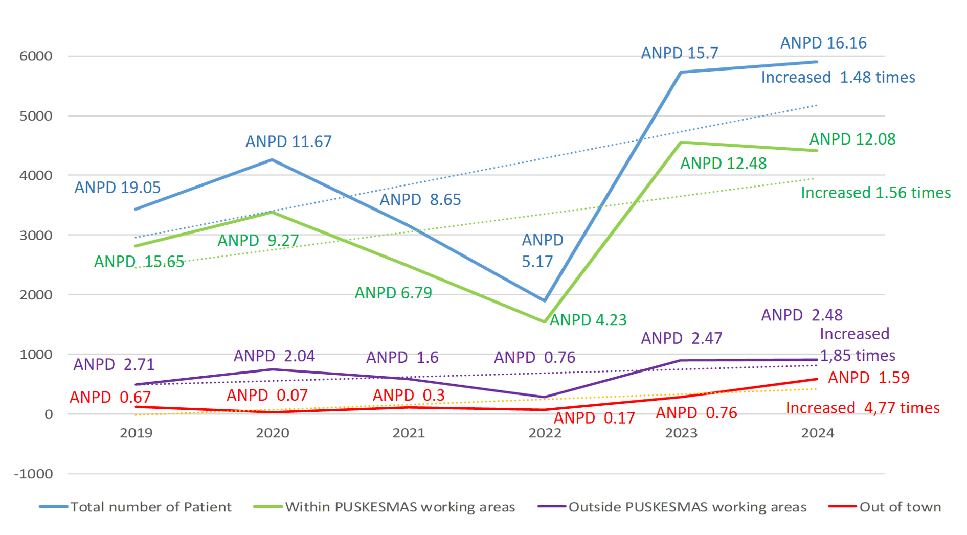
Fig. 3 Distribution of patients in Maternal and Child Health Clinic, 2019 – 2024. Blue represented total number of patients, green represented patients which houses were within the PUSKESMAS’s working areas, purple represented patients from outside the PUSKESMAS’s working areas and red represented patients who came from out of Bogor. ANPD= Average number of patients per day throughout the year

Figure 3 revealed that, as one of the favorite clinic of the PUSKESMAS, the number of Maternal-Child Health clinic patients were enormous, with total number of patients were 24,371 or 24.9% from the whole PUSKESMAS’s patients. In the total number of patients, average daily patient number from 2019 to 2024 as follow where the lowest was 4.23 patient per day in 2022 and the highest was 16.16 patients per day in 2024; with a 1.4 times increased from 2019 to 2024. In the group of patients which houses located within the PUSKESMAS working areas (n=19,189 or 78.73%), the average daily patient number was ranging from 4.23 in 2022 and the highest 12.48 patients per day in the year of 2023 with an increased in trend as many as 1.56 times from 2019 to 2024. In the group of patients which came from outside of the PUSKESMAS’s working areas, but still in the same city, namely Bogor (n=3893 or 15.97%) the range of average daily patient number was ranging from 0.76 in 2022 (the lowest) to 2.71 in 2019 (the highest) with 1.85 increased in number of patient from 2019 to 2024. On the other hand, the patient which came from out of Bogor (n=1289 or 5.28%), the average number of patient per day was ranging between 0.17 in 2022 to 1.59 in 2024 with increased as much as 4.77 times from 2019 to 2024. These numbers once again revealed the hidden potency of PUSKESMAS that can still be maximized and improved, e.g., regarding their service coverage in quantity and also quality.
Maternal-child health is one of the top national health priority in Indonesia; and one of the implementation is through the development of specialized and very basic programme in PUSKESMAS all over Indonesia namely the maternal-child health clinic.
Universal Health Coverage (UHC) is also one of the Indonesia’s government targets in the area of public health services to the achieve Sustainable Development Goals (SDGs). The UHC is a crucial and urgent resolution for all nations to expand health systems with equal access and affordable costs. The program is one of the efforts to lower the maternal and infant mortality rate. As a healthcare provider, PUSKESMAS, as one of the primary public health centers must ensure optimal care and services. Public health centers realize that providing health care refers to the core health efforts program [Salman, et al., 2024]. Our data once again indicate the enormous workload of the staffs which may affect the staff’s normative commitment to patient’s satisfactory, and this should be explore further in the future.
From the pandemic era, lesson learnt that PUSKESMAS administrative must maximize the utilization of health personnel to improve technical efficiency and condition service activities by adjusting regional policies while still complying with health protocols. [Rizqi, et al., 2023]. From the data in 2020, we learnt that Maternal health services in Indonesia faced significant challenges during the COVID-19 pandemic. The service had to manage the infection and ensure the continuity of maternity service for women [Ekawati, et al., 2023]. Maternal and child health in PUSKESMAS requires continuing Quality Improvement (QI) through Training, mentoring, and workshops for midwives and clinic teams’ interventions. Maternal Health Care Utilization Behavior combined with Local Wisdom should improve the awareness of the stake holder regarding the importance and sustainability of maternal-child health programme in the community, especially for the benefit of the more vulnerable sub population, such as women [Nainggolan & Siagian, 2019] and children [Siagian, 2023].
Positive impact of the increment in number of patients in the PUSKESMAS including the addition of operational equipment [Suranugraha, et al., 2018] and perhaps the addition of incentives provided [Gadsden et al., 2021]. In the case of this PUSKESMAS, perhaps it is also an indication of the possibilities expansion in service quality, including type and time of service. Nevertheless, there was also a negative impact such as feeling overwhelmed due to an increase in the quantity of activities and additional administrative affairs [Carayon and Gurses, 2008]. It may also have sparked a negative interaction between staff due to the number of incentives received [Suranugraha, et al., 2018]. The regulation on the use of budget should empowers PUSKESMAS to better arrange the schedule of activities and manage human resources. However, these regulations are considered restrictive and the administrative flow of funds is perhaps too birocrative that hinder the optimal use of the budget.

4. Conclusion

PUSKESMAS is still the main backbone of Indonesia’s primary health facilities. The tendency to expand in quantity or in quality of service is very huge, and all stake holders must be aware of the positive and negative impact of the increment of patient population that come to the PUSKESMAS. It is very important to help PUSKESMAS to be ready for its up grading in terms of health service consignment.

DISCLAIMER (ARTIFICIAL INTELLIGENCE)

Author(s) hereby declare that no generative AI Technologies such as large language models (CHATGPT, COPILOT, etc.) And text-to-image generators have been used during writing or editing of this manuscript.

COMPETING INTERESTS DISCLAIMER:
Authors have declared that they have no known competing financial interests OR non-financial interests OR personal relationships that could have appeared to influence the work reported in this paper.

References

Anita, B., Febriawati, H., Yandrizal, Y. (2016). The Role of Public Health Centers (Puskesmas) as the Gatekeeper of National Health Insurance. Jurnal Kesehatan Masyarakat. 12. https://doi.org/10.15294/kemas.v12i1.3933.
Aprilia, M., & Wella, W. (2024). Visualization and Prediction The Number of Patients Visit in Curug Health Center. G-Tech: Jurnal Teknologi Terapan, 8(3), 1379–1385. https://doi.org/10.33379/gtech.v8i3.4245
Arogyaswamy, S., Vukovic, N., Keniston, A., Apgar, S., Bowden, K., Kantor, M. A., et al. (2022). The Impact of Hospital Capacity Strain: a Qualitative Analysis of Experience and Solutions at 13 Academic Medical Centers. Journal of general internal medicine, 37(6), 1463–1474. https://doi.org/10.1007/s11606-021-07106-8
Asante, A., Cheng, Q., Susilo, D., Satrya, A., Haemmerli, M., Fattah, R. A., et al. (2023). The benefits and burden of health financing in Indonesia: analyses of nationally representative cross-sectional data. The Lancet. Global health, 11(5), e770–e780. https://doi.org/10.1016/S2214-109X(23)00064-5
Astuti, D., Kongsin, S., Jiamton, S., Prakongsai, P., & Hearnden, S. R. (2024). Utilization of Primary Health Care Under National Health Insurance in Samarinda Municipality, East Kalimantan Province, Indonesia. Journal of Multidisciplinary Healthcare, 17, 1025–1039. https://doi.org/10.2147/JMDH.S447332
Bau, A., & Kapitan, G., D. (2024) An Overview of the Simplification of the Flow and File of Membership Administration Services on the Satisfaction of JKN Participants at the BPJS Health Kupang Branch. Jurnal Jaminan Kesehatan Nasional, 4, 1, 26-39 https://doi.org/10.53756/jjkn.v4i1.190
Beckman, A. L., Tietschert, M., Old, A., Orav, E., J., Singer, S., J., Figueroa, J., F. (2023) High-performing primary care clinics across high-need, high-cost Medicare populations: BMJ Open Quality, 12:e002271. https://doi.org/10.1136/bmjoq-2023-002271
Budi, R., S., Adisasmito, W., B., B., Bachtiar, A., Rosanti, E. (2024) Balancing Community and Individual Health Efforts by Utilizing Sub-Primary Health Care at Regions: Analysis for Policy. Journal of Indonesian Health Policy and Administration, 9, 2, 3. https://doi.org/10.7454/ihpa.v9i2.8278
Carayon P, Gurses AP. Nursing Workload and Patient Safety—A Human Factors Engineering Perspective. In: Hughes RG, editor. Patient Safety and Quality: An Evidence-Based Handbook for Nurses. Rockville (MD): Agency for Healthcare Research and Quality (US); 2008 Apr. Chapter 30. Available from: https://www.ncbi.nlm.nih.gov/books/NBK2657/
Caron, R. M., Noel, K., Reed, R. N., Sibel, J., & Smith, H. J. (2023). Health Promotion, Health Protection, and Disease Prevention: Challenges and Opportunities in a Dynamic Landscape. AJPM focus, 3(1), 100167. https://doi.org/10.1016/j.focus.2023.100167
Ekawati, F. M., Claramita, M., Hort, K., Furler, J., Licqurish, S., & Gunn, J. (2017). Patients' experience of using primary care services in the context of Indonesian universal health coverage reforms. Asia Pacific family medicine, 16, 4. https://doi.org/10.1186/s12930-017-0034-6
Ekawati, F. M., Putri, D. A. D., Novitasari, D. A., & Muchlis, M. (2023). Provision of maternal health service in Indonesian primary care during the COVID-19 pandemic. Journal of family medicine and primary care, 12(7), 1320–1330. https://doi.org/10.4103/jfmpc.jfmpc_2201_22
Fanda, R. B., Probandari, A., Yuniar, Y., Hendarwan, H., Trisnantoro, L., Jongeneel, N., & Kok, M. O. (2024). The availability of essential medicines in primary health centers in Indonesia: achievements and challenges across the archipelago. The Lancet regional health. Southeast Asia, 22, 100345. https://doi.org/10.1016/j.lansea.2023.100345
Fuady, A., Anindhita, M., Haniifah, M., Ahsan, A., Sugiharto, A., Haya, M. A. N., et al. (2024). Bridging the gap: financing health promotion and disease prevention in Indonesia. Health research policy and systems, 22(1), 146. https://doi.org/10.1186/s12961-024-01206-7
Gadsden, T., Jan, S., Sujarwoto, S., Kusumo, B. E., & Palagyi, A. (2021). Assessing the feasibility and acceptability of a financial versus behavioural incentive-based intervention for community health workers in rural Indonesia. Pilot and feasibility studies, 7(1), 132. https://doi.org/10.1186/s40814-021-00871-7
Hanson, K., Brikci, N., Erlangga, D., Alebachew, A., De Allegri, M., Balabanova, D., et al. (2022). The Lancet Global Health Commission on financing primary health care: putting people at the centre. The Lancet. Global health, 10(5), e715–e772. https://doi.org/10.1016/S2214-109X(22)00005-5
Hasanbasri, M., Maula, A. W., Wiratama, B. S., Espressivo, A., & Marthias, T. (2024). Analyzing Primary Healthcare Governance in Indonesia: Perspectives of Community Health Workers. Cureus, 16(3), e56099. https://doi.org/10.7759/cureus.56099
https://opendata.jabarprov.go.id/id/dataset/jumlah-kunjungan-pasien-di-fasilitas-pelayanan-kesehatan-tingkat-pertama-puskesmas-berdasarkan-kategori-kunjungan-di-jawa-barat
Indra P, I., M., I., Imelda, D., J., Machdum, S., V. (2023). Community Health Centers as Social Development Agents. Asian Journal of Management, Entrepreneurship and Social Science, 4(01), 506-524. Retrieved from https://www.ajmesc.com/index.php/ajmesc/article/view/604
Khoiriyah, S., & Hidayat, M., S. (2024) Analysis of The Increase In National Health Insurance Contributions on The Rights and Obligations of Participants at The Puput Community Health Center. International Journal of Healthcare Research, 7,1, 54-64. https://doi.org/10.12928/ijhr.v7i1.11353
Kitsios, F., & Kamariotou, M. (2021). Job satisfaction behind motivation: An empirical study in public health workers. Heliyon, 7(4), e06857. https://doi.org/10.1016/j.heliyon.2021.e06857
Kusuma., A., N. (2022) Analysis of Community Health Centers (Puskesmas) to Realize the Quality and Degree of Health Services for the Indonesian Community. Budapest International Research and Critics Institute-Journal (BIRCI-Journal), 5, 3, 23645-23655 https://doi.org/10.33258/birci.v5i3.6379
McCarthy, M. L., Zeger, S. L., Ding, R., Levin, S. R., Desmond, J. S., Lee, J., & Aronsky, D. (2009). Crowding delays treatment and lengthens emergency department length of stay, even among high-acuity patients. Annals of emergency medicine, 54(4), 492–503.e4. https://doi.org/10.1016/j.annemergmed.2009.03.006
Nainggolan, S., Siagian, F., E. (2019) The Prevalence of Anemia in Pregnant Women in the 10 Priority Villages for Stunting Control in Sumedang District, West Java: A Community-based Survey. International Journal Of Community Medicine And Public Health, 6, 9, 3760-3767.
Nursolihah, I., Sembiring, D. A., & Runggandini, S. A. (2023). The Effect of Collaboration Between Hospitals with BPJS Kesehatan on the Number of Hospital Visits in Indonesia. Journal of Pharmaceutical and Sciences, 6(2), 393–399. https://doi.org/10.36490/journal-jps.com.v6i2.118
Rahman, K., & Ruwiah. (2024). Utilization of health service facilities for all communities in Indonesia. World Journal of Advanced Research and Reviews.https://doi.org/10.30574/wjarr.2024.24.2.3392
Rizqi, Y., N., K., Kurniawan, A., Nafisah, L. (2023) Analysis of the efficiency of maternal and child health services (MCH) at public health centers in the Banyumas district. Jurnal Ilmu Kesehatan Masyarakat (JIKM), 162-173 https://doi.org/10.26553/jikm.2023.14.2.162-173
Salman, S., Hilmi, I. L., Oktavianti, A., Salsabila, I., Lestari, S. A., Putria, D. K., & Windari, W. (2024). Article review: Utilization of maternal and child health insurance in delivery services at district or city health centers in Indonesia. Journal of Pharmaceutical and Sciences, 7(1), 58–66. https://doi.org/10.36490/journal-jps.com.v7i1.360
Sambodo, N. P., Bonfrer, I., Sparrow, R., Pradhan, M., & van Doorslaer, E. (2023). Effects of performance-based capitation payment on the use of public primary health care services in Indonesia. Social science & medicine (1982), 327, 115921. https://doi.org/10.1016/j.socscimed.2023.115921
Sartini, M., Carbone, A., Demartini, A., Giribone, L., Oliva, M., Spagnolo, A. M., et al. (2022). Overcrowding in Emergency Department: Causes, Consequences, and Solutions-A Narrative Review. Healthcare (Basel, Switzerland), 10(9), 1625. https://doi.org/10.3390/healthcare10091625
Siagian, F., E. (2023). Intestinal Parasitic Infection Responsible for Undernourishment and Stunted Growth in Children of School Going Age. Asian Journal of Research in Infectious Diseases 14, 1, 18-25. https://doi.org/10.9734/ajrid/2023/v14i1278.
Soeroso, E., F. (2023) Assessment and Health Service Quality Improvement Plan. International Journal of Science and Society, 5(4), 776-796. https://doi.org/10.54783/ijsoc.v5i4.848
Supriadi, S., & Putri, I. A. (2022). Overview of Claim Return for Outpatient JKN Hospital X in South Tangerang. Proceedings, 83(1), 59. https://doi.org/10.3390/proceedings2022083059
Suranugraha, K., Nopiyani, N., M., Januraga, P., P. (2018). Impact of Budget Increase and Primary health care Performance in the Era of National Health Insurance: Case Study in the Buleleng District. Kesmas: National Public Health Journal. 13. https://doi.org/10.21109/kesmas.v13i2.1875.
Werdhani R. A. (2019). Medical problem in Asia pacific and ways to solve it: The roles of primary care/family physician (Indonesia Xperience). Journal of family medicine and primary care, 8(5), 1523–1527. https://doi.org/10.4103/jfmpc.jfmpc_154_19
Wulandari, R. D., Laksono, A. D., Rohmah, N., & Ashar, H. (2023). Regional differences in primary healthcare utilization in Java Region-Indonesia. PloS one, 18(3), e0283709. https://doi.org/10.1371/journal.pone.0283709
Zahroh, A., H., Putri, R. A., Shima L., Erdayani, Martaliza, R., Risk Adjustment of Capitation Payment System: What Can Indonesia Adopt from other Countries? Jurnal Ekonomi Kesehatan Indonesia 3 (1), 2018

