***Case report***

**COLONIC PERFORATION IN DENGUE FEVER: A REPORT OF THREE CASES**

**ABSTRACT**

Dengue fever is a widespread viral infection endemic in tropical and subtropical regions. While its common manifestations include fever, headache, and musculoskeletal pain, gastrointestinal complications such as colonic perforation are exceedingly rare. Dengue is a viral disease with reported incidence of upto 96 million cases worldwide.Dengue is caused by flavivirus which has 4 serotypes which are antigenicaly distinct ( DEN1,2,3,4) and are transmitted by Aedes aegypti mosquito. Symptoms include high fever, headache, rash and muscle and joint pain. It may also cause nausea and vomiting. In severe cases there is serious bleeding and shock, which can be life threatening.This disease is rarely associated with bowel perforation. Till now only 10 cases of dengue associated bowel perforation reported worldwide. The site of intestinal perforation was gastric, jejunal or appendicular perforation in these cases [11-19]

We report three cases of colonic perforation in patients with dengue fever, highlighting the need for prompt recognition and surgical intervention in such atypical presentations.

**KEYWORDS**

Dengue fever; Colonic perforation; Intestinal perforation; Acute abdomen; Case report; Surgical emergency

**INTRODUCTION**

Dengue fever, caused by the flavivirus with four antigenically distinct serotypes (DEN-1, DEN-2, DEN-3, DEN-4), is transmitted by the *Aedes aegypti* mosquito. Globally, it affects up to 96 million people annually [1]. Common symptoms include high fever, headache, rash, and musculoskeletal pain, with severe cases leading to hemorrhage and shock. Gastrointestinal manifestations are atypical, and intestinal perforation is exceptionally rare, with only a few cases reported involving gastric, jejunal, or appendiceal perforations [2–4]. We present three cases of colonic (cecal) perforation associated with dengue fever.

**CASE PRESENTATION**

**CASE 1**

A 13-year-old female presented with a 15-day history of intermittent fever and generalized weakness. She developed abdominal pain over 10 days, characterized by dull aching, abdominal distension, obstipation, and bilious vomiting. Physical examination revealed moderate dehydration, tachycardia (102/min), tachypnea (24/min), hypotension (98/62 mmHg), pallor, diffuse abdominal tenderness with guarding, and sluggish bowel sounds.

Laboratory findings showed thrombocytopenia (78,000/µL) with normal leukocyte counts. Dengue NS1 antigen was positive; malaria and Widal tests were negative. Chest X-ray indicated pneumoperitoneum, and ultrasound-guided ascitic tap revealed purulent fluid. An emergency exploratory laparotomy uncovered a 3×1 cm perforation at the base of the cecum. The patient underwent limited resection (10 cm of cecum and ileum) with end ileostomy and right pelvic drain placement. She recovered well postoperatively.

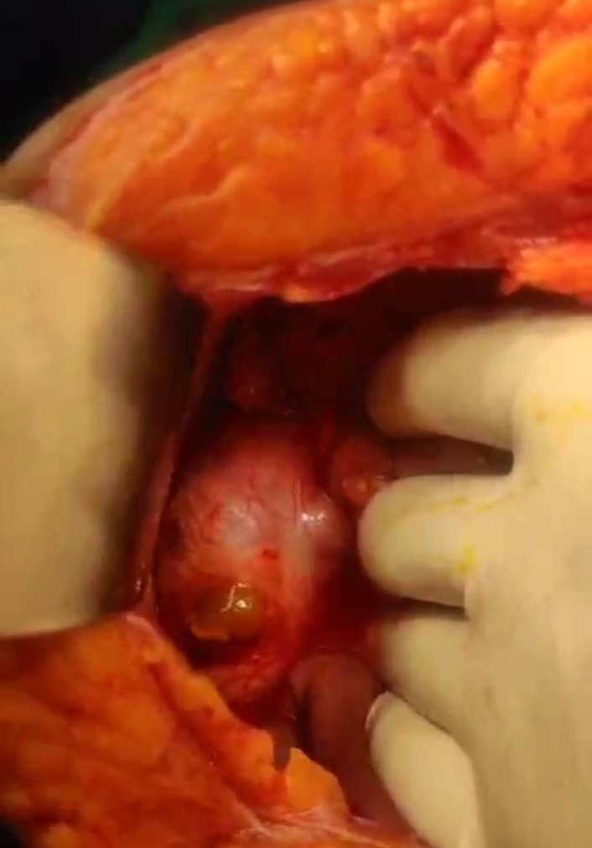

**FIGURE 1: Image showing intraoperative finding( 3x1cm caecal perforation at base)**

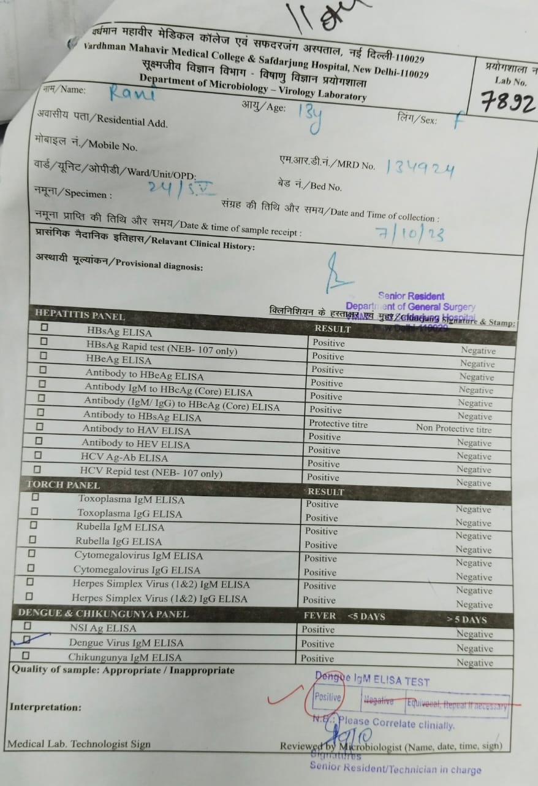

**FIGURE 2: Blood report showing positive ELISA test for dengue**

**CASE 2**

A 27-year-old female was admitted with abdominal pain and bilious vomiting. Initial investigations showed hemoglobin of 11.0 g/dL, leukocyte count of 6,800/µL, and platelet count of 78,000/µL. Dengue NS1 antigen was positive. She received supportive care and was discharged after four days.

Three days post-discharge, she developed severe abdominal pain, distension, and vomiting. Ultrasonography revealed ascites with free air, and erect abdominal X-ray confirmed pneumoperitoneum. On examination, she was tachycardic (120/min), tachypneic (25/min), and hypotensive (82/60 mmHg). Abdomen was distended and tender with absent bowel sounds. After resuscitation, emergency exploratory laparotomy revealed a 2x2 cm perforation in the cecum. Primary repair with diversion ileostomy was performed. She was discharged on postoperative day five.

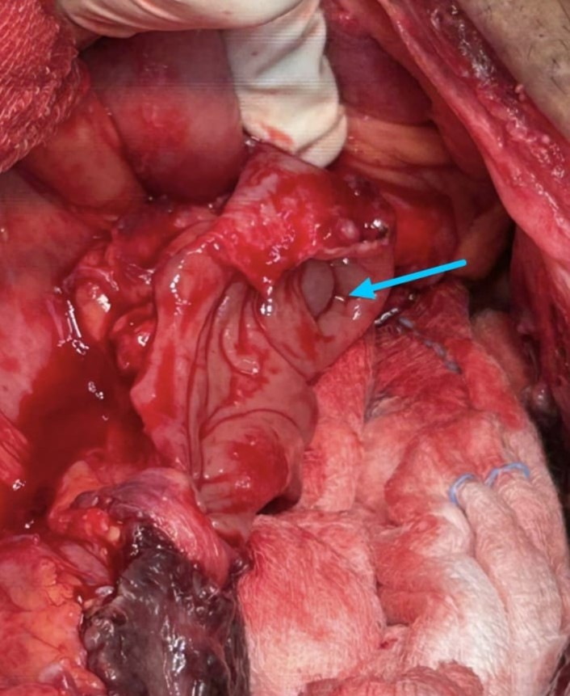

**FIGURE 3 :showing intraoperative finding ( 2x2cm caecal perforation)**

**CASE 3**

A 48-year-old female attended the gynecology outpatient department with abdominal pain and per vaginal discharge. Initial management with analgesics and antibiotics resolved the discharge, but abdominal pain and high-grade fever persisted. Dengue NS1 antigen was positive; malaria and typhoid tests were negative. After seven days of conservative management, she developed severe abdominal pain and bilious vomiting.

Ultrasound showed ascites with internal echoes suggestive of pyoperitoneum. Erect abdominal X-ray revealed pneumoperitoneum. Laboratory results showed hemoglobin of 11.2 g/dL, platelet count of 80,000/µL, and leukocytosis (16,000/µL). Emergency exploratory laparotomy uncovered a 1×1 cm perforation in the cecum. Primary repair with diversion ileostomy was performed. The patient recovered uneventfully and was discharged on postoperative day five.

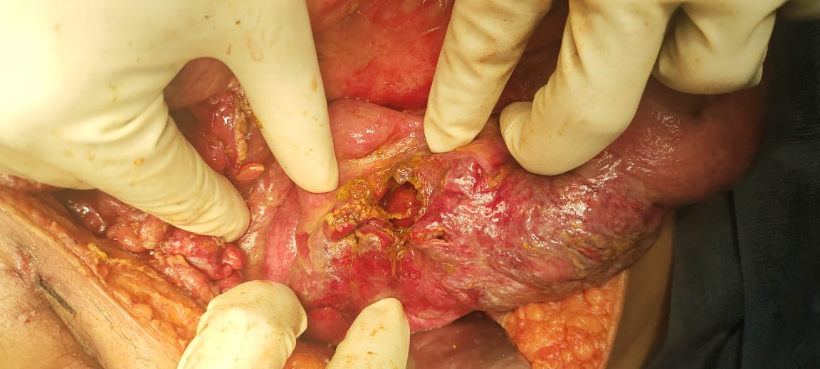

FIGURE 4 : showing intraoperative finding ( 1x1 cm caecal perforation)

**DISCUSSION**

Dengue fever is prevalent in tropical and subtropical regions, posing significant public health challenges [5]. While common symptoms are well-documented, atypical manifestations involving the gastrointestinal tract are emerging [6,7]. Abdominal pain in dengue is usually managed conservatively; however, severe pain with signs of peritonitis should raise suspicion for intestinal perforation.

The exact mechanism of intestinal perforation in dengue is unclear. Hypotheses suggest direct viral invasion causing mucosal injury or ischemia due to plasma leakage and thrombocytopenia leading to hemorrhage within the intestinal wall [8,9]. Elevated serum intestinal fatty acid-binding protein levels in dengue patients indicate mucosal injury [10].

Our cases underscore the importance of considering intestinal perforation in dengue patients presenting with acute abdomen. Early surgical intervention is crucial for favorable outcomes. Clinicians should maintain a high index of suspicion, especially in endemic areas.

**CONCLUSION**

Intestinal perforation is a rare but severe complication of dengue fever. In patients with dengue presenting with acute abdominal pain and signs of peritonitis, intestinal perforation should be considered. Prompt surgical management is essential to improve patient outcomes.

**CONFLICT OF INTEREST**

The authors declare no conflicts of interest.

**ETHICAL APPROVAL and consent**

Ethical approval was obtained from the institutional review board. Written informed consent was obtained from all patients for publication of this case report and accompanying images.

Disclaimer (Artificial intelligence)

Author(s) hereby declare that NO generative AI technologies such as Large Language Models (ChatGPT, COPILOT, etc.) and text-to-image generators have been used during the writing or editing of this manuscript.

**REFERENCES**

1. World Health Organization. Dengue and severe dengue. [Internet]. 2022 [cited 2023 Oct 1]. Available from: <https://www.who.int/news-room/fact-sheets/detail/dengue-and-severe-dengue>
2. Lee IK, Liu JW, Yang KD. Clinical characteristics and risk factors for concurrent bacteremia in adults with dengue hemorrhagic fever. Am J Trop Med Hyg. 2005;72(2):221–226. doi:10.4269/ajtmh.2005.72.221
3. Sharma K, Dey AB, Kumar V, et al. Dengue hemorrhagic fever causing acute abdomen and hepatitis. J Assoc Physicians India. 1998;46(3):328–329.
4. Santos CJ, Pinho JD, Mendes VG, et al. Acute abdomen and dengue fever. Rev Col Bras Cir. 2013;40(1):78–79. doi:10.1590/S0100-69912013000100016
5. Gubler DJ. Epidemic dengue/dengue hemorrhagic fever: a global public health problem in the 21st century. Emerg Infect Dis. 1998;4(3):552–556. doi:10.3201/eid0403.980367
6. Gulati S, Maheshwari A. Atypical manifestations of dengue. Trop Med Int Health. 2007;12(9):1087–1095. doi:10.1111/j.1365-3156.2007.01891.x
7. Koshy JM, John M, Kaur R, et al. Dengue fever presenting as acute abdomen. Trop Doct. 2012;42(1):58–59. doi:10.1258/td.2011.110339
8. Thomas L, Verlaeten O, Linares C, et al. Influence of the volume of fluid replacement on clinical evolution in dengue fever: a prospective study of 114 cases. Trop Med Int Health. 2005;10(9):597–612. doi:10.1111/j.1365-3156.2005.01442.x
9. Kularatne SA, Pathirage MM, Gunasena S, et al. Detailed pathological features of liver involvement in dengue hemorrhagic fever. J Clin Virol. 2018;99-100:1–6. doi:10.1016/j.jcv.2017.12.004
10. Vejchapipat P, Theamboonlers A, Chongsrisawat V, et al. An evidence of intestinal mucosal injury in dengue infection. Southeast Asian J Trop Med Public Health. 2006;37(1):79–82.
11. .Mandhane N, Ansari S, Shaikh T et al. Dengue presenting as gastric perforation: first case reported till date. Int J Res Med Sci 2015;3: 2139–40. 10.18203/2320-6012.ijrms20150343 [DOI] [Google Scholar]
12. Jain AC, Viswanath S. Multiple jejunal perforations in dengue. Int J Adv Med 2014;1:153–4.
13. Desai G, Gupta S, Ali S et al. Appendicular perforation in dengue fever: our experience. Asian Pac J Trop Dis 2014;4(Suppl 2):S571–2. 10.1016/S2222-1808(14)60680-0
14. .Khanna S, Vij JC, Kumar A et al. Dengue fever is a differential diagnosis in patients with fever and abdominal pain in an endemic area. Ann Trop Med Parasitol 2004;98:757–60. 10.1179/000349804X3153 [DOI] [PubMed] [Google Scholar]
15. .Kyle JL, Harris E. Global spread and persistence of dengue. Annu Rev Microbiol 2008;62:71–92. 10.1146/annurev.micro.62.081307.163005 [DOI] [PubMed] [Google Scholar]
16. Pawaria A, Mishra D, Juneja M et al. Atypical manifestations of dengue fever. Indian Pediatr 2014;51:495–6. 10.1007/s13312-014-0434-8 [DOI] [PMC free article] [PubMed] [Google Scholar]
17. Gulati S, Maheshwari A. Atypical manifestations of dengue. Trop Med Int Health. 2007;12(9):1087-95.
18. Ooi ET, Ganesananthan S, Anil R, Kwok FY, Sinniah M. Gastrointestinal manifestations of dengue Infection in adults. Med J Malaysia. 2008;63(5):4015
19. Narayana M, Aravind MA, Thilothammal N, Prema R, Sargunam CSR, Ramamurthy N. Dengue fever epidemic in Chennai: a study of clinical profile and outcome. Indian Pediatr. 2002;39:1027-33.