***Case report***

**A Case of Refractory Pericarditis in Systemic Scleroderma: Diagnostic and Therapeutic Pitfalls**

**Abstract**

**Introduction:** Pericardial involvement in systemic scleroderma is rare but may be life-threatening when refractory to standard therapy. Among these, refractory pericarditis is a particularly severe complication.

**Case report:** The patient presented with diffuse poikilodermal lesions, chest pain, oedema of the lower limbs and dyspnoea for ten days. Physical examination revealed tachycardia, a scleroderma-like facies, dyschromic plaques, skin sclerosis with a modified Rodnan score of 21, and a right heart failure syndrome. The electrocardiogram showed diffuse microvoltage, while echocardiography revealed a large circumferential pericardial effusion (35 mm opposite the left ventricle and 24 mm opposite the right ventricle). Biological tests revealed an inflammatory syndrome. Despite several pericardial aspirations, the effusion rapidly reconstituted. We adopted the diagnosis of a cardiac attack of SSc with refractory pericarditis of large volume. After two weeks, a moderate-sized effusion (17 mm opposite the right ventricle) was noted, treated with corticosteroids, azathioprine and hydroxychloroquine. The patient responded favorably to a combination of corticosteroids, azathioprine, and hydroxychloroquine, with resolution of symptoms and reduction of effusion.

**Conclusion:** This case illustrates the diagnostic and therapeutic challenges posed by refractory pericarditis in systemic scleroderma.

**Keys words :** pericarditis, refractory, systemic scleroderma, Burkina Faso**Introduction**

Systemic scleroderma (SSc) is a rare and complex autoimmune disease characterised by progressive connective tissue fibrosis and multisystem involvement, including the heart. [1]. Cardiac involvement in scleroderma can vary considerably, from conduction disorders and cardiomyopathy to more severe manifestations such as pericarditis. [2]. Although pericarditis is less common than other cardiac complications of scleroderma, it represents a considerable diagnostic and therapeutic challenge. [3]. Scleroderma pericarditis often manifests as persistent inflammation of the pericardium, frequently resistant to conventional treatments. [4]. The aim of this review is to discuss the challenges encountered in the management of refractory pericarditis associated with scleroderma, examining the treatment options available, their efficacy and the particularities associated with this condition.

**Case presentation**

The patient was 29 years old with no known cardiovascular risk factors. She had been followed irregularly for 4 years for SSc and had broken off treatment a year earlier. She presented with diffuse poikilodermal lesions, chest pain, and shortness of breath. The onset of this symptomatology dated back about 10 days, with the appearance of retrosternal chest pain, which subsided in a half-sitting position, leaning forward, associated with oedema of the lower limbs, all evolving in a febrile context. On admission, the general examination revealed a blood pressure of 105/65 mmHg and a tachycardia of 110 beats per minute. The physical examination revealed effaced facial folds with reduced mouth opening, a tapered nose and a mummy-like face. Dyschromic, mottled sclerotic patches on the trunk and limbs and diffuse skin sclerosis with a modified Rodnan score of 21 were also noted (Figure 1). The rest of the physical examination revealed a syndrome of right heart failure. The electrocardiogram showed diffuse microvoltage, and the echocardiogram showed a large circumferential pericardial effusion (35 mm opposite the left ventricle and 24 mm opposite the right ventricle) (Figure 2). Biological tests revealed an inflammatory syndrome, with CRP at 56 mg/dL and fibrinemia at 3.4 g/L. Drainage yielded one litre of sterile, citrine-yellow pericardial fluid. We accepted the diagnosis of a cardiac involvement secondary to SSc with refractory pericarditis of significant effusion in favour of discontinuing treatment. She underwent several pericardial aspirations over a two-week period, at the end of which a follow-up echocardiogram revealed an effusion that was always circumferential and of moderate size (17 mm opposite the right ventricle) (Figure 3). The treatment consisted of methylprednisolone 16mg tablet: 1 and a half tablets per day, colchicine 1mg (½ tablet per day), hydroxychloroquine (200mg tablet: 1 tablet twice a day) and azathioprine (50mg 01 tablet during) combined with betamethasone applied locally and a moisturising cream. The outcome was favourable after four weeks of immunosuppressive and immunomodulatory treatment, with improvement in signs of right heart failure, stabilisation of dermatological lesions and drying of the pericardium. The patient was discharged home after a month's hospitalisation, with a gradual reduction in oral and local corticosteroids after 6 months, as well as colchicine. Background treatment with hydroxychloroquine (200mg tablet: 1 tablet twice daily) and azathioprine (50mg 01 tablet during treatment) was continued.

**Discussion**

SSc affects around 1 to 2 people in 100,000 per year, with a predominance of women of childbearing age. [5]. The prevalence of cardiac involvement in scleroderma varies between studies, but evidence suggests that 30-50% of patients may develop cardiac manifestations during the course of their disease. [3]. Pericarditis is a less frequent complication compared with other scleroderma-related cardiac disorders such as cardiomyopathy or conduction disorders. [3]. However, when it does occur, it can be particularly difficult to treat, especially in our resource-limited setting. The increased prevalence of pericarditis in severe and diffuse systemic forms of scleroderma highlights the need for extra vigilance in these patients.

Clinically, pericarditis in scleroderma often presents with chest pain, shortness of breath and sometimes signs of heart failure. [6]. In this case, the patient presented with retro-sternal pain, exacerbated by lying down and relieved by half-sitting bent forward, associated with oedema of the lower limbs and a febrile context. The right heart failure syndrome observed on physical examination confirmed the severity of the cardiac damage, suggesting cardiac compression due to the large pericardial effusion. Skin fibrosis led to loss of the natural folds of the face and reduced oral mobility, giving a "mummy face" appearance. The positive prayer sign, where the hands cannot touch due to taut skin, and a modified Rodnan score of 21, indicate a diffuse and severe form of the disease, with extensive involvement of the dermis [1].

Echocardiography plays a crucial role in the diagnosis of pericarditis. Echocardiographic examinations can visualise pericardial effusion, the presence of signs of inflammation and overall cardiac function [7,8]. In this case, echocardiography revealed abundant circumferential pericardial effusion, with significant measurements opposite the left and right ventricles (35 mm and 24 mm respectively). The absence of complications such as cardiac tamponade led to more specialised treatment options. Follow-up ultrasound scans showed persistent effusion despite the interventions, highlighting the refractoriness of pericarditis to conservative treatment. This persistence indicates chronic inflammation or a failure of drainage to control the effusion effectively.

Biologically, inflammatory markers such as C-reactive protein (CRP) and sedimentation rate are often elevated in cases of pericarditis [9]. However, these markers are not specific to scleroderma and may be influenced by other aspects of the disease. In this case, biological tests showed moderate elevation (elevated CRP (56 mg/dL) and increased fibrinemia (3.4 g/L)) of inflammatory markers, confirming persistent inflammation despite adequate anti-inflammatory treatment. This suggested the need to explore more targeted therapies. The pericardial fluid drained was citrine yellow and sterile, ruling out infection and indicating non-infectious inflammation.

The treatment of refractory pericarditis in scleroderma requires a combined and adapted approach [10]. Initially, the patient underwent several pericardial aspirations to reduce the effusion and relieve symptoms. In addition, she received a combination of corticosteroids (methyprednisone), colchicine and topical anti-inflammatories (betamethasone) [11]. In this case, the corticosteroids were initially effective, but the symptoms reappeared, leading to the introduction of more specific drugs, notably immunosuppressive agents such as azathioprine and immunomodulatory agents such as hydroxychloroquine, with the aim of controlling the persistent systemic inflammation. Corticosteroids and colchicine are the first-line treatments for pericarditis, aimed at controlling inflammation [12]. Immunosuppressants and immunomodulators are used to restore the underlying autoimmune response, which is essential in refractory cases [13]. Careful monitoring of clinical responses and side-effects is crucial for adjusting doses and optimising the management of this complex disease.

**Conclusion**

This case report illustrates the complex management of refractory pericarditis in systemic scleroderma. This patient, who had suffered from scleroderma for several years, presented with clinical and paraclinical symptoms suggestive of pericarditis, but had an inadequate response to the usual treatment. This case highlights the difficulties encountered in the accurate diagnosis and effective management of this complication, which may require a multidisciplinary approach involving cardiologists, dermatologists and rheumatologists.

**Data Availability**

The data that support the findings of this study are available from both open access. All data generated or analyzed during this study are included in this article, with full bibliographic details provided for both open access and paid sources.

**Ethical Approval**

This study protocol was reviewed, and the need for approval was waived by the Hillel Yaffe Helsinki ethics committee.

**Consent**

A written informed consent was obtained from the patient for publication of this case report and any accompanying images.

Option 1: Author(s) hereby declare that NO generative AI technologies such as Large Language Models (ChatGPT, COPILOT, etc.) and text-to-image generators have been used during the writing or editing of this manuscript.

**References**

1. Cacciatore C, Riviere S, Cohen A, Gatfosse M, Ederhy S, Fain O, et al. Systemic scleroderma: efficacy of intravenous immunoglobulins for severe cardiac involvement? Rev Internal Medicine. 2018;39(7):594-6.

2. Meune C, Vignaux O, Kahan A, Allanore Y. Heart involvement in systemic sclerosis: Evolving concept and diagnostic methodologies. Arch Cardiovasc Dis. 2010;103(1):46-52.

3. Kahan A. Primary myocardial involvement in systemic scleroderma. Bull Académie Natl Médecine. 2011 ;195(1):69-77.

4. Yehuda Adler, Philippe Charron, Massimo Imazio, Luigi Badano, Gonzalo Barón-Esquivias, and al.: The Task Force for the Diagnosis and Management of Pericardial Diseases of the European Sabaté Société de cardiologie (ESC), *European Heart Journal*, volume 36, numéro 42, 7 novembre 2015, pages 2921-2964, <https://doi.org/10.1093/eurheartj/ehv318>.

5. Magnant J, Diot E. Systemic scleroderma: epidemiology and environmental factors. Presse Médicale. 2006;35(12, Part 2):1894-901.

6. Guédon AF, Carrat F, Mouthon L, Launay D, Chaigne B, Pugnet G, et al. Cardiac involvement in systemic scleroderma: results of a French national cohort study. Rev Médecine Interne. 2022;43:A83.

7. Guérin L, Aubry A, Vieillard-Baron A. Pericardial effusion in intensive care - clinical and echographic criteria for diagnosis of tamponade - indications for emergency drainage. Intensive care medicine. 2016;25(5):453-63.

8. Coiffier G, Lescoat A, Albert JD, Droitcourt C, Cazalets C, Jego P, et al. Evaluation of the hand by pulsed Doppler ultrasonography corroborates the global evaluation of the scleroderma patient and reveals new markers of disease severity. Rev Internal Medicine. 2015;36:A52-3.

9. Roubille C. Management of cardiovascular comorbidities in chronic inflammatory and dysimmune diseases. Rev Médecine Interne. 2024 ;45(4):194-9.

10. Allanore Y, Matucci-Cerinic M, Distler O. Treatment of systemic sclerosis: is there any hope for the future? RMD Open. BMJ Specialist Journals; 2016;2(2):e000260.

11. IMAZIO, Massimo, BRUCATO, Antonio, CEMIN, Roberto, *et al.* A randomized trial of colchicine for acute pericarditis. *New England Journal of Medicine*, 2013, vol. 369, no 16, p. 1522-1528.

12. Delahaye_Recommendations of the European Society of Cardiology on pericardial diseases. General Reviews ESC Recommendations 2015.

13. Sanges S, Rivière S, Mekinian A, Martin T, Le Quellec A, Chatelus E, et al. Intravenous immunoglobulins in systemic sclerosis: Data from a French nationwide cohort of 46 patients and review of the literature. Autoimmun Rev. 2017;16(4):377-84.

**ICONOGRAPHY**

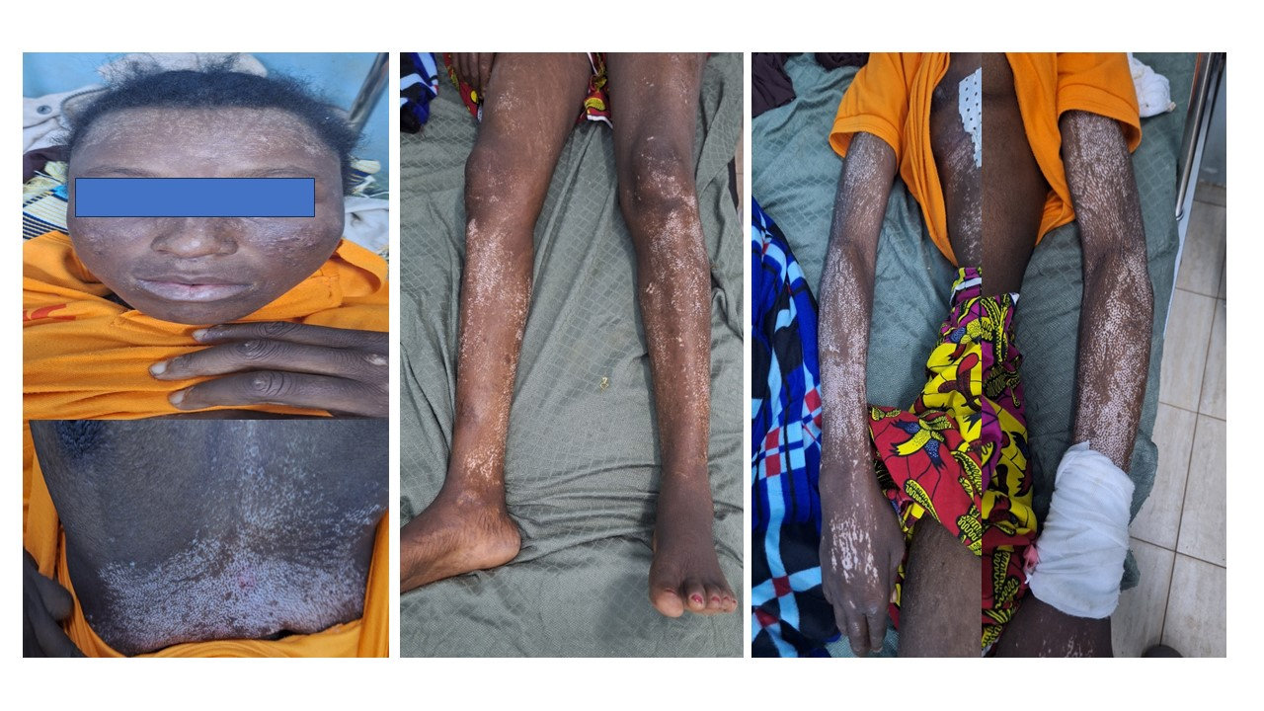

Figure 1: Diffuse cutaneous sclerosis with scleroderma fasciae. Dyschromic, mottled sclerotic plaques located on the lower back, thorax, legs, arms and forearms.

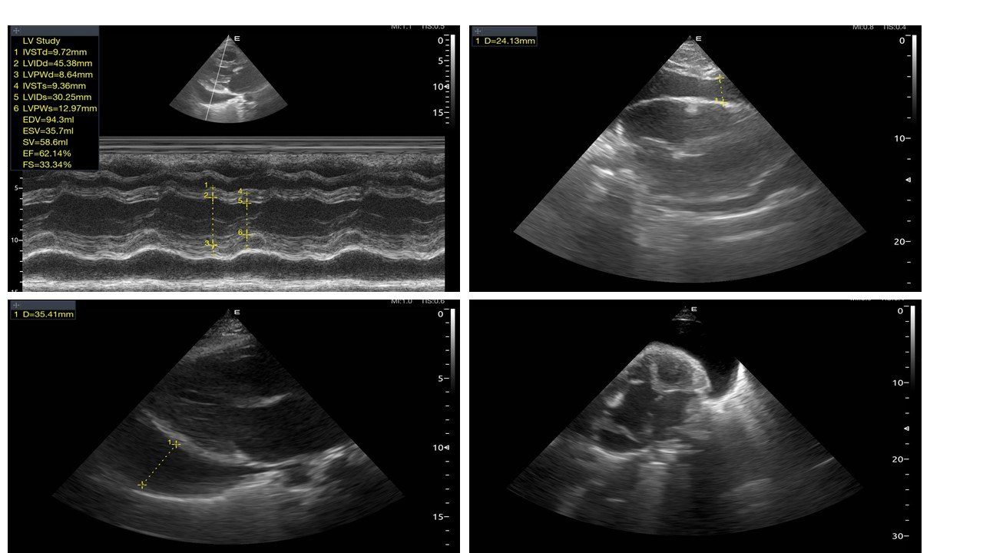

Figure 2: Transthoracic echocardiography showing a large circumferential pericardial effusion (35 mm opposite the left ventricle and 24 mm opposite the right ventricle).

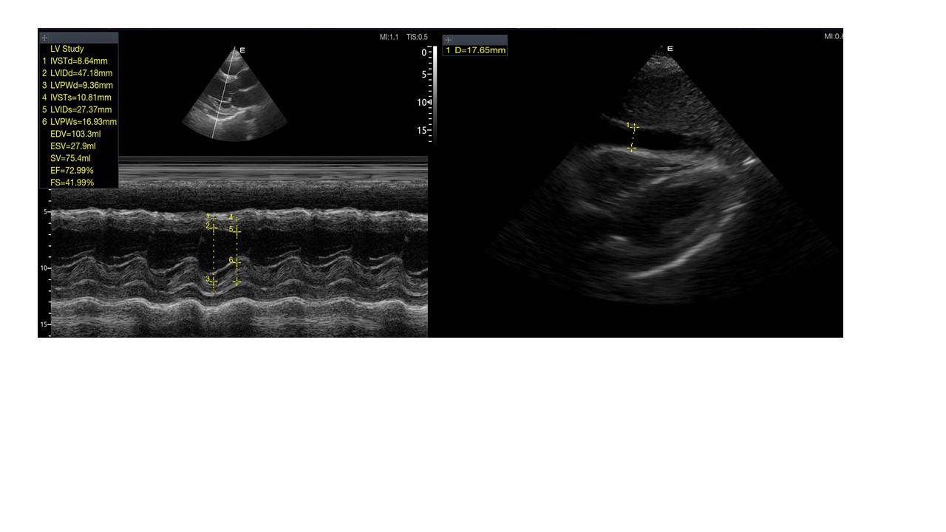

Figure 3: Transthoracic echocardiography showing an always circumferential effusion of moderate size (17 mm opposite the right ventricle).