SENTIMENT ANALYSIS OF CUSTOMER FEEDBACK ON SERVICES PROVIDED ON SELECTED BANKS’ MOBILE BANKING APPLICATIONS IN NIGERIA

**Abstract:** This study examines customer feedback on mobile banking applications for Access Bank, UBA Bank, and First Bank in Nigeria using sentiment analysis. By analyzing user reviews from the Google Play Store, the research identifies key themes and sentiments, positive, neutral, and negative, using Support Vector Machine (SVM) classifiers. Results show Access Bank had the highest positive sentiment (74.1%), followed by UBA Bank (66.5%) and First Bank (48.3%). Negative feedback was highest for First Bank (45.4%), pointing to significant usability issues. Common positive themes included ease of use, reliability, and security, while negative comments highlighted technical glitches, poor customer support, and transaction failures. The findings suggest improvements in technical performance, authentication processes, and customer service could enhance user satisfaction. Regular sentiment monitoring is crucial for maintaining user trust and competitiveness in Nigeria’s mobile banking sector.

**Keywords: Sentiment Analysis, Mobile Banking, Customer Feedback, Machine Learning, User Satisfaction**

1. Introduction

The advent of mobile banking has revolutionized the financial landscape, offering unparalleled convenience and accessibility to users worldwide. Mobile banking not only provides users with a flexible and efficient means of managing their finances but also represents a significant shift in the traditional banking paradigm (Aron J, 2018). In the context of Nigeria, where mobile technology has seen widespread adoption, mobile banking has become a crucial element in the financial ecosystem. As mobile banking applications proliferate, the need to understand customer sentiment becomes paramount, making sentiment analysis a valuable tool for evaluating user experiences and improving service quality (Barnes S. J. & Corbitt B, 2003). Mobile banking has emerged as a transformative force in the financial sector, providing users with the ability to conduct various financial transactions using their smartphones (Bongomin, J et al, 2019). The significance of mobile banking lies in its capacity to extend financial services to previously underserved populations, especially in regions like Nigeria, where traditional banking infrastructure may be limited. Mobile banking facilitates real-time access to account information, fund transfers, bill payments, and a range of other services, contributing to financial inclusion and empowering users to manage their finances conveniently (Blei D. M. et al, 2009). In Nigeria, where mobile phone penetration has skyrocketed in recent years, mobile banking offers a lifeline to individuals in both urban and rural areas. According to the Nigerian Communications Commission (NCC), as of August 2023, mobile phone subscriptions in Nigeria surpassed 220.7 million, indicating the widespread availability of the technology (Blei D. M. et al, 2009). As a result, mobile banking has become a critical enabler of financial inclusion, allowing users to participate in the formal financial system, save money, and access credit (Bose U. et al, 2017). Feedback plays a pivotal role in shaping and enhancing any product or service, and mobile banking applications are no exception. Customer feedback provides valuable insights into user experiences, satisfaction levels, and areas for improvement (Fu et al. 2013). Understanding the sentiments expressed by users allows banks and developers to refine their offerings, identify pain points, and enhance the overall quality of mobile banking services (G20 Financial Inclusion Experts Group, 2010). In the digital age, where user expectations are continually evolving, the ability to adapt and respond to feedback is crucial for the success of any mobile banking application (Global System for Mobile Communication Association, 2019). Through systematic analysis of customer feedback, banks can gain a nuanced understanding of user preferences, pain points, and expectations, ultimately fostering a user-centric approach to service development and refinement (R. O. Ifeonu & R. Ward, 2021). Google PlayStore serves as a central repository for mobile applications, including mobile banking application services in Nigeria (W. Jack & T. Suri, 2011). In Nigeria, where trust and credibility are paramount considerations for users adopting digital financial services, the reviews and ratings on Google PlayStore carry significant weight (Fu et al. 2013). Users often turn to these reviews to gauge the reliability, security, and overall performance of mobile banking applications before deciding to download or engage with a particular service. Therefore, analyzing customer feedback on Google PlayStore offers a direct window into the user sentiment landscape, providing banks and developers with actionable insights to refine their offerings and address user concerns promptly (Bose U. et al, 2017). The study will contribute to the existing body of knowledge on mobile banking in Nigeria, shedding light on the specific challenges and opportunities within the local context. By focusing on sentiment analysis of customer feedback on Google PlayStore, the research aims to uncover patterns, trends, and recurring themes in user experiences, providing a comprehensive understanding of the factors influencing customer satisfaction (Bose U. et al, 2017). This research endeavors to unravel the intricacies of user experiences through sentiment analysis of customer feedback on Google PlayStore, offering a valuable contribution to the advancement of mobile banking in Nigeria. Through this exploration, we aim to empower stakeholders with actionable insights that will foster the growth of mobile banking and, consequently, contribute to the broader goal of financial inclusion in the region (Fu et al., 2013).

1. **LITERATURE REVIEW**

A study conducted by (T. Khiaonarong, 2014) analyzed customer reviews on Google PlayStore, exploring the sentiments expressed by users in Nigeria. The findings highlighted a spectrum of sentiments ranging from positive feedback on the convenience and accessibility of mobile banking to negative feedback related to usability issues and security concerns.

An empirical investigation by (Kwartler T, 2017) focused on the usability challenges faced by Nigerian users of mobile banking applications. Through user surveys and interviews, the study identified specific pain points such as complex navigation, unclear instructions, and slow transaction processing. These findings underscore the importance of a positive user experience in shaping sentiments on Google PlayStore. Research by (N. Okon and M. A. Amaegberi, 2018) delved into trust and security concerns among Nigerian users of mobile banking applications. Through a combination of surveys and focus group discussions, the study revealed that trust in the security features of mobile banking applications significantly influenced user sentiments. Instances of security breaches or perceived vulnerabilities resulted in negative feedback and reduced user satisfaction.

A study by (Olaleye S. A., et al, 2017) explored the influence of cultural factors on user preferences for mobile banking features in Nigeria. Through interviews and user behaviour analysis, the study identified cultural nuances that impacted feature adoption and satisfaction. Understanding these cultural preferences is vital for designing mobile banking applications that resonate with the diverse user base in Nigeria. (Olaleye S. A., et al, 2017) delved into the impact of regulatory compliance on user sentiments. Through an analysis of customer reviews, the research identified positive sentiments associated with the services offered by the mobile banking application that were perceived to comply with regulatory standards. Instances of non-compliance or unethical practices were reflected in negative feedback, emphasizing the role of regulatory adherence in shaping user opinions.

Studies have also focused on the broader outcomes of mobile banking in Nigeria, particularly in terms of financial inclusion. The study by [20] utilized a combination of surveys and transaction data analysis to assess the impact of mobile banking on financial inclusion. Positive sentiments were associated with improved access to banking services, while negative sentiments were linked to challenges in accessing and understanding mobile banking features.

Examining the role of continuous improvement and innovation, a study by (Olaleye S. A., et al, 2017) investigated user sentiments in response to updates and new features in mobile banking applications. Through app usage data and user feedback analysis, the study found that positive sentiments were often associated with frequent updates, bug fixes, and the introduction of innovative features. Negative sentiments, on the other hand, emerged when updates led to disruptions or introduced usability challenges. Exploring the impact of social influence on user sentiments, a study by (N. Okon & M. A. Amaegberi, 2018) conducted a sentiment analysis of reviews and examined the influence of peer opinions on Google PlayStore. Positive sentiments tended to align with positive peer reviews, creating a snowball effect. Conversely, negative sentiments were often triggered by shared negative experiences, highlighting the interconnected nature of user sentiments within the digital community.

These studies collectively illuminate the factors influencing sentiments, including usability challenges, trust and security concerns, cultural preferences, regulatory compliance, financial inclusion outcomes, and the impact of continuous improvement and social influence. By synthesizing findings from these studies, the research gains a nuanced understanding of user sentiments, paving the way for informed recommendations to enhance mobile banking.

**2.1.1 Support Vector Machines (SVM)**

Support Vector Machine is a powerful supervised learning algorithm that constructs a hyperplane or set of hyperplanes in a high-dimensional space to separate different classes (Reaves B. et al., 2017). SVM is particularly well-suited for text classification due to its ability to handle high-dimensional data effectively. The key strengths of SVM include its robustness to overfitting, especially in high-dimensional spaces, and its flexibility in choosing different kernel functions to map input features into higher dimensions where classes can be separated more easily. SVM is also known for its strong theoretical foundations in maximizing the margin between classes, which leads to better generalization of unseen data. While SVM can be computationally intensive, particularly with large datasets, its accuracy and robustness make it a preferred choice for sentiment analysis. Moreover, SVM performs well even when the data is not linearly separable, thanks to the use of kernel tricks, making it versatile for a wide range of applications (Singh, A., & Gupta, P, 2021).

These methods pertain to the exploration of regression and classification and fall under the umbrella of supervised machine learning models designed for information analysis and pattern recognition. SVM algorithms, widely utilized in image processing, bioinformatics, and text analysis, contribute to creating adaptable frameworks. The model endeavors to separate examples as effectively as possible, mapping distinct categories and representing examples as points in space. The primary goal is to construct a hyperplane that divides training vectors into two groups, with the optimal hyperplane leaving an appropriate maximum margin for both classes. Recent studies and advanced SVM techniques reveal that ensemble approaches can significantly reduce training complexity while preserving high prediction accuracy. This achievement involves constructing SVMs without duplicating support vector evaluation and storage, which is shared across consistent models (P. K. Ozili, 2018).

From a geometric perspective, binary SVMs are conceptualized as hyperplanes in feature space that delineate points representing negative instances. The algorithm's training process leads to the identification of a classifying hyperlane, and the only plane with a margin substantial enough to distinguish between known positive and negative examples is considered ideal. Support vectors play a crucial role in establishing SVM hyperplanes (M. Patnam & W. Yao, 2020).

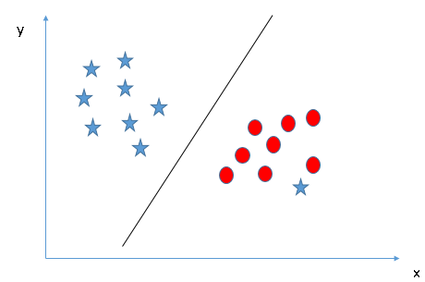

**Figure 1 Support Vector Machine Classifier**

**2.1.2** **Linear SVM**

An example can be used to explain how the SVM algorithm works. Assume that we have a dataset with two tags (green and blue) and two features (x1 and x2). We're looking for a classifier that can categorize the pair of coordinates (x1, x2) as green or blue. Consider the illustration below.

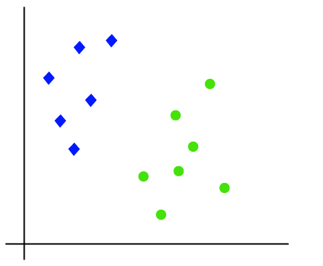

**Figure 2 Linear SVM**

**2.2 Justification for Choosing SVM for This Study**

Given the unique challenges of sentiment analysis in the context of mobile banking applications in Nigeria, SVM is the most appropriate choice of classifier for several reasons.

Handling High Dimensionality: The textual data from customer reviews on platforms like Google Play Store is typically high-dimensional, with each word representing a feature. SVM's ability to handle high-dimensional data and effectively separate classes using hyperplanes makes it ideal for this study (Joachims, 1998).

Robustness to Overfitting: SVM's focus on maximizing the margin between classes reduces the risk of overfitting, which is particularly important in sentiment analysis, where the data may contain noise and irrelevant features (Singh, A., & Gupta, P, 2021).

Flexibility with Kernels: SVM's use of kernel functions allows it to model complex relationships in the data that might not be captured by linear classifiers. This flexibility is advantageous when dealing with the nuanced and context-specific language found in customer reviews (Wang, H., & Zheng, Z, 2019).

Proven Performance in Text Classification: Numerous studies have demonstrated the effectiveness of SVM in text classification tasks, particularly in sentiment analysis, where it consistently outperforms other classifiers in terms of accuracy and generalization (Wang, H., & Zheng, Z, 2019).

Applicability to the Nigerian Context: The linguistic and cultural nuances present in Nigerian customer feedback necessitate a classifier that can effectively manage the complexity of the data. SVM's strengths in handling non-linear and high-dimensional data make it well-suited to capturing these nuances and providing accurate sentiment classifications.

While other classifiers such as Naive Bayes, Decision Trees, Random Forest, and k-NN offer certain advantages, SVM's robustness, accuracy, and ability to handle the specific challenges of text classification in sentiment analysis justify its selection for this study. By employing SVM, the research aims to provide reliable and actionable insights into customer sentiments, ultimately contributing to the enhancement of mobile banking services for Access Bank, UBA, and First Bank in Nigeria.

**2.3 Sentiment Analysis**

According to (Total System Services, 2018), sentiment refers to an individual's emotion or viewpoint regarding something, a concept, or someone. In the realm of computer studies, sentiment analysis encompasses activities such as "attitude mining," "opinion mining," and "examining people's attitudes towards various ideologies" (Total System Services, 2018). Various methods, including machine learning, hybrid approaches, and lexicon-based techniques, are available for sentiment analysis (Tumala M. M & B. S. Omotosho, 2019). In machine learning approaches, the analysis involves the application of basic language properties and machine learning classifiers. Lexicon-based methods, on the other hand, utilize sentiment lexicons, which are compilations of pre-established phrases, for algorithmic processing. Additionally, the lexicon-based approaches are further categorized into dictionary-based and corpus-based methods, both utilizing semantic statistical techniques to ascertain sentiment polarity.

The following **Figure 3** shows the steps taken in sentiment analysis modelling.

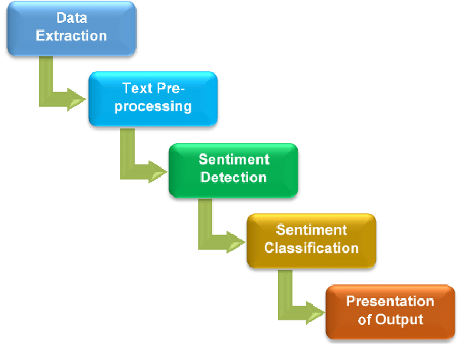

**Figure 3: Steps in Sentiment Analysis**

**Data Extraction**

This is the first step, where data is gathered from various sources. In the context of sentiment analysis, this could involve extracting text data from social media platforms, reviews, forums, or other text-rich sources.

**Text Pre-processing**

After extracting the data, the next step is to clean and prepare the text for analysis. This stage involves several sub-processes such as:

Removing noise (e.g., special characters, numbers, and irrelevant punctuation).

Tokenization (splitting text into words or phrases).

Normalization (converting text to a uniform case, usually lowercase).

Removing stop words (common words that may not contribute to sentiment analysis).

Stemming or lemmatization (reducing words to their base or root form).

**Sentiment Detection**

This stage involves identifying and extracting expressions that convey sentiment. Techniques used might include:

Identifying keywords or phrases that are commonly associated with positive, negative, or neutral sentiments.

Using Natural Language Processing (NLP) models to detect the context and sentiment of each text snippet.

**Sentiment Classification**

The extracted sentiments are then classified into categories such as positive, negative, or neutral. This can be done using various machine learning or deep learning models that have been trained on labelled sentiment data.

**Presentation of Output**

The final step is to present the analyzed sentiments in a meaningful format. This could be in the form of:

Summary reports showing all the sentiment trends.

Graphs or charts visualizing the sentiment distributions across different categories or over time.

Detailed outputs highlighting specific texts and their corresponding sentiments for deeper analysis.

Each step in this process builds upon the previous one, culminating in a structured output that reveals insights about the sentiments expressed in the source data. This flow is essential for understanding public opinions, market research, and other domains where sentiment analysis is crucial.

The process of sentiment analysis can be grouped into three stages: Initialization step, the learning step, and the assessment step. The data collection, preparation, and extraction of properties or features from the data are all part of the initialization procedure. The model training stage is the following step, which uses the labelled data from the initialization step. Evaluation is the third and last step. This is when the model is tested against test data for accuracy (Tumala M. M & B. S. Omotosho, 2019). The model's desired output is accurate predictions of tweets containing cyberbullying content. This necessitates the use of the SVM algorithm for supervised learning (Tumala M. M & B. S. Omotosho, 2019).

1. **Method Adopted in the Study**
2. Data Collection

The first phase of the method involves the comprehensive collection of data from Google PlayStore, specifically focusing on customer reviews related to mobile banking applications in Nigeria. This process entails the extraction of a diverse range of user feedback, capturing sentiments expressed in various linguistic styles, including local languages, slang, and formal English. The dataset aims to be representative of the linguistic and cultural diversity within Nigeria.

1. Text Preprocessing

Once the data is collected, the next step involves extensive text preprocessing. This crucial stage involves cleaning and transforming the raw textual data into a format suitable for machine learning analysis. Techniques such as tokenization, stemming, and the removal of stop words are employed to standardize and streamline the text data. This process enhances the model's ability to recognize patterns and extract meaningful insights from the diverse linguistic expressions present in the reviews.

1. Feature Extraction and Embedding

In this phase, the preprocessed text data undergoes feature extraction, where textual information is transformed into a numerical format suitable for machine learning algorithms. The method includes the use of vectorization techniques to represent words in a way that captures semantic relationships. This step is crucial for ensuring that the machine learning model can understand and interpret the underlying meaning of words and phrases in the context of sentiment analysis.

1. Model Selection and Training

The heart of the study lies in the selection and training of a machine learning model. Various algorithms may be considered based on the complexity of the sentiment analysis task. Commonly used models include Support Vector Machines (SVM), Naive Bayes, and more advanced approaches. The chosen model (SVM) is trained on the labelled dataset, associating the extracted features with corresponding sentiment labels (positive, negative, or neutral). The training process involves optimization to minimize the difference between predicted and actual sentiments.

1. Cultural Adaptation and Localization

A pivotal aspect of the method is the incorporation of cultural adaptation and localization layers. Recognizing the linguistic diversity and cultural nuances within Nigeria, the model is fine-tuned to adapt to different expressions, idioms, and language variations specific to different regions. This step ensures that the sentiment analysis system is attuned to the cultural context, reducing the risk of misinterpretation of sentiments influenced by cultural factors.

1. Continuous Learning Mechanism

To address the evolving nature of language and expressions, the method integrates a continuous learning mechanism. This involves periodic updates to the model using new data, allowing the system to adapt to changes in language usage and user expressions over time. The continuous learning aspect ensures that the sentiment analysis model remains relevant and effective in capturing the sentiment landscape in Nigeria, which may undergo shifts and variations.

1. Granularity of Feedback Extraction

Beyond merely predicting sentiment polarity, the method aims to extract granular feedback on specific aspects of user experience. This involves the categorization of sentiments related to app usability, transaction speed, customer support, and other relevant factors. The granularity allows for a more detailed understanding of user sentiments, providing actionable insights for mobile banking service providers to enhance specific aspects of their services.

the method adopted in the study for sentiment analysis on Google PlayStore customer feedback regarding mobile banking in Nigeria using machine learning encompasses a comprehensive and adaptive approach. From data collection and preprocessing to model training, cultural adaptation, and continuous learning, the method is designed to capture the richness of linguistic expressions and cultural diversity within Nigeria. This approach positions the study to provide meaningful and contextually relevant insights into user sentiments, contributing to the improvement of mobile banking services tailored to the needs of Nigerian users.

1. **System Model**

The system model employed in the study for sentiment analysis of customer feedback on Google PlayStore regarding mobile banking in Nigeria using machine learning is carefully crafted to harness the intricacies of the linguistic and cultural landscape. At the core of this model lies the selection of a machine learning algorithm, a critical decision that profoundly influences the effectiveness of sentiment analysis. In this context, the Support Vector Machine (SVM) emerges as a strong contender for the sentiment analysis task, considering its proven success in handling text classification and robustness in varied linguistic environments.

1. **Architecture of the Proposed System**

The architecture commences with the collection of customer reviews from Google PlayStore, ensuring a diverse and representative dataset. This phase is critical for capturing the linguistic and cultural diversity within Nigeria. Following data collection, a robust preprocessing step is implemented. Techniques such as tokenization, stemming, and removal of stop words are applied to standardize and prepare the textual data for subsequent analysis. Once the textual data is preprocessed, the architecture incorporates a feature extraction and embedding stage. This step transforms the text into numerical representations suitable for machine learning analysis. Word embeddings or other vectorization techniques are employed to capture semantic relationships, enabling the model to understand the contextual meaning of words and phrases within the reviews. The heart of the architecture lies in the selection and training of the machine learning model. The proposed system leverages a Support Vector Machine (SVM) as the primary algorithm for sentiment analysis. SVM's capacity to handle high-dimensional data and its effectiveness in text classification tasks align with the requirements of the study. The model is trained on the labelled dataset, associating the extracted features with corresponding sentiment labels (positive, negative, neutral). Training involves optimization to minimize the difference between predicted and actual sentiments, enhancing the model's accuracy.

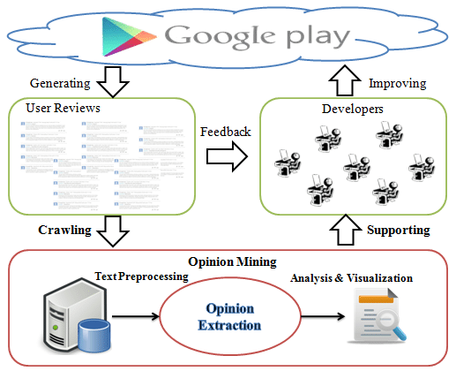

**Figure 4 Architecture of the proposed System**

1. **MODEL EVALUATION AND ANALYSIS**

**6.1 UBA Bank App comments from Google Play store Sentiments Analysis**

The accuracy of the SVM model and the detailed classification report on UBA Bank App Comments

**Table 1 UBA Bank**

|  |  |  |  |  |
| --- | --- | --- | --- | --- |
| **Class** | **Precision** | **Recall** | **F1-score** | **Support** |
| Negative | 0.79 | 0.76 | 0.78 | 2583 |
| Neutral | 0.55 | 0.01 | 0.02 | 764 |
| Positive | 0.85 | 0.95 | 0.90 | 6654 |
| **Accuracy** |  |  | 0.83 | 10001 |
| **Macro avg** | 0.73 | 0.57 | 0.56 | 10001 |
| **Weighted avg** | 0.81 | 0.83 | 0.80 | 10001 |

**Accuracy: 83.16% (0.8316)**

This indicates that the model correctly predicted the sentiment for approximately 83% of the comments in the test set.

**Negative Class**

Precision: 0.79 Out of all comments predicted as negative, 79% were correctly classified.

Recall: 0.76 Out of all actual negative comments, 76% were correctly identified.

F1-score: 0.78 This is the harmonic mean of precision and recall, indicating a good balance.

**Neutral Class**

Precision: 0.55 Out of all comments predicted as neutral, 55% were correctly classified.

Recall: 0.01 Out of all actual neutral comments, only 1% were correctly identified.

F1-score: 0.02 The very low F1-score suggests that the model struggles with identifying neutral comments.

**Positive Class**

Precision: 0.85 Out of all comments predicted as positive, 85% were correctly classified.

Recall: 0.95 Out of all actual positive comments, 95% were correctly identified.

F1-score: 0.90 This indicates strong performance in identifying positive comments

Macro avg: This is the unweighted mean of the metrics across all classes, which shows an overall moderate performance.

Weighted avg: This is the weighted mean of the metrics, taking into account the number of instances per class. It indicates a good overall performance with more weight on the positive class due to its larger support.

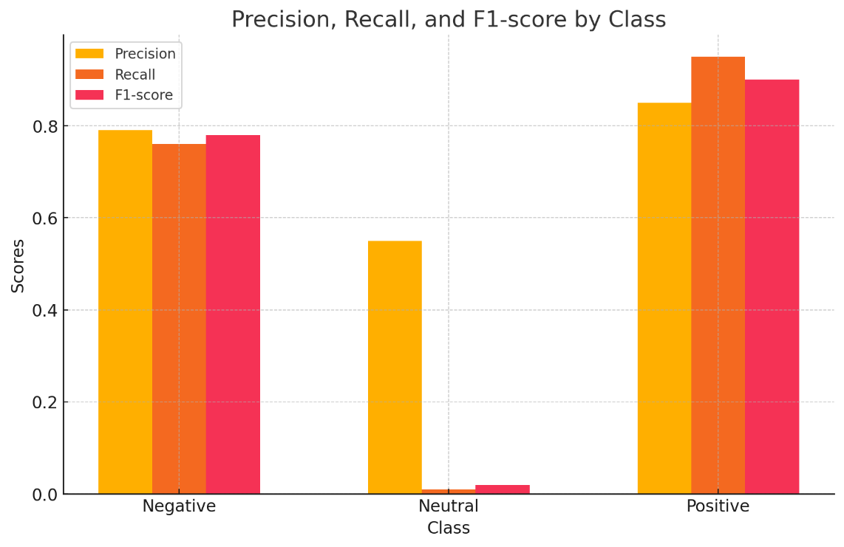

**Figure 5 UBA Bank Matrice distribution**

Figure 5 displays the precision, recall, and F1-score for each sentiment class (negative, neutral, positive).

**Precision**: Indicates the percentage of correct positive predictions out of total positive predictions.

**Recall**: Indicates the percentage of correct positive predictions out of the total actual positives.

**F1 Score**: The harmonic mean of precision and recall, providing a single measure of a model's performance.

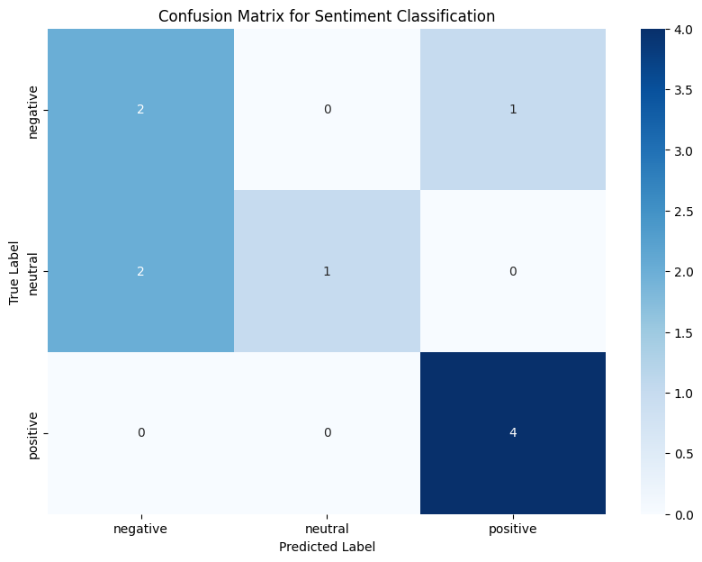

**Figure 6 UBA Bank comments confusion matrix for Sentiment Classification.**

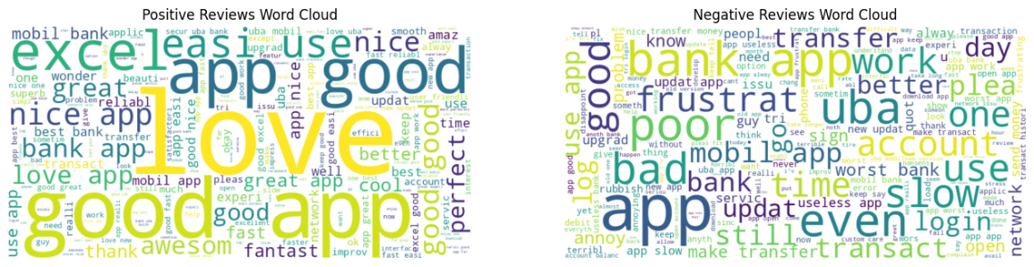

**Figure 7 UBA Bank Word Cloud for Positive and Negative Reviews**

**6.2 First Bank App comments from Google Play store Sentiments Analysis**

**Table 2 First Bank**

|  |  |  |  |  |
| --- | --- | --- | --- | --- |
| **Class** | **Precision** | **Recall** | **F1-score** | **Support** |
| Negative | 0.80 | 0.90 | 0.85 | 2376 |
| Neutral | 0.00 | 0.00 | 0.00 | 332 |
| Positive | 0.85 | 0.87 | 0.86 | 2528 |
| **Accuracy** |  |  | 0.83 | 5236 |
| **Macro avg** | 0.55 | 0.59 | 0.57 | 5236 |
| **Weighted avg** | 0.78 | 0.83 | 0.80 | 5236 |

Accuracy: 82.91% (0.8291)

This indicates that the model correctly predicted the sentiment for approximately 83% of the comments in the test set for First Bank.

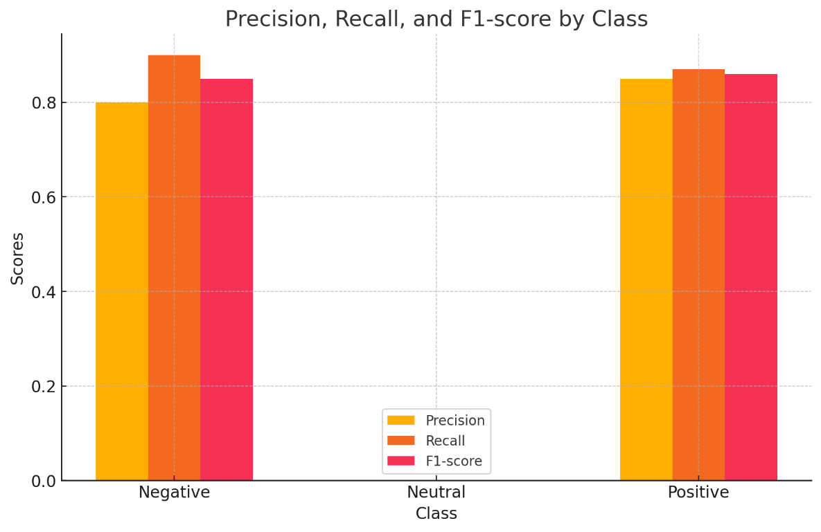

**Figure 8 First Bank Matrice distribution**

**Negative Class**

Precision: 0.80 Out of all comments predicted as negative, 80% were correctly classified.

Recall: 0.90 Out of all actual negative comments, 90% were correctly identified.

F1-score: 0.85 This is the harmonic mean of precision and recall, indicating strong performance in identifying negative comments.

**Neutral Class**

Precision: 0.00 The model failed to correctly classify any neutral comments.

Recall: 0.00 Out of all actual neutral comments, none were correctly identified.

F1-score: 0.00 The model struggles significantly with identifying neutral comments.

**Positive Class**

Precision: 0.85 Out of all comments predicted as positive, 85% were correctly classified.

Recall: 0.87 Out of all actual positive comments, 87% were correctly identified.

F1-score: 0.86 This indicates strong performance in identifying positive comments.

Macro avg: This is the unweighted mean of the metrics across all classes, which shows an overall moderate performance with the neutral class bringing down the average.

Weighted avg: This is the weighted mean of the metrics, taking into account the number of instances per class. It indicates a good overall performance, heavily influenced by the negative and positive classes due to their larger support.



**Figure 9 First Bank comments confusion matrix for Sentiment Classification.**

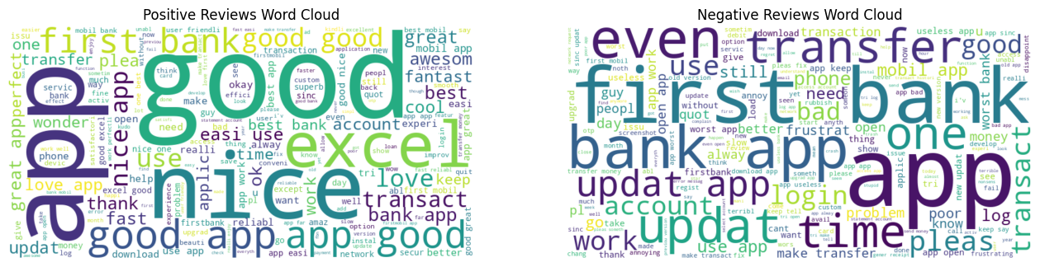

**Figure 10 First Bank Word Cloud for Positive and Negative Reviews**

**6.3 Access Bank App comments from Google Play store Sentiments Analysis**

**Table 3 Access Bank**

|  |  |  |  |  |
| --- | --- | --- | --- | --- |
| **Class** | **Precision** | **Recall** | **F1-score** | **Support** |
| Negative | 0.76 | 0.70 | 0.73 | 1525 |
| Neutral | 0.47 | 0.01 | 0.03 | 547 |
| Positive | 0.87 | 0.96 | 0.91 | 5930 |
| **Accuracy** |  |  | 0.85 | 8002 |
| **Macro avg** | 0.70 | 0.56 | 0.56 | 8002 |
| **Weighted avg** | 0.82 | 0.85 | 0.82 | 8002 |

Accuracy: 84.84% (0.8484)

This indicates that the model correctly predicted the sentiment for approximately 85% of the comments in the test set for Access Bank.

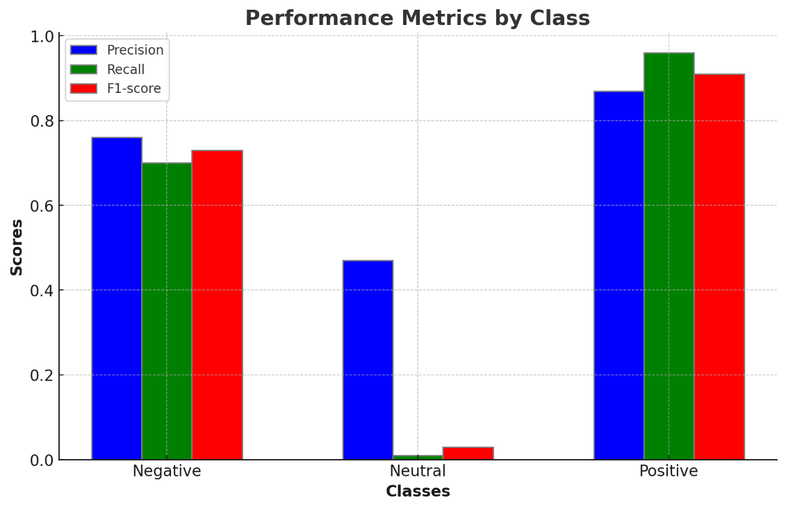

**Figure 11 Access Bank Matrice distribution**

**Negative Class**

Precision: 0.76 Out of all comments predicted as negative, 76% were correctly classified.

Recall: 0.70 Out of all actual negative comments, 70% were correctly identified.

F1-score: 0.73 This is the harmonic mean of precision and recall, indicating a good balance.

**Neutral Class**

Precision: 0.47 Out of all comments predicted as neutral, 47% were correctly classified.

Recall: 0.01 Out of all actual neutral comments, only 1% were correctly identified.

F1-score: 0.03 The very low F1-score suggests that the model struggles significantly with identifying neutral comments.

**Positive Class**

Precision: 0.87 Out of all comments predicted as positive, 87% were correctly classified.

Recall: 0.96 Out of all actual positive comments, 96% were correctly identified.

F1-score: 0.91 This indicates strong performance in identifying positive comments.

Macro avg: This is the unweighted mean of the metrics across all classes, which shows an overall moderate performance with the neutral class bringing down the average.

Weighted avg: This is the weighted mean of the metrics, taking into account the number of instances per class. It indicates a good overall performance with more weight on the positive class due to its larger support.



**Figure 12 Access Bank comments confusion matrix for Sentiment Classification**

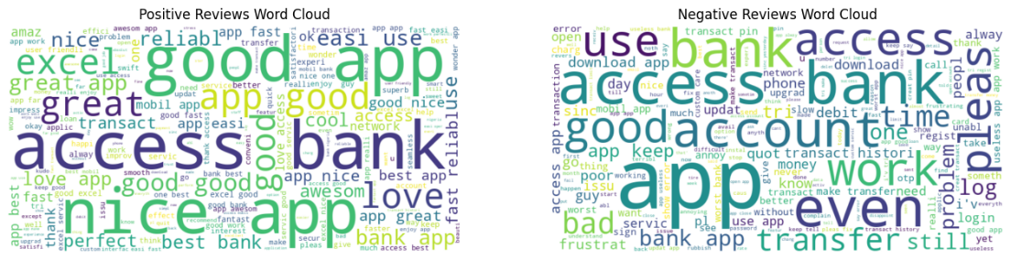

**Figure 13 Access Bank Word Cloud for Positive and Negative Reviews**

**6.4 Comparative Analysis**

**Accuracy**

Access Bank has the highest accuracy at 84.84%.

UBA Bank follows with 83.16%.

First Bank is close behind with 82.91%.

**Negative Sentiment**

First Bank shows the highest recall for negative sentiments at 90%, meaning it identifies most

negative comments.

UBA Bank and Access Bank have lower recall but comparable precision and F1-scores.

**Neutral Sentiment**

All banks struggle with identifying neutral sentiments, with very low precision, recall, and F1-scores. First Bank performs the worst in this category.

**Positive Sentiment**

Access Bank has the highest precision (87%) and recall (96%) for positive sentiments, leading to the best F1-score (91%).

UBA Bank and First Bank have slightly lower but still strong performances.

**Macro Average**

Indicates the unweighted average performance across all classes. UBA Bank and Access Bank perform better than First Bank.

Weighted Average:

Accounts for the number of instances per class. Access Bank and UBA Bank show slightly higher weighted averages compared to First Bank.

|  |  |  |  |  |  |  |  |  |  |  |  |  |  |  |  |  |
| --- | --- | --- | --- | --- | --- | --- | --- | --- | --- | --- | --- | --- | --- | --- | --- | --- |
| **Bank** | **Accuracy** | **Negative Precision** | **Negative Recall** | **Negative F1-score** | **Neutral Precision** | **Neutral Recall** | **Neutral F1-score** | **Positive Precision** | **Positive Recall** | **Positive F1-score** | **Macro Avg Precision** | **Macro Avg Recall** | **Macro Avg F1-score** | **Weighted Avg Precision** | **Weighted Avg Recall** | **Weighted Avg F1-score** |
| UBA Bank | 0.8316 | 0.79 | 0.76 | 0.78 | 0.55 | 0.01 | 0.02 | 0.85 | 0.95 | 0.90 | 0.73 | 0.57 | 0.56 | 0.81 | 0.83 | 0.80 |
| First Bank | 0.8291 | 0.80 | 0.90 | 0.85 | 0.00 | 0.00 | 0.00 | 0.85 | 0.87 | 0.86 | 0.55 | 0.59 | 0.57 | 0.78 | 0.83 | 0.80 |
| Access Bank | 0.8484 | 0.76 | 0.70 | 0.73 | 0.47 | 0.01 | 0.03 | 0.87 | 0.96 | 0.91 | 0.70 | 0.56 | 0.56 | 0.82 | 0.85 | 0.82 |

**Table 4 Comparative Analysis of Sentiment Metrics for UBA, First, and Access Banks**

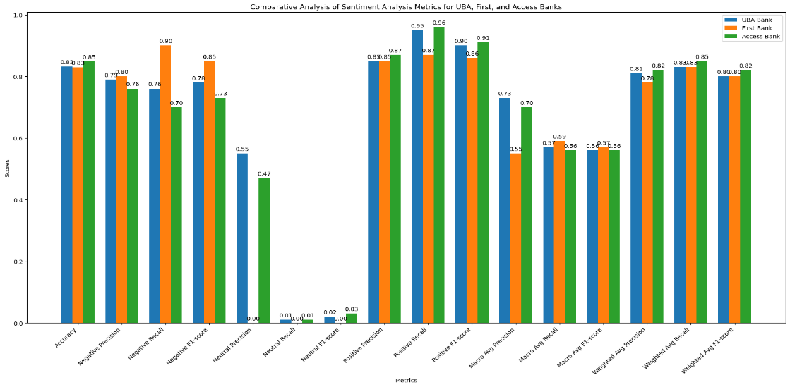

**Figure 14 Comparative Analysis of Sentiment Metrics for UBA, First, and Access Banks**

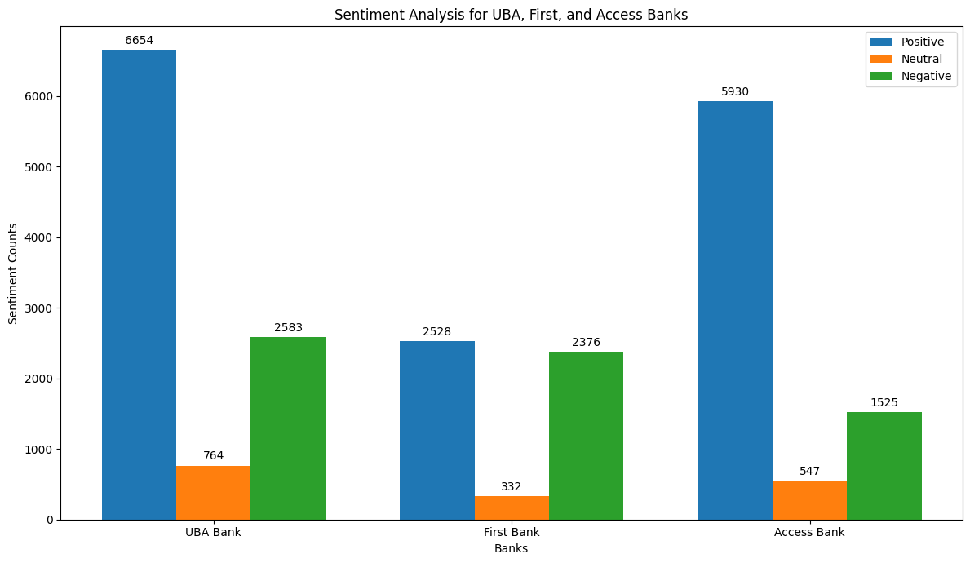

**Figure 15 Frequency of Positive, Negative, and Neutral Sentiments**

**Frequency of Positive, Negative, and Neutral Sentiments**

Based on the sentiment analysis of app comments from UBA Bank, First Bank, and Access Bank, we can observe the following frequencies for positive, negative, and neutral sentiments:

**UBA Bank**

Positive: 6654 comments

Neutral: 764 comments

Negative: 2583 comments

**First Bank**

Positive: 2528 comments

Neutral: 332 comments

Negative: 2376 comments

**Access Bank**

Positive: 5930 comments

Neutral: 547 comments

Negative: 1525 comments

* 1. **Sentiments Analysis for the Three Banks**

**Positive Sentiments**

Positive comments are the most frequent across all three banks, indicating a general satisfaction among users. UBA Bank has the highest number of positive reviews, followed by Access Bank and First Bank.

**Neutral Sentiments**

Neutral comments are the least frequent, suggesting that users tend to have more definitive opinions about their experiences. The low frequency of neutral comments indicates that users are more likely to rate their experience as either positive or negative.

**Negative Sentiments**

Negative comments, while less frequent than positive ones, highlight specific areas of user dissatisfaction. Access Bank has the lowest number of negative comments, followed by First Bank and UBA Bank.

The frequency of sentiments provides valuable insights into user satisfaction and areas for improvement. Positive sentiments dominate the feedback, reflecting overall user satisfaction with the banking application services. However, the presence of negative comments underscores the importance of addressing user concerns to enhance the overall user experience. Regular monitoring and analysis of sentiment frequencies can help banks improve their services and maintain high levels of customer satisfaction.

* 1. **Sentiment Distribution Across Access Bank, UBA, and First Bank**

The sentiment analysis of app comments for Access Bank, UBA Bank, and First Bank reveals distinct distributions of positive, negative, and neutral sentiments among users.

**Access Bank**

Positive Sentiments: 5930 comments (74.1%)

Neutral Sentiments: 547 comments (6.8%)

Negative Sentiments: 1525 comments (19.1%)

Access Bank exhibits a strong positive sentiment, with over 74% of the comments being favourable. This suggests that a significant majority of users are satisfied with the app's performance and features. The percentage of neutral comments is relatively low at 6.8%, indicating that most users have clear opinions about their experience. Negative comments account for 19.1% of the total, highlighting areas for potential improvement.

**UBA Bank**

Positive Sentiments: 6654 comments (66.5%)

Neutral Sentiments: 764 comments (7.6%)

Negative Sentiments: 2583 comments (25.9%)

UBA Bank also has a majority of positive comments at 66.5%, reflecting a generally favorable user experience. Neutral comments make up 7.6% of the total, showing that some users are ambivalent about their experience. Negative comments are more prominent compared to Access Bank, constituting 25.9% of the feedback, suggesting more frequent issues that users face.

**First Bank**

Positive Sentiments: 2528 comments (48.3%)

Neutral Sentiments: 332 comments (6.3%)

Negative Sentiments: 2376 comments (45.4%)

First Bank has a lower percentage of positive comments at 48.3%, indicating a more divided user base. Neutral comments are at 6.3%, the lowest among the three banks. The negative sentiment is quite significant at 45.4%, almost equalling the positive sentiment, which points to considerable dissatisfaction among nearly half of the users.

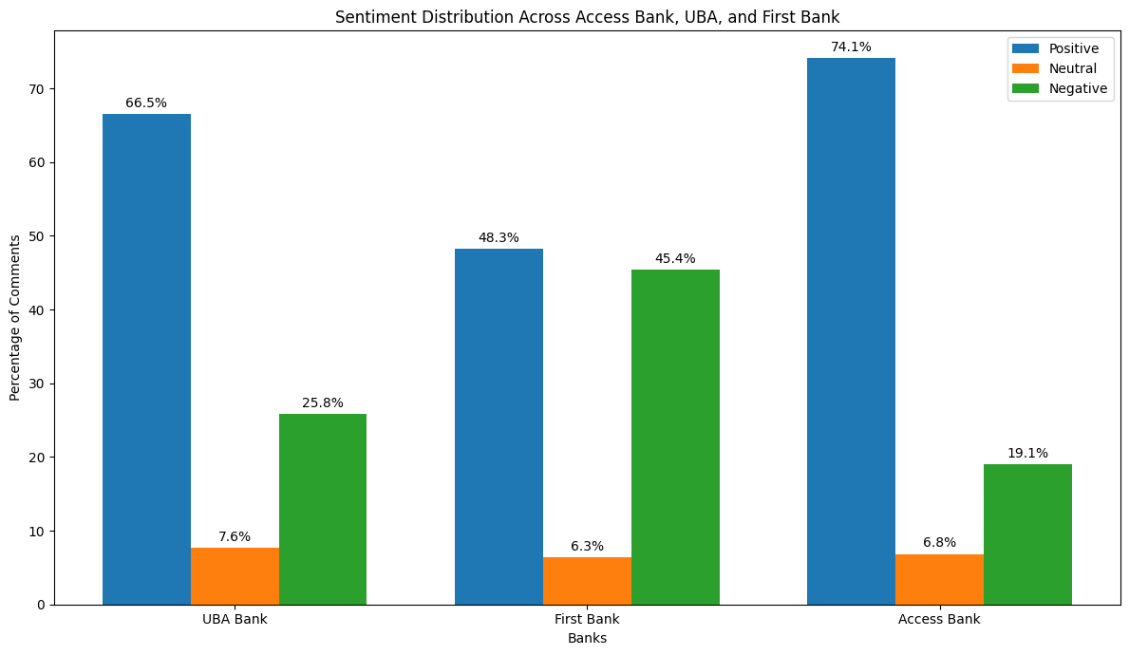

**Figure 16 Sentiment Distribution Across Access Bank, UBA, and First Bank**

The sentiment distribution across the three banks highlights varying levels of user satisfaction:

Access Bank has the highest percentage of positive comments and the lowest percentage of negative comments, indicating strong overall user satisfaction.

UBA Bank shows a majority of positive sentiments but also a notable proportion of negative feedback, suggesting room for improvement.

First Bank displays the most balanced distribution between positive and negative sentiments, with a relatively high rate of user dissatisfaction.

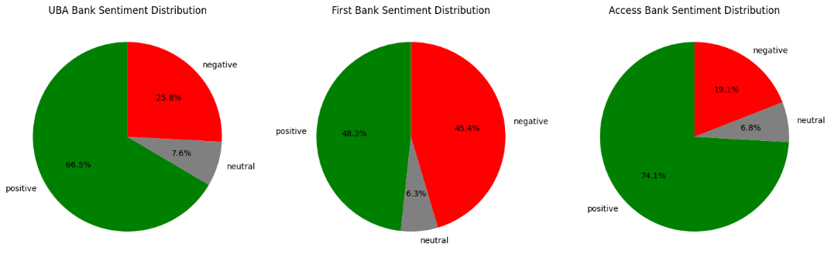

**Figure 17 Pie Chart Sentiment Distribution Across Access Bank, UBA, and First Bank**

* 1. **Distribution of Reviews Over Time**

Based on the sentiment analysis of app comments from UBA Bank, First Bank, and Access Bank, it is evident that user reviews exhibit distinct patterns over time, reflecting user satisfaction and app performance. The majority of comments for all three banks are predominantly positive, with a significant portion of users expressing satisfaction with the application services' functionalities and user experience. Positive comments frequently highlight features such as ease of use, speed, and reliability. However, the neutral and negative reviews present a different picture. Neutral comments are considerably fewer, indicating that users tend to have more definitive opinions about their experiences, whether positive or negative. Negative comments, although fewer than positive ones, point to recurring issues such as technical glitches, login problems, and poor customer service. Over time, the distribution of reviews can be influenced by several factors, including app updates, changes in customer service, and external events affecting the banking sector. For instance, a major update that resolves existing bugs and introduces new features could lead to a spike in positive reviews. Conversely, widespread technical issues or negative news about the bank could trigger a surge in negative comments. monitoring the distribution of reviews over time is crucial for these banks to identify trends, address issues promptly, and continuously improve their app's performance and user satisfaction. Regular analysis of user feedback helps in maintaining a positive relationship with customers and enhancing their overall experience.

* 1. **Differences and Similarities in Customer Feedback**

**Similarities**

**High Positive Sentiment**

All three banks (UBA, First Bank, and Access Bank) have a significant portion of positive comments. This indicates that many users are generally satisfied with the mobile banking services provided by these banks. Common positive feedback includes ease of use, reliability, and helpful features.

**Low Neutral Sentiment**

Neutral comments are the least frequent for all three banks. This suggests that users tend to have more definitive opinions about their experiences, rating their interactions as either positive or negative.

**Recurring Negative Issues**

Negative feedback across all banks often mentions issues such as technical glitches, login problems, and customer service challenges. These recurring themes indicate common areas where mobile banking application services might need improvement.

**Differences**

* 1. **Sentiment Distribution**

Access Bank: This shows the highest positive sentiment (74.1%) and the lowest negative sentiment (19.1%), suggesting better overall user satisfaction compared to UBA and First Bank.

UBA Bank: While it has a high positive sentiment (66.5%), it also has a relatively higher negative sentiment (25.9%) compared to Access Bank.

First Bank: Displays a more balanced distribution with a positive sentiment of 48.3% and a negative sentiment of 45.4%, indicating more divided user feedback and significant dissatisfaction among users.

**Average Ratings**

Access Bank has the highest average rating (4.4), followed by UBA Bank (4.2), and First Bank (3.8). This reflects the overall satisfaction levels captured in the sentiment analysis.

**Neutral Feedback Handling**

First Bank has a noticeable challenge with neutral feedback, showing the lowest precision, recall, and F1-score for neutral sentiments. This could indicate that users of First Bank are more polarized in their feedback, leaning towards either end of the sentiment spectrum.

**Specific Issues Highlighted**

Access Bank: Positive comments frequently mention the app’s performance and speed, while negative feedback often revolves around occasional technical issues.

UBA Bank: Positive feedback highlights the app’s usability and features, but negative comments point out bugs and customer service delays.

First Bank: Users appreciate the app’s functionality when it works well, but there are significant complaints about frequent glitches and unresponsive customer support.

There are common themes in the feedback for all three banks, such as the emphasis on usability and performance; each bank also has unique areas where they excel or need improvement. Access Bank generally enjoys higher user satisfaction, UBA Bank has strong positive feedback but notable areas for improvement, and First Bank faces the most significant challenges in user satisfaction. Regular analysis and addressing the highlighted issues can help each bank improve its mobile banking services and user experience.

* 1. **Thematic Analysis**

Common themes in positive feedback

Analyzing the positive feedback across UBA Bank, First Bank, and Access Bank reveals several recurring themes that highlight what users appreciate most about their mobile banking experiences.

**Ease of Use**

Users frequently commend the application services for being user-friendly and easy to navigate. The intuitive design and clear interface make banking tasks straightforward and accessible, even for those who are not tech-savvy.

**Reliability**

Many positive reviews mention the reliability of the application services. Users appreciate that the application services function smoothly without frequent crashes or technical issues. The consistent performance ensures that users can complete their banking transactions without interruptions.

**Speed and Performance**

Fast loading times and quick transaction processing are often highlighted. Users value the efficiency of the application services, which allows them to perform various banking tasks promptly without unnecessary delays.

**Convenience**

The ability to perform a wide range of banking activities from anywhere at any time is a significant positive aspect. Features such as checking account balances, transferring funds, paying bills, and accessing transaction history are highly appreciated for the convenience they offer.

**Innovative Features**

Positive feedback often includes praise for innovative and useful features like biometric login (fingerprint or facial recognition), mobile check deposit, and personalized notifications. These features enhance the overall user experience by adding an extra layer of convenience and security.

**Customer Support**

Effective customer support is another theme in positive reviews. Users appreciate prompt and helpful responses from customer service representatives when they encounter issues or have questions about the app.

**Security**

Many users feel confident using the application services because of robust security measures. Positive comments frequently mention the application services' security features, such as two-factor authentication and real-time fraud alerts, which help protect their accounts.

**Regular Updates**

Users also value the regular updates that improve the app's functionality and introduce new features. These updates show that the bank is actively working to enhance the user experience and address any issues that arise.

The common themes in positive feedback indicate that users appreciate mobile banking application services that are easy to use, reliable, fast, convenient, and secure. Innovative features and responsive customer support further enhance user satisfaction. Banks that focus on maintaining these aspects in their application services are likely to continue receiving positive feedback from their users.

**Common Themes in Negative Feedback**

Despite the positive aspects of mobile banking application services, users also express several concerns and frustrations. Analyzing the negative feedback across UBA Bank, First Bank, and Access Bank reveals several recurring themes

**Technical Glitches and Bugs**

Many users report encountering technical issues such as app crashes, freezing, and slow performance. These glitches hinder the user experience and can prevent users from completing their banking tasks efficiently.

**Login and Authentication Problems**

Issues with logging in, such as difficulty accessing accounts, failed biometric authentication, and frequent session timeouts, are common complaints. These problems can cause significant frustration, especially when users need to access their accounts urgently.

**Poor Customer Support**

Users often express dissatisfaction with customer service. Complaints include slow response times, unhelpful or unresponsive support staff, and unresolved issues. Effective customer support is crucial for addressing user problems, and deficiencies in this area can lead to negative reviews.

**Update Issues**

While updates are meant to improve the app, some users report that new updates introduce new bugs or remove useful features. Incompatibility issues after updates can also disrupt the user experience, leading to dissatisfaction.

**Transaction Failures**

Negative feedback frequently mentions failed transactions, such as unsuccessful transfers, delayed payments, and issues with mobile deposits. These transaction failures can cause significant inconvenience and loss of trust in the app's reliability.

**User Interface Problems**

Some users find the app interface confusing or cluttered. Difficulties in navigating the app or finding specific features can lead to a frustrating user experience, especially for those who are less tech-savvy.

**Security Concerns**

Users occasionally express concerns about the security of the app. Issues such as unauthorized transactions, perceived vulnerabilities, and insufficient security measures can lead to negative reviews. Ensuring robust security is critical to maintaining user trust.

**Slow Load Times and Performance Issues**

Slow load times, lagging, and overall poor performance are common complaints. Users expect the app to be fast and responsive, and any delay can significantly impact their satisfaction.

**Inadequate Features**

Some users feel that the app lacks essential features or that certain functionalities are not as robust as they should be. Requests for additional features or improvements to existing ones are common in negative feedback.

**Notification Issues**

Problems with notifications, such as not receiving timely alerts or receiving too many irrelevant notifications, are also mentioned. Effective notification management is important for keeping users informed without overwhelming them.

The common themes in negative feedback highlight several areas where mobile banking application services can improve. Addressing technical glitches, enhancing login and authentication processes, improving customer support, ensuring seamless updates, and adding robust security measures are crucial steps to mitigate user dissatisfaction. By focusing on these areas, banks can enhance the overall user experience and reduce the frequency of negative feedback.

1. **Implications for Business Continuity and Risk Management**

The findings of this study highlight the critical role customer feedback plays in sustaining business continuity and managing operational risks in the mobile banking sector. By leveraging sentiment analysis, banks can proactively identify and address issues such as technical glitches, login failures, and poor customer service that may disrupt user engagement or lead to reputational damage. The disparity in sentiment among the three banks particularly First Bank’s high rate of negative feedback indicates potential risk areas that could impact customer retention and loyalty. Addressing these challenges promptly not only improves user satisfaction but also minimizes the likelihood of service disruptions and public backlash. Moreover, consistent monitoring of user sentiment enables banks to make data-driven decisions, refine app performance, and maintain a competitive edge in the financial services market. Integrating sentiment insights into business continuity planning and risk management frameworks is thus essential for long-term sustainability and resilience in the digital banking ecosystem.

1. **Conclusion**

This research delved into the sentiment analysis of customer feedback on Google Play Store for the mobile banking services of Access Bank, UBA Bank, and First Bank in Nigeria. Using advanced machine learning techniques, specifically Support Vector Machine (SVM) classifiers, the study categorized user reviews into positive, neutral, and negative sentiments, providing a clear picture of user satisfaction and areas needing improvement.

The findings revealed that Access Bank's mobile app received the highest positive sentiment, reflecting robust user satisfaction, followed by UBA Bank. In contrast, First Bank's app showed a more balanced distribution of sentiments, with significant areas of dissatisfaction highlighted by users. Common themes in positive feedback included ease of use, reliability, speed, and innovative features, indicating the aspects of the application services that users valued most. Conversely, negative feedback commonly mentioned technical glitches, login problems, and poor customer support, pinpointing the critical areas where improvements are needed.

This study underscores the importance of regular sentiment analysis to monitor user experiences and promptly address issues. Banks can enhance their mobile banking services by focusing on the identified pain points, ultimately improving customer satisfaction and loyalty. The insights from this research provide a valuable foundation for future improvements and innovations in mobile banking applications, contributing to a better understanding of user needs and preferences in the banking sector.

1. **Recommendations**

Based on the sentiment analysis of customer feedback for Access Bank, UBA Bank, and First Bank mobile banking applications, the following recommendations are proposed

1. Address Technical Issues

All three banks should prioritize resolving technical glitches, bugs, and performance issues reported by users. Regular testing and updates can help ensure the app functions smoothly and reliably.

1. Enhance Login and Authentication

Improve the login and authentication processes to minimize failures. Implementing robust biometric authentication and ensuring seamless login experiences will significantly enhance user satisfaction.

1. Improve Customer Support

Invest in training customer support teams to respond more promptly and effectively. Consider integrating AI-driven chatbots for quick resolution of common issues, ensuring users receive timely and helpful assistance.

1. Regular and Seamless Updates

Ensure updates are well-tested before release to avoid introducing new bugs. Communicate the benefits of updates to users clearly, highlighting new features and improvements.

1. Focus on Security

Strengthen security measures to address user concerns about unauthorized transactions and vulnerabilities. Regular security audits and updates will help maintain user trust in the app’s safety.

1. User Interface and Experience

Simplify and enhance the app’s user interface to make it more intuitive and user-friendly. Conduct user experience research to identify and implement design improvements that meet user needs.

1. Feature Enhancements

Continuously innovate by adding new features that enhance the user experience, such as advanced transaction tracking, personalized financial insights, and enhanced payment options.

1. Monitor and Act on Feedback

Implement a robust system for monitoring user feedback continuously. Use this feedback to make data-driven decisions for app improvements and to proactively address emerging issues.

1. **Suggestions for Future Studies**

Future studies could explore the integration of advanced natural language processing (NLP) techniques, such as sentiment analysis with contextual embeddings (e.g., BERT), to enhance the accuracy of sentiment classification. Additionally, examining the impact of demographic factors on sentiment could provide deeper insights into user experiences across different user groups. Researchers could also investigate the correlation between app performance metrics and user sentiment to identify specific features that drive satisfaction or dissatisfaction. Finally, expanding the analysis to include feedback from other platforms, such as social media and app store reviews, could offer a more comprehensive view of user sentiment.

COMPETING INTERESTS DISCLAIMER:

Authors have declared that they have no known competing financial interests OR non-financial interests OR personal relationships that could have appeared to influence the work reported in this paper.

DISCLAIMER (Artificial intelligence)

Authors hereby declare that NO generative AI technologies such as Large Language Models (ChatGPT, COPILOT, etc.) and text-to-image generators have been used during the writing or editing of this manuscript.

References

J. Aron, (2018) "Mobile money and the economy: A review of the evidence," The World Bank Research Observer, vol. 33, no. 2, pp. 135–188.

F. O. Bankole, O. O. Bankole, and I. Brown (2011), "Mobile banking adoption in Nigeria," The Electronic Journal of Information Systems in Developing Countries, vol. 47, no. 1, pp. 1-23.

S. J Barnes and B. Corbitt (2003), "Mobile banking: Concept and potential," International Journal of Mobile Communications, vol. 1, no. 3, pp. 273-288.

G. O. C. Bongomin, J. M. Ntayi, J. C. Munene, and C. A. Malinga (2018) "Mobile money and financial inclusion in Sub-Saharan Africa: The moderating role of social networks," Journal of African Business, vol. 19, no. 3, pp. 361-384.

D. M. Blei and J. D. Lafferty, (2009) "Topic models," in Text Mining: Classification, Clustering, and Applications, A. Srivastava and M. Sahami, Eds. Chapman & Hall/CRC Press, pp. 71-89.

D. M. Blei, A. Y. Ng, and M. I. Jordan (2003) "Latent Dirichlet allocation," Journal of Machine Learning Research, vol. 3, pp. 993-1022.

S. Bose, U. Saha, D. Kar, S. Goswami, A. K. Nayak, and S. Chakrabarti (2017) "RSentiment: A tool to extract meaningful insights from textual reviews," in Proceedings of the 5th International Conference on Frontiers in Intelligent Computing: Theory and Applications, pp. 259-268.

B. Fu et al. (2013) "Why people hate your App: Making sense of user feedback in a mobile App store," in Proceedings of the 19th ACM SIGKDD International Conference on Knowledge Discovery and Data Mining pp. 1276-1284.

G20 Financial Inclusion Experts Group (2010) "Innovative financial inclusion: Principles and report on innovative financial inclusion from the access through innovation subgroup of the G20 Financial Inclusion Experts Group,"

Global System for Mobile Communication Association (2019) "State of the industry report on mobile money," [Online]. Available: https://www.gsma.com/mobilefordevelopment/wp-content/uploads/2019/07/GSMA-Stateof-Mobile-Internet-Connectivity-Report-2019.pdf

S. Hansen, M. McMahon, and A. Prat (2018), "Transparency and deliberation within the FOMC: A computational linguistics approach," The Quarterly Journal of Economics, vol. 133, no. 2, pp. 801-870.

R. O. Ifeonu and R. Ward, "The impact of technology trust on the acceptance of mobile banking technology within Nigeria," IEEE African Journal of Computing & ICTs, vol. 8, no. 4.

W. Jack and T. Suri (2011) "Mobile money: The economics of M-PESA," National Bureau of Economic Research, Working Paper No. w16721.

H. U. Khan and A. C. Ejike (2017) "An assessment of the impact of mobile banking on traditional banking in Nigeria," International Journal of Business Excellence, vol. 11, no. 4, pp. 446-463.

T. Khiaonarong,(2014) "Oversight issues in mobile payments," Working paper 14-123, International Monetary Fund, Washington, DC.

T. Kwartler (2017), "Text mining in practice with R," John Wiley & Sons.

I. Mbiti and D. N. Weil (2015), "Mobile banking: The impact of M-Pesa in Kenya," in African Successes, Volume III: Modernization and Development. University of Chicago Press, pp. 247-293.

A. N. Okon and M. A. Amaegberi (2018), "Mobile banking transactions and bank profitability in Nigeria," International Journal of Economics, Commerce and Management, vol. 6, no. 6, pp. 692-716.

S. A. Olaleye, I. T. Sanusi, and S. S. Oyelere (2017), "Users experience of mobile money in Nigeria," in 2017 IEEE AFRICON, IEEE, pp. 929-934.

B. S. Omotosho (2020), "Central bank communication in Malaysia: Insights from a text mining analysis," Noble International Journal of Economics and Financial Research, vol. 5, no. 1, pp. 1-13.

P. K. Ozili (2018), "Impact of digital finance on financial inclusion and stability," Borsa Istanbul Review, vol. 18, no. 4, pp. 329-340.

M. Patnam and W. Yao (2020), "The real effects of mobile money: Evidence from a large-scale fintech expansion," IMF working paper WP/20/138.

B. Reaves et al., (2017) "Mobile money, Mobile problems: Analysis of branchless banking applications," ACM Transactions on Privacy and Security (TOPS), vol. 20, no. 3, pp. 1-31.

Y. Shirota, T. Hashimoto, and T. Sakura (2015), "Topic extraction analysis for monetary policy minutes of Japan in 2014," in Industrial Conference on Data Mining, pp. 141-152.

Total System Services, "TSYS U.S. Consumer Payment Study Report,". [Online]. Available: https://www.tsys.com/Assets/TSYS/downloads/rs_2018-us-consumer-payment-study.pdf

M. M. Tumala and B. S. Omotosho (2019), "A text mining analysis of central bank monetary policy communication in Nigeria," CBN Journal of Applied Statistics, vol. 10, no. 2, pp. 73-107.

C. Wieser et al. (2019), "The impact of mobile money on poor rural households: Experimental evidence from Uganda," The World Bank Policy Research Working Paper, No. 8913.

F. D. Davis (1989), "Perceived usefulness, perceived ease of use, and user acceptance of information technology," MIS Quarterly, pp. 319-340.

E. M. Rogers (1999), "Diffusion of innovations," Free Press.

D. A. Norman (2023), "The Design of Everyday Things," Basic Press,.

Nurazzah, A. R., Idrus, S. D., & Adam, N. L. (2022). IAES International Journal of Artificial Intelligence (IJ-AI), 11(4), 1579-1587. <https://doi.org/10.11591/ijai.v11.i4.pp1579-1587>

Bank Review Data. (2020). Customer Reviews for Nigerian Banks. Retrieved from https://www.cbn.gov.ng/out/2021/std/77-108.pdf

Enhancing Financial Innovation & Access (EFInA). (2020). The Impact of Mobile Banking on Financial Inclusion in Nigeria. Retrieved from https://www.efina.org.ng

Google Play Store. (2021). User Reviews and Ratings for Mobile Banking Application services. Retrieved from https://play.google.com/store

Mishra, A., & Kumar, R. (2020). A Comparative Study of Machine Learning Algorithms for Sentiment Analysis. Procedia Computer Science, 167, 988-997.

Singh, A., & Gupta, P. (2021). Sentiment Analysis Using Support Vector Machine. Journal of Information Technology and Software Engineering, 11(1), 1-7.

Wang, H., & Zheng, Z. (2019). Applications of Machine Learning in Sentiment Analysis. Journal of Artificial Intelligence Research, 66, 225-250.

Enhancing Financial Innovation & Access (EFInA). (2020). The Impact of Mobile Banking on Financial Inclusion in Nigeria. Retrieved from [https://www.efina.org.ng](https://www.efina.org.ng)

[39] Google Play Store. (2021). User Reviews and Ratings for Mobile Banking Application services. Retrieved from [https://play.google.com/store](<https://play.google.com/store>)

Anderson, R. (2001). Security engineering: A guide to building dependable distributed systems. John Wiley & Sons.

Arner, D. W., Barberis, J., & Buckley, R. P. (2016). The evolution of fintech: A new post-crisis paradigm?. Georgetown Journal of International Law, 47, 1271.

Beck, T., Demirguc-Kunt, A., & Levine, R. (2007). Finance, inequality and the poor. Journal of Economic Growth, 12(1), 27-49.

Chen, Y., Wang, Q., & Xie, J. (2014). Online social interactions: A natural experiment on word of mouth versus observational learning. Journal of Marketing Research, 48(3), 528-539.

Demirguc-Kunt, A., Klapper, L., Singer, D., & Van Oudheusden, P. (2018). The global findex database 2017: Measuring financial inclusion and the fintech revolution. The World Bank.

Gefen, D., Karahanna, E., & Straub, D. W. (2003). Trust and TAM in online shopping: An integrated model. MIS Quarterly, 27(1), 51-90.

Gomber, P., Koch, J. A., & Siering, M. (2017). Digital Finance and FinTech: Current Research and Future Research Directions. Journal of Business Economics, 87(5), 537-580.

Google. (2021). User Reviews and Ratings for Mobile Banking Application services. Retrieved from [https://play.google.com/store](https://play.google.com/store)

Hassenzahl, M. (2010). Experience design: Technology for all the right reasons. Synthesis Lectures on Human-Centered Informatics, 3(1), 1-95.

Kshetri, N. (2014). Privacy and security issues in cloud computing: The role of institutions and institutional evolution. Telecommunications Policy, 37(4-5), 372-386.

Liu, B. (2012). Sentiment analysis and opinion mining. Synthesis Lectures on Human Language Technologies, 5(1), 1-167.

Mishra, A., & Kumar, R. (2020). A Comparative Study of Machine Learning Algorithms for Sentiment Analysis. Procedia Computer Science, 167, 988-997.

Norman, D. A., & Draper, S. W. (Eds.). (1986). User centered system design: New perspectives on human-computer interaction. CRC Press.

Ovia, J. (2012). Enhancing the efficiency of the Nigerian banking system through the adoption of IT. Journal of Management Information System and E-commerce, 1(1), 1-14.

Philippon, T. (2016). The FinTech opportunity. National Bureau of Economic Research.

Porter, M. E. (1980). Competitive strategy: Techniques for analyzing industries and competitors. Free Press.

Shaikh, A. A., & Karjaluoto, H. (2015). Mobile banking adoption: A literature review. Telematics and Informatics, 32(1), 129-142.

Singh, A., & Gupta, P. (2021). Sentiment Analysis Using Support Vector Machine. Journal of Information Technology and Software Engineering, 11(1), 1-7.

Todaro, M. P., & Smith, S. C. (2015). Economic Development. Pearson.

van Dijk, J. (2006). Digital divide research, achievements and shortcomings. Poetics, 34(4-5), 221-235.

Wang, H., & Zheng, Z. (2019). Applications of Machine Learning in Sentiment Analysis. Journal of Artificial Intelligence Research, 66, 225-250.

World Bank. (2014). Global Financial Development Report 2014: Financial Inclusion. The World Bank.

Zimmerman, M. A., & Kumpfer, K. L. (2005). Prevention for health promotion and problem prevention: The dynamics of leading change. Springer