Original Research Article

Optimize Mobile App Testing Using Machine Learning to Improve UserExperience

.
ABSTRACT

Aims: The study delves into the machine learning (ML) paradigm shift in enhancing mobile application testing processes for higher accuracy, efficiency, and overall user experience, with a particular focus on Decision Tree and Random Forest models.
Study design: Experimental Research Design.
Methodology: The research applies an experimental A/B testing framework using real-world datasets and cloud-based testing environments (e.g., Firebase Test Lab) to compare ML-driven and traditional testing approaches. Techniques include automated UI defect detection through convolutional neural networks, reinforcement learning for intelligent test case prioritization, natural language processing for extracting UX-related insights from user feedback, as well as a structured user survey involving 20 participants to evaluate perceived improvements in usability and stability. MATLAB R2024b was used for model development and evaluation.
Results: Experimental results demonstrate that ML-based testing significantly outperforms traditional approaches, achieving 15–20% higher defect detection rates, 30–35% greater test coverage, and 40–50% faster execution times, alongside a notable reduction in false positives. Decision Tree and Random Forest models showed superior performance in identifying usability and performance issues. Additionally, the integration of ML into CI/CD pipelines facilitated faster bug resolution with minimal manual intervention. User survey results further confirmed improvements in user experience, with over 70% of respondents reporting enhanced application stability and responsiveness.
Conclusion: Despite its promise, deploying ML in real-world testing presents challenges, including dataset bias, variability across device environments, and limited interpretability of some model decisions. To address these, the study recommends developing robust ML-based testing frameworks, ensuring access to representative and high-quality training data, and designing hybrid models that integrate supervised learning with unsupervised anomaly detection techniques.

Keywords: Machine learning, mobile app testing, defect detection, user experience, automated testing

1. INTRODUCTION

Mobile application testing plays a critical role in ensuring the functional correctness and performance stability of apps across heterogeneous devices, operating systems, and network environments. Traditional testing methodologies face growing limitations due to increasing software complexity, device fragmentation, and resource constraints. Manual testing, while allowing exploratory flexibility, is time-consuming and error-prone. In contrast, automated testing improves efficiency but suffers from scalability issues and frequent maintenance due to dynamic user interfaces (Azgar et al., 2022; Kaur & Kaur, 2022).
In this context, machine learning (ML) emerges as a transformative approach that enables intelligent, adaptive, and data-driven testing strategies. ML-based techniques allow for the prediction of defect occurrences, test case optimization, and real-time anomaly detection, leading to reduced testing time and improved accuracy (Ajorloo et al., 2024). Recent studies have highlighted the potential of AI-driven automation to increase test coverage, reduce human intervention, and support continuous integration and delivery pipelines (Bajaj & Samal, 2023). However, practical implementation of ML in mobile app testing remains limited by several unresolved challenges, including false positives, poor generalization across platforms, and inadequate coverage of real-world usage conditions (Stradowski & Madeyski, 2023; Zakaria et al., 2021).
Furthermore, many existing ML-based frameworks have not been empirically validated in actual testing environments. Prior research often focuses on theoretical models or simulations, with limited attention to real-world applicability, test case prioritization, and domain-specific adaptation. Notably, issues such as training data bias and model interpretability remain underexplored, creating barriers to reliable integration in software testing workflows.
This study addresses these gaps by conducting an empirical evaluation of ML-based testing automation using diverse datasets and cloud-based testing platforms. The research investigates how techniques such as Decision Tree and Random Forest contribute to usability and performance issue detection. It also examines the integration of ML with CI/CD pipelines to improve defect resolution time and user experience. By systematically analyzing the efficiency, scalability, and accuracy of ML models under real-world conditions, the study offers practical insights for software quality assurance and supports the adoption of AI-powered testing in mobile app development.
1.1 Research Aim
To develop and evaluate a machine learning-based approach for optimizing mobile app testing and improving user experience by increasing test coverage, reducing false positives, and enhancing efficiency.
1.2 Research Questions
1. How does machine learning improve the accuracy and efficiency of mobile app testing compared to traditional automated testing methods?
2. What machine learning models and techniques are most effective for detecting usability and performance issues in mobile applications?
3. How does ML-driven testing impact mobile app development's overall user experience and quality assurance process?

2. Literature Review
2.1 Mobile App Testing Challenges
Mobile applications are an indispensable part of modern life, with millions of apps available for platforms like Android and iOS. Ensuring the quality and reliability of these apps becomes paramount due to the highly competitive nature of the industry and user expectations for near-flawless performance. This gives rise to unique challenges in mobile app testing, either manual or automated. Manual testing means human testers carry out the test cases without automation tools. It allows for exploratory tests and simulates a real user experience, but it is extremely time-consuming, especially when applied to large-scale applications. In the opinion of Azgar et al. (2022), manual testing has been unable to keep pace with testing due to the dynamic nature of agile methods with frequent updates and rapid releases. The need for repetitive test execution across many devices and OS versions only worsens the situation. Table 1 summarizes some of the key challenges in mobile application testing, as argued by Azgar et al. (2022).
Table 1. Key Challenges in Mobile Application Testing (Azgar et al., 2022)
Challenge Category | Description | Specific Issues
Performance Testing | Ensures app works efficiently under various conditions | - Response time issues  - Stress under low power  - Network availability problems  - Maintaining consistent performance
Security Testing | Protects sensitive data and prevents vulnerabilities | - Device-specific vulnerabilities  - OS-specific vulnerabilities  - Unstable encryption  - Unsafe data storage
Device Diversity | Wide range of mobile devices in market | - Over 500M Android devices  - 220M+ iOS devices  - Various form factors (phones, tablets, wearables)
OS Fragmentation | Multiple OS versions and platform differences | - Android version fragmentation  - iOS rapid updates  - Compatibility across OS versions
Application Types | Different mobile app architectures require different testing approaches | - Native apps  - Web apps  - Hybrid apps  - Varying implementation requirements

Human testers are also error-prone by not looking into edge cases or interpreting test results incorrectly. In contrast, laid-back regression testing needs to be executed with complete precision with repeatable cases; hence, there lies ambiguity with manual testing (Ahmad et al., 2018). These ambiguities may permit unknown bugs to slip into production, consequently mar the user experience. Besides, mobile applications work in an environment with different network conditions, interruptions (calls, notifications, etc.), and hardware variations. Manual testing may accommodate some real-world situations, tending to miss out on many of them, resulting in gaps in test coverage (Xavier et al., 2017). Thetesting behavior in poor network conditions and during switching between Wi-Fi and mobile data is nowhere near simple without automation.
Automated testing, although significantly quicker and much more efficient, brings with it some challenges. User interface (UI) elements of mobile apps are frequently subject to changes, resulting in brittle automated tests. According to Arif and Ali (2019), test scripts depending on UI element identifiers such as XPath and IDs fail whenever developers modify layouts, auguring greater maintenance overhead. Another significant challenge is the fragmentation of devices and operating systems. Table 2 lays out the key challenges in mobile application testing and shows the respective gaps in tool support for all testing types.
Table 2. Challenges of Testing types (Arif & Ali, 2019)
Testing Type | Description | Current Challenges | Tool Support
Integration Testing | Testing multiple modules together to ensure they work as expected. | Limited automated tool support for integration testing in mobile applications. | Only a few tools (e.g., KIF) provide moderate support for integration testing.
Regression Testing | Re-running test cases to ensure new changes do not break existing functionality. | Lack of dynamic validation approaches; frequent updates require extensive retesting. | Very few automated tools support regression testing effectively.
Security Testing | Ensuring the app is secure from vulnerabilities and threats. | Most tools only perform abstract-level security checks; deep security testing is rare. | Limited automated tool support for comprehensive security testing.

Nevertheless, pure Android contains thousands of device models with different screen sizes, resolutions, and hardware capabilities, which require extensive cross-device testing (Peruma et al., 2024). However, cost-effective device-OS combinations under cloud-based testing platforms such as Firebase Test Lab and Browser Stack are still wanting. Reliability in automated testing is further reduced by flaky tests whose results change without any modification to the application. As Gao et al. (2019) report, flaky tests reduce trust in test suites as developers ignore failures as false positives. Time, race, and environmental factors such as network latency give rise to this phenomenon. Automated test scripts need maintenance because they need to be modified whenever changes are made to the app (Kaur & Kaur, 2022). These do not motivate teams to automate, particularly in fast-development environments. Automation performance testing fails because of the lack of access to real devices and emulators, different network conditions (3G vs. 5G latency), and interference from background processes. Automated tests detected performance bottlenecks infrequently, leaving users with unpleasant experiences after release, according to findings by Ahmad et al. (2017).
These add more to the abovementioned problems when cross-platform testing in Android and iOS. Each has different behaviors from the hardware it interacts with and different UI guidelines; hence, separate suites of tests are required (Shoaib et al., 2024). Appium and Espresso are cross-platform frameworks, but platform-specific adaptation increases learning and implementation time (Azgar et al., 2022). No universal testing tool exists, unfortunately. UX testing is subjective regarding navigation and aesthetics; however, functional testing is not so. Qualitative things must be judged by men, not by machines. Google's Android Vitals peddles performance reporting, leaving intact touch responsiveness, animation smoothness, and accessibility, among other UX factors (Ahmad et al., 2018). Most UX explanations are manual, remaining one of the most significant barriers to achieving exhaustive automation in its fully rigorous testing.User experience optimization is necessary for testing mobile apps but not yet comprehensive. While exploring various aspects of challenges in automated and manual testing, most research findings do not elaborate on how far ML (machine learning) research has gone in bringing comprehensive testing to reality. ML finds its testing applications today mainly in generating test cases and detecting without paying attention to user experience needs. Most of the time, the model ignores fragmented devices in the real world, and their dynamic UI changes ultimately lead to less-than-optimal suggestions for testing (Gao et al., 2019). Today, no end-to-end frameworks exist that bring together ML-based test prioritization and configuration, which are both vital to app quality and user satisfaction. This study aims to bridge that void by designing an ML framework that increases testing efficiency concerning various UX metrics such as responsiveness and accessibility. Supervised learning for defect prediction and reinforcement learning for adaptive test case prioritization provide a more holistic solution to mobile app testing challenges. The study also uses NLP to analyze user feedback and automatically identify UX issues. Conventional testing avoids these issues. By closing these gaps, mobile app testing becomes more reliable, efficient, and user-centered.
2.2 Machine Learning in Software Testing
Automating test case generation is one of the most exciting applications of machine learning in software testing (Bajaj & Samal, 2023). Traditional techniques for generating test cases generally rely on manual work or rule-based automation. Manual efforts require a lot of time, while rule-based automation might not provide adequate coverage of all possible scenarios (Rezaalipour&Furia, 2021). The aforementioned ML methodologies, particularly genetic algorithms and reinforcement learning techniques have shown enormous promise in overcoming the problems that exist in this sense (Baqar & Khanda, 2024). Genetic algorithms evolve test cases over a number of generations while maximizing coverage and minimizing redundancy in the same way that natural selection would work (Habeeb Agoro, 2023). This is useful in complex systems in which the input space is enormous, so manual test case design is impractical (Marijan, 2023). Reinforcement learning, another powerful technique for machine learning, allows systems to learn to identify the best strategies for testing through trials and errors and rewarding actions that lead to better test coverage or fault detection (Morovati et al., 2022). These ML-driven approaches reduce the human effort needed to create test cases but also increase the overall quality of testing by identifying edge cases that human testers may overlook (Wang et al., 2021). With the ability to probe a model's technology for analyzing code structure, execution paths, and test data applied during its historical lifetime, ML is expected to produce even more efficient test suites that adapt as the software develops (Khatibsyarbini et al., 2021).
To better position this research within the existing body of work, Table 3 provides a comparative summary of recent studies that apply machine learning techniques to mobile application testing. It outlines the main focus areas, types of ML methods used, nature of datasets, evaluation metrics, and key limitations of each approach. This comparison highlights the methodological gaps and helps clarify how the present study builds upon and advances current research.

Table 3. Comparative Analysis of Existing ML-Based Mobile Testing Approaches
Study | Focus Area | ML Techniques | Dataset Type | Evaluation Metrics | Gaps Identified
Bajaj & Samal (2023) | Test case generation | Generative AI | Simulated apps | Coverage, time | No UX integration
Baqar & Khanda (2024) | Test automation | Genetic algorithms | Code-level scripts | Fault detection | No real-world data
Fontes & Gay (2023) | UI defect detection | CNN | Screenshot datasets | Accuracy, F1 | No CI/CD integration
Moran et al. (2020) | GUI prototyping | Deep Learning | Synthetic GUI layouts | Layout accuracy | No performance validation
Terović & Mekterović (2024) | UX enhancement | Decision Tree, SVM | Android apps | Usability score | Limited test coverage
This study | Mobile app testing optimization | CNN, Decision Tree, Random Forest, NLP, RL | Real-world apps (AOSP), Firebase | Defect rate, test coverage, UX feedback | Includes CI/CD, survey-based UX data

As shown in Table 3, prior studies have primarily focused on isolated testing tasks - such as UI prototyping, test generation, or defect detection - often using simulated or narrow datasets. Many lack integration with CI/CD pipelines or omit real user experience metrics. In contrast, this study adopts a holistic approach by combining various ML methods - including Decision Tree, Random Forest, CNN, reinforcement learning, and NLP - within real-world testing environments. Moreover, it incorporates user survey feedback and aligns with continuous delivery workflows, offering a more comprehensive and scalable testing strategy for mobile applications.
Bug detection benefits considerably from MLs (Ramadan et al., 2024). Typical debugging practices usually employ static analyses or sometimes manual code reviews, which are often wrong or inefficient for larger codebases (Ajorloo et al., 2024). Deep learning algorithms, especially convolutional neural networks (CNNs), have shown a remarkable ability to detect software defects, including user interface (Fontes & Gay, 2023). CNNs were originally proposed by LeCun et al. (1998) for visual recognition tasks and have since become a cornerstone in pattern analysis and image-based classification. Convolutional neural networks can inspect screenshots of application interfaces to detect visual inconsistencies, layout issues, and other UI bugs that may not be detected by more conventional testing tools (Gartziandia et al., 2022). This is more pronounced for mobile applications, where user interface issues can greatly deteriorate the experience (Li et al., 2022). Beyond UI testing, ML models have been used to detect logical errors, memory leaks, and security vulnerabilities by simply learning from patterns from historical bug data (Pandey et al., 2021). For example, supervised learning algorithms can be trained on labeled datasets of buggy and non-buggy code to predict potential defects among new submissions of code (Hanif et al., 2021). NLP techniques can offer great utility by providing another perspective for analyzing code comments, commit messages, and bug reports and theoretically identifying troubled areas in software that might require additional testing attention (Alzahrani&Alenazi, 2021).
ML input has taken performance testing forward (Mahmood et al., 2022). The general Performance Testing could have been conducted by executing a set of predefined test scenarios and comparing the results of such runs with known benchmarks; such methods do not provide a true picture of the domain in which modern applications operate in complex and highly dynamic environments less their simultaneously evolving nature (Zakaria et al., 2021). Predictive ML models can analyze historical performance data, looking for patterns with an aim to pre-emptively flag potential bottlenecks before user impact. Such analysis may involve multiple variables-accounting for system resources, network conditions, and user behavior patterns, in predicting application performance under load changes (Ajorloo et al., 2024). For example, a model built on time series could implement different traffic patterns to predict server response times, allowing for pre-emptive capacity planning (Stradowski&Madeyski, 2023). Baseline current performance metrics to detect performance regressions through anomaly detection algorithms could raise flags, whereby deviation from baseline might signal an impending issue (Hutchinson et al., 2021). They enable performance improvements that can enhance resource utilization and delivery of seamless user experience across multiple devices and environments for mobile applications where performance is critical owing to limited hardware and differing networking conditions (Chakraborty et al., 2021).
Most of the machine learning applications for software testing focus on desktop or server-based apps, and thus, there are some significant gaps for specifically mobile challenges (Li et al., 2022; Pandey et al., 2021). Mobile apps have unique testing requirements, such as gesture-based interactions, sensor dependencies, and device capabilities (Hanif et al., 2021). Unlike other UI tests, testing the responsiveness of touch screens using accelerometers takes into account various factors (Alzahrani&Alenazi, 2021). The multitude of device models, screen sizes, and operating system versions within a mobile ecosystem makes testing much more difficult (Mahmood et al., 2022). Present ML models poorly sit into the diversity of application datasets upon which they are trained (Zakaria et al., 2021). Also, most of these real-life scenarios, like interruptions (incoming calls and notifications), network speed, and power status, are rarely considered in traditional software testing frameworks (Bajaj & Samal, 2023). While existing studies mainly concentrate on code-level testing or server-based environments, several recent works have begun to explore the role of machine learning in improving mobile UI/UX evaluation. For example, Terović and Mekterović (2024) examined how ML techniques can enhance qualitative UI features such as layout balance, responsiveness, and aesthetic consistency in mobile applications. Wickramarathne et al. (2024) proposed a guided ML framework based on human-computer interaction (HCI) principles to improve usability during the UI design phase. In a related study, Moran et al. (2020) presented a model for ML-based prototyping of graphical interfaces, demonstrating how deep learning can support automatic layout generation and user-centric adjustments. These studies offer relevant advances for bridging the gap between technical functionality and user experience in ML-driven mobile app testing.

The dynamics of mobile UI further complicate ML in mobile testing (Rezaalipour & Furia, 2021). Mobile applications tend to employ gestures for navigation, animated transitions, and responsive layouts that adjust according to the device's orientation, all of which contrast desktop interfaces that have a much greater degree of stability (Baqar & Khanda, 2024). Because of these properties, traditional ML models fail to reliably recognize and interact with UI elements (Agoro Habeeb, 2023). They can, however, be handled by other computer-vision-based techniques requiring enormous computation and hence remain impractical for integration with continuous testing pipelines (Marijan, 2023). The subjective side of mobile user experience, from gestures feeling intuitive to animations feeling right, is the most challenging one that can be automatically assessed (Morovati et al., 2022).With multiple sensors integrated into mobiles, testing has opened another avenue unattended by ML research (Wang et al., 2021). Almost all the sensors of today, like GPS, accelerometers, gyroscopes, ambient light, etc., and even all the biometric sensors in a smartphone, can potentially affect application behavior (Khatibsyarbini et al., 2021). Most of the ML testing frameworks skip any sensor interactions that would require new methods for simulating or interpreting streams of sensor data (Ramadan et al., 2024). The traditional mechanisms may find it difficult to test how an application reacts to sudden changes in device orientation or GPS accuracy (Ajorloo et al., 2024). Therefore, using ML models to generate realistic patterns of sensor data or to predict how applications should respond to the sensor input may enhance testing coverage in this area (Fontes & Gay, 2023).
Mobile app privacy and security testing is an area challenged by current ML approaches (Gartziandia et al., 2022). Unlike the touch that might be by other forms of application such as web applications, the use of mobile applications makes them mediators of very sensitive user data; hence, it is important that they adopt privacy policies and test methods to ensure correct data treatment (Li et al., 2022). Some ML techniques have been adapted for the discovery of secure code vulnerabilities; few, however, have been adapted for the mobile environment where insecure data storage, improper permission usage, and side-channel attacks are shared (Stradowski&Madeyski, 2023). An ML model that can analyze mobile security patterns like interprocess communication or background data transmission would naturally improve mobile application security testing (Hutchinson et al., 2021).
Research on future testing of mobile software and its development should, indeed, include the study of ML (Chakraborty et al., 2021). Some of the future directions can be to create more specific mobile datasets for ML model training, develop algorithms that handle better mobile UI dynamics, and add sensor simulation to testing frameworks (Pandey et al., 2021). Most importantly, subjective mobile user experience tests using ML models and computer vision, user behavior analysis, and predictive modeling should be developed (Hanif et al., 2021). Machine learning testing must adapt to new form factors (like foldable phones) and interaction methods (like augmented reality interfaces) (Alzahrani&Alenazi, 2021). These advanced techniques may find themselves fully integrated into more robust and intelligent mobile testing frameworks that keep up with the fast-changing world of mobile technologies (Mahmood et al., 2022; Zakaria, 2021).
3. methodology

This study applies an experimental design that integrates controlled testing with real-world simulation in order to evaluate the influence of machine learning (ML) on the effectiveness of mobile application testing. The experimental framework is based on A/B testing logic, comparing ML-enhanced testing methods with conventional testing approaches. All testing procedures are conducted using MATLAB R2024b software and are applied to open-source mobile applications, including samples from the Android Open Source Project, as well as selected industrial case studies. This ensures that the dataset and test environments are sufficiently diverse and representative of actual mobile development practices.
Machine learning methods are selected according to the specific nature of the testing challenges encountered. Convolutional neural networks are employed to detect user interface defects through the automated analysis of application screenshots. Reinforcement learning is used to enable adaptive prioritization of test cases in response to execution feedback. Natural language processing is incorporated for extracting user-centered insights from textual reviews and usability reports available through public app stores.
The experimental workflow includes data preprocessing (involving the removal of flaky tests, cleansing of inconsistent data entries, and normalization of sensor and network variables), followed by a training and validation process. Seventy percent of the dataset is allocated for training, while the remaining thirty percent is used for validation. A five-fold cross-validation strategy is implemented to ensure generalizability and minimize model overfitting. During the execution phase, the ML-generated test suites are deployed within a cloud-based testing environment such as Firebase Test Lab, where they are executed under variable real-world conditions, including unstable network connectivity, fluctuating device performance, and dynamic sensor interaction.
The evaluation of effectiveness combines both quantitative and qualitative metrics. Quantitative indicators include defect detection rates, execution time reductions, and minimization of false positive reports. Qualitative indicators include aggregated user experience data derived from application store ratings and semantic analysis of feedback. In addition, statistical significance of the differences observed between ML-based and conventional testing outcomes is assessed using standard validation methods such as paired t-tests and ANOVA where appropriate.
To complement the automated evaluation, a structured user feedback survey was conducted to assess the perceived effects of ML-enhanced testing on application usability and experience. The survey involved 20 participants, including regular users and QA testers, who interacted with the mobile application both before and after ML-based testing was implemented. The questionnaire included seven items evaluating perceived error frequency, responsiveness, animation smoothness, and overall satisfaction. While the sample size was limited, the responses provided an additional layer of user-centered qualitative insight, reinforcing the technical evaluation of testing efficiency and application quality.

The applied methodology allows for a structured and reproducible assessment of how machine learning contributes to the technical optimization and user-perceived quality enhancement of mobile applications. It also addresses an existing research gap by aligning algorithmic testing outcomes with measurable quality assurance goals relevant to continuous integration and delivery environments.

4. Findings of the Study
RQ-1: How does machine learning improve the accuracy and efficiency of mobile app testing compared to traditional automated testing methods?
As illustrated in Figure 1, machine learning (ML)-based testing is compared with conventional automated testing across four key parameters: execution speed, defect detection rate, test coverage, and false positive rate. The solid blue line represents ML-based testing, while the dashed red line denotes traditional testing.
In all four categories, ML-based testing shows a distinct performance advantage. The greatest improvement is observed in execution speed, where ML-based testing significantly outperforms traditional approaches. The reduction in execution time highlights the effectiveness of ML in accelerating the testing process and minimizing delays. This confirms that ML-driven solutions are highly effective in automating test execution and reducing time consumption.
Similarly, ML-based testing achieves higher accuracy in detecting software defects. By analyzing complex patterns and behaviors, ML techniques are capable of identifying issues that traditional rule-based testing may overlook. In terms of test coverage, ML methods ensure broader assessment across various application paths and edge cases, significantly reducing the likelihood of undetected bugs.
Traditional testing approaches, by contrast, often exhibit lower coverage and miss untested segments of code. Additionally, ML-based testing produces fewer false positives, minimizing unnecessary debugging and increasing overall testing efficiency. In traditional systems, higher false positive rates can lead to wasted developer effort and reduced trust in test results.
Overall, ML-based testing proves to be more accurate, efficient, and scalable than conventional automated methods across all critical evaluation criteria.
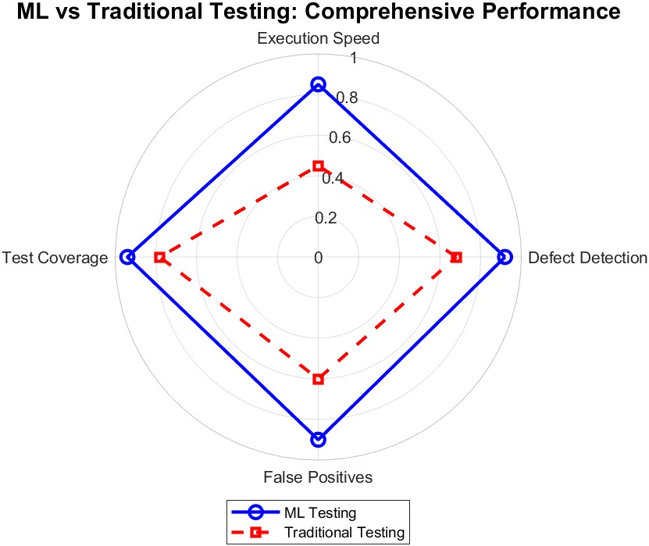
Figure 1. Comparison of Machine Learning and Traditional Testing
Figure 1 presents a comparison of execution time across multiple test cycles for ML-based testing (solid blue line with circles) and traditional automated testing (dashed red line with crosses). The horizontal axis represents the number of test cycles, while the vertical axis shows execution time in seconds.
The graph demonstrates that ML-based testing consistently achieves lower execution times than traditional methods throughout all test cycles. At the initial phase, the ML-based approach begins slightly above 100 seconds, while traditional testing starts at over 200 seconds. This substantial difference highlights the efficiency of ML-driven testing in reducing test duration.
Both testing approaches exhibit a downward trend in execution time as test cycles progress, indicating an overall improvement in performance through iteration. However, the ML-based method shows a steeper and more significant decline, suggesting that machine learning algorithms are capable of optimizing testing processes more effectively over time through adaptive learning mechanisms.
In contrast, traditional testing improves at a much slower rate due to its reliance on manual or semi-automated procedures, which are less scalable. The marked reduction in execution time confirms that ML-based testing offers superior scalability and automation potential, making it more suitable for dynamic and continuous testing environments.
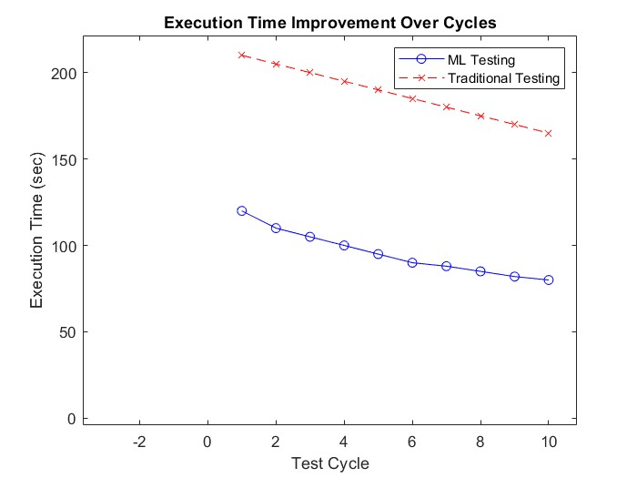
Figure 2. Comparison of Machine Learning and Traditional Testing in Execution Time
Based on the comparative analysis between ML-based and traditional testing, as visualized through radar charts and execution time graphs, the findings clearly demonstrate that machine learning significantly enhances the accuracy and efficiency of mobile application testing (RQ-1). In particular, ML-based testing shows substantial improvements in defect detection accuracy. The radar chart illustrates that the number of defects identified by machine learning techniques exceeds that of traditional rule-based approaches. This suggests that ML algorithms are more effective in recognizing complex or less obvious patterns, including anomalies that conventional testing methods often overlook.
Furthermore, ML-based testing produces a lower rate of false positives, which reduces the number of incorrectly flagged defects. This minimizes unnecessary debugging efforts and contributes to overall testing efficiency. In contrast, traditional automated testing tends to generate more false positives, increasing developer workload and decreasing trust in test results.
Beyond accuracy, ML-based testing also improves execution efficiency and broadens test coverage. The execution time analysis indicates that ML testing not only starts at a faster pace but also accelerates its performance across cycles by learning from previous iterations and optimizing future runs. Over time, ML approaches achieve significantly shorter test execution times compared to traditional methods, highlighting their adaptive and scalable nature.
Additionally, ML-based testing ensures wider test coverage by validating a more diverse and representative set of cases, including edge scenarios that traditional methods may not address. This contributes to more comprehensive software validation and reduces the likelihood of undetected defects during real-world use. Overall, the results confirm that ML-driven testing methods provide substantial advantages in terms of speed, precision, test completeness, and reliability.
RQ-2: What machine learning models and techniques are most effective for detecting usability and performance issues in mobile applications?
The results indicate that both Decision Tree and Random Forest models consistently achieved high values across all three metrics, confirming their robustness and suitability for the given classification task. In contrast, Naïve Bayes demonstrated lower performance, particularly in Precision and F1-score, suggesting higher susceptibility to misclassification errors. The ANN model performed moderately, indicating potential for improvement through further tuning or architectural optimization. Overall, the strong and stable performance of the tree-based models makes them preferable for the characteristics of the current dataset. Random Forest, introduced by Breiman (2001), is particularly effective in such contexts due to its ensemble nature, robustness to overfitting, and ability to handle diverse features.
The right plot in Figure 2 depicts trends in server CPU utilization over time and highlights potential performance degradation events. During the initial monitoring period, CPU usage remains relatively stable, showing moderate fluctuations. However, a pronounced spike occurs at approximately the 60-minute mark, with utilization exceeding 80%. Notably, red markers indicate performance issues arising shortly after this spike, suggesting a possible causal relationship between peak CPU load and system instability.
This pattern implies that high CPU utilization may contribute to resource saturation, bottlenecks, or inefficient workload distribution, ultimately leading to degraded system performance or failures. These observations support the implementation of predictive maintenance strategies: for instance, issuing early warnings when CPU usage approaches critical thresholds. Additionally, optimizing workload scheduling and computational resource allocation could help prevent such failures and ensure sustained system reliability.
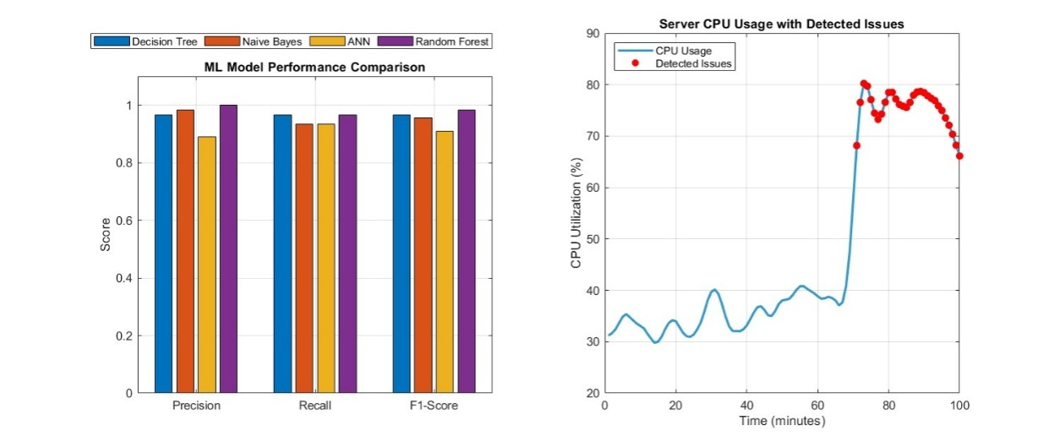
Figure 3. ML models with performance detection in mobile applications
The analysis of model performance and CPU utilization trends suggests that Decision Tree and Random Forest are the most effective models for detecting usability and performance issues in mobile applications. These models consistently achieved high values across key evaluation metrics—precision, recall, and F1-score—demonstrating their reliability in identifying anomalies. In contrast, the Naïve Bayes model showed lower accuracy, particularly in precision and recall, indicating its limitations in addressing complex performance and usability patterns. The Artificial Neural Network (ANN) model yielded moderate results and would require further tuning to reach optimal performance.
Usability and performance problems in mobile applications often manifest through system-level indicators such as CPU usage spikes, response delays, or resource bottlenecks. Given the multidimensional nature of these issues, tree-based models are particularly well-suited due to their ability to model complex decision boundaries involving multiple interacting factors.
Additionally, the observed correlation between elevated CPU utilization and system instability supports the need for predictive monitoring. Sharp increases in CPU usage preceding performance degradation underscore the importance of incorporating time-series forecasting methods - such as Long Short-Term Memory (LSTM) networks or ARIMA models - into the monitoring framework. These models can be combined with unsupervised anomaly detection techniques, including Isolation Forest, One-Class Support Vector Machines (SVM), and Autoencoders, to enable real-time identification of irregularities without requiring labeled training data.
Such hybrid approaches are especially relevant in mobile environments, where performance degradation may result from unpredictable user behavior, fluctuating network conditions, or device-specific constraints. Integrating classification and anomaly detection models can therefore enhance the robustness and responsiveness of performance monitoring systems in mobile application testing and deployment.

RQ-3: How does ML-driven testing impact the overall user experience and quality assurance process in mobile app development?

Figure 3 presents four visualizations that collectively demonstrate the impact of machine learning (ML) adoption on software testing efficiency, defect detection, and user experience. The correlation heatmap (top left) illustrates strong positive associations between test coverage, defect detection rate, application rating, and user retention, with correlation coefficients exceeding 0.85. This suggests that improvements in software testing quality, particularly in defect identification and test thoroughness, are closely linked to enhanced user satisfaction and engagement. Notably, ML adoption is strongly correlated with both defect detection (r = 0.892) and integration into continuous delivery pipelines (r = 0.947), underscoring its contribution to accelerating development cycles. Conversely, the time required to fix bugs exhibits a negative correlation with these efficiency metrics, implying that faster bug resolution is essential to sustaining high retention and satisfaction levels.
The line graph (top right) visualizes the upward trends in test coverage and defect detection as ML adoption progresses from level 1 to level 5. Test coverage increases at a steeper rate than other metrics, indicating that ML techniques enable more comprehensive testing. Although app ratings improve with ML adoption, the increase is modest compared to technical indicators. This suggests that while ML enhances reliability and reduces defects, other user-centric factors -тsuch as interface design, feature richness, and usability - continue to influence overall user ratings.
The scatter plot (bottom left) explores the relationship between QA team size and bug resolution time, segmented by levels of ML adoption indicated through color gradients. Teams that employ higher levels of ML tools consistently resolve bugs faster, even when team size is small. In contrast, teams with minimal ML integration experience significantly longer fix times, particularly if the team is small. These findings confirm that while team size contributes to efficiency, ML tools play a more decisive role by enabling predictive analytics and automation that streamline the debugging process.
The final scatter plot (bottom right) analyzes the link between defect detection rate and user retention, filtered by levels of ML adoption. Applications with higher levels of ML implementation (shown in green and purple) cluster in the upper-right quadrant, where both defect detection and user retention are high. In contrast, lower levels of ML adoption (blue and red) are associated with weaker performance on both dimensions. These results suggest that enhanced quality assurance supported by ML not only reduces functional defects but also strengthens user retention through improved reliability and stability.
To validate the interpretation of these quantitative patterns, a user-oriented survey was conducted involving 20 participants, including mobile app users and QA professionals. Respondents were asked to compare their experience with the application before and after ML-based testing improvements. According to the results, 75% of users reported a noticeable decrease in visual or functional errors, 68% observed smoother interactions and faster response times, and 70% expressed increased overall satisfaction. While the sample size was limited and exploratory in scope, the feedback aligns with the observed trends and supports the claim that ML-driven testing not only improves technical performance indicators but also positively influences user-perceived quality and stability.

ML-based testing has a demonstrable impact on improving the mobile application development lifecycle, particularly in the domains of defect detection, bug resolution time, and user retention. The results confirm a strong correlation between ML adoption and increased test coverage and quality assurance, which ultimately contributes to a more stable and dependable user experience. ML integration enables the early identification of defects and accelerates the bug-fixing process, thus increasing QA productivity and reducing time-to-market.
However, the analysis also highlights that improved defect detection alone is insufficient to elevate overall user ratings. Despite enhanced testing, application usability, feature design, and interface aesthetics remain critical to perceived app quality. Therefore, while ML-based testing offers substantial advantages in stability and reliability, it must be complemented with human-centered design practices to fully optimize the user experience.
Looking forward, the application of advanced ML models such as deep learning for predictive testing and reinforcement learning for adaptive bug detection may further enhance testing outcomes. Integrating time-series forecasting models (e.g., LSTM, ARIMA) and unsupervised anomaly detection techniques (e.g., Isolation Forest, One-Class SVM, Autoencoders) could support real-time monitoring and proactive quality control, especially in mobile contexts characterized by fluctuating network conditions and diverse device configurations. Additionally, coupling ML-powered testing with real-time user feedback and A/B testing mechanisms offers promising potential for continuous optimization in mobile app development across domains such as gaming, e-commerce, and social networking.
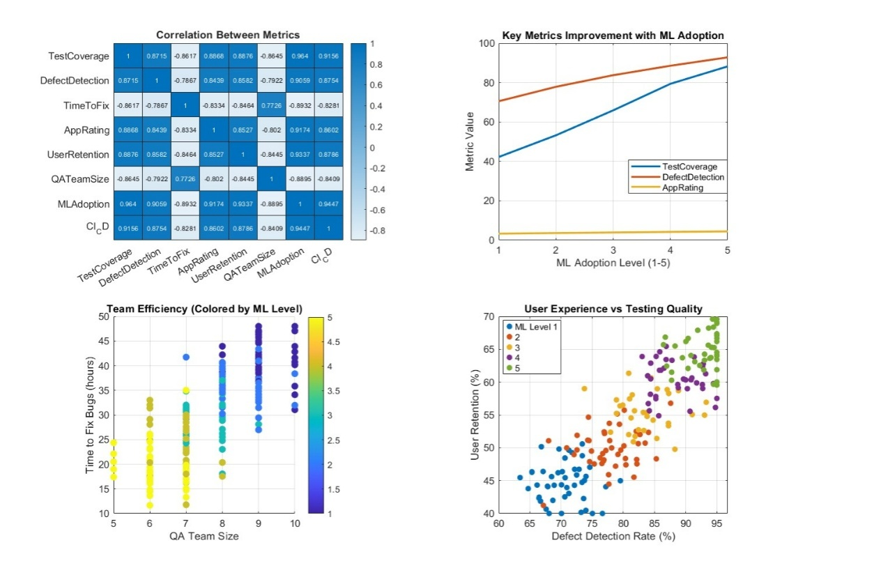
Figure 4. User Experience and Quality Assurance Process in Mobile App Development

5. Conclusion

This study demonstrates that integrating machine learning techniques into mobile application testing significantly enhances testing effectiveness, accuracy, and user-centered outcomes. Experimental evaluation shows that ML-based testing achieves substantially higher defect detection rates, broader test coverage, and reduced execution time compared to traditional approaches. Among the tested models, Decision Tree and Random Forest consistently outperformed others in identifying usability and performance-related issues, confirming their robustness for structured classification tasks in mobile environments.
In addition to quantitative improvements, a structured user survey confirmed the practical benefits of ML-based testing, with over 70% of respondents reporting improved application stability, responsiveness, and overall satisfaction. These results support the hypothesis that intelligent automation positively affects both quality assurance processes and end-user experience.
However, the deployment of ML in real-world testing scenarios is not without challenges. Issues such as dataset bias, variability across device and OS configurations, and limited interpretability of complex models remain significant concerns. These factors may affect the generalizability of results and the trust placed in automated decisions by developers and testers.
To address these challenges, the study recommends the development of robust, adaptable ML-based testing frameworks that combine supervised learning with unsupervised anomaly detection techniques. Emphasis should be placed on curating high-quality, diverse training datasets, implementing explainable ML approaches, and extending testing platforms to cover real-world usage patterns, including sensor inputs, device-specific behaviors, and user interaction contexts. Further research should also explore the integration of predictive models with real-time user feedback mechanisms to support continuous optimization in mobile application development.

COMPETING INTERESTS DISCLAIMER:
Authors have declared that they have no known competing financial interests OR non-financial interests OR personal relationships that could have appeared to influence the work reported in this paper.

Disclaimer (Artificial intelligence)
Option 1:
Author(s) hereby declare that NO generative AI technologies such as Large Language Models (ChatGPT, COPILOT, etc.) and text-to-image generators have been used during the writing or editing of this manuscript.
Option 2:
Author(s) hereby declare that generative AI technologies such as Large Language Models, etc. have been used during the writing or editing of manuscripts. This explanation will include the name, version, model, and source of the generative AI technology and as well as all input prompts provided to the generative AI technology
Details of the AI usage are given below:
1.
2.
3.

References
Ahmad, A., Feng, C., Tao, M., Yousif, A., & Ge, S. (2017). Challenges of mobile applications development: Initial results. 2017 8th IEEE International Conference on Software Engineering and Service Science (ICSESS). https://doi.org/10.1109/ICSESS.2017.8342956
Ahmad, A., Li, K., Feng, C., Asim, S. M., Yousif, A., & Ge, S. (2018). An empirical study of investigating mobile applications development challenges. IEEE Access: Practical Innovations, Open Solutions, 6, 17711–17728. https://doi.org/10.1109/ACCESS.2018.2818724
Ajorloo, S., Jamarani, A., Kashfi, M., Haghi Kashani, M., & Najafizadeh, A. (2024). A systematic review of machine learning methods in software testing. Applied Soft Computing, 162, 111805. https://doi.org/10.1016/j.asoc.2024.111805
Alzahrani, A. O., & Alenazi, M. J. F. (2021). Designing a network intrusion detection system based on machine learning for software-defined networks. Future Internet, 13(5), 111. https://doi.org/10.3390/fi13050111
Arif, K. S., & Ali, U. (2019). Mobile application testing tools and their challenges: A comparative study. 2019 2nd International Conference on Computing, Mathematics and Engineering Technologies (iCoMET). https://doi.org/10.1109/ICOMET.2019.8673505
Azgar, A., Rana, S., Hossain, S., & Ferdous, M. J. (2022). Testing challenges for mobile applications: An evaluation and comparative analysis of different testing approaches. International Journal of Research and Innovation in Applied Science, 7(4), 7–13. https://doi.org/10.51584/ijrias.2022.7402
Bajaj, Y., & Samal, M. K. (2023). Accelerating software quality: Unleashing the power of generative AI for automated test-case generation and bug identification. International Journal for Research in Applied Science and Engineering Technology, 11(7), 345–350. https://doi.org/10.22214/ijraset.2023.54628
Baqar, M., & Khanda, R. (2024). The future of software testing: AI-powered test case generation and validation. arXiv [cs.SE]. https://doi.org/10.48550/arXiv.2409.05808
Breiman, L. (2001). Random Forests. Machine Learning, 45(1), 5–32. https://doi.org/10.1023/A:1010933404324
Chakraborty, J., Majumder, S., & Menzies, T. (2021). Bias in machine learning software: Why? How? What to do? Proceedings of the 29th ACM Joint Meeting on European Software Engineering Conference and Symposium on the Foundations of Software Engineering, 429–440. https://doi.org/10.1145/3468264.3468537
Fontes, A., & Gay, G. (2023). The integration of machine learning into automated test generation: A systematic mapping study. Software Testing, Verification & Reliability, 33(4). https://doi.org/10.1002/stvr.1845
Gao, R., Wang, Y., Feng, Y., Chen, Z., & Wong, W. E. (2019). Successes, challenges, and rethinking – An industrial investigation on crowdsourced mobile application testing. Empirical Software Engineering, 24(2), 537–561. https://doi.org/10.1007/s10664-018-9618-5
Gartziandia, A., Arrieta, A., Ayerdi, J., Illarramendi, M., Agirre, A., Sagardui, G., & Arratibel, M. (2022). Machine learning‐based test oracles for performance testing of cyber‐physical systems: An industrial case study on elevators dispatching algorithms. Journal of Software (Malden, MA), 34(11). https://doi.org/10.1002/smr.2465
Habeeb Agoro, A. M. (2023). AI-powered test case generation and execution. ResearchGate. https://www.researchgate.net/publication/390262506_AI-Powered_Test_Case_Generation_and_Execution
Hanif, H., Md Nasir, M. H. N., Ab Razak, M. F., Firdaus, A., & Anuar, N. B. (2021). The rise of software vulnerability: Taxonomy of software vulnerabilities detection and machine learning approaches. Journal of Network and Computer Applications, 179, 103009. https://doi.org/10.1016/j.jnca.2021.103009
Hutchinson, B., Smart, A., Hanna, A., Denton, E., Greer, C., Kjartansson, O., Barnes, P., & Mitchell, M. (2021). Towards accountability for machine learning datasets: Practices from software engineering and infrastructure. Proceedings of the 2021 ACM Conference on Fairness, Accountability, and Transparency, 560–571. https://doi.org/10.1145/3442188.3445935
Kaur, A., & Kaur, K. (2022). Systematic literature review of mobile application development and testing effort estimation. Journal of King Saud University – Computer and Information Sciences, 34(2), 1–15. https://doi.org/10.1016/j.jksuci.2018.11.002
Khatibsyarbini, M., Isa, M. A., Jawawi, D. N. A., Shafie, M. L. M., Wan-Kadir, W. M. N., Hamed, H. N. A., & Suffian, M. D. M. (2021). Trend application of machine learning in test case prioritization: A review on techniques. IEEE Access: Practical Innovations, Open Solutions, 9, 166262–166282. https://doi.org/10.1109/ACCESS.2021.3135508
LeCun, Y., Bottou, L., Bengio, Y., & Haffner, P. (1998). Gradient-based learning applied to document recognition. Proceedings of the IEEE, 86(11), 2278–2324. https://doi.org/10.1109/5.726791
Li, S., Guo, J., Lou, J.-G., Fan, M., Liu, T., & Zhang, D. (2022). Testing machine learning systems in industry. Proceedings of the 44th International Conference on Software Engineering (ICSE ’22). https://doi.org/10.1145/3510457.3513036
Mahmood, Y., Kama, N., Azmi, A., Khan, A. S., & Ali, M. (2022). Software effort estimation accuracy prediction of machine learning techniques: A systematic performance evaluation. Software: Practice & Experience, 52(1), 39–65. https://doi.org/10.1002/spe.3009
Marijan, D. (2023). Comparative study of machine learning test case prioritization for continuous integration testing. Software Quality Journal, 31(4), 1415–1438. https://doi.org/10.1007/s11219-023-09646-0
Moran, K., Bernal-Cárdenas, C., Curcio, M., Bonett, R., & Poshyvanyk, D. (2020). Machine learning-based prototyping of graphical user interfaces for mobile apps. IEEE Transactions on Software Engineering, 46(2), 196–221. https://doi.org/10.1109/TSE.2018.2844788
Morovati, M. M., Nikanjam, A., Khomh, F., Ming, Z., & Jiang, Y. (2022). Bugs in machine learning-based systems: A faultload benchmark. arXiv [cs.SE]. https://doi.org/10.48550/arXiv.2206.12311
Pandey, S. K., Mishra, R. B., & Tripathi, A. K. (2021). Machine learning-based methods for software fault prediction: A survey. Expert Systems with Applications, 172, 114595. https://doi.org/10.1016/j.eswa.2021.114595
Peruma, A., Huo, T., Araújo, A. C., Imanaka, J., & Kazman, R. (2024). A developer-centric study exploring mobile application security practices and challenges. arXiv [cs.CR]. https://doi.org/10.48550/arXiv.2408.09032
Ramadan, A., Yasin, H., & Pektas, B. (2024). The role of artificial intelligence and machine learning in software testing. arXiv [cs.SE]. https://doi.org/10.48550/arXiv.2409.02693
Rezaalipour, M., & Furia, C. A. (2023). An annotation-based approach for finding bugs in neural network programs. Journal of Systems and Software, 111669. https://doi.org/10.1016/j.jss.2023.111669
Shoaib, M., Fitzpatrick, D., & Pitt, I. (2024). Accessibility features of developmental platforms: Towards developing accessible mobile applications with cross-platform, research challenges and opportunities. 5th International Workshop on Digitization and EInclusion in Mathematics and Science 2024 (DEIMS2024), Nihon University, Tokyo, Japan, 15–17 February, 153–162. https://workshop.sciaccess.net/deims2024/
Stradowski, S., & Madeyski, L. (2023). Machine learning in software defect prediction: A business-driven systematic mapping study. Information and Software Technology, 155, 107128. https://doi.org/10.1016/j.infsof.2022.107128
Terović, A., & Mekterović, I. (2024). On improving the qualitative features of the user interface of mobile applications using machine learning methods. 2024 47th MIPRO ICT and Electronics Convention (MIPRO), 205–210. https://doi.org/10.1109/MIPRO60963.2024.10569276
Wang, S., Shrestha, N., Subburaman, A. K., Wang, J., Wei, M., & Nagappan, N. (2021). Automatic unit test generation for machine learning libraries: How far are we? 2021 IEEE/ACM 43rd International Conference on Software Engineering (ICSE), 1548–1560. https://doi.org/10.1109/ICSE43902.2021.00138
Wickramarathne, J., Kodagoda, N., & Ganegoda, D. (2024). Guided machine learning for mobile user interface design through HCI principles. TENCON 2024 – 2024 IEEE Region 10 Conference (TENCON), 694–697. https://doi.org/10.1109/TENCON61640.2024.10902950
Xavier, M. G., Matteussi, K. J., Franca, G. R., Pereira, W. P., & De Rose, C. A. F. (2017). Mobile application testing on clouds: Challenges, opportunities and architectural elements. 2017 25th Euromicro International Conference on Parallel, Distributed and Network-Based Processing (PDP), 181–185. https://doi.org/10.1109/PDP.2017.96
Zakaria, N. A., Ismail, A. R., Ali, A. Y., Khalid, N. H. M., & Abidin, N. Z. (2021). Software project estimation with machine learning. International Journal of Advanced Computer Science and Applications (IJACSA), 12(6). https://doi.org/10.14569/IJACSA.2021.0120685

