MULTI-MODEL LEARNING METHODS FOR OIL PRICE PREDICTION

ABSTRACT
Present-day oil prices are rising due to certain conditions like inflation entire world. It is a major problem in the world. It affects so many fields connected to human life. Oil price prediction is most important for business scenarios. Machine learning algorithms play a key role in oil price prediction. Machine learning models predict the price of fuel. This paper aims to compare the machine learning models with multi-model learning models. To know in terms of accuracy and performance. Ensemble machine learning algorithms are most adaptive for different environments. The predicted price of crude oil in the future is decided using machine learning algorithms. In our research, we tested five models for calculating oil price prediction. Among these five models, tuning three models with hyperparameters. Hyperparameter tuning means AutoML, which boosts the performance of the models. The above three models’ performance shows more than 93%. Two models, support vector machine and linear regression, do not perform well. The accuracy rate is more than 50%.
Keywords: Automatic Machine Learning, Oil Prices Prediction, Hybrid Machine Learning.
- TION
Unstable prices of crude oil create more confusion for businesspeople and also cause customers to suffer due to these high prices. These crude prices are dependent on Dubai and Saudi Arabia's oil prices. Transportation is also one of the causes of crude oil price changes [2]. These crude oil prices have more effects on developing countries like India. Most of the researchers concentrate on machine learning algorithms to predict accurate results of oil prices in the real world. The prediction of crude oil prices based on past dataset predicted values. Features are considered as input, and the target list is considered as predicted values. Different machine learning models are feasible to some extent for predicting crude oil prices [3]. Oil price prediction is most important for business scenarios. Machine learning algorithms play a key role in oil price prediction. Machine learning models predict the price of fuel. To know in terms of accuracy and performance. Ensemble machine learning algorithms are most adaptive for different environments [4]. Present-day oil prices are rising due to certain conditions like inflation entire world. It is a major problem in the world. It affects so many fields connected to human life. Figure 1 shows the Monthly crude oil spot prices (2019-2024).

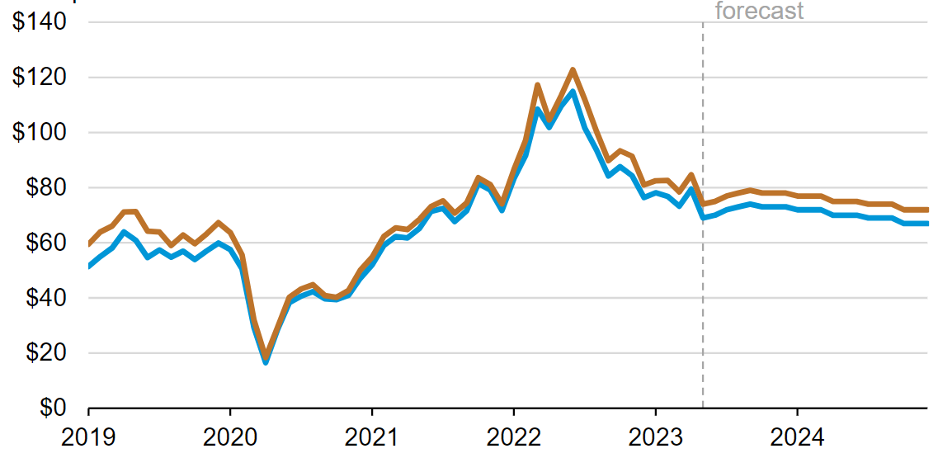
Figure 1: Monthly crude oil spot prices (2019-2024) [1]
In a few countries, crude oil is a major source of income. For example, Saudi Arabia, Russia, the United States, and Iran etc. All these countries' crude oil plays a critical role in their economy and the global economy. If any dispute arises between any countries of crude oil production, it impacts on world economy, like price fluctuations affecting economic activities and social stability [5]. The two best real-time examples of price fluctuation of crude oil from 2019 to 2024. One is Covid-19 is the biggest calamities in the past 100 years. Due to this problem shake the crude oil market is shaken because the oil price drops suddenly [6]. For this price decline, oil companies decided to reduce production. The second real-time example is the Russia and Ukraine War, due to this problem suddenly decline the supply of crude oil and the price is increased. Now also this trend is also continuous throughout the world [7].

Crude oil price fluctuations and economic recession still remain unsettled due to certain problems arising in the world. Crude oil price is a most complex issue, through using different models on fluctuates of crude oil price is dynamically high and low every day in the market [8]. This type of market behavior is adjusted to use factors like supply and demand in the financial market. Supply and demand relation is a complex for technological development to sort out the issue [9]. Today also it is also a major issue faced by academicians and researchers to resolve price fluctuations. It consciously disturbs the world's economic activities throughout the world [10].

The following paper continues next section with the projected scheme and building. Section three with outcomes and investigation, with a comparative study. The ending section concludes the paper with an optimal solution.

- PROPOSED SYSTEM AND ARCHITECTURE
Crude oil is the most dominant item in the world. Oil price prediction is most important for business scenarios. Machine learning algorithms play a key role in oil price prediction. Machine learning models predict the price of fuel. To know in terms of accuracy and performance [11]. Multi-model learning algorithms are most adaptive for different environments. Present-day oil prices are rising due to certain conditions like inflation entire world. It is a major problem in the world. It affects so many fields connected to human life. The predicted price of crude oil in the future is decided using machine learning algorithms. In our research, we tested five models for calculating oil price prediction. Among these five models, we tuned three models with hyperparameters [12]. Hyperparameter tuning means AutoML boosts the performance of the models.

The succeeding figure 2 shows our proposed architecture starting from data collection to the final result, with different phases included in this diagram [13]. The phases are
- Data Collection
- Pre-processing the data
- Extract the features
- Selection of algorithms
- Model Training
- Evaluation of Model Test
- Prediction
The phases are common for machine learning algorithm implementation in real-time scenarios. Data collection for the corresponding problem statement. From the pre-processing point of view, many procedures are available to remove abnormal data points. Feature extraction is also the most important phase for generating accurate results at the final stage. Here, data redundancy algorithms also apply to remove the redundancy.

The next phase is the selection of algorithms to select suitable algorithms for the data. The next phase with model training, after the evaluation of the model test, and then the generation of the final result [14]. Figure 2 describes the architecture of the proposed system with multiple phases.
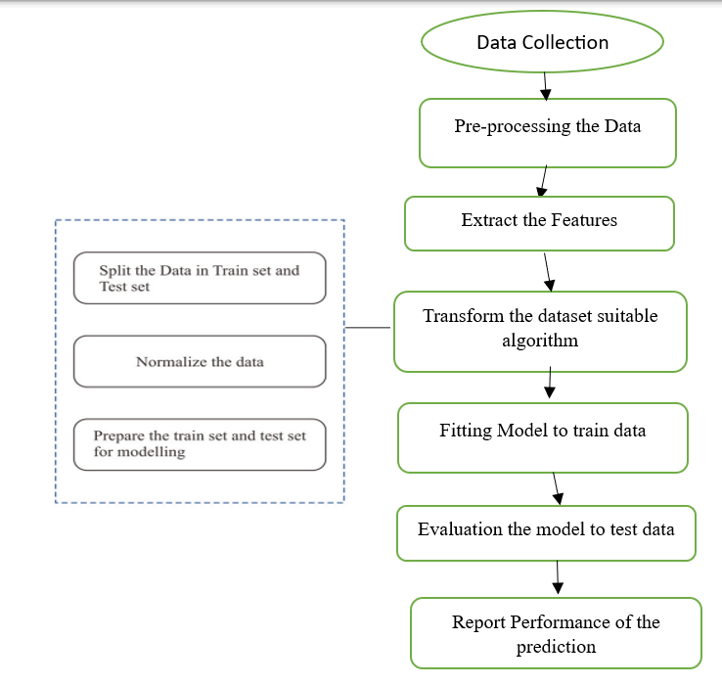
Figure 2: Proposed architecture
- RESULTS AND ANALYSIS
Oil price prediction is most important for business scenarios. Machine learning algorithms play a key role in oil price prediction. Machine learning models predict the price of fuel. The following phases are for the implementation of our project.

3.1 Importing modules

Before starting our implementation, import the libraries of the Python programming language. All are essential for implementing multiple models in our project.

3.2 Loading the Dataset
Loading the dataset into the current system. Dataset with multiple attributes starting from count to max.


3.3 Data Scaling
Data Scaling is a mandatory process for getting accurate results from a given input. Check missing values and fill those values using dissimilar methods; otherwise, ignore those values. Remove abnormal values also.

3.4 Data Visualization
Based on the given dataset, after pre-processing of the data, it can be shown in graphs with multiple diagnosis slots, with the count. Figure 3 shows the diagnosis against count, which means price against total barrel count. Diagnose the oil prices with the corresponding closing values.
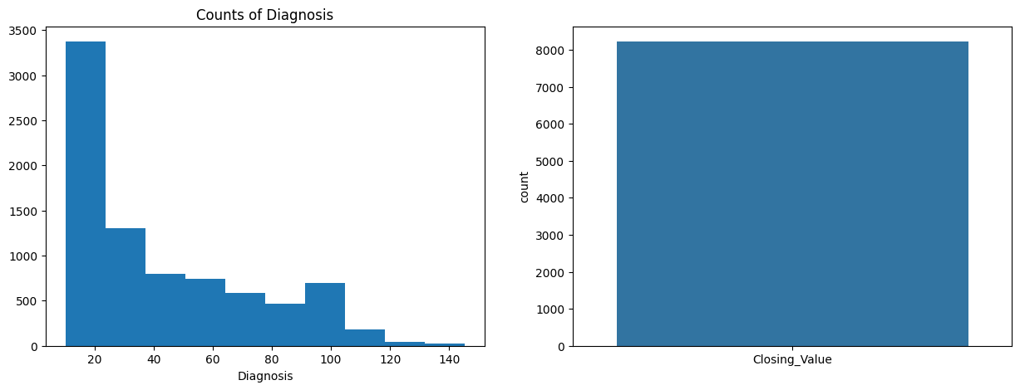
Figure 3: counts of diagnosis oil price values
Figure 4 describes the closing oil price values of oil price prediction with machine learning techniques. Based on availability and demand, closing values change. If you observe in graph, it can be shown.
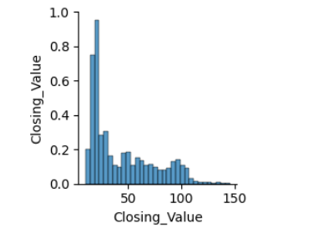
Figure 4: closing oil price values
Figure 5 shows the Column chart variation of oil prices over the years from 2017 to 2023. The following graph shows the variation of prices from 2017 to 2023. Prices can increase year by year. But sometimes prices can be decreased based on demand and availability.
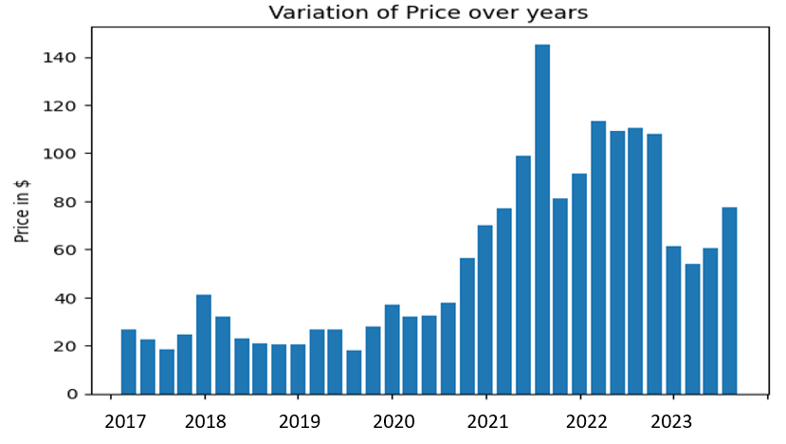
Figure 5: Column chart variation of oil prices over the years

3.5 Model Implementation

Five models are implemented for oil price prediction in this research. There are LR, RF, SVM, gradient boosting, and decision tree. The following code is for the implementation of different models.

3.5.1 Linear Regression
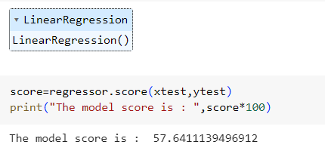
In our research, we used Linear regression and it generated an accuracy rate is 57.64%. It can be mainly used for linear relations, which means a one-to-one variable connection. Figure 6 shows the Line chart of oil prices over the years from 2017 to 2023. The oil price increased year by year in the graph using linear regression.
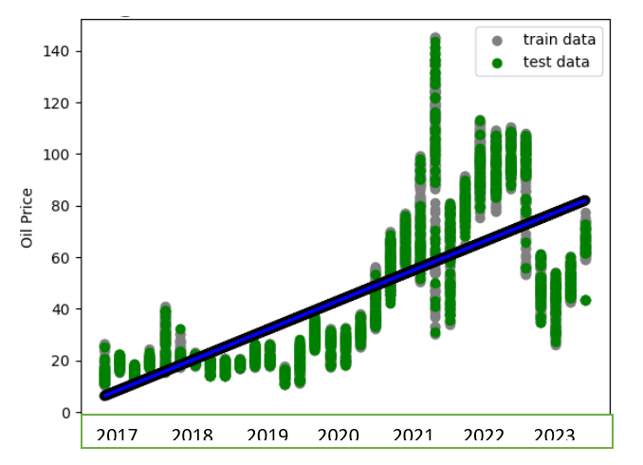
Figure 6: Line chart of oil prices over the years (LR)
In Figure 6, we used Linear regression and it generated an accuracy rate is 57.64%. It is medium-range accuracy, not better. The graph shows an increasing price, which means that year by year, oil prices increase.

3.5.2 Decision Tree Regressor
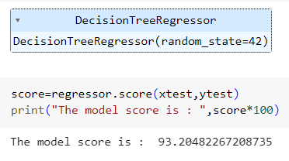
Figure 7 describes the Line chart of oil prices over the years from 2017 to 2923 using a decision tree. It also shows increased prices. This model gives a 93.2% accuracy rate. It is higher than Linear regression on the given dataset.
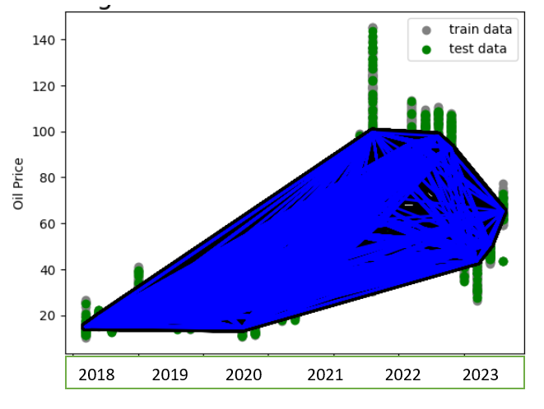
Figure 7: Line chart of oil prices over the years (DT)

3.5.3 Random Forest Regressor
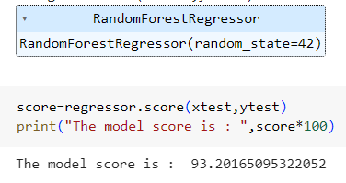

Figure 8 shows the Line chart of oil prices over the years from 2018 to 2023 using a random forest tree. It also shows increased prices. This random forest model gives a 93.2% accuracy rate. It is higher than linear regression. Random forest regression is a bagging model; it comes under ensemble learning.
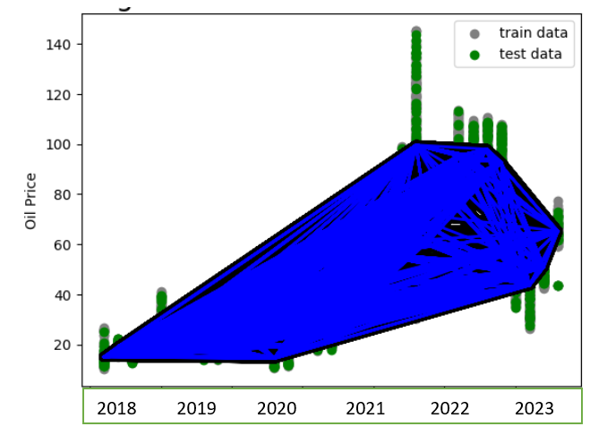
Figure 8: Line chart of oil prices over the years (RF)

3.5.4 Support vector machine
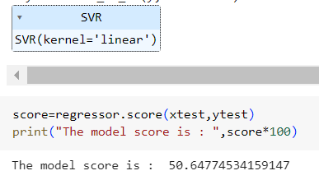
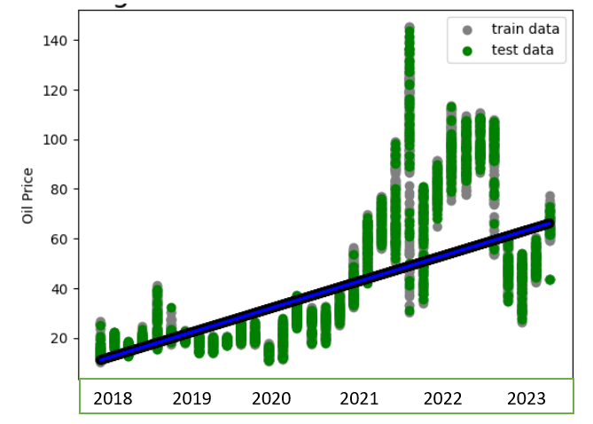
Figure 9: Line chart of oil prices over the years (SVM)
A support vector machine (SVM) is a supervised machine learning algorithm that classifies data by finding the best separating hyperplane. SVMs are used for classification, regression, and outlier detection. Figure 9 shows the Line chart of oil prices over the years from 2018 to 2023 using a support vector machine. It also shows increased prices. Support vector machine predicts a 50.64% accuracy rate.

3.5.5 Gradient Boosting Regressor
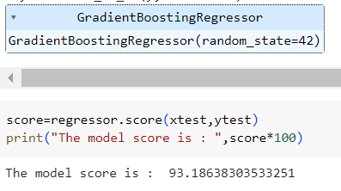
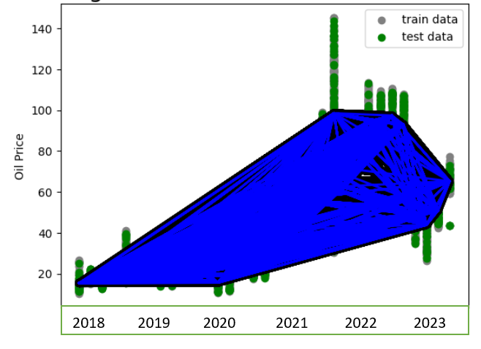
Figure 10: Line chart of oil prices over the years (GB)
Figure 10 shows the Line chart of oil prices over the years from 2018 to 2023 using gradient boosting. It also shows increased prices. Gradient Boosting is similar to the random forest model. Both models generate the same accuracy and optimal rate.

3.6 Hyperparameter Tuning (AutoML)

3.6.1 Tuning Gradient Boosting Regressor



3.6.2 Tuning Decision Tree Regressor

Hyperparameter tuning is an enhancement of machine learning models, which provides a higher accuracy rate compared to a single model. Three models were used for hyperparameter tuning. (AutoML).

Random Forest Regressor
Table 1: RF parameter calculation
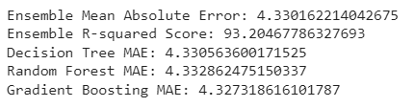
In our research, we tested five models for calculating oil price prediction. Among these five models, tuning three models with hyperparameters. Hyperparameter tuning means AutoML, which boosts the performance of the models. The above three models’ performance shows more than 93%. Two models, support vector machine and linear regression not perform well. The accuracy rate is more than 50%. Table 2 shows the Comparison of models' accuracy. The RMSE value is lower in the random forest tree compared to SVM and linear regression. The following table provides more understandable calculations regarding accuracy. Hyper-tuning models predict a higher accuracy rate. Three models predict higher and similar accuracy rates. But the normal model does not provide more accuracy.

Table 2: Comparison of Models' accuracy
S. No. | Name of the Model | Accuracy Rate (%)
1 | Linear Regression | 50.74
2 | Support Vector Machine | 50.1
3 | Tuning Random Forest Tree | 93.2
4 | Tuning Gradient Boosting | 93.2
5 | Tuning Decision Tree | 93.2
- CONCLUSION
Oil price prediction is most important for business scenarios. Machine learning algorithms play a key role in oil price prediction. Machine learning models predict the price of fuel. To know in terms of accuracy and performance. Ensemble machine learning algorithms are most adaptive for different environments. The predicted price of crude oil in the future will be decided using machine learning algorithms. In our research, we tested five models for calculating oil price prediction. Among these five models, tuning three models with hyperparameters. Hyperparameter tuning means AutoML boosts the performance of the models. The above three models’ performance shows more than 93%. Two models, support vector machine and linear regression, do not perform well. The accuracy rate is more than 50%.

Disclaimer (Artificial intelligence)
Option 1:
Author(s) hereby declare that NO generative AI technologies such as Large Language Models (ChatGPT, COPILOT, etc) and text-to-image generators have been used during writing or editing of manuscripts.
Option 2:
Author(s) hereby declare that generative AI technologies such as Large Language Models, etc have been used during writing or editing of manuscripts. This explanation will include the name, version, model, and source of the generative AI technology and as well as all input prompts provided to the generative AI technology
Details of the AI usage are given below:
1.
2.
3.

References
- https://www.eia.gov/todayinenergy/detail.php?id=56560
- Shiva Keertan J and Subhani Shaik,” Machine Learning Algorithms for Oil Price Prediction”, International Journal of Innovative Technology and Exploring Engineering, Volume-8 Issue-8, 2019.
- Dr. Sunil Butada and Subhani Shaik, “IPL Match Prediction using Machine Learning”, IJAST, Vol 29, Issue 5, April 2020.
- Dr. R. Vijaya Kumar Reddy, Dr. Shaik Subhani, Dr. G. Rajesh Chandra, Dr. B. Srinivasa Rao,” Breast Cancer Prediction using Classification Techniques”, International Journal of Emerging Trends in Engineering Research, Vol. 8, No.9,2020.
- Mr. Sujan Reddy, Ms. Renu Sri, and Subhani Shaik,” Sentimental Analysis using Logistic Regression”, International Journal of Engineering Research and Applications (IJERA), Vol 11, Series-2, July 2021.
- Ms. Mamatha, Srinivasa Datta, and Subhani Shaik”, Fake Profile Identification using Machine Learning Algorithms”, International Journal of Engineering Research and Applications (IJERA), Vol. 11, Series-2, July 2021.
- R. Vijaya Kumar Reddy, Subhani Shaik, B. Srinivasa Rao, “Machine learning based outlier detection for medical data” Indonesian Journal of Electrical Engineering and Computer Science, Vol. 24, No. 1, October 2021.
- Ch. Shravya, Pravallika, and Subhani Shaik,” Heart disease prediction using Machine learning Techniques”, International Journal of Innovative Technology and Exploring Engineering, Vol. 8, Issue 6, 2019.
- P. Santosh and Subhani Shaik,” Heart disease prediction with PCA and SRP”, International Journal of Engineering and Advanced Technology, Volume-8, Issue-4, 2019.
- J. Lavanya, M. Ramesh, J. Sravan Kumar, G. Rajaramesh, and Subhani Shaik,” Hate Speech Detection Using Decision Tree Algorithm”, Journal of Advances in Mathematics and Computer Science, Volume 38, Issue 8, Page 66-75, June 2023.
- Neeraja, Anupam, Sriram, Subhani Shaik, and V. Kakulapati,” Fraud Detection of AD Clicks Using Machine Learning Techniques”, Journal of Scientific Research and Reports, Volume 29, Issue 7, Page 84-89, June 2023.
- P. Pranathi, V. Revathi, P. Varshitha, Subhani Shaik and Sunil Bhutada,” Logistic Regression Based Cyber Harassment Identification”, Journal of Advances in Mathematics and Computer Science, Volume 38, Issue 8, Page 76-85, June 2023.
- Subhani Shaik, P. Santhosh Kumar, S. Vikram Reddy, K. Sai Srinivas Reddy, and Sunil Bhutada,” Machine Learning based Employee Attrition Predicting”, Asian Journal of Research in Computer Science, Volume 15, Issue 3, Page 34-39, March 2023.
- Subhani Shaik and Dr. Uppu Ravibabu, "Detection and Classification of Power Quality Disturbances Using Curvelet Transform and Support Vector Machines", in the 5th IEEE International Conference on Information Communication and Embedded System (ICICES-2016) at S. A. Engineering College, Chennai, India on 25th -26th February 2016.

