Time Series Prediction for Traffic Flow Forecasting Using CNN

Abstract
Traffic problems are very common nowadays throughout the world. In India also heavy traffic also occurred in many populated cities. For this reason, the public loses their time and life, and this pollution impacts human health. So, traffic research is necessary for this situation. We concentrate on the traffic network to find a better solution or model to predict future traffic. Our proposed model uses a time series for traffic forecasting. It deals with time series analysis for traffic congestion, traffic control, and traffic prediction. This paper focuses on appropriate datasets with different vehicles in various time series. A novel time series forecasting model was used for this research, and it also predicted a 99% accuracy rate. A comparative study is also presented in this research.
Keywords: Time Series, Previous Trends, Machine Learning, Traffic flow
- INTRODUCTION
Every person needs to be accurate and useful in traffic flow control in their area for a better life in terms of time and health. Development of traffic operations with low carbon emissions by enabling drivers and the public [1]. To improve the efficiency of traffic control in congested areas. Intelligent transportation systems have enhanced the accuracy of traffic control and predictions. It will be required in modern days to control the traffic flow based on passenger-provided information [2]. Every day, traffic data is increasing more and more, it also creates complexity for generating accurate models to control traffic. So many control systems are available for traffic flow control. Most of the system's traditional implementations are not suitable for modern traffic and still struggle to control traffic flow at different times. VGG16 is a Convolutional Neural Network (CNN) architecture primarily used for image recognition and classification. It's a deep learning model known for its effectiveness in computer vision tasks.

In deep learning, a Convolutional Neural Network (CNN) is a type of neural network architecture primarily used for analyzing and classifying images. CNNs excel at automatically extracting visual features from images, making them particularly effective for tasks like image recognition and object detection. Convolutional Neural Networks (CNNs) are a type of deep learning algorithm specifically designed to process and analyze image data. They are well-suited for tasks like image classification, object detection, and image recognition. CNNs use a unique structure with convolutional and pooling layers to automatically learn and extract features from images, making them highly effective for computer vision applications.

Despite the advancements in algorithms designed to estimate traffic flow, many still face challenges due to the vast dimensions of traffic data. These large datasets make it difficult to predict traffic flow accurately while maintaining minimal complexity. Although numerous studies and research papers suggest that machine learning techniques work well in handling such massive datasets, improving the effectiveness and accuracy of traffic flow predictions remains an ongoing challenge.

In Tashkent's growing megacities, the issues related to traffic management are becoming more and more pronounced and urgent. The number of vehicles operating in the city is enormous, about 900 thousand. This figure not only exceeds the designed capacity of the infrastructure, but also raises very serious concerns in terms of sustainability and urban traffic management.
Given the population of over three million and a growing fleet of over seventy-six thousand cars per year, the issues of efficient urban transport management have become a fact of life for residents of Tashkent. Long traffic stagnations, dissatisfaction with mobility, economic losses, and environmental degradation are all challenges that need to be addressed properly.

ImageNet Large-Scale Visual Recognition Challenge (ILSVRC) is an annual event to showcase and challenge computer vision models. In the 2014 ImageNet challenge, Karen Simonyan & Andrew Zisserman from the Visual Geometry Group, Department of Engineering Science, won the 1st and 2nd place in object detection and classification.
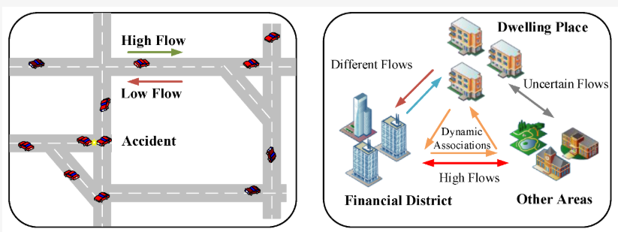
Figure 1. Different traffic flows
We also tried to delve into the area of traffic network study in order to select the appropriate model for traffic forecasting, which is predicting the traffic volume using time series analysis. The only area that in some measure combines the two concepts, traffic prediction and traffic control, is traffic time-series analysis, and in particular, the regression methods. In this study, we have collected a suitable dataset that comprises the hourly record of a week's worth of different types of vehicles. We performed some tests of time series forecasting.

- METHODOLOGY AND ARCHITECTURE
Time series forecasting is when scientists or analysts attempt to make a prediction based on data collected over a period of time, especially data with time stamps. It consists of constructing models through previously conducted analyses and later employing them to make observations and take further actions.

The term time series forecasting refers to the act of employing statistics and models to conduct an analysis of a given time series data with a view to making predictions and guiding decision-making processes. It’s often never an exact prediction, and the chance of forecasts may be totally different, particularly when it comes to the usually changeable factors within time series data, along with outside influences. But it is possible to generate intelligent insight, anticipating which outcomes are more probable than others. In many cases, the more thorough the information that we have, the greater the odds of reliable estimations we can get.

In deep learning, a Convolutional Neural Network (CNN) is a type of neural network architecture primarily used for analyzing and classifying images. CNNs excel at automatically extracting visual features from images, making them particularly effective for tasks like image recognition and object detection. Convolutional Neural Networks (CNNs) are a type of deep learning algorithm specifically designed to process and analyse image data. They are well-suited for tasks like image classification, object detection, and image recognition. CNNs use a unique structure with convolutional and pooling layers to automatically learn and extract features from images, making them highly effective for computer vision applications.

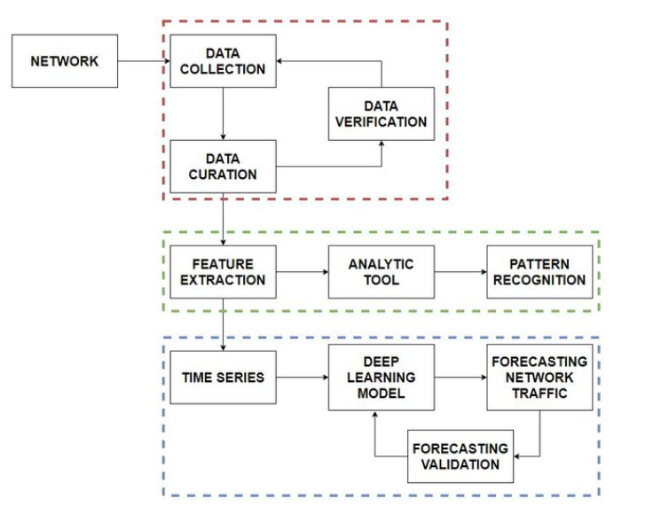
Figure 2. Proposed architecture for traffic forecasting.
Time series analysis is a specific method involving the study of the preferred method to collect data, is to capture the relevant data points over fixed intervals of time instead of collecting data at random times. In this paper, the structure of the traffic flow is considered as a combination of a periodic component, a residual component, and a volatile component. the residual component is a smooth, evolving, changing trend impacted by some major phenomena like local policy and road reconstruction. A volatile component is a mixed bunch of unknowns, which is due to external influences and uncertainties such as inclement weather, failure of sensors, and chance occurrences. The following Figure 2 describes the proposed architecture of our project. It shows the different phases for predicting the traffic flow.

- RESULTS AND ANALYSIS
  - Dataset Description
The dataset represents synthetic traffic data for a certain location over a one-year period. It includes information about the traffic volume, weather conditions, and special events that may affect traffic.
Features:
Timestamp: The date and time of the observation. Weather: The weather condition at the time of the observation (e.g., Clear, Cloudy, Rain, Snow).
Events: A binary variable indicating whether there was a special event affecting traffic at the time of the observation (True or False).

Traffic Volume: The volume of traffic at the location at the time of the observation. The dataset is intended for use in analyzing traffic patterns and trends, as well as for developing and testing models related to traffic prediction and management.
Table 1: Sample time series dataset
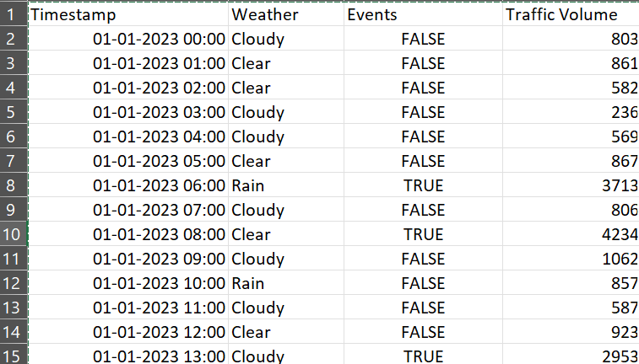
  - Data preprocessing
The data gathered was processed into 960 samples (Figure 1), with each sample representing a 15-minute interval, or 96 samples each day. The first eight days of data were used as a training set to create forecasting models, while the other two days of data were used as the test set to assess how accurate each model was. Thus, the training set and test set comprise 768 samples and 192 samples, respectively.
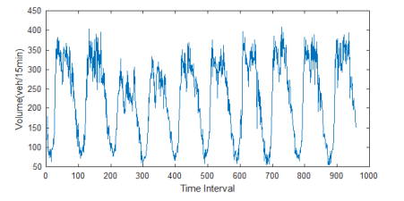
Figure 3. Traffic flow time series
Traffic flow time series often exhibit periodic variations, particularly with daily patterns of congestion during morning and evening rush hours. These cycles of traffic flow need to be considered for accurate predictions of future traffic conditions. To examine if periodicity exists in the time series, an autocorrelation analysis is performed. Based on the autocorrelation curve (Figure 4), the time series shows significant periodicity, indicating regular fluctuations with stable trends despite occasional variations.
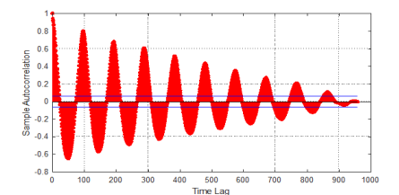
Figure 4. Autocorrelation curve of our traffic flow time series
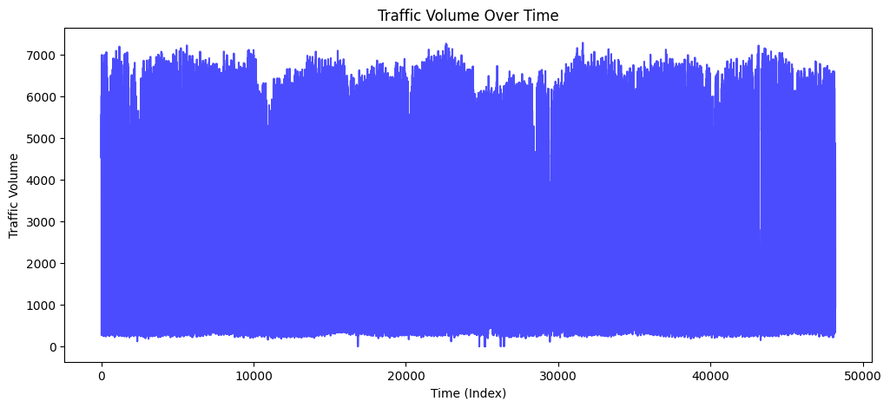
Figure 5. Traffic Volume over time
Figure 5 illustrates the variation in traffic volume over time. The graph represents time in seconds, ranging from 0 to 50,000 seconds, and traffic volume measured from 0 to 7,000 units. Throughout most of the observed period, the traffic volume remains relatively high. The pattern shows fluctuations, yet the volume predominantly stays elevated. By the end of the timeframe, the data concludes with consistently high traffic levels.

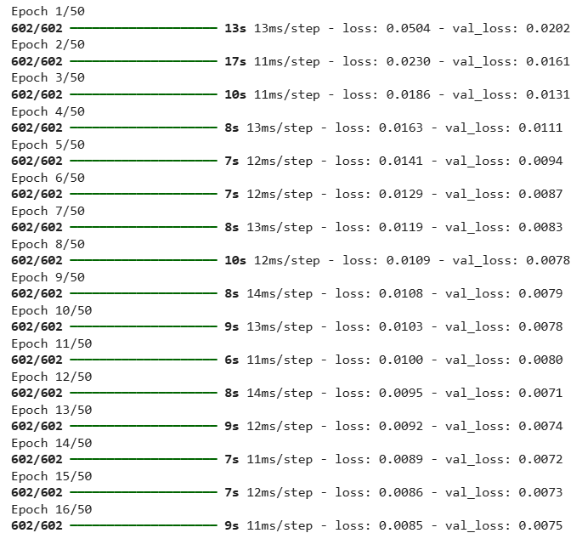
Figure 6. Model Compilation
Figure 6 presents the results of multiple model compilations over time, highlighting the loss and validation loss recorded at various time intervals in seconds. By employing the VGG16 model alongside a CNN, we achieved over 99% accuracy with minimal loss. The dataset utilized for this analysis includes detailed information on the number of various vehicle types recorded hourly over a span of seven consecutive days. This data was processed using the VGG16 model to conduct time-series forecasting, resulting in a statistical analysis confirming an accuracy rate exceeding 99%.
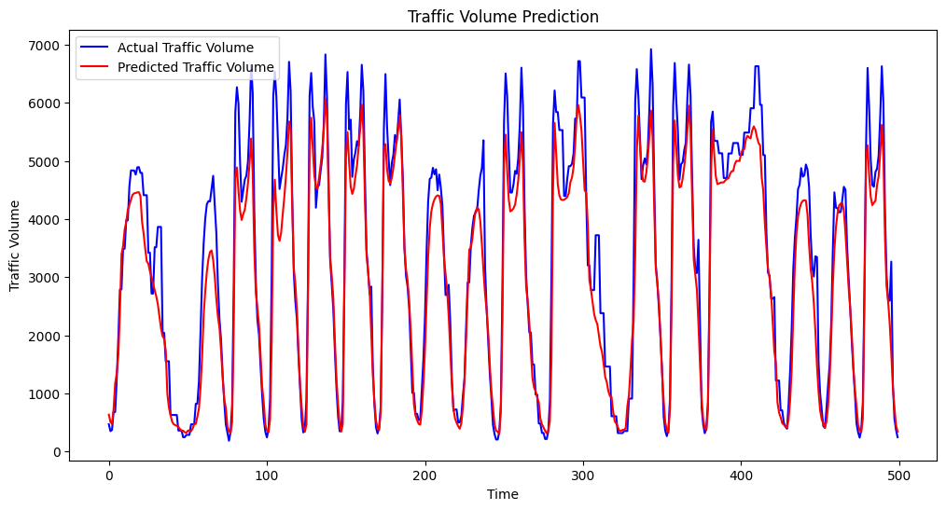
Figure 7. Traffic Volume Prediction
Figure 7 illustrates traffic prediction patterns over time. Upon analysis, the predicted traffic volume appears to be lower than the actual recorded volume. In logistic regression, predicted values represent the probabilities of data points belonging to specific classes, while actual values are the true class labels. The difference between these values helps train the model and refine its parameters.

To evaluate the model's performance, plotting actual values on the x-axis and predicted values on the y-axis can provide insight. If the points are closely aligned along the diagonal line, this indicates that the model performs well in predicting outcomes. It’s important to note that predicted values for individual data points may not match their true values exactly. Instead, the true value is expected to fall within a certain range around the predicted value. Understanding these intervals involves specific mathematical methods to calculate them accurately.

For this study, we utilized a dataset containing hourly vehicle counts over seven consecutive days. By applying time-series forecasting techniques, our statistical analysis demonstrated an accuracy rate exceeding 99%.
  - Comparative study
Table 2: Comparative study of models
S. No. | Name of the Model | Accuracy (%)
1 | CNN | 99
2 | Random Forest | 89 [3]
3 | Logistic Regression | 91[4]
4 | XGBoost | 93[3]
5 | Decision Tree | 76 [5]

The above table shows that, compared to ML models, deep learning models (CNN) are predict better results. By applying time-series forecasting techniques, our statistical analysis demonstrated an accuracy rate exceeding 99%.

- CONCLUSION
Traffic problems are very common nowadays throughout the world. In India also heavy traffic also occurred in many populated cities. For this reason, the public loses their time, and life, and pollution impacts human health. We concentrate on the traffic network to find a better solution or model to predict future traffic. Our proposed model uses a time series for traffic forecasting. It deals with time series analysis for traffic congestion, traffic control, and traffic prediction. This paper focuses on appropriate datasets with different vehicles in various time series. A novel time series forecasting model was used for this research, and it also predicted a 99% accuracy rate.

Disclaimer (Artificial intelligence)
Option 1:
Author(s) hereby declare that NO generative AI technologies such as Large Language Models (ChatGPT, COPILOT, etc.) and text-to-image generators have been used during the writing or editing of this manuscript.
Option 2:
Author(s) hereby declare that generative AI technologies such as Large Language Models, etc. have been used during the writing or editing of manuscripts. This explanation will include the name, version, model, and source of the generative AI technology and as well as all input prompts provided to the generative AI technology
Details of the AI usage are given below:
1.
2.
3.
REFERENCES
- Subhani Shaik and Dr. Uppu Ravibabu “A Novel approach based on Curvelet Transform for Detecting Climate Signal using Time Series” IJARCS, Vol. 8, No.3, March- April 2017.
- Subhani Shaik, “DM Algorithms Based Clustering for Road Accident Data Analysis,” International Journal of Computer Sciences and Engineering, Vol.-6, Issue 9, Sept. 2018.
- Subhani Shaik, V Kakulapati, Saadiq, Ontela Sanjay, and Krishna Reddy,” Real-Time Threat Detection Using the Yolo Version-4 Algorithm”, Acta Scientific Computer Sciences, Volume 5, Issue 5, May 2023.
- K. Vaishnavi, G. Pranay Reddy, T. Balaram Reddy, N. Ch. Srimannarayana Iyengar and Subhani Shaik,” Real-time Object Detection Using Deep Learning”, Journal of Advances in Mathematics and Computer Science, Volume 38, Issue 8, Page 24-32, June 2023.
- Subhani Shaik and Dr. R. Vijay Kumar Reddy,” Bank Marketing using Intelligent Targeting”, 1st International Conference on Machine Intelligence and Soft Computing (ICMISC-2020), Vignan University, Guntur, 3rd & 4th September 2020.
- Eathakota Rupin, Tarandeep Singh, P. N. Siva Jyothi, Subhani Shaik and Sunil Bhutada,” Office Management Chatbot using Artificial Intelligence”, International Conference on Soft Computing and Signal Processing(Springer-Scopus), pp 127-142, 16 April 2023.
- Mohammad Asif Baba, Thupakula Sai Varun, Madasu Shalivahana, Subhani Shaik and N. Ch. Sriman Narayana Iyengar”, Detection of Abductors using machine learning algorithms”, International Conference on Soft Computing and Signal Processing (Springer-Scopus), pp 127-142, 16 April 2023.
- KP Surya Teja, Vigneswara Reddy, and Subhani Shaik,” Flight Delay Prediction Using Machine Learning Algorithm XGBoost”, Journal of Advanced Research in Dynamical and Control Systems, Vol. 11, No. 5, 2019.
- Md. Samiuddina, G. Rajender, K. Sai Abhiram Varma, A. Ravi Kumar, and Subhani Shaik,” Health Insurance Cost Prediction Using Deep Neural Network”, Asian Journal of Research in Computer Science, Volume 16, Issue 2, Page 46-53, June 2023.
- K. Vaishnavi, G. Pranay Reddy, T. Balaram Reddy, N. Ch. Srimannarayana Iyengar and Subhani Shaik,” Real-time Object Detection Using Deep Learning”, Journal of Advances in Mathematics and Computer Science, Volume 38, Issue 8, Page 24-32, June 2023.
- Pasumarthi Koushik, Patha Ruchitha, Devarapally Adithya, Subhani Shaik, Sunil Bhutada,” Deep Learning Approach for Expression-Based Songs Recommendation System”, Accelerating discoveries in Data Science and Artificial Intelligence I, ICDSAI 2023, Liet Vizaianagaram, April 24-25, India.

