***Review Article***

**Optimizing Digital Marketing through Machine Learning in Cloud-Based Enterprise Systems: The Role of Web Technologies**

**Abstract**

The convergence of machine learning, cloud computing, and web technologies is transforming company strategies in digital marketing. As firms increasingly depend on data-driven tactics, machine learning provides robust capabilities for monitoring customer behavior, forecasting trends, and customizing marketing initiatives. When utilized in scalable cloud systems, these technologies provide real-time processing of extensive datasets, resulting in more flexible and efficient marketing campaigns. This article examines current developments in the incorporation of machine learning into cloud-based corporate systems, specifically highlighting its function in enhancing digital marketing. Principal topics encompass the utilization of predictive models, automation of customer interaction, and the deployment of web-based platforms to enhance data acquisition and campaign execution. Although these advances provide substantial potential, difficulties including data protection, algorithmic transparency, and system integration remain. The paper continues by delineating potential research avenues intended to tackle these issues and improve the efficacy and ethical application of machine learning in corporate marketing frameworks.

**Keywords**: Machine Learning, Digital Marketing Optimization, Cloud-Based Enterprise Systems, Web Technologies, Customer Segmentation, Marketing Automation, Predictive Analytics

1. **Introduction**

There are significant uses of machine learning, such as predictive analytics, tailored recommendations, sentiment analysis, and consumer segmentation. These technologies provide more precise and efficient marketing initiatives [1]. IBM's approach emphasizes Business Analytics and Optimization, advancing from descriptive to predictive and prescriptive analytics. Descriptive analytics elucidates historical occurrences, predictive analytics anticipates future trends, and prescriptive analytics recommends appropriate actions [2]. Machine learning enhances traffic predictions through the analysis of extensive datasets, hence increasing the efficiency of transport networks. Due to the intricacy of traffic data, methodologies such as deep learning and soft computing provide efficient solutions for precise forecasting [3].

Digitalization is swiftly revolutionizing sectors, in contrast to the more gradual progression of previous industrialization. As digital systems advance, evaluating their hazards is essential [4]. Cloud computing lets customers utilize IT infrastructure as a utility, but resource management is difficult. ML-based resource management methodologies, difficulties, and future possibilities are discussed in this study.[5] Digital channels including Email, SMS, Social Media, and Search are becoming more popular for client interaction and acquisition. Digital marketing offers precise data collecting at several touchpoints, unlike traditional marketing. Few studies have predicted the efficacy of integrated digital lifecycle campaigns (DLCs). Most have measured the performance of separate digital channels [6]. Digital marketing channels like email, SMS, social media, and search are becoming more important since they engage and acquire customers more efficiently than traditional methods [7]. More accurate forecasts, automated decision-making, and deeper customer behavior insights are revolutionizing marketing using machine learning (ML). Many marketers and researchers find ML complicated and hard to execute, therefore its full potential is neglected [8]. New technologies like IoT, Big Data Analytics, AI, and robots are driving Industry 4.0, making smart factories more efficient and customer-driven. Security, self-adaptation, and huge data management remain issues despite these advances [9].

Modular design concepts improve AI-driven sales pipeline optimization in this study. It helps companies boost revenue while retaining system agility.[10] Marketing with customer segmentation boosts sales and retention. Machine learning improves client behavior recognition. This guarantees firms have cost-effective, data-driven marketing strategies.[11]. AI helps organizations optimize marketing with hyper-personalization, predictive analytics, and chatbots. AI helps Amazon propose items, and 84% of marketing firms use it to increase productivity and decision-making.[12]. With these methods, companies may boost productivity, increase brand awareness, and better target customers all while keeping security under control.[13] Traditional architectures struggle to handle data volume, diversity, and velocity, resulting in fragmented insights and poor decision-making [14]. Many researchers and software developers have devoted significant efforts to enhancing the functionality and precision of facial expression recognition technologies [15].

Modular software design improves AI models in sales pipeline forecasting, addressing the limitations of monolithic structures that struggle with scalability and integration of complicated AI algorithms [16]. Traditional marketing struggles to satisfy customer personalization [17]. It establishes a framework for assessing AI's revolutionary impact on digital marketing.[18] Digital revolution has a major influence on marketing, requiring adaptable and inventive techniques to react to shifting customer behavior [19] Marketing is crucial to corporate success, and machine learning is being utilized to optimize marketing techniques [20] Due to their capacity to handle complicated tasks and vast datasets, AI and deep learning are being used in more industries [21] Massive amounts of textual data must be organized efficiently in the age of big data due to the fast increase of digital material [22].

The fast spread of COVID-19 in late 2019 caused a global health catastrophe, especially among the elderly and chronically ill [23] Clustering has become essential for grouping related objects and identifying them, especially in document analysis, as large data grows. Real-time systems with several processors are complicated, yet multitasking and time-sharing increase execution efficiency [24]. This technology is quick, efficient, and suited for embedded systems, especially driver alertness systems that must balance cost and performance.[25] Because of advancements in imaging technology, facial expression recognition (FER) is becoming more popular in fields such as forensics and health care.[26] The study compares various classifiers to discover which algorithm has the greatest accuracy and reliability for predicting vaccination results.[27].

1. **Research Methodology**

This study adopts a structured research methodology grounded in a systematic literature review to investigate the integration of machine learning in cloud-based enterprise systems, particularly in the context of digital marketing optimization. The approach synthesizes findings from a variety of credible sources to highlight current developments, opportunities, and challenges in the field.

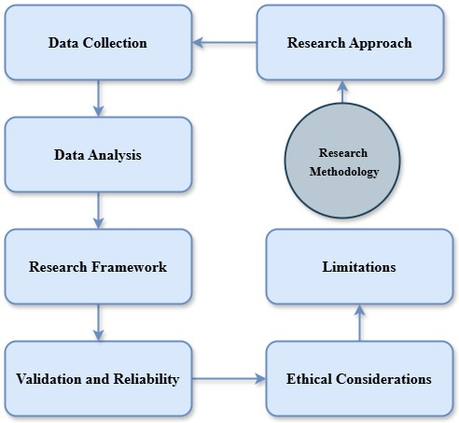

Figure1: General Flowchart of the Methodology.

1. **Background theory**

The advent of data-driven decisions, individualized consumer experiences, and predictive analytics made possible by machine learning has shook up digital marketing [28]. One of the most important parts of contemporary marketing strategy is customer segmentation. Many businesses utilize the Recency, Frequency, and Monetary (RFM) model to divide their clientele into different groups according to how they buy [29]. Among the most important advantages are faster decision-making, shorter sales cycles, and higher conversion rates [30]. The success of digital marketing campaigns depends on their ability to strike a balance between efficiency and safety. Data integrity in digital marketing campaigns may be guaranteed with the use of machine learning classification algorithms, which can detect and mitigate security issues [31]. By analyzing past performance data and determining the best communication techniques, this method helps companies enhance their lifecycle campaigns.[32]

Loyalty programs and consumer interaction in Industry 4.0 settings are enhanced by these solutions, which incorporate big data storage, machine learning analytics, and automated decision-making [33]. Deep learning and reinforcement learning are two algorithms that enhance digital marketing campaigns' return on investment (ROI) by refining consumer targeting [34]. Enterprise architectures that are easy to scale allow for better consumer interaction through real-time data processing, predictive analytics, and customization powered by AI [35]. ERP (Enterprise Resource Planning) systems are improved by deep learning because it boosts decision support, demand forecasting, and inventory management [36]. Businesses are able to gain improved scalability, maintainability, and faster deployment of artificial intelligence models in dynamic sales settings by deconstructing complicated systems into discrete modules to meet these goals [37].

1. **Literature Review**

**Matošević et al. (2021)** investigated the use of machine learning in online page categorization for search engine optimization, drawing attention to the ways in which classification models powered by artificial intelligence improve web ranking by detecting crucial on-page SEO elements like page titles, meta descriptions, and H1 tags. Machine learning outperforms baseline methods in web page categorization, according to their study. This finding sheds light on how to optimize web pages so that they adhere to SEO rules.

**Miklosik and Evans (2020)** explored the influence that big data and machine learning have had on digital marketing, highlighting critical issues in data management, customization, and decision-making that is powered by artificial intelligence. The findings of their study highlighted the fact that although big data improves the effectiveness of marketing, organizations frequently struggle with issues related to data governance and integration.

**Kong et al. (2022)** investigated the influence that AI-powered consumer segmentation models have on the performance of digital marketing. According to the findings of their research, machine learning may improve personalized marketing methods, which in turn can improve client targeting and conversion rates. When it comes to optimizing marketing decision-making, the study highlighted the need of integrating big data and artificial intelligence.

**Ullal et al. (2021)** the function of deep learning in marketing automation was explored, with a particular focus on the contributions that deep learning makes to sentiment analysis, predictive modeling, and involvement of consumers. The results of their research demonstrated how neural networks may enhance the success of marketing campaigns and decision-making in real time, hence making marketing tactics more flexible and proficient​.

**Anny (2015)** discussed how artificial intelligence may improve sales forecasting, customer segmentation, and decision-making, and analyzed how AI might be integrated into ERP systems. The study presented a predictive analytics framework for enterprise resource planning (ERP) that was powered by artificial intelligence (AI). The framework highlighted the role that AI-driven automation plays in enhancing business intelligence and operational efficiency, while also addressing problems such as high installation costs and workforce adaption.

**Bayoude et al. (2018)** focused on the influence that machine learning has had on digital marketing, and found that 84 percent of marketing firms had either implemented or extended their usage of AI-based solutions for predictive analytics, targeted advertising, and consumer behavior modeling. According to the findings of their research, artificial intelligence-driven automation improves marketing efficiency by lowering costs and boosting the level of customisation experienced in advertising campaigns.

**Anderson (2025)** the incorporation of deep learning models into business systems for predictive marketing analytics was investigated, with a particular focus on the ways in which neural networks, convolutional neural networks, and recurrent neural networks improve customer segmentation, sentiment analysis, and sales forecasting operations. The research presented a systematic framework for using deep learning into marketing tactics in order to enhance the accuracy of decision-making and the overall scalability of the process.

**Yathiraju (2022)** IT experts' impressions of the influence that artificial intelligence has on SaaS-ERP security, automation, and efficiency were the subject of this study, which investigated the integration of AI into cloud-based ERP systems. The study found that there are a number of problems, including hazards to data security and high installation costs; nevertheless, it also found that artificial intelligence enhances the flexibility of ERP systems and business intelligence.

**Miklosik and Evans (2020)** investigated the use of big data and machine learning in digital marketing, focusing on the difficulties associated with data management, customization, and decision-making that is driven by artificial intelligence. Their research revealed that although artificial intelligence improves the effectiveness of marketing and predictive analytics, firms have challenges in terms of data governance and integration.

**Ullal et al. (2021)** with a particular emphasis on the uses of deep learning in marketing automation, demonstrating how neural networks may improve predictive modeling, campaign optimization, and consumer behavior analysis. According to the findings of their study, marketing solutions that are powered by artificial intelligence result in increased conversion rates and enhanced strategic decision-making.

**Micu et al. (2019)** investigated the application of machine learning (ML) algorithms for the purpose of enhancing digital marketing tactics for the purpose of optimizing the performance of online commerce. Using Google Cloud's AutoML Vision, the researchers studied 1,420 Romanian e-commerce enterprises in order to categorize brand logos and evaluate other components of websites.

**Wang (2019)** investigated the role that machine learning plays in operations management and marketing, demonstrating its ability to handle complex business difficulties through predictive analytics, strategic decision-making, and consumer behavior modeling.

**Puso et al. (2023)** The application of machine learning for energy management in cloud computing was examined, with a particular focus on improving resource allocation and minimizing operating expenses. Within the scope of the research, deep reinforcement learning.

**Kong (2022)** conducted research on the use of machine learning and large amounts of data in the process of marketing strategy development. It was established in the research that improved consumer segmentation may be achieved by the utilization of an upgraded k-means clustering method.

**Chornous and Fareniuk (2022)** utilized machine learning to optimize marketing decisions within the telecoms industry, with a particular emphasis on client segmentation and individualized communication methods along the process. Self-Organizing Maps (SOM), k-means clustering, and classification algorithms such as Random Forest were utilized by them in order to minimize marketing expenses, increase consumer engagement, and improve retention rates.

**Mishra and Tyagi (2023)** IoT-based cloud applications for business analytics and marketing optimization were investigated for their potential to include machine learning. In order to evaluate massive amounts of Internet of Things data, their study concentrated on machine learning methods such as decision trees, neural networks, and clustering approaches.

**Yu (2023)** explored the implementation of machine learning-based marketing tactics, with a particular emphasis on the development of precision marketing strategies through the analysis of large amounts of data. The research demonstrated how machine learning models may be used to effectively enhance marketing tactics by analyzing transactional data, consumer preferences, and purchase behavior.

**Ngcobo et al. (2024)** managed to carry out a comprehensive analysis of enterprise data management (EDM) and the part it plays in improving the operation of businesses. As part of their research, they investigated the ways in which cloud-based data platforms such as Amazon Web Services (AWS), Microsoft Azure, and Google Cloud may be integrated to facilitate real-time data analytics, improve decision-making, and boost operational efficiency.

**Ivanov (2019)** we investigated the influence that cloud technologies have had on digital marketing and emphasized the importance of doing a speedy analysis of multidimensional data in order to comprehend the patterns of customer behavior and market trends.

**Prasad and Chandrika (2022)** evaluated the value of on-page optimization tactics in digital marketing, including keyword optimization, internal linking, usability, and Meta descriptions. Their study indicated that these strategies effectively boost search engine rankings, organic traffic, and consumer interaction, eventually leading to marketing success.

**Miklosik et al. (2019)** Research was conducted to investigate the use of analytical tools based on machine learning in digital marketing, with a particular emphasis on the potential of these tools to improve marketing strategies and streamline decision-making processes.

**Ullal et al. (2021)** explored the role of machine learning (ML) and artificial intelligence (AI) in transforming digital marketing. They found that ML techniques like sentiment analysis, predictive modeling, and deep learning improve customer targeting, personalized marketing, and decision-making accuracy.

**Ibrahim, Zeebaree, and Jacksi (2019)**[38] : uncovered the shortcomings of conventional keyword-based clustering methods and highlighted the merits of semantic approaches that utilize tools such as WordNet in an extensive examination of semantic similarity-based document clustering.

**Khalid and Zeebaree (2021)**[39]**:** tackled the growing challenge of data visualization in big data settings, stressing the need for sophisticated visualization techniques backed by scalable infrastructures like cloud computing and VR platforms to deal with dispersed and heterogeneous data.

**Zeebaree and Yaseen (2011)**[40]**:** honed in on the effects of parallel processing on distributed memory systems' performance, recommending a load-balanced architecture that boosts execution efficiency via client-server communic Optimal ERP Solution:

**Dino et al. (2020)**[41]**:** provided a detailed evaluation of hybrid feature extraction approaches combined with various classification models, demonstrating how methods such as LDN, HOG, CNN, and PCA improve identification accuracy across diverse facial expression databases. Complementing this,

**Mahmood et al. (2021)**[42]**:** presented an evaluation of the performance of several supervised learning classifiers by employing chi-square-selected features, and came to the conclusion that Random Forest attained the greatest accuracy (94.23%) on the CK+ dataset, surpassing models such as SVM and MLP when trained with a minimum feature set.

**Zeebaree and Jacksi (2015)**[43]further contributed to parallel computing by investigating the impacts of forced multiprocess execution in shared memory systems. This investigation demonstrated how load distribution and CPU count have a substantial impact on performance and resource consumption.

**Jghef et al. (2022)** [44]proposed a hybrid optimization model that combines Ant Colony Optimization (ACO) and Grey Wolf Optimization (GWO), leading to the introduction of a novel bio-inspired framework for Internet of Drone Things (IoDT) settings that are both safe and efficient.

**Jacksi, Zeebaree, and Dimililer (2018**)[45]He created the LOD Explorer system, which addresses the issues that non-expert users encounter while dealing with RDF and SPARQL-based data. Their method provides a simple, interactive interface for studying semantic data structures, hence increasing the accessibility of semantic web technologies**.**

**Salih et al. (2024)**[46]: Used machine learning to predict diabetes using the PIMA Indian dataset, applying preprocessing techniques such as outlier removal, imputation, and normalization, followed by dimensionality reduction via PCA. They achieved an accuracy of 89.86% using Support Vector Machine (SVM), highlighting the value of integrating strong feature engineering with appropriate classification models.

**Lastly, Armya, Abdulrahman, Abdulkareem, and Salih (2023)** [47]: Investigated the relationship between distributed systems, IoT, and web technologies in improving smart city functioning. Their research demonstrated how real-time data collecting, assisted by IoT sensors and cloud platforms, enables adaptive systems in urban infrastructure such as traffic control, energy optimization, and public safety.

1. **Comparison and Discussion**

Table 1: Comparative Analysis of Machine Learning Applications in Cloud-Based Digital Marketing and Enterprise Systems.

|  |  |  |  |  |
| --- | --- | --- | --- | --- |
| **Ref.** | **Datasets** | **Algorithms** | **Platforms** | **Fields** |
| [48] | Takes data from Econsultancy-RedEye surveys of 700 digital marketers. | Segmentation, customer journey analysis, and conversion funnel analysis. | Not specifically stated, but references cloud-based Google Analytics, Omniture, and WebTrends. | A/B testing, multivariate testing, behavioral email marketing, and social media monitoring and RACE. |
| [49] | 600 web pages from the DMOZ list were chosen at random and put into three groups by hand by SEO experts: low, medium, and high SEO quality. | We examined Decision Trees, Naïve Bayes, KNN, SVM, and Logistic Regression. The highest accuracy was 69.67%. | Not specifically stated, machine learning was used for data processing and categorization. | H1 headers, and keyword frequency in content. HTML structural analysis and SEO auditing tools are used. |
| [50] | Industry data and case studies to explore machine learning in marketing. | Predictive modeling, propensity modeling, methods that are used in suggestion systems and chatbots. | Processing big amounts of data for predictive analytics, which usually uses cloud-based services. | AI-driven marketing tools, social media analytics, chatbots, and tailored content. |
| [51] | Case studies from companies like Boden and Ace Mart that used IBM Core metrics showed that their sales and marketing ROI went up. | Explores sophisticated web analytics and marketing automation technologies. | IBM Coremetrics is a cloud-based analytics tool that integrates with IBM WebSphere Commerce. | Online analytics solutions such IBM Coremetrics, Omniture SiteCatalyst, Google Analytics, and Webtrends. It specializes in JavaScript. |
| [52] | Examines 69 peer-reviewed publications from academic databases. | ML-driven marketing solutions include predictive analytics, sentiment analysis. | Cites cloud-based big data processing and analytics for marketing insights. | AI-driven marketing, social media analytics, tailored advertising. |
| [53] | Case studies from a multinational retail chain, e-commerce platform, financial institution. | Predictive modeling, machine learning for sales forecasting, NLP for sentiment analysis. | ERP integration using cloud-based AI systems like Microsoft Azure AI, IBM Watson, and TensorFlow. | Covers ERP-integrated AI-driven chatbots, virtual assistants, and automated marketing solutions to improve digital marketing. |
| [54] | CRM, web analytics, social media, and transactional database data without a dataset. | CNNs for sentiment analysis, RNNs for sales forecasting, Autoencoders for anomaly detection, and GANs. | AWS, Azure, and Google Cloud are AI model training and deployment platforms. | CRM and customer data platforms. |
| [55] | Utilizes CRM, historical sales, and third-party analytics data. Additionally, sales managers, data scientists. | Regression, decision trees, and neural networks for sales forecasting, lead scoring, and pipeline optimization. | Docker, Kubernetes, and Apache Kafka for real-time. Integration of CI/CD pipelines automates updates. | AI, visualization dashboards, and ML. |
| [56] | Examined 1,353 SMEs from 26 countries to compare cloud-enabled and non-cloud SMEs in resource consumption, scalability, API integration, and cybersecurity. | It talks about AI-driven analytics, predictive models, and automation in cloud ERP and BI systems. | Cloud-based ERP, business intelligence (BI), and safety systems with AI integration. SaaS ERP, IoT-enabled cloud solutions. | BI tools that run in the cloud, ERP systems, and safety models that use AI. It talks about APIs for integrating systems. |
| [57] | How to use both organized and unstructured data from contacts with customers. | Using statistical machine learning methods, such as decision trees, classification models, and prediction modeling. | Cloud-based data analytics and AI-driven marketing automation tools are discussed, but not in detail. | AI, data-driven CRM, predictive analytics, and automatic customer insights. |
| [58] | Financial data, website designs, and brand features from 1,420 Romanian e-commerce. | Google Cloud AutoML Vision can be used to classify images, the Pearson correlation test can be used to find key factors for e-commerce success. | Google Cloud Platform to train machine learning models and do jobs. | How to use AI-driven marketing data to improve the success of online sales. |
| [59] | It looks at customer journeys, conversion patterns, and marketing attribution. | GBDT, Markov models, vector autoregression models, probability classification. | cloud-based data processing and marketing tools powered by AI. | Statistical cookie matching for multi-channel tracking,. |
| [60] | CloudSim simulations, and cloud service logs. Also uses PlanetLab and Complutense University of Madrid data. | DRL, Random Forest, SVM, K-Means clustering, and Linear/Logistic Regression for energy efficiency improvement. | TensorFlow, CloudSim, Weka, Hadoop, and Scikit-Learn for cloud computing energy management. | AI-driven and cloud-based optimization frameworks. |
| [61] | Retail transaction data to determine spending habits. Purchase frequency, transaction value, and customer loyalty are measured. | Enhances K-means clustering for encrypted customer data processing. | Cloud-based data exchange and encrypted processing in digital marketing apps. | Covers privacy-preserving marketing tactics using AI-powered client segmentation. |
| [62] | Ukrainian telecoms company subscriber profiles, dataset has 13,500 clients. | SOM, K-Means, (Random Forest, J48, IBk, Decision Table, and OneR). | Data-driven marketing automation, which may include cloud services. | Personalized email marketing, targeted SMS/Viber campaigns, and AI-driven. |
| [63] | Large data from IoT devices such smart homes, wearables, and industrial IoT applications. | Compares Neural Networks, Decision Trees, Random Forest, SVM, and SOM to IoT data. | AWS, Microsoft Azure, and Google Cloud for ML-based data analysis are discussed for IoT AI solutions. | Covers cloud-based IoT applications including smart automation, AI-driven. |
| [64] | Big data from e-commerce platforms, social media, and client transactions without naming a dataset. | Supervised (classification, regression), unsupervised (clustering, dimensionality reduction). | Cloud-based AI technologies and big data platforms are referenced. | AI-driven customization, recommendation systems, sentiment analysis, and chatbots. |
| [65] | IBM Global Services, and Animoto. | Integrates anomaly detection, stacking-based workload prediction. | Testing on Azure Cloud, discussing AWS and Google Cloud use. | API-driven and AI-driven. |
| [66] | Examines 31 MLaaS security research articles on cloud-based ML implementations. | Adversarial assaults, model inversion, data poisoning, and model extraction. | Google Cloud ML Engine, Microsoft Azure ML, and AWS Deep Learning AMI security threats. | Cloud-based ML deployment tactics, API security, and data encryption. |
| [67] | Compares cloud-based ML platforms AWS, Azure, and GCP without a dataset. | Analyses cloud-based ML models including supervised learning, neural networks. | AWS, Microsoft Azure, and Google Cloud Platform integration, cost, processing power, and security. | Digital transformation techniques using cloud-based AI. |
| [68] | 136 EDM studies on data integration, real-time analytics, and cloud-based. | Data-driven decision-making, AI-based data integration, and real-time analytics. | AWS, Azure, and Google Cloud offer scalable storage, processing, and real-time data analytics. | EDM techniques using APIs, middleware, real-time data processing frameworks, and cloud-based business intelligence tools. |
| [69] | Market segmentation and expert-based ranking. | Ranking models, consumer segmentation, and AI-driven marketing. | Describes digital marketing analytics and data processing. | Covers OLAP systems, digital advertising, and cloud-based AI-driven. |
| [70] | The paper examines SEO and digital marketing case study. | The document mentions SEO automation tools that assess ranking elements and recommend adjustments. | It mentions cloud-based SEO tools like Google Search Console, SEMrush, and Moz. | Offers web-based SEO, schema markup, and content optimization. |
| [71] | Qualitative and quantitative studies on Slovakian marketers, media, and advertising. | Data-driven decision-making, and consumer segmentation utilizing AI-driven analytical tools. | Cite cloud-based AI and digital marketing automation technologies. | AI-powered marketing tools, programmatic advertising, predictive analytics, and real-time campaign optimization. |
| [72] | Surveys and interviews with 1,250 Indian digital customers. | Uses regression models, fsQCA, and AI-driven consumer behavior analysis. | Does not define a platform for cloud-based AI technologies. | Digital marketing tactics that are led by AI, behavioral analytics. |

The comparison table in the article is designed to consolidate data from many research exploring the convergence of machine learning, cloud-based corporate systems, and digital marketing. Each row in the table denotes a separate research, whereas each column delineates a specific facet of the study's emphasis, execution, and contribution. This organized style provides a thorough yet succinct introduction of the application of machine learning in optimizing digital marketing tactics inside cloud-based platforms.

1. **Extracted Statistics**

Here is the chart illustrating the usage frequency of various machine learning approaches throughout the analyzed research. It demonstrates that supervised learning is the most usually employed, followed by deep learning, unsupervised learning, and specialized techniques like NLP and sentiment analysis.

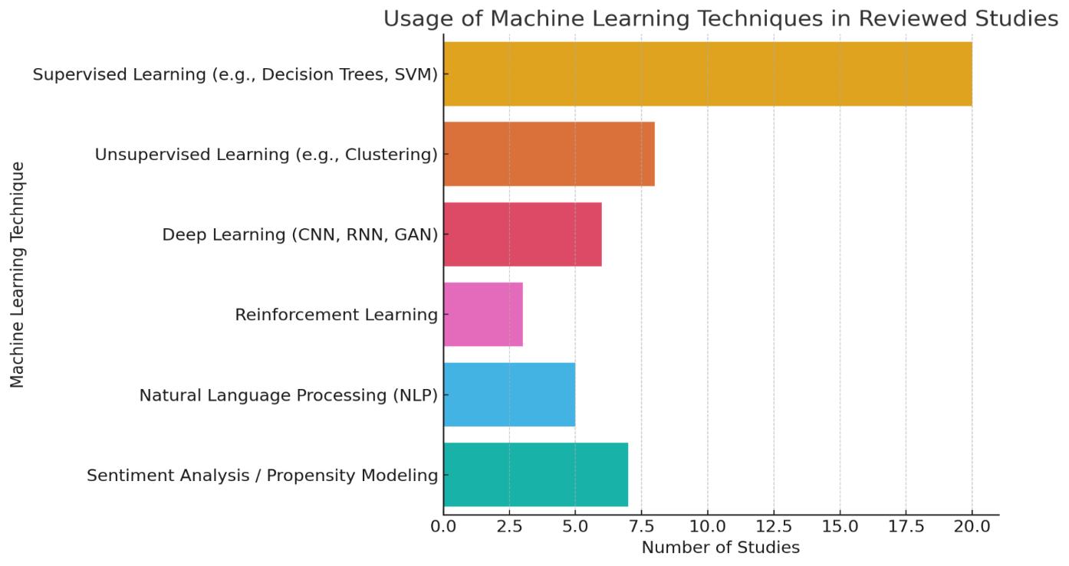

Figure 2: Usage of Machine Learning Techniques in Reviewed Studies.

It is clear how the studies that were examined distributed the use of cloud platforms in this pie chart. The majority of studies did not identify which platform was used, however the most common ones were AWS and Google Cloud Platform (GCP), followed by Microsoft Azure and IBM Cloud.

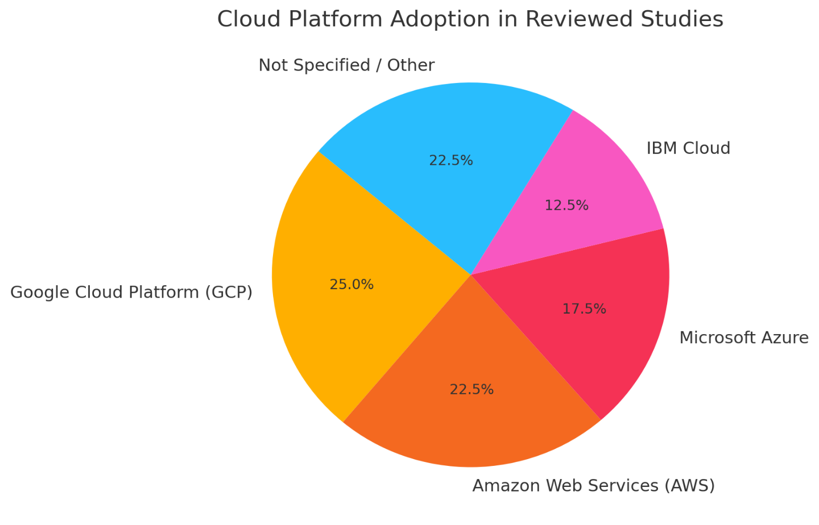

Figure 3: Cloud Platform Adoption in Reviewed Studies

This bar chart shows the many kinds of data sources that were used in the reported research. Although most studies did not specify where they obtained their data, the most common sources are online purchases, customer relationship management systems, and web analytics.

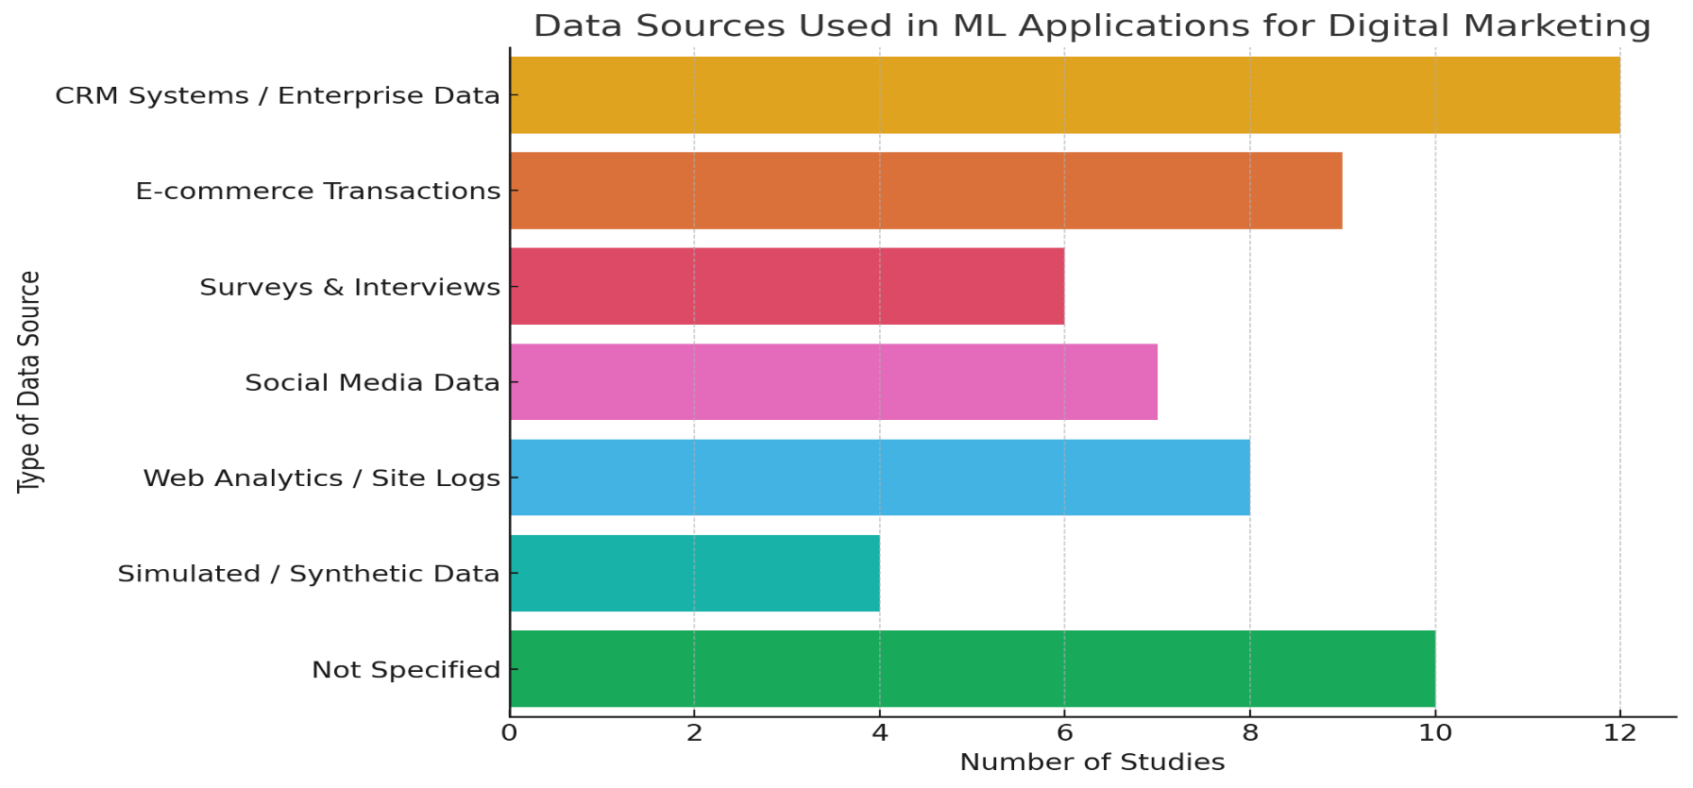

Figure 4: Data Sources Used in ML Applications for Digital Marketing

The following is a pie chart that illustrates the distribution of application domains for machine learning across all of the studies that were checked out. Among the priority areas, the most prominent ones are customer segmentation and customization, followed by sales forecasting, marketing automation, and campaign engagement.

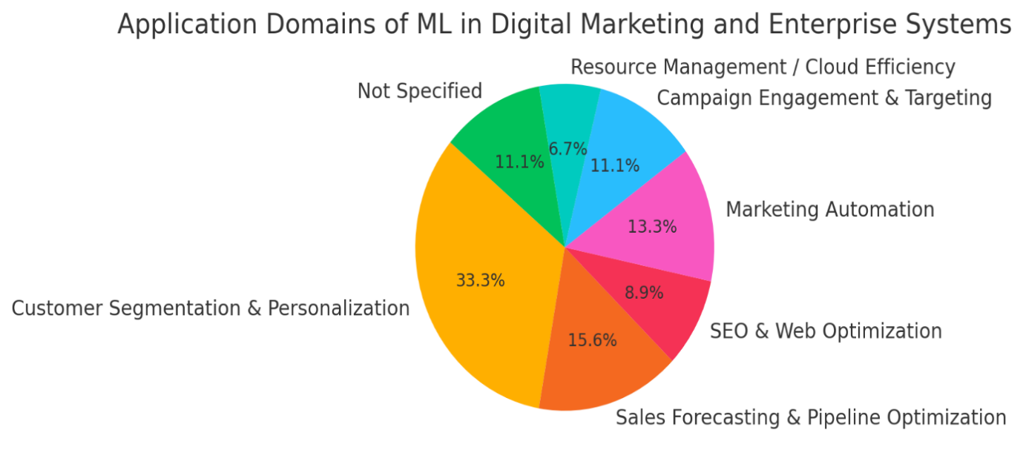

Figure 5: Application Domains of ML in Digital Marketing and Enterprise Systems

The line graph that illustrates the different performance indicators and accuracy levels that were reported across all of the studies that were analyzed is presented below. It demonstrates that machine learning models often perform well in areas like as client segmentation, sales forecasting, and engagement prediction, with accuracies frequently ranging between sixty percent and eighty percent.

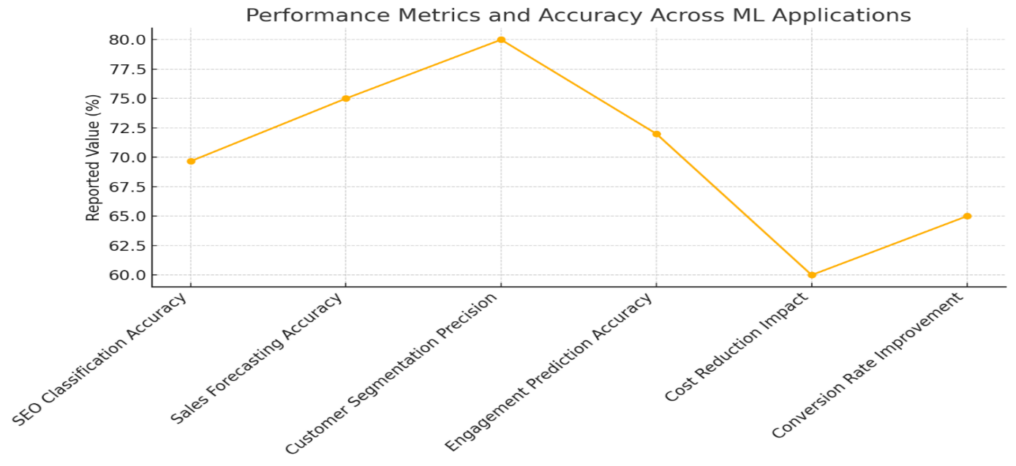

Figure 6: Performance Metrics and Accuracy across ML Applications

The following are well-formulated recommendations for future study and practice in the field of machine learning applied to digital marketing inside cloud-based corporate systems. These recommendations are based on the whole content of your review article as well as the comparative analysis of studies.

1. **Recommendations**

* Enhance ML Model Interpretability and Transparency.
* Integrate Ethical and Privacy-Preserving AI Practices.
* Promote Modular and Scalable System Architectures.
* Standardize Evaluation Metrics Across Domains.
* Strengthen Cloud-Based ML Infrastructure and Interoperability.
* Focus on Cross-Channel and Lifecycle Campaign Optimization.
* Bridge the Gap between Research and Practice.
* Invest in Skill Development and Tool Accessibility.
* Leverage Real-Time Data for Dynamic Decision-Making.
* Encourage Interdisciplinary Collaboration.

1. **Conclusion**

This review emphasizes the revolutionary influence of machine learning on digital marketing in cloud-based corporate systems. The amalgamation of machine learning algorithms, cloud computing platforms, and web technologies has empowered enterprises to execute intelligent, data-driven marketing plans with enhanced precision and efficacy. Scalable cloud infrastructures enable the processing of extensive and intricate datasets, while web technologies enhance real-time client engagement and data collecting across digital platforms. Diverse machine learning methodologies, including as deep learning, clustering, and predictive modeling, have been effectively utilized to improve consumer segmentation, campaign efficacy, personalization, and automation. Nonetheless, despite these gains, obstacles including data privacy concerns, ethical dilemmas, integration complexity, and restricted model interpretability persist as key issues. The absence of standards and the significant learning curve related to the implementation of these technologies, especially for small and medium firms, impede wider adoption. Confronting these difficulties necessitates continuous research, multidisciplinary cooperation, and the establishment of transparent and safe machine learning frameworks.

**COMPETING INTERESTS DISCLAIMER:**

Authors have declared that they have no known competing financial interests OR non-financial interests OR personal relationships that could have appeared to influence the work reported in this paper.

Disclaimer (Artificial intelligence)

Option 1:

Author(s) hereby declare that NO generative AI technologies such as Large Language Models (ChatGPT, COPILOT, etc.) and text-to-image generators have been used during the writing or editing of this manuscript.

**References**

[1] M. Kumari, R. Sinha, P. Chakrabarty, M. G. Hasnain, N. Qamar, and S. Gupta, “Exploring Machine Learning’s Impact on Digital Marketing,” in *2024 15th International Conference on Computing Communication and Networking Technologies (ICCCNT)*, IEEE, 2024, pp. 1–5.

[2] T. Khan, W. Tian, and R. Buyya, “Machine Learning (ML)-Centric Resource Management in Cloud Computing: A Review and Future Directions,” May 2021, [Online]. Available: http://arxiv.org/abs/2105.05079

[3] Kunal, “Review of Various Applications of Machine Learning.”, Asian Journal of Convergence in Technology, Volume VIII and Issue II , ISSN NO: 2350-1146 I.F-5.11,2022,DOI**:**<https://doi.org/10.33130/AJCT.2022v08i02.013>

[4] Baghirzade, A. R. (n.d.). *Development of cloud, digital technologies and the introduction of chip technologies*. Plekhanov Russian University of Economics. arXiv preprint arXiv:2012.08864. <https://arxiv.org/abs/2012.08864>

[5] T. H. . Davenport, J. G. . Harris, and G. . Loveman, *Competing on analytics : the new science of winning*. Harvard Business School Press, 2007.

[6] R. Lakatos *et al.*, “A Cloud-based Machine Learning Pipeline for the Efficient Extraction of Insights from Customer Reviews,” Jun. 2023, doi: 10.3390/bdcc8030020.

[7] V. Duvvuri, “A graph-based machine learning approach to predicting digital lifecycle campaign engagement,” in *ACM International Conference Proceeding Series*, Association for Computing Machinery, Jan. 2021, pp. 5–10. doi: 10.1145/3453800.3453802.

[8] V. A. Brei, “Machine learning in marketing,” *Foundations and Trends in Marketing*, vol. 14, no. 3, pp. 173–236, Aug. 2020, doi: 10.1561/1700000065.

[9] A. Galletta, L. Carnevale, A. Celesti, M. Fazio, and M. Villari, “A Cloud-Based System for Improving Retention Marketing Loyalty Programs in Industry 4.0: A Study on Big Data Storage Implications,” *IEEE Access*, vol. 6, pp. 5485–5492, Nov. 2017, doi: 10.1109/ACCESS.2017.2776400.

[10] H. Peter, “A Comprehensive Framework for Designing Modular Enterprise Software Architectures to Enhance AI-Driven Sales Pipeline Optimization,” 2024.

[11] M. R. Andi Purnomo, A. Azzam, and A. Uswatun Khasanah, “Effective Marketing Strategy Determination Based on Customers Clustering Using Machine Learning Technique,” in *Journal of Physics: Conference Series*, Institute of Physics Publishing, Mar. 2020. doi: 10.1088/1742-6596/1471/1/012023.

[12] A. V. Srivastava, Mr. L. S. Umrao, and Mr. D. Kumar, “Application of Machine Learning Algorithms in Online Marketing,” *Int J Res Appl Sci Eng Technol*, vol. 11, no. 3, pp. 2306–2312, Mar. 2023, doi: 10.22214/ijraset.2023.49585.

[13] Y. Liu and X. Huang, “Brand Digital Marketing under Intranet Security Control Based on the Machine Learning Classification Algorithm,” *Security and Communication Networks*, vol. 2021, 2021, doi: 10.1155/2021/9977221.

[14] J. Paul, “Building Scalable Enterprise Architectures for Unified Customer Insights: Integrating AI and Data Management Tools,” 2024.

[15] Maiwan B. Abdulrazaq et al, “An Analytical Appraisal for Supervised Classifiers' Performance on Facial Expression Recognition Based on Relief-F Feature Selection,” in *Journal of Physics: Conference Series*, Institute of Physics Publishing, 1804 (2021) 012055. doi: 10.1088/1742-6596/1804/1/012055.

[16] H. Peter, “Evaluating the Impact of Modular Software Design on the Performance of AI Models in Sales Pipeline Forecasting,” 2024.

[17] Hamdoun, S. H., Abed, M. Q., Salman, S. M., Al-Bayati, H. N. A., & Balina, O. (2024). *The intersection of statistics and machine learning: A comprehensive analysis*. *Journal of Ecohumanism*, 3(5), 406–421. https://doi.org/10.62754/joe.v3i5.3914

[18] M. A. Islam, S. I. Fakir, S. Bin Masud, Md. D. Hossen, M. T. Islam, and M. R. Siddiky, “Artificial intelligence in digital marketing automation: Enhancing personalization, predictive analytics, and ethical integration,” *Edelweiss Applied Science and Technology*, vol. 8, no. 6, Nov. 2024, doi: 10.55214/25768484.v8i6.3404.

[19] N. S. Saba, R. Gandhi, S. R. Rajendran, and N. D. Abraham, “Revolutionizing digital marketing using machine learning,” in *Contemporary approaches of digital marketing and the role of machine intelligence*, IGI Global, 2023, pp. 1–22.

[20] L. Buiak, M. Shynkaryk, Y. Semenenko, and K. Pryshliak, “Optimization of Marketing Department Activities using Machine Learning Technologies,” in *2024 14th International Conference on Advanced Computer Information Technologies (ACIT)*, IEEE, 2024, pp. 293–298.

[21] R. M. Abdullah, L. M. Abdulrahman, N. M. Abdulkareem, and A. A. Salih, “Modular Platforms based on Clouded Web Technology and Distributed Deep Learning Systems,” *Journal of Smart Internet of Things*, vol. 2023, no. 2, pp. 154–173, Dec. 2023, doi: 10.2478/jsiot-2023-0018.

[22] S. H. Haji, A. Al-zebari, A. Sengur, S. Fattah, and N. Mahdi, “Document Clustering in the Age of Big Data: Incorporating Semantic Information for Improved Results,” *Journal of Applied Science and Technology Trends*, vol. 4, no. 01, pp. 34–53, Feb. 2023, doi: 10.38094/jastt401143.

[23] S. Muawanah, U. Muzayanah, M. G. R. Pandin, M. D. S. Alam, and J. P. N. Trisnaningtyas, “Stress and Coping Strategies of Madrasah’s Teachers on Applying Distance Learning During COVID-19 Pandemic in Indonesia,” *Qubahan Academic Journal*, vol. 3, no. 4, pp. 206–218, Nov. 2023, doi: 10.48161/Issn.2709-8206.

[24] Haji, L.M. et al., 2020. "Dynamic Resource Allocation for Distributed Systems and Cloud Computing." Test Engineering and Management, 83, pp.22417–22426.

[25] B. R. Ibrahim *et al.*, “Embedded System for Eye Blink Detection Using Machine Learning Technique,” in *1st Babylon International Conference on Information Technology and Science 2021, BICITS 2021*, Institute of Electrical and Electronics Engineers Inc., 2021, pp. 58–62. doi: 10.1109/BICITS51482.2021.9509908.

[26] Mahmood, M.R. et al. (2021). "Classification techniques’ performance evaluation for facial expression recognition." Indonesian Journal of Electrical Engineering and Computer Science, 21(2), 1176–1184, doi: 10.11591/ijeecs.v21.i2.pp1176-1184

[27] Abdulkareem, N. M., Abdulazeez, A. M., Zeebaree, D. Q., & Hasan, D. A. (2021). COVID-19 world vaccination progress using machine learning classification algorithms. *Qubahan Academic Journal*, *1*(2), Article 53. <https://doi.org/10.48161/qaj.v1n2a53>.

[28] V. A. Brei, “Machine learning in marketing,” *Foundations and Trends in Marketing*, vol. 14, no. 3, pp. 173–236, Aug. 2020, doi: 10.1561/1700000065.

[29] M. R. Andi Purnomo, A. Azzam, and A. Uswatun Khasanah, “Effective Marketing Strategy Determination Based on Customers Clustering Using Machine Learning Technique,” in *Journal of Physics: Conference Series*, Institute of Physics Publishing, Mar. 2020. doi: 10.1088/1742-6596/1471/1/012023.

[31] Y. Liu and X. Huang, “Brand Digital Marketing under Intranet Security Control Based on the Machine Learning Classification Algorithm,” *Security and Communication Networks*, vol. 2021, 2021, doi: 10.1155/2021/9977221.

[32] V. Duvvuri, “A graph-based machine learning approach to predicting digital lifecycle campaign engagement,” in *ACM International Conference Proceeding Series*, Association for Computing Machinery, Jan. 2021, pp. 5–10. doi: 10.1145/3453800.3453802.

[33] A. Galletta, L. Carnevale, A. Celesti, M. Fazio, and M. Villari, “A Cloud-Based System for Improving Retention Marketing Loyalty Programs in Industry 4.0: A Study on Big Data Storage Implications,” *IEEE Access*, vol. 6, pp. 5485–5492, Nov. 2017, doi: 10.1109/ACCESS.2017.2776400.

[34] A. V. Srivastava, Mr. L. S. Umrao, and Mr. D. Kumar, “Application of Machine Learning Algorithms in Online Marketing,” *Int J Res Appl Sci Eng Technol*, vol. 11, no. 3, pp. 2306–2312, Mar. 2023, doi: 10.22214/ijraset.2023.49585.

[35] J. Paul, “Building Scalable Enterprise Architectures for Unified Customer Insights: Integrating AI and Data Management Tools,” 2024.

[36] L. Sen Zhang, “Deep Learning Based Optimization of Cloud Enterprise Resource Planning (ERP) Systems for Adaptive Decision Support and Management Effectiveness Analysis,” *IEEE Access*, 2024, doi: 10.1109/ACCESS.2024.3514879.

[38] R. K. Ibrahim, S. R. M. Zeebaree, and K. F. S. Jacksi, “Survey on semantic similarity based on document clustering,” *Advances in Science, Technology and Engineering Systems*, vol. 4, no. 5, pp. 115–122, 2019, doi: 10.25046/aj040515.

[39] Z. M. Khalid, S. R. M. Zeebaree, and A. Author, “Big Data Analysis for Data Visualization: A Review”, Science and Business Journal, Volume 5, Issue: 2 Page: 64-75, 2021, doi: 10.5281/zenodo.4481357.

[40] S. R. M. Zebari and N. O. Yaseen, “Effects of Parallel Processing Implementation on Balanced Load-Division Depending on Distributed Memory Systems,” *J. Univ. Anbar Pure Sci.*, vol. 5, no. 3, pp. 50–56, 2011, doi: 10.37652/juaps.2011.44313.

[41] D. H. *et al.*, “Facial Expression Recognition based on Hybrid Feature Extraction Techniques with Different Classifiers,” *TEST Eng. Manag.*, vol. 83, no. June, pp. 22319–22329, 2020.

[42] S. M. Mohammed, K. Jacksi, and S. R. M. Zeebaree, “Glove Word Embedding and DBSCAN algorithms for Semantic Document Clustering,” in *3rd International Conference on Advanced Science and Engineering, ICOASE 2020*, Institute of Electrical and Electronics Engineers Inc., Dec. 2020, pp. 211–216. doi: 10.1109/ICOASE51841.2020.9436540.

[43] S. R. M Zeebaree and K. Jacksi, “Effects of Processes Forcing on CPU and Total Execution-Time Using Multiprocessor Shared Memory System,” *INTERNATIONAL JOURNAL OF COMPUTER ENGINEERING IN RESEARCH TRENDS*, vol. 2, pp. 275–279, 2015.

[44] Y. S. Jghef *et al.*, “Bio-Inspired Dynamic Trust and Congestion-Aware Zone-Based Secured Internet of Drone Things (SIoDT),” *Drones*, vol. 6, no. 11, Nov. 2022, doi: 10.3390/drones6110337.

[45] Jacksi, K., Zeebaree, S. R. M., & Dimililer, N. (2018). LOD Explorer: Presenting the Web of Data. *International Journal of Advanced Computer Science and Applications (IJACSA)*, *9*(1), 45–51. https://doi.org/10.14569/IJACSA.2018.090107.

[46] Salih, M. S., Ibrahim, R. K., Zeebaree, S. R. M., Zebari, D. A., Abdulrahman, L. M., & Abdulkareem, N. M. (2024). Diabetic prediction based on machine learning using PIMA Indian dataset. *Communications on Applied Nonlinear Analysis, 31*(5s), 138–156. https://doi.org/10.52783/cana.v31.1008

[47] R. E. A. Armya, L. M. Abdulrahman, N. M. Abdulkareem, and A. A. Salih, “Web-based Efficiency of Distributed Systems and IoT on Functionality of Smart City Applications,” *Journal of Smart Internet of Things*, vol. 2023, no. 2, pp. 142–161, Dec. 2023, doi: 10.2478/jsiot-2023-0017.

[48] D. Chaffey and M. Patron, “From web analytics to digital marketing optimization: Increasing the commercial value of digital analytics,” *Journal of Direct, Data and Digital Marketing Practice*, vol. 14, no. 1, pp. 30–45, Jul. 2012, doi: 10.1057/dddmp.2012.20.

[49] G. Matošević, J. Dobša, and D. Mladenić, “Using machine learning for web page classification in search engine optimization,” *Future Internet*, vol. 13, no. 1, pp. 1–20, Jan. 2021, doi: 10.3390/fi13010009.

[50] K. Bayoude, Y. Ouassit, S. Ardchir, and M. Azouazi, “How Machine Learning Potentials are transforming the Practice of Digital Marketing: State of the Art,” vol. 6, no. 2, pp. 373–379, 2018, [Online]. Available: http://pen.ius.edu.ba

[51] A. Ruuskanen, “Abstract Author(s) Title Number of Pages Date.”

[52] A. Miklosik and N. Evans, “Impact of Big Data and Machine Learning on Digital Transformation in Marketing: A Literature Review,” 2020, *Institute of Electrical and Electronics Engineers Inc.* doi: 10.1109/ACCESS.2020.2998754.

[53]Anny, D. (2023, April). *Integrating AI into ERP systems: A framework for enhancing sales and customer insights*. Obafemi Awolowo University. Retrieved from <https://www.researchgate.net/publication/389516319> .

[54] K. Anderson, “Integrating Deep Learning Models into Enterprise Systems: Frameworks and Best Practices for Predictive Marketing Analytics.”

[55] H. Peter, “Integration of Machine Learning Models into Modular Enterprise Architectures for Real-Time Sales Pipeline Analytics,” 2024.

[56] N. Yathiraju, “Investigating the use of an Artificial Intelligence Model in an ERP Cloud-Based System,” *International Journal of Electrical, Electronics and Computers*, vol. 7, no. 2, pp. 01–26, 2022, doi: 10.22161/eec.72.1.

[57] Y. Lee, “The role of big data marketing method based on statistical machine learning algorithm,” *Advances in Engineering Technology Research*, vol. 3, no. 1, p. 267, Nov. 2022, doi: 10.56028/aetr.3.1.267.

[58] A. Micu, M. Geru, A. Capatina, A. Constantin, R. Rusu, and A. A. Panait, “Leveraging e-Commerce Performance through Machine Learning Algorithms,” *Annals of Dunarea de Jos University of Galati. Fascicle I. Economics and Applied Informatics*, vol. 25, no. 2, pp. 162–171, Jul. 2019, doi: 10.35219/eai1584040947.

[59] Q. Wang, “Machine Learning Applications in Operations Management and Digital Marketing.”

[60] N. Puso, T. Sigwele, and O. Z. Mustapha, “Machine Learning Centered Energy Optimization In Cloud Computing: A Review,” *Indonesian Journal of Electrical Engineering and Informatics*, vol. 11, no. 3, pp. 834–853, Sep. 2023, doi: 10.52549/ijeei.v11i3.5037.

[61] C. Kong, “Research on Enterprise Digital Precision Marketing Strategy Based on Big Data,” *Math Probl Eng*, vol. 2022, 2022, doi: 10.1155/2022/4279983.

[62] G. Chornous and Y. Fareniuk, “Optimization of Marketing Decisions Based on Machine Learning: Case for Telecommunications.”

[63] S. Mishra and A. Kumar Tyagi, “The Role of Machine Learning Techniques in Internet of Things Based Cloud Applications.”

[64] Q. Yu, “Research on Marketing Methods based on Machine Learning Model,” 2023.

[65] N. Tanwar and Dr. P. K. K V, “Review on Machine Learning for Resource Usage Cost Optimization in Cloud Computing,” *Int J Res Appl Sci Eng Technol*, vol. 11, no. 5, pp. 468–472, May 2023, doi: 10.22214/ijraset.2023.51489.

[66] A. Qayyum *et al.*, “Securing Machine Learning in the Cloud: A Systematic Review of Cloud Machine Learning Security,” Nov. 12, 2020, *Frontiers Media S.A.* doi: 10.3389/fdata.2020.587139.

[67] R. Reznikov and S. Turlakova, “IMPORTANCE OF MACHINE LEARNING AND DATA SCIENCE IN MODERN BUSINESS,” *Efektyvna ekonomika*, no. 5, May 2024, doi: 10.32702/2307-2105.2024.5.13.

[68] K. Ngcobo, S. Bhengu, A. Mudau, B. Thango (Y2-rated Researcher), and L. Matshaka, “From Single Shot to Structure: End-to-End Network based Deflectometry for Specular Free-Form Surface Reconstruction,” Sep. 25, 2024. doi: 10.20944/preprints202409.1913.v1.

[69] M. Ivanov, “The digital marketing with the application of cloud technologies,” *SHS Web of Conferences*, vol. 65, p. 04019, 2019, doi: 10.1051/shsconf/20196504019.

[70] Dr. G. N. R. Prasad and Dr. T. S. P. Chandrika, “The Role of an On-Page Optimization for an Effective Digital Marketing,” *International Journal of Research Publication and Reviews*, pp. 3409–3412, May 2022, doi: 10.55248/gengpi.2022.3.5.21.

[71] A. Miklosik, M. Kuchta, N. Evans, and S. Zak, “Towards the Adoption of Machine Learning-Based Analytical Tools in Digital Marketing,” *IEEE Access*, vol. 7, pp. 85705–85718, 2019, doi: 10.1109/ACCESS.2019.2924425.

[72] M. S. Ullal, I. T. Hawaldar, R. Soni, and M. Nadeem, “The Role of Machine Learning in Digital Marketing,” *Sage Open*, vol. 11, no. 4, 2021, doi: 10.1177/21582440211050394.