Terror of Target Points and Loss Limits Modeling in the New York Trading Market based on Deep Learning

Abstract
In recent decades, the prediction of financial markets based on artificial intelligence has expanded a lot, which has led to the emergence of non-parametric models in this field. Models based on historical data provide traders with high accuracy predictions and do not require simplifying assumptions such as the absence of arbitrage in the market. Machine learning and especially deep learning are one of the newest topics in this field, which has been used the most in studies in recent years. According to the risk in the capital market, the use of derivative instruments, especially the option contract, is necessary for investment risk management. Forming a portfolio with the lowest available risk and with a return close to the return of the entire market is something that many investment companies are looking for. As a result, the need for a tool to predict the price of these contracts is felt, and the most important variable for pricing option contracts is implied volatility. This research is looking for a model to predict the implied volatility of option contracts using deep learning techniques, so that the prediction of this model can be used to estimate the price of option contracts. For this purpose, a modeling of target points and loss limits in the New York trading market is considered. In the proposed model, first, a probabilistic neural network with spokes, clustering operation and then classification at the data level are performed, and then the time series method based on the Brownian curve, based on control theory, can reduce dimensions, select and extract features. Based on the proposed approach, it has been shown that based on the Brownian curve, it has the ability to optimize the results of the probabilistic neural network, and the results of the combined approach, in addition to having the problem of high computational complexity, have more optimal results in terms of evaluation criteria, including accuracy.

Keywords: New York Trading Market, Target Points and Loss Limit, Implied Volatility Prediction, Deep Learning

Introduction
An option contract is used as a derivative instrument in the stock market and gives its buyer the right, not the obligation to buy or sell a certain financial asset (stocks, funds, etc.) at a certain price and up to a certain time [1]. The use of option contracts significantly reduces the transaction risk and allows the investor to make future transactions at a certain price [2]. A look at the world's financial markets and the trading volume of option contracts shows the importance of this tool for traders. Forecasting the price Volatility of option contracts is an important issue for investment and risk management and is one of the main factors for pricing this type of contracts [1].
The pricing of option contracts was first proposed by the Black-Scholes model [3], and after that, other parametric models such as jump diffusion [4] and Stochastic Volatility [5] presented, but one of the most common shortcomings of these types is the existence of simplifying assumptions that are not very similar. In fact, they do not have financial markets. The hypothesis of constant Volatility and following a certain type of distribution function is the case that makes this type of model useless in a volatile market [6]. The main variable to explain the behavior of an option contract during the price Volatility of that contract is because it provides a view of the future of the market and our expectation of its trends [7]. Recent years have seen a proliferation of the deep reinforcement learning algorithm’s application in algorithmic trading. Deep reinforcement learning agents, which combine price prediction and trading signal production, have been used to construct several completely automated trading systems or strategies [82].

In recent decades, the prediction of financial markets based on artificial intelligence has expanded a lot, which has led to the emergence of non-parametric models in this field. Models based on historical data provide traders with high accuracy predictions and do not require simplifying assumptions such as the absence of arbitrage in the market. Machine learning and especially deep learning are one of the newest topics in this field, which has been used the most in studies in recent years [8].
Artificial neural networks are the core of deep learning, which was first proposed in 1943 based on the functioning of human brain neurons in calculations as a simple model [9]. Prediction models based on deep learning were able to perform much better than basic models (such as Support Vector Machine or SVM) and find many applications in various fields, including medicine. Due to the fact that deep learning prediction models can be very widely used in the financial field, the need to use and improve deep learning models in this field is felt [10]. Therefore, this research uses the estimation of implied volatility of VIX in digital currency and forex indices based on probabilistic neural networks based on the Brownian curve.

Additionally, “transformer models have revolutionized time series forecasting across various domains by addressing key limitations of traditional methods. Their self-attention mechanism allows for capturing long-range dependencies and complex temporal patterns without the need for recurrent structures, making them particularly effective for multivariate and long-horizon forecasts. In finance, Transformers have improved stock price prediction and risk assessment”[83].

“A novel stacked deep learning framework that aims to improve the accuracy and robustness of time-series forecasting by capturing the non-linear patterns inherent in real-world time series data, is another notable model. The model combines a bi-directional long-short-term memory network with a convolutional 1D and a max-pooling-1D layer in each stack and incorporates an enhanced version of the adaptive moment estimation and an error correction method to further improve its performance.It can forecast securities lending indicators, aiding investors and financial institutions in making informed decisions regarding investment portfolios and risk management” [84].

Machine learning methods have made an impact as one of the most effective techniques in the World Trade Organization, especially in the stock market. So that today, planning operations, data separation, estimation and forecasting of stock exchange, or these methods are done. Such techniques that are used in the stock exchange organization should have the ability to learn and support data for estimation and prediction. The stock market index, with the growth and decline of stocks, is a worrisome issue that many reports are given daily due to the loss of financial resources or profitability. When the stock market includes a wide range of diverse stocks, physical security, network security, encryption and access authorization require special concepts and mechanisms to guarantee and predict its future. The general approach of this research is to provide a mechanism of forecasting the currency market from the forex market. In general, the data available at https://www.eoddata.com/download.aspx?e=FOREX is used, which can be used for one to three months. The approach of this research is the use of deep neural networks, which includes various techniques. One of them, which is considered as a main idea in this research, is the probabilistic deep neural network that uses a mapping in time series that is based on Brownian curve regression. The reason for using deep neural network with probabilistic technique is the novelty of the method, fast convergence, high speed of big data processing and its predictive ability. Likewise, time series are used for forecasting and estimating data along with data mining techniques, the most prominent of these methods being the Brownian curve. It should be mentioned that this research was done in a way that in the coding section in MATLAB, you can enter the data of digital currencies or the stock market and predict them as well.

Furthermore, the N-BEATS (Neural Basis Expansion Analysis for Time Series) model introduces a novel architecture that features stacked blocks of fully connected layers for both forecasting and backcasting. Unlike traditional models, N-BEATS does not rely on time-series-specific components like trend or seasonality, allowing it to dynamically adapt to complex patterns and enhance predictive accuracy [85].

Although various technical solutions for forecasting stock market indices and currency prices have been presented in recent years, and sometimes they are being improved, the problem of forecasting stock market and currency prices is considered as an important approach. Similarly, many approaches in the field of forecasting the stock market and the price of currency, stocks, and stock market indices have been presented with the approach of neural networks, which are among the new methods in [8-14] and also various studies in the references [15-38] has been done, and the literature of this research has been described and reviewed in the following, and also new methods have been proposed in [39-81], all of which have their own advantages and disadvantages, including Examples include computational complexity, high execution time, non-generalization of the algorithm, and insufficient accuracy.

Literature Review
In the field of estimating and predicting fluctuations in the stock market and financial markets, many studies have been conducted, and an attempt is made to study the most recent cases. In [39], the analysis of stock market data using the FCM method for data clustering has been discussed, but since this method is weak in the training sector, therefore, the artificial neural network has been used to improve clustering. The data for the years 2007 to 2012 are from the Tehran Stock Exchange, which worked on the Moving Average problem.
In [40] presented an approach based on the model graph to predict stock market using big data. At first, the dynamic Time Warping algorithm was used to find a similar pattern between the data and to find its proximity data. In the following, Stepwise Regression Analysis has been used to extract features. Likewise, in the following, the Jaro–Winkler distance method and Symbolic Aggregate Approximation (SAX) have been used as a measure of accuracy in forecasting. In [86], it was noted that financial time series analysis often demands precise alignment of multivariate data for accurate modeling and prediction. A study was conducted on S&P 500 data and Kaggle Datasets and the results suggested that the integration of Dynamic Time Warping (DTW) with Long Short-Term Memory (LSTM) networks enhances the alignment process in financial time series data. The integrated approach is effective and emphasizes the superiority of the custom DTW algorithm under speciﬁc conditions.

In another research presented in [41], stock market prediction was done using an artificial neural network. The NASDAQ stock considered in this research, and the forecast is made on it, which was included in the period from January 28, 2015 to June 18, 2015. The use of optimal particle swarm algorithm along with the neural network, along with fuzzy functions to predict the Mexican stock market based on statistical arbitrage presented in [42]. The use of the first and second type of fuzzy along with the neural network considered for classification and the optimal particle swarm algorithm for extracting features from stock market data. A supervised classification method with input enhancement and training has been presented in [43], which uses a standard dataset called KOSPI based on statistical arbitrage.
In [44] presented a comprehensive review of 82 such soft computing hybrids available in the research literature and background work. This observation is confirmed by the fact that both hybrids based on evolutionary computing as well as hybrids based on fuzzy logic also contain some neural network architecture as a dominant building material. In [45], “the analysis of the performance of the evolutionarily evolved recurrent polynomial neural network has been performed in the Forex currency market forecasting program. In this paper, a hybrid forex market forecasting model is developed using a Recurrent Legendre Polynomial Neural Network or RLPNN with a learning strategy based on the improved shuffled frog leaping (ISFL) algorithm. The recurrent network used in this study is a high-order single-layer neural network constructed using Legendre polynomials with feedback paths. Furthermore, a nature-inspired learning strategy based on the memetic evolution of an initial population of frogs in search of their food locations is presented to estimate undiscovered network parameters”. In [87], acknowledged that artificial intelligence has redefined numerous areas by unleashing capabilities beyond the imagination of processing and analyzing complex data. As BRICS nations are also developing economies, they are not characterized by the same market stability that more mature economies enjoy, increasing the importance of reliable forecasting techniques. A hybrid CNN-LSTM model marks a leap forward towards successful financial forecasting and fills critically needed gaps left by isolated models. Spatial and temporal modeling capabilities, as intelligent as this tool has, position it as an innovative tool to navigate the intricacies of modern financial markets.
In [46], “an elastic network model for predicting the evolution of the forex market or ENMX is introduced and formulated. In this article, a new algorithm inspired by the behavior of macromolecules in dissolution, for modeling the evolution of the forex market, called the ENMX algorithm (elastic network model for the forex market), was introduced. This algorithm allows the system to escape from a potential local minimum, so it can reproduce the volatile nature of the forex market, allowing the simulation to move away from equilibrium. ENMX introduces several new models in the forex market simulation. First, different probability distributions such as Gaussian and Pseudo-Voigt, the latter showing better behavior distributions, have been used to model changes in quota prices. Finally, the ENMX algorithm is also compared with traditional econometric approaches such as the VAR model and a drift-free random walk, using a classical statistic and a profitability measure. The results show ENMX outperforms both models in terms of quality by a wide margin”.
In [47], a new approach of string theory is applied to the real financial market. The models are built with the idea of predictive models based on string variables or PMBSI. The performance of PMBSI is compared with support vector machine or SVM and artificial neural networks on a synthetic and financial time series.
In [48] presented the volatility drop of A and B shares for the Chinese stock market and its effect on the return of the Chinese index. The findings of this research showed that to explain the return of the Chinese stock index, the total volatility spillover index provides more useful information than the global volatility index. In [49], the role of the implied volatility index of the United States in predicting the volatility of the Chinese stock market is presented by examining the evidence of heterogeneous self-aggressive or HAR models. In [50] price discovery in the option market, the volatility index is presented with the univariate GARCH approach. In this article, the GARCH option pricing model is applied to the Standard and Poor's 500 (S & P500) volatility index option pricing. The objective is to determine whether the GARCH option pricing model can be used for price discovery in the volatility index option market.
In [51] has been carefully studied whether China's volatility index can reflect investors' sentiments. This study examines whether China's official volatility index, the Implied Volatility Index, can represent investor sentiment. In order to comprehensively describe investors' sentiments, a three-dimensional investor's sentiment measurement system consisting of macro, medium and micro levels has been created, and the implicit volatility index has been divided into three components to measure short-term, medium-term and long-term trends by EEMD obtained.
In [52] “investigated and presented the role of volatility index in asset pricing in the case of the Indian stock market. This study examines whether the volatility index, a proxy for total volatility risk, can be used as an additional factor in a standard asset pricing model for the Indian stock market after controlling for documented risk factors. This study first examines the empirical performance of the capital asset pricing model, Fama French's three-factor model, and Carhart's four-factor model. Based on the GRS test, the Fama French three-factor model used as a basic model to investigate the role of the volatility index as an additional factor considered in the asset pricing model”.
In [53], index option trading and stock volatility are presented by examining the evidence available in SSE 50 and CSI 500 stocks. The impact of stock derivatives on the underlying assets has been investigated by separating the influence between stock futures and options based on the proposed difference-in-difference scheme. Empirical results indicated options trading reduces stock volatility in the Shanghai Stock Exchange. In [54], the prediction of implied instability risk indicators presented by reviewing international evidence using the Hammerstein-ARX approach. In this article, the authors investigated the predictability of the volatility risk index of the United States (US) with respect to the volatility risk indices of Europe and Asia and vice versa. The authors of the article have used the Hammerstein-ARX method for model dependence between different volatility risk indicators. The unknown parameters of the non-linear Hammerstein-ARX model are satisfied using the optimal particle swarm algorithm to minimize the error between the actual output and the predicted output. Empirical findings show that the US implied volatility risk index is particularly powerful in predicting the European and Asian volatility risk indices than the opposite case. It is also shown that the US implied volatility risk index reacts linearly and non-linearly to other international implied volatility risk indices and vice versa.
In [55], “a hybrid deep learning approach combining LSTM-ANN networks with GARCH model was presented to predict copper price violation. Predicting the violation of copper prices is an important and yet challenging task. This article proposed a new hybrid method for predicting copper price fluctuations considering the non-linear and time-varying characteristics of several factors that affect the price of copper. In this method, two important techniques are made. One of them is the classic GARCH model, which encodes useful statistical information about time-varying copper price violation in a compact form through GARCH forecasts. Another is a deep neural network that combines GARCH forecasts with domestic and international market factors to search for better non-linear features. It also combines short-term memory (LSTM) and traditional artificial neural network (ANN) to produce better volatility forecasts. The existing method combines the merits of these two methods and is especially suitable for predicting copper price violation. The experimental results represented that the GARCH predictions can act as informative features to significantly increase the predictive power of the neural network model, and the integration of LSTM and ANN networks is an effective approach in constructing useful deep neural network structures to increase predictive performance”.
In [56], prediction of stock index volatility studied by providing a deep learning model with probability loss function. In this article, a deep neural network and a short-term memory model (LSTM) were used to predict stock index violation. The results indicated the deep learning models with function based on probability reduction can predict the volatility more accurately than the econometric model and the deep learning models with distance loss function, and the LSTM model is the best model in the two deep learning models based on performance, based on loss. The purpose of this research for prediction is RSI.
In [57], “the violation index is presented under the review of machine learning techniques and neural networks. The CBOE Volatility Index, also known as the VIX or Volatility Index, is a popular measure of expected market volatility in the SP 500 Index, calculated and published by the Chicago Board Options Exchange (CBOE). It is also often known as the fear index or fear meter. The current volatility index value quotes the expected annual change in the SP 500 index for the next 30 days based on options theory and current options market data. Despite its theoretical foundations in option pricing theory, the CBOE Volatility Index is prone to inadvertent and intentional errors because it is a weighted average for out-of-the-money calls and uncertain trades. This article discusses several methods for replicating the volatility index as well as volatility index futures using a subset of relevant options as well as neural networks trained to automatically learn the underlying formula. Using subset selection approaches on top of the original CBOE method as well as building machine learning models and neural networks including random forests, support vector machines, forward neural networks and short-term memory models (LSTM), it is shown is that a small number of options is enough to replicate the volatility index”.
In [58] “presented the improvement of future volatility index forecasts using machine learning methods. The problem of predicting market volatility is a difficult task for most fund managers. Volatility forecasts are used for risk management, trading alpha (risk) and reducing trading friction. This paper's analysis compares three existing financial models that predict future market volatility using the Chicago Board Options Exchange Rate Volatility Index, to six machine learning/deep supervised regression methods. This analysis determines which model provides the best forecast of market volatility. This analysis shows that machine learning methods / deep recurrent neural networks (DRNN), and long short-term memory (LSTM) have better results than existing linear regression, principal component analysis (PCA) and the method provides ARIMA. Comparing the estimated test data against the actual test, both RNN and LSTM methods showed lower mean squared error (MSE), mean absolute error (MAE), higher explained variance, and higher correlation. Finally, an accuracy matrix was generated for each model, which showed that RNN and LSTM had better overall accuracy due to true positive and negative predictions as well as very low false positive predictions”.
In [59] “neural networks and arbitrage have been studied and presented in the volatility index, and a deep learning approach for the volatility index. The Chicago Board Options Exchange Volatility Index, considered by many market participants as a common measure of market risk and investor sentiment, reflecting the market's expectation of 30-day forward implied volatility derived from real-time option prices. In the S&P 500 index, while smaller deviations between implied and realized volatility are a well-known stylized fact of financial markets, large and time-varying differences are also often observed throughout the day. In addition, fundamental deviations between the volatility index and its futures may lead to arbitrage opportunities in the volatility index market”.
In [60], a method based on combined regression and LSTM deep learning was presented to predict volatility in order to change the trend. Regression techniques used for prediction and classification problems, and the same principle applied to identify outliers in the data. A random data set of several trials has been trained and tested with the regression method. This study uses Indian Volatility Index data to forecast the next day's volatility. The results show a significant improvement in accuracy with the proposed method. The results in this article show that LSTM techniques are based on regression, decision trees, random forest, support vector machine, reinforcement techniques and neural network-based techniques.
In [61], the directional prediction of implicit volatility studied by presenting a machine learning approach. This study examines whether the direction of US implied volatility and the volatility index can be predicted. The main conclusion of the analysis is that the implementation of machine learning techniques in forecasting implied volatility can be more effective compared to the main econometric models and model selection techniques, because they are both in terms of statistical evaluation and economic evaluation. In [62], prediction of stock volatility was presented based on RSI based on text mining and deep learning under high frequency data. This paper uses shareholder text opinion information to build a text sentiment factor that integrates the impact of comments and then other transaction information on volatility prediction based on high-frequency financial data with a short-term memory deep learning model (LSTM). This study shows that under the LSTM model framework, the forecasting accuracy for volatility with sentiment index is better than the LSTM model without sentiment index and 10 traditional econometric models under six loss functions.
In [63] presented a digital currency price prediction scheme based on deep learning for use in financial institutions. In this paper, a hybrid cryptocurrency forecasting scheme based on LSTM and GRU is proposed, which focuses on only two digital currencies, namely Litecoin and Monero. The results indicated the proposed scheme accurately predicts the prices with high accuracy and shows that this scheme can be applicable in price forecasts of different digital currencies.
In [64], the global trend of digital currencies was predicted using social media. The purpose of this article is to investigate the trend of global digital currency price movement according to communication data in social media. The idea is to analyze thematic trends in online communities and social media platforms to understand and extract insights that can be used to predict price fluctuations in digital currencies.
In [65] studied and discussed Ethereum blockchain digital currency price prediction in an industrial financial system. In this study, price forecasting was done with two machine learning methods, namely, linear regression and support vector machine using a time series consisting of daily closing prices of Ethereum digital currencies. When using the proposed model, the SVM method has a higher accuracy of approximately 96.06% than the LR method of approximately 85.46%. In addition, the accuracy score of the proposed model can be increased up to 99% by adding features to the SVM method.
In [66], “the complexity of neural networks for predicting the high-frequency trend of the exchange rate of digital currencies has been discussed using technical indicators. This study examines the suitability of neural networks with a convolution section as an alternative to traditional multi-layer perceptron’s in the field of digital currency exchange rate trend classification using technical analysis at high frequencies. Experimental work compares the performance of four different network architectures—convolutional neural network, CNN-LSTM hybrid network, multilayer perceptron, and radial basis function neural network—to predict whether six popular cryptocurrencies Bitcoin, Dash, Ethereum, Litecoin, Monero, and XRP. The results, based on 18 technical indicators obtained from exchange rates with a resolution of one minute during a year, show that all series were predictable to a certain extent using technical indicators. Convolutional LSTM neural networks outperformed others, while CNN neural networks were also able to provide good results, especially in Bitcoin, Ether, and Litecoin digital currencies”.
In [67], stochastic modeling has been done to analyze and predict the trend of the stock market using the hidden Markov model. The existing literature shows that various hidden Markov models are applied to predict the stock market trend and the calculation is done up to the HMM parameters (A, B, π). The present work is based on a hidden Markov model with the development of probability distribution. There are about 495 observations that show a significant correlation (95%) between HDFC Bank stock value and Sensex price, looking at HDFC Bank stock value and Sensex closing price data for two financial years from April 2017 to March 2019. The coefficient of variation for HDFC Bank share value and Sensex closing prices are 9.724 and 7.645 respectively. The given IPV shows that the loss position is 54.05% probable and the gain position percentage is 45.55% observed with the Sensex price. Probability of observable sequences with a value shown indicates that the probability of HDFC stock price going up and down is 0.47 and 0.46, respectively. According to the results, it can be seen that there is a maximum possibility of increase in HDFC Bank stock price in two consecutive days. Fixed probabilities indicate that transition probabilities are fixed with order 8 (eighth stage transition). The Sensex steady state TPM concludes that there is a 48% chance of a loss and a 51% chance of a gain in the Sensex price in the future regardless of its initial state. Finally, the steady state for OPM is obtained and this stationary distribution of OPM for HDFC Bank stock price shows that there is a 40% probability that HDFC Bank stock will decrease in value and a 55% probability that HDFC Bank will increase in value regardless of its initial state in the future. It may be interpreted that the value of HDFC Bank stock is increasing from the 19th day onwards, and it may be suggested that investing in HDFC Bank in the long run can be the best choice for investors. The results show that on an average, HDFC Bank stock value is falling with an average time of 0.57889 with a variance of 0.714343, which indicates that the share value is always in an uptrend.
In [68], presented a stock market forecasting framework based on multi-task learning during the COVID-19 pandemic. This paper presents a multitask learning-based stock market forecasting framework (COVID-19-MLSF) that can effectively extract the internal and external features of the stock market and their relationships during COVID-19. The innovation consists of three components: the design of a new market sentiment index (NMSI) and the COVID-19 index to represent the externalities of the stock market during the COVID-19 pandemic. In addition, it introduces a multi-task learning framework to extract global and local features of the stock market. In addition, a temporal convolutional neural network with multiscale attention mechanism (MA-TCN) along with a multi-view convolutional-bidirectional neural network with temporal attention (MVCNN-BiLSTM-Att), setting the model to explain the situation in the current change of COVID-19 and its impact on the stock market is designed. Experiments showed the proposed model of this paper achieves superior performance both in terms of forecasting accuracy of China CSI 300 index during the period of COVID-19 and in terms of market transactions.
In [69], the prediction of stock market volatility by changing the GARCH-MIDAS regime has been done by examining the role of geopolitical risks. The authors of this article investigate the role of geopolitical risks in predicting stock market volatility in monthly horizons in the framework of mixed sampling of GARCH data (AR-MSGARCH-MIDAS) and strong autoregressive auto regression. The authors conducted an empirical analysis of out-of-sample forecasting using 1) daily Dow Jones Industrial Average returns and 2) geopolitical risks and macroeconomic variables sampled monthly over a 122-year time frame. The results determined that the impact of geopolitical risks as explanatory variables for stock market volatility forecasts in monthly horizons basically depends on the specific forecasting model chosen by the forecaster.
In [70], the prediction of the fall of the stock market has been made through machine learning. This paper used a comprehensive set of predictor variables from five major European countries to compare the performance of simple univariate and machine learning-based multivariate models in predicting stock market crashes. In terms of statistical prediction performance, an accident prediction model based on support vector machine performs better than the random classifier and is superior to the average univariate criterion as well as the multivariate logistic regression model. In [71], the forecasting of stock market returns was proposed with a combined forecasting perspective. Based on traditional macroeconomic variables, this article mainly examines the predictability of these variables for stock market returns. The experimental results showed the average composite forecasting model can achieve superior out-of-sample performance compared to other stock market return forecasting models. In addition, the performance of the average composite forecast model is also robust during different forecast windows, different market conditions and multi-step forecasts.
In [72], the prediction of global stock market volatility in the world of uncertainty has been investigated. The authors of this article have shown that uncertainty contains information beyond volatility factors and strongly affects stock market volatility. Using several important measures of uncertainty (e.g., uncertainty and implied volatility indices), the CBOE volatility index is proven to perform best in point (density) forecasting. Financial Stress Index (FSI) in Directional Forecasting In addition, the predictive power of the volatility index improved dramatically after the outbreak of the COVID-19, and a portfolio strategy based on the volatility index allows medium-variance investors to achieve higher returns. In [73], long-term adjusted volatility with a powerful capability in predicting stock market returns has been proposed. This research develops long-term adjusted volatility by removing the interference information of short-term volatility from simple long-term volatility and examines the role of long-term adjusted volatility in the predictability of stock market returns. Using a sample from January 2000 to December 2019 and considering 19 popular predictors, long-term adjusted volatility positively predicts the next month's return of the S&P 500, and the univariate model with long-term adjusted volatility has the best prediction performance with adjusted r-squared within the sample with a rate of 3.825%. In addition, it was found that long-term adjusted volatility has predictive power for long-term stock returns (3-12 months) and can predict the returns of industry portfolios and characteristic portfolios.
In [74], the prediction of Pakistani stock market volatility presented by examining the evidence of economic variables and uncertainty index. This study examined the effect of economic policy uncertainty index (EPU) and macroeconomic variables on the volatility of Pakistan's stock market using GARCH-MIDAS (mixed data sampling) model. In [75] proposed forecasting real activity using cross stock market information in the era of COVID-19. In [76], studied the prediction of US stock market returns by aggressive stock selection opportunity. The out-of-sample results also showed changing the opportunity of aggressive stock selection improves the return forecasting performance and increases the economic value of investors. In particular, the predictive information of aggressive stock selection opportunity change is independent of traditional macroeconomic predictors. Economic channel evidence suggests that aggressive stock-picking opportunity shifts increase future market volatility and then lead to lower market returns.
In [77], the prediction of the future profit of the stock market based on artificial intelligence has been made. The proposed model is based on long-term short-term memory (LSTM) to allow it to learn the long-term dependence of stock market patterns. As a powerful deep learning approach, LSTM makes it possible to learn highly complex data prediction and classification problems. Due to the highly complex nature of stock market dividends, an evolutionary algorithm based on the combined shuffled frog leaping algorithm (SFLA) is developed to provide a competitive stochastic search. The proposed SFLA can mimic the lifestyle of frogs for cooperative search in a global space. In order to improve the training process, a modification approach based on mutation and combination is developed, which can increase the performance of SFLA. The dataset of real stock market returns is used to evaluate the high performance of the proposed model.
In [78], a new look at the forecasting of stock market regimes (and returns) in the United States has been done in order to predict bull and bear markets (bullish and bearish). To face this challenge, a new approach is proposed which is a combination of dimensionality reduction, regime switching models, and forecasting composites to forecast excess returns on the S&P 500. First, weekly data of 146 popular macroeconomic and financial variables are collected using different principal components. Then Markov switching models with time-varying transition probabilities using principal components are used as the second analysis technique in the predictor. Third, models are combined into prediction clusters to protect against model risk and evaluate the usefulness of different specifications. Weekly forecasts respond to regime changes in time to participate in recovery or prevent losses. This is also reflected in improved risk-adjusted performance metrics compared to multiple metrics. However, when considering stock market returns, forecasts do not outperform common benchmarks. This being so, they add statistical and especially economic value during recessions or declining markets.
In [79] presented a prediction of the Bayesian-based dynamic relationship between oil market and Islamic stock indices of Islamic oil exporting countries using a cascaded back propagation network. This paper is the first attempt to predict the time-varying total return and volatility relationship between oil prices and Islamic stock indices of seven oil exporting countries: Iran, Oman, Saudi Arabia, Qatar, Kuwait, Bahrain and the United Arab Emirates. The whole analysis follows two main steps. The first stage performs connectivity analysis using a Bayesian time-varying parameter vector autoregressive model (BTVP-VAR), while the second stage performs the training process in a cascaded forward back propagation network (CFBPN) into five groups. Both spillovers, raw returns and raw volatility, and total inputs are used to predict the overall dynamic return/volatility relationship. The results of the continuity analysis show that Iran's Islamic stock index is not related to the oil market and the Islamic stock indices of other oil-exporting Islamic countries. Islamic stock indices of the United Arab Emirates and Saudi Arabia play a leading role in this network.
In [80] proposed stock market forecasting for an efficient portfolio is done by combining XGBoost and Hilbert-Huang transform. Forming a portfolio in the financial markets is the duty of not accepting unnecessary risks. In this research, the first introduced model named HHT-XGB has been proposed to predict the change in the next closing price of the stocks under study. The proposed model combines Hilbert-Huang transform as a feature engineering part and extreme gradient boosting (XGBoost) as a close price trend classifier. The output of the classification is a sequence of ups and downs that is used to optimize the weighting of the stock portfolio with the best trading performance. The raw financial data of the back testing process shows that the HHT-XGB strategy outperforms the benchmark strategies even with underperforming markets.
In [81], a review of machine learning techniques and data for stock market forecasting has been done. The authors of this article have reviewed 138 journal articles published between 2000 and 2019. The main contributions of this review are: 1) an extensive review of the data, in particular, the markets and stock indices covered by the forecasts, as well as 2173 unique variables used for stock market forecasts, including technical indicators, macro variables economic and fundamental indicators, and 2) an in-depth review of machine learning techniques and their types that have been used for forecasting.

Methodology
In the proposed model, first, a probabilistic neural network with spokes, clustering operation and then classification at the data level are performed, and then the time series method based on the Brownian curve, based on control theory, can reduce dimensions, select and extract features. Considering the entropy criteria and repetition loops based on the classification operation obtained, which increases the speed of the probabilistic neural network method and can also help to improve the ROC and AUC charts, and can accurately examine financial transactions in datasets. Therefore, the proposed approach has two parts: the first part is the clustering and classification operation with the spiking model and the second part is dimension reduction, selection and extraction of features along with classification using the time series method based on the Brownian curve.
This research uses the principles of probabilistic neural network and chaos theory to predict the volatility index of VIX. All the relationships written in this part are based on the conclusions of this research and have no reference. In the first step, the return is decomposed into effects, which is the equation as (1).
$r_{t}=μ+\sum_{ه=1}^{m}{θ_{i}\left(r_{t-i}-μ\right)+\sum_{j=1}^{n}{γ_{j}ε_{t-j}ε_{t}}}$ (1)
In this regard, $μ$ is the middle limit of $r_{t}$ and $ε_{t}$ is the working error. In this research, it is assumed that $ε_{t}$ originates from the equation (2).
$ε_{t}=z_{t}h_{t}^{1/2}$ (2)
In this equation $z_{t}\sim N(0,1)$. Hence, $h_{t}$ is the conditional variance at time $t$. Then, the conditional variance of a linear function of its errors and delays is assumed as the equation (3).
$h_{t}=ω+\sum_{i=1}^{p}{α_{i}ε_{t-1}^{2}+\sum_{j=1}^{q}{β_{j}h_{t-j}}}$ (3)
It should be stated that $r_{t}$ is the daily rate of return at time $t$ and $p_{t}$ is a cost close to time $p_{t}$ and $q_{t}$ is an unexpected cost (severe drop). In addition to the probabilistic neural network model presented below, a simple method for estimating the VIX volatility index is created. Similar to Markowitz, who uses historical statistics as predicted risk, this research also calculates the standard deviation of the return series in a window of n trading days and uses it as a forecast of volatility for the next trading day. This is a simple but intuitive method and can be used as a benchmark to evaluate other methods. The parameter to be estimated is only the window length n. To obtain the estimate, an optimization method similar to econometric models is used, which means that the best window length is the value that can maximize the probability of the sample data to estimate the implied volatility of VIX. Vector formulas can be used to describe probabilistic neural network in the form of equation (4).
$$X=\left[\begin{matrix}h_{t-1} \\ x_{t}\end{matrix}\right],$$
$$f_{t}=σ\left(W_{f}X+B_{f}\right),$$
$$i_{t}=σ\left(W_{i}X+B_{i}\right),$$
$$o_{t}=σ\left(W_{o}X+B_{o}\right),$$
$$c_{t}=f_{t}∇c_{t-1}+i_{t}∇\tanh\left(W_{c}X+B_{c}\right),$$
$h_{t}=o_{t}∇ tanh⁡(c_{t})$ (4)
In the above relations, $h_{t}$ is the hidden state at time $t$ and $x_{t}$ represents the input at time $t$. $σ$ is the activation function. This research will use LeakyReLU probabilistic neural network. $f_{t}$ is for the convolution layer and $i_{t}$ is for the pooling layer (random and maximum type). Similarly, $o_{t}$ for the layer is fully connected, which gives the final result to the output layer. $∇$ represents dot multiplication. As discussed in the introduction, when training probabilistic neural network models in estimating and forecasting the VIX volatility index, a probability-based loss function is used. If $r_{t}$ is the return series that is observed from time 1 to time $T$, $T$ and $σ_{t}$ is the volatility predicted by the model at the same time step, assuming a normal distribution, the probability of the sample can be calculated in the form of equation (5).
$L=\prod_{i=1}^{T}{\frac{1}{\sqrt{2πσ_{t}}}exp⁡(-\frac{r_{t}^{2}}{2σ_{t}^{2}})}$ (5)
Based on this, the log-likelihood function can be obtained according to the equation (6).
$logL=\sum_{i=1}^{T}{-\frac{1}{2}\log\left(2π\right)-\log{σ_{t}-\frac{r_{t}^{2}}{2σ_{t}^{2}}}}$ (6)
The log-likelihood performance should be maximized through optimization, while probabilistic neural network models are always trained by minimizing their loss performance. Therefore, negative log-likelihood should be used to make the loss function in probabilistic neural network models. To further reduce the computational cost of probabilistic neural network models, a simple function is used as the loss function of the probabilistic model in the form of equation (8).
$loss=\sum_{i=1}^{T}{(2\log{σ_{t}+\frac{r_{t}^{2}}{σ_{t}^{2}}}})$ (7)
Once all the models discussed so far have been tested, equation (6) is used to calculate the probability function of entering the test sample and compare the values. It doesn't matter whether it is in the training stages or in the testing stages of all the methods, the prediction method is implemented day by day. This means that it predicts volatility in a window and the window moves forward one trading day at a time. After the day-to-day fluctuations were predicted and the series of fluctuations $σ_{t}$ from time 1 to time was obtained, it can be used to calculate equations (6) and (7) in different processes. Other settings of the probabilistic neural network model should also be considered. The number of units of the input layer is set to 10, which means that a 10-day return series is used each time. The number of hidden layers is two. The first hidden layer has 40 units and the second hidden layer has 80 units. The activation function of the hidden layers is selected as LeakyReLU and the threshold level in these two layers is set to 0.3. The activation function of the output layer is set as sigmoid. The error back propagation network is used as an optimizer to train the model. The batch size is set to 2048. If the lost performance of the credit pool does not fall, there is an early stop. Finally, the probabilistic neural network model combines time with a fully connected layer. The input set length is set to 10. The number of units in each layer is 20. The fully connected layer has 40 units and its activation function is chosen as LeakyReLU. For the fully connected layer, the threshold value is set to 0.5, while in the output connected final layer that uses the SoftMax function, there is no threshold. The activation function of the output layer is set as sigmoid. The error back propagation network is used as an optimizer to train the model. The batch size is set to 2048. If the lost performance of the credit pool does not fall, there is an early stop.
It is noteworthy that the activation function of the output layer in two probabilistic neural network models is an important setting when introducing the probability-based loss function. If the loss function is a distance function, they use it and a linear activation function can be good enough. But when the probability loss function as Equation (7) is used, some activation functions such as the linear function cannot help the convergence of the models during training. The performance of LeakyReLU and sigmoid activation function is a good option in the output layer, and the proposed model can be successfully trained.
The classification is quite clear when the data is in the form of absolute features. Brownian curve is used to improve feature classification and accurately distinguish sentiment analysis from the signal. Each value can be considered as a subset of the Brownian curve in one of the values in the range of zero or one. Three classes of low-level features, middle-level features, and high-level features are used to classify numerical feature values. The centers of the three categories and the maximum and minimum values along each feature will be used as the main parameters of the function. $F_{j,max}$ and $F_{j,min}$ are the maximum and minimum values, as well as $F_{j,high}$, $F_{j,med}$ and $F_{j,low}$, three types of cluster centers along the feature $F_{j}$ considering $N$ training examples are $F_{j}^{1}$, $F_{j}^{2}$ and $F_{j}^{n}$. The membership values of an input sample along the $j$’th feature corresponds to the three-dimensional language expression in the form of relations (8), (9) and (10).
$μ_{low}\left(F_{j}\right)=\left\{\begin{aligned}0 F_{j}≥F_{j,med} \\ \frac{F_{j,med}-F_{j}}{F_{j,med}-F_{j,low}} F_{j,low}≤F_{j}<F_{j,med} \\ 1 F_{j,min}≤F_{j}<F_{j,low}\end{aligned}\right\}$ (8)
$μ_{med}\left(F_{j}\right)=\left\{\begin{aligned}\frac{F_{j}-F_{j,min}}{F_{j,low}-F_{j,min}} F_{j,min}≤F_{j}<F_{j,low} \\ 1 F_{j,low}≤F_{j}<F_{j,med} \\ \frac{F_{j,high}-F_{j}}{F_{j,high}-F_{j,mid}} F_{j,med}≤F_{j}<F_{j,high} \\ 0 F_{j}≥F_{j,high}\end{aligned}\right\}$ (9)
$μ_{high}\left(F_{j}\right)=\left\{\begin{aligned}0 F_{j}<F_{j,med} \\ \frac{F_{j,high}-F_{j}}{F_{j,high}-F_{j,med}} F_{j,med}≤F_{j}<F_{j,high} \\ 1 F_{j,high}≤F_{j}≤F_{j,max}\end{aligned}\right\}$ (10)
Based on the proposed approach and the data set that will be selected, each sample belongs to a class, therefore, unlike the Brownian curve part, there is no need to improve the class label in the classification, which is based on the contrasting mapping structure of the Brownian curve model and the mechanism.

Results and Discussion
The data of this research is taken from the website https://www.eoddata.com/download.aspx?e=FOREX, where parts of the currency data can be prepared for forex for free. In the Download Data section, the Foreign Exchange sub-section is selected. Format section is MetaStock ASCII (7Column). The time period has been downloaded from July 1, 2020 to August 10, 2020 for a period of 40 days. This research considers Dow Jones data for its list of 30 companies. At first, after entering the data into the program from June to July, which is considered a total of 40 real days, it displays a display of the stock price movement structures in 40 days. Here, the combined probabilistic neural network approach based on Brownian curve (PNNB) is given to the data to display the price changes and its output is shown in Figure (1).
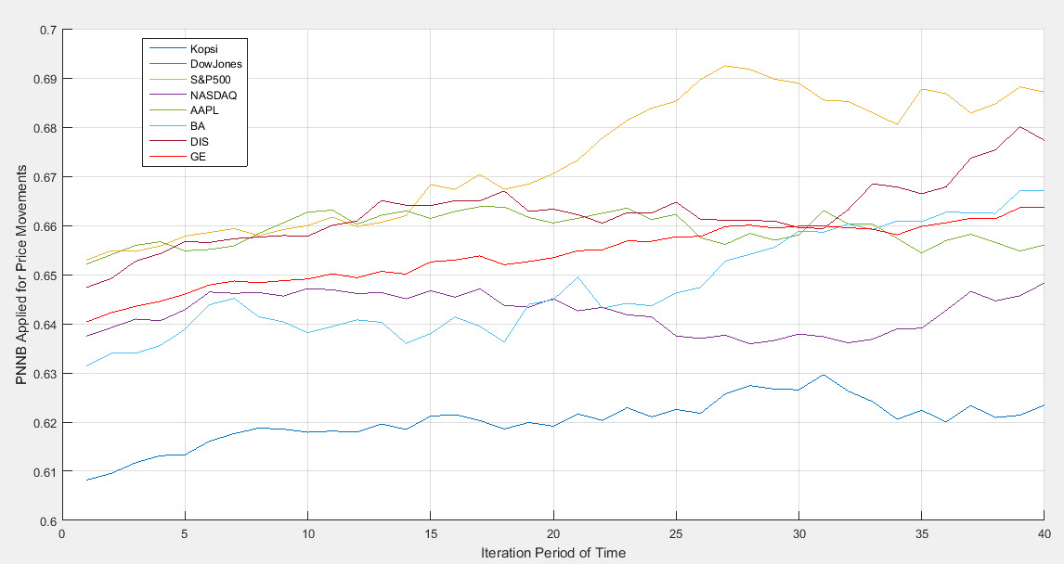
Figure (1). Price changes after applying the PNNB approach

According to the approach proposed by PNNB, it can be seen that the price movement based on the 4-day identification time period for the S&P500 with the orange chart has been the most dynamic. It is followed by DIS with magenta chart, BA with cyan chart, GE with red chart, AAPL with green chart, NASDAQ with purple chart, Dow Jones with pink chart and Kopsi with solid blue chart. So, the best stock to use in a portfolio design and selection in the stock portfolio is the S&P500, which should be predicted. It is worth noting that if other data is given and the price movement of each of them performs better in the 4-day time period of the data, the stock that performed best is qualified as the original population (based on the chaotic algorithm). Brownian) and is generally selected as an index stock, and its data is analyzed from 2006 to 2022 (about 5000 days in buying and selling). It is quite clear that the proposed approach based on the available data has placed the S&P500 index as the choice in the stock portfolio. Next, the stages of forecasting and identifying buying and selling situations will be discussed. The 5,000-day bid chart is displayed from the data call for the S&P500, as shown in Figure (2).
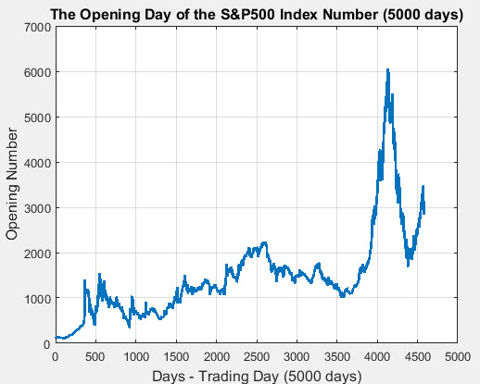
Figure (2). Chart of rates to buy in 5,000 days from the data call for the S&P500

Then, the combined approach of PNNB is applied to the S&P500 chart in Figure (2) so that all the points can be considered to identify the lower limit, middle limit and upper limit for buying and selling. Its result is clear in Figure (3).

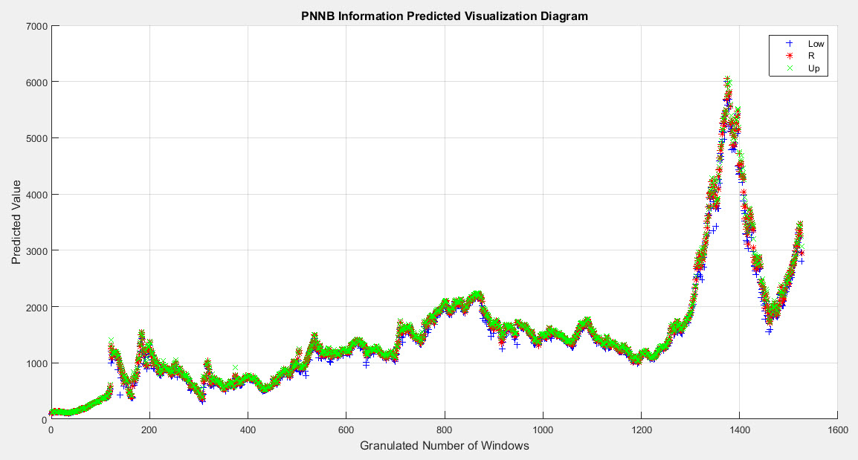
Figure (3). Identifying the lower limit, middle limit and upper limit for buying and selling the S&P500 index in the best possible conditions in 1600 days

In Figure (3), identifying the lower limit (blue symbol), middle limit (red symbol) and upper limit (green diagram) for buying and selling the S&P500 index in the best possible conditions in 1600 days selected with the help of PNNB is selected and displayed. All the mentioned points in the S&P500 price chart at 1800 are exactly the same as the 5000 days in Figure (2) and the same pattern has been examined. For a better understanding of Figure (3), a magnification is done on it, which will be in the form of Figure (4).

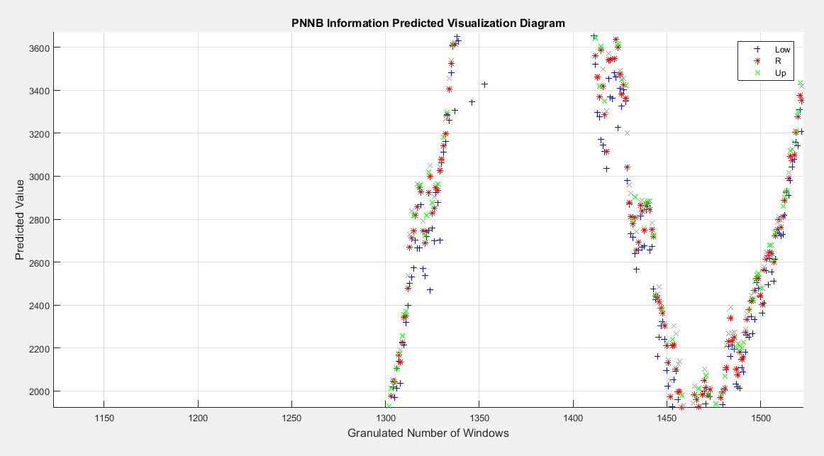
Figure (4). Zoom in Figure (2) to better visualize the identification of the low limit, middle limit and high limit for buying and selling the S&P500 index in the best possible conditions in 1600 days.

S&P500 stock selection is best for buying during the fall in the blue dots and for selling in the green dots. In the state of stagnation, the red part is also where you can take risks to buy or sell. Then, a chart for the best possible situations when buying the S&P500 is examined, which examines all the buying opportunities during the growth, and its error is where most of the falls occurred between the day 1350 and 1450, which are the errors of the work. The output of this section is also evident in Figure (5).
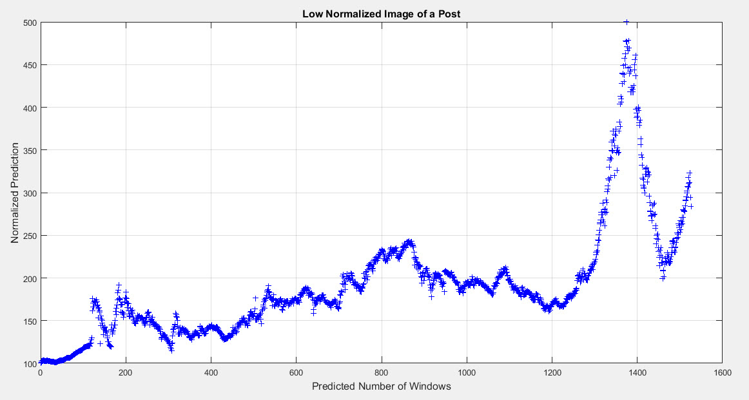
Figure (5). Examining buying opportunities during growth and the occurrence of forecasting errors during a major crash

The accurate and appropriate forecast for creating a stock portfolio with the S&P500 index can be seen in Figure (5), which is currently even beyond the forecasted value based on the analysis and shows the possibility of further growth. The accuracy result of the proposed approach after implementation is equal to 92% and its error rate is 8%. For evaluation, two other criteria have been used, which are the ROC curve and the AUC rate, the result of which is shown in Figure (6).

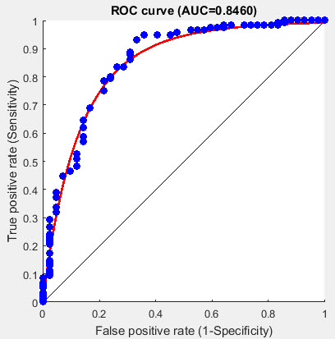
Figure (6). ROC result and AUC rate of the proposed approach

According to Figure (6), the ROC diagram is colored red and the middle line is regression. The area under the ROC to regression is called the area under the curve or AUC. The better the fit of the data on the ROC, the better the AUC. The value of AUC is 0.8460, which is 84.60% as a percentage, which is a good rate.

Conclusion
Predicting stock price trend is practically an interesting and challenging subject. Fundamental and technical analysis are the first two methods for predicting the stock price and its indices in the digital markets and the stock market. Various technical, fundamental and statistical indicators have been presented with different results. However, no single technique or combination of techniques has been successful enough to consistently "beat the market." With the development of neural networks, researchers and investors hope that the secrets of the market will be discovered. Although this is not an easy task due to its nonlinearity and uncertainty, many experiments using different methods have been presented, which can be referred to [25-33]. In this research, a new and optimal method is presented in the field of foreign exchange market forecasting from forex data, which uses the combined probabilistic neural network approach based on the Brownian curve. Based on the proposed approach, it has been shown that based on the Brownian curve, it has the ability to optimize the results of the probabilistic neural network, and the results of the combined approach, in addition to having the problem of high computational complexity, have more optimal results in terms of evaluation criteria, including accuracy. In terms of percentage, the area under the curve or AUC is based on percentage, mean squared error and other cases.

COMPETING INTERESTS DISCLAIMER:
Authors have declared that they have no known competing financial interests OR non-financial interests OR personal relationships that could have appeared to influence the work reported in this paper.

Disclaimer (Artificial intelligence)
Option 1:
Author(s) hereby declare that NO generative AI technologies such as Large Language Models (ChatGPT, COPILOT, etc.) and text-to-image generators have been used during the writing or editing of this manuscript.
Option 2:
Author(s) hereby declare that generative AI technologies such as Large Language Models, etc. have been used during the writing or editing of manuscripts. This explanation will include the name, version, model, and source of the generative AI technology and as well as all input prompts provided to the generative AI technology
Details of the AI usage are given below:
1.
2.
3.

References
[1] Singh A. N., Picot A., Kranz J., Gupta M. P., Ojha A. (2013). Information security management (ISM) practices: lessons from select cases from India and Germany. Global Journal of Flexible Systems Management, Vol. 14, No. 4, pp. 225–239.
[2] Ernst Young, (2012). Fighting to close the gap.
[3] Zahoor Ahmed Soomro, Mahmood Hussain Shah, Javed Ahmed. (2016). Information security management needs more holistic approach: A literature review. International Journal of Information Management. Vol. 16, pp. 215–225.
[4] Siponen M., Mahmood M. A. & Pahnila, S. (2009). Are employees putting your company at risk by not following information security policies? Communications of the ACM, Vol. 52, No. 12, pp. 145–147
[5] Ring T. (2013). A breach too far? Computer Fraud & Security, Vol. 6, pp. 5–9.
[6] Warwick Ashford, (2012). Many UK firms underestimate cost of data breaches, study finds. Retrieved from http://www.computerweekly.com/news/2240171040/Many-UK-firms-underestimate-cost-of-data-breaches-study-finds.
[7] Suchira Chaigusin, Chaiyaporn Chirathamjaree, Judy Clayden. (2008). The Use of Neural Networks in the Prediction of the Stock Exchange of Thailand (SET) Index. International Conference on Computational Intelligence for Modelling Control & Automation, pp. 670-673, 2008.
[8] Svitlana Galeshchuk. (2016). Neural networks performance in exchange rate prediction, Neurocomputing, Vol. 172, pp. 446-452.
[9] Mustafa Jahangoshai Rezaee, Mehrdad Jozmaleki, and Mahsa Valipour. (2018). Integrating dynamic fuzzy C-means, data envelopment analysis and artificial neural network to online prediction performance of companies in stock exchange. Physica A: Statistical Mechanics and its Applications, Vol. 489, 1 January 2018, pp. 78-93.
[10] Seungwoo Jeon, Bonghee Hong, and Victor Chang. (2018). Pattern graph tracking-based stock price prediction using big data. 2018. Future Generation Computer Systems, Vol. 80, March 2018, pp. 171-187.
[11] Amin Hedayati Moghaddam, Moein Hedayati Moghaddam, and Morteza Esfandyari. 2016. Stock market index prediction using artificial neural network. Journal of Economics, Finance and Administrative Science, Vol. 21, Issue 41, December 2016, pp. 89-93.
[12] Martha Pulido, Patricia Melin, and Oscar Castillo. 2014. Particle swarm optimization of ensemble neural networks with fuzzy aggregation for time series prediction of the Mexican Stock Exchange. Information Sciences, Vol. 280, 1 October 2014, pp. 188-204.
[13] Hyeuk Kim, and Sang Tae Han. 2016. The Enhanced Classification for the Stock Index Prediction. Procedia Computer Science, Vol. 91, 2016, pp. 284-286.
[14] G. Uetz. (1992). Foraging strategies of spiders. Trends in Ecology and Evolution. Vol. 7, No. 5, pp. 155–159.
[15] Cain Evansa, Konstantinos Pappasa, and Fatos Xhafa. (2013). Utilizing artificial neural networks and genetic algorithms to build an algo-trading model for intra-day foreign exchange speculation. Mathematical and Computer Modelling, Vol. 58, Issues 5–6, September 2013, pp. 1249-1266.
[16] Alexander Jakob Dautel, Wolfgang Karl Härdle, Stefan Lessmann, and Hsin-Vonn Seow. (2020). Forex exchange rate forecasting using deep recurrent neural networks. Digital Finance, Open Access, 2020.
[17] J. Batten, C. Ciner, B. Lucey. Volatility in precious metals markets. Resour. Pol., 35 (2) (2010), pp. 65-71.
[18] V. Corradi, W. Distaso, A. Mele. Macroeconomic determinants of stock volatility and volatility premiums. J. Monetary Econ., 60 (2) (2013), pp. 203-220.
[19] D. Mo, R. Gupta, B. Li, T. Singh. The macroeconomic determinants of commodity futures volatility: evidence from Chinese and Indian markets. Econ. Modell., 70 (2018), pp. 543-560.
[20] D. Lewis, K. Mertens, J. Stock. Weekly Economic Index. Retrieved from FRED, Federal Reserve Bank of St. Louis (2020). https://fred.stlouisfed.org/series/WEI, Accessed 26th May 2020
[21] I.J. Arnold, E.B. Vrugt. Stock market volatility and macroeconomic uncertainty: Evidence from survey data. (2006).
[22] Z. Chinzara. Macroeconomic uncertainty and conditional stock market volatility in South Africa. S. Afr. J. Econ., 79 (1) (2011), pp. 27-49.
[23] What Is the Economic VIX? The Wall Street Journal, May 2021.
[24] Joerg Osterrieder, Daniel Kucharczyk, Silas Rudolf, and Daniel Wittwer. Neural networks and arbitrage in the VIX: A deep learning approach for the VIX. Digit Finance, Volume 2, No. 1, 2020, Pages 97-115.
[25] Flavio Barboza, Herbert Kimura, and Edward Altman. “Machine learning models and bankruptcy prediction.” Expert Systems with Applications, Vol. 83, pp. 405-417, 2017.
[26] Pallavi Kamath, Pallavi Patil, Shrilatha S., and Sushma Sowmya S. Crop yield forecasting using data mining. Global Transitions Proceedings Volume 2, Issue 2, November 2021, Pages 402-407.
[27] Hyeuk Kim, and Sang Tae Han. 2016. The Enhanced Classification for the Stock Index Prediction. Procedia Computer Science, Vol. 91, 2016, pp. 284-286.
[28] Juergen Schmidhuber. Deep Learning in Neural Networks: An Overview. Neural and Evolutionary Computing (cs.NE); Machine Learning (cs.LG), arXiv: 1404.7828, 2015, 88 Pages.
[29] Chen L. C., Barron J. T., Papandreou G., Murphy K., and Yuille AL. Semantic image segmentation with task-specific edge detection using CNNS and a discriminatively trained domain transform. In: Proceedings of the IEEE conference on computer vision and pattern recognition, 2016, Pages 4545–4554.
[30] Chen L. C., Papandreou G., Kokkinos I., Murphy K., and Yuille A. L. Deeplab: semantic image segmentation with deep convolutional nets, atrous convolution, and fully connected crfs. arXiv preprint arXiv:1606.00915, 2016.
[31] Front. Neurosci. (2018). Deep Learning With Spiking Neurons: Opportunities and Challenges. 25 October 2018, Online Link: https://www.frontiersin.org/articles/10.3389/fnins.2018.00774/full.
[32] Didier Nibbering, and Trevor J. Hastie. Multiclass-penalized logistic regression. Computational Statistics & Data Analysis, Volume 169, May 2022, 107414.
[33] Bertrand Duplantier. Brownian Motion. Diverse and Undulating. Einstein, 1905-2005, Poincar ́e Seminar 1 (2005) T. Damour, O. Darrigol, B. Duplantier & V. Rivasseau, eds. Progress in Mathematical Physics, Vol. 47, 201 – 293 Birkh ̈auser Verlag, Basel, 2006.
[34] Tom Jewett. (2015). Database Design with UML and SQL, 3rd Edition, TomJewett.com.
[35] Ahmed K. Elmagarmid. (1992). Database Transaction Models for Advanced Applications (The Morgan Kaufmann Series in Data Management Systems). 1st Edition, The Morgan Kaufmann Series in Data Management Systems, Morgan Kaufmann; 1 edition (April 15, 1992), 611 pages.
[36] Adil Mobarek, Siddig Abdelrhman, Areege Abdel-Mutal, Sara Adam, Nawal Elbadri, and Tarig Mohammed Ahmed. (2015). TRANSACTION PROCESSING, TECHNIQUES IN MOBILE DATABASE: An OVERVIEW. International Journal on Computational Science & Applications (IJCSA), Vol. 5, No. 1.
[37] D. Roselin Selvarani, and Dr. T. N. Ravi (2012). A SURVEY ON DATA AND TRANSACTION MANAGEMENT IN MOBILE DATABASES. IJDMS, Vol. 4, No. 5.
[38] Vijay Kumar (2007). Tutorial 5: Management of Transactions on Mobile Database Systems. IEEE International Conference on Advanced Computing and Communications, ADCOM 2007, pp. xxviii.
[39] Mustafa Jahangoshai Rezaee, Mehrdad Jozmaleki, and Mahsa Valipour. (2018). Integrating dynamic fuzzy C-means, data envelopment analysis and artificial neural network to online prediction performance of companies in stock exchange. Physica A: Statistical Mechanics and its Applications, Vol. 489, 1 January 2018, pp. 78-93.
[40] Seungwoo Jeon, Bonghee Hong, and Victor Chang. (2018). Pattern graph tracking-based stock price prediction using big data. 2018. Future Generation Computer Systems, Vol. 80, March 2018, pp. 171-187.
[41] Amin Hedayati Moghaddam, Moein Hedayati Moghaddam, and Morteza Esfandyari. (2016). Stock market index prediction using artificial neural network. Journal of Economics, Finance and Administrative Science, Vol. 21, Issue 41, December 2016, pp. 89-93.
[42] Martha Pulido, Patricia Melin, and Oscar Castillo. (2014). Particle swarm optimization of ensemble neural networks with fuzzy aggregation for time series prediction of the Mexican Stock Exchange. Information Sciences, Vol. 280, 1 October 2014, pp. 188-204.
[43] Hyeuk Kim, and Sang Tae Han. (2016). The Enhanced Classification for the Stock Index Prediction. Procedia Computer Science, Vol. 91, 2016, pp. 284-286.
[44] Dadabada Pradeepkumar, and Vadlamani Ravi. (2018). Soft computing hybrids for FOREX rate prediction: A comprehensive review. Computers & Operations Research, Vol. 99, November 2018, pp. 262-284.
[45] Rajashree Dash. (2017). Performance analysis of an evolutionary recurrent Legendre Polynomial Neural Network in application to FOREX prediction. Journal of King Saud University - Computer and Information Sciences, In press, corrected proof, Available online 16 December 2017.
[46] Antonio V. Contreras, Antonio Llanes, Alberto Pérez-Bernabeu, Sergio Navarro, and José M. Cecilia. (2018). ENMX: An elastic network model to predict the FOREX market evolution. Simulation Modelling Practice and Theory, Vol. 86, August 2018, pp. 1-10.
[47] R. Pincak. (2013). The string prediction models as invariants of time series in the forex market. Physica A: Statistical Mechanics and its Applications, Vol. 392, Issue 24, 15 December 2013, pp. 6414-6426.
[48] Chien-Ping Chung, Tzu-Hsiang Liao, and Hsiu-Chuan Lee. Volatility spillovers of A- and B-shares for the Chinese stock market and its impact on the Chinese index returns. Pacific-Basin Finance Journal, Volume 65, February 2021, 101466.
[49] Jihong Xiao, Fenghua Wen, Yupei Zhao, and Xiong Wang. The role of US implied volatility index in forecasting Chinese stock market volatility: Evidence from HAR models. International Review of Economics & Finance, Volume 74, July 2021, Pages 311-333.
[50] Pierre J. Venter, and Eben Maré. Price discovery in the volatility index option market: A univariate GARCH approach. Finance Research Letters, Available online 15 April 2021, 102069 In Press, Corrected Proof.
[51] Wen Long, Manyi Zhao, and Yeran Tang. Can the Chinese volatility index reflect investor sentiment? International Review of Financial Analysis Volume 73, January 2021, 101612.
[52] Pratap Chandra Pati, Prabin Raji, and Parama Barai. The role of the volatility index in asset pricing: The case of the Indian stock market. The Quarterly Review of Economics and Finance, Volume 74, November 2019, Pages 336-346.
[53] Cong Sui, Peter Lung, and Mo Yang. Index option trading and equity volatility: Evidence from the SSE 50 and CSI 500 stocks. International Review of Economics & Finance, Volume 73, May 2021, Pages 60-75.
[54] Kais Tissaoui. Forecasting implied volatility risk indexes: International evidence using Hammerstein-ARX approach. International Review of Financial Analysis, Volume 64, July 2019, Pages 232-249.
[55] Yan Hu, Jian Ni, and Liu Wen. A hybrid deep learning approach by integrating LSTM-ANN networks with GARCH model for copper price volatility prediction. Physica A: Statistical Mechanics and its Applications, Volume 557, 1 November 2020, 124907.
[56] Fang Jia, and Boli Yang. Forecasting Volatility of Stock Index: Deep Learning Model with Likelihood-Based Loss Function. Complexity, Special Issue: Machine Learning Applications in Complex Economics and Financial Networks, Volume 2021, Article ID 5511802.
[57] Ali Hirsa, Joerg Osterrieder, Branka Hadji Misheva, Wenxin Cao, Yiwen Fu, Hanze Sun, and Kin Wai Wong. The VIX index under scrutiny of machine learning techniques and neural networks. General Finance (q-fin.GN); Trading and Market Microstructure (q-fin.TR), arXiv:2102.02119, 2021.
[58] James Hosker, Slobodan Djurdjevic, Hieu Nguyen, and Robert Slater. Improving VIX Futures Forecasts using Machine Learning Methods. DATA SCIENCE REVIEW, Volume 1, No. 4, 2018.
[59] Joerg Osterrieder, Daniel Kucharczyk, Silas Rudolf, and Daniel Wittwer. Neural networks and arbitrage in the VIX: A deep learning approach for the VIX. Digit Finance, Volume 2, No. 1, 2020, Pages 97-115.
[60] P. Hemanth Kumar, and S. Basavaraj Patil. A Hybrid Regression and Deep Learning LSTM Based Technique for Predicting Volatility IndeX (VIX) Direction of Change (Trend). Indian Journal of Science and Technology, Volume 11, Issue 47, 2018, Pages 1-9.
[61] Spyridon D. Vrontos, John Galakis, and Ionnis D. Vrontos. Implied volatility directional forecasting: a machine learning approach. Quantitative Finance, 2021.
[62] Bolin Lei, Zhengdi Liu, and Yuping Song. On stock volatility forecasting based on text mining and deep learning under high-frequency data. Wiley Journal of Forecasting, 2021.
[63] Mohil Maheshkumar Patel, Sudeep Tanwar, Rajesh Gupta, and Neeraj Kumar. A Deep Learning-based Cryptocurrency Price Prediction Scheme for Financial Institutions. Journal of Information Security and Applications, Volume 55, December 2020, 102583.
[64] Poongodi M.و Tu N. Nguyenو Mounir Hamdi, and Korhan Cengiz. Global cryptocurrency trend prediction using social media. Information Processing & Management, Volume 58, Issue 6, November 2021, 102708.
[65] Poongodi M., Ashutosh Sharma, Vijayakumar V., Vaibhav Bhardwaj, Abhinav Parkash Sharma, Razi Iqbal, and Rajiv Kumare. Prediction of the price of Ethereum blockchain cryptocurrency in an industrial finance system. Computers & Electrical Engineering, Volume 81, January 2020, 106527.
[66] Saúl Alonso-Monsalve, Andrés L. Suárez-Cetrulo, Alejandro Cervantes, and David Quintana. Convolution on neural networks for high-frequency trend prediction of cryptocurrency exchange rates using technical indicators. Expert Systems with Applications, Volume 149, 1 July 2020, 113250.
[67] Gulbadin Farooq Dar, Tirupathi Rao Padi, Sarode Rekha, and Qaiser Farooq Dar. Stochastic Modeling for the Analysis and Forecasting of Stock Market Trend using Hidden Markov Model. Asian Journal of Probability and Statistics, Volume 18, No. 1, Pages 43-56, 2022, Article no.AJPAS.88569.
[68] Chenxun Yuan, Xiang Ma, Hua Wang, Caiming Zhang, and Xuemei Li. COVID19-MLSF: A multi-task learning-based stock market forecasting framework during the COVID-19 pandemic. Expert Systems with Applications, Available online 16 January 2023, 119549 In Press, Journal Pre-proof.
[69] Mawuli Segnon, Rangan Gupta, and Bernd Wilfling. Forecasting stock market volatility with regime-switching GARCH-MIDAS: The role of geopolitical risks. International Journal of Forecasting, Available online 2 January 2023 In Press, Corrected Proof.
[70] Hubert Dichtl, Wolfgang Drobetz, and Tizian Otto. Forecasting Stock Market Crashes via Machine Learning. Journal of Financial Stability, Available online 19 December 2022, 101099 In Press, Journal Pre-proof.
[71] Wendai Lv, and Jipeng Qi. Stock market return predictability: A combination forecast perspective. International Review of Financial Analysis, Volume 84, November 2022, 102376.
[72] Zhao-Chen Li, Chi Xie, Zhi-Jian Zeng, Gang-Jin Wang, and Ting Zhang. Forecasting global stock market volatilities in an uncertain world. International Review of Financial Analysis, Volume 85, January 2023, 102463.
[73] Rui Qiu, Jing Liu, and Yan Li. Long-term adjusted volatility: Powerful capability in forecasting stock market returns. International Review of Financial Analysis, Volume 86, March 2023, 102530.
[74] Maria Ghani, Qiang Guo, Feng Ma, and Tao Li. Forecasting Pakistan stock market volatility: Evidence from economic variables and the uncertainty index. International Review of Economics & Finance, Volume 80, July 2022, Pages 1180-1189.
[75] Nicolas Chatelais, Arthur Stalla-Bourdillon, and Menzie D. Chinn. Forecasting real activity using cross-sectoral stock market information. Journal of International Money and Finance, Volume 131, March 2023, 102800.
[76] Yan Li, Chao Liang, and Toan Luu Duc Huynh. Forecasting US stock market returns by the aggressive stock-selection opportunity. Finance Research Letters, Volume 50, December 2022, 103323.
[77] Jia Luo, Ge Zhu, and Hui Xiang. Artificial Intelligent based day-ahead stock market profit forecasting. Computers and Electrical Engineering, Volume 99, April 2022, 107837.
[78] Felix Haase, and Matthias Neuenkirch. Predictability of bull and bear markets: A new look at forecasting stock market regimes (and returns) in the US. International Journal of Forecasting, Available online 25 February 2022 In Press, Corrected Proof.
[79] Mahdi Ghaemi Asl, Oluwasegun Babatunde Adekoy, Muhammad Mahdi Rashidi, Mohammad Ghasemi Doudkanlou, and Ali Dolatabadi. Forecast of Bayesian-based dynamic connectedness between oil market and Islamic stock indices of Islamic oil-exporting countries: Application of the cascade-forward backpropagation network. Resources Policy, Volume 77, August 2022, 102778.
[80] Arsalan Dezhkam, and Mohammad Taghi Manzuri. Forecasting stock market for an efficient portfolio by combining XGBoost and Hilbert–Huang ​transform. Engineering Applications of Artificial Intelligence, Volume 118, February 2023, 105626.
[81] Mahinda Mailagaha Kumbure, Christoph Lohrmann, Pasi Luukka, and Jari Porras. Machine learning techniques and data for stock market forecasting: A literature review. Expert Systems with Applications, Volume 197, 1 July 2022, 116659.
[82] Sahu SK, Mokhade A, Bokde ND. An overview of machine learning, deep learning, and reinforcement learning-based techniques in quantitative finance: recent progress and challenges. Applied Sciences. 2023 Feb 2;13(3):1956.

[83] Nayak GH, Alam MW, Avinash G, Kumar RR, Ray M, Barman S, Singh KN, Naik BS, Alam NM, Pal P, Rathod S. Transformer-based deep learning architecture for time series forecasting. Software Impacts. 2024 Nov 1;22:100716.

[84] Varshney RP, Sharma DK. Optimizing Time-Series forecasting using stacked deep learning framework with enhanced adaptive moment estimation and error correction. Expert Systems with Applications. 2024 Sep 1;249:123487.

[85] Naik, B. S., Karthik, V. C., Manjunatha, B., Veershetty, G. H., H. N., Varshini, B. S., P, H., & Rao, S. G. (2024). Stock Price Forecasting using N-Beats Deep Learning Architecture. Journal of Scientific Research and Reports, 30(9), 483–494.

[86] Belkhouja T, Yan Y, Doppa JR. Dynamic time warping based adversarial framework for time-series domain. IEEE transactions on pattern analysis and machine intelligence. 2022 Dec 5;45(6):7353-66.

[87] Abir SI, Sarwer MH, Hasan M, Sultana N, Dolon MS, Arefeen SS, Shimanto AH, Zakaria RM, Al Shiam SA, Shoha S, Saha TR. Deep Learning for Financial Markets: A Case-Based Analysis of BRICS Nations in the Era of Intelligent Forecasting. Journal of Economics, Finance and Accounting Studies. 2025;7(1):01-15.

