Successful Management of Infective Endocarditis Involving Double Native Valves After TUR-P: A Case Report

.
ABSTRACT

Aims: Infective endocarditis (IE) is an uncommon, yet potentially fatal disease characterized by infection of the endocardial surface, frequently affecting heart valves. Surgical interventions involving the urinary system can lead to temporary bacteraemia, which is crucial for the development of infective endocarditis. This report presents a case of double valve infective endocarditis in a diabetic patient subsequent to transurethral prostate removal, which was successfully addressed through surgical intervention.
Presentation of Case: A 65-year-old male patient with a history of hypertension and diabetes presented with new-onset heart failure and low-grade fever one month following transurethral resection of the prostate (TURP). Physical examination indicated signs of congestion and the presence of systolic and diastolic murmurs. Echocardiography demonstrated significant vegetations on the mitral and aortic valves, accompanied by severe regurgitation. Empirical antibiotic therapy was commenced; however, multiple blood cultures yielded negative results. The patient underwent concurrent mitral and aortic valve replacement along with coronary artery bypass grafting (CABG) due to symptoms of heart failure and the risk of embolism. Histological examination and culture of the valve revealed Staphylococcus warneri as the causative microorganism. The patient was subsequently discharged successfully.
Discussion and Conclusion: Managing IE to prevent and treat consequences including embolism and heart failure depends critically on parenteral antibiotics and quick surgical intervention. Staphylococcus warneri is low virulent, but it can be invasive in sensitive people, which emphasizes the significance of early identification and treatment.

Keywords: double valve infective endocarditis; double valve replacement; transurethral prostatic resection; S. warneri

1. INTRODUCTION

Infective endocarditis (IE) is a severe infection that targets the inner lining of the heart and its valves. It generally encompasses a native or prosthetic heart valve or an intracardiac device (Delgado et al., 2023). The epidemiology of this disease has experienced notable changes in recent years, likely due to the rise in invasive cardiac interventions, increased life expectancy, and the existence of associated comorbidities. Despite significant advancements in diagnosis, treatment, and microbiological techniques, infective endocarditis remains associated with considerable morbidity and mortality, exhibiting a 30-day mortality rate that can reach 30% (Ambrosioni et al., 2023).

While diabetes mellitus has been linked with prognostic indicators such as advanced age, comorbidities, atypical clinical presentation, and longer IE diagnosis time, common risk factors for the development of infective endocarditis are male sex, intravenous drug use, poor dental hygiene and infection, structural heart disease, prosthetic valves, intracardiac devices, previous episode of infective endocarditis, and long-term haemodialysis (Chambers & Bayer, 2020; Naaim et al., 2023). Whereas the right heart valves are afflicted in just 5–10% of cases, IE mostly affects the left heart valves in 85–90% of cases (Cimmino et al., 2023). Usually affecting the mitral and aortic valves, involvement of multiple heart valves is a rare disorder that is connected with a higher chance of developing congestive heart failure and a larger rate of mortality (Monari et al., 2023).

The predominant pathogen for acute infective endocarditis (IE) is Staphylococcus aureus (26–28%), typically associated with acute and destructive forms of IE (Delgado et al., 2023), although coagulase-negative Staphylococcus, such as Staphylococcus warneri, may cause more chronic valve infections (Alawad, Ali, & Goravey, 2022). Staphylococcus warneri is generally considered non-pathogenic but can occasionally cause infections in specific populations, including immunocompromised individuals, the elderly, patients with extended hospital stays, and those with invasive medical equipment (Alawad et al., 2022).

The management of IE focusses on the total eradication of the microbial infection with antibiotic medication, while surgical intervention assists in the removal of infectious debris (Delgado et al., 2023). Surgical management is indicated primarily for symptoms of heart failure, uncontrolled infection characterised by prolonged fever or persistent bacteraemia despite antibiotic treatment, mechanical complications such as heart block, annular or aortic abscess, or destructive penetrating lesions, and the prevention of septic embolization, especially to the central nervous system (Delgado et al., 2023; Pettersson et al., 2017). This report discusses a case of double valve infective endocarditis following transurethral prostate resection, which was adequately managed with surgical surgery.

2. PRESENTATION OF CASE

A 65-year-old male with a history of chronic hypertension and type 2 diabetes mellitus arrived with newly developed heart failure and a low-grade fever one month before hospital admission. The patient has a history of lower urinary tract syndrome and underwent transurethral resection of the prostate (TUR-P) one month prior to admission. The physical examination revealed a systolic murmur at the apex and a diastolic murmur in the right second intercostal region. The chest X-ray demonstrated mild cardiomegaly with pulmonary oedema, and the ECG showed sinus rhythm with left ventricular hypertrophy (Figure 1). Laboratory results revealed raised CRP levels, minor anaemia (Hb 9.8 g/dL), leucocytosis (11,500/µL), and mild thrombocytopenia (140,000/µL), in addition to a decreased glomerular filtration rate (22 mL/min/1.73 m²). Echocardiography indicated a mildly dilated left ventricle (LVIDd 60 mm) with a normal ejection fraction of 72% and maintained left ventricle motion. The echocardiographic assessment of the valves indicated the presence of vegetation measuring 0.7 x 2.3 cm affixed to the posterior mitral leaflet (PML), leading to significant mitral regurgitation. Furthermore, there was a back-and-forth vegetation measuring 0.5 x 1.4 cm affixed to the non-coronary cusp (NCC), resulting in valve damage and significant aortic regurgitation (Figure 2).

The patient was evaluated for suspected infective endocarditis and administered empirical antibiotic therapy consisting of Ampicillin, Ceftriaxone, and Moxifloxacin. Nonetheless, blood cultures conducted three times revealed no discernible pathogens. After approximately one month of in-hospitalisation with no significant improvement, the decision was made to conduct a double valve replacement on the patient due to the presence of heart failure and the extent of the vegetation. Pre-operative coronary angiography demonstrated 80% stenosis in the mid left anterior descending artery (LAD). The patient subsequently received a successful double valve replacement of the mitral and aortic valves, accompanied with a single coronary artery bypass graft (SVG to the distal LAD). Histological analysis of aortic valve tissue indicated signs of an inflammatory disease (valvulitis) and identified Gram-positive cocci, with tissue culture confirming Staphylococcus warneri as the pathogen. Post-operative echocardiogram indicated normal valve function, and the patient was subsequently discharged satisfactorily after completing the antibiotic regimen.

3. discussion

Infective endocarditis (IE) is defined by the infection of a natural or prosthetic heart valve, endocardium, or an implanted cardiac device. The disease's aetiology and epidemiology have changed in recent years, evidenced by a doubling of the average patient age and an increased prevalence among individuals with indwelling cardiac devices (Cahill & Prendergast, 2016). The microbiology of the disease has changed, with staphylococci, typically associated with healthcare encounters and invasive procedures, overtaking streptococci as the primary causative agent of the disease (Cahill & Prendergast, 2016). Notwithstanding the introduction of innovative diagnostic and therapeutic methods, the one-year mortality rate has remained unchanged and is exceedingly high at 30% (Cahill & Prendergast, 2016).

We described a 65-years old diabetic patients with abrupt heart failure and protracted subfebrile fever that underwent urology invasive operation two months prior that was subsequently identified with IE. The global growth in diabetes mellitus has associated with an increased proportion of diabetes among persons suffering from IE (De Miguel-Yanes et al., 2019). With the increase in life expectancy, individuals, including those with diabetes, will experience prolonged exposure to risk factors for infective endocarditis (IE), such as degenerative valvular lesions, prosthetic valves, intra-cardiac electronic devices, and long-term intravenous lines (Sy & Kritharides, 2010). Diabetes mellitus also affects the immune system, hence boosting the risk of sepsis and aggravating outcomes in patients with bacteraemia (De Miguel-Yanes et al., 2019).

The initial clinical evaluation of a suspected case of IE requires a careful consideration of risk factors, alongside the gathering of relevant historical and examination evidence to support the diagnosis. The main cardiac risk factors include a history of IE, the presence of prosthetic valves or cardiac devices, as well as valvular or congenital heart conditions. On the other hand, non-cardiac risk factors involve intravenous drug use, the presence of indwelling intravenous lines, immunosuppression, and recent dental or surgical procedures (Cahill & Prendergast, 2016; Delgado et al., 2023). The patient has previously undergone a transurethral excision of the prostate (TUR-P) due to benign prostatic hyperplasia. Injury to the prostate tissue during the procedure can create an opportunity for infection, which may result in temporary bacteraemia that is crucial for the development of IE.

IE poses a diagnostic challenge due to its varied clinical presentations. Among these, fever is observed in 90% of patients, while a cardiac murmur is present in 85% of cases, making them the most frequently encountered symptoms. When patients present with sepsis or fever of unknown origin, it is important to consider a diagnosis of IE, especially if there are accompanying risk factors (Delgado et al., 2023). Signs such as splenomegaly or cutaneous manifestations, including petechiae or splinter haemorrhages, provide supportive evidence (Cahill & Prendergast, 2016). In contrast to common medical teachings, it is important to note that Osler’s nodes, Janeway lesions, and Roth spots are infrequently observed (Cahill & Prendergast, 2016). Complications like heart failure, stroke, or metastatic infections, including vertebral osteomyelitis and peripheral abscess, occur with greater frequency (Cahill & Prendergast, 2016). The results from standard laboratory tests typically show non-specific indicators, such as increased inflammatory markers and normocytic–normochromic anaemia. It is crucial to conduct an admission and daily electrocardiogram, as the emergence of new conduction diseases, including atrioventricular block, bundle branch block, or complete heart block, may suggest a possible extension of infection to the paravalvular area or the myocardium (Cahill & Prendergast, 2016). The patient in our case presented with new-onset heart failure accompanied by a prolonged low-grade fever that persisted for one month before admission. During the physical examination, cardiac murmurs were detected; however, no additional physical signs typically associated with infective endocarditis were found. This might be related to the causative organism in this instance, which is typically a commensal organism exhibiting low virulence.

Diagnosing IE requires a thoughtful combination of clinical observations, microbiological findings, and imaging results. The revised Duke clinical diagnostic criteria include these three domains and categorise findings into major or minor criteria (see Table 1). To establish a definitive diagnosis, it is essential to meet either two major criteria, one major criterion in conjunction with three minor criteria, or a total of five minor criteria. It is important for clinicians and researchers to recognise that the Duke criteria were initially created for the purpose of scientific research classification, rather than serving as a clinical tool (Cahill & Prendergast, 2016). The patient satisfied two significant criteria: (1) histologic examination showed evidence of valvulitis, and Staphylococcus warneri was identified in the culture of aortic tissue; and (2) echocardiographic results demonstrated an oscillating intracardiac mass (vegetation) on both the mitral and aortic valves, aligned with the regurgitant jets (Figure 2).

Gram-positive cocci, such as staphylococcus, streptococcus, and enterococcus, are responsible for a significant majority, approximately 80–90%, of endocarditis cases. In high-income countries, IE is mainly linked to Staphylococcus aureus, which is found in around 30% of cases (Murdoch et al., 2009). Staphylococcal IE can affects both native and prosthetic valves, reaching beyond specific groups like individuals on haemodialysis and those who use intravenous drugs. The development of antibiotic resistance occurs at a swift pace, with methicillin-resistant strains appearing worldwide (Cahill & Prendergast, 2016). Coagulase-negative staphylococci (CoNS), such as S. epidermidis, S. lugdunensis, S. warneri, and S. capitis, are commonly found as skin commensals. Hospital-acquired native valve endocarditis is often linked to Coagulase-negative Staphylococci, as noted by Cahill and Prendergast in 2016. The patient exhibited symptoms and signs of IE following an in-hospital invasive procedure, specifically transurethral resection of the prostate for benign prostatic hyperplasia. The commensals are capable of generating biofilm, quickly forming abscesses, and demonstrating resistance to a variety of antibiotics (Cahill & Prendergast, 2016).

Staphylococcus warneri is prevalent in 50% of healthy individuals and makes up 4.0%–7.8% of the total skin staphylococci (Becker, Heilmann, & Peters, 2014). It can be found in the nostrils, head, legs, and arms. This microbe is not often recognised as a human pathogen; nonetheless, it can be found in individuals with weakened immune systems or those who have medical prostheses, including artificial heart valves, central venous catheters, and disc prostheses (Becker et al., 2014). This report discusses an uncommon case of endocarditis linked to Staphylococcus warneri. At first, three consecutive blood cultures yielded negative results for both bacteria and fungi. However, the culture of the aortic tissue subsequently tested positive for this particular bacterium.

Numerous studies have documented instances of IE associated with Staphylococcus warneri, occurring in both healthy individuals with robust immune systems and no apparent risk factors (Bhardwaj et al., 2016; El Nakadi & El Nakadi, 2021; Gelman et al., 2022), as well as in patients who have underlying predisposing conditions (Arslan, Saltoglu, Mete, & Mert, 2011; Stöllberger et al., 2006; Yamamoto et al., 2020). In this case, the clear predisposing factors for IE include diabetes mellitus and a prior history of TUR-P. Diabetes mellitus is recognised as a significant risk factor for the development of infectious diseases. Individuals who use insulin show an elevated risk of being hospitalised for infectious diseases, as well as a higher mortality rate associated with IE (Duval et al., 2006). A recent cohort study revealed that individuals living with type 1 diabetes face a heightened risk of severe infections, such as endocarditis (Carey et al., 2018).

Bacteraemia frequently occurs during TUR-P procedures. In their study, Mohee et al. (2016) investigated a cohort of 73 patients who had undergone TUR-P. They found that 23.2% of these individuals developed asymptomatic bacteraemia, with Enterococcus faecalis and Pseudomonas aeruginosa identified as the most commonly cultured organisms (Mohee et al., 2016). The research indicated a rising odds ratio (OR) for the development of bacteraemia at 10 and 20 minutes after the procedure, implying a connection between the length of the procedure and the risk of bacteraemia. Moreover, the analysis revealed no statistical correlation between the results of pre-operative urine cultures and the outcomes of blood cultures (Mohee et al., 2016). This suggests that urine may not serve as the primary source of bacteraemia in cases of sepsis related to TUR-P and that there may be an underlying prostatic infection that is playing a role in the development of bacteraemia. During the procedure, transient bacteraemia may act as a contributing factor to the onset of IE.

Numerous retrospective studies have demonstrated that surgery can independently predict survival among patients with infective endocarditis across various clinical contexts, offering a potential curative treatment option for certain groups of patients (Delgado et al., 2023). Surgical intervention is primarily indicated in cases of heart failure due to valve regurgitation, persistent infection, and the need to prevent embolism (Delgado et al., 2023). The patient presented with a sudden onset of heart failure, marked by significant mitral and aortic regurgitation. Additionally, there were vegetations observed on the mitral and aortic valves, measuring at least 10 mm. The pre-operative angiography revealed notable narrowing in the mid section of the LAD, while the proximal left circumflex artery (LCx) showed only minor narrowing. As a result, mitral and aortic valve replacement, in addition to coronary artery bypass grafting (CABG), was carried out, leading to positive outcomes. A recent study highlighted that double-valve surgery for IE is a procedure with significant risks. Nevertheless, it has been linked to better survival rates over time, probably because of earlier hospital visits and timely surgical interventions (Miller et al., 2024). In this instance, the surgical procedure was performed following about a month of hospitalisation, during which antibiotic treatment did not yield significant results.

When deciding on the suitable type of valve prosthesis for individuals with infective endocarditis, a range of patient characteristics is taken into account. Choosing the appropriate valves involves considering various factors, including the patient's recent stroke history, the potential for new bleeding incidents, the expected complexity of the recovery process, and the individual's ability to participate in decisions regarding long-term anticoagulation for mechanical heart valves (Delgado et al., 2023). Older patients with an increased risk of bleeding, pregnancy or the possibility of becoming pregnant, and challenges with medical compliance tend to support the choice of a bioprosthetic valve. Conversely, in younger patients, considerations like a high risk of re-infection, strong adherence to medication, and a longer life expectancy typically favour the use of a mechanical valve. In this instance, the decision was made to utilise a bioprosthetic valve for the replacement of both the mitral and aortic valves, carefully considering the patient's age and the associated risk of bleeding. When there are no specific contraindications for a particular valve substitute, the final choice should reflect the preferences of the patient (Delgado et al., 2023). After a thorough discussion with the patient and his family, it was determined that a double valve replacement using a bioprosthetic valve would be performed, followed by a continuation of antibiotics for up to six weeks. The patient received anticoagulation treatment with a vitamin K antagonist for a duration of three months, after which they transitioned to a regimen of single antiplatelet therapy using low-dose aspirin.

4. Conclusion

Effectively managing IE necessitates collaboration among various healthcare professionals, including infectious disease specialists, cardiologists, and cardiothoracic surgeons. Treatment primarily involves the use of intravenous antibiotics, and in cases where complications arise—such as valve dysfunction, heart failure, ongoing infection, or the potential for systemic embolization—surgical intervention becomes necessary. Recognising the prompt need for intervention and ensuring timely surgical procedures are crucial for enhancing patient outcomes, especially in intricate cases that involve multiple valves. This case underscores the significance of considering less common pathogens, like Staphylococcus warneri, in patients who present with relevant risk factors. While generally regarded as having low virulence, S. warneri has the potential to act as an invasive pathogen in individuals with compromised immune systems.

Consent

All authors declare that ‘written informed consent was obtained from the patient (or other approved parties) for publication of this case report and accompanying images. A copy of the written consent is available for review by the Editorial office/Chief Editor/Editorial Board members of this journal.

DISCLAIMER (ARTIFICIAL INTELLIGENCE)
Author(s) hereby declares that NO generative AI technologies such as Large Language Models (ChatGPT, COPILOT, etc.) and text-to-image generators have been used during the writing or editing of this manuscript.

References

Alawad, M. J., Ali, G. A., & Goravey, W. (2022). Underrecognized pathogen; Staphylococcus warneri ‐associated native mitral valve endocarditis in an immunocompetent host: A case report and literature review . Clinical Case Reports, 10(4). doi:10.1002/ccr3.5591
Ambrosioni, J., Hernández-Meneses, M., Durante-Mangoni, E., Tattevin, P., Olaison, L., Freiberger, T., … Sexton, D. J. (2023). Epidemiological Changes and Improvement in Outcomes of Infective Endocarditis in Europe in the Twenty-First Century: An International Collaboration on Endocarditis (ICE) Prospective Cohort Study (2000–2012). Infectious Diseases and Therapy, 12(4), 1083–1101. doi:10.1007/s40121-023-00763-8
Arslan, F., Saltoglu, N., Mete, B., & Mert, A. (2011). Recurrent Staphylococcus warnerii prosthetic valve endocarditis: A case report and review. Annals of Clinical Microbiology and Antimicrobials, 10. doi:10.1186/1476-0711-10-14
Becker, K., Heilmann, C., & Peters, G. (2014). Coagulase-negative staphylococci. Clinical Microbiology Reviews, 27(4), 870–926. doi:10.1128/CMR.00109-13
Cahill, T. J., & Prendergast, B. D. (2016). Infective endocarditis. In The Lancet (Vol. 387, pp. 882–893). Lancet Publishing Group. doi:10.1016/S0140-6736(15)00067-7
Carey, I. M., Critchley, J. A., Dewilde, S., Harris, T., Hosking, F. J., & Cook, D. G. (2018). Risk of infection in type 1 and type 2 diabetes compared with the general population: A matched cohort study. Diabetes Care, 41(3), 513–521. doi:10.2337/dc17-2131
Chambers, H. F., & Bayer, A. S. (2020). Native-Valve Infective Endocarditis. New England Journal of Medicine, 383(6), 567–576. doi:10.1056/nejmcp2000400
Cimmino, G., Bottino, R., Formisano, T., Orlandi, M., Molinari, D., Sperlongano, S., … Coppola, N. (2023, February 1). Current Views on Infective Endocarditis: Changing Epidemiology, Improving Diagnostic Tools and Centering the Patient for Up-to-Date Management. Life. MDPI. doi:10.3390/life13020377
De Miguel-Yanes, J. M., Jiménez-García, R., Hernández-Barrera, V., De Miguel-Díez, J., Méndez-Bailón, M., Muñoz-Rivas, N., … López-De-Andrés, A. (2019). Infective endocarditis according to type 2 diabetes mellitus status: An observational study in Spain, 2001-2015. Cardiovascular Diabetology, 18(1). doi:10.1186/s12933-019-0968-0
Delgado, V., Ajmone Marsan, N., De Waha, S., Bonaros, N., Brida, M., Burri, H., … Borger, M. A. (2023). 2023 ESC Guidelines for the management of endocarditis. European Heart Journal, 44(39), 3948–4042. doi:10.1093/eurheartj/ehad193
Duval, X., Alla, F., Doco-Lecompte, T., Le Moing, V., Delahaye, F., Mainardi, J.-L., … Leport, C. (2006). Diabetes mellitus and infective endocarditis: the insulin factor in patient morbidity and mortality. European Heart Journal, 28(1), 59–64. doi:10.1093/eurheartj/ehl318
Li, J. S., Sexton, D. J., Mick, N., Nettles, R., Fowler Jr., V. G., Ryan, T., … Corey, G. R. (2000). Proposed Modifications to the Duke Criteria for the Diagnosis of Infective Endocarditis. Clinical Infectious Diseases, 30(4), 633–638. doi:10.1086/313753
Miller, P. C., Schulte, L. J., Marghitu, T., Huang, S. X., Kaneko, T., Damiano, R. J., & Kachroo, P. (2024). Outcomes of double-valve surgery for infective endocarditis are improving in the modern era. Journal of Thoracic and Cardiovascular Surgery, 168(3), 832–842. doi:10.1016/j.jtcvs.2023.09.072
Mohee, A. R., Gascoyne-Binzi, D., West, R., Bhattarai, S., Eardley, I., & Sandoe, J. A. T. (2016). Bacteraemia during transurethral resection of the prostate: What are the risk factors and is it more common than we think? PLoS ONE, 11(7). doi:10.1371/journal.pone.0157864
Monari, C., Molinari, D., Cornelli, A., Alessio, L., Coppolino, F., Barbareschi, C., … Formisano, T. (2023). An Unusual Case of a Double Tricuspid and Mitral Valves Infective Endocarditis Complicated by Multiple Septic Embolisms Secondary to an Atrial Septal Defect: A Case Report and Review of Literature. Infectious Disease Reports, 15(5), 494–503. doi:10.3390/idr15050049
Murdoch, D. R., Corey, G. R., Hoen, B., Miró, J. M., Fowler Jr, V. G., Bayer, A. S., … Investigators, I. C. on E. C. S. (ICE-P. (2009). Clinical Presentation, Etiology, and Outcome of Infective Endocarditis in the 21st Century: The International Collaboration on Endocarditis–Prospective Cohort Study. Archives of Internal Medicine, 169(5), 463–473. doi:10.1001/archinternmed.2008.603
Naaim, M., Essaket, I., Nafidi, S., Eljamili, M., Karimi, S. El, & Hattaoui, M. El. (2023). Lactococcus lactis Causes Pulmonary Valve Endocarditis in a Patient with Complex Congenital Heart Disease. Asian Journal of Research in Infectious Diseases, 14(3), 1–9. doi:10.9734/ajrid/2023/v14i3292
Pettersson, G. B., Coselli, J. S., Coselli, J. S., Hussain, S. T., Griffin, B., Blackstone, E. H., … Woc-Colburn, L. E. (2017). 2016 The American Association for Thoracic Surgery (AATS) consensus guidelines: Surgical treatment of infective endocarditis: Executive summary. Journal of Thoracic and Cardiovascular Surgery, 153(6), 1241-1258.e29. doi:10.1016/j.jtcvs.2016.09.093
Stöllberger, C., Wechsler-Fördös, A., Geppert, F., Gulz, W., Brownstone, E., Nicolakis, M., & Finsterer, J. (2006). Staphylococcus warneri endocarditis after implantation of a lumbar disc prosthesis in an immunocompetent patient. Journal of Infection, 52(1), e15–e18. doi:https://doi.org/10.1016/j.jinf.2005.04.016
Sy, R. W., & Kritharides, L. (2010). Health care exposure and age in infective endocarditis: results of a contemporary population-based profile of 1536 patients in Australia. European Heart Journal, 31(15), 1890–1897. doi:10.1093/eurheartj/ehq110
Yamamoto, J., Endo, A., Sugawara, H., Izumi, T., Takahashi, K., Yamamoto, S., … Katagiri, H. (2020). Native valve endocarditis due to staphylococcus warneri developing in a patient with type 1 diabetes. Internal Medicine, 59(18), 2269–2274. doi:10.2169/INTERNALMEDICINE.4661-20

Abbreviations

CABG : coronary artery bypass grafting
CoNS : coagulase-negative staphylococci
CRP : C-reactive protein
ECG : electrocardiogram
Hb : haemoglobin
IE : infective endocarditis
LAD : left anterior descending
LCx : left circumflex artery
LVIDd : left ventricular internal diameter end diastole
NCC : non-coronary cusp
PML : posterior mitral leaflet
SVG : saphenous vein graft
TUR-P : transurethral resection of the prostate

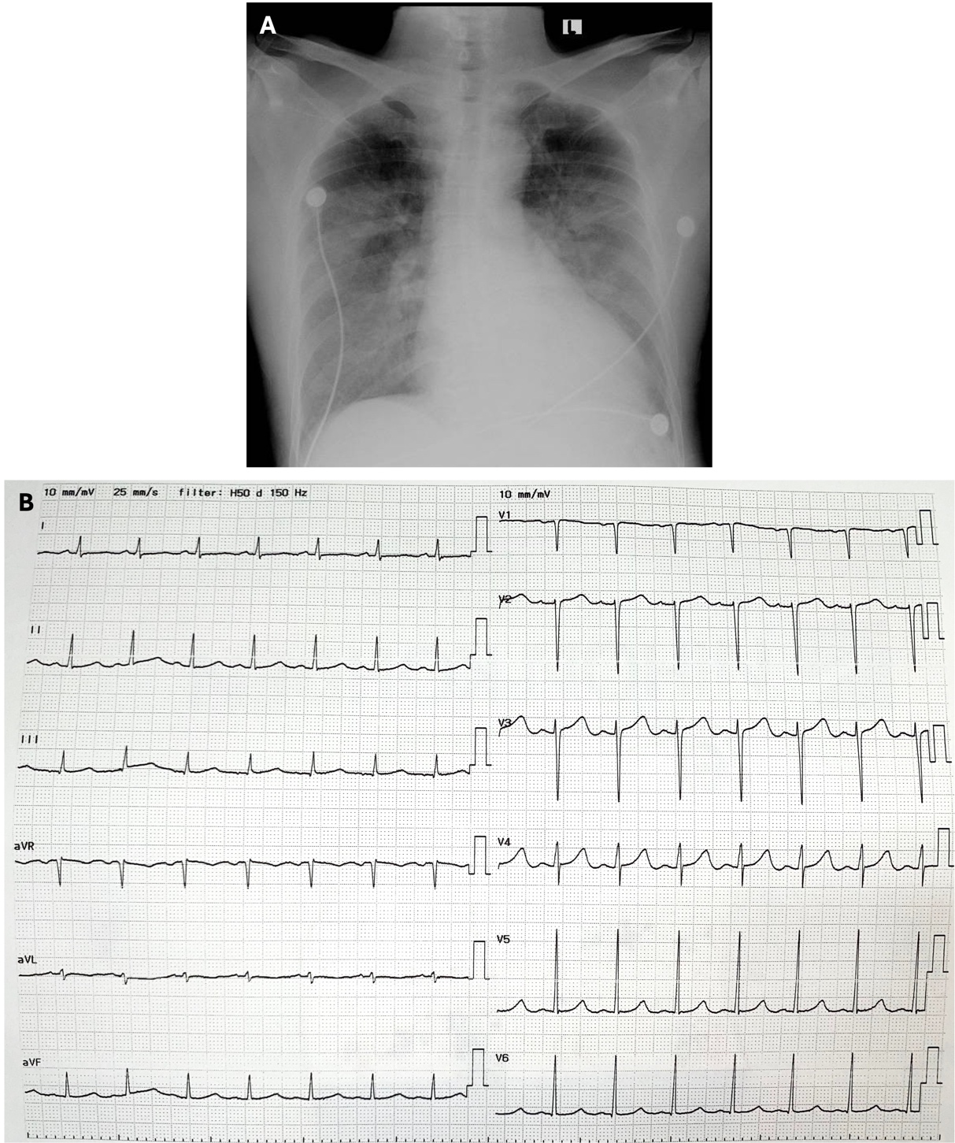

Figure 1. (A) Chest x-ray showing slight cardiomegaly with increased pulmonary vasculature indicating pulmonary congestion. (B) Electrocardiogram showing sinus rhythm with left ventricular hypertrophy (Sokolov-Lyon criteria). No arrythmia was detected.

Table 1. Definition of infective endocarditis according to the modified Duke criteria (Li et al., 2000)
Major criteria | Minor criteria
Pathologic criteria  - Microorganisms demonstrated by culture or histologic examination of a vegetation, a vegetation that has embolized, or an intracardiac abscess specimen; or  - Pathologic lesions: vegetation or intracardiac abscess confirmed by histologic examination showing active endocarditis. | Predisposition, predisposing heart condition, or injection drug use.
Blood culture positive for IE  - Typical microorganisms consistent with IE from 2 separate blood cultures:  - oral streptococci, Streptococcus gallolyticus, HACEK group, Staphylococcus aureus; or  - community-acquired enterococci, in the absence of a primary focus; or  - Microorganisms consistent with IE from persistently positive blood cultures, defined as follows:  - at least 2 positive cultures of blood samples drawn >12 h apart; or  - all of 3 or a majority of >4 separate cultures of blood (with first and last sample drawn at least 1 h apart).  - Single positive blood culture for Coxiella burnetii or antiphase I IgG antibody titre >1:800. | Fever, temperature >38°C.
Evidence of endocardial involvement  Echocardiogram positive for IE (TOE recommended in patients with prosthetic valves, rated at least ‘possible IE’ by clinical criteria, or complicated IE [paravalvular abscess]; TTE as first test in other patients), defined as follows:  - oscillating intracardiac mass on valve or supporting structures, in the path of regurgitant jets, or on implanted material in the absence of an alternative anatomic explanation; or  - abscess; or  - new partial dehiscence of prosthetic valve. | Microbiological evidence: positive blood culture but does not meet a major criterion as noted above a or serological evidence of active infection with organism consistent with IE.
New valvular regurgitation (worsening or changing of pre-existing murmur not sufficient) | Vascular phenomena, major arterial emboli, septic pulmonary infarcts, mycotic aneurysm, intracranial haemorrhage, conjunctival haemorrhages, and Janeway lesions.
 | Immunologic phenomena: glomerulonephritis, Osler nodes, Roth spots, and rheumatoid factor.

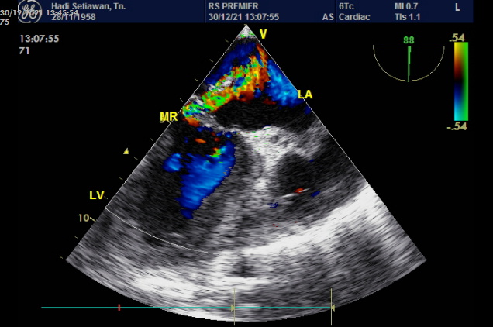
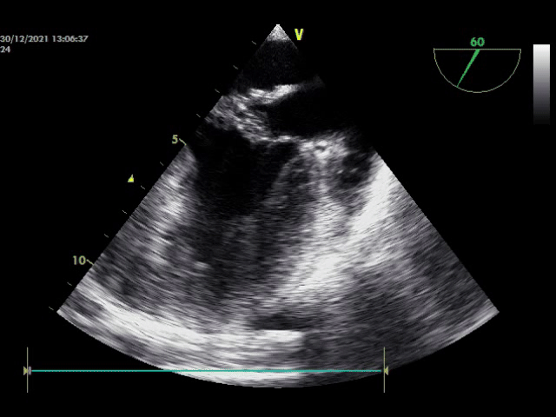
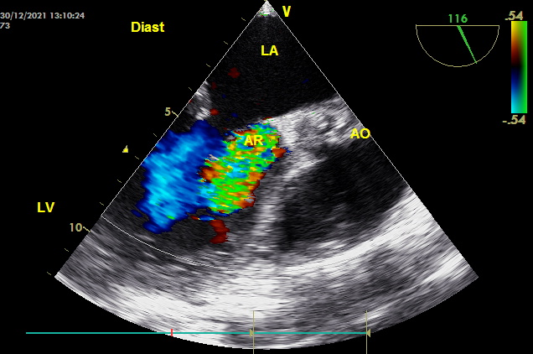
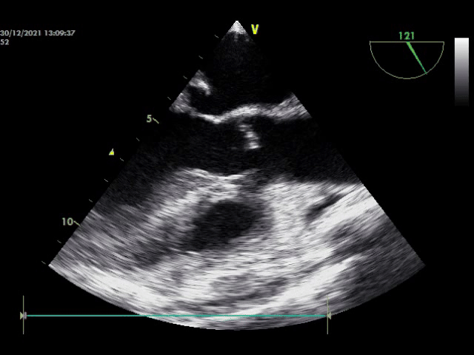
B
A

Figure 2. (A) Long-axis view of transoesophageal echocardiography showing oscillating mass at the aortic valve (left panel) causing severe aortic regurgitation (right panel). (B) Two-chamber view of transoesophageal echocardiography showing vegetation at the posterior mitral leaflet (left panel) with severe mitral regurgitation (right panel).

