***Case report***

**Congenitally Corrected Transposition of the Great Arteries in a 74-Year-Old Misdiagnosed as Ischemic Cardiomyopathy: A Case of Misinterpreted Ventricular Morphology**

### ABSTRACT

**Congenitally Corrected Transposition of the Great Arteries (CCTGA)** is a rare form of congenital heart disease (CHD) that presents with both **atrioventricular (AV)** and **ventriculoarterial** (VA) discordance. This condition accounts for a small proportion of CHD, and its presentation in later life can be challenging due to its gradual nature. We present the case of a **74-year-old male** misdiagnosed with **ischemic cardiomyopathy of left ventricle**, who presented with symptoms of **congestive heart failure (CHF)** after decades of being asymptomatic. Diagnostic work-up revealed features of **CCTGA**, including **severe left AV valve regurgitation** and evidence of left sided **right ventricular dysfunction**. This case highlights the importance of considering CHD in older adults, particularly those presenting with signs of heart failure, and underscores the need for early diagnosis and intervention.

Keywords: congenital heart disease (CHD), Ventricular Morphology,heart disease, Congenitally Corrected Transposition of the Great Arteries (CCTGA), heart failure

### INTRODUCTION

**Congenitally Corrected Transposition of the Great Arteries (CCTGA)** is a rare congenital heart disease (CHD) characterized by **atrioventricular** (AV) and **ventriculoarterial** (VA) discordance. The defect is noted in approximately 0.5-1% of all CHD cases (1). Described by **Von Rokitansky** in 1875, CCTGA occurs when the **right atrium** drains into the **left ventricle (LV)**, while the **left atrium** drains into the **right ventricle (RV) (2)**. The anatomical mismatch results in the **LV** being connected to the pulmonary artery (for pulmonary circulation) and the **RV** connected to the aorta (for systemic circulation) [9,10]. This creates long-term challenges, primarily for the RV, which is not designed to pump against systemic pressures. Over time, the systemic RV becomes susceptible to **dilatation** and **dysfunction**, often manifesting clinically by the **fourth decade of life (3,4)**. However, some patients remain asymptomatic until much later, as seen in the case of this **74-year-old male** patient, who was misdiagnosed with **ischemic left ventricular cardiomyopathy**.

### CASE PRESENTATION

A **74-year-old male** was referred to our clinic with complaints of **dyspnea on exertion**, which had gradually worsened over the past few months. He had no significant prior medical history, and his past health had been largely unremarkable until the onset of symptoms.

On examination, the patient’s vital signs were as follows: **pulse rate was regular of 95 beats/minute**, **blood pressure of 132/74 mm Hg**, and **oxygen saturation of 91%** on room air. He exhibited **bilateral pedal edema**, **fine crackles** in both lower lung fields, **loud P2** (indicating pulmonary hypertension), and a **pansystolic murmur**in the **mitral area**, suggesting a valvular disorder.The electrocardiogram revealed a **ventricular rate of 95/minute** and findings consistent with **right ventricular strain**.The X-ray showed features of **cardiomegaly** and **pulmonary congestion**.**Echocardiography** showed **AV and VA discordance** confirming the diagnosis of **CCTGA**. The ventricles were L looped with morphological LV on right side and morphological RV on left side.Morphological RV was identified by the three leaflet tricuspid valve that inserted more apically than the mitral valve (Figure 1).The **great arteries** were **L-malposed**, reinforcing the diagnosis. The pulmonary trunk, identified by its bifurcation, arose from the morphological LV.**Both atrial and ventricular septum were intact**(Figure 2).There was **severe left AV valve regurgitation (AVVR)**, with **moderate right AVVR**, leading to **dilatation** of both atria.The right ventricle, functioning as the systemic ventricle on the left side, was dilated and hypertrophic**,** with**ejection fraction of 45%**, indicating **right ventricular dysfunction**.There was **pressure gradient of 50 mmHg** measured across the **right AV valve**, suggesting **pulmonary hypertension secondary to left sided right ventricular failure and pulmonary venous congestion** .Based on the clinical presentation, electrocardiogram, chest X-ray, and echocardiographic findings, the patient was diagnosed with **CCTGA** complicated by m**ild dysfunction** of the **systemic RV** ,m**oderate systemic AVVR**,m**oderate pulmonary hypertension**. Further investigations like cardiac MRI and cardiac catheterization could not be performed as patient’s family members declined the consent for these procedures. Patient was treated with medications such as **diuretics**, **ACE inhibitors**, and **digoxin** to manage heart failure symptoms. The clinical symptoms improved and patient was discharged after 5 days of treatment.

### DISCUSSION

CCTGA is a congenital anomaly in which the normal atrial and ventricular connections are anatomically reversed. If there are no associated significant defect like atrial,ventricular septal defect, valvular regurgitation or stenosis; these patients remain asymptomatic and can live well into the adulthood. The oldest reported case of CCTGA in the literature is that of an 88 year old patient (5). However, by the **fourth decade** or later the **RV**, which is not designed to withstand systemic pressures, becomes prone to **dilatation** and **dysfunction (4,6)**. Rarely, some patients remain asymptomatic until their seventh decade, as seen in our case (5) The systemic RV can adapt to increased afterload , which may delay the symptom onset. At the molecular level, maladaptive right ventricular hypertrophy (RVH) shows more significant disruptions in processes such as **angiogenesis** (formation of new blood vessels), **adrenergic signaling** (response to stress hormones), and **glucose metabolism**, compared to the adaptive response of the RV. While the specific factors influencing the adaptive response, such as **fetal gene switching** and others, are not fully understood, there are already known **candidate genes** and **transcription factors** that may play a role in this process (7). Progressive left( tricuspid) AVVR, coronary flow abnormality, arrhythmia and conduction abnormalities are other associated risk factors (8).The systemic RV in our patient may have been able to effectively adapt to increasing systemic pressures from birth, potentially due to an adaptive response in the form ofRVH. This could represent a phenotypic manifestation of a protective genetic profile, allowing the RV to compensate for the elevated pressures over time .The patient in this case, initially misdiagnosed with **ischemic left ventricular cardiomyopathy** misinterpreting systemic dysfunctional morphological RV as morphological LV. This highlights the challenges of diagnosing **CCTGA** in elderly patients who present with signs of **congestive heart failure (CHF)**. The condition is often mistaken for more common causes of heart failure, such as **ischemic heart disease**.

### CONCLUSION

This case underscores the importance of considering **CHD**, such as **CCTGA**, in older adults who present with symptoms of **heart failure**, even if they have lived asymptomatically for many years. Health care providers, particularly those not experienced with the congenital heart diseases, might not consider it as a differential diagnosis when interpreting the echocardiography results. Awareness of this rare condition can help clinicians make an early and accurate diagnosis, facilitating timely interventions and improving patient outcomes.

Disclaimer (Artificial intelligence)

Author(s) hereby declare that NO generative AI technologies such as Large Language Models (ChatGPT, COPILOT, etc.) and text-to-image generators have been used during the writing or editing of this manuscript.

**Consent:**

As per international standards or university standards, patient(s) written consent has been collected and preserved by the author(s).

### REFERENCES

1.Connelly MS, Liu PP, Williams WG,et al. Congenitally corrected transposition of the great arteries in the adult: functional status and complications. J Am Coll Cardiol 1996;27: 1238–43

2.Von Rokitansky K. Die Defekte der Scheidewände des Herzens. Pathologisch-anatomischeAbhandlung. Wien: Wilhelm Braumüller, 1875.

3. Hornung TS, Calder L. Congenitally corrected transposition of the great arteries. Heart. 2010Jul;96(14):1154-61.

4.Ikeda U, Furuse M, Suzuki O, Kimura K, Sekiguchi H, Shimada K. Long-term survival in aged patients with corrected transposition of the great arteries. Chest. 1992 May;101(5):1382-5.

5.Osakada K, Ohya M, Waki K, Nasu H, Kadota K. Congenitally Corrected Transposition of the Great Arteries at Age 88 Years. CJC Open. 2020 Aug 18;2(6):726-728.

6. Placci A, Lovato L, Bonvicini M. Congenitally corrected transposition of the great arteries in an 83-year-old asymptomatic patient: description and literature review. BMJ Case Rep. 2014 Oct 21;2014:bcr2014204228.

7. Ryan JJ, Archer SL. The right ventricle in pulmonary arterial hypertension: disorders of metabolism, angiogenesis and adrenergic signaling in right ventricular failure. Circ Res. 2014 Jun 20;115(1):176-88.

8. Lundstrom U, Bull C, Wyse RK, et al. The natural and “unnatural” history of congenitally corrected transposition. Am J Cardiol1990;65:1222–9

9. Nielsen, S. K., Rasmussen, T. B., Hey, T. M., Zaremba, T., Lassen, J. F., & Mogensen, J. (2024). Frequency of misdiagnosis in hypertrophic cardiomyopathy. European Heart Journal-Quality of Care and Clinical Outcomes, qcae031.

10. Wong, C. W., Tafuro, J., Azam, Z., Satchithananda, D., Duckett, S., Barker, D., ... & Kwok, C. S. (2021). Misdiagnosis of heart failure: a systematic review of the literature. Journal of cardiac failure, 27(9), 925-933.

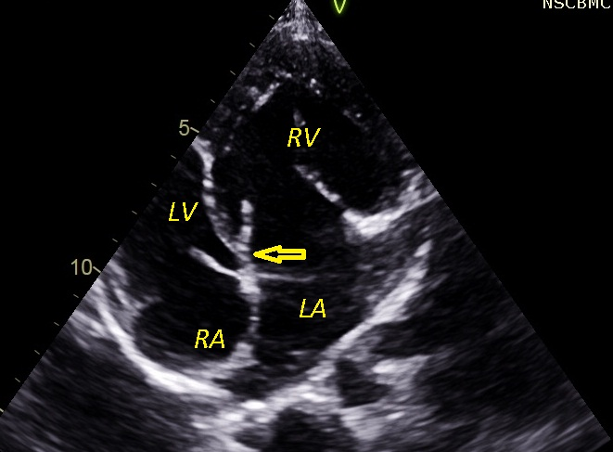

Figure 1 – Echocardiographic 4 chamber view shows RV on left side and LV on right side

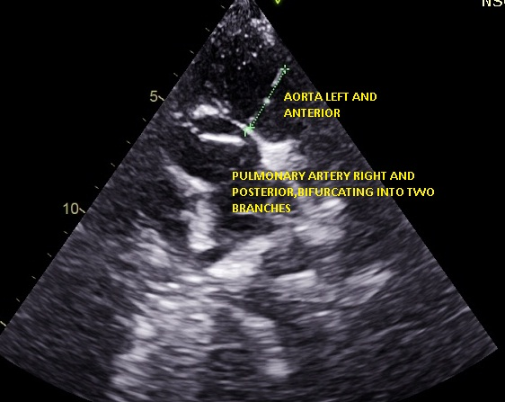

Figure 2- Echocardiography shows L malposed great vessels