# **Assessment of Renal Function in Drivers Consuming Alcohol and NSAID in Oluyole Local Government Area, Ibadan, Oyo State**

### **Abstract**

**Background:** There is a strong relationship between alcohol use disorder (AUD) and kidney dysfunction, and it remains a mystery, with little or no research to explain the cause. In this present research, we investigated the impact of alcohol consumption and the use of nonsteroidal anti-inflammatory drugs (NSAID) on renal function and hypertension prevalence among commercial bus drivers, a more vulnerable occupational group.

**Methods:**  This cross-sectional study used commercial bus drivers as participants, and assessed their serum creatinine, urea, potassium, and blood pressure levels. These Participants were grouped based on their alcohol consumption and NSAID use, and statistical analysis was done to determine the associations between these variables and renal function markers.

**Results:** We reported **12.1% of participants to have had a high creatinine level**, although no reasonable difference was seen statistically between alcohol consumers and non-consumers. **(p>0.05)**. Hypokalemia was seen in about **42.4% of participants,** showing a statistically significant deviation from controls **(p<0.001),** underscoring the likelihood of alcohol-induced electrolyte imbalances. **15% of participants had** hypertension, with **age and BMI (>25 kg/m²) presented as significant risk factors**. Nevertheless, no statistically significant relationship was seen between hypertension and renal function markers **(p>0.05)**.

**Conclusion:** Although we did not see a notable alteration in the serum creatinine levels of alcohol consumer participants, there were a lot of **electrolyte imbalances and hypertension** risk, which highlight the urgent need for frequent health checkups, diet checks, and occupational health interventions among commercial bus drivers. Future research endeavors should make use of **direct GFR measurement and longitudinal designs** to establish causality and identify early markers of alcohol-induced renal dysfunction.

**Keywords:** Alcohol use disorder, renal function, hypertension, potassium imbalance, commercial drivers, NSAIDs

**Introduction**  
Each profession has its hazards, with some carrying more risk than others. Among these, driving commercially has been recognized as an occupation that is prone to a high risk of hazards, especially when safety protocols are not well put in place (1). Developing countries such as Nigeria struggle with adherence to occupational health and safety (OHS) regulations. The commercial system of transportation, which is an important component of urban mobility and economic development, suffers from this limitation the most(2). These policies from OHS were originally made to ensure workers are protected physically, mentally, and socially by reducing the risk of occupational hazards. These measures were supposed to be strictly adhered to for commercial bus drivers because they are more vulnerable to physical, psychological, and social risks(3).

The socioeconomic growth of most urban areas depends largely on their Commercial transportation system, because it enhances connectivity, minimizes traffic, and ensures economic productivity(4). Despite how important this is, this sector faces the most considerable challenges, especially when it comes to the health and safety of drivers. Commercial drivers most of the time face risks from the environment that expose them to long-term health risks(5). Nigeria currently faces a menace in its commercial transportation system, which is the usage of psychoactive substances like alcohol, tobacco, and cannabis, among these drivers(6). Regardless of the numerous sensitization programs by the Federal Road Safety Corps (FRSC) and civil society organizations about this, the excessive use of substances remains prominent among Nigerian drivers. There is currently no notable legal framework that establishes blood alcohol concentration (BAC) limits for commercial drivers in Nigeria, subsequently leading to continuous safety and health concerns. A major contributing factor to the problem is the widespread availability of alcohol and other stimulants in motor parks and roadside establishments(6). A study conducted by Ozoh et al (2017 reported more than 3,000 motor parks, kiosks, and eateries along Nigerian highways as spots for alcohol and tobacco consumption among drivers(7). These substances are claimed to be used to fight tiredness and fatigue and regain strength after a long day at work.

Another study by Olaniyi et al 2020 on the behavior of commercial bus drivers while driving in the southwestern part of Nigeria showed that 60% of drivers who were 45 years and below, frequently consume alcohol while driving(8). This and other risk factors worsening the incidence of road accidents in Nigeria include inadequate education, poor road conditions, and bad vehicles. Additionally, drivers mostly take energizers to remain awake during long trips. All these have not only increased the risk of road accidents but also put the health of the drivers at risk of long-term severe health conditions(9).

Although behavioral risks that are linked with substance abuse among commercial drivers have been well-documented, there is limited or no research on the long-term physiological consequences, particularly concerning renal function(6). There are physiological consequences to abusing substances, especially on renal health, leading to further research. The kidneys are very important in maintaining the body's homeostasis, filtering waste products, and ensuring essential body fluids are regulated(10). There has been notable evidence of renal impairment due to exposure to toxic substances such as alcohol and non-steroidal anti-inflammatory drugs (NSAIDs). NSAIDs are mostly used for the relief of pain; they act by inhibiting cyclooxygenase enzymes, thereby hindering the production of prostaglandin, a very important intermediary in renal metabolism(11). Addiction to these substances can lead to difficulty in renal filtration, imbalances of electrolytes, and systemic complications. Due to the ongoing menace of high rates of alcohol and NSAID consumption among Nigerian commercial drivers, there is an urgent need to examine their potential impact on renal health(12).

This present study aimed to bridge this gap by investigating key biomarkers of renal function, including plasma glucose, creatinine, urea and potassium levels, and glucose, among commercial drivers in Nigeria.

# **MATERIALS AND METHODS**

## **Study Location**

This study was conducted at various motor parks in **Oluyole Local Government Area, Ibadan, Oyo State, Nigeria**. And the study duration is November 2022 to June 2023 . Ethical approval was obtained from the **Ministry of Health, Oyo State,** and informed consent was secured from all study participants before enrollment.

## **Study Design:**

It was a **cross-sectional, comparative study** that evaluated renal function among commercial drivers who consume alcohol and NSAIDs, with a control group of non-transport workers.

## **Study Population:**

The study recruited a total of **200 participants:**

* **100 commercial drivers** (exposed group)
* **100 non-commercial drivers** (control group)

Both groups were matched for age and gender to minimize confounding variables.

## **Sample Size Calculation**

The sample size was calculated using **Cochran’s formula for a single proportion,** based on an existing prevalence rate of **11.5%** from a study on visual impairment among commercial drivers in Nigeria. The final sample size was adjusted to **200 participants** to account for a **10% non-response rate.** (13)

### **Inclusion Criteria**

* Male commercial drivers aged **25–55 years.**
* Minimum of **one year of professional driving experience.**
* Regular consumption of alcohol and/or NSAIDs (self-reported).

### **Exclusion Criteria**

* Diagnosed cases of **diabetes mellitus, hypertension, chronic kidney disease, or other metabolic syndromes.**
* History of **renal disorders or recent hospitalization** due to kidney-related conditions.
* Recent use of nephrotoxic medications other than NSAIDs.

Study Protocol:

In all study participants, blood was collected and investigated for serum/plasma of glucose, creatinine, urea, and potassium. The following laboratory materials were used for sample collection, processing, and analysis.

* **Sample Collection Kit**: Cotton wool, disposable hand gloves, sterile needles and syringes, micropipettes (for precise reagent handling), pipette tips, lithium heparin tubes, fluoride oxalate tubes, and plain serum tubes.
* **Laboratory Equipment**: Centrifuge (for plasma separation), spectrophotometer (for biochemical analysis), glucometer (for point-of-care glucose testing), water bath (for incubation), ion-selective electrode (ISE) analyzer (for electrolyte determination).

### **Sample Collection: 5 mL of venous blood** was drawn from each participant using aseptic techniques and aliquoted into **Fluoride oxalate tubes** for glucose analysis**, Lithium heparin tubes** for creatinine, urea, and electrolyte analysis,and **Plain tubes** for serum-based tests.

### **Sample Processing:** Blood samples were **centrifuged at 2500 rpm for 10 minutes** to separate plasma/serum and Plasma was stored at **-20°C** until biochemical analysis(14).

### **Biological Analysis:**

* **Blood Glucose Analysis by G**lucose Oxidase-Peroxidase(GOD-POD) Method (Randox Glucose Kit)
* **Blood Urea Analysis by** Urease-Berthelot Method (Randox Urea Kit)
* **Serum Creatinine Analysis by** Jaffe's Method (Randox Creatinine Assay Kit)
* Estimation of Electrolytes by Ion-selective electrode (ISE) method by ISE analyzer.

**Analyser Model and number for glucose, urea, and creatinine include is Roche Cobas 311**

## **Statistical Analysis**

Data was analyzed using **SPSS version 25.0**. Descriptive statistics were presented as **mean ± standard deviation (SD)** for continuous variables and **percentages for categorical variables.** Group differences were assessed using **independent t-tests** and **chi-square tests,** while **multiple regression analysis** was performed to determine associations between substance use and renal function markers. A **p-value < 0.05** will be considered statistically significant.

## **Sample Size Calculation**

The sample size was calculated using **Cochran’s formula for a single proportion,** based on an existing prevalence rate of **11.5%** from a study on visual impairment among commercial drivers in Nigeria. The final sample size was adjusted to **200 participants** to account for a **10% non-response rate.** (13)

## **Data Collection**

### **Questionnaire Administration**

A **structured questionnaire** was administered to collect:

1. **Sociodemographic data** (age, education level, driving experience).
2. **Medical history** (pre-existing conditions, medication use).
3. **Lifestyle factors** (alcohol and NSAID consumption patterns, smoking, dietary habits).
4. **Occupational exposure** (average daily driving hours, stress levels).

To address literacy barriers, the questionnaire was available in **English, Hausa, Yoruba, and Pidgin English,** and an interviewer-assisted approach was used.

## **RESULTS AND FINDINGS**

#### **Table 1: Demographic Characteristics of Participants**

| Variable | Test Group (n=33) | Control Group (n=33) | p-value |
| --- | --- | --- | --- |
| **Gender** |  |  |  |
| Male | 90.9% | 87.9% | - |
| Female | 9.1% | 12.1% | - |
| **Age Group** |  |  |  |
| 21-30 years | 60.6% | 57.6% | 0.448 |
| 31-40 years | 30.3% | 36.4% |  |
| 41-50 years | 3.0% | 6.1% |  |
| 51-60 years | 6.1% | - |  |

Table 1 and Fig. 1 present the demographic distribution of participants. The majority of participants were male, with similar age distributions between the test and control groups.

**Key Findings:** most of the participants were aged **21-30 years**, with no significant difference observed in age distribution between groups.

### **Fig 1: Pie-chart and Bar-graph of Demographic Characteristics of participants**

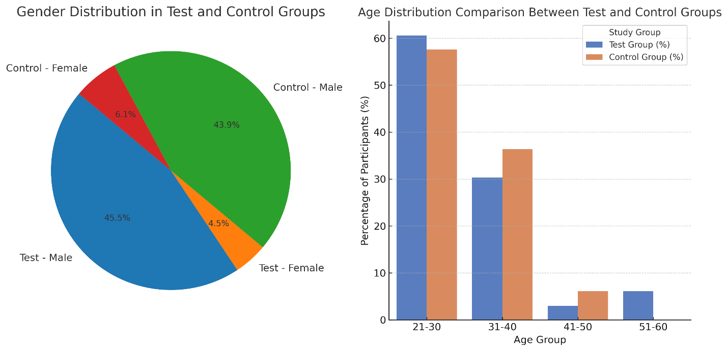

#### ****Prevalence of Hypertension and Glucose Abnormalities****

Table 2 and Figure 2 compare the prevalence of **hypertension and glucose abnormalities** between groups.

| Condition | Test Group (%) | Control Group (%) | p-value |
| --- | --- | --- | --- |
| **Diastolic Hypertension** | 36.4% | 15.2% | 0.015* |
| **Systolic Hypertension** | 48.5% | 12.1% | 0.002** |
| **High Blood Glucose** | 39.4% | 30.3% | 0.509 |

**Table 2: Hypertension and Glucose Levels Between Test and Control Groups**

**Key Findings: The test group was reported to be more hypertensive than the control group. (p<0.05)**. The **blood glucose levels of the test group were also high but** considered statistically significant (**p = 0.509).**

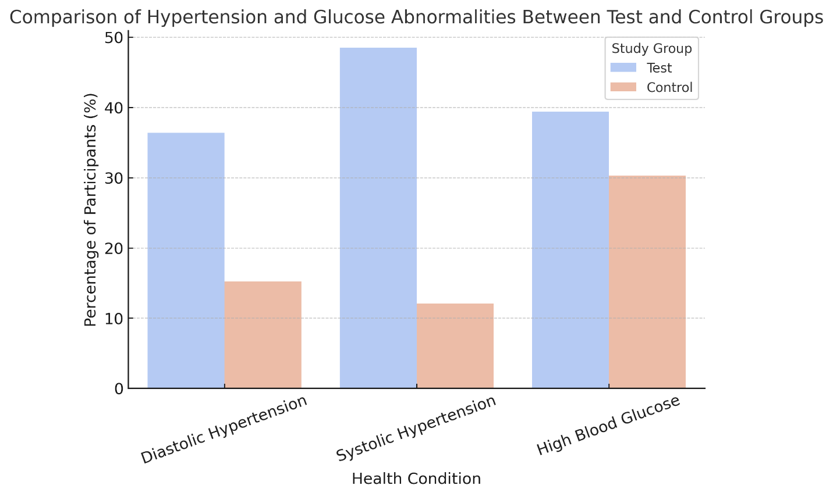

#### Figure 2: Comparison of Hypertension and Glucose Abnormalities between test and control group

#### ****Electrolyte and Renal Function Markers****

Table 3 and Figure 3 shows the distribution of renal function and electrolyte markers.

| Test | Category | Test Group (%) | Control Group (%) | p-value |
| --- | --- | --- | --- | --- |
| **Potassium Level** | Low | 42.4% | 12.1% | 0.001** |
|  | Normal | 57.6% | 87.9% | - |
| **Urea Level** | High | 15.2% | 0% | 0.000** |
|  | Low | 6.1% | 0% | - |
|  | Normal | 78.8% | 100% | - |
| **Creatinine Level** | High | 12.1% | 0% | 0.152 |
|  | Low | 3.0% | 0% | - |
|  | Normal | 84.8% | 100% | - |

**Table 3: Comparison of Renal Function and Electrolytes**

**Key Findings:** The **potassium and urea levels** **(p<0.05)** were reported to be **significantly different,** suggesting a possible **renal impairment**. No significant difference was seen in **Creatinine levels** between groups **(p=0.152).**

**Figure 3: Comparison of potassium, Urea and creatinine level between test and control groups**

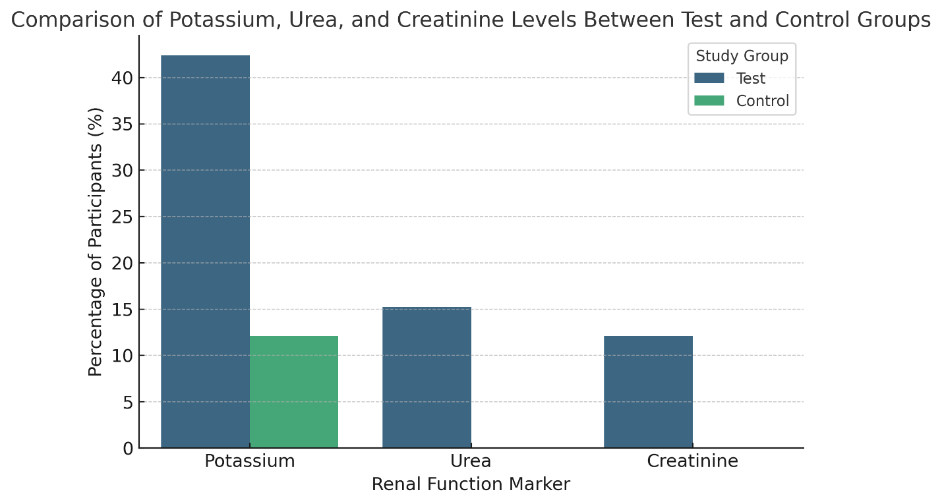

#### ****Association Between Renal Function and Hypertension****

Table 4 and Figure 4 summarize the relationship between **renal markers (urea, creatinine) and hypertension**.

| Test | Hypertensive (%) | Normotensive (%) | p-value |
| --- | --- | --- | --- |
| **Urea Level** | 36.4% | 63.6% | 0.674 |
| **Creatinine Level** | 36.4% | 63.6% | 0.638 |

**Table 4: Association Between Renal Function and Hypertension**

**Key Findings: No significant relationship** was observed between **urea or creatinine levels and hypertension** (**p>0.05**). These findings proposed that **hypertension in this population may not be a result of renal function markers**.

**Figure 4: Comparison of urea and creatinine levels with hypertension status** 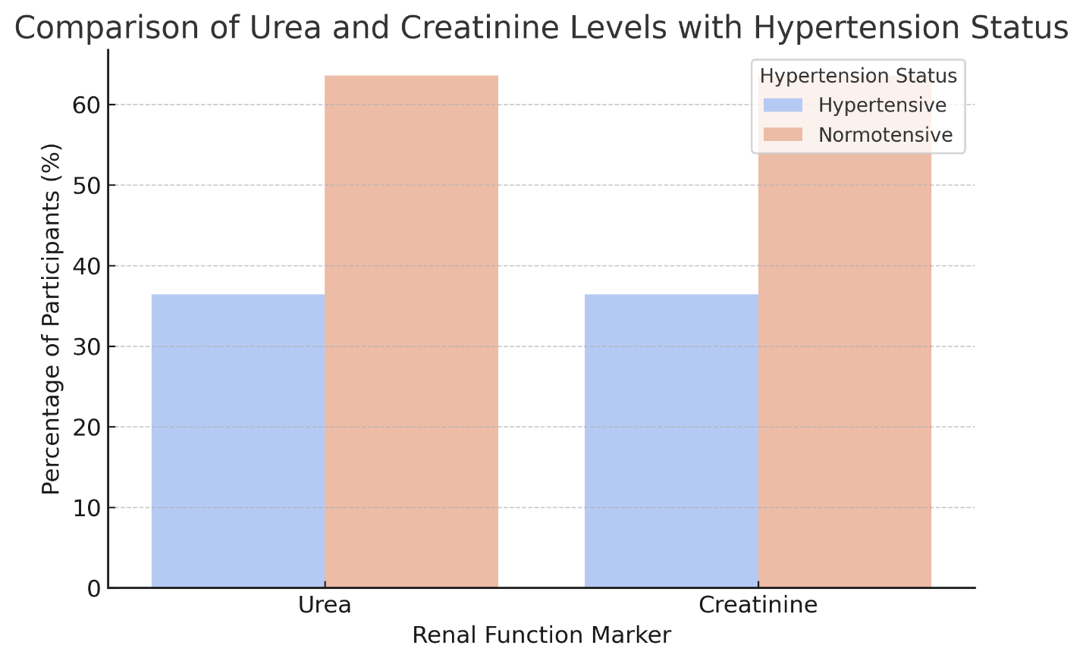

### **Table 5: Key Statistical Tests**

| Comparison | t-value | p-value | Interpretation |
| --- | --- | --- | --- |
| **Test vs Control Age** | 0.768 | 0.448 | Not significant |
| **Test vs Control Glucose** | 0.667 | 0.509 | Not significant |
| **Test vs Control Potassium** | -3.669 | 0.001** | Significant |
| **Test vs Control Urea** | 4.019 | 0.000** | Significant |
| **Test vs Control Creatinine** | 1.468 | 0.152 | Not significant |

(p < 0.05 indicates a significant difference)

**Urea and potassium levels were significantly different between the test and control groups,** indicating possible renal function impairment among alcohol-consuming drivers. Other biochemical parameters showed no significant differences.

## **Summary of Findings**

* **A higher prevalence of hypertension was seen** among commercial drivers than the control group, though not statistically significant.
* **Higher levels of Glucose i**n the test group but not significantly different from controls.
* Significant differences in **Renal function markers:** urea and potassium levels suggest potential renal dysfunction among alcohol-consuming drivers.
* **Statistical Significance** differences in urea and potassium levels (p < 0.05), while creatinine levels were not.

## **DISCUSSION**

The connection between alcohol use disorder (AUD) and kidney dysfunction is multifaceted and has continued to be a mystery that needs to be tackled. Previous epidemiological studies have suggested a potential relationship between chronic alcohol consumption and renal impairment, but there is no conclusive experimental evidence(16). The method by which alcohol can enhance kidney injury is still understudied but believed to involve oxidative stress, inflammation, and electrolyte imbalances(17). In this present study, we specifically aimed to examine the prevalence of renal dysfunction and hypertension among commercial bus drivers who consume alcohol and nonsteroidal anti-inflammatory drugs (NSAIDs), a population more vulnerable to occupational stress, lifestyle, and dietary habits(18).

### **Renal Function and Alcohol Consumption**

Serum creatinine is a universally explored biomarker for assessing renal function, still, the way it is being interpreted may be impacted by some factors like muscle mass, how hydrated a person is, and dietary intake(19). Our study reported that 12.1% of participants showed highly elevated serum creatinine levels. Regardless, the mean serum creatinine concentration among alcohol consumers was not significantly different from that of nonconsumers (p>0.05). This finding is in alignment with Demnitiz et al., 2020, who reported that no significant relationship was seen between alcohol consumption and creatinine levels among commercial bus drivers(20). Although this showed that modesty in alcohol consumption may probably not affect renal function, it still does not eliminate subclinical kidney injury or long-term deterioration, which creatinine may not have captured(21). Glomerular filtration rate (GFR) is still the gold standard for assessing renal function, we recommend that future studies consider direct GFR measurements to better explicate the effect of alcohol consumption on renal health(22).

### **Potassium Dysregulation and Alcohol Use**

The kidneys are a very important organ in maintaining the body's electrolyte balance. We found that **42.4% of the participants suffered from hypokalemia,** which is a statistically significant deviation from the control group (**p<0.001**). This aligns with previous research that reported that alcohol consumption may lead to the depletion of potassium. The mechanisms behind this remain a mystery but may be due to increased renal excretion, hormonal imbalances, or altered fluid regulation(23).

Potassium depletion has clinical relevance as it can lead to **hyponatremia, muscle weakness, arrhythmias, and impaired neuromuscular function.** Additionally, previous studies have suggested that a shortage of potassium in the body may **stimulate antidiuretic hormone (ADH) activity,** leading to fluid retention and potentially worsening sodium imbalance. This report necessitates the need for **electrolyte monitoring in chronic alcohol consumers,** particularly among individuals exposed to additional risk factors such as **dehydration, NSAID use, and poor dietary intake.**

### **Prevalence and Risk Factors for Hypertension**

We also reported a prevalence of 15% for a hypertensive population, which is lower than the elevated number reported by Lakshman et al. (2018) in South India (18), but could be compared to the **20.5% prevalence reported by Adesola et al., 2014 among commercial drivers in Nigeria** (24). This suggests regional variability in hypertension risk, likely influenced by lifestyle, dietary patterns, and healthcare access.

Driving encourages a sedentary lifestyle, stress, and poor diet, all of which have been established to be risk factors for hypertension. The connection between **body mass index (BMI) and hypertension** seen in this study aligns with previous reports on obesity being a key driver of elevated blood pressure. Additionally, our results showed that an increase in **age and BMI (≥25 kg/m²) are notable indications of hypertension,** further emphasizing the role of metabolic factors in cardiovascular risk among commercial drivers(25).

Interestingly, we saw **no significant link between hypertension and urea, creatinine, or potassium levels (p>0.05).** This showed that even though renal dysfunction and hypertension may coexist, **hypertension as seen in this population was more likely as a result of lifestyle rather than direct renal impairment.** This is similar to previous studies that suggested hypertension and kidney disease exist independently, especially in early disease stages(26).

### **Clinical and Public Health Implications**

The outcome of this study has broader **clinical and occupational health implications. Owing to** the **high prevalence of electrolyte imbalances and hypertension,** strategized measures such as **routine health checkups, dietary modifications, and lifestyle changes** should be advocated for commercial drivers(27). Blood pressure and renal monitoring of these drivers should be regularly monitored to ensure early detection and management of hypertension and electrolyte imbalance. **Public health education** on the potential risks associated with excessive alcohol and NSAID consumption, especially their potential impact on renal and cardiovascular health(28). **Nutritional counseling, exercise, and stress management** should be encouraged to mitigate the long-term health risks associated with commercial driving.

**Conclusion**

This study found a concerning prevalence of renal impairment, electrolyte abnormalities, and hypertension among commercial bus drivers who use alcohol and NSAIDs. Although there is no direct link between alcohol intake and higher creatinine levels, the high prevalence of hypokalemia and hypertension highlights the systemic metabolic problems that these drivers face. This study underscores the critical need for occupational health programs that include regular medical exams, dietary interventions, and lifestyle changes to reduce the long-term health hazards associated with alcohol and NSAID use in this susceptible demographic.

In the future, additional research must use a holistic strategy that incorporates biochemical, clinical, and epidemiological perspectives, allowing for a better understanding of the interaction between alcohol intake, renal impairment, and hypertension. This comprehensive approach will help to design successful public health strategies and policies focused at protecting the health of commercial bus drivers and enhancing overall workplace wellness.

### **Study Limitations and Future Research Directions**

Regardless of how strong the study seems to be, there are several limitations we can acknowledge

1. **Lack of direct GFR measurement:** Serum creatinine is an indirect marker of renal function, and **cystatin C or estimated GFR (eGFR)** could be employed to provide a more accurate assessment.
2. **Potential underreporting of alcohol and NSAID use:** Bias is inevitable in self-reported data. Future studies should incorporate **biomarkers of alcohol consumption (e.g., blood ethanol levels, carbohydrate-deficient transferrin [CDT])** for a more objective assessment void of bias
3. **Cross-sectional design: our study captured the** associations but did not establish causality. Longitudinal studies are employed to determine this population's long-term renal and cardiovascular outcomes.
4. **Limited control for confounders:** although we controlled for BMI and age, other potential confounders such as **smoking, dietary sodium intake, genetic predisposition, and physical activity levels** were not fully assessed.

Future research should adopt a diverse approach **that** combines **biochemical, genetic, and epidemiological data** to holistically understand the interrelationship between alcohol, renal dysfunction, and hypertension in high-risk occupational groups.

**Ethical Approval and Consent:**

**Ethical approval was obtained from the Ethical Committee of the Ministry of Health, Oyo State. Participants received a detailed explanation regarding the study objectives, procedures, potential risks, and benefits. Written informed consent was also obtained before participation, ensuring compliance with the Declaration of Helsinki on Human Research Ethics.**

**Disclaimer (Artificial intelligence)**

**Option 1:**

**Author(s) hereby declare that NO generative AI technologies such as Large Language Models (ChatGPT, COPILOT, etc.) and text-to-image generators have been used during the writing or editing of this manuscript.**

**Option 2:**

**Author(s) hereby declare that generative AI technologies such as Large Language Models, etc. have been used during the writing or editing of manuscripts. This explanation will include the name, version, model, and source of the generative AI technology and as well as all input prompts provided to the generative AI technology**

**Details of the AI usage are given below:**

**1. option 1**

**2.**

**3.**

**REFERENCES**

1. Castro C, Ventsislavova P, Garcia-Fernandez P, Crundall D. Risky Decision-Making and Hazard Prediction are Negatively Related and Could Be Assessed Independently Using Driving Footage. Psychol Res Behav Manag. 2021 Jun 24;14:857–76.

2. Verma A, Harsha V, Subramanian GH. Evolution of Urban Transportation Policies in India: A Review and Analysis. Transportation in Developing Economies. 2021;7(2):25.

3. Jain A, Hassard J, Leka S, Di Tecco C, Iavicoli S. The Role of Occupational Health Services in Psychosocial Risk Management and the Promotion of Mental Health and Well-Being at Work. Int J Environ Res Public Health. 2021 Mar 31;18(7):3632.

4. Tucho GT. A review of the socio-economic impacts of informal transportation and its complementarity to address equity and achieve sustainable development goals. Journal of Engineering and Applied Science. 2022 Mar 13;69(1):28.

5. Amoadu M, Sarfo JO, Ansah EW. Working conditions of commercial drivers: a scoping review of psychosocial work factors, health outcomes, and interventions. BMC Public Health. 2024 Oct 24;24(1):2944.

6. Akande RO, Akande JO, Babatunde OA, Ajayi AO, Ajayi AA, Ige RO, et al. Psychoactive substance abuse among commercial bus drivers in Umuahia, Abia State, South-Eastern Nigeria: an uncontrolled “epidemic” with attendant road traffic crashes. BMC Public Health. 2023 Feb 6;23:250.

7. Ozoh OB, Akanbi MO, Amadi CE, Vollmer WM, Bruce NG. The prevalence of and factors associated with tobacco smoking behavior among long-distance drivers in Lagos, Nigeria. Afr Health Sci. 2017 Dec;17(4):1110–9.

8. Adelekan AT, Osoba AA. Substance abuse and criminal behaviors among commercial vehicle drivers in Lagos State. Forensic Res Criminol Int J [Internet]. 2020 Jan 30 [cited 2025 Mar 20];8(1). Available from: <https://medcraveonline.com/FRCIJ/FRCIJ-08-00305.pdf>

9. Ahanhanzo yg, kpozèhouen a, salami l, gaffan n, dos santos bh, leveque A. Prevalence of fatigue while driving among two-wheeled vehicle drivers and associated factors: Exploratory approach from secondary analysis based on hospital data, Benin. J Public Health Afr. 2023 Dec 1;14(12):2601.

10. Singh VP, Singh N, Jaggi AS. A Review on Renal Toxicity Profile of Common Abusive Drugs. Korean J Physiol Pharmacol. 2013 Aug;17(4):347–57.

11. Gunaydin C, Bilge SS. Effects of Nonsteroidal Anti-Inflammatory Drugs at the Molecular Level. Eurasian J Med. 2018 Jun;50(2):116–21.

12. Epstein M. Alcohol’s Impact on Kidney Function. Alcohol Health Res World. 1997;21(1):84–92.

13. Pourhoseingholi MA, Vahedi M, Rahimzadeh M. Sample size calculation in medical studies. Gastroenterol Hepatol Bed Bench. 2013;6(1):14–7.

14. Luz AJ, Poeta J, Linden R, Antunes MV, Caminha LI, Sprinz E. Related factors to atazanavir plasma levels in a cohort of HIV positive individuals with undetectable viral load. Braz J Infect Dis. 2013 Aug 6;17(6):657–60.

15. Trinder P. Determination of blood glucose using an oxidase-peroxidase system with a non-carcinogenic chromogen. J Clin Pathol. 1969 Mar;22(2):158–61.

16. Pan C syuan, Ju TR, Lee CC, Chen YP, Hsu CY, Hung DZ, et al. Alcohol use disorder tied to development of chronic kidney disease: A nationwide database analysis. PLOS ONE. 2018 Sep 6;13(9):e0203410.

17. Latchoumycandane C, Nagy LE, McIntyre TM. Chronic Ethanol Ingestion Induces Oxidative Kidney Injury through Taurine-inhibitable Inflammation. Free Radic Biol Med. 2014 Apr;69:403 16.

18. Lakshman A, Manikath N, Rahim A, Anilakumari VP. Prevalence and Risk Factors of Hypertension among Male Occupational Bus Drivers in North Kerala, South India: A Cross-Sectional Study. ISRN Prev Med. 2014 Apr 23;2014:318532.

19. Patel SS, Molnar MZ, Tayek JA, Ix JH, Noori N, Benner D, et al. Serum creatinine as a marker of muscle mass in chronic kidney disease: results of a cross-sectional study and review of the literature. J Cachexia Sarcopenia Muscle. 2013 Mar;4(1):19–29.

20. Demnitz N, Topiwala A, Zsoldos E, Stagg CJ, Emir UE, Johansen-Berg H, et al. Alcohol consumption is associated with reduced creatine levels in the hippocampus of older adults. Psychiatry Res. 2020 Jan 30;295:111019.

21. Lee YJ, Cho S, Kim SR. Effect of alcohol consumption on kidney function: population-based cohort study. Sci Rep. 2021 Jan 27;11:2381.

22. Pottel H, Delanaye P, Cavalier E. Exploring Renal Function Assessment: Creatinine, Cystatin C, and Estimated Glomerular Filtration Rate Focused on the European Kidney Function Consortium Equation. Annals of Laboratory Medicine. 2024 Mar 1;44(2):135–43.

23. Adewale A, Ifudu O. Kidney injury, fluid, electrolyte and acid-base abnormalities in alcoholics. Niger Med J. 2014;55(2):93–8.

24. Adesola A, Imhasoloeva M, Akinsulore A. Prevalence and correlates of erectile dysfunction among long-distance commercial vehicle drivers and commercial motorcycle riders in Ibadan, Nigeria: a comparative cross-sectional study. Afr Health Sci. 2022 Sep;22(3)::1–12.

25. Anto EO, Owiredu WKBA, Adua E, Obirikorang C, Fondjo LA, Annani-Akollor ME, et al. Prevalence and lifestyle-related risk factors of obesity and unrecognized hypertension among bus drivers in Ghana. Heliyon. 2020 Jan 6;6(1):e03147.

26. Sica DA. The Kidney and Hypertension: Causes and Treatment. J Clin Hypertens (Greenwich). 2008 Aug 22;10(7):541–8.

27. Ajayi IO, Oyewole OE, Ogah OS, Akinyemi JO, Salawu MM, Bamgboye EA, et al. Development and evaluation of a package to improve hypertension control in Nigeria [DEPIHCON]: a cluster-randomized controlled trial. Trials. 2022 May 2;23:366.

28. Martin U, Coleman JJ. Monitoring renal function in hypertension. BMJ. 2006 Oct 28;333(7574):896–9.