**Original Research Article**

**Variations in Nutritionally Significant** **Organic Components of Milk Depending on the Energy Status of Simmental Cows**

**ABSTRACT**

|  |
| --- |
| This paper presents the results of a study on the quality of milk from Simmental cows during the peripartal period, focusing on the analysis of key biochemical parameters (proteins, fats, lactose, and urea).  Special emphasis was placed on evaluating the relationships among these components to identify potential dietary imbalances in cows, aiming to ensure high nutritional quality of milk intended for human consumption while simultaneously preventing metabolic disorders and reproductive problems in the animals.    The study was conducted on 46 Simmental cows in the early lactation phase, where milk samples were analyzed for fat and protein content, as well as urea concentration. Urea analysis was performed using an enzymatic kinetic method. Fat and protein contents were determined using the Milkoscan device.The research demonstrated that the energy status of high-yielding dairy cows significantly affects their production outcomes, reproductive performance, and health condition.    The analysis of biochemical milk parameters, such as urea, total proteins, and fats, proved to be an effective and practical method for assessing the nutritional and metabolic status of cows. This allows for early detection of metabolic disorders and timely implementation of preventive measures. Positive correlations found between fat, protein, and urea levels confirm the importance of a balanced diet in maintaining optimal milk quality.    This approach provides an economical and straightforward diagnostic method suitable for farms of all sizes, contributing to more rational and efficient management of milk production. |

*Keywords: cow's milk quality, nutritional status, organic components, metabolism, energy status*

**1. INTRODUCTION**

The quality of milk intended for human consumption directly depends on maintaining the metabolic balance of cows (Nešić, 2013). Milk analysis, including the concentration of urea and the ratio of milk fat to protein, allows for precise monitoring of the animal's energy status. Optimal values for urea (above 4 mmol/l) and protein (more than 3.2%) indicate a satisfactory nutritional status in cows, while deviations may point to an energy deficit or inadequate nutrition. Increased lipomobilization, often occurring during energy deficits, can increase milk fat content while simultaneously reducing protein content, which may affect the technological properties of milk during processing (Knob et al., 2021; Kirovski et al., 2011, 2012; Van Knegsel et al., 2005).

For processing milk into high-quality products such as yogurt, cheese, or milk powder, preserving the balance of milk components is critical (Nešić, 2013). High fat and protein content is desirable for cheese production, while the balance of lactose and protein is essential for fermented dairy products (Walstra et al., 2006). Negative energy balance in the first weeks of lactation can disrupt this equilibrium, reducing product quality and yield. Additionally, the presence of drug residues, ketone bodies, and other metabolites can significantly compromise the safety of milk for human consumption (Barlowska et al., 2024; Cabezas-Garcia et al., 2021; Roche et al., 2009).

Considering all of the above, maintaining the metabolic stability of cows during the peripartal period and early lactation is necessary not only to achieve high production but also to ensure milk meets the nutritional and hygienic standards of the modern market. Only through an adequate approach to nutrition, health care, and raw milk quality control can high-quality products intended for human consumption be guaranteed, thereby contributing to a sustainable and competitive dairy industry (Barlowska et al., 2024; Đoković et al., 2016; Kirovski et al., 2011, 2012).

The peripartal period and early lactation phase in dairy cows represent critical points in the production-reproduction cycle, during which significant physiological changes occur, impacting the metabolic, reproductive, and production stability of the animals. These changes are crucial not only for ensuring high milk production but also for preserving its quality, which has direct implications for human nutrition and the processing of dairy products. Successful adaptation of the metabolic and endocrine systems during this period enables the cow's transition from a state of advanced pregnancy to a state of intensive lactation (Barlowska et al., 2024; Cabezas-Garcia et al., 2021; Kirovski et al., 2011, 2012).

However, common disorders during this period, such as reduced milk production, anestrus, ovarian cystic degeneration, prolonged service periods, and extended calving intervals, not only cause direct production losses but also affect the hygienic quality and nutritional value of milk. The presence of drug residues and metabolic disorders often compromises the quality of raw milk, making it unsuitable for consumption or processing into high-quality dairy products (Đoković 2014; Đoković et al 2016; Šamanc et al., 2011, 2013).

Metabolic changes in high-yielding cows during pregnancy and lactation require a specialized approach to nutrition and health care to preserve the balance between the animal's needs and production capacities. Energy turnover, which amounts to 41–52 MJ of metabolized energy (ME) in non-lactating cows, can reach up to 175 MJ ME per day in cows with the highest milk yields. Most of this energy is directed toward the synthesis of milk’s basic components, including fats, proteins, and lactose, directly influencing its nutritional value. For example, cows producing 29.4 litre of milk per day with 3.3% milk fat require 77.9 MJ of net energy for lactation (NEL), while even higher yields demand energy needs exceeding 100 MJ NEL per day (Kirovski et al., 2011, 2012, 2013; Gross et al., 2011).

A particular challenge in the early lactation phase is the negative energy balance, which arises from a mismatch between the energy required for milk production and the limited intake of food. It is more beneficial to prioritize selection based on performance in early lactation traits, rather than those that appear later in life (Shashikant et al.,2024). During the first weeks of lactation, the average energy deficit amounts to 28.9 MJ NEL per day (Kirovski et al., 2012). This deficit is compensated by mobilizing body reserves, primarily fat, where 840 g of fat is released from each kilogram of body tissue. Mobilized fat not only enables the realization of the genetic potential for milk production but also significantly affects its composition. High concentrations of free fatty acids in the blood often result in an increase in milk fat content, which is crucial for the quality of dairy products such as cheese and butter. However, this can negatively impact the balance of other components, such as proteins (Knob et al., 2021; Kirovski et al., 2012; Lakić et al., 2018; Nogalski et al., 2012).

**2. MATERIALS AND METHODS**

The study was conducted during July and August 2023 on ten farms in the municipality of Blace, involving a total of 46 Simmental cows in the early lactation phase (first 60 days). The cows were at various lactation stages, ranging from the first to the sixth, with an average daily milk yield of 22.5 litre. All cows were fed diets tailored to their production category, following recommendations for optimal feeding conditions. Milking was performed twice daily—morning and evening.

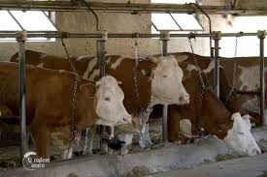

**Picture 1. Evaluated cows**

For the purposes of the study, 50 ml milk samples were collected during the morning milking of each animal. The samples were transported to the laboratory in portable refrigerators at a temperature of +8 ºC and subsequently frozen at -20 ºC until the time of analysis.

Milk analyses included the determination of fat, protein, lactose, dry matter content, and urea concentration. The fat, protein, lactose, and dry matter content were analyzed using the Milkoscan device (series 130, type 10900, A/S, N.FOSS ELECTRIC) in the Eko-Lab d.o.o. laboratory in Belgrade (IDF, 2015; Lefier et al., 1996).

The concentration of urea in milk was determined using an enzymatic kinetic method with the VETSCREEN analyzer at the Laboratory of the Faculty of Veterinary Medicine in Belgrade. The method is based on the hydrolysis of urea, under the influence of urease, into ammonia and carbon dioxide, wherein the released ammonia, in the presence of glutamate dehydrogenase (GLDH), along with α-ketoglutarate and NADH, is transformed into glutamate. The rate of NADH oxidation at a wavelength of 340 nm is proportional to the concentration of urea (Baset et al., 2013).

The reaction system utilizes two main reagents: TRIS buffer (pH 7.55; 80 mmol/l) and an enzymatic reagent containing urease (> 35 KU/l), GLDH (> 2 KU/l), ADP (0.6 mmol/l), α-ketoglutarate (10 mmol/l), and NADH (0.32 mmol/l). The working reagent is prepared by dissolving the enzymatic reagent in the buffer reagent. The calibration standard is urea at a concentration of 10.0 mmol/l.

The analysis is performed by adding 10 μl of milk sample to 1 ml of working reagent. After homogenizing the mixture, absorbance is measured at 340 nm in two intervals—after 30 and 60 seconds. The rate of change in absorbance directly reflects the urea concentration in the sample (Baset et al., 2013).

The evaluation of the relationships between protein and urea, as well as fat and protein, was conducted to reliably diagnose the energy status of the examined cows (Đoković et al., 2016; Kirovski et al., 2011, 2013).

The results were statistically processed and presented in tables using descriptive statistical parameters (mean values – X, standard deviations – SD, standard errors – SE, coefficients of variation – CV, and variation intervals – IV). Additionally, Pearson’s correlation coefficient was determined for specific biochemical components using Excel (Microsoft Office 365).

**3. RESULTS AND DISCUSSION**

The content of protein, fat, lactose, urea concentration, and dry matter percentage in milk samples collected during morning milking was thoroughly analyzed and is presented in Table 1. The aim was to evaluate the qualitative characteristics of the milk. The Table 1 provides aggregated results. These parameters, which directly influence the nutritional value and technological properties of milk, are key indicators of proper nutrition and the metabolic status of cows, as well as a basis for optimizing the quality of milk intended for human consumption.

**Table 1. Content of protein (%), fat (%), lactose (g/100 ml), urea concentration (mmol/l), and dry matter percentage in milk samples from cows during morning milking**

|  |  |  |  |  |  |  |
| --- | --- | --- | --- | --- | --- | --- |
|  |  | Milk fat  (%) | Milk Protein  (%) | Lactose  (g/100ml) | Urea concentration  (mmol/l) | Dry matter  (%) |
|  | IV | 0.95-6.56 | 2.71-3.87 | 4.16-4.86 | 2.19-12.78 | 7.91-9.31 |
| Aggregate Milk  (n=46) | X | 3.90 | 3.56 | 5.20 | 3.86 | 9.50 |
| SD | 1.29 | 0.41 | 0.35 | 2.34 | 0.66 |
| SE | 0.19 | 0.06 | 0.05 | 0.34 | 0.09 |
| CV | 33.07 | 1.15 | 0.67 | 60.62 | 6.95 |
| IV | 0,89-7,48 | 3,04-4,61 | 4,65-6,05 | 0,31-9,03 | 8,5-11,39 |

X – mean value; SD – standard deviation; SE – standard error; CV – coefficient of variation; IV – interval of variation

On the farms, the average milk fat content was 3.90 ± 1.29%, indicating relative stability of this parameter within the studied population. The protein content in milk did not show significant variations across different farms, with an average value of 3.56 ± 0.41%, reflecting homogeneity in feeding and the metabolic status of the animals. The average lactose concentration in milk from cows on small-scale farms was 5.20 ± 0.35 g/100 ml, aligning with the expected nutritional parameters for this category of milk. The average urea concentration in milk was 3.86 ± 2.34 mmol/l, suggesting a balance between the intake and metabolism of nitrogen compounds. The dry matter content of milk had a mean value of 9.50 ± 0.66%, indicating an adequate quality of milk in terms of its total nutrient content.

Figure 1 shows the relationship between protein content and urea concentration in milk samples collected during morning milking.

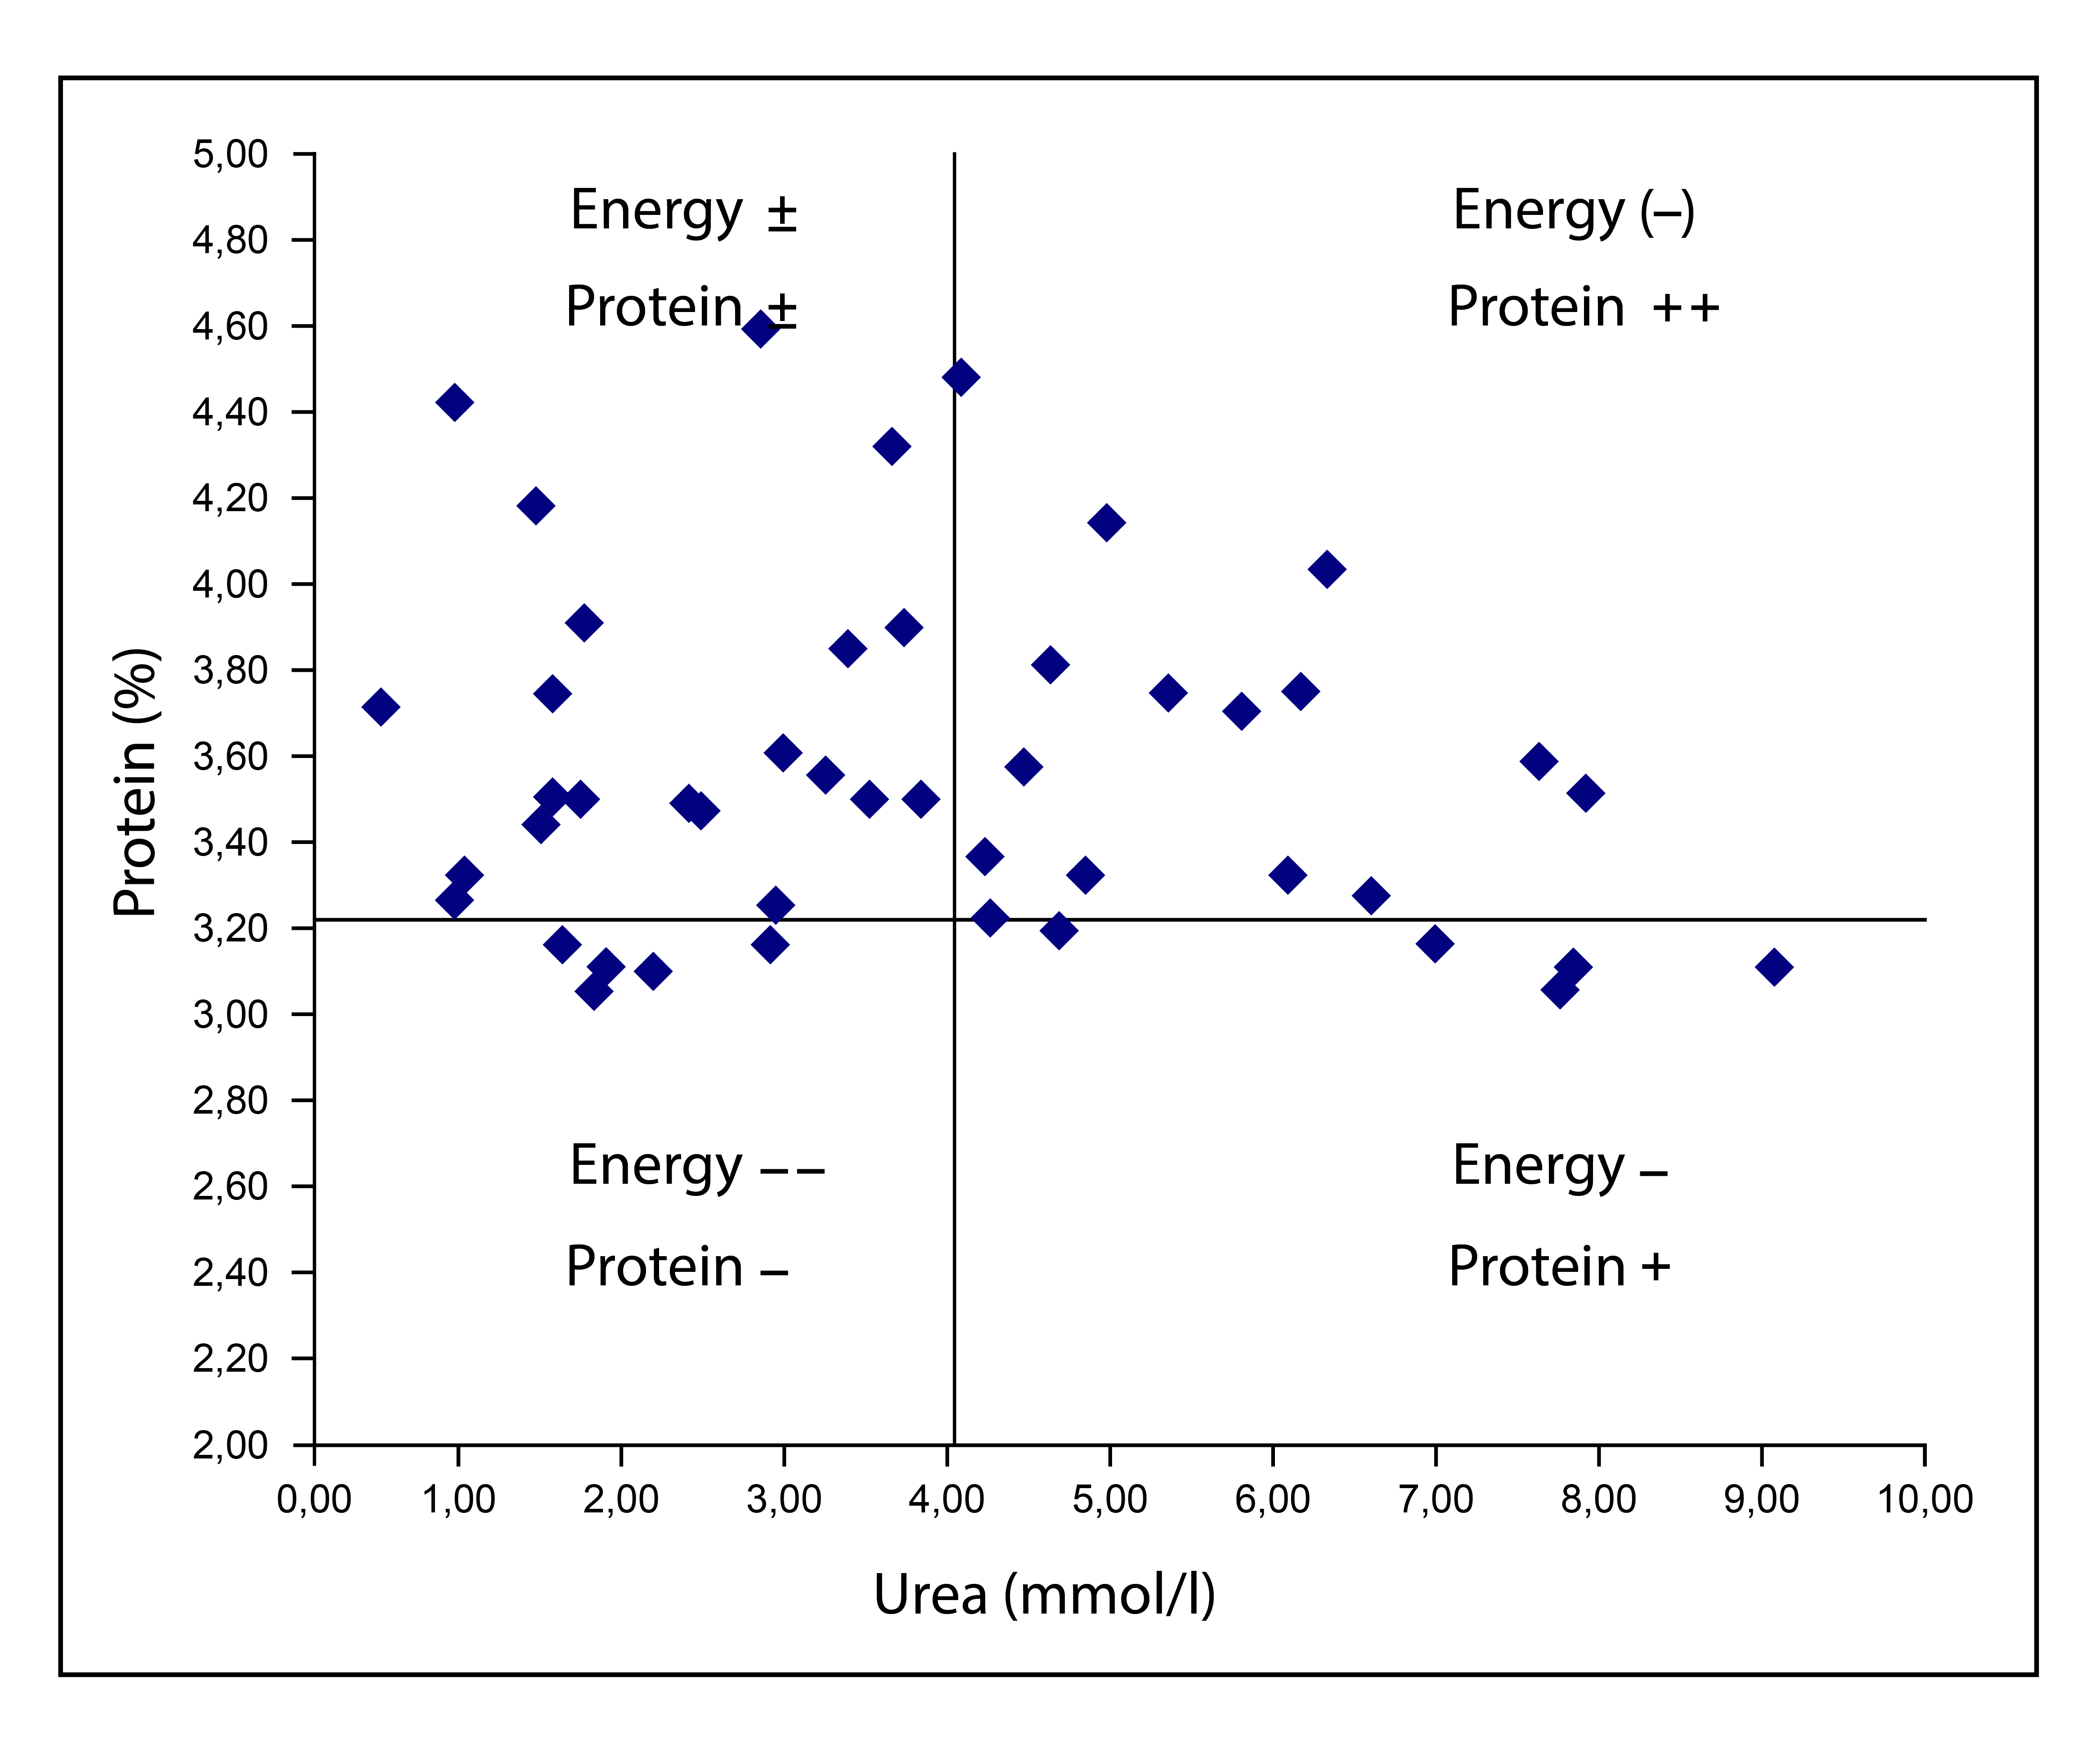

**Figure 1. Relationship between urea concentration and protein content in milk from cows during morning milking**

According to the data presented in Figure 1, it can be observed that 21 points (45.65%) are located in the upper left quadrant, indicating cows that received an optimal amount of protein and energy through their diet and were in a balanced energy status. In the upper right quadrant, 16 points (34.78%) suggest cows in this group were fed an optimal amount of energy but experienced a protein surplus, which could lead to metabolic imbalances if not corrected. The remaining points indicate cows fed diets with energy content below optimal levels, potentially contributing to negative energy balances. This data suggests that 9 out of the 46 cows (19.57%) were in a phase of negative energy balance, making them susceptible to the development of metabolic and reproductive disorders, highlighting the need for better monitoring of nutritional status and adjustments to diets to prevent potential issues in production and cow health.

Based on the results of statistical analysis, Pearson’s correlation coefficient between protein content in milk and urea concentration was approximately r ≈ 0.654, indicating a moderate positive correlation between these variables. This correlation suggests a statistically significant relationship between protein intake and nitrogen compound metabolism, confirming a balanced nutritional status in cows. Testing the null hypothesis (H₀), which posited no statistically significant relationship between milk quality parameters, led to the rejection of this hypothesis, as the correlation was significant . This finding further supports the assertion that the cows were in an optimal energy status, as the relationship between milk protein and urea concentration was evident, particularly in groups of cows with balanced protein and energy intake (Kirovski et al., 2011, 2013; Roy et al., 2011; Trifković et al., 2015).

These results hold significance for further research and better dietary management to avoid metabolic and reproductive disorders, as observed in cow populations experiencing negative energy balance, which was detected in the analyzed data (Roy et al., 2011; Schwab et al., 2017).

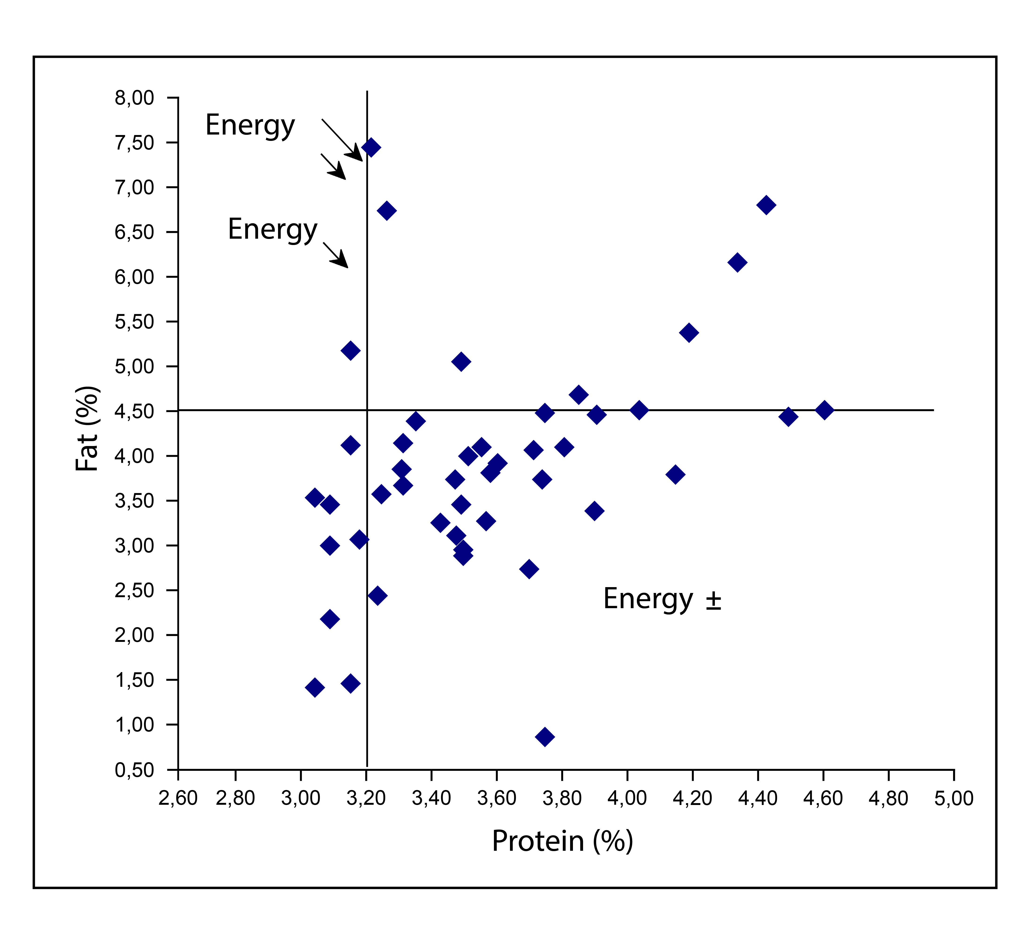**Figure 2. Relationship between fat and protein in milk from morning milking**

According to the data presented in Figure 2, the majority of cows on small-scale farms (78.26%) were fed an optimal amount of energy, as indicated by the points located in the right quadrant. A smaller proportion of cows (21.74%) were fed diets with an energy deficit. The protein content in the milk of cows from small-scale farms averaged 3.56 ± 0.41%, with no significant variations observed across different farms. These results align with findings from other authors, such as Kirovski et al. (2012) and Đoković et al. (2016), who reported similar protein levels in the milk of cows from other breeds. When compared to the findings of Đoković et al. (2016), where the protein concentration in Holstein cow milk at the beginning of lactation was significantly higher (4.67 ± 2.72%), our results indicate a lower protein content in the milk of the examined cows.

The mean urea concentration in milk from cows on small-scale farms was 3.86 ± 2.34 mmol/l, which is lower compared to the results of Đoković et al. (2016), who reported an average urea concentration of 4.55 ± 0.67 mmol/l in Holstein cow milk. Additionally, the average urea values for Simmental cows in their studies were 4.82 ± 2.45 mmol/l, which is statistically significantly higher compared to our results. In cases of energy deficits but sufficient protein intake, urea concentrations typically range between 5 and 10 mmol/l, with slightly lower protein content (around 3%), indicating an urgent need for dietary adjustments and analysis of potential metabolic disorders (Đoković et al., 2016; Kirovski et al., 2011, 2013).

The results of this study show that the average fat content in the milk of Simmental cows was 3.90 ± 1.29%, consistent with literature findings suggesting that during fat mobilization in the body, increased concentrations of free fatty acids in the bloodstream can affect the extent of fat synthesis in the mammary gland, leading to an increase in milk fat content (Kirovski et al., 2011, 2012). When compared with the research of Đoković et al. (2016), where the fat content in Holstein cow milk was reported as 3.42 ± 0.48%, our results fall within a similar range, confirming a general trend in milk production on farms.

Based on the statistical analysis, Pearson's correlation coefficient between fat and protein content in milk was determined to be approximately r ≈ 0.730, indicating a moderately strong positive correlation between these variables. This correlation suggests that an increase in milk protein content is significantly accompanied by an increase in milk fat content, reflecting the interconnected processes of synthesizing these components in the mammary gland. Given that milk fat and protein content reflect not only the genetic potential of cows but also the quality of their diet and metabolic status, these results confirm that a balanced intake of protein and energy in the diet contributes to optimal milk quality (Toscano et al., 2023; Kirovski et al., 2011). Testing the null hypothesis (H₀), which stated there was no statistically significant relationship between these parameters, resulted in its rejection, as the correlation was statistically significant (p < 0.05), consistent with findings in the literature. These data further emphasize the importance of proper dietary formulation to achieve optimal nutritional status and cow health, particularly during phases of high production demands (Roy et al., 2011).

Anamnestic data on feeding, production-reproductive indicators, and cow health, collected through surveys with farmers, revealed significant discrepancies in feeding practices, including both the quantity of roughage and concentrated feed and the composition of the diet. The feeding was not fully aligned with the production and reproductive needs of the cows, with particular emphasis on errors in the feeding of dry cows. These results are consistent with findings from other researchers (Đoković et al., 2016), who also observed deviations in the concentration of organic milk components, indicating lapses in feeding practices, including insufficient or excessive protein amounts. On the farms analyzed in this study, significant deviations in milk composition clearly highlight the need for dietary corrections, particularly in terms of balancing energy and protein (Pictures 1 and 2).

Further analysis of the cows’ health revealed that three cows were diagnosed with endometritis and ovarian cystic degeneration, while other issues observed included vaginal prolapse, mastitis, prolonged service periods, and other reproductive disorders. Nutrition played a key role in all these cases, with particular emphasis on problems during the dry phase. The quality of milk, along with its nutritional composition, directly affects its suitability for human consumption and processing. Milk with low fat or protein content, or high urea concentration, can result in reduced nutritional quality, which has long-term consequences for consumer health and product quality. Moreover, deviations in milk composition can impact processing technology, as changes in fat and protein composition can affect the texture, stability, and flavor of products such as cheese and yogurt.

As part of this study, a survey was conducted on eight representative farms with a total of 65 cows, averaging a daily milk yield of 23 litre. Reproductive traits such as the time of first estrus, service period duration (Table 2), and insemination index were examined. The time of first estrus after calving for all cows ranged between 25 and 30 days post-calving.

**Table 2. Length of the Service Period**

|  |  |
| --- | --- |
|  | Service period  (Aggregate) (days) |
|  | 75.38 |
| SD | 27.93 |
| SE | 4.21 |
| CV(%) | 37.05 |
| IV | 44 -160 |

X – mean value; SD – standard deviation; SE – standard error; CV – coefficient of variation; IV – interval of variation

On small-scale farms, when observed collectively across all farms, the service period was statistically significantly shorter compared to the service period reported in studies by other authors (Šamanc et al., 2013; Kirovski et al., 2015). The differences were statistically significant at farm A (p < 0.01), farm B (p < 0.001), and farm C (p < 0.001). The insemination index for cows on all surveyed farms was determined to be an average of 1.44 ± 0.21 (Table 3).

**Table 3. Insemination Index for Simmental Cows on Small-Scale Farms**

|  |  |
| --- | --- |
|  | Insemenation index (Aggregate) |
|  | 1.44 |
| SD | 0.21 |
| CV (%) | 14.5 |
| SE | 0.04 |
| IV | 1-7 |

X – mean value; SD – standard deviation; SE – standard error; CV – coefficient of variation; IV – interval of variation

The service period in cows represents the time interval from calving to achieving conception again. According to the literature, the service period ranges between 60 and 120 days, depending on breed, age, milk production, and nutritional factors. The authors of this study emphasize that the duration of the service period depends on the quality of the diet, as an imbalanced ratio between protein and energy intake can significantly affect metabolic processes and the energy status of animals, directly impacting reproductive activity. It is considered that Simmental cows, which are not subjected to high milk production demands, have a shorter service period compared to high-yielding breeds, whose service periods are generally much longer.

The results of this study confirm this assumption, as the average service period for Simmental cows was 78.38 ± 27.93 days. Similarly, studies by other authors indicate that the service period for Holstein cows often exceeds 120 days, which is still acceptable for this breed. Šamanc et al. (2013) reported that cows with metabolic disorders, such as liver steatosis, have an extended service period that can exceed 150 days, particularly in cases of diffuse forms of liver steatosis. Considering the importance of proper nutrition for the functioning of the reproductive system, the results of this study clearly indicate that energy deficits and a relative excess of protein negatively affect the duration of the service period. The literature also notes that as milk production increases—averaging 1,140 litre over the past decade—the service period is extended by an average of 16 days (Bojković-Kovačević, 2016).

The insemination index, an important reproductive parameter representing the average number of inseminations per pregnant cow, was 1.44 ± 0.21 in this study. For Holstein-Friesian cows, however, studies (Kirovski et al., 2011, 2012; Šamanc et al., 2013) report significantly higher values. This condition is one of the factors contributing to the pathogenesis of negative energy balance and increased reproductive parameter values.

The connection between milk quality and reproductive traits in dairy cows is a crucial aspect of evaluating their productivity, as nutritional status directly impacts both parameters. Previous analyses have shown that energy status, specifically the balance between energy and protein intake, is critically important for achieving optimal milk quality. This balance also similarly affects the reproductive efficiency of cows (Bojković-Kovačević, 2016). The average service period in this study, 75.38 ± 27.93 days, and the insemination index, 1.44 ± 0.21, are important indicators of reproductive ability and highlight the relationship between nutrition, energy status, and reproductive parameters.

On small-scale farms, shorter service periods indicate that cows with an optimal nutritional status achieved better reproductive performance. In contrast, the literature highlights that high milk production and metabolic disorders can prolong the service period and reduce reproductive efficiency (Bojković-Kovačević, 2016; Roche et al., 2013). The results of this study confirm that energy deficits or suboptimal protein-energy balance can negatively impact reproductive processes, which is reflected in the length of the service period and the number of inseminations. Linking these parameters with milk quality enables a comprehensive assessment of productivity and cow health, paving the way for improved dietary and reproductive management to achieve maximum production and reproductive outcomes (Maltz et al., 2013).

**4. CONCLUSION**

Based on the conducted research and obtained results, it can be concluded that the energy status of cows has a critical impact on their reproductive performance, production results, and overall health. The examination of biochemical milk components, such as urea, total proteins, and fat, represents an effective method for assessing the energy status of high-yielding cows and can significantly contribute to the early detection of potential metabolic disorders. This approach allows for timely preventive measures to be taken against negative energy balance and other health issues that directly affect productivity.

The use of milk’s organic components as indicators of energy status offers practical advantages by simplifying sample collection and laboratory analysis, enabling a more economical and efficient diagnostic procedure for producers of all farm sizes, whether small-scale or large-scale farms. This method is more rational compared to traditional metabolic profiling, which requires the analysis of a greater number of parameters and can cost more.

The research results indicate that the content of fat, protein, and urea in milk, as well as their interrelationships, can serve as reliable indicators of the nutritional and metabolic status of cows. Moderate positive correlations between these parameters were observed, confirming the importance of proper dietary formulation in maintaining the balance of nitrogen compounds and achieving optimal milk quality.

Additionally, the findings confirm previous theories that the health status and production on farms with high-yielding cows in our country often reflect insufficient application of modern feeding technologies. Prolonged energy deficits, resulting from an imbalanced ratio between energy and protein intake, lead to metabolic disorders, reduced milk production, and impaired reproductive capabilities, causing significant financial losses and inefficient utilization of genetic potential.

**Ethical approval**

Author hereby declare that "Principles of laboratory animal care" (NIH publication No. 85-23, revised 1985) were followed, as well as specific national laws where applicable. All experiments have been examined and approved by the appropriate ethics committee.

Disclaimer (Artificial intelligence)

Option 1:

Author(s) hereby declare that NO generative AI technologies such as Large Language Models (ChatGPT, COPILOT, etc.) and text-to-image generators have been used during the writing or editing of this manuscript.

**REFERENCES**

Barłowska, J., Wójcik-Saganek A., Litwińczuk Z., Brodziak A., Teter A, Kędzierska-Matysek M., (2024) Nutritional value and technological parameters of milk from organic and conventional farms in Poland. [Annals of Animal Science](https://www.researchgate.net/journal/Annals-of-Animal-Science-2300-8733?_tp=eyJjb250ZXh0Ijp7ImZpcnN0UGFnZSI6InB1YmxpY2F0aW9uIiwicGFnZSI6InB1YmxpY2F0aW9uIn19) 24(3), https://doi.org/10.2478/aoas-2024-0008

Baset, M., Huque, K., Sarker, N., Hossain, M., & Islam, M. (2013) Evaluation of Milk Urea Nitrogen of Dairy Cows Reared Under Different Feed Bases in the Different Seasons. *Journal of Science Foundation*, 8 (1-2). https://doi.org/10.3329/jsf.v8i1-2.14632

Bojković-Kovačević, S. S. (2016) Metabolic status of peripartal Holstein cows, as a prognostic factor of production results in early lactation (PhD thesis). University of Belgrade, Faculty of Veterinary Medicine, Belgrade.

Cabezas-Garcia, E. H., Gordon, A. W., Mulligan, F. J., & Ferris, C. P. (2021) Revisiting the Relationships between Fat-to-Protein Ratio in Milk and Energy Balance in Dairy Cows of Different Parities, and at Different Stages of Lactation. *Animals*, 11 (11), 3256. https://doi.org/10.3390/ani11113256

Đoković, R., Ilić, Z., Kurćubić, V., Petrović, M. P., Caro-Petrović, V., Milošević, B., & Omerović, I. (2016) Određivanje metaboličkog i hranidbenog statusa kod mlečnih krava tokom početka i sredine laktacije. *Biotechnology in Animal Husbandry*, 32 (1), 1–8. https:// doi.org/10.2298/BAH1601001D

Đoković, R., Cincović, M., & Belić, B. (2014) Fiziologija i patofiziologija metabolizma krava u peripartalnom periodu. Novi Sad.

Gross, J., van Dorland, H. A., Bruckmaier, R. M., & Schwarz, F. J. (2011) Milk fatty acid profile related to energy balance in dairy cows. *Journal of Dairy Research*, 78 (4), 479–488. https://doi.org/10.1017/s0022029911000550

IDF (2015) Milk and Milk Products - Guidance on the Application of Mid-Infrared Spectrometry for the Determination of Fat, Protein, and Other Components. *IDF Standard 141C:2015.*

Kirovski, D., Šamanc, H., Prodanović, R., Sladojević, Ž., & Vujanac, I. (2011) Evaluation of dairy cows energy status by biochemical analysis of organic components of milk. In: Proceedings of Days of Veterinary Medicine, 9–11 September 2011, Ohrid, Macedonia.

Kirovski, D., Šamanc, H., Prodanović, R., Sladojević, Ž., & Vujanac, I. (2012) Nutritivni status visoko mlečnih krava: procena na osnovu sastava mleka. *Veterinarski žurnal Republike Srpske*, XIII (2), 109–116. https:// doi.org/10.7251/VJRS1302109K

Kirovski, D., Šamanc, H., Vujanac, I., Prodanović, R., Sladojević, Ž., & Savić, Đ. (2013) Prediction of energy balance of early lactation dairy cows from milk composition measures at individual cow level. In: *II International Symposium and XVIII Scientific Conference of Agronomists of Republic of Srpska*, 26–29 March, Trebinje, Bosnia and Herzegovina, Book of Abstracts.

Knob, D.A., Thaler Neto, A., Schweizer, H., Weigand, A.C., Kappes, R., Scholz, A.M. (2021) Energy Balance Indicators during the Transition Period and Early Lactation of Purebred Holstein and Simmental Cows and Their Crosses.*Animals* 2021, *11*, 309.https://doi.org/10.3390/ani11020309

Lakić, I., Cincović, M. R., Belić, B., Đoković, R., Majkić, M., Petrović, M. Ž., & Nikolić, S. (2018) Lipoliza i ketogeneza kod krava u ranoj laktaciji. *Acta Agriculturae Serbica*, 23 (46), 265–276. https://doi.org/10.5937/AASer1846265L

Lefier, D., Grappin, R., & Pochet, S. (1996) Determination of Fat, Protein, and Lactose in Raw Milk by Fourier Transform Infrared Spectroscopy and by Analysis with a Conventional Filter-Based Milk Analyzer. Journal of AOAC International, 79 (3), 711–717. https://doi.org/10.1093/jaoac/79.3.711

Maltz, E., Barbosa, L. F., Bueno, P., Scagion, L., Kaniyamattam, K., Greco, L. F., ... Santos, J. E. P. (2013) Effect of feeding according to energy balance on performance, nutrient excretion, and feeding behavior of early lactation dairy cows. *Journal of Dairy Science*, 96 (8), 5249–5266. https://doi.org/10.3168/jds.2013-6549

Nešić, V. (2013) Tehnologija mleka. Univerzitet u Nišu. ISBN: 978-86-82367-85-7.

Nogalski, Z., Wroński, M., Sobczuk-Szul, M., Mochol, M., & Pogorzelska, P. (2012) The Effect of Body Energy Reserve Mobilization on the Fatty Acid Profile of Milk in High-Yielding Cows. *Asian-Australasian Journal of Animal Sciences*, 25 (12), 1712–1720. https://doi.org/10.5713/ajas.2012.12279

Roche, J. R., Bell, A. W., Overton, T. R., & Loor, J. J. (2013) Nutritional management of the transition cow in the 21st century: A paradigm shift in thinking. *Animal Production Science.* https://doi.org/10.1071/an12293

Roy, B., Brahma, B., Ghosh, S., Pankaj, P. K., & Mandal, G. (2011) Evaluation of milk urea concentration as a useful indicator for dairy herd management: A review. *Asian Journal of Animal and Veterinary Advances*, 1 (1), 1–19. https://doi.org/10.3923/ajava.2011.1.19

Schwab, C. G., & Broderick, G. A. (2017) A 100-Year Review: Protein and amino acid nutrition in dairy cows. *Journal of Dairy Science*, 100 (12), 10094–10112. https://doi.org/10.3168/jds.2017-13320

Shashikant, Singh C, Barwal R, Singh CB, Shahi B, Sarma O. Genetic Studies on First Lactation Traits and Life Time Milk Yield in Crossbred Cattle. J. Adv. Biol. Biotechnol. [Internet]. 2024 Oct. 4 [cited 2025 Apr. 7];27(10):741-8. Available from: https://journaljabb.com/index.php/JABB/article/view/1496

Šamanc, H., Kirovski, D., Stojić, V., Stojanović, D., Vujanac, I., Prodanović, R., & Bojković-Kovačević, S. (2011) Application of metabolic profile test in the prediction and diagnosis of fatty liver in Holstein cows. *Acta Veterinaria Beograd*, 61 (6), 543–553. https://doi.org/10.2298/AVB1106543S

Šamanc, H., Kirovski, D., Nada, L., Celeska, I., Bojković-Kovačević, S., Sladojević, Ž., & Ivanov, I. (2013) A comparison of energy balance-related variable concentrations in jugular and mammary vein blood of dairy cows with different milk yield. *Acta Veterinaria Hungarica* 61(1), 52-63. https://doi.org/10.1556/avet.2013.055

Trifkovic, J., Stoja Jotanović Savic, D. (2015) Organic milk ingredients as an indicator of energy status of cows with different milk production during the first 100 days of lactation The Journal Agriculture and Forestry 61 (1). https://doi.org/[10.17707/AgricultForest.61.1.32](http://dx.doi.org/10.17707/AgricultForest.61.1.32)

Toscano, A., Giannuzzi, D., Pegolo, S., Vanzin, A., Bisutti, V., Gallo, L., Trevisi, E., Cecchinato, A., Schiavon, S. (2023) Associations between the detailed milk mineral profile, milk composition, and metabolic status in Holstein cows. J Dairy Sci. 106(9):6577-6591. https://doi.org/10.3168/jds.2022-23161.

Van Knegsel, A. T. M., van den Brand, H., Dijkstra, J., Tamminga, S., & Kemp, B. (2005) Effect of dietary energy source on energy balance, production, metabolic disorders and reproduction in lactating dairy cattle. *Reproduction Nutrition Development*, 45 (6), 665–688. https://doi.org/10.1051/rnd:2005059

Walstra, P., Wouters, J. T. M., & Geurts, T. J. (2006) Dairy Science and Technology. CRC Press. https://doi.org/10.1201/9781420028010