Original Research Article
Physicochemical Properties and Antibacterial Activity of Liquid Smoke from Eucalyptus Leaves and Log Waste of E.pellita in East Kalimantan, Indonesia

.
ABSTRACT

Eucalyptus serves as a resource in the pulp and paper industry, with its leaves and logs being considered forest harvesting waste and possessing the potential to generate liquid smoke for secondary products. This study investigated the physicochemical properties of Eucalyptus pellita leaves and log liquid smoke sourced from East Kalimantan, along with their potential antibacterial activity. The liquid smoke production uses pyrolysis and distillation methods to upgrade the product's liquid smoke from grade 3 to grades 2 and 1. Analysis of physicochemical properties of this liquid smoke includes pH, specific gravity, and phytochemical content. The agar diffusion method was used to test for antibacterial activity against Propionibacterium acnes and Staphylococcus aureus. The research findings indicate that the liquid smoke derived from leaf and log waste of eucalyptus exhibits physicochemical properties that range from grade 3 to 1, conforming to Japanese standards across all grades concerning pH and color. In the case of eucalyptus leaf waste, the specific gravity is classified as grade 2 from distillation, measuring 1.0010 g mL⁻¹. For eucalyptus log waste, it is categorized as grade 3 from pyrolysis and grade 2 from distillation, with specific gravity values of 1.0112 g mL⁻¹ and 1.0081 g mL⁻¹, respectively. The results of the phytochemical tests on both raw materials contain alkaloid and terpenoid compounds. The inhibition zone and subsequent Duncan Multiple Range test demonstrate that liquid smoke obtained from leaves effectively suppresses the growth of Staphylococcus aureus, with concentrations of 50% (moderate), 75% (strong), and 100% (strong) exhibiting the greatest efficacy. An antibacterial assay of Propionibacterium acnes demonstrated that a concentration of 100% (strong) produced the most efficacious treatment. Eucalyptus log waste exhibited maximum effectiveness in the Staphylococcus aureus bacterial assay at concentrations of 75% and 100%. The Propionibacterium acnes bacterial assay demonstrated optimal efficacy at a concentration of 100%.

Keywords: Antibacterial, East Kalimantan, Eucalyptus, Leaf Waste, Log Waste, Physicochemical Properties

1. INTRODUCTION

The integration of industrial development, climate change mitigation, and renewable energy diversification represents a critical challenge in sustainable forest management within tropical regions (Sadono et al., 2021). Indonesia's forestry sector encompasses a forest and water conservation area of 125.793 million hectares. This area includes protected forests at 23.50%, permanent production forests at 23.24%, limited production forests at 21.30%, convertible production forests at 10.17%, and nature reserves and nature tourism areas at 21.79%. In Kalimantan, the production of forestry products in processed wood is categorized as follows: chip and particle board at 1,416.96 thousand m³, plywood at 660.89 thousand m³, sawn timber at 261.22 thousand m³, veneer at 165.88 thousand m³, wood pellets at 39.74 thousand m³, and other processed wood at 0.98 thousand m³ (BPS, 2022). Forest plants cultivated for processed wood include acacia, jabon, ulin, meranti, and eucalyptus.
Eucalyptus is a rapidly growing species utilized in industrial forestry. This plant offers numerous benefits and economic value, with its wood utilized in pulp and paper production, furniture manufacturing, plywood, and the charcoal industry (Kartiko et al., 2021). Simultaneously, there are byproducts from the processing, including leaves, stems, and branches, that remain unutilized.
Eucalyptus belongs to the Myrtaceae family and is native to tropical areas of Australia, Papua New Guinea, and Indonesia. It typically inhabits humid environments, including gentle slopes, riverbanks, and alluvial plains, receiving annual rainfall between 900 and 2200 mm (Bailleres et al., 2008; Goldbeck et al., 2014; Hii et al., 2017). In Southeast Asia, eucalyptus has been employed for paper and pulp production owing to its fibrous composition, and it serves as a primary source of essential oil characterized by a potent aromatic scent. The role of Eucalyptus in food, medicine, and agriculture has garnered significant attention in scientific research, attributed to the diverse biological activities of its oil, including antimicrobial, antioxidant, insecticidal, and herbicidal properties (Barbosa et al., 2016; Chahomchuen et al., 2020; Chandorkar et al., 2021; Yip et al., 2024).
The application of these materials for potential extraction in oil is novel; however, detailed information regarding liquid smoke from eucalyptus, particularly from Kalimantan, remains lacking. Liquid smoke is a bio-oil derived from the condensation of vapor produced during the pyrolysis of biomass. It is utilized to inhibit the growth of bacteria and fungi, thereby preserving food and non-food items. Liquid smoke serves as an antioxidant, anti-inflammatory, antimicrobial, and antibacterial agent, comprising compounds such as aldehydes, carboxylic acids, phenols, and ketones, which do not significantly alter the flavor of food (Desvita et al., 2023; Kailaku et al., 2017; Sokamte tegang et al., 2020). This research aims to investigate the physicochemical properties of smoke derived from the leaves and log waste of E. pellita, found in East Kalimantan, and to assess its potential antibacterial activity against Staphylococcus aureus and Propionibacterium acnes.

2. material and methods

The research was conducted in the Non-Wood Forest Products and Wood Properties and Product Analysis Laboratory, part of the Forest Products Processing Study Program within the Department of Environment and Forestry. The raw materials were collected from Surya Hutani Jaya LLC in Sebulu District, Kutai Kartanegara, East Kalimantan. The raw materials, consisting of leaf and log waste, undergo purification and air-drying for a duration of 2 to 3 days.
2.1 Procedure
2.1.1 Production and Distillation of Liquid Smoke
Liquid smoke production utilizes the pyrolysis method, as demonstrated in previous research (Dewi et al., 2022; Ratnani, 2020; Sahrum et al., 2021). The raw materials, consisting of cleaned and air-dried leaf and log waste, are measured at 50 kg for the liquid smoke production process. The production process lasts 8 hours, maintaining a temperature range of 300°C to 450°C for liquid smoke production. Cooling water circulates to aid in the condensation of smoke and vapor from combustion into liquid smoke within the designated storage container. The application of that method results in liquid smoke grade 3. The following process entails the enhancement of liquid smoke quality through distillation methods. The distillation technique used is based on the research by (Yulistiani et al., 2020). This method entails the introduction of liquid smoke into the distillation unit, followed by heating with a stove for approximately three hours. Cooled pipes transport the vapor of the cooking liquid smoke, transforming it into grade 2 liquid smoke. The cessation of evaporation in the cooked liquid smoke signifies the completion of the cooking process, resulting in grade 2 liquid smoke. The grade 2 liquid smoke raw material undergoes the same distillation process as grade 1 liquid smoke.
2.1.2 Physicochemical Properties
The analyzed physicochemical properties include pH, specific gravity, color, and phytochemical evaluation. The testing procedure is conducted in the laboratory following the pyrolysis and distillation of raw materials, resulting in the production of liquid smoke of a specified grade.
2.1.1.1 pH
The pH testing procedure entails the direct immersion of a pH meter into the liquid smoke produced, contingent upon its grade. The pH meter is initially calibrated using a buffer solution to ensure data validity, followed by three testing repetitions to enhance accuracy.
2.1.1.1 Specific Gravity
The specific gravity of the liquid smoke was determined utilizing a pycnometer and a digital scale. The determination of specific gravity uses the formula established in a prior study (Fibonacci, 2019), articulated as follows:
$Specific gravity= \frac{bc-bp}{ba-bp}$
Explanation:
Ba = weight of the pycnometer + aquades
Bp = weight of the empty pycnometer
Bc = weight of the pycnometer + weight of the liquid smoke sample
2.1.1.1 Phytochemical Analysis
A phytochemical study was conducted utilizing color testing, referencing prior research (Rahman et al., 2023). Two hundred milliliters of liquid smoke were measured and subsequently transferred to a glass beaker for dissolution with acetone. The liquid smoke solution was subsequently distributed evenly into six test tubes: one designated as the control and five assigned for phytochemical analysis. The test results are compared with those of the control test tube.
2.1.3 Antibacterial Activity Test
The antibacterial activity test was performed utilizing the agar diffusion method (disc diffusion Kirby and Bauer), modified from the research conducted by (Rompas et al., 2022). The concentrations employed for sample testing were 10%, 25%, 50%, 75%, and 100%. In this experiment, Staphylococcus aureus and Propionibacterium acnes were utilized to represent gram-negative bacteria, while Chloramphenicol was employed as a gram-positive antibiotic.
2.2 Data Analysis
A descriptive analysis was conducted to identify the data variables that clarify the physical, chemical, and antibacterial properties of eucalyptus leaf and log waste. The antibacterial analysis comprised measuring the diameter of the inhibitory zone around the well, performed in triplicate, and subsequently analyzed using the Duncan test.

3. results and discussion

3.1 Physicochemical Properties
The physicochemical parameters of eucalyptus liquid smoke obtained from leaf and log waste are detailed in Table 1. Leaf and log waste can be categorized according to Japanese standards, which are based on physicochemical parameters that adhere to acceptable limits for pH, specific gravity, and color (Izza et al., 2023; Yulistiani et al., 2020; Yusraini et al., 2018). The pH test results demonstrate a decrease in standard values from grade 3 to grade 1. The purifying process is initiated through distillation, which removes contaminants. The increased production of extractive chemicals, such as alcohol, resin, wax, and fatty acids, during distillation can markedly elevate the acidity of liquid smoke when these compounds are present in considerable quantities. The pH value is influenced by the type of raw material, as evidenced by the higher pH of leaf liquid smoke compared to that of log waste. The diversity of raw materials affects the levels of organic acids, such as acetic acid, produced from cellulose degradation in the exothermic pyrolysis process (Afrah et al., 2024; Izza et al., 2023). The quality standard for liquid smoke, based on the Japanese quality standard that employs the pyrolysis and distillation process model, is established between 1.5 and 3.7 (Yulistiani et al., 2020). The varying acidity levels of liquid smoke affect the inhibition of bacterial and fungal activity as well as their growth rates. Low pH conditions, which indicate increased acid content in liquid smoke, suggest its potential efficacy as an antibacterial agent (Diatmika et al., 2019; Ridolf et al., 2018; Rosyid Ridho et al., 2021).
The density of liquid smoke influences its effectiveness as a bio disinfectant, biopesticide, and preservative for materials and food. Density, or mass density, is defined as the ratio of weight to the unit volume of an object; a higher weight per unit volume signifies greater density. Table 1 demonstrates that the density of eucalyptus log waste is greater than that of eucalyptus leaf waste. The density of the compliant raw materials is determined in eucalyptus leaf waste, classified as grade 2 from distillation, with a density of 1.0010 g mL⁻¹. In eucalyptus log waste, categorized as grade 3 from pyrolysis and grade 2 from distillation, the density values are 1.0112 g mL⁻¹ and 1.0081 g mL⁻¹, respectively. The density value indicates the concentration of chemicals present in the liquid smoke, such as phenols, carbonyls, acids, and tar by-products. The concentration of total dissolved tar is closely related to specific gravity and indicates the presence of phenolic compounds that may serve as antifungal agents and wood preservatives (Theapparat et al., 2018).
Table 1. Physicochemical Properties Eucalyptus Liquid Smoke
No | Liquid smoke sample | Grade
No | Liquid smoke sample | 3 | 2 | 1
1 | Eucalpytus leaves waste
 | pH | 3.55 | 3.29 | 3.06
 | Specific Gravity (g mL⁻¹) | 1.0030 | 1.0010 | 0.9877
 | Color | Reddish Brown | Light Brown | Clear Color
2 | Eucalpytus log waste
 | pH | 3.28 | 3.25 | 2.94
 | Specific Gravity (g mL-¹) | 1.0112 | 1.0081 | 1.0008
 | Color | Golden Brown | Light Brown | Purplish Clear Color

The color of the liquid smoke in all raw material samples conforms to the quality standards established for Japanese liquid smoke (Fig 1). The established quality criteria for the color of liquid smoke indicate that liquid smoke produced through pyrolysis ranges from yellow, pale radish, brown, reddish-brown to colorless. In contrast, liquid smoke obtained via distillation is characterized as colorless, pale yellow, and pale reddish-brown. Liquid smoke derived from eucalyptus leaves is characterized by a reddish-brown hue, whereas that obtained from eucalyptus log waste exhibits a golden-brown coloration. Grade 3 liquid smoke exhibits a dark coloration attributed to its elevated tar content, which is carcinogenic. Consequently, it is primarily utilized as a rubber coagulant, wood preservative, or termite exterminator. The liquid smoke grade 2 derived from eucalyptus leaves and log waste exhibits a light brown hue, which is lighter than that of liquid smoke grade 3. The evaporation process during distillation facilitates the separation of undesirable compounds, including tar and polycyclic aromatic hydrocarbons. Grade 1 liquid smoke derived from eucalyptus leaves is colorless or clear, while grade 1 liquid smoke from eucalyptus log waste exhibits a clear purplish hue. Grade 1 liquid smoke, when filtered with zeolite, will be devoid of harmful substances like benzopyrene, whereas filtration using activated carbon results in liquid smoke characterized by a mild aroma (Fauzan & Ikhwanus, 2017).
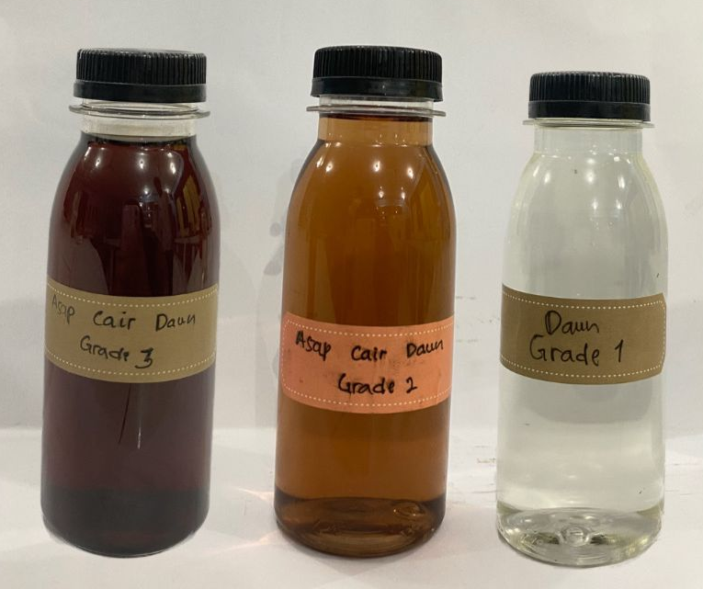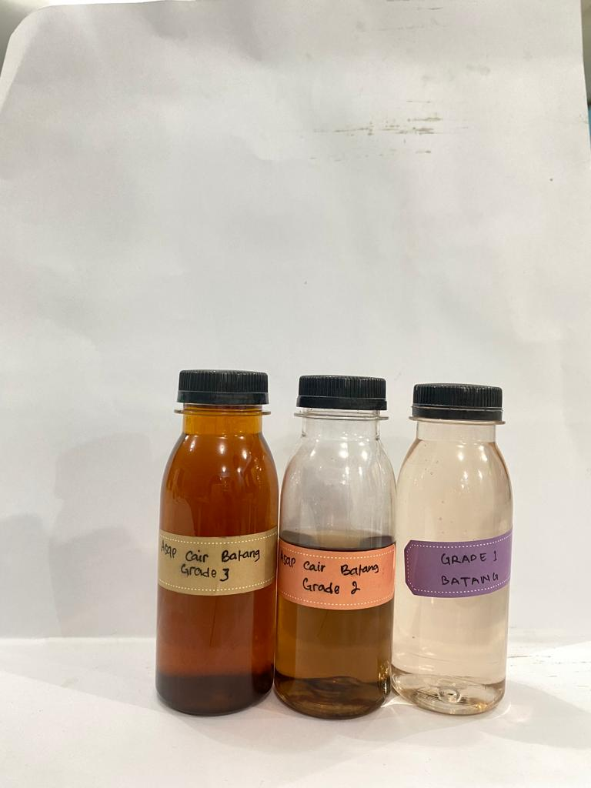
(a)
(b)

Fig 1. Comparison of the color of liquid smoke grade 3, grade 2, grade 1 (a) Eucalyptus leaves waste and (b) Eucalyptus log waste

Table 2. Phytochemical analysis of liquid smoke
Sample | Phytochemical content
Sample | Alkaloid | Flavonoid | Saponin | Tanin | Terpenoid | Steroid
Leaf Eucalyptus | + | - | - | - | + | -
Eucalyptus Log waste | + | - | - | - | + | -
Note: + = there are composite content, - = there are no composite content
The liquid smoke grade 1 testing results of leaf and log waste (Table 2) demonstrate the presence of alkaloid and terpenoid compounds. Different from the findings of Gurav et al. (2023) regarding phytochemicals, which found that Eucalyptus globulus leaves contain alkaloids, terpenoids, saponins, and tannins. Liquid smoke that contains alkaloid compounds is characterized by a color change to orange or red. Alkaloids represent a class of secondary metabolites that function as biopesticides by inhibiting insects and nematodes, leading to mutagenesis and toxicity. The mechanism involves the disruption of cell wall formation, resulting in cell death (Tampubolon et al., 2018; Wulandari et al., 2019). Terpenoid compounds were identified in the phytochemical test, as evidenced by the development of a red-purple color. Secondary metabolite compounds suggest that liquid smoke may serve as an antibacterial agent by reducing the permeability of bacterial cell walls, leading to nutrient deficiency and subsequent growth inhibition of bacterial cells (Windiyanti et al., 2023).
3.2 Antibacterial Activity
Table 3. The Antibacterial effect of liquid smoke
Sample | Bacteria | Concentration | Inhibition zone (mm) | Inhibition category
Leaf Eucalyptus | Staphylococcus aureus | 10 | 0,0 ± 0,0ª | No Inhibition
Leaf Eucalyptus | Staphylococcus aureus | 25 | 4,7 ± 4,0^{b} | Weak
Leaf Eucalyptus | Staphylococcus aureus | 50 | 9,3 ± 0,6^{c} | Moderate
Leaf Eucalyptus | Staphylococcus aureus | 75 | 10,3 ± 0,6^{c} | Strong
Leaf Eucalyptus | Staphylococcus aureus | 100 | 11,7 ± 0,6^{c} | Strong
Leaf Eucalyptus | Staphylococcus aureus | Control - | 0,0 ± 0,0ª | No Inhibition
Leaf Eucalyptus | Staphylococcus aureus | Control + | 25,7 ± 0,6^{d} | Very strong
Leaf Eucalyptus | Propionibacterium acnes | 10 | 0,0 ± 0,0ª | No Inhibition
Leaf Eucalyptus | Propionibacterium acnes | 25 | 4,7 ± 4,0^{b} | Weak
Leaf Eucalyptus | Propionibacterium acnes | 50 | 7,7 ± 0,6^{bc} | Moderate
Leaf Eucalyptus | Propionibacterium acnes | 75 | 10,3 ± 0,6^{cd} | Strong
Leaf Eucalyptus | Propionibacterium acnes | 100 | 11,0 ± 0,0^{d} | Strong
Leaf Eucalyptus | Propionibacterium acnes | Control - | 0,0 ± 0,0ª | No Inhibition
Leaf Eucalyptus | Propionibacterium acnes | Control + | 27,0 ± 1,0e | Very strong
Eucalyptus Log waste | Staphylococcus aureus | 10 | 5,0 ± 4,4ª | Moderate
Eucalyptus Log waste | Staphylococcus aureus | 25 | 8,7 ± 0,6^{b} | Moderate
Eucalyptus Log waste | Staphylococcus aureus | 50 | 12,0 ± 1,0^{bc} | Strong
Eucalyptus Log waste | Staphylococcus aureus | 75 | 14,3 ± 1,2^{d} | Strong
Eucalyptus Log waste | Staphylococcus aureus | 100 | 16,0 ± 1,0^{d} | Strong
Eucalyptus Log waste | Staphylococcus aureus | Control - | 0,0 ± 0,0ª | No Inhibition
Eucalyptus Log waste | Staphylococcus aureus | Control + | 26,0 ± 0,0e | Very strong
Eucalyptus Log waste | Propionibacterium acnes | 10 | 5,0 ± 4,4ª | Moderate
Eucalyptus Log waste | Propionibacterium acnes | 25 | 7,7 ± 0,6ª | Moderate
Eucalyptus Log waste | Propionibacterium acnes | 50 | 11,3 ± 1,2^{b} | Strong
Eucalyptus Log waste | Propionibacterium acnes | 75 | 13,7 ± 0,6^{b} | Strong
Eucalyptus Log waste | Propionibacterium acnes | 100 | 17,3 ± 1,2^{c} | Strong
Eucalyptus Log waste | Propionibacterium acnes | Control - | 0,0 ± 0,0ª | No Inhibition
Eucalyptus Log waste | Propionibacterium acnes | Control + | 26,7 ± 1,2^{d} | Very strong
Note: Control - = distilled water. Control + = Chloramphenicol
Different superscript letters indicate significant differences (α =0.05) in inhibition zone diameters.
The antibacterial activity was assessed by analyzing the inhibition zones in the treated media samples. The inhibition zone is classified into four levels: weak (<5 mm), moderate (5-10 mm), strong (10-20 mm), and very strong (>20 mm). (Mohamad et al., 2015; Sangi et al., 2023). The agar diffusion method (disc diffusion Kirby and Bauer) analysis (Fig 2) indicates that the proportion of liquid smoke grade 1 raw material and variations in liquid smoke concentration influence antibacterial effectiveness against Staphylococcus aureus and Propionibacterium acnes, as presented in table 3. The biomass type and liquid smoke concentration significantly influence antibacterial activity sensitivity and inhibition. Increased concentrations of liquid smoke correlate with larger diameters of inhibition zones. Observations indicate that 75% and 100% concentrations of the liquid smoke sample exhibit greater inhibitory effects on Staphylococcus aureus and Propionibacterium acnes compared to other concentrations. The correlation between phytochemical test results indicating the presence of terpenoid compounds in liquid smoke suggests a potential inhibitory effect on bacterial growth. Terpenoid compounds are thought to inhibit growth by interfering with the formation of membranes and cell walls, resulting in either incomplete formation or defective structures. The inhibition process by these compounds on membrane and cell wall formation involves terpenoid compounds reacting with porins in the outer membrane of bacterial cell walls, leading to the formation of strong polymer bonds and subsequent damage to porins. Damage to porins leads to the entry of compounds that decrease the permeability of the bacterial cell wall, resulting in nutrient deficiency and subsequent inhibition or death of bacterial cells (Nurulita et al., 2022).

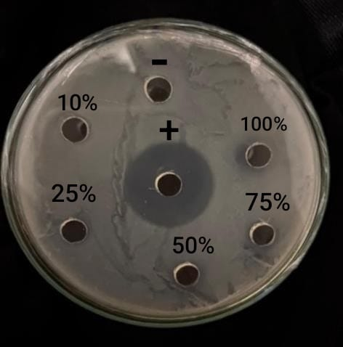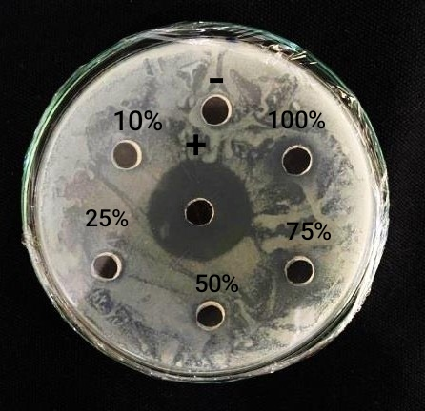
P. acnes
S. aureus
S. aureus
P. acnes
(a)
(b)

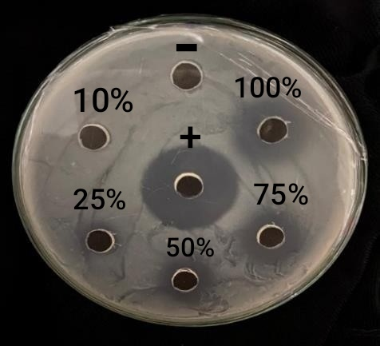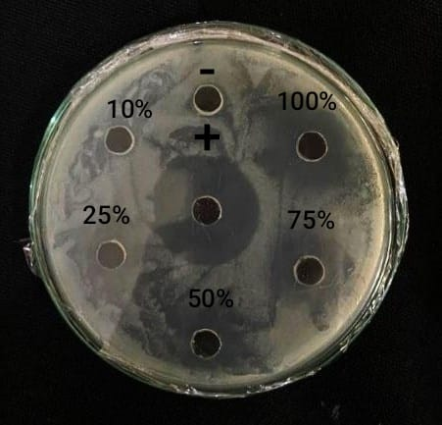

Fig 2. Result of the antibacterial activity test of (a) Eucalyptus leaves waste and (b) Eucalyptus log waste againt Staphylococcus aureus and Propionibacterium acnes

Furthermore, components in liquid smoke, such as acids, phenols, carbonyl compounds, and their derivatives, induce coagulation of microbial cells. Acetic acid inhibits bacterial growth through the disruption of the cell membrane and the inhibition of enzyme synthesis. Phenolic compounds are capable of damaging cellular structures and inhibiting cell wall synthesis, resulting in bacterial cell lysis. The action of carbonyl compounds as antibacterial agents is characterized by their ability to inactivate enzymes within the cytoplasmic membrane, leading to the disruption of bacterial cell growth. Statistical analysis employing one-way ANOVA and subsequent duncan multiple range test indicated significant differences (α = 0.05) among various treatment groups. Specifically, for the liquid smoke sample derived from leaves tested against the bacteria Staphylococcus aureus, further evaluations demonstrated that the treatments at concentrations of 50%, 75%, and 100% were the most effective. Antibacterial testing with Propionibacterium acnes indicates that the optimal treatment concentration is 100%. The liquid smoke sample derived from Eucalyptus log waste demonstrated optimal efficacy against Staphylococcus aureus at concentrations of 75% and 100%. In contrast, the most effective treatment for Propionibacterium acnes was observed at a concentration of 100%.

4. Conclusion

The properties of liquid smoke derived from leaves and log waste comply with the standards set by Japan for liquid smoke. The liquid smoke contains phytochemicals such as alkaloids and terpenoids, which may serve as effective antimicrobials against various bacterial pathogens. This is evidenced by gram-negative antibacterial tests conducted in culture, specifically against Staphylococcus aureus and Propionibacterium acnes, both of which are implicated in skin infections, including acne, within the cosmetic industry. Liquid smoke application in the cosmetics sector may satisfy consumer preferences for natural products while maintaining safety standards. The best treatment concentrations for the Staphylococcus aureus bacterial test are between 75% and 100%, while for the Propionibacterium acnes bacterial test, the best treatment concentration based on further testing is 100%.

Disclaimer (Artificial intelligence)
Option 1:
Author(s) hereby declare that NO generative AI technologies such as Large Language Models (ChatGPT, COPILOT, etc.) and text-to-image generators have been used during the writing or editing of this manuscript.

References

Bailleres, H., Hopewell, G. P., & Mcgavin, R. L. (2008). Publication: Evaluation of wood characteristics of tropical post-mid rotation plantation Eucalyptus cloeziana and E. pellita: Part (c) Wood quality and structural properties (Vol. 61, Issue May). www.fwpa.com.au
Barbosa, L., Filomeno, C., & Teixeira, R. (2016). Chemical Variability and Biological Activities of Eucalyptus spp. Essential Oils. Molecules, 21(12), 1671. https://doi.org/10.3390/molecules21121671
BPS. (2022). Statistik Produksi Kehutanan 2022. Badan Pusat Statistik, 32. https://www.bps.go.id/id/publication/2022/07/29/e6e4600abae56ef5d4507463/statistik-produksi-kehutanan-2021.html
Chahomchuen, T., Insuan, O., & Insuan, W. (2020). Chemical profile of leaf essential oils from four Eucalyptus species from Thailand and their biological activities. Microchemical Journal, 158, 105248. https://doi.org/10.1016/j.microc.2020.105248
Chandorkar, N., Tambe, S., Amin, P., & Madankar, C. (2021). A systematic and comprehensive review on current understanding of the pharmacological actions, molecular mechanisms, and clinical implications of the genus Eucalyptus. Phytomedicine Plus, 1(4), 100089. https://doi.org/10.1016/j.phyplu.2021.100089
Desvita, H., Faisal, M., Mahidin, M., & Suhendrayatna. (2023). Natural antimicrobial properties of liquid smoke derived from cocoa pod shells in meatball preservation. South African Journal of Chemical Engineering, 46, 106–111. https://doi.org/10.1016/j.sajce.2023.08.003
Dewi, F. C., Tuhuteru, S., Aladin, A., Yani, S., Lestari, R. H. S., Padang, I. S., & Subrata, B. A. G. (2022). Liquid Smoke of Red Fruit (Pandanus Conoideus. L.) Waste with Pyrolysis Method For Controlling Sweet Potatoes (Ipomea Batatas. L.) Pest. International Journal of Environmental, Sustainability, and Social Science, 3(1), 109–115. https://doi.org/10.38142/ijesss.v3i1.168
Diatmika, I. G. N. A. Y. A., Kencana, P. K. D., & Arda, G. (2019). Karakteristik Asap Cair Batang Bambu Tabah (Gigantochloa nigrociliata BUSE-KURZ) yang Dipirolisis pada Suhu yang Berbeda. Jurnal BETA (Biosistem Dan Teknik Pertanian), 7(2), 271. https://doi.org/10.24843/jbeta.2019.v07.i02.p07
Fauzan, F., & Ikhwanus, M. (2017). Pemurnian Asap Cair Tempurung Kelapa Melalui Distilasi dan Filtrasi Menggunakan Zeolit dan Arang Aktif. Prosiding Semnastek, 016, 1–5.
Fibonacci, A. (2019). Sintesis Alkohol Dari Limbah Nangka (Artocarpus heterophyllus) sebagai Campuran Bahan Bakar Minyak (Biofuel). Walisongo Journal of Chemistry, 2(1), 17. https://doi.org/10.21580/wjc.v2i1.4043
Goldbeck, J. C., do Nascimento, J. E., Jacob, R. G., Fiorentini, Â. M., & da Silva, W. P. (2014). Bioactivity of essential oils from Eucalyptus globulus and Eucalyptus urograndis against planktonic cells and biofilms of Streptococcus mutans. Industrial Crops and Products, 60, 304–309. https://doi.org/10.1016/j.indcrop.2014.05.030
Gurav, N. V., Gade, R. M., & Choudhari, R. J. (2023). Phytochemical and Thin Layer Chromatographic Analysis of Chloroform and Methanol Extracts of Azadirachta indica and Eucalyptus globulus Leaves. International Journal of Plant & Soil Science, 35(19), 502–513. https://doi.org/10.9734/ijpss/2023/v35i193576
Hii, S. Y., Ha, K. S., Ngui, M. L., Ak Penguang, S., Duju, A., Teng, X. Y., & Meder, R. (2017). Assessment of plantation-grown Eucalyptus pellita in Borneo, Malaysia for solid wood utilisation. Australian Forestry, 80(1), 26–33. https://doi.org/10.1080/00049158.2016.1272526
Izza, N., Rihayat, T., Astuti, R. D. D., Aida, A., Izzati, I. A., Aidy, N., & Safitri, A. (2023). Comparison of Raw Materials for Making Liquid Smoke with Pyrolysis Method as an Alternative to Formalin and Borax in Food (Vol. 1). Atlantis Press International BV. https://doi.org/10.2991/978-94-6463-118-0_13
Kailaku, S., Syakir, M., Mulyawanti, I., & Syah, A. (2017). Antimicrobial activity of coconut shell liquid smoke. IOP Conference Series: Materials Science and Engineering, 206, 012050. https://doi.org/10.1088/1757-899X/206/1/012050
Kartiko, A. B., Putri, A. S., Rosamah, E., & Kuspradini, H. (2021). Evaluation of Antibacterial Activity and Physico-Chemical Profiles of Eucalyptus pellita Essential Oil from East Kalimantan. https://doi.org/10.2991/absr.k.210408.002
Mohamad, H., Andriani, Y., Bakar, K., Siang, C. C., & Fitrya, D. (2015). Research Article Effect of drying method on anti-microbial , anti-oxidant activities and isolation of bioactive compounds from Peperomia pellucida ( L ) Hbk. 7(8), 578–584.
Nurulita, Y., Fitri, A., Sari, I. E., Sary, D. N., & Tjandrawati, T. (2022). Identifikasi Metabolit Sekunder Sekresi Jamur Lokal Tanah Gambut Riau Penicillium sp. LBKURCC34 Sebagai Antimikroba. Chimica et Natura Acta, 10(3), 124–133. https://doi.org/10.24198/cna.v10.n3.45994
Rahman, A., Anwar, R., & Lewar, Y. S. (2023). Identification of Secondary Metabolite Compounds in Nut Grass (Cyperus rotundus L.) Using Different Solvents Types. Median : Jurnal Ilmu Ilmu Eksakta, 15(3), 136–145. https://doi.org/10.33506/md.v15i3.2788
Ratnani, R. D. (2020). Effect of Temperature and Pyrolysis Time in Liquid Smoke Production from Dried Water Hyacinth. Journal of Environmental Treatment Techniques, 9(1), 164–171. https://doi.org/10.47277/jett/9(1)171
Ridolf, L. D., Abrina Anggraini, S. P., Gani, M. O., & Noviadi, T. (2018). Pemanfaatan Limbah Bambu Menjadi Asap Cair sebagai Pengawet Alami pada Struktur Kayu. Reka Buana : Jurnal Ilmiah Teknik Sipil Dan Teknik Kimia, 3(2), 73. https://doi.org/10.33366/rekabuana.v3i2.964
Rompas, S. A. T., Wewengkang, D. S., & Mpila, D. A. (2022). Antibacterial Activity Test Of Marine Organisms Tunicates Polycarpa aurata Against Escherichia coli AND Staphylococcus aureus. Pharmacon, 11(1), 1271–1278.
Rosyid Ridho, M. Sabiq Irwan H, Eko Malis, & Mislan. (2021). Utilization of Liquid Smoke for Odor Control at the Final Disposal Site Kalibaru, Banyuwangi. GANDRUNG: Jurnal Pengabdian Kepada Masyarakat, 2(1), 149–157. https://doi.org/10.36526/gandrung.v2i1.1224
Sadono, R., Wahyu, W., & Idris, F. (2021). Allometric Equations for Estimating Aboveground Biomass of Eucalyptus urophylla S.T. Blake in East Nusa Tenggara. Jurnal Manajemen Hutan Tropika (Journal of Tropical Forest Management), 27(1), 24–31. https://doi.org/10.7226/jtfm.27.1.24
Sahrum, R. P., Syaiful, A. Z., & Al-Gazali. (2021). Uji Kualitas Asap Cair Tempurung Kelapa Dan Serbuk Gergaji Kayu Metode Pirolisis. Saintis, 2(2), 72–78.
Sangi, M. S., Koleangan, H. S. J., Kumaunang, M., & Dapas, S. O. (2023). Antioxidant and antibacterial activity of Pangi fruit (Pangium edule Reinw). 080017. https://doi.org/10.1063/5.0119173
Sokamte tegang, A., Mbougueng, P. D., Sachindra, N. M., Douanla Nodem, N. F., & Tatsadjieu Ngoune, L. (2020). Characterization of volatile compounds of liquid smoke flavourings from some tropical hardwoods. Scientific African, 8, e00443. https://doi.org/10.1016/j.sciaf.2020.e00443
Tampubolon, K., Sihombing, F. N., Purba, Z., Samosir, S. T. S., & Karim, S. (2018). Potensi metabolit sekunder gulma sebagai pestisida nabati di Indonesia Potency of secondary metabolite from weeds as natural pesticides in Indonesia. Kultivasi, 17(3), 683–693.
Theapparat, Y., Chandumpai, A., & Faroongsarng, D. (2018). Physicochemistry and Utilization of Wood Vinegar from Carbonization of Tropical Biomass Waste. In Tropical Forests - New Edition. InTech. https://doi.org/10.5772/intechopen.77380
Windiyanti, R., Khotimah, S., & Zakiah, Z. (2023). Potensi Ekstrak Buah Jambu Tangkalak (Bellucia pentamera Naudin) sebagai Penghambat Pertumbuhan Escherichia coli ATCC 25922 dan Staphylococcus aureus. Life Scince, 12(1), 86–96.
Wulandari, G., Rahman, A. A., & Rubiyanti, R. (2019). Uji Aktivitas Antibakteri Ekstrak Etanol Kulit Buah Alpukat (Persea americana Mill) Terhadap Bakteri Staphylococcus aureus. Media Informasi, 15(1), 74–80. https://doi.org/10.37160/bmi.v15i1.229
Yip, S. C., Ho, L. Y., Wu, T.-Y., & Sit, N. W. (2024). Chemical composition and bioactivities of Eucalyptus essential oils from selected pure and hybrid species: A review. Industrial Crops and Products, 222, 120118. https://doi.org/10.1016/j.indcrop.2024.120118
Yulistiani, F., Husna, A., Fuadah, R., Keryanti, Sihombing, R. P., Permanasari, A. R., & Wibisono, W. (2020). The Effect of Distillation Temperature in Liquid Smoke Purification Process: A Review. January. https://doi.org/10.2991/aer.k.201221.088
Yusraini, E., Halimatuddahliana, & Gea, S. (2018). IbM of Small Medium Enterprise of Coconut Milk and Liquid Smoke from Coconut Shells. Journal of Saintech Transfer, 1(1), 89–101. https://doi.org/10.32734/jst.v1i1.237

