Original Research Article

Impact of Different Levels of Fermented Cow Manure on the Growth, Yield, and Quality of Clitoria (Clitoria ternata L.)

ABSTRACT
This study was conducted at the Experimental Farm of the Department of Crop Science, Faculty of Natural Resources and Environmental Studies, University of Kordofan, El-Obeid, Sudan, to evaluate the impact of different levels of fermented cow manure on the growth, yield, and quality of Clitoria forage (Clitoria ternatea L.). The experiment included five treatments, comprising control (no manure) and fermented cow manure application rates of 5, 10, 20, and 40 tons/ha (denoted as CM0, CM1, CM2, CM3, and CM4, respectively). The treatments were arranged in a Randomized Complete Block Design (RCBD) with four replications. The parameters assessed included plant height (cm), number of branches per plant, number of leaves per branch, stem diameter (cm), leaf area (cm²), leaf-to-stem ratio, membrane stability index (MSI%), relative water content (RWC%), fresh forage yield (tons/ha), dry forage yield (tons/ha), protein content (%), fiber content (%), and ash content (%). Results indicated significant variations among treatments for most measured parameters. Fermented cow manure enhanced growth characteristics and forage yield, with the highest fresh and dry forage yields achieved at 40 tons/ha. Furthermore, the application of 40 tons/ha of fermented cow manure markedly increased protein (28.13%) and ash (11.58%) content, while reducing fiber content compared to the control treatment, which recorded the lowest values for protein (18.37%) and ash (8.14%) content. Based on these findings, it is recommended that applying fermented cow manure at a rate of 40 tons/ha is optimal for maximizing growth, yield, and quality of Clitoria ternatea forage

Key words: Cow manure, growth, yield, quality, Clitoria (Clitoria ternata L.)

- Introduction

Sudan, one of Africa's largest countries, covers an area of 1.88 million km² and holds a significant position in livestock production. The country is home to over 104.9 million heads of livestock, including 29.8 million cattle, 39.5 million sheep, 30.8 million goats, and 4.75 million camels, ASBAR, (2011). Forage crop production plays a critical role in sustaining livestock, serving as the primary energy source for their growth, maintenance, and productivity, Yossif and Ibrahim, (2013). In recent years, the demand for forage in Sudan has increased substantially, prompting continuous efforts to expand forage crop production, Himmeda et al., (2015).
However, Sudan's rangelands have been adversely affected by overgrazing, climate change, and the rapid expansion of rain-fed agriculture, resulting in diminished forage availability and a negative impact on livestock productivity. To address these challenges, adopting suitable cultivars and effective fertilization programs has become vital, Omer, (1994). The rising costs of chemical fertilizers, which are often unaffordable for farmers, have made organic fertilizers an attractive alternative. Organic manures not only meet crop nutrient requirements but also enhance soil's physical, chemical, and biological properties, improving moisture retention and overall crop productivity while maintaining produce quality, Malieswarappa et al., (1999). A 28-year study in China demonstrated that organic manure significantly improved soil hydraulic properties, field capacity, total porosity, and water retention, while reducing soil bulk density compared to control treatments and a mix of organic and inorganic fertilizers, Shi et al., (2016). Similar findings have been reported by other researchers, Dutta et al., (2016).
Clitoria ternatea L., commonly known as butterfly pea (Australia) or Kordofan pea (Sudan), belongs to the Fabaceae family and is one of the most important forage legumes in regions such as Asia, the tropics, South and Central America, the West and East Indies, Sudan, and China. While primarily cultivated as a cover crop, Clitoria is also grown as an ornamental plant along fence rows. The species adapts to diverse soil types, including sandy and loamy soils, as well as varying climatic conditions such as temperature and rainfall. It is particularly well-suited for cultivation in the drier regions of Kordofan, Sudan, Morsy and Awadalla, (2017). As a perennial forage crop, butterfly pea is favored by livestock due to its high nutritional value, with leaves containing up to 30% crude protein and 14% crude fiber, Jamil et al., (2018). This legume can undergo multiple defoliations within a single year, making it a highly productive fodder crop.
To date, limited studies have focused on the use of organic manures and their effects on the growth, physiological responses, forage yield, and quality of Clitoria. Thus, the primary objective of this study is to evaluate the impact of cattle manure application on the growth, forage yield, and quality of Clitoria ternatea grown in sandy soils of Kordofan, an arid region in Sudan.

2. Materials and Methods
2.1 Experimental Site

The field experiment was carried out at the Experimental Farm of the Department of Crop Science, Faculty of Natural Resources and Environmental Studies, University of Kordofan, El-Obeid, Sudan, during the period of June to September 2024. The study aimed to evaluate the effect of various levels of fermented cow manure on the growth, yield, and quality of Clitoria ternata forage.
The experimental site is located in the arid and semi-arid zone of Sudan, (latitude 11 - 15 N and longitude 27 - 32 E).The soil at the site is predominantly sandy, with an annual rainfall ranging from 350 to 450 mm, Ahmed, (2009). The maximum daily temperature typically fluctuates between 30°C and 50°C throughout the year.
2.2 Experimental Design
The treatments in this study comprised five levels of fermented cow manure: 0, 5, 10, 20, and 40 tons/ha, denoted as Control (CT), CM1, CM2, CM3, and CM4, respectively. These treatments were arranged in a Randomized Complete Block Design (RCBD) with four replications. Seeds of clitoria used in this experiment were obtained from the local market. Fertilizer used was cow manure, which was collected from farm of Department of Animal Production. The manure was applied manually on June 30, 2024, by broadcasting it at the bottom of the ridges, mixing it thoroughly with soil using a hand hoe, and distributing it evenly across the plots. Each plot was irrigated immediately after fertilizer application and continued daily until the tenth day. Sowing was done manually on July 10, 2024, on the eastern side of the ridges. A seed rate of 45 kg/ha was applied. The experimental site was prepared by leveling the field and creating ridges with an 80 cm spacing. Each experimental plot measured 5 × 5 meters and consisted of seven ridges, each six meters long. For sampling purposes, the second and fifth ridges within each plot were utilized. Spacing between experimental units was one meter, while the spacing between replications was two meters. The plots were irrigated immediately after sowing and subsequently at intervals of 5 to 7 days, based on the crop's requirements. Separate irrigation was provided for each plot to prevent movement of cow manure into adjacent plots. Throughout the experimental period, plots were maintained weed-free through manual hand weeding.
2.3 Studied parameters
2.3.1 Plant height (cm)
Plant height was measured as an average height of ten plants per plot taken from the soil surface to the tallest leaf by covering all the leaves until they were perpendicular.
2.3.2 Number of branches per plant
The number of branches was measured by counting the number of branches on every ten-plant stem and after that the average number of number of branches per plant was recorded
2.3.3 Number of leaves per plant S
It was recorded by calculating all leaves of ten randomly selected plants that had fully opened then the average number of leaves per plant was determined.
2.3.4 Stem diameter
The stem diameter was estimated by reading the number of ten plant showed by the caliper at the base stem and then the average was obtained
2.3.5 Leaf area
Leaf area was measured by using plant canopy analyzer, Model LAI-2270 manufactured by Li-cor Biosciences, USA.
2.3.6 Leaf: stem ratio
For the ten randomly selected plants was measured on fresh weight basis by estimating weight of fresh leaves over their fresh stems.
2.3.7 Membrane stability index (MSI %)
Was calculated following the method of Premachandra et al., (1990) using Equation
MSI% = [1- EC1\ EC2] x 100
2.3.8 Relative water content (RWC %)
Determined according to the method of Hayat et al., (2007) using the following Equation
RWC% = [ (FW-DW)\(TW-DW)] x 100
2.3.9 Forage productivity (tons\ha)
One square meter entire plot from each experimental unit was harvested and weighed to get forage fresh yield, while a sample was taken from same plot area, oven dried at 70 ⁰C until constant weight to obtain dry forage yield. Both fresh and dry yields were transformed into tons/ha.
2.3.10 Forage quality (Protein, fiber, and ash)
The chemical analysis of forage quality components (on dry matter basis) included the following:
1- Crude protein content (CP): total nitrogen percentage was determined according to the modified micro Kjeldahl method. Crude protein content was estimated by the following equation:
Crude protein (%) = N % X 6.25 A.O.A.C, (1995).
2- Crude fiber (CF) and Ash content were determined according to respective AOAC official method described for each test AOAC, (2006).
2.5 Statistical Analysis
Data were collected and analyzed using analysis of variance (ANOVA) and SPSS (SPSS Inc, Chicago, IL). Significant different means of the measured data were separated at the 0.05 probability level by the Least Significant Different (LSD).
3. Results
3.1 Impact of different fermented cow manure levels on Growth attributes
Impact of different fermented cow manure levels on growth parameters of clitoria plant in the two cuts is shown in Table (1). The growth parameters of plant height, number of branches per plant, number of leaves per plant, leaf area, stem diameter, and leaf: stem ratio, were influenced significantly (P<0.05) by cow manure fertilizer levels. The highest results were observed from the application of 40 ton/ha fermented cow manure fertilizer. Based on this study, the rates of fertilization had a significant (P<0.05) effects on the plan height, number of branches, and number of leaves, leaf area, stem diameter, and leaf: stem ratio. The application of cow manure fertilizer increased plant height from 15.04 to 17.19 %, number of branches from 54.23 to 59.68%, number of leaves from 39.80 to 47..30% , leaf area from 50.03 to 60.39% , stem diameter from 25.68 to 26.51, and leaf: stem ratio from 39.66 to 44.44% respectively compared to control.

Table 1. Impact of different fermented cow manure levels on plant height (cm), number of branches/plant, number of leaves/plant, and leaf area (cm²) at first and second cut during growing season
 | Plant height (cm) |  | No. of branches/plant |  | No. of leaves/plant |  | Leaf area (cm²)
Treatments | First cut | Second cut | First cut | Second cut | First cut | Second cut | First cut | Second cut
CT | 78.64e | 80.84e | 8.12e | 10.13e | 63.27e | 80.11e | 7.18d | 4.76e
CM1 | 83.29d | 87.25d | 10.30d | 12.27d | 81.35d | 96.13d | 9.48c | 6.95d
CM2 | 85.52c | 90.85c | 12.48c | 14.28c | 98.09c | 112.53c | 11.25b | 9.24c
CM3 | 88.35b | 93.31b | 14.37b | 17.30b | 115.13b | 125.34b | 13.32a | 10.06b
CM4 | 92.56a | 97.62a | 20.14a | 22.13a | 120.06a | 133.08a | 14.37a | 12.02a
LSD | 1.95 | 1.81 | 1.39 | 1.78 | 1.43 | 1.06 | 2.88 | 3.11
C.V% | 8.64 | 6.88 | 10.33 | 10.49 | 4.72 | 3.65 | 6.13 | 7.12
Different small letters in the same column refer to significant differences between treatments at P < 0.05 level

3.2 Impact of different fermented cow manure levels on physiological attributes
Impact of different cow manure levels on physiological parameters of clitoria plant is shown in table 2. The physiological parameters of membranes stability index (MSI) and relative water content (RWC) were significantly affected by fermented cow manure fertilizer rates. The highest results were scored at 40 ton \ ha of cow manure; according to the results the cow manure fertilizer treatment had significant effects on the MSI% and RWC%. The highest rate of cow manure increased the MSI from 21.20 to 25.21% and RWC from 10.67 to 16.27 % when compared to the control.

Table 2. Impact of different fermented cow manure levels on stem diameter (cm), leaf: stem ratio, MSI (%), and RWC (%) at first and second cut during growing season
 | Stem diameter (cm) |  | Leaf: stem ratio |  | MSI (%) |  | RWC (%)
Treatments | First cut | Second cut | First cut | Second cut | First cut | Second cut | First cut | Second cut
CT | 0.55e | 0.61e | 1.05e | 0.85e | 67.20e | 35.95e | 76.16e | 69.28e
CM1 | 0.63d | 0.68d | 1.37d | 0.96d | 71.18d | 38.21d | 78.79d | 72.48d
CM2 | 0.65c | 0.72c | 1.58c | 1.24c | 75.42c | 42.25c | 80.90c | 74.95c
CM3 | 0.69b | 0.75b | 1.65b | 1.39b | 82.32b | 45.81b | 83.07b | 77.44b
CM4 | 0.74a | 0.83a | 1.74a | 1.53a | 85.28a | 48.07a | 85.26a | 82.74a
LSD | 1.79 | 1.98 | 2.03 | 2.23 | 1.57 | 2.11 | 1.62 | 1.73
C.V% | 11.46 | 8.12 | 15.32 | 12.63 | 9.31 | 6.78 | 8.34 | 7.48
Different small letters in the same column refer to significant differences between treatments at P < 0.05 level

3.3 Impact of different fermented cow manure levels on yield attributes
3.3.1 Fresh forage yield
Impact of different fermented cow manure levels on fresh forage yield of clitoria plan in the two cuts is shown in figure 1. The results demonstrated that there were significant (P<0.05) differences among the treatments in the fresh forage yield both in first and second cut. All cow manure treatments resulted in higher fresh forage yield compared to the control (Fig. 1). On the other hand, the cow manure rate CM4 (40 ton /ha) scored the highest yield compared to the control followed by CM3 (20 ton / ha), CM2 (10 ton/ ha) , and CM1 (5 ton\ ha). The highest rate of cow manure fertilizer (40 ton \ ha) increased the fresh forage yield from 63.26 to 63.54% compared to control.
3.3.2 Dry forage yield
Figure 2 showed that there was considerable different on dry forage yield between fermented cow manure fertilizer treatments and the control. However, all cow manure fertilizer treatments had a significantly (p< 0.05) higher dry forage yield (ton/ ha) when compared to the control (Fig. 2). Cow manure level (40 ton/ha) resulted in the highest dry yield, followed by (20 ton/ha) , (10 ton \ ha) ,and (5 ton/ha). The level of cow manure fertilizer (40 ton \ ha) increased the dry forage yield from 65.89 to 69.83% compared to the control.
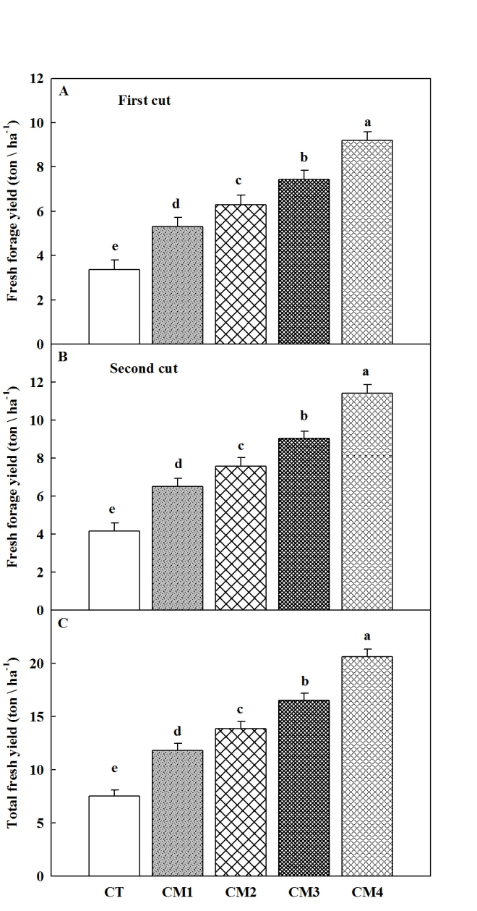
Fig.1. Impact of different fermented cow manure levels on forage fresh yield in clitoria
Data are mean +SD (n=3), Different small letters indicate significant differences between treatments at P < 0.05

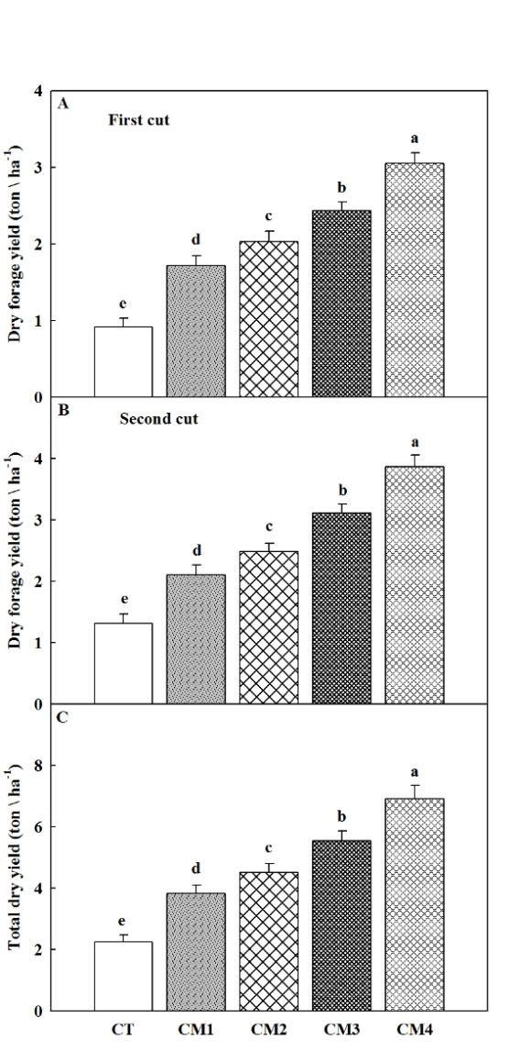
Fig. 2. Impact of different fermented cow manure levels on forage dry yield in clitoria
Data are mean +SD (n=3), Different small letters indicate significant differences between treatments at P < 0.05

3.4 Impact of different fermented cow manure levels on quality attributes
3.4.1 Protein (%)
The results of Figure 3 demonstrated that the percentage of crude protein contents increased with increasing the level of cow manure. Plants fertilized with (40 ton/ha) of fermented cow manure showed highest crude protein (%)) (28.13) which was noticeably higher than all other treatments, and lowest value was recorded in control (18.37) crude protein (%).
3.4.2 Fiber percentage (%)
As shown in Figure 4, all fermented cow manure treatments significantly (P < 0.05) lowered the fiber percentage (%) compared to the control. However, the results of fermented cow manure treatments illustrated that 40 ton/ha recorded lowest fiber (%) (10.18) and the highest value were scored in control (16.23) fiber (%).
3. 4. 3 Ash percentages (%)
The results of Figure 5 confirmed that fermented cow manure treatments significantly (P < 0.05) difference in ash concentrations percentage as compared with control. Treatment 40 ton/ha fermented cow manure/ha scored highest ash percentage (%) (11.58) followed by 20 ton /ha (10.89) ash (%),10 ton \ ha (10.39) , and 5 ton /ha (8.14) ash percentage (%).
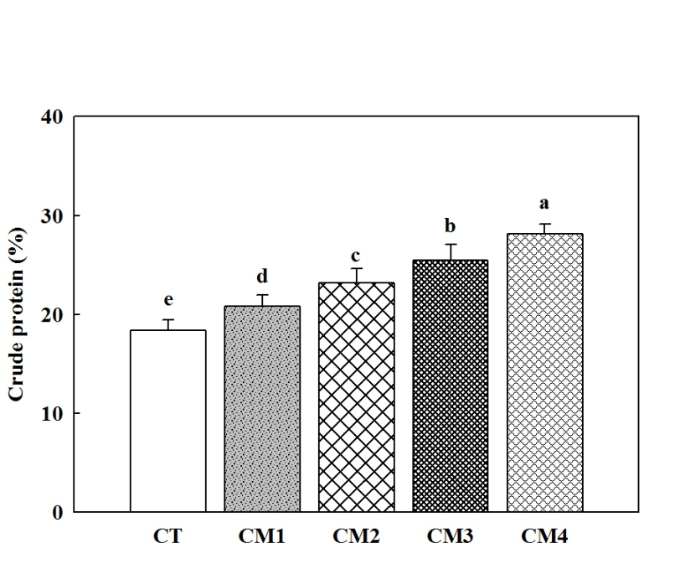
Fig.3. Impact of different fermented cow manure levels on crude protein (%) in clitoria
Data are mean +SD (n=3), Different small letters indicate significant differences between treatments at P < 0.05

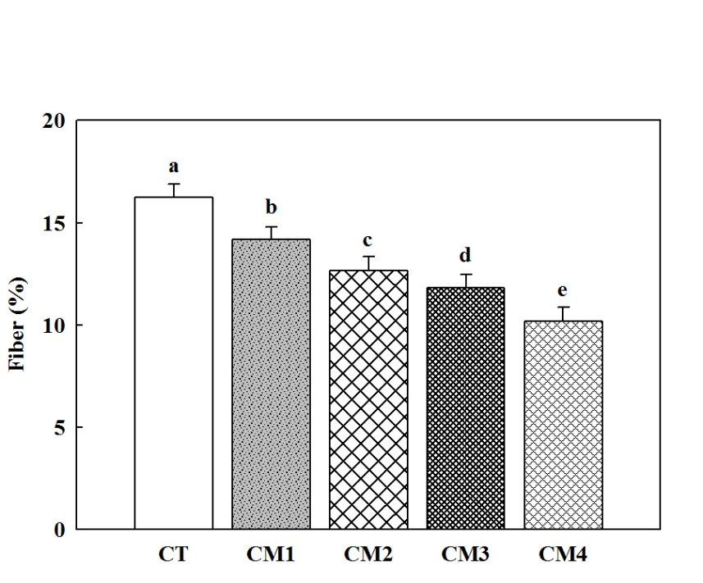
Fig.4. Impact of different fermented cow manure levels on fiber (%) content in clitoria
Data are mean +SD (n=3), Different small letters indicate significant differences between treatments at P < 0.05

4. Discussion
In the present study, the growth traits of clitoria plant studied were, plant height, number of branches per plant , number of leaves per plant, leaf area, stem diameter, and leaf: stem ratio. The change in these parameters is very important aspect for forage production, since they are vegetative characters that contribute forage yield components. The treatments of fermented cow manure scored taller plants, higher number of branches per plant, higher number leaves per plant, bigger leaf area, highest stem diameter, higher leaf : stem ratio, and improved the yield of fresh and dry matter of clitoria plant forage compared to the control. These responses may perhaps refer to its high concentration of nitrogen in fermented cow manure, Eleduma et al., (2020). These findings were agreement with Aminifard et al., (2010) reported that nitrogen fertilizer application improved the plant height.
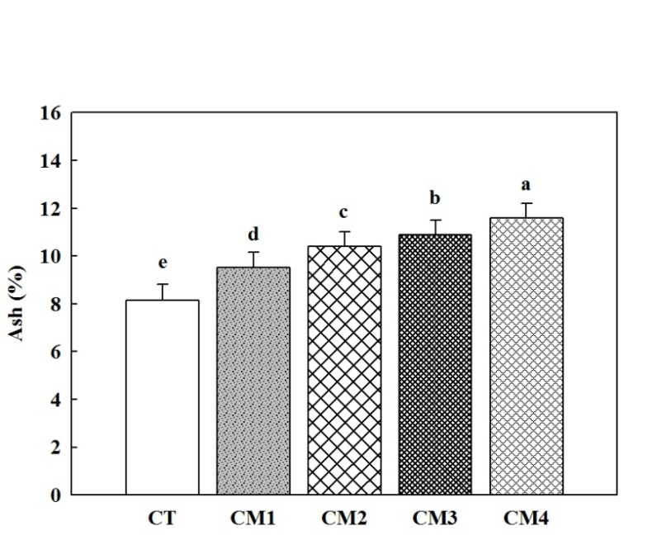
Fig.5. Impact of different fermented cow manure levels on ash (%) content in clitoria
Data are mean +SD (n=3), Different small letters indicate significant differences between treatments at P < 0.05

The highest number of branches per plant and number of plant leaves in the present research was obtained in plants amended with 40 ton\ ha of organic fertilizer which was radically (P<0.05) higher than the control and other plants amended with other levels. The exogenous of fermented cow manure to the soil at different rates might have enhanced soil structure and soil fertility, increased organic matter of soil and improved microbial activity, Khalil et al., (2010), and released nutrients from manure hence support and enhanced rapid root growth, which may have improved branch and leaf growth, Abou El-Magd et al., (2005).
Leaf area (LA) is an essential growth determining plant capacity to trap solar energy for photosynthesis and has significant effect on plant growth and yield. The influence of fermented cow manure on leaf area remained considerable under vary application rates; maximum leaf area was recorded at 40 t/ha which was statistically higher than 20 t/ha, 10 t/ha, 5 t/ha and 0 t/ha. Nitrogen (N) is one of the most important plant nutrients influencing plant growth, yield and leaf area increase with increase in N dose (Tafteh and Sepaskhah ,2012, and Oscar and Tollennar, 2012). Enhanced leaf area in soil amended with organic fertilizer might probably be related to availability of N which endorsed leaf area during vegetative development and also helped to keep functional leaf area during the growth period, Cox et al., (1993). Stem diameter was significantly (P < 0.05) affected by different rate of fermented cow manure treatment. Application of 40 ton/ ha fermented cow manure recorded highest response in respect, which was followed by application of 20 ton/ha, while the control treatment scored the least plant diameter. Mean treatment value obtained from plant amended with 40, 20, 10, 5 t/ha, and controls were in comparison were significantly different. Organic manures have been assumed to improve soil fertility by activating microbial biomass of soil, which in turn leads to development in corps Awad, (2019), and this could have been responsible for the observed enhance in stem diameter. Also Abhiskek et al., (2024) mentioned that organic manures increased the morphological and floral attributes of marigold plant.
Fresh and dry matter forage yield was examined in this study. Forage yield is regularly related to growth attributes. All fermented cow manure fertilizer treatments had a significantly (P<0.05) influence on forage yield (fresh and dry), when compared to the control. Cow manure fertilizer resulted in an increase in growth parameters as well as forage yield. Cow manure rate CM4 (40 ton /ha) produced higher fresh and dry forage at first and second cut compared to the control. The results were also in conformity with Awad, (2017), who found that the highest yield of clitoria forage was obtained under fermented cow manure while the lowest yield was recorded with control. Awad, (2017) mentioned that fermented cow manure application improved the fresh weight of clitoria. Use of 40 ton /ha of fermented cow manure considerably increased the dry matter yield of clitoria forage Elfeel1 and Ali, (2014). Awad, (2019) reported that there was positive relationship between nitrogen and dry forage yield in sorghum forage.
The most significant factor affecting the nutritional value of fodder crop is protein content Afzal, et al., (2012). In the present study, fermented cow manure enhanced the protein concentration when compared with the control, the highest crude protein content was recorded in (40 ton/ ha) of cow manure, while the lowest content of protein was obtained in (0 ton/ ha) of control. Significant differences for crude protein concentrations amongst the clitoria plant recorded by Wardi, et al., (2023), who found that cow manure fertilizer significantly (P<0.05) improved the crude protein concentration (%). Our findings also established that the protein content was enhanced under cow manure treatments as a source of nitrogen when compared to the control. The increase in protein content with increasing the cow manure rate might be due to nitrogen improving the formation of amino acid and consequently increasing protein content. Feisal, et al., (2024), mentioned that maximum content of fibers was obtained in the control, and it decreased with increased in nitrogen rate. In this study, cow manure containing nitrogen clearly decreased the fiber percent compared to the control. As a result, it demonstrates that use of cow manure fertilizer enhances clitoria forage quality due to reduce in fiber content, as has also been mentioned by Awad, (2017). Feisal, et al., (2024), described that nitrogen fertilizer had a significant impact on ash percentage increases. Our results also showed that the application of fermented cow manure (nitrogen contain) increases ash percentage content.
5. CONCLUSIONS
The findings of this study clearly demonstrated that the application of fermented cow manure significantly enhanced growth parameters and forage yield (both fresh and dry) of Clitoria ternata Quality attributes such as protein, ash, and fiber content were also markedly influenced by the application of fermented cow manure. Among the treatments, CM4 (40 tons/ha) exhibited the highest growth performance, increased forage yield, and superior forage quality.
Based on these results, it is recommended to apply fermented cow manure at a rate of 40 tons/ha to achieve optimal growth, yield, and quality of Clitoria ternata forage. Future studies are encouraged to investigate the effects of varying levels of fermented cow manure to further validate and refine these findings.

COMPETING INTERESTS
Authors have declared that no competing interests exist.

Disclaimer (Artificial intelligence)
Author(s) hereby declare that NO generative AI technologies such as Large Language Models (ChatGPT, COPILOT, etc.) and text-to-image generators have been used during the writing or editing of this manuscript.

References
A.O.A.C., 1995. Associationof Official Analytical Chemists. Official Method of analyaia, 15th Ed., Washington, D.C.,USA.
Abhishek, Harpal Singh, G.K Ahirwar and Dushyant, (2024). Assessment of Different Organic Manures on Morphological and Floral Attributes of Marigold (Tagetes erecta L.). Journal of Scientific Research and Reports, 30(8): 936-941.
Abou El-Magd, MM, Hoda Mohammed A, Fawzy ZF (2005) Relationships, Growth, Yield of Broccoli with Increasing N, P or K Ratio in a Mixture of NPK Fertilizers. Annals of Agricultural Science Moshtohor 43: 791-805. Link: https://bit.ly/3iRzJRl.
Afzal, M., Ahmad, A. and Ahmad, A.H., 2012. Effect of nitrogen on growth and yield of sorghum forage (Sorghum bicolor (L.) Moench CV.) Under three cuttings system. Cercetări Agronomice in Moldova, 45(4), pp.57-64.
Ahmed, AA. Effectiveness of screening and Hardening methods for drought Resistance in Sorghum Genotype (Sorghum bicolor (L) Moench), Evaluated under Arid Conditions, PhD Thesis of Agronomy. Gazeira University.Sudan; 2009.
Ahmed, M. Yossif and Yassin M. Ibrahim. Effect of Organic and Inorganic Fertilizers on Proximate Analysis of Rhodes Grass (Chloris gayana L. Knuth.). Universal Journal of Plant Science 1(4): 137-140. 2013.
Asma, Himmeda. Mohammed Fatur. Abu bakr Ismail. Hafiz Ali. Magda Elmahdie. (2015).The Effect of Chicken Manure on the Yield and Nutritive Value of Fodder Sorghum Sudanese Under Rain-fed Conditions. International Journal of Sciences: Basic and Applied Research (IJSBAR)(2015) Volume 24, No 7, pp 143-149.
Aminifard MH, Aroiee HO, Fatemi H, Ameri AS, Karimpour S (2010) Responses of eggplant (Solanum melongena L.) to different rates of nitrogen under fi eld conditions. Journal of Central European agriculture􀉸 11: 243-248. Link: https://bit.ly/2Q5oPej.
AOAC, (2006). Official Methods 942.05 and 978.10 for ash determination and fiber analysis. Association of Official Analytical Chemists Inc., USA.
Awad, O. Abusuwar. (2019). EFFECT OF FERMENTED MANURES ON INTERCROPPED SUDAN GRASS (SORGHUM SUDANESE L.) AND CLITORIA (CLITORIA TERNATE) GROWN IN AN ARID SALINE ENVIRONMENT. The Journal of Animal & Plant Sciences, 29(1): 269-277. Awad, Osman Abusuwar. (2017) . Performance of Clitoria grown in stressed environment as affected by compost of organic and inorganic nutrients. Cogent Food & Agriculture 3: 1303908, DOI: 10.1080/23311932.2017.1303908.
Cox, WJ, Kalonge S, Cherney DJR, Reid WS (1993) Growth Yield and Qualitym of Forage Maize under Different Nitrogen Management Practices. Agronomy Journal 85: 341-347. Link: https://bit.ly/2Q30hmg. Degradation and Development, 27, 60–67. http://dx.doi.org/10.1002/ldr.v27.1.
Dutta, T., Dell, C. J., & Stehouwer, R. C. (2016). Nitrous oxide emissions from a coal mine land reclaimed with stabilized manure. Land Degradation & Development, 27, 427–437.ndoi:10.1002/ldr.2408
Eleduma, AF, Aderibigbe ATB and Obabire SO. (2020). Effect of cattle manure on the performances of maize (Zea mays L) grown in forest savannah transition zone Southwest Nigeria. Int J Agric Sc Food Technol 6(2): 110-114.
Elfeel1, AA and Ali K. Elsafori1. (2014). Cultivation of Clitoria ternatea L. under arid conditions: Effects of fertilization and season on leaf traits, stomatal conductance, leaf area index and forage yield .Bothalia Journal. 44(9): 147-165.
Feisal, M. Ismaeil, Salah Eldeen E. Ahmed, Abderhim A. Jabereldar, Entisar Elilah B. Mohammed Ahmed and Mohammed H. B . (2024). Effect of different Chicken Manure Rates on Yield and Quality of Sudan Grass (Sorghum sudanense Piper.). Asian Journal of Research and Review in Agriculture. 6(1): 161- 170.
Feisal M. Ismaeil, Salah Eldeen E. Ahmed, Abderhim A. Jabereldar, Entisar Elilah B. Mohammed Ahmed and Mohammed H. B. (2024). Effect of different Nitrogen Levels on Yield and Quality of Forage Sorghum (Sorghum bicolor L. Moench cv. Abusabien). Asian Journal of Advances in Agricultural Research. 24 (7): 28-38.
Hayat, S, Ali B, Hasan SA, Ahmad A. 2007. Brassinosteroid enhanced the level of antioxidants under cadmium stress in Brassica juncea. Environ Exp Bot. 60:33–41. doi:10.1016/j.envexpbot.2006.06.002.Indonesia. Animal Production. 25 (1):14-23
Jamil, N., MNM Zairi, A Nasim, and F Pa’ee. 2018. Influences of Environmental Conditions to Phytoconstituents in Clitoria ternatea (Butterfly Pea Flower). Journal of Science and Technology. 10(2):208-228.
Khalil, RS, Muhammad SK, Rehman F, Khan A, Amanullah AZ, et al. (2010) Phenology, Leaf Area Index and Grain Yield of Rainfed Wheat Infl uenced by Organic and Inorganic Fertilizer. Pakistan Journal of Botany 42: 3671-3685. Link: https://bit.ly/2Q6R5NW.
Malieswarappa, HP, Nansappa HV, Hedge MR, Balu SR (1999) Influence of planting material, plant population and organic manure on yield of East India Galangal and on soil physiochemical and biological properties.
Morsy, A. S.M. and A. Awadalla. (2017). Growth, Forage Yield and Quality of Clitoria (Clitoria ternatea) as Affected by Dates and Methods of Sowing and Phosphorus Fertilizer under Toshka Region Condition. Middle East Journal of Agriculture
Omer, E. Effect of farmyard manure and urea fertilization on growth and yield of teff grass (Eragrostis Tiff. Z. ucc.).M.Sc. Thesis. Fac. of Agric. University of Khartoum, Sudan. 1994.
Oscar, RV, Tollennar M (2006) Effect of Genotype, Nitrogen, Plant Density and Row Spacing on the Area-Per-Leaf Profi le in Maize. Agronomy Journal 98: 94- 99. Link: https://bit.ly/327TGfN.
Premachandra, GS, Saneoka H, Ogata S. 1990. Cell membrane stability, an indicator of drought tolerance, as affected by applied nitrogen in soybean. The J Agric Sci. 115:63–66. doi:10.1017/S0021859600073925. Research. 6(2): 506-518.
SBAR, Statistical Bulletin for Animal Resources. Ministry of animal resources and fisheries, Issues No. 20, Sudan. 2011
Shi, Y., Zhao, X., Gao, X., Zhang, S., & Wu, P. (2016). The effects of long-term fertiliser applications on soil organic carbon and hydraulic properties of a loess soil in China. Land
Tafteh, A, Sepaskhah AR (2012) Yield and Nitrogen Leaching in Maize Field under Different Nitrogen Rates and Partial Root Drying Irrigation. International Journal of Plant Production 6: 93-113. Link: https://bit.ly/3h5AvcZ.
Wardi, Wardi1, Nafiatul Umami, Asih Kurniawati, Bambang Suhartanto, Chusnul Hanim, and Zen Adyatama. (2023). Productivity of Butterfly Pea (Clitoria ternatea L.) Influenced by Urea Fertilizer Rates and Harvest Ages in KulonProgo, Yogyakarta,

