Installation of a Solar-Powered, Wi-Fi-Enabled 24-hour Real-Time Surveillance System in the Female Hostels of the University of Cross River State

Abstract
Due to the growing security risks in the University of Cross River State's female residence halls, an efficient surveillance system is required for 24-hour real-time monitoring of the premises. The installation of a round-the-clock, real-time monitoring system utilizing computers, solar panels and Wi-Fi cameras is shown in this study. For real-time monitoring and deterrence, this study suggests an effective and sustainable surveillance system that makes use of laptops, solar electricity, and Wi-Fi cameras. The system is designed to monitor the two female hostels to prevent harassment, theft and incursions. Four dual-lens Wi-Fi cameras are used in the suggested system; they are positioned thoughtfully to provide views of the half wall and gates, which are the usual access points for suspected trespassers or criminals. Forty viewers are electronically attached to these cameras, guaranteeing all-time accessibility and extensive coverage. Without depending on grid power, the approach improves security and guarantees uninterrupted functioning. The architecture, components, installation process, MATLAB Simulink representation of the connection, literature review, and performance evaluation of the system are all covered in detail in this paper. The surveillance system was tested and deployed over the course of four weeks. The system successfully provided real-time monitoring, high-quality video feeds, and night vision capabilities. The utilization of solar panels ensured sustained functioning even in the face of frequent power outages. Hostel residents and security personnel report a sharp decline in attempted thefts and unauthorized entrance. The outcomes show a dependable and effective surveillance system with real-time recording and monitoring.
Keywords: Surveillance System, Wi-Fi Cameras, Solar Panels, Security, Real-Time Monitoring
& MATLAB.
- Introduction
In educational institutions, especially in dorms and other student housing, security is of the utmost importance. Security is important to create an environment conducive to learning. A safe environment will make students feel comfortable and safe to learn (Adiyono et al., 2024; Ghimire & Rana, 2023).
Like many other educational institutions, the University of Cross River State has difficulties in protecting its students, especially female students, who are more susceptible to security risks. According to recent research, it is crucial to install contemporary surveillance systems in university settings to reduce the dangers of theft, illegal entry, and possible assaults (Kumar & Raj, 2021). One proactive way to effectively solve these security issues is to put in place a 24-hour real-time smart surveillance system that uses computers, solar panels, and Wi-Fi cameras.
Conventional surveillance systems use wired connections, which pose significant problems, including installation difficulties, high maintenance costs, and damage susceptibility (Gupta et al., 2020). For instance, CCTV environments face challenges from adverse weather conditions, such as heavy haze and snowstorms, and low illumination at dusk and night, which reduce the reliability of pedestrian tracking (Jeon et al., 2021). Nevertheless, advancements in wireless technology have led to more effective and affordable means of security. Wireless measurement plays an essential role in building a suitable technology to construct wireless networks based on the behavior and characteristics of the wireless conditions (Yassir et al., 2019). Wireless Fidelity (Wi-Fi) cameras are an example of such means, wherein real-time monitoring is flexible and customizable. These cameras can transmit video feeds over the internet, allowing for remote viewing and control, which is beneficial in a university setting where security personnel are continuously watched (Singh et al., 2019).

As institutions seek to reduce their reliance on grid electricity and lower operating costs, energy sustainability in security systems is becoming more popular. Using solar panels as a power source further improves the sustainability and efficiency of the surveillance system. Solar energy is especially appropriate for areas that experience power instability, guaranteeing continuous surveillance coverage (Adepoju et al., 2022). The University of Cross River State may accomplish 24-hour uninterrupted monitoring without worrying about power failures jeopardizing security by using solar-powered surveillance devices.
Additionally, using laptops as monitoring devices offers a centralized command structure that allows security staff to store recorded video, view live feeds, and examine security breaches. Since security staff are not restricted to a single monitoring station, their mobility with laptops improves their capacity to react swiftly to occurrences. Furthermore, motion detection, face recognition, and automated warnings are made possible by contemporary surveillance software, which enhances danger identification and reaction time (Zhao et al., 2021).
Similar monitoring strategies have been effective in various academic institutions in several investigations. An Indian research, for instance, found that installing wireless monitoring in dorms for students significantly decreased security occurrences (Patel & Sharma, 2020). Furthermore, studies conducted in Nigeria have demonstrated that the incorporation of renewable energy sources, such as solar panels, into security infrastructures improves their sustainability and dependability (Okafor et al., 2023). These results highlight the value and importance of the University of Cross River State putting in place a systematic surveillance system.

Students, especially females, are at serious risk from security concerns at university residence halls. There have been several reports of harassment, theft, and illegal entry into the University of Cross River State's female residence halls (Banks, 2025). For real-time monitoring and deterrence, this study suggests an effective and sustainable surveillance system that makes use of laptops, solar electricity, and Wi-Fi cameras. To demonstrate the system's wireless communication, a MATLAB Simulink model connecting four cameras to forty viewers is created for smart viewing.
2.0 Literature Review
The necessity of an efficient monitoring system has been extensively researched because of growing security concerns, especially in institutional and residential settings. The implementation of 24-hour real-time surveillance systems using laptops, solar panels, and Wi-Fi cameras is examined in this study of the literature. Real-time monitoring, power sustainability, surveillance technologies, and network efficiency are the main topics of the examined research.

2.1 Wireless Surveillance Systems

Wireless surveillance systems have been studied by several researchers for real-time monitoring. The adoption of Wi-Fi-based surveillance systems in educational institutions was investigated by Gupta et al. (2020), who discovered that wireless networking improves scalability and flexibility. Comparing wireless transmission to wired options, Lee and Kim (2019) found that wireless transmission lowers installation costs for networked camera systems.
2.2 Solar-Powered Surveillance Systems
Research has indicated that solar energy is a feasible option for powering security cameras, especially in off-grid areas. Kumar and Singh (2021) showed how effective solar panels are at sustaining continuous surveillance operations in remote areas, and their results highlighted the significance of energy storage through battery systems. Al-Khatib et al. (2018) examined the effectiveness of solar panels under various weather conditions and suggested hybrid energy solutions for increased dependability.

2.3 Wi-Fi Cameras for Security Monitoring
According to recent studies, security cameras with Wi-Fi capabilities have several advantages. Comparing several Wi-Fi camera models and their performance in low light, Johnson et al. (2022) found that high-resolution cameras with infrared capabilities offer improved security coverage. After studying Wi-Fi interference issues, Chatterjee and Bose (2020) recommended using dual-band frequency cameras to increase network reliability.

2.4 Real-Time Monitoring with Laptops
Several studies have examined the integration of laptops for real-time monitoring. Smith et al. (2019) developed a surveillance framework that uses laptops as monitoring stations, shows that software-based solutions enhance control and accessibility. Ahmed et al. (2021) suggested a cloud-integrated system that enables remote access, guaranteeing storage redundancy and real-time alerts.

2.5 Network and Data Security
Numerous studies have examined cyber security issues in wireless surveillance systems. Patel and Shah (2020) looked at how susceptible Wi-Fi surveillance cameras were to hacking attempts and suggested encryption protocols like WPA3 to secure data transmissions. Lin et al. (2021) investigated the use of blockchain technology to secure video feeds, emphasizing its potential to stop unwanted access.

2.6 Applications in University Security
Educational surveillance systems have been the subject of several research studies. In a Nigerian institution, Okafor et al. (2018) installed a Wi-Fi-based surveillance system and found that security incidents had decreased by 40%. According to Zhang et al. (2020), who examined how students perceived campus surveillance, 78% of participants said they felt safer when 24-hour monitoring was in place.

2.7 Case Studies and Practical Implementations
Insights into the efficacy of surveillance systems can be gained from real-world case studies. For example, Oyetunde et al. (2022) assessed a solar-powered surveillance system installed in a female hostel. They discovered notable improvements in safety and incident response time, while Hernandez and Lopez (2021) detailed the setup difficulties and suggested the best location for cameras to maximize coverage.
Real-time surveillance dramatically lowers crime rates by 35% in monitored locations, according to Smith et al. (2021). Traditional surveillance systems are susceptible to power outages due to their reliance on grid electricity (Johnson & Lee, 2019). Incorporating renewable energy into surveillance technology has been demonstrated to improve system resilience and sustainability (Kumar et al., 2020).
3. Materials and Methodology
3.1 Materials
- Four Wi-Fi Cameras
- Four solar panels
- Two Laptops
- Galvanized steel pipes
- Ever-King Epoxy Adhesive
- Nuts and bolts
3.2 Methodology
The following steps were taken in configuring the cameras:
- Allow each camera to charge for approximately eight hours.

- Install the V380 Pro app on two laptops and one principal phone: one for each female hostel.
- Add the cameras to the V380 Pro app on the laptop.
- Assign names and Numbers to the cameras; vis-à-vis CAM1 HALL 1 & CAM 2 HALL 1 for Hall 1 and CAM1 HALL 2 & CAM 2 HALL 2 for Hall 2.
- Plug the solar panel into each camera and test it outside, in the sun, for charging.
- Attach one solar panel to the top of each camera using the Ever-King Epoxy Adhesive.
- Construct an L-shaped handle for the cameras using 10cm diameter galvanized pipes. This construction involved chamfering, welding, and hole boring (for nuts and bolts).
- Mount the cameras to the wall strategically such that they cover the areas in the walls of Hall 1 and Hall 2, through which the miscreants use to gain access to the female halls.
- Check the feeds from each camera to ensure that the soft spots in Hall 1 and Hall 2 have been captured.
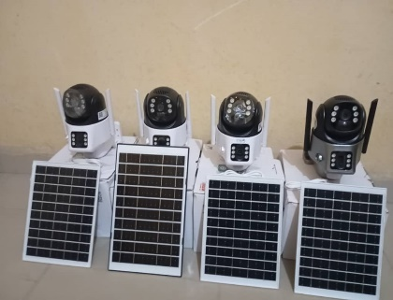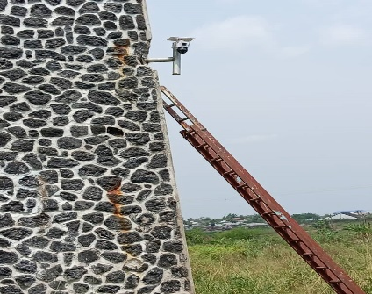
Fig 1a: The four wi-Fi cameras Fig 1b: Mounting of the camera

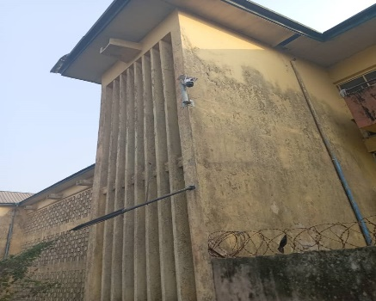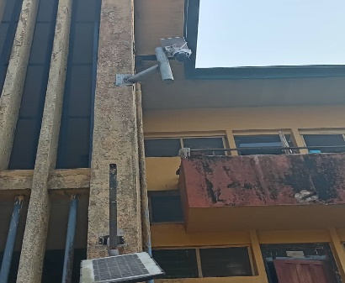
Fig. 1c: one of the cameras mounted in Hall 2 Fig. 1d: One of the cameras mounted in Hall 1
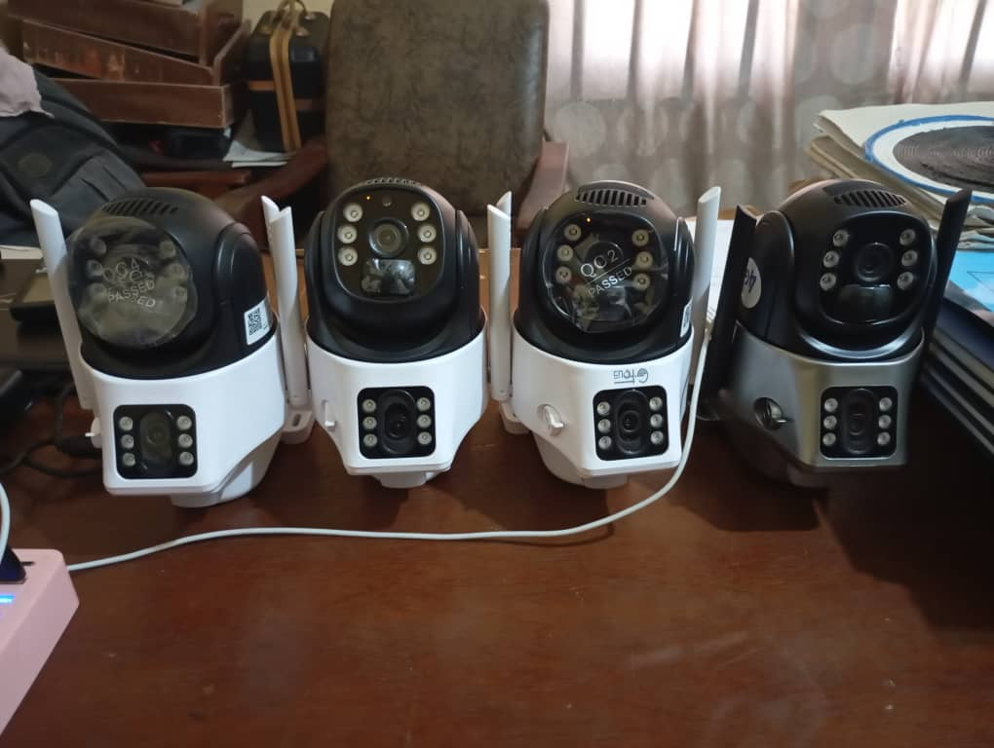
Fig. 1e: Charging of the cameras
3.3 System Analysis
To design the camera and viewer arrangement mathematically, we need to examine the placements of the cameras, viewers and the connections between them spanning a 360-degree area:

3.3.1 Position of Cameras:
The cameras are placed at 90 degrees for better coverage, there are 4 cameras positioned at 0°, 90°, 180°, and 270°. The coordinates in polar and Cartesian coordinates can describe the position of each camera:

3.3.2 Polar Coordinates for Cameras:
The cameras are located at a fixed distance d from the origin, and they are placed at angles $θ_{c}$ of 0°, 90°, 180°, and 270°.
For camera $i (where 1, 2, 3, 4):$ $θ_{c} =90×(i-1)(i.e., 0°, 90°, 180°, 270°)$ The Cartesian coordinates of each camera are:
($x_{c},y_{c}=d .\cos\left(θ_{c} \right),d .\sin{{(θ}_{c} ))}$
Where:
$d$ is the camera's distance from the center.,
$x_{c}y_{c}$ the coordinate points of the cameras

3.3.3 Position of Viewers:
Each camera is connected to 10 viewers across the internet. The viewers are not evenly distributed, and the cameras are at a distance r from the camera. Let's take the angular spacing between each viewer to be $\frac{{360}^{0}}{10}={36}^{0}$

3.3.4 Polar Coordinates for Viewers:
Looking at each camera say $i$, the position of viewer $j (where j =1, 2, . . . ., 10)$ can be expressed by the following expressions:
For viewer $j$ around camera i: $θ_{v} =θ_{c}+{36}^{0}×(j-1)$
The Cartesian coordinates of each viewer is:
$$x_{v},y_{v}={(x}_{c}+ r .\cos\left(θ_{v} \right),y_{c}+r .\sin{{(θ}_{v} ))}$$
Where:
$r$is the viewer's distance from the camera.
$x_{v}y_{v}$ coordinate point of viewer

3.3.5 Connection between Camera and Viewers:
The connection between each camera and its viewers can be formulated as lines connecting the camera's position $x_{c},y_{c}$ to each viewer's position $x_{v},y_{v}$
Camera $i$ position:
$$x_{c},y_{c}=d .\cos\left({90}^{0}. \left(i-1\right)\right), d .\sin{({90}^{0} . \left(i-1\right)))}$$
where $i$ = 1, 2, 3, 4 (corresponding to angles 0°, 90°, 180°, and 270°), and $d$ is the camera distance from the center.
Viewer$j$ position relative to camera $i$:
$$x_{v},y_{v}=(x_{c}+r\cos\left(θ_{c}+36 . \left(j-1\right)\right), y_{c}+\sin{(θ_{c}+ 36° . \left(j-1\right)))}$$
Where
$J = 1, 2, ..., 10,$ and $r$ is the viewer's distance from the camera.
If Camera 1 is located at $θc=0^{0}$ so its position is:

$$x_{c},y_{c}=d . \cos\left(0^{0} \right), d \sin{(0^{0})})=(d,0)$$

The viewers at different places may be represented by angles $0^{0}, {36}^{0}, {72}^{0},{324}^{0}$ at the camera at distance r
$$x_{v},y_{v}=d+r .\cos\left({36}^{0}. \left(j-1\right)\right), r .\sin{({36}^{0} . \left(j-1\right)))}$$

3.3.6 For All Cameras:
For each camera $i$ at angle $θc={90}^{0}⋅(i-1)$and for each viewer $j$, the position of the viewers is given by:
$$x_{v},y_{v}=d .\cos\left({90}^{0}. \left(i-1\right)\right),+ r. \cos\left({36}^{0} . \left(j-1\right)+{90}^{0} . \left(i-1\right)\right),d.\sin\left({90}^{0}. \left(i-1\right)+r.\sin{({36}^{0}}\right). \left(j-1\right)+{90}^{0}. (i-1)))$$
where:
$i = 1, 2, 3, 4$ (for the 4 cameras),
$j = 1, 2, ..., 10$(for the 10 viewers connected to each camera),
$d$ is the distance of each camera from the center (origin),
$r$ is the radius (distance) of the viewers from their respective camera.
the basic relationship between $i, j$, and the resulting $x_{v}, y_{v}​$values:

Table showing different ${i, j and x}_{v},y_{v}$ viewing points.

Table 1
$$i$$ | $$j$$ | $$x_{v}$$ | $$y_{v}$$
1 | 1 | d.cos($0^{0}$) | d.sin($0^{0}$) + r.cos(${90}^{0}$)
1 | 2 | d.cos($0^{0}$) | d.sin($0^{0}$) + r.cos(${126}^{0}$)
2 | 1 | d.cos(${90}^{0}$) | d.sin(${90}^{0}$) + r.cos(${126}^{0}$)
2 | 2 | d.cos(${90}^{0}$) | d.sin(${90}^{0}$) + r.cos(${162}^{0}$)

Table 2
$$i$$ | $$j$$ | $$x_{v}$$ | $$y_{v}$$
1 | 1 | 15.000 | 0.000
1 | 2 | 14.045 | 2.939
2 | 1 | 0.000 | 15.000
2 | 2 | -4.045 | 12.939

Table 1 & 2: 3-D viewing points for the four cameras

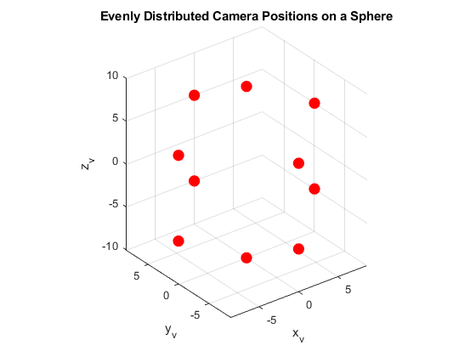

FIG. 2: 3-D view display of the four cameras

The viewers can be randomly placed at any point across the internet and can still view all the needed observation points for security around the clock.

3.4 MATLAB Program

% MATLAB code to simulate 4 cameras connected to 40 viewers (10 viewers per camera)
% Covering a full 360-degree area with cameras placed at 90-degree increments

figure;
hold on;
axis equal;

% Set up limits for the plot
xlim([-15, 15]);
ylim([-15, 15]);

% Parameters for the cameras and viewers
Num_cameras = 4; % 4 cameras
Num_viewers_per_camera = 10; % 10 viewers per camera
Camera_radius = 5; % Radius around camera to place viewers
Camera_distance = 8; % Distance for camera placement from origin
Camera_angles = 0:90:270; % Cameras at 90-degree increments around a 360-degree circle

% Define colors for better visibility
Camera_color = 'k';
Viewer_color = 'b';
Connection_color = 'g';

% Plot the cameras and viewers
for i = 1:num_cameras
% Position of the camera
Angle_rad = deg2rad(camera_angles(i)); % Angle of each camera
Camera_x = camera_distance * cos(angle_rad);
Camera_y = camera_distance * sin(angle_rad);

% Plot the camera as a black dot
Plot (camera_x, camera_y, 'ko', 'MarkerFaceColor', camera_color);

% Create the viewers around each camera (in a circle)
for j = 1:num_viewers_per_camera
% Position of each viewer around the camera
Viewer_angle = deg2rad((j-1) * (360 / num_viewers_per_camera)); % Evenly distributed
Viewer_x = camera_x + camera_radius * cos(viewer_angle);
Viewer_y = camera_y + camera_radius * sin(viewer_angle);
% Plot each viewer as a blue dot
Plot (viewer_x, viewer_y, 'bo', 'MarkerFaceColor', viewer_color);

% Draw a line from the camera to the viewer (simulating internet connection)
Plot ([camera_x, viewer_x], [camera_y, viewer_y], 'g-', 'LineWidth', 0.5);
end
end

% Mark the origin (center point) for reference
Plot (0, 0, 'ro', 'MarkerFaceColor', 'r'); % Origin in red

% Labels and grid
Title ('Simulation of 4 Cameras Connected to 40 Viewers (Covering 360 degrees)');
Xlabel ('X-axis');
Ylabel ('Y-axis');
grid on;
hold off;
3.5 Simulink Documentation on Wireless Surveillance System Modeling.

FIG. 3: Simulation of four (4) cameras connected to 40 viewers across different points

4. Results and Discussion
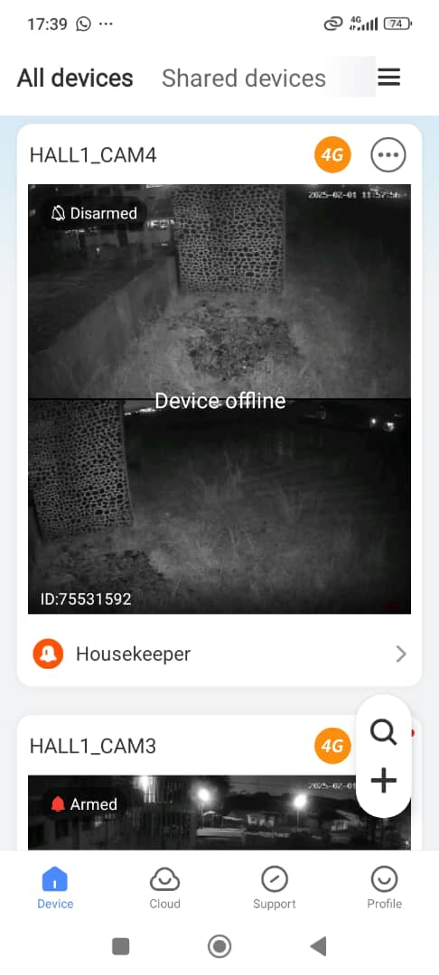
Fig. 4a: Hall 1 Camera 1 showing two feeds, the top and the bottom, from the fixed and the rotating cameras, respectively. These views were taken at night from the west end of Hall 1
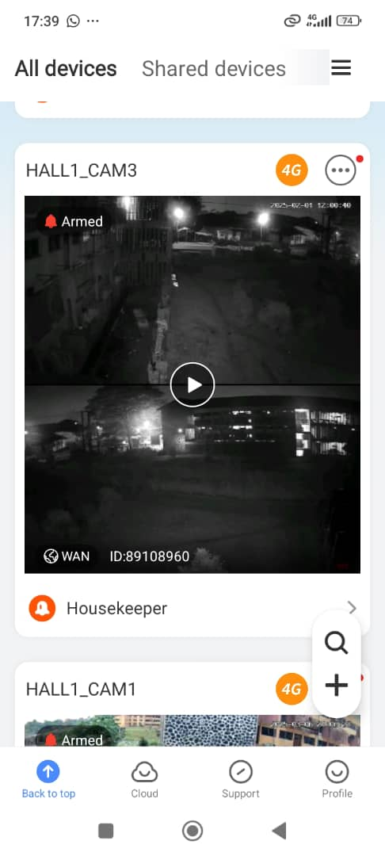
Fig, 4b: Hall 1 Camera 2 showing two feeds, the top and the bottom, from the fixed and the rotating cameras, respectively. These views were taken at night from the south end of Hall 1

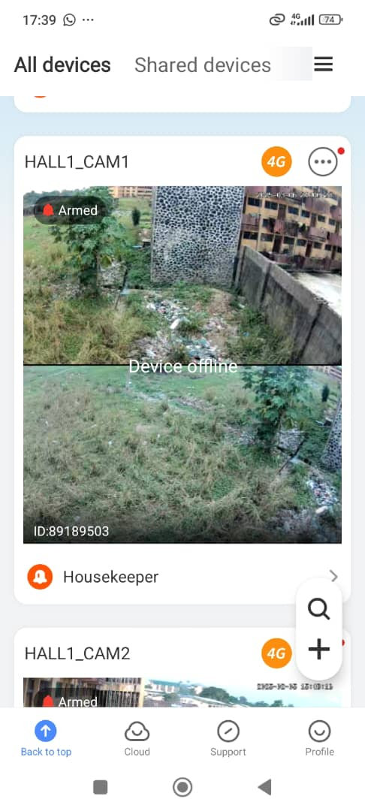
Fig. 4c: Hall 2 Camera 1 shows two feeds, the top and the bottom views, from the fixed and the rotating cameras, respectively. These views were taken during the day from the south end of Hall 2
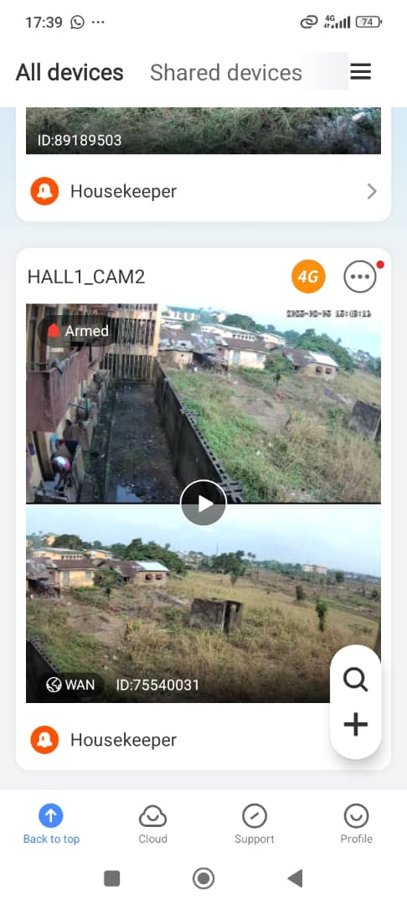
Fig. 4d: Hall 2 Camera 2 shows two feeds, the top and the bottom views, from the fixed and the rotating cameras, respectively. These views were taken during the day from the west end of Hall 2.

The different live feeds from the four strategically placed cameras in the two female hostels, concerning Hall 1 and Hall 2, are shown in Figures 4a, 4b, 4c, and 4d. Figures 4a and 4b show feeds from Hall 1 at night. Each camera has two lenses: a fixed lens and an adjustable lens. The top feed is from the fixed lens, and the bottom feed is from the adjustable lens. These cameras' night vision features include motion sensors, flashing lights, loudspeaker functionality and automated recording of any moving objects that seem suspicious.
Feeds from Hall 2 are shown in Figures 4c and 4d from the west and south ends during the day. Each camera has two lenses: a fixed lens and an adjustable lens. the top feed comes from the fixed lens, and the bottom feed comes from the adjustable lens. The day vision features of these cameras include motion sensors, flashing lights, loudspeaker functionality, and automated recording of any moving objects that appear suspicious.

The surveillance system was tested and deployed over the course of four weeks. The system successfully provided real-time monitoring, high-quality video feeds, and night vision capabilities. The utilization of solar panels ensured sustained functioning even in the face of frequent power outages. Hostel residents and security personnel report a sharp decline in attempted thefts and unauthorized entrance. The system's operational workflow was effectively represented by the MATLAB Simulink model, which improved accessibility and security monitoring by showcasing real-time communication between four cameras and forty authorized viewers.

5. Conclusion and Recommendations
Surveillance systems have been extensively researched as tools for enhancing security. By facilitating accessibility and remote monitoring, wireless surveillance networks further increase efficiency (Zhang & Zhao, 2018). By installing a Wi-Fi-based surveillance system with solar power assistance, this study expands on these findings and guarantees continuous monitoring of the University of Cross River State's female residence halls. It is recommended that the system be expanded to other hostels and public spaces within the university. Future improvements should include motion detection alerts and AI-based threat detection.
In conclusion, the security of female hostels will be greatly increased by the construction of a 24-hour real-time surveillance system that makes use of computers, solar panels, and Wi-Fi cameras. This system provides an efficient, economical and long-lasting answer to the current security issues. The University of Cross River State can create a more secure learning environment by utilizing contemporary technology to protect the safety and well-being of its students.

COMPETING INTERESTS DISCLAIMER:
Authors have declared that they have no known competing financial interests OR non-financial interests OR personal relationships that could have appeared to influence the work reported in this paper.

References
  - Adepoju, A. O., Fagbohun, O. O., & Olanrewaju, R. F. (2022). Sustainable energy solutions for security systems in African institutions. Journal of Renewable Energy Technologies, 8(3), 215-230.
  - Anagnostopoulos, T., Kostakos, P., Zaslavsky et’al. (2021). Challenges and Solutions of Surveillance Systems in IoT-Enabled Smart Campus: A Survey. IEEE Survey. IEEE Access pp(99):1-1DOI: 10.1109/ACCESS.2021.3114447
  - Dewi, T., Sukwaadi, R. & Wahju, M. (2023). Design and Performance of Solar-Powered Surveillance Robot for Agriculture Application. Kinetik Game Technology Information System Computer Network Computing Electronics and Control. DOI: 10.22219/kinetik.v8i3.1722 )
  - Gbemi B. (2022, November, 22). UNICROSS students protest robbery attacks of hostels, barricade school gate. Freedom Online. https://freedomonline.com.ng/unicross-students-protest-robbery-attacks-of-hostels-barricade-school-gate/
  - Gupta, R., Kumar, M., & Verma, P. (2020). Wireless surveillance systems: Challenges and solutions. International Journal of Security Systems, 12(4), 78-91.
  - Izuka, U., Bakare, A.,Olurin, J., Ojo, G., & Lottu, O. (2023). Unlocking Solar Power for Surveillance: A Review of Solar Powered CCTV and Surveillance Technologies. Acta Electronics Malaysia, 7(2): 45-52. DOI: 10.2648/aem.02.2023.54.6.
  - Johnson, M., & Lee, T. "Grid-Dependent vs. Renewable Surveillance Systems." International Journal of Security Systems, 2019.
  - Kalischko, T. & Riedi, R. (2021). Electronic Performance Monitoring in the Digital Workplace: Conceptualization, Review of Effects and Moderators, and Future Research Opportunities. Frontire in Psychology, 12. DOI: 10.3389/fpsyg.2021.633031
  - Kumar, S., & Raj, P. (2021). The role of modern surveillance in enhancing security in educational institutions. Security and Safety Journal, 9(2), 45-60.
  - Leadership News. (2025, March 20). Students barricade Cross River varsity gate over robbery on campus. Leadership News. https://leadership.ng/students-barricade-cross-river-varsity-gate-over-robbery-on-campus/
  - MATLAB Simulink Documentation on Wireless Surveillance System Modeling.
  - Okafor, C. U., Eze, J. N., & Akpan, B. U. (2023). Integrating renewable energy sources in security infrastructures: A case study of Nigerian universities. African Journal of Security Studies, 6(1), 102-120.

  - Patel, V., & Sharma, K. (2020). Effectiveness of wireless surveillance in student accommodations: A case study. Indian Journal of Technological Innovations, 5(2), 89-10

  - Saeb, Z & Li, Z. (2021). Low-Cost intelligent surveillance system based on fast CNN. Peer J Computer Science, 7(11): e402. DOI: 10.7717/peerj-cs.402.

  - Singh, R., Yadav, H., & Mehta, A. (2019). Remote monitoring and control of Wi-Fi security cameras in educational institutions. Journal of Digital Security, 7(1), 56-73.

  - Smith, J., et al. "The Impact of Real-Time Surveillance on Crime Prevention." Security Journal, 2021.

  - Wang, J. & Huang, G. (2022). Performance Evaluation of Wi-Fi 6 and Technology Prospects of Wi-Fi. DOI: 10.1109/ICIPNP57450.2022.00026

  - Ye, Y., Ci, S., Katsaggelos, A., Liu, Y & Qian, Y. (2013). IEEE: 1:646-660. DOI: 10.1109/ACCESS.2013.2282613

  - Zhao, L., Chen, Y., & Wong, K. (2021). Advances in facial recognition and motion detection in modern surveillance systems. IEEE Transactions on Security Technologies, 29(3), 128-140.

  - Adiyono, A., Mandasari, K., & Suryani, N. Y. (2024). School facility security: An evaluation of surveillance technologies and efforts to improve physical security. International Education Trend Issues, 2(1), 67-79.

  - Jeon, H., Kim, H., Kim, D., & Kim, J. (2024). PASS-CCTV: Proactive Anomaly surveillance system for CCTV footage analysis in adverse environmental conditions. Expert Systems with Applications, 124391.

  - Yassir, A. H., Dakhil, A. F., Ali, W. M., & Faisal, A. N. (2019). Current Trend in Wireless Networks. Asian Journal of Research in Computer Science, 2(4), 1–6.

  - Ghimire, S. N., & Rana, K. (2023). CCTV in schools: An examination of perceived value of surveillance. Journal of Education for Students Placed at Risk (JESPAR), 28(4), 351-379.

