**Case report**

**THE LENS, THE LIMB, AND THE CLOT: AN ATYPICAL PAEDIATRIC PRESENTATION OF HOMOCYSTINURIA**

**ABSTRACT**

|  |
| --- |
| AIM  To highlight a rare presentation of homocystinuria in a pediatric patient, initially manifesting as venous thrombosis, and later diagnosed through multidisciplinary evaluation of systemic features.  CASE PRESENTATION  A 10-year-old boy, born to third-degree consanguineous parents, presented with progressive right lower limb swelling, later involving the left limb. Doppler ultrasonography revealed thrombosis of the infrarenal inferior vena cava extending into the bilateral common and right external iliac veins, for which anticoagulation was initiated. There was no history of fever, trauma, or systemic illness. Two years later, he developed seizures. On examination, he was disoriented, with a tall stature (165 cm) and increased arm span (170 cm). Ophthalmologic evaluation revealed ectopia lentis of the left eye. In view of multisystem involvement—thrombosis, seizures, marfanoid habitus, and lens dislocation—homocystinuria was suspected. Serum homocysteine levels were markedly elevated, and genetic testing confirmed a pathogenic variant consistent with the diagnosis. Multidisciplinary management involving neurology and hematology teams was initiated. The patient has remained clinically stable and is under regular follow-up for the past three years.  CONCLUSION  This case emphasizes the need to consider metabolic disorders such as homocystinuria in children with unexplained thrombotic and neurological symptoms. A high index of suspicion, combined with coordinated multidisciplinary care, is crucial for early diagnosis and improved long-term outcomes. |

Keywords: [Homocystinuria, hyperhomocysteinemia, thrombosis, ectopia lentis, pediatric metabolic disorder, cerebral venous thrombosis]

1. INTRODUCTION

Homocystinuria is a rare autosomal recessive inborn error of metabolism that results from a deficiency of the enzyme cystathionine β-synthase (CBS), which plays a pivotal role in the transsulfuration pathway of methionine metabolism. This enzymatic defect leads to the accumulation of homocysteine and methionine in plasma, along with increased excretion of homocysteine in the urine¹. Elevated plasma homocysteine levels are toxic to various organ systems and contribute to the multisystemic clinical manifestations of the disease.

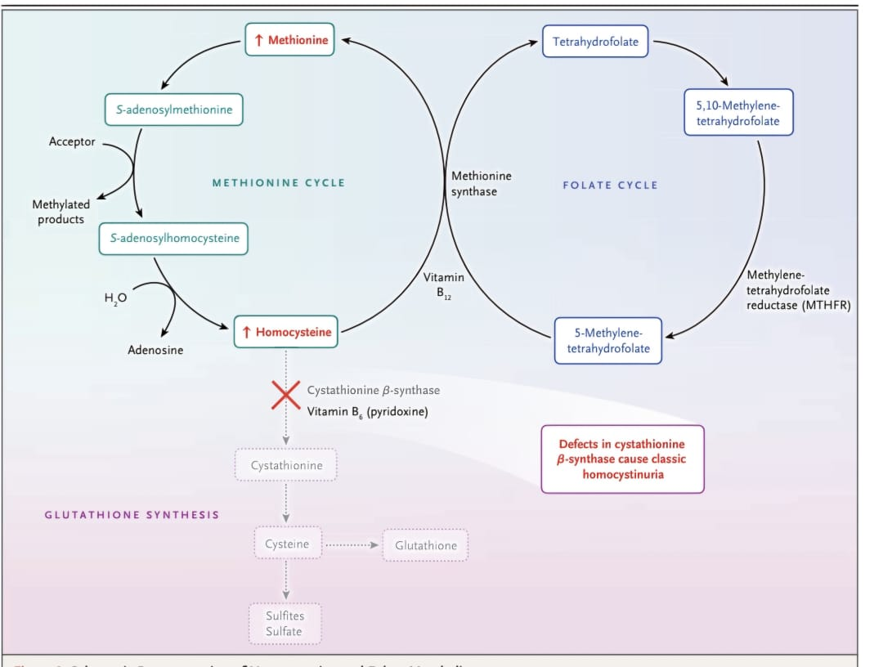

Figure 1- Schematic representation of homocysteine and Folate metabolism

Clinically, homocystinuria often presents with phenotypic features that closely resemble Marfan syndrome, such as tall stature, arachnodactyly, and ectopia lentis. However, unlike Marfan syndrome, homocystinuria is frequently associated with cognitive impairment and a significantly increased risk of thromboembolic events, which may be life-threatening if not promptly recognized and managed¹. Thrombotic complications can involve both arterial and venous systems, and in some instances, may manifest as serious neurological events, such as cerebral venous sinus thrombosis².

Due to its protean manifestations and potential for severe morbidity and mortality, early diagnosis is imperative. Biochemical screening, genetic testing, and clinical suspicion in patients presenting with compatible features are critical for timely intervention. Moreover, a multidisciplinary approach involving metabolic specialists, neurologists, ophthalmologists, geneticists, and dietitians is essential to optimize patient outcomes and reduce long-term complications¹.

2. CASE REPORT

We report the case of a 10-year-old boy who was the fourth offspring of third-degree consanguineous parents, born through normal vaginal delivery with a good APGAR score and an uneventful neonatal period. There was no significant perinatal complication or developmental delay. At the age of four, he required a blood transfusion due to anemia, but no clear etiology was identified at that time.

At ten years of age, the child developed progressive swelling in the right lower limb. The swelling had a gradual onset, initially subsided with oral medications, but later recurred and involved the left lower limb. Eight days after the onset of bilateral swelling, the mother observed a change in his gait, prompting hospital evaluation. On admission, there was no associated history of pain, fever, diurnal variation, cough, trauma, or any gastrointestinal or urinary complaints. A Doppler ultrasound of the abdomen and pelvis revealed thrombosis of the infrarenal inferior vena cava (IVC), with extension into both common iliac veins and the right external iliac vein.On examination bilateral dorsalis pedis pulse was feeble. Anticoagulation therapy was initiated, and serial monitoring of the coagulation profile was done.

The child remained under follow-up, and after two years, he presented with two episodes of seizures where he had stiffening of all the four limbs with uprolling of eyes.. On clinical examination at that time, his temperature was 98.2°F, , pulse rate 76 beats per minute, respiratory rate 26 breaths per minute,blood pressure 118/70 mm Hg and oxygen saturation was 99% on room air. His anthropometric measurements revealed a height of 165 cm and a weight of 40 kg, with an arm span of 170 cm. He was conscious but disoriented to time and place. Given the tall stature, disproportionately long limbs (marfanoid habitus), and neurological findings, a connective tissue disorder was suspected.

Basic baseline evaluation confirmed a haematological disarray with an elevated prothrombin time (PT) of 20.7 seconds and activated partial thromboplastin time (aPTT) of 38.7 seconds. Further systemic evaluation was done to investigate the cause of his seizures and skeletal phenotype. MRI brain showed Altered signal intensities involving the bilateral fronto-parieto-temporal subcortical white matter and bilateral gangliocapsular region predominantly involving lentiform nuclei on both sides, along with significant volume loss involving the supra and infratentorial brain parenchyma with resultant prominence of ventricular system. An altered lens morphology with minimal subluxation was also noted. Ophthalmologic examination revealed ectopia lentis with a subluxated lens in the left eye.Systemic examination -Cardio-vascular,Respiratory and Per abdomen examination was normal.Neurological examination revealed intellectual disability with normal tone and power and reflexes were also normal. In view of the thrombotic episodes, ectopia lentis, tall stature, seizures, and the background of consanguinity, a metabolic disorder—particularly homocystinuria—was considered. Biochemical testing showed **markedly elevated homocysteine levels of 422 μmol/L (normal range of 5.46 - 16.20 μmol/L)**. Genetic testing subsequently confirmed the diagnosis by identifying **a pathogenic variant causative of the reported phenotype.Gene Testing identified a homozygous variant (p.Thr262Met) in Exon 9 of CBS gene**

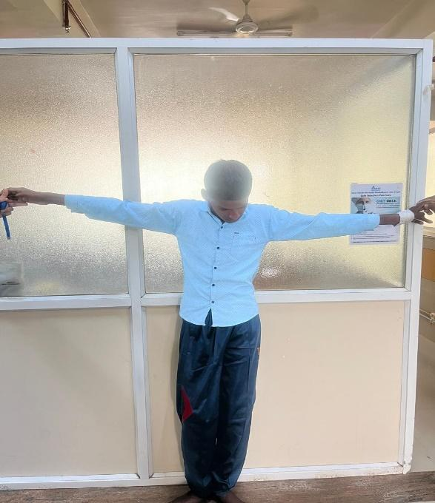

Figure2: **Arm Span(170cm)> Height(165cm)** in presenting patient

The diagnosis was the result of a collaborative, multidisciplinary effort. Neurologists were involved in managing the seizure episodes(started on **oral levetiracetam)**, while haematologists took charge of the ongoing thrombotic complications(iV anticoagulation was started along with oral betaine to reduce homocysteine levels). The metabolic and genetic team confirmed the diagnosis and initiated targeted management. Dietary modifications(**more intake of green leafy vegetables,citrus fruits,beans,legumes**) vitamin supplementation(**pyridoxine,vitamine B9,B12)**, and careful follow-up were instituted as part of the treatment plan.

The child has now been under regular follow-up for the past three years and is showing good clinical improvement. His seizures are controlled, and there have been no further thrombotic episodes. This case underscores the importance of considering metabolic disorders such as homocystinuria in the differential diagnosis of children presenting with unexplained thrombotic events, especially when associated with skeletal and ocular abnormalities. Early diagnosis and a coordinated, multidisciplinary approach significantly improved this child’s prognosis and quality of life.

3. DISCUSSION

Homocystinuria, a rare autosomal recessive disorder resulting from cystathionine beta-synthase (CBS) deficiency, is characterized by elevated plasma homocysteine and methionine levels. It presents with a spectrum of clinical features, including ectopia lentis, skeletal abnormalities, intellectual disability, and notably, a significant predisposition to thromboembolic events. The current case highlights these classical features and reinforces the importance of early suspicion and diagnosis.

This case has been described as an atypical presentation of homocystinuria because the initial manifestation was extensive venous thrombosis rather than the more commonly recognized features such as ectopia lentis, marfanoid habitus, or intellectual disability. The patient presented with progressive lower limb swelling due to thrombosis of the inferior vena cava and iliac veins, which is an unusual first symptom for homocystinuria. The classic signs of the disease, including lens dislocation and skeletal abnormalities, were identified only later, following seizure episodes. This deviation from the typical progression of symptoms delayed diagnosis, underscoring the importance of considering metabolic disorders in cases of unexplained thrombotic and neurological events.

Our patient presented with extensive venous thrombosis at an early age, followed by seizures and the discovery of ectopia lentis, ultimately leading to the diagnosis of homocystinuria. The thrombotic tendency seen in homocystinuria is among the most serious complications and is well documented in literature. Mudd et al. describe thrombosis as a hallmark feature of untreated homocystinuria, often affecting the venous system, including cerebral and peripheral veins, even in young children without traditional risk factors for hypercoagulability [1].

Several case reports have mirrored these findings. Cochran and Packman reported a case of sagittal sinus thrombosis in an infant, where homocystinuria was diagnosed only after neurological deterioration and imaging findings prompted further metabolic workup [2] . Kang et al. documented a similar case of superior sagittal sinus thrombosis with additional deficiencies of antithrombin III and factor VII in a patient with homocystinuria, indicating potential synergistic factors that exacerbate thrombotic risk in such patients [3] .

Buoni et al. described a case of transverse sinus thrombosis associated with drug-resistant epilepsy in a child, where the underlying diagnosis of homocystinuria was made following extensive investigation [4] . These presentations emphasize that thrombosis can often be the first or most severe manifestation of the disease and may remain unrecognized unless a high index of suspicion is maintained.

Additionally, Sarov et al. presented a case where homocystinuria was revealed by cerebral venous thrombosis, stressing the importance of early homocysteine level measurement in all young patients with unexplained thrombotic events [5]. In our case, a similar pattern emerged: venous thrombosis prompted deeper evaluation, which, supported by skeletal features and ectopia lentis, led to metabolic testing and confirmation via genetic analysis.

The pathophysiology underlying thrombosis in homocystinuria is multifactorial. Elevated homocysteine levels promote endothelial dysfunction, increase oxidative stress, enhance platelet aggregation, and interfere with anticoagulant pathways, all contributing to a hypercoagulable state. One of the article further notes that vascular damage due to homocysteine is concentration-dependent, and the risk of thrombosis correlates with the degree of elevation in homocysteine levels [1] .

Our case also highlights the effectiveness of a multidisciplinary approach. Neurology contributed to seizure management, hematology provided guidance on anticoagulation, and metabolic specialists coordinated long-term care. With regular follow-up and targeted interventions, the child has remained clinically stable over the past three years—a testament to the benefits of early identification and comprehensive care.

4. CONCLUSION

In conclusion, this case adds to the growing body of evidence underscoring the variability of clinical presentations in homocystinuria and the critical role of thrombotic events as potential early markers. Physicians should maintain a high index of suspicion for homocystinuria in any child presenting with unexplained thromboembolism, especially in the presence of ocular or skeletal abnormalities. Early diagnosis, guided by clinical acumen and supported by biochemical and genetic testing, can lead to interventions that significantly alter the disease course and improve quality of life.

ABBREVIATIONS

CBS- cystathionine beta-synthase, PT- prothrombin time, aPTT- activated partial thromboplastin time, IVC- infrarenal inferior vena cava, MRI- magnetic resonance imaging, APGAR- Appearance, Pulse, Grimace, Activity, and Respiration.

Disclaimer (Artificial intelligence)

Option 1:

Author(s) hereby declare that NO generative AI technologies such as Large Language Models (ChatGPT, COPILOT, etc.) and text-to-image generators have been used during the writing or editing of this manuscript.

Option 2:

Author(s) hereby declare that generative AI technologies such as Large Language Models, etc. have been used during the writing or editing of manuscripts. This explanation will include the name, version, model, and source of the generative AI technology and as well as all input prompts provided to the generative AI technology

Details of the AI usage are given below:

1.

2.

3.

REFERENCES

1. Mudd SH, Levy HL, Kraus JP. Homocystinuria due to cystathionine beta-synthase deficiency. N Engl J Med. 2018;379:e31.

2. Cochran FB, Packman S. Homocystinuria presenting as sagittal sinus thrombosis. Eur Neurol. 1992;32(1):1–4.

3. Kumar T, Sharma GS, Singh LR. Homocystinuria: therapeutic approach. Clinica Chimica Acta. 2016 Jul 1;458:55-624.

4. Buoni S, Molinelli M, Mariottini A, Zammarchi E. Homocystinuria with transverse sinus thrombosis. J Child Neurol. 2001;16(9):690–2.

5. Sarov M, Not A, de Baulny HO, Masnou P, Sedel F. A case of homocystinuria due to CBS gene mutations revealed by cerebral venous thrombosis. J Neurol Sci. 2014;344(1-2):224–6.

6. Bittmann S, Villalon G, Moschuring-Alieva E, Luchter E, Bittmann L. Current and Novel Therapeutical Approaches of Classical Homocystinuria in Childhood With Special Focus on Enzyme Replacement Therapy, Liver-Directed Therapy and Gene Therapy. J Clin Med Res. 2023 Feb;15(2):76-83.

7. Karimzadeh P, Jafari N, Alai M, Jabbehdari S, Nejad Biglari H. Homocystinuria: Diagnosis and Neuroimaging Findings of Iranian Pediatric patients. Iran J Child Neurol. 2015 Winter;9(1):94-8.