Continuous Ambulatory Peritoneal Dialysis For Renal Failure In Children: An Emergency Life-Saving Procedure

.

ABSTRACT

|  |
| --- |
| Background: Pediatric renal failure presents a critical healthcare challenge, necessitating effective renal replacement therapies. Continuous Ambulatory Peritoneal Dialysis (CAPD) has emerged as a preferred modality, particularly in children, due to its feasibility for home-based care. This study explores continuous ambulatory peritoneal dialysis effectiveness, associated complications, and clinical outcomes in pediatric patients.  Objective: To study the role of continuous ambulatory peritoneal dialysis in children with acute kidney injury and chronic kidney disease  Methods: A prospective study was conducted at J.N. Medical College, KLES Dr. P.K. Hospital & MRC, Belagavi over a period of 2 years 8 months. Seven children, aged 1 month to 18 years, requiring continuous ambulatory peritoneal dialysis due to declining renal function unresponsive to other treatments, were enrolled. CAPD catheters were surgically inserted, and caregivers received comprehensive training for home-based dialysis. Patients were monitored for renal function recovery, complications, and treatment outcomes.  Results: Out of the seven cases, three patients recovered renal function and successfully discontinued CAPD, two continued CAPD while awaiting transplantation, one developed peritonitis requiring catheter removal, and one succumbed to septicemia.  Conclusion: CAPD is an effective alternative for pediatric renal failure, providing long-term management and bridging patients to kidney transplantation. Increasing awareness and caregiver training can further enhance CAPD outcomes in children. |

***Keywords:*** *Continuous Ambulatory Peritoneal Dialysis, Pediatric Renal Failure, Acute Kidney Injury, Chronic Kidney Disease, Peritoneal Dialysis, Hemolytic Uremic Syndrome*

**INTRODUCTION:** Renal failure in pediatric patients is a life-threatening condition requiring immediate medical intervention. While hemodialysis is a commonly used renal replacement therapy (RRT), it presents significant challenges in children due to vascular access difficulties and hemodynamic instability1. Continuous Ambulatory Peritoneal Dialysis (CAPD) provides a viable alternative, allowing dialysis to be performed at home with fewer complications related to vascular access2.

Continuous ambulatory peritoneal dialysis is particularly beneficial for infants and young children who require prolonged dialysis. It offers improved metabolic control, better fluid balance, and a higher degree of independence compared to hemodialysis3.Despite these advantages, CAPD remains underutilized due to limited awareness, insufficient training, and concerns about complications such as peritonitis4. This study evaluates the effectiveness of continuous ambulatory peritoneal dialysis in pediatric patients, highlighting its advantages, clinical outcomes, and challenges.

**REVIEW OF LITERATURE:**

**Pediatric Renal Failure and the Need for Dialysis**

Renal failure in children can be attributed to various conditions, including congenital anomalies, glomerulopathies, infections, and systemic diseases such as diabetes and hypertension5. Acute Kidney Injury (AKI) often results from dehydration, sepsis, or nephrotoxic drug exposure, while Chronic Kidney Disease (CKD) progresses over time due to genetic and structural abnormalities6. Dialysis becomes essential when renal function declines to the extent that conservative management is no longer effective7.

**CAPD vs. Hemodialysis in Pediatrics**

Hemodialysis remains the most commonly utilized dialysis method but presents considerable challenges in pediatric patients, particularly in terms of vascular access and hemodynamic fluctuations1. CAPD, on the other hand, offers a gentler and more continuous mode of dialysis, preserving residual kidney function and reducing the risk of cardiovascular complications3. Moreover, CAPD can be performed at home, reducing the burden on healthcare facilities and improving the quality of life for patients and their families4.

**Clinical Outcomes of CAPD in Children**

Several studies have highlighted the benefits of CAPD in pediatric nephrology, demonstrating comparable survival rates to hemodialysis while allowing for greater patient autonomy. However, complications such as peritonitis, catheter dysfunction, and metabolic imbalances must be carefully managed to optimize outcomes.

**MATERIALS AND METHODS:**

Study Design and Setting- This prospective study was conducted at J.N. Medical College, KLES Dr. P.K. Hospital & MRC, Belagavi over a period of 2 years 8 months, focusing on pediatric patients requiring continuous ambulatory peritoneal dialysis due to worsening renal function.

**Inclusion Criteria:** Pediatric patients (aged 1 month to 18 years) diagnosed with acute kidney injury or chronic kidney disease.

**Exclusion Criteria:**

Severe peritoneal adhesions preventing effective dialysis

Active, uncontrolled infections at the time of catheter placement

**CAPD Procedure:** Patients underwent CAPD catheter insertion under general anesthesia using a Tenckhoff catheter. Caregivers were extensively trained in dialysis procedures, infection prevention, and emergency management. Dialysis exchanges were initially conducted under medical supervision before transitioning to home-based treatment.

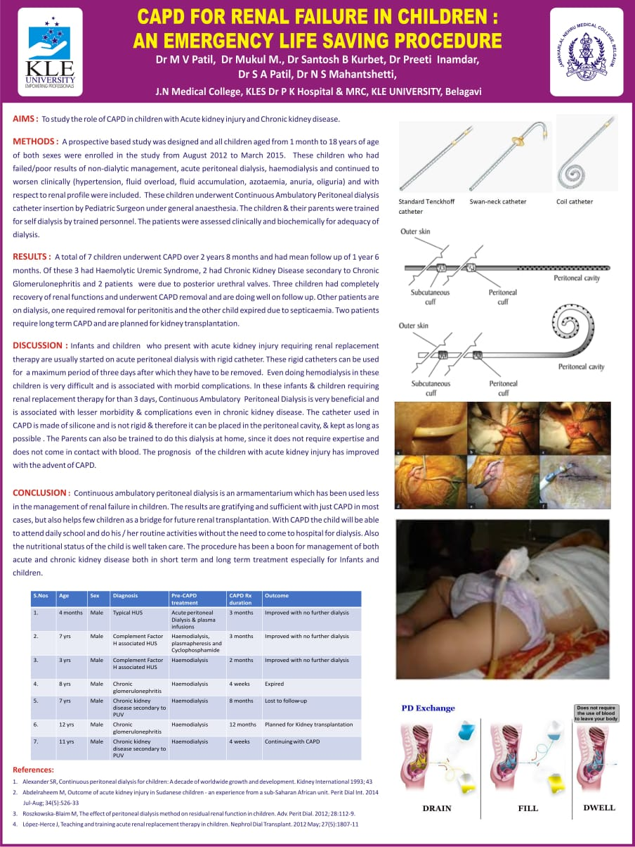

Fig 1- Standard Tenckhoff catheter and coil catheter



Fig 2- **CAPD Procedure and PD exchange**

**Data Collection and Outcome Measures:**

Key parameters monitored included:

1. Renal function recovery (serum creatinine, blood urea nitrogen
2. Incidence of infections (peritonitis)
3. Catheter-related complications
4. Long-term patient outcomes and survival rates

**RESULTS:** A total of 7 children underwent CAPD over 2 years 8 months and had mean follow up of 1 year 6 months.



Table 1- Outcome of CAPD in pediatric patients

The table presents data on seven male pediatric patients who underwent Continuous Ambulatory Peritoneal Dialysis (CAPD). The patient’s ages range from 4 months to 12 years, with 14.3% being infants (<1 year), 42.9% between 3-7 years, and another 42.9% between 8-12 years. This indicates that chronic kidney conditions requiring CAPD are more commonly diagnosed in children above three years of age. The most frequent diagnosis include Chronic Glomerulonephritis (28.6%) and Chronic Kidney Disease secondary to Posterior Urethral Valves (PUV) (28.6%), followed by Complement Factor H-associated Hemolytic Uremic Syndrome (HUS) (28.6%) and Typical HUS (14.3%).

Regarding pre-CAPD treatments, most patients (85.7%) underwent hemodialysis, while one received acute peritoneal dialysis and plasma infusions. The duration of CAPD treatment varied, with the shortest being four weeks and the longest lasting 12 months. Treatment outcomes reveal that 42.9% of patients improved without requiring further dialysis, while 14.3% continued CAPD. However, one patient (14.3%) expired, and another (14.3%) was lost to follow-up. Additionally, one patient (14.3%) was scheduled for a kidney transplant. These findings suggest that CAPD can be effective for managing pediatric kidney conditions, though long-term monitoring remains essential to track outcomes and prevent complications.

**DISCUSSION:** Continuous Ambulatory Peritoneal Dialysis (CAPD) is a preferred renal replacement therapy for infants and children with acute kidney injury (AKI) or chronic kidney disease (CKD), particularly when prolonged dialysis is required. Initially, rigid catheters are used for acute peritoneal dialysis but must be removed within three days to prevent complications such as infections and peritoneal irritation8. Hemodialysis, though an alternative, poses challenges in young children due to difficulties in vascular access, higher infection risks, and cardiovascular instability9. CAPD, which utilizes a soft silicone catheter, offers a safer and more effective long-term solution.

One significant advantage of CAPD is its feasibility for home-based care. Parents can be trained to perform the procedure, reducing hospital dependency and minimizing the risk of nosocomial infections10. Unlike hemodialysis, which requires frequent hospital visits, CAPD is a continuous process that does not involve blood access, making it a less invasive and more convenient option for pediatric patients11. Additionally, CAPD helps preserve residual kidney function, which is essential for slowing disease progression and maintaining overall health12

CAPD also plays a crucial role in the growth and development of children with kidney disease. By providing better fluid and nutritional management, it enables improved nutrient absorption, reducing dietary restrictions13. This contributes to normal growth milestones, which are often impaired in children undergoing hemodialysis. Furthermore, CAPD allows children to maintain a routine lifestyle, attend school, and engage in normal activities, enhancing their overall quality of life9.

In conclusion, CAPD is a safer, more effective, and child-friendly alternative to hemodialysis. Its advantages, including home-based feasibility, preservation of kidney function, and support for growth, make it an essential treatment for pediatric kidney disease. By improving prognosis and reducing complications, CAPD significantly enhances the quality of life for children and their families.

**Challenges and Limitations:**

1. Peritonitis Risk – Requires stringent infection control measures.

2. Training Requirements – Caregivers need proper education to perform CAPD safely.

3. Long-Term Viability – Some patients eventually require kidney transplantation.

**Future Recommendations:**

1.Enhanced training programs for caregivers to reduce infection risks.

2.Improved catheter designs with antimicrobial properties.

3.Increased accessibility of CAPD in resource-limited settings.

**CONCLUSION:**

Continuous ambulatory peritoneal dialysis is a viable and effective renal replacement therapy for pediatric patients with renal failure, offering advantages such as home-based care and preservation of residual kidney function. The study highlights CAPD’s role in improving survival and quality of life in children with end-stage renal disease. Increased awareness, training programs, and better accessibility can further optimize CAPD’s benefits in pediatric nephrology.

**Consent**

As per international standards, parental written consent has been collected and preserved by the author(s).

ABBREVIATIONS

CAPD: continuous ambulatory peritoneal dialysis, AKI: acute kidney injury, CKD: chronic kidney disease, HUS: haemolytic uraemic syndrome

DISCLAIMER (ARTIFICIAL INTELLIGENCE)

Authors hereby declare that NO generative AI technologies such as Large Language Models (ChatGPT, COPILOT, etc) and text-to-image generators have been used during writing or editing of this manuscript

References:

1. Chand Dh, Valentini RP, Kamil Es. Challenges of Vascular Access in the Pediatric Population. Adv Chronic Kidney Dis. 2020;27(3):251-257.

2. Tchokonte-Nana V, Njem Pk, Ndamukong KJN, Et Al. Continuous Ambulatory Peritoneal Dialysis (CAPD) In Children. Pan Afr Med J. 2019;33:133.

3. Fine RN, Ho M, Tejani A, et al. Continuous Ambulatory Peritoneal Dialysis in a Pediatric Population. Am J Dis Child. 1986;140(9):918-921.

4. American Nephrology Nurses Association. Pediatric Peritoneal Dialysis Fact Sheet. 2020.

5. National Institute of Diabetes and Digestive and Kidney Diseases. Kidney disease in children [Internet]. Bethesda (MD): National Institute of Health; 2022 [cited 2025 Mar 28]. Available from: https://www.niddk.nih.gov/health-information/kidney-disease/children

6. Children's Hospital of Philadelphia. Acute kidney injury (AKI) [Internet]. Philadelphia (PA): CHOP; [cited 2025 Mar 28]. Available from: https://www.chop.edu/conditions-diseases/acute-kidney-injury-aki

7. Children's Hospital Colorado. Kidney failure in children [Internet]. Aurora (CO): Children's Hospital Colorado; [cited 2025 Mar 28]. Available from: https://www.childrenscolorado.org/conditions-and-advice/conditions-and-symptoms/conditions/kidney-failure-children/

8. Bakkaloglu, S. A., Warady, B. A., & Schaefer, F. (2020). Peritoneal Dialysis in Children: Update 2020. Pediatric Nephrology, 35(1), 37-54.

9. Ng, K. H., Wong, W., & Chan, J. (2022). Advances in Pediatric Peritoneal Dialysis: A Review. Clinical Kidney Journal, 15(4), 567-579.

10. Sethi, S. K., Wadhwani, N., & Sharma, A. P. (2019). Challenges in Pediatric Dialysis: A Comprehensive Review. Indian Journal of Nephrology, 29(3), 145-153.

11. Warady, B. A., & Bakkaloglu, S. A. (2021). Current Concepts in Pediatric Dialysis: A Global Perspective. Kidney International Reports, 6(5), 1204-1215.

12. Warady, B. A., Schaefer, F., & Fine, R. N. (2019). Pediatric Dialysis. Springer Nature.

13. Warady, B. A., Ng, K. H., & Schaefer, F. (2020). Home-Based Dialysis In Children: The Future Of Renal Replacement Therapy. Nature Reviews Nephrology, 16(9), 507-519.