# Sly disease :

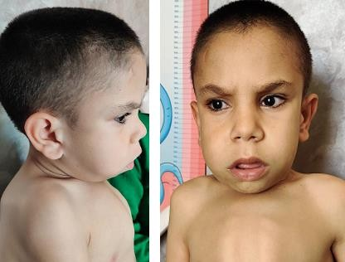

**First case report in Morocco**

# ABSTRACT

A nine year old child with clinical and radiological features leading to Sly disease, The diagnostic was confirmed with high urinary glycosaminoglycans and very low leukocyte β-glucuronidase activity. This is the first case of MPS VII reported from Morocco.

# Key word

*Sly disease, Mucopolysaccharidosis Type*

VII, β-glucuronidase activity.

***INTRODUCTION***

“Sly disease (Mucopolysaccharidosis Type VII) is an extremely rare lysosomal storage disorder with autosomal recessive inheritance due to β-glucuronidase enzyme deficiency”1. “Less-severe forms of Sly disease present during the first years of life with features of MPS-I but slower progression” [6,7]. We present the first Morrocan case Sly disease in order to decribe its clinical, biological and radiological, features

# CASE REPORT

It’s a nine year-old child, he was born to first-degree consanguineous parents.

*Figure 1 : Coarse facies, pathognomonic clinical sign*

The diagnosis of Sly Disaese was suspected on the clinical features : coarse facies **(figure 1),** macrocephaly, short stature, low weight, Joint stiffness, right inguinal hernia, mental retardation, recurrent upper respiratory tract, snoring and noisy breathing, bilateral Cloudy cornea and slight insufficiency of mitral valve with a remodeled mitral valve, and radiological data multiple dysostosis **(figure 2).**

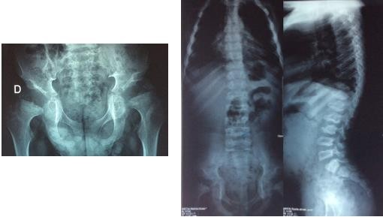

*Figure 2 : Radiological findings*

The diagnosis was confirmed by the study of urinary glycosaminoglycans witch were high and leukocyte β-glucuronidase activity was low (< 0.1 μmol / l / h for a normal value> 5 μmol / l / h) **(Table1)**. molecular analyses is ongoing.

The treatment was only symptomatic.

|  |  |  |  |
| --- | --- | --- | --- |
|  | **Enzymes**  **activities** | **Unit** | **Cut-off**  **value** |
| Alpha-L-Iduronidase | 4.9 | umol/L/h | > 1.5 |
| Iduronat-2-sulfatase | 6.1 | umol/L/h | > 2.5 |
| N-Acetylgalactosamin-6-s | 3.0 | umol/L/h | > 0.2 |
| Arylsulfatase B | 28.5 | umol/L/h | > 1.0 |
| Beta-glucuronidase | 0.1 | umol/L/h | > 5.0 |

*Table1 : Biological findings*

# DISCUSSION

“Sly syndrome is caused by mutations of the *GUSB* gene located on chromosome 7q21.11. Mutations result in a deficiency of β-glucuronidase, intracellular storage of glycosaminoglycan fragments and a very wide range of clinical involvement” 2.

“The most severe form presents as lethal nonimmune fetal hydrops and may be detected in utero by ultrasound exam”3. “Some severely affected newborns survive for some months and have, or develop, signs of lysosomal storage including thick skin, visceromegaly, and dysostosis multiplex” [3].

In this case, the patient had clinical features that match the pathology, added to both biological and radiological features that confirms the diagnosis.

“Less-severe forms of the Sly disease present during the first years of life with features of MPS-I but slower progression.

Corneal clouding varies. Patients with manifestation after 4 years of life have skeletal abnormalities of dysostosis multiplex but normal intelligence and usually clear corneae”4,5.

Sly disease was confirmed by elevated urinary glycosaminoglycans (GAGs) and deficiency of β-glucuronidase and molecular analyses.

# CONCLUSION

Sly disease patients usually exhibit milder phenotypes than other types of MPS. The treatment of Sly disease is currently symptomatic pending the advancement of enzymatic replacement therapy.

**Ethical Approval:**

As per international standards or university standards written ethical approval has been collected and preserved by the author(s).

**Consent**

As per international standards, parental written consent has been collected and preserved by the author(s).

# REFERENCES

1. *Sly WS, Quinton BA, Mc Alister WH, Rimoin DL. Beta glucuronidase deficiency: report of clinical, radiologic, and biochemical features of a new*

*mucopolysaccharidosis. J Pediatr1973; 82: 249- 257.*

1. *Islam MR, Shah GN, Sly WS. PCR-based restriction fragment length polymorphism and haplotype of the most common mutation L176F in the beta- glucuronidase gene. Genet Test 2007; 11:*

*72-74.*

1. *Cheng Y,Verp MS, Knutel T, Hibbard JU. Mucopolysaccharidosis type VII as a cause of recurrent non-immune hydrops fetalis. J Perinat Med 2003; 31: 535-*

*537.*

1. *Nampoothiri S, Kappanayil M, Hiran KR, Sunitha V. Sly Disease: Mucopolysaccharidosis Type VII. Indian Pediatr. 2008 Oct;45(10):859-61. PMID: 18948660.*
2. *Yamada Y, Kato K, Sukegawa K, Tomatsu S, Fukuda S, Emura S, et al. Treatment of MPS VII (Sly disease) by allogenic BMT in a female withhomozygous A619V mutation. Bone Marrow Transplant 1998; 21: 629-634*
3. Yamada Y, Kato K, Sukegawa K, Tomatsu S, Fukuda S, Emura S, Kojima S, Matsuyama T, Sly WS, Kondo N, Orii T. Treatment of MPS VII (Sly disease) by allogeneic BMT in a female with homozygous A619V mutation. Bone marrow transplantation. 1998 Mar;21(6):629-34.
4. Montaño AM, Lock-Hock N, Steiner RD, Graham BH, Szlago M, Greenstein R, Pineda M, Gonzalez-Meneses A, Çoker M, Bartholomew D, Sands MS. Clinical course of sly syndrome (mucopolysaccharidosis type VII). Journal of medical genetics. 2016 Jun 1;53(6):403-18.