**Effects of Soot Particulate Matter Inhalation on The Cerebral Cortex in Male Wistar Rats**

**Abstract**

**Background:** Burning fossil fuels releases hazardous pollutants, including soot (carbon particulate matter), nitrogen oxides (NOx), and sulfur oxides (SOx). The cerebral cortex, a critical region for cognitive function, is particularly vulnerable to environmental toxins due to its high metabolic activity. This study investigated the neurotoxic effects of inhaled soot particulate matter on the cerebral cortex of male Wistar rats. **Methods:** Thirty-two rats were divided into four groups (n=8 per group). Group A served as the unexposed control, while Groups B, C, and D were exposed to varying concentrations of soot (1.221±0.169 mg/m³, 1.290±0.214 mg/m³, and 1.282±0.235 mg/m³, respectively) for 28 days. Brain tissues were collected on days 3 and 28 post-exposure and analyzed histologically using hematoxylin and eosin (H&E) staining. **Results:** The control group (A) exhibited normal cytoarchitecture with intact neurons, distinct nuclei, and prominent nucleoli. In contrast, soot-exposed groups (B–D) displayed significant pathological changes, including hypoperfusion-induced vascular congestion, neuronal degeneration, excessive vacuolation, pyknosis, and necrosis. Neurodegeneration worsened by day 28, indicating progressive damage. **Conclusion:** Chronic inhalation of soot particulate matter induces severe and time-dependent neurodegeneration in the cerebral cortex. These findings underscore the potential neurotoxicity of air pollution and highlight the need for stricter environmental regulations to mitigate neurological health risks.

**Keywords:** Particulate Matter; Cerebral cortex; Soot; Histological indicators, oxidative stress, Pollutants, neurodegeneration; Wistar Rats

**INTRODUCTION**

“Soot emissions represent a major source of ambient particulate matter and combustion derived nano-particles in most urban settings” (Portugal *et al*., 2024). “Petroleum and natural gas are mostly made up of hydrocarbons. They act as lubricants, fuels, and raw materials for the manufacture of rubber, plastic, fibre, explosives, and industrial chemicals. The burning of all fossil fuels (coal and biomass included) releases large quantities of carbon dioxide (CO2) into the atmosphere. The CO2 molecules do not allow much of the long wave solar radiation absorbed by Earth’s surface to reradiate from the surface and escape into space” (Isaacman-VanWertz *et al*., 2020). “Several lines of research have led to the concern that the brain represents a relevant target for the effects of such particles. Early evidence of the potential neuropathological effects of ambient air particles comes from comparative histology studies on the brains of mongrel dogs. More recently, similar findings have been observed in post-mortem brain tissues of lifelong residents from cities with significantly different levels of air pollution” (Aderinto *et al*., 2025). “These studies identified signs of oxidative stress and brain inflammation linked to high levels of air pollution. Key findings included increased expression of the transcription factor Nuclear Factor Kappa B (NFKB) and upregulation of inflammatory genes such as cyclooxygenase-2 (COX-2) and inducible nitric oxide synthase (iNOS)” (Guo *et al*., 2024). Several studies have reported that hydrocarbons in the form of soot induces specific neurotoxicity in mice (Bendtsen *et al* 2021), rat (Gerber *et al*., 2024) and human (Ritchie *et al*, 2021). The cerebral cortex is the largest portion of vertebrate brain that plays crucial role in neural transactions which enhance memory, plasticity, cognition, speech and mental activity. Moreover, it is considered in several studies as a site to explore hydrocarbon induced neurotoxicity (Mercado, 2009; Tormoehlen *et al*., 2014).

“Controlled inhalation studies in mice confirmed that ambient particulate matter and nano-particles may trigger oxidative stress, toxicity and inflammation in brain tissue (Milani *et al* 2020). Moreover, it has been demonstrated that small fractions of inhaled nanoparticles may actually reach the brain” (Portugal *et al*., 2024). “Several invitro studies demonstrated that nanoparticles including diesel engine exhaust particles may cause neurotoxic effects to specific brain cells and disturb blood brain barrier functions” (Gerber *et al* 2024). Despite the hazardous effects of soot particulate matter on the Cerebral Cortex, there is scarcity of literatures on the effects of soot on the cytoarchitecture of the cerebral cortex. This is the driving force behind this research. The aim of this study was to evaluate the effects of soot on the histology of the cerebral cortex.

**MATERIALS AND METHOD**

**Study design**

The study was conducted using male Wistar rat and the rats were exposed to Carbon Soot particulate matter by inhalation. Approval for this research was sought from the Research Ethics Committee of the University of Port Harcourt. The carbon soot as a particulate matter, used for this study was gotten from combustion of crude oil. An artisanal refinery and combustion chamber was produced in the Engineering workshop from the Department of Mechanical Engineering, University of Port Harcourt. The central component was a cylindrical metal tank, measuring 20 cm in height and 15 cm in diameter, designed to hold raw crude. It was securely mounted on a metal stand, strategically positioned above the combustion chamber. The flow of crude was meticulously regulated by a valve, which was connected to a 2.5 cm diameter metal pipe. This pipe linked the tank to the combustion chamber. To counteract and minimize the high temperatures associated with emissions, an exhaust pipe of 5 cm diameter was enveloped within a recycled water-cooling system. This exhaust system further branched out into three distinct metal pipes, with diameters of 1.27 cm, 1.91 cm, and 2.54 cm, respectively. Each of these pipes was equipped with control valves, ensuring the delivery of varying emission concentrations to three separate exposure cages. The design was adept at facilitating a study of diverse emission impacts under varying conditions.

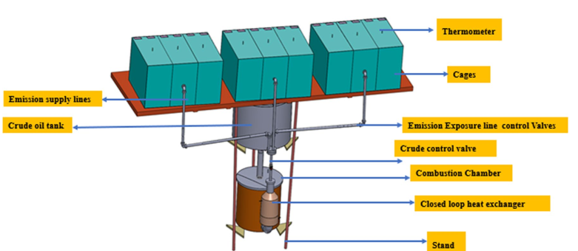

**Figure 1:** Isometric model of locally fabricated artisanal refinery combustion chamber

**Carbon Soot Particulate Matter Exposure System**

The whole-body exposure system was utilized for the study. The Carbon Soot Particulate Matter (CSPM) inhalation apparatus comprised the following components: a sample of CSPM, a particulate matter concentration analyzer and quantifier (PM sensor and meter), three inhalation exposure cages, a circulatory machine (installed fan), and a thermometer for continuous temperature monitoring.

**Animal Grouping/Exposure to Soot**

Thirty-two (32) Wistar strain healthy adult (age of 7 – 8weeks) male of 160 – 180g body weight were kept in the Animal house of the Faculty of Basic Medical Sciences. The rats were divided into 4 groups of 8 animals each. The animals were kept and nurtured under laboratory conditions, temperature, humidity, and light, and were allowed free access to food and water *ad libitum*.

**Table 1. Experimental groups based on treatment conditions**

|  |  |  |
| --- | --- | --- |
| **Group** | **Identification** | **Treatment** |
| A | General control | Rats in this group were not exposed to Carbon Soot Particulate Matter |
| B | Exposure Group 1 | Were exposed to an average concentration of 1.221±0.169 mg/m³ of Carbon Soot Particulate Matter (PM2.5) |
| C | Exposure Group 2 | Were exposed to an average concentration of 1.290±0.214 mg/m³ of Carbon Soot Particulate Matter (PM2.5) |
| D | Exposure Group 3 | Rats in this group were exposed to an average concentration of 1.282±0.235 mg/m³ of Carbon Soot Particulate Matter (PM2.5) |

The exposure of animals was conducted for 28 days. Four animals from each group were sacrificed on day 3 and day 28 during the exposure to the soot.

**Sacrificing of animals and Tissue Processing**

On day 3 and day 28, after exposure to soot, some rats were sacrificed. The rats were anesthetized with diethyl ether and incision made in the thoracic region to expose the heart. The right atrium cut to drain the blood immediately followed by trans-cardiac perfusion using 0.9% saline and then 10ml of 4% paraformaldehyde (PFA) solution through the left ventricle of the heart. The brain was extracted, post fixed overnight in 4% paraformaldehyde at 4°C. Tissues were prepared histologically for microscopy.

**Histopathological Examination**

The brain tissues were processed through various stages, including fixation, dehydration, clearing, impregnation, embedding, sectioning, and staining with hematoxylin and eosin (H&E), followed by mounting. These standard processing methods were described by Baker (1945), and Isirima and Uahomo (2023).

**Method of Data Analysis**

Since no numerical data were generated in this study, the analysis was based on qualitative histological assessment. The histological slides were examined under a light microscope to evaluate tissue architecture, cellular integrity, and morphological changes in the brain samples. Observations were compared across experimental groups to identify structural alterations. Representative photomicrographs were captured for documentation and interpretation of findings.

**RESULTS**

**Cytoarchitecture of the Cerebral Cortex for day 3 post exposure to Soot**

The result of the cytoarchitecture of the H&E-stained Cerebral Cortex for day 3 post exposure to Soot is shown in Figure 2. The result of Group A, B, C and D are represented, using 1, 2, 3, and 4 on the micrographs. It was observed that, there were intact neurons with large nuclei and prominent nucleoli in the Group A (control group). Observe the hypoperfusion induced marked congestion of blood vessels (HCBV), excessive degeneration of neuronal cells (DN), excessive vacuolation (EV), Pyknosis and necrosis of neural cells in the group B, C and D.

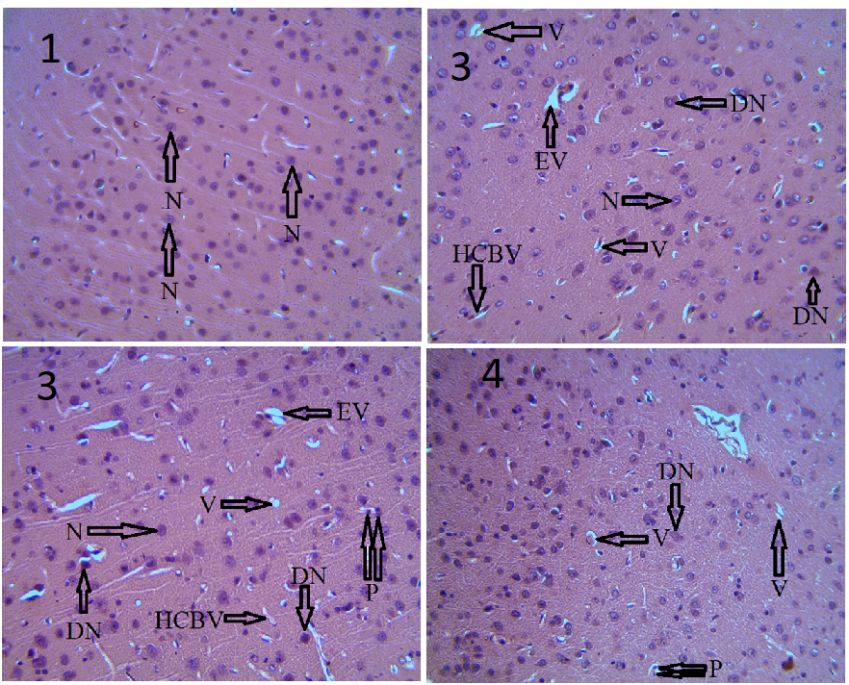

**Figure 2:** Representative photomicrograph (H&E stain, ×400 magnification) of the cerebral cortex cytoarchitecture in Groups A (control), B, C, and D at day 3 post-soot exposure. Groups A, B, C, and D are labeled as 1, 2, 3, and 4, respectively. Key observations: N – intact neurons, HCBV – hypoperfusion-induced marked congestion of blood vessels, DN – excessive neuronal degeneration, EV – excessive vacuolation, P – pyknosis and karyorrhexis, MD – mild neuronal degeneration, MV – mild vacuolation.

**Cytoarchitecture of the Cerebral Cortex for day 28 post exposure to Soot**

The cytoarchitecture of the H&E-stained Cerebral Cortex for day 28 post exposure to Soot is shown in Figure 3. The result of Group A, B, C and D are represented, using 1, 2, 3, and 4 on the micrographs. It was observed that, there were intact neurons with large nuclei and prominent nucleoli in the Group A (control group). Observe the hypoperfusion induced marked congestion of blood vessels (HCBV), excessive degeneration of neuronal cells (DN), excessive vacuolation (EV), Pyknosis and necrosis of neural cells in the group B, C and D.

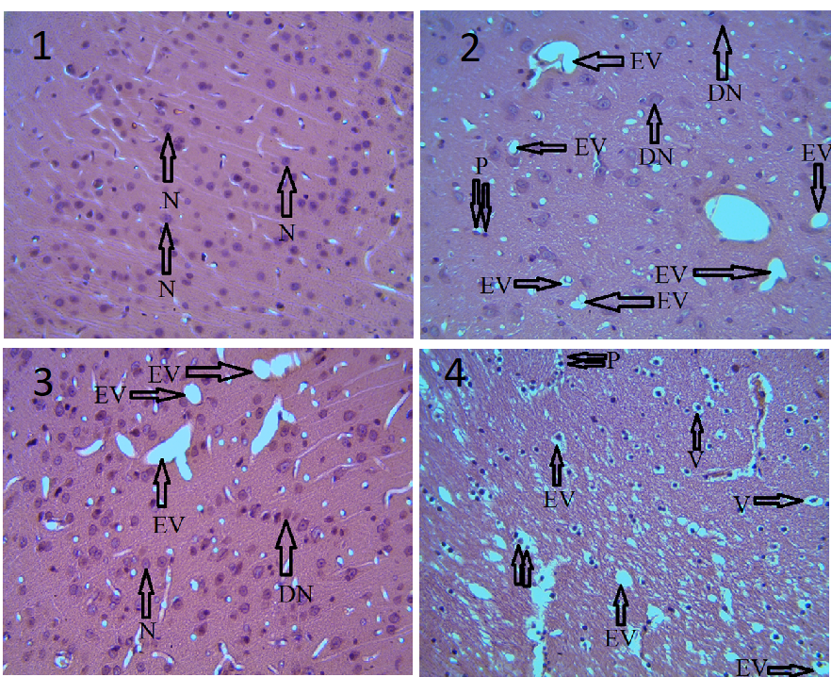

**Figure 3:** Representative photomicrograph (H&E stain, ×400) of the cerebral cortex cytoarchitecture in Groups A (control), B, C, and D at day 28 post-soot exposure (labeled 1, 2, 3, and 4, respectively). Key observations: N - Intact neurons, HCBV - Hypoperfusion-induced marked congestion of blood vessels, DN - Excessive neuronal degeneration, EV - Excessive vacuolation, P - Pyknosis and karyorrhexis, MD - Mild neuronal degeneration, MV - Mild vacuolation

**DISCUSSION**

Soot is commonly found in hydrocarbon industries and households that rely on hydrocarbon-based fuels like kerosene. Its widespread presence in the atmosphere increases the risk of contamination and exposure, raising public health concerns about its potential adverse effects on non-target organisms (Shetty *et al*., 2023). The impact of soot exposure varies across experimental studies and case reports, depending on factors such as duration, concentration, and route of exposure. In this study, we examined the potential effects of inhaled soot on the cerebral cortex of Wistar rats. The cerebral cortex plays a crucial role in fine motor control, motion fractionation, and sensorimotor integration (Jawabri *et al*., 2025).

“There is a well-established association between exposure to particulate matter (PM) and numerous adverse cardiac health effects. Particulate exposure has been implicated in the possible development of neurological conditions such as Alzheimer’s and idiopathic Parkinson’s disease” (Gotz *et al*., 2004; Kovacs, 2004; Linse *et al*., 2007). “Although extensive efforts have been directed toward understanding particle fate and cell–particle interactions in cardiovascular targets, those mechanisms and pathways through which inhaled PM may act on the central nervous system are just now becoming more fully explored” (Hopkins *et al*., 2017). “PM may gain access to the brain through the systemic circulation by crossing the blood-brain endothelial barrier, potentially due to exposure-induced changes in endothelial membrane permeability. Alternatively, PM could bypass the blood-brain barrier entirely by directly entering the brain via olfactory sensory neurons (OSNs). These neurons extend from the olfactory epithelium in the nasal cavity and project their axons directly into the olfactory bulb of the brain, providing a direct route for PM infiltration” (Mombaerts, 2006). “Ambient particulates in polluted air can consist of a multifaceted mixture of highly diverse chemical entities, including hydrocarbons, sulfates, nitrates, metals, soot, and a combination of other organic and inorganic compounds” (Kumar and Gill, 2009). “Combustion-derived PM commonly contains transition metals, with iron being the predominant metal found in the ultrafine size fraction” (Hughes and Cass 1998). “The impact of iron-soot exposure and the nose-to-brain transport of inhaled ultrafine particles has been investigated in previous studies” (Hopkins *et al*., 2018). They observed in their study that there was an increase in microglial cell activation and neural inflammation. The report of Hopkins *et al*. (2018) confirms inhaled ultrafine iron oxide can reach the brain via olfactory nerve fascicles. “In their study, there were evidences of inflammatory changes in the olfactory bulb following exposure to ultrafine iron–soot particles which provides further support to the concept that long-term exposure to ambient PM may play a role in neurological disease in humans. The present study investigates the effects of inhalation exposure, demonstrating that it induces oxidative damage in the cerebral cortex. Oxidative stress is known to adversely impact the central nervous system (CNS), as evidenced by prior research” (Bromberg, 2016; Martinez-Lazcano *et al*., 2013). Reactive oxygen and nitrogen species (RONS) are formed as a result of Soot. Biological molecules of the body can be destroyed as a result of the diffusion of RONS into the bloodstream (Rivas-Arancibia *et al.*, 2010; Li *et al.*, 2013). Millions of people today, have health challenges as a result of oxidative and inflammatory activities (Kurt *et al.*, 2016). Oxidative damage, inflammation of neurons and apoptosis can be caused by RONS which can be caused by Soot inhalation (Rivas-Arancibia *et al.*, 2010; Martinez-Lazcano *et al.*, 2013; Rodriguez-Martinez *et al.*, 2016). This is because; the brain demands a high level of oxygen and energy. The presence of a very high level of transition metals in neurons enables catalysis that leads to the formation of reactive hydroxyl radical (Gandhi & Abramov, 2012). The cerebral cortex of an animal is highly sensitive to oxidative damage (Sender *et al.*, 2019). Mitra *et al.* (2015) stated that, the striatum and substantia nigra are also sensitivity to oxidative damage. Leuner & Gould (2010) reported that, sensitivity to oxidative damage on the hippocampus is highly increased in the CA regions and the dentate gyrus. In the present study, it was observed that, the cytoarchitecture of the H&E-stained Cerebral Cortex for day 3 post exposure to Soot showed intact neurons with large nuclei and prominent nucleoli in the control group. The experimental group: B, C and D showed hypoperfusion induced marked congestion of blood vessels (HCBV), excessive degeneration of neuronal cells (DN), excessive vacuolation (EV), Pyknosis and necrosis of neural cells. It was also observed that the level of neurodegeneration was increased on day 28 post exposure to Soot.

**CONCLUSION**

The present study documented the ability of soot to induce tissue reaction and neuropathology in the cerebral cortex of adult male albino rats upon their exposure to soot. Tissue reaction appear histopathologically as hypoperfusion induced marked congestion of blood vessels, excessive degeneration of neuronal cells, excessive vacuolation, pyknosis and necrosis of neural cells. This result should be taken seriously in order to protect industrial and medical field workers from possible soot induced cerebral related hazards. Knowledge gained from this study will be useful to the Neuroscientist, Anatomists and the Clinician.

**Ethics Approval:**

The study was carried out in adherence to ethical guidelines set by the National Institute of Health (NIH) for the ethical treatment of animals in research. The study was approved by the Research Ethics Committee of the University of Port Harcourt, Rivers State, Nigeria before commencement of the study.

**Disclaimer (Artificial intelligence)**

Author(s) hereby declares that NO generative AI technologies such as Large Language Models (ChatGPT, COPILOT, etc.) and text-to-image generators have been used during the writing or editing of this manuscript.

**REFERENCES**

Aderinto, N., Ajagbe, A. O., Olatunji, G., *et al*. (2025). Correction: The impact of air pollution on neurodegenerative diseases: A narrative review of current evidence. Egyptian Journal of Internal Medicine, 37, 41. <https://doi.org/10.1186/s43162-025-00427-8>

Baker, J. R. (1945). *Cytological technique* (2nd ed.). Methuen.

Bendtsen, K. M., Bengtsen, E., Saber, A. T., & Vogel, U. (2021). A review of health effects associated with exposure to jet engine emissions in and around airports. *Environmental health : a global access science source*, *20*(1), 10. <https://doi.org/10.1186/s12940-020-00690-y>

Bromberg P. A. (2016). Mechanisms of the acute effects of inhaled ozone in humans. *Biochimica et biophysica acta*, *1860*(12), 2771–2781. <https://doi.org/10.1016/j.bbagen.2016.07.015>

Gambari, S. A., Erameh, T. O., Ugbomoiko, D. O., Ibrahim, A. O., Adegboye, A. A., & Omonijo, A. (2023). Comparison of the Efficacy of Haematoxylin & Eosin (H&E) and Periodic Acid Schiff (PAS) Staining Techniques in the Diagnosis of Typhoid Intestinal Perforation (TIP) among Patients Attending Federal Medical Centre, Keffi Nasarawa State, Nigeria. International Journal of TROPICAL DISEASE & Health, 44(18), 15–22. <https://doi.org/10.9734/ijtdh/2023/v44i181474>

Gandhi, S., & Abramov, A. Y. (2012). Mechanism of oxidative stress in neurodegeneration. *Oxidative medicine and cellular longevity*, *2012*, 428010. <https://doi.org/10.1155/2012/428010>

Gerber, L. S., de Leijer, D. C. A., Rujas Arranz, A., Lehmann, J. M. M. L., Verheul, M. E., Cassee, F. R., & Westerink, R. H. S. (2024). In vitro neurotoxicity of particles from diesel and biodiesel fueled engines following direct and simulated inhalation exposure. *Environment international*, *184*, 108481. <https://doi.org/10.1016/j.envint.2024.108481>

Götz, J., Schild, A., Hoerndli, F., & Pennanen, L. (2004). Amyloid-induced neurofibrillary tangle formation in Alzheimer's disease: insight from transgenic mouse and tissue-culture models. *International journal of developmental neuroscience : the official journal of the International Society for Developmental Neuroscience*, *22*(7), 453–465. <https://doi.org/10.1016/j.ijdevneu.2004.07.013>

Guo, Q., Jin, Y., Chen, X., Ye, X., Shen, X., Lin, M., Zeng, C., Zhou, T., & Zhang, J. (2024). NF-κB in biology and targeted therapy: new insights and translational implications. *Signal transduction and targeted therapy*, *9*(1), 53. <https://doi.org/10.1038/s41392-024-01757-9>

Hopkins, L. E., Laing, E. A., Peake, J. L., Uyeminami, D., Mack, S. M., Li, X., Smiley-Jewell, S., & Pinkerton, K. E. (2018). Repeated Iron-Soot Exposure and Nose-to-brain Transport of Inhaled Ultrafine Particles. *Toxicologic pathology*, *46*(1), 75–84. <https://doi.org/10.1177/0192623317729222>

Hughes, L. S., Cass, G. R., Gone, J., Ames, M., & Olmez, I. (1998). Physical and Chemical Characterization of Atmospheric Ultrafine Particles in the Los Angeles Area. Environmental Science and Technology, 32(9), 1153–1161. <https://doi.org/10.1021/es970280r>

Isaacman-VanWertz, G., Lu, X., Weiner, E., Smiley, E., & Widdowson, M. (2020). Characterization of Hydrocarbon Groups in Complex Mixtures Using Gas Chromatography with Unit-Mass Resolution Electron Ionization Mass Spectrometry. Analytical chemistry, 92(18), 12481–12488. <https://doi.org/10.1021/acs.analchem.0c02308>

Isirima, J. C., & Uahomo, P. O. (2023). *Acalypha wilkesiana* exhibits antihyperglycemic potentials and ameliorates damages to pancreas and spleen of diabetic rat model. *Saudi Journal of Biomedical Research, 8*(7), 83-94. <https://doi.org/10.36348/sjbr.2023.v08i07.001>

Jawabri KH and Sharma S. (2025): Physiology, Cerebral Cortex Functions. In: StatPearls [Internet]. Treasure Island (FL): StatPearls Publishing.

Kovács T. (2004). Mechanisms of olfactory dysfunction in aging and neurodegenerative disorders. *Ageing research reviews*, *3*(2), 215–232. <https://doi.org/10.1016/j.arr.2003.10.003>

Kumar, V., & Gill, K. D. (2009). Aluminium neurotoxicity: neurobehavioural and oxidative aspects. *Archives of toxicology*, *83*(11), 965–978. <https://doi.org/10.1007/s00204-009-0455-6>

Kurt, O. K., Zhang, J., & Pinkerton, K. E. (2016). Pulmonary health effects of air pollution. *Current opinion in pulmonary medicine*, *22*(2), 138–143. <https://doi.org/10.1097/MCP.0000000000000248>

Leuner, B., & Gould, E. (2010). Structural plasticity and hippocampal function. *Annual review of psychology*, *61*, 111–C3. <https://doi.org/10.1146/annurev.psych.093008.100359>

Li, Z., Tighe, R. M., Feng, F., Ledford, J. G., & Hollingsworth, J. W. (2013). Genes of innate immunity and the biological response to inhaled ozone. *Journal of biochemical and molecular toxicology*, *27*(1), 3–16. <https://doi.org/10.1002/jbt.21453>

Linse, S., Cabaleiro-Lago, C., Xue, W. F., Lynch, I., Lindman, S., Thulin, E., Radford, S. E., & Dawson, K. A. (2007). Nucleation of protein fibrillation by nanoparticles. *Proceedings of the National Academy of Sciences of the United States of America*, *104*(21), 8691–8696. <https://doi.org/10.1073/pnas.0701250104>

Martínez-Lazcano, J. C., González-Guevara, E., del Carmen Rubio, M., Franco-Pérez, J., Custodio, V., Hernández-Cerón, M., Livera, C., & Paz, C. (2013). The effects of ozone exposure and associated injury mechanisms on the central nervous system. Reviews in the neurosciences, 24(3), 337–352. <https://doi.org/10.1515/revneuro-2012-0084>

Mercado E. (2009). Cognitive Plasticity and Cortical Modules. *Current directions in psychological science*, *18*(3), 153–158. <https://doi.org/10.1111/j.1467-8721.2009.01627.x>

Milani, C., Farina, F., Botto, L., Massimino, L., Lonati, E., Donzelli, E., Ballarini, E., Crippa, L., Marmiroli, P., Bulbarelli, A., & Palestini, P. (2020). Systemic Exposure to Air Pollution Induces Oxidative Stress and Inflammation in Mouse Brain, Contributing to Neurodegeneration Onset. International journal of molecular sciences, 21(10), 3699. <https://doi.org/10.3390/ijms21103699>

Mitra, S., Siddiqui, W. A., & Khandelwal, S. (2015). Differential susceptibility of brain regions to tributyltin chloride toxicity. *Environmental toxicology*, *30*(12), 1393–1405. <https://doi.org/10.1002/tox.22009>

Mombaerts P. (2006). Axonal wiring in the mouse olfactory system. *Annual review of cell and developmental biology*, *22*, 713–737. <https://doi.org/10.1146/annurev.cellbio.21.012804.093915>

Portugal, J., Bedia, C., Amato, F., Juárez-Facio, A. T., Stamatiou, R., Lazou, A., Campiglio, C. E., Elihn, K., & Piña, B. (2024). Toxicity of airborne nanoparticles: Facts and challenges. *Environment international*, *190*, 108889. <https://doi.org/10.1016/j.envint.2024.108889>

Ritchie, G. D., Still, K. R., Alexander, W. K., Nordholm, A. F., Wilson, C. L., Rossi, J., 3rd, & Mattie, D. R. (2001). A review of the neurotoxicity risk of selected hydrocarbon fuels. *Journal of toxicology and environmental health. Part B, Critical reviews*, *4*(3), 223–312. <https://doi.org/10.1080/109374001301419728>

Rivas-Arancibia, S., Guevara-Guzmán, R., López-Vidal, Y., Rodríguez-Martínez, E., Zanardo-Gomes, M., Angoa-Pérez, M., & Raisman-Vozari, R. (2010). Oxidative stress caused by ozone exposure induces loss of brain repair in the hippocampus of adult rats. *Toxicological sciences : an official journal of the Society of Toxicology*, *113*(1), 187–197. <https://doi.org/10.1093/toxsci/kfp252>

Rodríguez-Martínez, E., Nava-Ruiz, C., Escamilla-Chimal, E., Borgonio-Perez, G., & Rivas-Arancibia, S. (2016). The Effect of Chronic Ozone Exposure on the Activation of Endoplasmic Reticulum Stress and Apoptosis in Rat Hippocampus. Frontiers in aging neuroscience, 8, 245. <https://doi.org/10.3389/fnagi.2016.00245>

Shetty, S. S., D, D., S, H., Sonkusare, S., Naik, P. B., Kumari N, S., & Madhyastha, H. (2023). Environmental pollutants and their effects on human health. *Heliyon*, *9*(9), e19496. <https://doi.org/10.1016/j.heliyon.2023.e19496>

Tormoehlen, L. M., Tekulve, K. J., & Nañagas, K. A. (2014). Hydrocarbon toxicity: A review. *Clinical toxicology (Philadelphia, Pa.)*, *52*(5), 479–489. <https://doi.org/10.3109/15563650.2014.923904>