**Effect of Ethanolic Extract of *Psidium Guajava* Leaves on**

**The Histochemistry and Histological Integrity of the Cerebellum and Cerebral Cortex in Rats**

ABSTRACT

|  |
| --- |
| **Aims:** Psidium Guajava, also called guava is reported to be of high medicinal value due to its phytochemical compositions. The effects of its aqueous leaf extract were investigated in the cerebellum and cerebral cortex of adult Wistar rats.  **Study design:** Twenty inbred adult male Wistar rats of average weight 200 g were divided into groups 1– 4. The control received 5 ml kg-1 of distilled water, while the treatment groups received oral doses of 100 mg kg-1, 150 mg kg-1, and 200 mg kg-1 body weight of *P. guajava* for twenty-one days  **Place and Duration of Study:** This research was undertaken at the Department of Zoology, Faculty of Biological Sciences, Akwa Ibom State University, Nigeria, and the Department of Anatomy, Faculty of Basic Medical Sciences, University of Uyo, Nigeria, in July 2024.  **Methodology:** The animals were sacrificed after they were deeply anesthetized with ketamine–hydrochloride. The brains were perfused fixed in 10 % buffered formalin. They were processed using hematoxylin and eosin for cellular and neuronal integrity. Representative sections were also used for histochemical analysis using Cresyl Fast Violet staining techniques.  **Results:** There was a low significant difference (P = .05) in body weights of the animals in the treatment groups when compared to the control. However, there was no significant difference in the respective weights of the animals in the different test groups when compared to each other. Histological observations of the cerebellum showed atrophied, karyorrhectic, hypertrophied and vacuolated neuronal cells. The cerebral cortical cytoarchitecture showed increased (P = .05) glia densities with pyknotic and hypertrophied pyramidal neuron. Also, the cerebellum and cerebral cortical layers had chromatolysis of neuronal cells with poor Nissl substance expressions when compared with the control group.  **Conclusion:** Psidium Guajava induced a dose-dependent adverse effects on the neurohistology and histochemical integrity of the cerebellum and cerebral cortex This may suggest neuronal and biochemical degeneration, thus resulting in impaired cerebellar and cerebral cortical functions |

*Keywords: Psidium Guajava, cerebellum, cerebral cortex. histology****,*** *Nissl substance.*

1. INTRODUCTION

Plant products have been an important source of medicine for thousands of years with many species widely used by the rural population for the treatment of various illnesses (Jonah *et al.,*2022; Udofia *et al.,*2022). It is estimated that approximately a quarter of processed drugs contain plant extracts or active ingredient obtained from or modeled on plant substances (Tripathi and Tripathi, 2003). This is because many plants have varied chemical compositions referred to as phytochemicals, with a good number of them known to be of economic and medicinal value (Ekong *et al.,* 2014). Those that are of medicinal value are often used as herbal remedy for the restoration and maintenance of good health by the rural dwellers. Some of these herbs have been considered as drugs and are therefore generally safe and effective in the treatment and management of various illnesses (Jonah *et al.*, 2022; Ekong *et al.,* 2014). This treatment usually involves the use of certain plant parts such as, roots, leaves, stems, flowers and rhizomes, as decoctions, infusions and steam baths by both urban and rural dwellers (Jonah *et al.,* 2022).

One of such plant is Guava (*Psidium Guajava*). It is about 8 meters high, easily identified by its peculiar smooth, copper-coloured thin bark with greenish layer underneath (Uboh *et al.,* 2010). *Psidium Guajava* is often cultivated throughout the tropics with its leaves and fruit being the most used part of the plant. In local Nigeria languages, *P. guajava* is called, guaba in Yoruba, guwaiva in Hausa, gova in Igbo and ugwaba in Efik (Okujagu *et al.,* 2005). The major phytochemical constituents of this plant include alkaloids, anthocyanins, carotenoids, essential oils, fatty acids, lectins, phenols, saponins, tannins, triterpenes, and vitamin C (Uboh *et al.,* 2010; Belemtougri *et al.,* 2006; Conde – Garcia *et al.*, 2003; Begum *et al.,*2002a and b; Chevellier, 1986). The active constituent in this plant is reported to be quercetin (Uboh *et al.,*2010).

*Psidium Guajava* is reported to have antioxidant effect which is beneficial to the heart as a cardio - protective agent (Jimenej-Escrig, 2002). Its analgesic, anti-bacterial, anti-diarrhea, anti-hypoglycemic, anti-malarial, anti-ulcerous and antioxidant properties are well documented (Qian *et al.,*2004). Other properties and action documented include: anti-anxiety, anticonvulsant, blood cleanser and a menstrual stimulant. The fruit is still enjoyed as a sweet treat and for medicinal uses by indigenous people throughout the rain forest zone up till today (Uboh *et al.,*2010; Gill, 1992). Traditionally, guava leaf and bark decoctions have been reported to be used by many tribes for diarrhoea, dysentery, sore throats, vomiting, stomach upsets, vertigo, regulation of menstrual periods, management of mouth sores, bleeding gums, douche for vaginal discharge and to tighten and tone vaginal walls after childbirth in the tropical Amazon and India (Nwogu *et al.,* 2007; Holetz, 2002).

However, many plant materials such as *Rauwolfia vomitoria,* *Gongronema latifolium, Triclisia subcordata, Hippocratea Africana* and *Allum sativum* have been reported to have histopathological effects on certain brain areas (Ekong *et al.,*2014, Jonah *et al* 2022), thereby necessitating this present study to investigate what might become of the histological morphologies and histochemical parameters of the cerebellum and the cerebral cortex upon *Psidium guajava* administration.

The cerebellum is the largest portion of the hindbrain. Its principal function is to regulate and maintain balance, and to coordinate timing and precision of body movement (Udoh *et al,* 2025; Harold and Vishy 2010; Wolf *et al.,* 2009); it also plays an important role in cognition (Wolf *et al.,* 2009). The cerebellum has multiple connections with other parts of the brain such as the brain stem, thalamus, vestibular nuclei, cerebral cortex and the hippocampus (Udoh *et al.,*2025; Udoh *et al.,* 2014*;* Harold and Vishy 2010; Yu and Magnuson, (2015). This enables it to constantly monitor sensory inputs from effector organs and then refine and coordinate their responses (Harold and Vishy (2010).

The cerebral cortex on the other hand is the largest site of [neural integration](https://en.m.wikipedia.org/wiki/Neuron) in the central nervous system. It plays a key role in [attention](https://en.m.wikipedia.org/wiki/Attention), [perception](https://en.m.wikipedia.org/wiki/Perception), [awareness](https://en.m.wikipedia.org/wiki/Awareness), [thought](https://en.m.wikipedia.org/wiki/Thought), [memory](https://en.m.wikipedia.org/wiki/Memory), [language](https://en.m.wikipedia.org/wiki/Language), and [consciousness](https://en.m.wikipedia.org/wiki/Consciousness). Both brain areas are functionally inter-related in a bi - directional manner through their neuronal integrations (Harold and Vishy, 2010). Therefore, given the reported cases of neurodegenerations which arises as a result of the wrong use or administration of herbal or plant materials; this present study investigated the effects of Psidium Guajava on the neurohistology and histochemical parameters of the cerebellum and cerebral cortex in adult male Wistar rats.

2. materials and methods

Twenty inbred adults male Wistar rats of average weight 200 g, were obtained and housed in the Animal House of the Faculty of Biological Sciences, Akwa Ibom State University, Nigeria. The animals were housed in 4 standard home cages (40 cm × 35 cm) with wire gauze roof and wood shavings as beddings. This study took place in the month of July whereby the room temperature was between 27oC – 30oC, and the animals were exposed to 12:12 hours light/dark cycles and fed with normal commercial pelletized growers mash (Vital Feed Grand Cereal Ltd, Jos, Nigeria) and clean water *ad-libitum*. The animals were allowed to acclimatize for seven days and were handled according to international guidelines as laid down by the National Institute of Health (NIH) of the United States of America for the regulation of laboratory animals (National Institute of Health, 2011).

**2.1 Collection, Identification and Authentication of Plant Materials**

Fresh leaves of *P. guajava* were collected in July 2024 from Akwa Ibom State University Botanical Garden, Mkpat Enin, Nigeria. They were identified and authenticated by a curator at the university’s Herbarium with the voucher and specimen deposited. The leaves were sorted to eliminate any dead matter and other unwanted particles. They were air-dried for 2 weeks and then ground into fine powder with an electric dry mill (Moulinex). A total of 200g of the powder was soaked in 1 L of 70% ethanol for 48 hours at room temperature. The mixture was subsequently filtered into 500 ml conical flask with Watman filter paper (No.1). The filtrate was dried at a temperature of 30 ºC for 15 hours to produce a semi gel-like extract weighing 100.5 g. The required extract concentrates were then made by dilution with distilled water and administered to the animals, modified after Jonah *et al (*2022) and Uboh *et al.,* (2010*)*.

**2.2 Phytochemical Screening**

Phytochemical Screening of the extracts was carried out according to standard procedures and methodologies modified after Arora *et al.,* (2019).

**2.3 Experimental protocol**

The rats were divided into four groups: Control, 1, 2 and 3, of five animals each. The control received 5 mL of distilled water (placebo), while groups 1, 2 and 3 were the treatment groups and received respectively 100 mgkg-1, 150 mg kg-1,and 200 mg kg-1 body weight of aqueous extracts of *P. guajava.*  The treatment which was for twenty-one days was by oral gavages (**Table 1**). The body weights of the animals were taken prior and everyday till the end of the experiment.

**Table 1. Protocol of Administration of *P. guajava in The Control and Treatment Groups* for 21 days**

|  |  |  |  |
| --- | --- | --- | --- |
| Groups  (n-4) | Treatments |  | Duration |
| (Control) | 5 mL distilled water |  |  |
| 1 | 100 mgkg-1 *PG* |  | 21 |
| 2 | 150 mgkg-1 PG |  | 21 |
| 3 | 200 mgkg-1PG |  | 21 |
|  |  |  |  |

*\*PG = Psidium Guajava\**

**2.4 Tissue Processing**

The animals were sacrificed after they were deeply anesthetized with 60 mg kg-1 ketamine–hydrochloride (#50155, Rotex Medica, Trittau, Germany). Intra - cardial perfusion with phosphate-buffered saline (PBS, 2M, pH 6.4) was carried out by means of a cannula and then perfused-fixed with 10% buffered formalin. On complete perfusion, the skull was opened and the brain of the animal removed and post fixed in 10% buffered formalin for 48 h. The whole cerebellum and cerebral cortex were further routinely processed for histological studies using haematoxylin and eosin (Ellis, 2019), and Cresyl Fast Violet Stains (Luke, 2016) respectively. Sections were viewed under the light microscope and photomicrographs were obtained using the microscope camera linked to a computer.

**2.5 Statistical Analysis**

One-way analysis of variance was used to analyse all the data, followed by a *post hoc* Tukey’s test. All analysis was done using GraphPad Prism for Windows (version 5.01, San Diego California, USA). Data at probability level P = .05 was regarded as significant and are presented as Mean ± Standard error of mean.

3. results and discussion

**3.1 Phytochemical Analysis:** The phytochemical analysis of the ethanolic leaf extract of *P. guajava* showed that it contained moderate number of Polyphenols, Cardiac glycoside; abundant quantities of Tannins, Saponin, Flavonoids and Alkaloid with traces of Reducing Compounds and Anthraquinone without Terpenes (Table 2).

**Table 2. Phytochemical Analysis for *P. guajava* Leaf Extract**

|  |  |
| --- | --- |
| Phytochemical Parameters | *P. guajava* Leaf |
| Polyphenols | ++ |
| Saponins | +++ |
| Flavanoid | +++ |
| Alkaloid | +++ |
| Cardiac Glycoside | ++ |
| Anthraquinone | + |
| Reducing Compund | + |
| Tannins | +++ |
| Terpenes | ND |

*\* +++ = Abundant, ++ = Moderate, + = Trace, ND = Not Detected*

**3.2 Body Weight Changes:**  In this present study, the body weights of the animals in all the treatment groups were significantly lower than that of the control at (P = .05). However, there was no significant difference in the respective weights of the animals in the different test group when compared to each other (Figure1)

**Figure 1: Showing Body Weight Changes After *P. guajava Administration***

**3.3 Histomorphological Observations:**

**Hematoxylin and Eosin (H&E):** Sections of the cerebellum of the control rat given distilled water shows normal histological appearance of neurons and glia in the Purkinje cell layer (PKL), granular layer (GL) and the molecular layer (ML) (Plate 1a), Histological section of the cerebellum of group 1 animals given 100 mgkg-1body weight of *P. guajava* shows extreme vacuolations surrounding each Purkinje neurons, some of the neuronal cell bodies are enlarged when compared to the control with pyknotic nuclei (arrow), the molecular layer cells appears unaffected (Plate 1b)**.** Histological section of the cerebellum of the group 2 animals given 150 mgkg-1body weight of *P. guajava* highlights atrophic glia cells (arrow heads) in the molecular layer, with vacuolations in the Purkinje cell layer (arrows); the Purkinje cells are also hypertrophied with karyorrhexis, (Plate 1c). Histological section of the cerebellum of group 3 animals given 200 mgkg-1body weight of *P.* guajavashows mostly atrophied neurons and glia in the molecular and Purkinje cell layers (Plate 1d).

The section of the cerebral cortex of the control rats shows six distinct layers from superficial to deep: M (marginal zone), Cp (cortical plate), Sp (subplate), Iz (intermediate zone), SVz (subventricular zone), and Vz (ventricular zone) The cortical layers appear normal without any significant abnormalities (Plate 2a). In group 1 animals receiving 100 mgkg-1body weight of *P. guajava* leaf extract, marked vacuolations are observed throughout all six cortical layers. Additionally, there is an increased cellular population of glia cells compared to the control group. Pyramidal neurons appear hypertrophied and pyknotic (Plate 2b). In group 2 animals given 150 mgkg-1body weight of *P. guajava,* there is sparse or reduced population of glia cells, and the pyramidal-shaped neuronal cell bodies show atrophy (Plate 2c). The sections of the cerebral cortex in group 3 animals administered 200 mgkg-1body weight of *P. guajava* shows reduced glia population compared to the control group. The pyramidal and granular neurons appear slightly reduced in size with vacuolations present in all cortical layers (Plate 2d).

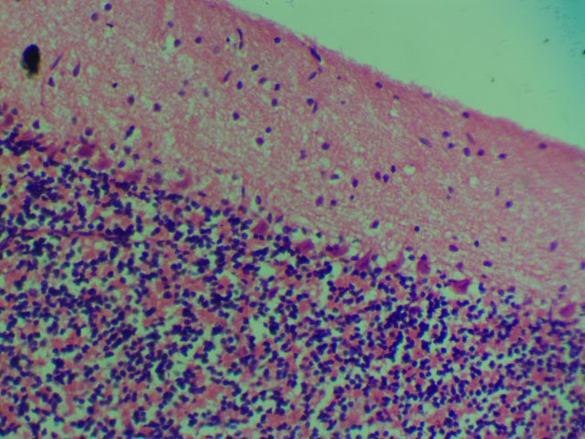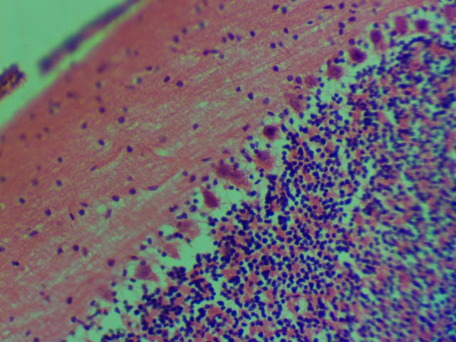

**b**

**a**

**PKL**

**ML**

**PKL**

**GL**

**ML**

**GL**

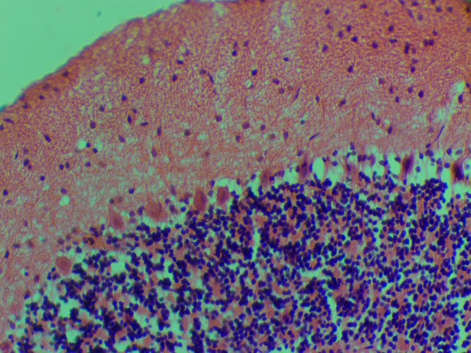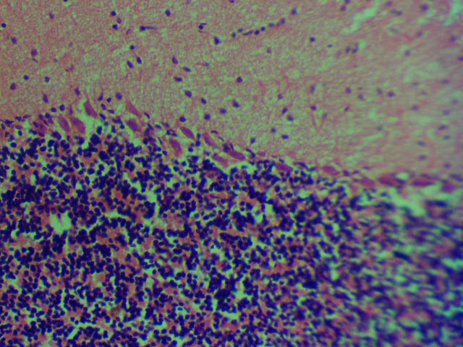

**Plate.1:** **The sections of the cerebellum of the control and test groups: H & E x400**

***a:*** *Sections of the cerebellum of control rat given distilled water, showing normal histological appearance of neurons and glia in the Purkinje cell layer (PKL), granular layer (GL) and the molecular layer (ML),* ***b:*** *Histological section of the cerebellum of group 1 animals given 100 mgkg-1 of P. guajava showing extreme vacuolations surrounding each Purkinje neurons, some of the neuronal cell bodies are enlarged with pyknotic nuclei (arrow) when compared with the control, the molecular layer cell appears okay or unaffected,****. c:*** *Histological section of the cerebellum of the group’s 3 animals given 150 mg/kg of P. guajava atrophic glia cells (arrow heads) in the molecular layer, with vacuolations in the Purkinje cell layer (PKL, arrows); the Purkinje cells are also hypertrophied with karyorrhexis,* ***d:*** *Histological section of the cerebellum of group 4 animals given 200 mg/kg body weight of P.guajava showing mostly atrophied neurons and glia in the molecular and Purkinje cell layers,*

.

**c**

**d**

**ML**

**PKL**

**GL**

**ML**

**PKL**

**GL**

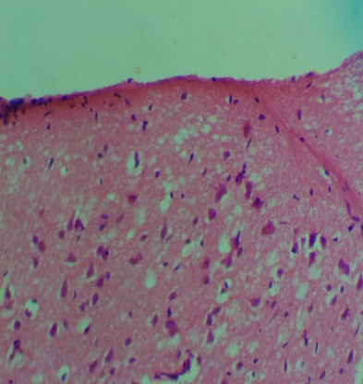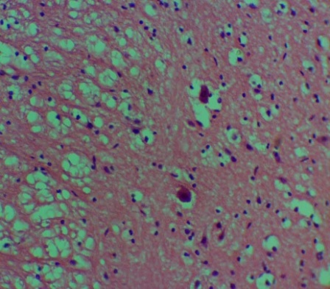

**V**

**SV**

**V**

**p**

**IM**

**SP**

**CP**

**M**

**g**

**SP**

**IM**

**SV**

**V**

**a**

**b**

**CP**

**M**

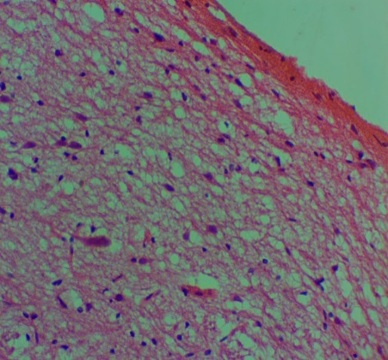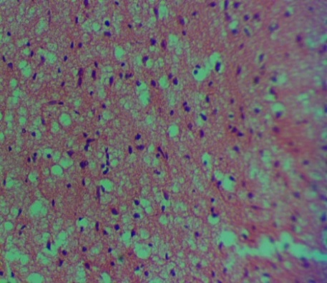

**v**

**N**

**c**

**d**

**g**

**v**

**P**

**v**

**V**

**Plate 2:The sections of the cerebral Cortex of the control and test groups: H & E**

***a:*** *The section of the cerebral cortex of the control group shows six cortical layers. The layers from superficial to the deep were;M= marginal zone, Cp= cortical plate, Sp= subplate, Iz= intermediate zone, SVz= subventricular zone and the Vz= ventricular zone x400* ***b:*** *The histological section of the cerebral cortex of group 1 animals that received 100* mgkg-1 *of leaf extract of P. guajava, shows marked vacuolations (V) throughout the six cortical layers with increased cellular population of glia cells (g) with hypertrophied and pyknotic pyramidal neurons (p) when compared to the control group x400.* ***c:*** *Section of the cerebral cortex of group 2 animals given 150* mgkg-1 *of P. guajava showing sparse or reduced glia population (g), and atrophy of the pyramidal shaped neuronal cell body (p) x400.* ***d:*** *Histological section of the cerebral cortex of group 3 animals given 200* mgkg-1 *of P. guajava shows a less dense population of glia (g), but the pyramidal and granular neurons (N) appeared slightly reduced in size with vacuolations (V) in all the cortical layers compared with the control group. The layers from superficial to the deep were Cp= cortical plate, Sp= sub-plate, Iz= intermediate zone, SVz= sub-ventricular zone and the Vz= ventricular zone. H & E. Mag. x400*

**Histochemical Observations**

**Cresyl Fast Volet Stain (CRV):** Section of the cerebellum of the control group given distilled water shows Nissl substance stains throughout the three cortical layers (Plate 3a). However, the histological sections of the *P. guajava* groups given 100 mgkg-1, 150 mgkg-1of *P. guajava* shows chromatolysis (arrow heads) of Purkinje neuron but with Nissl substance staining intensity in the Purkinge and granular cell layers, however with less staining intensity in the Nissl substance (arrows) throughout the molecular layers. (ML) (Plates 3b).The histological sections of the cerebellar cortex of group 3 animals given 200 mgkg-1 shows hypertrophied Purkinje neurons in the Purkinje cell layer, however with deeply expressed Nissl granules throughout the three cortical layers.

Cresyl Fast Violet (CFV) stain of the cerebral cortex unveiled notable differences in Nissl substance expression across various cortical layers among the *P. guajava* groups when compared to the control. In the control group cerebral cortex, there is a uniform and robust staining of Nissl substance observed across all the six cortical layers

including the marginal zone (M), cortical plate (Cp), subplate (Sp), intermediate zone (Iz), subventricular zone (SVz), and ventricular zone (Vz), with the marginal layer displaying particularly intense staining. This is also evident in group 1 given 100 mgkg-1 *P. guajava* (Plates 4a and 4b). Conversely, in the cerebral cortex of group 2 animals given 150 mgkg-1body weight of *P. guajava*, there is a discernible reduction in staining intensity, particularly evident in the marginal layer, accompanied by signs of chromatolysis in pyramidal neurons, indicating potential cellular stress or damage also observed at x400 magnification (Plate 4c). Furthermore, group 3 animals  cerebral cortex given 200 mgkg-1body weight of *P. guajava* exhibits pronounced loss of Nissl stain intensity (arrow heads) throughout the entire cortical layers, indicative of more severe alterations in neuronal health or function (Plate 4d). These findings underscore the potential impact of the treatment’s regimen on the structural integrity and metabolic activity of the neurons within the cerebral cortex.

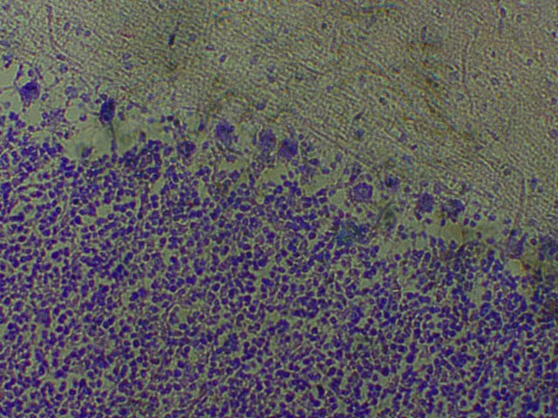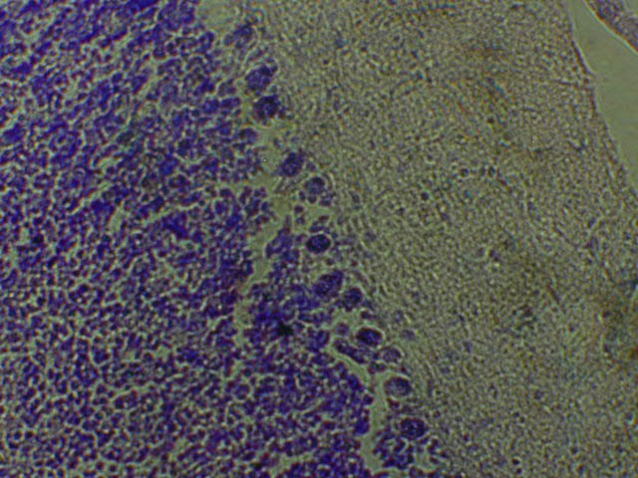

**a**

**b**

**GL**

**ML**

**PKL**

**GL**

**ML**

**PKL**

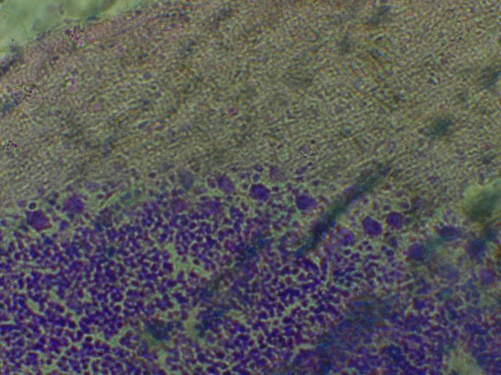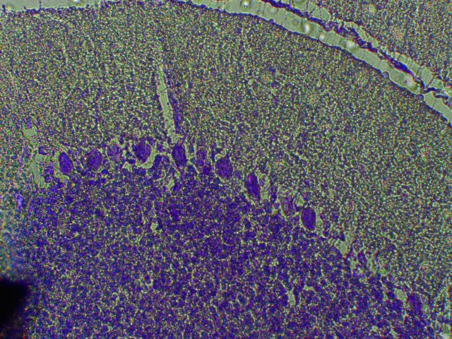

**c**

**d**

**GL**

**PKL**

**PKL**

**GL**

**ML**

**PKL**

**Plate 3:** **The sections of the cerebellum of the control and test groups: Cresyl fast violet (CFV)**

*a, Section of the cerebellum of rats given distilled water showing Nissl substance stains throughout the three cortical areas.*

*b, c: Histological sections of the test groups given 100* mgkg-1*(b) and 150* mgkg-1*(c) of P. guajava showing chromatolysis of (arrow heads) of Purkinje neuron but with Nissl substance staining intensity in the Purkinje and Granular cell layers, however with less staining intensity in the Nissl substance (arrows) throughout the molecular layers. (ML) in the three plates examined. ×400.*

*d: Histological sections of the cerebellar cortex of group 3 animals given 200* mgkg-1 *P. guajava showing hypertrophied Purkinje neuronal cells however, with deep Nissl granular expressions throughout the three cortical layers*

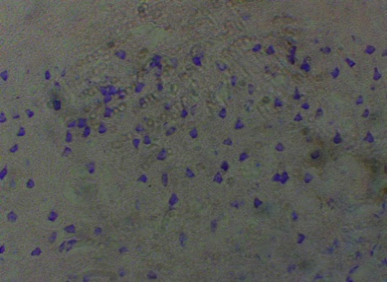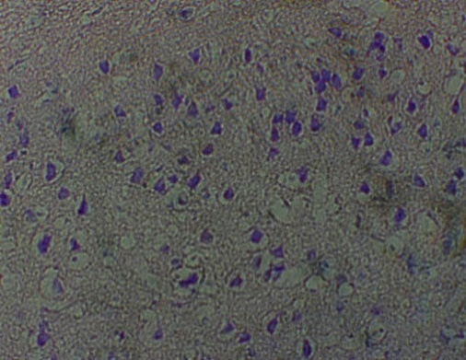

**CP**

**M**

**SP**

**IM**

**SV**

**V**

**b**

**M**

**CP**

**SP**

**IM**

**SV**

**V**

**a**

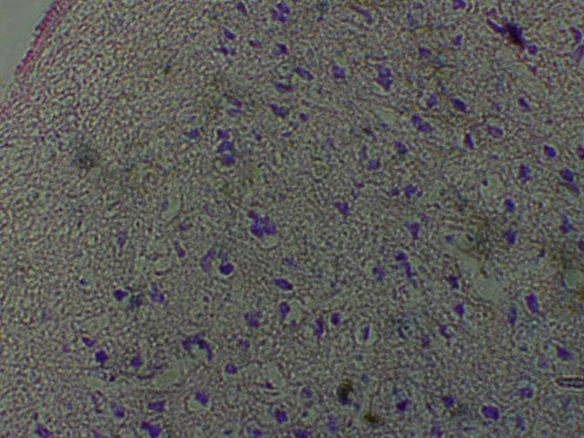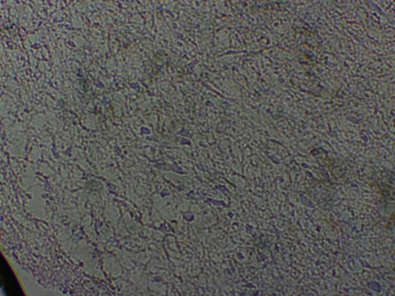

**N**

**M**

**CP**

**SP**

**IM**

**SV**

**V**

**M**

**CP**

**SP**

**IM**

**SV**

**V**

**d**

**c**

**Plate 4**: **The sections of the cerebral cortex of the control and test groups: Cresyl fast violet (CFV) x400.**

***a and b: The section of the cerebral cortex of the control and group 1 shows deeply stained Nissl substance expressions in the six cortical layers. The layers from superficial to the deep are;*** ***M= marginal zone, Cp= cortical plate, Sp= subplate, Iz= intermediate zone, SVz= subventricular zone and the Vz= ventricular zone x400.***

***c: Section of the cerebral cortex of group 2 animals shows obvious reduction in the staining intensity for Nissl substance especially in the marginal (M) layer, with chromatolysis of the pyramidal neuron (N) x400.***

***d: Section of the cerebral cortex of group 3 animals showing marked loos of Nissl stain intensity throughout the six cortical layers. The layers examined are M= marginal zone, Cp= cortical plate, Sp= subplate, Iz= intermediate zone, SVz= subventricular zone and the Vz= ventricular zone x400***

**4. DISCUSSION**

Research indicates that the phytochemical components of some plants can significantly reduce the body weight in Wistar rats. According to Obike *et al.,* (2024), anti-nutritional phytochemicals, such as saponins and tannins have been shown to reduce the body weight of experimental animals. In this present study, the administration of guava leaf extract to the Wistar rats in this present study resulted in noticeable decrease in body weight. This may have been as a result of the fact that the leaf extract of *P.guajava*  used in this present study was found to contain saponin and Tannins in abundance. The relative abundance of these phytochemicals must have informed the present result. This reduction may have occurred through various mechanisms, including suppression of the animal growth, inhibition of digestion, or by hindering the activity of pancreatic lipase as previously reported by Oyeyemi *et al.,* (2018) and Shittu *et al.,* (2016). The phytochemicals found in the guava leaves, must have affected their appetite regulation, fat metabolism, and antioxidant activity. However, it is important to note that the amount of weight loss can vary based on the dosage and duration of extract administration, and results may differ depending on the specific strain of rat and the experimental conditions (Ekong *et al.,*2014). In this present study, the body weighs of the animals administered *P.guajava*  was found to be significantly lower than that of the control although no difference in body weight was recorded when the individual groups were compared to each other.

Metallic analysis of powdered leaf extracts of *P.guajava*  by Okunrobo *et al.,*(2010) reveals that the leaf material of guava contains an intolerable levels of Zinc at 28.25mg/kg where the upper tolerable intake is 25 mg/kg (Abdallah and Samman 1993); and Manganese at 29.23 mg/kg where the tolerable upper intake level is 11 mg daily (Harper, 2003). These metallic quantities, especially of manganese may result in possible cytotoxic changes in the basal ganglia as well as the cerebellum and cerebral cortex (Okomrobo *et al.,*2010). In this present study, the cerebellum and cerebral cortical sections show histopathological manifestations including pyknosis, hypertrophy, and vacuolations. Considering the fact that *P. guajava* is reportedly high in manganese (Fell,1993), the histopathological manifestations shown in this present study may have been due to this reported high metallic content, thereby resulting in the disruption of the functional circuitry in the cerebellum. This altered histological features are more prominent in the degenerating Purkinje neurons in the Purkinje cell layer in a dose dependent manner. The present study aligns with Opoola and Ajibade’s (2023) report on degenerating Purkinje neurons upon exposure to manganese. According to Opoola and Ajibade, the Manganese toxicity can also impair cognitive functions, such as learning, memory.

The cerebral cortex is the part of the brain which is primarily implicated in cognitive memory functions. Report has it that changes in the cellular morphology and population can affect these functional abilities of the cerebral cortex either positively or negatively (Ekong *et al.,* 2014; Wang *et al.,* 2004). In this present study, group 1 animals receiving 100 mgkg-1of *P. guajava* showed marked vacuolations throughout the six cortical layers and an increased population of glia cells compared to the control group. This is in agreement with the findings of a previous study by Udoh *et al.,* (2014) and Ekong *et al.,* (2014) on degeneration of neurons in the cerebral and cerebellar cortex. The apparent high glia population density is indicative of trauma from the treatment regimes. This high general cellular population density may be due to either gliosis and/or neurogenesis. Gliosis usually result when the brain is traumatized by chemical agents and/or infections (Okon *et al.,* 2022; Udoh *et al., 2020),* and the plants may have done that in this present study. In group 2 animals given 150 mgkg-1of *P. guajava*, there was a sparse or reduced population of glia cells, and the pyramidal-shaped neuronal cell bodies showed atrophy. The reduction in the number of glia cells could have implications for the maintenance of neuronal health and function. In group 3 animals administered 200 mgkg-1of *P. guajava,* there was a less dense population of glia cells compared to the control group. Pyramidal and granular neurons appeared slightly reduced in size with vacuolations present in all cortical layers indicating signs of type II neuronal cell death as previously reported by Mitral *et al.,* (2009), Pagnussat *et al.,* (2007), and Okon *et al.,* (2022).

The function of Nissl bodies in neurons is for the manufacture and release of protein for intracellular use. Results of this present study shows loss of Nissl substance in the molecular layers of the cerebral cortex of all the *P. guajava* groups, along with chromatolysis which indicates that the plant may have a deleterious effect on Nissl bodies. Nissl bodies show changes under physiological and pathological conditions where they may dissolve and disappear, a condition known as chromatolysis. Chromatolysis can be triggered by axotomy, ischemia and toxicity to the cell, as well as cell exhaustion or virus infections leading to disintegration of Nissl bodies (Goldstein *et al.,* 1987). It may also be altered by chemicals, toxins, certain drugs and hypoxia causing loss of function or interference in normal metabolism and a resultant impaired protein synthesis (Davis and Robertson, 1991).

Neuronal degeneration has also been reported to cause a decrease in Nissl bodies resulting from chromatolysis (Martins *et al.,* 1978). Degeneration of Nissl substances is usually characterized by disintegrating cellular remains that are confined to the periphery of the cell with homogenous cytoplasm (Davis and Robertson, 1991). Other alterations are characterized by changes in the membrane configuration forming lamella bodies (Davis and Robertson, 1991). The observed loss of Nissl bodies in terms of reduced staining intensity in the cerebral and cerebellar cortex of the treated rats in the present study agrees with the findings of Ajibade *et al.* (2006) and Adjene and Momah (2010). The findings according to these authors showed that the Nissl substances in the cerebellar cortex and the intracranial visual relay centres in control rats stained more intensely and distinctly compared with the less intense stain of degenerated Nissl substances in the treated rats. Degeneration and loss of Nissl substances may consequently affect the synthesis of both structural proteins and transport proteins within the cerebral cortex and cerebellum. The density of Nissl substance in the cerebral cortex of group 3 animals which received the highest dose of Guava was lower in all the test groups compared to the control. This must have been as a result of Injury to the axons or neuronal exhaustion resulting from the high dosage administered to this group resulting in reduction in the Nissl body densities and staining intensity as previously reported by Martin *et al.,* (2002) and Udoh *et al , (*2020) and Davies *et al.,*  (2022).

.

1. **Conclusion**

In this present study, the leaves of *Psidium guajava* has been shown to contain Polyphenols, Cardiac glycoside, Flavonoids, Alkaloid, Reducing Compounds, Anthraquinone and a high concentration of saponin and tannin reported in weight reduction. Previously reported metallic analysis revealed the presence of a high and intolerable level of manganese and zinc in this plant material, which could support the histopathological feature such as hypertrophy, pyknosis, Karyorrhexis, atrophy, gliosis, vacuolation and chromatolysis seen in the cerebral cortex and cerebellum in the present study, indicating insult or injury to these brain area in a dose dependent manner. Therefore, this plant material must be administered under strict and regulated supervision

Consent

Not applicable

Ethical approval

All authors hereby declare that "Principles of laboratory animal care" (NIH publication No. 85-23, revised 1985) were followed, as well as specific national laws where applicable. All experiments have been examined and approved by the appropriate ethics committee

**Disclaimer (Artificial intelligence)**

Authors hereby declares that NO generative AI technologies such as Large Language Models (ChatGPT, COPILOT, etc.) and text-to-image generators have been used during the writing or editing of this manuscript.

**REFERENCES**

1. Jonah, U. P., Udoh, N. B., & Udofia, L. E. (2022). Studies on the use of root extracts of *Triclisia subcordata* and *Hippocratea africana* on the neurohistology of the cerebellum of adult Wistar rats. *Asian Journal of Research and Reports in Neurology*, 5(2), 27–36.

<https://www.sdiarticle5.com/reviewhistory/89227>

1. Udofia, L. E., Udoh, N. B., Edohoabasi, B. G., & Owowo, E. E. (2022). Antimalarial activity of Bambusa vulgaris on Plasmodium berghei berghei in mice. Nigerian Journal of Parasitology, 43(2). <https://dx.doi.org/10.4314/njpar.v43iXXX>
2. TripathiL., & Tripathi J. N. (2003). Role of biotechnology in medicinal plants. Tropical Journal of Pharmacology Research, 2 (2): 243-253.
3. Ekong, M. B., Ekpene, U. U., Thompson, F. E., Peter, A. I., Udoh, N. B., & Ekandem, G. J. (2014). Effects of co-treatment of *Rauwolfia vomitoria* and *Gongronema latifolium* on neurobehavior and the neurohistology of the cerebral cortex in mice. *Internet Journal of Medical Update*, 10(1), 310. <https://doi.org/10.4314/ijmu.v10i1.2>
4. Uboh, E.F., Okon I. E., & Ekong, M.B (2010). Effect of Aqueous Extract of Psidium Guajava Leaves on Liver Enzymes, Histological Integrity and Hematological Indices in Rats Gastroenterology Research • 2010;3(1):32-38. <https://www.gastrores.org.doi.10.4021/gr2010.02.174w>
5. Okujagu, T. F., Etatuvie Sam O., Ifeyinwa E., Jimoh B., & Nwokeke.(2005).Book of abstract of published Research finding on Nigerian Medicinal plant and traditional medicinepractice.1: 90.
6. Belemtougri R.G, Constantin B, Cognard C, Raymond G, & Sawadogo L. (2006) Effects of two medicinal plants Psidium guajava L. (Myrtaceae) and Diospyros mespiliformis L. (Ebenaceae) leaf extracts on rat skeletal muscle cells in primary culture. J Zhejiang Univ Sci. B 2006;7(1):56-63
7. Conde G. E, A., Nascimento V.T., & Santiago S. A. B (2003). Inotropic effects of extracts of Psidium guajava L. (guava) leaves on the guinea pig atrium. Braz J Med Biol Res;36(5):661-668.
8. Begum S., Hassan S. I,, Siddiqui B.S., Shaheen F., Ghayur M.N,& Gilani A.H (2002). Triterpenoids from the leaves of Psidium guajava. Phytochemistry 2002;61(4):399-403.
9. Begum S., Hassan S.I., & Siddiqui B.S (2002) Two new triterpenoids from the fresh leaves of Psidium guajava. Planta Med 2002;68(12):1149-1152.
10. Chevellier, A. (1996) The Encylopedia of Medical Plant. London. Dorling Kindersley Ltd. (online), 1996. <http://www.chclibrary.org/plant.html>
11. Jimenej-Escrig A. (2002). Guava fruit (Psidium Guajava L.) as a new source of antioxidant Dietary fiber. Journal of Agricultural Food Chemistry,49(11):5489- 93.
12. Qian, H., & Nihorimbere, V. (2004). Antioxidant power of phytochemicals from Psidium guajava leaf. Journal of Zhejiang University Science 5: 676.
13. Gill, L. S. (1992). Ethno-medical uses of plant in Nigeria. University of Benin press Benin City, Nigeria. ISBN 9782027200, 9789782027207. 209.
14. Nwogu L. A, Alisi C. S, Ibegbulem C. O,, & Igwe C. U.(2007).. Phytochemical and Antimicrobial Activity of Ethanolic Extract of Landolphia owariensis leaf. Afric J. Biotechnol 2007;6(7):890-893.
15. Holetz, FB, et al. (2002). Screening of some plants used in the Brazilian folk medicine for the treatment of infectious diseases. Mem. Inst. Oswaldo Cruz 2002;97(7):1027- 31.
16. Udoh, N. B., Ekong M.B., Udoakang,N .P.,& Udofia. L.E (2025). “Microstructural, Immunoreactivity and Biochemical Studies of the Cerebellum After Artequin Administration in Adult Wistar Rats”. Asian Journal of Research and Reports in Neurology 8 (1):57-70. <https://doi.org/10.9734/ajorrin/2025/v8i1124>.
17. Yu, W., & Magnuson, K. E. (2015). Cognitive collaborations: Bidirectional functional connectivity between the cerebellum and the hippocampus. *Neuroscience*, 9(5), 177–187.
18. Harold, E., & Vishy, M. (2010). *Clinical anatomy: Applied anatomy for students and junior doctors* (12th ed., pp. 362–363).
19. Wolf, U., Rapoport, M. J., & Schweizer, T. A. (2009). Evaluating the affective component of the cerebellar cognitive affective syndrome. *Neuropsychiatry and Clinical Neuroscience*, 21(3), 245–453.
20. Udoh, N. B., Ekanem, T. B., Ekong, M. B., Peter, A. I., & Akpantah, A. O. (2014). Hippocampal glial degenerative potentials of mefloquine and artequin in adult Wistar rats. *International Journal of Brain Science*, 2014, Article ID 104785. <https://doi.org/10.1155/2014/104785>
21. Yu, W., & Magnuson, K. E. (2015). Cognitive collaborations: Bidirectional functional connectivity between the cerebellum and the hippocampus. *Neuroscience*, 9(5), 177–187
22. National Institute of Health. (2011). *Guide for the care and use of laboratory animals* (8th ed.). National Academies Press.
23. Arora, S., & Ranvir, S. (2019) Phytochemicals: Benefits, Concerns and Challenges Book on Advancement in Functional Food Ingredients: 205–227 Edited By: Harish Kumarcopyright © Jaya Publishing House, Delhi, India; 2019.
24. Ellis, R. (2019). Hematoxylin and eosin (H&E) staining protocol. IMS’s Division of Pathology, The Queen Elizabeth Hospital, Woodville Road, Woodville, South Australia. <http://www.ihcworld.com/protocol/special_stain/h_and_e_ellis.htm>
25. Luke, H., Rumelo. A., Arthur, C. & Rob, S. (2016). Cresyl violet staining (nissl staining),queensland brain institute's advanced microimaging and analysis facility. *American Journal of Tropical Medicine and Hygiene*, 70(2):238 - 243.
26. Obike, C.A., Ijeh, I.I., Egbuonu. A.C.C & Ubah, E.E (2024). Body and Organ Weight Changes in Male Wistar Rats Treated with WITH SAPONINS EXTRACT OF Vernonia amygdalina AND Vernonia colorata. Scientia Africana, Vol. 23 (No. 3), August, 2024. Pp 133-146.<https://dx.doi.org/10.4314/sa.v23i3.13>.
27. Shittu, O. B., Ajayi, O. L., Bankole, S. O., & Popoola, T. O. (2016). Intestinal ameliorative effects of traditional Ogitutu, Vernonia amygdalina and Psidium guajava in mice infected with Vibrio cholera. African Health Science, 16 (2): 620-628
28. Oyeyemi, I. T., Aderiike, A. A., Adewumi, A., Aleshinloye, A. O., & Oyeyemi, O. (2018). Vernonia amygdalina: A folkloric herb with anthelminthic properties. BeniSuef University Journal of Basic and Applied Science (18): 43-49.
29. Okunrobo, L.O., Kate E Imafidon, & Adeyemi A Alabi (2010) Phytochemical, Proximate and Metal Content Analysis of the Leaves of *Psidium guajava* Linn (Myrtaceae). International Journal of Health Research, December 2010; 3(4): 217-221. Available at <http://www.ijhr.org>
30. Harper A. E (2003). Contribution of women scientist in the US to the development of recommended dietary allowances. J Nutri 2003; 133:3599-3702.
31. Abdallah S. M., & Samman S (1993). The effect of increasing dietary zinc on the activity of superoxide dismutase and zinc concentration in erythrocytes of healthy female subjects. Euro J Clin Nutr 1993; 47:327-332.
32. Fell, J. M.*.*(1996)Manganese toxicity in children receiving long-term parenteral nutrition. Lancet 1996; 347:1218-1221.
33. Opoola S. S., & Ajibade A. J. (2023) Neurotoxic Effects of Manganese Chloride on the Cerebellar Cortex of Adult Wistar Rats * EAS Journal of Pharmacy and Pharmacology Volume-5 | Issue-3 | May-Jun- 2023. doi:10.36349/easjpp. 2023.v05i03.002
34. Goldstein, M. E., Cooper, H. S., Bruce, J., Carden, M. J., Lee, V. M. & Schlaepfer, W. W. (1987). Phosphorylation of neurofilament proteins and chromolysis following transection of rat sciatic nerve.*Journal of Neuroscience*, 5(5): 1586 – 1594
35. Mitra, N. K., Nadarajah, V. D. & Siong, H. H. (2009). Effect of concurrent application of heat, swim stress and repeated dermal application of chlorpyrifos on the hippocampal neurons in mice. *Folia Neuropathologica*, 47(1): 60 - 68.
36. Pagnussat, A. S., Faccioni-Heuser, M. C., Netto, C. A. & Achaval, M. (2007). An ultrastructural study of cell death in the ca1 pyramidal field of the hippocapmus in rats submitted to transient global ischemia followed by reperfusion. *Journal of Anatomy*, 211(5): 589 - 599.
37. Okon, K. A., Edem, G. D., Udoh, N. B., & Umanah, S. N. (2022). *Rauvolfia vomitoria* remediates neurodegenerative deficiencies in hippocampus of Wistar rats treated with lead nitrate. *Journal of Advanced Education and Sciences*, 2(1), 19–23.
38. Davis, R. L. & Robertson, D. M. (1991). *Textbook of Neuropathology*, 2ndEdition.Williams and Wilkins, London, pp5-7.
39. Suntornsuk, L., Gritsanapun, W., & Nilkamhank, S.(2002), Paochom Quantitation of vitamin C content in herbal juice using direct titration. J Pharm Biomed Anal 2002;28(5):849- 855.
40. Martins, L. J., Al-Abdulla, N. A., Kirsh, J. R., Sieber, F. E. & Portera-Cailliau, C. (1978). Neurodegeneration in excitotoxicity, global cerebral ischaemia and target deprivation: a perspective on the contributions of apoptosis and necrosis. *Journal ofBrainResponse*, 46(4): 281 - 309.
41. Ajibade, A. J., Adenowo, T. K., Fajemilehin, M. E., Caxton-Martins, E. A. & Omotoso, E.O. (2006). Some histological observations on the cerebellar cortex of adult Wistar rats following quinine administration. *Science Focus*, 11: 97 -100.
42. Adjene, J. O & Momah, V. (2010). Histological effects of chronic administration of efavirenz on the superior colliculus of adult Wistar rats. *Bioscience. Research*, 22(6): 47*–*52.
43. Martin, L. A., Tan, S. & Goldowitz, D. (2002) .Clonal architecture of the mouse hippocampus. *Journal of Neuroscience,*22(9): 3520-3530.
44. Wang, S., Malhotra, J. E., Rhoads & Norman C. A. (2004). Identifying high-red shift active galactic nuclei using x-ray hardness.*The American Astronomical Society*of Neurology23(6): 13–24.
45. Udoh, N. B., Ekanem, T. B., & Ekong, M. B. (2020). Behavioural and microstructural evaluation of the hippocampus of adult Wistar rats following artequin administration. *Current Research in Neuroscience*, 10(1), 1–10. <https://doi.org/10.3923/crn.2020.1.10>
46. Davies K.G., Olorunsola, E.O., Udokang, N. P., Umana, K. T., Alozie, M. F., Edagha, I. A. (2022) Ameliorative Effects of Vernonia amygdalina and Moringa oleifera Extracts on Cognitive Impairment in Diabetic Wistar Rats. Nig. J. Neurosci. 13(2):6. <http://doi.org/10.47081/njn2022.13.2/004>