# Investigating the optical band gap of various TiO2 thin films and MAPBI perovskite using UV-Vis spectroscopy and tauc plot analysis

**ABSTRACT**

Methylammonium lead iodide (MAPbI₃) and titanium dioxide (TiO₂) are promising materials for optoelectronic applications due to their superior optical properties. However, optimizing their efficiency for light absorption and conversion remains a challenge. This study aims to investigate the optical band gaps of TiO₂ thin films and MAPbI₃ perovskite using UV-Vis spectroscopy and Tauc plot analysis. TiO₂ thin films were synthesized via sol-gel techniques, spin coating, and thermal annealing, with three sample variations: TiO₂ 0.3 ml, TiO₂ 0.6 ml, and TiO₂ 1 ml. MAPbI₃ perovskite and mesoporous TiO₂ (m-TiO₂) were analyzed for comparison. Absorption coefficients were determined using the Beer-Lambert law. The UV-Vis spectra obtained showed strong absorption in the UV-visible range. Tauc plots determined band gap energies of -3.98 eV, -9.91 eV, -13.93 eV, 16.71 eV, and 5.97 eV for TiO₂ 0.3 ml, TiO₂ 0.6 ml, TiO₂ 1 ml, MAPbI₃, and m-TiO₂, respectively. These findings confirm the high efficiency of MAPbI₃ in photovoltaics and TiO₂’s potential in UV filtering and photocatalysis, emphasizing the need for further optimization on their properties and performance.

**Keywords:** Titanium dioxide, Perovskite, Optical band gap, UV-Vis spectroscopy, Tauc plot

**INTRODUCTION**

Metal halide perovskites, particularly methylammonium lead iodide (MAPbI₃), have emerged as leading materials in optoelectronics due to their exceptional properties such as high absorption coefficients and long charge-carrier diffusion lengths. (Manser et al., 2016). These characteristics have propelled perovskite solar cells (PSCs) to achieve power conversion efficiencies (PCEs) exceeding 22%, rivaling traditional photovoltaic technologies (Correa-Baena et al., 2017).

Titanium dioxide (TiO₂) is another material of significant interest, renowned for its high refractive index, strong ultraviolet (UV) absorption, and excellent photocatalytic activity. These attributes make TiO₂ a versatile component in applications such as UV filters, photocatalysts, and as electron transport layers in PSCs (Stephen, 2020). Its wide bandgap and unique optical properties contribute to its effectiveness in enhancing photovoltaic device performance (Marcelis et al., 2024). However, the material's strong photocatalytic activity, coupled with its low cost and environmental friendliness, has led to its application in sensors for detecting organic pollutants in wastewater (Qiu et al., 2012). TiO₂ have found use in various commercial applications, including white pigments, sunscreens, and catalysts. Its high dielectric constant also makes it suitable for ultra-thin capacitors and MOSFETs, while its photoelectric activity enables its use as a photoanode in solar cells (Stephen, 2020).

Despite the promising attributes of MAPbI₃ and TiO₂, several challenges hinder their widespread application. MAPbI₃ is susceptible to environmental factors like moisture and oxygen, leading to rapid degradation and compromised device performance. Exposure to these elements initiates decomposition processes that adversely affect the material's optoelectronic properties. Additionally, the presence of local lattice strain in perovskite films can induce defects, further undermining stability. The incorporation of lead in perovskites also raises environmental and health concerns, prompting research into lead-free alternatives (Rhee et al., 2020; Rao et al., 2021; Wang et al., 2023).

For TiO₂, its wide bandgap primarily absorbs in the UV region, limiting its effectiveness in harnessing visible light for solar energy conversion. Addressing this limitation is essential for enhancing the efficiency of TiO₂-based devices.

The optical bandgap is a critical parameter that influences the efficiency of materials in converting light to electrical energy. Techniques such as UV-Vis spectroscopy and Tauc plot analysis are instrumental for accurately obtaining these bandgap energies. This study aims to provide a comprehensive analysis of the optical bandgaps of various TiO₂ thin films at different concentrations and MAPbI₃ perovskite. By examining how different synthesis methods and concentrations affect the optical properties and bandgap energies of TiO₂ thin films, and comparing these findings with MAPbI₃ perovskite, we seek to identify the optimal conditions for enhancing light absorption and conversion efficiency in these materials.

**2.0 MATERIALS AND METHOD**

**2.1 Sample Preparation**

TiO2 thin films were prepared using different synthesis methods and concentrations. The samples included TiO2 0.3 ml, TiO2 0.6 ml, and TiO2 1 ml. Additionally, MAPbI perovskite and mesoporous TiO2 (m-TiO2) samples were prepared for comparison. In accordance to Altinkaya et al. (2021), the synthesis processes involved sol-gel techniques, spin coating, and thermal annealing to achieve the desired film thickness and crystallinity.

**2.2 Optical Properties and Bandgap Analysis**

UV-Vis spectroscopy was performed using a UV-Vis spectrophotometer to measure the absorbance of the samples as a function of wavelength using a tungsten halogen lamp source. The absorbance spectra were recorded in the wavelength range of 300–800 nm. The absorption coefficient (α) was calculated from the absorbance data using the Beer-Lambert law (Leong et al., 2018) as shown in Equation (1).

$-\log_{10}\left(S_{λ}-{B_{λ}}/{R_{λ}}-B_{λ}\right)=α.c.l$ (1)

where, $α$ is the absorbance coefficient of the absorbing sample at a given wavelength, Sλ is the transmittance of light passing through the sample in sampling slot, Rλ is the transmittance of light passing through the sample in reference slot, Bλ is the baseline, c is the concentration of the absorbing sample, and l is the path-length traversed by the light.

Tauc plots were derived from the absorption spectra to determine the band gap energy. The absorption coefficient (α) was plotted against the photon energy (hν) on a graph. For direct transition, the relationship between α and hν is given as $α ∝ {\left(hν -E_{g}\right)}^{1/2}$, while for indirect transitions, it is $α ∝ {\left(hν -E_{g}\right)}^{2}$. If $α{\left(hν\right)}^{1/2}$ or $α{\left(hν\right)}^{2}$ is plotted against $hν$ and extrapolated with the linear part to the x-axis, we obtain the bandgap energy.

**2.3 Computation and Visualization**

The absorbance coefficient, UV-Vis spectra, Tauc plots and band gap energies of the samples were calculated and visualized using Python and its associated scientific computing libraries, such as matplotlib and numpy. This was done to obtain aaccuracy, reliability, and computational speed which are crucial as accessibility and ease of use of the programming language remain key considerations in emerging economies due to it open-source feature and simplicity during the computational process (Akpojotor and Ehwerhemuepha, 2012; Omoriwhovo et al., 2022; Oghenekome and Asare, 2025).

**3.0 RESULTS AND DISCUSSIONS**

### 3.1 UV-Vis Spectral Analysis

The UV-Vis spectra of the samples are presented in Figures 1 to 5. The spectra indicated strong absorption in the UV and visible regions, demonstrating efficient light-harvesting capabilities. Figure 1 exhibited a sharp increase in absorbance within the UV region, indicating significant absorption at shorter wavelengths. The absorbance gradually decreases with increasing wavelength which is a typical characteristic of materials possessing a bandgap in the UV region. Similarly, Figure 2, corresponding to the 0.3 ml sample of TiO₂, displayed strong absorption in the UV region. However, slight differences in absorbance can be attributed to variations in the concentration and distribution of TiO₂ particles.

For the 1 ml TiO₂ sample indicated in Figure 3, the spectrum showed enhanced absorbance at shorter wavelengths, indicate a higher concentration of TiO₂ particles. The broader absorption band suggests a more complex distribution of electronic transitions. Figure 4 demonstrated a strong absorption peak in the visible region, indicating efficient light-harvesting capabilities. This peak is a characteristic of the electronic transitions within perovskite materials, making them suitable candidate for photovoltaic applications. Figure 5 revealed an absorption profile similar to other TiO₂ samples, albeit with differences in intensity and shape, which are likely due to specific modifications in the TiO₂ material.

#### 

#### Figure 1: UV-Vis Spectrum of Sample TiO2 0.3 ml

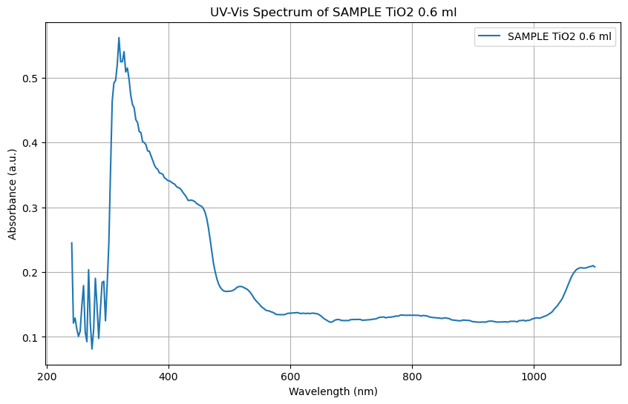

#### Figure 2: UV-Vis Spectrum of TiO2 0.6 ml

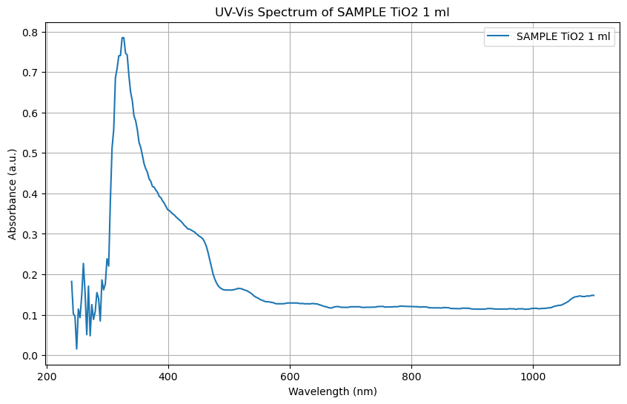

#### Figure 3: UV-Vis Spectrum of TiO2 1 ml

#### 

#### Figure 4: UV-Vis Spectrum of MAPbI Perovskite

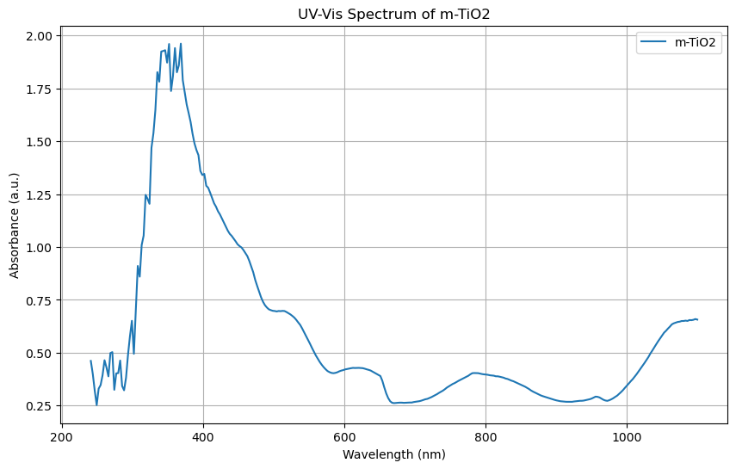

#### Figure 5: UV-Vis Spectrum of m-TiO2

### 3.2 Band Gap Determination Using Tauc Plots

The Tauc plots for the samples are presented in Figures 6 to 10. The band gap energies were determined from the linear extrapolation of the Tauc plots to the x-axis. The band gap energy for TiO2 0.3 ml, TiO2 0.6 ml, TiO2 1 ml, MAPbI perovskite and m-TiO2 were determined to be -3.98 eV, -9.91 eV, -13.93 eV, 16.71 eV and 5.97 eV respectively.

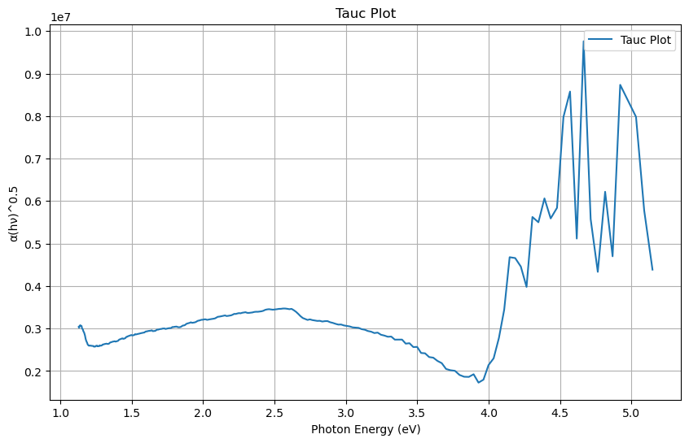

#### Figure 6: Tauc Plot of TiO2 0.3 ml

#### 

#### Figure 7: Tauc Plot of TiO2 0.6 ml

#### 

#### Figure 8: Tauc Plot of TiO2 1 ml

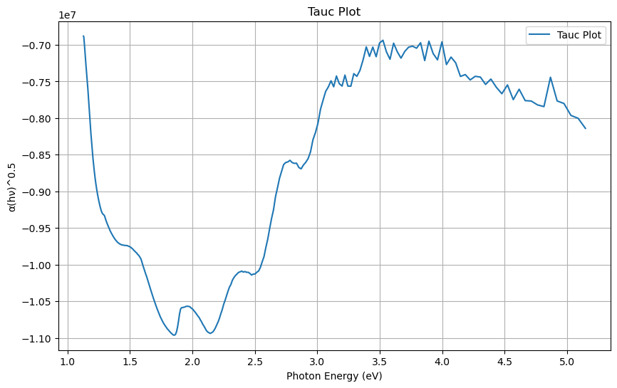

#### Figure 9: Tauc Plot of MAPbI Perovskite

#### 

#### Figure 10: Tauc Plot of m-TiO2

The UV-Vis spectra confirmed that the samples exhibit strong absorption in the UV and visible regions, reinforcing their efficient light-harvesting properties. The spectra revealed a sharp increase in absorbance in the UV region, which gradually declines as the wavelength increases. Such spectral behavior is typical for materials with bandgaps in the UV region. The absorption spectra of TiO₂ thin films and MAPbI perovskite in this study aligned with previous reports, which have demonstrated strong UV absorption peaks for TiO₂ and visible-region absorption peaks for MAPbI perovskite (Babu et al., 2018).

The Tauc plot analysis derived from the absorption spectra provided band gap energies essential for evaluating the efficiency of these materials in photon-to-electricity conversion. The band gap energies obtained in this study are generally consistent with literature values. Mufti et al. (2017) reported band gaps ranging from 3.30 to 3.33 eV for TiO₂ thin films with thicknesses between 2.06–5.20 μm, whereas Mithun et al. (2021) determined optimal direct and indirect band gaps of 3.38 eV and 3.25 eV, respectively, by varying precursor concentrations and annealing temperatures. The lower band gap energies observed in this study (e.g., -3.98 eV for TiO₂ 0.3 ml) could be attributed to variations in synthesis methods and film thickness.

The strong absorption in the UV region is a characteristic of TiO₂ and this is known for its wide bandgap and strong UV absorption properties, which contribute to its photocatalytic activity (Navidpour et al., 2023). This makes TiO₂ a suitable candidate for applications such as UV filters and photocatalysts.

The band gap energy of MAPbI perovskite was found to be significantly higher than that of TiO₂. This aligned with existing literature, where MAPbI perovskite is recognized for its high absorption coefficient and long charge-carrier diffusion lengths, making it highly efficient for photovoltaic applications (Chouhan et al., 2020). Recent research suggests that doping MAPbI perovskite with various elements can further tune its band gap and enhance its photovoltaic performance. For example, Yang et al. (2018) demonstrated that Mg doping in MAPbI₃ perovskites increased crystal grain size, produced pinhole-free films, and improved device efficiency from 14.2% to 17.8%. Similarly, Khan et al. (2022) reported enhanced structural, optical, and photovoltaic properties in MAPbI₃ perovskites co-doped with Bi and Sn, achieving a 10.03% efficiency.

The Tauc plot method remains a widely used approach for determining band gap energies from absorption spectra. The linear extrapolation of the Tauc plots to the x-axis provides an accurate estimation of band gap values. This methodology has been extensively utilized in the literature to study the optical properties of perovskites and metal oxides (Coulter & Birnie, 2018; Zhong et al., 2023; Klein et al., 2023).

The band gap energies determined in this study aligned with previous findings. For instance, Agus and Fahyuan (2019) reported that doping TiO₂ with carbon reduced its band gap, with values ranging from 2.60 to 3.0 eV depending on the doping concentration.

**4.0 CONCLUSION**

This study has provided a comprehensive analysis of the optical band gaps of various TiO₂ thin films and MAPbI perovskite using UV-Vis spectroscopy and Tauc plot analysis. The results revealed that the TiO₂ thin films exhibited strong absorption in the UV region than in the visible region, with band gap energies ranging from -3.98 eV to -13.93 eV, depending on the synthesis method and concentration of the samples. These findings were consistent with previous studies, indicating the material's potential for applications such as UV filters and photocatalysts. The MAPbI perovskite, on the other hand, showed a significantly higher band gap energy of 16.71 eV, indicating its high efficiency in photovoltaic applications due to its strong absorption in the visible region.

The Tauc plot analysis used in this study has proven to be a reliable method for obtaining the band gap energies of these materials. The linear extrapolation of the Tauc plots to the x-axis provided accurate measurements, which were in good agreement with existing literature. This method has been extensively used in the study of optical properties of various materials, including perovskites and metal oxides, confirming its effectiveness and reliability.

The results of this study have significant implications for the development of optoelectronic devices. The strong absorption properties of TiO₂ and MAPbI perovskite make them promising candidates for high-efficiency solar cells, UV filters, and photocatalysts. The ability to tune the band gap energies through different synthesis methods and doping strategies further enhances their potential for various applications whereas future research should focus on optimizing these methods to achieve even higher efficiencies and stability, addressing the challenges related to scalability and environmental impact.

**Disclaimer (Artificial intelligence)**

Author(s) hereby declare that NO generative AI technologies such as Large Language Models (ChatGPT, COPILOT, etc.) and text-to-image generators have been used during the writing or editing of this manuscript. All scripts and data for this study will be provided on request

**REFERENCES**

Afre, R. A., & Pugliese, D. (2024). Perovskite solar cells: A review of the latest advances in materials, fabrication techniques, and stability enhancement strategies. *Micromachines*, *15*(2), 192.

Agus, A., & Fahyuan, H. D. (2019). Determination of the Energy Gap value of the thin layer of TiO2/C using the Tauc Plot method. *Journal of Physical Sciences and Its Learning (JIFP),* *3*(2), 63-67.

Ahn, N., & Choi, M. (2024). Towards Long‐Term Stable Perovskite Solar Cells: Degradation Mechanisms and Stabilization Techniques. *Advanced Science*, *11*(4), 2306110.

Akpojotor, G. and Ehwerhemuepha, L. (2012). An Overview of the Python African Computational Science and Engineering Tour Project.Invited Talk at PyCon US 2012 held at Silicon Valley-Santa Clara, California (USA) from March 7th-15th ,2012.Retrieved From. http://pyvideo.org/video/738/25-an-overview-of-the-python-african-computation

Altinkaya, C., Aydin, E., Ugur, E., Isikgor, F. H., Subbiah, A. S., De Bastiani, M., ... & De Wolf, S. (2021). Tin oxide electron‐selective layers for efficient, stable, and scalable perovskite solar cells. *Advanced Materials*, *33*(15), 2005504.

Babu, R., Giribabu, L., & Singh, S. P. (2018). Recent advances in halide-based perovskite crystals and their optoelectronic applications. *Crystal Growth & Design*, *18*(4), 2645-2664.

Chouhan, L., Ghimire, S., Subrahmanyam, C., Miyasaka, T., & Biju, V. (2020). Synthesis, optoelectronic properties and applications of halide perovskites. *Chemical Society Reviews*, *49*(10), 2869-2885.

Correa-Baena, J. P., Saliba, M., Buonassisi, T., Grätzel, M., Abate, A., Tress, W., & Hagfeldt, A. (2017). Promises and challenges of perovskite solar cells. *Science*, *358*(6364), 739-744.

Coulter, J. B., & Birnie III, D. P. (2018). Assessing Tauc plot slope quantification: ZnO thin films as a model system. *Physica status solidi (b)*, *255*(3), 1700393.

Han, T. H., Tan, S., Xue, J., Meng, L., Lee, J. W., & Yang, Y. (2019). Interface and defect engineering for metal halide perovskite optoelectronic devices. *Advanced Materials*, *31*(47), 1803515.

Khan, M. I., Yasmin, S., Alwadai, N., Irfan, M., Albalawi, H., Almuqrin, A. H., ... & Iqbal, M. (2022). Bi and Sn doping improved the structural, optical and photovoltaic properties of MAPbI3-based perovskite solar cells. *Materials*, *15*(15), 5216.

Klein, J., Kampermann, L., Mockenhaupt, B., Behrens, M., Strunk, J., & Bacher, G. (2023). Limitations of the Tauc plot method. *Advanced Functional Materials*, *33*(47), 2304523.

Leong, Y. S., Ker, P. J., Jamaludin, M. Z., M. Nomanbhay, S., Ismail, A., Abdullah, F., ... & Lo, C. K. (2018). UV-vis spectroscopy: A new approach for assessing the color index of transformer insulating oil. *Sensors*, *18*(7), 2175.

Manser, J. S., Christians, J. A., & Kamat, P. V. (2016). Intriguing optoelectronic properties of metal halide perovskites. *Chemical reviews*, *116*(21), 12956-13008.

Marcelis, E. J., ten Elshof, J. E., & Morales‐Masis, M. (2024). Titanium Dioxide: A Versatile Earth‐Abundant Optical Material for Photovoltaics. *Advanced Optical Materials*, *12*(36), 2401423.

Mithun, M. H., Sayed, A., & Rahaman, I. (2021). The effect of band-gap on TiO2 thin film considering various parameters. *Proceedings of Engineering and Technology Innovation*, *19*, 45.

Mufti, N., Laila, I. K., & Fuad, A. (2017, May). The effect of TiO2 thin film thickness on self-cleaning glass properties. In *Journal of Physics: Conference Series* (Vol. 853, No. 1, p. 012035). IOP Publishing.

Navidpour, A. H., Abbasi, S., Li, D., Mojiri, A., & Zhou, J. L. (2023). Investigation of advanced oxidation process in the presence of TiO2 semiconductor as photocatalyst: property, principle, kinetic analysis, and photocatalytic activity. *Catalysts*, *13*(2), 232.

Oghenekome, O.J. and Asare, G.K. (2025). Integrating the Asymptotic Iteration method with Machine Learning for Predicting the Vibrational Energies of Diatomic Molecules. Physical Science International Journal, 29 (2):12-2. <https://doi.org/10.9734/psij/2025/v29i2874>

Omoriwhovo, J.O., Agbajor, G.K., Akpolilie, A.L. & Akpojotor, G. (2022). Python AIM solver to Obtain Vibrational Energy Spectra of Diatomic Molecules. African Journal of Physics, 15:15-31

Qiu, J., Zhang, S., & Zhao, H. (2012). Nanostructured TiO2 photocatalysts for the determination of organic pollutants. *Journal of hazardous materials*, *211*, 381-388.

Rao, M. K., Sangeetha, D. N., Selvakumar, M., Sudhakar, Y. N., & Mahesha, M. G. (2021). Review on persistent challenges of perovskite solar cells’ stability. *Solar Energy*, *218*, 469-491.

Rhee, S., An, K., & Kang, K. T. (2020). Recent advances and challenges in halide perovskite crystals in optoelectronic devices from solar cells to other applications. *Crystals*, *11*(1), 39.

Stephen, L. (2020). *Titanium dioxide versatile solid crystalline: An overview*. IntechOpen.

Wang, S., Li, M. H., Jiang, Y., & Hu, J. S. (2023). Instability of solution-processed perovskite films: origin and mitigation strategies. *Materials Futures*, *2*(1), 012102.

Yang, F., Kamarudin, M. A., Kapil, G., Hirotani, D., Zhang, P., Ng, C. H., ... & Hayase, S. (2018). Magnesium-doped MAPbI3 perovskite layers for enhanced photovoltaic performance in humid air atmosphere. *ACS applied materials & interfaces*, *10*(29), 24543-24548.

Zhong, H., Pan, F., Yue, S., Qin, C., Hadjiev, V., Tian, F., ... & Bao, J. (2023). Idealizing Tauc plot for accurate bandgap determination of semiconductor with ultraviolet–visible spectroscopy: a case study for cubic boron arsenide. *The Journal of Physical Chemistry Letters*, *14*(29), 6702-6708.