**Anticancer Bioactive Compounds from Nigerian Medicinal Plants: A Review**

**Abstract**

Cancer remains the leading global cause of death, with fatalities rising daily. Medicinal plants have long been used in cancer management, particularly in developing countries such as Nigeria. Synthetic drugs, though commonly used for cancer treatment, often come with harmful side effects. As a result, the use of easily accessible and affordable medicinal plants offers a promising alternative to mitigate the toxicity linked to synthetic treatments.

**Key words**: Bioactive compounds, Cancer, Anticancer, Nigerian medicinal plants, Flora

**INTRODUCTION**

Cancer remains the leading cause of death worldwide, with the number of cancer-related fatalities increasing daily (Ferlay *et al.,* 2015). In 2020 alone, cancer accounted for nearly 10 million deaths globally (Ferlay *et al.,* 2020; Bray *et al.,* 2024). This alarming trend highlights the urgent need for intensified research into the discovery and development of new anticancer drugs derived from natural products, ensuring maximum selective toxicity alongside existing treatments (GBD, 2015). Cancer is characterized by the uncontrolled proliferation of body cells, which results from disruptions in cellular regulation and interference with the cell cycle. These abnormalities contribute to the formation of malignant tumors, which may spread to other parts of the body (Tyagi *et al.,* 2017).

In Nigeria, despite the widespread use of synthetic drugs, plant extracts remain a crucial source of anticancer agents. Medicinal plants have long been utilized in cancer treatment, particularly in developing countries like Nigeria (Franklyn *et al.,* 2021; Lasswell and Hufford, 1977). However, synthetic anticancer drugs are frequently associated with toxic side effects, making the exploration of readily available and cost-effective medicinal plants a promising alternative (Neha *et al.,* 2024; Rashid *et al.,* 2002). These plants contain bioactive compounds responsible for their pharmacological properties. Clinical studies and phytochemical analyses have confirmed the antitumor activity of several herbal remedies derived from Nigerian flora against various cancers (Marc *et al.,* 2024; Pledgie-Tracy *et al.,* 2007; Risinger *et al.,* 2009).

Although numerous chemotherapeutic agents have been developed from medicinal plants, many plants with potential anticancer properties remain undiscovered. Currently, over 115,000 plant extracts are under evaluation for their anticancer activity in different research institutes. Therefore, extensive phytochemical investigations are necessary to identify plant extracts with anticancer potential and develop them into effective chemotherapeutic agents (Patel *et al.,* 2024; Shoeb, 2006; Sultana *et al.,* 2014).

Ethnobotanical knowledge plays a crucial role in the discovery of new drugs, a process known as ethnobotanical bioprospecting. This approach relies on the traditional medicinal uses of plants within different ethnic communities in Nigeria, where the efficacy of an herb in treating a specific disease determines its significance (Chaachouay and Zidane, 2024). Ethnomedicinal knowledge is often passed down through generations, serving as a valuable and reliable resource for identifying plants with anticancer properties (Quiroga *et al.,* 2012; Chikezie *et al.,* 2015).

This review compiles information on anticancer bioactive compounds isolated from Nigerian medicinal plants that have undergone empirical research. It also discusses the plant parts used, the bioactive compounds responsible for anticancer activity, their pharmacological mechanisms, and the structural characteristics of these isolated compounds.

**Anticancer Bioactive Compounds Isolated From Nigerian Medicinal Plants**

1. ***Acronychia baueri* (Yellow Aspen)**

Acronychia baueri, commonly known as Yellow Aspen, is a plant species belonging to the Rutaceae family. Its leaves can be either simple or pinnate, while its flowers are bisexual, featuring four sepals, four petals, and eight stamens. This species has a wide geographical distribution, found across Africa, India, Malaysia, Australia, and the islands of the western Pacific Ocean (Richards *et al.,* 2020).

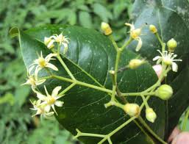

Figure 1. *Acronychia baueri* (adapted from Wikipedia)

The aqueous extract from the bark of Acronychia baueri has been found to possess significant antitumor properties. This activity is attributed to the presence of alkaloids, including normelicopidine, melicopine, and acronycine, as well as the triterpene lupeol. Among these compounds, acronycine demonstrated the strongest antitumor effect (Svoboda *et al.,* 1996; Ohiagu *et al.,* 2021).

1. **Normelicopidine**



Figure 2. Normelicopidine (adapted from Wikipedia)

1. **Melicopine**

Melicopine is a naturally occurring compound classified within the acridone family and is the first acridone derivative known to exhibit locomotor activity. It has demonstrated antioxidant properties and the ability to inhibit transcription-polymerase chain reaction (PCR) in vitro (Veligeti *et al.,* 2020; Svoboda *et al.,* 1996). As an anticancer agent, melicopine has been shown to suppress the growth of cervical cancer cells, likely through the induction of apoptosis and inhibition of cell proliferation (Svoboda *et al.,* 1996). Additionally, it can inhibit the growth of plant cancer cells by triggering cell death via necrosis or apoptosis, depending on the administered dose. Melicopine’s cytotoxic effects extend beyond tumor cells, as it also exhibits toxicity against non-transformed cells, indicating its potential application in chemotherapy (Svoboda *et al.,* 1996).

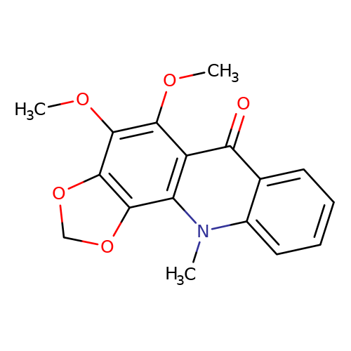

Figure 3. Melicopine (adapted from Wikipedia)

1. **Acronycine**

Acronycine is a natural alkaloid that is isolated from *Acronychia* *baueri* of the *Rutacaea* family (Nguyen *et al.,* 2009; Svoboda *et al.,* 1996). This molecule has an acridone skeleton fused with a dimethyl-2H-pyran ring.

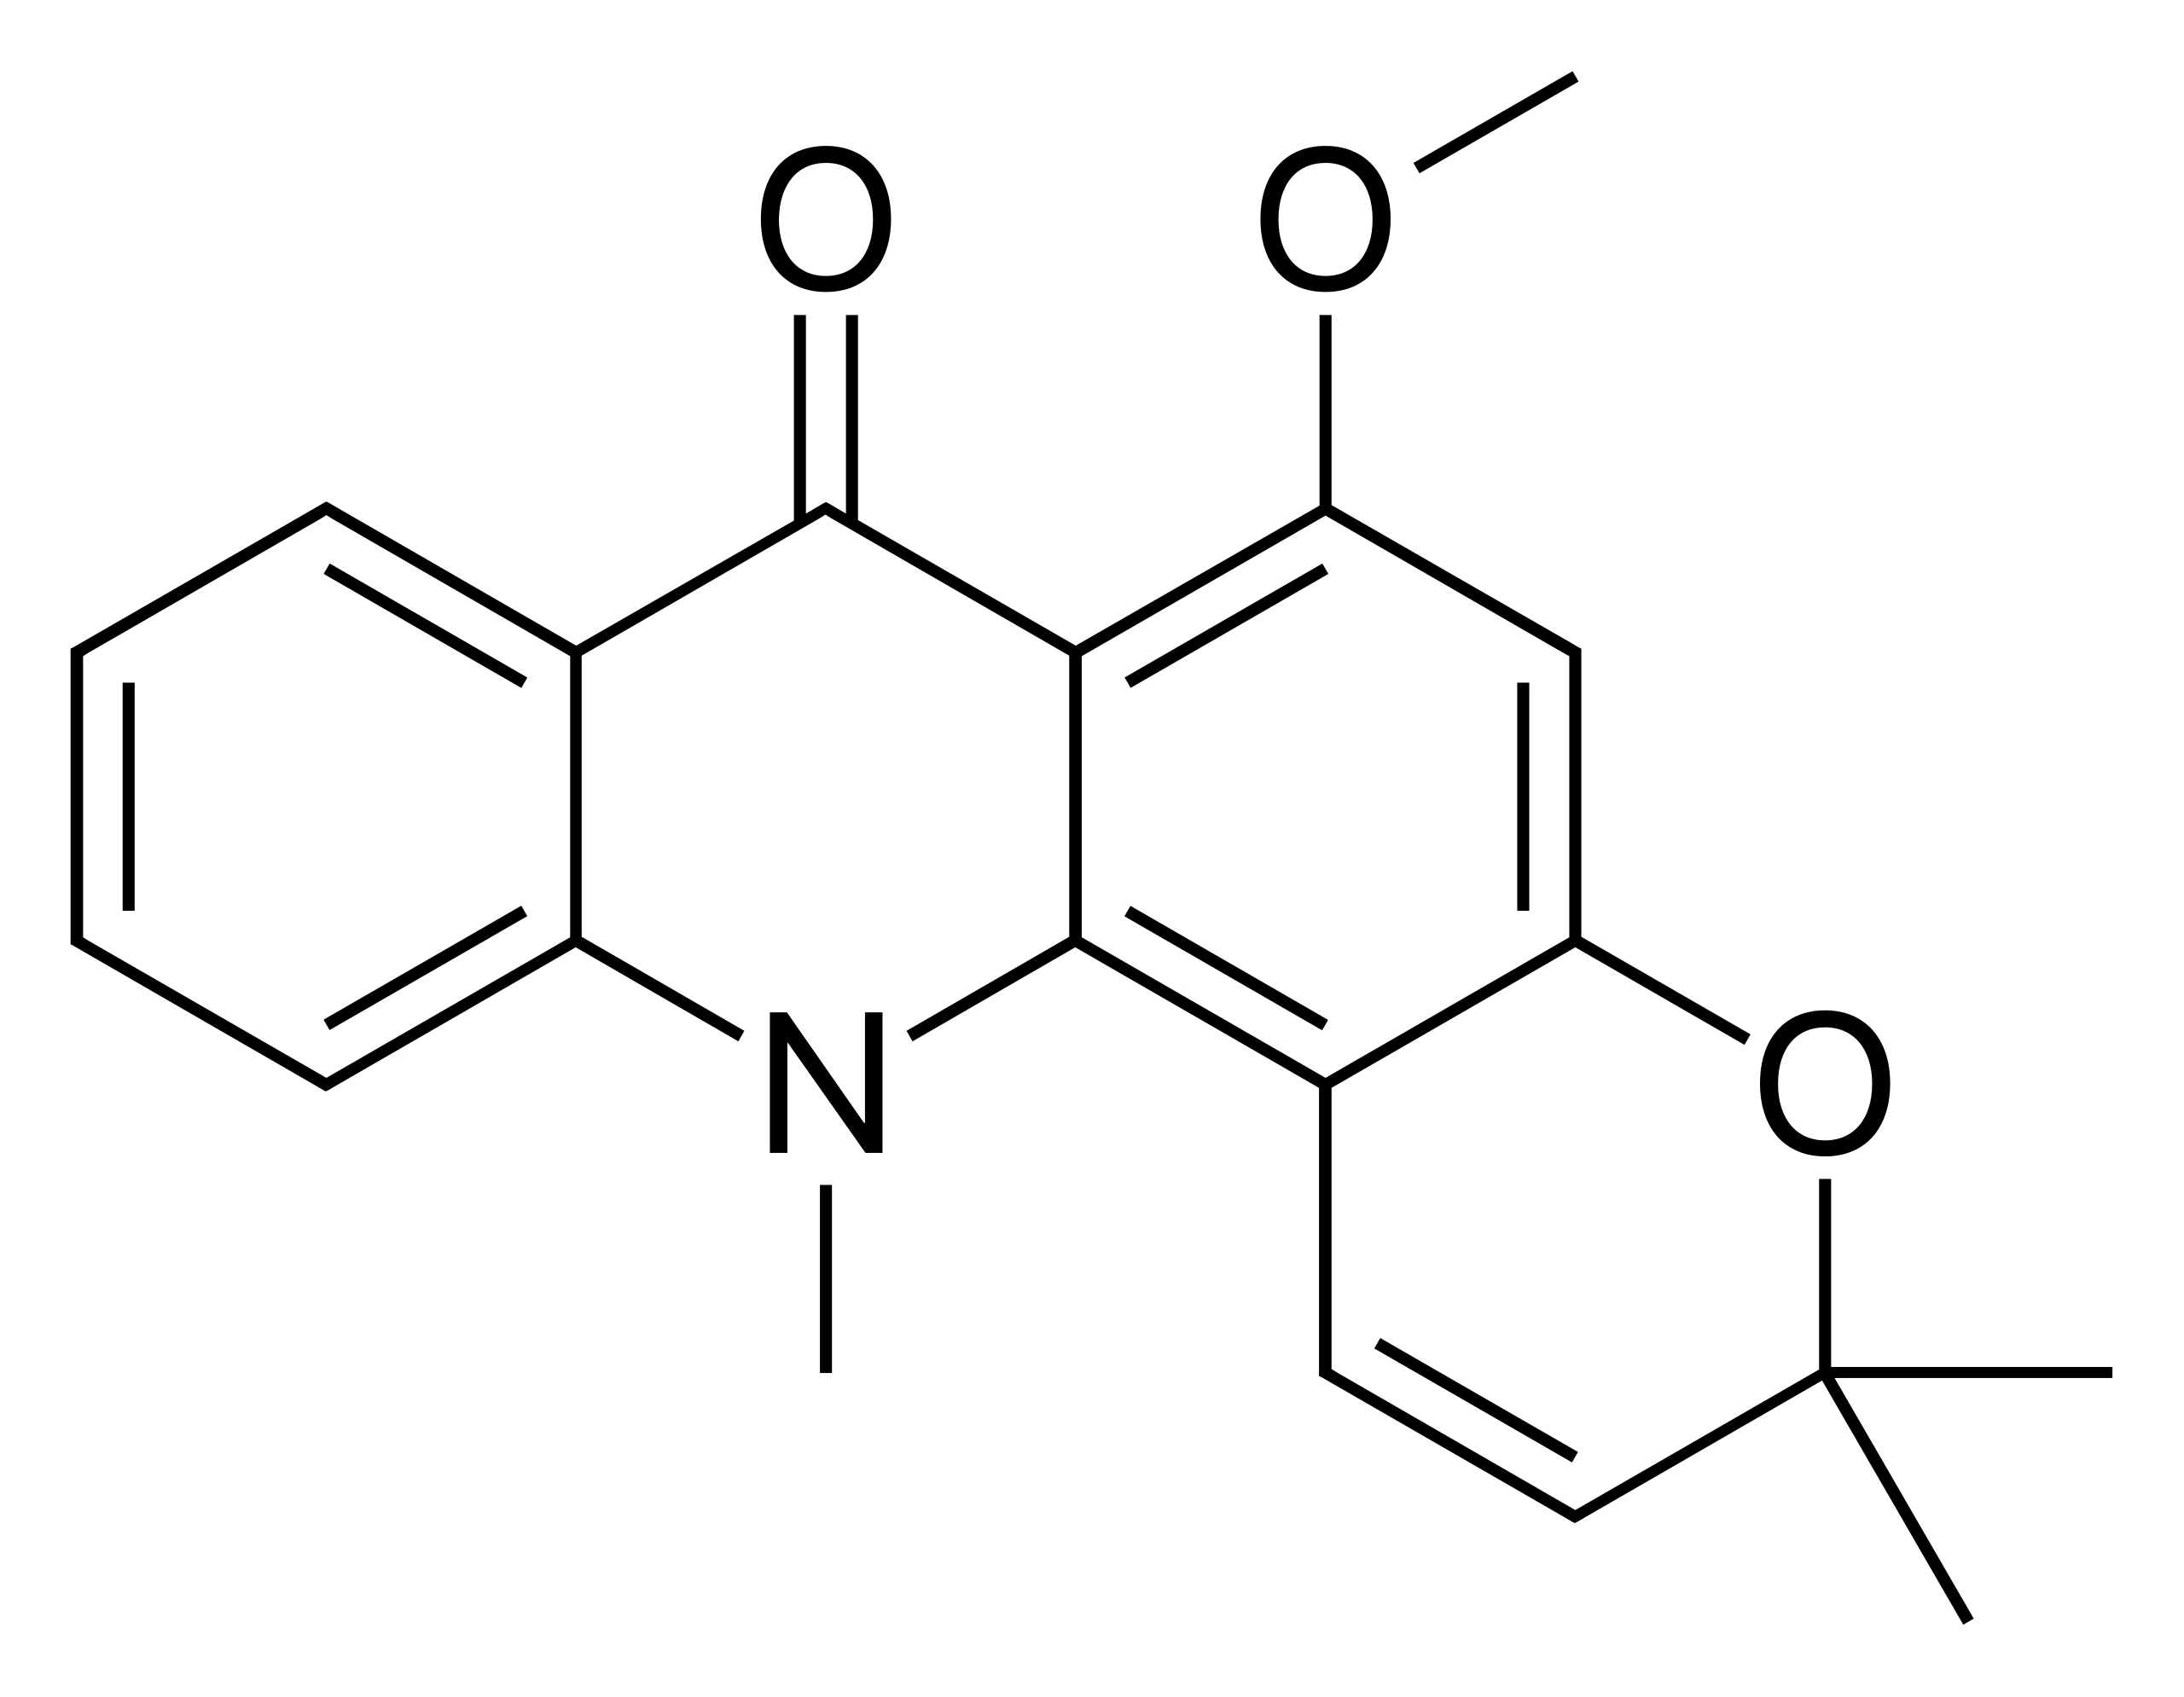

Figure 4. Acronycine (adapted from Wikipedia)

1. ***Ageratum conyzoides* (Goat weed)**

Ageratum conyzoides, commonly known as billygoat-weed, chickweed, goat weed, white weed, or mentrasto, is a plant species belonging to the Compositae family. It is native to tropical regions of the Americas, particularly Brazil, but has become an invasive weed in various parts of the world, including West Africa. This herb typically grows to a height of 0.5 to 1 meter, with ovate leaves measuring 2 to 6 cm in length. Its flowers range in color from white to mauve (Chahal *et al.,* 2021).

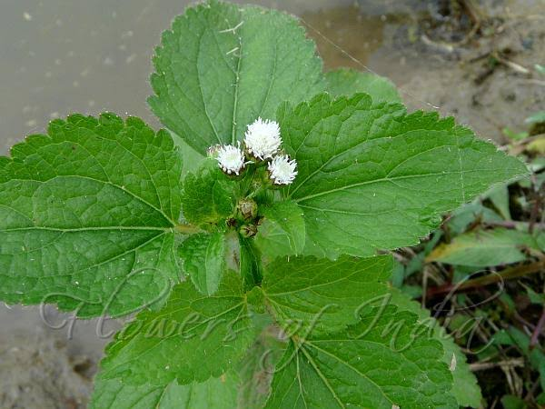

Figure 5. *Agaretum conyzoides* (adapted from Wikipedia)

*Ageratum conyzoides,* mostly known as goat weed is given different names in various communities in Nigeria. The Yorubas call it Imiesu; Igbo, Ula ujula; Hausa, Ahenhen and Igedes, Ufuopioko (Adebayo *et al.,* 2010).

The cytotoxicity of ethylacetate extract of *A. conyzoides* on A549 (lung carcinoma) and P388 (leukemia) cell lines in humans and mouse, respectively, has been reported (Adebayo *et al.,* 2010). The leaf extract of *A. conyzoides* also inhibited the proliferation of SF-767, LNCaP, PC-3, and SF-763 cancer cell lines (Bayala *et al.,* 2014). The anticancer effect of the leaf extract of *A. conyzoides* was reported to be as a result of the presence of the anticancer compounds: kaempferol, oxygenated terpenes, Sesquiterpene, lactone-Santonin, and monoterpene hydrocarbons whereby kaempferol exhibited the highest anticancer activity (Ohiagu *et al.,* 2021; Adebayo *et al.,* 2010; Bayala *et al.,* 2014).

1. **Kaempferol**

Kaempferol (3,4′,5,7-tetrahydroxyflavone) is a natural flavonol, a type of flavonoid, found in a variety of plants and plant-derived foods including kale, beans, tea, spinach, and broccoli (Holland *et al.,* 2020). Kaempferol is a yellow crystalline solid with a melting point of 276–278 °C (529–532 °F) (Bayala *et al.,* 2014).

Many studies have described the beneficial effects of dietary kaempferol in reducing the risk of chronic diseases, especially cancer (Bayala *et al.,* 2014). Epidemiological studies have shown an inverse relationship between kaempferol intake and cancer (Bayala *et al.,* 2014). Kaempferol may help by augmenting the body’s antioxidant defense against free radicals, which promote the development of cancer. At the molecular level, kaempferol has been reported to modulate a number of key elements in cellular signal transduction pathways linked to apoptosis, angiogenesis, inflammation, and metastasis. Significantly, kaempferol inhibits cancer cell growth and angiognesis and induces cancer cell apoptosis, but on the other hand, kaempferol appears to preserve normal cell viability, in some cases exerting a protective effect (Bayala *et al.,* 2014).

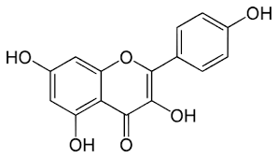

Figure 6. . Kaempferol (adapted from Wikipedia)

1. **Sesquiterpenes**

Sesquiterpenes are C15-terpenoids built from three isoprene units. They are found particularly in higher plants and in many other living systems such as marine organisms and fungi. Naturally, they occur as hydrocarbons or in oxygenated forms including lactones, alcohols, acids, aldehydes, and ketones (Proshkina *et al.,* 2020).

1. **Santonin**

Santonin is a naturally occurring sesquiterpene lactone, santonin exerts anticancer effects in multi-drug resistant breast cancer cells by inducing mitochondrial mediated apoptosis, caspase activation, cell cycle arrest, and by targeting Ras/Raf/MEK/ERK signaling pathway (Bayala *et al.,* 2014)

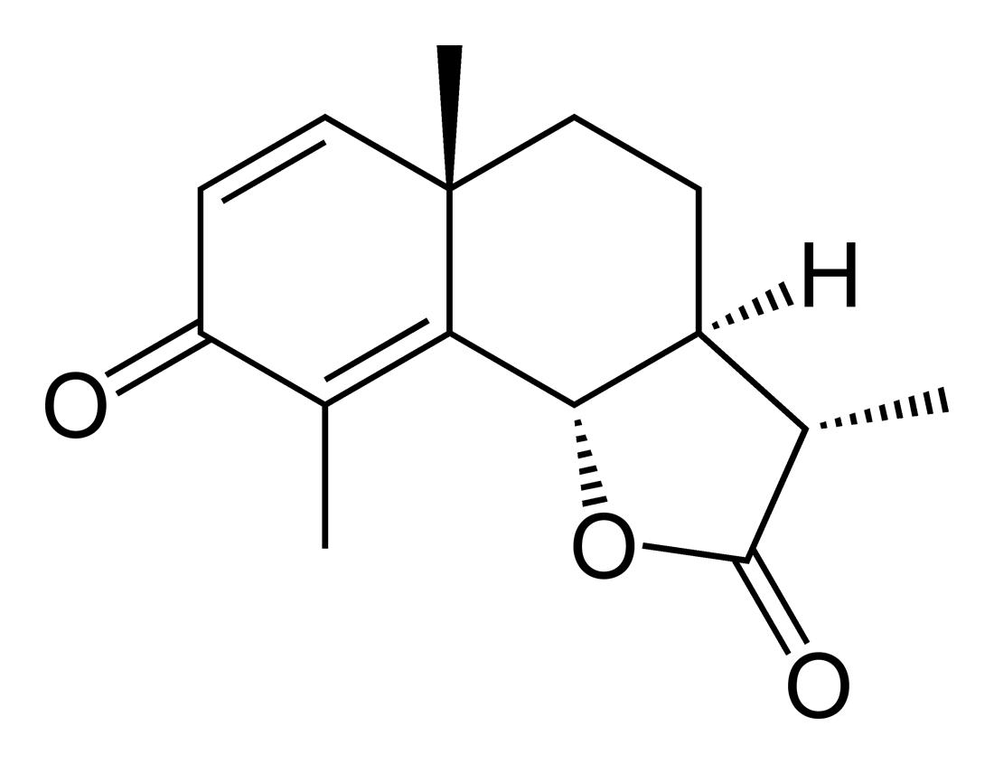

Figure 7. Santonin (adapted from Wikipedia)

1. ***Alchornea cordifolia* (Christmas bush)**

*Alchornea cordifolia* is a shrub or small tree of the *Euphorbiaceae* family, distributed throughout tropical Africa. It can grow up to 8 metres tall. The plant is used in traditional African medicine (Kuete *et al.,* 2016). Common name is the Christmas bush. It is called oje in Ebira-Etuno; uwonmwe in Edo; mbom in Efik; tahi in Gwari; bambani or bombana in Hausa; ubebe or ububo in Igbo; ipain in Ijaw; ukpaoromi in Yekhee; and epa or ipan-esin in Yoruba.

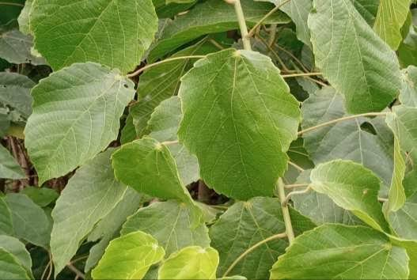

Figure 8. *Alchornea cordifolia* (adapted from Wikipedia)

The methanolic leaf extract of *Ageratum cordifolia* has been shown to induce cell death by activating caspases, disrupting the mitochondrial membrane, and promoting the generation of reactive oxygen species (ROS) in adriamycin-sensitive leukemia (CCRF-CEM) cells (Adaze *et al.,* 2020). Similarly, the methanolic bark extract of *A. cordifolia* has also been reported to exhibit harmful effects on CCRF-CEM cells (Kuete *et al.,* 2016). Several bioactive compounds with potential anticancer properties have been identified in *A. cordifolia,* including kaempferol (a flavonoid), saponins, cardiac glycosides, steroids, anthraquinones, terpenes, xanthones, alkaloids, and tanflavonoids.

1. ***Allium sativum* (Garlic)**

“Garlic (*Allium sativum*) is a species of bulbous flowering plant in the genus Allium which belongs to the *Amaryllidaceae* family. Its close relatives include the onion, shallot, leek, chive, (Block, 2010). Welsh onion, and Chinese onion” (Adaki *et al.,* 2014; Petrovic *et al.,* 2018). “It is native to Africa, South Asia, Central Asia and Northeastern Iran and has long been used as a seasoning worldwide, with a history of several thousand years of human consumption and use” (Block, 2010). It was known to ancient Egyptians and has been used as both food flavoring and a traditional medicine.

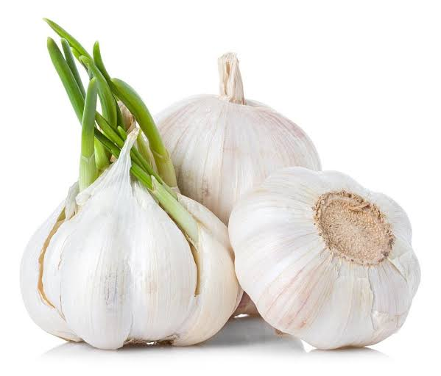

Figure 9. *Allium sativum* (adapted from Wikipedia)

*A. sativum L.*, also known as garlic, is a rich source of **S-allylcysteine** and **S-allylmercapto-L-cysteine.** “These bioactive compounds are known to exhibit high radical scavenging activity, which is essential in the inhibition of cancer development. S-allylcysteine also retarded tumor growth” (Holland *et al.,* 2020). “Additionally, *A. sativum* repressed the proliferations of skin, colon, lung, prostate, leukemia, and breast cancer cells in vitro” (Adaki *et al.,* 2014; Petrovic *et al.,* 2018).

1. **S-allylcysteine**

“S-Allylcysteine is an organosulfur compound that is a constituent of fresh garlic. It is a derivative of the amino acid cysteine in which an allyl group replaces the proton on Sulfur” (Adaki *et al.,* 2014; Petrovic *et al.,* 2018).

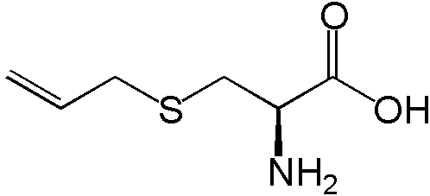

Figure 10. S-allylcysteine(adapted from Wikipedia

1. **S-allylmercapto-L-cysteine.**



Figure 11. S-allylmercapto-L-cysteine (adapted from Wikipedia)

1. ***Aloe barbadensis* (Aloe vera)**

Aloe vera is a succulent plant species of the genus *Aloe,* in the *Asphodelaceae* family (Padmaharish and Lakshmi, 2017). “It is widely distributed, and is considered an invasive species in many world regions. Aloe vera is an evergreen perennial plant; it originates from the Arabian Peninsula, but grows wild in tropical, semi-tropical, and arid climates around the World” (Kerr *et al.,* 1972). “It is cultivated for commercial products, mainly as a topical treatment used over centuries” (Padmaharish and Lakshmi 2017; Kerr *et al.,* 1972). “The specie is attractive for decorative purposes, and succeeds indoors as a potted plant” (Kerr *et al.,* 1972).

“The leaves of Aloe vera contain significant amounts of the polysaccharide gel acemannan which can be used for a wide range of medical purposes” (Padmaharish and Lakshmi, 2017). The skin contains aloin which is toxic. Products made from Aloe vera usually only use the plants gel.

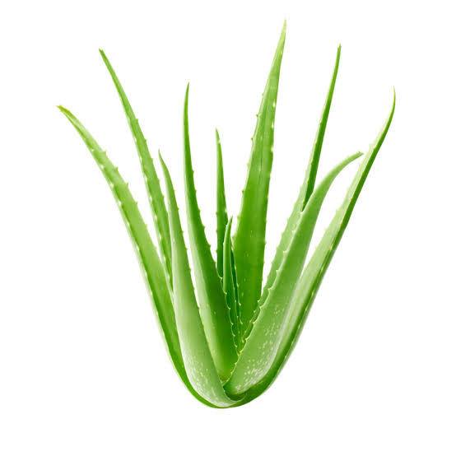

Figure 12. *Aloe barbadensis* (adapted from Wikipedia)

“Ethanol extract of *A. barbadensis* (Aloe vera) exhibited antitumor activities through the modulation of lipid peroxidation and stimulation of the antioxidant defense system in mice” (Ohiagu *et al.,* 2021; Padmaharish and Lakshmi, 2017; Kerr *et al.,* 1972). “The anticancer activity of *A. barbadensis* was attributed to aloe-emodin, which was identified in leaf extract of the plant. This bioactive compound exhibited cytotoxicity in hepatoma cell and neuroectodermal tumors, as well as lung squamous cell carcinoma” (Kerr *et al.,* 1972). The cytotoxicity of *A. barbadensis* against HepG2 and HCC cancer cell lines has also been reported by Padmaharish and Lakshmi (2017).

1. **Aloe emodin**

“Aloe emodin is a dihydroxyanthraquinone that is chrysazin carrying a hydroxymethyl group at position 3. It has been isolated from plant species of the genus Aloe. It has a role as an antineoplastic agent and a plant metabolite” (Chiang *et al.,* 2012; Badgwell *et al.,* 2004). “It is a dihydroxyanthraquinone and an aromatic primary alcohol. It is functionally related to a chrysazin” (Badgwell *et al.,* 2004).

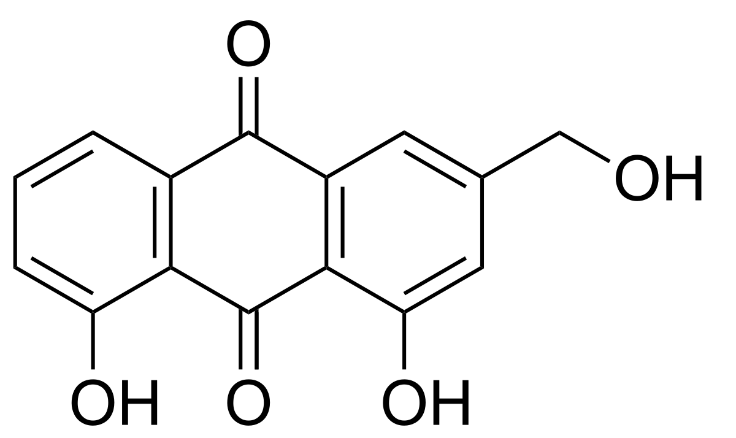

Figure 13. Aloe emodin (adapted from Wikipedia)

1. ***Alstonia boonei***

*“Alstonia boonei* is a very large, deciduous, tropical-forest tree belonging to the *Dogbane* Family *Apocynaceae*. It is native to tropical West Africa, with a range extending into Ethiopia and Tanzania. Its common name in the English timber trade is cheese wood, pattern wood or stool wood” (Ojewole, 1984).

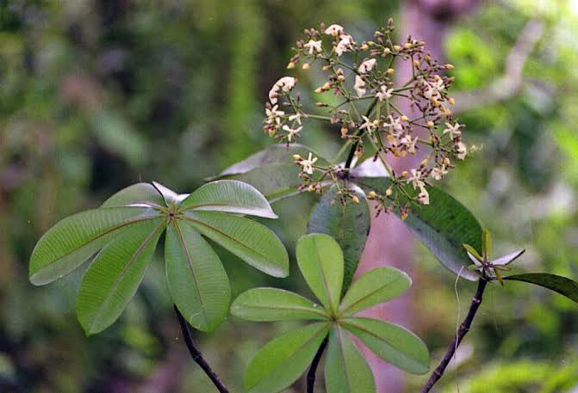

Figure 14. *Alstonia boonei* (adapted from Wikipedia)

“The methanol and n-hexane stem-bark extracts of *A. boonei* have been established to be cytotoxic to cancer cells” (Balogun *et al.,* 2016). “The bioactive compound, echitamine, present in the stem-bark of *A. boonei* hindered the development and caused the extermination of fibrosarcoma in rat models” (Ohiagu *et al.,* 2021; Ojewole, 1984). “Two bioactive compounds, namely, eugenol and 1, 2-benzenedicarboxylic acid (Phthalic acid) isolated from the leaf and root, respectively, of *A. boonei* suppressed the proliferation of MiaPaCa (pancreas), A549 (lung), PC-3 (prostate), and HCT-116 (colon) cancer cell lines” (Jaganathan and Supriyanto, 2012). “Alstiboonine is another bioactive compound from stem-bark of *A. boonei* that has been noted to exhibit deleterious effects on cancer cells” (Balogun *et al.,* 2016).

1. **Eugenol**

“Eugenol is an allyl chain-substituted guaiacol, a member of the allylbenzene class of chemical compounds” (Jaganathan and Supriyanto, 2012). “It is a colorless to pale yellow, aromatic oily liquid extracted from certain essential oils especially from clove, nutmeg, cinnamon, basil and bay leaf” (NCBI, 2025).

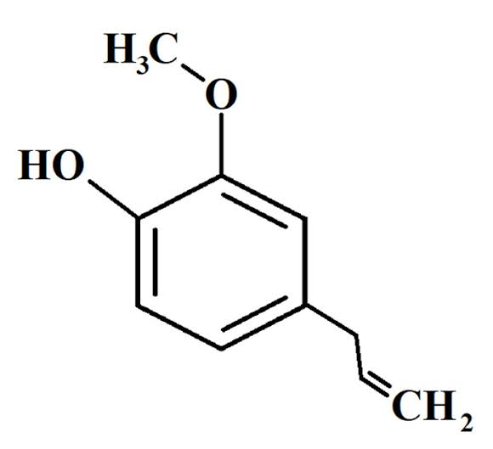

Figure 15. Eugenol (adapted from Wikipedia)

1. **Phthalic acid**

“Phthalic acid is an aromatic dicarboxylic acid , with formula C6H4(CO2H)2. Although phthalic acid is of modest commercial importance, the closely related derivative phthalic anhydride is a commodity chemical produced on a large scale” (Lorz *et al.,* 2007). “Phthalic acid is one of three isomers of benzenedicarboxylic acid, the others being isophthalic acid and terephthalic acid” (Bang *et al.,* 2011).

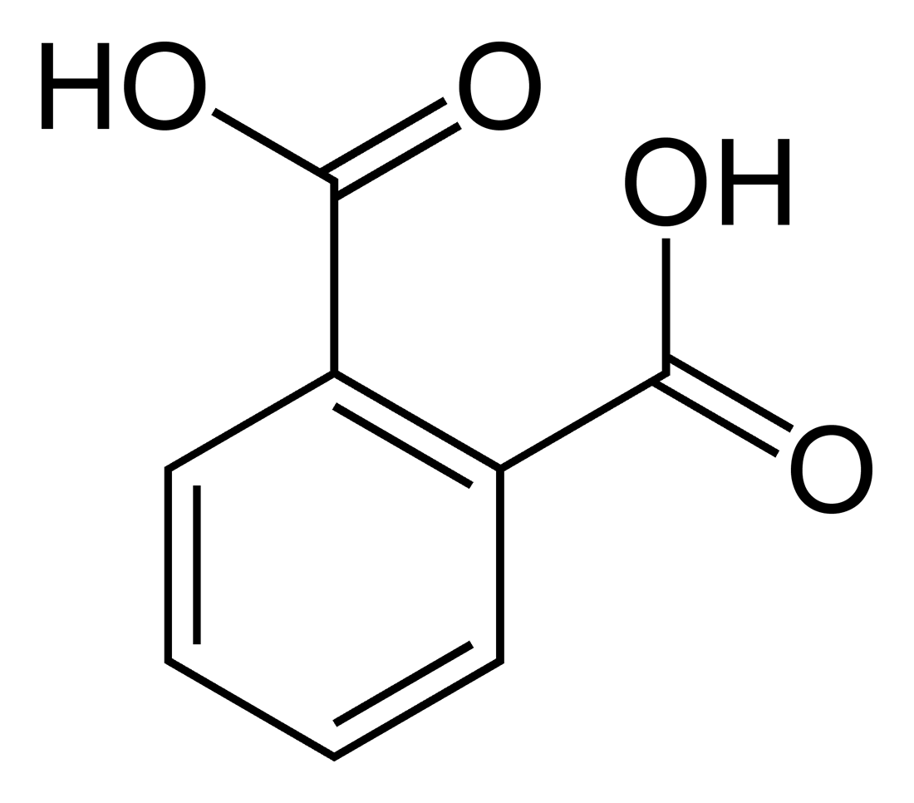

Figure 16. Phthalic acid (adapted from Wikipedia)

1. **Alstonine**

“Alstonine is an indoloquinolizidine alkaloid and putative antipsychotic constituent of various plant species including *Alstonia* *boonei*, *Catharanthus* *roseus*, *Picralima* *nitida, Rauwolfia caffra* and *Rauwolfia vomitoria”* (Emelia *et al.,* 2020; Elisabetsky *et al.,* 2006).

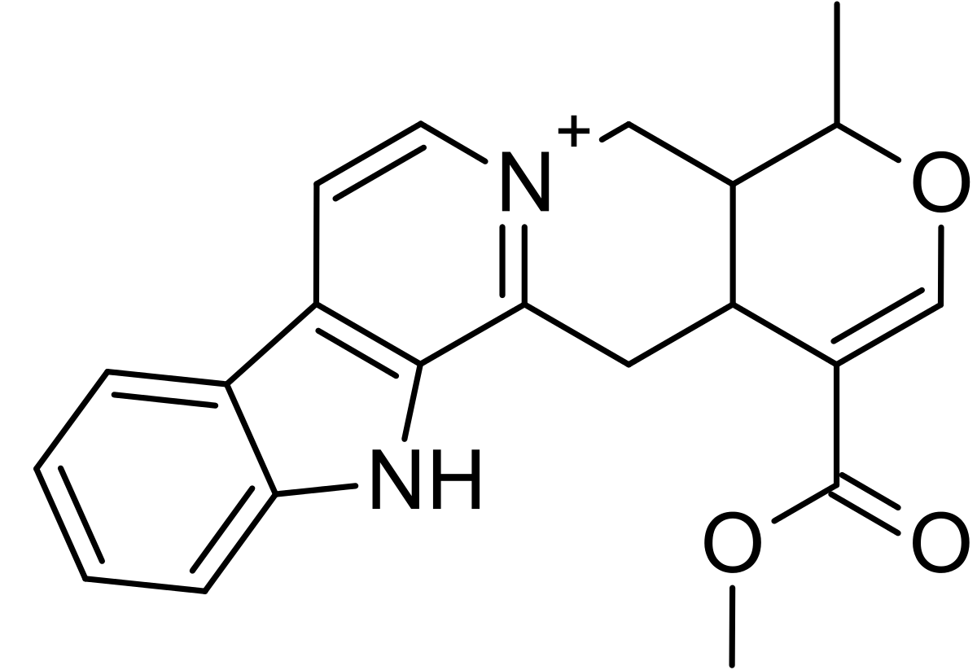

Figure 17. Alstonine (adapted from Wikipedia)

1. ***Anacardium occidentale* (Cashew)**

“The cashew tree (*Anacardium occidentale*) is a tropical evergreen tree native to South America in the genus *Anacardium* of the *Anacardiaceae* family; it produces the cashew seed and the cashew apple accessory fruit” (Morton, 1987). “The tree can grow as tall as 14 metres (46 feet), but the dwarf cultivars, growing up to 6 m (20 ft), prove more profitable, with earlier maturity and greater yields. The cashew seed is commonly considered a snack nut (cashew nut) eaten on its own, used in recipes, or processed into cashew cheese or cashew butter” (James, 1983). “Like the tree, the nut is often simply called a cashew. Cashew allergies are triggered by the proteins found in tree nuts, and cooking often does not remove or change these proteins” (James, 1983).

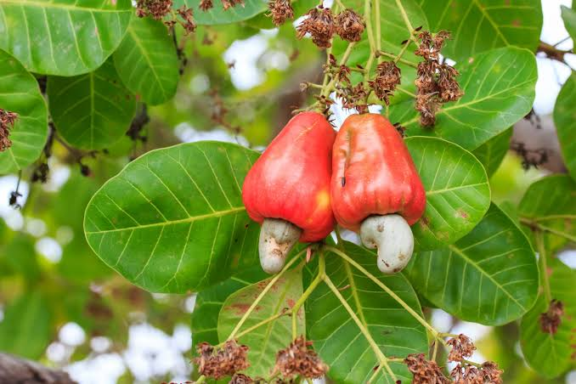

Figure 18. *Anacardium occidentale* (adapted from Wikipedia)

“Hydroethanolic leaf extract of *A. occidentale* has shown cytotoxicity against leukemia cells. The leaf of this medicinal plant inhibited the proliferation of leukemic cancer cells and was slightly cytotoxic to the cell lines: Hep-2 (laryngeal cancer), HL-60 (leukemia), and Raji (Burkitt lymphoma). These anticancer activities were attributed to the presence of agathisflavone in the hydroethanolic leaf extract of *A. occidentale”* (Konan *et al.,* 2012). According to Taiwo *et al.,* (2017), methyl gallate, anacardicin, zoapatanolide A, and agathisflavone exhibited cytotoxicity against HeLa (cervical cancer) cells. Furthermore, Obembe and Ige (2016) noted that the stem-bark and leaves extract of *A. occidentale* are rich sources of the anticancer compounds such as tannins, alkaloids, saponins and polyphenols.

1. **Agathisflavone**

“Agathisflavone is a natural biflavone with restricted occurrence in plants. This biflavone presents several biological activities and can be important to developing new drugs” (Konan *et al.,* 2012).

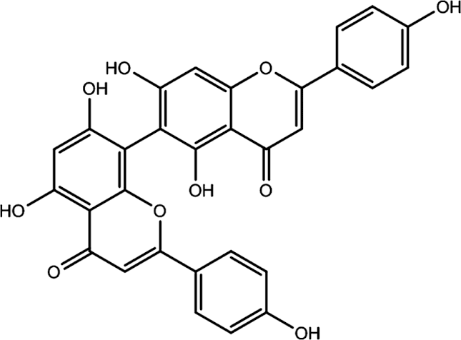

Figure 19. Agathisflavone (adapted from Wikipedia)

1. **Methyl Gallate**

“Methyl gallate is a phenolic compound. It is the methyl ester of gallic acid. It is found in *Anacardium occidentale, Terminalia myriocarpa, Bergenia ciliata* (hairy Bergenia) *and Geranium niveum*. It is found in the fruit extract of *Paeonia anomala*. It is also found in wine” (Taiwo *et al.,* 2017).



Figure 20. Methyl gallate (adapted from Wikipedia)

1. **Anacardicin**



Figure 21. Anacardicin (adapted from Wikipedia)

1. **Zoapatanolide A**

Zoapatanolide A is a compound obtained from the leaves of *Montanoa tomentosa and Anacardium occidentale*. It is a heliangolide sesquiterpene lactone (Quijano *et al.,* 1982).

1. ***Anogeissus leiocarpa***

*“Anogeissus leiocarpa* is a tall deciduous tree in the family of *Combretaceae*, native to the savannas of tropical Africa” (Steentoft, 1988). “It is the sole West African species of the genus *Anogeissus*, a genus otherwise distributed from tropical central and east Africa through tropical Southeast Asia” (Steentoft, 1988).

*Anogeissus leiocarpa* germinates in the new soils produced by seasonal wetlands. It is a forest fringe plant, growing at the edges of the rainforest, although not deep in the rainforest. It also grows in savanna, and along riverbanks, where it forms gallery forests. The tree flowers in the rainy season, from June to October. The fruit are winged samaras, and are dispersed by ants.

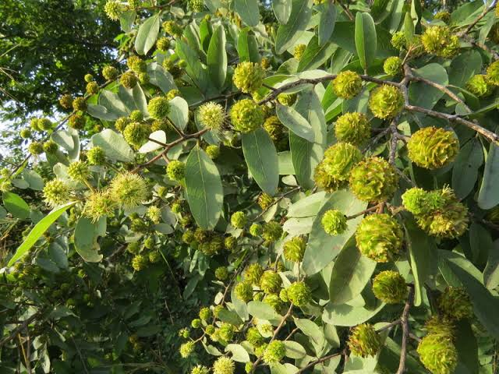

Figure 22. *Anogeissus leiocarpa* (adapted from Wikipedia)

The inhibition of cancer cell proliferation by leaf and root extracts of *A. leiocarpus* have been reported by Olugbami *et al.*, (2017) and Salau *et al.,* (2013) respectively. “The ethanolic leaf extract of *A. leiocarpus* hindered the proliferation of liver carcinoma HepG2 cell lines” (Olugbami *et al.,* 2017), “whereas the root extract hindered Ehrlich ascites carcinoma cell lines” (Salau *et al.,* 2013). “Ellagic acid, castalagin, and flavogallonic acid are bioactive compounds known for their cancer cell proliferation inhibitory activity and have been isolated from *A. leiocarpus”* (Seeram *et al.,* 2005; Shuaibu *et al.,* 2008; Fernandes *et al.,* 2009)

1. **Ellagic acid**

“Ellagic acid is a polyphenol found in numerous fruits and vegetables. It is the dilactone of hexahydroxydiphenic acid. Ellagic acid occurs largely as ellagitannins in woody dicotyledon plants such as grapes, nuts, strawberries, black currents, raspberries, strawberries, cranberries, walnuts, pecans, pomegranates, wolfberry, and other plant foods, it is one of the well-studied phytochemicals” (Sharifi-Rad *et al.,* 2024). “It possesses antioxidant, antimutagenic, and anticancer properties” (Seeram *et al.,* 2005).

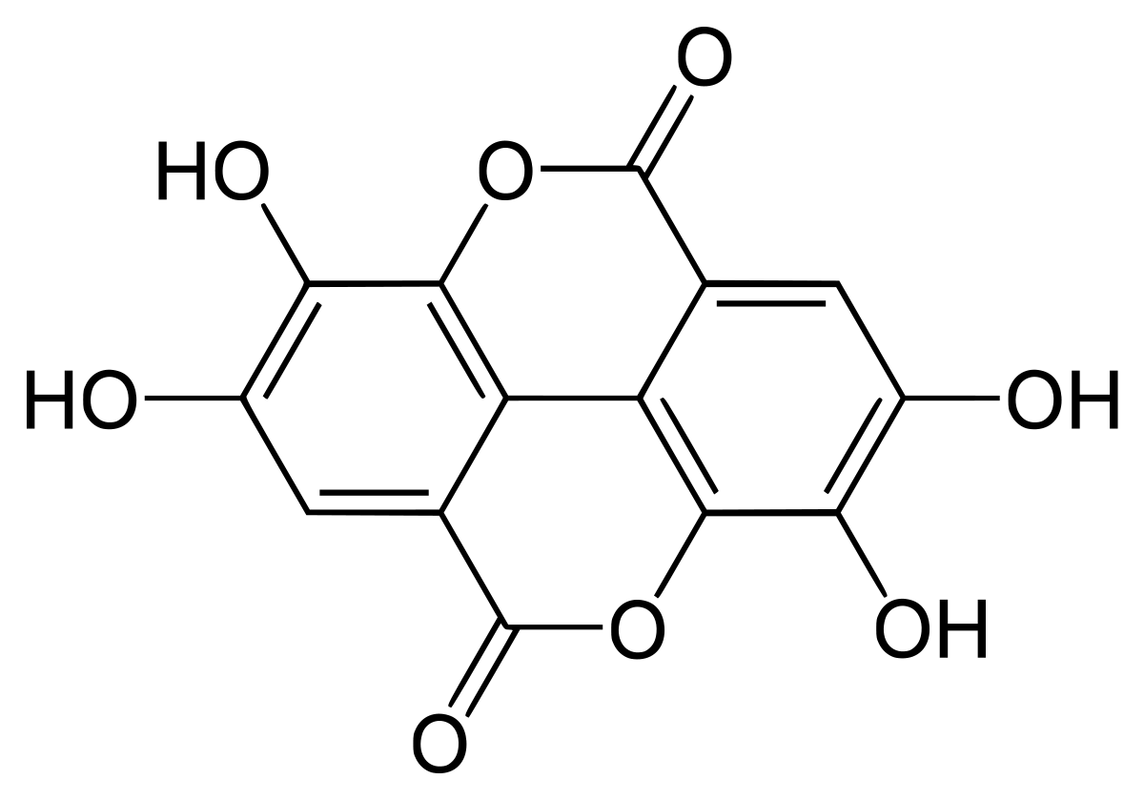

Figure 23. Ellagic acid (adapted from Wikipedia)

1. **Castalagin**

“Castalagin is an ellagitannin , a type of hydrolyzable tannin, found in oak and chestnut wood and in the stem barks of *Anogeissus leiocarpus* and *Terminalia avicennoides”* (Žitek-Makoter *et al.,* 2024).

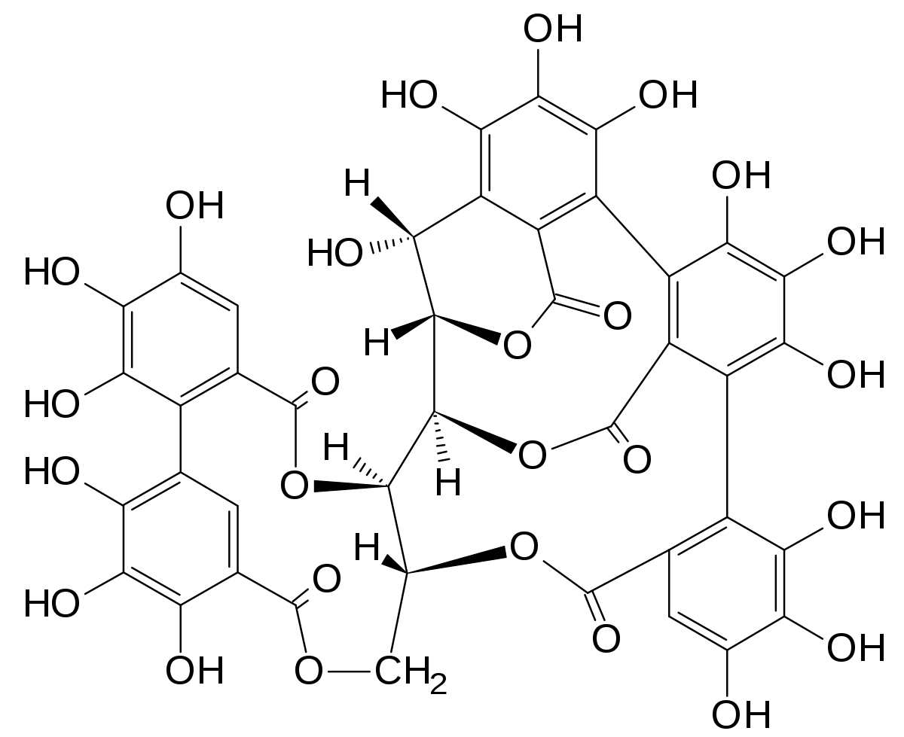

Figure 24. Castalagin (adapted from Wikipedia)

1. **Flavogallonic acid**

“Flavogallonic acid is a hydrolysable tannin that can be found in *Anogeissus leiocarpus,* valonea oak (*Quercus macrolepis*) in chestnut wood or in *Terminalia myriocarpa”* (Motto *et al.,* 2021).

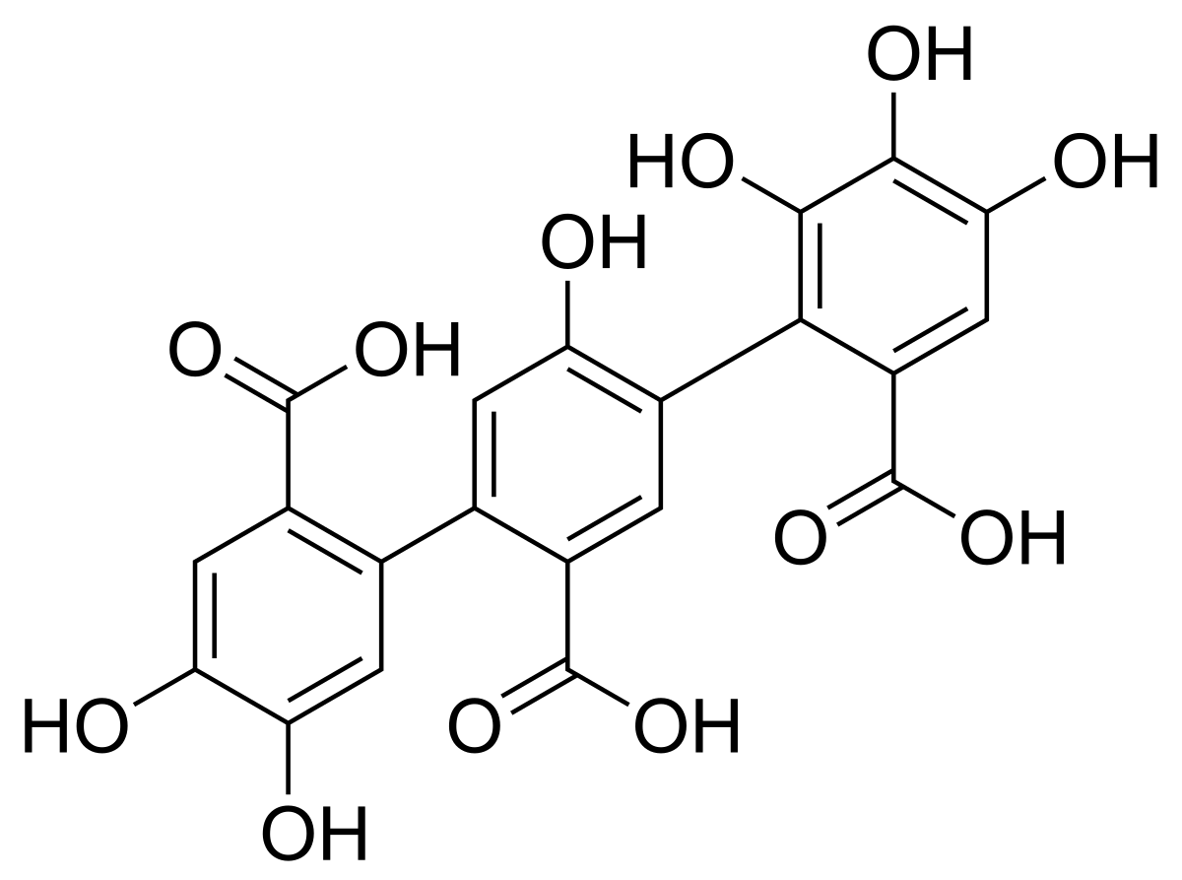

Figure 25. Flavogallonic acid (adapted from Wikipedia)

1. ***Astragalus membranaceus***

*“Astragalus mongholicus,* synonyms including *Astragalus propinquus* and *Astragalus membranaceus*, is a flowering plant in the family *Fabaceae* . It is one of the 50 fundamental herbs used in traditional Mongolian medicine. It is a perennial plant and it is not listed as being threatened” (Hou *et al.,* 2024).

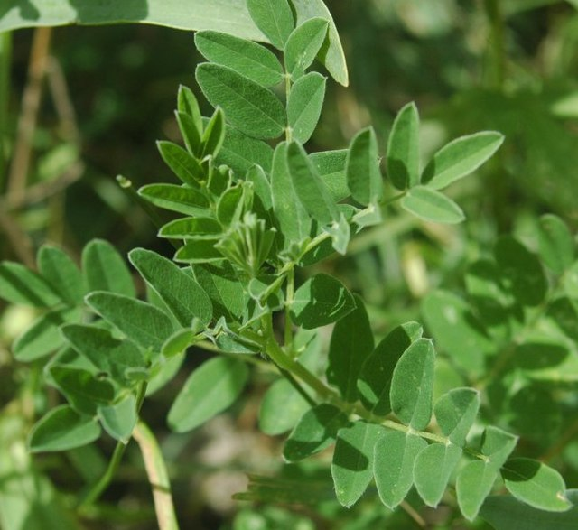

Figure 26. *Astragalus* *membranaceus* (adapted from Wikipedia)

“Root extract of *A. membranaceus* exhibited antitumor activity in vitro and in vivo through its cytostatic activity in myeloid and macrophage-like tumors. This plant also repressed syngeneic tumor development. The potency of root extracts of *A. membranaceus* to restore the functionality of T cells in cancer patients has been ascertained and reported” (William and Kwok, 2007). “*A. membranaceus* inhibited the proliferation and induced the apoptosis of breast cancer cell lines (MDA-MB-231, MCF-7, and SK-BR-3). The bioactive compounds, namely, isoflavones, calycosin, ononin, formononetin, and campanulin, have been isolated from *A. membranaceus* and established to be potent anticancer agents” (Hou *et al.,* 2024).

1. **Calycosin**

“Calycosin is an O-methylated isoflavone. It can be isolated from *Astragalus membranaceus/mongholicus* and *Trifolium pratense* L. (red clover)” (Sheik *et al.,* 2023).

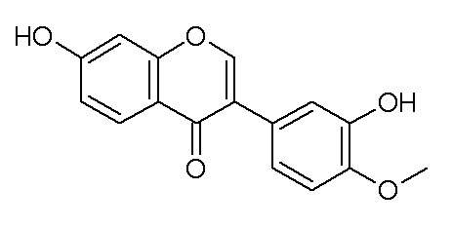

Figure 27. Calycosin

**Ononin**

“Ononin is an isoflavone glycoside, the 7-O-β-D- glucopyranoside of formononetin, which in turn is the 4'-O-methoxy derivative of the parent isoflavone daidzein” (You-Ping, 1998).

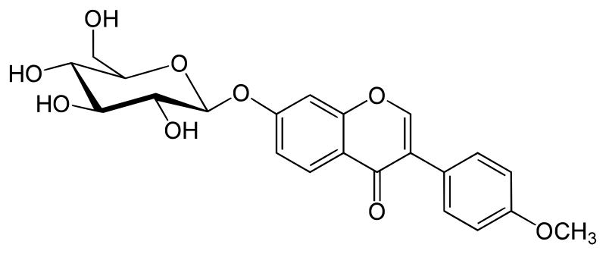

Figure 28. Ononin

1. **Formononetin**

Formononetin is an O-methylated isoflavone (Singh *et al.,* 2024).

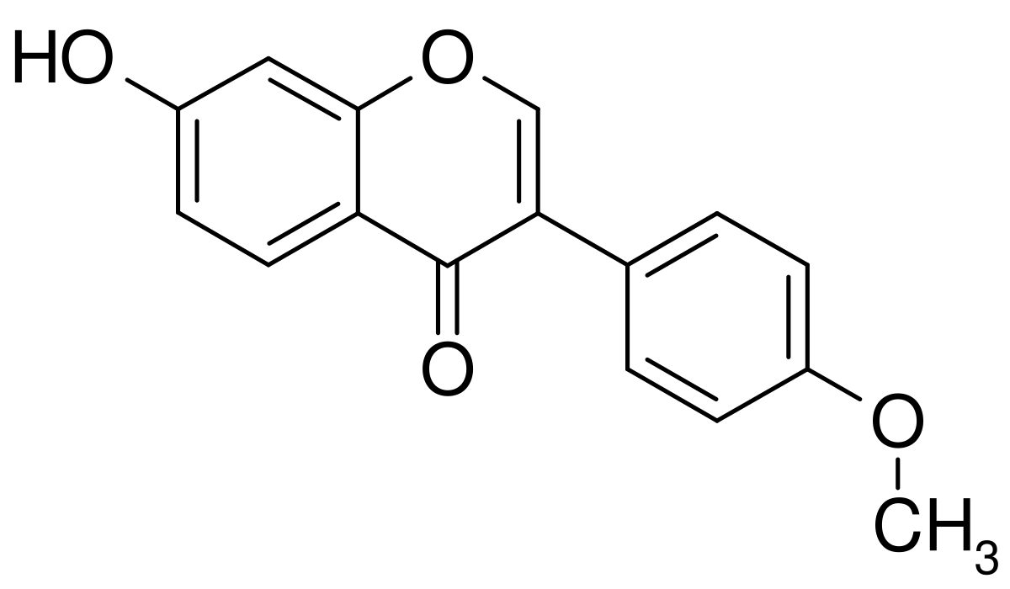

Figure 29. Formononetin

1. **Campanulin**

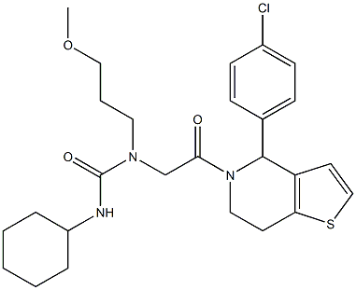

Figure 30. Campanulin

***Cajanus cajan* (Pigeon pea)**

“The pigeon pea (*Cajanus cajan*) is a perennial legume from the family *Fabaceae* native to the Old World. The pigeon pea is widely cultivated in tropical and semitropical regions around the world, being commonly consumed in South Asia, Southeast Asia, Africa, Latin America and the Caribbean” (Kingwell-Banham *et al.,* 2014).

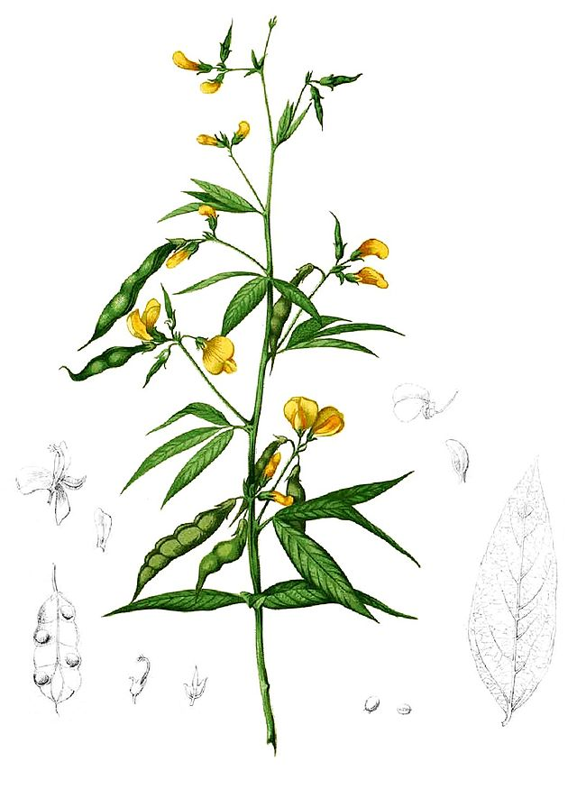

Figure 31. *Cajanus cajan* (adapted from Wikipedia)

“The ethanolic leaf extract of *C. cajan* repressed CaCo-2 (colorectal), MCF-7 (breast), and HeLa (cervical) cancer cell lines” (Schuster *et al.,* 2016). “The bioactive compounds, longistylin C, and longistylin A, from *C. cajan* inhibited the proliferation of A549 (lung), CCRF-CEM, Ehrlich’s ascites carcinoma, and HepG2 cancer cell lines” (Ashidi *et al.,* 2010). “Other bioactive compounds from *C. cajan* with promising anticancer activity include the stilbenoids and flavonoids” (Pal *et al.,* 2011).

1. **Longistylin A**

“Longistylin A (LLA) is an abundant stilbene isolated from the leaves of *Cajanus cajan* (Pigeon pea)” (Hou et al., 2024).

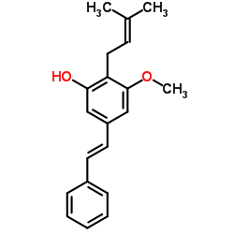

Figure 32. Longistylin A

1. **Longistylin C**

It is a stilbenoid. It is a natural product found in *Lonchocarpus acuminatus, Lonchocarpus chiricanus*, and *Cajanus cajan* (Emmanuel *et al.,* 2020)

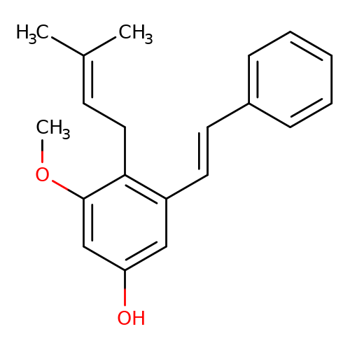

Figure 33. Longistylin C (adapted from Wikipedia)

1. ***Cryptolepis sanguinolenta***

*“Cryptolepis sanguinolenta* is a species of flowering plant in the family *Apocynaceae*. An extract from the root is traditionally used in West Africa for malaria treatment. The roots of *Cryptolepis sanguinolenta* contain a major alkaloid called cryptolepine. The roots are also used as a yellow dye” (Ansah, 2002).

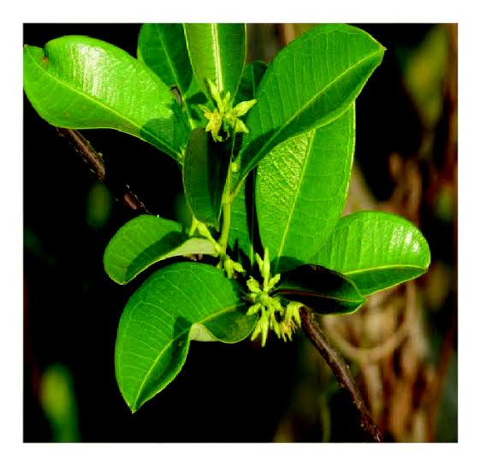

Figure 34. *Cryptolepis* *sanguinolenta* (adapted from Wikipedia)

“The aqueous root extract of *C. sanguinolenta* has shown potency to suppress V79 cell lines (lung fibroblast cells). This effect has been attributed to cryptolepine (an alkaloid), which vastly occurs in *C*. *sanguinolenta*. Cryptolepine acts by inhibiting the proliferation and viability of cancer cell lines including V79” (Kimbi and Fagbenro-Beyioku, 1996). “Other alkaloids with anticancer activity from *C. sanguinolenta* include ascryptolepinoic acid, quindoline, and methyl cryptolepinoate” (Paulo *et al.,* 2000).

1. **Cryptolepine**

“Cryptolepine is a monomeric heterocyclic indoloquinoline conjugate which is derived from *Cryptolepis sanguinolenta*, a plant known for its anti-malarial and anticancer activity” (Tudu *et al.,* 2023).

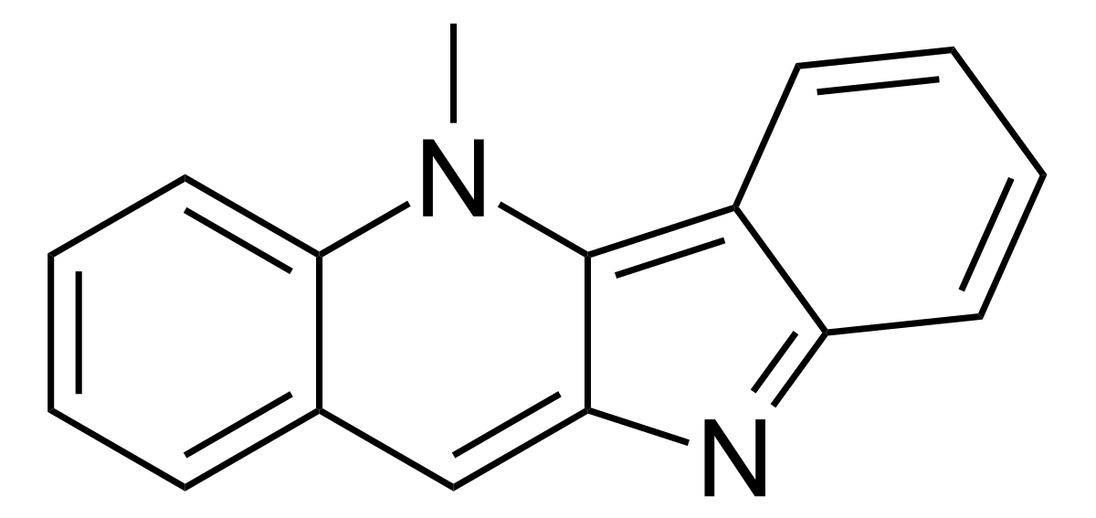

Figure 35. Cryptolepine

1. ***Derris scandens***

*“Derris scandens* is a plant species in the genus *Derris* of the family *Fabaceae*. It grows throughout the Indian subcontinent, Southeast Asia, Malesia and Australasia. It has been used as a herb in Thai traditional medicine for the treatment of musculoskeletal pain. Gastrointestinal symptoms were reported as the most serious side effects from its oral use” (Puttarak *et al.,* 2016).

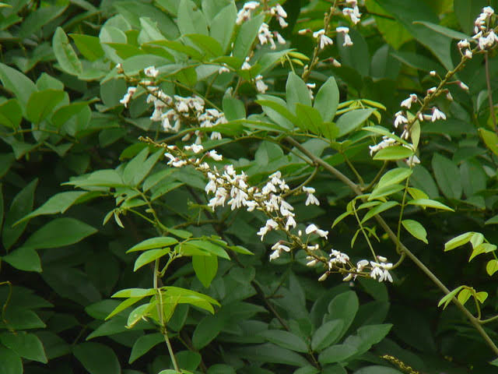

Figure 36. *Derris scandens* (adapted from Wikipedia)

“Ethanolic root extract of *D. scandens* was reported to repress human colon cancer HT29 cells in concert with radiosensitization. Furthermore, *D*. *scandens* provoked HT29 cells death through apoptosis and mitotic inhibition when augmented with γ-irradiation. *D. scandens* also acts by suppression of Erk1/2 activation” (Arunee *et al.,* 2014). “Certain isoflavones isolated from *D*. *scandens* with anticancer potentials include glyurallin, derriscandenon B and C, isochandaisone, and derrubone” (Ito *et al.,* 2020).

1. **Glyurallin**

“Glyurallin is a natural compound isolated from the roots of *Derris scandens*, *Glycyrrhiza aspera*, showing an antigenotoxic effect against carcinogenic N-methyl-N-nitrosourea (MNU)” (Sharifi-Rad *et al.,* 2024).

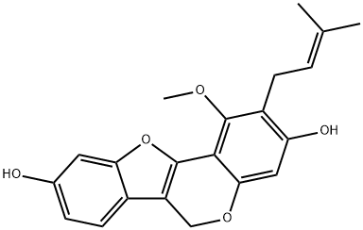

Figure 37. Glyurallin

1. ***Fagara zanthoxyloides***

*“Fagara zanthoxyloides* also known as (*Zanthoxylum zanthoxyloides*) is a plant species in the genus Zanthoxylum of the *Rutaceae* family. It is a much-branched tree with dense, dark-green foliage and abundant prickles. These prickles or thorns extend to the leaf stalks and the leaflets midribs. The leaves are elliptic, slightly obovate. The flowers are greenish-white in narrow axillary and terminal panicles usually without thorns. It is always in fruit between July and September each year” (Okagu *et al.,* 2021).

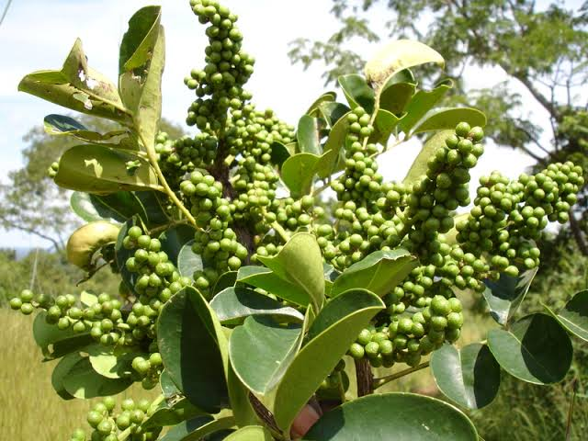

Figure 38. *Fagara zanthoxyloides* (adapted from Wikipedia)

“Root extract of *F. zanthoxyloides* is a rich source of fagaronine. This bioactive compound is cytotoxic to human leukemia. The aqueous root extract of *F. zanthoxyloides* reduced the viability and hindered the proliferation of the following prostate cancer cell lines: PC-3, CWR-22, LNCaP, and DU-145” (Pastorino *et al.,* 2018).

1. **Fagaronine**

“Fagaronine is a benzophenanthridine alkaloid found in *Zanthoxylum zanthoxyloides* and other species in the genus Zanthoxylum” (Dupont *et al.,* 2005).

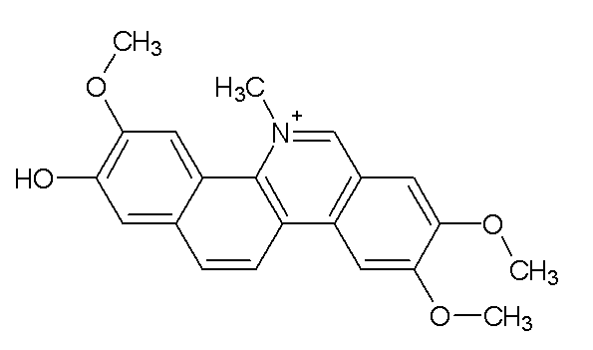

Figure 39. Fagaronine

1. ***Glycyrrhiza glabra* (Liquorice)**

“Liquorice (British English) or licorice is the common name of *Glycyrrhiza glabra*, a flowering plant of the bean family *Fabaceae*, from the root of which a sweet, aromatic flavouring is extracted. It is herbaceous perennial legume native to Western Asia, North Africa, and Southern Europe” (Pastorino *et al.,* 2018).

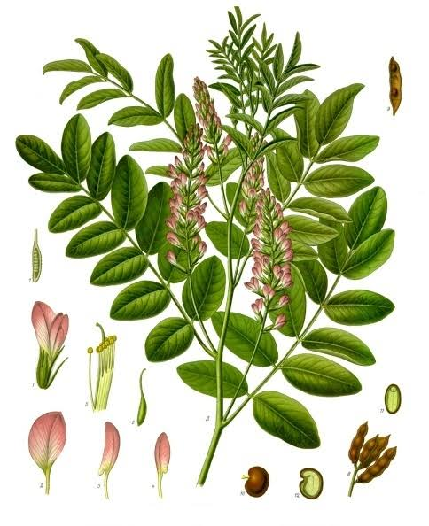

Figure 40. *Glycyrrhiza glabra* (adapted from Wikipedia)

1. **Licochalcone**

“Licochalcone vastly occurs in *G. glabra*. This bioactive compound exerted apoptotic activity against prostate cancer cells and caused obstruction of the cell cycle through the repression of G2/M cells, cdc2, and cyclin B1. *G. glabra* reduced the levels of cyclin D1 and the transcription factor E2F, raised cyclin E levels and inhibited CDK 4/6” (Yue *et al.,* 2004). “Another bioactive compound, isoliquiritigenin, isolated from *G. glabra,* suppressed prostate cancer proliferation. Isoliquiritigenin initiated the arrest of S- and G2/M-phases and also induced GADD153 mRNA and protein functions that are involved in cell cycle arrest (Fabisiak *et al.,* 1993). The aqueous extract of *G. glabra* exerted anticancer activity against breast cancer (MCF-7) and colon cancer (HT-29) cell lines” (Nazmi *et al.,* 2018).

1. **Licochalcone A**

“Licochalcone A is a chalconoid, a type of natural phenol. It can be isolated from the root of *Glycyrrhiza glabra* or *Glycyrrhiza inflata.* It shows antimalarial, anticancer, antibacterial and antiviral properties in vitro” (Villa et al., 2024).

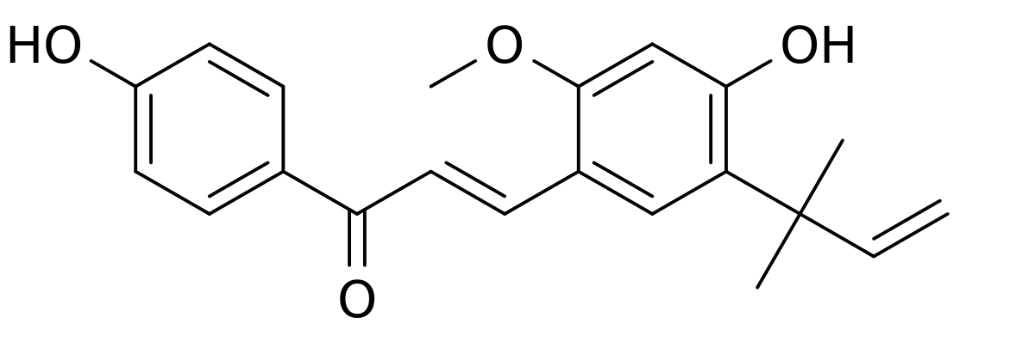

Figure 41. Licochalcone A

1. **Isoliquiritigenin**

“Isoliquiritigenin is a phenolic chemical compound found in licorice” (Tuli *et al.,* 2024).

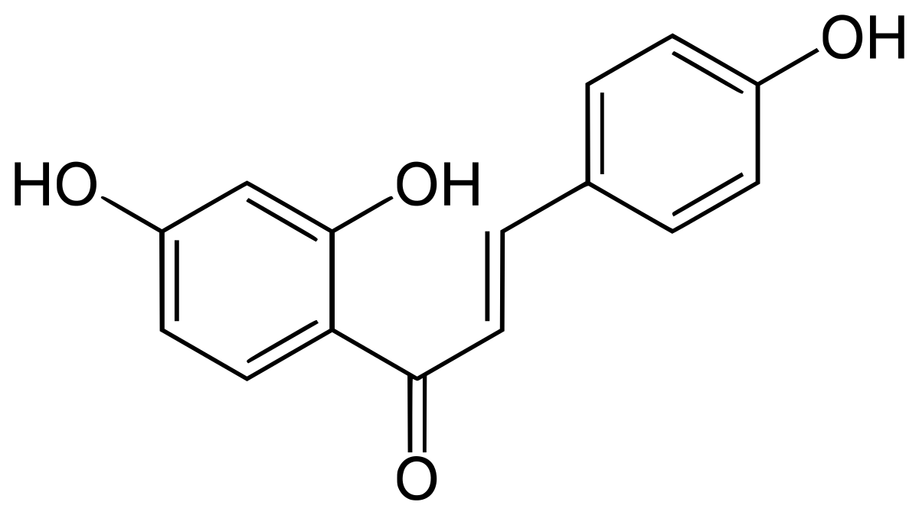

Figure 42. Isoliquiritigenin

1. ***Rauvolfia vomitoria***

“Rauvolfia, the poison devil's-pepper, is a plant species in the genus *Rauvolfia* of the *Apocynaceae* family. It is native from East Senegal to Sudan and Tanzania, south to Angola; and naturalized in China, Bangladesh, different ranges of Himalayan and Puerto Rico. The plant contains a number of compounds of interest to the pharmaceutical industry and is widely used in traditional medicine” (Mahalakshmi *et al.,* 2019).

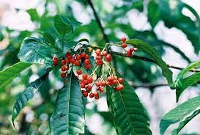

Figure 43. *Rauvolfia vomitoria* (adapted from Wikipedia)

“Ethanolic root extract of *R. vomitoria* has been reported to be cytotoxic to pancreatic, prostate, and ovarian cancer cells” (Bemis *et al.,* 2006; Yu *et al.,* 2013; Yue *et al.,* 2004) The ethanolic root extract of *R. vomitoria* initiated apoptosis and hindered the expansion of tumors in pancreatic cells according to the study conducted by Yue et al., (2004). “This anticancer activity was attributed to the presence of β-carboline in *R. vomitoria*. Furthermore, *R. vomitoria* extract repressed the proliferation as well as induced cell cycle arrest in prostate cancer cells” (Bemis *et al.,* 2006). “Additionally, ethanolic root extract of *R. vomitoria* inhibited the development of ovarian cancer cell lines (OVCAR-8, OVCAR-5, SHIN-3) and also initiated apoptosis of cancer cells” (Yu *et al.,* 2013)*.*

1. **β-Carboline**

“β-Carboline (9H-pyrido[3,4-b]indole) represents the basic chemical structure for more than one hundred alkaloids and synthetic compounds. The effects of these substances depend on their respective substituents. Natural β-carbolines primarily influence brain functions but can also exhibit antioxidant effects. Synthetically designed β-carboline derivatives have recently been shown to have neuroprotective, cognitive enhancing and anti- cancer properties” (Aaghaz *et al.,* 2021).

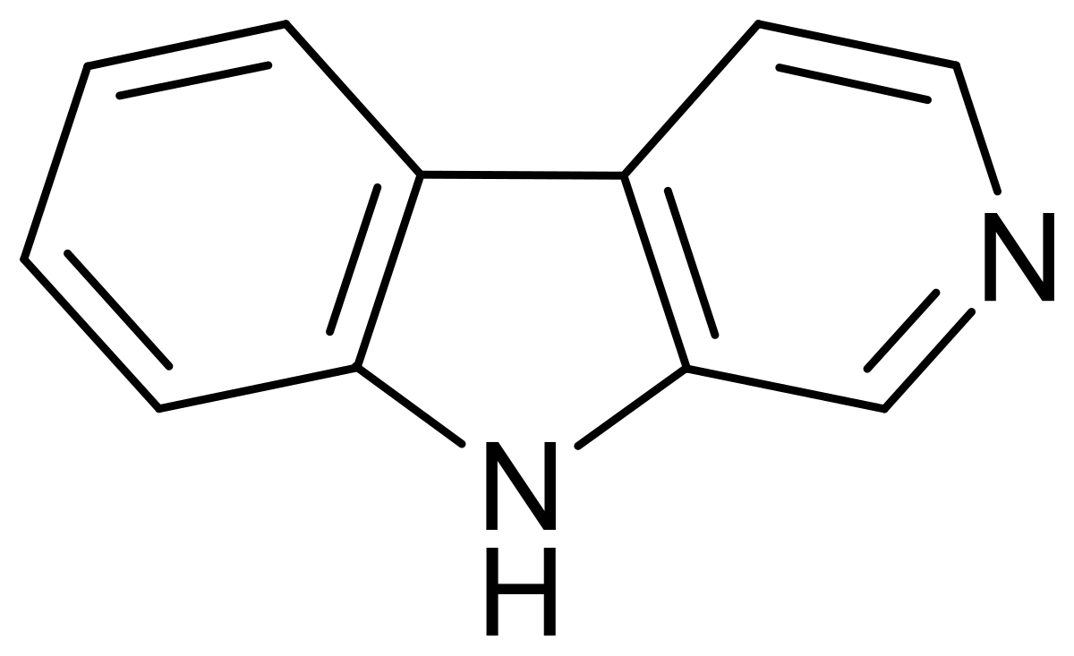

Figure 44. β-Carboline

**CONCLUSION**

This review highlights 15 Nigerian medicinal plants with demonstrated anticancer activity against various cancers, including those affecting the prostate, cervix, lungs, skin, colon, esophagus, blood, ovaries, brain, breast, stomach, pancreas, larynx, and kidneys. These findings suggest the potential of these plants as sources of anticancer drug agents. The primary bioactive compounds responsible for their anticancer effects include polyphenols, flavonoids, alkaloids, saponins, triterpenes, tannins, and quinones. These compounds exhibit pharmacological actions such as antiproliferative, cytotoxic, cytostatic, antimetastatic, apoptotic, and antioxidative properties. Additionally, they have been shown to induce cell cycle arrest, inhibit angiogenesis, and reduce cancer cell viability. The review emphasizes that extracts from the leaves, roots, and stem bark of these medicinal plants contain the highest concentrations of bioactive compounds with anticancer properties. Therefore, further research into the anticancer potential of these plant parts is recommended. Harnessing Nigerian medicinal plants could provide an affordable and accessible source of anticancer drugs.

**Disclaimer (Artificial intelligence)**

Author(s) hereby declare that NO generative AI technologies such as Large Language Models (ChatGPT, COPILOT, etc.) and text-to-image generators have been used during the writing or editing of this manuscript.

**REFERENCES**

Aaghaz S, Sharma K, Jain R, Kamal A (April 2021). "β-Carbolines as potential anticancer agents". *European Journal of Medicinal Chemistry*. 216: 113321. doi:10.1016/j.ejmech.2021.113321. PMID 33684825. S2CID 232159513.

Adaki S, Adaki R, Shah K, Karagir A (2014) Garlic: review of literature. *Indian J Cancer* 51(4):577–581. <https://doi.org/10.4103/0019-509X.175383>.

Adaze B E., Sylvester I O., Okobi E. E., (2020). Aqueous leaf extract of Sutherlandia frutescens attenuates ROS-induced apoptosis and loss of mitochondrial membrane potential in MPP+-treated SH-SY5Y cells. *Tropical Journal of Pharmaceutical Research March* 19 (3): 549-555.

Adebayo AH, Tan NH, Akindahunsi AA, Zeng GZ, Zhang YM (2010) Anticancer and antiradical scavenging activity of Ageratum conyzoides L. (Asteraceae). *Pharmacogn Mag* 6(21):62–66

Ansah, C (2002). "The Popular Herbal Antimalarial, Extract of Cryptolepis sanguinolenta, is Potently Cytotoxic". *Toxicological Sciences.* 70 (2): 245–251. doi:10.1093/toxsci/70.2.245. PMID 12441369.

Arunee H, Kornkanok I, Nanteetip L, Daniel S (2014) Ethanolic extract from Derris scandens Benth mediates radiosensitzation via two distinct modes of cell death in human colon cancer HT-29 cells. *Asian Pac J Cancer Prev* 15(4):1871–1877.

Ashidi JS, Houghton PJ, Hylands PJ, Efferth T (2010) Ethnobotanical survey and cytotoxicity testing of plants of South-western Nigeria used to treat cancer, with isolation of cytotoxic constituents from Cajanus cajan Mill sp. leaves. *J Ethnopharmacol* 128(2):501–512. https://doi.org/10.1016/j.jep.2010.01.009.

Badgwell DB, Walker CM, Baker WT, Strickland FM (2004). "Ethanol and aloe emodin alter the p53 mutational spectrum in ultraviolet radiation-induced murine skin tumors". *Molecular Carcinogenesis*. 39 (3): 127–38. doi:10.1002/mc.10170. PMID 14991742. S2CID 24146785.

Balogun OS, Ajayi OS, Agberotimi BJ (2016) A cytotoxic indole alkaloid from Alstonia boonei. *J Biol Act Prod Fr Nat* 6(4):347–351

Bang du Y, Lee IK, Lee BM. Toxicological characterization of phthalic Acid. Toxicol Res. 2011 Dec;27(4):191-203. doi: 10.5487/TR.2011.27.4.191. PMID: 24278572; PMCID: PMC3834394.

Bayala B, Bassole IH, Gnoula C, Nebie R, Yonli A, Morel L (2014) Chemical composition, antioxidant, anti-inflammatory and anti-proliferative activities of essential oils of plants from Burkina Faso. *PLoS One* 9(3):e92122. https://doi.org/10.1371/journal.pone.0092122.

Bemis DL, Capodice JL, Gorroochurn P, Katz AE, Buttyan R (2006) Anti-prostate cancer activity of ab-carboline alkaloid enriched extract from Rauwolfia vomitoria. *Int J Oncol* 29(5):1065–1073.

Block, Eric (2010). Garlic and Other Alliums: The Lore and the Science. *Royal Society of Chemistry.* ISBN 978-0-85404-190-9.

Bray F, Laversanne M, Sung H, *et al.,* (2024) Global cancer statistics 2022: GLOBOCAN estimates of incidence and mortality worldwide for 36 cancers in 185 countries. *CA Cancer J Clin*; 74(3): 229-263. doi:[10.3322/caac.21834](https://doi.org/10.3322/caac.21834)

Chaachouay, N., & Zidane, L. (2024). Plant-Derived Natural Products: A Source for Drug Discovery and Development. Drugs and Drug Candidates, 3(1), 184-207. <https://doi.org/10.3390/ddc3010011>.

Chahal R, Nanda A, Akkol EK, Sobarzo-Sánchez E, Arya A, Kaushik D, Dutt R, Bhardwaj R, Rahman MH, Mittal V. (2021). *Ageratum conyzoides* L. and Its Secondary Metabolites in the Management of Different Fungal Pathogens. Molecules. 26(10):2933. doi: 10.3390/molecules26102933. PMID: 34069197; PMCID: PMC8156077.

Chiang, H.M., Lin, Y. T., Hsiao, P. L.; Su, Y. H; Tsao, H. T., and Wen, K. C., (2012) "Determination of marked components - aloin and aloe-emodin - in aloe vera before and after hydrolysis," *Journal of Food and Drug Analysis*. 20(3):646-652. <https://doi.org/10.6227/jfda.2012200311>

Chikezie PC, Ibegbulem CO, Mbagwu FN (2015). Bioactive principles from medicinal plants. *Res J Phytochem* 9(3):88–115. https://doi.org/10.3923/rjphyto.2015.88.115.

Dupont, C; Couillerot, E; Gillet, R; Caron, C; Zeches-Hanrot, M; Riou, JF; Trentesaux, C (2005). "The benzophenanthridine alkaloid fagaronine induces erythroleukemic cell differentiation by gene activation". *Planta Medica.* 71 (6): 489–94. doi:10.1055/s-2005-864147. PMID 15971117.

Elisabetsky, E; Costa-Campos, L (2006). "The Alkaloid Alstonine: A Review of Its Pharmacological Properties". *Evidence-Based Complementary and Alternative Medicine.* 3 (1): 39–48. doi:10.1093/ecam/nek011. PMC 1375234. PMID 16550222.

Emelia O. B., Kirk B. D., Cindy K., Andrew G. , Samuel F. M, Gladys S., (2020). Pharmacognostic Characteristics and Mutagenic Studies of Alstonia boonei De Wild. *Research Journal of Pharmacognosy (RJP)* 7(1): 7-15.

Emmanuel U, Onyekachi J, Uchenna O. (2020). Phytochemical, anti-inflammatory and analgesic properties of stembark extract and fractions of *Lonchocarpus sericeus* Poir. (Papilionaceae) in albino mice*. Avicenna J Phytomed*. 10(6):584-593. PMID: 33299815; PMCID: PMC7711298.

Fabisiak JP, Borisenko GG, Kagan VE (1993) Quantitative method of measuring phosphatidylserine externalization during apoptosis using electron paramagnetic resonance (EPR) spectroscopy and annexin conjugated iron. *Methods Mol Biol* 1105:613–621.

Ferlay J, Ervik M, Lam F, Colombet M, Mery L, Piñeros M, et al. Global Cancer Observatory: Cancer Today. Lyon: International Agency for Research on Cancer; 2020 (<https://gco.iarc.fr/today>, accessed March 2025).

Ferlay J, Soerjomataram I, Dikshit R, Eser S, Mathers C, Rebelo M (2015) Cancer incidence and mortality worldwide: Sources, methods and major patterns in GLOBOCAN 2012. *Int J Cancer* 136(5):359–386.

Fernandes A, Fernandes I, Cruz L, Mateus N, Cabral M, de Freitas V (2009) Antioxidant and biological properties of bioactive phenolic compounds from Quercus suber L. *J Agric Food Chem* 57(23):11154–11160. <https://doi.org/10.1021/jf902093m>

Franklyn O. O., Paul C. C., Chinwendu M. C., and Christian E. E., (2021). Anticancer activity of Nigerian medicinalplants: a review. *Future Journal ofPharmaceutical Sciences*. 7:70 :1-21

GBD (2015) Mortality and causes of death collaborators: global, regional, and national life expectancy, all-cause mortality, and cause-specific mortality for 249 causes of death, 1980-2015: A systematic analysis for the global burden of disease study 2015. *Lancet* 388(10053):1459–1544.

Holland, Thomas M.; Agarwal, Puja; Wang, Yamin; Leurgans, Sue E.; Bennett, David A.; Booth, Sarah L.; Morris, Martha Clare (2020). "Dietary flavonols and risk of Alzheimer dementia". *Neurology*. 94 (16): e1749–e1756. doi:10.1212/WNL.0000000000008981. ISSN 0028-3878. PMC 7282875. PMID 31996451.

Hou, W., Huang, L., Wang, J., Luyten, W., Lai, J., Zhou, Z., Kang, S., Dai, P., Wang, Y., Huang, H., & Lan, J. (2024). Cajaninstilbene Acid and Its Derivative as Multi-Therapeutic Agents: A Comprehensive Review. Molecules, 29(22), 5440. https://doi.org/10.3390/molecules29225440

Ito C, Matsui T, Miyabe K, Hasan CM, Rashid MA, Tokuda H, Itoigawa M (2020) Three isoflavones from Derris scandens (Roxb.) Benth and their cancer chemopreventive activity and in vitro antiproliferative effects. Phytochem 175:112376.https://doi.org/10.1016/*j.phytochem*.2020.112376

Jaganathan SK, Supriyanto E (2012) Antiproliferative and molecular mechanism of eugenol-induced apoptosis in cancer cells. *Mol* 17(6):6290–6304. https://doi.org/10.3390/molecules17066290

James A Duke (1983). "Anacardium occidentale L." Handbook of Energy Crops. (unpublished); In: NewCROP, New Crop Resource Online Program, Center for New Crops and Plant Products, Purdue University.

Kerr JF, Wyllie AH, Currie AR (1972) Apoptosis: a basic biological phenomenon with wide range implications in tissue kinetics. *Br J Cancer* 26(4):239–257. https://doi.org/10.1038/bjc.1972.33

Kimbi HK, Fagbenro-Beyioku AF (1996) Efficacy of Cymbopogon giganteus and Enantia chrantha against chloroquine resistant Plasmodium yoelii nigeriensis. *East Afr Med J* 73(10):636–637

Kingwell-Banham, Eleanor; Fuller, Dorian Q. (2014), "Pigeon Pea: Origins and Development", in Smith, Claire (ed.), Encyclopedia of Global Archaeology, New York, NY: Springer, pp. 5941–5944, doi:10.1007/978-1-4419-0465-2_2320, ISBN 978-1-4419-0465-2, S2CID 129688840, retrieved 2022-05-05.

Konan NA, Lincopan N, Collantes Díaz IE, de Fátima JJ, Tiba MM, Amarante Mendes JG (2012) Cytotoxicity of cashew flavonoids towards malignant cell lines. *Exp Toxicol Pathol* 64(5):435–440. https://doi.org/10.1016/j.etp.2010.10.010.

Kuete V, Tchinda CF, Mambe FT, Beng VP, Efferth T (2016) Cytotoxicity of methanol extracts of 10 Cameroonian medicinal plants towards multi-factorial drug-resistant cancer cell lines. *BMC Complement Altern Med* 16(1):267. https://doi.org/10.1186/s12906-016-1253-3.

Lasswell WL Jr, Hufford CD (1977). Cytotoxic C-benzylated flavonoids from Uvaria chamae. *J OrganometChem* 42(8):1295–1302 https://doi.org/10.102 /jo00428a006.

Lorz, Peter M.; Towae, Friedrich K.; Enke, Walter; 2007). "Phthalic Acid and Derivatives". Ullmann's Encyclopedia of Industrial Chemistry. Weinheim: Wiley-VCH. doi:10.1002/14356007.a20_181.pub2.

Mahalakshmi S.N., Achala H.G., Ramyashree K.R and Prashith Kekuda T.R., (2019). Rauvolfia tetraphylla L. (Apocynaceae) - A Comprehensive Review on Its Ethnobotanical Uses, Phytochemistry and Pharmacological Activities. *International Journal of Pharmacy and Biological Sciences-IJPBSTM*. 9(2): 664-682.

Marc D.W., Bagora B., Julio B., Silvère B., Jacques S., Jean-Marc A. L., (2024). Contribution of Sub-Saharan African medicinal plants to cancer research: Scientific basis 2013–2023, *Pharmacological Research*, **202**;107138, ISSN 1043-6618, <https://doi.org/10.1016/j.phrs.2024.107138>.

Motto AE, Lawson-Evi P, Bakoma B, Eklu-Gadegbeku K, Aklikokou K.(2021). Antihyperlipidemic and antioxidant properties of hydro-alcoholic extracts from *Anogeissus leiocarpus* (Combretaceae). Heliyon.7(4):e06648. doi: 10.1016/j.heliyon.2021.e06648. PMID: 33889775; PMCID: PMC8047486.

Morton, Julia F. (1987). Cashew apple, Anacardium occidentale L. Fruits of warm climates. Center for New Crops and Plant Products, Department of Horticulture and Landscape Architecture, Purdue University, W. Lafayette, IN. pp. 239–240. ISBN 978-0-9610184-1-2.

National Center for Biotechnology Information (2025). PubChem Compound Summary for CID 3314, Eugenol. Retrieved March 18, 2025 from <https://pubchem.ncbi.nlm.nih.gov/compound/Eugenol>.

Nazmi SA, Nourazarian A, Bahhaj R, Khakikhatibi F (2018) The anticancer effect of Arctium lappa and Glycyrrhiza glabra on HT-29 colon cancer and MCF-7 breast cancer cell lines. *Crescent J Med Biol Sci* 5(2):133–137.

Neha Y., Rohitas D., Rupa M. A., (2024). comprehensive review on the use of traditional Chinese medicine for cancer treatment, Pharmacological Research - Modern Chinese Medicine, **11**,100423, ISSN 2667-1425,<https://doi.org/10.1016/j.prmcm.2024.100423>.

Nguyen Q.C., Nguyen T.T., Yougnia R., Gaslonde T., Dufat H., Michel S. and Tillequin F.. (2009). Acronycine Derivatives: A Promising Series of Anti-Cancer Agents. Anti-Cancer Agents in Medicinal Chemistry, 9, 804-815.

Obembe OO, Ige AO (2016) Sperm parameters of male Wistar rats treated with Anacardium occidentale L. leaf extract. *Res J Heal Sci* 4(1):83–89

Ohiagu, F.O., Chikezie, P.C., Chikezie, C.M. *et al.* Anticancer activity of Nigerian medicinal plants: a review. *Futur J Pharm Sci* **7**, 70 (2021). https://doi.org/10.1186/s43094-021-00222-6

Ojewole JAO (1984) Studies on the pharmacology of echitamine, an alkaloid from the stem-bark of Alstonia boonei L. (Apocynaceae). *Int J CrudeDrugRes*22(3):121–143.https://doi.org/10.3109/13880208409070663

Okagu IU, Ndefo JC, Aham EC, Udenigwe CC. (2021). *Zanthoxylum* Species: A Comprehensive Review of Traditional Uses, Phytochemistry, Pharmacological and Nutraceutical Applications. Molecules. 26(13):4023. doi: 10.3390/molecules26134023. PMID: 34209371; PMCID: PMC8272177.

Olugbami JO, Damoiseaux R, France B, Onibiyo EM, Gbadegesin MA, Sharma S (2017a) A comparative assessment of antiproliferative properties of resveratrol and ethanol leaf extract of Anogeissus leiocarpus (DC) Guill and Perr against HepG2 hepatocarcinoma cells. *BMC Complement Altern Med* 17(1):381. https://doi.org/10.1186/s12906-017-1873-2.

Padmaharish V, Lakshmi T (2017) Anticancer activities of medicinal plants-an update. *J Pharm Sci Res* 9(4):432–440 https://plantnet.rbgsyd.nsw.gov.au/cgibin/NSWfl.pl?page=nswfl&lvl=sp&name=Ageratum~conyzoides

Pal D, Mishra P, Sachan N, Ghosh AK (2011) Biological activities and medicinal properties of Cajanus cajan (L) Millsp. *J Adv Pharm Technol Res* 2(4):207–214. <https://doi.org/10.4103/2231-4040.90874>.

Pastorino G, Cornara L, Soares S, Rodrigues F, Oliveira MBPP. (2018). Liquorice (Glycyrrhiza glabra): A phytochemical and pharmacological review. Phytother Res. 32(12):2323-2339. doi: 10.1002/ptr.6178. Epub 2018 Aug 17. PMID: 30117204; PMCID: PMC7167772.

Patel S, Rana K, Arya P, Nelson J, Hernandez V, Minakova V**.  Anticancer Activity of Phytochemicals of the Papaya Plant Assessed: A Narrative Review**.  J Cancer Prev 2024;29:58-68.  <https://doi.org/10.15430/JCP.24.020>

Paulo A, Gomes ET, Steele J, Warhurst DC, Houghton PJ (2000) Anti-plasmodial activity of Cryptolepis sanguinolenta alkaloids from leaves and roots. *Planta Med* 66(1):30–34. https://doi.org/10.1055/s-2000-11106.

Petrovic V, Nepal A, Olaisen C, Bachke S, Hira J, Søgaard CK (2018) Anti-cancer potential of home made fresh garlic extract is related to increased endoplasmic reticulum stress. *Nutr* 10(4):450.

Pledgie-Tracy A, Sobolewski MD, Davidson NE (2007) Sulforaphane induces cell type-specific apoptosis in human breast cancer cell lines. *Mol Cancer Ther* 6(3):1013–1021. <https://doi.org/10.1158/1535-7163.MCT-06-0494>.

Proshkina, E., Plyusnin, S., Babak, T., Lashmanova, E., Maganova, F., Koval, L., Platonova, E., Shaposhnikov, M., & Moskalev, A. (2020). Terpenoids as Potential Geroprotectors. Antioxidants, 9(6), 529. https://doi.org/10.3390/antiox9060529.

Puttarak, Panupong; Sawangjit, Ratree; Chaiyakunapruk, Nathorn (2016). "Efficacy and safety of Derris scandens (Roxb.) Benth. for musculoskeletal pain treatment: A systematic review and meta-analysis of randomized controlled trials" (PDF). *Journal of Ethnopharmacology*. 194: 316–323. doi:10.1016/j.jep.2016.09.021. PMID 27620659.

Quijano L., Calderón J.S., Gómez F., Ríos T., (1982). Zoapatanolide A and B, two new heliangolides from Montanoa tomentosa, Phytochemistry, 21(8):2041-2044, ISSN 0031-9422, <https://doi.org/10.1016/0031-9422(82)83039-2>.

Quiroga R, Meneses L, Bussmann RW (2012) Medicinal ethnobotany in Huacareta (Chuquisaca, Bolivia). *J Ethnobiol Ethnomed* 8(1):29. https://doi.org/10.1186/1746-4269-8-29.

Rashid H, Gafur GM, Sadik RMAA (2002) Biological activities of a new derivative from Ipomoea turpithum. *Pak J Biol Sci* 5:968–969.

Richards, P.G.; Harden, Gwen J. "Genus Acronychia". Royal Botanic Gardens Sydney. Retrieved 1 July 2020.

Risinger AL, Giles FJ, Mooberry SL (2009) Microtubule dynamics as a target in oncology. Cancer Treat Rev 35(3):255–261. https://doi.org/10.1016/j.ctrv.2008.11.001.

Salau AK, Yakubu M, Oladiji A (2013) Cytotoxic activity of aqueous extracts of Anogeissus leiocarpus and Terminalia avicennioides root barks against Ehrlich ascites carcinoma cells. *Indian J Pharm* 45(4):381–385. https://doi.org/10.4103/0253-7613.115023.

Schuster R, Holzer W, Doerfler H, Weckwerth W, Viernstein H, Okonogi S (2016) Cajanus cajan - a source of PPARc activators leading to anti-inflammatory and cytotoxic effects. *Food Funct* 7(9):3798–3806. https://doi.org/10.1039/C6FO00689B

Seeram NP, Adams LS, Henning SM, Niu Y, Zhang Y, Nair MG (2005) In vitro antiproliferative, apoptotic and antioxidant activities of punicalagin, ellagic acid and a total pomegranate tannin extract are enhanced in combination with other polyphenols as found in pomegranate juice. *J Nutr Biochem* 16(6):360–367. https://doi.org/10.1016/j.jnutbio.2005.01.006.

Sharifi-Rad J, Quispe C, Castillo CMS, Caroca R, Lazo-Vélez MA, Antonyak H, Polishchuk A, Lysiuk R, Oliinyk P, De Masi L, Bontempo P, Martorell M, Daştan SD, Rigano D, Wink M, Cho WC. (2024). Ellagic Acid: A Review on Its Natural Sources, Chemical Stability, and Therapeutic Potential. Oxid Med Cell Longev.3848084. doi: 10.1155/2022/3848084.

Shoeb M (2006) Anti-cancer agents from medicinal plants. *Bang J Pharmacol* 1(2):35–41.

Sheik Aliya, Munirah Alhammadi, Uichang Park, Jitendra N. Tiwari, Jeong-Hwan Lee, Young-Kyu Han, Yun Suk Huh. (2023). The potential role of formononetin in cancer treatment: An updated review, Biomedicine & Pharmacotherapy, **168**, 115811, ISSN 0753-3322, <https://doi.org/10.1016/j.biopha.2023.115811>.

Shuaibu MN, Wuyep PA, Yanagi T, Hirayama K, Tanaka T, Kouno I (2008) The use of microfluorometric method for activity-guided isolation of antiplasmodial compound from plant extracts. *Parasitol Res* 102(6):1119–1127. <https://doi.org/10.1007/s00436-008-0879-6>.

Singh L, Kaur H, Chandra Arya G, Bhatti R. (2024). Neuroprotective potential of formononetin, a naturally occurring isoflavone phytoestrogen. *Chem Biol Drug Des*. 103(1):e14353. doi: 10.1111/cbdd.14353. Epub 2023 Sep 18. PMID: 37722967.

Steentoft, Margaret (1988). Flowering Plants in West Africa. Cambridge University Press. ISBN 0-521-26192-9.

Sultana S, Asif HM, Nazar HMI, Akhtar N, Rehman JU, Rehman RU (2014) Medicinal plants combating against cancer - a green anticancer approach. *Asian Pac J Cancer Prev* 15(11):4385–4394. https://doi.org/10.7314/APJCP.2014.15.11.4385.

Svoboda GH, Poore GA, Simpson PJ, Boder GB (1996) Alkaloids of Acronychia baueri Schott: isolation of the alkaloids and a study of the antitumor and other biological properties of acronycine. *J Pharm Sci* 55(8):758–768.

Taiwo BJ, Fatokun AA, Olubiyi OO, Bamigboye-Taiwo OT, van Heerden FR, Wright CW (2017) Identification of compounds with cytotoxic activity from the leaf of the Nigerian medicinal plant, Anacardium occidentale L. (Anacardiaceae). *Bioorg Med Chem* 25(8):2327–2335. https://doi.org/10.1016/j.bmc.2017.02.040.

Tudu CK, Bandyopadhyay A, Kumar M, Radha, Das T, Nandy S, Ghorai M, Gopalakrishnan AV, Proćków J, Dey A. (2023). Unravelling the pharmacological properties of cryptolepine and its derivatives: a mini-review insight. Naunyn Schmiedebergs Arch Pharmacol. 396(2):229-238. doi: 10.1007/s00210-022-02302-7. Epub 2022 Oct 17. PMID: 36251044; PMCID: PMC9574835.

Tuli HS, Garg VK, Mehta JK, Kaur G, Mohapatra RK, Dhama K, Sak K, Kumar A, Varol M, Aggarwal D, Anand U, Kaur J, Gillan R, Sethi G, Bishayee A.(2024). Licorice (*Glycyrrhiza glabra* L.)-Derived Phytochemicals Target Multiple Signaling Pathways to Confer Oncopreventive and Oncotherapeutic Effects. Onco Targets Ther. 15:1419-1448. doi: 10.2147/OTT.S366630.

Tyagi N, Sharma GN, Shrivastava B, Saxena P, Kumar N (2017) Medicinal plants: used in anti-cancer treatment. *Int J Res Dev Pharm L Sci* 6(5):2732–2739.

Veligeti R, Madhu RB, Anireddy J, Pasupuleti VR, Avula VKR, Ethiraj KS, Uppalanchi S, Kasturi S, Perumal Y, Anantaraju HS, Polkam N, Guda MR, Vallela S, Zyryanov GV.(2020). Synthesis of novel cytotoxic tetracyclic acridone derivatives and study of their molecular docking, ADMET, QSAR, bioactivity and protein binding properties. Sci Rep. 10(1):20720. doi: 10.1038/s41598-020-77590-1. PMID: 33244007; PMCID: PMC7691360.

Villa, S. M., Heckman, J., & Bandyopadhyay, D. (2024). Medicinally Privileged Natural Chalcones: Abundance, Mechanisms of Action, and Clinical Trials. International Journal of Molecular Sciences, 25(17), 9623. https://doi.org/10.3390/ijms25179623

You-Ping Zhu (28 May 1998). Chinese Materia Medica: Chemistry, Pharmacology and Applications. p. 622. ISBN 9057022850.

Yu J, Ma Y, Drisko J, Chen Q (2013). Antitumor activities of Rauwolfia vomitoria extract and potentiation of carboplatin effects against ovarian cancer.*CurrTherResClinExp*75:8–14.https://doi.org/10.1016/j.curtheres.2013.04.001

Yue F, Tze-Chen H, Junqiao G (2004) Licochalcone- A: a novel flavonoid isolated from licorice root (Glycyrrhiza glabra), causes G2 and late-G1 arrests in androgen-independent PC-3 prostate cancer cells. *Biochem Biophys Res Commun* 322(1):263–270.

Žitek Makoter T, Knez Marevci M, Knez Ž. (2024). Ellagitannin Content in Extracts of the Chestnut Wood *Aesculus*. Molecules. 29(17):4015. doi: 10.3390/molecules29174015. PMID: 39274862; PMCID: PMC11397544.