THERMAL ANALYSIS AND KINETIC STUDIES OF OXIMINO METAL COMPLEXES: INSIGHTS INTO STABILITY AND DECOMPOSITION MECHANISMS

**Abstract**

This study explores the thermal characterization of metal chelates, a field that remains relatively under-investigated despite its potential applications across various scientific and industrial domains. A brief overview of previous research is presented, highlighting the limited but growing body of work in this area. The utility of the Freeman–Carroll equation for evaluating isothermal stability systems is discussed, with reference to a previously published study by our research group (2022) on substituted thiourea, which examined similar kinetic parameters as those evaluated in the present work.

The preparation and characterization of oximino ligands and their metal complexes with copper(II) acetate, copper(II) nitrate, uranyl(II) nitrate, manganese(II) chloride, and lead(II) acetate have been carried out in the solid state. A total of twenty complexes—eight copper(II), four uranyl, four manganese(II), and four lead(II)—were subjected to thermal analysis using thermogravimetric (TG), differential thermal (DTA), and differential thermogravimetric (DTG) techniques.

Based on the observed decomposition behaviour, the complexes were classified into two categories: those undergoing simultaneous reactions and those undergoing successive reactions. Kinetic parameters such as order of reaction, activation energy, enthalpy changes, and thermal stability were calculated using the Freeman–Carroll method and the peak-and-area approach. The decomposition patterns obtained from thermal analysis not only confirm the formation of the metal complexes but also provide insight into their stability and structural characteristics.

**Keywords:** Freeman and Carroll equation; peak and area method, thermal reaction patterns, kinetic parameters, reaction order and activation energy.

**1.0 Introduction**

This study offers valuable insights into the thermal and kinetic behaviour of transition metal and actinide complexes formed with malon-di-anilide oxime ligands. Thermogravimetric analysis (TGA), which quantifies material weight changes as a function of temperature or time under various atmospheres (e.g., nitrogen, helium, air, or vacuum), serves as the primary analytical technique. The evaluation of kinetic parameters—such as activation energy, order of reaction, and enthalpy changes, through advanced thermal methods enhances the understanding of complex stability and reactivity (Freeman, 1969; Criado, 1982; Liu, 1999).

Understanding the decomposition behaviour and thermal stability of metal complexes is essential for their application in diverse fields including catalysis, material science, coordination chemistry, and the manufacturing of greases, paints, inks, plastics, cosmetics, textiles, and pharmaceuticals. In these industries, such compounds serve as lubricants, driers, catalysts, wetting agents, thickening agents, stabilizers, waterproofing agents, fungicides, and pesticides. Among them, metallic soaps with the general formula (RCOO)₂M—where M denotes metals like Zn, Cd, Pb, Ba, Ca, Co, Cu, Al, or Fe, and R represents linear or branched alkyl groups—are thermally evaluated (Vishal, 2017). The thermogravimetric analysis of cadmium soaps (e.g., caproate, caprylate, caprate, laurate, and myristate) reveals that their decomposition follows zero-order kinetics, with activation energies ranging from 2 to 6 kcal/mol.

Surface-active agents, characterized by the presence of both polar and non-polar groups within the same molecule, exhibit properties such as micellization and solubilization (Suman, 2018). Dicarboxylic acid metal soaps have been synthesized via metathesis and studied for their thermal behaviour and suitability as thermal stabilizers in polymers like PVC. The application of metal alkanoates, depends largely on their physicochemical properties, including thermal stability, chemical reactivity, physical state, and solubility in various solvents.

Though some studies have explored, the relationship between the structure of chelating agents and the thermal stability of metal chelates (Goitom, 2016; Ana, 2013; Mallikarjun, 1992, 2004; Mansoor, 2008; Verma, 1997; Gurnule, 2014; Iorungwa, 2023; Devhade, 2015; Borase, 2021; Madhusudanan, 1975; Sadafale, 2020; Patel, 2013; Bhartiya, 2008; Ghanashyam, 2021; Michael, 2007; Mullasseril, 2022; Ajay, 2020; Kharadi, 2012), such investigations remain limited. Chalcone-based ligands, known for their biological activities (germicidal, bactericidal, fungicidal, and carcinogenic), have also been utilized in thermal decomposition studies. Mallikarjun (2004) reported the thermal stability and kinetic parameters of Ni(II) chelates with various substituted chalcones using the Freeman and Carroll differential method.

Our recent work (Shrivastava, 2024; 1981) detailed the synthesis and characterization of malon-di-(α-naphthyl)amide-oxime (HINMANAP) and its complexes with Cu(II), Ni(II), Fe(II), Co(III), Zn(II), Cd(II), and Hg(II). These complexes, isolated in solid form, were studied using solution methods to determine metal-to-ligand ratios, and characterized via magnetic, infrared, electronic, reflectance, electron spin resonance (ESR), and proton magnetic resonance (PMR) spectroscopy. A continuation of this research (Shrivastava, 2025; 1985) involves the synthesis and characterization of a series of related ligands: L1 = malon-di-anilide oxime (HINMAO), L2 = malon-di-(p-toluidide) oxime (HINM-p-TO), L3 = malon-di-(o-anisidide) oxime (HINM-o-ANISO), and L4 = malon-di-(p-anisidide) oxime (HINM-p-ANISO), and their complexes with copper(II) acetate, copper(II) nitrate, uranyl(II) nitrate, manganese(II) chloride, and lead(II) acetate.

The present study focuses on the thermal behaviour and kinetic analysis of these oximino complexes to confirm their formation and investigate their decomposition patterns. Through thermogravimetric (TG), differential thermal (DTA), and differential thermogravimetric (DTG) analyses, this work provides a comprehensive understanding of their stability, decomposition mechanisms, and metal–ligand interactions. These findings contribute significantly to the broader field of coordination chemistry and thermal analysis, offering robust methodologies for the evaluation of newly synthesized metal complexes.

**2.0 Experimental methods**

All chemicals, including cupric chloride, cupric nitrate, uranyl nitrate, manganese chloride, lead acetate, nickel chloride, cobalt chloride, zinc sulphate, cadmium bromide, ferrous ammonium sulphate, benzene, acetone, chloroform, and pyridine, were of AR or LR grade. LR-grade chemicals were purified prior to use. Double-distilled conductivity water was used throughout. Ethyl alcohol was filtered and fractionally distilled at 77–78 °C over anhydrous calcium oxide; ether was distilled and dried over sodium metal; pyridine was distilled at 114–118 °C over sodium hydroxide pellets; ethyl acetate at 77–78 °C; chloroform at 65 °C over anhydrous calcium chloride; and acetone was distilled. Buffers for solution studies included N/20 potassium hydrogen phthalate (pH 4) and N/100 sodium tetraborate (pH 9.2) for pH meter calibration (Shrivastava, 2025;1985), and sodium acetate-acetic acid buffers for pH 6–7.5. Glass apparatus, including burettes, pipettes, and standard flasks, were calibrated by standard methods (Shrivastava, 2025;1985).

**2.1 Equipment used are:**

An analytical balance with 0.1 mg sensitivity was calibrated using the method described by Scott (Shrivastava, 2025;1985). Ultraviolet absorption measurements were performed on a Systronic MK II 106 spectrophotometer, calibrated with 0.004% K₂CrO₄ solution in 0.05M potassium hydroxide and 0.0062% potassium permanganate solution. The observed spectra aligned well with reported literature values (Shrivastava, 2025;1985). Reflectance spectra of solid complexes were recorded using a CZ VSU 2-P spectrophotometer from Germany, calibrated with a standard magnesium carbonate block. Infrared spectra were obtained in KBr using a Beckman IR 20 spectrophotometer from USA. pH measurements were made using a Model LI-10 pH meter of ELICO Pvt Ltd., Hyderabad, India with glass and calomel electrodes. Conductivity was measured using a Magic Eye conductivity bridge supplied by Toshniwal. CHN were estimated by microanalytical method. Magnetic susceptibility measurements by Gouy’s method (Shrivastava, 2025;1985). Thermal analysis of complexes was carried out on Mettler thermoanalyser using Al2O3 as a reference material, heating rate of 10 0C/min was employed for all the samples (Shrivastava, 2025;1985). Typically, 50-100mg of the sample was utilised for the analysis and percentage weight loss is calculated at every peak that is observed in the thermogram, as per the requirement of the method and the equipment used.

**2.2 Preparation of reagents:**

L1= Malon-di-anilide oxime (HINMAO), L2= Malon-di-(p-toludide) oxime (HINM-p-TO), L3= Malon-di-(o-anisidide) oxime (HINM-o-ANISO) and L4= Malon-di-(p-anisidide) oxime (HINM-p-ANISO). These reagents are prepared according to the procedure described in the literature (Shrivastava, 2025;1985). These mesoximes, are prepared in two stages: (i) preparation of an amide and (ii) Converting an amide into an oxime. They were all characterized by analytical and spectral methods of analysis (Shrivastava, 2025;1985), Table 1 and Table 2 give the relevant data and are reproduced below.

**Table 1: Analytical data for the reagents synthesized**

|  |  |  |  |  |  |  |  |  |  |  |
| --- | --- | --- | --- | --- | --- | --- | --- | --- | --- | --- |
| **Oxime** | | **Molecular formula** | **C%** | | **H%** | | **N%** | | **M pt** | |
| **Found** | **Expt.** | **Found** | **Expt** | **Found** | **Expt** | **0C** |
| L1 | HINMAO | C5H13N3O3 | 62.70 | 63.60 | 4.60 | 4.90 | 15.10 | 14.70 | 124 |
| L2 | HINM-p-TO | C17H17N3O3 | 65.90 | 65.70 | 5.90 | 5.40 | 13.20 | 13.50 | 124 |
| L3 | HINM-o-ANISO | C17H17N3O5 | 59.50 | 59.48 | 5.10 | 4.95 | 12.10 | 12.25 | 189 |
| L4 | HINM-p-ANISO | C17H17N3O5 | 59.40 | 59.48 | 5.10 | 4.96 | 12.30 | 12.25 | 177 |

**Table 2: Electronic and Infrared data for the reagents synthesized**

|  |  |  |  |  |  |  |  |
| --- | --- | --- | --- | --- | --- | --- | --- |
| **Oxime** | | **Electronic spectra** **cm-1** | **Infrared spectra cm-1** | | | | |
| free -OH group | NH Vibration | Free C=O | C=N stretching | N-O stretching |
| L1 | HINMAO | 24,200 | 3360 | 3020 | 1680 | 1590 | 1240 |
| L2 | HINM-p-TO | 23,500 | 3320 | 3010 | 1670 | 1590 | 1240 |
| L3 | HINM-o-ANISO | 25,000 | 3340 | 3030 | 1660 | 1590 | 1250 |
| L4 | HINM-p-ANISO | 25,000 | 3320 | 3020 | 1660 | 1580 | 1240 |

**2.3 Thermal methods of analysis:**

All the eight green Cu(II) complexes, four yellow UO2(II) complexes, four red Mn(II) complexes and four yellow Pb(II) complexes were subjected to Thermogravimetric analysis (TGA), Differential thermal analysis (DTA) and Differential thermal gravimetry (DTG) (Swarnabala, 2022; Chatwal, 1979; Daniels, 1973; Wendlandt, 1964; Coats, 1963).

**3.0 Results and discussion**

Thermoanalytical studies have been carried out and parameters such as thermal stability, activation energy, order of reaction and enthalpy changes have been evaluated. The thermograms (these look very similar to the thermograms shown in reference (Swarnabala, 2022)) (Figs 1 to 36) of the metal complexes indicate the nature of the decomposition involved. They could be classified broadly into two categories **(a) successive reaction and (b) simultaneous reaction**. All the metal complexes except uranyl(II) exhibit successive reaction, whereas UO2(II) complexes exhibit simultaneous reaction.

It is observed that all the eight Cu(II) (Figs 1,3,5,7,9,11,13,15), four Mn(II) (Figs17,19,21,23), four Pb(II) (Figs 25,27,29,31) and four UO2(II) (33,34,35,36) complexes do not show any loss up to 2000C indicating that these complexes do not contain water of hydration. This is in agreement with the finding of infrared spectral data which do not show any band in the region 3600-3300 cm-1, and also analytical CHN, metal analysis for the metal complexes. (Shrivastava, 2025;1985).

It is further noted that metal complexes of L1=HINMAO (ac, NO3) are more stable as compared to L2=HINM-p-TO (ac, NO3), L3=HINM-o-ANISO (ac, NO3) and L4=HINM-p-ANISO (ac, NO3) complexes because steric hindrance due to comparatively bulky -CH3 and -OCH3 cause strain in chelate ring resulting in decrease in thermal stability.

The loss in weight due to thermal decomposition as observed at different temperatures in TGA was calculated and plotted against the temperatures respectively for each of the complexes, using Freeman and Carroll equation, coordinates through graphs, etc - Tables 3-21.

**3.1 Evaluation of kinetic parameters**

1) Energy of activation (Ea) and

2) Order of reaction (n)

The determination of kinetic parameters from TGA have been widely reviewed (Wendlandt, 1964; Coats, 1963).). The difference differential method of Freeman and Carroll (Freeman, 1958; Liu, 1999) is most widely used to evaluate these parameters from the kinetic analysis of TGA data. This method is given by equation:

{(Δ log dw/dT)/(Δ log Wr)} = { – (Ea/2.303R) x [(Δ 1/T)/(Δ log Wr)] + n}

From the above equation, a plot of (Δlog dw/dT)/(Δlog Wr) vs (Δ(1/T)/Δ log Wr) provides a linear relationship. The slop will afford the value of Ea/2.303R (Energy of activation) and intercept on x-axis, the value of n (Order of reaction).

Thus, the values of kinetic parameters for all the eight green Cu(II), four Mn(II), four Pb(II) complexes were evaluated. The decomposition patterns are found to follow successive reactions. All graphs look exactly like the ones that are given in reference (Swarnabala, 2022).

The methodology of evaluation of activation energy, Ea and order of reaction, n is given as follows: (Figs 2,4,6,8,10,12,14,16 for Cu(II) complexes; Figs 18,20,22,24 for Mn(II) complexes; Figs 26,28,30,32 for Pb(II) complexes):

“First graph ‘a’ was plotted as dw, that is, weight loss at different points against the corresponding temperature, dT in Kelvin scale. The slop values were taken at each point. The logarithm of slop value that is Δlog dw/dT was plotted against the logarithm values of Wr [Δlog of (final weight loss-corresponding weight loss) at each point in graph ‘b’. The slope values were evaluated for these points. The graph ‘c’ was obtained by plotting Δ1/T vs Δ log Wr; slope values at each point. The slop values of graph ‘b’ vs the slop values of graph ‘c’ were plotted in graph ‘d’ which shows a linear relationship. The slop values of this graph are used to calculate the Ea and the intercept on the x axis gives the order of reaction (n)”.

By integrating the area under the peak, one can determine quantitatively, the heat absorbed or released during the event, which is crucial for understanding the material's thermal behaviour. All the complexes decompose exothermically, the first exothermic decomposition supplies heat to the system hence second and third step follow over a narrow temperature range.

Enthalpy changes of Cu(II), Mn(II) and Pb(II) complexes were evaluated by ‘peak and area’ method as recommended by (Murphy, 1968). These enthalpy changes are for gases decomposition process involving different bond making and breaking. Therefore, no definite trend could be obtained from this data. It would be essential to know details of each individual process in depth and that could not be done due to lack of in-house facility of the equipment.

**3.2 Copper (II) complexes:**

All the eight green Cu(II) complexes (Figs 1, 3, 5, 7, 9, 11, 13, 15) are found to be thermally stable up to 2000C, indicating them to be not hydrates as confirmed from infrared spectra of Cu(II) complexes which does not exhibit any band in the region 3600-3300 cm-1.

The thermal stability of Cu(II) complexes shows that Cu(L1)NO3 complex is the most stable while Cu(L2)NO3 and Cu(L4)NO3 complexes are the least stable. Copper(II) acetate complexes are most stable than corresponding nitrate complexes ΔHC-O> ΔHN-O.

DTA curve indicates that Cu(II) complexes decompose in three exothermic steps - first exothermic decomposition supplies heat to the system and hence, the second and third steps follow over a narrow temperature range.

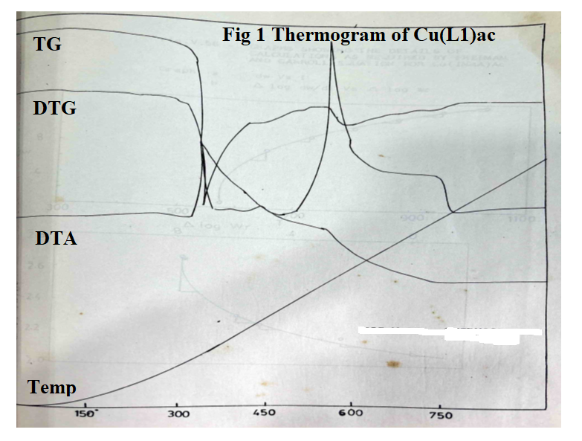 **Fig 1: Thermogram of Cu(INMAO)ac complex – TG,DTG,DTA vs Temp oC**

The loss in weight due to thermal decomposition as observed at different temperatures in TGA was calculated and plotted against the temperatures respectively and the coordinates of graphs required for Freeman and Carroll equation, (Δ log dw/dT)/(Δ log Wr) = - Ea/2.303R [(Δ 1/T)/(Δ log Wr)] + n; for evaluation of kinetic parameters, Ea = 22.07 Kcal/mole; n = 0.78for Cu(INMAO)ac complex are given in Table 3 and Fig 2.

**Table 3: Statement showing coordinates of graphs required for Cu(L1)ac complex.**

|  |  |  |  |  |  |  |  |  |
| --- | --- | --- | --- | --- | --- | --- | --- | --- |
| **Temperature T K** | **Weight loss (dw)** | **Slope values dw/dT** | **Δ log dw/dT\*** | **Wr = (Wc-W)** | **Δ log Wr\*** | **Slope values 4 vs 6** | **Δ 1/T x 10-4** | **Slope values Δ 1/T vs Δ log Wr** |
| 573 | 0.6010 | - | - | 12.95 | $\overline{1}$.1123 | - | 17.45 | - |
| 648 | 7.55 | 0.048 | $\overline{2}$.6812 | 6.01 | 0.7789 | 3.0 | 15.43 | 1.2 |
| 723 | 9.70 | 0.020 | $\overline{2}$.3010 | 3.86 | 0.5866 | 0.7 | 13.83 | 1.0 |
| 798 | 10.38 | 0.018 | $\overline{2}$.2553 | 3.18 | 0.5024 | 0.6 | 12.53 | 0.8 |
| 873 | 11.93 | 0.015 | $\overline{2}$.1761 | 1.63 | 0.2122 | 0.5 | 11.45 | 0.6 |
| 948 | 12.96 | 0.012 | $\overline{2}$.0792 | 0.60 | $\overline{1}$.7782 | 0.3 | 10.54 | 0.4 |
| 1023 | 13.56 | 0.008 | - | - | - | - | 9.77 | - |

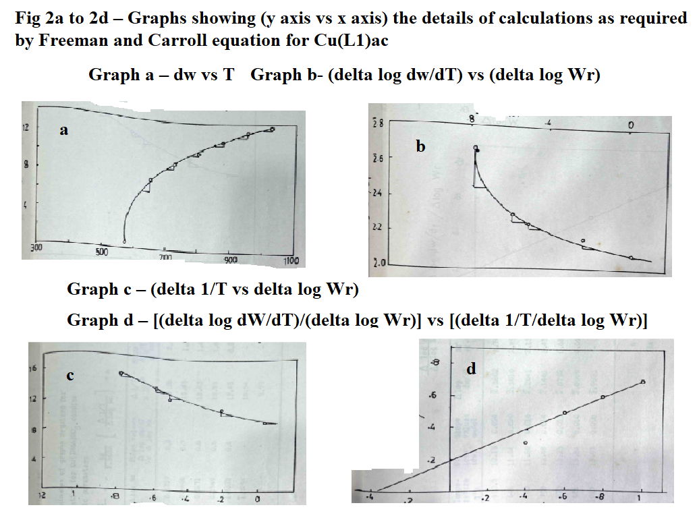 **Fig 2 a-d – Graphs showing (y axis vs x axis) for Cu(INMAO)ac complex**

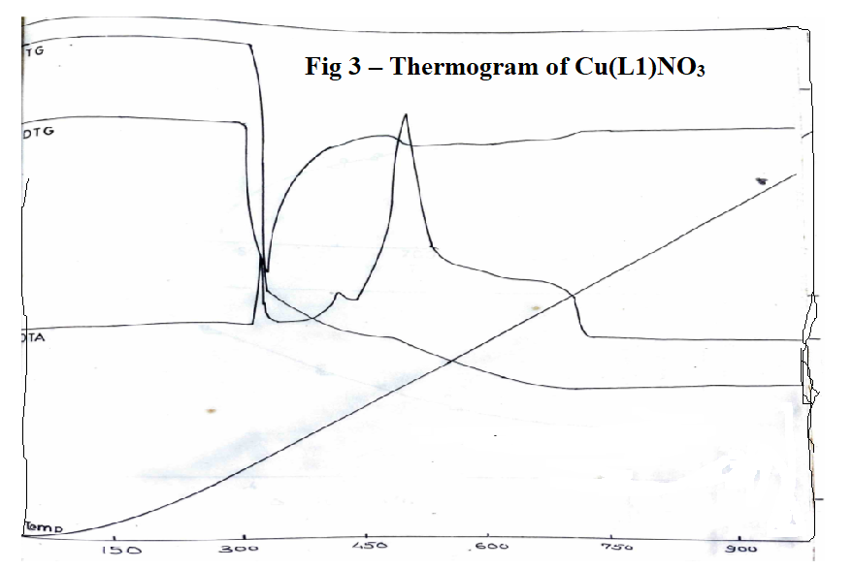 **Fig 3: Thermogram of Cu(INMAO)NO3 complex – TG,DTG,DTA vs Temp oC**

The loss in weight due to thermal decomposition as observed at different temperatures in TGA was calculated and plotted against the temperatures respectively and the coordinates of graphs required for Freeman and Carroll equation, (Δ log dw/dT)/(Δ log Wr) = - Ea/2.303R [(Δ 1/T)/(Δ log Wr)] + n; for evaluation of kinetic parameters, Ea = 11.03 Kcal/mole; n = 0.8 for Cu(INMAO)NO3 complex are given in Table 4 and Fig 4.

**Table 4: Statement showing coordinates of graphs required for Cu(L1)NO3 complex.**

|  |  |  |  |  |  |  |  |  |
| --- | --- | --- | --- | --- | --- | --- | --- | --- |
| **Temperature T K** | **Weight loss (dw)** | **Slope values dw/dT** | **Δ log dw/dT\*** | **Wr = (Wc-W)** | **Δ log Wr\*** | **Slope values 4 vs 6** | **Δ 1/T x 10-4** | **Slope values Δ 1/T vs Δ log Wr** |
| 610.5 | 10.19 | 0.024 | $\overline{2}$.3802 | 3.74 | 0.5727 | 0.8 | 16.38 | 2.0 |
| 648 | 11.04 | 0.020 | $\overline{2}$.3010 | 2.89 | 0.4608 | 0.7 | 15.45 | 1.8 |
| 723 | 11.80 | 0.016 | $\overline{2}$.2041 | 2.13 | 0.3271 | 0.6 | 13.83 | 1.4 |
| 798 | 12.48 | 0.014 | $\overline{2}$.1461 | 1.45 | 0.1599 | 0.5 | 12.53 | 1.0 |
| 873 | 13.25 | 0.012 | $\overline{2}$.0792 | 0.68 | $\overline{1}$.8325 | 0.4 | 11.45 | 0.8 |
| 948 | 13.84 | 0.010 | $\overline{2}$.0000 | 0.09 | $\overline{1}$.9294 | - | 10.54 | - |
| 1023 | 13.93 | 0.008 | 3.9031 | - | - | - | 9.77 | - |

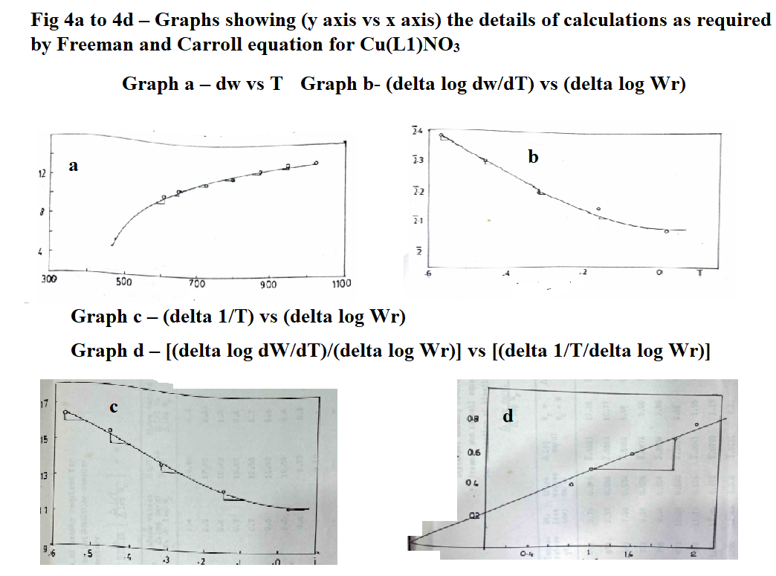

**Fig 4 a-d – Graphs showing (y axis vs x axis) for Cu(INMAO)NO3 complex**

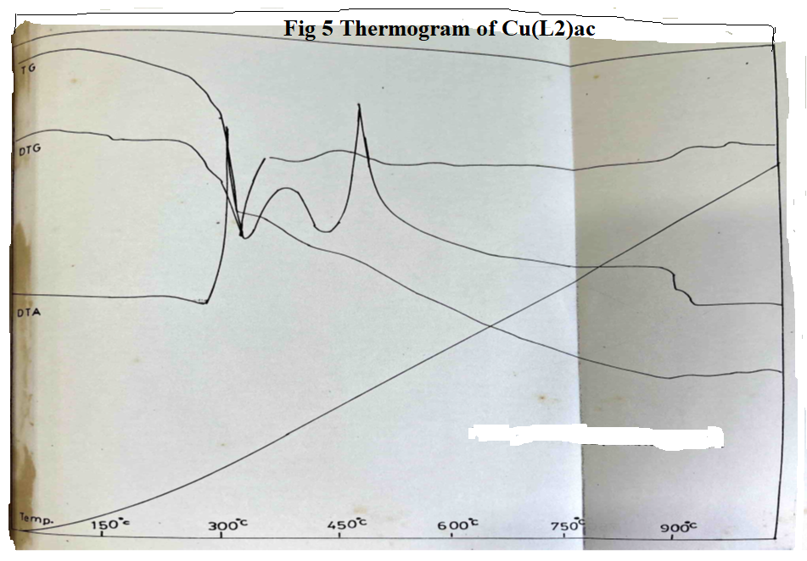 **Fig 5: Thermogram of Cu(INM-p-TO)ac complex – TG,DTG,DTA vs Temp oC**

The loss in weight due to thermal decomposition as observed at different temperatures in TGA was calculated and plotted against the temperatures respectively and the coordinates of graphs required for Freeman and Carroll equation, (Δ log dw/dT)/(Δ log Wr) = - Ea/2.303R [(Δ 1/T)/(Δ log Wr)] + n; for evaluation of kinetic parameters Ea = 20.96 Kcal/mole; n = 0.15;for Cu(INM-p-TO)ac complex are given in Table 5 and Fig 6.

**Table 5: Statement showing coordinates of graphs required for Cu(L2)ac complex.**

|  |  |  |  |  |  |  |  |  |
| --- | --- | --- | --- | --- | --- | --- | --- | --- |
| **Temperature T K** | **Weight loss (dw)** | **Slope values dw/dT** | **Δ log dw/dT\*** | **Wr = (Wc-W)** | **Δ log Wr\*** | **Slope values 4 vs 6** | **Δ 1/T x 10-4** | **Slope values Δ 1/T vs Δ log Wr** |
| 498 | 0.76 | 0.040 | $\overline{2}$.6021 | 12.38 | $\overline{1}$.0927 | 1.4 | 20.80 | 4.0 |
| 573 | 2.37 | 0.036 | $\overline{2}$.5563 | 10.77 | $\overline{1}$.0304 | 1.2 | 17.45 | 2.2 |
| 648 | 7.20 | 0.032 | $\overline{2}$.5051 | 5.94 | 0.7738 | 0.8 | 15.43 | 1.0 |
| 723 | 8.14 | 0.028 | $\overline{2}$.4472 | 5.00 | 0.6990 | 0.7 | 13.83 | 0.8 |
| 798 | 9.24 | 0.024 | $\overline{2}$.3802 | 3.90 | 0.5911 | 0.7 | 12.53 | 0.7 |
| 873 | 10.26 | 0.020 | $\overline{2}$.3010 | 2.88 | 0.4594 | 0.6 | 11.45 | 0.6 |
| 948 | 11.19 | 0.016 | $\overline{2}$.2041 | 1.95 | 0.2900 | 0.5 | 10.54 | 0.4 |
| 1023 | 11.95 | 0.012 | $\overline{2}$.0792 | 1.19 | 0.0755 | 0.4 | 9.77 | 0.3 |
| 1098 | 12.63 | 0.008 | 3.9031 | 0.51 | $\overline{1}$.7076 | - | 9.10 | - |
| 1173 | 13.14 | - | - | - | - | - | - | - |

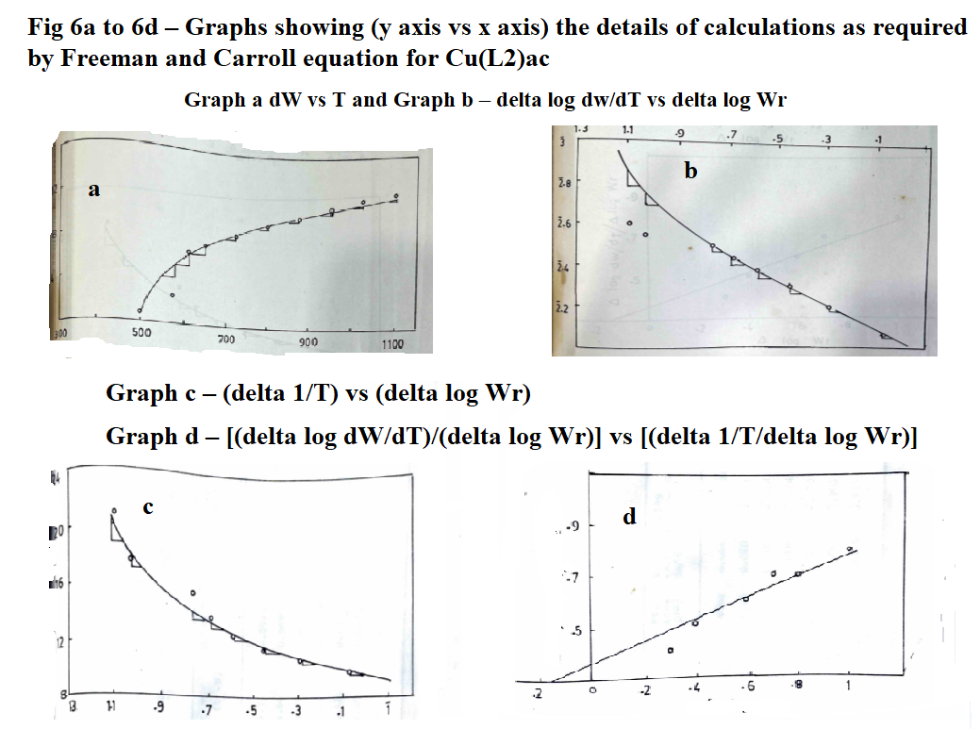

**Fig 6 a-d – Graphs showing (y axis vs x axis) for Cu(INM-p-TO)ac complex**

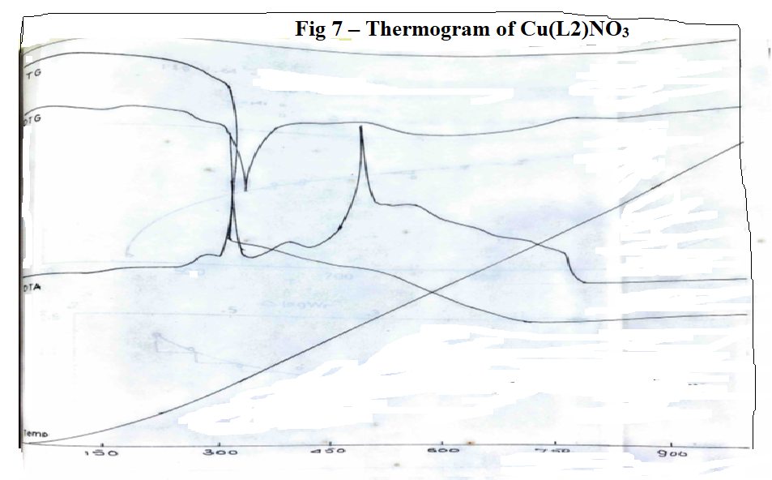 **Fig 7: Thermogram of Cu(INM-p-TO)NO3 complex – TG,DTG,DTA vs Temp oC**

The loss in weight due to thermal decomposition as observed at different temperatures in TGA was calculated and plotted against the temperatures respectively and the coordinates of graphs required for Freeman and Carroll equation, (Δ log dw/dT)/(Δ log Wr) = - Ea/2.303R [(Δ 1/T)/(Δ log Wr)] + n; for evaluation of kinetic parameters, Ea = 19.42 Kcal/mole; n = 0.7 for Cu(INM-p-TO)NO3 complex are given in Table 6 and Fig 8.

**Table 6: Statement showing coordinates of graphs required for Cu(L2)NO3 complex.**

|  |  |  |  |  |  |  |  |  |
| --- | --- | --- | --- | --- | --- | --- | --- | --- |
| **Temperature T K** | **Weight loss (dw)** | **Slope values dw/dT** | **Δ log dw/dT\*** | **Wr = (Wc-W)** | **Δ log Wr\*** | **Slope values 4 vs 6** | **Δ 1/T x 10-4** | **Slope values Δ 1/T vs Δ log Wr** |
| 610.5 | 9.92 | 0.024 | $\overline{2}$.3802 | 3.90 | 0.5911 | 2.0 | 16.38 | 3.0 |
| 648 | 10.28 | 0.020 | $\overline{2}$.3010 | 3.54 | 0.5490 | 1.2 | 15.45 | 2.0 |
| 723 | 10.81 | 0.016 | $\overline{2}$.2041 | 3.01 | 0.4771 | 0.8 | 13.83 | 1.0 |
| 798 | 11.25 | 0.015 | $\overline{2}$.1761 | 2.57 | 0.4099 | 0.6 | 12.53 | 0.8 |
| 873 | 12.41 | 0.012 | $\overline{2}$.0791 | 1.41 | 0.1461 | 0.2 | 11.48 | 0.6 |
| 948 | 13.47 | 0.008 | 3.9031 | 0.35 | $\overline{1}$.5441 | - | 10.54 | - |
| 1023 | 13.82 | 0.0028 | 3.4471 | - | - | - | 9.77 | - |

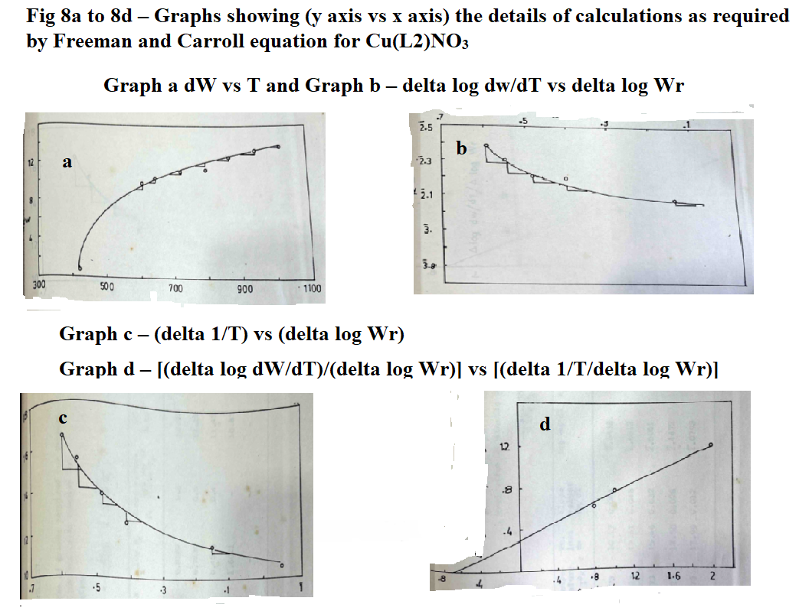

**Fig 8 a-d – Graphs showing (y axis vs x axis) for Cu(INM-p-TO)ac complex**

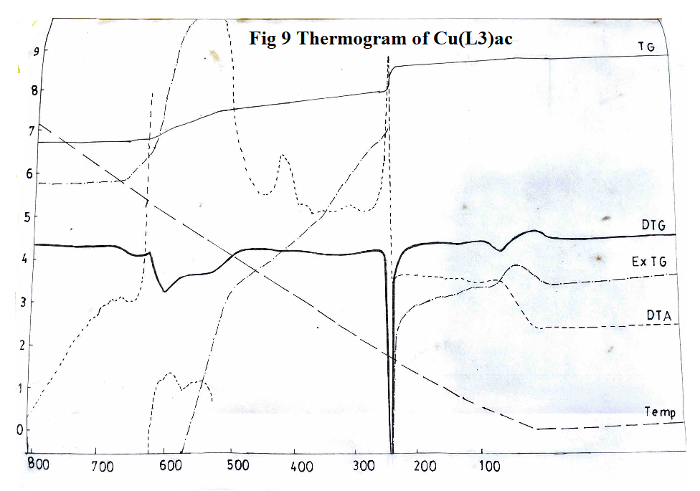 **Fig 9: Thermogram of Cu(INM-o-ANISO)ac complex – TG,DTG,ExTG,DTA vs Temp oC**

The loss in weight due to thermal decomposition as observed at different temperatures in TGA was calculated and plotted against the temperatures respectively and the coordinates of graphs required for Freeman and Carroll equation, (Δ log dw/dT)/(Δ log Wr) = - Ea/2.303R [(Δ 1/T)/(Δ log Wr)] + n; for evaluation of kinetic parameters, Ea = 19.12 Kcal/mole and n = 0.65 for Cu(INM-o-ANISO)ac complex are given in Table 7 and Fig 10.

**Table 7: Statement showing coordinates of graphs required for Cu(L3)ac complex.**

|  |  |  |  |  |  |  |  |  |
| --- | --- | --- | --- | --- | --- | --- | --- | --- |
| **Temperature T K** | **Weight loss (dw)** | **Slope values dw/dT** | **Δ log dw/dT\*** | **Wr = (Wc-W)** | **Δ log Wr\*** | **Slope values 4 vs 6** | **Δ 1/T x 10-4** | **Slope values Δ 1/T vs Δ log Wr** |
| 773 | 10.17 | 0.044 | $\overline{2}$.6438 | 7.73 | 0.8882 | 0.6 | 12.93 | 0.8 |
| 823 | 12.61 | 0.048 | $\overline{2}$.6812 | 5.29 | 0.7235 | 0.5 | 12.15 | 0.4 |
| 873 | 15.46 | 0.032 | $\overline{2}$.5051 | 2.85 | 0.4548 | 0.4 | 11.45 | 0.2 |
| 923 | 17.50 | 0.028 | $\overline{2}$.4472 | 0.40 | $\overline{1}$.6021 | - | 10.83 | - |
| 973 | 17.90 | 0.012 | $\overline{2}$.0793 | - | - | - | - | - |

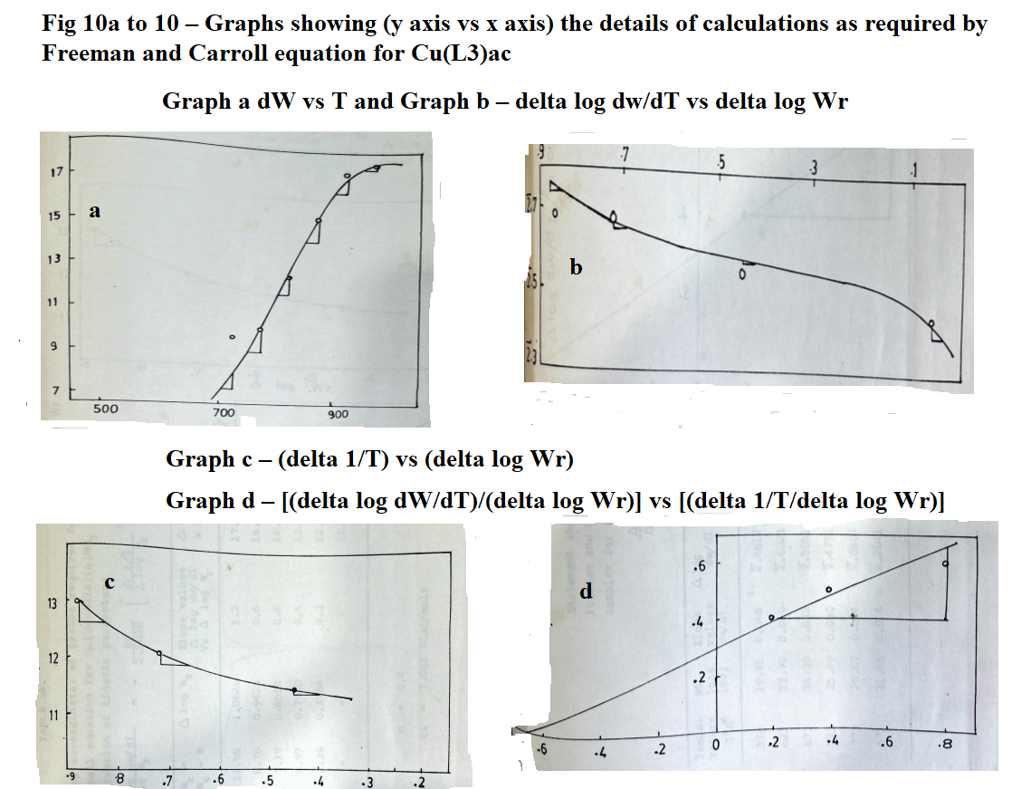 **Fig 10 a-d – Graphs showing (y axis vs x axis) for Cu(INM-o-ANISO)ac complex**

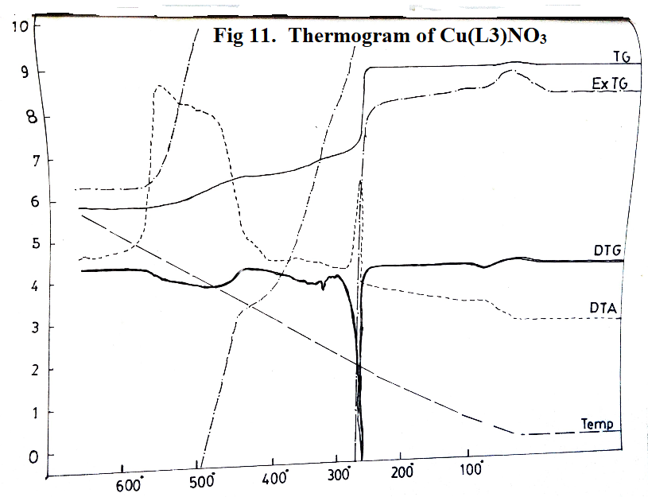 **Fig 11: Thermogram of Cu(INM-o-ANISO)NO3 complex–TG,ExTG,DTG,DTA vs Temp oC**

The loss in weight due to thermal decomposition as observed at different temperatures in TGA was calculated and plotted against the temperatures respectively and the coordinates of graphs required for Freeman and Carroll equation, (Δ log dw/dT)/(Δ log Wr) = - Ea/2.303R [(Δ 1/T)/(Δ log Wr)] + n; for evaluation of kinetic parameters, Ea = 7.062 Kcal/mole; n = 0.4 for Cu(INM-o-ANISO)ac complex are given in Table 8 and Fig 12.

**Table 8: Statement showing coordinates of graphs required for Cu(L3)NO3 complex.**

|  |  |  |  |  |  |  |  |  |
| --- | --- | --- | --- | --- | --- | --- | --- | --- |
| **Temperature T K** | **Weight loss (dw)** | **Slope values dw/dT** | **Δ log dw/dT\*** | **Wr = (Wc-W)** | **Δ log Wr\*** | **Slope values 4 vs 6** | **Δ 1/T x 10-4** | **Slope values Δ 1/T vs Δ log Wr** |
| 573 | 19.91 | 0.048 | $\overline{2}$.6812 | 11.55 | $\overline{1}$.0626 | 1.2 | 17.45 | 3.2 |
| 623 | 22.70 | 0.040 | $\overline{2}$.6021 | 8.76 | 0.9425 | 0.6 | 16.05 | 2.0 |
| 673 | 24.29 | 0.032 | $\overline{2}$.5051 | 7.17 | 0.8555 | 0.5 | 14.85 | 1.2 |
| 723 | 25.49 | 0030 | $\overline{2}$.4771 | 5.97 | 0.7760 | 0.4 | 14.83 | 0.8 |
| 773 | 29.07 | 0.024 | $\overline{2}$.3802 | 2.39 | 0.3784 | 0.3 | 12.93 | 0.4 |
| 673 | 31.46 | 0.016 | $\overline{2}$.2041 | - | - | - | 11.45 | - |

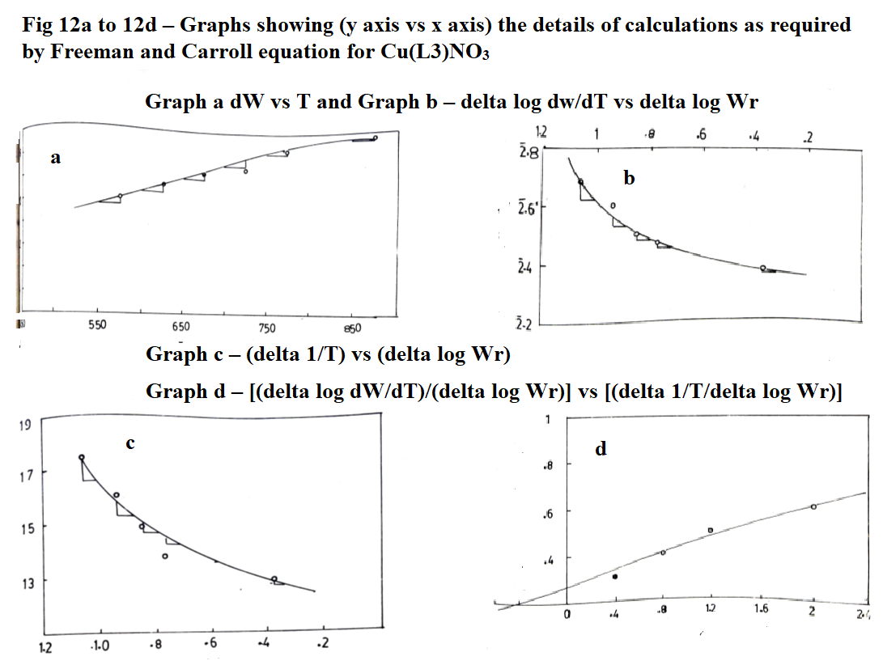 **Fig 12 a-d – Graphs showing (y axis vs x axis) for Cu(INM-o-ANISO)NO3 complex**

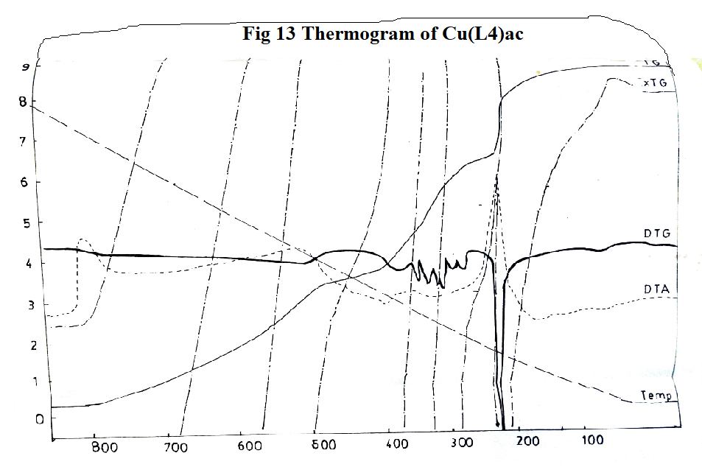 **Fig 13: Thermogram of Cu(INM-p-ANISO)ac complex – TG,ExTG,DTG,DTA vs Temp oC**

The loss in weight due to thermal decomposition as observed at different temperatures in TGA was calculated and plotted against the temperatures respectively and the coordinates of graphs required for Freeman and Carroll equation, (Δ log dw/dT)/(Δ log Wr) = - Ea/2.303R [(Δ 1/T)/(Δ log Wr)] + n; for evaluation of kinetic parameters, Ea = 22.01 Kcal/mole; n = 0.44 for Cu(INM-p-ANISO)ac complex are given in Table 9 and Fig 14.

**Table 9: Statement showing coordinates of graphs required for Cu(L4)ac complex.**

|  |  |  |  |  |  |  |  |  |
| --- | --- | --- | --- | --- | --- | --- | --- | --- |
| **Temperature T K** | **Weight loss (dw)** | **Slope values dw/dT** | **Δ log dw/dT\*** | **Wr = (Wc-W)** | **Δ log Wr** | **Slope values 4 vs 6** | **Δ 1/T x 10-4** | **Slope values Δ 1/T vs Δ log Wr** |
| 525 | 24.56 | 0.16 | 1.2041 | 63.05 | $\overline{1}$.7996 | 1.10 | 19.04 | 2.4 |
| 625 | 43.61 | 0.14 | 1.1461 | 44.02 | $\overline{1}$.6437 | 0.45 | 16.00 | 1.4 |
| 725 | 55.51 | 0.16 | 1.2041 | 32.12 | $\overline{1}$.5068 | 0.35 | 13.79 | 0.8 |
| 825 | 66.22 | 0.14 | 1.1461 | 21.41 | $\overline{1}$.3306 | 0.30 | 12.12 | 0.6 |
| 925 | 78.91 | 0.12 | 1.0792 | 8.72 | 0.9400 | 0.20 | 10.81 | 0.4 |
| 1025 | 84.85 | 0.08 | $\overline{2}$.9031 | 2.78 | 0.4440 | - | 9.75 | 0.2 |
| 1075 | 87.63 | 0.04 | $\overline{2}$.6021 | - | - | - | 9.32 | - |

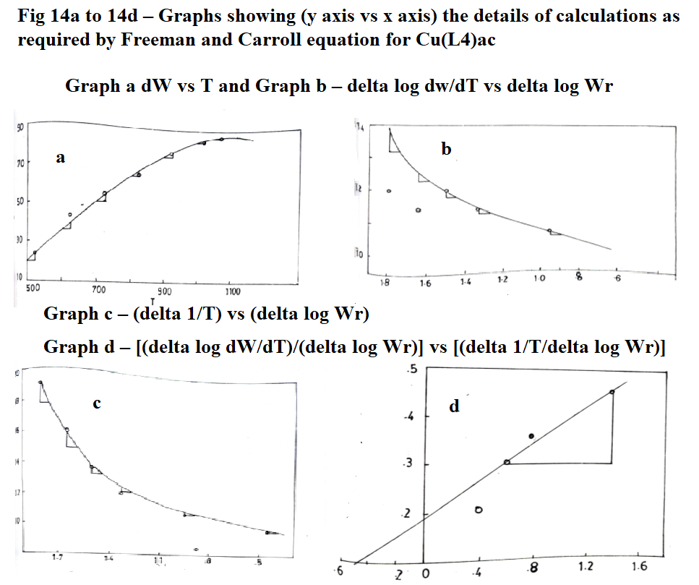 **Fig 14 a-d – Graphs showing (y axis vs x axis) for Cu(INM-p-ANISO)ac complex**

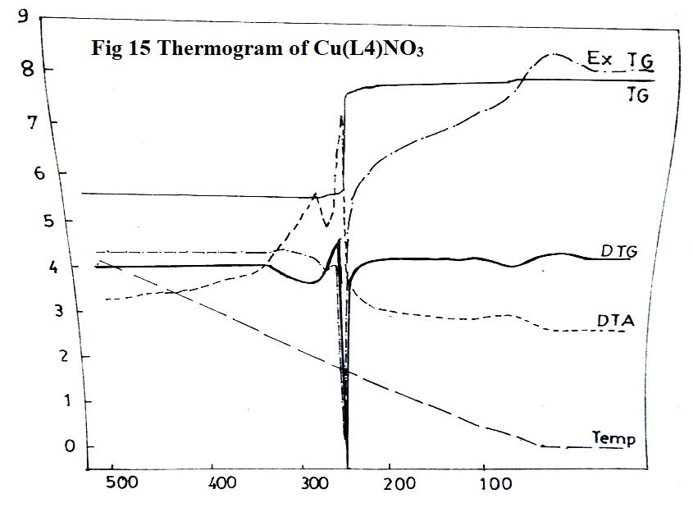 **Fig 15: Thermogram of Cu(INM-p-ANISO)NO3 complex – TG,DTG,DTA vs Temp oC**

The loss in weight due to thermal decomposition as observed at different temperatures in TGA was calculated and plotted against the temperatures respectively and the coordinates of graphs required for Freeman and Carroll equation, (Δ log dw/dT)/(Δ log Wr) = - Ea/2.303R [(Δ 1/T)/(Δ log Wr)] + n; for evaluation of kinetic parameters, Ea = 19.50 Kcal/mole and n = 0.18 for Cu(INM-p-ANISO)NO3 complex are given in Table 10 and Fig 16.

**Table 10: Statement showing coordinates of graphs required for Cu(L4)NO3 complex.**

|  |  |  |  |  |  |  |  |  |
| --- | --- | --- | --- | --- | --- | --- | --- | --- |
| **Temperature T K** | **Weight loss (dw)** | **Slope values dw/dT** | **Δ log dw/dT\*** | **Wr = (Wc-W)** | **Δ log Wr** | **Slope values 4 vs 6** | **Δ 1/T x 10-4** | **Slope values Δ 1/T vs Δ log Wr** |
| 423 | 1.58 | 0.052 | $\overline{2}$.7160 | 22.75 | $\overline{1}$.3570 | 1.6 | 23.64 | 4.4 |
| 473 | 2.37 | 0.040 | $\overline{2}$.6021 | 21.96 | $\overline{1}$.3416 | 0.9 | 21.14 | 1.8 |
| 523 | 22.94 | 0.032 | $\overline{2}$.5051 | 1.39 | 0.1430 | 0.1 | 19.12 | 0.2 |
| 573 | 24.33 | 0.024 | $\overline{2}$.3802 | - | - | - | 17.45 | - |

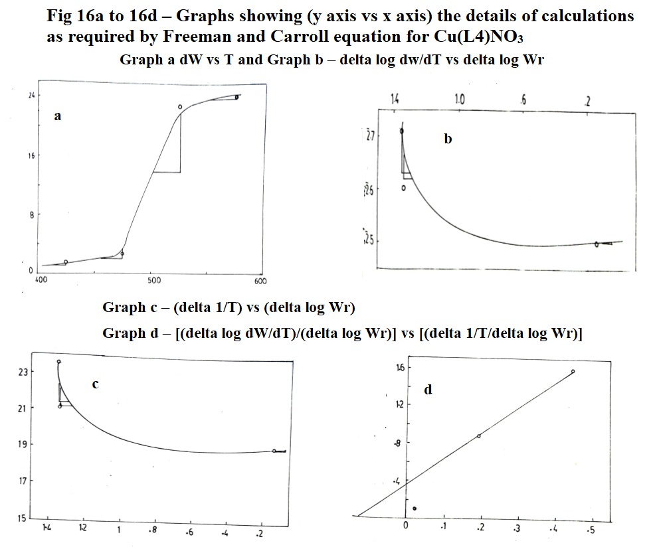 **Fig 16 a-d – Graphs showing (y axis vs x axis) for Cu(INM-p-ANISO)NO3 complex**

The thermal stability of Cu(II) complexes decreasing with bulky groups attached to the ligands, temperature range, % of decomposition, corresponding group decomposed as well as kinetic parameters Ea the activation energy, n the order of reaction and (ΔH the change in enthalpy = peak area x calibration factor (K = 0.62 cal/sq.cm)/sample wt) are given in Table 11.

**Table 11: Statement showing thermal stability and kinetic parameters of all eight copper(II) complexes.**

|  |  |  |  |  |  |  |  |
| --- | --- | --- | --- | --- | --- | --- | --- |
| **Complex** | **Decomposition** | | | **Thermal stability**  **0C** | **Ea Kcal/**  **mole** | **n** | **ΔH** |
| **Temperature 0C** | **%** | **Corresponding group** |
| Cu(L1)ac | 250-300  525-575 | 29.16  49.67 | R-NH-C=O  R-NH-C=O & C6H5 | 300 | 22.07 | 0.78 | -330.15 |
| Cu(L1)NO3 | 270-300 | 47.84 | R-NH-C=O  R-NH-C=O & C6H5 | 310 | 11.03 | 0.80 | -263.65 |
| Cu(L2)ac | 250-300  525-575 | 31.25  52.01 | R-NH-C=O  R-NH-C=O & C6H5CH3 | 225 | 20.96 | 0.15 | -286.24 |
| Cu(L2)NO3 | 270-300 | 50.21 | R-NH-C=O  R-NH-C=O & C6H5CH3 | 200 | 19.42 | 0.70 | -58.64 |
| Cu(L3)ac | 250-300  525-575 | 30.18  58.46 | R-NH-C=O  R-NH-C=O & C6H5OCH3 | 240 | 19.12 | 0.65 | -9.15 |
| Cu(L3)NO3 | 270-300 | 53.06 | R-NH-C=O  R-NH-C=O & C6H5OCH3 | 255 | 7.062 | 0.40 | -12.43 |
| Cu(L4)ac | 250-300  525-575 | 31.44  59.80 | R-NH-C=O  R-NH-C=O & C6H5OCH3 | 225 | 22.07 | 0.44 | -172.17 |
| Cu(L4)NO3 | 270-300 | 55.25 | R-NH-C=O  R-NH-C=O & C6H5OCH3 | 200 | 19.50 | 0.18 | -1800 |

**3.3.1.2 Mn (II) complexes:**

All the four Mn(II) complexes, Mn(L1)2, Mn(L2)2, Mn(L3)2, Mn(L4)2 are found to be thermally stable up to 2500C (Figs 17, 19, 21, 23).

The thermal stability of these complexes up to 2500C clearly indicates that they do not contain any water molecule, in agreement with the infrared spectral data, which do not show any band in the region 3360-3300 cm-1. The order of thermal stability of the four Mn(II) complexes is found to be Mn(L3)2>Mn(L1)2>Mn(L2)2>Mn(L4)2 as their decomposition temperature ranges from 317, 291, 275, 240 oC respectively. The order of thermal stability indicates that Mn(L2)2 complex is found to be more stable than other Mn(II) complexes whereas Mn(L4)2 complex is the least stable. However, these four complexes are more stable than Mn(II) complexes of 2- hydroxy-1-naphthalodoxime and salicylaldoxime reported earlier (Ramesh, 1980).

DTA curve indicates that these complexes decompose in three exothermic steps, first exothermic decomposition of these complexes supply heat to the system, and hence the second and third steps follow over a narrow temperature range.

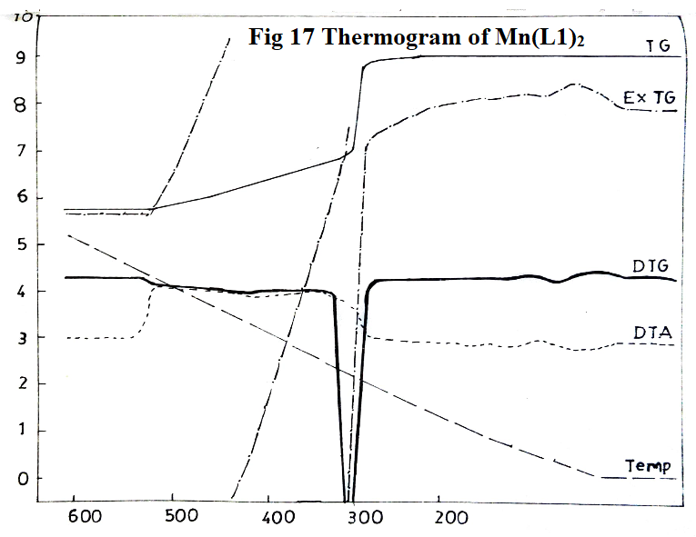 **Fig 17: Thermogram of Mn(INMAO)2 complex – TG,ExTG,DTG,DTA vs Temp oC**

The loss in weight due to thermal decomposition as observed at different temperatures in TGA was calculated and plotted against the temperatures respectively and the coordinates of graphs required for Freeman and Carroll equation, (Δ log dw/dT)/(Δ log Wr) = - Ea/2.303R [(Δ 1/T)/(Δ log Wr)] + n; for evaluation of kinetic parameters, Ea = 22.07 Kcal/mole; n = 0.4 for Mn(INMAO)2 complex are given in Table 12 and Fig 18.

**Table 12: Statement showing coordinates of graphs required for Mn(L1)2 complex.**

|  |  |  |  |  |  |  |  |  |
| --- | --- | --- | --- | --- | --- | --- | --- | --- |
| **Temperature T K** | **Weight loss (dw)** | **Slope values dw/dT** | **Δ log dw/dT\*** | **Wr = (Wc-W)** | **Δ log Wr\*** | **Slope values 4 vs 6** | **Δ 1/T x 10-4** | **Slope values Δ 1/T vs Δ log Wr** |
| 573 | 18.81 | 0.072 | $\overline{2}$.8573 | 13.61 | $\overline{1}$.1338 | 0.45 | 17.45 | 0.80 |
| 623 | 28.62 | 0.068 | $\overline{2}$.8325 | 8.80 | 0.9448 | 0.50 | 16.05 | 0.90 |
| 673 | 26.42 | 0.064 | $\overline{2}$.8062 | 6.00 | 07786 | 0.60 | 14.85 | 1.00 |
| 723 | 29.22 | 0.048 | $\overline{2}$.6812 | 3.20 | 0.5059 | 0.70 | 13.83 | 1.20 |
| 773 | 31.62 | 0.032 | $\overline{2}$.5051 | 0.80 | $\overline{1}$.9036 | 0.80 | 12.93 | - |
| 823 | 32.42 | 0.012 | $\overline{2}$.0792 | - | - | - | 12.15 | - |

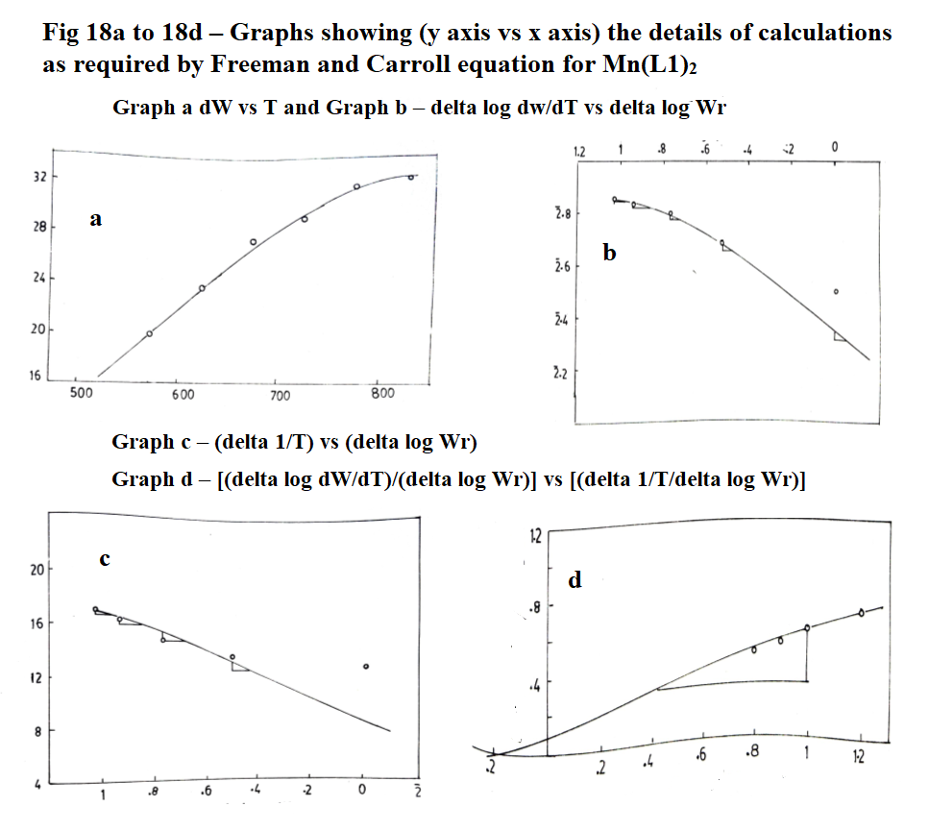 **Fig 18 a-d – Graphs showing (y axis vs x axis) for Mn(INMAO)2 complex**

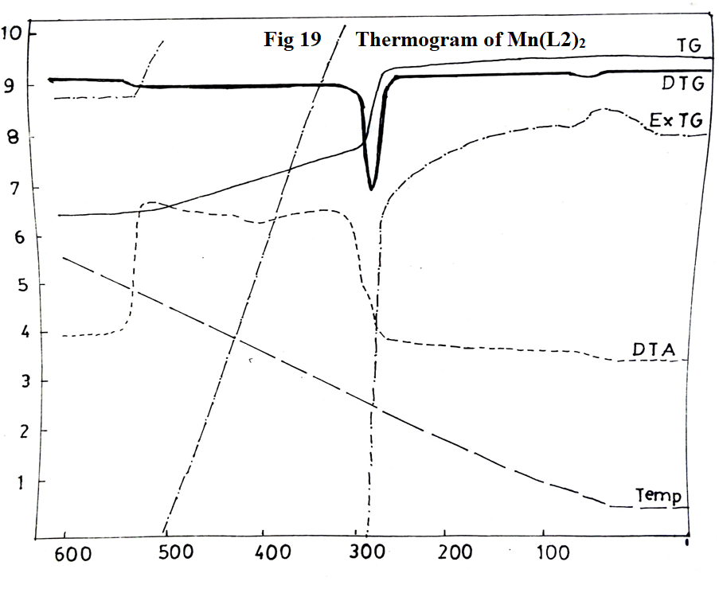 **Fig 19: Thermogram of Mn(INM-p-TO)2 complex – TG,ExTG,DTG,DTA vs Temp oC**

The loss in weight due to thermal decomposition as observed at different temperatures in TGA was calculated and plotted against the temperatures respectively and the coordinates of graphs required for Freeman and Carroll equation, (Δ log dw/dT)/(Δ log Wr) = - Ea/2.303R [(Δ 1/T)/(Δ log Wr)] + n; for evaluation of kinetic parameters, Ea = 22.07 Kcal/mole; n = 0.39 for Mn(INM-p-TO)2 complex are given in Table 13 and Fig 20.

**Table 13: Statement showing coordinates of graphs required for Mn(L2)2 complex.**

|  |  |  |  |  |  |  |  |  |
| --- | --- | --- | --- | --- | --- | --- | --- | --- |
| **Temperature T K** | **Weight loss (dw)** | **Slope values dw/dT** | **Δ log dw/dT\*** | **Wr = (Wc-W)** | **Δ log Wr\*** | **Slope values 4 vs 6** | **Δ 1/T x 10-4** | **Slope values Δ 1/T vs Δ log Wr** |
| 573 | 15.34 | 0.112 | $\overline{1}$.0492 | 13.77 | $\overline{1}$.1388 | 1.3 | 17.45 | 1.2 |
| 623 | 19.27 | 0.072 | $\overline{2}$.8573 | 9.84 | 0.9930 | 0.9 | 16.05 | 0.8 |
| 673 | 22.03 | 0.056 | $\overline{2}$.7482 | 7.08 | 0.8500 | 0.5 | 14.85 | 0.6 |
| 723 | 24.78 | 0.048 | $\overline{2}$.6812 | 4.33 | 0.6365 | 0.4 | 13.83 | 0.4 |
| 773 | 27.53 | 0.040 | $\overline{2}$.6021 | 1.58 | 0.1987 | 0.35 | 12.93 | 0.3 |
| 823 | 28.72 | 0.032 | $\overline{2}$.5051 | 039 | $\overline{1}$.5911 | 0.3 | 12.15 | 0.2 |
| 873 | 29.11 | 0.016 | - | 0 | 0 | 0 | 11.45 | - |

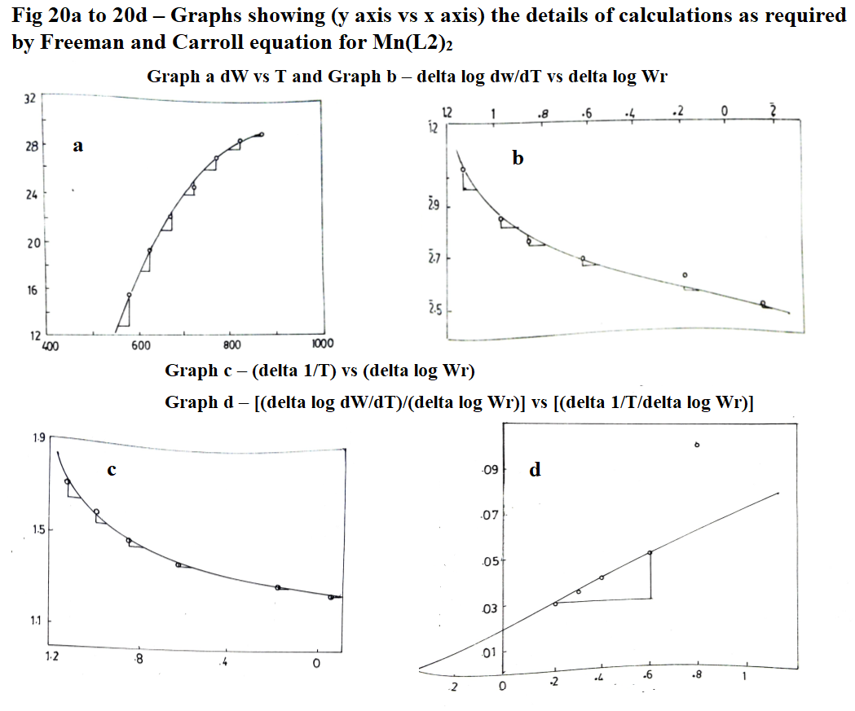 **Fig 20 a-d – Graphs showing (y axis vs x axis) for Mn(INM-p-TO)2 complex**

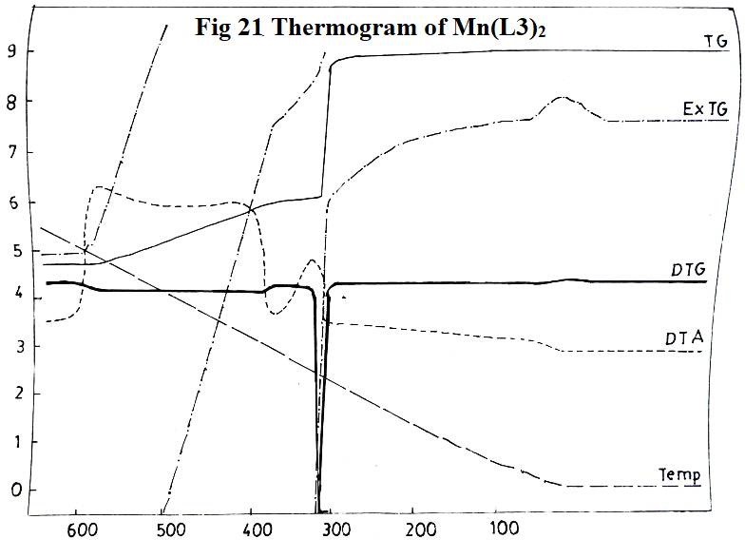 **Fig 21: Thermogram of Mn(INM-O-ANISO)2 complex – TG,ExTG,DTG,DTA vs Temp oC**

The loss in weight due to thermal decomposition as observed at different temperatures in TGA was calculated and plotted against the temperatures respectively and the coordinates of graphs required for Freeman and Carroll equation, (Δ log dw/dT)/(Δ log Wr) = - Ea/2.303R [(Δ 1/T)/(Δ log Wr)] + n; for evaluation of kinetic parameters, Ea = 22.07 Kcal/mole; n = 0.25 for Mn(INM-o-ANISO)2 complex are given in Table 14 and Fig 22.

**Table 14: Statement showing coordinates of graphs required for Mn(L3)2 complex.**

|  |  |  |  |  |  |  |  |  |
| --- | --- | --- | --- | --- | --- | --- | --- | --- |
| **Temperature T K** | **Weight loss (dw)** | **Slope values dw/dT** | **Δ log dw/dT\*** | **Wr = (Wc-W)** | **Δ log Wr** | **Slope values 4 vs 6** | **Δ 1/T x 10-4** | **Slope values Δ 1/T vs Δ log Wr** |
| 623 | 29.58 | - | - | 13.59 | $\overline{1}$.1332 | - | 16.05 | 1.2 |
| 673 | 31.98 | 0.080 | $\overline{2}$.9031 | 11.19 | $\overline{1}$.0487 | 0.6 | 14.85 | 0.8 |
| 723 | 35.57 | 0.072 | $\overline{2}$.8573 | 7.60 | 0.8808 | 0.5 | 13.83 | 0.6 |
| 773 | 38.77 | 0.064 | $\overline{2}$.8062 | 4.40 | 0.6435 | 0.3 | 12.93 | 0.3 |
| 823 | 41.17 | 0.048 | $\overline{2}$.6812 | 2.00 | 0.3010 | 0.2 | 12.15 | 0.2 |
| 873 | 43.17 | 0.032 | $\overline{2}$.5052 | - | - | - | 11.45 | - |

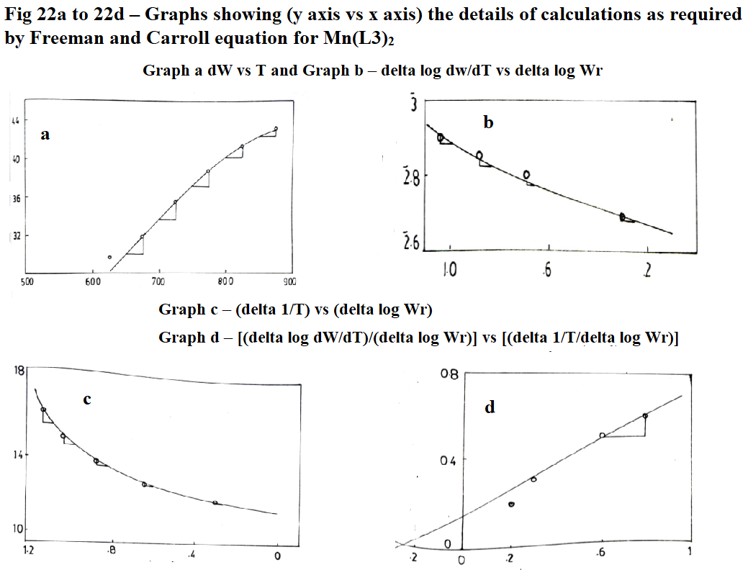 **Fig 22 a-d – Graphs showing (y axis vs x axis) for Mn(INM-o-ANISO)2 complex**

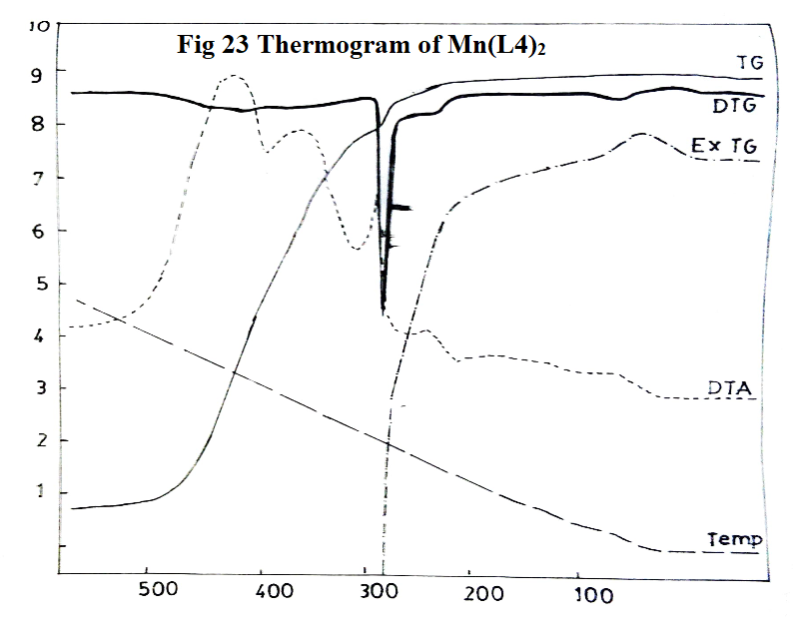 **Fig 23: Thermogram of Mn(INM-p-ANISO)2 complex – TG,ExTG,DTG,DTA vs Temp oC**

The loss in weight due to thermal decomposition as observed at different temperatures in TGA was calculated and plotted against the temperatures respectively and the coordinates of graphs required for Freeman and Carroll equation, (Δ log dw/dT)/(Δ log Wr) = - Ea/2.303R [(Δ 1/T)/(Δ log Wr)] + n; for evaluation of kinetic parameters, Ea = 11.035 Kcal/mole; n = 0.66 for Mn(INM-o-ANISO)2 complex are given in Table 15 and Fig 24.

**Table 15: Statement showing coordinates of graphs required for Mn(L4)2 complex.**

|  |  |  |  |  |  |  |  |  |
| --- | --- | --- | --- | --- | --- | --- | --- | --- |
| **Temperature T K** | **Weight loss (dw)** | **Slope values dw/dT** | **Δ log dw/dT\*** | **Wr = (Wc-W)** | **Δ log Wr** | **Slope values 4 vs 6** | **Δ 1/T x 10-4** | **Slope values Δ 1/T vs Δ log Wr** |
| 523 | 3.36 | 0.072 | $\overline{2}$.8573 | 14.30 | $\overline{1}$.1553 | 0.6 | 19.12 | 1.0 |
| 573 | 10.51 | 0.056 | $\overline{2}$.7482 | 7.15 | 0.8543 | 0.8 | 17.45 | 1.6 |
| 623 | 11.77 | 0.052 | $\overline{2}$.7160 | 5.89 | 0.7701 | 1.0 | 16.05 | 1.8 |
| 673 | 13.87 | 0.044 | $\overline{2}$.6435 | 3.79 | 0.5786 | 1.2 | 14.85 | 2.4 |
| 723 | 16.40 | 0.032 | $\overline{2}$.5051 | 1.26 | 0.1004 | 1.2 | 13.83 | - |
| 773 | 17.66 | - | - | - | - | - | - | - |

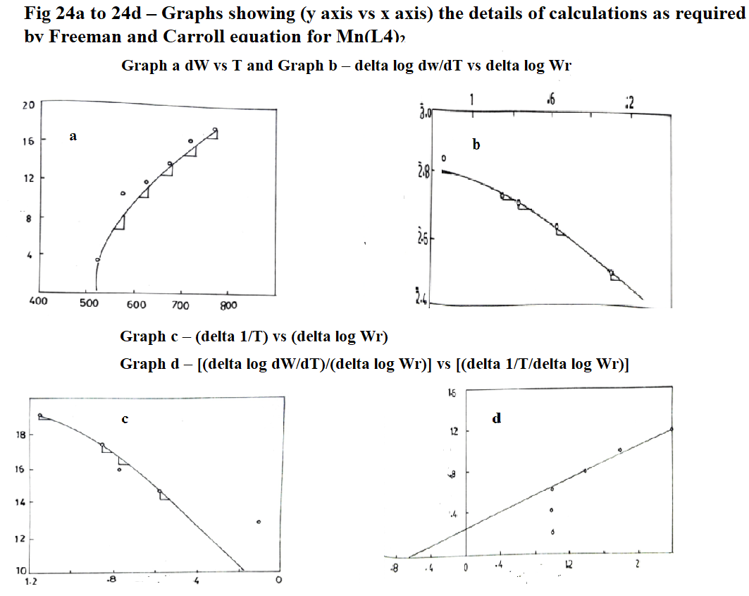 **Fig 24 a-d – Graphs showing (y axis vs x axis) for Mn(INM-p-ANISO)2 complex**

The thermal stability of Mn(II) complexes, temperature range, % of decomposition, corresponding group decomposed as well as kinetic parameters, Ea the activation energy, n the order of reaction and (ΔH the change in enthalpy = peak area x calibration factor (K = 0.62 cal/sq.cm)/sample wt) are given in Table 16.

**Table 16: Statement showing thermal stability and kinetic parameters of all four manganese(II) complexes.**

|  |  |  |  |  |  |  |  |
| --- | --- | --- | --- | --- | --- | --- | --- |
| **Complex** | **Decomposition** | | | **Thermal stability**  **0C** | **Ea Kcal/**  **mole** | **n** | **ΔH** |
| **Temperature 0C** | **%** | **Corresponding group** |
| Mn(L1)2 | 280-315  420-430  460-480 | 49.47  58.94  57.00 | R, R-NH, R-NH two C=O | 291 | 22.07 | 0.40 | -10.66 |
| Mn(L2)2 | 280-315  420-430  460-480 | 53.48  60.63  70.93 | R, R-NH, R-NH two C=O | 275 | 22.07 | 0.39 | -41.58 |
| Mn(L3)2 | 280-315  420-430  460-480 | 59.67  66.14  73.38 | R, R-NH, R-NH two C=O | 317 | 22.07 | 0.25 | -109.23 |
| Mn(L4)2 | 280-315  420-430  460-480 | 57.10  65.50  74.10 | R, R-NH, R-NH two C=O | 240 | 11.035 | 0.66 | -29.04 |

**3.3.1.3 Lead(II) complexes:**

Thermogravimetric analysis of yellow Pb(II) complexes (Figs 25, 27, 29, 31) indicate that these are thermally stable up to 1900C . Thermal stability of these complexes indicates that they are not hydrates as confirmed from the infrared spectra. The order of thermal stability is found to be Pb(L1)2>Pb (L2)2>Pb(L3)2(O)>Pb(L4)2.

The order of thermal stability indicates that Pb(L1)2 complex is found to be most stable whereas Pb(L4)2 complex is found to be least stable.

DTA curve exhibits that these complexes decompose in three different exothermic steps. The first exothermic decomposition supplies heat to the system and hence the second and third step follow over a narrow range of temperature. Residue in each case was found to be PbO.

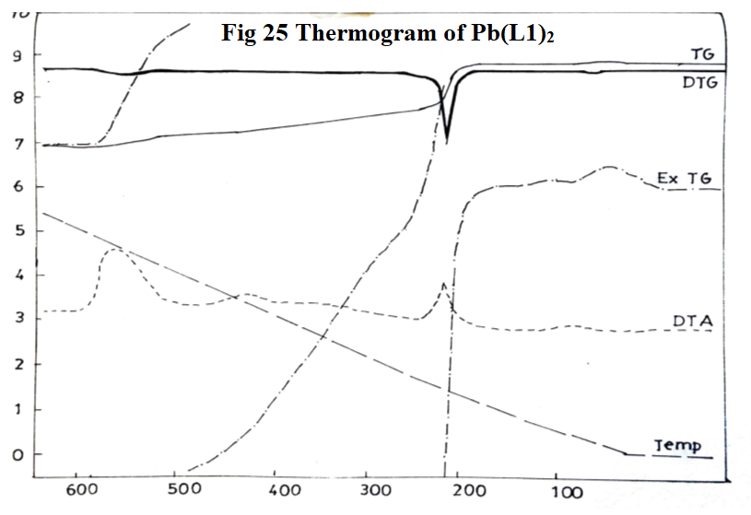 **Fig 25: Thermogram of Pb(INMAO)2 complex – TG,ExTG,DTG,DTA vs Temp oC**

The loss in weight due to thermal decomposition as observed at different temperatures in TGA was calculated and plotted against the temperatures respectively and the coordinates of graphs required for Freeman and Carroll equation, (Δ log dw/dT)/(Δ log Wr) = - Ea/2.303R [(Δ 1/T)/(Δ log Wr)] + n; for evaluation of kinetic parameters, Ea = 13.24 Kcal/mole; n = 0.38 for Pb(INMAO)2 complex are given in Table 17 and Fig 26.

**Table 17: Statement showing coordinates of graphs required for Pb(L1)2 complex.**

|  |  |  |  |  |  |  |  |  |
| --- | --- | --- | --- | --- | --- | --- | --- | --- |
| **Temperature T K** | **Weight loss (dw)** | **Slope values dw/dT** | **Δ log dw/dT\*** | **Wr = (Wc-W)** | **Δ log Wr** | **Slope values 4 vs 6** | **Δ 1/T x 10-4** | **Slope values Δ 1/T vs Δ log Wr** |
| 523 | 10.38 | 0.052 | $\overline{2}$.7160 | 915 | 0.9614 | 0.40 | 19.12 | 0.44 |
| 573 | 12.05 | 0.048 | $\overline{2}$.6812 | 7.48 | 0.8739 | 0.50 | 17.45 | 0.60 |
| 623 | 13.71 | 0.040 | $\overline{2}$.6021 | 5.83 | 0.7657 | 0.60 | 16.05 | 0.80 |
| 673 | 15.37 | 0.036 | $\overline{2}$.5563 | 4.16 | 0.6191 | 0.76 | 14.85 | 1.00 |
| 723 | 16.20 | 0.032 | $\overline{2}$.5051 | 3.33 | 0.5224 | 0.80 | 13.83 | 1.30 |
| 773 | 16.83 | 0.030 | $\overline{2}$.4771 | 2.70 | 0.4314 | 1.00 | 12.93 | 1.60 |
| 823 | 18.49 | 0.016 | $\overline{2}$.2041 | 1.040 | 0.0170 | - | 12.15 | 2.00 |
| 873 | 19.53 | 0.028 | $\overline{2}$.4472 | - | - | - | - | 2.22 |

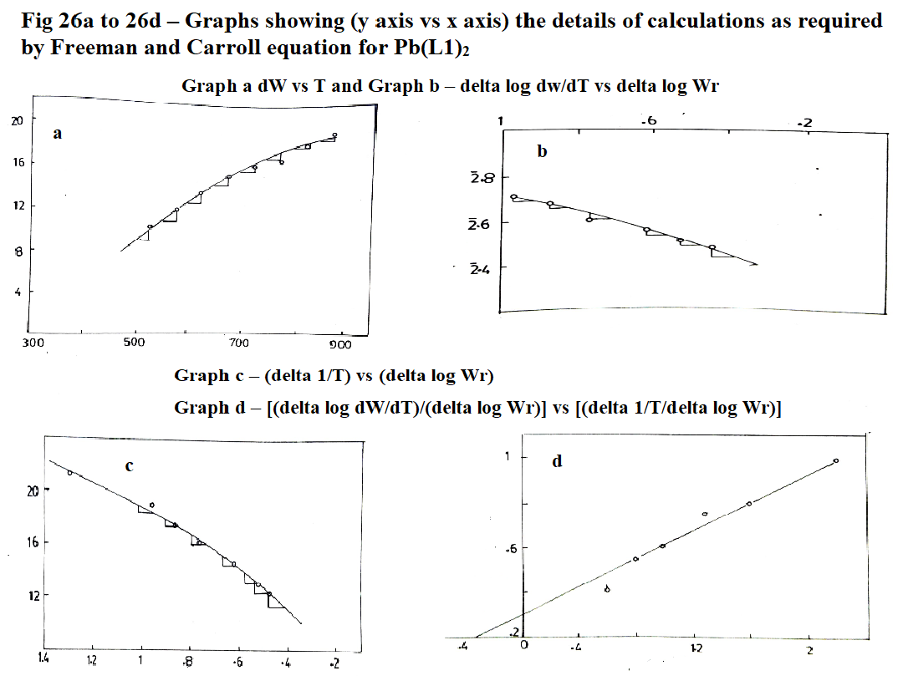 **Fig 26 a-d – Graphs showing (y axis vs x axis) for Pb(INMAO)2 complex**

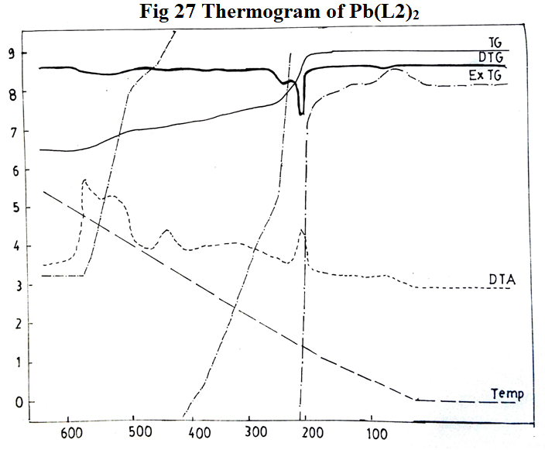 **Fig 27: Thermogram of Pb(INM-p-TO)2 complex – TG,ExTG,DTG,DTA vs Temp oC**

The loss in weight due to thermal decomposition as observed at different temperatures in TGA was calculated and plotted against the temperatures respectively and the coordinates of graphs required for Freeman and Carroll equation (Δ log dw/dT)/(Δ log Wr) = - Ea/2.303R [(Δ 1/T)/(Δ log Wr)] + n; for evaluation of kinetic parameters, Ea = 11.47 Kcal/mole; n = 0.62 for Pb(INM-p-TO)2 complex are given in Table 18 and Fig 28.

**Table 18: Statement showing coordinates of graphs required for Pb(L2)2 complex.**

|  |  |  |  |  |  |  |  |  |
| --- | --- | --- | --- | --- | --- | --- | --- | --- |
| **Temperature T K** | **Weight loss (dw)** | **Slope values dw/dT** | **Δ log dw/dT\*** | **Wr = (Wc-W)** | **Δ log Wr** | **Slope values 4 vs 6** | **Δ 1/T x 10-4** | **Slope values Δ 1/T vs Δ log Wr** |
| 523 | 13.22 | 0.080 | $\overline{2}$.9031 | 12.22 | $\overline{1}$.0871 | 0.40 | 19.12 | 1.2 |
| 573 | 15.22 | 0.056 | $\overline{2}$.7462 | 10.22 | $\overline{1}$.0096 | 0.70 | 17.45 | 1.6 |
| 623 | 17.23 | 0.040 | $\overline{2}$.6021 | 8.21 | 0.9143 | 0.75 | 16.05 | 1.8 |
| 673 | 18.43 | 0.036 | $\overline{2}$.5563 | 7.01 | 0.8457 | 0.80 | 14.85 | 2.0 |
| 723 | 19.63 | 0.032 | $\overline{2}$.5051 | 5.61 | 0.7490 | 0.90 | 13.83 | 2.4 |
| 773 | 21.03 | 0.028 | $\overline{2}$.4472 | 4.41 | 06444 | 1.00 | 12.93 | 2.8 |
| 823 | 24.44 | 0.024 | $\overline{2}$.3802 | 1.00 | 0.0000 | - | 12.15 | - |
| 873 | 25.44 | 0.020 | $\overline{2}$.3010 | - | - | - | - | - |

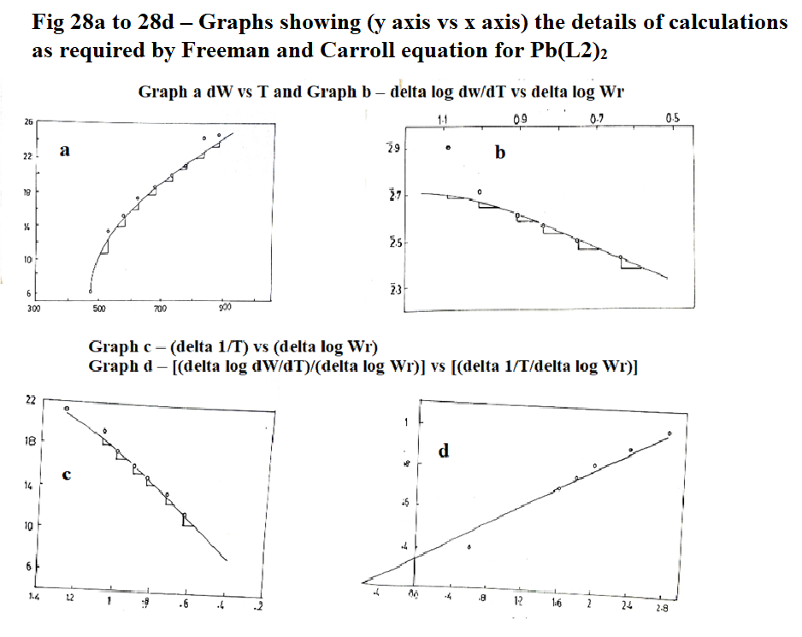 **Fig 28 a-d – Graphs showing (y axis vs x axis) for Pb(INM-p-TO)2 complex**

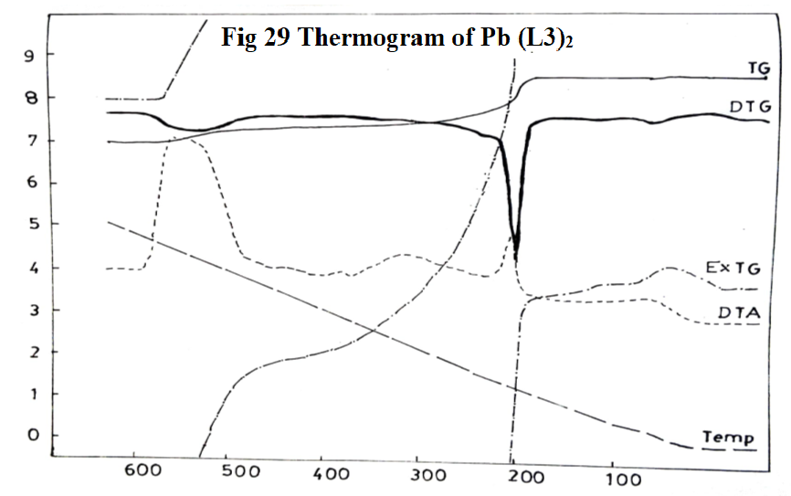 **Fig 29: Thermogram of Pb(INM-o-ANISO)2 complex – TG,ExTG,DTG,DTA vs Temp oC**

The loss in weight due to thermal decomposition as observed at different temperatures in TGA was calculated and plotted against the temperatures respectively and the coordinates of graphs required for Freeman and Carroll equation, (Δ log dw/dT)/(Δ log Wr) = - Ea/2.303R [(Δ 1/T)/(Δ log Wr)] + n; for evaluation of kinetic parameters, Ea = 15.00 Kcal/mole; n = 0.32 for Pb(INM-o-ANISO)2 complex are given in Table 19and Fig 30.

**Table 19: Statement showing coordinates of graphs required for Pb(L3)2 complex.**

|  |  |  |  |  |  |  |  |  |
| --- | --- | --- | --- | --- | --- | --- | --- | --- |
| **Temperature T K** | **Weight loss (dw)** | **Slope values dw/dT** | **Δ log dw/dT\*** | **Wr = (Wc-W)** | **Δ log Wr\*** | **Slope values 4 vs 6** | **Δ 1/T x 10-4** | **Slope values Δ 1/T vs Δ log Wr** |
| 523 | 8.54 | 0.052 | $\overline{2}$.7160 | 6.91 | 0.8395 | 2.4 | 19.12 | 3.2 |
| 573 | 10.16 | 0.040 | $\overline{2}$.4021 | 5.29 | 0.7235 | 1.4 | 17.45 | 2.6 |
| 623 | 10.77 | 0.024 | $\overline{2}$.3874 | 4.68 | 0.6702 | 1.2 | 16.05 | 1.8 |
| 673 | 11.59 | 0.020 | $\overline{2}$.3010 | 3.86 | 0.5866 | 1.0 | 14.85 | 1.2 |
| 723 | 11.99 | 0.016 | $\overline{2}$.2041 | 3.46 | 0.5391 | 08 | 13.83 | 1.0 |
| 773 | 12.81 | 0.014 | $\overline{2}$.1461 | 2.64 | 0.4216 | 0.6 | 12.93 | 0.6 |
| 823 | 14.84 | 0.012 | $\overline{2}$.0792 | 0.61 | $\overline{1}$.7853 | - | 12.15 | - |
| 873 | 15.45 | 0.008 | - | - | - | - | 11.48 | - |

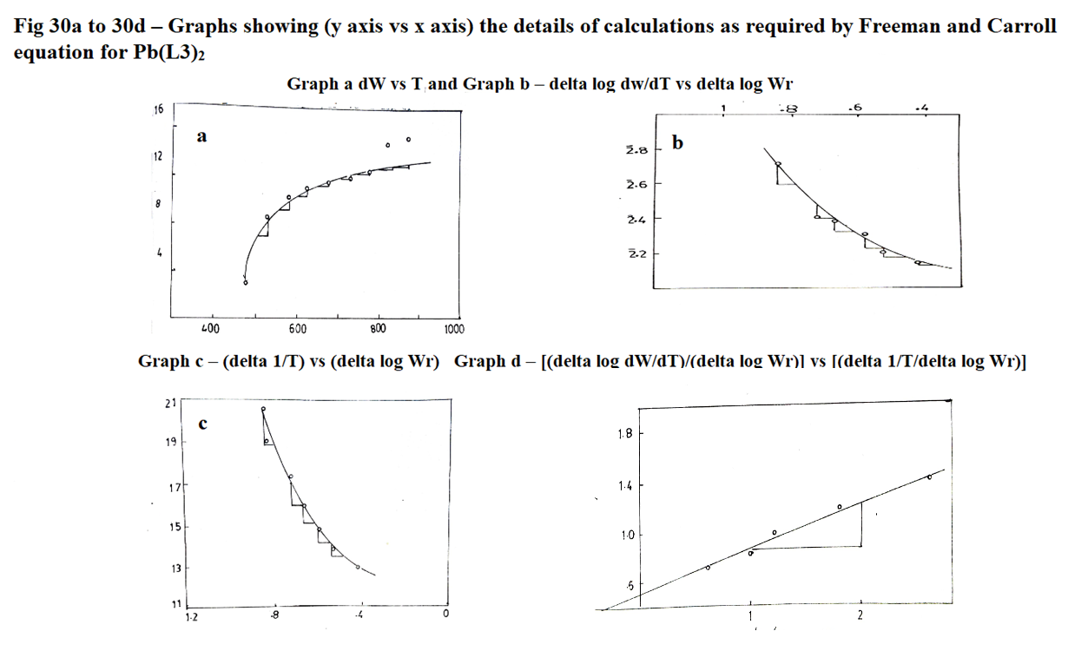 **Fig 30 a-d – Graphs showing (y axis vs x axis) for Pb(INM-o-ANISO)2 complex**

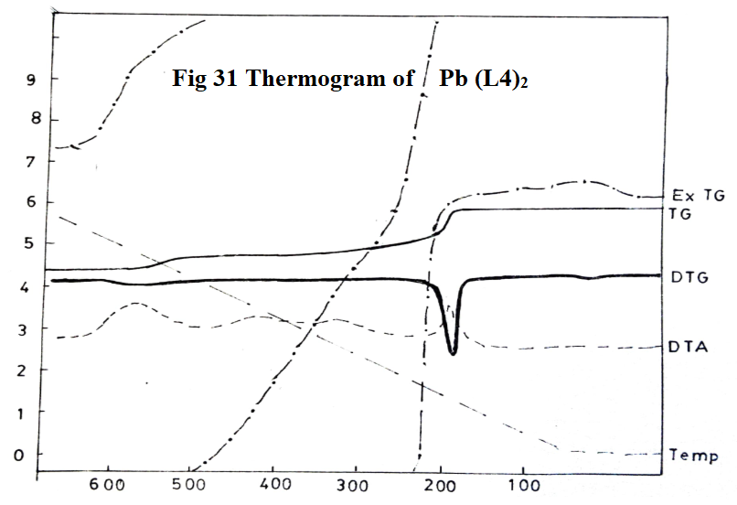 **Fig 31: Thermogram of Pb(INM-p-ANISO)2 complex – TG,ExTG,DTG,DTA vs Temp oC**

The loss in weight due to thermal decomposition as observed at different temperatures in TGA was calculated and plotted against the temperatures respectively and the coordinates of graphs required for Freeman and Carroll equation, (Δ log dw/dT)/(Δ log Wr) = - Ea/2.303R [(Δ 1/T)/(Δ log Wr)] + n; for evaluation of kinetic parameters, EA = 13.24 Kcal/mole, order of reaction, n = 0.54 for Pb(INM-p-ANISO)2 complex are given in Table 20 and Fig 32.

**Table 20: Statement showing coordinates of graphs required for Pb(L4)2 complex.**

|  |  |  |  |  |  |  |  |  |
| --- | --- | --- | --- | --- | --- | --- | --- | --- |
| **Temperature T K** | **Weight loss (dw)** | **Slope values dw/dT** | **Δ log dw/dT\*** | **Wr = (Wc-W)** | **Δ log Wr\*** | **Slope values 4 vs 6** | **Δ 1/T x 10-4** | **Slope values Δ 1/T vs Δ log Wr** |
| 523 | 12.65 | 0.044 | $\overline{2}$.6435 | 10.24 | $\overline{1}$.0103 | 0.8 | 19.12 | 2.2 |
| 573 | 15.01 | 0.036 | $\overline{2}$.5573 | 7.88 | 0.8955 | 0.7 | 17.45 | 1.8 |
| 623 | 16.03 | 0.032 | $\overline{2}$.5051 | 6.86 | 0.8363 | 0.6 | 16.05 | 1.4 |
| 673 | 17.01 | 0.028 | $\overline{2}$.4472 | 5.88 | 0.7694 | 0.5 | 14.85 | 1.2 |
| 723 | 17.81 | 0.024 | $\overline{2}$.3802 | 5.08 | 0.7059 | 0.4 | 13.83 | 1.0 |
| 773 | 19.01 | 0.020 | $\overline{2}$.3010 | 3.88 | 0.5888 | 0.4 | 12.93 | 0.8 |
| 823 | 21.99 | 0.016 | $\overline{2}$.2041 | 0.90 | $\overline{1}$.9542 | - | 12.15 | - |
| 873 | 22.89 | 0.008 | - | - | - | - | 11.48 | - |

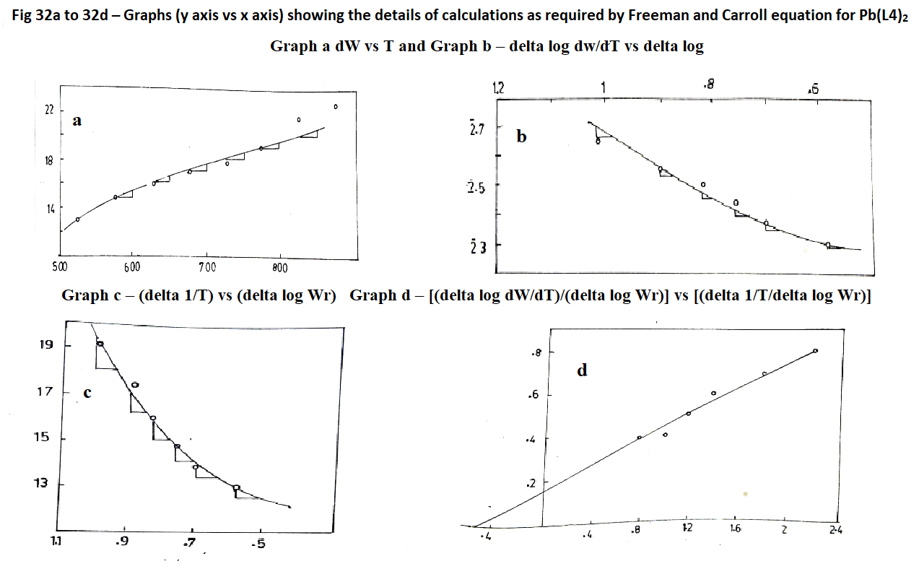 **Fig 32 a-d – Graphs showing (y axis vs x axis) for Pb(INM-p-ANISO)2 complex**

The thermal stability of Pb(II) complexes, temperature range, % of decomposition, corresponding group decomposed as well as kinetic parameters, Ea the activation energy, n the order of reaction and (ΔH the change in enthalpy = peak area x calibration factor (K = 0.62 cal/sq.cm)/sample wt) are given in Table 21.

**Table 21: Statement showing thermal stability and kinetic parameters of all four lead(II) complexes.**

|  |  |  |  |  |  |  |  |
| --- | --- | --- | --- | --- | --- | --- | --- |
| **Complex** | **Decomposition** | | | **Thermal stability**  **0C** | **Ea Kcal/ mole** | **n** | **ΔH** |
| **Temperature 0C** | **%** | **Corresponding group** |
| Pb(L1)2 | 250-300  325-350  375-400 | 40.62  46.87  54.68 | R, R-NH, R-NH two C=O | 225 | 13.24 | 0.38 | -117.62 |
| Pb(L2)2 | 250-300  325-350  375-400 | 43.52  51.76  58.82 | R, R-NH, R-NH two C=O | 210 | 11.47 | 0.62 | -84.14 |
| Pb(L3)2 | 250-300  325-350  375-400 | 47.61  53.8  61.81 | R, R-NH, R-NH two C=O | 200 | 15.00 | 0.32 | -76.51 |
| Pb(L4)2 | 250-300  325-350  375-400 | 46.82  52.9  60.8 | R, R-NH, R-NH two C=O | 190 | 13.24 | 0.54 | -80.28 |

**3.3.1.4 UO2(II) complexes:**

In case of all four complexes (Fig 33 to 36), the decomposition is found to be continued over a range from 2000C to 9000C. Freeman and Carroll equation is not applicable to calculating any of the kinetic parameters in decomposition involving simultaneous type of reactions. However, the order of thermal stability is found to be UO2(L2)2>UO2(L4)2>UO2(L1)2>UO2(L3)2.

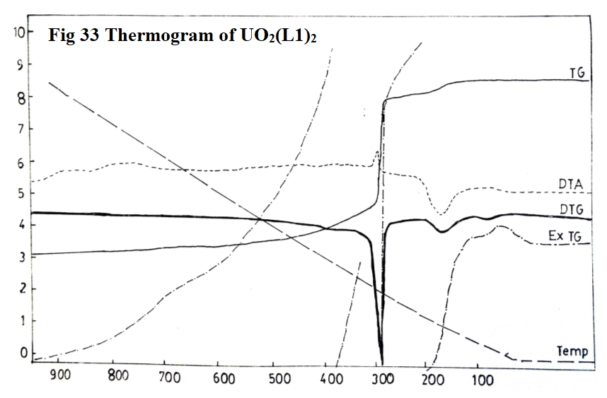 **Fig 33: Thermogram of UO2(INMAO)2 complex – TG,ExTG,DTG,DTA vs Temp oC**

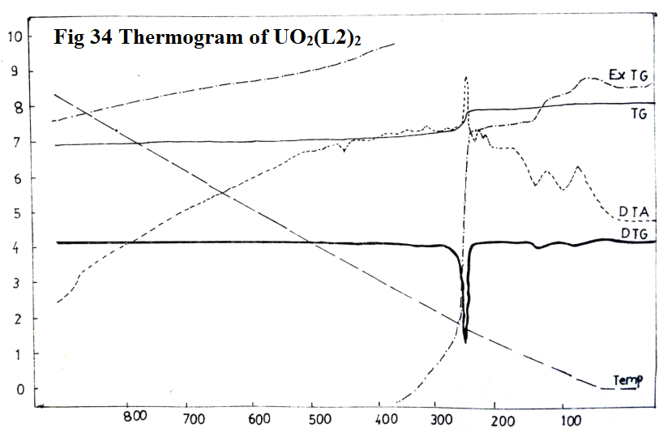 **Fig 34: Thermogram of UO2(INM-p-TO)2 complex – TG,ExTG,DTG,DTA vs Temp oC**

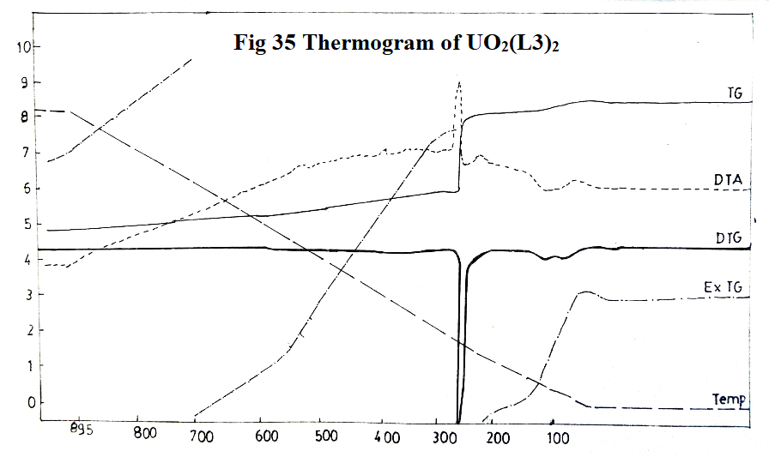 **Fig 35: Thermogram of UO2(INM-o-ANISO)2 complex – TG,ExTG,DTG,DTA vs Temp oC**

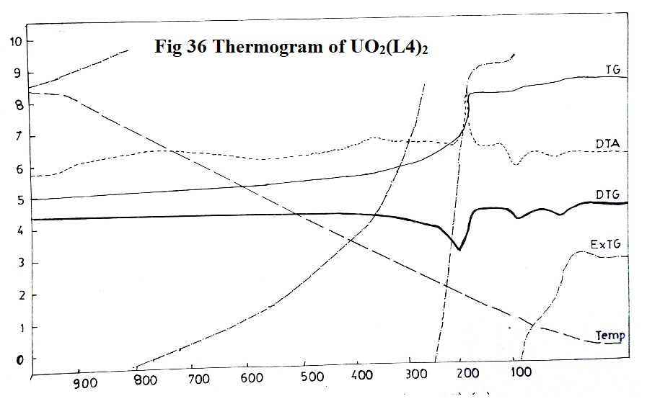 **Fig 36: Thermogram of UO2(INM-p-ANISO)2 complex – TG,ExTG,DTG,DTA vs Temp oC**

**4.0 CONCLUSION**

Cu(II), UO2(II), Mn(II) and Pb(II) acetate and nitrate complexes of L1 = Malon-di-anilide oxime (HINMAO), L2 = Malon-di-(p) toluidide oxime (HINM-p-TO), L3 = Malon-di-(o) anisidide oxime (HINM-o-ANISO), and L4 = Malon-di-(p) anisidide oxime (HINM-p-ANISO) were prepared in solid state and their spectral and magnetic properties were determined to confirm their structures and are communicated.

All the above metal complexes were subjected to thermogravimetric analysis. Thermal studies were carried out by - Thermogravimetric analysis (TG); Differential Thermal Analysis (DTA) and Differential Thermogravimetric (DTG) techniques. These thermal degradation data have been used to evaluate kinetic parameters such as: order of reaction, activation energy, heat changes and thermal stabilities.

The decomposition curves were obtained as dynamic curves with a linear increase of temperature with heating rate of 10 0C/min except UO2(II) complexes all the metal complexes exhibit successive reactions. These decomposition properties in the four successive reactions are discussed in detail in the light of Freeman and Carrol equation. This difference-differential method was utilised for evaluation of kinetic parameters like order of reaction and activation of energy. Thermal stabilities of the complexes were found, and the enthalpy changes were evaluated using “peak and area” method.

Disclaimer (Artificial intelligence)

Option 1:

Author(s) hereby declare that NO generative AI technologies such as Large Language Models (ChatGPT, COPILOT, etc.) and text-to-image generators have been used during the writing or editing of this manuscript.

Option 2:

Author(s) hereby declare that generative AI technologies such as Large Language Models, etc. have been used during the writing or editing of manuscripts. This explanation will include the name, version, model, and source of the generative AI technology and as well as all input prompts provided to the generative AI technology

Details of the AI usage are given below:

1.

2.

3.

**REFERENCES:**

Ajay Kumar, Ku. Sarita Prasad and Akhilesh Prasad, (2020), Solid state kinetics of Cr(III) complex derived from Schiff base of 5-amino1,2,3,4 thiatriazole with-orthomethoxybenzaldehyde, International Journal of Creative Research Thoughts (IJCRT) www.ijcrt.org, 2020 IJCRT | Volume 8, Issue 10 October 2020, www.ijcrt.org IJCRT2010394 2870-2874, chrome-extension://efaidnbmnnnibpcajpcglclefindmkaj/<https://ijcrt.org/>papers /IJCRT2010394.pdf

Ana M. C. Grisa, Janaina S. Crespo and Mara Zeni, (2013), Kinetic parameters for degradation of municipal waste polymer, Journal of Research in Environmental Science and Toxicology (ISSN: 2315-5698) Vol. 2(7) pp. 126-130, DOI: http:/dx.doi.org/10.14303/jrest.2013.077

Bhartiya S. K. and Roy Jamadar, (2008), Studies on solid state kinetics of some metal chelates of macro organic ligands, Int. J. Chem. Sci.: 6(2), 1111-1114 chrome-extension://efaidnbmnnnibpcajpcglclefindmkaj/https://www.tsijournals.com/articles/studies-on-solid-state-kinetics-of-some-metal-chelates-of-macro-organic-ligands.pdf

Borase Jitendra N, ·Mahale R. G, Rajput S. S, Shirsath Dhanraj S, (2021), Design, synthesis and biological evaluation of heterocyclic methyl substituted pyridine Schiff base transition metal complexes, SN Applied Sciences (2021) 3:197, <https://doi.org/10.1007/s42452-021-04144-z>

Chatwal and Anand, (1979), Instrumental Methods of Analysis, 1st Ed, Himalaya Publishing House

Coats, A. W., & Redfern, J. P. (1963). Thermogravimetric analysis. A review. The Analyst, 88(1053), 906*.* <https://doi.org/10.1039/an9638800906>

Criado, J. M., Dollimore, D., & Heal, G. R. (1982). *A critical study of the suitability of the freeman and carroll method for the kinetic analysis of reactions of thermal decomposition of solids. Thermochimica Acta, 54(1-2), 159–165.* doi:10.1016/0040-6031(82)85075-2  and references therein

Daniels, T. (1973) Thermal Analysis, Kogan Page, Wiley, London.

[Dattatraya Anarse](https://www.researchgate.net/scientific-contributions/Dattatraya-Anarse-2307332770?_tp=eyJjb250ZXh0Ijp7ImZpcnN0UGFnZSI6InB1YmxpY2F0aW9uIiwicGFnZSI6InB1YmxpY2F0aW9uIn19), [Kadam](https://www.researchgate.net/scientific-contributions/M-B-Kadam-2307333966?_tp=eyJjb250ZXh0Ijp7ImZpcnN0UGFnZSI6InB1YmxpY2F0aW9uIiwicGFnZSI6InB1YmxpY2F0aW9uIn19) M B, [Sunatkari](https://www.researchgate.net/scientific-contributions/A-L-Sunatkari-2307228708?_tp=eyJjb250ZXh0Ijp7ImZpcnN0UGFnZSI6InB1YmxpY2F0aW9uIiwicGFnZSI6InB1YmxpY2F0aW9uIn19) A L, [Chavan](https://www.researchgate.net/scientific-contributions/AU-Chavan-60487861?_tp=eyJjb250ZXh0Ijp7ImZpcnN0UGFnZSI6InB1YmxpY2F0aW9uIiwicGFnZSI6InB1YmxpY2F0aW9uIn19) A U, [Prasad](https://www.researchgate.net/scientific-contributions/M-R-Prasad-2307334314?_tp=eyJjb250ZXh0Ijp7ImZpcnN0UGFnZSI6InB1YmxpY2F0aW9uIiwicGFnZSI6InB1YmxpY2F0aW9uIn19) M R, [Sarawade](https://www.researchgate.net/scientific-contributions/P-B-Sarawade-2307502726?_tp=eyJjb250ZXh0Ijp7ImZpcnN0UGFnZSI6InB1YmxpY2F0aW9uIiwicGFnZSI6InB1YmxpY2F0aW9uIn19) P B, (2025), Oxidation Kinetics Studies of Ti3C2Tx MXene using Freeman-Carroll method, [Journal of Condensed Matter](https://www.researchgate.net/journal/Journal-of-Condensed-Matter-2583-9152?_tp=eyJjb250ZXh0Ijp7ImZpcnN0UGFnZSI6InB1YmxpY2F0aW9uIiwicGFnZSI6InB1YmxpY2F0aW9uIn19) 2(02):43-45, DOI:[10.61343/jcm.v2i02.108](http://dx.doi.org/10.61343/jcm.v2i02.108)

Devhade J.B, (2015), Non-isothermal Degradation and Kinetic Parameters of Some Complexes, Journal of Applicable Chemistry 2015, 4 (5): 1556-1560 (International Peer Reviewed Journal)

Freeman, E. S., & CNon-isothermal Degradation and Kinetic Parameters of Some Complexes J.B. Devhadearroll, B. (1958). The Application of Thermoanalytical Techniques to Reaction Kinetics: The Thermogravimetric Evaluation of the Kinetics of the Decomposition of Calcium Oxalate Monohydrate. The Journal of Physical Chemistry, 62(4), 394–397*.* <https://doi.org/10.1021/j150562a003>

Freeman, E. S., & Carroll, B. (1969). *Interpretation of the kinetics of thermogravimetric analysis. The Journal of Physical Chemistry, 73(3), 751–752.* doi:10.1021/j100723a051

Ghanshyam Kumar & R. P. S. Chauhan, (2021), Thermal Decomposition Kinetic Studies of Nickel Complexes, IOSR Journal of Applied Chemistry (IOSR-JAC) e-ISSN: 2278-5736.Volume 14, Issue 10 Ser. II (October 2021), PP 01-06 [www.iosrjournals.org](http://www.iosrjournals.org), DOI: 10.9790/5736-1410020106

Goitom Gebreyohannes B, Chebude Y, J. T. Raju V, (2016). Synthesis and Characterization of Metal Complexes of Derivative of 1,10-phenanthroline, Int. Res. J. Pure Appl. Chem. [Internet], Sep. 15 [cited 2025 Mar. 31];12(4):1-8. Available from: <https://journalirjpac.com/index.php/IRJPAC/article/view/93>

Gurnule Wasudeo B and Bisen Vaishali R, (2014), Kinetics of Thermal Decomposition of Copolymer Resin-II Derived from 4-hydroxylbenzaldehyde, Phenyl hydrazine and Formaldehyde, Research Journal of Pharmaceutical, Biological and Chemical Sciences, Vol 5, No 4, PP 1283, chrome-extension://efaidnbmnnnibpcajpcglclefindmkaj /http://www.rjpbcs.com/pdf/2014_5(4)/[142].pdf

Iorungwa, M. S., Dafa, S.T., Wuana, R.A., Iornumbe, E. N. and Tivkaa, J. T, (2023), Thermal Stability Profiling of Co(II), Mn(II), and Ni(II)-Hydrazone Based Complexes: The Role of Kinetic and Thermodynamics Parameters, ChemSearch Journal 14(2): 46 – 57, December, 2023 Publication of Chemical Society of Nigeria, Kano Chapter.

Kharadi, G.J. (2012), Thermal decomposition and mass spectra of mixed ligand copper(II) complexes of 1,10-phenanthroline and coumarin derivatives. J Therm Anal Calorim **107**, 651–659. <https://doi.org/10.1007/s10973-011-1671-x>

Liu, N. A., & Fan, W. C. (1999), Critical consideration on the Freeman and Carroll method for evaluating global mass loss kinetics of polymer thermal degradation. Thermochimica Acta, 338(1-2), 85–94 <https://doi.org/10.1016/s0040-6031(99)00197-5>

Madhusudanan, P. M., Yusuff, K. K. M., & Nair, C. G. R. (1975). *Thermal decomposition kinetics of diethyl dithiocarbamate complexes of copper(II) and nickel(II). Journal of Thermal Analysis, 8(1), 31–43.* doi:10.1007/bf01912460

Mallikarjun K.G., (2004), Thermal Decomposition Kinetics of Ni(II) Chelates of Substituted Chalcones, E-Journal of Chemistry Vol. 1, No. 2, pp 105-109, April, <https://onlinelibrary.wiley.com/doi/pdf/10.1155/2004/385034> and references therein

Mallikarjun, K. G., & Naidu, R. S. (1992). Thermal decomposition kinetics of Cu(II) chelates of substituted chalcones. Thermochimica Acta, 206, 273–278. doi:10.1016/0040-6031(92)85304-e

Mansoor Alam Md,. Nesar ahmed Md and Kazmi A H, (2008), Kinetics of Metal Complexes of Methylmorpholine, Asian Journal of Chemistry, Vol. 20, No. 5 ,4129-4131

Michael, P. E. P., Barbe, J. M., Juneja, H. D., & Paliwal, L. J. (2007). Synthesis, characterization and thermal degradation of 8-hydroxyquinoline–guanidine–formaldehyde terpolymer. European Polymer Journal, 43(12), 4995–5000.  doi:10.1016/j.eurpolymj.2007.09.006

Mullasseril Abhilash, (2022), Computation of kinetic parameters of pyridino cobalt (ii), nickel (ii), copper (ii) complexes a comparative study, International journal of medical, pharmaceutical and biological sciences, Volume-2 Issue-2 Article ID: 0032, <http://www.aphinfo.com/ijmpbs>, July-September 2022, chrome-extension://efaidnbmnnnibpcajpcglclefindmkaj/https://aphinfo.com/wp-content/uploads /2024/01/32.-Computation-of-Kinetic-Parameters-of-Pyridino-Cobalt-II-Nickel-II-Copper-II-Complexes-A-Com.pdf

Murphy C B, (1968), Treatise on analytical chem, Part I, Vol B P 5449, InterScience Publishers N Y

Patel Atul K, Patel Jiten C, Dholariya Hitesh R, Patel Ketan S, Patel Vishal K, and Patel Kanuprasad D, (2013), Synthesis, Characterization and Biological Evaluation: Copper(II) Complexes of Hydroxy coumarins with Ciprofloxacin, Research Journal of Pharmaceutical, Biological and Chemical Sciences, RJPBCS, Volume 4 Issue 3 Page No. 564, chrome-extension://efaidnbmnnnibpcajpcglclefindmkaj/https://www.rjpbcs.com/pdf/2013_4(3)/[60].pdf

Ramesh A, Seshadri N R and Raghava N R, (1980) Studies on Cu(II), Ni(II), Co(II), Mo(II) & Zn(II) Complexes with 2-Hydroxy-l-naphthaldoxime, Indian J Chem, Vol 19A, 1133-1135, <http://nopr.niscpr.res.in/handle/123456789/51076>

Sadafale V A and Mandlik P R, (2020), Cr(III), Mn(III), Fe(III) and VO(IV) complexes of 2,4-dihydroxyacetophenone and sulphapyridine, Journal of Emerging Technologies and Innovative Research (JETIR) JETIR February 2020 , Volume 7, Issue 2, 369-373, chrome-extension://efaidnbmnnnibpcajpcglclefindmkaj/https://www.jetir.org/papers/JETIRDI06072.pdf

Shrivastava, Mukesh, Swarnabala G, Khatavkar S. B., Sadana G. S., and Anahita Bharadwaj, (2024), “Structural Investigations of Some Metal Complexes of Malon-Di-(α-Naphthyl) Amide-Oxime”. Asian Journal of Chemical Sciences 14 (6):154-80, <https://doi.org/10.9734/ajocs/2024/v14i6342> and references therein,

Shrivastava Mukesh Dinesh, 1981, Structural investigations of some metal complexes of malon-di-α-naphthyl amide oxime, April, Master of Science in Chemistry, Department of Chemistry, G N Khalsa College, Matunga, The University of Bombay, Bombay – 400019 and references therein in introduction from 6-55.

Shrivastava Mukesh, Swarnabala G., Khatavkar S. B., Sadana G. S. and Bharadwaj Anahita, (2025), Synthesis and characterization of some oximino metal complexes using magnetic and spectral data predicting approximate geometry – Part 1, Asian J of Chem Sci., Accepted for publication.

Shrivastava Mukesh Kumar Dinesh, (1985), Structural investigations of some oximino metal complexes, Aug, PhD in Chemistry, Department of Chemistry, G N Khalsa College, Matunga, The University of Bombay, Bombay – 400019 and references therein in.

Suman Kumari, Mithlesh Shukla, and R.K Shukla, (2018), 63 KINETIC STUDY OF THERMAL DECOMPOSITION OF METAL DIALKANOATES, Journal of Emerging Technologies and Innovative Research (JETIR), Volume 5, Issue 1 JETIR (ISSN-2349-5162) JETIR1801012, [www.jetir.org](http://www.jetir.org)

Swarnabala, G., S. B. Khatavkar, G. S. Sadana, and Anahita Bharadwaj, (2022). “Physico-Chemical Characterization of Some Metal Complexes Formed by Substituted Thiourea”, Asian Journal of Chemical Sciences 12 (2):50-89. <https://doi.org/10.9734/ajocs/2022/v12i2218> and references therein.

Verma, U N, Singh B, (1997), Solid state kinetics of palladium-N-(2-benzothiazolyl)-thiourea complex from TG analysis, Asian J of Chemistry, Vol 9, No 3, 427-430, chrome-extension://efaidnbmnnnibpcajpcglclefindmkaj/file:///D:/Swarna%20academic%20works/PhD%20students/Mukesh%20Shrivatsava%20PhD%20thesis%20Aug%201985/Gallery%20proofs%20PART%202/AJC-9-3-17.pdf

Vishal Chaudhary, (2017), Thermogravimetric Analysis of Cadmium Soaps by Using Freeman-Carroll’s and Coats-Redfern’s Equations, International Journal of Applied Chemistry. ISSN 0973-1792 Vol 13, Num 2 pp. 303-309, chrome-extension://efaidnbmnnnibpcajpcglcleindm kaj/<https://www.ripublication.com/ijac17/>ijacv13n2_12.pdf

Wendlandt W.W. (1964), Thermal Methods of Analysis, Interscience, Wiley, New York p 29

………………………………………xxxxxxxxxxxxxxxxxxxxx………………………………