***Original Research Article***

**Exploring N-Benzylidene-Isonicotinohydrazide Schiff Base and Its Ni(II), Cu(II), and Co(II) Complexes: Synthesis, Spectroscopic, Computational, and Molecular Docking Insights with the COVID-19 Protein Receptor**

**ABSTRACT**

*A Schiff base ligand (L), N-benzylidene-isonicotinohydrazide (C₁₃H₁₁N₃O), was synthesized via the condensation of benzaldehyde and isoniazid in an ethanolic medium. The ligand was characterized by FT-IR, ¹HNMR, UV-Vis, ESI-MS, and elemental analysis, confirming its successful formation. Metal complexes of Ni(II), Co(II), and Cu(II) were synthesized by reacting the ligand with corresponding metal acetate salts under reflux conditions. Spectroscopic data revealed that coordination occurred through the azomethine nitrogen and carbonyl oxygen, as evidenced by shifts in characteristic IR bands. Electronic spectra and magnetic moment studies indicated that all three complexes adopted a distorted square planar geometry. Molar conductivity measurements confirmed their non-electrolytic nature. Density functional theory (DFT) calculations provided insight into the optimized geometries and electronic properties of the ligand and complexes, with HOMO-LUMO energy gap analysis suggesting enhanced reactivity upon complexation. Molecular docking of the free ligand and its metal complexes was performed against the SARS-CoV-2 main protease (PDB ID: 6XBH), yielding promising results.*

*Keywords:* Schiff base; Metal Complex; Density functional theory (DFT); Molecular docking.

**1. INTRODUCTION**

“Schiff bases, formed through the condensation reaction between an amine and a carbonyl compound, represent a significant class of ligands capable of coordinating with a wide range of metal ions through their azomethine nitrogen” [1]. “Over the past few decades, these compounds have been widely studied in coordination chemistry due to their versatility as precursor molecules. Additionally, they exhibit notable biological activities, including antifungal, antibacterial, antiviral, anticancer, and antioxidant properties” [2, 3].

“The overuse of antimicrobial agents has significantly contributed to the emergence of drug-resistant microbes, which continue to be a major cause of mortality worldwide. Due to the limited availability of effective treatments, microbial infections pose severe challenges to human health. To address the increasing resistance to antimicrobial agents, researchers are actively developing new classes of antimicrobial drugs with effective mechanisms of action. In recent years, transition metal complexes have gained attention for their diverse clinical, biochemical, and pharmacological properties” [4-6].

“Schiff base metal complexes exhibit a broad range of pharmaceutical activities. Due to their biological significance, transition metal complexes containing Schiff base ligands with nitrogen and oxygen donor atoms play a crucial role in various therapeutic applications. These complexes have been recognized for their antibacterial, antifungal, anticonvulsant, anti-inflammatory, antioxidant, antitumoral, analgesic, and anthelmintic properties. Anthelmintic agents are drugs used to treat parasitic worm infections” [7].

“In the quest for novel compounds, isoniazid derivatives have been identified as promising agents with tuberculostatic activity. Research indicates that isoniazid functions as a prodrug, which is activated by mycobacterial catalase-peroxidase. Once converted, it targets the mycobacterial cell wall by inhibiting the FAS-II (fatty acid synthetase II) system, thereby preventing the synthesis of long-chain fatty acid precursors essential for mycolic acid formation” [8, 9].

This study focused on synthesizing a Schiff base ligand from the condensation reaction between isonicotinohydrazide and benzaldehyde alongside its metallic complexes. Various characterization techniques were employed to confirm the structural properties of the synthesized compounds. The binding affinity of the synthesized compounds to the SARS-CoV-2 main protease, (SARS-CoV-2, PDB-ID: 6XBH), was investigated through molecular docking studies.

**2. METODOLOGY**

**2.1 Materials and Reagents**

The chemicals used in this study were procured from commercial sources and were used directly without additional purification. Key reagents, including benzaldehyde, isoniazid, copper(II) acetate tetrahydrate, cobalt(II) acetate tetrahydrate, nickel(II) acetate tetrahydrate, DMSO (dimethyl sulfoxide), and 1,1-diphenyl-1-picrylhydrazyl (DPPH), were obtained from Sigma Aldrich, India. Analytical-grade organic solvents, such as ethanol and DMF (dimethylformamide), were used as supplied.

**2.2 Instrumentation**

Various analytical techniques were used to characterize the synthesized ligands and metal complexes. Melting points were determined with an AZ6512 electrothermal melting point apparatus. Infrared spectra were recorded on an FTIR-8400 SHIMADZU spectrophotometer using KBr pellets. UV-Vis spectral analysis was conducted at a concentration of 5 × 10⁻⁴ M using a Shimadzu Double Beam spectrophotometer (models UV-1200 and UV-1650PC). The magnetic properties of the solid complexes were measured with a SHERWOOD SCIENTIFIC Magnetic Susceptibility Balance. Electrical conductivity of 10⁻³ M solutions in DMSO was determined using a WPACM35 conductivity meter with a platinum electrode. Mass spectrometry was performed using an Agilent Technologies MSD SL Trap mass spectrometer with an ESI source, coupled with an 1100 Series HPLC system. Elemental composition was analyzed using a LECO CHNS-932 elemental analyzer.

**2.3 Synthesis of the ligand, N-benzylidene-isonicotinohydrazide (C₁₃H₁₁N₃O)**

The Schiff base ligand (L) was synthesized via a condensation reaction between benzaldehyde (20 mmol, 2.1 mL) and isoniazid (10 mmol, 1.08 g) following the procedure outlined in Scheme S1. Benzaldehyde was dissolved in 20 mL of ethanol, while isoniazid was separately dissolved in hot ethanol. The two solutions were combined and refluxed for 6–7 hours. After cooling, a white crystalline solid precipitated, which was filtered, washed sequentially with ethanol, acetone, and diethyl ether, and then dried in a vacuum desiccator over anhydrous CaCl₂. The product exhibited good solubility in ethanol, methanol, chloroform, and DMSO. Stability was assessed by recording its UV-Vis spectrum in DMSO at different time intervals.



**Scheme 1. Synthesis route of Schiff base Ligand (L)**

White crystals, Yield: 80%, Melting Point: 199–200°C, ¹H NMR (d₆-DMSO): 12.04 (s, 1H), 8.75 (ddd, 2H), 8.43 (s, 1H), 8.07 (ddd, 2H), 7.78 (dtd, 2H), 7.72 (dddd, 2H), 7.43 (tt, 2H), FT-IR (KBr, cm⁻¹): 3298, 3350 (N-H); 1692 (C=O, amide); 1566 (C=N, azomethine), ESI-MS (m/z): 225.6764, 136.2447, 91.025, Elemental Analysis [Calculated (Found) %]: C: 69.32 (69.75), H: 4.92 (4.98), N: 18.66 (18.95), O: 7.10 (7.42).

**2.4 Synthesis of Metal Complexes**

The Schiff base ligand N-benzylidene-isonicotinohydrazide was reacted with respective metal acetate salts (1 mmol) in a warm ethanolic solution (20 mL) under reflux for 5–6 hours with continuous stirring, leading to the formation of metal complexes as colorful precipitates. The precipitates were filtered, washed with ethanol, and dried over anhydrous CaCl₂. Thin-layer chromatography (TLC) confirmed the purity of the complexes. The solubility tests indicated that the complexes dissolved in DMSO and DMF.



**Scheme 2. Synthesis route of metal complexes, where M= Cu2+, Ni2+& Co2+.**

**Copper(II) Complex (CuL)**

Green solid, Yield: 75%, Melting Point: 301–302°C, FT-IR (KBr, cm⁻¹): 3401 (O-H), 1384 (C-O), 693 (Cu-O), 465 (Cu-N), ESI-MS (m/z): 512.2881, 225.5619, 136.1335, 91.5227 Elemental Analysis [Calculated (Found) %]: C: 60.99 (69.84), H: 3.90 (4.97), N: 16.66 (18.97), O: 6.25 (7.34).

**Cobalt(II) Complex (CoL)**

Brown solid, Yield: 80%, Melting Point: >300°C, FT-IR (KBr, cm⁻¹): 3410 (O-H), 1375 (C-O), 703 (Co-O), 467 (Co-N), ESI-MS (m/z): 507.2393, 225.7623, 136.1928, 91.213, Elemental Analysis [Calculated (Found) %]: C: 61.54 (61.65), H: 3.97 (4.01), N: 16.56 (16.78), Co: 11.61 (11.75), O: 6.31 (6.56).

**Nickel(II) Complex (NiL)**

Yellow solid, Yield: 75%, Melting Point: 310–311°C, FT-IR (KBr, cm⁻¹): 3413 (O-H), 1372 (C-O), 703 (Ni-O), 472 (Ni-N), ESI-MS (m/z): 507.5684, 225.7719, 136.2231, 91.067. Elemental Analysis [Calculated (Found) %]: C, 61.57 (61.87), H, 3.97 (4.02), N, 16.57 (16.88), O, 6.31 (6.64)%.

**2.5 Computational Calculations**

The two-dimensional (2D) structures were created using ChemDraw 19.0 software and saved in the MDL molfile (.mol) format [10]. These 2D structures were then converted to three-dimensional (3D) models using GaussView 5.0 software. Subsequently, the energy minimization of the generated structures was carried out using Gabedit 2.5.1 software [11].

The three-dimensional crystal structure of the SARS-CoV-2 (COVID-19) main protease (PDB ID: 6XBH) was retrieved from the RCSB Protein Data Bank (PDB). Using Discovery Studio (v24.1.0.23298), all heteroatoms and water molecules present in the crystal structure were eliminated. To remove unfavorable interactions between protein atoms, energy minimization was performed via the conjugate gradient method, utilizing the GROMOS96 43b1 force field implemented in Swiss-PdbViewer (Version 4.1.0).

Molecular docking studies were performed to explore the interaction between the SARS-CoV-2 main protease (PDB ID: 6XBH) and the Schiff base ligands, along with their metal complexes, using PyRx software (version 0.8) [12]. The docking process began by importing the protein structure (PDB ID: 6XBH) into PyRx and preparing it as a macromolecule. The ligands were then loaded and converted into PDBQT format for further processing. The docking calculations were performed using AutoDock Vina (version 1.2.5) integrated into PyRx software [13]. To further analyze and visualize the docking results, Discovery Studio (version 4.1) and LigPlot+ (version 2.2.8) were employed for evaluating non-bonded interactions and depicting the binding poses.

The geometries of the synthesized compounds were first optimized and analyzed using Gauss View 5.0. Density Functional Theory (DFT) calculations were performed with the GAUSSIAN 09 software package, employing the B3LYP functional. For the metal complexes, the LANL2DZ basis set was applied, while the 6-311G++(d, p) basis set was used for atoms present in the ligand, including carbon, hydrogen, nitrogen, and oxygen. This computational approach aimed to achieve reliable structural optimization and electronic property evaluation [4].

**3. RESULTS AND DISCUSSION**

**3.1 FT-IR Spectra**

“The infrared (IR) spectral data for the free ligand and its metal complexes are displayed in Fig. 1 and Table 1. The ligand shows a distinct absorption peak at 1598 cm⁻¹, which corresponds to the azomethine ν(C=N) stretching vibration. This observation confirms the successful condensation between the -CHO group of benzaldehyde and the –NH2 group of isoniazid [14-16]. Additionally, a band appearing at 1692 cm⁻¹ is attributed to the ν(C=O) stretching vibration” [1]. “Strong absorption bands at 1193 cm⁻¹ and 1566 cm⁻¹ indicate the presence of C-O and C=N bonds, respectively, within the ligand's structure” [17, 18].

“In the metal complexes involving Ni(II), Co(II), and Cu(II), the characteristic ν(C=O) stretching vibration of the Schiff base ligand, originally found at 1692 cm⁻¹, shifts to the range of 1557–1603 cm⁻¹. This shift signifies the coordination of the carbonyl oxygen with the metal ions. Moreover, the bands appearing between 701 and 703 cm⁻¹ in the FT-IR spectra of the complexes are associated with M–O vibrations, supporting the formation of metal-ligand bonds” [19, 20].

“Furthermore, the band at 1566 cm⁻¹ is shifted downward to the range of 1521–1524 cm⁻¹, suggesting the coordination of the azomethine nitrogen with the metal ions” [21, 22]. “Additionally, weak bands in the region of 470–472 cm⁻¹ are attributed to M–N vibrations” [23].The overall IR spectral analysis strongly supports the successful formation of Schiff base metal complexes through coordination with metal ions.

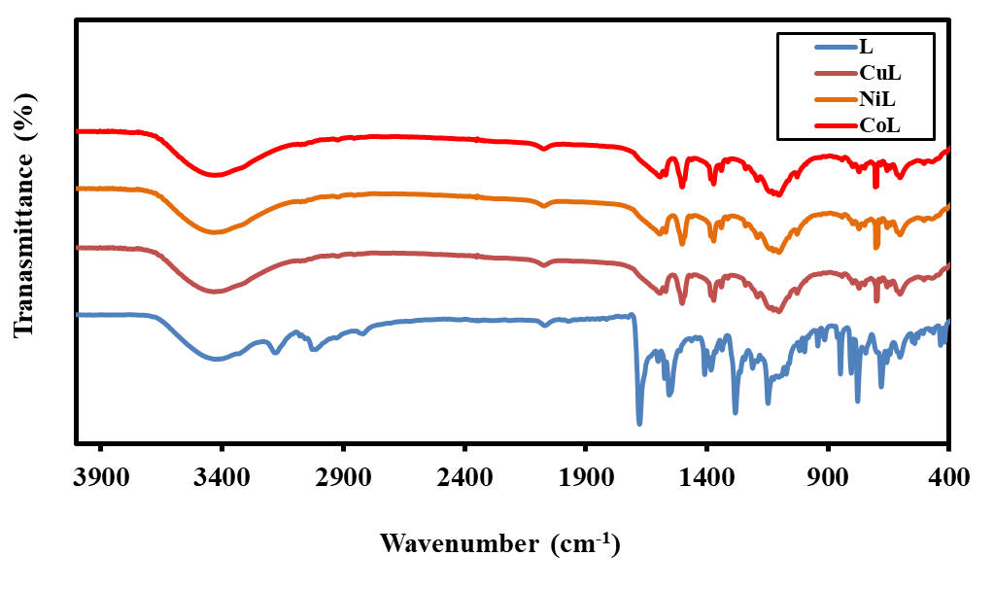

**Fig. 1 FT-IR spectra of the Schiff base ligand, L, and its metal complexes.**

**Table 1** FT-IR spectral data of the ligand and its Ni(II), Co(II), and Cu(II) metal complexes in cm-1.

|  |  |  |  |  |  |  |
| --- | --- | --- | --- | --- | --- | --- |
| **Compounds** | **ν(O-H)** | **ν(C=N)** | **ν(C=O)** | **ν(C-O)** | **ν(M-O)** | **ν(M-N)** |
| L | - | 1566 | 1692 | - | - | - |
| CuL | 3401 | 1524 | - | 1384 | 693 | 465 |
| NiL | 3410 | 1526 | - | 1375 | 703 | 467 |
| CoL | 3413 | 1521 | - | 1372 | 703 | 472 |

**3.2 Magnetic Moment, Electronic Spectra, and Molar Conductivity**

“The UV–Vis absorption spectra of the ligand and its metal complexes with Ni(II), Co(II), and Cu(II) were recorded in DMSO at room temperature, covering the wavelength range of 200–800 nm, as shown in Fig. 2 Table 2” [24]. The spectra of all complexes in DMSO remained consistent, indicating their stability in solution.

“The electronic spectrum of the free ligand exhibited prominent absorption peaks at 267 nm (37453 cm⁻¹) and 302 nm (33112 cm⁻¹), which are assigned to π→π* and n→π* transitions, respectively” [25, 26]. “For the NiL and CoL complexes, absorption peaks appeared at 256 nm (39062 cm⁻¹) and 264 nm (37878 cm⁻¹), respectively, corresponding to intra-ligand transitions (π→π*). Additionally, the peaks observed at 320 nm (31250 cm⁻¹) and 309 nm (32362 cm⁻¹) are associated with n→π* transitions, likely resulting from the interaction between the lone pair of electrons on the azomethine nitrogen and the anti-bonding orbital of the p orbital.Furthermore, NiL and CoL complexes exhibited additional absorption bands at 352 nm (28409 cm⁻¹) and 365 nm (27397 cm⁻¹), respectively, which are attributed to ligand-to-metal charge transfer (LMCT). The CuL complex displayed absorption bands at 257 nm (38910 cm⁻¹), 324 nm (30864 cm⁻¹), and 419 nm (23866 cm⁻¹), corresponding to π→π*, n→π*, and d→d transitions, respectively” [27, 28].

“The shifts in frequencies and intensities of the absorption bands in the metal complexes compared to the free ligand suggest successful coordination between the ligand and the metal ions.

Molar conductivity measurements for the ligand and metal complexes in DMSO (10⁻³ M) were found to be 2, 8, 12, and 10 ohm⁻¹ cm² mol⁻¹, respectively. These values, when compared with literature data, indicate that the complexes are non-electrolytic in nature” [29].

“Magnetic moment measurements revealed values of 1.90, 1.82, and 1.78 B.M for the NiL, CuL, and CoL complexes, respectively. Combined with the electronic spectral data, these findings suggest that all three complexes possess distorted square planar geometries” [30].

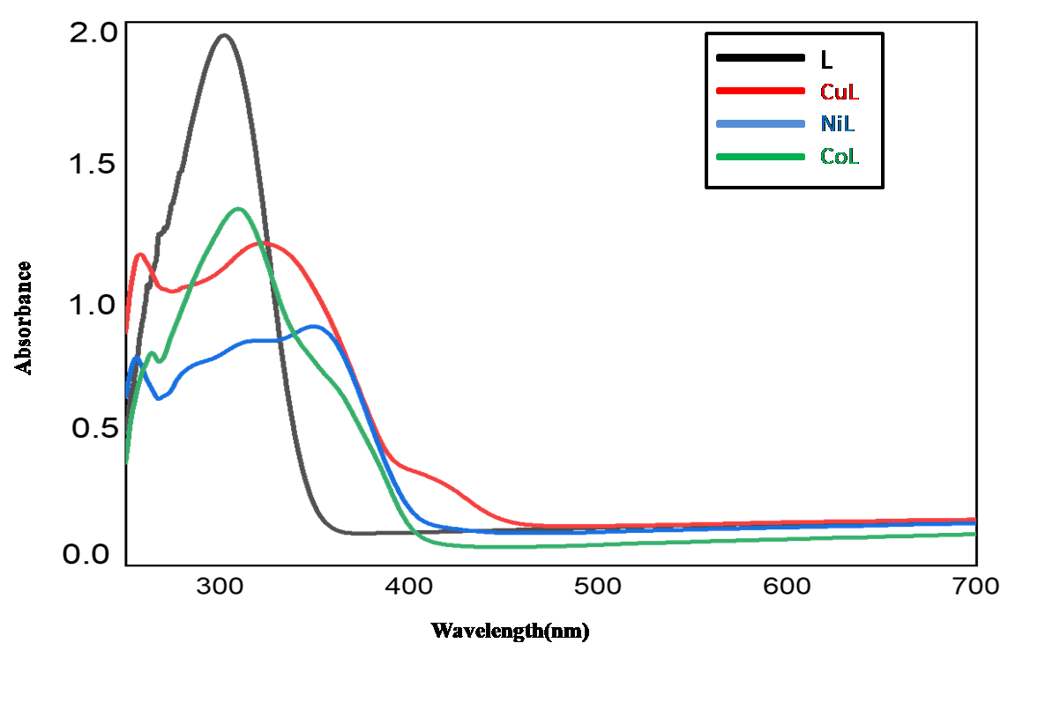

**Fig.2. Electronic spectra of the ligand and its metal complexes.**

**Table 2 Electronic spectral data, Magnetic moments, and molar conductance of the ligand and its metal complexes.**

|  |  |  |  |  |  |
| --- | --- | --- | --- | --- | --- |
| **Compounds** | **Wavelength**  **(nm)** | **Wavenumber**  **(cm-1)** | **Assignment** | **Magnetic Moment**  **(B.M)** | **Molar Conductance (ohm–1 cm2 mol–1**) |
| L | 267  302 | 37453  33112 | π→π*  n→π* | - | 2 |
| CuL | 257  324  419 | 38910  30864  23866 | π→π*  n→π*  C.T (L→M) | 1.82 | 8 |
| CoL | 264  309  365 | 37878  32362  27397 | π→π*  n→π*  C.T (L→M) | 1.78 | 12 |
| NiL | 256  320  352 | 39062  31250  28409 | π→π*  n→π*  C.T (L→M) | 1.90 | 10 |

**3.3 NMR Spectra**

“The 1H NMR spectrum of the ligand (Fig. 3) exhibits a prominent peak at 12.04 ppm, which corresponds to the azomethine proton, confirming the successful formation of the Schiff base. This peak, along with additional signals observed in the spectrum, provides strong evidence supporting the proposed structure of the ligand” [31].

δ (ppm)

δ (ppm)

**Fig. 3 1HNMR spectra of the ligand, L.**

**Table 3: 1HNMR data for ligand (L).**

|  |  |  |
| --- | --- | --- |
| **Proton** | **Chemical shift(ppm)** | **Types** |
| H-1, H-5 | 7.78 | Dublet |
| H-2, H-4 | 7.72 | Dublet |
| H-3 | 7.43 | Dublet |
| H-6 | 8.43 | Singlet |
| H-7 | 12.04 | Singlet |
| H-8, H-11 | 8.07 | Dublet |
| H-9, H-10 | 8.75 | Dublet |

**3.4 ESI-MS Spectra**

The ESI-MS spectra of the ligand and its complexes are presented in Fig. 4. The experimentally obtained m/z values align well with the calculated molecular weights, supporting the proposed structures of the synthesized compounds.

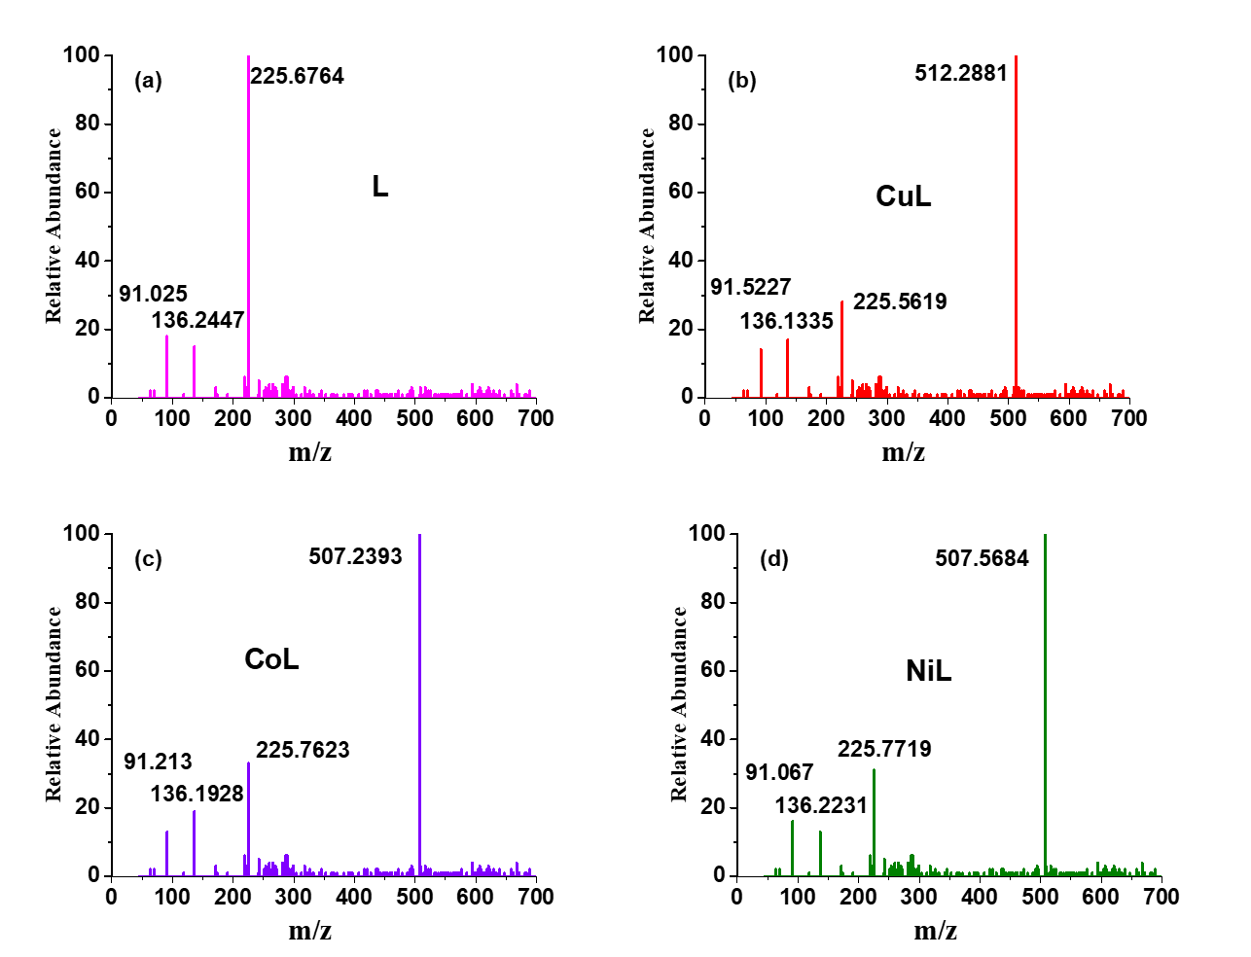

**Fig. 4 ESI-MS spectra of the ligand and its metal complexes.**

**3.5 Structural Analysis**

The structures of the ligand (L) with metal ions such as Cu(II), Co(II), and Ni(II), were investigated using various techniques, including elemental analysis, molar conductivity, magnetic moments, IR, 1H-NMR, UV–Vis spectroscopy, and mass spectrometry. The proposed structures of the synthesized metal complexes are illustrated in Fig. 5.



a

b

c

**Fig. 5 Proposed structures of (a) CuL(b) NiL and (c) CoL Complexes.**

**3.6 Geometry optimization**

“The DFT-optimized structures of the free ligand and its metal complexes with CuL, NiL, and CoL demonstrate noticeable differences in bond lengths and angles, indicating deviations from perfect square planar geometries. As presented in Tables 4 -6, all three complexes display distorted square planar configurations, as reflected by deviations from the ideal 90° bond angles” [32]. “These distortions, which are particularly prominent in the CuL and NiL complexes, can be attributed to steric and electronic influences that significantly impact the coordination environment” [4]. The optimized 3D geometries of the ligand and metal complexes are illustrated in Fig. 6.

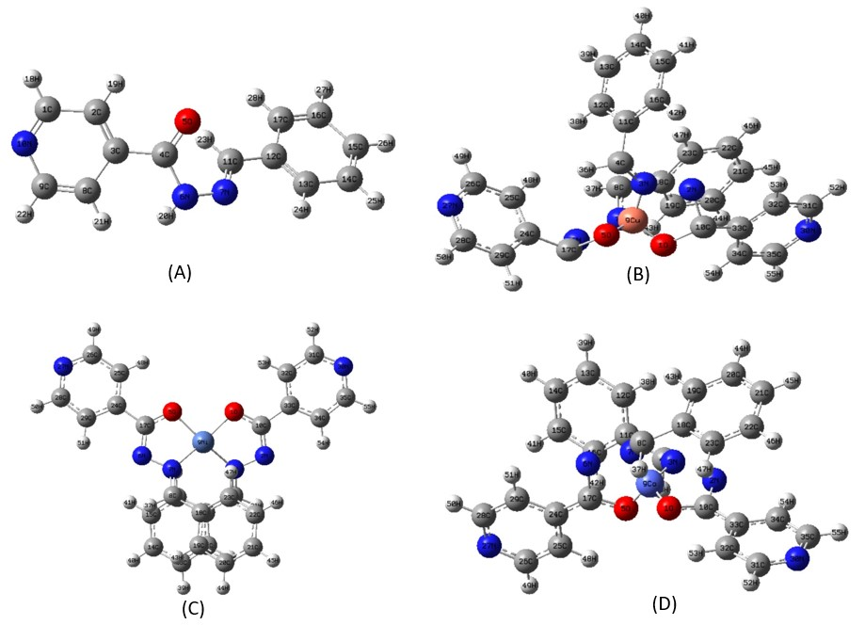

**Fig. 6 Optimized 3D geometry of the a) Ligand (L), (b) CuL,(c) NiL and (d) CoL complexes**

“In the CuL complex, notable deviations from the ideal 90° bond angles are evident, such as O1–Cu9–N3 (92.29°) and O1–Cu9–O5 (79.86°). These distortions are primarily due to steric hindrance within the ligand framework and electronic factors related to metal-ligand interactions” [33].

“In the case of the NiL complex, bond angles like O1–Ni9–N3 (82.72°) and O5–Ni9–N7 (82.68°) indicate moderate distortion from the ideal square planar geometry. The comparatively shorter Ni–O bond lengths relative to Cu–O suggest a stronger metal-ligand interaction in the NiL complex” [11].

“For the CoL complex, slightly larger bond angles such as O1–Co9–O5 (96.02°) and N7–Co9–N3 (107.28°) indicate a less distorted structure compared to the CuL and NiL complexes. Furthermore, the coordination of the free ligand via the carbonyl oxygen and azomethine nitrogen atoms leads to a slight increase in bond lengths, particularly for C10–O1, N2–N3, C4–N3, and N7–N6. These geometric variations suggest that the observed distortions are influenced by the nature of the coordinating ligand and the electronic environment around the metal centers” [33].

**Table 4 Selected geometrical parameters of the ligand (L).**

|  |  |  |  |
| --- | --- | --- | --- |
| **Ligand** | | | |
| **Bond connectivity** | **Bond length Value (Å)** | **Bond connectivity** | **Bond length Value (Å)** |
| C(1)-C(2) | 1.3957 | C(14)-C(15) | 1.3968 |
| C(2)-C(3) | 1.4025 | C(15)-C(16) | 1.4013 |
| C(3)-C(4) | 1.4987 | C(16)-C(17) | 1.3915 |
| C(4)-O(5) | 1.2411 | C(11)-H(23) | 1.0948 |
| C(8)-C(9) | 1.3926 | N(7)-H(20) | 1.0147 |
| C(9)-N(10) | 1.3532 | C(9)-H(22) | 1.0806 |
| N(6)-N(7) | 1.3768 | C(1)-H(18) | 1.0811 |
| N(7)-C(11) | 1.2929 | C(17)-H(28) | 1.0804 |
| C(11)-C(12) | 1.4613 | C(16)-H(27) | 1.0817 |
| C(12)-C(13) | 1.4061 | C(15)-H(26) | 1.0817 |
| C(13)-C(14) | 1.3955 | C(14)-H(25) | 1.0817 |
| H(18)-C(1)-C(2) | 120.99 | O(5)-C(4)-N(6) | 123.46 |
| H(19)-C(2)-C(3) | 121.70 | C(4)-N(6)-N(7) | 120.72 |
| C(2)-C(3)-C(4) | 123.91 | C(11)-N(7)-N(6) | 118.01 |
| C(1)-C(10)-C(9) | 117.70 | H(24)-C(13)-C(12) | 119.63 |
| C(3)-C(4)-C(5) | 121.84 | C(13)-C(12)-C(11) | 119.38 |

**Table 5 Selected geometrical parameters of synthesized metal complexes.**

|  |  |  |  |  |  |
| --- | --- | --- | --- | --- | --- |
| **CuL**  **B3LYP/LANL2DZ** | | **NiL**  **B3LYP/LANL2DZ** | | **CoL**  **B3LYP/LANL2DZ** | |
| **Bond length**  **(Å)** | **Bond angle (Degree)** | **Bond length(Å)** | **Bond angle (Degree)** | **Bond length**  **(Å)** | **Bond angle**  **(Degree)** |
| O1-9Cu  1.95158 | O1-9Cu-3N  79.85949 | O1—Ni9  1.87230 | O1-Ni9-N3  82.71646 | O1—Co9  1.88035 | O1-Co9-N3  81.66449 |
| Cu9-O5  1.93550 | O1-9Cu-7N  107.17850 | Ni9-O5  1.87242 | O1-Ni9-O5  91.96763 | Co9-O5  1.88035 | O1-Co9-O5  96.02247 |
| N7-N3  2.07663 | 7N-9Cu-3N  81.85731 | N7-Ni9  1.93267 | N7-Ni9-N3  105.87832 | N7-Co9  1.97463 | N7-Co9-N3  107.28091 |
| N3-Cu9  2.01890 | O5-Cu9-N3  92.29483 | N3-Ni9  1.93222 | O5-Ni9-N7  82.68486 | N3-Co9  1.97463 | O5-Co9-N7  81.66433 |
| C10-O1  1.33226 | N3-Cu9-O1  92.29483 | C10-O1  1.33371 | N3-Ni9-O1  82.71646 | C10-O1  1.33525 | N3-Co9-O1  81.66449 |
| N2-N3  1.40806 | C10-N-2N3  109.52695 | N2-N3  1.43315 | C10-N2-N3  108.55136 | N2-N3  1.43428 | C10-N2-N3  108.75339 |
| N7-N6  1.43670 | C17-O5-Cu9  112.00383 | N7-N6  1.43302 | C17-O5-Ni9  110.67203 | N7-N6  1.43428 | C17-O5-Co9  112.50644 |
| N7-C8  1.31710 | N7-N6-C17  112.58425 | N7-C8  1.31012 | N7-N6-C17  108.54234 | N7-C8  1.31193 | N7-N6-C17  108.75319 |
| C31-N30  1.35971 | Cu9-N3-N2  114.53666 | C31-N30  1.35846 | Ni9-N3-N2  111.52572 | C31-N30  1.35847 | Co9-N3-N2  112.24781 |
| C4-N3  1.31257 | N2-N3-C4  121.87934 | C4-N3  1.31011 | N2-N3-C4  113.74888 | C4-N3  1.31193 | N2-N3-C4  113.19867 |
| C-31H52  1.08678 | C31-N30-C35  117.44453 | C31-H52  1.08673 | C31-N30-C35  117.52475 | C31-H52  1.08675 | C31-N30-C35  117.51606 |
| C12-C13  1.42258 | C28-N27-C26  117.39878 | C12-C13  1.40317 | C28-N27-C26  117.52509 | C12-C13  1.40245 | C287N27-C26  117.51602 |

**Table 6 Molecular formula (MF), molecular weight (MW), dipole moment (Debye), energies (Hartree) and enthalpy of the ligand and its metal complexes.**

|  |  |  |  |  |  |  |
| --- | --- | --- | --- | --- | --- | --- |
| **Name** | **MF** | **MW** | **Dipole**  **moment** | **Internal**  **energy** | **Enthalpy** | **Free**  **energy** |
| L | C13H11N3O | 225.25 | 1.9203 | -741.412624 | -741.411679 | -741.469635 |
| CuL | C26H20CuN6O2 | 512.03 | 2.4453 | -1677.246414 | -1677.245470 | -1677.342097 |
| NiL | C26H20N6NiO2 | 507.08 | 10.4217 | -1650.409297 | -1650.408352 | -1650.501180 |
| CoL | C26H20CoN6O2 | 506.07 | 10.8265 | -1626.173457 | -1626.172513 | -1626.267127 |

**3.7 Frontier Molecular Orbitals (FMOs)**

The frontier molecular orbital (FMO) approach is instrumental in understanding a molecule’s chemical reactivity and kinetic stability by analyzing its highest occupied molecular orbital (HOMO) and lowest unoccupied molecular orbital (LUMO). The energy difference (∆E) between these orbitals (ΔE = EHOMO − ELUMO) offers crucial insights into molecular stability and intra-molecular interactions, including charge transfer between donor and acceptor atoms. The computed key parameters are summarized in Table 7, while the ∆E values of the ligand and its metal complexes are illustrated in Fig. 7-10.

**Table 7 Energy gap (eV0 of HOMO LUMO, hardness(*η*), softness (*S*), chemical potential (*μ*), electronegativity (*χ*) and electrophilicity(*ω*) of ligand (L) and its metal complexes.**

|  |  |  |  |  |  |  |  |  |
| --- | --- | --- | --- | --- | --- | --- | --- | --- |
| Name | ϵHOMO | ϵLUMO | Δ*E*(eV) | *η* | *S* | *μ*(eV) | χ(Pauling) | ***ω*** |
| L | -6.4031 | -2.1309 | 4.2722 | 2.1361 | 0.2341 | 4.2670 | -4.2670 | 4.2618 |
| CuL | -6.2469 | -2.4305 | 3.8164 | 1.9082 | 0.2620 | 4.3387 | -4.3387 | 4.9325 |
| NiL | -6.1826 | -2.4626 | 3.7200 | 1.8600 | 0.2688 | 4.3226 | -4.3226 | 5.0228 |
| CoL | -6.1546 | -2.4604 | 3.6942 | 1.8471 | 0.2706 | 4.3075 | -4.3075 | 5.0226 |

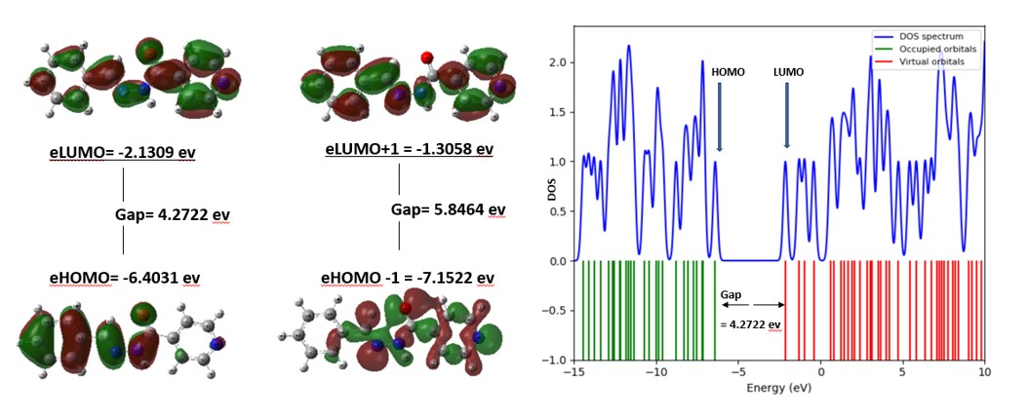

**Fig. 7 HOMO-LUMO Energy Gap and DOS plot of the ligand, L.**

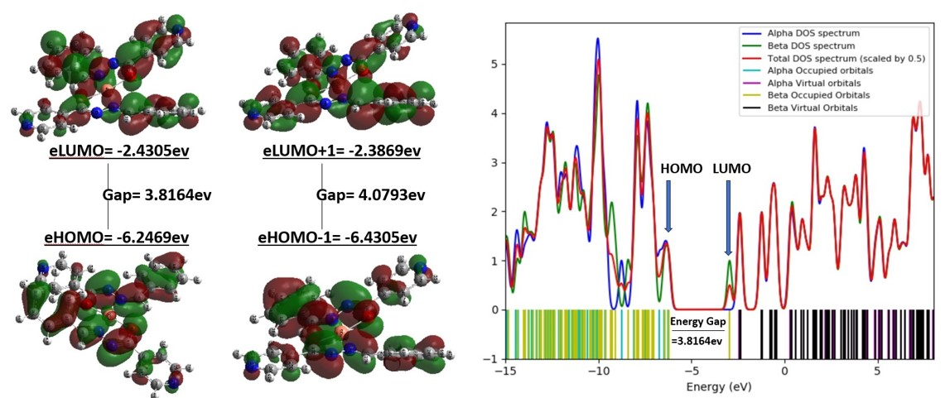

**Fig. 8 HOMO-LUMO Energy Gap and DOS plot of the complex, CuL.**

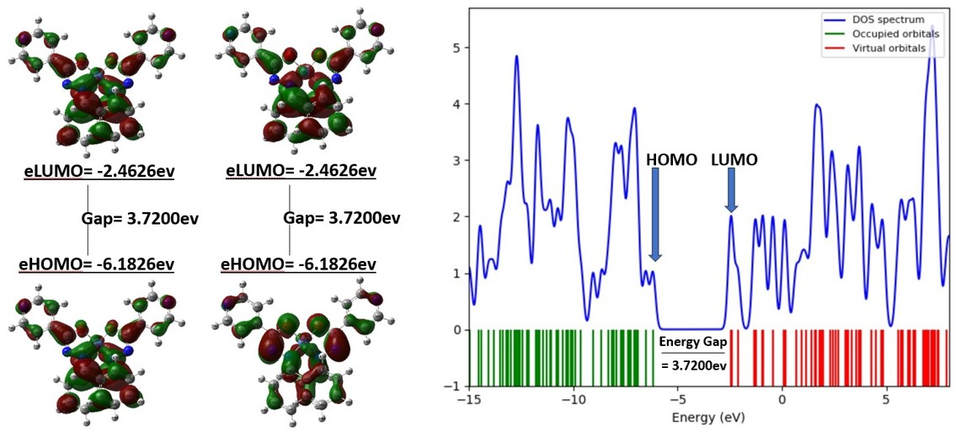

**Fig. 9 HOMO-LUMO Energy Gap and DOS plot of the complex, NiL.**

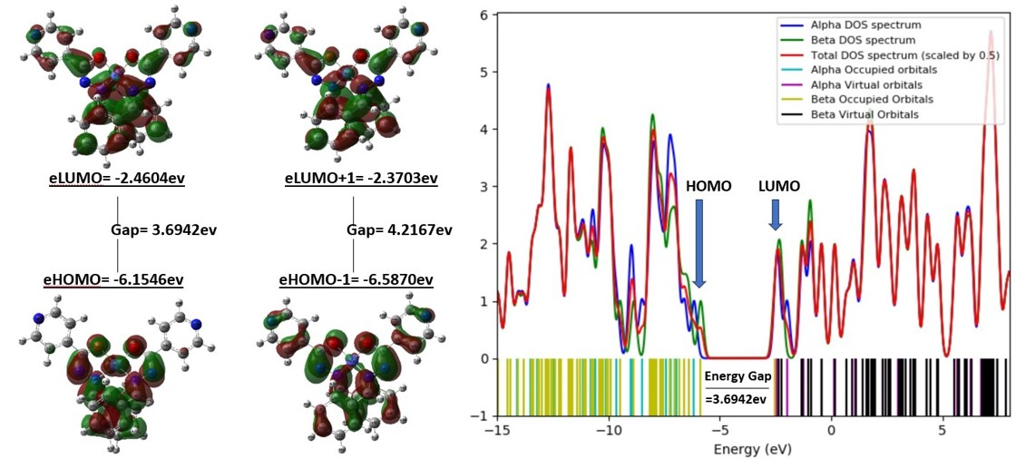

**Fig. 10 HOMO-LUMO Energy Gap and DOS plot of the complex, CoL.**

The energy gap between EHOMO and ELUMO plays a crucial role in determining chemical reactivity and influences the hardness and softness of chemical species, where a larger gap corresponds to a harder and less reactive molecule [34]. The ligand exhibited the highest chemical stability and lowest reactivity, with the largest ΔE value of 4.2722 eV. In contrast, CoL had the smallest energy gap of 3.6942 eV, indicating greater reactivity, followed closely by NiL and CuL. Chemical hardness (η) refers to a species' ability to resist charge transfer. According to the Hard and Soft Acids and Bases (HSAB) theory, "hard acids tend to coordinate with hard bases, while soft acids prefer soft bases." The Maximum Hardness Theorem states that chemical hardness is essential for stability, with harder molecules being more stable than softer ones. In Pearson’s classification, Cu²⁺, Ni²⁺, and Co²⁺ ions are categorized as borderline acids, with their experimental hardness values following the order Cu²⁺ > Ni²⁺ > Co²⁺ [35, 36]. Our calculations yielded the same trend, aligning with previous studies [37]. The data in the corresponding table indicate that the ligand (η = 2.1361 eV) is harder than the metal ions, suggesting a stronger interaction with Cu²⁺. Among the metal complexes, CuL exhibited the highest hardness value (1.9082 eV), making it the most stable compared to NiL and CoL. The electrophilicity index (ω), which measures a species' tendency to interact with nucleophiles based on electronegativity and hardness, was highest for NiL (ω = 5.0228 eV), indicating its strong electrophilic nature. The CoL complex also exhibited a relatively high electrophilicity value (ω = 5.0226 eV), whereas the ligand was the least electrophilic.

**3.8 Docking Studies**

Molecular docking is a powerful computational technique used to predict the most stable receptor–ligand complex, providing valuable insights into interaction mechanisms and facilitating the drug discovery process. This method is commonly utilized as a virtual screening tool in the initial stages of drug design and development.[38-41] In this study, molecular docking was performed to investigate the interactions between the synthesized compounds and the crystal structure of the SARS-CoV-2 main protease (PDB ID: 6XBH)). The results presented in Table 8 indicate that the compounds exhibited favorable interactions with the active binding sites of the target proteins (Fig. 11-14).

**Table 8 Interaction of the ligand molecules (L, CuL, CoL, NiL) against 6XBH protein mentioning binding energy, interacting amino acids, bond types, and their distance.**

|  |  |  |  |  |
| --- | --- | --- | --- | --- |
| **Name** | **Binding affinity(kcal/mol)** | **Residue in Contact** | **Interaction Type** | **Distance(A’)** |
| CoL+ 6XBH | -8.0 | Tyr239 | H | 3.05 |
| Asp289 | H | 3.50 |
| Leu287 | PA | 4.88 |
| Met276 | PA | 5.18 |
| CuL+ 6XBH | -6.6 | Lys137 | H | 2.11 |
| Leu282 | H | 2.53 |
| Phe3 | H | 2.80 |
| Glu290 | Pa | 4.71 |
| Glu290 | CC | 5.18 |
| Lys5 | H | 2.46 |
| Lys5 | H | 2.13 |
| NiL+ 6XBH | -7.1 | Lys5 | H | 1.91 |
| Lys5 | H | 2.46 |
| Lys5 | PS | 3.75 |
| Glu288 | CC | 5.40 |
| Glu288 | CC | 3.16 |
| Glu288 | CC | 2.89 |
| Leu286 | PA | 5.44 |
| L+ 6XBH | -6.0 | Thr111 | H | 2.00 |
| Thr111 | H | 2.84 |
| Phe294 | PPS | 5.65 |

H =conventional hydrogen bond, A =alkyl, PA =pi-alkyl, PC =Pi-cation, Pa = pi-anion, X =Halogen bond, Pd =Pi-donor, PS =Pi-sigma, PSu =Pi-sulfur, PPS =Pi-Pi stacked, PPTSh =Pi-Pi T-shaped

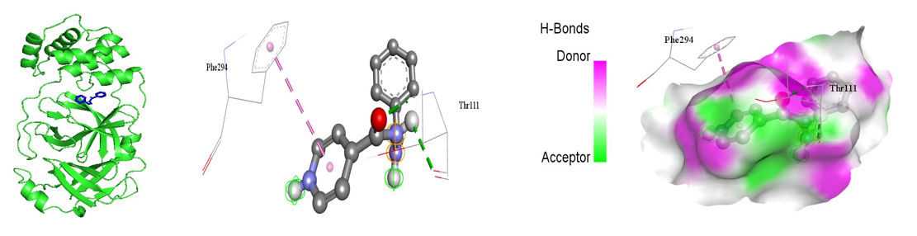

**Fig.11 Molecular docking simulation studies of hydrophobic interactions of the ligand, L with amino acid residues of PDB ID: 6XBH.**

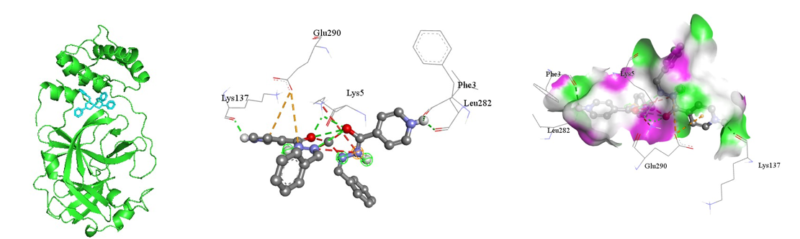

**Fig.12 Molecular docking simulation studies of hydrophobic interactions of the complex, CuL with amino acid residues of PDB ID: 6XBH.**

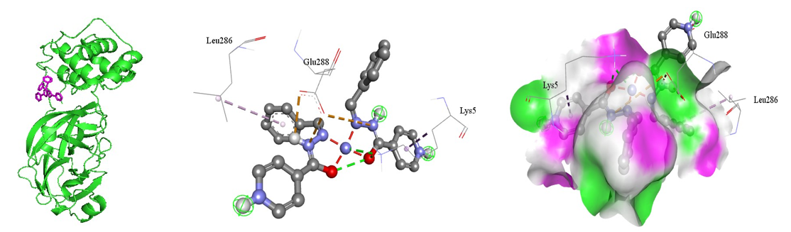

**Fig.13 Molecular docking simulation studies of hydrophobic interactions of the complex, NiL with amino acid residues of PDB ID: 6XBH.**

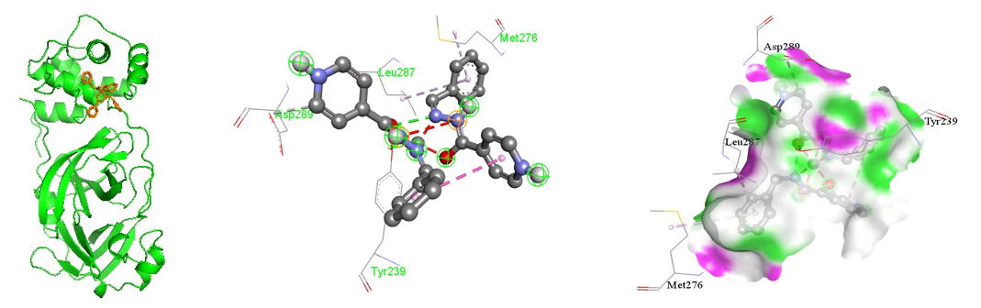

**Fig.14 Molecular docking simulation studies of hydrophobic interactions of the complex, CoL with amino acid residues of PDB ID: 6XBH.**

Following an analysis of the predicted binding conformations of the ligand and its complexes with Ni(II), Cu(II), and Co(II) using 6XBH docking, the optimal conformations indicated binding free energy values (ΔG) of -6.0, -7.1, -6.6, and -8.0 kcal/mol, respectively. The ligand, along with Ni(II), Cu(II), and Co(II) complexes, interacts through hydrogen donor bonding with the amino acid residues of threonine (Thr 111), Lysine (Lys 5), Leucine (Leu 282), Aspartic acid (Asp 289), with interaction distances measured at 2.84, 2.46, 2.53, and 3.50 Å, respectively.

The interaction energy values suggest that the Co(II) complex exhibits the highest stability, characterized by the lowest binding energy. From a binding energy perspective, this complex demonstrates strong interactions with the target proteins of the novel coronavirus.

**4. CONCLUSION**

The synthesis and characterization of the Schiff base ligand N-benzylidene-isonicotinohydrazide and its Ni(II), Co(II), and Cu(II) complexes have been successfully achieved. Spectroscopic techniques confirmed the structural integrity of the ligand and metal coordination via azomethine nitrogen and carbonyl oxygen atoms. Magnetic and electronic spectral analyses suggested that the complexes adopt a distorted square planar geometry. DFT calculations further validated the experimental findings, revealing significant electronic structure variations and charge transfer effects upon complexation. The calculated HOMO-LUMO energy gaps indicated increased reactivity in the metal complexes compared to the free ligand. Overall, this study provides valuable experimental data and theoretical insights for the future development and application of anti-COVID-19 drugs. The ligand demonstrated effectiveness against the novel coronavirus, while its Co(II) complex, exhibiting lower binding energy than the free ligand (L), suggests a potential for strong antiviral activity. These findings could contribute to the development of new treatments for coronavirus infections in the future.

**ACKNOWLEDGEMENTS**

The authors express their gratitude to the Faculty of Science, Rajshahi University, Bangladesh for funding to carry out this research (Grant No. 941….5/52/RU/Science-13/2023-2024). The authors are also thankful to the Department of Chemistry, Rajshahi University, Bangladesh for the contribution at different stages in this study.

**COMPETING INTERESTS**

Authors have declared that no competing interests exist.

Disclaimer (Artificial intelligence)

Author(s) hereby declare that generative AI technology, such as Large Language Models (e.g., ChatGPT), has been used during editing of the manuscript.

**REFERENCES**

1. El‐ajaily, M.M., et al., *Transition Metal Complexes of (E)‐2 ((2‐hydroxybenzylidene) amino‐3‐mercaptopropanoic acid: XRD, Anticancer, Molecular modeling and Molecular Docking Studies.* ChemistrySelect, 2019. **4**(34): p. 9999-10005.

2. Rana, M.S., et al., *A review on synthesis and biological activities of 2‐aminophenol‐based schiff bases and their transition metal complexes.* Applied Organometallic Chemistry, 2024. **38**(12): p. e7724.

3. Rana, M.S., et al., *Antioxidant activity of Schiff base ligands using the DPPH scavenging assay: an updated review.* RSC advances, 2024. **14**(45): p. 33094-33123.

4. Sarangi, A.K., et al., *Synthesis and characterization of some binuclear metal complexes with a pentadentate azodye ligand: an experimental and theoretical study.* Applied Organometallic Chemistry, 2020. **34**(8): p. e5693.

5. Mohapatra, R.K., et al., *Biological aspects of Schiff base–metal complexes derived from benzaldehydes: an overview.* Journal of the Iranian Chemical Society, 2018. **15**: p. 2193-2227.

6. Asraf, M.A., et al., *Structural Elucidation, 3D Molecular Modeling and Antibacterial Activity of Ni (II), Co (II), Cu (II) and Mn (II) Complexes Containing Salophen Ligand.* Asian Journal of Applied Chemistry Research, 2019: p. 1-15.

7. Ommenya, F., et al., *Synthesis, Characterization and Antibacterial Activity of Schiff Base, 4‐Chloro‐2‐{(E)‐[(4‐Fluorophenyl) imino] methyl} phenol Metal (II) Complexes.* Journal of Chemistry, 2020. **2020**(1): p. 1745236.

8. Mohamad, S., P. Ibrahim, and A. Sadikun, *Susceptibility of Mycobacterium tuberculosis to isoniazid and its derivative, 1-isonicotinyl-2-nonanoyl hydrazine: investigation at cellular level.* Tuberculosis, 2004. **84**(1-2): p. 56-62.

9. Deepak Kumara, B., et al., *Synthesis of novel 1, 2, 3-triazole derivatives of isoniazid and their in vitro and in vivo antimycobacterial activity evaluation.* In vivo, 2014. **100**: p. 3858.

10. Al Azzam, K.M., E.-S. Negim, and H.Y. Aboul-Enein, *ADME studies of TUG-770 (a GPR-40 inhibitor agonist) for the treatment of type 2 diabetes using SwissADME predictor: In silico study.* Journal of Applied Pharmaceutical Science, 2022. **12**(4): p. 159-169.

11. Ahmed, R.K., et al., *Designing of eight-coordinate manganese (II) complexes as bio-active materials: Synthesis, X-ray crystal structures, spectroscopic, DFT, and molecular docking studies.* Polyhedron, 2023. **244**: p. 116606.

12. Ounthaisong, U. and P. Tangyuenyongwatana, *Cross-docking study of flavonoids against tyrosinase enzymes using PyRx 0.8 virtual screening tool.* TJPS, 2017. **41**(2017).

13. Trott, O. and A.J. Olson, *AutoDock Vina: improving the speed and accuracy of docking with a new scoring function, efficient optimization, and multithreading.* Journal of computational chemistry, 2010. **31**(2): p. 455-461.

14. Reddy, G.R., S. Balasubramanian, and K. Chennakesavulu, *Zeolite encapsulated Ni (II) and Cu (II) complexes with tetradentate N 2 O 2 Schiff base ligand: catalytic activity towards oxidation of benzhydrol and degradation of rhodamine-B.* Journal of Materials Chemistry A, 2014. **2**(37): p. 15598-15610.

15. Asraf, M.A., et al., *Structural elucidation, 3D molecular modeling and antibacterial activity of Ni (II), Co (II), Cu (II) and Mn (II) complexes containing salophen ligand.* Asian Journal of Applied Chemistry Research, 2019. **3**(3): p. 1-15.

16. Asraf, M.A., et al., *Molecular computation and antibacterial activity of Cu (II) complex of naphthaldehyde thiosemicarbazone.* Americal Journal of Pure and Applied Biosciences, 2020. **2**(3): p. 85-93.

17. Manikandan, R., P. Viswanathamurthi, and M. Muthukumar, *Ruthenium (II) hydrazone Schiff base complexes: Synthesis, spectral study and catalytic applications.* Spectrochimica Acta Part A: Molecular and Biomolecular Spectroscopy, 2011. **83**(1): p. 297-303.

18. Fekri, R., et al., *Synthesis, characterization, anticancer and antibacterial evaluation of Schiff base ligands derived from hydrazone and their transition metal complexes.* Inorganica Chimica Acta, 2019. **484**: p. 245-254.

19. Benítez, J., et al., *New oxidovanadium (IV) N-acylhydrazone complexes: Promising antileishmanial and antitrypanosomal agents.* European Journal of Medicinal Chemistry, 2013. **62**: p. 20-27.

20. Ali, A.Q., et al., *Synthesis of platinum (II) complexes of isatin thiosemicarbazones derivatives: In vitro anti-cancer and deoxyribose nucleic acid binding activities.* Inorganica Chimica Acta, 2014. **416**: p. 235-244.

21. Azam, M., et al., *Synthesis, characterization of Uranyl (VI), Th (IV), Zr (IV) mixed-ligand complexes with S-methyl-2-(4-methoxybenzylidine) dithiocarbazate and N-donor co-ligand, and their evaluation as antimicrobial agent.* Journal of Saudi Chemical Society, 2021. **25**(3): p. 101207.

22. Asraf, M.A., et al., *Homogeneous photochemical water oxidation with metal salophen complexes in neutral media.* Photochemical & Photobiological Sciences, 2019. **18**(11): p. 2782-2791.

23. Asraf, M.A., et al., *Cobalt salophen complexes for light-driven water oxidation.* Catalysis Science & Technology, 2016. **6**(12): p. 4271-4282.

24. Afsan, F., et al., *Synthesis, spectral and thermal characterization of selected metal complexes containing schiff base ligands with antimicrobial activities.* Asian J. Chem. Sci, 2018. **4**(3): p. 1-19.

25. Ouari, K., et al., *Spectroscopic, crystal structural and electrochemical studies of zinc (II)-Schiff base complex obtained from 2, 3-diaminobenzene and 2-hydroxy naphthaldehyde.* Spectrochimica Acta Part A: Molecular and Biomolecular Spectroscopy, 2015. **135**: p. 624-631.

26. Ali, M.M., et al., *One pot synthesis of Cu (II) and Ni (II) peroxo complexes containing Schiff base: physicochemical, spectral and antibacterial investigations.* Asian J. Chem. Sci, 2020. **8**: p. 15-21.

27. Gondia, N., J. Priya, and S. Sharma, *Synthesis and physico-chemical characterization of a Schiff base and its zinc complex.* Research on Chemical Intermediates, 2017. **43**: p. 1165-1178.

28. Hossain, M., et al., *Co (II), Ni (II), and Cu (II) complexes containing isatin-based Schiff Base ligand: synthesis, physicochemical characterization, DFT calculations, antibacterial Activity, and molecular docking analysis.* Russian Journal of General Chemistry, 2022. **92**(12): p. 2723-2733.

29. Konstantinovic, S.S., et al., *Synthesis and characterization of Co (II), Ni (II), Cu (II) and Zn (II) complexes with 3-salicylidenehydrazono-2-indolinone.* Journal of the Serbian Chemical Society, 2003. **68**(8-9): p. 641-647.

30. Anacona, J., J. Calvo, and O.A. Almanza, *Synthesis, Spectroscopic, and Magnetic Studies of Mono‐and Polynuclear Schiff Base Metal Complexes Containing Salicylidene‐Cefotaxime Ligand.* International Journal of Inorganic Chemistry, 2013. **2013**(1): p. 108740.

31. Islam, M.A., et al., *Experimental and computational insights into antibacterial and antioxidant properties of metal complexes with isoniazid-based Schiff base ligands.* Journal of Molecular Structure, 2025. **1324**: p. 140916.

32. Abdallah, A.M., et al., *Coordination behavior of cocaine toward d-block metal ions: synthesis, spectral analysis, density functional theory (DFT) studies, and chemotherapeutic activity.* Journal of Molecular Structure, 2023. **1293**: p. 136301.

33. Mahmoud, N.H., et al., *Spectroscopic studies, DFT calculations, cytotoxicity activity, and docking stimulation of novel metal complexes of Schiff base ligand of isonicotinohydrazide derivative.* Applied Organometallic Chemistry, 2022. **36**(7): p. e6697.

34. Kusmariya, B.S. and A. Mishra, *Co (II), Ni (II), Cu (II) and Zn (II) complexes of tridentate ONO donor Schiff base ligand: synthesis, characterization, thermal, non-isothermal kinetics and DFT calculations.* Journal of molecular structure, 2017. **1130**: p. 727-738.

35. Tanwar, A., et al., *Minimum magnetizability principle.* The Journal of chemical physics, 2006. **125**(5).

36. Parr, R.G. and R.G. Pearson, *Absolute hardness: companion parameter to absolute electronegativity.* Journal of the American chemical society, 1983. **105**(26): p. 7512-7516.

37. Al Zoubi, W., *Biological activities of Schiff bases and their complexes: a review of recent works.* International Journal of Organic Chemistry, 2013. **3**(3): p. 73-95.

38. Jamshidvand, A., et al., *Studies on DNA binding properties of new Schiff base ligands using spectroscopic, electrochemical and computational methods: Influence of substitutions on DNA-binding.* Journal of Molecular Liquids, 2018. **253**: p. 61-71.

39. Kargar, H., et al., *Synthesis, characterization, crystal structures, DFT, TD-DFT, molecular docking and DNA binding studies of novel copper (II) and zinc (II) complexes bearing halogenated bidentate N, O-donor Schiff base ligands.* Polyhedron, 2021. **195**: p. 114988.

40. Ahmed, Y.M., M. Omar, and G.G. Mohamed, *Synthesis, spectroscopic characterization, and thermal studies of novel Schiff base complexes: theoretical simulation studies on coronavirus (COVID-19) using molecular docking.* Journal of the Iranian Chemical Society, 2022. **19**(3): p. 901-919.

41. Mohamed, G.G., M. Omar, and Y.M. Ahmed, *Metal complexes of Tridentate Schiff base: Synthesis, characterization, biological activity and molecular docking studies with COVID‐19 protein receptor.* Zeitschrift für anorganische und allgemeine Chemie, 2021. **647**(23-24): p. 2201-2218.