Addition of Two Species of Testate Amoebae (Phylum Tubulinea and Cercozoa) to Indian Fauna

.
ABSTRACT

Testate amoebae belong to the single celled organisms classified under protist fauna characterized by developing complex covering of outer chitin shells; they are renowned as bio indicators owing to their high reactivity to any change in the environment. This communication reports 2 new additions of moss inhabitant micro fauna to Indian testate fauna viz., Arcella costata Ehrenberg, 1847 and Trinema lenticularis Siemensma et Lucow, 2025, from Wayanad Wildlife Sanctuary, Kerala

Keywords: Testate Amoebae, Protozoa, Moss, Wayanad wildlife sanctuary, Pollution Indicator.

- INTRODUCTION
Wayanad Wildlife Sanctuary (WWS) shares borders with Nagarhole and Bandipur protected areas in Karnataka to its northeastern side and with Mudumalai Wildlife Sanctuary in Tamil Nadu toward the southeast. The sanctuary was established in 1973 through Government Order GO(MS)182/73/AD dated 30.05.1973 which officially declared its status as a Wildlife Sanctuary. The area is well known for high biodiversity because it belongs to the Nilgiri Biosphere Reserve complex. Chethalayam serves as a historic location found inside the Kurichiat Range that maintains its lush green vegetation. The historical British Rest House from 1892 at Chethalayam contributes cultural importance to the ecological richness of the area [1].
- Testate amoebae along with other shelled protozoa exist in numerous ecological niches. These microorganisms show excellent bioindication properties because they have high sensitivity to ecological changes and they reproduce quickly [2, 3]. These organisms show global distribution because they exist in various settings which include tropical areas alongside polar territories together with terrestrial regions and marine systems. Testate amoebae provide valuable ecological tracking tools because they show immediate reactions to changes in moisture levels and pH as well as other environmental influences [4]. Testate amoebae respond to changes in water quality and pollution levels together with climate change enabling their use in paleo environmental research and current ecological assessment [5,6,7,8]. The diverse group of testate amoebae drives essential ecosystem processes which primarily occurs in microhabitats of soil and aquatic environments through nutrient cycling and organic matter decomposition processes that establish their ecological value while serving as sensitive bioindicators [9].
- This study documents two new records of moss inhabitant micro fauna to Indian testate fauna viz., Arcella costata Ehrenberg, 1847 and Trinema lenticularis Siemensma et Lucow, 2025, from the study area Wayanad Wildlife Sanctuary (WWS), Kerala (Fig. 1).
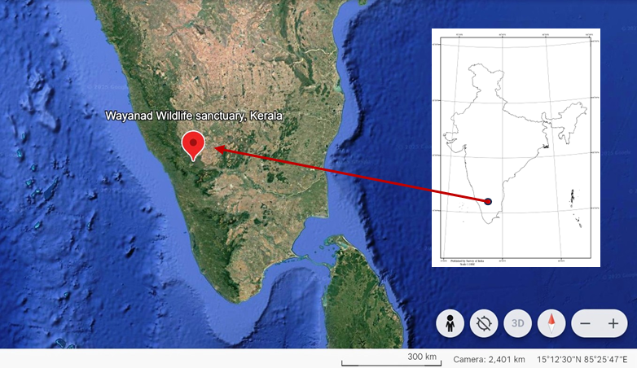
Fig. 1: Study area,Wayanad Wildlife Sanctuary, Kerala (Source: SOI & Google Earth)
- GLOBAL AND INDIAN DIVERSITY OF TESTATE AMOEBAE
Free-living testate amoebae extend their presence throughout the globe through more than 675 documented species from 104 genera and 22 families which have been observed even in polar regions. Studies have identified 209 Indian testate species from 37 genera which fall under two classes and two orders [10]. The widespread distribution of testate amoebae demonstrates their ability to thrive in diverse environments while making them highly important bioindicators due to their presence in every habitat from polar ice to various Indian regions. The study adds two new testate amoebae species from Indian testate fauna namely Arcella costata Ehrenberg, 1847 and Trinema lenticularis Siemensma et Lucow, 2025 which were discovered in moss habitats.

3. materialS and methods

The moss samples for the present study were collected in December 2023 as part of a faunal survey program within the WWS. The samples were obtained from tree bark biotopes by scraping with a spatula into polythene bags and brought to the laboratory for further processing. The processing of samples followed the non-flooded petri dish method outlined by Foissner [11]. Subsequently, permanent slide mounts were prepared from each sample and examined using Leica DM 2000 microscope equipped with camera attachment for image capturing and species-level identification. The registered permanent slides were deposited in the National Zoological collections of Western Ghats Regional Centre, Zoological Survey of India, Kozhikode.

4.RESULTS
The details of new additions of testate species to India are provided below.
Phylum Tubulinea Smirnov et al., 2005
Class Elardia Kang et al., 2017
Order Arcellinida Kent, 1880
Family Arcellidae Ehrenberg 1843
Genus Arcella Ehrenberg, 1832
Diagnosis :Test membraneous, rigid, appearing either smooth in texture or with a very fine reticulate pattern, usually yellowish in colour, turning brown with age; in dorsal or ventral view circular or oval in shape, in lateral view varying from plano-convex to hemispherical; externally test plain or in some cases variously ornamented, encrusted with chitinous particles; oral aperture central, usually circular, rarely of different shape, turned inwards and appearing as an inverted funnel; nuclei two or more.
  - Description of Species
- Arcella costata Ehrenberg, 1847 (Fig.2)
Diagnosis: Test relatively large, round in plan, high in profile, slightly narrowing towards the flat or slightly narrowing towards the flat or pointed aboral pole is clearly expressed hexagonal prism with distinct edges and ribs. The aperture is round without a collar, located in the centre of the concave ventral surface. The diameter of the test is 65-100µm, the height of the test is 44-48µm; the diameter of the aperture is 17µm

Material examined: Reg. No. ZSI/WGRC/IR.INV.29228, 3 examples; date of collection, 17.xii.2023 (11.760°N and 76.251°E); Tree moss, Chethalayam, Krichiat range, Wayanad WLS, Kerala.
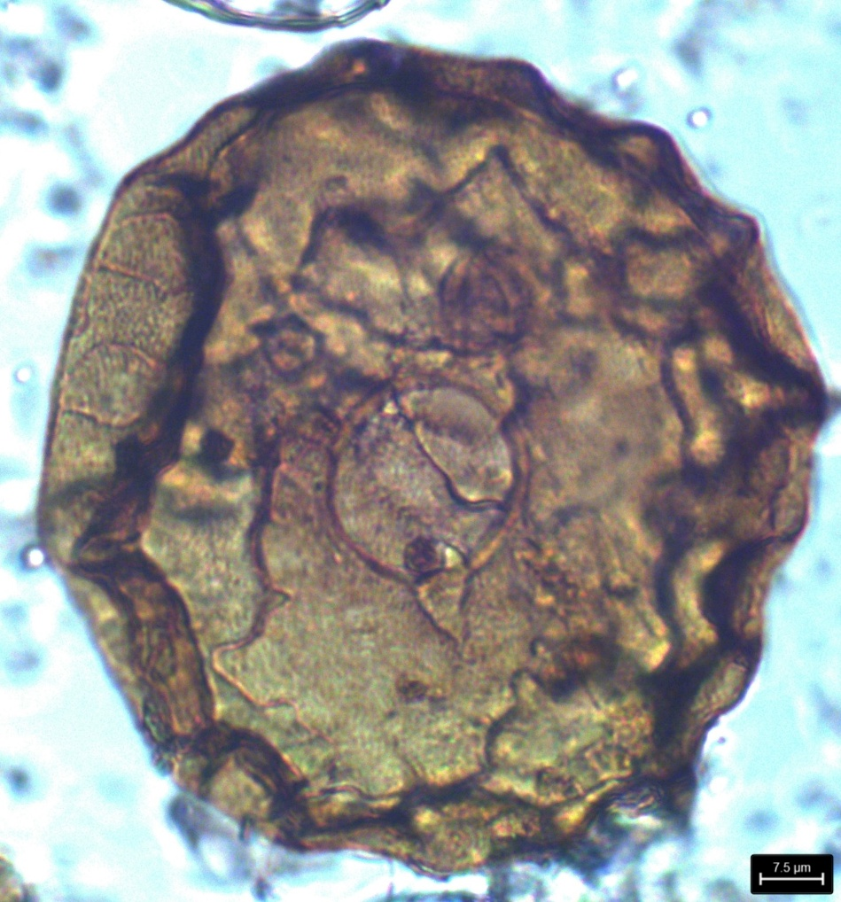
Fig.2. Arcella costata Ehrenberg, 1847
Phylum Cercozoa Cavalier-Smith 1998, emend. Adl et al. 2005; emend. Cavalier-Smith, 2018
Class Silicofilosea Adl et al., 2005, emend. Adl et al., 2012
Order Euglyphida Copeland 1956, emend. Cavalier-Smith 1997
Family Trinematidae Hoogenraad & De Groot 1940, emend Adl et al. 2012
Genus Trinema Dujardin, 1841, emend. Łuców et al., 2024
Diagnosis: In ventral view, shell is ovoid or broad oval, sometimes with almost parallel sides. In lateral view, the dorsal side is arched or flattened towards the aperture, ventral side is either flat or concave. Shell is covered by body-scales of two types: large circular plates and smaller circular or broad elliptical scales in between, overlapping. Aperture is sub-terminal or ventral, circular or oval, invaginated, surrounded by rows of toothed apertural plates.

- Trinema lenticularis Siemensma et Lucow, 2025 (Fig.3)
Diagnosis: Test elongated-ovoid in ventral view, in cross-section slightly compressed, a little deeper than wide. In lateral view, test bi-convex with rounded corners, aperture is circular and located at the ventral-anterior side and bordered by one row of small denticulate apertural scales. Shell composed of two types of scales: (1) large round scales that more or less overlap each other and (2) smaller broadly elliptical to oblong scales that lie beneath the larger scales and cover the gaps and transitions between the large scales. Shell length 35-48 µm; width 14-19 µm and aperture width 6-9 µm.
Material examined: Reg. No. ZSI/WGRC/IR.INV.29229, 2 examples; date of collection, 19.xii.2023 (11.697°N and 76.258°E); Tree moss, Kuppadi forest station office, Kurichiat range, Wayanad WLS, Kerala.
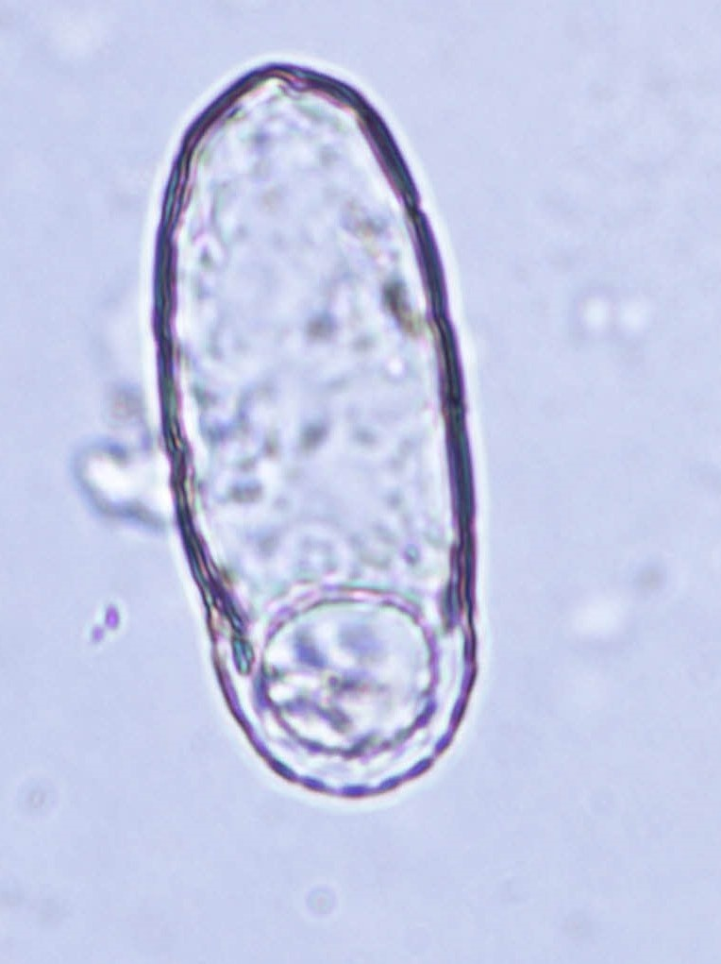
Fig. 3. Trinema lenticularis Siemensma et Lucow, 2025

- CONCLUSION:
The present communication reports two species of testate amoebae viz., Arcella costata Ehrenberg, 1847 and Trinema lenticularis Siemensma et Lucow, 2025 as new records to Indian testate fauna. Further detailed studies are required to explore more records of these interesting hidden fauna.

DISCLAIMER (ARTIFICIAL INTELLIGENCE)

Author(s) hereby declare that NO generative AI technologies such as Large
Language Models (Chat GPT, COPILOT, etc.) and text-to-image generators have
been used during the writing or editing of this manuscript.

- References
- Kerala Forest Department (2025). Retrieved from https://forest.kerala.gov.in/ (accessed on 13 April 2025).
- Mitchell E.A.D and Gilbert D (2004) . Vertical micro-distribution and response to nitrogen deposition of testate amoebae in Sphagnum. Journal of Eukaryotic Microbiology, 51 : 485 – 495 .
- Mitchell E. A. D., Edward, Charman, Dan and Warner (2008). Testate amoebae analysis in ecological and paleoecological studies of wetlands: past, present and future. Biodivers Conserv. 17: 2115-2137. Doi: 17. 10.1007/s10531-007-9221-3.
- Nguyen-Viet, H., Bernard, N., Mitchell, E. A. D., Cortet, J., Badot, P.-M., and Gilbert, D. (2007). Relationship between testate amoeba (protist) communities and atmospheric heavy metals accumulated in Barbula indica (Bryophyta) in Vietnam. Microbial Ecol. 53: 53-65.
- Vincke S, Gremmen N, Beyens I, Van de Vijver B (2004a). The moss dwelling testaceans fauna of IIe de Possession. Polar Biology,27: 753-766.
- Mattheeussen R, Ledeganct P, Vincke S, Van de Vijver B, Nijs I, Beyens L (2005). Habitat selection of aquatic testate amoebae communities on Qeqertarsuq (Disko Island), West Greenland. Acta Protozoologica, 44:253-263.
- Bobrov, A., Charman, D. J and Warner, B. G. (1999). Ecology of Testate Amoebae (Protozoa: Rhizopoda) on Peatlands in Western Russia with Special Attention to Niche Separation in closely related taxa. Protist.; 150(2): 125-136.
- Jassey, V. E., Signarbieux, C., Hättenschwiler, S., Bragazza, L., Buttler, A., Delarue, F and Mitchell, E. A. D (2013). An unexpected role for mixotrophs in the response of peatland carbon cycling to climate warming. Scientific Reports, 3: 23-54.
- Ogden, C.G., Hedley, R.H. 1980. An atlas of freshwater testate amoebae: 95 plates. British Museum (Natural History) and Oxford University Press (London and Oxford). Pp. 222.
- Bindu, L., Purushothaman, J., Ambili, A., Chaudhary, A. (2024). Checklist of Fauna of India:Testate Amoeba (Protozoa: Tubulinea; Cercozoa; Stramenopiles). Version 1.0. Zoological Survey India.
DOI:https://doi.org/10.26515/Fauna/1/2023/Protista:Tubulinea; Cercozoa; Stramenopiles.
- Foissner, W. (1992). Estimating the species richness of soil protozoa using non-flooded petridish method. In Protocols in Protozoology. Lee, J.J and Soldo,A.T.(eds), Allen Press, 119pp.

