**Impact of Inhaled Carbon Soot Particulate Matter (PM10) on Brain Histology using Wistar Rats**

**ABSTRACT**

Environmental exposure to carbon soot particulate matter (PM) is a growing concern due to its potential neurotoxic effects. This study aimed to investigate the histopathological impact of inhaled carbon soot PM on the cerebellar cytoarchitecture of male Wistar rats. Twenty-three (23) male Wistar rats were randomized into four groups: a control group (unexposed) and three experimental groups exposed to varying concentrations of carbon soot PM (2.131±0.207 mg/m³, 2.161±0.232 mg/m³, and 2.278±0.221 mg/m³) for 28 days. The exposure system simulated real-world inhalation conditions. Animals were sacrificed on days 3 and 28 post-exposure. Brain tissues were processed histologically and stained with hematoxylin and eosin (H&E) for microscopic evaluation. No statistical analysis was performed. Histological analysis revealed significant cerebellar alterations in the exposed groups compared to controls. Notable findings included Purkinje cell layer disorganization, neuronal degeneration, vacuolations, and gliosis. The severity of these histopathological changes correlated with exposure duration and concentration, with the highest particulate concentration group showing pronounced neurodegenerative effects. Chronic inhalation of carbon soot PM induces structural cerebellar damage, suggesting potential neurotoxic implications for prolonged exposure. These findings underscore the need for stringent regulatory measures to mitigate airborne particulate matter exposure.

**Keywords:** Carbon soot, neurotoxicity, Particulate matter, Cerebellum, Brain Histology, Inhalation, Wistar rats.

**INTRODUCTION**

Particulate matter (PM), a complex mixture of solid and liquid particles suspended in air, is classified by aerodynamic diameter into PM10 (≤10 µm) and PM2.5 (≤2.5 µm), with PM10 originating from construction, road dust, and industrial activities, while PM2.5 stems from combustion sources like fossil fuels and vehicular emissions (Kim et al., 2015; Thompson, 2018). PM10’s larger size allows deposition in upper respiratory tracts, whereas PM2.5 penetrates deeper into lungs and enters systemic circulation, contributing to oxidative stress and inflammation (Chen et al., 2022; Pryor et al., 2022). Globally, PM exposure is linked to ~4.2 million annual deaths, with PM2.5 alone responsible for approximately 4 million deaths from cardiopulmonary illnesses, cancers, and neurodegenerative disorders (Thangavel et a., 2022; Chen et al., 2022).

In the Niger Delta regions of Nigeria, industrial activities like oil refining and gas flaring generate high PM10 levels, yet studies on its histological impacts remain sparse compared to PM2.5. While PM2.5’s neurotoxicity is well-documented—including cerebellar damage and cognitive impairment—PM10’s effects on brain histology are understudied, particularly in regions with chronic industrial pollution such as Rivers, Delta, and Bayelsa States of Nigeria (Thompson et al., 2018; Li et al., 2022). This gap necessitates research to elucidate PM10’s mechanisms, such as oxidative stress and inflammation, which may disrupt brain cytoarchitecture, as observed in PM2.5 studies (Chen et al., 2022; Pryor et al., 2022). Addressing this knowledge deficit is critical for mitigating PM10-related health risks in polluted regions like Nigeria, where limited data hinder evidence-based policies.

This study seeks to fill these gaps by evaluating the effects of chronic exposure to carbon soot particulate matter on the cytoarchitecture of the cerebellum in Wistar rats. Through histopathological assessments, the study aims to provide an understanding of the structural and cellular alterations induced by prolonged soot inhalation.

**MATERIALS AND METHODS**

**Study design**

The study was conducted using male albino Wistar rat and the rats were exposed to Carbon Soot particulate matter by inhalation.

**Carbon Soot Particulate Matter Production and Authentication**

The carbon soot used as particulate matter in this study was obtained from the combustion of crude oil sourced from Shell-BP Petroleum Development Company of Nigeria Limited in Rivers State, Nigeria. Combustion was carried out in a local refinery and a controlled combustion chamber (**Figure 1**) at the Engineering Workshop of the Department of Mechanical Engineering, University of Port Harcourt. The resulting carbon soot particulate matter was subsequently identified and authenticated by Dr. Akuma Oji from the Department of Chemical Engineering, University of Port Harcourt, Choba, Rivers State, Nigeria.

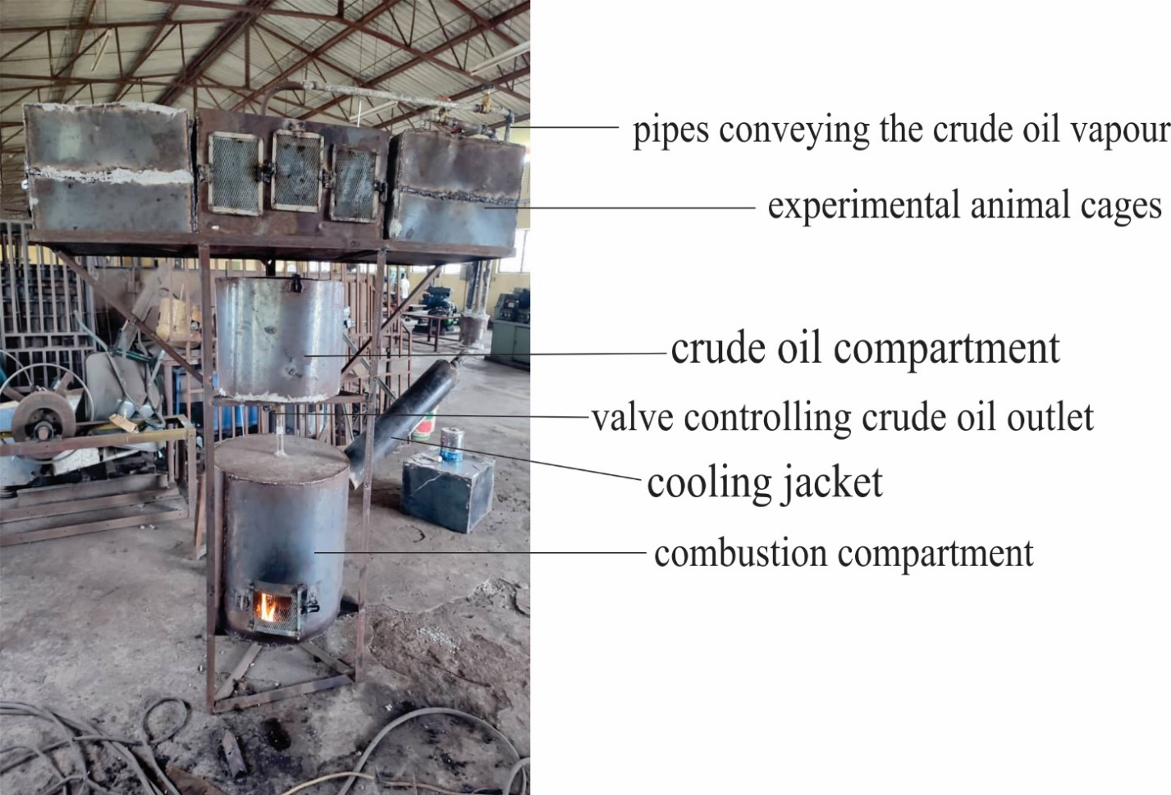

**Figure 1. A local refinery and combustion Chamber**

**Carbon Soot Particulate Matter Exposure System**

The whole-body exposure system, a well-established method for studying the effects of airborne pollutants like PM2.5 on animal models (Song et al., 2021), was utilized for the study. This approach allows for naturalistic exposure patterns similar to environmental conditions humans might experience. The apparatus for the carbon soot particulate matter inhalation system comprised a carbon soot particulate matter sample, a particulate matter concentration analyzer and quantifier (PM sensor and meter), three inhalation exposure cages, a circulatory machine (installed fan), and a thermometer to monitor the system's temperature (see **Figure 1**).

**Animal model**

A total of twenty-three (23) male Wistar rats, aged between 30 and 60 days and weighing 100–150 g, were procured from the Animal Farm House of the Department of Pharmacology, University of Port Harcourt. The animals were acclimatized for three weeks before exposure. They were housed in the animal facility of the Faculty of Basic Medical Sciences, University of Port Harcourt, under controlled laboratory conditions, including a temperature of 25 ± 2.0°C, a 12-hour light/dark cycle, and regulated humidity. The rats were provided free access to food and water ad libitum and were fed a standard rat diet (Eastern Premier Mills Limited, Calabar). Each rat was identified using distinct ear markings, and they were housed in wire-mesh cages lined with sawdust bedding, which was changed daily to maintain hygiene and minimize odor. The animal house was well-ventilated to ensure adequate airflow. All procedures adhered to standard ethical guidelines for laboratory animal care and use.

**Quality Assessment of the Inhalation System**

Prior to rat exposure, a quality assessment was conducted on the inhalation system of the local refinery and combustion chamber to assess its efficiency, soot production, and determine optimal exposure time and concentration. The analysis focused on volatile organic compounds (VOCs), methane, and CO₂. Soot production and accumulation were measured at intermittent time intervals of 30 to 60 minutes to evaluate variations in particulate matter generation.

**Baseline Assessment and Exposure Monitoring**

To establish a baseline and confirm the absence of contamination, three (3) rats were sacrificed and their cerebellar tissues were analyzed for soot deposition histologically. This was to ensure that the animals were free from soot contamination before the experiment. The rats were weighed, and their initial body weights recorded. During the study, the rats were exposed for four (4) hours per day, while emission measurements were recorded every three (3) days. Temperature measurements were taken at least three times per cage daily, and an additional thermometer was placed in the combustion chamber for continuous monitoring throughout the exposure duration.

**Experimental grouping/randomization**

The 20 male albino Wistar rats left after sacrificing 3 for baseline assessment were used for this study. The rats were randomized into 4 groups of 5 (n=5) animals each as shown in Table 1. The sample size of five (n=5) rats per group was selected based on common practice in preclinical studies, where small groups are typically used to minimize animal use in accordance with the 3Rs principle (Replacement, Reduction, and Refinement). This size provides a balance between ethical considerations and the need for sufficient statistical power to detect biologically meaningful effects.

**Table 1. Randomization of animals and exposure**

|  |  |  |
| --- | --- | --- |
| **Group** | **Identification** | **Exposure** |
| Group 1 | General Control | Rats in this group were not exposed to Carbon Soot Particulate Matter |
| Group 2 | Experimental Group 1 | Exposed to an average concentration of 2.131±0.207 mg/m³ of Carbon Soot Particulate Matter (PM10) for 28 days |
| Group 3 | Experimental Group 2 | Exposed to an average concentration of 2.161±0.232 mg/m³ of Carbon Soot Particulate Matter (PM10) for 28 days |
| Group 4 | Experimental Group 3 | Exposed to an average concentration of 2.278±0.221 mg/m³ of Carbon Soot Particulate Matter (PM10) for 28 days |

Source: Okoseimiema & Uahomo, 2025

**Animal Sacrifice and Processing of Tissues**

The exposure of animals was conducted for 28 days. The animals from each group were sacrificed on day 3 and 28 post exposure to the soot to assess both acute and chronic effects of the exposure to the particulate matter. The rats were anesthetized with diethyl ether and incision made in the thoracic region to expose the heart. The right atrium cut to drain the blood immediately followed by trans-cardiac perfusion using 0.9% saline and then 10ml of 4% paraformaldehyde (PFA) solution through the left ventricle of the heart. The brain was extracted, post-fixed overnight in 4% paraformaldehyde at 4°C. tissues were prepared histologically.

**Histological Preparation of brain** **tissues**

The processing of brain tissues followed a structured histological procedure. Upon removal, the tissues were immediately fixed in 10% formal saline fixative for two weeks to prevent autolysis and bacterial decomposition. Following fixation, dehydration was carried out using ascending grades of alcohol: 50% for two hours, 70% for another two hours, 95% overnight, and absolute alcohol for two hours the next morning. The tissues were then cleared using pure xylene for two hours to eliminate residual alcohol. Impregnation was performed by transferring the tissues into molten paraffin wax on a hot plate, allowing infiltration of the wax into the tissue. Embedding followed, where the tissues were placed in an embedding mold with molten paraffin wax, left to solidify, and then mounted on a wooden block holder in preparation for sectioning. The sectioning process utilized a sliding microtome (Germany), cutting the tissue into 5µm sections, which were floated on a slide containing 20% alcohol and placed on a warm water bath. The sections were then collected onto slides, dried on a hot plate, and further treated in a hot oven before staining.

Hematoxylin and eosin (H&E) staining was performed to enhance tissue visualization. The slides were first placed in xylene for five minutes, followed by dehydration through descending grades of alcohol (absolute, absolute, and 95%) with 10 dips in each solution. Afterward, the tissue sections were washed in tap water for one minute and stained with hematoxylin for three minutes. Following another one-minute wash, differentiation was carried out using 1% acid alcohol, followed by another tap water wash. The slides were then counterstained with eosin for five minutes and washed again in tap water for five minutes. Dehydration was repeated in ascending grades of alcohol (95%, absolute, and absolute alcohol), with 10 dips in each solution. The slides were subsequently placed in xylene twice for five minutes each, blotted in a one-way direction with filter paper, and finally cover-slipped using DPX mountant. After drying, photomicrographs were taken using a Zeiss Axioshop microscope to capture the stained tissue sections. Sections were observed under a digital brightfield microscope (OMAX 40-2000X 3MP Digital Compound Microscope, USA) and photomicrographs were taken 400x magnification.

**Method of data analysis**

Since no numerical data were generated in this study, the analysis was based on qualitative histological assessment. The histological slides were examined under a light microscope to evaluate tissue architecture, cellular integrity, and morphological changes in the brain samples. Observations were compared across experimental groups to identify structural alterations resulting from effluent exposure. Representative photomicrographs were captured for documentation and interpretation of findings.

**RESULTS**

**Cytoarchitecture of the cerebellum post-exposure to Soot**

The histopathological assessment of cerebellar cytoarchitecture following exposure to soot reveals progressive neurodegenerative changes over time (Figures 2 and 3). On day 3 post-exposure (Figure 2), Group A (general control) exhibited normal neuronal architecture with intact neurons (N), whereas Groups B, C, and D showed varying degrees of neuronal degeneration (DN), vacuolation (EV, V), and nuclear changes such as pyknosis and karyorrhexis (P). These findings suggest that even short-term exposure to soot may initiate early neurotoxic effects, characterized by structural damage to neurons.

By day 28 post-exposure (Figure 3), neurodegenerative alterations became more pronounced, particularly in Groups B, C, and D. In addition to persistent neuronal degeneration (DN) and extensive vacuolation (EV, V) observed at earlier time points, there was evidence of hypoperfusion-induced marked congestion of blood vessels (HCBV), indicating potential vascular compromise within the cerebellar tissue. The presence of pyknosis and karyorrhexis (P) further supports ongoing neuronal apoptosis and cell death.

The progressive worsening of cerebellar cytoarchitecture with increasing exposure duration suggests a dose- and time-dependent neurotoxic effect of soot-derived particulate matter, potentially mediated by oxidative stress, inflammation, and cerebrovascular dysfunction. These findings underscore the neurotoxic potential of chronic exposure to airborne pollutants, which may have significant implications for populations residing in high-pollution areas.

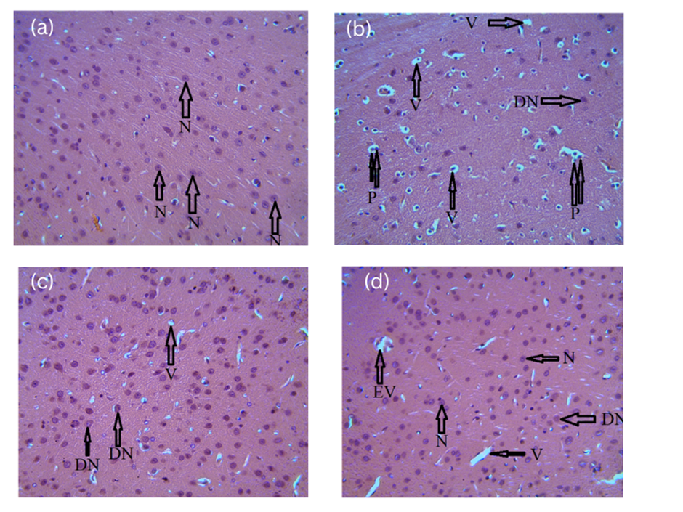

**Figure 2. Photomicrograph illustrating the cerebellar cytoarchitecture of** (a) Group A (general control), (b) Group B, (c) Group C, and (d) Group D on day 3 post-exposure to soot. H&E stain, magnification: ×400. Observed features include intact neurons (N), excessive neuronal degeneration (DN), extensive vacuolation (EV, V), and nuclear changes such as pyknosis and karyorrhexis (P).

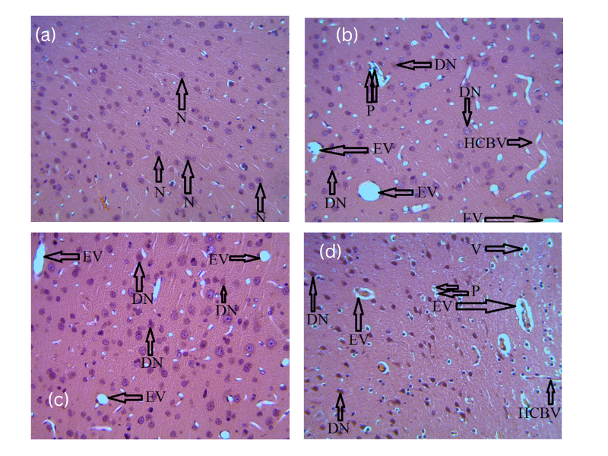

**Figure 3. Photomicrograph illustrating the cerebellar cytoarchitecture of** (a) Group A (general control), (b) Group B, (c) Group C, and (d) Group D on day 28 post-exposure to soot. H&E stain, magnification: ×400. Notable features include intact neurons (N), hypoperfusion-induced marked congestion of blood vessels (HCBV), excessive neuronal degeneration (DN), extensive vacuolation (EV, V), and nuclear changes such as pyknosis and karyorrhexis (P).

**DISCUSSION AND CONCLUSION**

​This study demonstrates that short-term exposure to soot-derived particulate matter (PM) induces early neurotoxic effects in the cerebellum of Wistar rats, characterized by structural damage to neurons, including neuronal degeneration, vacuolation, and nuclear changes. The progressive worsening of cerebellar cytoarchitecture with increasing exposure duration suggests a dose- and time-dependent neurotoxic effect of soot-derived particulate matter, potentially mediated by oxidative stress, inflammation, and cerebrovascular dysfunction. This is consistent with studies showing that PM exposure can induce neuroinflammation and oxidative stress, contributing to neurodegenerative and neurodevelopmental impairments (Lim & Kim, 2024).

The presence of hypoperfusion-induced marked congestion of blood vessels further supports the role of cerebrovascular dysfunction in PM-induced neurotoxicity, suggesting a potential link between air pollution and vascular compromise in brain tissues. Research has indicated that air pollutants can damage the blood-brain barrier through oxidative stress, leading to increased permeability and subsequent neuronal damage (Hahad et al., 2020).

The implications of these findings are significant in light of the increasing levels of air pollution in many urban areas in Nigeria. Chronic exposure to airborne pollutants can lead to long-term neurological deficits and increase the risk of neurodegenerative diseases (Adetona et al., 2020; Khreis et al., 2022). The observed effects on cerebellar cytoarchitecture may have implications for motor coordination, balance, and cognitive functions, as the cerebellum plays a crucial role in these processes. This study highlights the need for stricter air quality regulations and targeted interventions to reduce exposure risks in high-pollution areas, particularly in vulnerable populations such as children and the elderly.​

Despite these insights, the study has several limitations. The relatively short exposure duration (3 and 28 days) may not fully capture the chronic effects of soot-derived particulate matter on cerebellar cytoarchitecture. Additionally, the study focused solely on Wistar rats, which may limit generalizability to other species or humans due to physiological differences. Furthermore, the specific composition of soot-derived particulate matter may vary depending on the source, potentially influencing toxicity outcomes.​

Future studies should explore the long-term effects of chronic exposure to soot-derived particulate matter on cerebellar cytoarchitecture using larger sample sizes and extended durations. Investigating molecular pathways underlying PM-induced neurotoxicity, such as oxidative stress markers, inflammatory signaling pathways, and cerebrovascular dysfunction, could provide deeper insights into its mechanisms. Moreover, studies involving humanized models or population-based cohorts are needed to validate these findings in humans. Developing interventions to counteract PM-induced damage, such as antioxidants or anti-inflammatory agents, could also be a focus for future research.

**Ethics Approval:**

The study was carried out in adherence to ethical guidelines set by the National Institute of Health (NIH) for the ethical treatment of animals in research. The study was approved by the Research Ethics Committee of the University of Port Harcourt, Rivers State, Nigeria before commencement of the study.

**Disclaimer (Artificial intelligence)**

Authors hereby declare that NO generative AI technologies such as Large Language Models (ChatGPT, COPILOT, etc.) and text-to-image generators have been used during the writing or editing of this manuscript.

**REFERENCES**

Adetona, O., Ozoh, O. B., Oluseyi, T., Uzoegwu, Q., Odei, J., & Lucas, M. (2020). An exploratory evaluation of the potential pulmonary, neurological and other health effects of chronic exposure to emissions from municipal solid waste fires at a large dumpsite in Olusosun, Lagos, Nigeria. Environmental science and pollution research international, 27(24), 30885–30892. <https://doi.org/10.1007/s11356-020-09701-4>

Chen, H., Oliver, B. G., Pant, A., Olivera, A., Poronnik, P., Pollock, C. A., & Saad, S. (2022). Effects of air pollution on human health - Mechanistic evidence suggested by in vitro and in vivo modelling. Environmental research, 212(Pt C), 113378. <https://doi.org/10.1016/j.envres.2022.113378>

Hahad, O., Lelieveld, J., Birklein, F., Lieb, K., Daiber, A., & Münzel, T. (2020). Ambient Air Pollution Increases the Risk of Cerebrovascular and Neuropsychiatric Disorders through Induction of Inflammation and Oxidative Stress. International journal of molecular sciences, 21(12), 4306. <https://doi.org/10.3390/ijms21124306>

Khreis, H., Bredell, C., Wai Fung, K., Hong, L., Szybka, M., Phillips, V., Abbas, A., Lim, Y. H., Jovanovic Andersen, Z., Woodcock, J., & Brayne, C. (2022). Impact of long-term air pollution exposure on incidence of neurodegenerative diseases: A protocol for a systematic review and exposure-response meta-analysis. Environment international, 170, 107596. <https://doi.org/10.1016/j.envint.2022.107596>

Kim, K. H., Kabir, E., & Kabir, S. (2015). A review on the human health impact of airborne particulate matter. Environment international, 74, 136–143. <https://doi.org/10.1016/j.envint.2014.10.005>

Li, T., Yu, Y., Sun, Z., & Duan, J. (2022). A comprehensive understanding of ambient particulate matter and its components on the adverse health effects based from epidemiological and laboratory evidence. Particle and fibre toxicology, 19(1), 67. <https://doi.org/10.1186/s12989-022-00507-5>

Lim, E. Y., & Kim, G. D. (2024). Particulate Matter-Induced Emerging Health Effects Associated with Oxidative Stress and Inflammation. Antioxidants (Basel, Switzerland), 13(10), 1256. <https://doi.org/10.3390/antiox13101256>

Okoseimiema, S. C., & Uahomo, P. O. (2025). Chronic Inhalation of Carbon Soot PM2.5 Induces Weight Loss and Cerebellar Cytoarchitectural Disruption in Humans: A Scientific Perspective on Wistar Rats. *International Neuropsychiatric Disease Journal*, *22*(3), 27–39. <https://doi.org/10.9734/indj/2025/v22i3478>

Pryor, J. T., Cowley, L. O., & Simonds, S. E. (2022). The Physiological Effects of Air Pollution: Particulate Matter, Physiology and Disease. Frontiers in public health, 10, 882569. <https://doi.org/10.3389/fpubh.2022.882569>

Song, Y., Zhao, L., Qi, Z., Zhang, Y., Cao, G., Li, R., & Cai, Z. (2021). Application of a real-ambient fine particulate matter exposure system on different animal models. *Journal of Environmental Sciences, 105*, 64-70. <https://doi.org/10.1016/j.jes.2020.12.007>

Thangavel, P., Park, D., & Lee, Y. C. (2022). Recent Insights into Particulate Matter (PM2.5)-Mediated Toxicity in Humans: An Overview. International journal of environmental research and public health, 19(12), 7511. <https://doi.org/10.3390/ijerph19127511>

Thompson J. E. (2018). Airborne Particulate Matter: Human Exposure and Health Effects. Journal of occupational and environmental medicine, 60(5), 392–423. <https://doi.org/10.1097/JOM.0000000000001277>