**Exploring the Multifaceted Impact of Rheumatoid Arthritis: A Study from Benghazi, Libya**

**Abstract**

**Background:** Rheumatoid arthritis (RA) is a chronic autoimmune disorder that primarily causes symmetrical joint inflammation, particularly affecting the synovium. Key symptoms include morning stiffness, joint swelling, fatigue, and rheumatoid nodules in seropositive patients.

**Aim:** This study aims to assess the daily pattern of joint pain and stiffness, identify the most affected joints, evaluate comorbidities associated with RA and investigate the psychological and emotional impact of the disease on patient

**Material and Methods:** The study employed a cross-sectional survey design to collect data from 301 participants diagnosed with RA in Benghazi, Libya, between February and May 2024. Data analysis was conducted using SPSS, while Excel was used for accurate data entry and organization.

**Results**: The most prominent symptom reported was joint pain and stiffness, particularly in the morning, affecting 43.9% of participants. Joint involvement was highest in the hands, knees, and shoulders, with the hip joint being the least affected. A significant burden of comorbidities was observed, with hypertension and diabetes.

**Conclusion:** The study explores the clinical presentations of rheumatoid arthritis in Benghazi, Libya. Key findings include common symptoms like morning joint stiffness, highlighting the disease's impact on physical health. It also affects psychological well-being and employment status, with many patients experiencing comorbidities such as diabetes and hypertension, complicating their management.

Key words: Rheumatoid arthritis, chronic autoimmune disease, joints symmetrically, health

**Introduction**

Rheumatoid arthritis (RA) is a chronic autoimmune disease that affects several joints symmetrically.  RA happens when the immune system mistakenly attacks its own tissues, mainly the synovium (the lining of the membranes that surround the joints) causing inflammation and other symptoms (Zielinski *et al*., 2019). The multifaceted cause of RA involves environmental as well as genetic factors that play a crucial role in determining both the beginning and the severity of the disease (Aletaha *et al*., 2010). RA has an average prevalence of 20–50 cases per 100,000 individuals in North America and Europe, it has a prevalence rate of 0.51–1.1% worldwide (Alamanos & Drosos, 2005). The most common symptoms of RA include the following: excessive heat, stiff joints in the morning, fatigue, discomfort, swelling in the joints, and the appearance of nodules on the skin (Bullock *et al*., 2019; Rome & Stewart, 2020; Orange *et al*., 2020). The disease that mostly affects small joints over larger joints can also damage extra-articular tissues because it is a systemic disorder (Giles, 2019). Rheumatoid nodules in various locations are the most prevalent skin manifestations and are primarily seen in seropositive individuals with erosive conditions. the additional skin symptoms are the digital gangrene, ulcers, and periungual inflammation (Cojocaru *et al*., 2010). The pathophysiology of rheumatoid arthritis is yet unknown (Chemin *et al*., 2016; Aringer & Tony, 2012). Epigenetic and environmental factors trigger genomic structural alteration in those with susceptibility, leading to the development of self-antigens such as immunoglobulin. Therefore, proteins arginine residues are citrullinated by peptidyl arginine deaminases, resulting in the synthesis of citrulline and the development of self-induced inflammation and synovial damage (Curran *et al*., 2020; Scherer *et al*., 2020). It has been demonstrated that the innate immune system has an important role in triggering an overly reactive adaptive immune response, which significantly plays a role in the development and progression of rheumatoid arthritis (RA) (Edilova *et al*., 2021; Fang *et al*., 2020). While the exact cause and pathophysiology of RA remain unclear, autoimmune, genetic, and environmental factors are believed to be significant contributors to RA susceptibility (Karami *et al*., 2019). Psychiatric conditions appear to have a particularly interesting link with RA an association between post-traumatic stress disorder and an increased risk of RA has been described in both men (Boscarino, 2004) and women (Lee *et al*., 2015; Solyman *et al*., 2025). The management of RA requires a multifaceted approach, encompassing pharmacological interventions such as disease-modifying antirheumatic drugs (DMARDs) and non-pharmacological strategies to alleviate symptoms and slow disease progression.

**Aim**

This study seeks to evaluate the severity and daily patterns of joint pain and stiffness in patients, identify the joints most commonly affected, assess comorbidities associated with rheumatoid arthritis (RA), analyze changes in body weight before and after diagnosis, explore potential environmental triggers, and examine the psychological and emotional effects of the disease on patients.

**Material and Methods**

The study utilized a cross-sectional survey design and data was collected from local hospitals and clinics. As this survey had covered Benghazi city and its suburbs, the data was collected through face-to-face questionnaire from 301 participants between the ages of 18 years and older. The study was conducted after ethical approval was taken. The data collection was stated from February to May, 2024. The target population for this cross-sectional study was adults aged 18 years and older who diagnosed with rheumatoid arthritis by a certified rheumatologist regardless of residency within Benghazi, Libya or not. Individuals with other forms of arthritis that are not classified as rheumatoid arthritis are included in this study. Informed consent was the part of face-to-face questionnaire and only participants who were voluntarily willing to participate completed the questionnaire.

A self-prepared questionnaire was used to collect data from participants. It includes both closed ended questions, such as yes/no and multiple-choice, and open-ended questions to capture detailed responses. The questionnaire was divided into sections covering demographics, medical history, family history, lifestyle factors, symptoms, mental health disorders (including anxiety and depression assessments), treatment history, and laboratory test results. Statistical software such as SPSS was used to perform the necessary analyses. Data entry was managed using software like Excel to ensure accurate and organized recording of survey responses. For transparency, the complete questionnaire is provided as an annex to this article, allowing readers to review the instrument used in data collection.

**Results**

To assess the severity of joint pain and stiffness experienced by RA patients throughout the day.

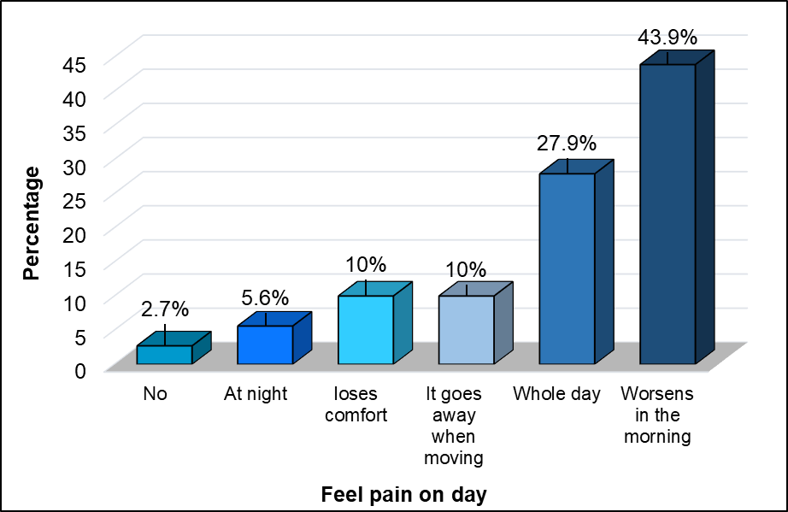The most prevalent symptom reported by patients was pain and joint stiffness that worsened in the morning, affecting 43.9% (n = 132) of the participants. This was followed by 27.9% (n = 84) of patients who experienced pain throughout the entire day. Equal proportions of patients 10% (n = 30) reported either experiencing discomfort that subsided with movement or a general loss of comfort. Pain occurring predominantly at night was noted by 5.6% (n = 17) of the participants, while the smallest proportion, 2.7% (n = 8), represented those who did not report any pain or stiffness symptoms (**Figure 1**).

**Figure 1:** The severity of joint pain and stiffness experienced by RA patients.

In our study of patients with rheumatoid arthritis (RA), we assessed the primary joints affected by the disease. The results show that the most commonly impacted joints are the hands, knees, and shoulders, with 80.4%, 72.4%, and 68.4% of patients reporting symptoms in these areas, respectively. Additionally, the wrists and ankles are frequently involved, with 60.5% and 66.1% of patients affected. Elbow involvement was reported by 55.1% of patients. Notably, hip involvement was the least prevalent, affecting only 39.9% of patients. These findings underscore the high frequency of joint impact in the upper and lower extremities, particularly the hands, knees, and shoulders, while hip involvement appears to be less common among RA patients (**Figure 2**).

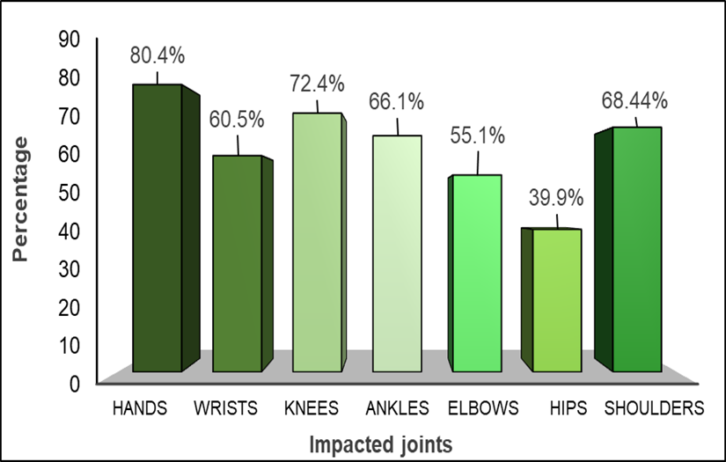

**Figure 2:** Joints that are primarily impacted by RA.

As shown in **figure 3**, our study of RA survivors, we examined the prevalence of various comorbidities and observed a notable incidence of chronic medical conditions. Hypertension was the most prevalent comorbidity, affecting 27.2% (n = 82) of patients. Diabetes mellitus (MD) was the second most common, observed in 19.6% (n = 59) of the cohort. Hypothyroidism (HT) followed, with a prevalence of 10% (n = 30). Additionally, 8.3% (n = 25) of patients experienced sinus infections (SI), while systemic lupus erythematosus (SLE) was present in 9% (n = 27) of the sample. Asthma and cardiovascular disease (CVD) were less frequent, affecting 5% (n = 15) and 4% (n = 12) of patients, respectively. These findings highlight the substantial burden of comorbidities in RA patients, with hypertension and diabetes representing significant contributors to the overall morbidity profile in this population

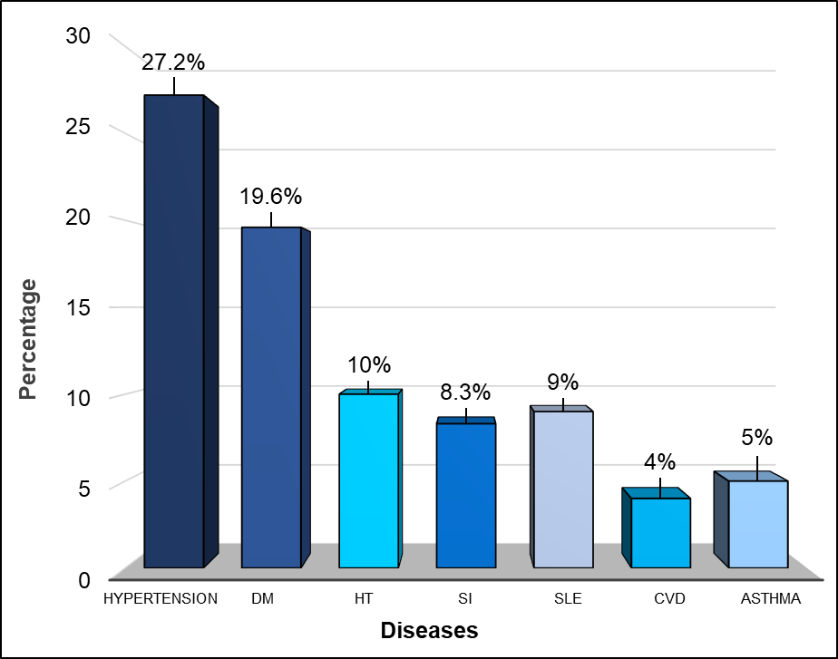

**Figure 3:** The relationship between RA and other medical conditions.

The majority of patients, 41.5% (n = 122), had a body weight between 61-80 kg following their RA diagnosis. A further 30.6% (n = 90) weighed between 81-100 kg. The next group, 15.6% (n = 46), had a weight ranging from 41-60 kg. A smaller proportion, 9% (n = 26), had weights between 101-120 kg, while only 0.7% (n = 2) of patients were in the 121-140 kg range. A minimal 0.3% (n = 1) weighed between 20-40 kg. The dataset had 2.3% (n = 7) missing information, indicating incomplete data for a small portion of the 294 patients (**Figure 4**).

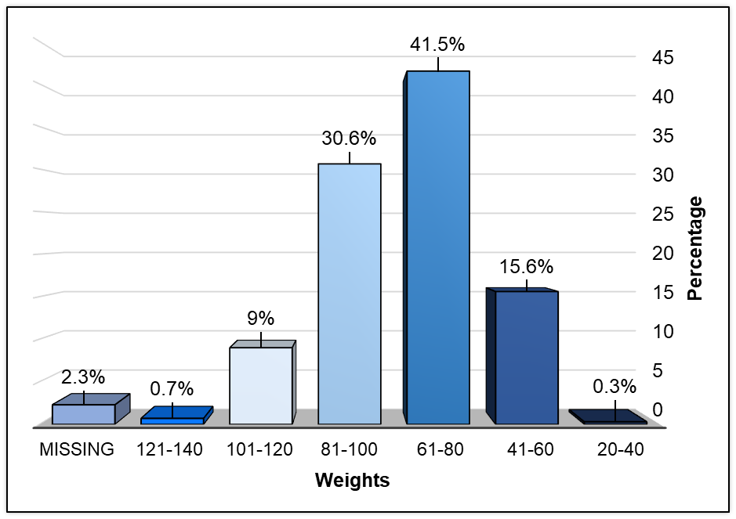

**Figure 4:** Post-RA diagnosis body weight distribution in Kg

Weight change analysis before RA diagnosis, represented in **Figure 5**, shows that 35% (n = 106) of patients experienced weight loss after RA diagnosis, making it the most prevalent change. In contrast, 32% (n = 97) reported weight gain, and 33% (n = 98) remained weight-stable.

**Figure 5:** Pre- RA diagnosis body weight changes.

This comparison between pre- and post-diagnosis weights demonstrates a significant shift in body weight among RA patients, with a notable proportion experiencing weight reduction after diagnosis. The weight loss observed in 35% of patients may be attributed to RA-related inflammation, systemic effects, or treatment side effects, whereas the weight gain in 32% could be linked to corticosteroid use or reduced physical activity. The stability observed in 33% indicates that a substantial group maintained their pre-diagnosis weight despite the progression of RA, possibly due to lifestyle factors or balanced disease management strategies. These results underscore the variable impact of RA on body weight, suggesting that tailored interventions are necessary to manage both weight loss and gain in RA patients.

To identify environmental exposures that trigger or worsen RA symptoms.

In our study of surveyed (RA) patients, we investigated the environmental factors that may trigger or exacerbate RA symptoms. The findings demonstrate that stress is the most significant environmental trigger, reported by 84.4% of the participants (n = 254). Exposure to environmental pollution and cold were also notable triggers, affecting 19.3% (n = 58) and 15.6% (n = 47) of participants, respectively. Detergent exposure was identified as the least common trigger, reported by only 2.3% (n = 7) of the patients. These results highlight the importance of stress management and environmental exposure control in mitigating RA symptoms. (**Figure 6**).

**Figure 6:** Environmental exposures that trigger or intensify the manifestation of RA

In our study of rheumatoid arthritis (RA) patients, we evaluated the impact of RA on emotional and psychological well-being. The data indicate that a significant proportion of patients, 70.4% (n = 212), reported experiencing emotional or psychological challenges such as depression, sadness, anxiety, and nervousness as a result of their condition. In contrast, 29.6% (n = 89) of patients reported no emotional or psychological impact. These findings emphasize the substantial emotional burden faced by RA patients, underscoring the need for comprehensive care that addresses both the physical and mental health aspects of the disease (**Figure 7**).

**Figure 7:** Impact of RA on patients' emotional wellness (i.e depression, sadness, anxiety, and nervousness) and psychological health

**Discussion**

Clinically, Osteoarthritis (OA) usually affects the distal interphalangeal (DIP) joint, whereas RA mostly affects the proximal interphalangeal (PIP) and metacarpophalangeal (MP) joints. Since, clinical variations may lead to different diagnoses for RA and OA (Bullock *et al*., 2018). In addition, OA the most prevalent kind of arthritis, is not brought on by an inflammatory disease but rather by natural aging. The immune system, heart, or lungs are unaffected by it. Furthermore, RA is symmetrical, whereas OA often affects just one side of the body, patients with RA also vary in that their morning stiffness lasts for a minimum of sixty minutes. Likewise, our results demonstrated that pain and joint stiffness among patients in the morning period was highest at about 43.9%, followed by the whole day at 27.9%. Morning stiffness is common in patients with osteoarthritis, but it usually goes away or gets better after 20 to 30 minutes (McGonagle *et al*., 2014; Dasgupta & Koolaee., 2016). Rheumatoid arthritis (RA) is defined as a systemic autoimmune pathology associated with a chronic inflammatory process, which can damage both joints and extra-articular organs, including the heart, kidney, lung, digestive system, eye, skin and nervous system (Cojocaru *et al*., 2010; Conforti *et al*., 2020). Previous study, proposed that atopy and allergic diseases (such as asthma, allergic rhinitis, and atopic dermatitis) are negatively correlated with the risk of RA which is contrast with our study where we noticed that the minority of RA patients suffered from allergic diseases such as sinusitis (8.3%) and asthma (5%). Recent epidemiological research, however, refuted the hypothesis and showed that RA is becoming more common in allergic populations (Rolfes *et al*., 2017; Lai *et al*., 2015). Although multiple systems in the cardiac system have an impact on the progression of degenerative conditions, RA patients may have an increased risk of cardiovascular death (Roman & Salmon, 2007). It might contain prognostic indications for diseases like hypertension and dyslipidemia (Baghdadi *et al*., 2015). Because both RA and aging are associated with growing complications such as cardiovascular disease (CVD), likewise our results demonstrate that 27.2% of patients suffered from hypertension and only 4% suffered from cardiovascular disease (CVD). Infections, interstitial lung disease, and cancer, these factors will have a significant impact on worldwide RA care (Radu & Bungau, 2021). Different study done by, (Kronzer *et al*., 2020) linked the acute and chronic respiratory disorders that affect the upper or lower respiratory tract to a higher risk of both seropositive and seronegative RA. Similarly, our results revealed a correlation between diseases and RA as about 30.6% of patients had shortness of breath, 23.3% of them had chest pain while about 19.9% had cough. However, the relationship was observed only in people who do not smoke, indicating the possibility of distinct or complementary pathogenic pathways between respiratory diseases and smoking. The correlation between persistent obstructive pulmonary disease and eventually RA has also been established by other research (Sheen *et al*., 2017; Ford *et al*., 2020; Bergstrom *et al*., 2011; Friedlander *et al*., 2019). Therefore, several other diseases have been identified as risk factors for incident RA, most notably other non-rheumatological immune-mediated diseases, such as autoimmune thyroid disease (i.e., Hashimoto thyroiditis and Graves' disease) (Somers *et al*., 2009; Bengtsson *et al*., 2013), type 1 diabetes mellitus (Somers *et al*., 2009; Liao *et al*., 2009), inflammatory bowel disease (Wilson *et al*., 2015) and, possibly, multiple sclerosis (Tseng *et al*., 2016) (less robust evidence) (Somers *et al*., 2009). Various common genetic risk determinants have been identified and other host and external factors are also likely to be important (Okada *et al*., 2013; Okada *et al*., 2018; Zhernakova *et al*., 2007; Farh *et al*., 2014; Costenbader *et al*., 2011; Liao *et al*., 2009). Interestingly, despite being an important RA comorbidity, one population-based case-control study has associated type 2 diabetes mellitus with increased risk of incident RA, similarly to our study we demonstrated the association between RA and other autoimmune diseases the first of was diabetes about 19.6% patients suffering from it, Hypothyroidism 10%, and SLE 9%. (Lu *et al*., 2014) although no effect had been reported in an earlier similar study (Liao *et al*., 2009). Furthermore, several studies have reported a protective effect of increasing body mass for radiographic joint damage and mortality in RA (Crowson *et al*., 2012; Flegal *et al*., 2012). These findings may seem to contradict our findings of an association between obesity and the development of RA with 33%. However, patients with RA may experience weight loss associated with their disease severity, which can lead to rheumatoid cachexia; this confirms our study, which showed a 35% decrease in weight. Although the data above support a large impact of host on the development of RA, the environment also plays a fundamental role in determining the ultimate risk of disease. In fact, extrinsic factors have been identified to interact with at-risk subjects and confer a multiplicative increase in the likelihood of developing RA (Romão & Fonseca, 2021). Environmental factors can have a large effect example; Airborne exposures, just as our results revealed that the association between environmental factors and RA. The portion of exposure to air pollutants was 19.3% and to the cold was 15%. Notably including smoking; microbiota and infectious agents; diet; and socioeconomic factors, including occupational and recreational exposures. Extensive data are available directly implicating these numerous aspects in the etiology of RA (Romão & Fonseca, 2021). In addition, some studies have shown that incidence rates differ throughout areas, even within the same country. These variations could have been induced by exposure to contaminants in the environment, changes in the climate, infectious illnesses, and food (Taylor-Gjevre *et al*., 2018; Costenbader, 2008; Solyman *et al.,* 2025). Moreover, stress is an important relationship between HPA axis disorders and mental health in RA. Some evidence suggests that a decrease in cooperative signaling between the HPA axis and the sympathetic nervous system, caused by chronic sympathetic nervous system activation and impaired regulation of acute physiological responses to negative emotional impacts (i.e depression, sadness, stress, anxiety, and nervousness), may make patients with RA who experience stress more susceptible to chronic inflammatory states (Straub, 2014). Our study revealed a strong correlation between rheumatoid arthritis (RA) and psychological stressors, with approximately 70.4% of patients reporting exposure to such factors as stress and depression. Thus, stress has been established as an exacerbating component in RA (Straub *et al*., 2005). Two meta-analyses found that people with depression have higher circulating levels of pro-inflammatory cytokines (Dowlati *et al*., 2009; Miller *et al*., 2009). Systemic vasculitis can cause cutaneous symptoms, gastrointestinal problems, heart dysfunction, and pulmonary signs. The most frequent skin symptoms are rheumatoid nodules in various places, which might appear primarily in seropositive individuals with erosive illness. Contrary to the results of our research, which showed that the majority of patients 58.8% did not suffer from any skin changes, some of the patients 11.3% suffered from dry skin and the minority 3.3% had vasculitis. Other skin indications include periungual inflammation, ulcers, and digital gangrene (Cojocaru *et al*. 2010).

**Conclusion**

Our work gives good insight into the clinical presentations of patients with rheumatoid arthritis seen in Benghazi, Libya. The common symptoms encountered among RA patients are as follows: stiffness of the joints, especially in the morning; RA affects more than just physical health—the psychological well-being and employment status of patients. In addition, the majority of RA patients had co-occurring conditions such as diabetes and hypertension, which further hampered the management of their illness.

**Ethical Approval and consent**

This study was conducted in accordance with the Declaration of Helsinki and received ethical approval from the Ethics Scientific Committee at Faculty of Biomedical Sciences, University of Benghazi, Benghazi, Libya. Informed consent was obtained from all participants prior to their inclusion in the study.

Survey used:

RA Questionnaire.pdf

Disclaimer (Artificial intelligence)

Author(s) hereby declare that NO generative AI technologies such as Large Language Models (ChatGPT, COPILOT, etc.) and text-to-image generators have been used during the writing or editing of this manuscript.

**References**

1. Aletaha, D., Neogi, T., Silman, A. J., Funovits, J., Felson, D. T., Bingham, C. O., ... & Hawker, G. (2010). 2010 Rheumatoid arthritis classification criteria: An American College of Rheumatology/European League Against Rheumatism collaborative initiative. *Arthritis & Rheumatism*, 62(9), 2569–2581. DOI: [10.1002/art.27584](https://doi.org/10.1002/art.27584)
2. Alamanos, Y., & Drosos, A. (2005). Epidemiology of adult rheumatoid arthritis. *Autoimmunity Reviews*, 4(3), 130–136. DOI: [10.1016/j.autrev.2004.09.002](https://doi.org/10.1016/j.autrev.2004.09.002)
3. Aringer, M., & Tony, H. (2012). Systemerkrankung rheumatoide Arthritis. *Zeitschrift Für Rheumatologie*, 71(10), 840. DOI: [10.1007/s00393-012-1033-5](https://doi.org/10.1007/s00393-012-1033-5)
4. Baghdadi, L. R., Woodman, R. J., Shanahan, E. M., & Mangoni, A. A. (2015). The impact of traditional cardiovascular risk factors on cardiovascular outcomes in patients with rheumatoid arthritis: A systematic review and meta-analysis. *PLoS ONE*, 10(2), e0117952.DOI: [10.1371/journal.pone.0117952](https://doi.org/10.1371/journal.pone.0117952)
5. Bengtsson, C., Padyukov, L., Källberg, H., & Saevarsdottir, S. (2013). Thyroxin substitution and the risk of developing rheumatoid arthritis; results from the Swedish population-based EIRA study. *Annals of the Rheumatic Diseases*, 73(6), 1096–1100. DOI: [10.1136/annrheumdis-2013-203715](https://doi.org/10.1136/annrheumdis-2013-203715)
6. Bergstrom, U., Jacobsson, L. T. H., Nilsson, J., Berglund, G., & Turesson, C. (2011). Pulmonary dysfunction, smoking, socioeconomic status and the risk of developing rheumatoid arthritis. *Rheumatology*, 50(11), 2005–2013. DOI: [10.1093/rheumatology/ker258](https://doi.org/10.1093/rheumatology/ker258)
7. Boscarino, J. A. (2004). Posttraumatic stress disorder and physical illness: Results from clinical and epidemiologic studies. *Annals of the New York Academy of Sciences*, 1032(1), 141–153. DOI: [10.1196/annals.1314.011](https://doi.org/10.1196/annals.1314.011)
8. Bullock, J., Rizvi, S. A. A., Saleh, A. M., Ahmed, S. S., Do, D. P., Ansari, R. A., & Ahmed, J. (2018). Rheumatoid arthritis: A brief overview of the treatment. *Medical Principles and Practice*, 27(6), 501–507. DOI: [10.1159/000493390](https://doi.org/10.1159/000493390)
9. Chemin, K., Klareskog, L., & Malmström, V. (2016). Is rheumatoid arthritis an autoimmune disease? *Current Opinion in Rheumatology*, 28(2), 181–188. DOI: [10.1097/BOR.0000000000000255](https://doi.org/10.1097/BOR.0000000000000255)
10. Cojocaru, M., Cojocaru, I. M., Silosi, I., Vrabie, C. D., & Tanasescu, R. (2010). Extra-articular manifestations in rheumatoid arthritis. *Maedica*, 5(4), 286–291.DOI: [21977172](https://pubmed.ncbi.nlm.nih.gov/21977172/).
11. Conforti, A., Di Cola, I., Pavlych, V., Ruscitti, P., Berardicurti, O., Ursini, F., ... & Cipriani, P. (2020). Beyond the joints, the extra-articular manifestations in rheumatoid arthritis. *Autoimmunity Reviews*, 20(2), 102735. DOI: [10.1016/j.autrev.2020.102735](https://doi.org/10.1016/j.autrev.2020.102735)
12. Costenbader, K. H. (2008). Geographic variation in rheumatoid arthritis incidence among women in the United States. *Archives of Internal Medicine*, 168(15), 1664. DOI: [10.1001/archinte.168.15.1664](https://doi.org/10.1001/archinte.168.15.1664)
13. Costenbader, K. H., Gay, S., Alarcón-Riquelme, M. E., Iaccarino, L., & Doria, A. (2011). Genes, epigenetic regulation and environmental factors: Which is the most relevant in developing autoimmune diseases? *Autoimmunity Reviews*, 11(8), 604–609. DOI: [10.1016/j.autrev.2011.10.022](https://doi.org/10.1016/j.autrev.2011.10.022)
14. Crowson, C. S., Matteson, E. L., Davis, J. M., & Gabriel, S. E. (2012). Contribution of obesity to the rise in incidence of rheumatoid arthritis. *Arthritis Care & Research*, 65(1), 71–77. DOI: [10.1002/acr.21660](https://doi.org/10.1002/acr.21660)
15. Curran, A. M., Naik, P., Giles, J. T., & Darrah, E. (2020). PAD enzymes in rheumatoid arthritis: Pathogenic effectors and autoimmune targets. *Nature Reviews Rheumatology*, 16(6), 301–315. DOI: [10.1038/s41584-020-0403-7](https://doi.org/10.1038/s41584-020-0403-7)
16. Dasgupta, R., & Koolaee, R. M. (2016). Medicine morning report: Beyond the pearls e-book. *Elsevier Health Sciences*.
17. Dowlati, Y., Herrmann, N., Swardfager, W., Liu, H., Sham, L., Reim, E. K., & Lanctôt, K. L. (2009). A meta-analysis of cytokines in major depression. *Biological Psychiatry*, 67(5), 446–457. DOI: [10.1016/j.biopsych.2009.09.033](https://doi.org/10.1016/j.biopsych.2009.09.033)
18. Edilova, M. I., Akram, A., & Abdul-Sater, A. A. (2021). Innate immunity drives pathogenesis of rheumatoid arthritis. *Biomedical Journal*, 44(2), 172–182. DOI: [10.1016/j.bj.2020.12.005](https://doi.org/10.1016/j.bj.2020.12.005)
19. Fang, Q., Zhou, C., & Nandakumar, K. S. (2020). Molecular and cellular pathways contributing to joint damage in rheumatoid arthritis. *Mediators of Inflammation*, 2020, 3830212. DOI: [10.1155/2020/3830212](https://doi.org/10.1155/2020/3830212)
20. Farh, K. K., Marson, A., Zhu, J., Kleinewietfeld, M., Housley, W. J., Beik, S., ... & Bernstein, B. E. (2014). Genetic and epigenetic fine mapping of causal autoimmune disease variants. *Nature*, 518(7539), 337–343. DOI: [10.1038/nature13835](https://doi.org/10.1038/nature13835)
21. Flegal, K. M., Carroll, M. D., Kit, B. K., & Ogden, C. L. (2012). Prevalence of obesity and trends in the distribution of body mass index among US adults, 1999-2010. *JAMA*, 307(5), 491. DOI: [10.1001/jama.2012.39](https://doi.org/10.1001/jama.2012.39)
22. Ford, J. A., Liu, X., Chu, S. H., Lu, B., Cho, M. H., Silverman, E. K., ... & Sparks, J. A. (2020). Asthma, chronic obstructive pulmonary disease, and subsequent risk for incident rheumatoid arthritis among women: A prospective cohort study. *Arthritis & Rheumatology*, 72(5), 704–713. DOI: [10.1002/art.41171](https://doi.org/10.1002/art.41171)
23. Friedlander, H. M., Ford, J. A., Zaccardelli, A., Terrio, A. V., Cho, M. H., & Sparks, J. A. (2019). Obstructive lung diseases and risk of rheumatoid arthritis. *Expert Review of Clinical Immunology*, 16(1), 37–50. DOI: [10.1080/1744666X.2019.1705784](https://doi.org/10.1080/1744666X.2019.1705784)
24. Giles, J. T. (2019). Extra-articular manifestations and comorbidity in rheumatoid arthritis: Potential impact of pre–rheumatoid arthritis prevention. *Clinical Therapeutics*, 41(7), 1246–1255. DOI: [10.1016/j.clinthera.2019.04.018](https://doi.org/10.1016/j.clinthera.2019.04.018)
25. Karami, J., Aslani, S., Jamshidi, A., Garshasbi, M., & Mahmoudi, M. (2019). Genetic implications in the pathogenesis of rheumatoid arthritis: An updated review. *Gene*, 702, 8–16. DOI: [10.1016/j.gene.2019.03.049](https://doi.org/10.1016/j.gene.2019.03.049)
26. Kronzer, V. L., Westerlind, H., Alfredsson, L., Crowson, C. S., Nyberg, F., Tornling, G., ... & Askling, J. (2020). Respiratory diseases as risk factors for seropositive and seronegative rheumatoid arthritis and in relation to smoking. *Arthritis & Rheumatology*, 73(1), 61–68. DOI: [10.1002/art.41491](https://doi.org/10.1002/art.41491)
27. Lee, Y. C., Agnew‐Blais, J., Malspeis, S., Keyes, K., Costenbader, K., Kubzansky, L. D., ... & Karlson, E. W. (2015). Post‐traumatic stress disorder and risk for incident rheumatoid arthritis. *Arthritis Care & Research*, 68(3), 292–298. DOI: [10.1002/acr.22653](https://doi.org/10.1002/acr.22653)
28. Liao, K. P., Gunnarsson, M., Källberg, H., Ding, B., Plenge, R. M., Padyukov, L., ... & Alfredsson, L. (2009). Specific association of type 1 diabetes mellitus with anti–cyclic citrullinated peptide–positive rheumatoid arthritis. *Arthritis & Rheumatism*, 60(3), 653–660. DOI: [10.1002/art.24362](https://doi.org/10.1002/art.24362)
29. Lu, M., Yan, S., Yin, W., Koo, M., & Lai, N. (2014). Risk of rheumatoid arthritis in patients with type 2 diabetes: A nationwide population-based case-control study. *PLoS ONE*, 9(7), e101528. DOI: [10.1371/journal.pone.0101528](https://doi.org/10.1371/journal.pone.0101528)
30. McGonagle, D., Hermann, K. A., & Tan, A. L. (2014). Differentiation between osteoarthritis and psoriatic arthritis: Implications for pathogenesis and treatment in the biologic therapy era. *Rheumatology*, 54(1), 29–38. DOI: [10.1093/rheumatology/keu328](https://doi.org/10.1093/rheumatology/keu328)
31. Miller, A. H., Maletic, V., & Raison, C. L. (2009). Inflammation and its discontents: The role of cytokines in the pathophysiology of major depression. *Biological Psychiatry*, 65(9), 732–741. DOI: [10.1016/j.biopsych.2008.11.029](https://doi.org/10.1016/j.biopsych.2008.11.029)
32. Okada, Y., Eyre, S., Suzuki, A., Kochi, Y., & Yamamoto, K. (2018). Genetics of rheumatoid arthritis: 2018 status. *Annals of the Rheumatic Diseases*, 78(4), 446–453. DOI: [10.1136/annrheumdis-2017-212852](https://doi.org/10.1136/annrheumdis-2017-212852)
33. Okada, Y., Wu, D., Trynka, G., Raj, T., Terao, C., Ikari, K., ... & Plenge, R. M. (2013). Genetics of rheumatoid arthritis contributes to biology and drug discovery. *Nature*, 506(7488), 376–381. DOI: [10.1038/nature12873](https://doi.org/10.1038/nature12873)
34. Orange, D. E., Blachere, N. E., DiCarlo, E. F., Mirza, S., Pannellini, T., Jiang, C. S., ... & Goodman, S. M. (2020). Rheumatoid arthritis morning stiffness is associated with synovial fibrin and neutrophils. *Arthritis & Rheumatology*, 72(4), 557–564. DOI: [10.1002/art.41141](https://doi.org/10.1002/art.41141)
35. Radu, A., & Bungau, S. G. (2021). Management of rheumatoid arthritis: An overview. *Cells*, 10(11), 2857. DOI: [10.3390/cells10112857](https://doi.org/10.3390/cells10112857)
36. Rolfes, M. C., Juhn, Y. J., Wi, C., & Sheen, Y. H. (2017). Association of asthma with rheumatoid arthritis: A population-based case-control study. *The Journal of Allergy and Clinical Immunology: In Practice*, 6(1), 219–226. DOI: [10.1016/j.jaip.2017.05.012](https://doi.org/10.1016/j.jaip.2017.05.012)
37. Rome, K., & Stewart, S. (2020). Rheumatic diseases. In *Elsevier eBooks* (pp. 222–260).
38. Romão, V. C., & Fonseca, J. E. (2021). Etiology and risk factors for rheumatoid arthritis: A state-of-the-art review. *Frontiers in Medicine*, 8. DOI: [10.3389/fmed.2021.689698](https://doi.org/10.3389/fmed.2021.689698)
39. Scherer, H. U., Häupl, T., & Burmester, G. R. (2020). The etiology of rheumatoid arthritis. *Journal of Autoimmunity*, 110, 102400. DOI: [10.1016/j.jaut.2020.102400](https://doi.org/10.1016/j.jaut.2020.102400)
40. Sheen, Y. H., Rolfes, M. C., Wi, C., Crowson, C. S., Pendegraft, R. S., King, K. S., ... & Juhn, Y. J. (2017). Association of asthma with rheumatoid arthritis: A population-based case-control study. *The Journal of Allergy and Clinical Immunology: In Practice*, 6(1), 219–226. DOI: [10.1016/j.jaip.2017.05.012](https://doi.org/10.1016/j.jaip.2017.05.012)
41. Solyman, M. S. M., Jaaka, R. I., Boushiha, S. R., Elmoghrby, H. A., Gargoum, K. A., Amer, A. H. (2025). Clinical characteristics of rheumatoid arthritis in Benghazi, Libya. *International Journal of Frontiers in Life Science Research*, 8(1), 030-037. <https://doi.org/10.53294/ijflsr.2025.8.1.0024>
42. Somers, E. C., Thomas, S. L., Smeeth, L., & Hall, A. J. (2009). Are individuals with an autoimmune disease at higher risk of a second autoimmune disorder? *American Journal of Epidemiology*, 169(6), 749–755. DOI: [10.1093/aje/kwn408](https://doi.org/10.1093/aje/kwn408)
43. Straub, R. H. (2014). Stress in RA: a trigger of proinflammatory pathways? *Nature Reviews Rheumatology*, 10(9), 516–518. DOI: [10.1038/nrrheum.2014.103](https://doi.org/10.1038/nrrheum.2014.103)
44. Straub, R. H., Dhabhar, F. S., Bijlsma, J. W. J., & Cutolo, M. (2005). How psychological stress via hormones and nerve fibers may exacerbate rheumatoid arthritis. *Arthritis & Rheumatism*, 52(1), 16–26. DOI: [10.1002/art.20747](https://doi.org/10.1002/art.20747)
45. Taylor-Gjevre, R., Nair, B., Jin, S., & Quail, J. (2018). Geographic variation in incidence and prevalence rates for rheumatoid arthritis in Saskatchewan, Canada 2001–2014. *Canadian Journal of Public Health*, 109(3), 427–435. DOI: [10.17269/s41997-018-0062-5](https://doi.org/10.17269/s41997-018-0062-5)
46. Tseng, C., Chang, S., Tsai, W., Ou, T., Wu, C., Sung, W., ... & Yen, J. (2016). Increased incidence of rheumatoid arthritis in multiple sclerosis. *Medicine*, 95(26), e3999. DOI: [10.1097/MD.0000000000003999](https://doi.org/10.1097/MD.0000000000003999)
47. Zhernakova, A., Alizadeh, B. Z., Bevova, M., Van Leeuwen, M. A., Coenen, M. J., Franke, B., ... & Wijmenga, C. (2007). Novel association in chromosome 4q27 region with rheumatoid arthritis and confirmation of type 1 diabetes point to a general risk locus for autoimmune diseases. *The American Journal of Human Genetics*, 81(6), 1284–1288. DOI: [10.1086/522036](https://doi.org/10.1086/522036)
48. Zielinski, M. R., Systrom, D. M., & Rose, N. R. (2019). Fatigue, sleep, and autoimmune and related disorders. *Frontiers in Immunology*, 10, 1827. DOI: [10.3389/fimmu.2019.01827](https://doi.org/10.3389/fimmu.2019.01827)
49. Roman, M. J., & Salmon, J. E. (2007). Cardiovascular manifestations of rheumatologic diseases. *Circulation*, 116(20), 2346–2355. DOI: [10.1161/CIRCULATIONAHA.106.678334](https://doi.org/10.1161/CIRCULATIONAHA.106.678334)
50. Saevarsdottir, S., Wedrén, S., Seddighzadeh, M., Bengtsson, C., Wesley, A., Lindblad, S., ... & Alfredsson, L. (2011). Patients with early rheumatoid arthritis who smoke are less likely to respond to treatment with methotrexate and tumor necrosis factor inhibitors. *Arthritis & Rheumatism*, 63(1), 26–36. DOI: [10.1002/art.27758](https://doi.org/10.1002/art.27758)
51. Sparks, J. A., Chang, S., Liao, K. P., Lu, B., Fine, A. R., Solomon, D. H., ... & Karlson, E. W. (2016). Rheumatoid arthritis and mortality among women during 36 years of prospective follow-up: Results from the Nurses' Health Study. *Arthritis Care & Research*, 68(6), 753–762. DOI: [10.1002/acr.22752](https://doi.org/10.1002/acr.22752)