**GIS and Mathematical Trend Surface Modeling of Groundwater Level in Parts of the Bundelkhand Craton, India**

**Abstract**

The application of mathematical trend surface modeling in combination with geostatistical methods has been demonstrated to be both a cost-effective and reliable approach for elucidating the geological characteristics of aquifer systems. This research introduces an innovative model for assessing the spatial variability of groundwater levels and the structural characteristics of associated aquifers. The model integrates geostatistical techniques with Geographic Information Systems (GIS), offering a robust framework for spatial analysis. The study encompasses seven districts of the Bundelkhand region and emphasizes the critical role of trend surface modeling of groundwater levels and GIS in enhancing the understanding of regional hydrogeological conditions. The objective of this research is twofold: first, to develop a model for analyzing polynomial surface trends through the application of geostatistical methods to the groundwater levels; and second, to investigate the relationship between groundwater variability and mathematical surface trends. The geostatistical analysis involved fitting theoretical semi-variograms to experimental data to determine the nugget, continuity, sill, and range of influence. Kriging, using these parameters, generated predictive maps of groundwater levels along with associated uncertainty. Point kriging cross-validation (PKCV) parameters were optimal, acceptable, and confirmed the unbiasedness hypothesis of kriging. Based on the PKCV, five essential parameters were computed to accept the anisotropy semi-variogram fitted model. These are (1) kriging mean error (KME), ideally close to zero so that there are no over or underestimates, (2) goodness of fit (R2), (3) the ratio of estimated variance (EV) to kriging variance (KV) lies between 0.95-1.05, (4) good eye visualization fit and (5) significant t-test on the correlation coefficient. The estimation of groundwater levels was facilitated by employing a second-order mathematical polynomial trend surface, with the resulting positive and negative residuals providing insights into the geology of the aquifer. A positive residual of the trend surface for the groundwater level variable is indicative of a favourable rock type for aquifer recharge, while a negative residual signifies an unfavourable rock type for aquifer recharge. In addition, the kriged surfaces for all seasons indicate severe groundwater depletion in the central zone of the study area. This methodology enhances the understanding of groundwater level fluctuations and provides a cost-effective approach for identifying critical areas in need of immediate, sustainable management interventions.

**Key words:** Polynomial Trend Surface, Kriging, GIS, Seasonal Variation

**1 Introduction**

Water is a vital natural resource for human survival, with its availability for ecological and anthropogenic processes significantly influenced by rainfall patterns (Saleem, et al., 2018). Rainwater and groundwater (GW) are interconnected, as rainwater replenishes aquifers through infiltration, a process termed *aquifer recharge* (Gabrielli, 2017). However, groundwater quality and quantity have declined globally due to anthropogenic activities (e.g., over-extraction, pollution) and geogenic factors (e.g., mineral dissolution) (Gautam & Bana, 2014). The spatial prediction of the subsurface water table can be accomplished using two distinct modeling approaches: physics-based or process-based models, such as Modflow (<https://www.usgs.gov>), and statistical learning or machine learning models (Mello & Ponti, 2018). The former approach often relies on several simplifying assumptions, which may influence the accuracy of predictions when compared to actual conditions (Yang et al., 2008). However, these models are advantageous for understanding the process and governing equations. In contrast, statistical learning or machine learning models do not incorporate the physics or mathematics of the process but predict the response based on data patterns from input learning data (Yasuda, H. et al. , 2020). Spatial prediction of groundwater levels in this region indicates the presence of approximately 78 dug wells in an area of 69,000 square kilometers. The challenge, however, lies in predicting the level of the water table in areas devoid of wells, which can span up to more than 100 square kilometers (Akhtar, Singh, & Rehman, 2016). These zones, therefore, suffer from a lack of knowledge about groundwater table fluctuations and infiltration rates. The endeavor to predict groundwater fluctuations and the high or low rate of rainfall infiltration in such areas without wells, based on information from the approximate 78 monitoring wells, is a challenging task. The research is innovative for two reasons. First, it uses a formulated geostatistical model. Second, it incorporates inconsistencies in spatial continuity, identifying surface trends that reflect the nature of the rock type (hard or soft rock). The study area is located in the Bundelkhand craton (Figure 2), which includes seven districts: Banda, Chitrakoot, Hamirpur, Jalaun, Jhansi, Lalitpur, and Mahoba. It is noteworthy that these districts are currently facing a pronounced groundwater availability crisis (Patel Deepak et al.). The region is bounded by coordinates 35.50N, 97.41E to 68.18W, 6.75S. The average elevation of the region is 341 meters above mean sea level (MSL). The topography is characterized by the presence of the Indo-Gangetic Plain in the north and the Vindhyan Basin in the south (Valdiya & Valdiya, 2016). The central and southern regions are characterized by the presence of rocky outcrops and broken hills, forming a stepped Vindhyan plateau that is repeated twice (Singh, G. P. 1999). The topography of the region is characterized by a slope, with barren and uneven terrain and sparse vegetation, a consequence of the presence of these highlands (Pati, J. K., 2020). The Bundelkhand plain is intersected by three mountain ranges, none of which exceed 600 meters in elevation (Figure 2). The direction of the flow of the region's rivers indicates a north-eastward sloping terrain, and the region is predominantly covered by Bundelkhand granite (Singh, G. P., 1999). The present study focuses on the geostatistical modeling of groundwater levels using surface trend modeling. Surface trend modeling of the groundwater level provides insights into the subsurface geology and the actual variations in water level (hydraulic head variation) conditions (Chaussard, E. et al., 2014). The data sets of groundwater level (m, MSL) variable are organized according to seasonal variation (Akhtar & Tripathi, 2024), including pre-monsoon (March, April, May), monsoon (July, August, September), post-monsoon (October, November, December), and the fluctuation period (post-monsoon and monsoon).Delineating groundwater risk zones provides valuable guidance for sustainable groundwater management and resource sustainability in critically affected regions, such as the Bundelkhand regions within the Indo-Gangetic Basin. Spatial prediction of groundwater table depth variations across different locations represents a crucial aspect of comprehensive groundwater resource management (Mishra, R. K., 2023). The integrated methodologies employed in this research offer a cost-effective approach, providing a detailed understanding of groundwater variability and risk assessment (Akhtar, S., 2023). This framework enhances hydrogeological modeling while contributing to the development of climate-resilient water management strategies in vulnerable regions.

**2. Methodology**

This study utilized two distinct methodologies to model groundwater levels (m, MSL) for the year 2017. The first methodology involved determining the order of the polynomial trend surface for each seasonal variation (pre-monsoon, monsoon, post-monsoon) and analysing groundwater level fluctuations between the monsoon and post-monsoon seasons. The second methodology aimed to geostatistically model the groundwater level data obtained from dug wells for the same year and seasonal variations. The workflow of the entire study is presented in Figure 1.

2.1 Polynomial Trend Surface Analysis

Spatial data often do not conform to geostatistical principles (Trapp, J. S., 1972), making it essential to examine the polynomial trend surface prior to applying geostatistics to spatial data. Geostatistics primarily deals with spatial information, emphasizing areas with high and low values (Kitanidis, P.K., 1997). This leads to the concept of a geographical trend, which is influenced by the spatial data’s location. Geostatistical estimation assumes stationarity, and deviations from this assumption are estimated using a global mean in simple kriging (Rodrigues et al., 2012). The concept of a regionalized variable, established by Matheron (1963), is based on random function theory. Measurements are assumed to reflect a specific random function for a given geographic location. Spatial data require certain constraints, referred to as the stationarity hypothesis (Vieira et al., 2010). The order of stationarity depends on the level of statistical stability required. Second-order stationarity, for example, requires that second-order moments, such as the mean and variance, remain constant. Consider a set of n values of Z(Xi), where the mean value E does not depend on the geographic location Xi. This is expressed as:

E{Z(Xi)} = m------------- (1)

The increase in variance [Z(Xi) –Z(Xi+h)] is finite and independent of the geographic location Xi, as shown in Equation 2:

VAR[Z(Xi)-Z(Xi+h)] = E[Z(Xi)-Z(Xi+h)]2---------------- (2)

Where 'm' represents the mean and 'h' represents a small positional increase in 'Xi'. A spatial dataset that displays a geometric trend surface indicates a consistent change in variable values across different spatial directions. The mean 'm' and the variance of the increment [Z(Xi) - Z(Xi+h)] then become location-dependent. A trend is identified when the semi-variogram lacks a stable sill, violating the inherent hypothesis (Equations 1 and 2) by showing dependency of mean and variance. Equation 3 calculated (2nd order trend surface, an example) for a simple trend surface (Trapp, J. S. 1972) variance on spatial position. In order to eliminate trends in the data, a trend surface can be fitted to the raw data by means of ordinary least squares (OLS) and the residuals can be calculated, as:

Z*(X, Y) = α+ α 1X+ α 2Y+ α 3X2+ α 4XY+ α 5Y2 -------------- (3)

Where Z*(X, Y is the estimated trend surface, X and Y are the spatial coordinates, and α 0, α 1,

α 2, α 3, α 4 and α 5 are the regression parameters determined by OLS. The residuals are then defined as:

Z (X, Y) residuals = Z (X, Y)- Z*(X, Y) -------------------------(4)

For a general n-th order trend surface, the equation is extended to include higher-order terms, reflecting more complex spatial variations:

$Z* (X, Y)=\sum_{i=0}^{n}{}\sum_{j=0}^{n-1}{αij​}Xi, Yj$--------------(5)

Where *n* represents the order of the trend surface, and *αij* are the coefficients obtained through regression analysis. If a linear geometric surface addresses the stationarity issue and produces a semi-variogram with a stable sill, further examination of the degree of the trend surface may not be required. It is essential to achieve a high coefficient of determination (R²) and a statistically significant F-test in order to determine the appropriate degree of the trend surface (S. Vieira et al., 2010).

**2.2** **Geostatistics**

Geostatistics were used in the second method for analyzing groundwater level in the present research. Geostatistics relies on the semi-variogram, which is estimated as half the average of the quadratic difference between two observations of a variable separated by a distance-vector h (Isaak, M. & Srivastava, R.M. 1989). The semi-variogram function at distance h is defined as ϒ(h):

ϒ(h) =2 ------------- (1)

Eq. (1) shows that N (h) is a total number of pairs of variables separated by this distance. Prior to developing geostatistical models, it is necessary to evaluate the semi-variogram model, which is designed for categories of the distance between sample pairs. The most widely used semi-variogram model is the spherical model (Sarangi et. al., 2005). When the variance of the nugget is not too significant but important, with a clear range (R) and sill (Co+C, Co-nugget, C-continuity), a spherical model of semi-variogram is a good choice among other semi-variogram models such as Gaussian or exponential (Sarangi et. al., 2005). Cross-validation is a technique used to test the acceptance and adequacy of the developed semi-variogram model (Emery, X, 2008). The semi-variogram model that best fits the data is selected using the point kriging cross-validation (PKCV) technique. This method minimizes the error variance and ensures that the prediction error's mean is zero, avoiding over or underestimation (Menafoglio et al., 2013). Kriging is a reliable interpolation technique that calculates weights based on surrounding known values to predict unknown locations. This section of the research focuses on ordinary kriging as a method for analysing the spatial variability of groundwater level (m, MSL). The kriged estimate of the mean value of grid G, denoted as G*, is calculated based on the values of g1, g2, g3, ..., gn and their respective weights a1, a2, a3, ..., an, where Σai=1. Therefore, the estimation is unbiased, with a mean error of zero for a large number of estimated values. Equation 2 provides the kriging variance.

= Σ (Gi − G∗)2 -------------- (2)

In order to obtain unbiased estimates in ordinary Kriging, a Lagrange multiplier (µ) is used as a coefficient for the construction of the variance minimum (equation 3) in the optimal solution of the Kriging system. The following set of equations must be solved concurrently:

$\left\{\begin{aligned}\sum_{i=1}^{n}{ƛiϒ\left(h\right)-µ=ϒ\left(h\right)} \\ \\ \sum_{i=1}^{n}{ƛi=1}\end{aligned}\right.$---------- (3)

Where λi is the weight associated with the data, and the Lagrange multiplier is represented by μ.

**4 Results and discussions**

The preliminary study revealed an unstable sill trend in groundwater levels across all three seasons (pre-monsoon, monsoon, and post-monsoon), as shown in Figures 3 and 4. However, no discernible trend was detected in the fluctuations of groundwater levels (the difference between post-monsoon and monsoon). The directional semi-variograms (Figure 4) revealed varying trends in groundwater levels across all three seasons. Further analysis of these semi-variograms at angles of 45°, 60°, 90°, and 135° (Figure 4) highlighted the most pronounced slope in the northeast, suggesting the presence of an underlying basin-like structure. This pattern is supported by the Digital Elevation Model (DEM) map (Figure 2), which shows the lowest elevation in the northeast, particularly in the Banda and Chitrakoot districts. The data was analyzed up to a third-order polynomial trend surface (Table 3), but the best optimum trend surface for the original dataset was identified as second order (Table 3 and Figure 5). This is shown in table 3, which indicates that the coefficient of determination (R2) and F-test value are optimal for the 2nd order trend surface. Table 1 presents statistics for the original groundwater level data. Figure 7 and Table 2 show the histogram, box plot and coefficient of variation of the residual data, respectively. As observed in Figure 7, the second-order residual follows a normal distribution without any outliers. The semi-variogram model for the second-order residual of groundwater levels, shown in Figure 8, exhibits a stable sill, confirming its suitability for geostatistical modeling. To examine seasonal variations in groundwater levels during the pre-monsoon, monsoon, and post-monsoon periods, the experimental semi-variogram was compared with the semi-variogram model (Figure 8) for cross-validation. The spherical model was selected due to the random distribution of sample points, with various lag distances and search radii considered for optimal model fitting. The Point Kriging Cross-Validation Technique (PKCV) was employed to validate the models, which were then aligned with the fitted experimental semi-variogram models (Table 5 and Figure 8). Figure 8 presents the fitted semi-variogram models of groundwater levels (second-order residual) for the three seasons and fluctuations. The equations for the spherical models, tailored to each seasonal variation and fluctuation, are provided in Table 4. Table 5 details the semi-variogram and geostatistical parameters. The coefficient of determination (R²) for observed versus estimated values from the fitted model indicates high accuracy, with values of 0.86, 0.80, 0.90, and 0.80 for each season and fluctuation, respectively, as shown in Figure 9. The slope of the regression line suggests minimal bias, further enhancing the model's reliability. To strengthen the credibility of these findings, a t-test was conducted in R, confirming the statistical significance of the correlation coefficient for all seasonal variations and fluctuations (Table 5). The experimental semi-variogram was matched to a theoretical semi-variogram, allowing for the estimation of nugget, continuity, sill, and range of influence (Table 5). Kriging was then performed using these semi-variogram parameters to generate predictive maps along with their kriging variance (uncertainties) for all three seasons, as well as for the fluctuation between monsoon and post-monsoon (Figure 10a to 10d). Before applying Kriging, the appropriate block size for the study area was determined. The Bundelkhand region, spanning 69,000 square kilometers, exhibits heterogeneous distribution. Block grids of 1000m × 1000m × 2m and 1000m × 1000m × 10m were delineated for all seasonal variations (pre-monsoon, monsoon, and post-monsoon) of the residual groundwater level and for the fluctuation in groundwater levels between monsoon and post-monsoon, respectively. The kriging method was applied after determining the center of each block. Figures 10a to 10d clearly illustrate the spatial distribution of kriged estimates of groundwater (GW) levels along with their associated uncertainties for all seasons. The maps indicate that GW levels are notably higher in the southern zone of Lalitpur district and the central and southern parts of Jhansi district. During the monsoon and post-monsoon seasons, the kriging estimate map shows an average rise in groundwater level of 0.74 meters. Figures 10a to 10d also present kriging variance (error) maps, depicting seasonal variations and fluctuations in the kriging estimates. In these maps, darker black shades represent maximum error, while lighter black shades indicate minimum error. The insights from the kriging variance (error) maps for the pre-monsoon, monsoon, post-monsoon, and fluctuation phases suggest a correlation between proximity to dug wells and reduced error. Specifically, error decreases near dug wells and increases with distance from these points, as shown in Figures 10a to 10d. Reflecting the unique conditions of the aquifer(s) and groundwater table (hydraulic head), the residuals of the second-order polynomial trend are visualized through geo-visualization maps, highlighting areas with positive and negative residuals (Figure 6).

The kriged estimate maps for each seasonal variation (pre-monsoon, monsoon, and post-monsoon) show positive residuals in the southern part of Lalitpur, the central part of Mahoba, Jalaun district, and the western part of the Jhansi region, as depicted in Figure 6. Areas with positive residuals are characterized by the presence of soft rocks (sedimentary/alluvial formations). The kriged estimate (KE) maps indicate that regions with positive residual estimates (Figure 6) have groundwater levels ranging between 190 and 180 meters above mean sea level (MSL). Conversely, areas with negative residuals correspond to hard rock formations, such as granite and metasedimentary rocks, which exhibit lower groundwater levels (170 to 150 meters MSL) compared to regions with positive residuals (Figure 6). The geo-visualization maps of the second-order residuals of groundwater levels for all three seasons indicate that the western parts of Lalitpur, Hamirpur, Chitrakoot, and Banda districts, as well as the southern part of the Jhansi region, exhibit negative residuals (Figure 6). This suggests that infiltration processes are less active in these areas, leading to lower groundwater levels compared to regions with positive residuals.

**5 Conclusions**

The study systematically analyzed groundwater (GW) level trends in two distinct phases to assess hydraulic head conditions (groundwater level, MSL) and aquifer rock properties. Trend surface analysis in the first phase revealed that the subsurface geology predominantly consists of hard rock formations, as indicated by negative groundwater level residuals (Figure 6). Conversely, regions with positive residuals were associated with soft rock formations, highlighting variations in aquifer properties (Figure 6). The analysis further identified the southern Jhansi region as a critical stress zone, experiencing severe groundwater depletion due to limited surface water percolation. The second phase employed geostatistical modeling to analyze groundwater levels using data from 78 monitored dug wells across the Bundelkhand region. This modeling serves as a strategic tool for informed decision-making, aiding in the optimal placement of new dug wells while mitigating the risks of groundwater overexploitation. The kriged estimates demonstrated strong alignment with observed groundwater levels, reinforcing the reliability of the model (Figures 10a to 10d). Geo-visualization maps of the second-order residuals across all three seasons (pre-monsoon, monsoon, post-monsoon) further indicated that regions in the western parts of Lalitpur, Hamirpur, Chitrakoot, and Banda districts, as well as the southern Jhansi region, are characterized by negative residuals, suggesting reduced infiltration and lower groundwater levels compared to areas with positive residuals (Figure 6). Kriged fluctuation analysis, conducted during the post-monsoon and monsoon seasons, revealed significant fluctuations in groundwater levels in Jhansi, Chitrakoot, Banda, and parts of Hamirpur and Jalun districts, potentially indicating overexploitation. The groundwater level increased by 0.74 meters from the monsoon to the post-monsoon season, with mean kriged estimates for the pre-monsoon, monsoon, and post-monsoon periods at 179.43 meters, 181.56 meters, and 180.46 meters, respectively. Kriged estimate maps indicated that the central zones of the study area are experiencing groundwater depletion across all seasonal variations. Experimental semi-variograms, validated against fitted models, demonstrated the spatial coherence, anisotropy, and heterogeneity of groundwater levels. Isotropy was confirmed by consistent sill values across all seasons and directions. This analysis offers essential insights for the strategic placement of new dug wells to address kriging variance (Figures 10a to 10d).

Disclaimer (Artificial intelligence)

Option 1:

Author(s) hereby declare that NO generative AI technologies such as Large Language Models (ChatGPT, COPILOT, etc.) and text-to-image generators have been used during the writing or editing of this manuscript.

Option 2:

Author(s) hereby declare that generative AI technologies such as Large Language Models, etc. have been used during the writing or editing of manuscripts. This explanation will include the name, version, model, and source of the generative AI technology and as well as all input prompts provided to the generative AI technology

Details of the AI usage are given below:

1.

2.

3.

**References**

Akhtar, S. (2023). Spatial-temporal Trends Mapping and Geostatistical Modelling of Groundwater Level Depth Over Northern Parts of Indo-Gangetic Basin, India. *Journal of Geography, Environment and Earth Science International*, *27*(10), 96-112.

Akhtar, S., & Tripathi, J. N. (2024). Spatiotemporal Geostatistical Techniques Approach for Evaluation of Groundwater Quality and Its Suitability for Potable Uses in Delhi City, India. In *Geospatial Technologies for Integrated Water Resources Management: Mapping, Modelling, and Decision-Making* (pp. 167-187). Cham: Springer Nature Switzerland.

Akhtar, S., Singh, P., & Rehman, S. (2016). GIS based modelling of routes of the Allahabad City (UP).

Chaussard, E., Bürgmann, R., Shirzaei, M., Fielding, E. J., & Baker, B. (2014). Predictability of hydraulic head changes and characterization of aquifer‐system and fault properties from InSAR‐derived ground deformation. *Journal of Geophysical Research: Solid Earth*, *119*(8), 6572-6590.

Gabrielli, C. P. (2017). *The Role of Bedrock Groundwater in Headwater Catchments: Processes, Patterns, Storage and Transit Time* (Doctoral dissertation, University of Saskatchewan).

Gautam, R. C., & Bana, R. S. (2014). Drought in India: its impact and mitigation strategies–a review. *Indian Journal of Agronomy*, *59*(2), 179-190.

Matheron, G. (2019). *Matheron's Theory of Regionalised Variables*. Oxford University Press.

Mello, R. F., & Ponti, M. A. (2018). *Machine learning: a practical approach on the statistical learning theory*. Springer.

Menafoglio, A., Secchi, P., & Dalla Rosa, M. (2013). A Universal Kriging predictor for spatially dependent functional data of a Hilbert Space.

Mishra, R. K. (2023). Fresh water availability and its global challenge. *British Journal of Multidisciplinary and Advanced Studies*, *4*(3), 1-78.

Pati, J. K. (2020). Evolution of Bundelkhand craton. *Episodes Journal of International Geoscience*, *43*(1), 69-87.

Rodrigues, M. S., Corá, J. E., & Fernandes, C. (2012). Spatial relationships between soil attributes and corn yield in no-tillage system. *Revista Brasileira de Ciência do Solo*, *36*, 599-609.

Saleem, Mohd., Athar Hussain, and Gauhar Mahmood. 2018. “A Systematic Approach for Design of Rainwater Harvesting System and Groundwater Aquifer Modeling.” *Applied Water Science* 8(5): 1–10. <https://doi.org/10.1007/s13201-018-0769-8>.

Sarangi, A., Cox, C. A., & Madramootoo, C. A. (2005). Geostatistical methods for prediction of spatial variability of rainfall in a mountainous region. *Transactions of the ASAE*, *48*(3), 943-954.

Trapp, J. S. (1972). Trend surface analysis as an aid in exploration for Mississippi Valley type ore deposits.

U.S. Geological Survey (n.d). U.S. Department of the Interior. Retrieved March 22, 2025, from <https://www.usgs.gov>.

Valdiya, K. S., & Valdiya, K. S. (2016). Indo-Gangetic plains: evolution and later developments. *The Making of India: Geodynamic Evolution*, 723-745.

Vieira, S. R., Carvalho, J. R. P. D., Ceddia, M. B., & González, A. P. (2010). Detrending non stationary data for geostatistical applications. *Bragantia*, *69*, 01-08.

Yasuda, H., Yamaguchi, K., Miyazawa, Y., Wiebe, R., Raney, J. R., & Yang, J. (2020). Data-driven prediction and analysis of chaotic origami dynamics. *Communications Physics*, *3*(1), 168.

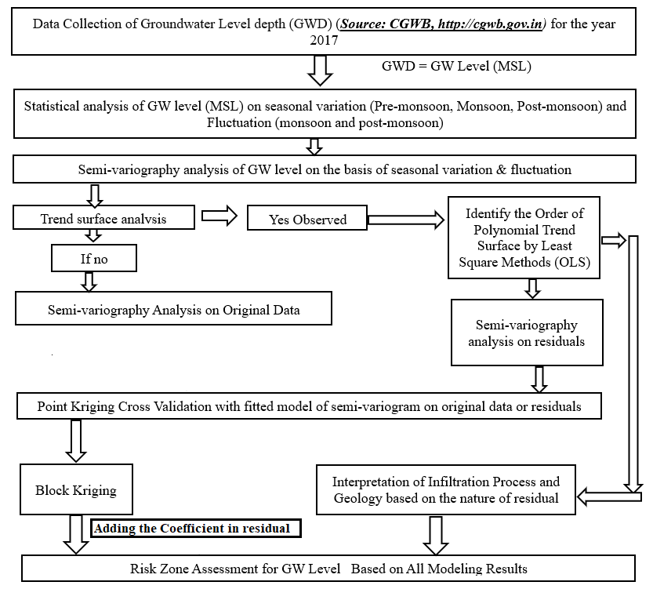

Fig 1: Flowchart of the study

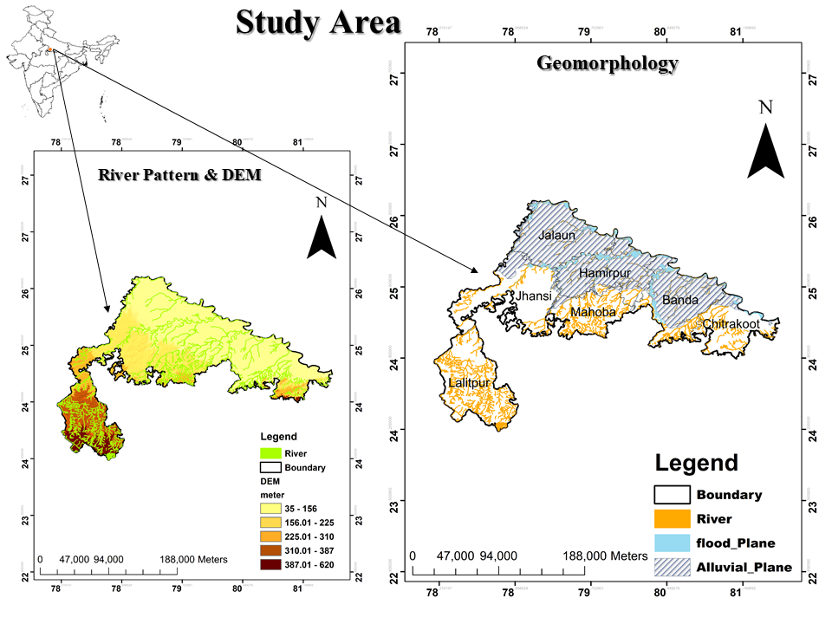

Fig 2: Study area

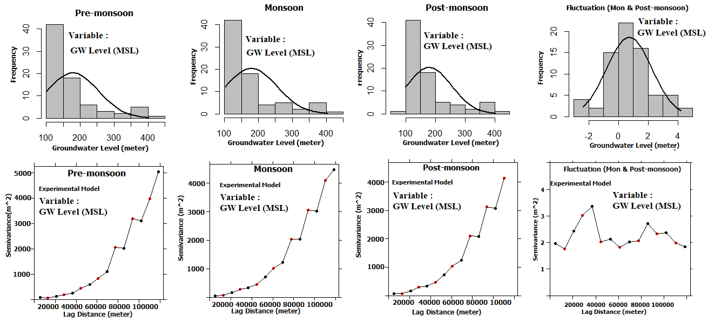

Fig 3: Groundwater level and fluctuation in pre-monsoon, monsoon, post-monsoon

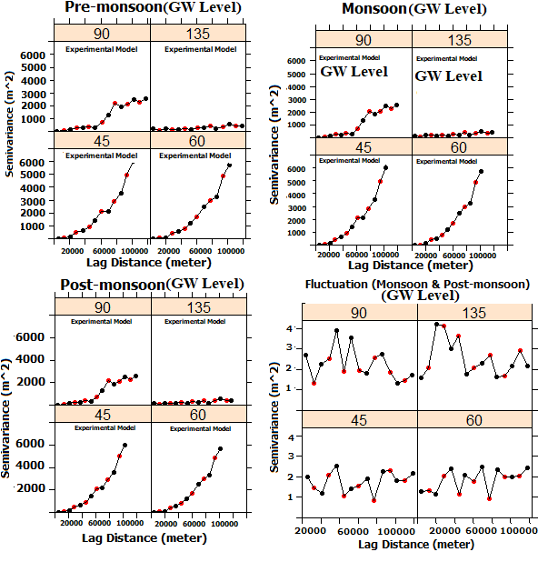

Fig 4: Directional semi-variograms showed trends in groundwater levels across the three seasons

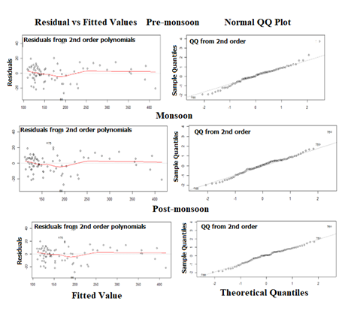

Fig 5: Residual vs Fitted values

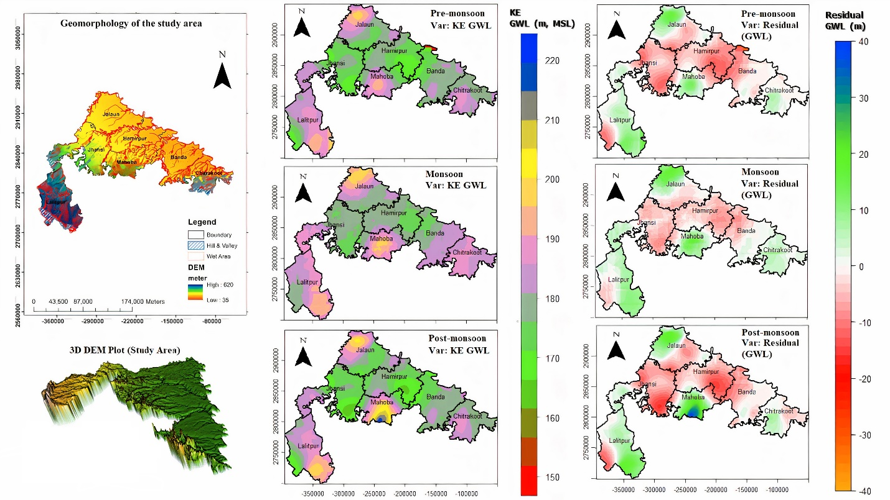

Fig 6: Comparison of geomorphology, second-order residuals of groundwater level (GWL), and kriging estimates (KE) across three different seasons—pre-monsoon, monsoon, and post-monsoon—for the study area.

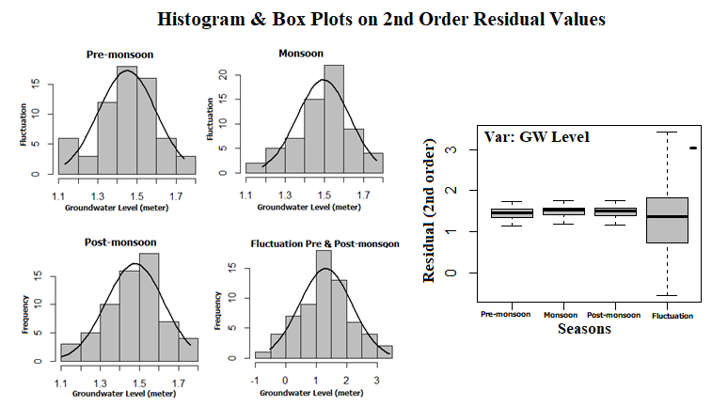

Fig 7 : Showing histogram, box plot and coefficient of variation of the residual data

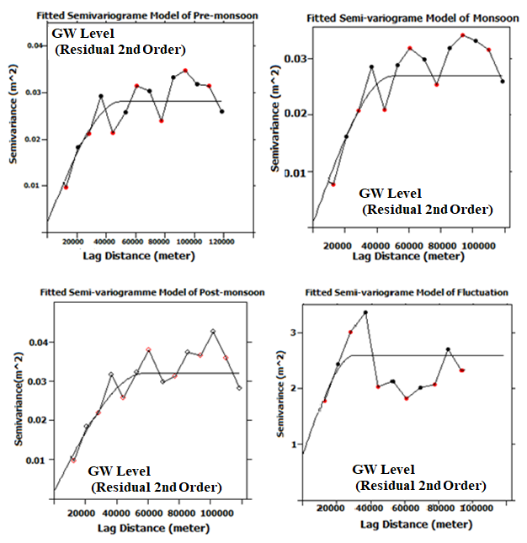

Fig 8 : Semi-variogram model for Fluctuation of groundwater level (GWL) and the second-order residual of the GWL.

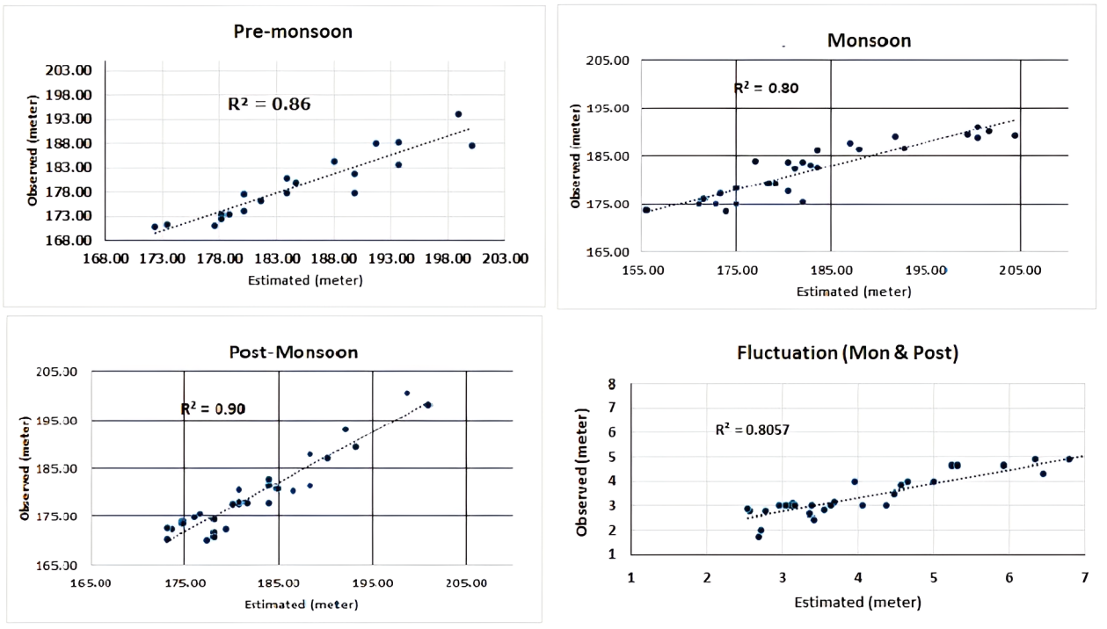

Fig 9 : The coefficient of determination (R2) for observed versus estimated values for each season and fluctuation for groundwater level (GWL) after the back transformation

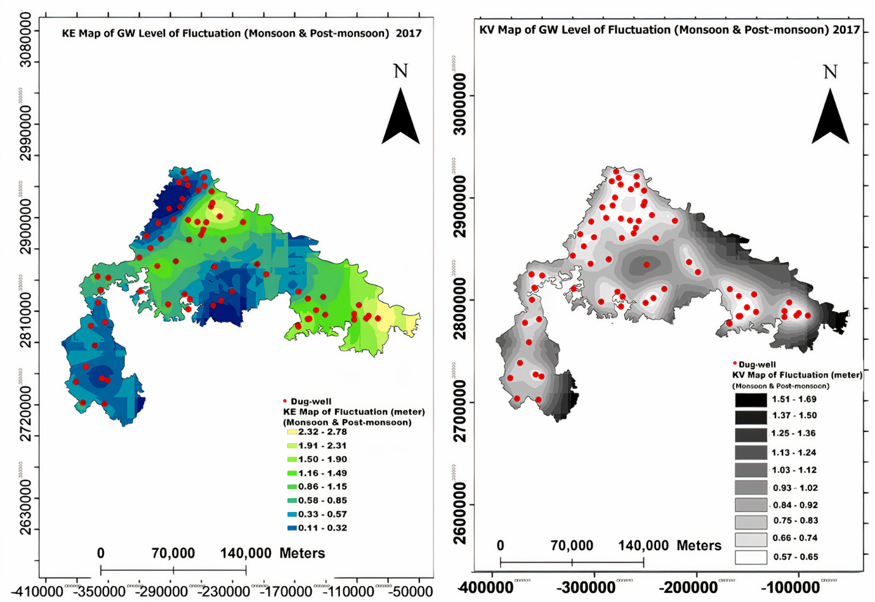

Fig 10a . Kriged Estimate (KE) map with Kriging variance (KV) showing groundwater level fluctuations between monsoon and post-monsoon seasons in 2017

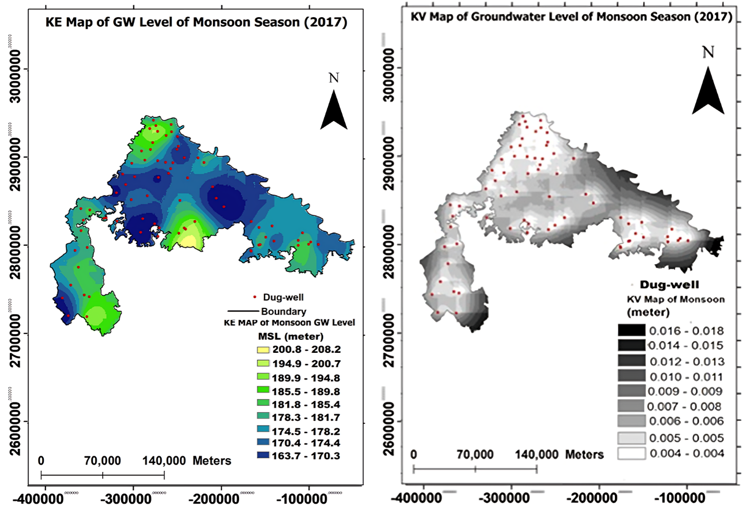

Fig 10b: Kriged Estimate (KE) map with Kriging variance (KV) showing groundwater level of monsoon season (2017)

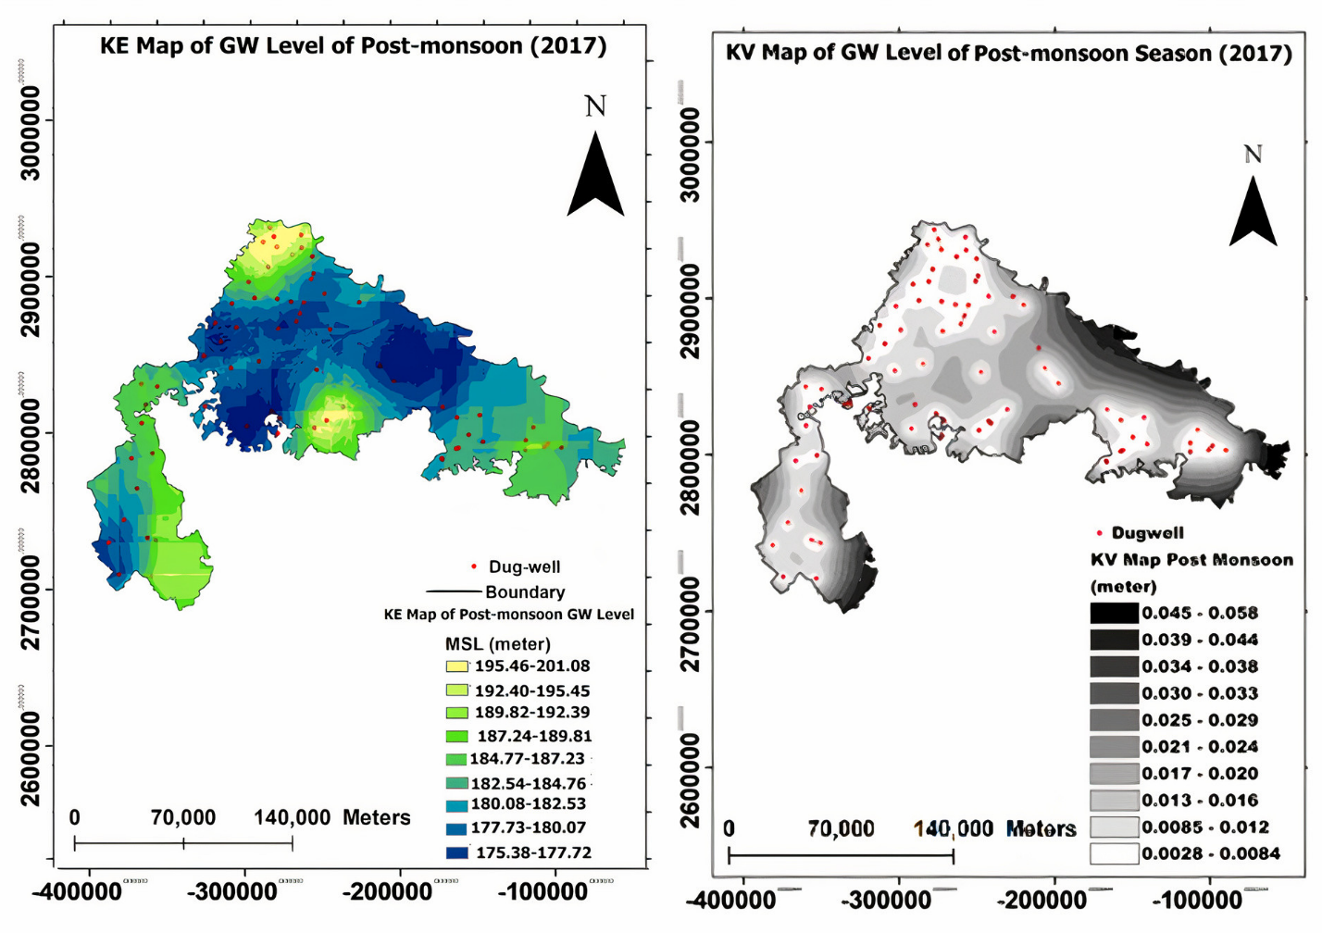

Fig 10c : Kriged Estimate (KE) map with Kriging variance (KV) showing groundwater level of post-monsoon season (2017)

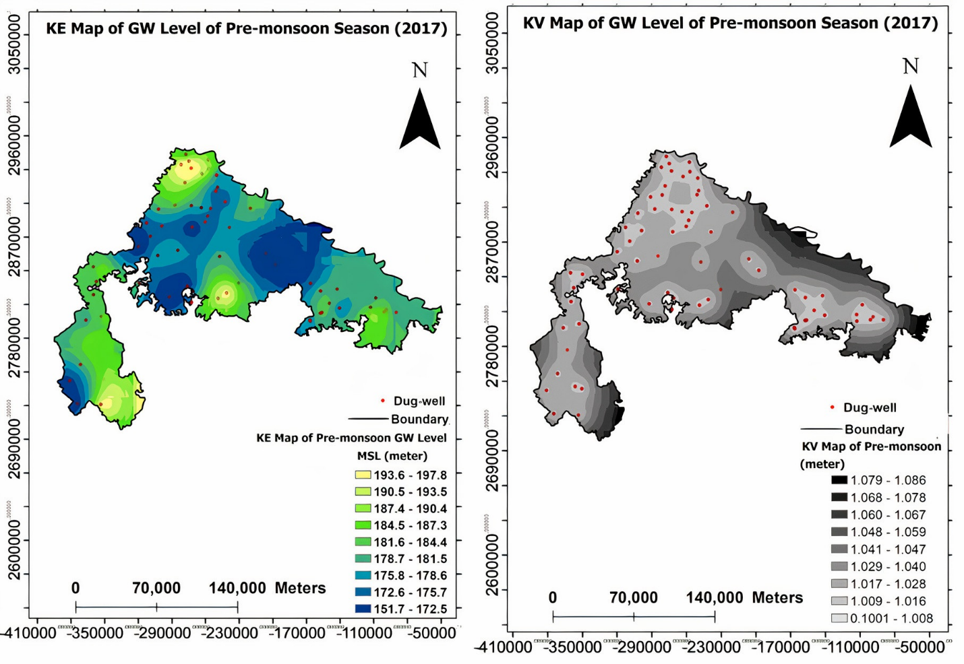

Fig 10 d : Kriged Estimate (KE) map with Kriging variance (KV) showing groundwater level of pre-monsoon season (2017)

|  |  |  |  |  |
| --- | --- | --- | --- | --- |
| **Table 1 Statistics of GW level (meter, MSL) of original data** | | | | |
| **Statistics** | **Pre-monsoon** | **Monsoon** | **Post-monsoon** | **Fluctuation** |
| **Mean** | 178.06 | 180.46 | 179.24 | 0.73 |
| **Std. Dev.** | 75.65 | 75.21 | 75.62 | 1.52 |
| **Min** | 100.80 | 102.50 | 99.56 | -2.40 |
| **Max** | 401.41 | 402.76 | 402.87 | 4.21 |
| **Skewness** | 1.52 | 1.54 | 1.52 | 0.32 |
| **SE. Skewness** | 0.27 | 0.27 | 0.27 | 0.28 |
| **Kurtosis** | 1.39 | 1.43 | 1.38 | -0.04 |
| **No. of Sample** | 77.00 | 77.00 | 77.00 | 71.00 |

|  |  |  |  |  |  |  |  |  |  |
| --- | --- | --- | --- | --- | --- | --- | --- | --- | --- |
| **Table 2 R2 & F test generated from 1st,2nd & 3rd order trend surface** | | | | | | | | | |
| Seasonal Variation | R^2 1st order | R^2 2nd order  (Optimum) | R^2 3rd order | 1st order Trend Surface | | **2nd order Trend Surface**  **(Optimum)** | | 3rd order Trend Surface | |
| F test | P value | **F test** | P value | F test | P value |
| Pre-monsoon | 0.94 | **0.98** | 0.96 | 584.65 | 2.22e-15 | **564.29** | 2.22e-16 | 580.33 | 2.22e-16 |
| Monsoon | 0.94 | **0.97** | 0.95 | 595.07 | 2.22e-13 | **572.93** | 2.22e-14 | 575.25 | 2.22e-12 |
| Post-monsoon | 0.94 | **0.98** | 0.95 | 595.82 | 2.22e-16 | **528.3** | 2.22e-16 | 530.36 | 2.22e-17 |

|  |  |  |  |  |  |  |
| --- | --- | --- | --- | --- | --- | --- |
| **Table 3 Coefficient of Variation Generated from 2nd order trend surface** | | | | | | |
| **Coefficient** | **Pre-monsoon** | | **Monsoon** | | **Post-monsoon** | |
|  | **Estimate** | **Std. Error** | **Estimate** | **Std. Error** | **Estimate** | **Std. Error** |
| B0 (Intercept) | 1.7898e+02 | 2.6212e+00 | 1.8014e+02 | 2.6787e+00 | 1.7953e+02 | 2.5610e+00 |
| B1 | -7.9111e-04 | 4.9803e-05 | -8.1216e-04 | 5.1380e-05 | -8.1996e-04 | 5.3742e-05 |
| B2 | -6.7370e-04 | 2.9827e-05 | -6.5851e-04 | 2.7927e-05 | -6.6217e-04 | 2.9211e-05 |
| B3 | 2.7629e-09 | 5.7333e-10 | 2.8642e-09 | 5.6593e-10 | 2.8325e-09 | 5.9195e-10 |
| B4 | 1.1403e-09 | 3.3034e-10 | 1.0715e-09 | 3.2007e-10 | 9.6621e-10 | 3.3478e-10 |
| B5 | 2.2174e-09 | 8.2487e-10 | 1.9479e-09 | 8.1340e-10 | 1.9189e-09 | 8.5079e-10 |

|  |  |  |
| --- | --- | --- |
| **Table 4 Spherical Model Equation of Fitted Model Semi-variogram** | | |
| **Sr. No.** | **Seasons** | **Spherical Model Equation** |
| 1 | Pre-Monsoon | ϒ(h)=0.007+0.02[1.5(h/50000) -0.5(h/50000)3 |
| 2 | Monsoon | ϒ(h)=0.01+0.011[1.5(h/42000) -0.5(h/42000)3 |
| 3 | Post-Monsoon | ϒ(h)=0.005+0.03[1.5(h/50000) -0.5(h/50000)3 |
| 4 | Fluctuation (monsoon & post-monsoon) | ϒ(h)=0.80+1.8[1.5(h/30000) -0.5(h/30000)3 |

|  |  |  |  |  |  |
| --- | --- | --- | --- | --- | --- |
| **Table 5 Semi-variogram & Geostatistical Parameters of Residuals (Generated from 2nd Order Trend Surface)** | | | | | |
| **Sr. No.** | **Semi-variogram Parameters of fitted model used for kriging (residuals)** | **Pre-monsoon (m)** | **Monsoon (m)** | **Post-monsoon (m)** | **Fluctuation (Monsoon & Post-monsoon, m)** |
| 1 | Co (%2) | 0.007 | 0.01 | 0.005 | 0.80 |
| 2 | C (%2) | 0.02 | 0.011 | 0.03 | 1.8 |
| 3 | (Co:C+Co) *100 |  |  |  |  |
| 4 | Radius of search (m) X Y Z. | 33333  33333  33333 | 75543  75543  75543 | 38666  38666  38666 | 26000  26000  26000 |
| 5 | Mean Kriging Estimate (EV) | 0.11 | 1.5 | 1.49 | 3.75 |
| 6 | Mean Kriging Variance (KV) | 0.01 | 0.02 | 0.01 | 2.35 |
| 7 | KV: EV | 1.03 | 1.03 | 1.05 | 0.95 |
| 8 | Mean absolute (Z-Z*) | 0.10 | 0.09 | 0.10 | 0.02 |
| 9 | % Error due to parameters | 0.04 | 0.03 | 0.04 | 0.54 |
|  | R2 | 0.86 | 0.80 | 0.90 | 0.80 |
|  | Student t-test on R2 | Significant | Significant | Significant | Significant |
| **Sr. No.** | **Geostatistical Parameters (Block Kriging) on Residuals & Back Transformation** | | | | |
| 1 | Block Dimension | 1000*1000*2 | 1000*1000*2 | 1000*1000*2 | 1000*1000*10 |
| 2 | Total number of blocks | 29750 | 29750 | 29750 | 29750 |
| 3 | No. of blocks kriged | 29665 | 29750 | 29750 | 29743 |
| 4 | Mean kriged estimate | 1.43 | 1.48 | 1.47 | **0.74** |
| 5 | Mean kriged estimate after aiding the coefficient of 2nd order trend surface (Back Transformation) | **179.43** | **181.56** | **180.46** | ***** |
| 6 | Mean kriged variance | 0.01 | 0.005 | 0.02 | 0.60 |
| ***** There is no trend in fluctuation of GW level (m, MSL) | | | | | |