**Nutritional, Functional and Sensory Characteristics of Infant Flours from a Blend of Fermented Plantain (*Musa paradisiaca*), Roasted Cashew (*Anacardium occidentale*) nut and Baobab pulp (*Adansonia digitata*)**

**Abstract**

Inadequate complementary feeding practices, and especially the low quality of home-made complementary foods is one of the main causes of malnutrition in developing countries. This study aimed to develop infant flours from local foodstuffs so as to meet the energy needs and nutrients requirements of young children. To achieve this goal, plantain was fermented and cooked, cashew nut was roasted and baobab pulp was used without any treatment. The ingredients were dried, ground into flours, and their proximate composition was determined. Based on their nutrient content, they were blended in different proportions using Design Expert software to obtain five formulations (FC1-FC5). The nutritional composition (proximate composition, vitamin A, vitamin C and iron content) and functional properties (water absorption capacity, bulk density, solubility and wettability) of the formulations were determined. Gruels were prepared from the produced flours and their energy density, viscosity and sensory properties (color, taste, texture and the overall acceptance) were assessed. Results indicate that moisture (5.88-6.33%), ash (4.17-5.94%), crude protein (9.17-10.23%), total sugar (66.19-69.14%), crude fiber (1.87-2.14%) vitamin C (27.99-29.85 mg/100 g) and energy value (405.59-409.36 kcal/100 g) of all the flours produced met the World Food Program (WFP) standards. All the formulations were limited in vitamin A (221.77-239.78µg/100 g) and iron (4.69-4.87 mg/100 g) according to WFP recommendations. All the flours produced had good water absorption capacity (335-392%), bulk density (60-64%), dispersibility (57.5-59.5%) and wettability index (15.5-17%), interesting functional properties for infant flours. The gruels prepared from these flours had good viscosity (2850-2900 mPa/s) and energy density (81.12-81.87 kcal/100 mL), but with low scores recorded in sensory evaluation of their color, taste, texture and the overall acceptance compared to a commercial infant gruel. Among the formulated flours, FC2 (Plantain 69%, cashew nut 27%, Baobab pulp 4%) and FC4 (Plantain 71%, cashew nut 25%, Baobab pulp 4%) were the most appreciated, but needed to be fortified in iron and vitamin A in order to be recommended as complementary flour to contribute to alleviate toddler malnutrition.

**Key words:** Food formulation, Infant flour, Food fortification, Food characterization, Sensory **Introduction**

“Protein energy malnutrition (PEM) and micronutrients deficiencies remain a public health concern in many developing countries, especially in low-income and middle- income countries. In Cameroon, 29% of young children suffer from PEM, while 35% are affected by vitamin A deficiency and 57% suffer from anemia due to iron deficiency” [1]. “The most affected are children aged 6 to 23 months which is a critical window for physiological development of children, with sub-optimal feeding practices inducing long-term developmental challenges in the kids” [2].

“Indeed, good nutrition is a prerequisite to effective development and good health of every child. Above the age of 6 months, breast milk cannot longer satisfy the nutritional needs of the child, introduction of complementary foods (CF) becomes therefore essential” [3]. “CF are foods given to children to complete nutrient supply from breastmilk. They should be nutritionally dense and easy to swallow for young children. In Cameroon, especially in urban areas, CFs with appropriate nutritional and functional qualities are mainly ready-to-use commercial infant flours which are unfortunately unavailable and unaffordable in rural areas where most of the households are poor and food insecure” [4].

These vulnerable populations therefore resort to homemade infant flours from cereals and tubers, but the gruels prepared from these flours are mostly low in protein, vitamins and minerals. They are also very often viscous, pushing mothers to dilute them to make it easier for children to swallow, which reduces their energy density [5]. “This raises the problems of choice of ingredients and technological treatments applied to them. As solution to address these problems, World Health Organization (WHO) and Food and Agriculture Organization (FAO) both encourage scientific research to use locally available foods to produce affordable infant flours with good nutritional and functional properties”. [6].

To go in this direction, many researchers have focused on the production of adequate complementary flours using locally available food plants [7-10], “the long-term goal being either to make infant flours affordable for the population or to transfer the production technology to them. Efforts on some trials were feasible for some, but not for others, notably for infant flour produced from unripe plantain as source of carbohydrates and roasted cashew nut as source of proteins” [7], “macronutrients important in the growth and development of young children. Gruels from such flours were very viscous and difficult to swallow for children less than 12 months. Also, there was no source of iron among the ingredients, yet iron is important for the immune system and blood formation. Furthermore, the composition also lacked a source of vitamin C which is nevertheless a powerful antioxidant and greatly contributes to the absorption of non-heme plant iron” [11,12].

The present work therefore seeks to correct these limitations to improve the nutritional and functional qualities of the flour. Concerning the high viscosity of the gruel, studies have reported that fermentation of starchy foods such as pumpkin and plantain by *Lactobacillus plantarum* reduces viscosity and increases total and soluble sugar content [9,10]. Concerning the minerals and vitamins content, this can be solved by adding some ingredients such as baobab pulp which is a potent source of iron and vitamin C [8,10], nutrients contributing to the immune system and bone development in toddlers. Based on all the above, the general objective of this study was to formulate and characterize precooked infant flour from cooked and fermented plantain flour fortified with roasted cashew nuts flour and baobab pulp powder.

1. **Materials and methods**
   1. **Collection of raw material**

The raw material was selected based on Codex Alimentarius guidelines [13]. Ingredients were used in this study based on their nutrients as follows: plantain (carbohydrate), cashew nut (protein, fat), baobab pulp (iron, vitamin C). Unripe plantain (*Musa paradisiaca* var. French corne), cashew nut (*Anacardium occidentale*) and baobab pulp (*Adansonia digitata*) were purchased from the Bamenda food market in the North-West region of Cameroon and brought to the School of Tropical Agriculture and Natural Resources (STANR) laboratory, Catholics University of Cameroon (CATUC) Bamenda for processing and analyses.

* 1. **Production of individual flours and powder**

### 2.2.1. Plantain flour processing

Fig. 1 presents the process diagram for the production of plantain flour as previously described by Feh *et al.* [10]. A mass of 2 kg of plantain was washed and divided into two lots of 1,500 and 500 g. The first lot (1,500 g) was cooked at 121°C for 15 mins in a cooker (Magimix, Surrey, UK), peeled, ground using a grinder (GEFU, model 10400, Ningbo, Zhejiang, China) and divided in three sub-lots of 500 g. Each sub-lot was transferred into a 2 L Erlenmeyer flask containing 1000 ml of distilled water. This was steamed in a water bath set at 85°C for 10 min, cooled to 30°C, and inoculated with 10 mL saline suspension of *Lactobacillus plantarum* (containing 108 CFU/g) obtained from calibration using one Mc Farland standard. The flask was incubated at 30°C for 48 hours, followed by a cooking at 100°C for 20 mins. The second lot was peeled and sliced into uniform-sized pieces 1 cm thick. Fermented/Cooked paste and raw slices of plantain were then dried at 45°C for 24 hours in a ventilated oven (Rivière & Bar QD105A, Paris, France), milled using a crusher (Culatti Micro Hammer Mill DCFH 48, Lutoslawskiego Witolda, Poland), sieved (250µm) and packaged in well-labeled zip-lock bags until analysis

### 2.2.2. Processing of Sesame Flour and baobab pulp powder

Fig. 2A shows the flow diagram for the production of cashew nut flour similar to an earlier illustration by Ngaha *et al*. [7]. A mass of 2 kg of cashew was cleaned and divided into two lots. The first lot (0.5 kg) was left raw while the second (1.5 kg) was toasted in an oven (Model Panacea 2430, Torre Picenardi, Italy) at 100°C for 15 mins. The two lots were then processed as described in Fig 2A, and characterized later.

Baobab powder was produced according the method described by Feh et al. [10] as shown in Fig. 2 (B). Baobab pulp was sorted to remove funiculus and other impurities, cracked to remove cores, and crushed using a mortar and pestle. The crushed product was sieved using a fine mesh sieve (≤250 µm) and stored in a well-labelled air-tight zip lock bag until its utilization.

Peeling

Slicing (1cm)

**Cooking**

(121oC/15 mins)

Dirty water

Washing

Clean water

Cooling (30oC)

**Fermentation**

(30oC/48hrs)

Drying

(48 hrs/45oC)

4

Grinding/Sieving

(≤250µm)

**Cooking**

(20 mins/100oC)

Peels

Grinding

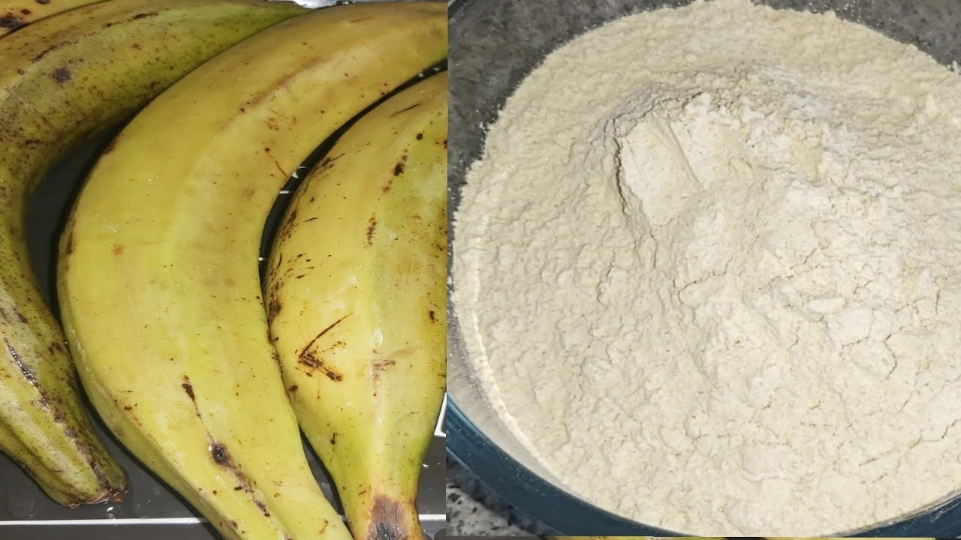

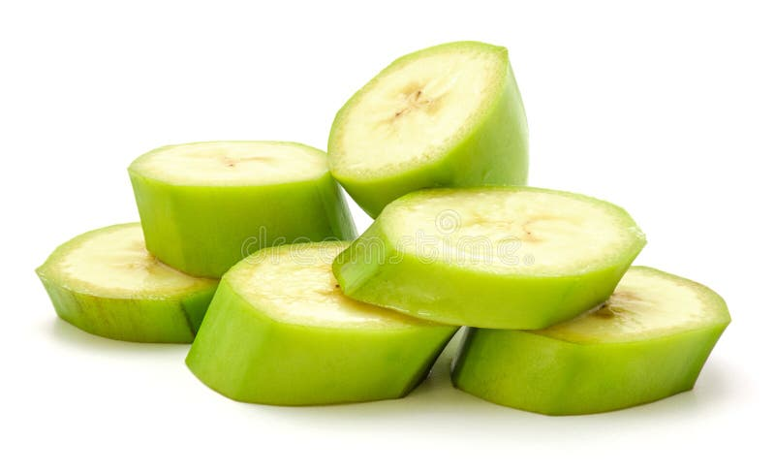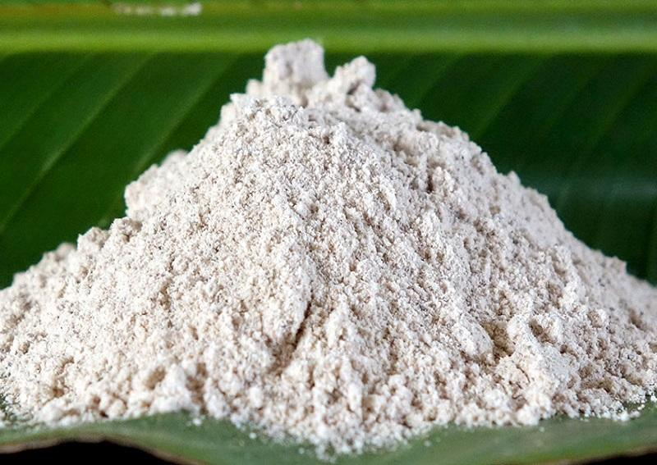

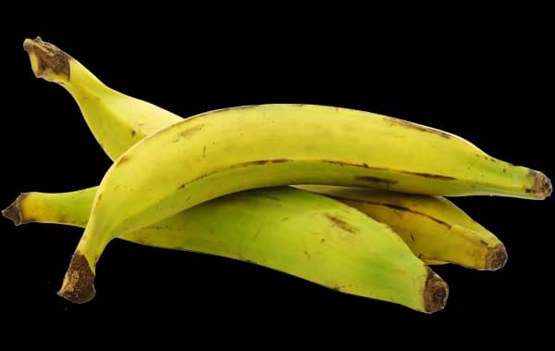

Fig. 1 Process diagram of plantain flour production

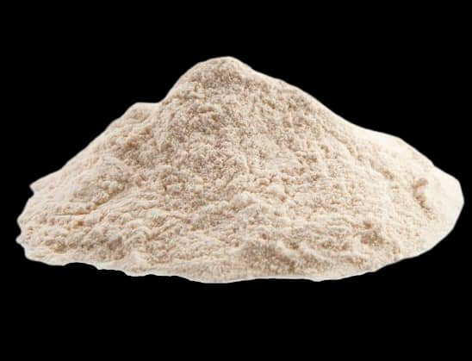

Sorting

Funiculus & foreign elements

Stoning

Cores

Milling/Sieving

(≤250 µm)

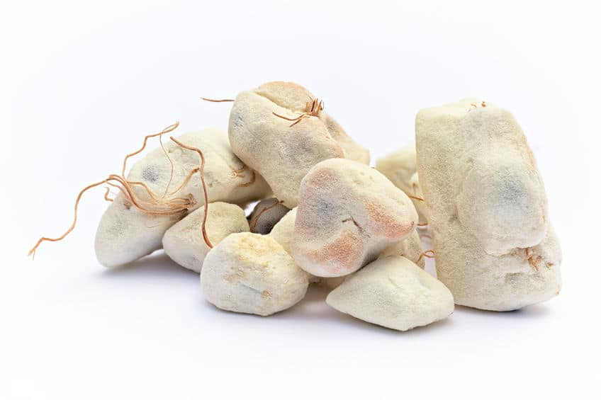

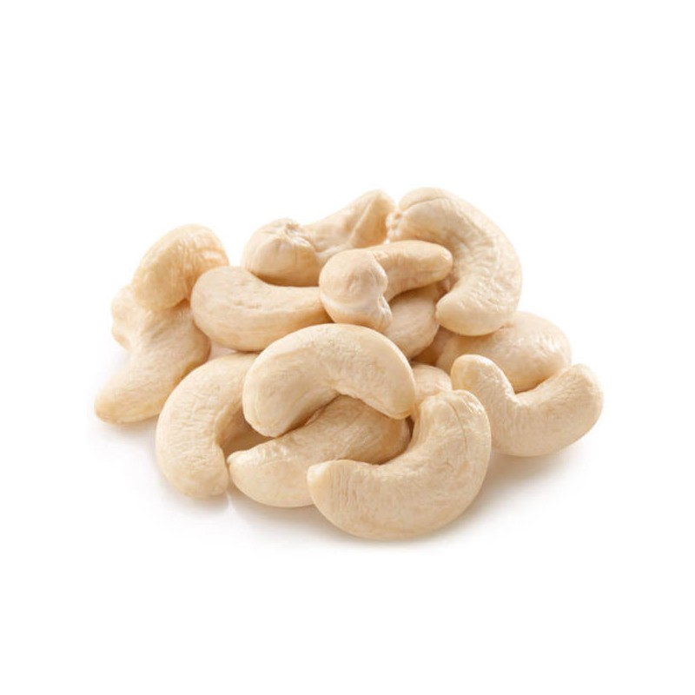

Sorting and cleaning

Drying (45°C/48 hrs)

Grinding/Sieving (≤500µm)

**Toasting** (100oC/15 mins)

Dirt and stones

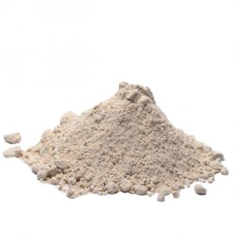

**(B)**

**(A)**

**Fig. 2** Flow Diagram of cashew nut flour (A) and baobab pulp powder (B) production

* 1. **Physicochemical characterization**

### 2.3.1. Nutrients content

“Proximate composition was determined on the infant flours produced, and treated and untreated ingredients, while mineral and vitamin analyses were performed only on infant flours. Proximate composition including moisture content, total ash, crude protein, crude fat, crude fiber, and total carbohydrate were determined according to standard methods previously reported” [7,9,14]. “As concerned micronutrient, iron content was quantified by colorimetric technique with orthophenanthrolin while vitamin A was quantified in terms of total carotenoids by spectrophotometric method and vitamin C by titrimetric method” [7,9,14].

***2.3.2. Energy value***

The energy value (EV) (kcal) for 100 g of flour was calculated using Eq. 1, based on the dry matter (Q), carbohydrate, protein, and fat content of the sample.

(1)

* 1. **Complementary flour formulation**

“After the production and characterization of ingredients, the infant flour was formulated with the help of the Design Expert software version 11. This formulation was based on the chemical composition of the individual flours, and took into account the WFP recommendations concerning amount of protein, carbohydrate and vitamin A in 100 g of infant flour” [15]. “Plantain flour was used as main ingredient, and blended with cashew nut flour and baobab pulp powder as enhancement ingredients. The proportion of baobab pulp powder was fixed at 4% because a previous study has reported that significant proportions of baobab pulp (>4%) involves a strong acidity, causing the rejection of flour by consumers” [10]. On the above basis, five formulations were obtained as shown in Table 1.

Table 1. Experimental matrix for the different formulations

|  |  |  |  |
| --- | --- | --- | --- |
| **Formulations** | **Plantain flour (%)** | **Cashew nut flour (%)** | **Baobab powder (%)** |
| FC1 | 68 | 28 | 4 |
| FC2 | 69 | 27 | 4 |
| FC3 | 70 | 26 | 4 |
| FC4 | 71 | 25 | 4 |
| FC5 | 72 | 24 | 4 |

* 1. **Functional properties of the formulated flours**

### 2.5.1. Water Absorption Capacity (WAC)

The WAC of flours was determined using a standard method described by Onwuka [10]. A volume of 20 mL of distilled water was added to 1 g of sample in a weighed centrifuge tube, agitated on a vortex mixer for 2 mins and centrifuged at 4000 rpm for 20 mins. The supernatant was decanted and discarded. The adhering drops of water were removed and then weighed. The WAC was expressed as the weight of water bound by 1 g of flour (Eq. 2).

$$WAC (\%)=\frac{Water absorbed (mL)}{Weight of sample (g)}×100$$

Where: Water absorbed (mL) = Volume of water added - Volume of water obtained after centrifugation.

(2)

### 2.5.2. Bulk Density (BD)

The BD of the flours was determined as described by Onwuka [10]. The sample (1 g) was poured into a 10 mL dry measuring cylinder and the volume was recorded for the loose bulk density. The bottom of the cylinder was tapped 50 times on the laboratory table and the volume was recorded for packed bulk density. The bulk density was calculated as shown in Eq. 3.

(3)

$$BD \left(\%\right)=\frac{Weight of sample}{Volume of sample after tapping}×100$$

### 2.5.3. Dispersibility

A mass of 1 g of flour was weighed into a 10 mL measuring cylinder and distilled water was added to reach a volume of 10 mL. The set up was stirred vigorously and allowed to settle for 3 hrs. The volume of settled particles was recorded and subtracted from 10. The difference was reported as % dispersibility as described by Kulkarni" [10].

### 2.5.4. Wettability

A mass of 1g of the flour sample was dropped from a height of 15 mm onto the surface of 200 cm of distilled water contained in 250 cm3 at room temperature. The wetting time was regarded as the time required for all the flour to become wetted and penetrate the surface of water as described by Amstrong *et al.* [10].

## **Preparation and characterization of gruels from formulated flours**

Gruels were prepared from the formulated flours as described by Feh *et al.* [10], and their viscosity and energy density determined. The viscosity of the different gruels was determined by calibrating a glass funnel which was placed on a clamp stand. The setup was designed following the principle of Ostwald’s capillary viscometer. The different gruels produced were placed at the top of the funnel to flow down to the bottom of the funnel through a constant height under the action of the force of gravity and the time noted. This gave the kinematic viscosity of the gruels.

The energy density (ED) of each gruel in Kcal per 100 mL of gruel, based on the Energy value (EV) of each flour and the volume (V) of gruel prepared was computed using Eq. 4.

(4)

$$ED=(\frac{EV}{V})×100$$

## **Sensory evaluation of the gruels**

“The hedonic test was performed at the food science laboratory of STANR, CATUC (Bamenda), based on a 9-point hedonic scale ranging from 1 (dislike extremely) to 9 (like extremely). The sensory attributes assessed were colour, taste, texture and the overall acceptance. The sensory test was conducted with 30 mothers aged from 20 to 35 years old chosen among students, teaching and non-teaching personnel of the CATUC, who were familiar with infant foods. which says that for preference evaluation This based on the fact that mothers’ liking is important in deciding if a food would be suitable for her child as toddlers present a challenge to sensory and consumer researchers because of their inability to communicate verbally, limited cognitive abilities, and very low attention span” [16]. The sensory test was performed with six samples, including five experimental gruels and a commercial one (Cerelac®) as control sample. The samples were simultaneously and randomly presented to the mothers. The randomization sequence was carried out using XLSTAT version 2016 (Addinsoft, Paris, France) which allowed to obtain a randomized design matrix of 6 (samples) by 4 (sensory attributes) for the 30 mothers (configurations). This aimed to present different samples to the mothers in a completely random order, ensuring that no sample systematically appears first, last or in a specific position. It permitted to minimize the biases caused by the presentation order and to allow a more accurate assessment of the sensory attributes of the gruels. The sensory evaluation was conducted at room temperature under controlled environmental conditions. To prevent any communication between mothers, they were seated in individual boxes enlightened by white light to prevent any changes in sample colour. During the evaluation, mothers were asked to rinse their mouths with water between samples and to assess the next sample after 4 minutes to prevent the carry-over effect. The colour was imposed on the participant as the first parameter to be analysed before any other parameter.

* 1. **Statistical analysis and tools**

All determinations were carried out in triplicates and the results were expressed as means ± standard deviation using Microsoft office excel software version 2016. Data were tested for normality and, one-way analysis of variance (ANOVA) was used for significant difference at P<0.05. This was done using SPSS version 12.5 and JMP version 11 software packages.

1. **Results and discussion**
   1. **Physicochemical characteristics of the ingredients**

The proximate composition of raw materials with and without treatments was determined and the results reported in Table 2. It appears that cooking and fermentation of plantain resulted in a significant (p<0.05) reduction in crude fiber, with a consequent increase in total sugar content. This result, similar to that of many other works [10,14] can be associated with the activity of *L. plantarum* which has enzymes that allow it to digest fiber, especially cellulose to cellulobiose and finally glucose [14].

“Roasting cashew nut resulted in a significant decrease (p<0.05) in total sugar and protein content, compared to an increase in total lipid. The decrease in total sugar and protein may be linked to their involvement in Maillard reactions during roasting” [17]. “The increase in total fat can be explained on the one hand by their concentration following the decrease in moisture content in roasted cashew nut, and on the other hand by the decrease in other macronutrients (sugar and protein) which leads to a relative increase in fat content. A similar trend was reported for roasted cashew nut and soybeans” [7,9].

“The moisture content decreased in roasted cashew nut while total ash increased significantly (p<0.05). The decrease in moisture content can be explained by the fact that during roasting, some vacuoles can be destroyed by heat, which leads to the release and evaporation of water” [18]. “The increase in total ash is linked to the effect of heat which could have freed some minerals from their binding to antinutrients, making them more available” [14].

The results in Table 2 reported a high total ash content in baobab pulp powder, which could reflect a significant amount of minerals, thus justifying the choice of this ingredient to fortify the produced flour. These findings are similar to those of other studies [8,10] who reported high total ash content in baobab pulp powder.

Table 2. Proximate composition of treated and untreated ingredients (per 100 g DW)

|  |  |  |  |  |  |
| --- | --- | --- | --- | --- | --- |
|  | **Plantain** | | **Cashew nut** | | **Baobab** |
| **Nutrient content** | **R** | **T** | **R** | **T** | **R** |
| Moisture content (%) | 7.62±0.31a | 7.81±0.38a | 3.01±0.15a | 2.14±0.10b | 8.51±0.12 |
| Total ash (%) | 3.65±0.25a | 3.91±0.24a | 2.65±0.28b | 3.43±0.31a | 9.11±0.29 |
| Total sugar (g/100g DW) | 79.93±0.91b | 81.64±0.59a | 25.23±1.20a | 22.01±0.99b | 61.35±1.21 |
| Fat content (g/100g DW) | 0.83±0.29a | 0.90±0.18a | 34.14±0.32b | 39.84±0.41a | 4.01±0.10 |
| Crude Protein (g/100g DW) | 4.78±0.27a | 4.89±0.38a | 30.16±0.64a | 28.25±1.04b | 6.93±0.15 |
| Crude Fiber (g/100g DW) | 1.29±0.09a | 0.35±0.05b | 4.22±0.28a | 4.15±0.12a | 16.32±0.87 |

R: Raw; T: Treated; Data are mean ± SD of triplicate readings; Means in the same line with different superscripts depict significant difference among treated and raw samples (p<0.05).

* 1. **Physicochemical characteristics of infant flours**

The nutritional composition of the produced flours was performed and the results recorded in Table 3. The moisture content of all the samples was close to 5% as recommended by the WFP for infant flours. “This result denotes a longer shelf life of the formulated flours because the stability of food products over time depends on the moisture water content as water regulates the microorganism and enzyme activities. The lower the water content, the longer the shelf life” [19].

Ash content of all the flours was higher than the standard threshold for infant flours (>2%) recommended by the WFP, with the lowest value for FC1 (4.17%) and the highest values for FC4 and FC5 (4.85 and 4.94% respectively). The result indicates that ash content increases with the proportion of plantain flour in the sample since baobab pulp, source of iron among the ingredients (see Table 2) does not vary from a formulation to another. “The high ash contents obtained are close to the one found in many other studies on infant flours” [7,9,10]. Since high ash content denotes high mineral content of food product [20], the result in Table 3 suggests that samples FC4 and FC5 may be the richest in mineral.

Crude protein content of the five flours produced was in the range 8-16% recommended by WFP, varying from 9.17 to 10.23 g/100 g DW for FC5 and FC1 respectively. The protein content increases with the quantity of cashew nut in the formulation since cashew nut is the main source of protein among the ingredients as showed in Table 2. “This result is similar to those of previous works using leguminous seeds in infant flour formulation” [7-10]. “The presence of protein in adequate quantity in the flours is interesting since proteins are required to promote growth and development of in young child” [21].

Total sugar content of all the flours was in the standard range 65-68% defined by the WFP, with values increasing with the proportion of plantain flour in the formulations, varying from 66.19 to 69.14 g/100 g DW for FC1 and FC5 respectively. “Total sugar content obtained in this work is close to those found in several studies on complementary flours with starchy food as main ingredient” [7-10]. All the flours produced were adequate for young children feeding, since they need calories for cellular synthesis to support growth and development during childhood.

“Fat content of all the flours formulated is also in the standard range 7-13% of the WFP, increasing with the addition of cashew nut which is the main source of fat as reported in Table 2. There was a significant increase (p<0.05) from 10.38 to 11.52 g/100 g DW for FC5 and FC1 respectively. The fat content obtained in this study is close to those reported by previous works” [7,8] with soybean, sesame seeds and cashew nut as source of fat in infant flour formulation, but is higher than what reported by Feh et al. [10] who have defatted sesame seed (source of fat) prior to its utilization.

The determination of proximate composition has permitted to calculate the energy value of the flours, and the findings in Table 3 show that all of them meet the WFP recommendation of 400 kcal/100 g of flour. “This result indicates that the formulated flours can provide enough calories to young children to support his growth and development, and is similar to those of many previous works using starchy foods, leguminous seeds and fruits to formulate infant foods” [7-10].

“Crude fiber content was less than 5% in all the samples as recommended for infant flours. The low fiber content is interesting since the problem of slow digestion of fiber is evaded and the child could eat more frequently without congestion in its stomach. In addition, high level of fiber in the diet reduce the absorption of vitamin A, an essential vitamin in childhood” [22]. “This result is close to those reported by several studies on complementary foods” [8,9].

“Vitamin A content in all the formulations was lower than 350-400 µg/100g of flour recommended by the WFP, ant this can be explained by the absence of a source of vitamin A among the ingredients (see Table 2). This means all the formulations need to be fortified with a source of Vitamin A, since this vitamin is crucial in cellular differentiation for growth and development, mechanism of vision, and maintenance of epithelial tissues” [23] These values are significantly lower than those reported in previous studies, certainly because there were sources of vitamin A such as pumpkin and yellow maize among the ingredients used by those authors [8,9]. However, “this limitation can be resolved by adding a little red palm oil during the preparation of the gruel since red palm oil is the best plant source of provitamin A” [24].

“All the vitamin C content found were close to the lower limit of the range indicated for infant flours. This level of vitamin C in the flours could be linked to the baobab pulp which is rich vitamin C (see Table 2). Similar results were reported by authors using baobab pulp in infant flour formulation” [8,10]. “Vitamin C is a powerful antioxidant, a crucial vitamin for young children as it is essential to maintain a healthy immune system, to enhance absorption of iron from plant foods by converting Fe3+ to Fe2+ in the small intestine, and to produce collagen” [11].

“Concerning iron content, none of the formulations met the recommendation of the WFP, though iron is essential for the formation of hemoglobin, myoglobin, and enzymes that play key roles in many metabolic reactions” [25]. This result is similar to the findings of several works using limited natural source of iron to fortify infant flours [8-10]. All the five formulations therefore need to be fortified with iron.

Table 3. Nutritional composition of the formulated flours

|  |  |  |  |  |  |  |
| --- | --- | --- | --- | --- | --- | --- |
| **Composition** | **FC1** | **FC2** | **FC3** | **FC4** | **FC5** | **Standard\*** |
| **Moisture content (%)** | 5.88±0.52a | 6.33±0.49a | 6.10±0.44a | 6.02±0.83a | 6.16±0.24a | <5 |
| **Ash (%)** | 4.17±0.10c | 4.34±0.12bc | 4.51±0.17b | 4.85±0.11a | 4.94±0.13a | >2 |
| **Crude Protein (g/100 g DW)** | 10.23±0.69a | 9.97±0.51a | 9.68±0.43a | 9.56±0.62a | 9.17±0.52a | 8-16 |
| **Total sugar (g/100 g DW)** | 66.19±1.32a | 66.45±1.40a | 67.08±1.34a | 68.36±1.23a | 69.14±1.51a | 65-68 |
| **Fat content (g/100 g DW)** | 11.52±0.52a | 11.23±0.63ab | 10.95±0.72ab | 10.62±0.58ab | 10.38±0.59b | 7-13 |
| **Energy Value (kcal)** | 409.36±10.83a | 406.75±11.02a | 405.59±10.72a | 407.26±11.43a | 406.66±10.17a | 400 |
| **Crude Fiber (g/100 g DW)** | 2.14±0.13a | 2.02±0.10a | 1.98±0.11ab | 1.93±0.12ab | 1.87±0.11b | <5 |
| **Vitamin A (µg/100 g DW)** | 239.78±10.43a | 234.45±7.54a | 230.89±11.24a | 227.91±9.38a | 221.77±8.07a | 350-400 |
| **Vitamin C (mg/100 g DW)** | 28.95±1.02a | 28.59±0.99a | 28.71±1.11a | 27.99±1.05a | 29.02±1.12a | 30-60 |
| **Iron (mg/100 g DW)** | 4.79±0.14a | 4.78±0.11a | 4.87±0.10a | 4.69±0.13a | 4.74±0.10a | 11.6-23 |

*Source: [22]; Data are mean±SD of triplicates; Values with different superscripts depict significant difference among samples (p<0.05). FC: Plantain/Cashew nut/Baobab pulp; FC1: 68/28/4; FC2: 69/27/4; FC3: 70/26/4; FC4: 71/25/4; FC5: 72/24/4.

* 1. **Functional characteristics of infant flours**

“Table 4 presents the functional characteristics of the formulated flours. Sample FC5 had the highest WAC (392%) while FC1 had the lowest one (335%). The variation in WAC between flours could be attributed to their respective total sugar and protein content. Indeed, associated to proteins, sugar are the main nutrients involved in WAC of foods” [26]. “The WAC of a food sample is an indication of the capacity of the material to absorb water. All flours produced had the capacity to absorb more than 3 times a volume of water relative to their weight, which is an advantage since the solid-liquid interactions are a limiting factor in the utilization of food powders” [27].

“There was no significant difference (p>0.05) in the bulk density (BD) of the flours. The BD indicates the arrangement of particles, packaging, and settling profile of a material” [28]. “Low BD would be useful in the formulation of infant flours because the lower the BD value, the higher the amount of food particles that can stay together, therefore increasing the energy density and nutrient content” [29]. “Range of BD from 60 to 64% for the formulated flours indicates good packing, therefore high nutrient-dense flours, due to their ability to be concentrated into a small volume” [30].

“The results on the dispersibility showed no significant difference (p>0.05) among the samples. Dispersibility is a measure of how much a flour can be reconstituted, flours with higher dispersibility being better than those with lower dispersibility. The dispersibility obtained in this work was >60% for all the samples, meaning that the flours should be easy to use in the preparation of toddler’s gruel”. [31].

The wettability index is defined as the time in seconds, required to wet all the particles of a flour [32]. The wettability was <20 s for all the samples, indicating that they can rapidly mix with water, and advantageous in the preparation of infant gruels.

Table 4. Functional Properties of the Formulated Infant Flour

|  |  |  |  |  |  |
| --- | --- | --- | --- | --- | --- |
| **Functional Properties** | **FC1** | **FC2** | **FC 3** | **FC 4** | **FC5** |
| Water Absorption Capacity (%) | 335.0±14.0b | 360.0±21.0b | 345.0±15.0ab | 336.0±18.0b | 392.0±22.0a |
| Bulk Density (%) | 61.0±2.0a | 64.0±1.0a | 60.0±3.0a | 62.0±2.0a | 62.0±3.0a |
| Dispersibility (%) | 59.5±3.5a | 58.5±2.1a | 57.5±1.4a | 58.5±2.0a | 58.0±1.5a |
| Wettability (s) | 16.0±0.5ab | 15.5±0.6b | 17.0±0.8a | 16.5±0.7ab | 16.0±0.7ab |

Data are mean±SD of triplicates; Values with different superscripts depict significant difference among samples (p<0.05). FC: Plantain/Cashew nut/Baobab pulp; FC1: 68/28/4; FC2: 69/27/4; FC3: 70/26/4; FC4: 71/25/4; FC5: 72/24/4.

* 1. **Characteristics of gruels prepared from formulated flours**

“Viscosity and energy density of the gruels prepared from the flours produced are presented in Table 5. Concerning viscosity, the maximum value (2900 mPa/s) was recorded for FC5 while the lowest was observed for FC1 (2850.5 mPa/s). This variation could be linked to the carbohydrate (starch) content of the flours, because when the starch slurry is heated, the starch granules swell and increase the viscosity” [33]. Therefore, flour with high proportions of plantain (starchy ingredient) was naturally the most viscous. However, the viscosity of all the gruels prepared in this study fell in the recommended range of 2500 – 3500 mPa/s set for infant gruels, indicating that they can be easily swallowed by young children. This finding is similar to the one of Feh *et al*. [10] who formulated an infant flour with fermented plantain flour as starchy ingredient, but is lower than the one of Ngaha et al. [7] who have not fermented plantain. This comparison permits to confirm that fermentation with *L. plantarum* reduces viscosity of gruels prepared from starchy foods, probably because during fermentation, starch is hydrolyzed in soluble sugars (maltose, dextrin and glucose).

“As for energy density, they were all close to the minimum of 80 kcal/100 mL recommended for infant gruels, with values varying from 81.12 to 81.87 kcal/100 mL. These findings are consistent with those of several works on complementary foods and illustrate that the gruels prepared can provide adequate quantity of energy to feel the toddler’s needs”. [7-10]

Table 5. Viscosity and energy density of the gruels prepared from formulated flours

|  |  |  |  |  |  |  |
| --- | --- | --- | --- | --- | --- | --- |
| **Parameter** | **FC1** | **FC2** | **FC3** | **FC4** | **FC5** | **Norms\*** |
| **Viscosity (mPa/s)** | 2850.50±17.50a | 2865.50±14.25a | 2875.00±12.50b | 2895.00±14.75b | 2900.00±17.25b | 2500 - 3500 |
| **ED (kcal/100 mL)** | 81.87±2.17 a | 81.35±2.20 a | 81.12±2.14 a | 81.45±2.29 a | 81.33±2.03 a | 80-120 |

ED: Energy Density; Data are mean±SD of triplicates; Values with different superscripts depict significant difference among samples (p<0.05). FC: Plantain/Cashew nut/Baobab pulp; FC1: 68/28/4; FC2: 69/27/4; FC3: 70/26/4; FC4: 71/25/4; FC5: 72/24/4.

* 1. **Sensory attributes of gruels**

In addition to nutritional quality, sensory quality of food products must be taken into consideration since the sensory characteristics of a product influence the consumer’s decision to purchase or repurchase. It is therefore by taking this crucial parameter into account that the sensory attributes of the formulated flours were assessed and compared to a known commercial infant flour, and the results are compiled in Table 5.

The result indicates that among the formulated flours, FC2 scored highest in taste and texture while FC4 scored highest in color. Regarding overall acceptability, FC2 and FC4 were most appreciated. The obtained for taste and texture of formulated flours may result from the fermentation applied to plantain. Indeed, studies have suggested that during fermentation, chemical compounds responsible for the development of new flavors and aromas are produced, thus improving the organoleptic quality of fermented products [34,35]. Moreover, during fermentation with *L. plantarum*, there is hydrolysis of polysaccharides (starch and fiber) into simple sugars [9], which helps produce gruels with reduced viscosity and a finer texture.

However, it should be noted that for all the sensory attributes evaluated, commercial flour used as control was more appreciated than all the formulated flours. This finding is similar to those obtained by many other authors [9,10], indicating the necessity to enhance the organoleptic attributes of formulated flours, as they exert a pivotal influence on mother’s decision to purchase infant foods and in child's consumption.

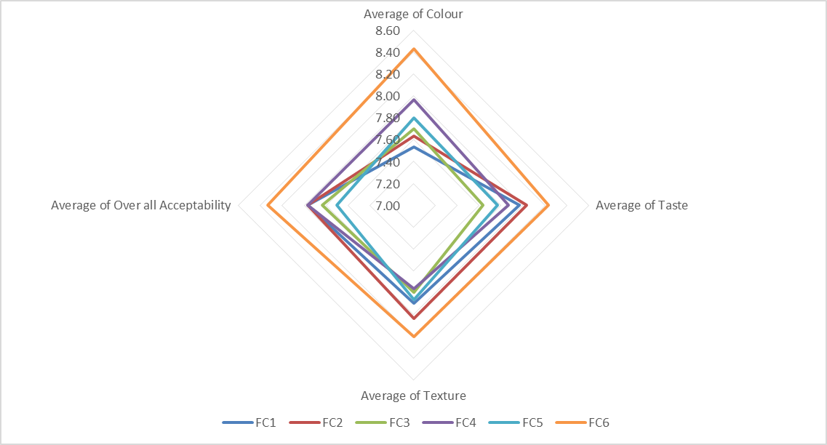

FC: Plantain/Cashew nut/Baobab pulp; FC1: 68/28/4; FC2: 69/27/4; FC3: 70/26/4; FC4: 71/25/4; FC5: 72/24/4.

**Fig. 3** Sensory attributes of gruels prepared from formulated flours and a control flour

**Conclusion**

This study aimed to produce infant flours from fermented plantain flour blend with roasted cashew nut and baobab pulp. Five complementary flours were produced, and they all respect the recommendations of WFP in terms of nutritional and functional characteristics. Among the flours formulated, FC2 (Plantain 69%, cashew nut 27%, Baobab pulp 4%) and FC4 (Plantain 71%, cashew nut 25%, Baobab pulp 4%) have the best taste, texture and overall acceptability, but are significantly less appreciated than commercial flour Cerelac®. Therefore, their sensory attributes need to be improved by adding some natural flavors for instance.

Furthermore, the flours are limited in iron. This finding suggests that the flours produced need to be fortified with iron before to be recommended for young children feeding, and it could be done by using another local sources of iron such as sweet potato leaves, moringa leaves, spinach or micronutrient mixes. Also, it will be interesting to assess the *in vivo* digestibility and bioavailability of the nutrients of these flours, as nutritional content alone cannot predict the use of a food product in the body. Also, the phytochemical analysis of the flours could be benefit to complete their characterization.

**Consent:**

The study was conducted according to the guidelines laid down in the Declaration of Helsinki. As the food materials used in the study were already known and consumed by the participants, a written informed consent was obtained from them for the sensory evaluation. The consent was witnessed and formally recorded. The anonymity of the participants was guaranteed, as well as the confidentiality of the information collected. In addition, measures were taken to ensure that all participants were neither ill nor allergic to foodstuffs used for the formulation.

**Disclaimer (Artificial intelligence)**

Option 1:

Author(s) hereby declare that NO generative AI technologies such as Large Language Models (ChatGPT, COPILOT, etc.) and text-to-image generators have been used during the writing or editing of this manuscript.

Option 2:

Author(s) hereby declare that generative AI technologies such as Large Language Models, etc. have been used during the writing or editing of manuscripts. This explanation will include the name, version, model, and source of the generative AI technology and as well as all input prompts provided to the generative AI technology

Details of the AI usage are given below:

1.

2.

3.

**References**

1. Programme Alimentaire Mondial (PAM) (2022) Revue de recherche en nutrition 22 : 193-220.
2. Chiabi A, Malangue B, Nguefack S, Dongmo FN, Fru F, Takou V et al (2017) The clinical spectrum of severe acute malnutrition in children in Cameroon: a hospital-based study in Yaounde-Cameroon. Transl. Pediatr. 6: 32-39. <https://doi.org/10.21037/tp.2016.07.05>
3. World Health Organization (WHO) (2019) Guiding principles for feeding non-breastfed children 6-24 months of age. WHO Press, Geneva, Switzerland 1-42.
4. Choudhury S, Headey DD, Masters WA (2019). First foods: Diet quality among infants aged 6–23 months in 42 countries. Food policy 88: 101762. <https://doi.org/10.1016/J.Foodpol.2019.101762>
5. Kimiywe J, Chege PM (2015) Complementary feeding practices and nutritional status of children 6-23 months in Kitui County, Kenya. Journal of applied Biosciences 85 (1): 7881-7890
6. Food and Agriculture Organization (FAO)/World Health Organization (WHO) (2009) Programme mixte FAO/OMS sur les normes alimentaires, Commission du Codex Alimentarius, 32ème session Rome (Italie) (2009) 1-223.
7. Ngaha DW, Ngangoum ES, Saidou C, Mohamadou S (2023) Formulation of three infant foods from plantain flour fortified with sesame (*Sesamum indicum*), Soya bean (*Glycinemax*) and Cashew nut (*Anacardium occidentale* L.). Food Chemistry Advances 3: 1-9. <https://doi.org/10.1016/j.focha.2023.100313>
8. Ngaha DW, Agume NAS, Ngatchic MTJ, Djello NH (2024) Physicochemical, Functional, Microbial, and Sensory Characteristics of Precooked Complementary Flour Produced from Yellow Maize Enriched with Roasted Cashew Almonds and Baobab Pulp. Journal of Food Quality 1579963: 10 p. <https://doi.org/10.1155/2024/1579963>
9. Tedom DW, Ngaha DW, Agume NAS, Ejoh AR (2024) Formulation of complementary flours from pretreated pumpkin pulp, soybeans and spinach leaves: Nutritional, functional and sensory characterization. Heliyon 10: e37604. <https://doi.org/10.1016/j.heliyon.2024.e37604>
10. Feh GW, Ngaha DW, Agume NAS, Ejoh AR (2025) Formulation and characterization of infant flours from a technical blend of plantain, sesame seeds and baobab pulp. Food, Nutrition and Health 2:8. <https://doi.org/10.1007/s44403-025-00017-0>
11. Tounian P, Chouraqui JP (2017) Fer et nutrition.
12. Ramachandran R, Manthena R, Gopi C, Dhanaraju MD (2024) Enhancement of non-heme iron absorption from vegetable foods by using Vitamin-C supplements in wistar rats. Research Journal of Pharmacy and Technology 17(5): 2224-2228.
13. Codex Alimentarius Commission (2013) Guidelines on formulated complementary foods for older infants and young children CAC/GL 8‐1991, World Health Organization & Food and Agriculture Organization of the United Nations, Rome, Italy.
14. Tedom DW, Fombang NE, Ngaha DW, Ejoh AR. (2019). Optimal conditions for production of fermented flour from pumpkin (*Cucurbita pepo*) for infant foods. European Journal of Nutrition and Food Safety10 (2):125-136.
15. World Food Program (2017) Plan stratégique du Programme Alimentaire Mondial pour 2017-2021. Deuxième session ordinaire du Conseil d’administration Rome 52.
16. Madrelle C, Lange I, Boutrolle et al (2017) Development of a new in-home testing method to assess infant food liking. Appetite 113: 274-283.
17. Machiels D, Istasse L (2002) La réaction de Maillard : Importance et application en chimie des aliments. Annales de Médecine Vétérinaire 146 : 347-352.
18. Bhattacharya S (2014) Roasting and toasting operations in food: Process engineering and applications. Conventional and Advance Food Processing Technologies 221-248.
19. D’Souza AA, Kumari D, Banerjee R (2017) Nanocomposite biosensors for point of-care-evaluation of food quality and safety. In A. M. Grumezescu (Ed.), Nanobiosensors. Academic Press 629-676. <https://doi.org/10.1016/B978-0-12-804301-1.00015-1>.
20. Nurhaliza PT, Masniary LL, Lubis Z (2021) Efect of Kweni mango juice addition and percentage of carboxymethyl cellulose (CMC) on the physicochemical characteristics of watermelon albedo fruitghurt. E3s Web of Conferences 332: 08002. <https://doi.org/10.1051/E3sconf/202133208002>.
21. Hudson JL, Baum JI, Diaz EC, Børsheim E (2021) Dietary protein requirements in children: Methods for consideration. Nutrients. 2021;13(5):1554. <https://doi.org/10.3390/Nu13051554>
22. Riedel SN (2024) Optimizing growth and development: a nutritional biochemical approach to pediatric health. Doctoral dissertation, Department of Chemistry and Biochemistry, Faculty of Medecine, University of Rijeka.
23. Menezes MS, Almeida CM (2024) Structural, functional, nutritional and clinical aspects of vitamin A: A review. Pharma Nutrition 100383.
24. Ngaha DW, Assiene AJA, Agume NAS, Tedom DW, Ejoh AR (2024) Nutritional, functional and sensory characteristics of an infant puree food from pre-treated pumpkin flesh (*Curcubita pepo* L.), soybean (*Glycine max* L.) and spinach leaves (*Spinacia oleracea*), Journal of Agriculture and Food Research 16: 101183. <https://doi.org/10.1016/j.jafr.2024.101183>
25. Badham J, Zimmermann MB, Kramer K (2007) Le guide de l'anémie nutritionnelle. Suisse : Sight and Life.
26. Vo TS, Vo TT, Tran TT, Pham ND (2022) Enhancement of water absorption capacity and compressibility of hydrogel sponges prepared from gelatin/chitosan matrix with different polyols. Progress in Natural Science: Materials International 32(1): 54-62. <https://doi.org/10.1016/j.pnsc.2021.10.001>.
27. Hussein JB, Ilesanmi JO, Aliyu HM, Akogwu V (2020) Chemical and sensory qualities of moimoi and akara produced from blends of Cowpea (*Vigna unguiculata*) and *Moringa oleifera* seed flour. Nigerian Journal of Technological Research 15: 15-23. <https://doi.org/10.4314/njtr.v15i3.3>.
28. Ramli NIZ, Tien BY, Hui BY, Han WK (2022) The effects of soaking time on the quality and properties of durian (Durio zibethinus) seed gum: a mini review. Malaysian Journal of Analytical Sciences 26: 944-952. <https://mjas.analis.com.my/mjas/v26_n5/pdf/Nurul_26_5_3.pdf>
29. Chandra S, Singh S (2013) Assessment of functional properties of different flours. African Journal of Agricultural Research 8(38): 4849-4852. <https://doi.org/:10.5897/AJAR2013.6905>.
30. El-Sayed SM (2020) Use of spinach powder as functional ingredient in the manufacture of UF-Soft cheese. Heliyon 6: e03278. <https://doi.org/10.1016/j.heliyon.2020.e03278>
31. Mbame MC, Tiencheu B, Feumba R, Tiepma FD, Ashu AO, Ufuan AA,… Oben J (2021) Formulation of Adequate Complementary Food for Children 6-24 months using local staple Food in the South- West Region of Cameroon. European Journal of Nutrition & Food safety 13(112): 89-108. <https://doi:.org/110.9734/EJNFS/2021/v13i1230471>.
32. Nguyen SHT, Webba HK, Hasan J, Tobin MJ, Crawford RJ, Ivanova EP (2013) Dual role of outer epicuticular lipids in determining the wettability of dragonfly wings. International Journal of Engineering Science 106: 126-134.
33. Be Miller JN, Huber KC (2008) Carbohydrates. In: Damodaran S, Parkin KL, Fennema OR, eds. Fennema’s food chemistry, 4th ed. Boca Raton, FL: CRC/Taylor & Francis 83-151.
34. Verni M, Pontonio E, Montemurro M, Rizzello GC (2022) Fermentation as strategy for improving nutritional, functional, technological, and sensory properties of legumes. In Legumes Research 2.
35. Senanayake D, Torley PJ, Chandrapala J, Terefe NS (2023) Microbial fermentation for improving the sensory, nutritional and functional attributes of legumes. Fermentation 9(7): 635.