**Comparison of Nutritional Content in Common Infant Formulas Available in Jordanian Pharmacies**

**Abstract**

**Background:** A variety of infant formulas are available in Jordan, which makes the decision of using one formula over another confusing to both parents and physicians. This study aims to assess the nutritional composition of commonly accessible infant formulas up to one year of age. Additionally, the nutritional adequacy of these infant formulas was compared to the standards for infant formula developed by *Codex Alimentarius* Commission.

**Methods:** Milk-based infant formulas available in Jordan were investigated. A smart phone camera was used to take images from all sides of each infant formula. The examined formulas were categorized into three groups based on the specified age for use. Energy and nutrient contents for products in each group were tabulated and visualized in graphs.

**Results:** A total of 33 infant formulas were available in Jordanian pharmacies: 20 for infants aged 0-6 months, five for 0-12 months, and eight for 6-12 months. Most formulas meet the standards of *Codex Alimentarius* Commission despite the variation of their nutrient composition. Formulas for infants aged 0-6 months are more restricted to contain sufficient amounts of all basic and essential nutrients than formulas intended for 6-12 months. Formulas intended for special medical purposes are more likely to have different composition compared to breast milk and should be used cautiously and only when necessary.

**Conclusions:** There is no evidence to recommend one brand over another; however, the presence of functional bioactive compounds that can promote infant’s health outcomes is the major factor to prefer one brand over another.

**Keywords:** Infant, Milk Formula, Codex Alimentarius, Breastfeeding, Jordan.

**1. Introduction**

Breastfeeding is the gold standard for infant nutrition, particularly for the first six months of life (Meek and Noble, 2022). Most health organizations, including the World Health Organization, recommend breastfeeding for infants until two years of age (Kramer and Kakuma, 2012).Despite the several health benefits reported for breastfeeding on both the children and mothers (Savino et al., 2013), the global breastfeeding rate remains low (Neves et al., 2021; Zong et al., 2021).In many situations, breastfeeding might not be possible, inadequate, or unwanted, where mothers choose to rely on infant formula to feed their infants. In Jordan, the majority of mothers commence breastfeeding shortly after giving birth (Al-Awwad et al., 2021). However, only a third of them continue with exclusive breastfeeding for the recommended six months. The primary obstacles reported for breastfeeding are maternal employment, cesarean delivery, infant’s hospitalization, inadequate breastmilk supply, and short maternity leave (Khasawneh and Khasawneh, 2017).Therefore, infant feeding using infant formulas is a common practice among Jordanian mothers.

Commercially available infant formulas serve as an efficient substitute for breastfeeding (Bakshi et al., 2023; Stevens et al., 2009). Over the years, there have been significant improvements in the production of infant formula, aiming to closely mimic the nutritional composition of human breast milk, thereby supporting normal growth and development in infants (Bakshi et al., 2023). All infant formulas should include a protein source, a fat source, a carbohydrate source, as well as a combination of vitamins, minerals, and other essential ingredients (Jardí Piñana et al., 2015; O'Connor, 2009; Owens et al., 2012).In most countries, including Jordan, a wide variety of infant formulas are available in the market from various manufacturers, which makes the decision of using one infant formula over another confusing and difficult to both parents and physicians (O'Connor, 2009).As a matter of fact, standards and guidelines for the manufacturing of infant formulas were developed by the *Codex Alimentarius* Commission, part of both the Food and Agriculture Organization of the United Nations and the World Health Organization, in 1981 and revised in 2007 (Koletzko et al., 2005; Koletzko and Shamir, 2006; WHO, 2023).These guidelines were implemented to ensure that infant formulas are manufactured to satisfy the nutritional needs of infants during the first months of life up to the introduction of appropriate complementary feeding.

All infant formulas that are available in the Jordanian market are regulated by the Jordan Food and Drug Administration (JFDA, 2017), which requires the manufacturers to provide a certificate proving that their products are compliant with the recommended international code of hygienic practice for foods for infants and children. However, it is a difficult task for the parents in Jordan to choose the best formula for their infants with the presence of different formula products form the same manufacturer and from other manufacturers.

The purpose of this study was to assess the nutritional composition of the commonly accessible infant formulas in the Jordanian market, which are recommended for term infants from birth until one-year of age. Additionally, the study aimed to evaluate the nutritional adequacy of these infant formulas. Only milk-based infant formulas were included in this study. The outcomes of this study would improve parental comprehension of the nutritional content of infant formulas, aiding both parents and physicians in making informed decisions when choosing among various infant formulas.

**2. Materials & Methods:**

For the current observational study, three main pharmacies were visited in Irbid city located in the northern region of Jordan. Infant formulas available in these pharmacies were examined, and only milk-based formulas intended for term infants from birth until 12 months were included in this study. A smart phone camera was used to take images from all sides of each infant formula. The images provided information about the product label on the front and nutrition information on the back side. The examined infant formulas were categorized into three primary groups based on the manufacturer's specified age for use. These include formulas for infants from birth to 6 months, formulas for infants from birth to 12 months, and formulas for 6 to 12 months infants. The energy and nutrient contents for products in each group were tabulated in Excel. The energy content was expressed as kilocalories per 100 mL of the prepared formula (Kcal/100 mL), while the nutrients content was expressed as amount per 100 Kcal of formula milk. Prism8 Graphpad program was then utilized to develop visualized graphs of the tabulated data of nutrients contents. The content data were also compared with the standard requirement for formula milk according to the *Codex Alimentarius* Commission (WHO, 2023).

**3. Results**

A total of 36 infant formulas were found available in the Jordanian pharmacies for infants up to one year. Three of these were excluded for being intended for premature and low birth weight infants (i.e., PreNAN® and Similac Neosure®) or are a soy-based formula (i.e., Similac Isomil-1®). Of the 33 formulas, 20 were for infants up to 6 months, five for infants from birth to 12 months, and eight for infants from 6 to 12 months. The prices ranged from 0.8 to 1.4 JD per 100 g of the powdered milk formula (1.1 to 2.0 dollar/100 g) (Figure 1A).

**3.1. Energy and Macronutrients Content of the Infant Formulas**

The energy and macronutrient content of the infant formulas are shown in Figure 1 & Tables S1-S3. All formulas met the standard caloric range of 60-70 kcal/100 mL (Table S3), except Similac Gain® (74 kcal/100 mL), which serves as a follow-on formula for infants over 6 months. Infant formulas are required to include the energy-yielding macronutrients of carbohydrate, protein, and fat within a range of minimum and maximum values for their effectiveness (Table 1) (WHO, 2023).Formulas in the Jordanian market comply with the standard ranges for carbohydrate (9-14 g/100 kcal), protein (1.8-3.0 g/100 kcal), and fat (4.4-6.0 g/100 kcal) (Figure 1 & Tables S1-S3). Only formulas for 6-12 months infants contain higher protein content (> 3g/ 100 kcal) (Figure 1D).

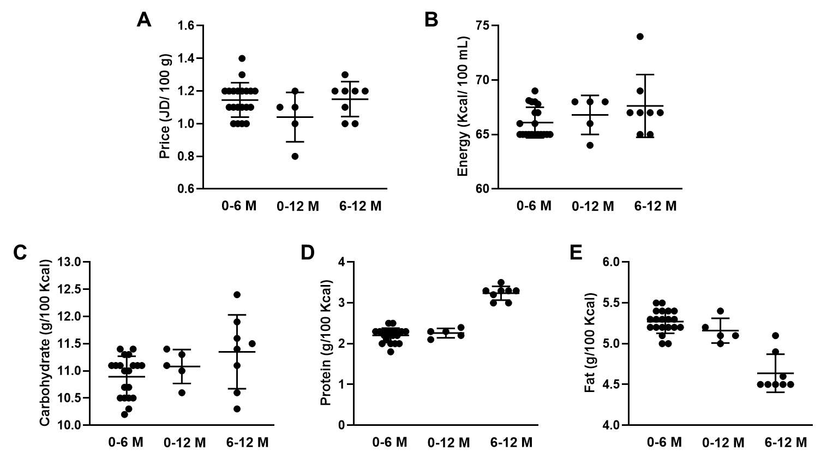

**Figure 1.** The energy and macronutrients contents for the 33 infant formulas available in Jordan. **A.** The prices of the different formulas in JD per 100 g of the formula. **B.** The energy content of the formulas in Kcal per 100 mL of the formula. **C.** The carbohydrate content of formulas in gram per 100 Kcal **D.** The protein content of formulas in gram per 100 Kcal. **E.** the fat content of formulas in gram per 100 kcal.

The sources of these macronutrients vary among formulas based on their intended use. For instance, most milk-based formulas use lactose as the primary carbohydrate, though some may also contain small amounts of glucose, galactose, maltose, 2’-o-fucosyllactose, oligofructose, maltodextrin, and starch. Conversely, lactose-free formulas utilize polysaccharides or maltodextrin as the primary carbohydrate source, with lactose levels below 0.05 g/100 g in these products. Furthermore, formulas for gastrointestinal issues typically have reduced lactose and higher amounts of polysaccharides or maltodextrin as the primary sources of carbohydrates.

Protein in regular infant formulas comes from a combination of whey protein and casein, whey protein alone, or casein alone (Tables S4-S6). Hydrolyzed or partially hydrolyzed whey protein are used in hypoallergenic and comfort formulas (Tables S4-S6). Comfort formulas help prevent digestive problems such as colic and constipation, whereas hypoallergenic (HA) formulas are for infants with cow's milk allergies. Notably, none of the formulas for infants aged 6-12 months contain hydrolyzed or partially hydrolyzed whey protein (Table S6). Among formulas for infants aged 0-12 months, only the Sahha Gentle® product includes hydrolyzed whey protein (Table S5).

The fat in infant formulas is mainly derived from vegetable oil and fat. Certain brands detail the quantities and varieties of fats present, including saturated, monounsaturated, and polyunsaturated fats, whereas others only indicate the overall fat content.

|  |  |  |  |  |
| --- | --- | --- | --- | --- |
| **Table 1.** Standard Levels of Essential and Optional Nutrients in Infant Formulas According to *Codex Alimentarius* Commission | | | | |
| **Nutrient** | **Unit** | **Minimum** | **Maximum** | **GUL** |
| **Energy** | kcal/100 mL | 60 | 70 |  |
| **Macronutrients** | | | | |
| Protein | g/100 kcal | 1.8 | 3.0 | -- |
| Total fat | g/100 kcal | 4.4 | 6.0 | -- |
| Total carbohydrates | g/100 kcal | 9.0 | 14.0 | -- |
| **Major Minerals** |  |  |  |  |
| Sodium | mg/100 Kcal | 20 | 60 | -- |
| Potassium | mg/100 Kcal | 60 | 180 | -- |
| Chloride | mg/100 Kcal | 50 | 160 | -- |
| Calcium | mg/100 Kcal | 50 | -- | 140 |
| Phosphorous | mg/100 Kcal | 25 | -- | 100 |
| Magnesium | mg/100 Kcal | 5 | -- | 15 |
| **Trace Minerals** |  |  |  |  |
| Iron | mg/100 Kcal | 0.45 | -- | -- |
| Zinc | mg/100 Kcal | 0.5 | -- | 1.5 |
| Copper | μg/100 kcal | 35 | -- | 120 |
| Manganese | μg/100 kcal | 1 | -- | 100 |
| Selenium | μg/100 kcal | 1 |  | 9 |
| Iodine | μg/100 kcal | 10 |  | 60 |
| **Fat-soluble Vitamins** |  |  |  |  |
| Vitamin A | μg/100 kcal | 60 | 180 | -- |
| Vitamin D3 | μg/100 kcal | 1 | 2.5 | -- |
| Vitamin E | mg/100 Kcal | 0.5 | -- | 5 |
| Vitamin K | μg/100 kcal | 4 | -- | 27 |
| **Water-soluble Vitamins** | |  |  |  |
| Vitamin B1 | μg/100 kcal | 60 | -- | 300 |
| Vitamin B2 | μg/100 kcal | 80 | -- | 500 |
| Vitamin B3 | mg/100 kcal | 0.3 | -- | 1.5 |
| Vitamin B5 | μg/100 kcal | 400 | -- | 2000 |
| Vitamin B6 | μg/100 kcal | 35 | -- | 175 |
| Vitamin B7 | μg/100 kcal | 1.5 | -- | 10 |
| Folic acid | μg/100 kcal | 10 | -- | 50 |
| Vitamin B12 | μg/100 kcal | 0.1 | -- | 1.5 |
| Vitamin C | mg/100 Kcal | 10 | -- | 70 |
| **Other Essential Nutrients** | | | | |
| Linoleic acid | mg/100 Kcal | 300 | -- | 1400 |
| α-Linolenic acid | mg/100 Kcal | 50 | -- | -- |
| Linoleic/ α-Linolenic acid ratio | -- | 5:1 | 15:1 |  |
| Choline | mg/100 Kcal | 7 | -- | 50 |
| Myo-Inositol | mg/100 Kcal | 4 | -- | 40 |
| L-Carnitine | mg/100 Kcal | 1.2 | -- | -- |
| **Optional Ingredients** | | | | |
| Taurine | mg/100 Kcal | -- | 12 | -- |
| Docosahexaenoic Acid | % of fatty acids | -- | -- | 0.5 |

**3.2. Major and Trace Minerals Content of the Infant Formulas**

Major and trace minerals are essential in infant formulas. During the early stages of an infant's life, the daily requirement of minerals is high to support rapid growth and development. *Codex Alimentarius* has established reference values to guide manufacturers meet infants' nutrient needs (Table 1) (WHO, 2023). For certain minerals, both minimum and maximum reference values were specified, while for others, only minimum values and guidance upper levels (GULs) are provided (Table 1). GULs guide manufacturers when data is insufficient for a science-based risk assessment, and they should not be interpreted as target values.

All investigated infant formulas exceeded the minimum required levels of major minerals (Figure 2). Formulas for infants 6-12 months generally contain higher levels of major minerals than those for infants aged 0-6 months and 0-12 months (Figure 2). The sodium content in Nan-2® formula is near the maximum reference value (58.5 vs 60 mg/100 Kcal) (Table S9 & Table 1). Similarly, Babelac-2®, Aptamil-2®, and Similac Gain-2® have potassium levels that are close to the maximum reference value (Table S9 & Table 1). Additionally, four of the 6-12-months formulas exceed the guidance upper level for calcium (140 mg/100 Kcal) (Figure 2D & Table S9). Aptamil-2®, Babelac-2®, and Similac Gain-2® contained the highest level of phosphorus among the other infant formulas (Figure 2E).

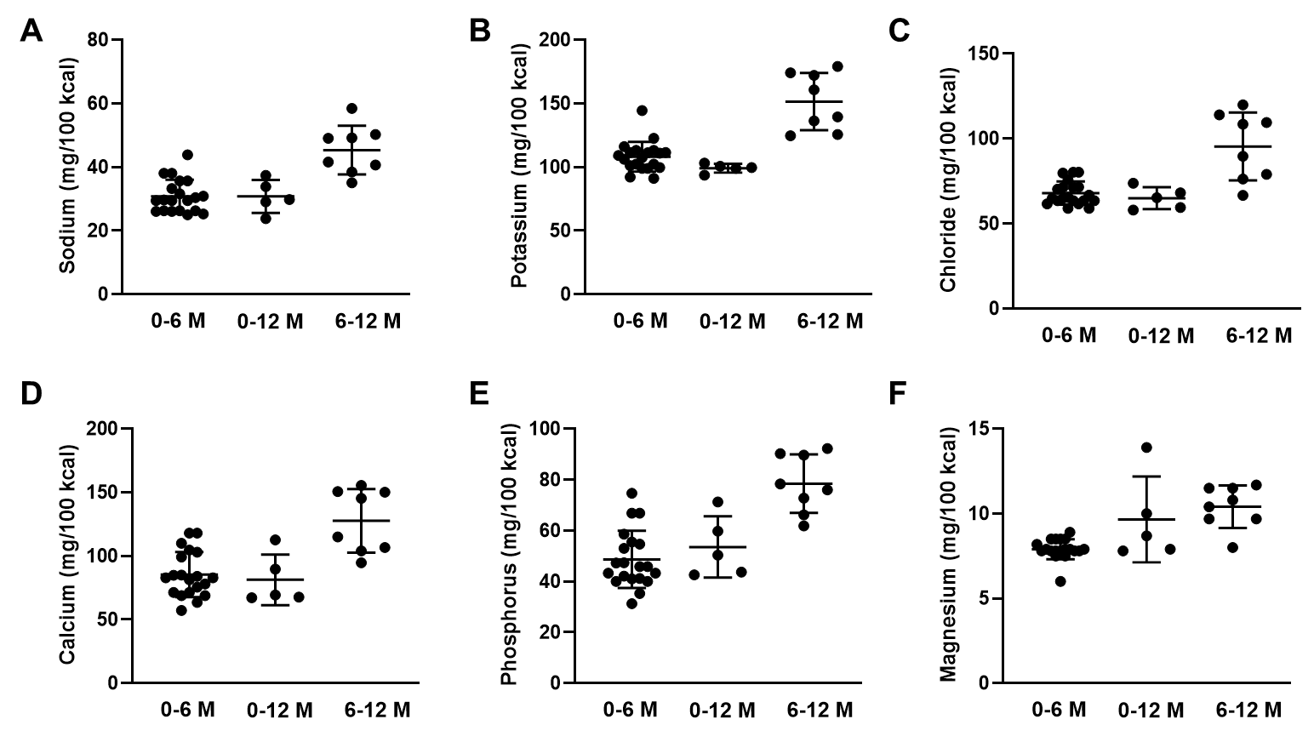

**Figure 2.** Major minerals contents among the 33 infant formulas available in Jordan presented in mg of the mineral per 100 Kcal of the formula. **A.** Sodium content. **B.** Potassium content. **C.** Chloride content. **D.** Calcium content. **E.** Phosphorus content. **F.** Magnesium content.

Trace minerals, including iron (Fe), zinc (Zn), copper (Cu), manganese (Mn), selenium (Se), and iodine (I) are essential ingredients in infant formulas. Fluoride (F) is the only trace mineral that should not be added to infant formulas (WHO, 2023). All investigated infant formulas exceeded the minimum iron level (0.45 mg/100 Kcal), with higher average iron content found in 6-12 month formulas (Figure 3). Similac Advance LF® had the highest iron and copper contents among the 0-6 months formulas (Table S10). Sahha Gentle® and Nan Optipro-2® include the highest level of zinc (1.2 mg/100 Kcal) (Tables S11 & S12). Aptamil AR® and Babelac AR® include the highest content of manganese among all formulas (61.3 μg/100 kcal) when the minimum level is 1 μg/100 kcal. The manganese level was not reported on the nutrients panel of Nan Optipro-2® formulas (Table S12). Selenium content ranged from 1.4-4 μg/100 Kcal across all formulas, but Sahha-2® and Similac Gain-2® do not report selenium levels on their nutrient panels (Table S12). Similac Gain-2® had the highest iodine level among the investigated formulas, at 41.2 μg/100 Kcal (Table S12). As mentioned previously, fluoride should not be added to infant formulas, and in all cases fluoride level should not exceed 100 μg/100 kcal. Only twelve of the 33 formulas report the level of fluoride on their products labels, all below the 100 μg/100 Kcal limit (Tables S10-S12).

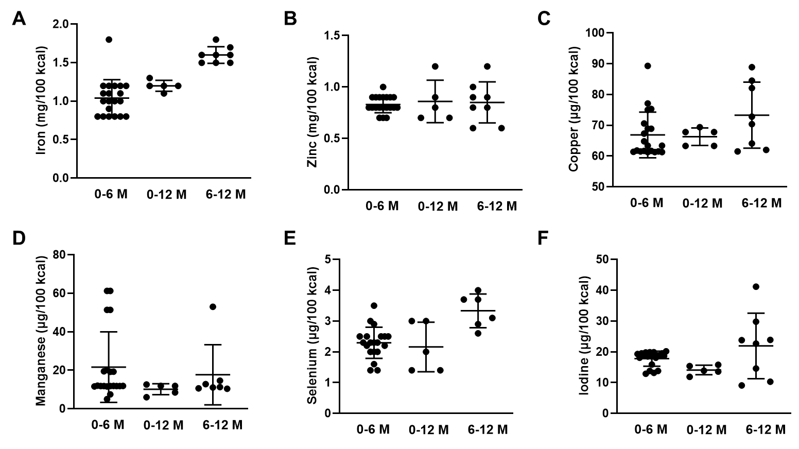

**Figure 3.** Trace minerals contents among the 33 infant formulas available in Jordan. **A.** Iron content in mg/100 Kcal. **B.** Zinc content in mg/100 Kcal. **C.** Copper content in μg/100 Kcal. **D.** Manganese content in μg/100 Kcal. **E.** Selenium content in μg/100 Kcal. **F.** Iodine content in μg/100 Kcal.

**3.3. Fat- and Water-Soluble Vitamins Content of the Infant Formulas**

The fat-soluble vitamins (vitamin A, D, E, and K) in Jordanian infant formulas exceed the minimum recommended levels (Figure 4 & Tables S13-S15). Sahha-1® has the highest level of vitamin A (119 μg/100 kcal), Aptamil-2® and Babelac-2® have the highest level of vitamin D (2.2 μg/100 kcal), and Blemil Plus-1® has the highest level of vitamin E (3.0 mg/100 kcal). Despite the variations in the levels of fat-soluble vitamins, all formulas stay below the maximum or guidance upper levels set by *Codex Alimentarius* (Table 1).

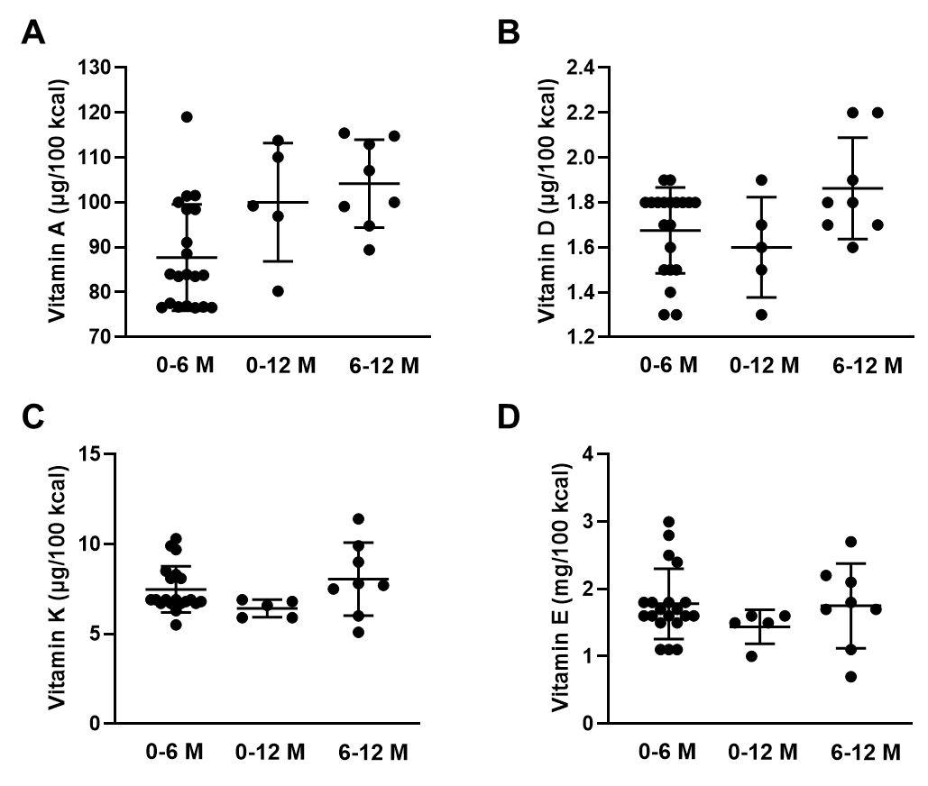

**Figure 4.** Fat-soluble vitamins contents among the 33 infant formulas available in Jordan. **A.** Vitamin A content in μg/100 kcal. **B.** Vitamin D content in μg/100 kcal. **C.** Vitamin K content in μg/100 kcal. **D.** Vitamin E content in mg/100 kcal.

The contents of water-soluble vitamins among the different infant formulas are shown in Figure 5 & Tables S13-S15. Nan Optipro-2® lists the highest levels of vitamin B1 (201.2 μg/100 kcal), B2 (246.4 μg/100 kcal), and B5 (1129.4 μg/100 kcal). Conversely, Similac Advance LF® contains a lower level of vitamin B2 than the minimum recommended value (67.0 vs. 80 μg/100 kcal) (Tables 1 & S13). The levels of vitamin B3 in Sahha-2® and Similac Gain-2® exceed the recommended GUL (Tables 1 & S15). Similarly, vitamin B6 slightly exceeds the GUL in Similac Gain-2® (179.0 vs 175 μg/100 kcal) (Table S13). It was also noted that certain brands of infant formula, such as Aptamil®, Babelac®, Sahha®, and Primilac®, have higher vitamin B3 content in their anti-regurgitation (AR) and/or lactose-free (LF) versions compared to their standard versions (Tables S13 & S14). All formulas contain folic acid, vitamin B12, and vitamin C within the recommended range.

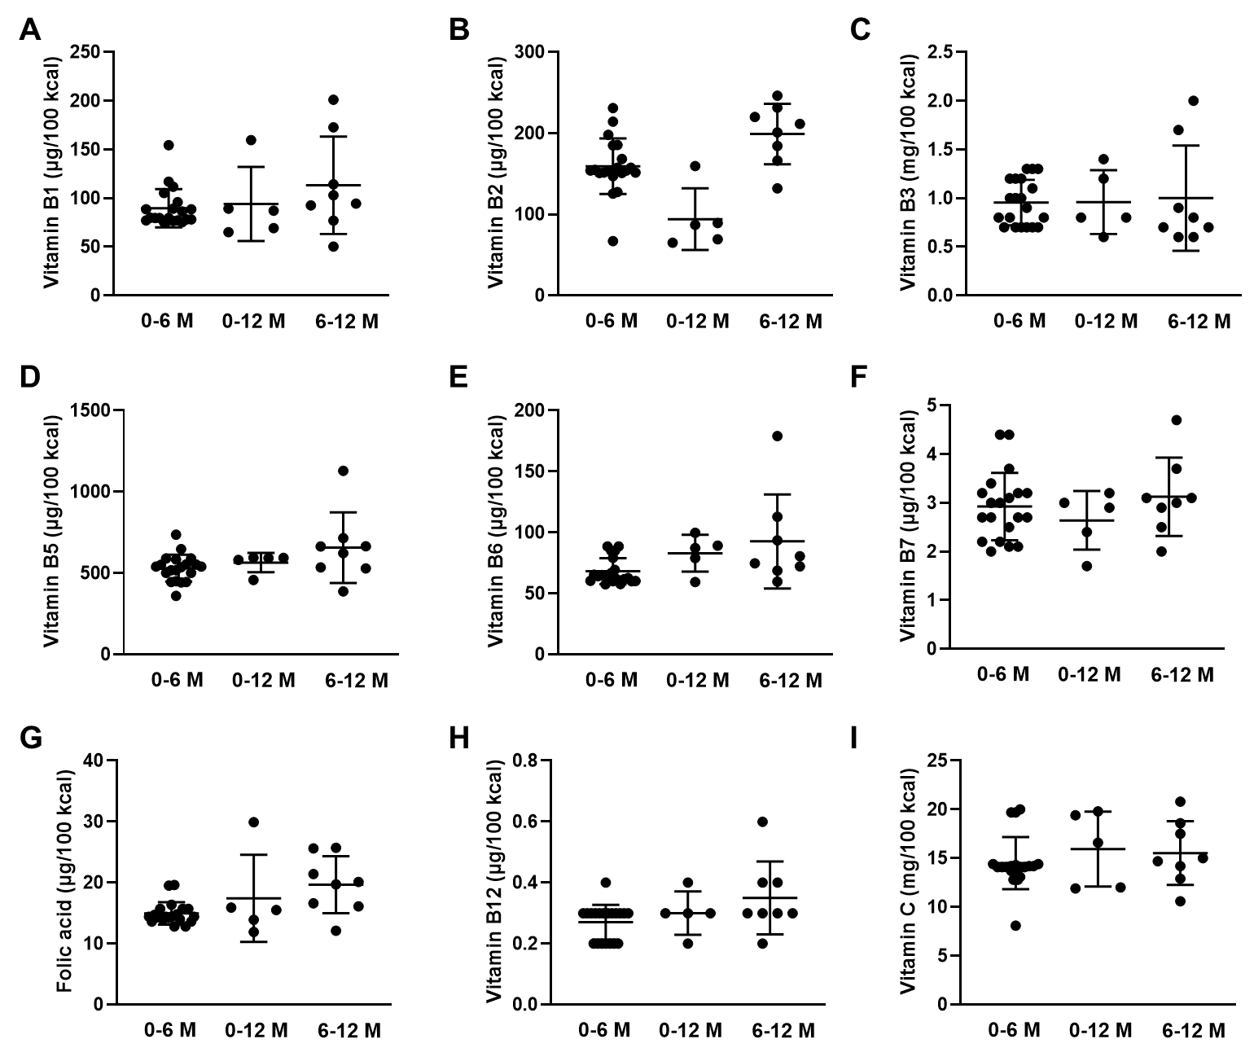

**Figure 5.** Water-soluble vitamins content among the 33 infant formulas available in Jordan. **A.** Vitamin B1 content μg/100 kcal. **B.** Vitamin B2 content in μg/100 kcal. **C.** Vitamin B3 content in mg/100 kcal. **D.** Vitamin B5 content in μg/100 kcal. **E.** Vitamin B6 content in μg/100 kcal. **F.** Vitaim B7 content in μg/100 kcal. **G.** Folic acid content in μg/100 kcal. **H.** Vitamin B12 content in μg/100 kcal. **I.** Vitamin C content in mg/100 kcal.

**3.4. Other Essential** **Nutrients in Infant Formulas**

Infant formulas are required to include essential ingredients, i.e., linoleic acid, α-linolenic acid, choline, inositol, and L-carnitine (Figure 6 & Tables S16-S18). Linoleic acid (the primary member of the omega-6 fatty acid family) and α-linolenic acid (the primary member of the omega-3 fatty acid family) are essential fatty acids that human body is unable to synthesize and must be obtained through diet (Einerhand et al., 2023). All formulas met the recommended levels for these fatty acids, except for Sahha-2®, which has lower α-linolenic acid compared to the minimum requirement (20.1 vs 50 mg/100 Kcal), resulting in linoleic to α-linolenic acid ratio above the maximum level(20 vs 15) (Table S18).

Choline is a structural part of phospholipids, and a source of methyl groups needed for many steps in metabolism (Bekdash, 2019). Only Nan Optipro-2® does not report the presence of choline. S-26 Gold-2® has the highest level of choline, while Sahha-2® contains the minimum requirement (7.0 mg/100 Kcal) (Table S18). For inositol, a sugar made in the body and found in foods, three formulas do not report the addition of inositol (i.e., Nan Optipro-2®, Sahha-2®, and Similac Gain-2®). Six infant formulas lack L-carnitine, a naturally occurring amino acid derivative that plays a critical role in energy production (Bakshi et al., 2023), most of which are for infants aged 6-12 months (Tables S16-S18).

**Figure 6.** The contents of other essential nutrients among the 33 infant formulas available in Jordan presented in mg/100 Kcal. **A.** Linoleic acid content. **B.** α-linolenic acid content. **C.** Linoleic to α-linolenic acid ratio. **D.** Choline content. **E.** Inositol content. **F.** L-carnitine content.

**3.5. Optional Ingredients in Infant formulas**

Many manufacturers add extra ingredients to infant formulas beyond the essential ingredients specified by *Codex Alimentarius*. These substances, often found in human milk, are included to mimic the benefits of breastfeeding and ensure the formula is suitable as the sole nutrition for infants (Almeida et al., 2021). According to *Codex Alimentarius* (WHO, 2023), infant formulas should contain sufficient amounts of these substances to achieve the intended effect, considering their levels in human milk. However, only docosahexaenoic acid (DHA), arachidonic acid (ARA), taurine, and total nucleotides are listed as optional ingredients by *Codex Alimentarius*.

Of the 33 infant formulas, 25 contained both DHA and ARA, which are essential omega-3 and omega-6 fatty acid derivatives (Tables S19-S21). In these formulas, ARA levels are equal to or greater than those of DHA (Figure 6), adhering to Codex Alimentarius guidelines, which states that ARA content should reach at least the same concentration as DHA (WHO, 2023). Nan Optipro-2® is the only formula that includes DHA but not ARA, while the remaining seven formulas contained neither.

Taurine, the most abundant free amino acid in breast milk (Verner et al., 2007), was found in 30 of the 33 infant formulas in amounts below the maximum level (12 mg/100 Kcal) (Figure 7). Three formulas, one is for 0-12 months and two for 6-12 months infants, do not list taurine on their nutritional panels (Tables S19-S21). Additionally, 24 formulas have added nucleotides, with 11 specifying the levels of the five different nucleotides added to their formulations (Tables S19-S21).

**Figure 7.** The contents of optional ingredients in the 33 infant formulas available in Jordan presented in mg/Kcal. **A.** Docosahexaenoic acid (DHA) content. **B.** Arachidonic acid (ARA) content. **C.** Taurine content. **D.** Nucleotides content.

Besides the previously mentioned optional ingredients, some formulas include additional optional substances such as oligosaccharides, carotenoids, free amino acids, phospholipids, and sphingomylin.

Oligosaccharides are non-digestible carbohydrates added to infant formula to mimic human milk oligosaccharides (Akkerman et al., 2022). Oligosaccharides can be present in infant formulas as dietary fiber, galacto-oligosaccharides (GOS), fructo-oligosaccharides (FOS), 2′-fucosyllactose, or oligofructose. Oligosaccharides were found in all brands of studied infant formulas, except those from Sahha® brand (Tables S22-S24). Additionally, all lactose-free (LF) and anti-regurgitation (AR) formulas do not contain oligosaccharides in their compositions. Dietary fiber of GOS and/or FOS origins are the common source of oligosaccharides used in infant formulas, while S-26 Gold® and Nan Optipro® use 2’-O-fucosyllactose and/or oligofructose.

Lutein and β-carotene, carotenoids found in human breast milk, are added to some infant formulas for their roles in the eye development of newborns (Gazzolo et al., 2021). S-26 Gold® and Similac Comfort® contain both, while lutein alone is present in Similac-1®, Blemil Plus-1®, and Similac Gain-2®. S-26 Gold® brand is unique for including additional ingredients such as the free amino acids L-tryptophan and L-tyrosine in S-26 Gold-1®, as well as phospholipids and sphingomyelin in S-26 Gold-1 and 2®.

**4. Discussion**

This study is the first to examine the composition of infant formulas in Jordan for infants up to one year old, summarizing the nutrients of these formulas to help parents make informed choices. It also reviews whether the formulas meet the nutrient requirements set by the *Codex Alimentarius* Commission.

Hypoallergenic (HA) formulas are processed by hydrolyzing whey protein, either extensively or partially, and are recommended for infants at high risk of cow's milk allergy or show manifestations of atopic disease, such as atopic dermatitis (Høst and Halken, 2004). HA formulas with partially hydrolyzed protein may have some effectiveness, though it appear to be less than that of extensively hydrolyzed formulas (Høst and Halken, 2004). In this study, Babelac HA® contains partially hydrolyzed whey protein, while Primilac HA1® and Aptamil HA® contain hydrolyzed whey protein (Table S4). All HA formulas also include the optional ingredients DHA, ARA, taurine, nucleotides, and oligosaccharides (Table S19 & S22).

Lactose-free (LF) formulas are for infants with lactose intolerance, acute diarrhea, or galactosaemia (Owens et al., 2012). Excessive use of LF and HA formulas has been reported (Strzalkowski et al., 2022). LF formulas replaces lactose with other glucose-derived polymers such as corn syrup, brown rice syrup, maltodextrin, or sucrose (Mokhtari et al., 2024). LF formulas in Jordan use glucose syrup in Aptamil LF® and Babelac LF®, corn syrup solids in Similac Advance LF®, and maltodextrin in Sahha LF® and Primilac LF®. These carbohydrate sources have a higher glycemic impact than lactose and are metabolized differently (Mokhtari et al., 2024). Therefore, unnecessary use of LF formulas is discouraged to avoid any potential long-term effects of these alternative carbohydrates on infant growth and development (Heyman, 2006). Of these five LF formulas, Similac Advance LF® lacks DHA and ARA as optional ingredients (Table S19). Sahha LF® is also missing several optional ingredients, including DHA, ARA, and nucleotides (Table S20).

Anti-reflux (AR) formulas are designed to reduce emesis, regurgitation, and reflux in infants by adding a thickening agent such as starch, guar gum, or carob/locust bean gum (Aggett et al., 2002). Furthermore, the amount of casein is usually increased in AR formulas to form relatively indigestible curds in the stomach and reduce gastric reflex (Xinias et al., 2003). In Jordan, Aptamil AR® and Babelac AR® use locust bean gum and have a high casein-to-whey ratio (80:20). Locust bean gum is nondigestible and excreted unchanged in the feces or fermented by the gut microbiota (Salvatore et al., 2018). Sahha AR® has a casein to whey protein ratio of 50:50 and uses starch to thicken the formula. Starch increases the formula viscosity to less extent compared to locust bean gum, however, there is no evidence to suggest that one thickener is clinically superior to another (Salvatore et al., 2018). Moreover, Sahha AR® does not include any of the optional ingredients found in the Aptamil AR® and Babelac AR® (Tables S19 & S20).

Anti-colic formulas are designed for infants experiencing colic and gastrointestinal symptoms. Colic is a common condition among newborns, often occurring in the first weeks after birth and typically subsiding by four to six months of age (Wolke et al., 2017). Manufacturers of anti-colic formulas use strategies like partially hydrolyzed whey proteins, reduced lactose, and the inclusion of prebiotic oligosaccharides and probiotics to help manage colic symptoms (Daelemans et al., 2018; Gordon et al., 2018). In Jordan, different terms are used to describe the formula intended to reduce infantile colic. These include “comfort” such as Aptmil Comfort® and Similac Comfort®, “extra care” such as Babelac EC®, “Gentle” such as Sahha Gentle®, and “Anti-colic” such as Primilac AC®. Aptmil Comfort® and Babelac EC® use hydrolyzed whey protein concentrate, reduced lactose (38% of total carbohydrates), as well as oligosaccharides of GOS and FOS. Similac Comfort® involves partially hydrolyzed whey protein and reduced lactose content, without specifying the exact quantity, along with galacto-oligosaccharides as prebiotics. Besides the hydrolyzed whey protein and the reduced lactose (39% of total carbohydrates), Sahha Gentle® is also supplemented with the probiotic *Bifidobacterium*. Primilac AC® does not include hydrolyzed whey protein but relies on reduced lactose (47% of total carbohydrates) and the presence of galacto-oligosaccharides for its anti-colic properties. It is worth noting that all these anti-colic formulas include the optional ingredients listed in Tables S19 & S20, except for Sahha Gentle®, which only contains taurine among other optional ingredients. Similac Comfort® is unique in that it includes carotenoids, lutein and β-carotene.

Regular infant formulas, which are not designed to manage specific conditions, are available in a variety of brands in Jordan. Nine brands are for infants aged 0-6 months (Table S1), while eight brands are follow-up formulas for infants aged 6-12 months (Table S3). The nutrient composition of these formulas, while regulated by the Jordan Food and Drug Administration, can vary greatly by formula brand and type. However, most formulas comply with the nutritional standards developed by the *Codex Alimentarius* Commission (Table 1). Formulas for infants 0-6 months are more restricted to contain enough of all basic and essential nutrients to meet infant needs at this stage of life. These formulas primary use lactose as carbohydrate source, which is the natural carbohydrate in human breast milk and provide 40% of the total energy of milk (Martin et al., 2016). A combination of whey and casein in a ratio of ~ 60:40 is the most common source of protein in formulas for infants aged 0-6 months, except for Nan Optipro-1® which contains 100% whey protein. In human breast milk, the whey/casein ratio fluctuates between 70:30 and 80:20 in early lactation and decreases to 50:50 in late lactation (Lönnerdal, 2003). Unlike whey which remains liquid and is easier to digest, casein tends to clot or curd in the stomach. Accordingly, infant formulas usually contain higher amounts of casein, making them harder to digest compared to human breast milk. Vitamins and minerals are included in the 0-6 months formulas in amounts that are sufficient to meet infant needs. Among the other essential nutrients, only Similac-1® does not report the presence of L-carnitine in its formulation (Table S16). Optional ingredients of DHA, ARA, taurine, nucleotides, and oligosaccharides are listed in all regular 0-6 months formulas except for Sahha-1® (Table S19 & S22). S-26 Gold® brand is unique to include a variety of optional substances which might contribute to its higher price.

Follow-up formulas for infants 6-12 months are used in combination with a complementary diet that is appropriate for infants at this age. The follow-up formulas are less restricted in following the nutritional standards of infant formulas. These formulas contain higher protein content with higher casein component compared to 0-6 months formulas (Table S6). For the other essential nutrients in infant formulas, Sahha-2® reports a level of α-linolenic acid below the minimum requirement. Nan Optipro-2® lacks three essential nutrients (i.e., choline, inositol, and L-carnitine). In Similac Gain-2®, both inositol and L-carnitine are missing. L-carnitine is also missing in S-26 Gold-2®, Sahha-2®, and Mami Lac-2® (Table S18). Regarding the optional substances, four of the eight follow-up formulas lack all or some of the optional ingredients as listed in Table S21.

This study offers valuable insights into the nutritional composition of infant formulas in the Jordanian market. However, there are some limitations to consider. First, the study only includes infant formulas that were available in Jordanian pharmacies at the time of data collection; other brands from different manufacturers may have become available since. Second, the listed formula prices reflect those at the time of data collection. Prices may change over time or be affected by sales from manufacturers. Third, the nutrient compositions of infant formulas are based on the product label information, with no quantitative measurements of actual nutrient levels.

**5. Conclusion**

The consumption of infant formulas is rapidly increasing worldwide, including in Jordan, highlighting the need for formulas that meet the nutritional needs of infants who cannot breastfeed. A diverse range of infant formulas are available in the Jordanian market, and this is the first study to investigate and compare their nutrient compositions. The results of this study serve as a general guidance for parents, physicians, and pharmacists in Jordan to help choose the optimal formula to meet the infant needs at affordable price. Currently, there is no evidence to recommend one brand over another. Formulas that contain sufficient amounts of basic nutrients are considered nutritionally interchangeable. However, the presence of functional bioactive compounds that can promote infant’s health outcomes other than growth, namely cognition, immunity, and temperament, could be the major factor in preferring one brand over another.

**Disclaimer (Artificial Intelligence)**

Authors hereby declare that generative AI technology, i.e. ChatGPT (GPT-4-turbo). OpenAI. (2025). Retrieved from <https://openai.com>, have been used only for improving the language and the readability of the manuscript.

**Supplementary:**

The contents of macronutrients, micronutrients, essential, and optional ingredients in formulas for infants aged 0-6 months, 0-12 months, and 6-12 months are included in Tables S1-S24 and are available in the supplementary file. The Supporting Information is available free of charge at

[https://justedujo my.sharepoint.com/:b:/g/personal/zyalsubeh_just_edu_jo/EfC96Hv244hJqRUZizMqtbUBooDvHZAtPGjIA7UPzvWGwA?e=D60NyN](https://justedujo-my.sharepoint.com/:b:/g/personal/zyalsubeh_just_edu_jo/EfC96Hv244hJqRUZizMqtbUBooDvHZAtPGjIA7UPzvWGwA?e=D60NyN)

**References**

Aggett PJ, Agostoni C, Goulet O, Hernell O, Koletzko B, Lafeber HL, Michaelsen KF, Milla P, Rigo J, Weaver LT. 2002. Antireflux or antiregurgitation milk products for infants and young children: A commentary by the espghan committee on nutrition. J Pediatr Gastroenterol Nutr. 34(5):496-498.

Akkerman R, Logtenberg MJ, Beukema M, de Haan BJ, Faas MM, Zoetendal EG, Schols HA, de Vos P. 2022. Combining galacto-oligosaccharides and 2'-fucosyllactose alters their fermentation kinetics by infant fecal microbiota and influences ahr-receptor dependent cytokine responses in immature dendritic cells. Food Funct. 13(12):6510-6521.

Al-Awwad NJ, Ayoub J, Barham R, Sarhan W, Al-Holy M, Abughoush M, Al-Hourani H, Olaimat A, Al-Jawaldeh A. 2021. Review of the nutrition situation in jordan: Trends and way forward. Nutrients. 14(1):135.

Almeida CC, Mendonça Pereira BF, Leandro KC, Costa MP, Spisso BF, Conte-Junior CA. 2021. Bioactive compounds in infant formula and their effects on infant nutrition and health: A systematic literature review. Int J Food Sci. 2021:8850080.

Bakshi S, Paswan VK, Yadav SP, Bhinchhar BK, Kharkwal S, Rose H, Kanetkar P, Kumar V, Al-Zamani ZAS, Bunkar DS. 2023. A comprehensive review on infant formula: Nutritional and functional constituents, recent trends in processing and its impact on infants' gut microbiota. Front Nutr. 10:1194679.

Bekdash RA. 2019. Neuroprotective effects of choline and other methyl donors. Nutrients. 11(12):2995.

Daelemans S, Peeters L, Hauser B, Vandenplas Y. 2018. Recent advances in understanding and managing infantile colic. F1000Res. 7.

Einerhand AWC, Mi W, Haandrikman A, Sheng XY, Calder PC. 2023. The impact of linoleic acid on infant health in the absence or presence of dha in infant formulas. Nutrients. 15(9):2187.

Gazzolo D, Picone S, Gaiero A, Bellettato M, Montrone G, Riccobene F, Lista G, Pellegrini G. 2021. Early pediatric benefit of lutein for maturing eyes and brain-an overview. Nutrients. 13(9):3239.

Gordon M, Biagioli E, Sorrenti M, Lingua C, Moja L, Banks SS, Ceratto S, Savino F. 2018. Dietary modifications for infantile colic. Cochrane Database Syst Rev. 10(10):Cd011029.

Heyman MB. 2006. Lactose intolerance in infants, children, and adolescents. Pediatrics. 118(3):1279-1286.

Høst A, Halken S. 2004. Hypoallergenic formulas--when, to whom and how long: After more than 15 years we know the right indication! Allergy. 59 Suppl 78:45-52.

Jardí Piñana C, Aranda Pons N, Bedmar Carretero C, Arija Val V. 2015. Nutritional composition of infant milk formulas. Level of compliance in their manufacture and adequacy of nutritional needs. An Pediatr. 83(6):417-429.

Principles of approving infant formula, special formula and complementary foods for infants. Jordan food and drug administration. 2017. Jordan Food and Drug Administration; [accessed 2024]. <https://www.jfda.jo/>.

Khasawneh W, Khasawneh AA. 2017. Predictors and barriers to breastfeeding in north of jordan: Could we do better? Int Breastfeed J. 12:49.

Koletzko B, Baker S, Cleghorn G, Neto UF, Gopalan S, Hernell O, Hock QS, Jirapinyo P, Lonnerdal B, Pencharz P et al. 2005. Global standard for the composition of infant formula: Recommendations of an espghan coordinated international expert group. J Pediatr Gastroenterol Nutr. 41(5):584-599.

Koletzko B, Shamir R. 2006. Standards for infant formula milk. Br Med J. 332(7542):621-622.

Kramer MS, Kakuma R. 2012. Optimal duration of exclusive breastfeeding. Cochrane Database Syst Rev. (8):CD003517.

Lönnerdal B. 2003. Nutritional and physiologic significance of human milk proteins. Am J Clin Nutr. 77(6):1537s-1543s.

Martin CR, Ling PR, Blackburn GL. 2016. Review of infant feeding: Key features of breast milk and infant formula. Nutrients. 8(5):279.

Meek JY, Noble L. 2022. Policy statement: Breastfeeding and the use of human milk. Pediatrics. 150(1).

Mokhtari P, Schmidt KA, Babaei M, Goran MI. 2024. Altered nutrient composition of lactose-reduced infant formula. Nutrients. 16(2):276.

Neves PAR, Vaz JS, Maia FS, Baker P, Gatica-Domínguez G, Piwoz E, Rollins N, Victora CG. 2021. Rates and time trends in the consumption of breastmilk, formula, and animal milk by children younger than 2 years from 2000 to 2019: Analysis of 113 countries. Lancet Child Adolesc Health. 5(9):619-630.

O'Connor NR. 2009. Infant formula. Am Fam Physician. 79(7):565-570.

Owens CJW, Labuschagne IL, Lombard MJ. 2012. The basics of prescribing infant formulas. S Afr fam pract. 54(1):25-30.

Salvatore S, Savino F, Singendonk M, Tabbers M, Benninga MA, Staiano A, Vandenplas Y. 2018. Thickened infant formula: What to know. Nutrition. 49:51-56.

Savino F, Benetti S, Liguori SA, Sorrenti M, Cordero Di Montezemolo L. 2013. Advances on human milk hormones and protection against obesity. Cell Mol Biol. 59(1):89-98.

Stevens EE, Patrick TE, Pickler R. 2009. A history of infant feeding. J Perinat Educ. 18(2):32-39.

Strzalkowski AJ, Järvinen KM, Schmidt B, Young BE. 2022. Protein and carbohydrate content of infant formula purchased in the united states. Clin Exp Allergy. 52(11):1291-1301.

Verner A, Craig S, McGuire W. 2007. Effect of taurine supplementation on growth and development in preterm or low birth weight infants. Cochrane Database Syst Rev. 2007(4):Cd006072.

World health organization/food agriculture organization of the united nations. Codex alimentarius commission (international food standards). Standards for infant formulas and formulas for special medical purposes intended for infants: Codex stan 72-1981 (revised 2007). Geneva: World health organization (2007). 2023. [accessed]. <https://www.fao.org/fao-who-codexalimentarius/codex-texts/list-standards/en/>.

Wolke D, Bilgin A, Samara M. 2017. Systematic review and meta-analysis: Fussing and crying durations and prevalence of colic in infants. J Pediatr. 185:55-61.e54.

Xinias I, Spiroglou K, Demertzidou V, Karatza E, Panteliadis C. 2003. An antiregurgitation milk formula in the management of infants with mild to moderate gastroesophageal reflux. Curr Ther Res Clin Exp. 64(4):270-278.

Zong X, Wu H, Zhao M, Magnussen CG, Xi B. 2021. Global prevalence of who infant feeding practices in 57 lmics in 2010-2018 and time trends since 2000 for 44 lmics. EClinicalMedicine. 37:100971.