Original Research Article

Food Habits and Stomach Content Analysis of Skipjack Tuna (Katsuwonus pelamis, Linnaeus 1758) caught in Mamuju waters, South Sulawesi, Indonesia

ABSTRACT
Skipjack tuna is a fast-swimming pelagic fish that has the ability to migrate between water areas. This study aims to determine the food habits and stomach fullness of skipjack tuna in Makassar Strait, Indonesia. The survey was implemented for 12 months from April 2019 to March 2020. Trolling lines were used for fish sampling. A total number of 252 fish was used for fish sampling. Food habits and stomach fullness of skipjack tuna were observed for data collection. The results showed that the food types found in the skipjack tuna stomach consists of fish 24.82-30.72%, (27.8 ± SE 1.31%), crustacean 22.48-30.24% (26.3 ± SE 1.47%), cephalopods 26.37-35.29% (31,7 ± SE 1.61%) dan unidentified 11.10-19.49% (14.3 ± SE 1.45%). The stomach fullness (SF) varied, which consisted of bursting 9.52-14.92% (11.90 ± SE 1.58%), ¾ filled 14.29-23.81% (22.22 ± SE 1.76%), ½ filled 28.57-33.33% (29.76 ± SE 1.47%) and empty 33.33-47.62% (36.11 ± SE 2.07%). Food types of skipjack tuna were dominated by cephalopods, and stomach fullness was mostly in empty condition.

Keywords: food habits, stomach fullness, Katsuwonus pelamis, Makassar Strait, Indonesia

- INTRODUCTION

Skipjack tuna is a pelagic fish that lives in groups with tuna and mackerel [1]. Skipjack tuna has high economic value and has a large market share. Skipjack tuna has been sought-after by local fishermen of Indonesia using varieties of fishing gear such as hand lines, trolling lines, purse seines, pole and line fishing rods, and gill nets. Indonesia has the second longest coastline in the world and has potentially become a skipjack tuna fishing grounds. Mamuju waters of West Sulawesi is known as one of the skipjack tuna fishing ground in Indonesia. Mamuju waters is a part of Makassar Strait, which is included in the Fisheries Management Area of ​​the Republic of Indonesia (WPPRI) Number 713. The WPPRI 713 includes the Makassar Strait, Flores Sea, Bone Bay, and the Bali Sea.

Many studies on skipjack tuna have been documented in WPPRI 713. [2], the size of the reproductive fit of fishing in Bone. [3] and [4] examined the size distribution and stock assessment in the Flores Sea. [5] and [6] in the waters of Bulukumba and Makassar Strait, examined stock assessment. [7] observed the stomach contents of skipjack tuna. [8], observed stock assessment in the Mamuju Sea. [9] and [10] reconstructed food webs through the stable isotope analysis (SIA) method using carbon (δ¹³C) and nitrogen (δ¹⁵N) to determine the trophic position of consumers. Referring to several previous studies in WPPRI 713, there is still less research on the biological aspects that specifically analyze the type of food and stomach contents which can be used as a reference in determining the migration of skipjack tuna in finding food. This study aims to determine the food habits and stomach fullness of skipjack tuna as basic information in implementing management strategies in Mamuju waters.

- MATERIALS AND METHODS
2.1 Time and place of research
The present study was conducted in the waters of Mamuju, Makassar Strait. Sampling was carried out for 12 months from April 2019 to March 2020. Fish sampling was performed at the Fish Landing Site. Fish and stomach contents observations were carried out in the fisheries biology laboratory of the Institute of Technology and Maritime Business.

2.2 Research Procedures
The sampled fish were caught using trolling line with hooks numbered 6 and 7. The sampled fish was collected at the Mamuju Fish Landing Place in the Makassar Strait from a ship operating by catching fish. The fork length and stomach length were measured using a ruler with an accuracy of 0.1 cm. The stomach of the fish was dissected and then observed the stomach fullness and type of food. A total 252 of fish or 21 fish samples per month was used for sampling landed at the fishing port in Mamuju, West Sulawesi. The fish stomach was placed in a bucket containing 4% formalin and then observed in the laboratory.

2.3 Data Analysis
The observation of the stomach fullness of skipjack tuna used based on [11], namely the "Index of Preponderance" method with the equation:

$$IP=\frac{(vi x oi)}{∑(vi x oi)} x 100\%$$

Where:
IP: Preponderance Index,
vi: food weight percentage,
oi: frequency of food

The oi value or FK equation:
FK = $\frac{A}{B} x 100\%$

Where

Fk = the present of food type (oi)
A = the present of food type to 1 in organism
B = total organism

The index of preponderance formula is modified, by replacing Vi or the percentage for certain types of food with the percentage of weight, therefore, the expected results are more accurate. If a type of food has an IP value of > 40%, it means that the type of food is included in the main food, an index of preponderance value of 4 to 40% means that the type of food is a complementary food, and if the IP value is <4%, then that type of food is an additional food. [12]. While the stomach filling of skipjack tuna was observed based on the category 1/4 full, 1/2 full, 3/4 full, and full, as stated by [13] and [14].

- RESULT AND DISCUSSION
3.1 Food Habit
The Skipjack tuna food was dominated by cephalopods ranging from 26,37-35,29% (31,7 ± SE 1,61%), fish species ranged from 24,82-30,72%, (27,8 ± SE 1,31%), crustaceans ranged from 22,48-30,24% (26,3 ± SE 1,47%) and the lowest for unidentified food types ranged from 11,10-19,49% (14,3 ± SE 1,45%) (Figure 1). Based on the percentage of food types obtained during the research, it shows that all the food eaten by skipjack tuna is included in the complementary food category.
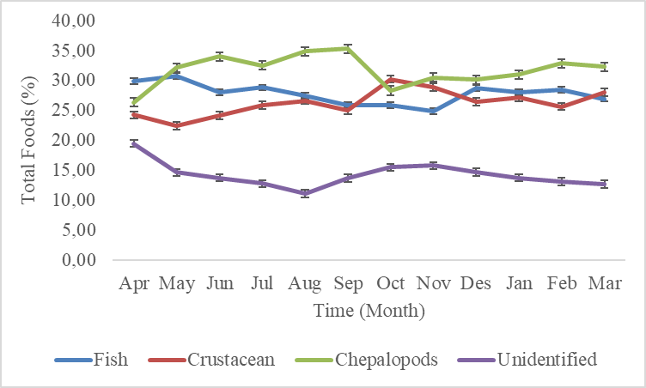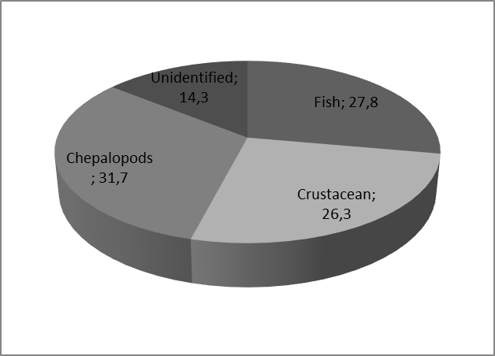

Figure 1. The amount of food found was based on the time of observation (top image) and the type of food found in the skipjack stomach (bottom image) in the Mamuju waters of the Makassar Strait.

The type of food found in the stomach of skipjack tuna showed that skipjack tuna is not selective in looking for food. Based on the data in Figure 1 shows that the type of chepalopods food is the highest of several other types of food found in the stomach of skipjack tuna. However, none of the types of food found in the stomach of skipjack tuna are categorized as the main food and also included in the category of complementary foods (IP of 14.3-31.7%). Even so, the dominant type of food found was cephalopods, but it was not the main food.
However, the dominant type of food found is cephalopods, but it is not the main food. This dominance is thought to be in the fishing area for this type of food which is available and abundant, making it an easily accessible prey. On the other hand, this type of food is rich in protein and essential fats which are needed by skipjack tuna to support its high activity as a fast and active swimming fish. Chepalopods have behavior and adaptations related to movements that attract the attention of skipjack tuna and the ink secreted by chepalopods can respond to hunting from skipjack tuna to catch fast-breeding prey. Another possibility is that the number of skipjack tuna is too large so they fight over each other when looking for a certain type of food. The diversity of food types found in the stomach of skipjack tuna is also an indicator of water fertility and the catching of squid that is lacking or food sources are moving and distributing to other areas both temporally and spatially.

However, the low number of types of food that cannot be identified is thought to be due to the digestive process of skipjack tuna which requires immediate energy from the food consumed which causes the food in the stomach to quickly break down into a form that can no longer be recognized so that the suit can be identified specifically. The food eaten by skipjack tuna has soft tissue that breaks down quickly in the stomach so it is absorbed quickly. During the digestive process, the food that has been swallowed is mixed with gastric juice and digestive enzymes, making it difficult to identify the type of food.

[15] the types of food found in the stomach of skipjack tuna in Bitung, North Sulawesi consisted of malalugis (Decapterus macarellus), sardines (Clupeidae), crab (Portunidae), mackerel (Rastrelliger sp.), and crushed fish. The main food items were 57% of malalugis (Decapterus macarellus), 9% of sardines (Clupeidae), and 4% of mackerel (Rastrelliger sp.) as complementary food, 0.09% of crab (Portunidae), and 30% of the unidentified fish species. [16] found the types of food in the stomachs of skipjack tuna in the form of fish, squid and shrimp in the coastal waters of Puger, Jember Regency. Several previous findings, [17] found that the main diet of skipjack tuna is relatively diverse, such as crustaceans consisting of stomatopods and megalops, while food is in the form of mollusks from the squid type. Meanwhile, the type of food consists of acanthurids, gempylids, lutjanids, nomeids, scombrids, serranids, and synodontids. [18] found that skipjack tuna is carnivorous with a composition of 55.7% sardines fish (Sardinella spp); 34.7% anchovy (Stelophorus spp); 7.9% flying fish (Decapterus spp); 0.9% squid (Loligo sp); 0.7% was in the form of crushed fish whose species could not be identified and 0.1% was in the form of crustaceans. [19] stated that the main natural food of tuna fish which are caught in the waters south of Seram Island and around Nusa Laut Island, the Banda Sea are crustaceans, mollusks, and fish, especially in the juvenile stage. [20], three main components are skipjack fish food, namely fish consisting of bait fish (Stolephorus spp), crustaceans and mollusks. Meanwhile, [15] explained that the food composition inside the stomach of skipjack tuna caught in the waters of the Celebes Sea included various types of small pelagic fish such as mackerel (Rastrelliger sp.), Malalugis flying fish (Decapterus macarellus), sardine (Clupea sp.), and crabs (Portunidae sp.) However, the dominant food is the flying fish (57%).

3.2 Stomach Fullness
The stomach fullness of skipjack tuna caught using trolling line was dominated by empty stomach conditions ranging from 33,33-47,62% (36,11 ± SE 2,07%)and the lowest was 9,20 - 14,92% (11,90 ± SE 1,58%) in other words, the stomach filling reached 63.89% (Figure 2).
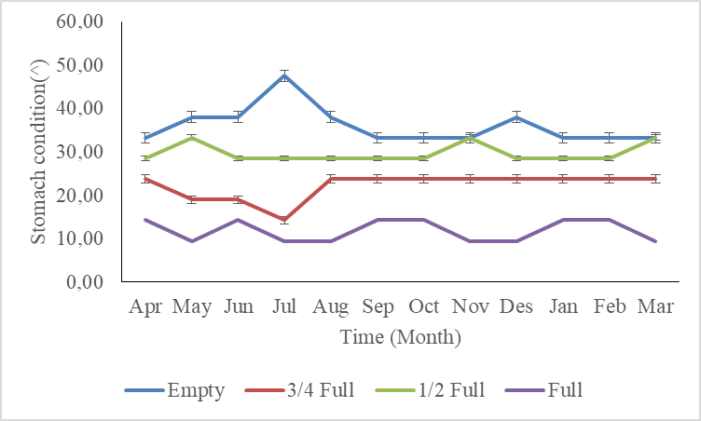

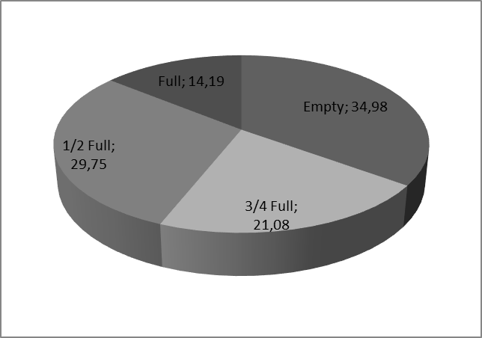

Figure 2. The amount of food found was based on the time of observation (top image) and the type of food found in the skipjack stomach (bottom image) in the Mamuju waters of the Makassar Strait.

[21] revealed that skipjack tuna is a generalist predator in all waters, consuming cephalopods and crustaceans as prey, especially in less productive waters during migration. The results of studies from several previous researchers show that the diet of skipjack tuna consists of fish, molluscs and crustaceans in very varying proportions at each research location. [22] found fish larvae, cephalopods and pelagic crustaceans, as common food for skipjack tuna. Skipjack tuna is classified as a mesopredator, forming pelagic ecosystems well and more widely [23].
[24] found that the composition of the stomach contents of skipjack tuna landed in Prigi, East Java was dominated by fish food at 63.78%. [25] found that the main food sources were anternfish (53%), krill (23%) and small pelagic fish (23%). Krill (Meganyctiphanes norvegica), flying fish (Exocoetus volitans), and anchovies (Engraulis encrasicolus) are the main prey of skipjack tuna in the Balearic Sea, Alboran Sea, and Gulf of Cadiz in the Mediterranean Sea [26]. Krill are the main prey of skipjack tuna on the coast of Baja California, while flying fish are important prey in offshore areas [27].
This study has a different result compared to the study conducted by [17]. Nakamura found that larger skipjack tuna eats more fish and fewer crustaceans. Skipjack tuna originated from coastal areas have eaten more coral-derived organisms than those that live offshore. In this study, the skipjack tuna samples were observed temporally based on time, while previous studies were spatially based on space and water depth.

The skipjack tuna tends to maintain their diet by always maintaining a balance of the types of food eaten (Figure 1). The skipjack tuna is more likely to maintain a balance between chepalopods and crustaceans. These findings indicate that these two types of food are a food menu that must always be available, hence, the quantity must always be maintained. The unidentified food based on the time of observation showed a decreasing trend from April to August. These findings suggest that at that time the food has been absorbed and entered the intestine. The increase and decrease in the amount of food in the stomach of skipjack tuna depend on the activity of fish movement, the level of competition and the number of herds, and the need for reproductive activities.

The level of stomach fullness reached 63,89% and the rest was empty, which is 36,11% on average because the food that has been eaten has been digested in the intestines so that when the fish is dissected, it is difficult to identify it. The speed of the skipjack fish digestion of the food eaten causes the volume of stomach contents to faster to empty. On the other hand, the high density and number of skipjack tuna in a school causes insufficient food availability to meet their needs so that many empty stomachs are still found.

Several research results that have been carried out at several locations have obtained varying results. The level of gastric fill in skipjack tuna may also be caused by feeding time. Differences in fishing time cause differences in the stomach volume of the fish caught. The predominance of high numbers of empty stomachs is predicted to be related to the fishing time which is carried out after sunset and is not the feeding time for skipjack tuna.

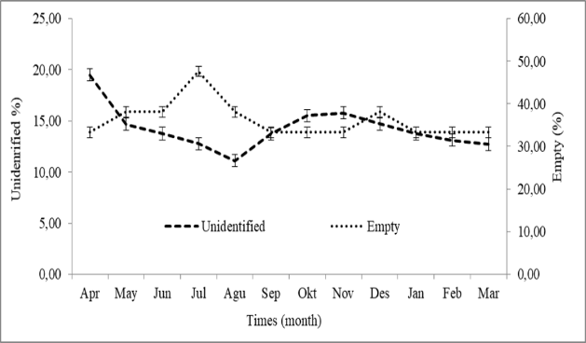

Figure 3. Condition of unidentified food and empty stomach of skipjack tuna

Figure 3 shows a trend that if the condition of unidentified food increases, the condition of the empty stomach decreases. Likewise, if the empty stomach condition increases accompanied by a decrease in the amount of unidentified food.

When the skipjack tuna's stomach is full, it is possible that the food in the stomach is in the early stages of digestion so it is easier to identify. Conversely, an empty stomach indicates that the food has been completely digested, making identification more difficult. This could be related to the ongoing and different levels of digestion because when the skipjack tuna's stomach is full, the food that has just been consumed has not yet had time to digest and break down completely so there are still pieces that may be identifiable. However, when the stomach is empty or almost empty, the food has been completely digested leaving little residue that can be recognized as an indication that digestion has been going on for a long time. On the other hand, if food is quickly digested and moved to the intestines, the stomach will empty more quickly leaving little that can be identified. However, a full stomach indicates that the digestive process is still ongoing so more food can be observed and identified.

CONCLUSIONS

None of the types of food found dominated and all of them had the status of complementary foods and stomach occupancy reached 63.89%. The diversity of food types found in the stomach of skipjack tuna is an indicator of food availability in the fishing area. Stomach fill depends on the availability of food in nature, the speed of digestion of food and the density of schools of skipjack tuna.
Disclaimer (Artificial intelligence)
Option 1:
Author(s) hereby declare that NO generative AI technologies such as Large Language Models (ChatGPT, COPILOT, etc.) and text-to-image generators have been used during the writing or editing of this manuscript.

REFERENCES

- Kantun W, Indra C, Arsana WS. Biological Aspect of Bullet Tuna Auxis rochei (Risso, 1810) in the Makassar Strait, West Sulawesi, Indonesia. Croatian Journal of Fisheries, 2019; 77 (3): 118-125. https://sciendo.com/article/10.2478/cjf-2019-0013
- Jamal M, Sondita FA, Haluan J, Wiryawan B. Utilization of Biological Data for Skipjack Skipjack Katsuwonus pelamis in the Context of Responsible Fisheries Management in Bone Bay Waters. Indonesian Nature Journal, 2011; 14:107-113. DOI:10.31258/jnat.14.1.107-113.
- Mallawa A, Amir F, Zainuddin M. Biological performance of the skipjack tuna Katsuwonus pelamis population caught by purse seine during the east season in Flores sea waters. Jurnal IPTEKS PSP 2014: 1 (2): 129-145. DOI: https://doi.org/10.20956/jipsp.v1i2.68
- Baso H. Biological study of the skipjack tuna Katsuwonus pelamis population in the Luwu waters of Bone Bay. Thesis, Hasanuddin University, 2013. Makassar 123 p.
- Agus NA. Study of several aspects of population dynamics and exploitation levels of skipjack tuna Katsuwonus pelamis in the waters of Barru Regency, South Sulawesi. 2012; 83 p.
- Fidyatul MT. Study of Several Population Dynamic Parameters of Skipjack Fish Katsuwonus pelamis in Bulukumba Waters, South Sulawesi. 2013. 53 p.
- Muchlisin ZA, Ramadhani I. Study of the stomach contents of skipjack tuna Katsuwonus pelamis and tuna (Auxis thazard). Natural Journal, 2004; 4(2): 20-23.
https://www.researchgate.net/publication/221875599
- Kantun W, Indra C, Arnold K, Riana AD. Stock assessment of skipjack tuna Katsuwonus pelamis in Makassar Strait, Indonesia. AACL Bioflux, 2021; 14 (2): 988-995. http://www.bioflux.com.ro/docs/2021.988-995.pdf
- Coletto JL, Botta S, Fischer LG, Newsome SD, Madureira LSP. Isotope-based inferences of skipjack tuna feeding ecology and movement in the southwestern Atlantic Ocean. Mar. Environ. Res. 2021; 165: 105246. [CrossRef] [PubMed]. DOI: 10.1016/j.marenvres.2020.105246 or https://pubmed.ncbi.nlm.nih.gov/33535137/
- Varela JL, Cañavate JP, Medina A, Mourente G. Inter-regional variation in feeding patterns of skipjack tuna (Katsuwonus pelamis) inferred from stomach content, stable isotope and fatty acid analyses. Mar. Environ. Res. 2019; 152: 104821. [CrossRef]. DOI: 10.1016/j.marenvres.2019.104821
- Biswas SP. Manual of methods in fish biology. South Asian Publisher Private Limitide., New Delhi. 1993.pp. 79-91. https://books.google.co.id/books/about/Manual_of_Methods_in_Fish_Biology.html?id=yRKPAAAACAAJ&redir_esc=y
- Nikolsky GV. The ecology of fishes. Translated by L.Birkett. Academic Press.1963. 352p
https://books.google.co.id/books/about/The_Ecology_of_Fishes.html?id=q7ACzgEACAAJ&redir_esc=y
- Bapal SV, Bal DV. Food of some young fishes from Bombay waters. Proceedings of Indian Academy Science. 1958; 35:78-92. DOI:10.1007/BF03050013 or https://www.ias.ac.in/public/Volumes/secb/035/02/0078-0092.pdf
- Rohit P, Rammohan K. Fishery and Biological Aspects of Yellowfin Tuna Thunnus albacares along Andhra Coast, India Asian Fisheries Science 2009; 22: 235-244. https://doi.org/10.33997/j.afs.2009.22.1.022
- Mardijah S. Analysis of the stomach contents of skipjack tuna Katsuwonus pelamis and yellowfin tuna (Thunnus albacares) landed in Bitung, North Sulawesi. J. Indonesian Fisheries Lit. 2008; 14 (2) : 227-235.
- Baidhowie, L. H., Redjeki, S., & Endrawati, H. Morphometry and Composition of Stomach Contents of Katsuwonus pelamis Landed at Puger Beach Jember East Java. Journal of Marine Research. 2019, 8(1), 69-74. https://ejournal3.undip.ac.id/index.php/jmr/article/view/24331
- Nakamura EL. Food and Feeding Habits of Skipjack Tuna (Katsuwonus pelamis) from the Marquesas and Tuamotu Islands. Journal Transactions of the American Fisheries Society. 2011; 94 (3): 236-242.
DOI: 10.1577/1548-8659(1965)94[236:fafhos]2.0.co;2
- Restianingsih and Amri K. Biological Aspects And Food Habits Of Skipjack Tuna (Katsuwonus pelamis) In Flores Seaand Adjacent Waters. Jurnal Bawal. 2018;10 (3): 187-196. https://www.researchgate.net/publication/332920825_BIOLOGICAL_ASPECTS_AND_FOOD_HABITS_OF_SKIPJACK_TUNA_Katsuwonus_pelamis_IN_FLORES_SEA_AND_ADJACENT_WATERS
- Wouthuyzen S, Peristiwady T, Manik N, Djoko S, Hukom FD. Food and Reproductive Aspects of Skipjack Fish Katsuwonus pelamis in the Banda Sea, A Comparative Study. Maluku Waters and Surrounding Areas, Center for Research and Development of Marine Resources, Research and Development Center for Oceanology, Indonesian Institute of Sciences, Ambon. 1990.
- Manik N. Some aspects of the biology of skipjack tuna (Katsuwonus pelamis) in the waters around South Seram Island and Nusa Laut Island. Journal of Oceanology and Indonesian Limnology, 2007; 33: 17 - 25.
- Chang YC, Chiang WC, Madigan DJ, Tsai FY, Chiang CL, Hsu, HH, Lin SM, Zhuang MY, Sun CT, Chen LC. Trophic Dynamics and Feeding Ecology of Skipjack Tuna (Katsuwonus pelamis) off Eastern and Western Taiwan. Molecules. 2022; 27: 1073. https://www.mdpi.com/1420-3049/27/3/1073
21. Tanabe T. Feeding Habits of Skipjack Tuna Katsuwonus pelamis and other Tuna Thunnus Spp. Juveniles in the Tropical Western Pacific. Fish. Sci. 2001; 67: 563–570. https://doi.org/10.1046/j.1444-2906.2001.00291.x
22. Baum JK, Worm B. Cascading Top-down Effects of Changing Oceanic Predator Abundances. J. Anim. Ecol. 2009; 78: 699-714. [CrossRef]. https://doi.org/10.1111/j.1365-2656.2009.01531.x
- Newsome TM, Greenville AC, ´Cirovi´D, Dickman CR, Johnson CN, Krofel M, Letnic M, Ripple WJ, Ritchie EG, Stoyanov S. Top Predators Constrain Mesopredator Distributions. Nat. Commun. 2017; 8:15469. [CrossRef]. https://www.nature.com/articles/ncomms15469
- Setya, A.Y,; Raden, A,; Sri, R. Morphometric conditions and composition of the stomach contents of skipjack tuna (Katsuwonus pelamis) landed in the Prigi area of ​​East Java. Journal of marine Reseach.. 2014. 3 (3): 226-332. http://ejournal-s1.undip.ac.id/index/php/jmr
- Coletto, J.L., Silvina, B., Luciano, G.F, Seth, D.N., Lauro, S.P.M. Isotope-based inferences of skipjack tuna feeding ecology and movement in the southwestern Atlantic Ocean. Marine Environmental Research. 2021. 165: 105246. https://sethnewsome.org/wp-content/uploads/2021/01/Coletto-et-al.-2021.pdf
- Varela, J.L., Ca˜navate, J.P, Medina, A., Mourente, G. Inter-regional variation in feeding patterns of skipjack tuna (Katsuwonus pelamis) inferred from stomach content, stable isotope and fatty acid analyses. Mar. Environ. Res. 2019. 152, 104821. https://doi.org/10.1016/j.marenvres.2019.104821
- Alatorre-Ramíres, V.G., et al. Trophic segregation of mixed schools of yellowfin tuna (Thunnus albacares) and skipjack tuna (Katsuwonus pelamis) caught in the eastern tropical Pacific Ocean. Fish. Bull. 2017. 115, 252–268. https://doi.org/10.7755/FB.115.2.11.

