Analysis of Coral Reef Community Structure and Coral Cover In Tanjung Seloka Village, Pulau Laut Selatan District, Kotabaru District, South Kalimantan Province, Indonesia

.
ABSTRACT
Involvement of local communities in conservation efforts is one of the keys to the success of preserving marine biological resources. This study aims to evaluate the structure of coral reef communities and the extent of coral cover in Tanjung Seloka Village, Pulau Laut Selatan District, Kotabaru Regency, South Kalimantan Province. The research was conducted in the coastal waters of Tanjung Seloka Village, examining bioecological parameters such as live coral cover and coral growth forms, physical parameters including temperature (Â°C), water clarity (m), and current velocity (m/s), as well as chemical parameters such as salinity (â€°), pH, and dissolved oxygen (DO). The Line Intercept Transect (LIT) method was employed to gather coral reef data. The findings revealed the presence of only two Acropora coral growth forms. The percentage of live coral cover ranged from 26.76% at Station 3 to 52.76% at Station 1. Coral reef conditions were classified between moderate and good. Most water quality parameters, including temperature, current speed, pH, and DO, remained within acceptable environmental standards. However, water clarity was below, and salinity was above, the quality thresholds set by the Minister of Environment Decree No. 51 of 2004.

Keywords: Coral Reef; Coral Cover; Tanjung Seloka Waters; Marine Ecosystem Health

1. INTRODUCTION

Tanjung Seloka Village, which is located in Pulau Laut Selatan District, Kotabaru Regency, South Kalimantan Province, has abundant marine resource potential, especially in the coral reef ecosystem. The community in this village is highly dependent on marine products as their main source of livelihood. Understanding the condition of the marine ecosystem as a whole to ensure sustainable use of resources and protect its existence from various threats (Coralwatch, 2011).
Coral reefs are a marine ecosystem that has very high biodiversity. In Indonesia, coral reefs provide important habitats for various species of fish and other marine organisms. Its ecological functions include protecting the coast from abrasion, supporting the fisheries sector, and playing an important role in supporting marine tourism (Hamner et al, 2007). The existence of coral reefs is increasingly under threat due to climate change, marine pollution, and environmentally unfriendly marine exploitation practices.
Research focused on identifying the types and structures of coral reef communities is needed, especially in areas with high marine ecosystem potential such as Tanjung Seloka Village. This study aims to identify the types of coral reefs and analyze their community structures as a basis for information in conservation efforts. Accurate data on the distribution and health conditions of coral reefs in the area.
The methods used in this study include Line Intercept Transect (LIT) and satellite image data processing using Landsat-8 imagery (Sarbini et al, 2016). This combined approach allows for a more comprehensive analysis of coral cover and community structure found on the seabed. The results of this method will strengthen the understanding of the dynamics of coral reef ecosystems, as well as become the basis for designing management policies based on scientific data (Oktarina et al, 2014).
In the context of coral reef conservation and rehabilitation technology, the use of Bioreef_Block has become one of the promising innovations. Bioree_Block technology is a modification of Bioreeftek which combines natural materials such as coconut shells with a hollow cubic concrete block structure. Function is as a medium for attaching coral planula larvae and a shelter for reef fish, thus supporting the natural and sustainable recovery process of coral reef ecosystems (Tony et al., 2021).
Previous research in Sungai Cuka Village, Kintap District, Tanah Laut Regency showed that the use of Bioreef_Block can gradually increase the diversity and abundance of reef fish. The physicochemical parameters of the water are mostly within the standard quality limits, although salinity tends to be low due to high rainfall. The increase in the uniformity index of coral fish communities after the installation of Bioreef_Block indicates that this technology is able to improve the condition of biotic communities in waters (Tony et al., 2021).
The LIT method successfully identified various forms of coral life, algae, other fauna, and abiotic components. Coral cover conditions ranging from moderate to good indicate that continuous monitoring is necessary to ensure the sustainability of marine ecosystems (Tony et al., 2025). This research is expected to make a real contribution to the development of marine and fisheries science, as well as support sustainable conservation measures in Kotabaru Regency.
The results of this study are expected to increase local community awareness of the importance of preserving coral reef ecosystems. This is because the involvement of local communities in conservation efforts is one of the keys to the success of preserving marine biological resources. The research aims to analyze the structure of coral reef communities and coral cover in Tanjung Seloka Village, Pulau Laut Selatan District, Kotabaru Regency, South Kalimantan Province.

2. material and methods

The study was conducted in the waters near Tanjung Seloka village, located in the Pulau Laut Selatan District of Kotabaru Regency, South Kalimantan Province. You can find the observation point in Figure 1 below:.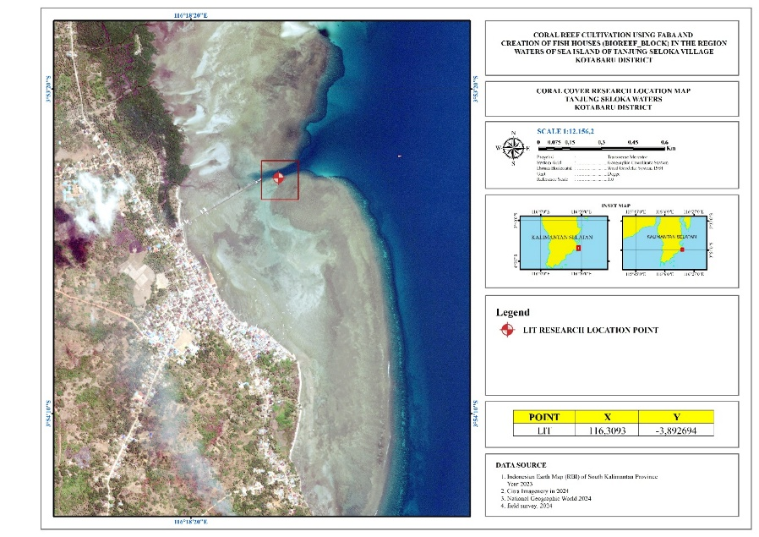
Figure 1. Map of research location

The environmental parameters assessed in this study encompassed bioecological components, such as live coral cover and coral lifeforms; physical factors, including temperature (°C), water clarity (m), and current velocity (m/s); and chemical factors, namely salinity (‰), pH, and dissolved oxygen (DO).
Coral reef data were collected using the Line Intercept Transect (LIT) technique, as described by English et al. (1994). This method is employed to estimate the coverage of corals and associated benthic communities inhabiting the reef ecosystem.
Table 1. Lifeform categories and codes for the LIT method (English et. al., 1994)
Lifeform |  | Code
Hard Coral (Acropora) | Digitate | ACD
Hard Coral (Acropora) | Branching | ACB
Hard Coral (Acropora) | Tabulate | ACT
Hard Coral (Acropora) | Encrusting | ACE
Hard Coral (Acropora) | Sub Massive | ACS
Hard Coral (Non Acropora) | Branching | CB
Hard Coral (Non Acropora) | Massive | CM
Hard Coral (Non Acropora) | Encrusting | CE
Hard Coral (Non Acropora) | Sub Massive | CS
Hard Coral (Non Acropora) | Foliose | CF
Hard Coral (Non Acropora) | Mushroom | CMR
Hard Coral (Non Acropora) | Meliopora | CME
Hard Coral (Non Acropora) | Heliopora | CHL
Dead Scleractinia | Dead coral | DC
Dead Scleractinia | DC with algae | DCA
Algae | Macro | MA
Algae | Turf | TA
Algae | Corralline | CA
Algae | Halimidae | HA
Algae | Alga Assemblage | AA
Other Fauna | Soft Coral | SC
Other Fauna | Spoonge | SP
Other Fauna | Zoanthids | ZO
Other Fauna | Others | OT
Abiotic | Sand | S
Abiotic | Rubble | R
Abiotic | Silt | SI
Abiotic | Water | WA
Abiotic | Rock | RCK

3. results and discussion

3.1 Results
Types and Conditions of Coral Reef Cover
The findings indicate the presence of two types of Acropora coral lifeforms in the waters of Sei Village, namely Acropora branching (ACB) and Acropora tabulate (ACT). Additionally, six types of non-Acropora corals were identified: Coral branching (CB), Coral massive (CM), Coral encrusting (CE), Coral foliose (CF), Coral mushroom (CMR), and Coral heliopora (CHL). The live coral cover percentage varied between 26.76% at Station 3 and 52.76% at Station 1. Based on these results, the coral reef condition in the waters surrounding Tanjung Seloka Village, Pulau Laut Selatan District, Kotabaru Regency, is categorized as ranging from moderate to good. The detailed percentages of live coral cover are presented in Table 2.

Table. 2. Percentage of live coral cover in the waters of Tanjung Seloka village
Station | 1 | 2 | 3
Percentage (%) | 52,76 | 36,23 | 26,76

Station 1, the hard coral (Acropora) cover consisted of Coral Branching (ACB) at 8.78% and Coral Tabulate (ACT) at 10.26%, contributing to a combined coverage of 19.04%. Meanwhile, the coverage of hard corals (Non-Acropora) included Coral Branching (CB) at 4.26%, Coral Massive (CM) at 22.4%, Coral Encrusting (CE) at 1.26%, Coral Foliose (CF) at 0.78%, Coral Mushroom (CMR) at 2.26%, and Coral Heliopora (CHL) at 2.76%, resulting in a total non-Acropora coral cover of 33.27%. The distribution of coral cover at Station 1 is illustrated in Figure 2.

Figure 2. Percentage of Coral Cover Station 1
The lifeform coverage at Station 1 is composed of Acropora Branching Tabulate, Branching, Massive, Encrusting, Foliose, Mushroom, Heliopora, Dead Coral with Algae (DC with Algae), Sponges, other associated fauna, as well as Sand and Rubble.
The percentage of station I lifeform cover in Figure 3 is as follows:

Figure 3. Percentage of Lifeform Coverage at Station 1
Station 2, the hard coral (Acropora) cover consisted of Coral Branching (ACB) at 8.26% and Coral Tabulate (ACT) at 2.8%, resulting in a combined Acropora cover of 11.06%. For the hard corals (Non-Acropora), the coverage included Coral Branching (CB) at 9.02%, Coral Massive (CM) at 2.92%, Coral Encrusting (CE) at 5.06%, Coral Foliose (CF) at 7.78%, and Coral Mushroom (CMR) at 0.48%, giving a total non-Acropora cover of 25.26%. The detailed coral cover percentage at Station 2 is presented in Figure 4.

Figure 4. Percentage of Coral Cover Station 2
Station 2, a total of 15 lifeform types were identified, including Tabulate, Branching, Massive, Encrusting, Foliose, Dead Coral with Algae (DC with Algae), Halimidae, Sponges, and Sand. In contrast, only five types were observed along Transect 2, namely Foliose, Dead Coral with Algae, Halimidae, Sponges, and Sand. The distribution of lifeform coverage across Transects 1 and 2 at Station 2 is illustrated in Figure 5.

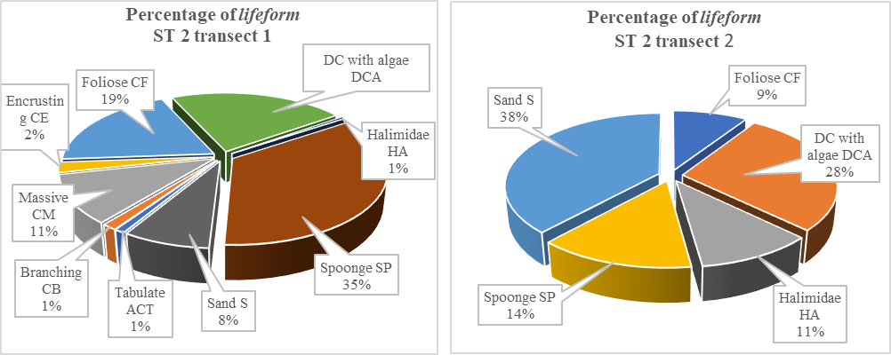
Figure 5. Percentage of Lifeform Cover Station 2 transects 1 and 2
Station 3, neither Transect 1 nor Transect 2 recorded the presence of hard coral (Acropora) cover. However, Non-Acropora hard corals were identified only on Transect 1, specifically the Massive and Foliose types, with a combined cover of 14.14%. The coral cover percentage at Station 3 is depicted in Figure 6.

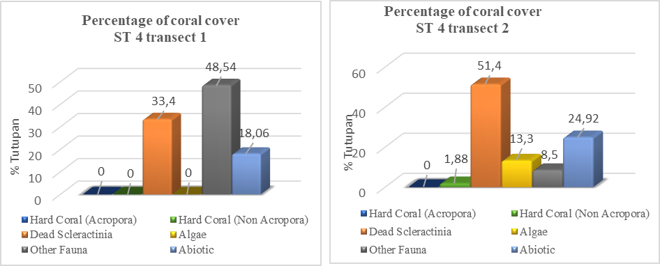
Figure 6. Percentage of Coral Cover Station 4 transects 1 and 2.
Station 4, transect 1 revealed 4 types of lifeform cover: DC with Algae, Sponge, Others, and Sand. Meanwhile, transect 2 at the same station displayed 6 types, including Encrusting, DC with Algae, Halimidae, Sponge, Others, and Sand. The percentage of lifeform cover for both transects at Station 4 is shown in Figure 7 below.
:

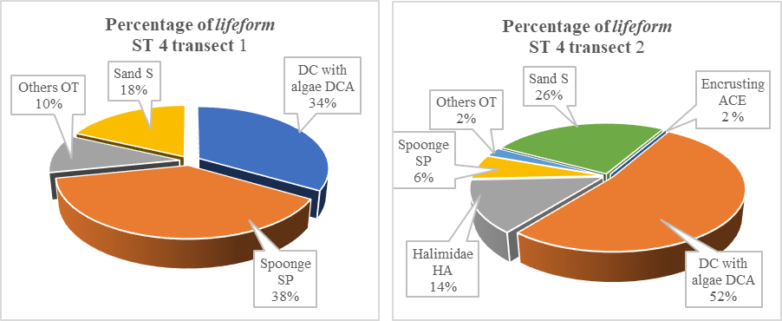
Figure 7. Percentage of lifeform cover for Station 4 transects 1 and 2
Table 3. Coral Reef Assessment Criteria according to Minister of Environment Decree No. 4 of 2011
Category | Live Coral Cover (%)
Very Good | 75 – 100
Good | 50 – 74,9
Average | 25 – 49,9
Bad | 0 – 24,9

Water quality parameter
The research findings on water quality parameters, including the physical and chemical factors of sea waters in Tanjung Seloka Village, South Island Island District, Kotabaru Regency, are presented in Table 4 below:

Table 4. Water quality parameter measurement results.
Parameter |  | Station |  |  | Minister of Environment Decree No. 51 of 2004
 |  | 1 | 2 | 3 | Minister of Environment Decree No. 51 of 2004
Pickup Time |  | 17.04 | 17.18 | 17.34 | Minister of Environment Decree No. 51 of 2004
Physical Factors | Temperature (°C) | 29,3 | 28 | 28,2 | 28 -30 °C
Physical Factors | Brightness (m) | 5,2 | 5,3 | 5,2 | > 5
Physical Factors | Current (m/s) | 0,04 | 0,06 | 0,08
Chemical Factors | Salinity (‰) | 31.5 | 30,4 | 30,8 | 33 - 34
Chemical Factors | pH | 7.77 | 7,94 | 7,76 | 7 - 8,5
Chemical Factors | DO (mg/l) | 6,6 | 7,1 | 6,4 | > 5

3.2 Discussion

The research findings can be summarized by concluding that the coral reefs in the waters of Tanjung Seloka Village, Pulau Laut Selatan District, Kotabaru Regency, are classified as fringing coral reefs. These reefs are located along the coast, with a depth of less than 8 meters towards the open sea, consistent with Nybakken's (2000) definition of fringing reefs, which are coral reefs found along the shore and extend no more than 40 meters deep.
At the research site, the coral reef flats are generally sloping, with coral growth rarely found beyond 8 meters in depth due to the dominance of a sandy-mud substrate. In the waters of Tanjung Seloka Village, the live coral cover is at 46.38%, indicating a moderate condition. Coral species found include both Massive and Encrusting corals.
The presence of hard coral cover, which serves as an indicator of coral reef health, is low across the stations, suggesting that the coral reefs are in a damaged state. Soft corals dominate the reefs, with hard corals primarily from the Massive group, and the growth of Halimeda algae is notable. Additionally, sponge species, along with other reef-associated organisms, are frequently observed, making up to 71% of the coverage. According to Iskandar et al. (2020), algae presence can compete with corals, hindering their survival. In comparison, the coral cover quality in the Kotabaru area is better than that of Sungai Cuka Village waters, Kintap District, Tanah Laut Regency, where coral conditions range from damaged to moderate (Tony et al., 2021). Thus, the coral reef ecosystem in Tanjung Seloka Village is characterized as a fringing reef or edge reef type.
The low coral cover in the research area is influenced by water quality factors, including salinity, which exceeds the quality standard threshold set by the Minister of Environment Decree No. 51 of 2004, with a recommended salinity tolerance range of 33-34‰. During data collection, the salinity at all stations ranged between 35-40‰. Meanwhile, parameters such as temperature, pH, and dissolved oxygen (DO) were within the standard tolerance limits. Water brightness also significantly impacts coral growth.
Sedimentation caused by human activities, such as mining, coastal construction, deforestation, and agriculture, leads to soil erosion that is carried into the sea. The research site is located at the mouth of the Cuka River in Tanjung Seloka Village, Pulau Laut Selatan District, Kotabaru Regency, where water turbidity levels are high. This turbidity threatens the life of the coral reefs as it causes the water to become murky. The brightness measurement at the research site was between 3 to 3.5 meters, with only Station 3 showing a brightness of 5.2 meters. Lower water brightness levels are detrimental to coral growth.
The average current speed in the research area is 0.07 m/s, with the highest value recorded at Station 3, reaching 0.10 m/s (as shown in Table 5). This current speed is higher than the 0.01 - 0.05 m/s range reported in the coastal waters of Angsana, Tanah Bumbu Regency, with an average of 0.03 m/s (Rina & Tony, 2013). Currents are important for coral growth, as they bring in food in the form of plankton and oxygen and assist in cleaning materials that accumulate on coral polyps (Dahuri, 2003). Moderate currents provide better conditions for coral, preventing damage while helping to clean the coral surfaces and reduce sedimentation. This also influences the coral growth and health, as seen in the Kima coral area in Bunati village, Tanah Bumbu, where coral cover is classified as moderate to good (Jainuddin, 2015). In contrast, the research site is categorized as damaged to moderate.

The presence of algae on coral reefs is a poor indicator of reef health. Algae growth, often due to pollution, can harm the coral as excessive algae outcompetes it for space. At all stations, Halimidae algae were found. The dominance of soft corals and algae further competes with hard corals for space, inhibiting the recruitment process of new coral by preventing larvae attachment and the development of coral saplings (Loya et al., 2004). Both hard and soft corals are important benthic communities on the reef, and their competition for space is influenced by factors such as nutrient levels, wave strength, and water temperature (Rustam et al., 2016). The high dominance of soft corals in the research area suggests an environment that favors algae growth, which can negatively affect coral recruitment and development.

4. Conclusion

The coral reef ecosystem in the waters of Tanjung Seloka Village, Pulau Laut Selatan District, Kotabaru Regency, was found to contain only two types of Acropora coral lifeforms. The live coral cover ranged from 26.76% at Station 3 to 52.76% at Station 1. The overall condition of the coral reefs in this area is classified as ranging from moderate to good. The water quality parameters measured, including temperature, brightness, current speed, salinity, pH, and dissolved oxygen (DO), remained within the tolerance limits of water quality standards. However, brightness levels were below the standard threshold, and salinity exceeded the standard threshold set by the Minister of Environment Decree No. 51 of 2004.

5. AcknowledgEments

The author expresses his deepest gratitude to PT PLN (Persero) East Kalimantan Main Development Unit for the support and facilitation provided in carrying out this research. Thanks are also expressed to the Indonesian Subaquatic Sport Association (POSSI) South Kalimantan, the Dean of the Faculty of Agriculture, Universitas Ahmad Yani, Banjarmasin, and the Dean of the Faculty of Fisheries and Marine Sciences, Universitas Lambung Mangkurat for their significant institutional support. High appreciation and appreciation was also given to the Village Head and the entire Tanjung Seloka Village community for their cooperation, contribution and warm welcome during the activity. Thank you to all those who have helped, either directly or indirectly, so that this activity can run smoothly and achieve the expected results. Hopefully all these efforts can provide sustainable benefits for society and environmental sustainability.

Disclaimer (Artificial intelligence)

Author(s) hereby declare that NO generative AI technologies such as Large Language Models (ChatGPT, COPILOT, etc.) and text-to-image generators have been used during the writing or editing of this manuscript.

References

Coralwatch. 2011. Coral Reefs and Climate Change. A Guide to Education and Awareness Building. The University of Queensland. Australia, 272 pages.
Dahuri, R. 2003. Marine Biodiversity Sustainable Development of Indonesia. Jakarta: Gramedia Pustaka Utama
English S., C. Wilkinson & V. Baker, 1997. Survey Manual for Tropical Marine Resources, 2nd Edition. (Townsville: Australian Institute of Marine Science).
English, S., Wilkinson, C., Baker, V,. 1994. Survey Manual For Tropical Marine Resources. ASEAN – Australia Marine Science Project Living CoastalResources. Australia.
Hamner PP. 2007. Export-import dynamics of zooplankton on a coral reef in Palau. Mar Ecol Prog Ser 334: 83-92.
Iskandar, R., Soemarno, Kusuma, Z., Wiadnya, D, G, R. 2020., Association between Coral Community Coverage with Coral Reef Fish Communities at Samber Gelap Island, South Kalimantan, Indonesia., Egyptian Journal of Aquatic Biology & Fisheries Zoology Department, Faculty of Science, Ain Shams University, Cairo, Egypt. ISSN 1110 – 6131 Vol. 25(3): 861 – 881 (2021)
Iskandar, R., Tony. F., 2013. Sedimentation Study at the Angsana River Estuary, Angsana District, Tanah Bumbu Regency, South Kalimantan, Enviro Scienteae 9 (2013) 106-111, ISSN 1978-8096.
Loya Y, Lubinevsk H, Rosenfeld M, Kramarsky-Winter E. 2004. Nutrient enrichment caused by in situ fish farms at Eilat, Red Sea is detrimental to coral reproduction. Mar Pollut Bull. 49(4):344–353.
Nybakken, J.W. 2000. Marine Biology: An Ecological Approach. PT. Gramedia. Jakarta
Oktarina, A., E. Kamal and Soeparno. 2014. Study of Coral Reef Condition and Management Strategy in Panjang Island, Air Bangis, West Pasaman Regency. Postgraduate Program, Bung Hatta University.
Rustam A, Yulius A, Heriati, Salim HL, Ramdhan M. 2016. Study of water quality in Central Lombok waters as a regional marine conservation area. Taslim Arifin et al (eds). Anthology: Coastal Resources Science and Technology for the Development of Blue Economy in Lombok Island. IPB Press. Bogor.
Sarbini, R., Kuslani, H., Nugraha, Y. 2016. Coral Reef Cover Observation Technique Using Line Intercept Transect on Kumbang Island, Karimun Jawa Islands. Litkayasa Engineering Bulletin, 14(1): 33-42.
Tony F., Iskandar Rina., Rifa’I M. Ahsin., Khasanah R. I. 2021., Effectiveness of Bioreef_Block Technology on Reef Fish Diversity In Marine Waters Of Sungai Cuka Village At Kintap District, Tanah Laut Regency of South Kalimantan, Indonesia. DOI 10.18551/rjoas.2021-07.24
Tony, F., Bijaksana, U., Fitriliyani, I., Mahmud, A., Widiyanto, D., Hutomo, M., & Iskandar, R. (2025). Coral reef coverage in the 17 Islands Marine Natural Tourism Park, Riung District, Ngada Regency, East Nusa Tenggara Province. International Journal of Research and Reviews, 12(2):89-101

