**Evaluation of Glucosamine hydrochloride from biowaste of** ***Macrobrachium rosenbergii* and *Penaeus monodon*, different ponds of Andhra Pradesh, India**

**ABSTRACT**

A variety of goods made from the skeletons of crustaceans have both biomedical and pharmacological abilities. As an amino monosaccharide that serves as a substrate for the synthesis of aggrecan and proteoglycans, glucosamine has therapeutic potential for osteoarthritis. The goal of the current work is to produce glucosamine hydrochloride (Glu-HCl) by acid hydrolysis from a variety of crustacean shells, specifically *Macrobrachium rosenbergii* and *Penaeus monodon* (tiger shrimp), and then quantify the result using reversed phase high performance liquid chromatography (RP-HPLC). The fiber found in crab, lobster, shrimp, and prawns is called chitin. Chitosan, a naturally occurring biopolymer, was created by deacetylating chitin, one of the main structural components that make up the exoskeleton of crustaceans. Chitosan is a linear polymer of a (1–4)-linked 2-amino 2-deoxy b-D glucopyranose. Shell trash is produced in large quantities by the aqua industry and is typically dumped, causing significant environmental nuisance. Glucosamine hydrochloride, chitin, and chitosan can all be obtained commercially from such waste. In this study, the yield % of the tiger shrimp (*Penaeus monodon*) and freshwater prawn (*Macrobrachium rosenbergii*) is being assessed. In comparison to *P. monodon*, *M. rosenbergii* was a superior producer. The recycling of crustacean waste into a product with added value is also covered in this study.

**Key Words:** Glucosamine hydrochloride, Chitin, Chitosan, *M. rosenbergii* and *P. monodon*.

**Introduction:**

The socioeconomic development of our nation is greatly influenced by the shrimp industrial sector, and shells are frequently thrown away as garbage. A cationic amino-polysaccharide, chitin is composed of N-acetyl-D-glucosamine residues that are connected by β (1-4). Crustaceans, mollusks, diatoms, insects, and fungus are among the species whose exoskeletons contain it [1]. Between 60,000 and 80,000 tonnes of chitinous waste are produced each year in India alone; a significant amount of chitin can be extracted from crustacean bio-waste [2, 3]. Numerous industries, including nanotechnology, pharmaceuticals, tissue engineering, genetic engineering, and the food industry, have found use for chitosan [3]. Because of their antibacterial qualities, coagulation, non-toxicity, biodegradability and biocompatibility in both plant and animal tissue [4, 5].

Gels, beads, colloids, films, and capsules can all be made from chitosan [6]. They can be used for everything from mechanical support to diet. But because they are thought to be non-biodegradable and take years to return to nature, they have also caused issues with disposal. In other words, they take up a lot of room and constitute a significant problem as environmental contamination raises the need for biopolymers, which have the qualities of being non-toxic, biocompatible, and biodegradable [7]. Nearly 40–50% of the weight of raw shrimp is produced as shrimp biowaste during processing by the shrimp industry [8, 9]. Shrimp trash is produced by these activities, and this solid waste is a problem for the environment [10].

A white to light-red solid powder, chitosan is derived from chitin and is insoluble in water and organic acids yet indigestible by human digestive enzymes [11]. Commercial interest in chitin and its derivative chitosan stems from their superior adsorption, chelating, biodegradability, and non-toxicity. Chitosan, in particular, has a lot of appealing uses in biotechnology, the food and pharmaceutical industries, cosmetics, environmental engineering, agriculture, and aquaculture because of these qualities [12]. In light of the importance and uses of chitosan, the current study aims to compare the yield percentage of glucosamine hydrochloride and quality characteristics of freshwater prawns *Macrobrachium rosenbergii* and marine shrimp *Penaeus monodon*.

**Materials and Methods**

Freshwater prawn bio-waste while the bio-waste of marine shrimp, *Penaeus monodon*, was obtained from shrimp culture ponds at Bapatla District, Andhra Pradesh, *Macrobrachium rosenbergii* was taken from freshwater culture ponds (Fig. 1 & 2). The two samples' moist weights were recorded after the bio-waste (carapace, exoskeleton, appendages, etc.) was removed. Before shipping for additional processing, the shell material was homogenized in a lab mixer and allowed to dry in an oven set at 500C for 24 hours. Weighing both dried shell samples after they had been dried allowed us to calculate their yield. Until they were needed, the collected shell samples were kept in the storage facility at roughly 250C. Biowaste is treated with 4% alkali to separate the protein and 4% acid to remove calcium carbonate. Concentrated 50% alkali can further deacetylate the resultant chitin product to prepare chitosan.

**Deproteinization:** 10 g of shell powder was dissolved in 300 ml of 2mol/dm3 H2SO4 solution at a ratio of 1:30 using crushed biowaste samples. Distilled water was used to wash the sample until the pH was neutral. The sample was demineralized and then dissolved in 300 milliliters of a 2 mol/dm3 NaOH solution to deproteinize it. After being stored for four hours once again, the material was cleaned until its pH was neutral [13].

**Deacetylation:** To perform the deacetylation procedure, 55% NaOH is added, and the mixture is then cooked on a hot plate for two hours at 1000C. After that, the samples are put under the hood and allowed to cool to ambient temperature for thirty minutes. In order to preserve the solid material, which is the chitosan, the samples are then continually cleaned with 50% NaOH and filtered. After being left exposed, the samples were oven-dried for six hours at 1100C. Following cooling, the sample was filtered to extract chitosan and rinsed with 55% NaOH [13, 14].

**Percentage of Yield**

Based on the weight of the shell bio-waste, the percentage of chitin and chitosan yield was determined [15].

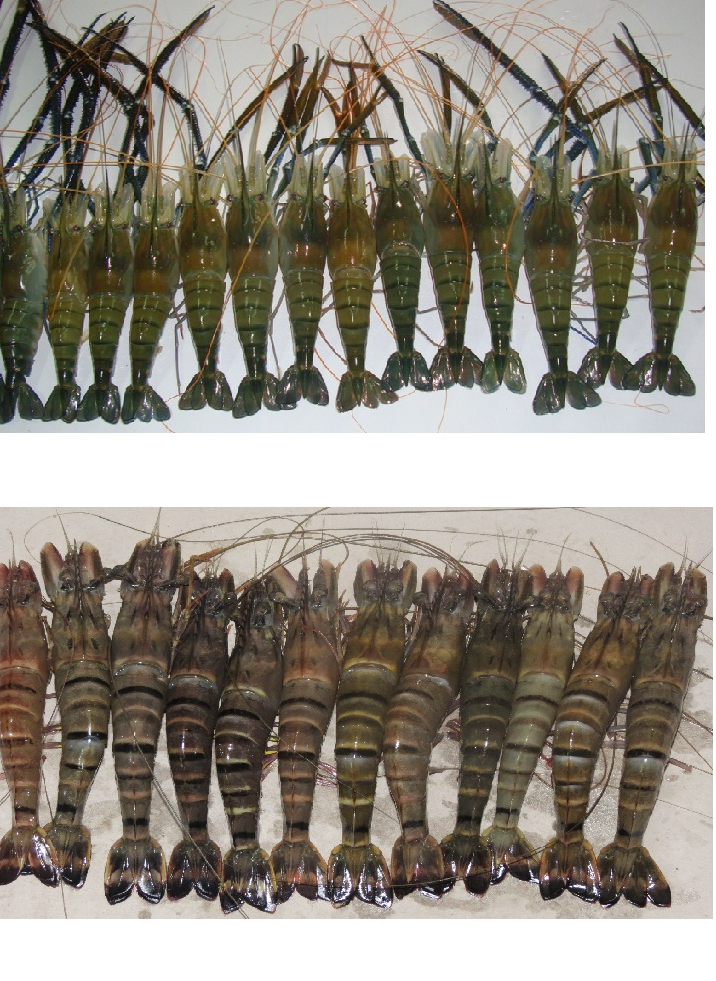

**Fig: 1. *Macrobrachium rosenbergii***



**Fig: 2. *Penaeus monodon***

**Preparation of Glucosamine HCL:**

The chitosan was hydrolyzed with concentrated Hydrochloric Acid (HCL) at 90°C for 75 minutes after being coarsely ground. After dissolving the resulting brownish black substance in distilled water, activated charcoal was used to remove the color. To recover glucosamine hydrochloride (Glu-HCL), the solution was filtered, and the filtrate was then evaporated at 45°C. After being cleaned with ethanol and dried in a hot air oven at 500 degrees Celsius, the crystals were subjected to high performance liquid chromatography analysis.

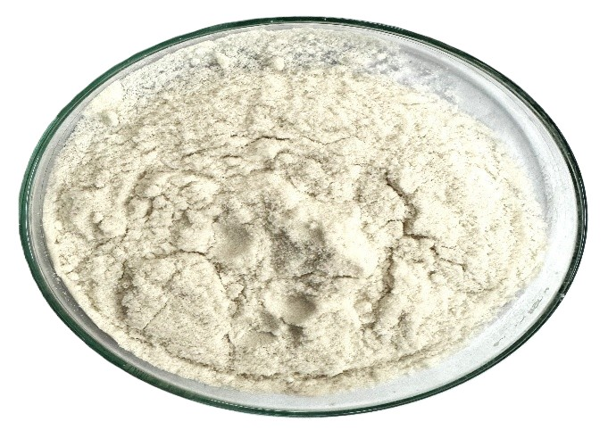

**Fig: 3. Glucosamine Hydrochloride**

**Results and Discussion:**

Crustacean and other arthropod shells are made of chitosan and chitin, both of which include glucosamine. A monosaccharide of critical physiological importance in the human body, β-linked D-glucosamine, is produced when chitin/chitosan is hydrolyzed. Table No. 1 shows the bio-waste yield from the freshwater prawn *Macrobrachium rosenbergii* and shrimp *Penaeus monodon*. The yield of glucosamine hydrochloride, which is the result of the current study (Fig.4). 580g of biowaste, 60.9 percent chitin and 40.2 percent chitosan, and 11.2 percent glucosamine hydrochloride were all created from one kilogram of prawn *Macrobrachium rosenbergii* sample used in this test. The *Penaeus monodon* produced 439g of biowaste, 49.6 percent of chitin & 35.5 percent of chitosan and finally 9.9 % of Glucosamine hydrochloride.

**Table - 1: The hydrolysis of chitosan results in monomers of yield of bio-waste from experimental organisms**

|  |  |  |
| --- | --- | --- |
| **Experimental Species** | **Bio-waste (g)** | **Total sample weight (g)** |
| *Macrobrachium rosenbergii* | 580 | 1000 |
| *Penaeus monodon* | 439 | 1000 |

**Fig: 4. Yield of Crude bio-waste, Chitin and Chitosan and Glucosamine hydrochloride from the *M. rosenbergii* and *P. monodon***

The shells of the crustaceans are cleaned, dried and ground into powder. Chitosan is obtained from chitin which is the primary structural polymer [16, 17]. The production of chitin from crab shells may range from 60% to 70% [18]. A higher yield, or 78%, from mud crabs was noted by Ali *et al.,* [19]. Chitosan's economic importance has increased recently because to the advantageous qualities of its soluble derivatives, which can be used in food processing facilities, cosmetics, and medicine to suppress tumor growth and cell viability [20, 21]. According to Diya *et al.,* [22] shrimp shells yield 30-36.7% chitosan. The source and isolation process of chitin determine the quality of chitosan, and chitosan with varying degrees of deacetylation is being marketed. Chitosan's uses are determined by its properties and molecular weight. Utilization of such shell wastes production of some useful products such as chitin and chitosan [23] and chemical treatment in anticancer and antitumor activity [24, 25]. Krishna *et al.,* [26] investigated the chitosan yield percentage and quality parameters in *M. rosenbergii*, *P. monodon* and *L. vennamei*. Applications of Chitosan in pharmaceutical fields are: Diluents in direct compression of tablets, binder in wet granulation, slow-release of drugs from tablets and granules, drug carrier in micro particle systems, films controlling drug release, preparation of hydrogels, agent for increasing viscosity in solutions, wetting agent, and improvement of dissolution of poorly soluble drug substances, biodegradable polymer (implants, micro particles) Carrier in relation to vaccine delivery or gene therapy.

Fabrics, gauzes, dialysis membranes, antiviral and antifungal medicines, and wound dressings are among the items made with chitin and chitosan [27]. Because it inhibits the growth of bacteria, chitosan aids in the healing process and protects wounds against bacterial invasion. It might work just as well against microbes that cause typhoid [28]. The degree of deacetylation is one quality measure that indicates an acetyl group that can be eliminated from the chitosan yield. A number of other factors impact the quality of chitosan. In the present study the *M. rosenbergii* produced 11.2% and *P. monodon* produced 9.9% of Glucosamine Hydrochloride (Fig.3) from 1kg of shell waste.

Elwakeel *et al.,* [29] reported that the bivalve shells are a promising sorbent for the efficient treatment of wastewater from textile industry. El-Qelish *et al.,* [30] studied that the potential of engineered composite (CABC) derived from coastal biowaste-based materials for tetracycline (TC) removal and biomethane production. Muath *et al.,* [31] stated that the ChiCu(OH)2 and ChiCuO sorbents are efficient adsorbents for practical applications in water/wastewater treatments. Further, stated that the Cu(OH)2 and CuO modified chitosan sorbents were synthesized via the copreciptiation method and the adsorptive removal of Cr(VI) oxyanions from aqueous medium. Alghamdi *et al.,* [32] stated a novel solution that tackles two pressing environmental issues: water purification and sustainable bioenergy generation and they developed an affordable and eco- friendly biocomposite from agal shells, referred to as CAL-GRABC, to remove phosphates from water and facilitate biogas production,

Rossi *et al.,* [33] stated that shrimp wastes are promising avenue for sustainable resource utilization and the extraction of valuable bioactive compounds. Jafari *et al.,* [34] reported that the glucosamine hydrochloride could exert beneficial effects to the treatment of diseases related to the inflammation oxidative damage. Hamdan *et al.,* [35] stated that shrimp waste to provide added bio-compounds offers environmental and therapeutic benefits. Elwakeel *et al.,* [36] reported that a comprehensive examination of chitosan, GMA, and their hybrids and Nano-composites as adsorbents, focusing on their availability, stability, sorption capacity, and durability.

**CONCLUSION**

This study shows the production of glucosamine from crustacean shells thereby recycling crustacean wastes. It was found as simple, efficient and suitable for the preparation Glucosamine is an amino-monosaccharide acting as substrate for the production have therapeutic activities. Chitin and chitosan from *M. rosenbergii* and *P. monodon* shell waste, would successfully reduce the environmental pollution.

**Disclaimer (Artificial intelligence)**

Option 1:

Author(s) hereby declare that NO generative AI technologies such as Large Language Models (ChatGPT, COPILOT, etc) and text-to-image generators have been used during writing or editing of manuscripts.

Option 2:

Author(s) hereby declare that generative AI technologies such as Large Language Models, etc have been used during writing or editing of manuscripts. This explanation will include the name, version, model, and source of the generative AI technology and as well as all input prompts provided to the generative AI technology

Details of the AI usage are given below:

1.

2.

3.

**References:**

1. No HK, Meyers SP. (1989). Crawfish chitosan as a coagulant in recovery of organic compounds from seafood processing streams. J Agric Food Chem 37(3):580–583.
2. Suresh P.V., and Chandrasekaran M. (1998). Utilization of prawn waste for chitinase production by the marine fungus *Beauveria bassiana* by solid state fermentation, *World J. Microb. Biotechnol.* 14: 655–660.
3. Panchakshari, V. K. Srikanth, P.V. Krishna and Ch. Suresh Babu. (2016). “*Extraction of Chitin and Chitosan from Biowaste of Scampi Macrobrichum rosenbergii and Tiger Shrimp Penaeus monodon”. Int. J. Curr .Microbiol .App .Sci,* 5(7): 751-758.
4. Thakur VK and Thakur MK. (2014). Recent advances in graft copolymerization and applications of chitosan: a review. *ACS Sustain. Chem. and Eng*., 2(12), 2637-2652.
5. Vakili M, Rafatullah M, Salamatinia B, Abdullah AZ, Ibrahim MH, Tan KB and Amouzgar P (2014). Application of chitosan and its derivatives as adsorbents for dye removal from water and wastewater: A review. *Carbohyd. Polym*., 113: 115-130.
6. Sakthivel D, Vijayakumar N and Anandan V (2015). Extraction of chitin and chitosan from Mangrove crab (*Sesarma plicatum*) from Thengaithittu Estuary Pondicherry Southeast Coast of India. *Hum. J*., 4 (1): 12-24.
7. Jayakumar R, Prabaharan M, Sudheesh Kumar PT, Nair SV, Tamura H. (2011). Biomaterials based on chitin and chitosan in wound dressing applications. Biotechnol. Adv. 29: 322–337.
8. Karthik, R.; Manigandan, V.; Saravanan, R.; Rajesh, R. P.; Chandrika, B. (2016). Structural characterization and in vitro biomedical activities of sulfated chitosan from Sepia pharaonis. Int. J. Biol. Macromol. 84, 319−328.
9. Xu Y., C. Gallert and J. Winter, (2008). “Chitin purification from shrimp wastes by microbial deproteination and decalcification”, Applied Microbiology and Biotechnology, 79(4): 687-697.
10. Kandra, P., M.M. Challa and H.K. Jyothi. (2012). “Efficient use of shrimp waste: present and future trends. Applied Microbiology and Biotechnology, 93(1): 17-29.
11. Varma R and Vasudevan S. (2020). Extraction, Characterization, and Antimicrobial Activity of Chitosan from Horse Mussel Modiolus modiolus. ACS Omega, 5, 20224−20230.
12. Tahami, M. (1994). Synthesis of chitosan and Glucosamine from crustaceans wastes (Shrimp, Crab, Lobster)”, Iranian Fisheries Journal, 3: 5-15.
13. Paul S, Jayan A, Sasikumar CS and Cherian SM. (2014). Extraction and purification of chitosan from sea prawn (*Fenneropenaeus indicus*). *Asian J. Pharm. Clin. Res*., 7(4): 201-204.
14. Burrows. F, Louime. C, Abazinge. M, Onokpise. O (2007). Extraction and Evaluation of Chitosan from Crab Exoskeleton as a Seed Fungicide and Plant Growth Enhancer. American-Eurasian J. Agric. & Environ. Sci., 2 (2): 103-111.
15. Zaku S.G., Emmanuel S.A., Aguzue O.C., Thomas S.A. (2011). Extraction and characterization of chitin; a functional biopolymer obtained from scales of common carp fish (Cyprinus carpio1): A lesser known source, African Journal of food science, Vol.5 (8), pp. 478-483.
16. Knaul JZ, Hudson SM, Creber KAM. (1999). Properties of chitin and chitosan polymers, Journal of Polymer Science: Part B: Polymer Physics, 72, 1079- 1094.
17. Baxter A, Dillon M, Taylor KDA. (1992) Improved method for I.R determination of the degree of N-acetylation of chitosan, International Journal of Biological Macromolecules. 14, 166- 169.
18. Arbia W, Arbia L, Adour L and Amrane A (2013). Chitin extraction from crustacean shells using biological methods-A Review. *Food Technol. Biotech*., 51(1): 12-25.
19. Ali M, Shakeel M and Mehmood K. (2019). Extraction and characterization of high purity chitosan by rapid and simple techniques from mud crabs taken from Abbottabad.Pak. J. Pharm. Sci., 2, (1), 171-175.
20. Synowiecki, J. And Al-Khateeb, N.A. (2003). Production, properties, and some new applications of chitin and its derivatives. *Critical Reviews in Food Science and Nutrition*, vol. 43, no. 2, p. 145-171.
21. Tharanathan RNand Kittur FS. (2003). Chitin--the undisputed biomolecule of great potential. Crit Rev Food Sci Nutr.; 43 (1): 61-87.
22. Divya. K., Rebello S., Jisha M. S., (2014). A simple and effective method for extraction of high purity chitosan from shrimp shell waste, proceedings of the conf. on advances in applied sciences and environmental engineering Chemistry, 90: 809-814.
23. Gagne and Simpson, B.K., (1993). Use of proteolytic enzyme to facilitate the recovery of chitin revocery from shrimp wastes. Food Biotechnol. 7: 253-263.
24. Muzzarelli, R.A.A. (1977). Chitin. Pergamon Press. New York, pp 97.
25. Gohel V, Chaudhari T, Vyas P, Chhatpar HS. (2004). Isolation and Identification of marine chitinolytic bacteria and their potential in antifungal biocontrol. Indian J. Exp. Biol. 42: 715-720.
26. Krishna P.V, Raghavendra rao, Aradhya Sarma B. V. L and Gurramma. M. (2022). Extraction and Evaluation of chitin and chitosan from biowaste of *Macrobrachium rosenbergii*, *Penaeus monodon* and *Litopenaeus vannamei* culture ponds, near bapatla, Andhra Pradesh. Int. Education Research Journal. 8(4): 47-50.
27. Subasinghe. S., (1999).Chitin from shellfish waste health benefits over –shadowing industrial areas. *Info fish International*, 3/99:58-65
28. Yadav, A.V. and S.B. Bhise (2004) .Chitosan: A potential biomaterial effective against typhoid. Curr. Sci., Vol.87, No.9: 1176-1178.
29. Elwakeel K. Z, Elgarahy A. M and Samya H. M. 2017. Use of beach bivalve shells located at Port Said coast (Egypt) as a green approach for methylene blue removal. Journal of Environmental chemical Engineering (5): 578-587.
30. El-Qelish M, Maged A, Elwakeel K. Z, Bhatnagar A and Elgarahy A. M. 2024. Dual valorization of coastal biowastes for tetracycline remediation and biomethane production: A composite assisted anaerobic digestion. Journal of Hazardous Materials (465): 133143.
31. Muath S. A, Khan A. Z, Alshitari W and Elwakeel K. Z. 2020. Recovery of Chromium (VI) Oxyanlons from Aqueous Solution Using Cu(OH)2 and CuO Embedded chitosan Adsorbents. Journal of Polymers and the Environment (28): 47-60.
32. Alghamdi H. M, El-Qelish. M, Elwakeel K. Z, Ali Zainy F. M, Yang Z and Elgarahy A. M. 2025. Development of sustainable biogenic marine waste-based composite for phosphate ions recovery and subsequent biogas production. Biomass and Bioenergy (197): 107819.
33. Rossi, N., Grosso, C. Delerue-Matos, C. (2024). Shrimp Waste Upcycling: Unveiling the Potential of Polysaccharides, Proteins, Carotenoids, and Fatty Acids with Emphasis on Extraction Techniques and Bioactive Properties. *Mar. Drugs*, 22, 153. https://doi.org/10.3390/md22040153.
34. Jafari. A, Tabarsa. M, Hossein N. Manesh, Hassan. A. G, Sang. G. Y, and Zahra. V. (2024). Glucosamine Hydrochloride and Glucosamine-Gallic Acid Nanoparticles for the Treatment of Osteoarthritis: Synthesis, Antioxidant, and Anti-Inflammatory. *Journal of Food Biochemistry*. 3272099 https://doi.org/10.1155/2024/3272099.
35. Hamdan Y.A, Hassane. O, Samia. E, Nadia. E, Bertrand. L, Mohammed Rhazi. (2024). Exploring the potential of chitosan from royal shrimp waste for elaboration of chitosan/bioglass biocomposite: Characterization and in-vitro bioactivity. *Int. Journal of Biological Macromolecules* 134909.
36. Elwakeel K. Z, Mohammad R. M, Alghamdi H. M and Elgarahy A. M. 2025. Hybrid adsorbents for pollutants removal: A comprehensive review of chitosan, glycidyl methacrylate and their composites. Journal of Molecular Liquids (426): 127262.