**PESTICIDE LEVELS IN TWO FISH SPECIES FROM A SECTION OF THE NIGER RIVER, ANAMBRA STATE, NIGERIA**.

**ABSTRACT**

Examination of pesticides from various fish species in the Nile River Anambra state was used to assess the level of contamination in the Niger River. With the assistance of a fisherman, two distinct fish species were gathered from two different spots along the river.Tilapia **(**tilapia zillii) and Elops machnata(machnata tenpounder or African ladyfish**)** are the species. A BUCK M910 gas chromatography (GC-FID) was used to identify the species' organochlorine pesticides (OCPs) and organophosphates (OPPs). Eleven distinct pesticides, including four organophosphates and six orgaochlorine pesticides, were found in each of the two sites. It was concluded that tilapia has a mean concentration of 3.1312±2.8362µg/ml, whereas elopsmachanata has the highest at 6.8618±9.8199µg/ml.

For both sites, ΣOCPs revealed that the highest concentration of organochlorine is found in elopsmachanata. Whereas ΣOPPs in tilapia have values of 2.2167 and 0.2626 on locations A and B, respectively, their values in site A were 5.7358 and 0.8732. Since the contamination of fish samples was a sign of river contamination, these values exceeded the Federal Environmental Protection Agency's (FEPA) acceptable limit of ˂0.02, which suggests possible adverse effects on consumers. Statistical analysis shows no significant difference in the two species and locations.

Key words: PESTICIDE, FISH, aquatic ecosystem, Nile River

1. **INTRODUCTION**

The European Parliament made a decision in response to the quest to preserve natural resources, uphold high standards of animal care, and integrate best environmental practices. The commission defines organic production as a comprehensive approach to food production and farm management that incorporates a high degree of biodiversity. The use of synthetic pesticides in organic production is prohibited by a rule passed by the European Parliament that addresses a number of issues. In line with consumers expectation, the organic sector aims to minimize contamination of organic produce with such substances (EU, 2018). The unintentional usage of chemicals that aid in production has increased due to the significant expansion in the human population. This use directly harms the ecosystem, causing contamination of the air, water, and soil, which in turn degrades the health of plants and animals and their existence (Fernandez-Alba, et al., 1998, Kalyoncu, et al., 2009). Among these substances are insecticides, which are utilized in veterinary medicine, public health, agriculture, and environmental health (Akumsek, et al., 2002). According to Chen et al. (2007), pesticides are chemicals used to prevent, control, or lessen biological organisms that are harmful to humans and animals as well as the ecosystem in which they live, such as insects, plant pathogens, weeds, mollusks, birds, mammals, fish, nematodes, and microorganisms (Chen, et al., 2007). Insecticides, herbicides, fungicides, rodenticides, and algaecide are all considered pesticides. These consist of substances categorized as (i) insecticides, including carbamates, organophosphates, and organochlorines; (ii) rodenticides, including anticoagulants; and (iii) herbicides, including 2,4-dichlorophenoxyacetic acid, paraquat, and diquat Ellenhom, et al., 2002) Numerous studies have been conducted to develop new and more potent pesticides to counteract the rising demand for food as a result of this, and the results have been overwhelmingly positive (Mostafalou and Abdollahi, 2013). this research and finding were geared because of the attack by pest and relevant diseases on vegetables, fruits and cereals causing loses of quantity as well as quality of food stuff

Despite the advantages, a number of writers have documented a number of negative impacts on plants, animals, and the ecosystem ( Oliveira, et al., 2021, Riedo, et al., 2021, Trudi, et al., 2021).  
When these compounds are misused or applied improperly, they can harm nontarget organisms, causing pollution or even death. Among the different POPs, organochlorine (OCPs) has been used extensively in Africa throughout history, and it has been documented that they are present in food (Babayemi, 2016). Tufan and Canan (2020) conducted research on the detection of pesticides and heavy metals in fish samples from four distinct Aegean and Marmara Sea locations.

Their findings showed organochlorine and organophosphates insecticides (Tufan and Canan, 2020). Organophosphates are frequently encountered in surface water and groundwater coming from agro-industrial processes. They are toxic and can be bioaccumulated ( Ricardo, et al., 2018). These organophosphates are widely used pesticides in United states for both agricultural and residential applications and sometimes wrongly used. This wrong use maybe in the form of careless application, intensive use and the non-use of the required dosage. Pollution of the soil or aquatic ecosystem by these chemicals can be achieved by the transportation of these pesticides through surface streams, evaporation into the atmosphere, absorption/desorption processes through filtration to the plants or photodegradation of the chemicals from one ecosystem to the other. These processes brought about threat to life of the environment (Munshi, et al., 2004).

The rate at which these pesticides are transported from one medium to another depends on the chemical properties of the pesticides such as water solubility, vapor pressure, soil tendency and resistance to time of disintegration. The hydrophobic nature of most pesticides and their organic molecular structure results to their ability to be suspended on the water surface or accumulate in the sediment layer at the bottom of lakes and compared to benthic, bottom fish, and other animals that feed sediment, pelagic organisms are less likely to become contaminated by these chemicals. It has been observed that pesticides can be discovered in amounts that potentially have an ecotoxicological effect in aquatic environments, even though current pesticides have modest bioaccumulation qualities. Through their digestive systems, gill epithelium, and epidermis, these aquatic species can absorb pesticides (Ayas, et al., 1997).

During agricultural operations, this pollution source is purposefully released into the environment. Its toxicity potential raises concern due to their negative impacts (Abdollahi, et al., 2004). Depending on their chemical classifications, these substances can be divided into organic and inorganic pesticides. While organic pesticides are more complicated and have serious long-term impacts, inorganic pesticides contain copper sulfate, copper, sulfur, ferrous sulfate, and lime (Kim, et al., 2017). According to Gilden et al, 2010, 80% of the pesticides produced are used in the agricultural sector while the remaining 20% are consumed for the public health activities like controlling vector-borne diseases, unwanted or extra plants while in industries to control insects, fungi, bacteria, pest’s algae in electrical appliances, daily used equipment and food packaging (Gilden, et al., 2010). Alavanja (2009) reported that an estimated 5.6 million pounds of pesticides are used annually worldwide, a figure that is surprisingly rising (Alavanja, 2009). Bourquet and Guillemaud (2016) reported that Europe accounts for 45% of the world's annual pesticide use, followed by the United States at 25% and the rest of the world at 25% (Bourguet and Guill. 2016). South Asian records show that China and the United States are at the top, with Pakistan coming in second (Yadav et al., 2015; Waheed et al., 2017). The eating of these tainted fish carries a danger of mortality as well as severe harm to the kidney, liver, brain, nerves, and skin (Cobbina, et al., 2015). In certain nations where their use is prohibited, the majority of these pesticides tend to decrease, but some, such as lidane and endosulfan, did not (Ibrahim, 2007). Additionally, pesticides can alter a plant's nutritional and metabolic processes. These alterations may have additional detrimental impacts on ecology, such as the formation of toxic and persistent mutagenic metabolites (Brain and Solomon, 2009).

1. **MATERIALS AND METHODS**
   1. **SAMPLE COLLECTION** :Two distinct fish species (4 composite samples) were gathered from two distinct Onitsha River Niger localities. Onitsha is located on the Niger River's east bank. In the Onitsha South Local Government Area of Anambra state, the extensively industrialized and commercialized city of Onitsha is traversed by the portion of the Niger River that is the subject of this study. place A's latitude and longitude are 6.7738 and 6.1581, respectively, while place B's are 6.1740 and 6.7820. A fisherman assisted in the collection of these fish species. The species of fish were weighed and cleaned. They were brought to the lab for examination.
   2. 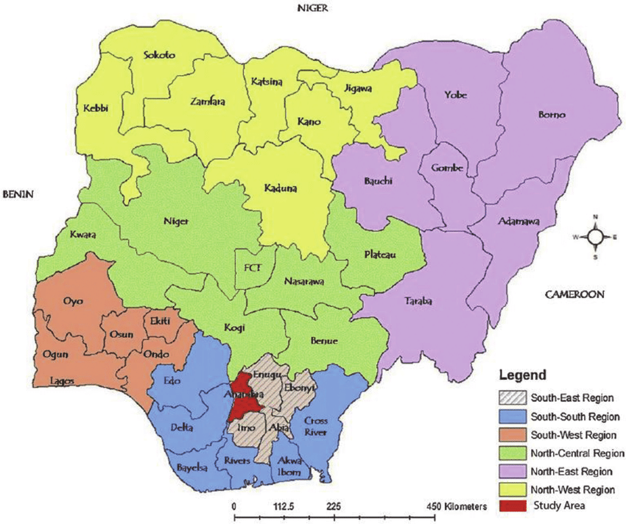

# Figure 1: Map of Nigeria showing Anambra State. (Source: Ezeomedo, I.C. (2019)

* 1. 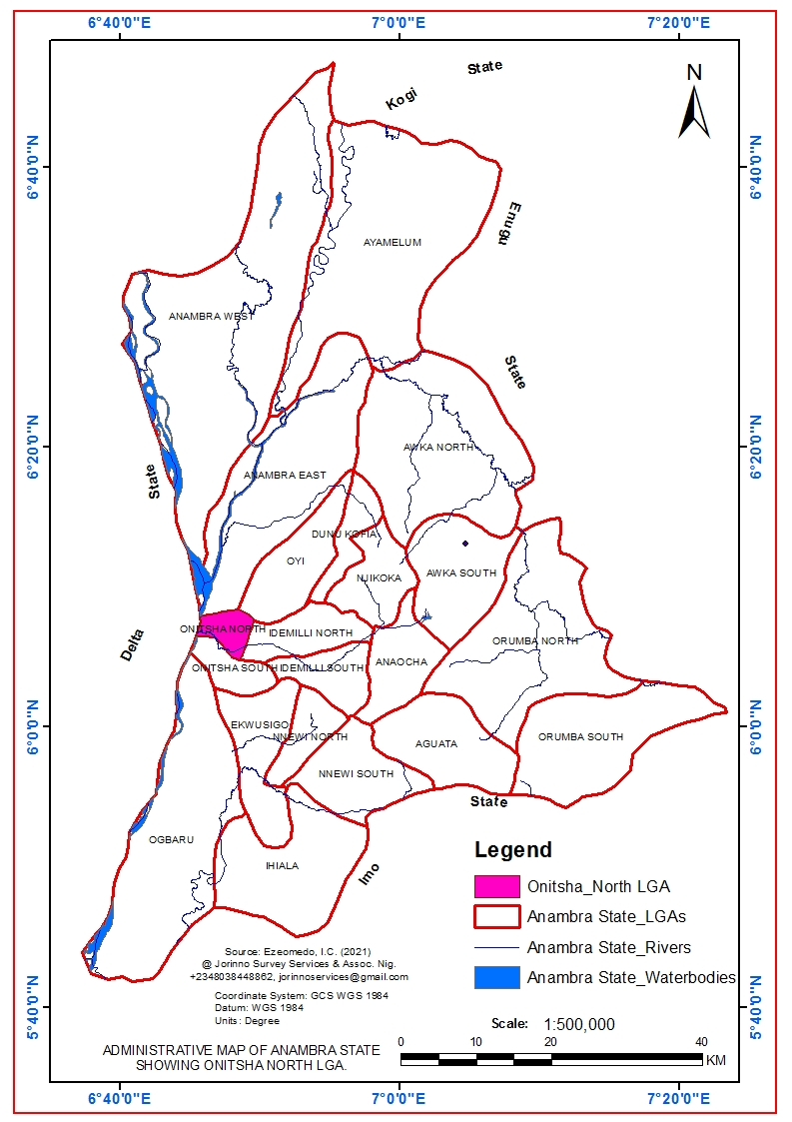

1. **Figure 2: Map of AnambraState Showing Onitsha North L.G.A. (Source: Ezeomedo, I.C. (2021)**

# PREPARATION OF SAMPLES FOR PESTICIDE ANALYSIS

Method used by Okonkwo,et al (2017) was adopted with little modification. Using N-Hexane and a Soxhlet device, 20g of the fish sample was extracted. The oil from the fish samples was extracted using 100 milliliters of N-Haxene. After weighing and transferring 1g of the extracted fish oil sample to a test tube, 10ml of 50% potassium hydroxide and 15ml of ethanol were added. For sixty minutes, the test tube was left to react in a water bath set at sixty degrees Celsius. The reaction product in the test tube was moved to a separatory funnel following the reaction time. After successfully washing the tube with 20 milliliters of ethanol, 10 milliliters of cold water, 10 milliliters of hot water, and 3 milliliters of hexane, the mixture was moved to the separating funnel. Ten milliliters of a 10% ethanol aqueous solution were used to mix and wash these extracts three times. Anhydrous sodium sulfate was used to dry the solution, and the solvent was then removed by evaporation. 200 µl of the 1000 µl of pyridine that was used to dissolve the sample was then transferred to a vial for pesticide analysis (Okonkwo, et al., 2017).

# QUANTIFICATION BY GC-FID

A BUCK M910 gas chromatography system with a flame ionization detector was used to analyze the insecticide. A 15 m × 250 µm × 0.15 µm RESTEK MXT-1 column was utilized. Helium 5.0pa.s was the carrier gas, flowing at 40ml/min, and the injector temperature was 280oC with a splitless injector of 2µl of sample and a linear velocity of 30cmS-1. The detector ran at 320°C after the oven, which started at 200°C, was heated to 330°C at a rate of 3°C per minute and maintained there for five minutes. The area of the discovered compounds and the mass of the internal standard were compared to determine the PCB components.

**Quality assurance and control**

Recovery analysis was used to examine the procedure's accuracy and precision. The amounts of pesticides in both spiked and unspiked samples were measured to ensure the quality assurance protocol. Standard solutions of 20 ppm environmental pesticides were made in 50 ml volumetric flasks. The composite samples were precisely weighed in three pieces, each weighing 2g. While the others were spoked with 1 milliliter of the standard, one was left unspiked. Sonication was used to move both the spiked and unspiked samples through the extraction procedure. GC-MS was used to clean up the extracts and analyze them for pesticides. The following formula was used to get the percentage recoveries:   
Recovery Percentage = X-Y/Z ×100  
where Z is the concentration of the additional spike, X is the concentration of the spiked sample, and Y is the concentration of the unspiked sample. The recovery percentage were in the range of 80-110%

1. **RESULTS :**

**Table 1:** **Concentration of pesticides (µg/ml ) from two different species of fish collected on two different locations.**

**Location A**

|  |  |  |
| --- | --- | --- |
| Pesticides | *Tilapia* | *Elopsmachanata* |
| Isopropylamine | 0.0046 | 0.4264 |
| 2,4- DDT | 0.0303 | 1.2768 |
| Dichlorovos | 0.0003 | 0.3422 |
| Aldrin | 0.9640 | 0.0000 |
| g-chlordane | 2.1636 | 7.6409 |
| Profenofos | 0.0084 | 0.8579 |
| Tetradifon | 0.0022 | 0.2503 |
| Heptachlor | 0.0135 | 0.4140 |
| Glyphosphate | 0.3895 | 0.0003 |
| Carbfuran | 0.2142 | 0.0128 |
| Dicophol | 0.0277 | 1.9734 |
| Total | 3.8183 | 13.195 |

**Table 2**: **Concentration of pesticides (µg/ml ) from two different species of fish collected on location B**.

|  |  |  |
| --- | --- | --- |
| Pesticides | *Tilapia* | *Elopsmachanata* |
| Isopropylamine | 0.0010 | 0.0108 |
| 2,4- DDT | 0.0424 | 0.0181 |
| Dichlorovos | 0.0110 | 0.0321 |
| Aldrin | 0.0012 | 0.3956 |
| g-chlordane | 0.1814 | 0.0951 |
| Profenofos | 0.0010 | 0.0013 |
| Tetradifon | 0.0104 | 0.0026 |
| Heptachlor | 0.3303 | 0.0299 |
| Glyphosphate | 0.0087 | 0.2179 |
| Carbfuran | 0.0008 | 0.4928 |
| Dicophol | 0.0111 | 0.0395 |
| Total | 0.5993 | 1.3357 |

**Table 3**: **Mean concentration of Pesticides (µg/ml) from two different fish species collected from two different locations.**

|  |  |  |
| --- | --- | --- |
| Pesticides | *Tilapia* | *Elopsmachanata* |
| Isopropylamine | 0.0028±0.0026 | 0.1473±0.2418 |
| 2,4- DDT | 0.364±0.0086 | 0.3251±0.6345 |
| Dichlorovos | 0.056±0.0757 | 0.1872±0.2193 |
| Aldrin | 0.4826±0.6808 | 0.1978±0.2797 |
| g-chlordane | 1.1725±1.4016 | 3.8629±5.3285 |
| Profenofos | 0.0047±0.0052 | 0.4296±0.6057 |
| Tetradifon | 0.0063±0.0058 | 0.1215±0.1681 |
| Heptachlor | 0.1719±0.2240 | 0.2220±0.2716 |
| Glyphosphate | 0.1991±0.2693 | 0.1091±0.1539 |
| Carbfuran | 0.1075±0.1509 | 0.2528±0.3394 |
| Dicophol | 0.0194±0.0117 | 1.0065±1.3675 |
| Total | 3.1312±2.8362 | 6.8618±9.8199 |

Table 4: FDA Permissible limits for pesticides (ppm).(FDA,2000).

|  |  |
| --- | --- |
| Peticides | values |
| Aldrin and Dieldrin | 0.3 |
| Chlordane | 0.3 |
| DDT, DDE and TDE | 5 |
| Dichlorvous | 0.1 |
| Endrin | 0,3 |
| Heptachlor and Heptachlor Epoxides | 0.3 |
| Hexachlorobenzene | 0.3 |
| Lindane | 0.3 |
| Methoxychlor | 1 |
| Mirex | 0.1 |
| Toxaphene | 5 |

G-chlordane has the highest pesticide concentration, 2.1636µg/ml in tilapia and 7.6309µg/ml in elopsmachanata, according to Table 1, which displays the concentration of pesticides on these two fish species that were collected from two different locations on the Onitsha River in Niger. Eleven different pesticides were found in the two fish species.

**Fig 3: Graph of Pesticides concentration from two different fish species**.

* 1. **Discussion:**

The pesticide concentrations in tilapia and elopsmachanata collected from two distinct sites on the Onitsha River in Niger are displayed in Table 1. The two fish species were found to contain eleven distinct pesticides. Organochlorine and organophosphates are these pesticides. The highest concentration of G-chlordane is found in tilapia (2.1636 µg/ml) and elopsmachanata (7.6309 µg/ml). G-chlordane is the pesticide with the highest concentration in the graphical representation of pesticides in Figure 1.

The surface runoff waters that residents find in the wetland can allow pesticides and other agrochemicals to infiltrate aquatic bodies. A river may become contaminated due to these and other causes. Results from this analysis as shown in table 1 presented high accumulation of pesticides with total of 13.195µg/ml in elopsmachanata to compare with the other species of tilapia with 3.8183µg/ml in location A , while location B recorded the concentration rate of 1.3356µg/ml in elopsmachanata and 0.5993 in tilapia as presented in table 2. The overall highest concentrations of OCs and Ops were recorded in location B(Odekpe). This could be attributed to the industrial and agricultural sites located in site B. that might increase the flow of insecticides, herbicides, and pesticides into the water bodies, and every effort must be made for its reversal.

G-chlordane's mean concentration is 3.8629±5.3285, the highest pesticide concentration in elopsmachanata, and 1.1725±1.4016 in tilapia. The mean concentration in elopsmachanata was 6.8618±9.8199 and in tilapia it was 3.312±2.835. The most common pesticide in both aquatic biota and a major contributor to the overall pesticide concentration was G-chlordane, however, all eleven of the examined chemicals were discovered in the elopsmachanata at location A, except Aldrin. A one-way Anova revealed that there was no statistically significant difference in the pesticide content in the fish samples (p=0.812)

The results of Kaur et al.'s study in North India, which showed DDT to be the most common pesticide, differ from this one. Comparing the levels of these pesticide concentrations with those set by the FDA and WHO revealed that some fall within the permitted ranges for human consumption, while others do not(Table 4). In their 2020 study, Tufan and Canan identified endosulfan as the most prevalent pesticide species in fish samples from the Aegean and Marmara Seas. In their research on the concentration of organochlorine pesticides in brackish water fish from the Niger River, Unyimadu et al. (2018) found that heptachlor had the greatest concentration, at roughly 509.9µg/kg. In their research on the assessment of persistent organochlorine pesticide residues in fish from the River Majidum in Lagos, Nigeria, Edwin, et al. (2021) found 21 different organochlorine residues, including 1 µg l 1 (Methoxychlor), p'p'DDT, Lindane (γHCH), Dieldrin, Heptachlor, Aldrin, Chlordane, Endrin aldehyde, Endrin ketone, Methoxichlor, and Endosulphan. Methoxychlor was 123.83 µg kg1 and lindane ((γ) HCH) was the highest in Macrobrachium vollenhovenii (39.35 µg kg1). Endrin ketone was present in high concentrations in Callinectes pallidus (133.13 µg kg1). The highest quantity of endrin ketone (110.35 µg kg1) and pp'DDT (41.40 µg kg1) were found in Tilapia zilli.These values exceeded those found in this investigation (Edwin, et al., 2021).Shinggu, et al., (2015) reported Dieldrin pesticide residue to have the highest value of 0.566 mg/Kg and 0.456 mg/Kg in samples of catfish (Chrysichthys nigrodigitatus) examined in the wet and dry seasons, respectively. Dieldrin, lambda-cyhalothrin, endosulfan I and II, alpha BHC, and pp' DDT were found in catfish, but only in tilapia. During the dry season, heptachlor was found in only catfish, while dieldrin was found in only tilapia and catfish. DDT was found at a value of 0.043 mg/kg only in catfish. Given that Lake Geriyo is located in the state capital, which has a dense population, the high quantity of DDT in the lake may be the result of extensive usage of this chemical to control mosquitoes. The town's municipal garbage may enter the lake and build up in the sediment and water(Zeshan, et al., 2021). The DDT and hexachlor levels found in this study were greater than those found in Edwin, et al. (2021) and Shinggu et al. (2015).

* 1. **ORGANOCHLORINE AND ORGANOPHOSPHATE PESTICIDES**.

**Table 5: Summation of organochlorine(OCPs) and organophosphates Pesticides (OPPs) from two fish species.**

|  |  |  |  |  |  |
| --- | --- | --- | --- | --- | --- |
| Organochlorine | tilapia | elops | Organophosphate | tilapia | elops |
| DDT | 0.364 | 0.3251 | Isopropylamine | 0.0028 | 0.1473 |
| Aldrin | 0.4826 | 0.1978 | Dichlorvos | 0.056 | 0.1872 |
| G-chlordane | 1.1725 | 3.8629 | Glyphosphate | 0.1991 | 0.1091 |
| Tetradifon | 0.0063 | 0.1215 | Profenofos | 0.0047 | 0.4296 |
| Dicophol | 0.0194 | 1.0065 |  |  |  |
| Heptachlor | 0.1719 | 0.2220 |  |  |  |
| ΣOCPs | 2.2167 | 5.7358 | ΣOPPs | 0.2626 | 0.8732 |

Table 5 displays the average concentrations of organochlorine pesticides (OCPs) and organophosphate pesticides (OPPs). Some organophosphates, such as isopropylamine, dichlorvos, glyphosphate, and profenofos, were also found, along with organochlorines, such as DDT, Aldrin, G-chlordane, Tetradifon, Heptachlor, and Dicophol. 2.2167 for tilapia and 5.7358 for elopsmachanata were its mean concentration values for ΣOCPs, whereas 0.2626 for tilapia and 0.8732 for elopsmachanata were those for ΣOPPs.

The highest OCPs and OPPs were found in elopsmachanata, with a G-chlordane value of 3.8629 and Dichlorovos value of 0.1872, respectively. Aldrin and chlordane are frequently used in seed preservation to inhibit or stop weevil growth. The fish samples used in this investigation had much higher OCP concentrations. Additionally, they are higher than the ˂0.02 ppm acceptable limit set by the Federal Environmental Protection Agency (FEPA). Fish species' varying eating habits and metabolic traits may be the cause of the diversity in OCP concentrations found in these species.

OPPs can readily deactivate and degrade by microbial activities, whereas OC pesticides like DDT (and its metabolites) are resistant to microbial and photolytic degradation and persist more in the environment (soils and water) where they are applied. This is why there is variation in the values realized for OCPs and OPPs concerning each fish species, as shown in Table 4. This finding is consistent with research by Tufan and Canan (2020). In their research on pesticides, Oluwole-Banjo et al. (2022) found various OCPs and OPPs in the various feed species they examined. P.p. DDT, Dieldrin, Endrin, Endosulfan, Endosulfan 11, Heptachlor, and Methoxychlor were the OCPs he found.

The corresponding values are 0.29±0.04, 1.47±0.38, 0.10±0.02, 0.95±0.37, 0.24±0.04, 0.63±0.06, and 1.83±0.44. The mean concentrations of the OPs, which included coumaphos, diazinon, dichlorvos, dimethoate, ethyl parathion, malathion, parathion, and trichlorfon, were 0.25±0.10, 1.95±0.10, 1.44±0.11, 0.91±0.06, 0.76±0.04, 2.20±0.06, 1.87±0.11, and 6.04±0.35 mg/kg, respectively (Oluwole-Banjo, 2022).

1. **CONCLUSION:**

The Onitsha River in Niger has been found to contain pesticides, particularly organochlorine insecticides, according to this study. Local agriculture practices and other human-caused factors are to blame for this. The analysis's findings demonstrated that the river's aquatic biota, including humans, are exposed to pesticides, including ones that were outlawed decades ago. This pesticide dosage, particularly the organochlorine, indicated a risk factor for both humans and aquatic organisms. The safety and preservation of these natural resources are absolutely essential to human health and well-being. Even while this initial analysis might not provide sufficient proof of the dangers of consuming aquatic

Thus, this study can be used as a useful tool and information for ERA. It has also become an eye-opener to uncover a health concern in this ecosystem, and an urgent need to preserve the water bodies. More analysis of the risk factors, Hazard Quotient, and Cancer risk assessment should be carried out on this river to ascertain the true value and risks associated with the consumption of fish from the river. This studyis a good effort to monitor and assess the hazardous effects of pesticides to the environment and human well-being. It will specifically focus on determining the concentration of pesticide residues causing biomagnification.It also aims to evaluate pesticide utilisation methods and the potential hazards of pesticide residues in the aquatic environment. In the future this type of study would be valuable to assess the human health risks linked to pesticide application randomly and unscientifically

ETHICAL APPROVAL

All authors hereby declare that "Principles of laboratory animal care" (NIH publication No. 85-23, revised

1985) were followed, as well as specific national laws where applicable. All experiments have been

examined and approved by the appropriate ethics committee

Disclaimer (Artificial intelligence)

Author(s) hereby declare that NO generative AI technologies such as Large Language Models (ChatGPT, COPILOT, etc.) and text-to-image generators have been used during the writing or editing of this manuscript.

**REFERNCES**

1. European Parliament (2018). The EU’s Organic Food Market: Facts and Rules (Infographic). Retrieved. https://www.europarl.europa.eu/news/en/headlines/so ciety/20180404STO00909/the-eu-s-organic-food-market-facts-and-rules-infograph ic. (Accessed 16 June 2022)
2. Fernandez-Alba, A.R., Ag¨uera, A., Contreras, M., Peñuela, G., Ferrer, I and Barcel´ o, D (1998). “Comparison of various sample handling and analytical procedures for the monitoring of pesticides and metabolites in ground waters,” Journal of Chromatography A, vol. 823, no. 1-2, pp. 35–47. <https://doi.org/10.1016/S0021-9673(98)00439-7>
3. Kalyoncu, L., Agca, I and Aktumsek, A (2009). “Some organochlorine pesticide residues in fish species in Konya, Turkey,” Chemosphere, vol. 74, no. 7, pp. 885–889. <https://doi.org/10.1016/j.chemosphere.2008.11.020>
4. Aktumsek, A., Kara, H., Nizamlioglu, F and I. Dinc, I (2002). “Monitoring of organochlorine pesticide residues in Pikeperch, Stizostedion lucioperca L. in Beysehir lake (central anatolia),” Environmental Technology, vol. 23, no. 4, pp. 391–394. <https://doi.org/10.1080/09593332508618402>
5. Chen, S., Shi, L., Shan, Z and Hu, Q (2007). “Determination of or ganochlorine pesticide residues in rice and human and fish fat by simplified two-dimensional gas chromatography,” Food Chemistry, vol. 104, no. 3, pp. 1315–1319. <https://doi.org/10.1016/j.foodchem.2006.10.032>
6. Ellenhom, M.J., Schonwald, S., Ordog, G., Wasserberger, J (1997). Ellenhom's medical toxicology: diagnosis and treatment of human poisoning. Williams and Wilkins, Maryland, pp 1614-1663. **ISBN-10 ‏ : ‎**068323093X. **ISBN-13 ‏ : ‎**978-0683230932
7. Mostafalou, S. and Abdollahi,M. (2013). Pesticides and human chronic diseases: Evidences, mechanisms, and perspectives. *Toxicol. Appl. Pharmacol., 268*: 157–177. <https://doi.org/10.1016/j.taap.2013.01.025>
8. Oliveira, J.M., Destro, A.L.F., Freitas, M.B.and Oliveira, L.L. (2021). How do pesticides affect bats? A brief review of recent publications. *Braz. J. Biol., 81*(2): 499-507. <https://doi.org/10.1590/1519-6984.225330>
9. Riedo, J., Wettstein, F., Rösch, E.,Herzog, A., Banerjee, C., Büchi, S.and van der Heijden, M.G. (2021). Widespread occurrence of pesticides in organically managed agricultural soils the ghost of a conventional agricultural past? *Environ.Sci. Technol., 55*(5): 2919-2928. <https://doi.org/10.1021/acs.est.0c06405>
10. Trudi, M., Daniel Ruan, H., Wang, L., Lyu, J., Sadler,R., Connell, D. and Phung, D.T. (2021). Agriculture development, pesticide application and its impact on the environment. *Int. J. Environ. Res. Publ. Health, 18*(3): 1112. <https://doi.org/10.3390/ijerph18031112>
11. Babayemi, J.O (2016) “Overview of Levels of Organochlorine Pesti ides in Surface Water and Food Items in Nigeria,” Journal of Environment and Earth Science,vol.6,no.8,pp.77–86.
12. Tufan, T. and Canan, O. (2020). Determination of Heavy metals and Pesticides in different types of fish samples collected from four different locations of Aegean and Marmara Sea. *Journal of Food Quality.* Vol .2020. Article. ID: 8101532. 12pages. <https://doi.org/10.1155/2020/8101532>
13. Ricardo, A., Torres, P., Efraim, A., Serna, G (2018). Organophosphorus pesticides. Emerging Green Chemical Technology. Pages 177-213. https//doi.org/10.1016/B978-0-12-810499-6.00007-3.
14. Munshi, A.B., Detlef, S.B., Schneider, R and Zuberi, R (2004). “Organochlorine concentrations in various fish from different locations at Karachi coast,” Marine Pollution Bulletin, vol. 49, no. 7-8, pp. 597–601, 2004.  http://doi.org/[10.1016/j.marpolbul.2004.03.019](https://doi.org/10.1016/j.marpolbul.2004.03.019)
15. Ayas, Z., Barlas, N and Kolankaya, D (1997). “Determination of organochlorine pesticide residues in various environments and organisms in G¨oksu delta, Turkey,” Aquatic Toxicology, vol. 39, no. 2, pp. 171–181. https:// doi.org/10.1016/S0166-445X(96)00849-1
16. Abdollahi , M., Ranjbar, A., Shadnia, S., Nikfar, S. and Rezaie, A. (2004).Pesticides and oxidative stress: A review. *Med Sci Monit 10*(6):141-147. https://www.researchgate.net/publication/8532508
17. Kim, K.H., Kabir, E. and Jahan, S.A. (2017). Exposure to pesticides and the associate human health effects. *Sci. Total Environ*., *575*: 525–535. <https://doi.org/10.1016/j.scitotenv.2016.09.009>
18. Gilden, R.C., Huffling, K. and Sattler, B. (2010). Pesticides and health risks. *J. Obstet. Gynecol. Neonatal. Nurs. 39*(1): 103-110. <https://doi.org/10.1111/j.1552-6909.2009.01092.x>.
19. Alavanja, M.C. (2009). Introduction: Pesticides use and exposure, extensive worldwide*. Rev. Environ. Health, 24*: 303-310. <https://doi.org/>[10.1515/reveh.2009.24.4.303](https://doi.org/10.1515/reveh.2009.24.4.303)
20. Bourguet, D. and Guillemaud, T. (2016). The hidden and external costs of pesticide use. *Sustain. Agric. Rev., 19:* 35-120. <https://doi.org/10.1007/978-3-319-26777-7_2>
21. Yadav, I.C., Devi, N.L., Syed, J.H., Cheng, Z., Li, J., Zhang, G. and Jones, K.C. (2015). Current status of persistent organic pesticides residues in air, water and soil, and their possible effect on neighboring countries: A comprehensive review of India. *Sci. Total Environ., 511*: 123–137. <https://doi.org/10.1016/j.scitotenv.2014.12.041>
22. Waheed, S., Halsall, C., Sweetman, A.J., Jones, K.C. and Malik, R.N. (2017). Pesticides contaminated dust exposure, risk diagnosis and exposure markers in occupational and residential settings of Lahore, Pakistan. *Environ. Toxicol. Pharmacol., 56*: 375-382. <https://doi.org/10.1016/j.etap.2017.11.003>.
23. Cobbina, S., Duwiejuah, A., Quansah, R., Obiri, S. and Bakobie, N. (2015). “Comparative assessment of heavy metals in drinking water sources in two small-scale mining communities in northern Ghana,” *International Journal of Environmental Research and Public Health*, vol. 12, no. 9, pp. 10620–10634. <https://doi.org/10.3390/ijerph120910620>
24. Ibrahim, M. S. (2007). Persistent Organic Pollutants in Malaysia. In S. T. G. J. J. P. G. An Li & K. S. L. Paul (Eds.), Developments in Environmental Science Chapter 14 (Vol. Volume 7, pp. 629-655): *Elsevier*. <https://doi.org/10.1016/S1474-8177(07)07014-3>
25. Brain, R.A and Solomon, K.R. (2009). Comparison of the hazards posed to amphibians by the glyphosate spray control program versus the chemical and physical activities of coca production in Colombia. 1 Toxicol Environ Health 72(15):937-948. <https://doi.org/doi:10.1080/15287390902929683>
26. Okonkwo, C.J., Archibong, I. E., Okereke, C.J ., Osuoha, J. O and Njoku, U. C (2017). Organic Pesticides Concentration in Water, Sediments and Fish Tissues obtained from Ogbakiri River in the Niger-Delta Region, Nigeria and Its Health Implication on Human Consumption. International Journal of Biochemistry and Biophysics 5(4): 83-90. https://doi.org/ 10.13189/ijbb.2017.050402
27. Unyimadu, J.P., Osibanjo, O. and Babayemi. J.O. (2018). Levels of Organochlorine Pesticides in Brackish Water Fish from Niger River, Nigeria. Journal of Environmental and Public Health. 9.https://doi.org/10.1155/2018/26583 06 .
28. Edwin, O.C, Akintade, O.A, Emeka, P.N, Oluwatosin, M.O. (2021). Assessment of Persistent Organochlorine Pesticide Residues in Commercially Important Fin and Shell Fishes of River Majidun, Lagos, Nigeria . Curr. J. Appl. Sci. Technol40(1): 142-153. https://doi.org/ 10.9734/CJAST/2021/v40i131244
29. Shinggu D,Y., Maitera, O, N and Barminas, T .J (2015) Determination of Organochlorine Pesticides Residue in Fish, Water and Sediment in Lake Geriyo, Adamawa State, Nigeria. Int. Res. J. Pure Appl. Chem. 8(4): 212-220, 2015, Article no.IRJPAC.2015.086 . https://doi.org/ 10.9734/IRJPAC/2015/17100
30. Zeshan, U.S and Saltanat, P (2021). Pesticide residues in Rita rita and Cyprinus carpio from river Ganga, India and assessment of human health risk. Toxicology reports. Vol. 8, 1638-1644. <https://doi.org/10.1016/j.toxrep.2021.08.013>.
31. Oluwole-Banjo, A.k., Agina, P and Umejiego, R (2022). Organochlorine and Organophosphorus Pesticides Residues in Commercial Poutry Feed samples in Lagos State , Nigeria. J.Appl. Sci. environ. Manage. Vol 26 (2) 297-305. <https://dx.doi.org/10.4314/jasem.v26i2.18>