Molecular Characterization and Prevalence of Intestinal Parasites in Oreochromis niloticus (Nile Tilapia) from Ureje Reservoir, Ado-Ekiti, Nigeria

ABSTRACT
Oreochromis niloticus commonly known as Nile Tilapia, is a widely distributed freshwater fish, largely consumed in Nigeria. Intestinal parasites pose a significant threat to its cultivation and consumption. This study aimed at determining the prevalence and molecular characterization of parasites isolated from Nile Tilapia collected from Ureje reservoir, in Ado-Ekiti, Nigeria. A total of two hundred and forty live Tilapia fishes were examined for intestinal parasites using a combination of microscopy and molecular techniques. The Oreochromis niloticus samples were examined for intestinal parasites using a combination of microscopy and molecular techniques. The parasitological examination of Oreochromis niloticus from Ureje Reservoir revealed the presence of five different species of intestinal parasites namely Schistosoma japonicum, Schistosoma mansoni, Ascaris lumbricoides, Eustrongylides sp., and Ancylostoma duodenale. Among the identified species Schistosoma japonicum had the highest number of occurrences (189) and Ancylostoma duodenale had the lowest number of occurrences (6). Microscopic analysis of fecal samples further confirmed the presence of parasitic eggs and cysts. The PCR and sequencing results confirmed the presence of Schistosoma japonicum, Schistosoma mansoni, Ascaris lumbricoides, and Eustrongylides sp. in the fish samples. The phylogenetic analysis (Figure 2) further showed that the parasite isolates clustered closely with known reference strains, indicating that the identified species are consistent with those reported in other studies. The study concluded that a high prevalence of parasitic infection of Tilapia fish can pose a significant threat to human health. It is therefore recommended that proper hygiene and proper cooking conditions are maintained in the preparation of Tilapia fish for consumption.
Keywords: Microscopic, Molecular, Tilapia, Ureje, Schistosoma japonicum

1.0 Introduction
Fish are one of the main sources of animal protein in human diets (Aragão et al., 2021). Fish meat has many beneficial components, such as polyunsaturated fatty acids (PUFA), essential minerals, omega-3 and omega-6 fatty acids, antioxidants and lipid soluble vitamins, which are important for human health (Badoni et al., 2021). Nile tilapia (Oreochromis niloticus) is considered to be one of most common freshwater fish and widely farmed fish species worldwide, including in Africa (Sockalingam et al., 2015). In Nigeria, Oreochromis niloticus is extensively farmed in ponds and dams for both commercial and subsistence purposes. Despite the species' widespread farming, there is limited information regarding the molecular identification of intestinal parasites in Oreochromis niloticus in Ekiti State. (Adelowo et al., 2022).
Similar to other vertebrates, fish play a significant role as the final or intermediate hosts for many parasites, with a potential for the zoonotic transmission of these parasites to humans (Ziarati et al., 2020). Parasites affect the survival of fish by reducing their size, altering the behavior of infected fish and making them vulnerable to other infections, resulting in higher mortality (Overstreet et al., 2021). Therefore, Intestinal parasites are a significant health concern in fish and pose a considerable risk to human health and can cause severe economic losses. Intestinal parasites in fish are caused by various organisms, such as protozoans, trematodes, cestodes, and nematodes (Overstreet et al., 2021). These parasites can cause a range of symptoms, including weight loss, poor growth, decreased immune function, and even death in severe cases (Bekele et al., 2015). In addition, some intestinal parasites can be transmitted to humans who consume contaminated fish, leading to serious health issues such as diarrhea, abdominal pain, and malnutrition (Zhao et al., 2015).
Molecular techniques, such as polymerase chain reaction (PCR) and DNA sequencing, have significantly improved the detection and identification of parasite species in fish. These techniques have proven to be valuable tools in the diagnosis and surveillance of parasitic infections in aquaculture systems and natural fish populations (Mohammedali et al., 2022). However, investigating the prevalence and molecular identification of intestinal parasites in Oreochromis niloticus in Nigeria Rivers using molecular techniques is essential to improve fish health, ensure food safety, and promote sustainable fish farming practices in the region.
Ureje River is important to the economy of Ekiti State, it provides fish as source of protein (Olagbemile and Owolabi 2022). However, there is limited information available on the prevalence and identification of intestinal parasites in this species of fish in the Ureje River. The molecular identification of intestinal parasites in Oreochromis niloticus in the Ureje River remain largely unknown (Owokotomo et al., 2020). As a result of anthropogenic activities, these is at risk of pollution that can cause increase in parasitic infection. Oreochromis niloticus, which is very important to life and the economy of Ekiti is at risk of parasite infection because of the activities around it. There is dearth of information available on the prevalence of intestinal parasites in Oreochromis niloticus from the Ureje River. Thus, this present study aimed to investigate the prevalence of parasite infection of the fish in Ureje River. So that effective management can be focused against the parasite.

2.0 Materials and Methods

2.1 Study Area
Ureje Reservoir is a significant water body located in Ado Ekiti, the capital of Ekiti State, a city in southwestern Nigeria. Ureje Reservoir is an artificial lake created to provide potable water to the ever-growing city of Ado-Ekiti. The river has a length of about 17 kilometers and flows through several communities in Ado Ekiti. The river is a major source of water for domestic, agricultural, and industrial activities in the area (Owokotomo et al., 2020) Fig.1. The construction of the reservoir was completed in 1973, and it started serving the city and its environs in 1974. The Ureje Reservior is situated in the northeastern part of Ado-Ekiti, covering an area of approximately 100 hectares.
2.2 Sample collection
The sample size for this study was determine by Cochran’s formula (Cochran, 1977), A total number of 240 Oreochromis niloticus was purchased from the fishermen at the landing site of Ureje reservoir, Ado-Ekiti.
2.3 Parasite Examination
The collected fish sample were dissected through making a cut on the ventral side from the anal opening to the lower jaw to expose the alimentary canals. The intestine was cut open for collection of faces, and was examined with the use of hand lens for macro parasites. Specimens of the fecal samples was stained with iodine and examined under the microscope (X 400) for cysts and vegetative forms of parasites. Parasites were identified using the fact sheets on pictorial guide on fish parasites.
2.4 Molecular Analysis
2.4.1 DNA Extraction
DNA was extracted using the QIAamp Fast DNA Stool Mini Kit (Qiagen, Germany) following the manufacturers’ procedure, and the resulting DNA was stored at -20°C until amplification
2.4.2 PCR Analysis Using GeneAmp 9700 PCR System Thermocycler.
The PCR was conducted in a 50 µl reaction volume using the GeneAmp 9700 PCR System Thermocycler (Applied Biosystems Inc., USA), with 10 µl of 5x GoTaq colorless reaction, 3 µl of 25 mM MgCl2, 1 µl of 10 mM dNTPs mix, and 1 µl of 10 pmol of each primer: 18S-CL-F3 (CTTGTCTCAAAGATTAAGCCATGCAT), 81R (TTCCTCCGCTAAATGATATGCTTAA) (Templeton et al., 2015). The PCR conditions include an initial cycle of initial denaturation at 94 ºC for 5 min, followed by 40 cycles of each cycle consisting of 30 secs of denaturation at 94ºC, 30 secs of primer annealing at 50 ºC, 60 secs of extension at 72ºC, and a final extension for 7 min at 72ºC.
The integrity of the amplified approximately 1.5Mb gene fragment was checked on a 1.5% Agarose gel run to confirm amplification using the buffer (1X Tris Acetic and EDTA buffer). Two (2µl) of 10X blue gel loading dye was added to 4µl of each PCR product and loaded into the wells. The gel was electrophoresed at 120V for 45 minutes and visualized by ultraviolet trans-illumination. The image wasl be photographed.
2.4.3 PCR for Sequencing
To prepare the sequencing cocktail, 10 µl of 5x GoTaq colorless reaction, 3 µl of 25mM MgCl₂, 1 µl of 10 mM dNTPs mix, 1 µl of 10 pmol each of, and D2AR primers, as well as 0.3 units of Taq DNA polymerase (Promega, USA), was mixed together in a total volume of 32 µl with sterile distilled water, followed by the addition of 20 µl of DNA template as reported by Templeton et al. (2015). The amplified fragments was sequenced using a Genetic Analyzer 3130xl sequencer from Applied Biosystems, following the manufacturers' manual. The sequencing kit used is the Big Dye terminator v3.1 cycle sequencing kit. All genetic analysis was performed using Bio-Edit7 software and MEGA 11. Sequences were identified by BLAST on GenBank at NCBI website.
3. Results
3.1 Prevalence and Intensity of Infection
The parasitological examination of Oreochromis niloticus from Ureje Reservoir revealed the presence of five different species of intestinal parasites (Schistosoma japonicum, Schistosoma mansoni, Ascaris lumbricoides, Eustrongylides sp., and Ancylostoma duodenale) as revealed in Table 1. Among the identified species Schistosoma japonicum had the highest number of occurrences (189) and Ancylostoma duodenale had the lowest number of occurrences (8). The other parasites present are Schistosoma mansoni (10), Ascaris lumbricoides (88), and Eustrongylocides (20), and the total number of parasites present was 313.

Table 1: Parasitic Infections in O. niloticus sampled from Ureje Reservoir
parasites | W1 | W2 | W3 | W4 | W5 | W6 | W7 | W8 | TP
Trematodes  Schistosoma japonicm | 25 | 23 | 26 | 29 | 25 | 18 | 17 | 16 | 189
Schistosoma masoni | 2 | - | 1 | 1 | 2 | 2 | - | 2 | 10
Nematode  Ascaris lumbricoides | 10 | 13 | 11 | 8 | 14 | 16 | 9 | 7 | 88
Eustrongylocides | 2 | - | 5 | 5 | 4 | 1 | 2 | 1 | 20
Ancylostoma duodenle | 1 | - | 2 | - | 1 | 1 | 1 | - | 6
Total |  |  |  |  |  |  |  |  | 313

W ꞊ Weekly
Tp ꞊ Total number of individual parasites

The findings from this study indicate a high prevalence of intestinal parasites in Oreochromis niloticus from the Ureje Reservoir, with 93.33% (224 out of 240) of the examined fish being infected (Table 2). The mean intensity of infection varied across sampling weeks, with values ranging from 0.9 to 1.84 parasites per infected fish. The highest intensity was observed in week five (1.84)

Table 2: Prevalence, Mean Intensity and Abundance of Parasites in O. niloticus from Ureje Reservoir
Wk | E Fish | I Fish | U Fish | No of parasites | Prevalence (%) | Mean intensity | Abundance
1 | 30 | 29 | 1 | 40 | 96.67 | 1.38 | 1.33
2 | 30 | 30 | - | 36 | 100 | 1.2 | 1.2
3 | 30 | 27 | 3 | 45 | 90 | 1.67 | 1.5
4 | 30 | 24 | 6 | 43 | 80 | 1.79 | 1.43
5 | 30 | 25 | 5 | 46 | 83.33 | 1.84 | 1.53
6 | 30 | 30 | - | 48 | 100 | 1.6 | 1.6
7 | 30 | 30 | - | 29 | 100 | 0.97 | 0.97
8 | 30 | 29 | 1 | 26 | 96.67 | 0.6 | 1.87
Total | 240 | 224 | 16 | 313 | 93.33 | 1.4 | 1.3
Wk: week, E Fish: Examined fish, I Fish: Infected fish, U Fish: Uninfected fish

Microscopic analysis of fecal samples further confirmed the presence of parasitic eggs and cysts. Schistosoma japonicum and Schistosoma mansoni eggs were observed under ×400 magnification (Plate 3), while Ascaris lumbricoides eggs were also detected (Plate 1). Eustrongylides eggs were identified in another fecal sample (Plate 4), confirming the diversity of parasite species present in the fish.

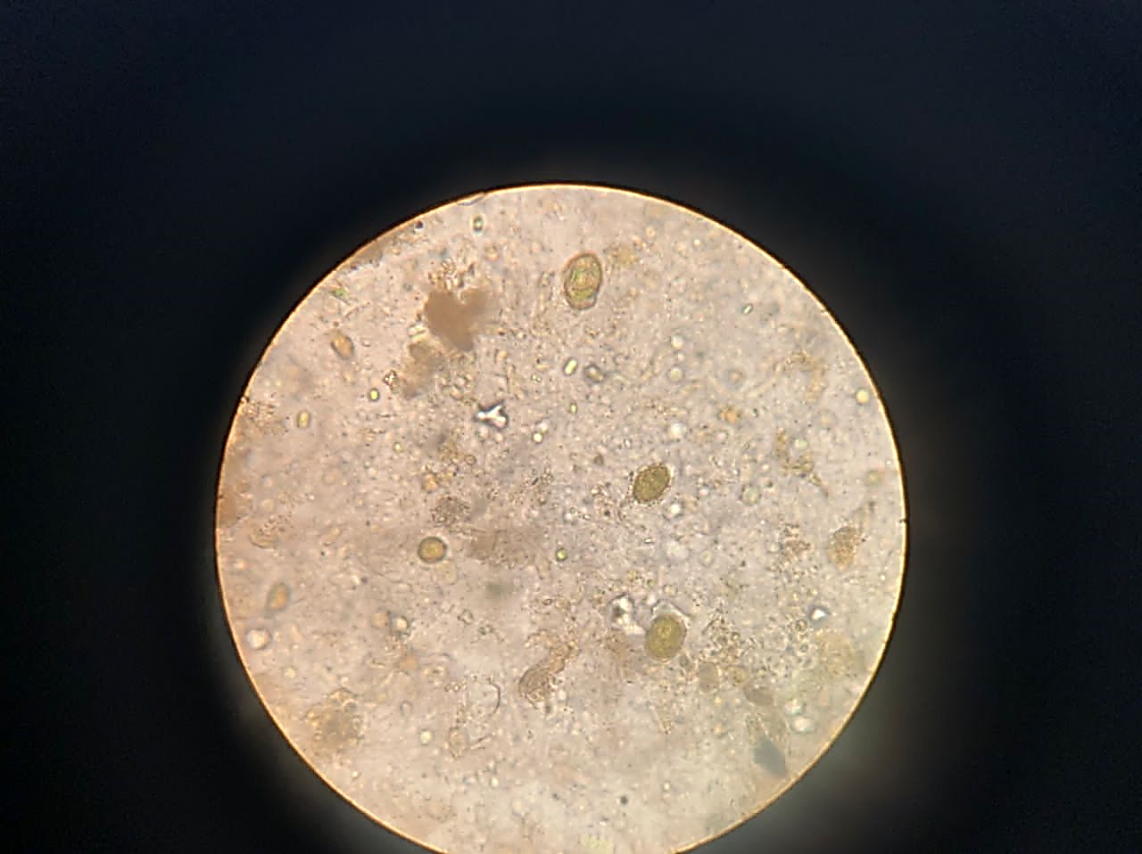
b
a
Plate 1: Arrows showing the egg of Ancylostoma duodenale (a), and Schistosoma japonicum (b) in faecal sample
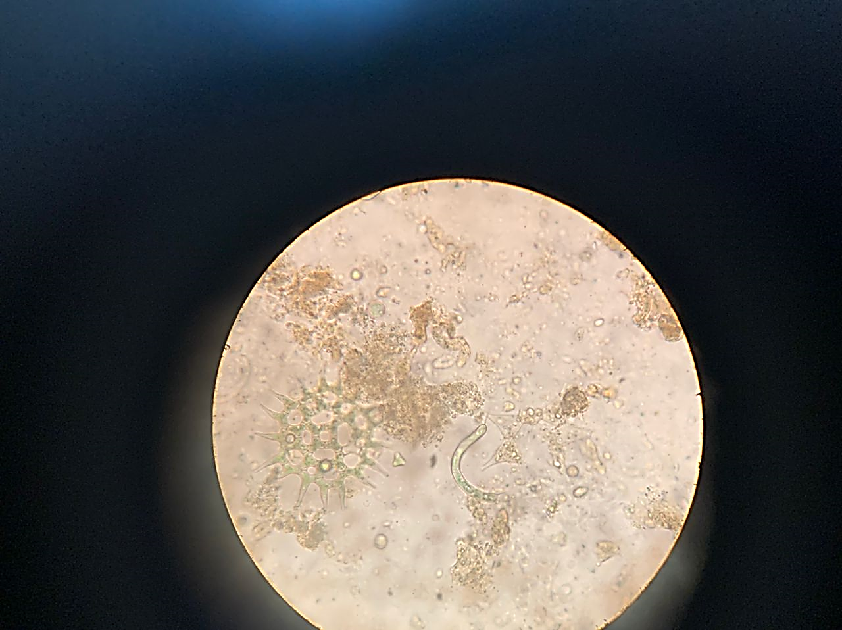
Plate 2: Arrows showing Ascaris lumbricoides in faecal sample

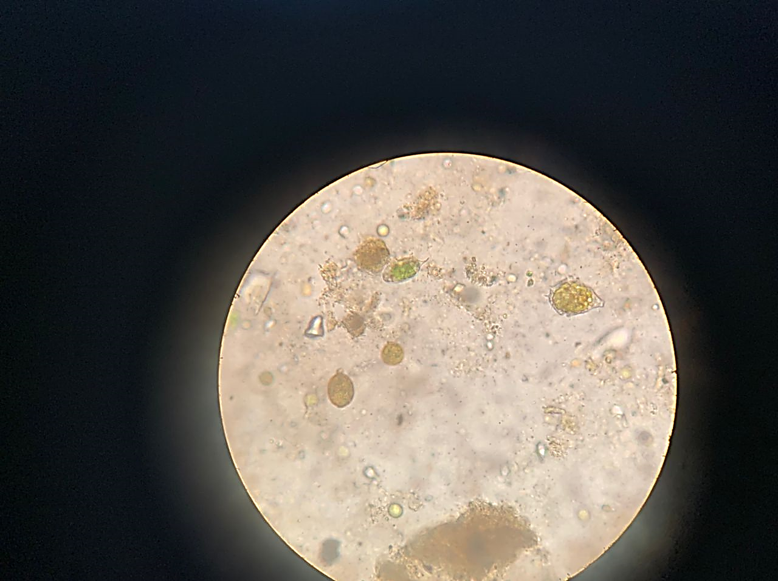
d
c
Plate 3: Arrows showing the egg of Schistosoma mansoni (c) and Schistosoma japonicum(d) in faecal sample

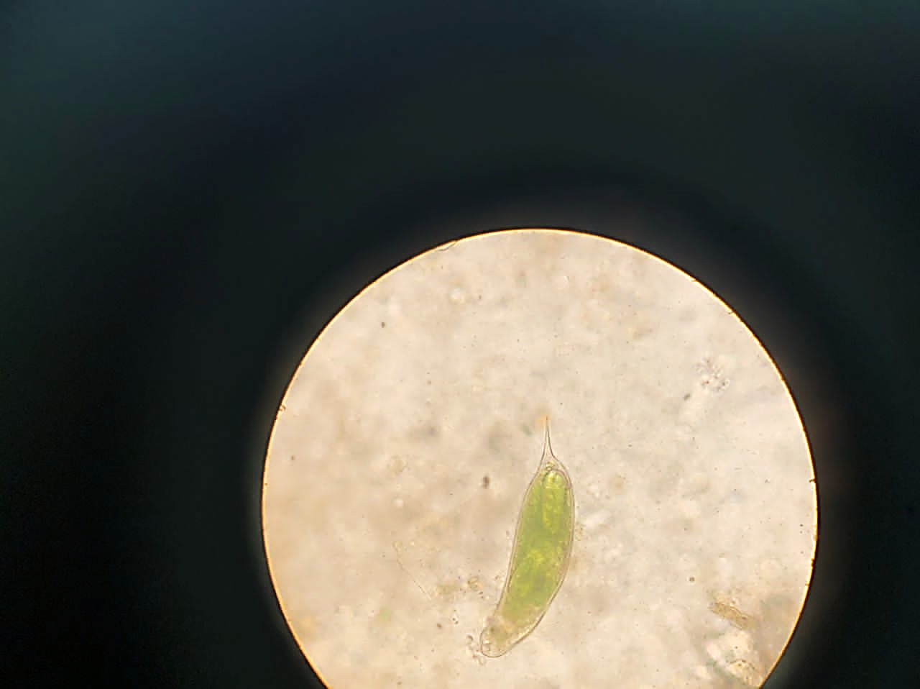
Plate 4: Arrow showing the egg of Schistosoma haematobum in faecal sample
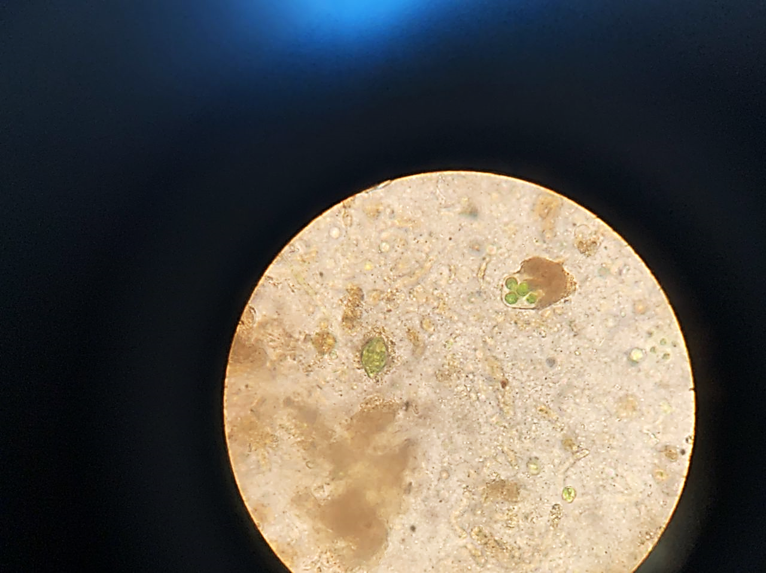
Plate 5: Arrow showing the egg of Eustrongylocides

3.2 Molecular Characterisation and Identification
The PCR analysis was successful in 15 fecal samples submitted for the analysis (Table 3). The PCR products were subjected to electrophoresis. Based on the electrophoresis results, the band patterns in all 15 samples show Agarose gel positive amplification of the 18S rRNA region in the selected samples. The PCR and sequencing results confirmed the presence of Schistosoma japonicum, Schistosoma mansoni, Ascaris lumbricoides, and Eustrongylides sp. in the fish samples. Sequencing of the PCR product shows that Agarose gel was positively amplified at 2kb (Plate 6). An amplification of 2kb indicates a positive amplification. The sequencing data revealed a 99–100% identity match with reference sequences from GenBank, supporting the accuracy of molecular identification. The phylogenetic analysis (Figure 1) further showed that the parasite isolates clustered closely with known reference strains, indicating that the identified species are consistent with those reported in other studies.
Table 3: NCBI Blast Showing the Identity of the Sequenced Organism
sample ID | Scientific Name | Max Score | Total Score | Query Cover | E value | Per. Ident | Accession
Sample 1 | Schistosoma mansoni | 2185 | 2185 | 99% | 0 | 99.83% | OQ883996
Sample 2 | Schistosoma japonicum | 2193 | 2193 | 99% | 0 | 99.67% | OQ883997
Sample 3 | Schistosoma japonicum | 2198 | 2198 | 99% | 0 | 99.67% | OQ883998
Sample 4 | Schistosoma mansoni | 2193 | 2193 | 99% | 0 | 100.00% | OQ883999
Sample 5 | Schistosoma japonicum | 2231 | 2231 | 100% | 0 | 100.00% | OQ884000
Sample 6 | Eustrongylides sp. HSS2 | 1369 | 1369 | 100% | 0 | 98.10% | OQ884001
Sample 7 | Schistosoma japonicum | 2217 | 2217 | 99% | 0 | 99.83% | OQ884002
Sample 8 | Eustrongylides sp. HSS2 | 1362 | 1362 | 100% | 0 | 98.33% | OQ884003
Sample 9 | Schistosoma japonicum | 2202 | 2202 | 99% | 0 | 99.67% | OQ884004
Sample 10 | Schistosoma japonicum | 2226 | 2226 | 100% | 0 | 99.92% | OQ884005
Sample 11 | Schistosoma mansoni | 2204 | 2204 | 99% | 0 | 99.92% | OQ884006
Sample 12 | Eustrongylides sp. HSS2 | 1352 | 1352 | 100% | 0 | 98.07% | OQ884007
Sample 13 | Eustrongylides sp. HSS1 | 1365 | 1365 | 100% | 0 | 97.39% | OQ884008
Sample 14 | Schistosoma mansoni | 2215 | 2215 | 100% | 0 | 100.00% | OQ884009
Sample 15 | Ascaris lumbricoides | 2037 | 2037 | 100% | 0 | 100.00% | OQ884010

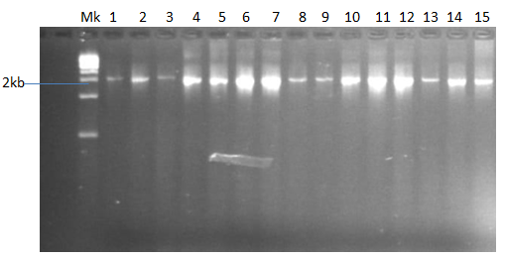
Plate 6: Agarose gel showing the positive amplification of the 18S rRNA region in the selected samples
Key Mk - DNA ladder; 1 - 15 parasite samples

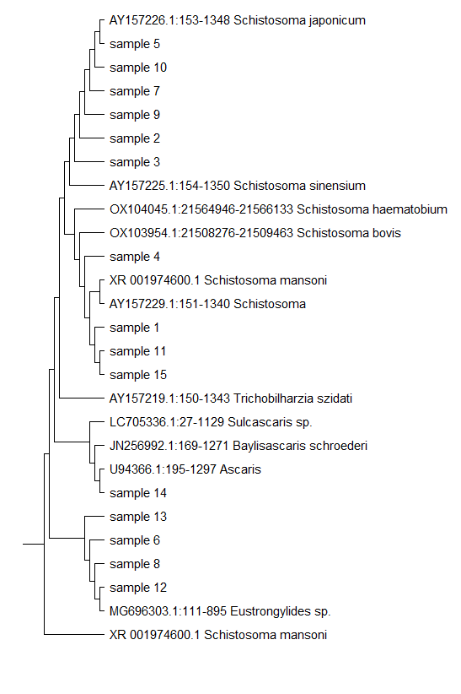
Figure 1: Phylogenetic tree showing the relationship between the parasites

4.0 Discussion of Findings
The present study investigated the prevalence and molecular characterization of intestinal parasites in Oreochromis niloticus from Ureje Reservoir, Ado-Ekiti, Nigeria. The findings of the study revealed the presence of five major parasitic species namely Schistosoma japonicum, Schistosoma mansoni, Ascaris lumbricoides, Eustrongylides sp., and Ancylostoma duodenale among which Schistosoma japonicum had the highest occurrence. This pattern suggests that trematodes, particularly Schistosoma species, are the dominant parasitic group affecting O. niloticus in Ureje Reservoir. The high burden of Schistosoma species could be linked to the presence of intermediate hosts such as freshwater snails, which are known vectors in the parasite's lifecycle (Okoro et al., 2023). The prevalence of infection recorded in this current study was higher than the prevalence of infection of reported by similar study in Koka Reservoir (66.3%), Ethiopia (Gulelat et al., 2013) and 59.5% in Agulu Lake, Nigeria (Okoye et al., 2014). The higher prevalence in Ureje Reservoir may be attributed to several factors, including poor water quality, high organic matter accumulation, and anthropogenic activities such as agricultural runoff and waste disposal, which create a favorable environment for parasite transmission.
The prevalence of infection recorded in this current study was higher than the prevalence of infection of 66.3% reported in Koka Reservoir, Ethiopia (Gulelat et al., 2013) and 59.5% in Agulu Lake, Nigeria (Okoye et al., 2014). The observed differences in the prevalence, mean intensity, and abundance in this study compared with other studies may likely be due to the effects of the differences in the physico-chemical parameters in the various locations (Kinga et al., 2022).
The mean intensity of infection varied across the sampling weeks, with the highest intensity observed in week five, which may suggest seasonal variations in infection rates. Previous studies have linked changes in parasitic infection rates to fluctuations in environmental factors such as temperature, dissolved oxygen levels, and nutrient availability (Jerônimo et al., 2022). These factors may influence both parasite reproduction and host susceptibility, leading to temporal differences in infection intensity.
The findings of this study further revealed that the use of molecular techniques provided a more accurate identification of the intestinal parasites in O. niloticus compared to traditional microscopic methods. PCR amplification targeting the 18S rRNA gene successfully confirmed the presence of Schistosoma japonicum, Schistosoma mansoni, Ascaris lumbricoides, and Eustrongylides sp. These findings align with previous studies that have used molecular tools to accurately identify and classify fish parasites (Chan et al., 2021). The detection of zoonotic parasites such as Schistosoma species and Ascaris lumbricoides in O. niloticus raises significant public health concerns. These findings underscore the importance of implementing proper fish handling, cooking, and sanitation measures to minimize health risks.

Conclusion
This study highlights the high prevalence and molecular characterization of intestinal parasites in O. niloticus from Ureje Reservoir, emphasizing the need for improved fish health management, environmental sanitation, and public health interventions. The identification of zoonotic parasites underscores the importance of ensuring proper fish handling, cooking, and wastewater management to mitigate health risks. Further research should explore seasonal variations in infection dynamics and evaluate targeted control measures to reduce parasite burdens in both wild and farmed fish populations.
Disclaimer (Artificial intelligence)
Option 1:
Author(s) hereby declare that NO generative AI technologies such as Large Language Models (ChatGPT, COPILOT, etc.) and text-to-image generators have been used during the writing or editing of this manuscript.
Option 2:
Author(s) hereby declare that generative AI technologies such as Large Language Models, etc. have been used during the writing or editing of manuscripts. This explanation will include the name, version, model, and source of the generative AI technology and as well as all input prompts provided to the generative AI technology
Details of the AI usage are given below:
1.
2.
3.

Reference
Aragão, C., Gonçalves, A.T., Costas, B., Azeredo, R., Xavier, M.J. and Engrola, S. (2022) ‘Alternative proteins for fish diets: implications beyond growth’, Animals, 12(9), p. 1211.
Badoni, P., Nazir, I., Aier, M., Maity, P.B., Samanta, S. and Das, A. (2021) ‘Significant role of fish nutrients with special emphasis to essential fatty acid in human nutrition’, International Journal of Current Microbiology and Applied Sciences, 10, pp. 2034-2046.
Bekele, J. and Hussien, D. (2015) ‘Prevalence of internal parasites of Oreochromis niloticus and Clarias gariepinus fish species in Lake Ziway, Ethiopia’, Journal of Aquaculture Research and Development, 6, pp. 1-4.
Chan, A.H.E., Chaisiri, K., Saralamba, S., Morand, S. and Thaenkham, U. (2021) ‘Assessing the suitability of mitochondrial and nuclear DNA genetic markers for molecular systematics and species identification of helminths’, Parasites & Vectors, 14(1), p. 233.
Cochran, W.G. (1977) Sampling Techniques Estimation of Population Ratio in Post-Stratified Sampling Using Variable Transformation. Open Journal of Statistics, 5(1).
Cochran, W.G. (1977) Sampling Techniques. Estimation of Population Ratio in Post-Stratified Sampling Using Variable Transformation, Open Journal of Statistics, Vol.5 No.1
Gulelat, Y., Eshetu, Y., Asmare, K. and Bekele, J. (2013) ‘Study on parasitic helminths infecting three fish species from Koka Reservoir, Ethiopia’, SINET: Ethiopian Journal of Science, 36, pp. 73-80.
Jerônimo, G.T., da Cruz, M.G., Bertaglia, E.D.A., Furtado, W.E. and Martins, M.L. (2022) ‘Fish parasites can reflect environmental quality in fish farms’, Reviews in Aquaculture, 14(3), pp. 1558-1571.
Kinga, H., Kengne-Ouafo, J.A., King, S.A., Egyirifa, R.K., Aboagye-Antwi, F. and Akorli, J. (2022) ‘Water physicochemical parameters and microbial composition distinguish Anopheles and Culex mosquito breeding sites: potential as ecological markers for larval source surveillance’, Journal of Medical Entomology, 59(5), pp. 1817-1826.
Mohammedali, M.A., Suliman, S.E., Abdelsalam Abdalla, M. and Fangama, M.I. (2022) ‘Investigation and PCR diagnosis of Escherichia coli infection (Zoonosis) in fish in Khartoum state, Sudan’, International Journal of Current Microbiology and Applied Sciences.
Okoro, O.J., Deme, G.G., Okoye, C.O., Eze, S.C., Odii, E.C., Gbadegesin, J.T., Okeke, E.S., Oyejobi, G.K., Nyaruaba, R. and Ebido, C.C. (2023) ‘Understanding key vectors and vector-borne diseases associated with freshwater ecosystems across Africa: implications for public health’, Science of The Total Environment, 862, p. 160732.
Okoye, I.C., Abu, S.J., Obiezue, N.N.R. and Ofoezie, I.E. (2014) ‘Prevalence and seasonality of parasites of fish in Agulu Lake, Southeast Nigeria’, African Journal of Biotechnology, 13, pp. 502-508.
Olagbemide, P.T. and Owolabi, O.D. (2022) ‘Prevalence, intensity and influence of size and seasons on parasites of Oreochromis niloticus in Ekiti State Dams, southwest Nigeria’, ABUAD International Journal of Natural and Applied Sciences, 2(2), pp. 123-131.
Overstreet, R.M. (2021) ‘Parasitic diseases of fishes and their relationship with toxicants and other environmental factors’, in Pathobiology of Marine and Estuarine Organisms. CRC Press, pp. 111-156.
Owokotomo, A.I., Ajayi, O.O., Alabi, O.O. and Chukwuka, A.V. (2020) ‘Watershed land use, surface water vulnerability and public health risks of two urban rivers, Ado-Ekiti, South-West Nigeria’, SN Applied Sciences, 2, pp. 1-21.
Templeton, J.E.L., Brotherton, P.M., Llamas, B., Soubrier, J., Haak, W., Cooper, A. and Austin, J.J. (2015) ‘DNA capture and next-generation sequencing can recover whole mitochondrial genomes from highly degraded samples for human identification’, Investigative Genetics, 4(1), p. 26.
Zhao, X., Li, P., Zhang, S., He, S., Xing, S., Cao, Z., Lu, R. and Li, Z. (2021) ‘Effects of environmental norfloxacin concentrations on the intestinal health and function of juvenile common carp and potential risk to humans’, Environmental Pollution, 287, p. 117612.
Ziarati, M., Zorriehzahra, M.J., Hassantabar, F., Mehrabi, Z., Dhawan, M., Sharun, K., Emran, T.B., Dhama, K., Chaicumpa, W. and Shamsi, S. (2022) ‘Zoonotic diseases of fish and their prevention and control’, Veterinary Quarterly, 42(1), pp. 95-118.

