Enhancing Teacher-Student Interaction Dynamics in Online Education: A Systematic Literature Review

# Abstract

Background: Online learning is rapidly expanding, with increasing market size and user scale. However, the lack of teacher-student interaction remains a significant challenge. Identifying factors impacting teacher-student interaction can help improve online learning environments. Despite its importance, systematic research in this area is limited. This study addresses this gap by exploring factors influencing teacher-student interactions in online learning.Purpose: The aim of this study was to identify and categorize factors affecting teacher-student interaction in online learning. Method: A systematic literature review was conducted using scientific publications in English and Chinese. Databases such as Scopus, PubMed, CNKI, ProQuest, Springer, and Google Scholar were searched for articles published up to 2022. The PRISMA guidelines were followed for article selection, and only articles with complete data and passing quality assessments were included. The final sample consisted of 33 articles published between 2015 and 2022. Results: The majority of participants (65%) were undergraduate students, and 58% of the studies employed quantitative methods to investigate factors influencing teacher-student interaction. The findings revealed that teacher-student interaction significantly impacts positive student outcomes, including satisfaction, motivation, academic achievement, and performance. Four main factors were identified: (a) technological factors, (b) student individual characteristics, (c) teacher trait factors, and (d) course design factors.Conclusion: Existing research predominantly focuses on undergraduate students and employs quantitative methods, while qualitative approaches and perspectives from primary/secondary school teachers and lecturers are underrepresented. Future research should address these gaps by incorporating diverse viewpoints and methodologies to comprehensively explore factors influencing teacher-student interaction in online learning environments.

**Keywords**: teacher-student interactions, online learning, positive outcomes, factors, review

# INTRODUCTION

Moore & Kearsley (2011) defined interaction in distance learning as "two-way communication among two or more persons for purposes of explaining and challenging perspectives." According to Moore(1989), interaction in online education consists of three types: interaction between students and students, the interaction between students and teachers, and interaction between students and subject content. The issue of online student-teacher interaction is receiving increasing attention from researchers, due to the rapid growth of online courses. There are many reasons that contribute to the rapid development of online courses. Firstly, there is the advancement of technology and the spread of the internet. For example, the 48th statistical report on the development of China's Internet shows that the total number of Internet users in China has reached 1.011 billion, and the Internet penetration rate has reached 71.6% (China Internet Network Information Center, 2021). Secondly, because of COVID-19, online learning is no more an option; it is a necessity. Online learning has become the main form of schooling forced by the COVID-19 pandemic. COVID-19 emerged in Wuhan, Hubei Province, China, in December 2019 and quickly evolved into a global pandemic (Pokhrel & Chhetri, 2021). This pandemic has forced the global shutdown of several activities, including educational activities, and this has led mass schools and universities to turn to online learning. As of mid-April 2020, United Nations Educational, Scientific and Cultural Organization, or UNESCO, reported that 1.5 billion children and young people in 195 countries are affected by school closures, from preschool to higher education (UNESCO, 2020a). At its peak, COVID-19 impacted over 1.6 billion learners of all ages - 94% of the world's student population (UNESCO, 2020b). As explained above, online learning has become an important way of learning.

Interaction is an important component of learning activities, and the interaction between students and teachers is an essential attribute of online learning. In the process of online learning, after sending the teaching content designed by the teacher, the teacher must actively help and guide the students to interact effectively with the teaching content (Hidinger, 2020; Jia, 2021; Tian et al., 2020). Some scholars pointed out that one of the key elements of effective teaching and quality online learning is to provide students with a means of exchanging ideas with teachers and among themselves (Glass & Sinha, 2018; Song & Park, 2021; Tao & Xu, 2022). With the rapid development of information technology, online learning provides new ideas to break through the limitations of traditional interaction modes in physical space. Online learning creates a virtual online learning space for teachers and students in different time and space conditions (M. Yang et al., 2019). Online courses are helpful for teachers and students to carry out one-to-one or one-to-many, synchronous or asynchronous interactions, and other ways, adding new forms and new content to the communication between teachers and students. Online interaction between teachers and students in colleges and universities is a manifestation of the trend, which not only helps to improve the teaching effect and quality of teachers but also helps to stimulate the initiative and enthusiasm of students in learning (Raza & Reddy, 2021). Some researchers also believe that online learning creates a knowledge-rich and interesting way for teachers and students to interact, which helps learners maintain their interest in learning and increase their participation in the course (Xu, 2021). A previous study showed that the higher the level of interaction with the teacher and other learners, the higher the satisfaction, the higher the engagement with the course content, and the better the results (Veletsianos, 2010). In other words, a lack of interaction may contribute to the failure of online education and student dropout (Purarjomandlangrudi, 2018). As explained above, there is no doubt that teacher-student interaction is of great importance in online teaching.

Earlier studies have shown that the effectiveness of online courses is influenced by student-teacher interaction. Finding the factors that influence teacher-student interaction can help students and faculty overcome potential problems and to create a better online interactive environment. The authors found that there is no previous systematic review exploring the factors that influence teacher-student interaction in the current body of knowledge. In this sense, the goal of this study is to identify and classify the factors that influence teacher-student interaction in online learning.

# METHODS

The selection criteria were based on PRISMA (2020) guidelines (Page et al., 2021). This title has already been registered on the International Platform of Registered Systematic Review and Meta-analysis Protocols, and the registration number is CRD42022330800. For this systematic search, we developed a search strategy to identify relevant literature. This search strategy was tailored to five databases: Scopus, PubMed, ProQuest, Springer, and China National Knowledge Infrastructure (CNKI), and the search terms were the following: TITLE-ABS-KEY ("teacher-student interaction*" OR "student-teacher interaction*" OR "professor-student interaction*") AND TITLE-ABS-KEY ("online learn*" OR "web-based" OR "internet" OR "e-learning" OR "distance" OR "virtual education" OR "computer" OR "technology"). In each database, a search was conducted by title-abs-key. And all searches spanned from database inception until April 21, 2022. In addition to that, all searches are limited to journal articles.

The research mainly focused on the mapping of existing literature on teacher-student interaction in the field of social science and computer science. The search span was from the years 2015-2022. All articles before 2015 were excluded from the search. There were 180 records extracted at this stage.

The study is based only on original research articles. To maintain the quality of the review, all duplications were checked thoroughly. Therefore, nine duplicate articles were deleted. Then abstracts of the articles were checked deeply for the analysis and purification of the articles to ensure the quality and relevance of academic literature included in the review process. The number of records after remained after screening based on title and abstracts was 50. A careful evaluation of each research paper was carried out at a later stage. The next exclusion criterion was to limit the papers published in the English or Chinese language. There were six articles in non-English or Chinese languages that were excluded from the study. Furthermore, three review articles were deleted. In addition, eight articles were missing associate factors. Finally, we selected 33 articles after assessing each article on therefore mentioned inclusion and exclusion criteria. In conclusion, in the data extraction phase, 33 articles were selected and the characteristics extracted were: a) the Article must be an original paper, b) the article must be in Chinese or English language and from the field of social sciences and computer sciences, c) extracted articles were published between 2015 to 2022. Figure 1 shows the literature inclusion and exclusion at every stage.

**Figure 1 Systematic review search and screening procedure**

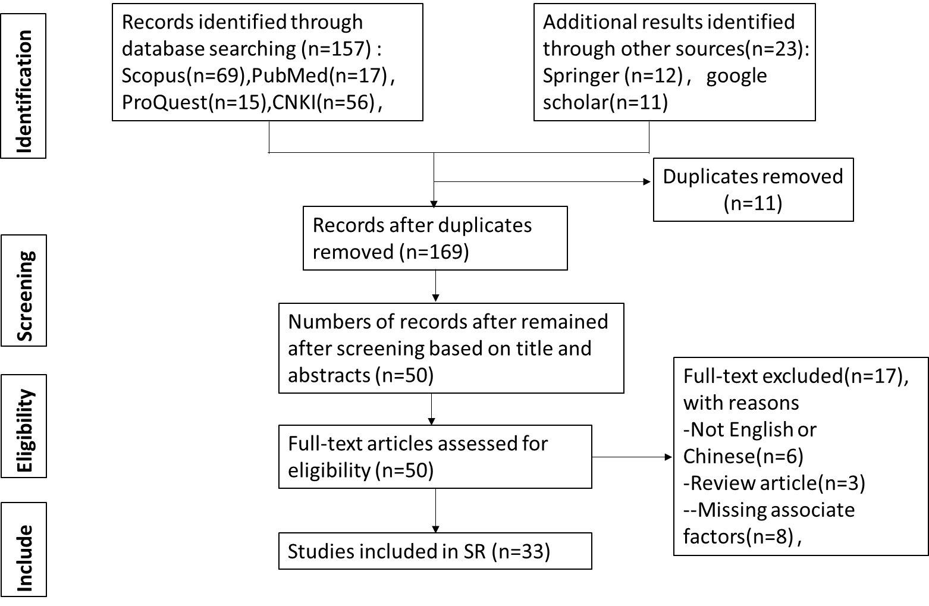

Study results (titles and/or abstracts) retrieved using the search strategy, as well as titles and/or abstracts of studies from other sources, will be independently screened by two review authors to identify studies that may meet the inclusion criteria described above. Data will be extracted independently by the two review authors, and discrepancies will be identified and resolved through discussion (with a third author if necessary).

# RESULTS AND INTERPRETATIONS

## 3.1 Types of Participants and Research Methodology

There are no restrictions on school grades in the literature review. In other words, these studies range from primary school to university. We have classified the participants of the reviewed research into eight main categories: graduate students, undergraduate and lecturers, primary school teachers and students, high school teachers and students, and middle school students. Figure 2 is a bar chart of these categories and the number of studies in each one. It can be implied that most of the studies have been conducted in universities, and most participants are undergraduate students. Lecturers are also an important part of the university classroom and play a critical role in enhancing the quality of higher education (Cochran-Smith, 2003; Goodwin & Kosnik, 2013; Ping et al., 2018). But little focus on lecturers.

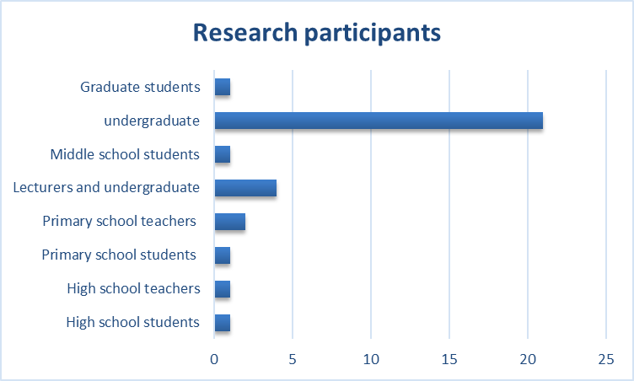

**Figure 2 Research participants**

Diverse research methodologies and instruments were used in the reviewed literature. Some researchers applied quantitative methods, which is an objective and systematic process whereby the researcher measures to obtain the data needed for the study. As Figure 3 shows, 58% of researchers use quantitative research, which is the largest methodology used. Some researchers chose a qualitative approach to identify participants' perspectives and provide deeper insights into the issues; this approach accounted for 33% of the total percentage. Other researchers chose a mixed research approach, meaning that both quantitative and qualitative methods were included in the same study, accounting for 9% of all reviewed studies.

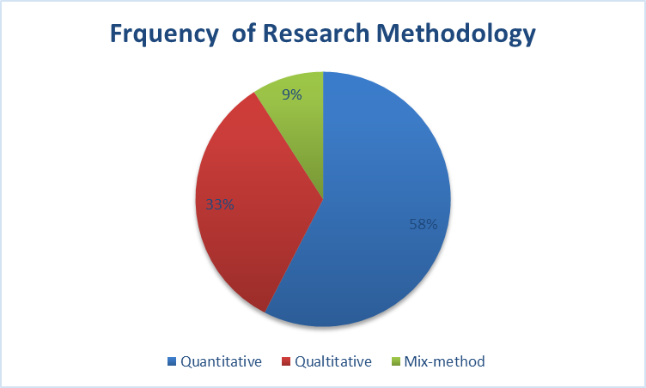

**Figure 3 Frequency of research methodology.**

## 3.2 Teacher-Student Interactions’ Positive Outcomes in Online Learning

Exciting studies have shown that online teacher-student interaction has a strong impact on different students’ positive outcomes, such as student satisfaction and motivation (Sason & Kellerman, 2021; X. Wang et al., 2022a; Zheng et al., 2022), academic achievement, and performance (H.-L. Sun et al., 2022; J. C.-Y. Sun & Wu, 2016; Zheng et al., 2022).

Firstly, teacher-student interaction strongly impacts students’ online learning satisfaction. For example, X. Wang et al.(2022b) conducted a quantitative study of 93 undergraduates to explore the impact of teacher-student interaction on online course satisfaction. The findings showed that there is a positive relationship between the content of the interaction, the distance of the interaction, and student satisfaction. Another mixed-method study from Sason & Kellerman (2021) also showed similar results. They surveyed 591 undergraduates from different departments at a teacher's college. The findings suggest that any type of interaction that supports teaching can improve the learning process itself and help students complete the course satisfactorily. Secondly, regarding the impact of online teacher-student interaction on students' academic performance. This is evident in the case conducted by Sun & Wu (2016), who investigated 181 freshmen and set up experimental and control groups. By analyzing the data from the questionnaires and test scores, they found that interaction improved student performance. In another similar case in China, H.-L. Sun et al. (2022) investigated 398 undergraduate students studying at Chinese universities, and they found that the positive teacher-student interaction had a positive impact on students' learning outcomes. Further, a pilot study found that the 'always respond positively' group scored 84.7 on the final exam, and the 'no answer' group scored 81.9 on the final exam (J. Wang et al., 2017). This finding suggests that students who gave effective feedback scored significantly better on the final exams of their courses. Also, an online survey completed by 781 Primary school students in Hong Kong showed that only 57 percent of students were satisfied with their schools' online learning arrangements, with 49.6 percent believing that online learning is an effective mode of learning (Zheng et al., 2022). In addition, multiple analyses have shown that teacher-student interaction in online classrooms is positively associated with student satisfaction, perceived effectiveness, and online learning preferences (Zheng et al., 2022). Finally, a qualitative study of eight undergraduate students showed that effective teacher-student interaction would help to build a good teacher-student relationship (F. Yang et al., 2020).

As explained above, there is no doubt that teacher-student interactions play a key role in teaching and learning and have a positive outcome in online learning. However, these prior studies suffer from the fact all from the perspective of students, and most of them are undergraduate students. And most of these studies were conducted with quantitative studies to explore whether there is a link between the degree of interaction and a specific thing.

## 3.3 Factors Impacting Teacher-student Interaction in Online Learning

The most important contribution of this literature review was categorizing factors that impact teacher-student interaction in online learning. According to the literature, developing and facilitating teacher-student interactions is crucial in online learning and there are different studies on this issue. There are several factors that contribute to improved teacher-student interaction in online learning: a) Technology factors, b) Students’ individual characteristics, c) Teacher trait factors, and d) course design factors. Figure 4 shows the four categories and specific factors that influence teacher-student interaction in online learning.

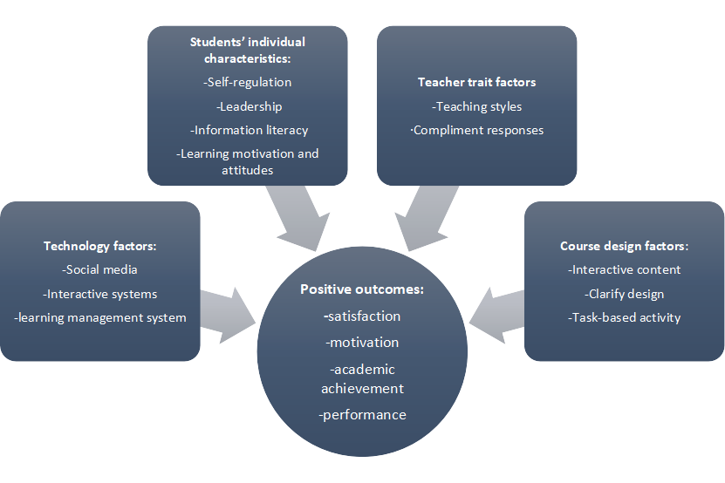

**Figure 4 Factors Impacting on Teacher-student Interaction in Online Learning**

First of all, some researchers applied specific technologies, such as social media, to increase interaction and create an interactive environment in their online courses (Chen & Chen, 2019; X. Li, 2019; Robles et al., 2019; J. Wang et al., 2017). For example, a survey of 166 law students in the north of Colombia showed that law students are highly satisfied with the use of WhatsApp chat groups and that the use of WhatsApp tools enhances student-teacher interaction (Robles et al., 2019). WeChat, a social networking software similar to WhatsApp, has also proven to be effective in facilitating interaction. The survey showed that 75% of students gave effective feedback on the use of WeChat to facilitate interaction (J. Wang et al., 2017). Because the frequent notifications via WeChat allow for regular contact with students, encourage feedback on the course, and promote student-student and student-teacher interaction. These researches indicated that the usability of social software was one of the factors to facilitates teacher-student interaction. Other studies use various interactive management systems, such as expression-response Analysis System (ERAS) and Flanders Interaction Analysis System (FIAS) (Dwarakanath Vallam et al., 2021; Lytvynenko et al., 2022; F. Yang et al., 2020; Yavich & Gerkerova, 2019; X. Zhang & Wang, 2018). For example, some researchers believe that interactive systems should be improved to facilitate online interaction between teachers and students. For example, teachers use an expression-response Analysis System (ERAS) to capture students' spontaneous nonverbal behaviors (such as facial expressions, body language, etc.) in real-time, thus effectively improving teaching strategies and student learning (Hung et al., 2017). W. Zhang & He (2021) developed a framework for an interactive classroom teaching system. By designing the framework for the teaching system, teachers can conduct activities such as question and answer, attendance and evaluation during the online teaching and learning process in order to improve classroom interaction. The study (W. Zhang & He, 2021) pointed out that the classroom interaction function module is an important module of this interactive system. There are various types of interactive classroom activities, including sign-in, classroom tests, random roll calls, etc. Another example of how to use the learning model to promote teacher-student interaction was conducted by Lytvynenko et al. (2022). They developed a learning model that provided dynamic interaction at each stage in the online course in Oxford. In addition, some researchers believe that developing an online discussion forum may contribute to facilitating student-teacher interaction (L. Wang & Chen, 2016). They highlighted the structure of the feature of the online discussion forum and pointed out that common features of forums are discussed below: private messages, attachments, emoticons, and poll. In addition, Dwarakanath Vallam et al.(2021) and Yavich & Gerkerova (2019) suggested that using information-pedagogical model via telecommunication means is a good way to increase the frequency of teacher-student interaction. As discussed above, this section identifies social media, interactive systems and learning management systerm have an important impact on teacher-student interaction.

Secondly, previous studies have shown that students’ individual characteristics are important factors affecting online interaction between teachers and students. Firstly, students’ self-regulation affects the occurrence of teacher-student interaction. For example, a quantitative study that surveyed 591 undergraduate students found that undergraduate students with high levels of self-regulation are more likely to interact with the teacher and take more responsibility for whether or not the interaction occurs (Sason & Kellerman, 2021). Also, student leadership influences teacher-student interaction. For example, a researcher used the Interaction System to collect interaction data and found that a greater proportion of group leaders interacted with teachers (X. Wang et al., 2022b). Further, students’ previous technical competencies are the influencing factors of teacher-student interaction in online learning. For example, a pilot study from Hung et al. (2017) showed that secondary school students with high levels of information technology were more adaptive to online learning content and showed higher levels of expression of neutral and positive social interactions. However, students with low IT proficiency reported a higher frequency of negative social interactions due to increased cognitive load. Lastly, undergraduate students' learning motivation and attitudes affect teacher-student interaction. For example, in a survey of 546 undergraduate students, the researchers found that both intrinsic and extrinsic learning motivation had an impact on the satisfaction of teacher-student interaction in online classrooms (Wu & Yao, 2020). Intrinsic motivation B=0.239, P<0.001, the contribution rate of intrinsic motivation to multiple regression equation was 23.9%; Extrinsic motivation B=0.097, P<0.05, the contribution rate of extrinsic motivation to multiple regression equation was 9.7%. Compared with extrinsic motivation, intrinsic learning motivation has a greater impact on interaction satisfaction. This showed that students with higher learning motivation are more satisfied with the interaction between teachers and students in online course learning, and more students interact with teachers under the impetus of internal learning motivation. In summary, it has been shown from this section that students’ self-regulation, leadership, information literacy, and learning motivation and attitudes have an impact on teacher-student interaction in online learning.

Thirdly, teacher trait factors were considered, which had an impact on teacher-student interactions. Firstly, there is a link between the teaching styles and the interaction between teacher and student. The teaching style is formed by teachers in their long-term teaching activities and it is a reflection of the individual teacher's stable teaching qualities and teaching style (Kesevan & Kesevan, 2022). A quantitative study examined which teaching styles undergraduates most liked to interact with (Wu & Yao, 2020). The results showed that half of the respondents preferred a humorous teaching style, meaning that students were more willing to interact with teachers when they created a relaxed and humorous atmosphere in the online classroom, and the higher the satisfaction level of teacher-student interaction. Further, compliment responses are helpful for teacher-student interaction. For example, a qualitative study explored compliment responses in an online course from the perspectives of English teachers and EFL learners, and both teachers and students mentioned in their interviews that they considered compliment exchanges to be an essential part of academic communication (F. Yang et al., 2020). And several students mentioned that they developed "stronger interpersonal bonds" with their teachers when they were able to respond with appropriate compliments online. In summary, it has been shown from this section that teaching styles and compliment responses are strongly connected to teacher-student interaction in online learning.

Finally, course design factors had an impact on teacher-student interaction in online learning. Firstly, the design of interactive content for teaching and learning. A study was conducted with a qualitative method to explore high school teachers' perception of teachers' role in virtual education (J. Zhang et al., 2021). The results showed that both teacher-student and peer interactions are limited, and they suggested that teachers should highlight online course design to consciously increase the amount and frequency of content-based interactions with students. Similarly, another study has shown that well-designed interactive content in online courses can be effective in increasing international students' satisfaction with online courses (X. Wang et al., 2022b). Secondly, some studies found that clarity of design significantly influenced students’ online interaction in asynchronous online learning (Deng & Huang, 2017; N. Li, 2020). For example, researchers described that clearly designed tasks are the basis for online activities, and clear activities help students to engage and interact (Zhuo & Guofeng, 2021). Another study (Robles et al., 2019) on enhancing online learners’ communication skills found that using synchronous electronic chats combined with task-based instruction enhances learners' communication skills. It is also pointed out that students benefit more from task-based online activities among students. In summary, it has been shown from this section that interactive content, clarifying design, and task-based activity are important factors to formulate teacher-student interaction.

# CONCLUSION

In this systematic review, we screened 180 journal articles and selected 33 articles that contained associate factors impacting teacher-student interactions in online learning. The review identified four main factors impacting teacher-student interactions, technology factors, students’ individual characteristics, teacher trait factors, and course design factors. According to the findings of this review, most of the research was conducted in university classrooms and measured relevant factors primarily from undergraduate students’ perspectives. Lecturers are also an important part of the university classroom and play a critical role in enhancing the quality of higher education (Cochran-Smith, 2003; Goodwin & Kosnik, 2013; Ping et al., 2018). At the same time, little focus is on lecturers’ perceptions. Also, the views of teachers and students in primary and secondary schools were ignored, too. Secondly, qualitative research methods adopted in to explore the impacting factors are not sufficient. Most studies utilized a quantitative method to measure and identify whether there is a link between the degree of teacher-student interaction and a specific thing. Further investigations should be carried out to identify the perceptions of teachers and students in basic education and lecturers in university.

**Disclaimer (Artificial intelligence)**

Option 1:

Author(s) hereby declare that NO generative AI technologies such as Large Language Models (ChatGPT, COPILOT, etc.) and text-to-image generators have been used during the writing or editing of this manuscript.

Option 2:

Author(s) hereby declare that generative AI technologies such as Large Language Models, etc. have been used during the writing or editing of manuscripts. This explanation will include the name, version, model, and source of the generative AI technology and as well as all input prompts provided to the generative AI technology

Details of the AI usage are given below:

1.

2.

3.

**Reference**

Chen, Q., & Chen, H. (2019). Design and Research of micro course based on wechat public platform—Taking ‘Shop Decoration Artist’ course as an example. *Wireless Internet Technology*, *02 vo 16*, 66-67+70.

China Internet Network Information Center. (2021). Statistical Report on the Development of the Internet in China. *Chinese newspaper industry*, *03*, 122.

Cochran-Smith, M. (2003). Learning and unlearning: The education of teacher educators. *Teaching and Teacher Education*, *19*(1), 5–28. https://doi.org/10.1016/S0742-051X(02)00091-4

Deng, Y., & Huang, X. (2017). On how to enhance the interaction and participation of teachers and students in basic Design courses. *education modernization*, *26 vo 4*, 123–125. https://doi.org/10.16541/j.cnki.2095-8420.2017.26.052

Dwarakanath Vallam, R., Bhatt, P., Mandal, D., & Narahari, Y. (2021). Improving Teacher-Student Interactions in Online Educational Forums using a Markov Chain based Stackelberg Game Model. In *ArXiv e-prints*. https://ui.adsabs.harvard.edu/abs/2021arXiv211201239D

Glass, A. L., & Sinha, N. (2018). Classroom instruction results in better exam performance than online instruction in a hybrid course. *Journal of General Psychology*, *145*(4), 362–376. Scopus. https://doi.org/10.1080/00221309.2018.1494128

Goodwin, A. L., & Kosnik, C. (2013). Quality teacher educators = quality teachers? Conceptualizing essential domains of knowledge for those who teach teachers. *Teacher Development*, *17*(3), 334–346. https://doi.org/10.1080/13664530.2013.813766

Hidinger, K. B. (2020). *A Phenomenology of Peer Interaction and Community in Accelerated Online Learning*. https://search.ebscohost.com/login.aspx?direct=true&db=ddu&AN=06E4406CB24367C0&site=ehost-live

Hung, J. C.-S., Chiang, K.-H., Huang, Y.-H., & Lin, K.-C. (2017). Augmenting teacher-student interaction in digital learning through affective computing. *Multimedia Tools and Applications*, *76*(18), 18361–18386. Scopus. https://doi.org/10.1007/s11042-016-4101-z

Jia, J. (2021). A study of ISEC students’ online learning behaviour in ethnic universities and colleges. *International Journal of Continuing Engineering Education and Life-Long Learning*, *31*(3), 325–337. Scopus. https://doi.org/10.1504/IJCEELL.2021.116031

Kesevan, H. V., & Kesevan, P. (2022). Teachers Teaching Styles in ESL Classroom Practices. *Journal of Positive School Psychology*, *6*(2), Article 2.

Li, N. (2020). Strategies for improving teacher-student interaction of undergraduate online homework. *Chinese educational technology and equipment*, *21*, 119–121.

Li, X. (2019). Analysis on the application of wechat in college badminton elective course teaching. *Modern Sports technology*, *08 vo 9*, 84-85+87. https://doi.org/10.16655/j.cnki.2095-2813.2019.08.084

Lytvynenko, N., Halyna, Y., Kateryna, Y., Nikolaieva, O., & Liudmila, B. (2022). Modern Learning Models through Teacher and Student Dynamic Interaction in HEI towards COVID-19 Pandemic Condition. *International Journal of Health Sciences*, *6*(1), 234–243. Scopus. https://doi.org/10.53730/ijhs.v6n1.3870

Moore, M. G. (1989). Editorial: Three types of interaction. *American Journal of Distance Education*, *3*(2), 1–7. https://doi.org/10.1080/08923648909526659

Moore, M. G., & Kearsley, G. (2011). *Distance Education: A Systems View of Online Learning*. Cengage Learning.

Page, M. J., McKenzie, J. E., Bossuyt, P. M., Boutron, I., Hoffmann, T. C., Mulrow, C. D., Shamseer, L., Tetzlaff, J. M., Akl, E. A., Brennan, S. E., Chou, R., Glanville, J., Grimshaw, J. M., Hróbjartsson, A., Lalu, M. M., Li, T., Loder, E. W., Mayo-Wilson, E., McDonald, S., … Moher, D. (2021). The PRISMA 2020 statement: An updated guideline for reporting systematic reviews. *BMJ*, n71. https://doi.org/10.1136/bmj.n71

Ping, C., Schellings, G., & Beijaard, D. (2018). Teacher educators’ professional learning: A literature review. *Teaching and Teacher Education*, *75*, 93–104. https://doi.org/10.1016/j.tate.2018.06.003

Pokhrel, S., & Chhetri, R. (2021). A Literature Review on Impact of COVID-19 Pandemic on Teaching and Learning. *Higher Education for the Future*, *8*(1), 133–141. https://doi.org/10.1177/2347631120983481

Purarjomandlangrudi, A. (2018). *Interaction and Engagement in Online Education: Impacts of Student Characteristics and Perceptions*. https://search.ebscohost.com/login.aspx?direct=true&db=ddu&AN=53156C302C5EE837&site=ehost-live

Raza, S. H., & Reddy, E. (2021). Intentionality and Players of Effective Online Courses in Mathematics. *Frontiers in Applied Mathematics and Statistics*, *7*. Scopus. https://doi.org/10.3389/fams.2021.612327

Robles, H., Guerrero, J., Llinás, H., & Montero, P. (2019). Online teacher-students interactions using Whatsapp in a law course. *Journal of Information Technology Education: Research*, *18*, 231–252. Scopus. https://doi.org/10.28945/4321

Sason, H., & Kellerman, A. (2021). TEACHER-STUDENT INTERACTION IN DISTANCE LEARNING IN EMERGENCY SITUATIONS. *Journal of Information Technology Education: Research*, *20*, 479–501. Scopus. https://doi.org/10.28945/4884

Song, C. E., & Park, H. (2021). Active learning in e-learning programs for evidence-based nursing in academic settings: A scoping review. *Journal of Continuing Education in Nursing*, *52*(9), 407–412. Scopus. https://doi.org/10.3928/00220124-20210804-05

Sun, H.-L., Sun, T., Sha, F.-Y., Gu, X.-Y., Hou, X.-R., Zhu, F.-Y., & Fang, P.-T. (2022). The Influence of Teacher–Student Interaction on the Effects of Online Learning: Based on a Serial Mediating Model. *Frontiers in Psychology*, *13*. Scopus. https://doi.org/10.3389/fpsyg.2022.779217

Sun, J. C.-Y., & Wu, Y.-T. (2016). Analysis of learning achievement and teacher-Student interactions in flipped and conventional classrooms. *International Review of Research in Open and Distance Learning*, *17*(1), 79–99. Scopus. https://doi.org/10.19173/irrodl.v17i1.2116

Tao, J., & Xu, Y. (2022). Parental support for young learners’ online learning of English in a Chinese primary school. *System*, *105*. Scopus. https://doi.org/10.1016/j.system.2021.102718

Tian, Y., Liu, Y., He, J., & Song, X. (2020). The impact of teacher-student interaction and self-regulation skills on learning performance on online platforms. *Exploration of higher vocational education*, *05 vo 19*, 52–58.

UNESCO. (2020a). *UNESCO Rallies International Organizations, Civil Society and Private Sector Partners in a Broad Coalition to Ensure #LearningNeverStops*. https://en.unesco.org/news/unesco-rallies-international-organizations-civil-society-and-private-sector-partners-broad

UNESCO. (2020b, August 6). *UN Secretary-General warns of education catastrophe, pointing to UNESCO estimate of 24 million learners at risk of dropping out*. UNESCO. https://en.unesco.org/news/secretary-general-warns-education-catastrophe-pointing-unesco-estimate-24-million-learners-0

Veletsianos, G. (2010). *Emerging Technologies in Distance Education*. Athabasca University Press.

Wang, J., Gao, F., Li, J., Zhang, J., Li, S., Xu, G., Xu, L., Chen, J., & Lu, L. (2017). The usability of WeChat as a mobile and interactive medium in student-centered medical teaching. *Biochemistry and Molecular Biology Education*, *45*(5), 421–425. https://doi.org/10.1002/bmb.21065

Wang, L., & Chen, Y. (2016). Teacher-student interaction in network teaching in colleges and universities. *Education observation*, *02 vo 5*, 52-53+137. https://doi.org/10.16070/j.cnki.cn45-1388/g4s.2016.03.023

Wang, X., Hassan, A. B., Pyng, H. S., & Ye, H. (2022a). Exploring the Influence of Teacher-Student Interaction Strength, Interaction Time, Interaction Distance and Interaction Content on International Student Satisfaction with Online Courses. *International Journal of Learning, Teaching and Educational Research*, *21*(2), 380–396. Scopus. https://doi.org/10.26803/ijlter.21.2.21

Wang, X., Hassan, A. B., Pyng, H. S., & Ye, H. (2022b). Exploring the Influence of Teacher-Student Interaction Strength, Interaction Time, Interaction Distance and Interaction Content on International Student Satisfaction with Online Courses. *International Journal of Learning, Teaching and Educational Research*, *21*(2), 380–396. Scopus. https://doi.org/10.26803/ijlter.21.2.21

Wu, W., & Yao, R. (2020). The satisfaction of teacher-student interaction in undergraduate online classroom and its influencing factors. *Science of University Education*, *04*, 95–104.

Xu, Y. (2021). *Study on primary school students’ online learning activities in the context of COVID-19* [Master, Hubei University]. https://kns.cnki.net/kcms/detail/detail.aspx?dbcode=CMFD&dbname=CMFDTEMP&filename=1021787250.nh&uniplatform=NZKPT&v=3dqiyvb32USrgrESmqS2_Nja_u8HjxSRD5jIc7uCnlp69n2wKpesBrpVD4_lpXx0

Yang, F., He, S., Qi, L., & Wen, J. (2020). Compliment Response in Teacher-Student Interaction: Examples from ICT Platforms. *International Journal of Information and Education Technology*, *10 vo 10*.

Yang, M., Ye, Z., & Han, Y. (2019). Discourse Analysis of teacher-student interaction and Student-student interaction in online Courses: A Case study of Media-assisted English Teaching at the Open University of China. *Distance Education in China*, *12 vo 40*, 34–41. https://doi.org/10.13541/j.cnki.chinade.2019.12.005

Yavich, R., & Gerkerova, A. (2019). Distance communication of the lecturer and students in the higher education. *International Journal of Higher Education*, *8*(2), 82–86. Scopus. https://doi.org/10.5430/ijhe.v8n2p82

Zhang, J., Zhang, M., Li, H., Yang, C., & Tan, J. (2021). Investigation on online teaching interaction and satisfaction of university teachers during the epidemic. *Education Tribune*, *10*, 28–37. https://doi.org/10.16215/j.cnki.cn44-1371/g4.2021.10.004

Zhang, W., & He, L. (2021). Online classroom teacher–student interaction system based on compressed sensing data collection and sensors. *Wireless Networks*. https://doi.org/10.1007/s11276-021-02695-y

Zhang, X., & Wang, D. (2018). Research on Teacher-Student Interaction in M-learning*. *Kuram ve Uygulamada Egitim Bilimleri*, *18*(5), 1598–1603. Education Database. https://doi.org/10.12738/estp.2018.5.058

Zheng, X., Zhang, D., Lau, E. N. S., Xu, Z., Zhang, Z., Mo, P. K. H., Yang, X., Mak, E. C. W., & Wong, S. Y. S. (2022). Primary School Students’ Online Learning During Coronavirus Disease 2019: Factors Associated With Satisfaction, Perceived Effectiveness, and Preference. *Frontiers in Psychology*, *13*. Scopus. https://doi.org/10.3389/fpsyg.2022.784826

Zhuo, K., & Guofeng, L. (2021). Popular music singing video teaching based on android mobile network and embedded system. *Journal of Ambient Intelligence and Humanized Computing*. Scopus. https://doi.org/10.1007/s12652-021-03208-7