Analyzing Land Use Change and Fragmentation Using Earth Observation Data: A Case Study of the Ken River Basin, India

Abstract
Land use/land cover (LULC) are a critical concern due to their significant impact on ecosystems, biodiversity, and climate patterns. The objective of this study is to understand the dynamics of land use and land cover (LULC) changes and quantify the fragmentation in the Ken River Basin using open-access remote sensing data and the FRAGSTATS software. Landsat images from 1995, 2015, and 2022 were utilized to analyze changes over these distinct time periods. We employed supervised classification using the maximum likelihood method to produce detailed land use and land cover maps. The analysis identified five land use classes: water bodies, forest, barren land, cultivable land, and built-up land, with cultivable land emerging as the most dominant class, followed closely by forest cover. To quantify the land cover classes, various landscape metrics at the class level were employed. The results reveal a concerning trend: both forest and agricultural land classes are experiencing increasing fragmentation over time. This rising fragmentation poses significant risks to the ecological integrity and sustainability of the Ken River Basin. By quantifying long-term land cover changes, this study assesses the effectiveness of conservation efforts and utilizes remote sensing and GIS techniques to inform and enhance best management practices in the region.

Keywords: LULC, Fragmentation, Landscape metrics, ecosystems, biodiversity, and climate patterns

- Introduction
Changes in the composition of land use and land cover (LULC) across the globe represent a critical concern due to their profound impact on ecosystems, biodiversity, and climate patterns. LULC change is driven by both natural phenomena and anthropogenic activities, which together influence the way landscapes develop and alter over time. In tropical and subtropical developing regions, factors such as population growth, infrastructure expansion, unplanned resource extraction, and mining activities have been particularly significant in driving these transformations (Kumar et al., 2018; Desta and Fetene, 2020). Such changes do not occur in isolation; they fundamentally reshape the structure, pattern, and dynamics of landscapes (Leitáo et al., 2006; Gabril et al., 2019).

To quantify landscape structure and changes effectively, a clear understanding of landscape indices is essential. These indices serve as quantitative measures of various landscape attributes, including patch size, patch density, shape, nearest neighbor distances, diversity, interspersion, distribution, and connectivity. By correlating landscape indices with ecological phenomena, researchers can gain valuable insights into how landscape structures evolve over time, enabling a deeper understanding of ecological processes (Olsen et al., 2006; Singh et al., 2016).

The implications of LULC changes are particularly pronounced in the vicinity of rivers, as these transformations directly affect both the physical characteristics and the ecological integrity of river systems (Chin, 2006; Kang and Kanniah, 2022). Numerous studies have highlighted the consequences of LULC change within river basins, including its effects on runoff, water yield, river morphology, groundwater levels, and the construction of dams (Geng et al., 2015; Wang et al., 2017; Kudnar, 2020; Ibitoye, 2021). These findings underscore the pressing need to monitor LULC changes in riverine environments, as they can have cascading effects on water quality, habitat availability, and the overall health of aquatic ecosystems.

To address these challenges, the integration of technological advancements and appropriate policy measures becomes imperative. Over recent decades, geospatial technology has gained widespread acceptance as a powerful tool for monitoring dynamic changes in the Earth's surface and natural resources. This approach offers low-cost, timely information that is crucial for informed decision-making (Burai et al., 2015; Kumar et al., 2018; Nascimento et al., 2020; Buczyńska, 2020; Patra et al., 2022; Rao et al., 2023). Moreover, specialized software such as FRAGSTATS enables researchers to conduct spatial analyses and compute disturbance indices, thereby facilitating a nuanced understanding of landscape fragmentation and integrity (Olsen et al., 2006; Singh et al., 2016; Pyngrope et al., 2020; Mustaquim and Islam 2023; Mustaquim and Islam 2024).

The primary aim of this study is to quantify the spatial and temporal changes in the landscape at the class level using Earth observation data from the Ken River Basin over the past 27 years. By analyzing these changes, this research seeks to provide a comprehensive understanding of the spatio-temporal dynamics within the area. Such information is critical for identifying patterns and trends in LULC transformations over time, enabling stakeholders to discern the implications of these changes for ecological health and resource management.

Moreover, understanding the sequences of LULC change is essential for informing sustainable planning and management practices that ensure long-term ecological balance, resource optimization, and resilience within the Ken Basin. Policymakers, conservationists, and land use planners can benefit from this information by developing strategies that mitigate adverse impacts, enhance ecosystem services, and promote sustainable development amid the pressures of a growing population and intensifying economic activities.

In summary, the study of LULC changes is vital for understanding the complex interactions between human activities and environmental systems. By providing insights into the patterns and drivers of landscape transformation, this research will contribute to a more nuanced understanding of the Ken Basin’s ecological dynamics. Ultimately, it aims to support the development of effective management strategies that balance ecological integrity with human needs, fostering a sustainable future for both the landscape and its inhabitants. The findings of this study will not only enhance our understanding of LULC changes in the Ken Basin but also contribute to the broader discourse on sustainable land management practices in comparable ecological and socio-economic contexts.

- Study Area
2.1 Geographical Location:
The Ken Basin is located in the states of Madhya Pradesh and Uttar Pradesh in Central India, encompassing geographic coordinates between longitudes 78°30′57′′E and 80°37′53′′E, and latitudes 23°8′3′′N and 25°53′15′′N (Fig. 1). The Ken River, which is a tributary of the Yamuna River—a major feeder of the Ganga—originates from the northwestern slopes of the Kaimur Hills in Madhya Pradesh at an elevation of 550 meters. Following a south-to-north trajectory, the river flows for approximately 427 kilometers before merging with the Yamuna near Chilla village in the Banda district of Uttar Pradesh, at an elevation of 95 meters.

The total drainage area of the Ken River is approximately 28,574 square kilometers. Over the past 25 years, the region has recorded an average annual rainfall of about 1,132 millimeters. The climatic conditions of the basin are characterized by an average maximum temperature of 44.2°C and a minimum temperature of 6.7°C during this period. Additionally, relative humidity levels in the area have varied widely, ranging from 9% to 95%, reflecting the basin's diverse climatic influences and seasonal variations.

This region plays a vital role in supporting local agriculture, biodiversity, and water resources, making it a significant area for ecological and hydrological studies. Understanding the environmental dynamics of the Ken Basin is essential for effective management and conservation efforts in the face of changing land use patterns and climate conditions.

Fig. 1 Map of Ken River Basin, India

- Data Used
3.1 Satellite data used for landscape analysis Ortho-rectified Landsat satellite images from three distinct time periods—March and April 2022, February 2015, and February and March 1995—were acquired from the United States Geological Survey (USGS) (http://www.usgs.gov/in). Details of the satellite images are provided in Table 1. The precise boundaries of the Ken Basin were delineated, and based on this boundary, subsets of the study area were extracted from all the satellite imagery for further analysis.

Table 1 Details of satellite images
Satellite/Sensor | Date/year | Path/row | Band used | Spatial  resolution (m)
Landsat 9/OLI TIRS | 29th March 2022 | 144/42 | 2,3,4,5 | 30
 | 29th March 2022 | 144/43 | 2,3,4,5 | 30
 | 29th March 2022 | 144/44 | 2,3,4,5 | 30
 | 5th April 2022 | 145/43 | 2,3,4,5 | 30
 | 5th April 2022 | 145/44 | 2,3,4,5 | 30
Landsat 8/OLI TIRS | 5th February 2015 | 145/43 | 2,3,4,5 | 30
 | 14th February 2015 | 144/42 | 2,3,4,5 | 30
 | 14th February 2015 | 144/43 | 2,3,4,5 | 30
 | 14th February 2015 | 144/44 | 2,3,4,5 | 30
 | 21st February 2015 | 145/44 | 2,3,4,5 | 30
Landsat 5/TM | 10th February 1995 | 145/43 | 1,2,3,4 | 30
 | 10th February 1995 | 145/44 | 1,2,3,4 | 30
 | 27th March 1995 | 144/42 | 1,2,3,4 | 30
 | 27th March 1995 | 144/43 | 1,2,3,4 | 30
 | 7th March 1995 | 144/44 | 1,2,3,4 | 30

3.2 Methodology
3.2.1 Land use and Land cover classification
LULC (Land Use and Land Cover) maps were generated using the supervised classification method, leveraging training areas and the maximum likelihood decision rule. Training polygons, representing known land cover types, were utilized to classify the remaining areas of the imagery (Jensen, 1996). The classification resulted in five LULC categories: Water, Forest, Barren Land, Cultivable Land, and Built-up Area, following the FAO classification system (FAO, 2010; 5.3). A detailed description of the land use and land cover classes is provided in Table 2. This methodology has been similarly employed by numerous researchers in past studies (Yuan et al., 2005; Paudel and Yuan, 2012).

Table 2 Land use and land cover class descriptions for the study area

LULC Classes | Description
Water Body | River, Lake
Forest | Tree canopy cover ≥ 40%
Barren Land | Contain open Soil, rock and sand
Cultivated Land | Agriculture land
Built-Up Area | LULC class referred to as urban and rural area include manmade structure.

3.2.2 Landscape metrics analysis
FRAGSTATS v4.2.1 is a spatial pattern analysis program primarily used to analyze landscape fragmentation. In this study, class-level landscape metrics were employed to quantify the spatial distribution and patterns of land use/cover classes. While hundreds of metrics are available for assessing fragmentation, selecting the most relevant indices is crucial to avoid redundancy in the analysis of landscape metrics. Several studies underscore the importance of carefully chosen metrics for quantifying landscape characteristics (Riitters et al., 1995; Cushman et al., 2008; Griffith, 2000).

The landscape structure metrics used in this study include Number of Patches (NP), Patch Density (PD), Largest Patch Index (LPI), Inter-juxtaposition Index (IJI), and MESH, as outlined in Table 3. By focusing on these specific metrics, the study aims to provide a comprehensive understanding of landscape fragmentation and its implications for the Ken Basin's ecological health.
Table 3 Description of class level metrics used in this study (Mc Garigal et al., 2002)
Metrics and Units | Description
NP = Total number of patches in this class | NP = 𝑛𝑖  n𝑖= number of patches in the landscape of patch type (class) i.
PD- (per unit per ha) Ratio of number of patches and the area of investigated | PD = 𝑛𝑖 /𝐴 (10,000) (100) n𝑖 = number of patches in the landscape of patch type (class) i.  A = total landscape area (𝑚2).
LPI –Ratio of largest patch area to investigated area | LPI = max(𝑎𝑖𝑗) 𝑗=1 /𝐴 (100)  a𝑖𝑗= area (𝑚²) of patch ij.  A =total landscape area (𝑚2)
IJI- Interspersion-juxtaposition index Degree of interspersion of patches of this class, with all other classes
MESH, ha (Effective Mesh Size) | MESH= ∑ 𝑎𝑖𝑗2 𝑛 𝑗=1/𝐴 (1/10,000) a𝑖𝑗 = area (𝑚2) of patch ij.  A = total landscape area (𝑚2).

- Results and discussion
4.1 Classification statistics and Accuracy assessment of study area
The accuracy of the maps derived from the satellite images exceeded 85% (Table 4, Fig. 2), which is sufficient for further analysis according to the Anderson classification scheme (Anderson et al., 1976). Figure 2 and the data in Table 4 illustrate the areas of various land use/land cover (LULC) classes for the years 1995, 2015, and 2022, revealing notable trends and changes over time.

Water bodies increased from 97.61 km² in 1995 to 154.74 km² in 2015, likely due to the construction of new reservoirs or improved water management practices. By 2022, the area of water bodies had further expanded to 198.50 km². In contrast, forest cover experienced a significant increase from 7,066.26 km² in 1995 to 8,425.30 km² in 2015, reflecting effective reforestation efforts, natural regeneration, or improved forest management policies. However, forest cover decreased to 6,714.52 km² by 2022, indicating potential challenges in maintaining these gains.

Barren land increased from 1,639.17 km² in 1995 to 2,822.06 km² in 2015; however, it decreased to 1,794.11 km² by 2022. This change suggests significant land reclamation efforts, afforestation initiatives, or shifts in land use policies aimed at reducing barren areas.

Cultivable land, one of the most dominant classes, decreased from 19,914.70 km² in 1995 to 17,228.30 km² in 2015, likely due to urban expansion or conversion to other uses. Remarkably, by 2022, cultivable land rebounded to 19,710.14 km², possibly due to efforts to enhance agricultural productivity or reclaim previously non-arable land. The area classified as built-up continuously increased throughout the study period, driven by urban growth, infrastructure development, and rising population density, which contributed to increased construction and urban sprawl.
Table 4 Classification Accuracy of satellite Images
Years | Overall accuracy (%) | Kappa coefficient
1995 | 86.50 | 0.8287
2015 | 87.75 | 0.8444
2022 | 89.96 | 0.8636

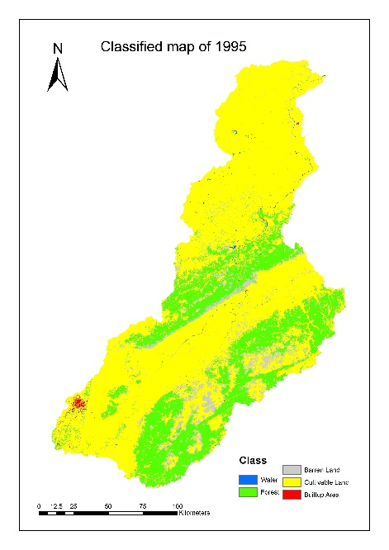 | 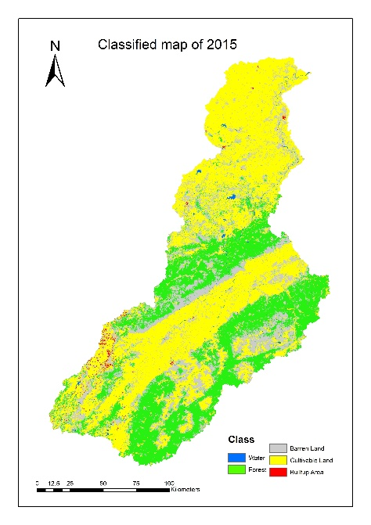 | 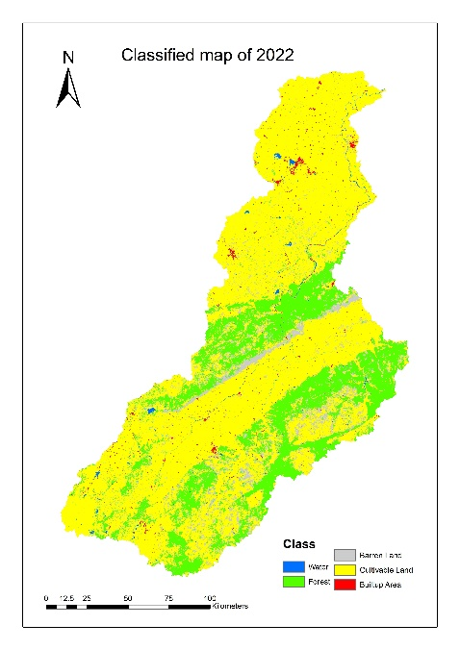

Fig. 2 classified map of the study area

Table 5 Area statistics of different land use classes of different years
 | 1995 |  | 2015 |  | 2022
Classes | Area  (km²) | Area % | Area  (km²) | Area % | Area  (km²) | Area %
Water | 97.61 | 0.34 | 154.74 | 0.54 | 198.50 | 0.69
Forest | 7066.26 | 24.49 | 8425.30 | 29.20 | 6714.52 | 23.27
Barren land | 1639.17 | 5.68 | 2822.06 | 9.78 | 1794.11 | 6.22
Cultivable land | 19914.70 | 69.03 | 17228.30 | 59.71 | 19559.14 | 68.32
Built-Up area | 133.30 | 0.46 | 220.63 | 0.76 | 433.75 | 1.50
Total | 28851.03 | 100 | 28851.03 | 100 | 28851.03 | 100

4.2 Landscape Analysis of Ken Basin
The classified images from three individual years were analyzed using landscape metrics to assess how the patterns of land use and land cover (LULC) classes changed over time (Table 6). Forests in the study area increased from 1995 to 2015; however, the number of forest patches rose dramatically from 30,533 to 51,317. By 2022, the forest area had decreased, indicating that many forest patches had disappeared during this period (Fig. 2). This increase in the number of patches suggests that the forests in this region became increasingly fragmented over the study period.

The primary cause of fragmentation in the forested areas can be attributed to significant settlement growth in the northern and southern parts of the study area, coupled with the expansion of agricultural land. Numerous studies worldwide have similarly identified the expansion of agricultural and settlement areas as key proximate drivers of forest degradation (Lepers et al., 2005; Sharma and Roy, 2007; Kumar et al., 2018; Sati et al., 2024).

Patch density for forests increased from 1995 to 2015 but subsequently declined from 2015 to 2022. Meanwhile, the Largest Patch Index (LPI) decreased throughout the study period. The Increase in Interspersion and Juxtaposition Index (IJI) for forests rose from 36.9731 in 1995 to 54.4047 in 2015, indicating that the patches were well interspersed and closely adjacent to other patch types. However, the IJI exhibited a decreasing trend in 2022, suggesting that the patches became less interspersed and not equally adjacent to other patch types over time.

Forest degradation was highlighted by increasing edge density from 2015 compared to 1995. Edge density also increased in 2022 relative to 1995, despite the decrease in forest area during this period, further indicating the degradation of forested regions.

Built-up areas represented another highly variable patch type, demonstrating continuous and rapid growth over time. The number of patches (NP) in built-up areas surged from 3,944 to 16,164 throughout the study period, while patch density (PD) increased from 0.1367 per 100 hectares in 1995 to 0.5632 per 100 hectares by 2022. Agricultural areas emerged as one of the most predominant land cover classes. Their NP decreased from 25,383 to 23,146 between 1995 and 2015, then rebounded to 24,844 in 2022. However, the LPI for agricultural land decreased from 66.228% in 1995 to 34.53% in 2022, signifying a decline in the predominance of this LULC type within the study area.
Table 6 Class-level landscape metrics
YEAR | CLASS | NP | PD | LPI | TE | ED | LSI | IJI
1995 | Water | 1555 | 0.0539 | 0.0189 | 1966710 | 0.6817 | 51.9304 | 13.0383
 | Forest | 30533 | 1.0584 | 3.9635 | 46801710 | 16.2227 | 140.5482 | 36.9731
 | Barren Land | 24255 | 0.8407 | 0.2141 | 26731050 | 9.2657 | 170.4689 | 45.8178
 | Cultivated Land | 25383 | 0.8798 | 66.228 | 59995590 | 20.796 | 108.0622 | 63.3741
 | Built-Up Area | 3944 | 0.1367 | 0.1027 | 2452020 | 0.8499 | 65.9403 | 34.622
2015 | Water | 2194 | 0.0761 | 0.0477 | 2758110 | 0.956 | 55.2617 | 69.9459
 | Forest | 51317 | 1.7788 | 3.5949 | 60902010 | 21.1106 | 168.8707 | 54.4047
 | Barren Land | 53501 | 1.8545 | 1.4179 | 77607060 | 26.9011 | 256.6567 | 61.034
 | Cultivated Land | 23146 | 0.8023 | 22.1094 | 72530370 | 25.1414 | 152.3424 | 64.7481
 | Built-Up Area | 9544 | 0.3308 | 0.0227 | 5601750 | 1.9417 | 105.7928 | 73.5421
2022 | Water | 2837 | 0.0989 | 0.042 | 3525540 | 1.2285 | 63.4455 | 50.7584
 | Forest | 43757 | 1.5247 | 3.5048 | 49191150 | 17.1403 | 153.6213 | 33.5311
 | Barren Land | 39844 | 1.3883 | 0.2391 | 33882150 | 11.806 | 213.1394 | 43.1967
 | Cultivated Land | 24844 | 0.8657 | 34.5339 | 79983150 | 27.8696 | 143.1183 | 75.5357
 | Built-Up Area | 16164 | 0.5632 | 0.0637 | 9543510 | 3.3254 | 134.6062 | 47.7048

- Conclusion
This study examined changes in land use and land cover (LULC) in the Ken Basin and quantified the landscape structure, patterns, and dynamics from 1995 to 2022 using geospatial technology and FRAGSTATS software. The results indicate that, with the exception of settlements, no significant trends were observed in other land cover classes, while settlements demonstrated a notable upward trend.
FRAGSTATS analysis revealed an increase in landscape fragmentation over time, primarily driven by escalating human-induced disturbances. This fragmentation is evidenced by changes in patch composition, connectivity, and spatial distribution, indicating a decline in overall landscape integrity. The increasing dominance of anthropogenic activities—such as urbanization, agricultural expansion, and resource extraction—has severely disrupted the natural landscape structure.
Understanding how changes in landscape fragmentation within this river basin affect ecosystems, groundwater, hydrology, and the overall environment is crucial for enhancing and sustaining future planning and management efforts. This knowledge is essential for preserving landscape integrity and supporting sustainable livelihoods in the region.
Disclaimer (Artificial intelligence)
Option 1:
Author(s) hereby declare that NO generative AI technologies such as Large Language Models (ChatGPT, COPILOT, etc.) and text-to-image generators have been used during the writing or editing of this manuscript.

References
Anderson, J.R., Hardy, E.E., Roach, J.T., Witmer, R.E., 1976. A Land use and land cover classification system for use with remote sensor data. Geological Survey Professional Paper 964 U. S. Govt. Printing Office, Washington.
Buczyńska, Anna., Remote sensing and GIS technologies in land reclamation and landscape planning processes on post-mining areas in the Polish and world literature. AIP Conference Proceedings. (2020). 2209. 040002. 10.1063/5.0000009.
Burai, P., Deák, B., Valkó, O., Tomor, T., Classification of Herbaceous Vegetation Using Airborne Hyperspectral Imagery. Remote Sens. (2015). 7, 2046-2066. https://doi.org/10.3390/rs70202046
Chin, A., 2006. Urban transformation of river landscapes in a global context. Geomorphology 79 (3), 460–487. https://doi.org/10.1016/j.geomorph.2006.06.033.
Chuen Siang Kang,C.S., Kanniah, K.D., Land use and land cover change and its impact on river morphology in Johor River Basin, Malaysia. Journal of Hydrology: Regional Studies 41 (2022) 101072
Cushman SA., McGarigal K., Neel MC., Parsimony in land scape metrics: strength, universality, and consistency. Ecol Indic 8:691–703 (2002). https:// doi. org/ 10. 1016/j. ecoli nd. 2007. 12. 002
Desta, H. and Fetene, A. (2020) Land-Use and Land-Cover Change in Lake Ziway Watershed of the Ethiopian Central Rift Valley Region and Its Environmental Impacts. Land Use Policy, 96, Article ID: 104682.
https://doi.org/10.1016/j.landusepol.2020.104682
Gabril EMA., Denis DM., Nath S, Paul A., Kumar M., Quanti fying LULC change and landscape fragmentation in Prayagraj district, India using geospatial techniques. Pharma Innov J (2019).
Gabril, EMA., Denis DM., Nath S., Paul A., Kumar M., Quantifying LULC change and landscape fragmentation in Prayagraj district, India using geospatial techniques. The Pharma Innovation Journal (2019).
Geng, X., Wang, X., Yan, H., Zhang, Q., Jin, G., 2015. Land use/land cover change induced impacts on water supply service in the upper reach of Heihe River Basin. Sustainability 7 (1), 366–383. 〈https://www.mdpi.com/2071-1050/7/1/366〉.
Griffith JA., Martinko EA., Price KP Landscape structure analysis of Kansas at three scales. Landsc Urban Plan (2000). 52:45–61. https://doi.org/10.1016/S0169-2046(00)00112-2
Ibitoye, M.O., 2021. A remote sensing-based evaluation of channel morphological characteristics of part of lower river Niger, Nigeria. SN Appl. Sci. 3 (3), 340. https:// doi.org/10.1007/s42452-021-04215-1.
Jensen, J.R., Introductory Digital Image Processing. Prentice-Hall, Englewood Cliffs, (1996). NJ, pp. 318
Kudnar, N.S., 2020. GIS-based assessment of morphological and hydrological parameters of Wainganga River Basin, Central India. Model. Earth Syst. Environ. 6 (3), 1933–1950. https://doi.org/10.1007/s40808-020-00804-y.
Kumar M., Denis DM., Singh SK., Szabó S., Suryavanshi S,. Landscape metrics for assessment of land cover change and fragmentation of a heterogeneous watershed. Remote Sensing Applications: Society and Environment. (2018) 10:224-233. https://doi.org/10.1016/j.rsase.2018.04.002
Leitáo ,B., Miller, J., Ahern, J., McGarigal, K., Measuring Landscapes. A Planner‘s Handbook. Island Press, Washington. (2006)
Lepers, E., Lambin, E.F., Janetos, A.C., DeFries, R., Achard, F., Ramankutty, N., Scholes, R.J., 2005. A synthesis of information on rapid land-cover change for the period 1981–2000. BioScience 55, 115–124.
McGarigal K., Cushman SA., Neel MC., Ene E FRAGSTATSv3., spatial pattern analysis program for categorical maps. (2002) Ministry of Coal., Govt. of India., (2024) https://coal.nic.in/
Mustaquim, M., & Islam, W. (2023). Multitemporal Analysis of Land Use/Cover Changes and Landscape Fragmentation in Murshidabad District of West Bengal, India. Current World Environment, 18(2), 647-661. https://doi.org/https://dx.doi.org/10.12944/CWE.18.2.18
Mustaquim, M., & Islam, W. (2024). Analysing Land Use and Cover Transformations in Berhampore, West Bengal, India: A CA-Markov and ANN Simulation Approach for Future Predictions. Agric Res. https://doi.org/10.1007/s40003-024-00745-3
Nascimento, F.S.; Gastauer, M.; Souza-Filho, P.W.M.; Nascimento, W.R., Jr.; Santos, D.C.; Costa, M.F. Land Cover Changes in Open-Cast Mining Complexes Based on High-Resolution Remote Sensing Data. Remote Sens. 2020, 12, 611. https://doi.org/10.3390/rs12040611
Olsen, L.M., Dale, V.H., Foster, T., 2006. Landscape patterns as indicators of ecological change at Fort Benning, Georgia, USA. Landsc. Urban Plan. 79, 137–149.
Patra, T., Dutta, D., Kundu, A. et al. Evolution of Opencast Mines in the Raniganj Coalfield (India): An Assessment through Multi-temporal Satellite Data. J Geol Soc India 98, 387–394 (2022). https://doi.org/10.1007/s12594-022-1990-5
Paudel, S., Yuan, F., 2012. Assessing landscape changes and dynamics using patch ana lysis and GIS Modelling. Int. J. Appl. Earth Obs. Geoinf. 16, 66–76.
Pyngrope, O.R., Kumar, M., Pebam, R. et al. Investigating forest fragmentation through earth observation datasets and metric analysis in the tropical rainforest area. SN Appl. Sci. 3, 705 (2021). https://doi.org/10.1007/s42452-021-04683-5
Rao, B. V. M., Mani, A., Devi, B. S., Vishnuvardhan, S., & Rao, C. S. (2023). Spatial and temporal variations of land use and land cover in Kadiri watershed using RS & GIS techniques. International Journal of Plant & Soil Science, 35(15), 23–31. https://journalijpss.com/index.php/IJPSS/article/view/3069

Riitters KH., O’neill RV., Hunsaker CT., Wickham JD., Yankee DH., Timmins SP., Jones KB., Jackson BL., A factor analysis of landscape pattern and structure metrics. Landscape Ecol 10:23 39. https://doi.org/10.1007/BF00158551 (1995)
Sati, V.P., Banerjee, S., Roy, C., Land Use and Land Cover Dynamics and Factors Affecting It in The Central Himalaya. Malaysian Applied Geography (MAGG) 2(2) 35-43 (2024).
Sharma, S., Roy, P.S., Forest fragmentation in the Himalaya: A Central Himalayan case study. Int. J. Sustain. Dev. World Ecol. 14, 201 210 (2007)
Singh, S.K., Srivastava, P.K., Szilard, S., Petropoulos, G.P., Gupta, M., Islam, M., 2016. Landscape transform and spatial metrics for mapping spatiotemporal land cover dynamics using Earth Observation data-sets. Geocarto Int. 1–15. http://dx.doi.org/ 10.1080/10106049.2015.1130084.
Wang, F., Ge, Q., Yu, Q., Wang, H., Xu, X., 2017. Impacts of land-use and land-cover changes on river runoff in Yellow River basin for period of 1956–2012. Chin. Geogr. Sci. 27 (1), 13–24. https://doi.org/10.1007/s11769-017-0843-3.
Yuan, F., Sawaya, K.E., Loeffelholz, B.C., Bauer, M.E., 2005. Land cover classification and change analysis of the Twin Cities (Minnesota) Metropolitan Area by multitemporal Landsat remote sensing. Remote Sens. Environ. 98, 317–328.

