Assessment of Amuruto River Water Quality Using Weighted Arithmetic Water Quality Index (WAWQI), Rivers State, Nigeria

.

# ABSTRACT

|  |
| --- |
| Water quality assessment is critical for monitoring environmental health, human safety, and aquatic life sustainability. This study evaluates the water quality of Amuruto River using the Weighted Arithmetic Water Quality Index (WAWQI) model for both wet and dry seasons. Various physicochemical and biological parameters were analyzed, and their impact on water quality was assessed. The wet season recorded a higher WAWQI score, indicating more severe pollution due to flooding and runoff, while the dry season showed increased chemical pollution due to reduced dilution. This study highlights the impact of agricultural runoff, petroleum spillages, timber processing, and sand mining on overall water quality. Results indicate a significant deterioration in water quality during the dry season, with a WAWQI of 27934.04, categorizing the river as "unsuitable for drinking." The wet season exhibited comparatively better conditions, with a WAWQI of 412.43, though still falling into the "very poor" category. Correlation analysis between individual parameters and overall water quality showed that Total Hydrocarbon Content (THC), TDS, Phosphates, Nitrates and Chemical Oxygen Demand (COD) were the most influential pollutants, due to anthropogenic activities and runoff and flooding. The findings emphasize the need for season-specific pollution control strategies. The strategies include industrial and domestic effluent control, wastewater treatment and public awareness, are recommended to restore water quality.  ***Key Words:*** *Assessment, Water Quality, Parameters, Contaminants, Season, Amuruto River* |

# 1. INTRODUCTION

Water quality assessment involves the comprehensive evaluation of the physical, chemical, and biological characteristics of a given body of water (Karo-Emebeyo, et al. 2023). The Weighted arithmetic water quality index (WAWQI) method is a good analytical tool for water quality index assessment of surface water (Patki, et al. 2022; Islam, et al. 2020). Rivers are essential for sustaining ecosystems, supporting human life, and facilitating economic activities (Prachi & Rajiv 2020). Surface water pollution has become a major concern due to rapid urbanization, industrial activities and climate-induced hydrological changes (Singh et al., 2020). However, increasing industrialization, agricultural runoff, and domestic waste discharge threaten water quality, leading to significant environmental and health concerns. Seasonal factors such as flooding and runoff can increase chemical pollution due to reduced dilution (Brown et al., 1970; WHO, 2024). Contamination of the freshwater ecosystem with petroleum may result from mishandling, deliberate disposal, spilling and leakage of petroleum products such as gasoline, lubricating oils, diesel fuel, heating oils, used and spent engine oil (Ekanem et al., 2021). Hydrocarbon contamination, exposes surface and underground water to toxic elements including benzene (which is a carcinogenic substance), and affects the quality of drinking water (UNEP, 2021). Monitoring the condition of aquatic ecosystems is important because they provide ecological goods and services on which human beings depend (Cornel et al., 2023). Several research had linked the deterioration of water quality in rivers and streams to increased agricultural activity along their reaches and catchments (Mohammed et al., 2020; Edegbene et al., 2023). Oil activities in the Niger Delta Area of Nigeria have increased the levels of organic, inorganic and microbial contaminants in surface water bodies in the area (Okoro & Diejomaoh 2022 & Ewim et al., (2023). WAWQI is the most important and standard tool used for surface and groundwater quality assessment by water resources management and sanitation agencies worldwide (Li et al., 2016). Elevated values of pollution of physicochemical and bacteriological variables poses a harsh ecological threat to the majority of aquatic organisms, particularly macroinvertebrates, in aquatic environments (Omovoh et al., 2022). Open defecation is a common practice amongst dweller in the Niger Delta and this has a far-reaching implication on the natural quality of water of bodies in the area which serves as a primary source of water for domestic use and a mean of livelihood (Uruh & Yusuf 2022). This study focuses on the Amuruto River, evaluating its water quality for both wet and dry seasons using the Weighted Arithmetic Water Quality Index (WAWQI) model, which provides a comprehensive assessment of pollution levels. Water quality index methods has been widely field tested and used to calculate and evaluate the water quality indices of many water bodies (Sandra et al, 2023; Gautam et al. 2021; Menberu et al. 2021; Hagage et al. 2022; Nandi et al. 2022; Ojukwu et al. 2022; Rahul et al. 2022). Kalagbor et al., (2019) provided a basis for expressing water quality by using just a single value leading to easier interpretation of the state of these rivers. The data obtained from water quality assessment and monitoring supplied empirical evidence needed for health and environmental decision making (Olubukola et al. 2021). The Weighted arithmetic water quality index (WAWQI) method is a good analytical tool for water quality index assessment of surface water (Patki et al, 2022; Islam, et al, 2020). WAWQI is the most important and standard tool used for surface and groundwater quality assessment by water resources management and sanitation agencies worldwide (Li et al., 2016). To fully understand the anthropogenic impact on biogeochemical cycles, studies must collectively consider the biogeochemical turnover and exchange among the atmosphere, and the aquatic and terrestrial ecosystems (Beusen et al. 2015).

**1.1 Aim and Objectives of the Study**

The study aim to assess Amuruto River Water Quality for Wet Season and Dry Season; Using Weighted Arithmetic Water Quality Index (WAWQI) and the objectives are to:

1. Determine the water quality rating of Amuruto River for wet season and dry season.
2. Assess seasonal variations in water quality.
3. Identify the most significant pollutants contributing to river degradation.
4. Propose remedial measures for improving the river's water quality.

**Empirical Review**

***2.4.1 Evolution of Water Quality Index Modeling***

Water quality index (WQI) modeling has been an important tool for assessing and managing water resources since the 1960s. In the late 1960s, the National Sanitation Foundation (NSF) developed the first WQI model, which included nine parameters: pH, temperature, dissolved oxygen, total dissolved solids, turbidity, total phosphorus, total nitrogen, fecal coliform bacteria, and biochemical oxygen demand. This model was based on a review of existing water quality indices and extensive field studies in the Ohio River. In the 1970s and 1980s, the US Environmental Protection Agency (EPA) developed several WQI models for different water resource types, including rivers, lakes, and estuaries. These models incorporated additional parameters such as conductivity, hardness, and alkalinity (USEPA, 2001). In the 1990s, the Canadian Council of Ministers of the Environment (CCME) developed the Canadian Water Quality Index (CCME WQI), which included 10 parameters: pH, temperature, dissolved oxygen, conductivity, total suspended solids, turbidity, total phosphorus, total nitrogen, fecal coliform bacteria, and Escherichia coli bacteria (CCME, 2001). In recent times, there has been a growing focus on developing WQI models that incorporate ecosystem health and resilience, as well as socio-economic factors such as land use and human activities. Watershed Health Assessment Framework (WHAF) developed by the US Geological Survey includes indicators of ecosystem health such as biological diversity and habitat quality, as well as human activities such as land use and population density (USGS, 2018). According to Rickwood and Carr 2009), CCME-WQI was adapted for use across 75 countries under the GEMS/Water Programme with three different versions of the index adapted with WHO guidelines. There are two indices that contain separate water quality measures: the health water quality index (HWQI), based on health guidelines and the acceptability water quality index (AWQI) based on acceptability or aesthetic guidelines. Another water quality index is the drinking water quality index (DWQI) which integrates all of the water quality measures in HWQI and AWQI together. Rickwood and Carr (2009) stated that developing the indices, the indicators for fecal contamination should be left out when levels always exceed 0 / 100 mL in most lakes and rivers. Monitoring and measuring models help in continuous recording of concentrations of nitrogen and phosphorus levels, which can be managed through process control technologies like integrated buffer zones, which seem to offer excellent retention capabilities (Sravani et al. 2020).

***2.4.2******Nigerian Industrial Standards for Drinking Water Quality (NISDWQ)***

The Nigerian industrial standards for drinking water quality (NISDWQ), established by the Standards Organization of Nigeria (SON), specify the permissible limits for various physical, chemical, and microbiological parameters in drinking water (NISDWQ/SON 2015) as shown in Table 1. These standards are based on the world health organization's guidelines for drinking-water quality (WHO/GDWQ) and are regularly reviewed and updated by standard organization of Nigeria (SON). It's worth noting that these standards apply to all sources of drinking water, including surface water, groundwater, and treated piped water supply systems

***2.4.3 Comparative Review of Global Water Quality Indexes***

Water quality index WQI addresses traditional methods of water quality assessment which encompass a wide-range of water quality parameters not feasible to measure due to cost and time constraints (Roohollah et al. 2019). Water quality index (WQI) is a tool used to evaluate and communicate the overall water quality of a given water body based on multiple water quality parameters. WQI provides a simple and effective way to communicate the water quality status to stakeholders and decision-makers. Several water quality index (WQI) models have been developed and used for the assessment of physicochemical and microbial parameters of rivers around the world. Prominent among them are: weight arithmetic water quality index (WAWQI), national sanitation foundation water quality index (NSFWQI), Canadian council of ministers of the environment water quality index (CCMEWQI), Oregon water quality index (OWQI) and Indian national water quality index (INWQI). Water quality indices (WQI) was initially developed in United States by Horton (Horton 1965), he selected ten most frequently used water quality parameters and assigned weight that signified the impact of the index, this tool has been utilized in Asia, Europe and Africa. Brown et al. (1970), developed another WQI that attached individual weights to water quality parameters. Dwivedi et al. (1997) reviewed modifications of WQI concepts. Recently, Prachi & Rajiv (2020) utilized different water quality indices such as National Sanitation Foundation Method (NSFWQI) and Bureau of Indian Standard Water Quality Index (BISWQI) in determining the indices. The researchers based general water quality approach on three main factors: parameter selection, determination of quality function (curve) for each parameter considered as the sub-index and sub-indices aggregation with mathematical expressions. Evaluation of water quality in region are mostly based on difference in number and variety of water quality parameters compared with known standards. WQI results are usually in a single value and it helps regulatory authorities to identify existing water quality and define effective management plans for deteriorating aquatic systems (Tyagi et al. 2013; Rana et al. 2018). Prachi and Rajiv (2020) reported a new approach in determining water quality indexing is presented through introduction of a Modified Water Quality Index (MWQI) which utilizes the maximum number of parameters and thereby provides a means to reduce ambiguity and eclipsing problems of WQI.

**2.5 Case Studies of WQI Used for Water Assessment**

Sandra et al. (2023) noted that WQI has been widely field tested and is used to calculate and evaluate the WQI of many water bodies. Water quality index (WQI) is a value-based method representing the overall water quality in terms of a single and crisp value, generally called an index number (Shwetank et al. 2020). The history of water quality assessment is abound with several aggregate indices composed of multiple water quality parameters been used to assess and compare the health aspects of water bodies as Lumb et al. (2011 and Sutadian et al. (2016)) used water quality index (WQI) to study several lakes showed fair water quality in monsoon season which then changed to medium in winter and poor for summer season. Multivariate statistical techniques (MST) and water quality identiﬁcation index (WQI) can be used to analyze spatiotemporal variation in water quality and determine the major pollution sources and results show that MST and WQII are useful tools to help the public and decision makers to evaluate the water quality of aquatic environment. And DOE-WQI has been used to calculate the concentration of DO, BOD, COD, SS, pH and NH3-N, noted that industrial and municipal wastes, agricultural and run-off from developing areas were mixing with river flow and surrounding water body thereby deteriorating the quality water quality. Canadian council of ministers of the environment (CCME) WQI weighed method can be used to assess water quality and as change in stream temperature is very likely to impact on surface water quality and aquatic ecosystem dynamics. Gradient boosting model (GBM) can be used to examine water quality and forecasted with the help of automatic water parameter measuring. The model can evaluates the water quality and anticipates the change that demonstrates the future water quality. Rim-Rukeh & Agbozu (2013) used Malaysian Water Quality Index (MWQI) to asses of Epie creek in Bayelsa, Niger Delta. Wireless sensor network (WSN) system can be used to determine the water quality parameters such as: turbidity, temperature, water quality, pH, and temperature of river. Principal component analysis (PCA) and hierarchical cluster analysis (HCA) methods can also be used to evaluate complex water quality data and to explore the sources of pollution. Water Quality Index (WQI) and simple water quality rating techniques are used to assess the suitability of the water samples collected from different river bodies. WQI to characterize drinking source water quality and proved that WQI is a valuable tool to monitor, communicate, and understand surface source water quality. WQI is considered a simple method to evaluate overall water quality and has been widely used and its values for each sampling location were determined using weight values assigned according to their relative importance for drinking purposes to each water quality parameter. Several literatures assesses the different parameters which affect the water quality (Singh et al. 2018; Sener et al. 2017; Kangabam et al. 2017; Fathi et al. 2018). Kalagbor et al. (2019) provided a basis for expressing water quality by using just a single value leading to easier interpretation of the state of these rivers. Several freshwater rivers in Rivers State and Niger Delta have been assessed for water quality using different models of water quality index (WQI). Some of these rivers and the WQI models used for their assessment are highlighted in Table 1.

**Table 1: Some freshwater rivers in Niger Delta, assessed using WQI models**

|  |  |  |
| --- | --- | --- |
| **Rivers** | **Author** | **Findings** |
| Nun River, Bayelsa State | Arimoro et al. (2015) | Water quality of the Nun River was generally poor, with a mean WQI value of 30.94 |
| Ekogbene River, Delta State | Kumar and Singh (2005 | Water quality of the Ekogbene River was generally poor, with a WQI value of 33.8 |
| Amassoma River, Bayelsa State | Ademoroti et al., 2017 | Water quality of the Amassoma River was generally poor, with a mean WQI value of 31.46. |
| Orashi River, Rivers State, | Magesh et al. (2012). | Water quality of the Orashi River was generally poor, with a WQI value of 39.19 |
| Niger River | CCME (2001) | Water quality of the Niger River was generally poor, with a WQI value of 37.65. |
| Kolo creek | (Agedah, et al 2015, Ogamba, et al 2015, Ogamba, et al. 2017, Aghoghovwia and Ohimain, 2014 and Eremasi, et al. 2015) |  |
| Igbedi creek | Seiyaboh, et al. 2013 |  |
| Ikoli creek | Ogamba, et al. 2015 |  |
| Nun River | Ogamba, et al. 2015 |  |
| Taylor creek | Nwankwoala, et al. 2016; Angaye et, al. 2015 |  |
| Sagbama Creek | Seiyaboh, et al., 2017 |  |
| Kumar and Singh's WQI Model | Kumar and Singh (2005) |  |

Source: Ogamba et al, (2017)

# 2. METHODOLOGY

**2.1 Study Area**

Amuruto River lies between latitude 4o 44’12.39756”N and longitude 6o 27’ 43.605”E.in Abua/Odual Local Government Area of Rivers State, Niger Delta, Nigeria (see figure 1 and figure 2). Amuruto River is an all season fresh water river with two tidal flow patterns. Amuruto River once hosted the first crude oil loading terminal (Kugbo loading bay) in Nigeria before the advent of crude oil pipeline system from the then from Shell B.P, Oloibiri oil field in late 1960s. Amuruto River is one of the rivers impacted by several crude oil spillages from the Nigeria Agip Oil Company (NAOC) owned and operated Ogoda-Brass 24 inches crude oil pipeline, without adequate compensations, environmental cleanup or remediation as also noted by (Helen et al., 2023). Several creeks (Ogbaru, Oghololo, Osobo, Osabiri, Otuatin and obhi-Oghu) empty into Amuruto River. Fishing, marine transportation, lumbering, sand mining, cassava processing, palm oil processing mills and open defecation are some of the human activities on the river (see plates 1 - 6 appendix 2). Residents use water from Amuruto River for drinking, bathing, washing and other cleaning activities.

**2.2 Sample Collection**

The study utilized experimental methods of sample collection and analysis; field observation, questionnaire administration and structured interview. A total of forty eight surface water samples were collected from randomly selected points at upstream, midstream and downstream of Amuruto River during the wet season (April–June) and dry season (December–February) using GPS to determine its coordinates (see Table 2 & 3).

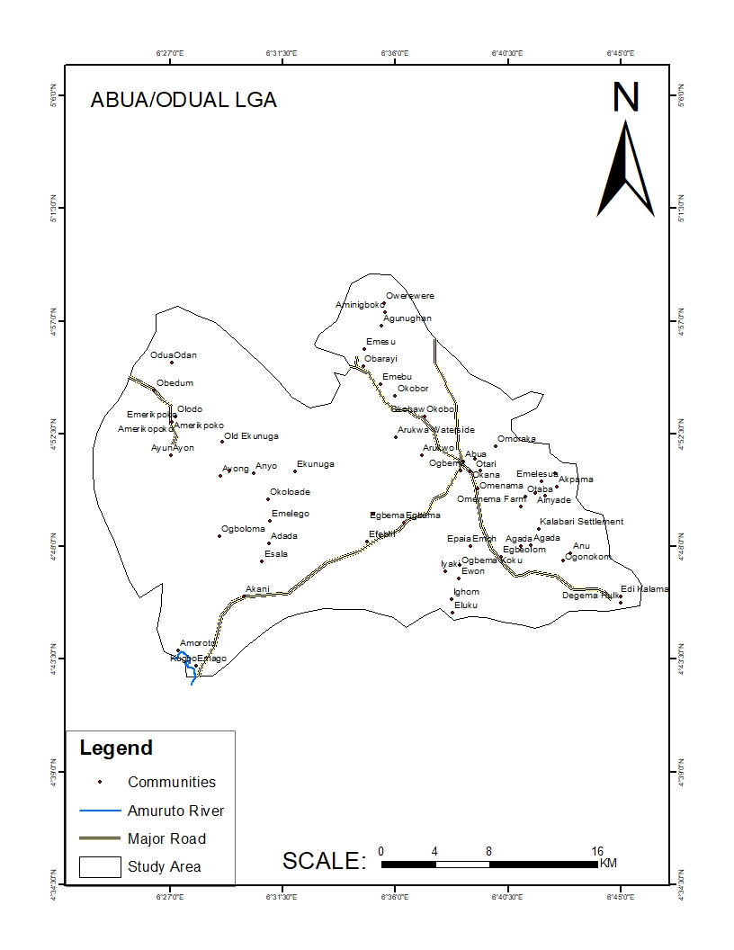

**Figure 1: Map of Abua/Odual L.G.A. showing Amuruto River**

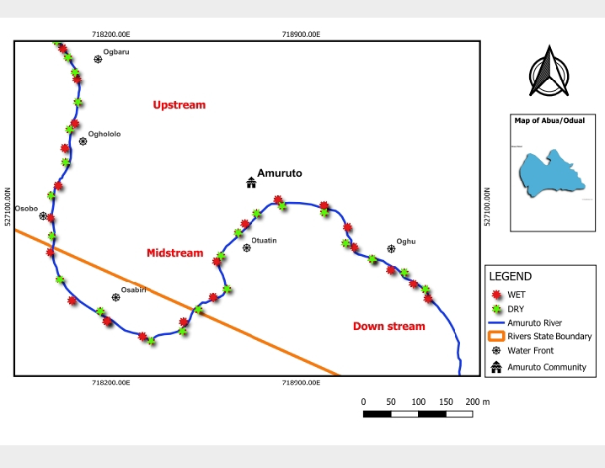

**Figure 2: Map of Sampled points on Amuruto River for wet and dry season**

**2.3 Data Analysis**

APHA (2012) and CPCB, (2017) in-situ experimental and laboratory protocols was followed in sampling and analysis of physicochemical and bacteriological water quality parameters. Temperature, pH, Electrical Conductivity (EC), Total Dissolved Solids (TDS), Dissolved Oxygen (DO), Turbidity, Nitrate, Phosphates, Alkalinity, and Color (physicochemical parameters), Biological Oxygen Demand (BOD), Chemical Oxygen Demand (COD), Total Hydrocarbon Content (THC) ( (organic and inorganic pollutants) and Total Coliform Bacteria, Escherichia coli, and Staphylococcus aureus (microbiological contaminants) were evaluated according to Prachi & Rajiv (2020) who utilized about twenty parameters to experimentally determine water quality indices. A simple WAWQI equation (see equation 1) was used to determine the water quality indices of the parameters. Three basic steps was followed in WQI determination. The first step is determining the weightage level (wi) for each water quality parameter (see equation 2). The second step is to determine the relative weight (Wi) for each water quality parameter (see equation 3) and then determine the quality rating value (Qi) (see equation 4). The third and last step calculated the values of WQI for quality parameters using (see equation 5). WAWQI was used to determine the overall water quality of for wet season and dry season. Correlation between wet season WQI and dry season WQI of the analyzed water quality parameters was determined. A convenience sampling approach was used for questionnaire administration (see appendix 3) based on the conveniently available population of respondents due to the agrarian and rural nature of the study area.

**Table 2: Coordinates for Wet Season Sampled Points on Amuruto River**

|  |  |  |  |  |  |  |  |
| --- | --- | --- | --- | --- | --- | --- | --- |
| **SAMPLE PERIOD** | **DATE OF SAMPLING** | **COORDINATES OF SAMPLE ZONE/POINTS** | | | | | |
| **Upstream** | | **Midstream** | | **Downstream** | |
| **Ogbaru** | **Oghololo** | **Osobo** | **Osabiri** | **Otuatin** | **Oghu** |
| WET SEASON | 3rd July,  2023 | Latitude  N 4o43’31.34316” | Latitude  N 4o43’56.96832” | Latitude  N 4o43’36.12” | Latitude  N 4o 43’42.42828” | Latitude  N 4o 43’46.07076” | Latitude  N 4o 43’36.90408” |
| Longitude  E 6o27’9.84996” | Longitude  E 6o27’1.152” | Longitude  E 6o27’18.95976” | Longitude  E 6o 27’20.13084” | Longitude  E 6o 27’32.56884” | Longitude  E 6o27’42.9426” |
| 13th August, 2023 | Latitude  N 4o43’38.13312” | Latitude  N 4o 43’49.88604” | Latitude  N 4o43’37.38432” | Latitude  N 4o43’37.11936” | Latitude  N 4o43’36.68052” | Latitude  N 4o43’36.90408” |
| Longitude  E 6o2741.87232” | Longitude  E 6o26’59.7372” | Longitude  E 6o27’42.77016” | Longitude  E 6o2742.91596” | Longitude  E 6o27’43.50456” | Longitude  E 6o27’42.9426’’ |
| 17th September, 2023 | Latitude  N 4o43’46.78392” | Latitude  N 4o43’46.49088” | Latitude  N 4o43’46.07076” | Latitude  N 4o43’40.14012” | Latitude  N 4o27’39.73008” | Latitude  N 4o43’38.2404” |
| Longitude  E 6o27’30.14316” | Longitude  E 6o27’31.44204” | Longitude  E 6o27’32.56884” | Longitude  E 6o27’38.18988” | Longitude  E 6o27’39.42468” | Longitude  E 6o27’41.73876” |
| 24th October, 2023 | Latitude  N 4o44’2.86512” | Latitude  N 4o44’1.6638” | Latitude  N 4o44’0.62592” | Latitude  N 4o43’59.93832” | Latitude  N 4o43’56.96832” | Latitude  N 4o43’54.48684” |
| Longitude  E 6o27’1.8252” | Longitude  E 6o27’2.29716” | Longitude  E 6o272.27556” | Longitude  E 6o27’2.13084” | Longitude  E 6o27’1.152” | Longitude  E 6o27’0.93024” |

**Table 3: Coordinates of Dry Season Sampled Points on Amuruto River**

|  |  |  |  |  |  |  |  |
| --- | --- | --- | --- | --- | --- | --- | --- |
| **SAMPLE PERIOD** | **DATE OF SAMPLING** | **COORDINATES OF SAMPLE ZONE/POINTS** | | | | | |
| **Upstream** | | **Midstream** | | **Downstream** | |
| **Ogbaru** | **Oghololo** | **Osobo** | **Osabiri** | **Otuatin** | **Oghu** |
| DRY SEASON | 3rd November, 2023 | Latitude  N 4o43’42.42828” | Latitude  N 4o43’43.27752” | Latitude  N 4o43’43.73904” | Latitude  N 4o43’44.44356” | Latitude  N 4o43’45.15528” | Latitude  N 4o43’45.70788” |
| Longitude  E 6o27’20.13084” | Longitude  E 6o27’20.745” | Longitude  E 6o27’21.40848” | Longitude  E 6o27’22.20624” | Longitude  E 6o27’22.99392” | Longitude  E 6o27’23.5026” |
| 13th December, 2023 | Latitude  N 4o43’42.42828” | Latitude  N 4o43’36.77376” | Latitude  N 4o43’37.74324” | Latitude  N 4o43’38.27496” | Latitude  N 4o43’38.90208” | Latitude  N 4o43’40.95336” |
| Longitude  E 6o27’20.13084” | Longitude  E 6o27’19.65816” | Longitude  E 6o27’19.737” | Longitude  E 6o2719.77588” | Longitude  E 6o27’19.3842” | Longitude  E 6o27’19.197” |
| 17th January, 2024 | Latitude  N 4o43’32.3418” | Latitude  N 4o43’32.95992” | Latitude  N 4o43’35.94288” | Latitude  N 4o43’36.12” | Latitude  N 4o43’36.12” | Latitude  N 4o43’36.1902” |
| Longitude  E 6o27’14.11308” | Longitude  E 6o27’15.40404” | Longitude  E 6o27’18.72648” | Longitude  E 6o27’18.95976” | Longitude  E 6o27’18.95976” | Longitude  E 6o27’19.11816” |
| 10th February, 2024 | Latitude  N 4o44’6.53028” | Latitude  N 4o44,4.9182” | Latitude  N 4o44’3.60276” | Latitude  N 4o43’34.30668” | Latitude  N 4o43’34.91976” | Latitude  N4o43’39.28908” |
| Longitude  E 6o26’59.83836” | Longitude  E 6o27’0.8892” | Longitude  E 6o27’1.55196” | Longitude  E 6o27’4.851” | Longitude  E 6o27’3.6288” | Longitude  E 6o26’59.35128” |

**2.6 Weighted Arithmetic Water Quality Index (WAWQI)**

Using water quality mean values of pH, Electrical conductivity, total dissolved solids, dissolved solids, phosphates, turbidity, nitrates, biological oxygen demand chemical oxygen demand, alkalinity, color, total hydrocarbon content, total coliform bacteria, Escherichia coli bacteria and staphylococcus aureus parameters of Amuruto River water for wet season and dry season (Table 4 & Table 5) to calculate the weighted arithmetic water quality index (WAWQI) of the water. Calculating water quality of Amuruto River for wet season and dry season with WHO, 2017 standard and ideal values of drinking water for each parameters, calculated quality rating (𝑞𝑖) and unit weight (𝑤𝑖) and 𝑊𝐴𝑊𝑄𝐼 for all parameters. Using Weighted Arithmetic Water Quality Index (WAWQI), we follow these steps:

Formula for WAWQI = $\frac{Σ_{i=1}^{n}Q_{i}W_{i}}{Σ_{i=1}^{n}W_{i}}$ (1)

Where: Quality Rating (𝑞𝑖) : 𝑞𝑖 = Quality rating for each parameter.

(𝑞𝑖) = $\frac{Measured value-Ideal value}{Standard value-Ideal value} × 100$ (2)

Where: 𝑉𝑖: Observed value of the parameter, 𝑆𝑖: Standard permissible limit of the parameter and 𝑉*0* = (ideal value) is usually zero for all parameters except pH and DO. For pH, the ideal value is 7, and for DO, the ideal value is typically 14.6 mg/L (saturation at 0°C).

Unit Weight (𝑤𝑖): 𝑤𝑖  = Unit weight for each parameter

(𝑤𝑖) =

Weighted arithmetic water quality index (WAWQI): = $\frac{Sum of Weighted contributions }{Sum of weights}$

WAWQWI $= \frac{Σ(qi × wi)}{(Σwi)}$ (4)

# 3.0 RESULTS AND DISCUSSIONS

**3.1 Calculating WAWQI of Amuruto River for Wet Season and Dry Season**

Using the physicochemical parameters and bacteriological parameter water quality mean values of Amuruto River water (Tables 1, 4, 5, 6 and 7) to calculate the weighted arithmetic water quality index (WAWQI) of the water for wet season and dry season. Calculating water quality rating of Amuruto River for wet season and dry season with WHO, 2017 standard and ideal values of drinking water for each parameters, calculated quality rating (𝑞𝑖) and unit weight (𝑤𝑖) and 𝑊𝐴𝑊𝑄𝐼 for all parameters. Adopting Equations 1, 2, 3 and 4 for calculating Weighted Arithmetic Water Quality Index (WAWQI).

**Table 4: WHO, 2017 drinking water standard values and ideal values water quality parameters used in calculating Amuruto River water WAWQI for wet season**

|  |  |  |  |
| --- | --- | --- | --- |
| **Parameter** | **Measured Value (mv)** | **WHO,2024 Standard**  **Value (sv)** | **Ideal Value (iv)** |
| pH | 6.275833 | 8.5 | 7 |
| Electrical conductivity (EC, µS/cm) | 6.275833 | 8.5 | 7 |
| Total dissolved solids (TDS, mg/L) | 1029.213 | 500 | 0 |
| Dissolved oxygen (DO, mg/L) | 686.2558 | 300 | 0 |
| Turbidity (NTU) | 7.786667 | 5 | 14.6 |
| Total suspended solids (m/L) | 10.48167 | 5 | 0 |
| Nitrate (mg/L) | 68.32334 | 50 | 0 |
| Phosphates (mg/L) | 61.09333 | 10 | 0 |
| Biological oxygen demand (BOD, mg/L) | 0.446084 | 0.1 | 0 |
| Chemical oxygen demand (COD, mg/L) | 12.21084 | 6 | 0 |
| Alkalinity (mg/L) | 519.8559 | 10 | 0 |
| Color (TCU) | 268.7408 | 120 | 0 |
| Total Hydrocarbon content (THC, mg/L) | 29.025 | 15 | 0 |
| Total coliform bacteria (MPN/100Ml) | 266.8308 | Nil | 0 |
| Escherichia coli bacteria (MPN/100Ml) | 377.5 | 0 | 0 |
| Staphylococcus aureus (MPN/100Ml) | 185.83 | 0 | 0 |

3.2 WAWQI Calculations for Wet Season

Using the measured values, standard values, ideal values in Table 4 to calculate quality rating, unit rates and weighted contribution of water quality parameters for wet season as shown in Table 5 for wet season.

pH: Measured Value = 6.275833, Ideal Value = 7, Standard Value = 8.5  
Quality Rating (𝑞pH): qpH = = = − 48.28

Unit Weight (𝑤pH): wpH = = 0.117647 Weighted Contribution (𝑞pH x 𝑤pH): − 48.28 × 0.117647 = − 5.68

Electrical conductivity (EC): Measured Value = 1029.213 µS/cm, Ideal Value = 0 µS/cm, Standard Value = 500 µS/cm  
Quality Rating (𝑞EC): 𝑞EC = = = 205.84

Unit Weight (𝑤EC): 𝑤EC = = 0.002 Weighted Contribution (𝑞EC x 𝑤EC): = 𝑞EC x 𝑤EC = 205.84 × 0.002 = 0.0457

Total dissolved solids (TDS): Measured Value = 686.2558 mg/L, Ideal Value = 0 mg/L, Standard Value = 300 mg/L

Quality Rating (𝑞TDS): qTDS = = = 228.75   
Unit Weight (𝑤TDS): wTDS = = 0.0033  
Weighted Contribution (𝑞TDS x 𝑤TDS): qTDS x wTDS = 228.75 × 0.0033 = 0.7549

Dissolved oxygen (DO): Measured Value = 7.786667 mg/L, Ideal Value = 14.6 mg/L, Standard Value = 5 mg/L  
Quality Rating (𝑞DO): qDO = = 70.97

Unit Weight (𝑤DO): wDO = = 0.2 Weighted Contribution (𝑞DO x 𝑤DO): qDO = 70.97 × 0.2 = 14.194

Turbidity (NTU): Measured Value = 10.48167 NTU, Ideal Value = 0 NTU, Standard Value = 5 NTU  
Quality Rating (𝑞Turbidity): qTurbidity = =209.63  
​Unit Weight (𝑤Turbidity): *w*Turbidity = Weighted Contribution (𝑞Turbidity x 𝑤Turbidity): 𝑞Turbidity x 𝑤Turbidity = 209.63 × 0.2 = 41.93

Total suspended solids (mg/L): Measured Value = 68.32334 mg/L, Ideal Value = 0 mg/L, Standard Value = 50 mg/L  
Quality Rating (𝑞Turbidity): qTSS = =136.65  
​Unit Weight (𝑤Turbidity): *w*TSS = Weighted Contribution (𝑞TSS x 𝑤TSS): 𝑞Turbidity x 𝑤TSS = 209.63 × 0.2 = 2.733

Nitrate (mg/L): Measured Value = 61.09333 mg/L, Standard Value = 10 mg/L, Ideal Value = 0 mg/L  
Quality Rating (𝑞Nitrate): qNitrate = = 610.933  
Unit Weight (𝑤Nitrate):wNitrate = = 0.01 Weighted Contribution (𝑞Nitrate x 𝑤Nitrate): qNitrate x wNitrate ): 610.933 × 0.01 = 6.44

Phosphates (mg/L): Measured Value = 0.446084 mg/L, Ideal Value = 0 mg/L, Standard Value = 0.1 mg/L  
Quality Rating (*𝑞Phosphates*): *qPhosphates* =   
Unit Weight (*𝑤Phosphates*): *wPhosphates* = = 10.0 Weighted Contribution (𝑞*Phosphates* x𝑤*Phosphates*): *qPhosphates* x *wPhosphates* = 446.08 × 10 = 4460.84

Biological oxygen demand (BOD): Measured Value = 12.21084 mg/L, Standard Value = 6 mg/L, Ideal Value = 0 mg/L  
Quality Rating (𝑞BOD): qBOD =   
Unit Weight (𝑤BOD): wBOD = = 0.1667 Weighted Contribution (𝑞BOD x 𝑤BOD): qBOD x wBOD = 203.51 × 0.1667 = 33.92

Chemical oxygen demand (COD): Measured Value = 519.8559 mg/L, Standard Value = 10 mg/L, Ideal Value = 0 mg/L  
Quality Rating (𝑞COD): qCOD = 5198.56

Unit Weight (𝑤COD): wCOD = = 0.1 Weighted Contribution (𝑞COD x COD𝑤): CODq x CODw = 5198.56 × 0.1 = 519.86

Alkalinity (mg/L): Measured Value = 268.7408 mg/L, Standard Value = 120 mg/L, Ideal Value = 0 mg/L  
Quality Rating (𝑞Alkalinity): qAlkalinity = = 223.95  
Unit Weight (𝑤Alkalinity): wAlkalinity = = 0.00833 Weighted Contribution (𝑞Alkalinity x 𝑤Alkalinity): qAlkalinity x wAlkalinity = 223.95 × 0.00833 =1.87

Color (TCU): Measured Value = 29.025 TCU, Standard Value = 15 TCU, Ideal Value = 0 TCU

Quality Rating (𝑞Color): qColor = = 193.5  
Unit Weight (𝑤Color): wColor = = 0.0667 Weighted Contribution (𝑞Color x 𝑤Color): qColor x wColor = 193.5 × 0.0667 = 12.906

Total Hydrocarbon content (THC): Measured Value = 266.8308 mg/L, Standard Value = 0, Ideal Value = 0 TCU

Since the standard value is 0, Total Hydrocarbon content (THC) contamination of the water is grossly unsafe for consumption.

Total coliform bacteria (TCB): Measured Value = 377.5MPN/100mL, Standard Value = 0 MPN/100mL, Ideal Value = 0 MPN/100mL. Since the standard value is 0. Coliform contamination is automatically considered unsafe.

Escherichia coli bacteria (ECB): Measured Value = 185.83 MPN/100mL, Standard Value = 0 MPN/100mL, Ideal Value = 0 MPN/100mL. Similarly, E. coli contamination is automatically considered unsafe.

Staphylococcus aureus bacteria (SAB); Measured Value = 74 MPN/100mL, Standard Value = 0 MPN/100mL, Ideal Value = 0 MPN/100mL. Staphylococcus aureus contamination is also deemed unsafe.

**3.3 Summing Up WAWQI Components for Wet Season**

**2.3.1 Weighted Contributions ∑(𝑞𝑖 x 𝑤𝑖)**

Sum of Weighted Contributions ∑(𝑞𝑖 x 𝑤𝑖): = 5.68 + 0.0457+ 0.7549 + 14.194 + 41.933 + 2.733 + 6.1093 + 4460.84 + 33.922 + 519.86 + 1.87 + 12.91 = 5089.492

**2.3.2 Sum of Weights (∑𝑤𝑖)**

Sum of Weights = 0.117647 + 0.002 + 0.0033 + 0.2 + 0.2 + 0.02 + 0.01 + 10.0 + 0.1667 + 0.1 + 0.0083 + 0.0667 = 10.8946

WAWQI = $\frac{Σ(qi × wi)}{(Σwi)}$ = $\frac{Sum of Weighted contributions }{Sum of weights}$ = $\frac{5089.492}{10.8946}=467.157$

The Weighted Arithmetic Water Quality Index (WAWQI) result for Amuruto River using mean values of 16 water quality parameters for wet season water is 467.2. WAWQI for wet season = 467.2. See table 5 for summary of computation of WAWQI for wet season.

**Table 5: Summary of WAWQI computations of each water quality parameter for wet season**

|  |  |  |  |  |  |  |
| --- | --- | --- | --- | --- | --- | --- |
| **Parameter** | **Measured value *(mv)*** | **WHO,2024 standard**  **value *(sv)*** | **Ideal value *(iv)*** | **Quality rating *(qi)*** | **Unit weight**  **(𝑤𝑖)** | **Weighted contributions *(𝑞𝑖 x 𝑤𝑖)*** |
| pH | 6.275833 | 8.5 | 7 | -48.28 | 0.117647 | − 5.68 |
| Electrical Conductivity (EC, µS/cm) | 1029.213 | 500 | 0 | 205.84 | 0.002 | 0.0457 |
| Total dissolved solids (TDS, mg/L) | 686.2558 | 300 | 0 | 228.75 | 0.0033 | 0.7549 |
| Dissolved oxygen (DO, mg/L) | 7.786667 | 5 | 14.6 | 70.97 | 0.2 | 14.194 |
| Turbidity (NTU) | 10.48167 | 5 | 0 | 209.63 | 0.2 | 41.933 |
| Total suspended solids (m/L) | 68.32334 | 50 | 0 | 136.65 | 0.02 | 2.733 |
| Nitrate (mg/L) | 61.09333 | 10 | 0 | 610.933 | 0.01 | 6.1093 |
| Phosphates (mg/L) | 0.446084 | 0.1 | 0 | 446.08 | 10.0 | 4460.84 |
| Biological oxygen demand (BOD, mg/L) | 12.21084 | 6 | 0 | 203.51 | 0.1667 | 33.922 |
| Chemical oxygen demand (COD, mg/L) | 519.8559 | 10 | 0 | 5198.56 | 0.1 | 519.86 |
| Alkalinity (mg/L) | 268.7408 | 120 | 0 | 223.95 | 0.0083 | 1.87 |
| Color (TCU) | 29.025 | 15 | 0 | 193.5 | 0.0667 | 12.91 |
| Total hydrocarbon content (THC, mg/L) | 266.8308 | Nil | 0 | - | - | - |
| Total coliform bacteria (MPN/100Ml) | 377.5 | 0 | 0 | - | - | - |
| Escherichia coli bacteria (MPN/100Ml) | 185.83 | 0 | 0 | - | - | - |
| Staphylococcus aureus (MPN/100Ml) | 74 | 0 | 0 | - | - | - |
| WAWQI for wet season = $\frac{Σ(qi × wi)}{(Σwi)}$ | | | | | 10.8946 | 5089.492 |

**Table 6: WHO, 2017 drinking water standard values and ideal values water quality parameters used in calculating Amuruto River water WAWQI for dry season**

|  |  |  |  |
| --- | --- | --- | --- |
| **Parameter** | **Measured value (mv)** | **WHO,2024 standard**  **value (sv)** | **Ideal value (iv)** |
| pH | 6.275833 | 8.5 | 7 |
| Electrical conductivity (EC, µS/cm) | 1029.213 | 500 | 0 |
| Total dissolved solids (TDS, mg/L) | 686.2558 | 300 | 0 |
| Dissolved oxygen (DO, mg/L) | 7.786667 | 5 | 14.6 |
| Turbidity (NTU) | 10.48167 | 5 | 0 |
| Total suspended solids (m/L) | 68.32334 | 50 | 0 |
| Nitrate (mg/L) | 61.09333 | 10 | 0 |
| Phosphates (mg/L) | 0.446084 | 0.1 | 0 |
| Biological oxygen demand (BOD, mg/L) | 12.21084 | 6 | 0 |
| Chemical oxygen demand (COD, mg/L) | 519.8559 | 10 | 0 |
| Alkalinity (mg/L) | 268.7408 | 120 | 0 |
| Color (TCU) | 46.38334 | 15 | 0 |
| Total Hydrocarbon content (THC, mg/L) | 175.33 | Nil | 0 |
| Total coliform bacteria (MPN/100Ml) | 35.35 | 0 | 0 |
| Escherichia coli bacteria (MPN/100Ml) | 170.1669 | 0 | 0 |
| Staphylococcus aureus (MPN/100Ml) | 72.8334 | 0 | 0 |

**3.4 WAWQI Calculations for Dry Season**

Using the measured values, standard values, ideal values in Table 6 to calculate quality rating, unit rates and weighted contribution of water quality parameters for wet season as shown in Table 7 for dry season. Applying formulas 4.1, 4.2, 4.3 and 4.4.

pH: Measured Value = 6.208334, Standard Value = 8.5, Ideal Value = 7

Quality Rating (𝑞pH): qpH = = = -52.777

Unit Weight (𝑤pH): wpH = = 0.117647 Weighted Contribution (𝑞pH x 𝑤pH): pH x 𝑤Ph= -52.777 × 0.117647 = -6.2091

Electrical Conductivity (EC): Measured Value = 1042.225 µS/cm, Standard Value = 500 µS/cm, Ideal Value = 0

Quality Rating (𝑞EC): 𝑞EC = = = 208.445

Unit Weight (𝑤EC): 𝑤EC = = 0.002 Weighted Contribution (𝑞EC x 𝑤EC): =   
𝑞EC x 𝑤EC = 2.08445 × 0.002 = 0.4169

Total dissolved solids (TDS): Measured Value = 694.0625 mg/L, Standard Value = 300 mg/L, Ideal Value = 0  
Quality Rating (𝑞TDS): qTDS = = = 23.021   
Unit Weight (𝑤TDS): wTDS = = 0.0033 Weighted Contribution (𝑞TDS x 𝑤TDS): qTDS x wTDS = 23.021 × 0.0033 = 0.0760

Dissolved oxygen (DO): Measured Value = 8.565834 mg/L, Standard Value = 5 mg/L, Ideal Value = 14.6 mg/L  
Quality Rating (𝑞DO): qDO = = 62.8559

Unit Weight (𝑤DO): wDO = = 0.2 Weighted Contribution (𝑞DO x 𝑤DO): qDO = 62.8559 × 0.2 = 12.5712

Turbidity: Measured Value = 8.356667 NTU, Standard Value = 5 NTU, Ideal Value = 0  
Quality Rating (𝑞Turbidity): qTurbidity = =167.133  
​Unit Weight (𝑤Turbidity): *w*Turbidity = Weighted Contribution (𝑞Turbidity x 𝑤Turbidity): 𝑞Turbidity x 𝑤Turbidity = 167.133 × 0.2 = 33.43

Total suspended solids (TSS): Measured Value = 81.47834 mg/L, Ideal Value = 50 mg/L, Standard Value = 0 mg/L  
Quality Rating (𝑞Turbidity): qTSS = =162.957  
​Unit Weight (𝑤Turbidity): *w*TSS = Weighted Contribution (𝑞TSS x 𝑤TSS): 𝑞TSS x 𝑤TSS = 162.957 × 0.02 = 3.259

Nitrate: Measured Value = 57.50083 mg/L, Standard Value = 10 mg/L, Ideal Value = 0

Quality Rating (𝑞Nitrate): qNitrate = = 575.008  
Unit Weight (𝑤Nitrate): wNitrate = = 0.01 Weighted Contribution (𝑞Nitrate x 𝑤Nitrate): qNitrate x wNitrate ): 575.008 × 0.01 = 5.7501

Phosphates: Measured Value = 0.461833 mg/L, Standard Value = 0.1 mg/L, Ideal Value = 0

Quality Rating (*𝑞Phosphates*): *qPhosphates* =   
Unit Weight (*𝑤Phosphates*): *wPhosphates* = = 10.0 Weighted Contribution (𝑞*Phosphates* x𝑤*Phosphates*): *qPhosphates* x *wPhosphates* = × 10 = 4618.33

Biological oxygen demand (BOD): Measured Value = 12.4575 mg/L, Standard Value = 6 mg/L, Ideal Value = 0  
Quality Rating (𝑞BOD): qBOD =   
Unit Weight (𝑤BOD): wBOD = = 0.1667 Weighted Contribution (𝑞BOD x 𝑤BOD): qBOD x wBOD = 207.61 × 0.1667 = 34.611

Chemical oxygen demand (COD): Measured Value = 547.6134 mg/L, Standard Value = 10 mg/L, Ideal Value = 0 mg/L  
Quality Rating (𝑞COD): qCOD = 5476.13

Unit Weight (𝑤COD): wCOD = = 0.1 Weighted Contribution (𝑞COD x COD𝑤): CODq x CODw = 5476.13 × 0.1 = 54.761

Alkalinity (mg/L): Measured Value = 283.5217 mg/L, Standard Value = 120 mg/L, Ideal Value = 0 mg/L  
Quality Rating (𝑞Alkalinity): qAlkalinity = = 236.27  
Unit Weight (𝑤Alkalinity): wAlkalinity = = 0.00833 Weighted Contribution (𝑞Alkalinity x 𝑤Alkalinity): qAlkalinity x wAlkalinity = 236.27 × 0.00833 = 1.968

Color (TCU): Measured Value = 46.38334 TCU, Standard Value = 15 TCU, Ideal Value = 0 TCU

Quality Rating (𝑞Color): qColor = = 309.22  
Unit Weight (𝑤Color): wColor = = 0.0667 Weighted Contribution (𝑞Color x 𝑤Color): qColor x wColor = 309.22 × 0.0667 = 20.67

Total Hydrocarbon content (THC); Measured Value = 175.33 mg/L, Standard Value = 0, Ideal Value = 0 TCU. Since the standard value is 0, Total Hydrocarbon content (THC) contamination of the water is grossly unsafe for consumption.

Total coliform bacteria (TCB): Measured Value = 35.35 MPN/100mL, Standard Value = 0 MPN/100mL, Ideal Value = 0 MPN/100mL. Since the standard value is 0. Coliform contamination is automatically considered unsafe.

Escherichia coli bacteria (ECB): Measured Value = 170.1669 MPN/100mL, Standard Value = 0 MPN/100mL  
Ideal Value = 0 MPN/100mL. Similarly, E. coli contamination is automatically considered unsafe.

Staphylococcus aureus bacteria (SAB); Measured Value = 72.83334 MPN/100mL, Standard Value = 0 MPN/100mL. Ideal Value = 0 MPN/100mL, Staphylococcus aureus contamination is also deemed unsafe.

**3.5 Summing Up WAWQI Components for Dry Season**

**3.5.1 Sum of weighted contributions ∑(𝑞𝑖 x 𝑤𝑖)**

Sum of weighted contributions ∑(𝑞𝑖 x 𝑤𝑖) = -6.2091 + 0.4169 + 0.0760 + 12.5712 + 22.43 + 3.259 + 5.7501 + 4618.33 + 34.611 + 54.761 + 236.27 + 20.63 = 5272.824

**3.5.2 Sum of Weights (∑𝑤𝑖)**

Sum of weights = 0.117647 + 0.002 + 0.0033 + 0.2 + 0.2 + 0.02 + 0.01 + 10.0 + 0.1667 + 0.1 + 0.00833 + 0.0667 = 10.894677

WAWQI = $\frac{Σ(qi × wi)}{(Σwi)}$ = $\frac{Sum of Weighted contributions }{Sum of weights}$ = $\frac{5527.824}{10.894677}=507.39$

Weighted Arithmetic water quality index (WAWQI) result using mean values of water quality parameters for dry season is 507.39. WAWQI for dry season = 507. See table 7 for summary of computation of WAWQI for dry season and Table 8 for weighted contributions of both wet and dry seasons.

**Table 7: Summary of WAWQI computation of each water quality parameter for dry season**

|  |  |  |  |  |  |  |
| --- | --- | --- | --- | --- | --- | --- |
| **Parameter** | **Measured value (mv)** | **WHO, 2024 standard**  **value (sv)** | **Ideal value (iv)** | **Quality rating (qi)** | **Unit weight (𝑤𝑖)** | **Weighted contributions**  **(𝑞𝑖 x 𝑤𝑖)** |
| pH | 6.208334 | 8.5 | 7 | -52.777 | 0.117647 | -6.2091 |
| Electrical conductivity (EC, µS/cm) | 1042.225 | 500 | 0 | 208.445 | 0.002 | 0.4169 |
| Total dissolved solids (TDS, mg/L) | 694.0625 | 300 | 0 | 23.021 | 0.0033 | 0.0760 |
| Dissolved oxygen (DO, mg/L) | 8.565834 | 5 | 14.6 | 62.8559 | 0.2 | 12.5712 |
| Turbidity (NTU) | 8.356667 | 5 | 0 | 167.133 | 0.2 | 33.43 |
| Total suspended solid (mg/L) | 81.47834 | 50 | 0 | 162.957 | 0.02 | 3.259 |
| Nitrate (mg/L) | 57.50083 | 10 | 0 | 575.008 | 0.01 | 5.7501 |
| Phosphates (mg/L) | 0.461833 | 0.1 | 0 | 461.833 | 10.0 | 4618.33 |
| Biological oxygen demand (BOD, mg/L) | 12.4575 | 6 | 0 | 207.61 | 0.1667 | 34.611 |
| Chemical oxygen demand (COD, mg/L) | 547.6134 | 10 | 0 | 5476.13 | 0.1 | 54.761 |
| Alkalinity (mg/L) | 283.5217 | 120 | 0 | 236.27 | 0.00833 | 1.968 |
| Color (TCU) | 46.38334 | 15 | 0 | 309.22 | 0.0667 | 20.67 |
| Total Hydrocarbon content (THC, mg/L) | 175.33 | Nil | 0 | 87665.0 | - | - |
| Total coliform bacteria (MPN/100Ml) | 35.35 | 0 | 0 | - | - | - |
| Escherichia coli bacteria (MPN/100Ml) | 170.1669 | 0 | 0 | - | - | - |
| Staphylococcus aureus (MPN/100Ml) | 72.8334 | 0 | 0 | - | - | - |
| WAWQI for dry season = $\frac{Σ(qi × wi)}{(Σwi)}$ | | | | | 10.89468 | 5272.824 |

**Table 8: Weighted contribution for both wet season and dry Seasons**

|  |  |  |
| --- | --- | --- |
| **Parameter** | **Wet season weighted contribution** | **Dry season weighted contribution** |
| pH | − 5.68 | -6.2091 |
| Electrical conductivity (EC, µS/cm) | 0.0457 | 0.4169 |
| Total dissolved solids (TDS, mg/L) | 0.7549 | 0.0760 |
| Dissolved oxygen (DO, mg/L) | 14.194 | 12.5712 |
| Turbidity (NTU) | 41.933 | 33.43 |
| Total suspended solids (m/L) | 2.733 | 3.259 |
| Nitrate (mg/L) | 6.1093 | 5.7501 |
| Phosphates (mg/L) | 4460.84 | 4618.33 |
| Biological oxygen demand (BOD, mg/L) | 33.922 | 34.611 |
| Chemical oxygen demand (COD, mg/L) | 519.86 | 54.761 |
| Alkalinity (mg/L) | 1.87 | 1.968 |
| Color (TCU) | 12.91 | 20.67 |
| Total Hydrocarbon content (THC, mg/L) | - | - |
| Total coliform bacteria (MPN/100Ml) | - | - |
| Escherichia coli bacteria (MPN/100Ml) | - | - |
| Staphylococcus aureus (MPN/100Ml) | - | - |
| WAWQI for dry season = $\frac{Σ(qi × wi)}{(Σwi)}$ | 5089.492 | 5272.824 |

**3.6 Interpretation of WAWQI for Wet Season and Dry Season Water**

According to the WAWQI rating threshold and its suitability in Table 9, the WAWQI for Amuruto River (467.2) for wet season is highly polluted beyond the WAWQI rating and exceeds the WHO, 2017 and other known drinking water standards. The water requires significant treatment as it is unsuitable for most uses. The high index is primarily due to parameters such as phosphates, chemical oxygen demand (COD) and turbidity, which have significantly high weights and ratings. Steps for remediation should prioritize these parameters. Phosphates has a contributing factor of 4460.849mg/L, chemical oxygen demand (COD) 519.86mg/L and turbidity 41.93mg/L. Immediate remediation is needed to control phosphates, COD, and turbidity pollution levels in the Amuruto River. Further testing and treatment are essential to make the water fit for human consumption. WAWQI of 507.4 for Amuruto River for dry season falls under the category of "unsuitable for drinking" based on the WAWQI classification. Key contributing factors such as total hydrocarbon content (THC) has an overwhelming influence on the WAWQI with a weighted contribution of 438325.0. Phosphates, COD and color also significantly exceed the WHO, 2017 permissible limits. Bacteriological parameters (Total Coliform, E. coli, and staphylococcus aureus) indicate severe contamination. Tables 8 explains WAWQI rating and its suitability.

**Table 9: WAWQI rating threshold and its suitability**

|  |  |  |  |  |
| --- | --- | --- | --- | --- |
| **WAWQI Range** | **Water Quality Status** | **Description** | **Color Code** | **Possible Uses** |
| 0 - 50 | Excellent | Water quality is pure and fit for drinking without treatment. | Green | Drinking, domestic, all uses. |
| 51 - 100 | Good | Suitable for drinking, but may require minimal treatment. | Light Green | Drinking (minimal treatment). |
| 101 - 200 | Poor | Not suitable for direct drinking but can be used for irrigation and industrial use. | Yellow | Irrigation, industrial use. |
| 201 - 300 | Very Poor | Unsuitable for drinking and domestic purposes; suitable only for industrial use. | Orange | Industrial, restricted irrigation. |
| > 300 | Unsuitable | Highly polluted, requires significant treatment; unsuitable for most uses. | Red | No direct uses; requires treatment. |

*Source: (Kumar et al., 2022)*

**3.6 Potential Concerns on Use of WAWQI**

There are some potential concerns about the determination of WQI using weighted arithmetic water quality index (WAWQI), see Table 10 the advantages and disadvantages. The main problems associated with water quality indexing are data eclipsing and ambiguity limitations, opacity and misinterpretations based on integrated methods (Swamee & Tyagi 1999, 2000). According to Swamee & Tyagi, (2000), the ambiguity can be related to spatial measurements in a water body since it’s not considered in the water quality indexing approach. Rigidity of parameters is one such problem which creates a lack of flexibility in terms of the concerned parameters and utilization in calculation of the concerned index.

**Table 10: Advantages and disadvantages of Weight Arithmetic WQI**

|  |  |
| --- | --- |
| **Advantages** | **Disadvantages** |
| Incorporate data from multiple water quality parameters into a mathematical equation that rates the health of water body with number  Less number of parameters required in comparison to all water quality parameters for particular use.  Useful for communication of overall water quality information to the concerned citizens and policy makers  Reflects the composite influence of different parameters i.e important for the assessment and management of water quality  Describe the suitability of both surface and groundwater sources for human consumption. | WQI may not carry enough information about the real quality situation of the water  Any uses of water quality data cannot be met with an index,  The eclipsing or over-emphasizing of a single bad parameter value  A single number cannot tell the whole story of water quality; there are many other water parameter that are not included in the index,  WQI based on some very important parameters can produce a simple indicator on water quality. |

*Source: (Patil et al. 2020)*

**3.7 Correlation Analysis of Analyzed Water Quality Parameters**

Results from the correlation matrix (see appendix 1) indicated that Temperature was highly correlated with color (0.97), indicating that temperature changes significantly affected the visual properties of water, likely due to changes in dissolved or suspended substances. strong negative correlation with THC (-0.95), suggesting temperature changes could inversely affect total hydrocarbon concentrations. Positive correlation with TSS (0.83) and DO (0.70), indicating that higher temperatures might increase suspended solids and oxygen solubility in water. pH has negative correlation with EC (-0.74) and BOD (-0.66), suggesting that lower pH (more acidic conditions) is associated with higher electrical conductivity and BOD. It might be due to increased nutrient solubility under acidic conditions, leading to higher BOD. Electrical Conductivity (EC) has positive correlation with TDS (0.63) and Nitrates (0.81), indicating that EC is a good indicator of dissolved solids and nutrient content in the water. Strong positive relationships with COD (0.73), TSS (0.70), and Staphylococcus concentrations (0.74), meaning EC could serve as a proxy for pollutant loads in the water. Total Dissolved Solids (TDS) has a very strong correlation with Phosphates (0.96), indicating a significant relationship between TDS levels and phosphate concentrations. This could mean higher dissolved solid content often co-occurs with higher nutrient pollution. High correlation with COD (0.90), which implies that dissolved solids significantly contribute to the chemical oxygen demand. Positive relationships with Staphylococcus concentrations (0.71), DO (0.73), and Nitrates (0.65), suggesting that TDS content is linked to both organic and inorganic pollutants, including pathogens like staphylococcus. Dissolved Oxygen (DO) has strong correlations with Phosphates (0.98), COD (0.93), and Staphylococcus concentrations (0.81) suggest that higher dissolved oxygen levels are associated with nutrient and organic pollution, potentially driving microbial activity. The positive relationship with BOD (0.71) shows that as DO increases, biological oxygen demand rises, possibly due to microbial respiration linked to nutrient pollution. Nitrates showed high correlation with BOD (0.88), Staphylococcus concentrations (0.66), and a moderate positive relationship with TSS (0.62), which highlights that nitrate pollution may contribute to higher biological oxygen demand and bacterial growth in the water. Phosphates shows strong positive correlations with BOD (0.88), COD (0.92), and Staphylococcus concentrations (0.72) indicate that phosphate pollution is a significant contributor to oxygen demand and microbial contamination in water. Biological oxygen demand (BOD) was is strongly correlated with COD (0.75) and Staphylococcus concentrations (0.78), which aligns with the understanding that higher biological activity and organic pollution drive both chemical oxygen demand and bacterial growth. Chemical oxygen demand (COD) exhibited strongest correlation is with Staphylococcus concentrations (0.85), suggesting that high levels of organic pollutants also foster bacterial growth, which could be a key indicator of water quality degradation. Turbidity and Total Suspended Solids TSS) was positively correlated with Alkalinity (0.74), BOD (0.78), and Nitrates (0.62), meaning that suspended solids are likely connected to both the nutrient content and the organic matter in the water. Turbidity has a moderate positive correlation with THC (0.62) and Staphylococcus (0.64), suggesting that higher turbidity (cloudiness) may be associated with hydrocarbon pollution and microbial contamination.

**3.8 Respondents Views on Amuruto River Water Quality**

The results of the questionnaire survey (see appendix 3) shows a total 191 males representing 68.9% and 86 females representing 31.0% of respondents. 124 respondents are between the age 26 -124yrs, 68 respondents are between the age 15-25yrs, 63 respondents are between the age 51-60yrs and only 22 persons are between the age 60yrs and above. 183 respondents were married, 74 single and 20 divorced or separated. The study survey showed 68 respondents had nuclear family type, 209 had joint/extended family type. The 105 respondents had household of 6-10 persons, 73 respondents. 11-15 persons, 65 had 1-5 persons and 34 respondents had 16 and above number of persons in a household. See table for the sex, age brackets and the number of household members resident in Amuruto community. 118 respondents were farmers (942.%), 44 were are into fishing, 21 lumbering, 16 palm produce, 19 business and 30 unemployed (10.8%). 52.3% of respondents are SSCE/GCE holders 47 persons are HND/BSC holders while 11 persons only had no formal education. Over 40% of respondents had lived in Amuruto for over 20 years. The survey showed that the resident’s main source of water for its household is Amuruto River is used mainly for washing and other hygiene services. Amuruto River has the highest daily water usage by residents than other water sources. Residents visit Amuruto River often for water source and other important resource utilization for fishing, swimming, washing clothes, fishing, drinking water collection, transportation, lumbering activities, palm oil milling cassava processing and defecation. The survey identified open water defecation, crude oil spillages, exotic aquatic weeds invasion and perennial flooding as the main sources of pollution of Amuruto River. Other factors identified by the survey include household wastes, lumbering activities, palm oil milling and cassava processing along the Amuruto River. The survey change of the color of water, obstruction of water ways by exotic aquatic weeds, shallow and narrowing of river course poor fish yield, unusual changes in water levels falling of trees and stumps along the river and general pollution are the environmental changes observed by respondents on the Amuruto River. Respondents also agreed to experiencing health concerns such as stooling, stomach aches, vomiting, skin rashes, coughing and cold while using water from Amuruto River. Respondents are very concerned about the environmental health condition of the Amuruto River describing the condition of water from the river as very poor mostly in the wet season. The survey revealed that the community placed ban on disposal of domestic wastes into the river, communal effort in manually clearing aquatic weeds, ban chemical fishing and calls for government and corporate intervention in providing enclosed laterine system for Amuruto Community.

# 4. SUMMARY, CONCLUSIONS & RECOMMENDATIONS

4.1 Summary

The results of assessment of water quality parameters and modeling of nutrients loading of Amuruto river from July, 2022 (wet season) – February, 2023) was analyzed in accordance to regulatory standard methods and weighted arithmetic water quality index rating of the water was determined for both seasons, correlation analysis of parameters was also determined and direct observation and questionnaire utilized to authenticated the outcome of this research. The water quality of the Amuruto River during the dry season is severely degraded and unfit for human consumption. Immediate action is required to address hydrocarbon pollution, nutrient contamination (phosphates and nitrates) and microbial (bacteria) contamination. Higher total dissolved solids (TDS) and conductivity in dry season was likely due to evaporation and reduced dilution capacity, increased COD and BOD was from industrial effluents, petroleum spillages and wastewater stagnation. Persistence of microbial pollution was due to insufficient river flushing. This results suggest that water from Amuruto River is unsuitable for drinking and even bathing without significant treatment. Both wet season and dry seasons indicate that Amuruto River water is unsuitable for drinking due to significantly high WAWQI values. The dry season shows a drastically higher WAWQI due to severe pollution, particularly from total hydrocarbon content (THC) and nutrients contamination. Urgent action is required to address hydrocarbon contamination, nutrient pollution (phosphates and nitrates) and bacterial contamination.

**4.4 Conclusions**

Results of the parameters monitored in all the locations of Amuruto River exceeded the WHO, 2017 standard limits for drinking water, except electrical conductivity value for dry season; therefore agrees with earlier report that such water quality was being seriously impaired. A WAWQI rating of 467.2 for wet season and 507.4 for dry shows how highly polluted Amuruto River water was as compared WAWQI rating scale of 100, exceeds WHO, 2017 drinking water standards. The water requires significant treatment as it is unsuitable for most uses as WAWQI rating for any river water above 100 falls under the category of "unsuitable for drinking" based on the WAWQI classification. There was significant seasonal variations in nutrient pollution in the Amuruto River as Nitrate and TDS show a strong positive correlation in the wet season but weaken in the dry season due to reduced dilution. Meanwhile, phosphate and microbial contamination maintain a moderate correlation, indicating continuous pollution from domestic and industrial activities. Nutrient loading in Amuruto River was higher in the dry season, exacerbated by reduced river flow and evaporation as there is strong correlations between nutrients and organic pollution indicators (BOD, COD, THC) suggest eutrophication risks. The wet season faces greater microbiological pollution due to runoff, while the dry season had more chemical pollution due to concentration effects. The dry season exhibited a drastic increase in pollution, making the water completely unsuitable for drinking. The wet season, though better, still fell into the "very poor" category, indicating persistent contamination. The high WAWQI indicates a severe water quality problem of the Amuruto River and is consistent with the high sub index values for each of the studied water quality parameters. The findings emphasized the need for season-specific pollution control strategies. The WAWQI result of Amuruto River water agrees with Ejiofor et, al. (2024) report that water sample from six different locations in six states of the Niger Delta (Nigeria) were very unsuitable for drinking, swimming and recreational activities as at the time of this study. Water from Amuruto River and any other freshwater river in the Niger Delta should be properly treated before consumption as the water is of low quality and constitute a danger to public health (Ewulonu,et al. 2019). Therefore, continuous monitoring of water quality of rivers and water bodies in the Niger Delta is essential to the sustenance of aquatic biodiversity, the environment and public health (Enetimi et al. 2016). Based on the study outcome, recommendations are made to improve the water quality management of the Amuruto River.

**4.3 Recommendations**

The under listed recommendations are possibilities to manage and reduce nutrient loading in the Amuruto River and ensuring better water quality and ecosystem health.

Regular monitoring of water quality parameters, including temperature, pH, EC, DO, turbidity, TSS, nitrate, phosphate, BOD, COD, alkalinity, color, THC, TCB, and Staphylococcus aureus.

Develop and enforce local and national regulations on harmful anthropogenic activities along the river banks and wastewater discharge to minimize nutrient loading into the river.

Periodically reevaluate and update models to incorporate new data and reflect changes in environmental conditions.

Implement measures to manage runoff and reduce pollution sources, especially during the wet season to lower contaminant levels and TCB.

Establish or restore riparian buffers along the riverbanks to reduce sediment and nutrient runoff into the river.

Develop and enforce local and national regulations on harmful anthropogenic activities along the river banks and wastewater discharge to minimize nutrient loading into the river.

Encourage research on tissue study of aquatic organism from Amuruto River to determine the absorption level of contaminants in river resources consumed by residents.

Promote sanitation programs to reduce open defecation and microbial contamination.

Implement continuous water quality monitoring programs to track changes in nutrients, TDS, and microbial loads.

Develop seasonal intervention plans to mitigate pollution spikes in both wet and dry seasons.

**4.4 Contribution to Knowledge**

This research contributes to knowledge by:

1. The Weighted arithmetic water quality index (WAWQI) of Amuruto River for wet season was 467.2 and 507 for dry season.
2. The WAWQI classified the water as very poor water quality and unsuitable for use except treated. Observed strong correlation between anthropogenic activities and water quality contamination in Amuruto River.
3. The research provided recent water quality data may be useful for sustainable management of Amuruto River water quality.

4.5 Further Research Areas

This study has opened up further research dimensions to Determine the absorption and adsorption rates of contaminants in edible aquatic resources from Amuruto River.

**Disclaimer (Artificial intelligence)**

Option 1:

Author(s) hereby declare that NO generative AI technologies such as Large Language Models (ChatGPT, COPILOT, etc.) and text-to-image generators have been used during the writing or editing of this manuscript.

References

American Public Health Association (APHA, 2012). Standard methods for the examination of water and wastewater, 22nd edn. American Public Health Association, Washington, DC.

Beusen, A. H. W., Van-Beek, L. P. H., Bouwman, A. F. , Mogollón, J. M. (2015). Coupling global models for hydrology and nutrient loading to simulate nitrogen and phosphorus retention in surface water – description of IMAGE-GNM and analysis of performance Middelburg Geosci. Model Dev. Discuss., 8, 7477–7539, 2015 [www.geosci-model-dev-discuss.net/8/7477/2015/](http://www.geosci-model-dev-discuss.net/8/7477/2015/).

Brown R. M, McClelland N. I., Deininger R.A. & Tozer R.G., (1970) A water quality index-do we dare. Water Sewage Works 339–343:25.

Brown, R. M., McClelland, N. I., Deininger, R.A. & Tozer, R.G. (1970) A water quality index-do we dare. Water Sewage Works 339–343:25.

Cornel, A.O., Reuben, O., Daniel, O., Hezron, D. O. (2023). Assessment of the currentstatus of water quality and nutrients enrichment of rivers Kisat and Auji and Nyalenda wastewater sedimentation ponds using multivariate technique. Research Article: Fisheries and Aquatic Ecology: Volume 02(03).

CPCB Ministry of Environment and Forest (2017). Guidelines of water quality monitoring CPCB Guidelines, 2017, 1-16.

Dwivedi, S. L. & Pathak V (2007). A preliminary assignment of water quality index to Mandakini River, Chitrakoot. Indian J Environ Prot 27: 1036–1038.

Edegbene, A.O., Ibrahim A.J., Ayuba, M., Ovie, T.T.O. and Akumabor, E.C. (2023) Assessing the ecological health of River Ringim, Northwestern, Nigeria using macroinvertebrate-based Chanchaga Multimetric Index, Water Sci., 37:1, 71-79, DOI:10.1080/23570008.2023.2215571

Ejiofor, C. E., Emmanuel, A. U., Kalu, O. O. & Chioma, N. (2024). Variations in Water Quality Index and Physicochemical Properties of Surface Water and Bottom Sediments of Selected Coastal Beaches of Niger Delta, Southern Nigeria. Journal of Agricultural Science and Technology. Vol. A( 14) pp. 193-205: doi: 10.17265/2161-6256/2024.05.003.

Ekanem, A. N., Udo, G. J. & Okori, B.S. (2021). Determination of Polycyclic Aromatic Hydrocarbons in Soil and Water Around Automobile Repair Workshops within Eket Metropolis in Akwa Ibom State, Nigeria using GC-MS. J. Environ. Treat. Tech. 9(4): 819-830.

Enetimi, I. S. & Sylvester, C. I. (2017). Review of Impact of Anthropogenic Activities in Surface Water Resources in the Niger Delta Region of Nigeria: A Case of Bayelsa State. International Journal of Ecotoxicology and Ecobiology. 2 (2), 61-73.

Ewulonu, C. C., Obire, O. & Akani, N. P. (2019). Microbiological and Physiochemical Quality of Freshwater in Isiokpo Community, Rivers State, Nigeria. South Asian Journal of Research in Microbiology 3(1): 1-8.

Fathi, E., Ahmadmahmoodi, R.Z. & Bidaki R.Z. (2018). Environmental Monitoring and Assessment.141, 297-307Water quality evaluation using water quality index and multivariate methods, Beheshtabad River, Iran. Appl Water Sci 8:210.

Gautam, A., Rai, S. C. & Rai, S. P. (2021). Assessment of groundwater quality beneath agriculturally advanced region of Northern Alluvial Plain, India; Sustainability 13(13) 7053.

Hagage, M., Madani, A. A. & Elbeih, S. F. (2022). Quaternary groundwater aquifer suitability for drinking in Akhmim, Upper Egypt: An assessment using water quality index and GIS techniques; Arab. J. Geosci. 15(2) 1–14.

Horton, R. K. (1965). An index-number system for rating water quality. J Water Pollut Control 37(3):300–305.

Islam, M. S., Azadi, M. A., Nasiruddin, M., & Islam, M. S. (2020). Water quality index of Halda River, Southeastern Bangladesh. Am. J. Environ. Eng., 10, 59–68.

Kalagbor, I.A., Johnny, V. I. & Ogbolokot, I. E. (2019). Application of National Sanitation Foundation and Weighted Arithmetic Water Quality Indices for the Assessment of Kaani and Kpean Rivers in Nigeria; American Journal of Water Resources, Vol. 7 (1), pp. 11-15. DOI: 10.12691/ajwr-7-1-2.

Kalagbor, I.A., Johnny, V. I. & Ogbolokot, I. E. (2019). Application of National Sanitation Foundation and Weighted Arithmetic Water Quality Indices for the Assessment of Kaani and Kpean Rivers in Nigeria; American Journal of Water Resources, Vol. 7 (1), pp. 11-15. DOI: 10.12691/ajwr-7-1-2.

Kangabam, R.D., Bhoominathan, S. D., Kanagaraj, S. & Govindaraju, M. (2017). Development of a water quality index (WQI) for the Loktak Lake in India. Appl Water Sci 7:2907–2918.

Karo-Emebeyo, O. E., Duke, O., Diejomaoh, C. L. (2023). Profile of Surface Water Quality at Sapele Section of Ethiope River, Delta State, Nigeria. International Journal of Innovative Research and Advanced Studies (IJIRAS) Volume 10(9).

Kumar, A., Bojjagani, S., Maurya, A. & Kisku, G. C. (2022). Spatial distribution of physicochemical-bacteriological parametric quality and water quality index of Gomti river, India. Environ Monit Assess. 194:159.

Li, R., Zou, Z., Ani, Y. (2016). Water quality assessment in Qu river based on fuzzy water pollution index method. J. Environ. Sci, 50, 87–92.

Lumb A., Sharma T. C., Bibeault, J. F. (2011). A Review of Genesis and Evolution of Water Quality Index (WQI) and Some Future Directions. Water Qual Expo Health. ; 3:11–24. doi:10.1007/s12403-011-0040-0.

Menberu, Z., Mogesse, B. & Reddythota D. (2021). Evaluation of water quality and eutrophication status of Hawassa Lake based on different water quality indices; Appl. Water Sci. 11(3) 1–10.

Mohammed, Y.M., Arimoro, F. O., Ayanwale, A.V., Adama, B. S., Keke, U.N., Auta, Y. I. & Umar B.L. (2020). Seasonal changes in the abundance of benthic macroinvertebrates & physico-chemical condition of Moussa stream Bida, Nigeria. Tropical Freshwater Biology, 29(1): 57-70. DOI: <https://dx.doi.org/10.4314/tfb.v29i1.4>.

Nandi, I., Pokharia, C., Chaturvedi, V. & Shah, K. (2022). Developing a robust tool for quality health assessment of rivers using optimized weighted arithmetic water quality index method: A study on River Ganges at Varanasi in India: Health assessment of River Ganga using WAWQI method; Int. J. Res. Appl. Sci. Biotechnol. 9(3) 7–20.

Ogamba, E. N., Ebere N. & Izah S.C. (2017). Heavy Metal Concentration in Water, Sediment and Tissues of Eichhornia crassipes from Kolo Creek, Niger Delta. Greener J. Environ. Manage. Public Safety; 6 (1): pp. 001-005.

Ojukwu, C. K, Chukwu-Okeah, G. O., Ezekwe, C. I. & Mmom, P. C. (2022), Assessment of major water sources in Onicha Local Government Area of Ebonyi State Nigeria using Water Quality Index.

Okoro, D. & Diejomaoh L. C. (2022). Profiling the surface water around Odeama Community of the Niger Delta area of Nigeria. Journal of Environmental Chemistry and Ecotoxicology; vol. 14(1): pp. 9-25. https://doi.org/10.5897/JECE2021.0485

Olubukola, A. A. R., Edet, E. E., & Godwin, O. E. (2021). Application of Water Quality Index for the Assessment of Water from Different Sources in Nigeria. Intech Open.

Omovoh, B.O., Arimoro, F.O., Anyanwale, A.V., Egwim. E.C., Omovoh, G.O., Akamagwuna F.C., Zakari H. & Edegbene A.O. (2022). Macroinvertebrates of Wupa River, Abuja, Nigeria: Do environmental variables pattern their assemblages?. Biol. Insights, 1: 612 <https://doi.org/10.55085/bi.2022.612>.

Patil, D. B. & Tijare, R. V., (2020). Studies on water quality of Godchiroli Lake. Pollut. Res. 20(1), 257–259.

Patki, V. K., Jahagirdar, S., Patil, Y. M., Karale R. & Nadagouda A. (2022). Prediction of water quality in municipal distribution system. Mater. Today Proc.

Patki, V. K., Jahagirdar, S., Patil, Y. M., Karale, R. & Nadagouda, A. (2022). Prediction of water quality in municipal distribution system. Mater. Today Proc.

Prachi, V. & Rajiv, G. (2020). Assessment of spatio-temporal variations in lake water body using indexing method. Environmental Science and Pollution Research (2020) 27 (10), 41856–41875.

Rahul, T. S., Karunya, J. B. & Wessley, G. J. J. (2022). A novel remote sensing based approach to estimate the water quality index using Sentinel-2 multispectral data; In: 2022 International Conference on Smart Technologies and Systems for Next Generation Computing (ICSTSN), IEEE, pp. 1–4.

Rana, R., Ganguly, R., Gupta, A.K., (2018) Indexing method for assessment of pollution potential of leachate from non-engineered landfill sites and its effect ongroundwater quality. Environ Monit Assess190 (1): 46

Rickwood, C. J. & Carr G. M. (2009). Development and sensitivity analysis of a global drinking water quality index. Environ Monit Assess; 156: 73–90. doi:10.1007/s10661-008-0464-6.

Rim-Rukeh, A. & Agbozu, I.E. (2013). Impact of partially treated sewage effluent on the water quality of recipient Epie Creek Niger Delta, Nigeria using Malaysian Water Quality Index (WQI). J. Appl. Sci. Environ. Manage. 17 (1), 5-12

Roohollah, N., Ronny, B., Majid, H., Jan, F. A. & Maryam, R. A. (2019). A critical review on the application of the National Sanitation Foundation Water. Environmental Pollution; vol. 244, pp. 575-587 <https://doi.org/10.1016/j.envpol.10.076>

Sandra, C., Paula, E., Naim, O., Youssef, E. & Desiree, E. (2023). A comprehensive review of water quality indices (WQIs): history, models, attempts and perspectives. Rev Environ Sci Biotechnol: 22(2): 349–395. Published online 2023 Mar 11. doi: 10.1007/s11157-023-09650-7.

Sandra, C., Paula, E., Naim, O., Youssef, E. & Desiree, E. (2023). A comprehensive review of water quality indices (WQIs): history, models, attempts and perspectives. Rev Environ Sci Biotechnol: 22(2): 349–395. Published online 2023 Mar 11. doi: 10.1007/s11157-023-09650-7.

Sener S., Sener E., Davraz A. (2017) Evaluation of water quality using water quality index (WQI) method and GIS in Aksu River (SW-Turkey). Sci Total Environ 584–585:131–144.

Shwetank, A., Suhas, J.K. & Chaudhary (2020). A comparative study of fuzzy logic and WQI for groundwater quality assessment. Proc. Comput. Sci., 171, pp. 1194-1203

Singh, P. K., Panigrahy, B. K., Verma, P. & Kumar B. (2018). Evaluation of the surface water quality index of Jharia coal mining region and its Management of Surface Water Resources. In: VP Singh et al (eds) Environmental Pollution, Water Science and Technology Library 77, <https://doi.org/10.1007/978-981-10-5792-2_34>.

Singh, V., Chandra, R., & Pandey, K. (2020). Water Pollution and Eutrophication: A Global Perspective.

Sravani, P., Manoj, K. K. & Saritha, V. (2020). A Review on Impacts of Agricultural Runoff on Freshwater Resources. International Journal on Emerging Technologies 11(2): 829-833.

Sutadian, A. D., Muttil, N., Yilmaz, A. G. & Perera B. J. C. (2016). Development of river water quality indices—a review. Environ Monit Assess. ; 188. Doi: 10.1007/s10661-015-5050-0.

Swamee, P. K. & Tyagi, A. (2000) Describing water quality with an aggregate index. J Environ Eng 126(5):451–455.

Tyagi. S., Sharma. B., Singh. P. & Dohbal R. (2013). Water quality Assessment Terms of Water Quality Index. American Journal of water Resources. 1(13), 34 – 38. Retrieved from <http://pibs.scienpub.com/ajwr>

UNEP (2021). Water quality. <https://www.unep.org/explore-topics/water/what-we-do/world-waterquality-alliance-wwqa-partnership-effort/faqs-water>.

UNEP (2021). Water quality. <https://www.unep.org/explore-topics/water/what-we-do/world-waterquality-alliance-wwqa-partnership-effort/faqs-water>.

Uruh, U. & Yusuf, M. (2022). Open Defecation and Eutrophication in the Niger Delta Region of Nigeria. International Journal of Novel Research in Engineering and Science Vol. 9, Issue 1, pp: (31-45): [www.noveltyjournals.com](http://www.noveltyjournals.com)

USEPA (2001). U.S. Environmental Protection Agency (USEPA). Contaminant Candidate List Preliminary Regulatory Determination Support Document for Sulfate. Office of Water, Washington, DC. EPA/815/R-01/015. 2001.

Watershed Health Assessment Framework (WHAF) developed by the US Geological Survey (USGS, 2018).

WHO, 2024. Guidelines for drinking water quality: small water supplies was published in 15 February 2024, <https://www.who.int/publications/i/item/9789240088740>.

Definitions, Acronyms, Abbreviations

µS/cm microsiemens per centimeter

AbsStdRes Absolute Standard Residual

APHA American Public Health Association

AWQI Acceptability Water Quality Index

BISWQI Bureau of Indian Standard Water Quality Index

BOD Biochemical Oxygen Demand

CCME Canadian Council of Ministers of the Environment

CCME-WQI Canadian Council of Ministers of Environment Water Quality Index

*CNO*3 Predictive Nitrate

COD Chemical Oxygen Demand

COHSE Centre for Occupational Health, Safety and Environment

CPCB Central Pollution Control Board

*CPO4* Predictive Phosphate

DO Dissolved Oxygen

ds Dry Season

DWS Downstream water sample

E. coli Escherichia Coli

EC Electrical Conductivity

ECB Escherichia Coli Bacteria

*F* Frequency

FC Fecal Coliforms

GEMS/WP Global Environment Monitoring System/Water Programme

GIS Geographic Information System

GNM Global Nutrient Model

GPS Global Positioning System

HWQI Health Water Quality Index

INWQI Indian National Water Quality Index

m³/s meters cube per second

Mg/L Milligrams per liter

MST Multivariate statistical techniques

MWQI Malaysian Water Quality Index

MWQI Modified Water Quality Index

MWS Midstream Water Sample

NAOC Nigeria Agip Oil Company

NISDWQ Nigerian industrial standards for drinking water quality

NO3 Nitrate

NSFWQI National Sanitation Foundation Water Quality Index

NTU Nephelomatric Turbidity Unit

OWQI Oregon Water Quality Index

PCA Component Analysis

pH Alkalinity

PO₄³⁻ Phosphate

*P*-values Probability value

R2 Coefficient of determination

Radj. Residual Adjusted

SAB Staphylococcus Aureus Bacteria

Shell B.P Shell British Petroleum

SON Standards Organization of Nigeria

SPSS Statistical Package for the Social Science

SS Sample Station

Std. Res Standard Residual

TCB Total Coliform Bacteria

TCU True Color Units

*TDA* Topological Data Analysis

TDS Total Dissolved Solids

THC Total Hydrocarbon Content

THC Total Hydrocarbon Content

TSS Total Suspended Solids

TSS Total Suspended Solids

*Turb* Turbidity

U Upstream

UNEP United Nations Environmental Programme

USEPA United States of America Environmental Protection Agency

USGS United States Geological Survey

uws Upstream water Sample

vs Versus

WAWQI Weight Arithmetic Water Quality Index

WHAF Watershed Health Assessment Framework

WHO World Health Organization

WHO World Health Organization

WHO/GDWQ World Health Organization's Guidelines for Drinking-Water Quality

WQI Water Quality Index

ws Wet Season

WSN Wireless Sensor Network

**APPENDIX 1: RAW LABORATORY REULTS OF WET SEASON AND DRY SEASON WATER QUALITY PARAMETERS OF AMURUTO RIVER**

|  |  |  |  |  |  |  |  |  |  |  |  |  |  |  |  |  |  |  |  |  |  |  |  |  |  |
| --- | --- | --- | --- | --- | --- | --- | --- | --- | --- | --- | --- | --- | --- | --- | --- | --- | --- | --- | --- | --- | --- | --- | --- | --- | --- |
| WET SEASON | | | | | | | | | | | | | | | | | | | | | | | | | |
| Parameter | | July, 2023 | | | | | | August, 2023 | | | | | | September, 2023 | | | | | | October, 2023 | | | | | |
| Up  stream | | Mid-stream | | Down  stream | | Up  stream | | Mid-stream | | Down  stream | | Up  stream | | Mid-stream | | Down  stream | | Up  stream | | Mid-stream | | Down  stream | |
| Temperature (oC) | | 25.45 | | 25.68 | | 25.55 | | 25.57 | | 25.72 | | 25.66 | | 25.52 | | 25.77 | | 25.69 | | 25.57 | | 26.22 | | 26.06 | |
| pH (Nil) | | 6.54 | | 6.39 | | 6.33 | | 6.24 | | 6.11 | | 6.02 | | 6.38 | | 6.17 | | 6.21 | | 6.42 | | 6.31 | | 6.19 | |
| Electrical Conductivity (µS/cm) | | 630.83 | | 875.14 | | 920.62 | | 984.73 | | 1370.18 | | 1510.42 | | 853.92 | | 1240.85 | | 1473.19 | | 640.69 | | 891.27 | | 958.72 | |
| Total dissolved solids (Mg/l) (ppm) | | 378.49 | | 525.08 | | 552.37 | | 590.83 | | 822.1 | | 906.25 | | 512.35 | | 744.51 | | 883.91 | | 590.83 | | 822.1 | | 906.25 | |
| Dissolved oxygen (Mg/l) | | 4.72 | | 5.96 | | 8.11 | | 5.68 | | 7.82 | | 10.14 | | 7.95 | | 8.64 | | 9.77 | | 6.28 | | 8.96 | | 9.41 | |
| Turbidity (NTU) | | 6.9 | | 7.8 | | 8.7 | | 16.2 | | 7.6 | | 8.5 | | 13.8 | | 11.4 | | 15.2 | | 8.41 | | 9.87 | | 11.4 | |
| Total suspended solids ((Mg/l) | | 48.13 | | 65.42 | | 86.3 | | 53.17 | | 72.56 | | 110.4 | | 48.4 | | 65.9 | | 87.6 | | 57.2 | | 53.4 | | 71.4 | |
| Nitrate (Mg/l) | | 42.74 | | 58.19 | | 67.36 | | 64.92 | | 76.33 | | 81.53 | | 53.74 | | 48.62 | | 76.33 | | 44.02 | | 51.85 | | 67.49 | |
| Phosphates (Mg/l) | | 0.582 | | 0.21 | | 0.118 | | 0.856 | | 0.391 | | 0.174 | | 0.643 | | 0.42 | | 0.364 | | 0.471 | | 0.528 | | 0.596 | |
| Biochemical oxygen demand (Mg/l) | | 6.96 | | 9.01 | | 11.48 | | 12.74 | | 15.03 | | 20.82 | | 10.54 | | 13.91 | | 17.39 | | 7.9 | | 9.24 | | 11.51 | |
| Chemical oxygen demand (Mg/l) | | 280.13 | | 395.18 | | 473.62 | | 420.35 | | 575.39 | | 640.97 | | 530.18 | | 610.02 | | 640.84 | | 420.73 | | 610.02 | | 640.84 | |
| Alkalinity (Mg/l) | | 270.17 | | 330.51 | | 408.43 | | 180.25 | | 240.93 | | 310.82 | | 220.74 | | 270.56 | | 350.87 | | 170.85 | | 210.64 | | 260.12 | |
| Colour (TCU) | | 17.8 | | 23.1 | | 29.6 | | 20.4 | | 28.3 | | 34.7 | | 24.2 | | 31.8 | | 33.4 | | 28.2 | | 36.3 | | 40.5 | |
| Total hydrocarbon content (Mg/l) | | 258.64 | | 231.07 | | 247.91 | | 228.1 | | 245.78 | | 266.31 | | 295.43 | | 265.2 | | 301.14 | | 311.19 | | 286.03 | | 265.17 | |
| Total coliform bacteria (cfu/ml) | | 1.56x102 | | 3.16x102 | | 5.96x102 | | 1.24x102 | | 2.53x102 | | 4.11x102 | | 2.18x102 | | 5.74x102 | | 6.94x102 | | 2.48x102 | | 4.22x102 | | 5.18x102 | |
| Escherichia coli (Fecal coliform bacteria) (cfu/ml) | | 1.08x102 | | 1.48x102 | | 2.27x102 | | 86 | | 1.17x102 | | 1.86x102 | | 1.03x102 | | 2.38x102 | | 3.94x102 | | 1.19x102 | | 1.74x102 | | 2.54x102 | |
| DRY SEASON | | | | | | | | | | | | | | | | | | | | | | | | |
| Parameter | November, 2023 | | | | | | December, 2023 | | | | | | January, 2024 | | | | | | February, 2024 | | | | | |
| Up  stream | | Mid-stream | | Down  stream | | Up  stream | | Mid-stream | | Down  stream | | Up  stream | | Mid-stream | | Down  stream | | Up  stream | | Mid-stream | | Down  stream | |
| Temperature (oC) | 26.32 | | 26.72 | | 26.68 | | 27.22 | | 27.79 | | 27.67 | | 28.04 | | 28.33 | | 28.61 | | 28.55 | | 28.72 | | 28.64 | |
| pH (Nil) | 6.36 | | 6.22 | | 6.04 | | 6.28 | | 6.19 | | 6.14 | | 6.21 | | 6.11 | | 6.02 | | 6.28 | | 6.2 | | 6.14 | |
| Electrical Conductivity (µS/cm) | 721.84 | | 870.53 | | 1120.29 | | 894.21 | | 962.57 | | 1241.52 | | 956.73 | | 1130.36 | | 1420.17 | | 984.54 | | 1260.19 | | 1551.37 | |
| Total dissolved solids (Mg/l) (ppm) | 433.1 | | 522.31 | | 672.17 | | 536.52 | | 577.54 | | 744.91 | | 574.03 | | 678.21 | | 852.1 | | 590.72 | | 756.11 | | 930.82 | |
| Dissolved oxygen (Mg/l) | 5.78 | | 7.64 | | 8.2 | | 7.95 | | 8.64 | | 9.21 | | 8.24 | | 9.08 | | 9.76 | | 8.96 | | 9.84 | | 10.64 | |
| Turbidity (NTU) | 5.2 | | 7.3 | | 7.8 | | 6.8 | | 7.6 | | 8.7 | | 7.2 | | 7.8 | | 8.9 | | 8.4 | | 8.7 | | 9.3 | |
| Total suspended solids (Mg/l) | 47.8 | | 63.1 | | 68.7 | | 63.95 | | 84.13 | | 92.41 | | 74.82 | | 95.08 | | 113.04 | | 84.27 | | 118.19 | | 130.74 | |
| Nitrate (Mg/l) | 38.26 | | 46.95 | | 51.32 | | 47.13 | | 54.92 | | 62.7 | | 52.41 | | 63.89 | | 72.48 | | 58.73 | | 64.4 | | 78.21 | |
| Phosphates (Mg/l) | 0.247 | | 0.385 | | 0.413 | | 0.31 | | 0.434 | | 0.476 | | 0.378 | | 0.491 | | 0.533 | | 0.389 | | 0.513 | | 0.598 | |
| Biochemical oxygen demand (Mg/l) | 8.13 | | 8.93 | | 10.57 | | 10.47 | | 11.63 | | 12.84 | | 13.69 | | 14.27 | | 14.96 | | 15.78 | | 16.65 | | 17.86 | |
| Chemical oxygen demand (Mg/l) | 331.85 | | 470.42 | | 550.64 | | 420.13 | | 510.86 | | 620.34 | | 481.74 | | 557.93 | | 658.24 | | 553.64 | | 620.41 | | 674.9 | |
| Alkalinity ((Mg/l) | 194.27 | | 230.94 | | 252.75 | | 240.89 | | 291.37 | | 330.43 | | 267.41 | | 352.53 | | 380.74 | | 290.64 | | 370.42 | | 420.95 | |
| Colour (TCU) | 31.8 | | 43.6 | | 48.1 | | 36.2 | | 47.4 | | 53.8 | | 44.8 | | 52.6 | | 58.2 | | 48.3 | | 56.4 | | 67.8 | |
| Total hydrocarbon content ((Mg/l  ) | 206.32 | | 189.34 | | 176.67 | | 144.29 | | 131.91 | | 129.52 | | 117,11 | | 109.28 | | 119.5 | | 115.03 | | 107.7 | | 103.34 | |
| Total coliform bacteria (cfu/ml) | 1.72x102 | | 3.08x102 | | 3.76x102 | | 2.11x102 | | 3.54x102 | | 4.21x102 | | 2.52x102 | | 3.96x102 | | 4.74x102 | | 2.74x102 | | 4.12x102 | | 4.90x102 | |
| Escherichia coli (Fecal coliform bacteria) (cfu/ml) | 62 | | 1.10x102 | | 1.47x102 | | 1.02x102 | | 1.65x102 | | 2.25x102 | | 1.28x102 | | 1.86x102 | | 2.41x102 | | 1.41x102 | | 1.97x102 | | 2.83x102 | |
| Staphylococcus Aureus (cfu/ml) | 39 | | 48 | | 61 | | 53 | | 72 | | 86 | | 64 | | 89 | | 95 | | 72 | | 96 | | 1.01x102 | |

**APPENDIX 2: FIELD PLATES SHOWING SOME ANTHROPOGENIC ACTIVITIES ALONG AMURUTO RIVER, RIVERS STATE NIGERIA**

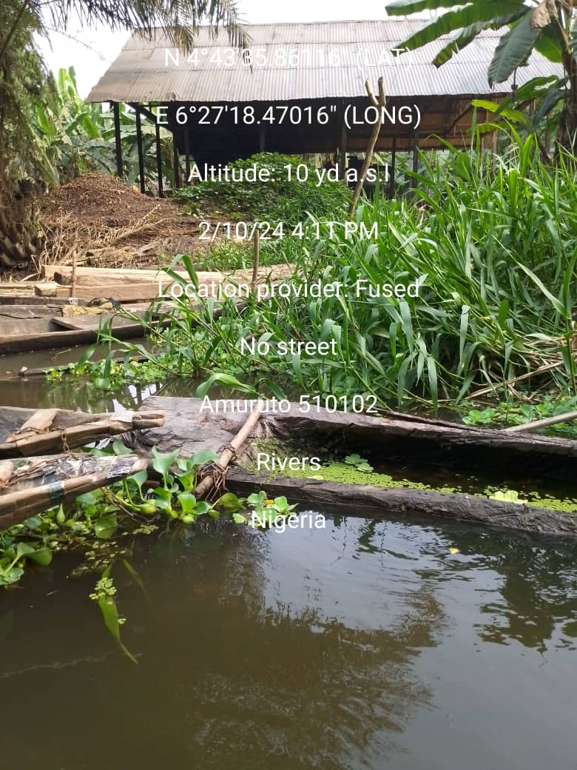 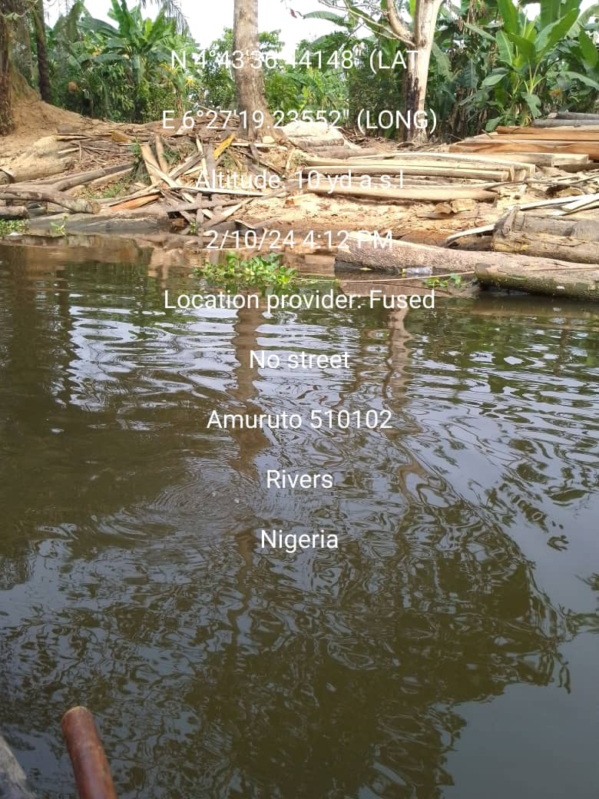

**Plate 1: Palm oil processing at Amuruto River Plate 2: Timber/wood sawing activities at Amuruto River**

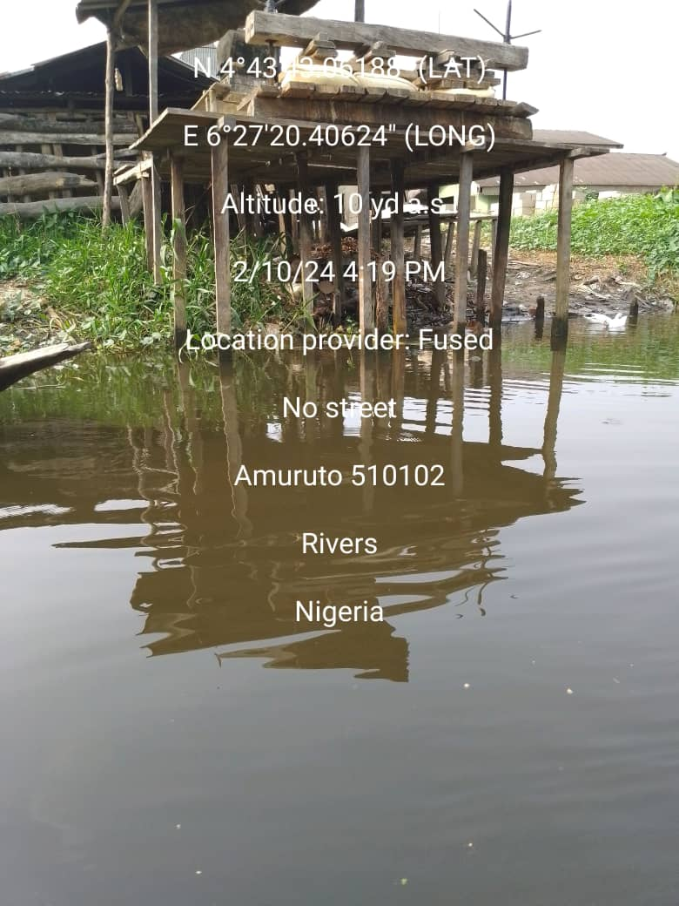 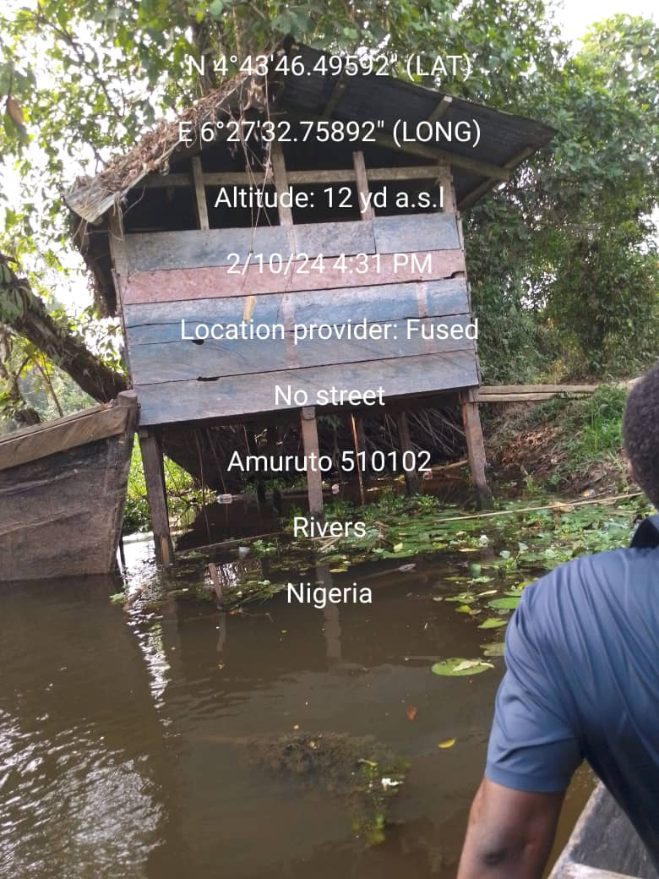

**Plate 3: Cassava processing activities at Amuruto River & Plate 4: Open defecation system along Amuruto River**

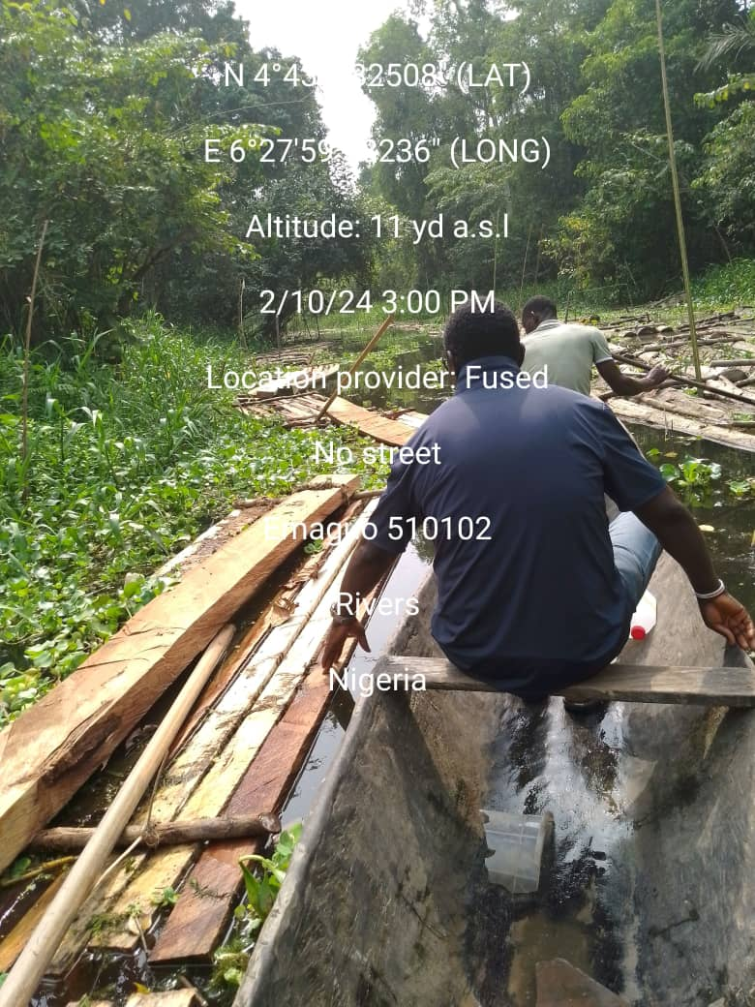 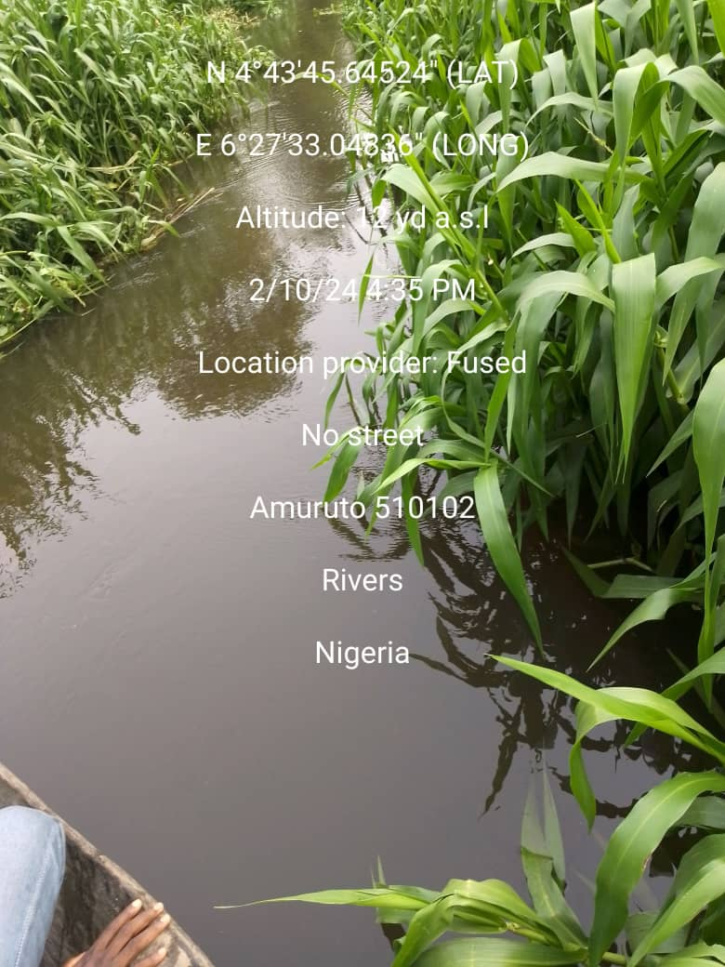

**Plate 5: Evidence of Lumbering activities along Amuruto River Plate 6: Exotic aquatic weed (*Hymenachne spp) infestation* on Amuruto River**

APPENDIX 3: questionnaire WATER ACCESSIBILTY AND ITS IMPACT ON WATER QUALITY

Centre for Occupational Health,

Safety and Environment (COHSE),

Institute of Petroleum Studies (IPS),

Faculty of Engineering,

University of Port Harcourt

Dear Respondent,

My name is ……………………………………………………………….... . I am a post graduate student of the above institution, collecting information on assessment of surface water quality of Amuruto Rivers and will appreciate your participation. I will like you to honestly answer the following questions on water accessibility and its impact on water quality. You have are chosen to participate in this study because your personal view and experience as a community member is important for this study. All responses will remain confidential.

Participation in this survey is voluntary as you can choose not answer a particular question or even all. You can also decline participation at will. But, I am hopeful of your participation as your views will surely count. You may ask any question you wish to ask. Thank you for participating in this study.

*Please, tick [√] the appropriate box or answer correctly and specify others on the dotted area.*

Name of Community Group/Institution: ………………………………………………………….

SECTION A: RESPONDENT’S SOCIO-DEMOGRAPHIC INFORMATION

|  |  |  |  |  |
| --- | --- | --- | --- | --- |
| 1. Gender of Respondent: 1. [ ] Male 2. [ ] Female | | | | |
| 2. Age bracket of Respondent: 1. [ ] 15 – 25yrs 2. [ ] 26 - 50yrs 3. [ ] 51 – 60yrs 4. [ ] 60yrs and above | | | | |
| 3. Marital Status of Respondent: 1. [ ] Single 2. 2. [ ] Married 3. [ ] Divorced/Separated | | | | |
| 4. Respondent Family Type: 1. [ ] Nuclear 2. [ ] Joint/Extended | | | | |
| 5. No of persons per Household: 1. [ ] 1 – 5 2. [ ] 6- 10 3. [ ] 11 – 12 4. [ ] 13 and above | | | | |
| Age Bracket | | Male | Female | Total |
| a. | 0 – 5yrs |  |  |  |
| b. | 6 – 17yrs |  |  |  |
| c. | 18 – 59yrs |  |  |  |
| d. | 60yrs and above |  |  |  |
| 6. How many family members are resident in Amuruto community: 1. [ ] 1 - 5 2. [ ] 6 - 10 3. [ ] 11 – 16 4. [ ] 17 and above | | | | |
| 7. Occupation of Members of Respondents Household: 1. [ ] Public servant 2. [ ] Farming 3. [ ] Fishing 4. [ ] Lumbering 5. [ ] Palm produce 6. [ ] Business 7. [ ] Unemployed | | | | |
| 8. Educational Qualification of Respondent: 1. [ ] FSLC 2. [ ] SSCE/GCE 3. [ ] HND/BSC 4. [ ] Post Graduate 5. [ ] No Formal Education | | | | |
| 9. Occupation of Respondent: 1. [ ] Public servant 2. [ ] Farming 3. [ ] Fishing 4. [ ] Lumbering  5. [ ] Palm produce 6. [ ] Business 7. [ ] Unemployed | | | | |
| 10. Length of residency of Respondent in Amuruto Community: 1. [ ] 1 – 5yrs 2. [ ] 6 – 10yrs 3. [ ] 11 – 15yrs 4. [ ] 16 – 20yrs 5. [ ] 21yrs and above | | | | |

SECTION B: HOUSEHOLD WATER SUPPLY AND PRACTICES

|  |  |  |  |  |  |  |
| --- | --- | --- | --- | --- | --- | --- |
| What is the main source of water for your household | | | | | | |
| Source | Code | 11  Drinking | 12  Cooking | 13  Laundry | 14  Hygiene | 15  Rate of water use from source |
| Amuruto River | 1 |  |  |  |  | [ ] Daily |
| Borehole | 2 |  |  |  |  | [ ] Weekly |
| Ponds/Catchments | 3 |  |  |  |  | [ ] Twice Weekly |
| Rain | 4 |  |  |  |  | [ ] Monthly |
| Dug well | 5 |  |  |  |  | [ ] Twice Monthly |
| Bottle Water | 6 |  |  |  |  | [ ] Rarely |
| Sachet water | 7 |  |  |  |  | [ ] Never |
| 16. How does you household dispose domestic wastes? 1. [ ] Dump in River 2. [ ] Designated dumpsite 3. [ ] Burning 3. [ ] Burying 4. [ ] Dump by corner of house | | | | | | |
| 17. How close is waste dumpsite to the Amuruto River? 1. [ ] Very close 2. [ ] Not very close 3. [ ] Close 3. [ ] Far away 4. [ ] No idea | | | | | | |
| 18. Do you and your household treat your water before use? 1. [ ] Yes 2. [ ] No | | | | | | |
| 19. If yes, what methods do you or your household use to treat water from the source before consumption or other uses? (Check and tick) 1. [ ] Boiling 2. [ ] Filtration (e.g. filters, cloth filters) 3. [ ] Chemical disinfection (e.g., chlorine tablets) 4. [ ] Solar disinfection (SODIS) 5. [ ] Sedimentation (allowing particles to settle) | | | | | | |
| 20. How effective do you find these water treatment methods in ensuring safe and clean water for your household's needs? 1. [ ] Very effective 2. [ ] Effective 3. [ ] Somewhat effective 3. [ ] Not very effective 4. [ ] Not effective at all | | | | | | |

SECTION C: AMURUTO RIVER AND ITS RESOURCES

|  |  |  |  |
| --- | --- | --- | --- |
| 21. Have you visited Amuruto River? 1. [ ] Yes 2. [ ] | | | |
| 22. If yes, how often do you visit Amuruto River? 1. [ ] Daily 2. [ ] Weekly 3. [ ] Twice Weekly 4. [ ] Monthly 5. [ ] Twice Monthly 6. [ ] Rarely 7. [ ] Never | | | |
| 23. What activities do you engage in when visiting the Amuruto River? 1. [ ] Fishing 2. [ ] Swimming 3. [ ] Washing clothes 4. [ ] Bathing 5. [ ] Drinking water collection 6. [ ] Transportation 7. [ ] Lumbering 8. [ ] Oil palm milling 9. Cassava processing | | | |
| 24. How important are these activities for sustaining your household's livelihood or way of life? 1. [ ] Very important 2. [ ] Important 3. [ ] Neutral 4. [ ] Not very important 5. [ ] Not important at all | | | |
| 25. In your opinion, what are the primary sources of pollution affecting the Amuruto River? 1. [ ] Open defecation on water 2. [ ] Oil pipeline spillages 3. [ ] Household waste 4. [ ] Lumbering activities 5. [ ] Flood 6. [ ] Palm oil milling wastes 7. [ ] Exotic aquatic weeds 8. Cassava and other crop processing | | | |
| 26. Have you observed any environmental changes around the Amuruto River? 1. [ ] Yes 2. [ ] No | | | |
| 27. If yes, please describe the observed changes: 1. [ ] Change water color 2. [ ] Extinct of traditional water lettuce and lilies 3. [ ] Obstruction of water way by exotic aquatic weeds 4. [ ] Poor fish yield 5. [ ] Change water level 6. [ ] Shallow and Narrow of river course  7. [ ] Falling trees and stumps in river 8. [ ] Deforestation 9. [ ] Pollution | | | |
| 28. Have you or anyone in your household experienced any health issues that you believe are related to the Amuruto River water use? 1. [ ] Yes 2. [ ] No 3. [ ] Not sure | | | |
| 29. If yes, please describe the health issues experienced 1. [ ] Stooling 2. [ ] Stomach aches 3. [ ] Vomiting 4. [ ] Skin rashes 5. [ ] Coughing 6. [ ] Cold | | | |
| 30. How concerned are you about the potential health risks associated with using water from the Amuruto River? 1. [ ] Very concerned 2. [ ] Concerned 3. [ ] Neutral 4. [ ] Not very concerned 5. [ ] Not concerned at all | | | |
| How would you describe the overall quality of water in the Amuruto River during wet season and dry season? | | | |
| Quality | Code | 31  Dry season | 32  Rainy season |
| [ ] Excellent | 1 |  |  |
| [ ] Good | 2 |  |  |
| [ ] Fair | 3 |  |  |
| [ ] Poor | 4 |  |  |
| [ ] Very Poor | 5 |  |  |
| [ ] Varies significantly by season | 6 |  |  |
| 33. Are you aware of any management efforts or initiatives aimed at protecting the Amuruto River and its resources? 1. [ ] Yes 2. [ ] No | | | |
| 34. If yes, please describe these management efforts: 1. [ ] Ban on disposal of domestic waste into river 2. [ ] Community manually clear aquatic weeds 3. [ ] Ban on chemical fishing 4. [ ] Government intervention | | | |

Questionnaires distributions to members of various groups/institutions

|  |  |  |  |
| --- | --- | --- | --- |
| Groups/Institutions | Distributed  Questionnaires | Retrieved Questionnaires | Percentage (%) of Retrieval |
| Council of Chief | 25 | 24 | 96 |
| Community Development Committee (CDC | 40 | 38 | 95 |
| Youth Association | 88 | 79 | 89.8 |
| Women Forum | 35 | 32 | 91.4 |
| Students Union | 45 | 44 | 97.8 |
| Opinion Leaders/Elites | 22 | 18 | 81.8 |
| Religious Leaders | 12 | 12 | 100 |
| Traders/Artisan | 28 | 20 | 71.4 |
| Farmers/  Fishermen | 14 | 10 | 71.4 |
| TOTAL | 309 | 277 | 90% |
| % of Total retrievals | | |

|  |  |
| --- | --- |
| Socio-demographic variables | Frequency |
| Male | 191 |
| Female | 86 |
| Age bracket of Respondents | |
| 15 – 25yrs | 68 |
| 26 - 50yrs | 124 |
| 51 – 60yrs | 63 |
| 60yrs and above | 22 |
| Total | 277 |
| Marital Status of Respondents | |
| Single | 74 |
| Married | 183 |
| Divorced/Separated | 20 |
| Total | 277 |
| Respondent Family Type |  |
| Nuclear | 68 |
| Joint/Extended | 209 |
| Total | 277 |
| No of persons per Household | |
| 1-5 | 65 |
| 6-10 | 105 |
| 11-15 | 73 |
| 16 and above | 34 |
| Total | 277 |
| Age Bracket | |
| Male |  |
| 0 – 5yrs | 44 |
| 6 – 17yrs | 26 |
| 18 – 59yrs | 28 |
| 60yrs and above | 22 |
| Female |  |
| 0 – 5yrs | 56 |
| 6 – 17yrs | 36 |
| 18 – 59yrs | 22 |
| 60yrs and above | 43 |
| Total | 277 |
| How many family members are resident in Amuruto community | |
| 1 - 5 persons | 77 |
| 6 - 10 persons | 111 |
| 11 - 15 persons | 63 |
| 16 and above | 26 |
| Total | 277 |
| Occupation of Members of Respondents Household | |
| Public servant | 29 |
| Farming | 118 |
| Fishing | 44 |
| Lumbering | 21 |
| Palm produce | 16 |
| Business | 19 |
| Unemployed | 30 |
| Total | 277 |
| Educational Qualification of Respondent | |
| FSLC | 57 |
| SSCE/GCE | 145 |
| HND/BSC | 47 |
| Post Graduate | 17 |
| No Formal Education | 11 |
| Total | 277 |
| Occupation of Respondent |  |
| Public servant | 27 |
| Farming | 102 |
| Fishing | 51 |
| Lumbering | 29 |
| Palm produce | 13 |
| Business | 27 |
| Unemployed | 28 |
| Total | 277 |
| Length of residency of Respondent in Amuruto Community | |
| 1 – 5yrs | 18 |
| 6 – 10yrs | 29 |
| 11 – 15yrs | 41 |
| 16 – 20yrs | 76 |
| 21yrs and above | 113 |
| Total | 277 |

|  |  |  |  |  |
| --- | --- | --- | --- | --- |
| Respondent’s main source of water supply and practice variables  Frequency | | | | |
| What is the for your household | | | | |
| Main source of water | Drinking water | Cooking water | Laundry water | Water for Hygiene |
| Amuruto River | 99 | 201 | 213 | 188 |
| Borehole | 33 | 12 | 12 | 21 |
| Ponds/Catchments | 17 | 55 | 33 | 46 |
| Rain | 32 | 9 | 19 | 22 |
| Dug well | - | - | - | - |
| Bottle Water | 19 | - | - | - |
| Sachet water | 77 | - | - | - |
| Total | 277 |  |  |  |
| Cooking water | |  |  |  |
| Amuruto River | 201 |  |  |  |
| Borehole | 12 |  |  |  |
| Ponds/Catchments | 55 |  |  |  |
| Rain | 9 |  |  |  |
| Dug well | - |  |  |  |
| Bottle Water | - |  |  |  |
| Sachet water | - |  |  |  |
| Total | 277 |  |  |  |
| Laundry water |  |  |  |  |
| Amuruto River | 213 |  |  |  |
| Borehole | 12 |  |  |  |
| Ponds/Catchments | 33 |  |  |  |
| Rain | 19 |  |  |  |
| Dug well | - |  |  |  |
| Bottle Water | - |  |  |  |
| Sachet water | - |  |  |  |
| Total | 277 |  |  |  |
| Water for Hygiene | |  |  |  |
| Amuruto River | 188 |  |  |  |
| Borehole | 21 |  |  |  |
| Ponds/Catchments | 46 |  |  |  |
| Rain | 22 |  |  |  |
| Dug well | - |  |  |  |
| Bottle Water | - |  |  |  |
| Sachet water | - |  |  |  |
| Total | 277 |  |  |  |
| Rate of water use from source | |  |  |  |
| Daily | 197 |  |  |  |
| Weekly | 30 |  |  |  |
| Twice Weekly | 12 |  |  |  |
| Monthly | 9 |  |  |  |
| Twice Monthly | 12 |  |  |  |
| Rarely | 14 |  |  |  |
| Never | 3 |  |  |  |
| Total | 277 |  |  |  |
| How does your household dispose domestic wastes? | |  |  |  |
| Very close | 57 |  |  |  |
| Not very close | 45 |  |  |  |
| Close | 43 |  |  |  |
| Far away | 120 |  |  |  |
| No idea | 12 |  |  |  |
| Total | 277 |  |  |  |
| Do you and your household treat your water before use? | |  |  |  |
| Yes | 92 |  |  |  |
| No | 185 |  |  |  |
| Total | 277 |  |  |  |
| If yes, what are the methods? | |  |  |  |
| Boiling | 19 |  |  |  |
| Filtration | 21 |  |  |  |
| Chemical disinfection | 34 |  |  |  |
| Solar disinfection (SODIS) | - |  |  |  |
| Sedimentation | 18 |  |  |  |
| Total | 92 |  |  |  |
| How effective do you find these water treatment methods in ensuring safe and clean water for your household's needs? | |  |  |  |
| Very effective | 35 |  |  |  |
| Effective | 19 |  |  |  |
| Somewhat effective | 12 |  |  |  |
| Not very effective | 7 |  |  |  |
| Not effective at all | 19 |  |  |  |
| Total | 92 |  |  |  |

|  |  |
| --- | --- |
| Amuruto River and its resource variables | Frequency |
| Have you visited Amuruto River? |  |
| Yes | 269 |
| No | 8 |
| Total | 277 |
| If yes, how often do you visit Amuruto River? |  |
| Daily | 124 |
| Weekly | 55 |
| Twice Weekly | 29 |
| Monthly | 18 |
| Twice Monthly | 27 |
| Rarely | 10 |
| Never | 6 |
| Total | 269 |
| What activities do you engage in when visiting the Amuruto River? |  |
| Fishing | 12 |
| Swimming | 23 |
| Washing clothes | 44 |
| Bathing | 100 |
| Drinking water collection | 36 |
| Transportation | 11 |
| Lumbering | 15 |
| Oil palm milling | 11 |
| Cassava processing | 17 |
| Total | 269 |
| Important of these activities for sustaining household's livelihood or way of life? |  |
| Very important | 237 |
| Important | 25 |
| Neutral | 4 |
| Not very important | 2 |
| Not important at all | 1 |
| Total | 269 |
| In your opinion, what are the primary sources of pollution affecting the Amuruto River? |  |
| Open defecation on water | 124 |
| Oil pipeline spillages | 52 |
| Household waste | 13 |
| Lumbering activities | 9 |
| Flood | 24 |
| Palm oil milling wastes | 7 |
| Exotic aquatic weeds | 44 |
| Cassava and other crop processing | 4 |
| Total | 277 |
| Have you observed any environmental changes around the Amuruto River? |  |
| Yes | 277 |
| No | - |
| Total | 277 |
| If yes, please describe the observed changes |  |
| Change water color | 114 |
| Extinct of traditional water lettuce and lilies | 29 |
| Obstruction of water way by exotic aquatic weeds | 46 |
| Poor fish yield | 23 |
| Change water level | 9 |
| Shallow and Narrow of river course | 29 |
| Falling trees and stumps in river | 7 |
| Deforestation | 2 |
| Pollution | 18 |
| Total | 277 |
| Have you or anyone in your household experienced any health issues that you believe are related to the Amuruto River water use? |  |
| Yes | 270 |
| No | 2 |
| Not sure | 5 |
| Total | 277 |
| If yes, please describe the health issues experienced |  |
| Stooling | 151 |
| Stomach aches | 34 |
| Vomiting | 29 |
| Skin rashes | 32 |
| Coughing | 7 |
| Cold | 17 |
| Total | 270 |
| How concerned are you about the potential health risks associated with using water from the Amuruto River? |  |
| Very concerned | 148 |
| Concerned | 82 |
| Neutral | 19 |
| Not very concerned | 22 |
| Not concerned at all | 6 |
| Total | 277 |
| How would you describe the overall quality of water in the Amuruto River during wet season? |  |
|  |  |
| Excellent (1) | - |
| Good (2) | - |
| Fair (3) | - |
| Poor (4) | 45 |
| Very poor (5) | 220 |
| Varies significantly by season (6) | 12 |
| Total | 277 |
| Dry season |  |
| Excellent (1) | - |
| Good (2) | 22 |
| Fair (3) | 79 |
| Poor (4) | 150 |
| Very poor (5) | 18 |
| Varies significantly by season (6) | 8 |
| Total | 277 |
| Are you aware of any management efforts or initiatives aimed at protecting the Amuruto River and its resources? |  |
| Yes | 70 |
| No | 207 |
| Total | 277 |
| If yes, please describe these management efforts |  |
| Ban on disposal of domestic waste into river | 45 |
| Community manually clear aquatic weeds | 20 |
| Ban on chemical fishing | 5 |
| Government intervention | - |
| Total | 70 |