Determining Nutrient Loading of Amuruto River Using Quadratic and Linear Models in Rivers State, Nigera

.

# ABSTRACT

|  |
| --- |
| The aim of this study is to determine nutrient loading of Amuruto river in Rivers State, Nigeria using quadratic and linear models by comparing nitrate, phosphate and TDS levels in both wet season and dry season, develop quadratic and linear regression nutrient loading models for Amuruto river, identify key pollution sources and recommend nutrient pollution controls. Study utilized empirical methods to analyze seventeen physicochemical and bacteriological parameters of Amuruto river water between July 2022 – October, 2022, November, February, 2023. Quadratic and linear regression nutrient models were developed for Amuruto River based on seasonal variations in Nitrate (NO₃⁻), Phosphates (PO₄³⁻) and Total Dissolved Solids (TDS) of wet and dry seasons. Nutrient loading was assessed and correlations with other water quality parameters and its implications to ecosystem health determined. Linear and quadratic models were developed for nutrient (Nitrate, Phosphate, TDS and Staphylococcus) loading of Amuruto River. The models highlighted influence of flooding, vegetation changes, silting, aquatic weed invasion, timber lumbering, agriculture, cassava, palm oil processing, open defecation and sand mining on nutrient concentrations. Results indicated that nitrate and phosphate levels were significantly higher in wet season, suggesting increased runoff from agricultural and domestic sources. TDS levels rose during dry season, indicating higher evaporation rates and reduced dilution. Correlation analysis showed a strong relationship between nutrient concentrations and BOD, COD and THC, emphasizing impact of nutrient pollution in Amuruto river health. The findings emphasized the need for sustainable nutrient management strategies to mitigate eutrophication risks and protect aquatic life.  ***Key words: Freshwater, modelling, nutrient load, pollution source, season, management*** |

# 1. INTRODUCTION

Nutrients are chemical elements critical to the development of plant and animal tissues (Roberta 2020). Nutrient pollution is a growing global problem, and it is one of the leading causes of water quality impairment (Cloern et  al. 2020) and a core threat to the integrity of coastal and estuarine ecosystems worldwide (Adams et  al. 2020). Changing environmental and climatic conditions, along with land use and land cover patterns, have been immensely affecting freshwater bodies (Sravani et al., 2020). There are vast number of surface water resources but not all resources are fit for human use (Bhateria & Jain, 2016). Oil activities in the Niger Delta Area of Nigeria have increased the levels of organic, inorganic and microbial contaminants in surface water bodies in the area (Okoro & Diejomaoh 2022 & Ewim et al. (2023). Major gap in our understanding of water quality models and their best applications is that there is no formal quantitative comparisons of the different models using a common problem and input data (Kari & Juliann, 2011). Amuruto River and its bank is used for several local economic activities such as timber lumbering and plank sawing, palm oil processing, cassava processing, open defecation (toilets) system, sand mining, transportation of goods and grossly infested by exotic aquatic weeds water hyacinth (Eirchonia cracipes spp) and lately with a more evasive specie Hymenachne spp which has invaded into extinction the traditional macrophytes (water lettus, lilies) (see Plates 3.2, 3.3, 3.4, 3.5, 3.6 and 3.7 in Appendix). Increased concentration of euphoric nutrients in surface water is one most challenging environmental problem confronting the Niger Delta region (Enetimi & Sylvester 2017) though, rivers play a critical role in transporting nutrients essential for sustaining aquatic ecosystems. Rivers also act as major conduits for nutrient transportation, primarily from natural weathering and anthropogenic sources such as agriculture and industrial discharges (Singh et al., 2018). Water quality assessment involves the comprehensive evaluation of the physical, chemical, and biological characteristics of a given body of water (Karo-Emebeyo et al., 2023).Elevated values of pollution of physicochemical and bacteriological variables poses a harsh ecological threat to the majority of aquatic organisms, particularly macroinvertebrates, in aquatic environments (Omovoh et al., 2022). Monitoring the condition of aquatic ecosystems is important because they provide ecological goods and services on which human beings depend (Cornel et al., 2023). Nutrient pollution is a growing global problem, and it is one of the leading causes of water quality impairment (Cloern et  al., 2020) and a core threat to the integrity of coastal and estuarine ecosystems worldwide (Adams et  al., 2020). Numerical models can assess the interaction between multiple processes in various river basin environments (Beusen et al. 2015). Once a nutrient model has been correctly validated on more extensive water quality databases, it constitutes a useful tool for further exploring the effects, at the basin scale, of the rapid changes of human activity in any water body (Garnier et al., 2002). However, excessive nutrient loading from agriculture, wastewater discharge, and urban runoff can lead to eutrophication, depleting oxygen levels and endangering aquatic life (WHO, 2017). Ogamba et al., (2017) reported that water quality has been a major problem to many nations including developing countries such as Nigeria. The most common chemical contaminants from agriculture NPS pollution is Nitrogen and phosphorus, which has been reported to be found in most of the world’s aquifers (Connor 2015). Nutrients concentrations in rivers vary seasonally due to natural processes (rainfall, flooding, and vegetation growth) and human-induced pollution (agriculture, industrial effluents, and domestic waste disposal) (Connor 2015). Nitrate (NO₃⁻) and Phosphates (PO₄³⁻) are among the primary contributors to nutrient pollution, while Total Dissolved Solids (TDS) serves as an indicator of overall water quality. Concentrations in rivers vary seasonally due to natural processes (rainfall, flooding, and vegetation growth) and human-induced pollution (agriculture, industrial effluents, and domestic waste disposal) (Bijay-Singh & Crowell, 2021); WHO, 2017). Uruh & Yusuf (2022) asserted that open defecation is a common practice amongst dweller in the Niger Delta and this has a far-reaching implication on the natural quality of water of bodies in the area which serves as a primary source of water for domestic use and a mean of livelihood. Once a nutrient model has been correctly validated on more extensive water quality databases, it constitutes a useful tool for further exploring the effects, at the basin scale, of the rapid changes of human activity in any water body (Garnier et al., 2002). This study evaluated nutrient parameter levels in Amuruto River during wet and dry seasons, developed quadratic and linear models that determined nutrient loading dynamics, explored seasonal variations, correlations with other parameters and potential ecological risks. The data obtained from water quality assessment and monitoring supplied empirical evidence needed for health and environmental decision making (Olubukola et al. 2021).The quadratic model also predicted the impact of natural activities (flooding, vegetation cover, and silting) and human activities (agriculture, cassava and palm oil processing, sand mining, and open defecation) on nutrient levels was assessed. Beusen et al. 2015) posited that numerical models can assess the interaction between multiple processes in various river basin environments. Beusen et al. (2015) used IMAGE-Global Nutrient Model (GNM) a global distributed spatially explicit model using hydrology as the basis for describing nitrogen (N) and phosphorus (P) delivery to surface water and transport and in-stream retention in rivers, lakes, wetlands and reservoirs. Beusen et al., (2015) further reported that there are differences between model results and observed concentrations for a range of water bodies given the global scale of the un-calibrated model with sensitivity analysis and data showing N and P delivery, retention and river export as a runoff product. Regression analysis was used to develop linear and quadratic nutrient models for Nitrate (NO₃⁻), Phosphates (PO₄³⁻) and correlated with bacteriological and other physicochemical parameters. According to Del - Porto & Steinfeld (1999), urine and faeces defecated in open water bodies or washed through runoffs contribute greatly to nutrients loading of freshwater rivers. The nutrient data were statistically compared to assess seasonal trends according to (APHA, 2012) and regression models developed for nutrient parameters, with nitrates, phosphates and total dissolved solids as the dependent variables in line with Jabbar & Grote (2019) who used watershed-scale modeling and small spatial-scale experiments and techniques can accurately calculate pollution loads from different land uses. Regressit an Excel addin was used to calibrate the models and coefficient of determination “R2” was calculated to determine the goodness of fit.

# 2. METHODOLOGY

**2.1 Study Area, Sampling and Analysis**

Amuruto River is an all season fresh water river with two tidal flow patterns lying between latitude 4o 44’12.39756”N and longitude 6o 27’ 43.605”E in Abua/Odual Local Government Area of Rivers State, Niger Delta, Nigeria (see Figure 2.1 & 2.2). Amuruto River. Amuruto River once hosted the first crude oil loading terminal (Kugbo loading bay) in Nigeria before the advent of crude oil pipeline system from Shell B.P, Oloibiri oil field in late 1960s.

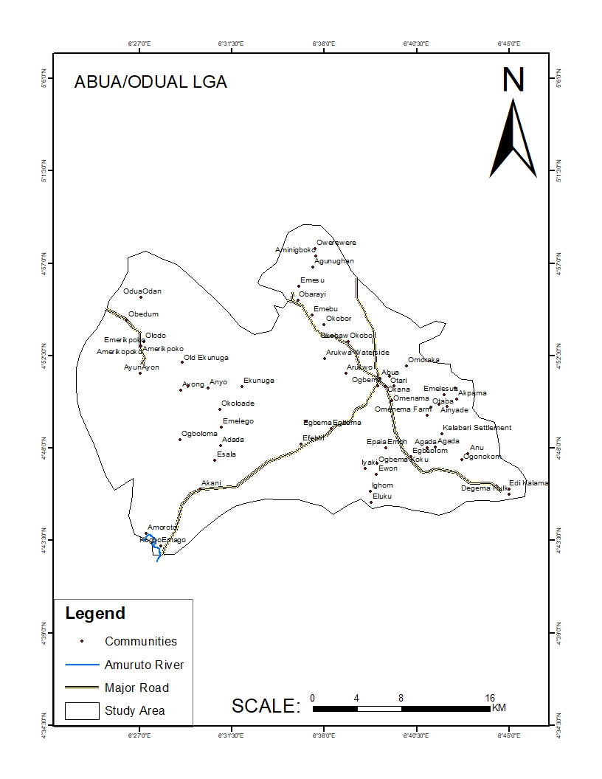

**Figure 2.1: Map of Abua/Odual L.G.A. showing Amuruto River**

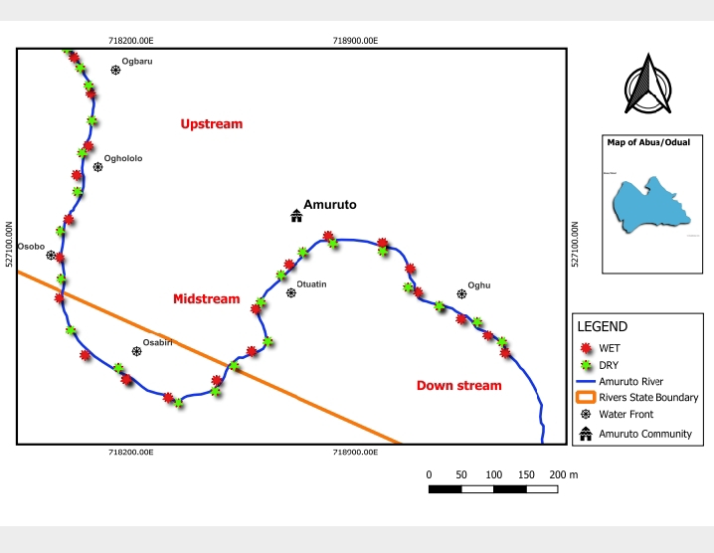

**Figure 2.2: Map of Sampled points on Amuruto River for wet and dry season**

**2.2 Sample Collection**

Water samples were collected from multiple locations along the Amuruto River during the wet season (April–June) and dry season (December–February) using handheld GPS to determine its coordinates (see tables 2.1 & 2.2) sample points (see Figure 2.2) and field photos (see Appendix 2). APHA (2012) and CPCB, (2017) in-situ experimental and laboratory protocols were followed in sampling and analysis of water quality parameters

**Table 2.1: Coordinates for Wet Season Sampled Points on Amuruto River**

|  |  |  |  |  |  |  |  |
| --- | --- | --- | --- | --- | --- | --- | --- |
| **SAMPLE PERIOD** | **DATE OF SAMPLING** | **COORDINATES OF SAMPLE ZONE/POINTS** | | | | | |
| **Upstream** | | **Midstream** | | **Downstream** | |
| **Ogbaru** | **Oghololo** | **Osobo** | **Osabiri** | **Otuatin** | **Oghu** |
| WET SEASON | 3rd July,  2023 | Latitude  N 4o43’31.34316” | Latitude  N 4o43’56.96832” | Latitude  N 4o43’36.12” | Latitude  N 4o 43’42.42828” | Latitude  N 4o 43’46.07076” | Latitude  N 4o 43’36.90408” |
| Longitude  E 6o27’9.84996” | Longitude  E 6o27’1.152” | Longitude  E 6o27’18.95976” | Longitude  E 6o 27’20.13084” | Longitude  E 6o 27’32.56884” | Longitude  E 6o27’42.9426” |
| 13th August, 2023 | Latitude  N 4o43’38.13312” | Latitude  N 4o 43’49.88604” | Latitude  N 4o43’37.38432” | Latitude  N 4o43’37.11936” | Latitude  N 4o43’36.68052” | Latitude  N 4o43’36.90408” |
| Longitude  E 6o2741.87232” | Longitude  E 6o26’59.7372” | Longitude  E 6o27’42.77016” | Longitude  E 6o2742.91596” | Longitude  E 6o27’43.50456” | Longitude  E 6o27’42.9426’’ |
| 17th September, 2023 | Latitude  N 4o43’46.78392” | Latitude  N 4o43’46.49088” | Latitude  N 4o43’46.07076” | Latitude  N 4o43’40.14012” | Latitude  N 4o27’39.73008” | Latitude  N 4o43’38.2404” |
| Longitude  E 6o27’30.14316” | Longitude  E 6o27’31.44204” | Longitude  E 6o27’32.56884” | Longitude  E 6o27’38.18988” | Longitude  E 6o27’39.42468” | Longitude  E 6o27’41.73876” |
| 24th October, 2023 | Latitude  N 4o44’2.86512” | Latitude  N 4o44’1.6638” | Latitude  N 4o44’0.62592” | Latitude  N 4o43’59.93832” | Latitude  N 4o43’56.96832” | Latitude  N 4o43’54.48684” |
| Longitude  E 6o27’1.8252” | Longitude  E 6o27’2.29716” | Longitude  E 6o272.27556” | Longitude  E 6o27’2.13084” | Longitude  E 6o27’1.152” | Longitude  E 6o27’0.93024” |

**Table 2.2: Coordinates of Dry Season Sampled Points on Amuruto River**

|  |  |  |  |  |  |  |  |
| --- | --- | --- | --- | --- | --- | --- | --- |
| **SAMPLE PERIOD** | **DATE OF SAMPLING** | **COORDINATES OF SAMPLE ZONE/POINTS** | | | | | |
| **Upstream** | | **Midstream** | | **Downstream** | |
| **Ogbaru** | **Oghololo** | **Osobo** | **Osabiri** | **Otuatin** | **Oghu** |
| DRY SEASON | 3rd November, 2023 | Latitude  N 4o43’42.42828” | Latitude  N 4o43’43.27752” | Latitude  N 4o43’43.73904” | Latitude  N 4o43’44.44356” | Latitude  N 4o43’45.15528” | Latitude  N 4o43’45.70788” |
| Longitude  E 6o27’20.13084” | Longitude  E 6o27’20.745” | Longitude  E 6o27’21.40848” | Longitude  E 6o27’22.20624” | Longitude  E 6o27’22.99392” | Longitude  E 6o27’23.5026” |
| 13th December, 2023 | Latitude  N 4o43’42.42828” | Latitude  N 4o43’36.77376” | Latitude  N 4o43’37.74324” | Latitude  N 4o43’38.27496” | Latitude  N 4o43’38.90208” | Latitude  N 4o43’40.95336” |
| Longitude  E 6o27’20.13084” | Longitude  E 6o27’19.65816” | Longitude  E 6o27’19.737” | Longitude  E 6o2719.77588” | Longitude  E 6o27’19.3842” | Longitude  E 6o27’19.197” |
| 17th January, 2024 | Latitude  N 4o43’32.3418” | Latitude  N 4o43’32.95992” | Latitude  N 4o43’35.94288” | Latitude  N 4o43’36.12” | Latitude  N 4o43’36.12” | Latitude  N 4o43’36.1902” |
| Longitude  E 6o27’14.11308” | Longitude  E 6o27’15.40404” | Longitude  E 6o27’18.72648” | Longitude  E 6o27’18.95976” | Longitude  E 6o27’18.95976” | Longitude  E 6o27’19.11816” |
| 10th February, 2024 | Latitude  N 4o44’6.53028” | Latitude  N 4o44,4.9182” | Latitude  N 4o44’3.60276” | Latitude  N 4o43’34.30668” | Latitude  N 4o43’34.91976” | Latitude  N4o43’39.28908” |
| Longitude  E 6o26’59.83836” | Longitude  E 6o27’0.8892” | Longitude  E 6o27’1.55196” | Longitude  E 6o27’4.851” | Longitude  E 6o27’3.6288” | Longitude  E 6o26’59.35128” |

**2.3 Nutrient Model Development**

Figure 2.3 shows nutrient model workflow diagram used in developing linear and quadratic models for nutrient prediction for both seasons, makes the process clearer for implementation. Water quality data for wet and dry seasons was collated and preprocessed, cleaned by handling missing values, normalized and organized and divide into (wet or dry) subsets. Identify the dependent variables (nitrates, phosphates, TDS) and independent variables (EC, TSS, BOD, COD, staphylococcus) for each season. Linear and quadratic regression model was applied to each subset of data (wet and dry season) and fitted into the model to the data, where the dependent variables are predicted based on the independent variables.

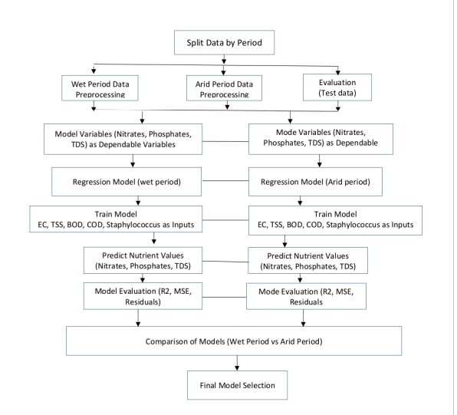

**Figure 2.3: Flow Diagram of Nutrient Model Development**

**2.3.1 Linear Nutrient Model**

A python R statistical techniques was used to perform regression analysis for both the wet and dry seasons yielding coefficients for each independent variable used to build the models. Coefficient of determination (R²) was used to evaluate model fit, how well the model explains the variance in the dependent variable to perform statistical significance tests (*P*-values) to determine which variables are most influential. Residuals analyzed to ensure that the model assumptions homoscedasticity, linearity, normality are met. Water quality parameters correlations with the nutrient levels during the different seasons was investigated. The linear regression models were trained using the independent variables (EC, TSS, BOD, COD, Staphylococcus) and the dependent nutrient variables (nitrates, phosphates, TDS). The trained model was used to predict the nutrient levels (nitrates, phosphates, TDS) for each season the model performance was evaluated using metrics such as R² (explained variance), Mean Squared Error (MSE), and analyzing residuals for model assumptions (linearity, normality), the regression results was compared for the wet and dry seasons to determine which model better explains the nutrient parameters based on the water quality data. The best and final model was choosen based on evaluation metrics used for predicting nutrient levels in future water quality monitoring. A hybrid approach combining linear and quadratic trends for seasonal analysis and regression models for long-term prediction provided the most comprehensive understanding used for Amuruto River. For each season, linear regression model was fitted to the data. Using the following formula for a linear regression model (equation 2.1).

𝑌 = $β_{0}+β_{1}×X_{1}+β_{2}×X_{2}+…{+β}_{n}×X_{n} 2.1$

Where: 𝑌 is the dependent variable (nitrates, phosphates, TDS), 𝑋1, 𝑋2, ⋯, 𝑋𝑛 are the independent variables, 𝛽0 is the intercept, 𝛽1, 𝛽2, ⋯, 𝛽𝑛 are the regression coefficients.

**2.3.2 Quadratic Model Development**

Quadratic models and trend analysis are ideal for understanding seasonal variations in nutrient loading (wet vs. dry season fluctuations). Quadratic models assumed a parabolic relationship between nutrient loading and influencing factors (seasonality, pollution sources). The general equation is: 𝑌 = 𝑎𝑋2 + 𝑏𝑋 + 𝑐 (2.2)

Where: 𝑌 = Nutrient loading, 𝑋 = Independent variable (season, pollution level) and 𝑎 = Model coefficients. Qualitative trend analysis explains possible reasons for seasonal differences. The quadratic models developed for wet and dry seasons assume that nutrient loading follows a parabolic trend increasing initially and then either stabilizing or declining based on environmental conditions. Qualitative models assume fixed peak and decline patterns, which may not always be accurate and does not incorporate multiple influencing factors explicitly (rainfall, land use, pollution sources) and Limited in making long-term projections.

**2.3.3 Correlations Analysis of Nutrient Parameters and Other Water Quality Parameters**

Nutrients parameters (nitrates, phosphates and TDS) concentrations were correlated with EC, TSS, BOD, Staphylococcus and COD concentrations. The goal of the correlation analysis is to predict the concentrations of nutrients (nitrate, phosphate, TDS) based on the other water quality parameters. The variables of regression mathematical models for nutrient loading in the Amuruto River was based on the correlation datasets of Nitrate, Phosphates and Total Dissolved Solids (TDS) as dependent variables and Electrical Conductivity (EC), Total Suspended Solids (TSS), Biochemical Oxygen Demand (BOD), Staphylococcus, Chemical Oxygen Demand (COD), Temperature, pH, Color, and Total Hydrocarbon Content (THC) as independent variables (see Table 4.2), statistical correlation of water quality data of Amuruto River for wet season and dry season (Table 4.3). The summarized mean values of parameters as in figure 4.4 was used to calculate correlation coefficients between different parameters for each season. Pearson correlation coefficient was used to measure the strength and direction of linear relationships between two variables, ranging from -1 (perfect negative correlation) to +1 (perfect positive correlation).

**3.0 RESULTS:**

**3.1 Linear Model for Nitrate, Phosphates, TDS and Staphylococcus aureus**

Multiple linear regression model, based on the underlying relationships and statistical R-squared and *P*-values explained nutrient (Nitrate, Phosphates and TDS) loading values using linear regression: Model 1: Nitrate prediction focus on EC, BOD, TSS and Staphylococcus as key predictors. Model 2: Phosphate prediction focus on EC, BOD, DO and Staphylococcus. Model 3: TDS prediction focus on EC, DO, BOD and COD. For each nutrient (Nitrate, Phosphates, TDS), the general formula of the linear regression model equation for nutrient parameters:

= 𝛽0 + 𝛽1 × Var1 + 𝛽2 × Var2 + 𝛽3 × Var3 + 𝛽4 × Var4 + 𝜖 (2.2)

where 𝛽0  is the intercept, 𝛽𝑖βi  are the coefficients for each variable and 𝜖ϵ is the error term.

Linear Model 1: Nitrate (mg/L): = 𝑎1 × 𝐸𝐶 + 𝑎2 × 𝐵𝑂𝐷 + 𝑎3 × 𝐶𝑂𝐷 + 𝑎4 × 𝑆𝑡𝑎𝑝ℎ𝑦𝑙𝑜𝑐𝑜𝑐𝑐𝑢𝑠 + 𝜖

Where: 𝑎1, 𝑎2, 𝑎3, 𝑎4a1, a2, a3, a4 are the coefficients (weights) for each variable and

𝜖 = error term.

Linear model 2: Phosphates (mg/L) = 𝑏1 × 𝐸𝐶 + 𝑏2 × 𝐷𝑂 + 𝑏3 × 𝐵𝑂𝐷 + 𝑏4 × 𝑆𝑡𝑎𝑝ℎ𝑦𝑙𝑜𝑐𝑜𝑐𝑐𝑢 + 𝜖

Linear model: TDS (mg/L): 𝑇𝐷𝑆 = 𝑐1 × 𝐸𝐶 + 𝑐2 × 𝐷𝑂 + 𝑐3 × 𝐶𝑂𝐷 + 𝑐4 × 𝑆𝑡𝑎𝑝ℎ𝑦𝑙𝑜𝑐𝑜𝑐𝑐𝑢𝑠 + 𝜖

**3.1.2 Model Validation**

Mean squared error (MSE) provided a measure of how well the model's predictions match the actual data. Lower values indicate better model performance. R-squared (optional) calculates R-squared to assess how well the model explains the variability of the dependent variable. K-fold cross-validation was used to assess the model's performance on different subsets of the data. Residual analysis check residual plots to ensure that errors are randomly distributed and that there is no pattern indicating model inadequacy. Feature importance was evaluated to understand the impact of each variable on the predictions. This approach ensures a reliable and validated regression models for predicting nutrient concentrations in the Amuruto River. (See Appendix 1) for regression analysis tables, Linear Model 4 for Phosphates, Std. Res., AbsStdRes, Leverage and Cook's D values for Actual, Predicted and Residual model 4 for Phosphates ­­MgI (4 variables, n=8), Linear Model 5 for Total Dissolved Solids (TDS) ( see figures 4.19, 4.20, 4.21 ) . Based on the table of correlation matrix, three models are proposed. The models are shown as Equations 2.1.1 – 2.17, linear and quadratic regression equations used to develop the nutrient models. Regressit an Excel addin is used to calibrate the models. The coefficient of determination “R2” was calculated to determine the goodness of fit. The calibrated models are shown as Equations 4 14 - 16. Nitrate = 70.414 + 10.229BOD - 0.099EC - 0.054S - 0.014TDS - 0.279TSS. Figures 3.1 – 3.15 are linear model charts illustrating the relationships between the dependent variables (nitrates, phosphates and TDS) and the independent variables (EC, TSS, BOD, COD, and Staphylococcus) for both the wet and dry seasons. The scatter plots with regression lines visualized the relationship between independent variables and dependent variables and assessed the fit of a linear regression model. Residual plots assessed the fit of the regression model by plotting the residuals (differences between observed and predicted values). Ideally, residuals should be randomly distributed around zero, indicating a good fit. The R² and MSE bar charts compared the performance of the regression model across different conditions (Wet vs. Dry seasons) using R² (coefficient of determination) and MSE (mean squared error). While, the correlation heatmap visualized the correlation coefficients between multiple variables in the dataset, helping to identify potential multicollinearity or relationships between predictors. Figure 4.34 shows comparison of nutrient parameters in wet season and dry season. Table 4.21 shows summary of linear regression model 5 results for total dissolved solids Mg/Lpp.

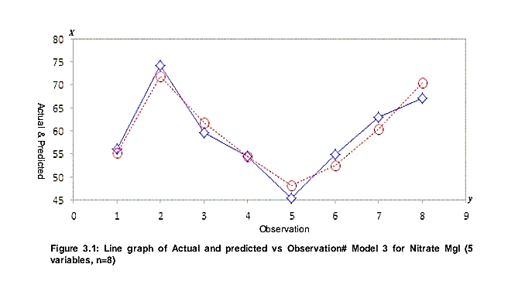

**Figure 3.1: Line graph of Actual and predicted vs Observation# Model 3 for Nitrate­­ MgI (5 variables, n=8**

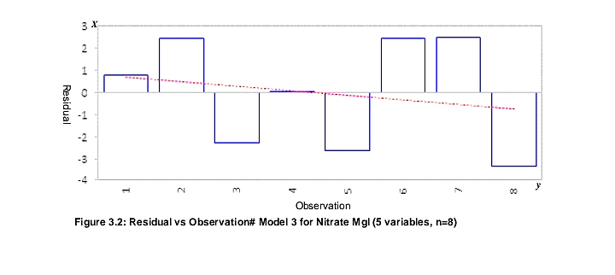

**Figure 3.2: Residual vs Observation# Model 3 for Nitrate­­ MgI (5 variables, n=8)**

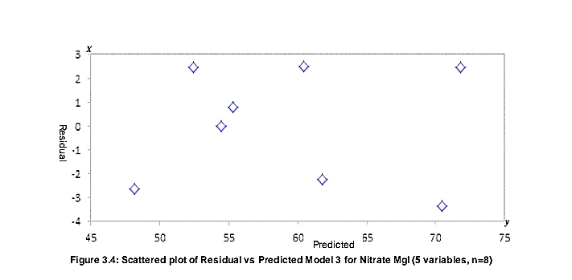

Predicted

**Figure 3.3: Scattered plot of Residual vs Predicted Model 3 for Nitrate­­ MgI (5 variables, n=8)**

***X***

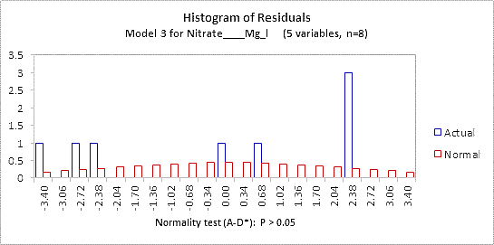

***y***

**Figure 3.4: Histogram of normality test of Residuals of Model 3 for Nitrate­­ MgI (5 variables, n=8)**

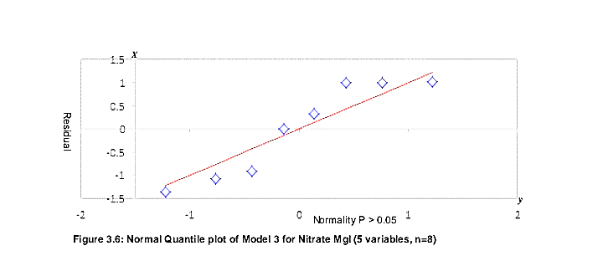

**Figure 3.5: Normal Quantile plot of Model 3 for Nitrate­­ MgI (5 variables, n=8)**

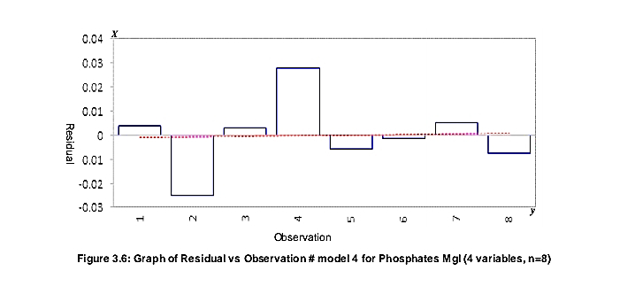

**Figure 3.6: Graph of Residual vs Observation # model 4 for Phosphates ­­MgI (4 variables, n=8)**

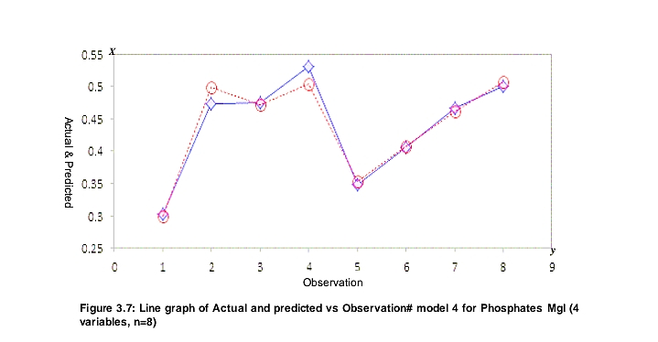

**Figure 3.7: Line graph of Actual and predicted vs Observation# model 4 for Phosphates ­­MgI (4 variables, n=8)**

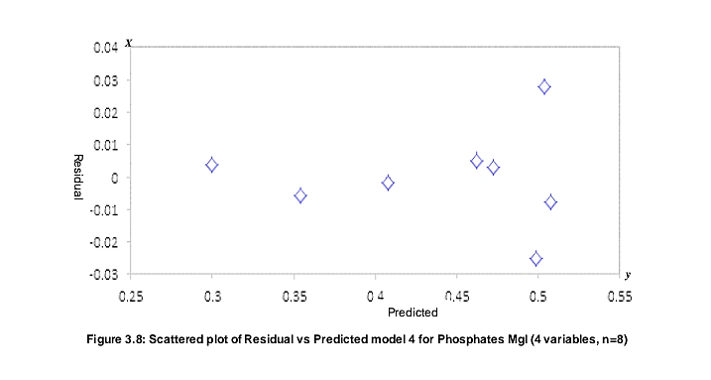

**Figure 3.8: Scattered plot of Residual vs Predicted model 4 for Phosphates ­­MgI (4 variables, n=8)**

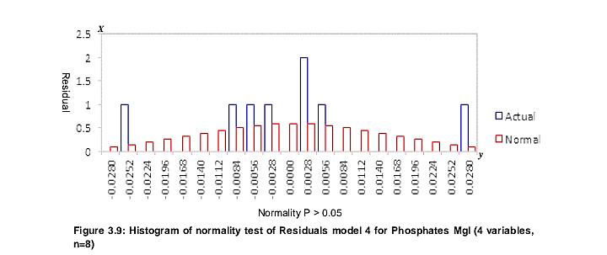

**Figure 3.9: Histogram of normality test of Residuals model 4 for Phosphates ­­MgI (4 variables, n=8)**

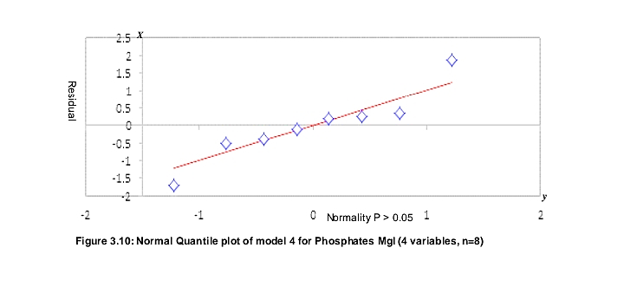

**Figure 3.10: Normal Quantile plot of model 4 for Phosphates ­­MgI (4 variables, n=8)**

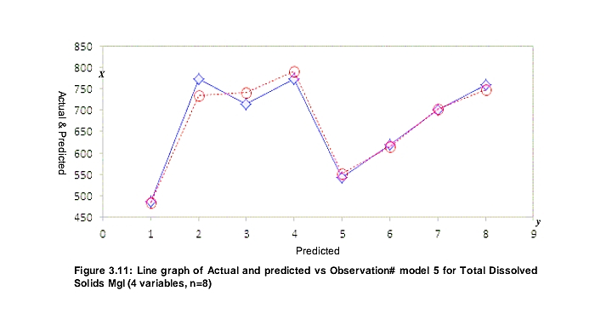

***X***

**Figure 3.11: Line graph of Actual and predicted vs Observation# model 5 for Total Dissolved Solids ­MgI (4 variables, n=8)**

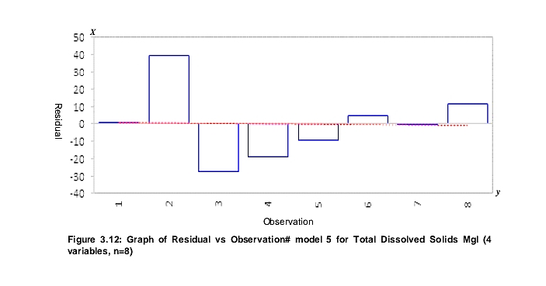

**Figure 3.12: Graph of Residual vs Observation# model 5 for Total Dissolved Solids MgI (4 variables, n=8)**

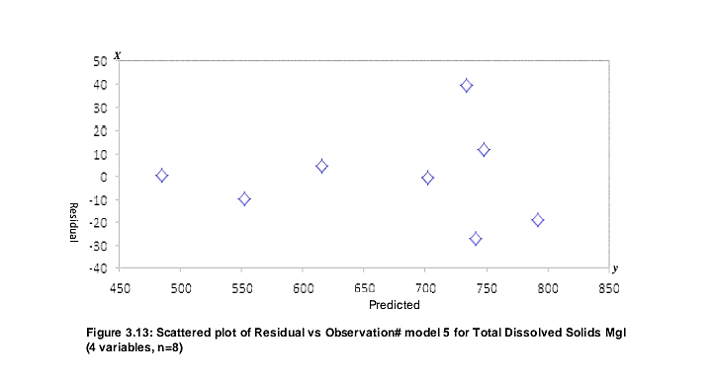

**Figure 3.13: Scattered plot of Residual vs Observation model 5 for Total Dissolved Solids ­­MgI (4 variables, n=8)**

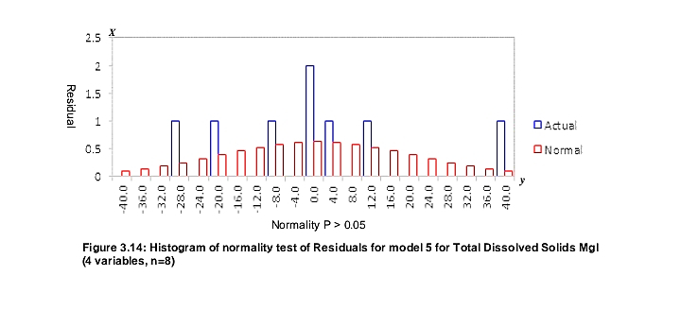

**Figure 3.14: Histogram of normality test of Residuals for model 5 for Total Dissolved Solids ­­MgI (4 variables, n=8)**

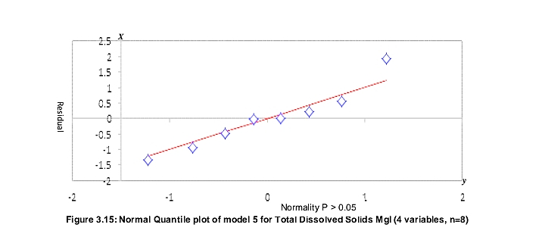

**Figure 3.15: Normal Quantile plot of model 5 for Total Dissolved Solids ­­MgI (4 variables, n=8)**

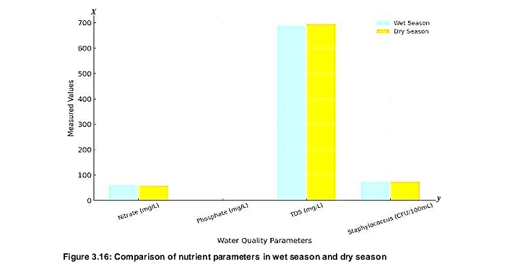

**Figure 3.16 compares the nutrient levels in wet season and dry seasons**

**3.2 Quadratic Model for Nitrate, Phosphates, TDS and Staphylococcus aureus**

The coefficients are the array of weights for each nutrient parameter and the intercept is the bias term. Linear regression models for Nitrate, Phosphates, TDS, and Staphylococcus aureus in both the wet and dry seasons. Adopting equation (2.2) to calculate quadratic model for nutrient parameters. Where: X = the season (0 for wet, 1 for dry), Y = the water quality parameter value, a = the coefficient (slope) and b is the intercept.

Linear model for Nitrate (mg/L): Nitrate = − 3.5925𝑋 + 61.09333

Linear model for Phosphates (mg/L): Phosphates = 0.01575 𝑋 + 0.44608

Linear model for TDS (mg/L): TDS = 7.8067𝑋 + 686.2558

Linear model for Staphylococcus aureus (CFU/100mL): S. aureus = −1.1667𝑋 + 74

3.2.1 Model Refinement

The regression line plots for Nitrate, Phosphates, TDS, and Staphylococcus aureus were used to visualization of linear and quadratic models showing how the nutrient parameters change across seasons. Seasonal loading estimation was done by multiplying concentrations with estimated river flow rates, to determine the actual nutrient loads as it is useful for understanding the total impact on the river ecosystem. Model expansion was done with monthly specific data fitted in quadratic models to capture more complex seasonal dynamics. Correlation and sensitivity analysis calculated correlation coefficients to show which parameters (like temperature or pH) most influence nutrient levels as it helped to identify the strongest drivers of water quality changes. Scenario analysis simulated the impact of human activities (e.g., increased agriculture or pollution) by adjusting input parameters and seeing how nutrient levels respond. Linear graphs and quadratic trends visualized Nitrate, Phosphates, TDS, and Staphylococcus aureus across wet and dry seasons, the regression models predicted future nutrient concentrations of the river, nutrient loads calculated by converting parameter concentrations to loads using typical river flow rates for the Niger Delta and data split into monthly points for more precise models (July–Oct for wet season, Nov–Feb for dry season) for better seasonality. The linear models captured seasonal trends well, with changes in nutrient and bacterial loadings between wet and dry seasons, while the quadratic models reduced to linear forms due minimal data points (one per season).

**3.2.2 Calculating River Flow Rates**

Assuming typical river flow rates for a freshwater river in the Niger Delta to estimate nutrient loads load for wet season (July – October) of Amuruto River with high flow, around 100 m³/s, dry season (November – February) with lower flow, around 50 m³/s. Using formula for load estimation:

Load (kg/day) = Concentration (mg/L) × Flow (m³/s) × 86.4 (3.3)

Load (kg/day) = Concentration (mg/L) × Flow (m³/s) × 86.4. Where 86.4 converts from seconds to days and mg to kg. Figure 4.39: shows linear and quadratic trends for Nitrate, Phosphate, TDS, and Staphylococcus aureus loads in Amuruto River for 8 months (July 2022 – February, 2023). Wet Season (July–October) had peak discharge of approximately 1,424 m³/s in October. Dry Season (November–February) had minimum discharge of around 750 m³/s in March. Given that October experiences peak discharge and March the minimum, flow rates for the other months was interpolated. The provided water quality data was organized into monthly averages, linear and quadratic regression models was fitted to the monthly data, graphs illustrated the trends created and nutrient loads estimated by combining concentration data with flow rates.

**3.3 Comparison of Quadratic and Linear Models**

Figure 3.17 is a graph showing comparative linear and quadratic trends for Nitrate, Phosphates, TDS and Staphylococcus aureus across wet and dry seasons. Figure 3.18 graph shows monthly nutrient loads for Nitrate, Phosphates, TDS and Staphylococcus aureus in the Amuruto River. Figure 3.19 graph showing both the observed nutrient loads and the predicted trends (linear and quadratic) for Nitrate, Phosphates, TDS, and Staphylococcus aureus in the Amuruto River. Figure 3.20: shows linear and quadratic trends for Nitrate, Phosphate, TDS and Staphylococcus aureus loads in Amuruto River for 8 months (July 2022 – February, 2023). Figure 3.21: Projected nutrient loading of Amuruto River for the next 12 months using both linear and quadratic models. Table 3.1 explains features of quadratic and linear models

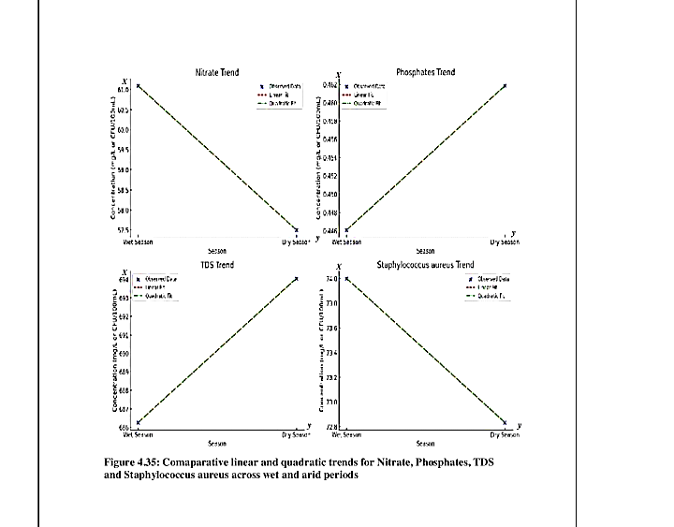

**Figure 3.17: Comparative Linear and Quadratic Trends for Nitrate, Phosphates, TDS and Staphylococcus Aureus across Wet and Dry Seasons**

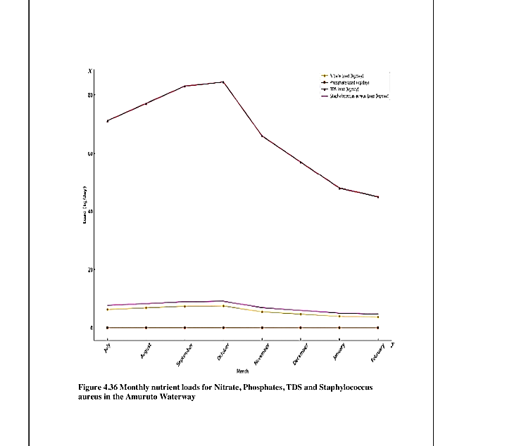

**Figure 3.18 Monthly nutrient loads for Nitrate, Phosphates, TDS and Staphylococcus Aureus in Amuruto River**

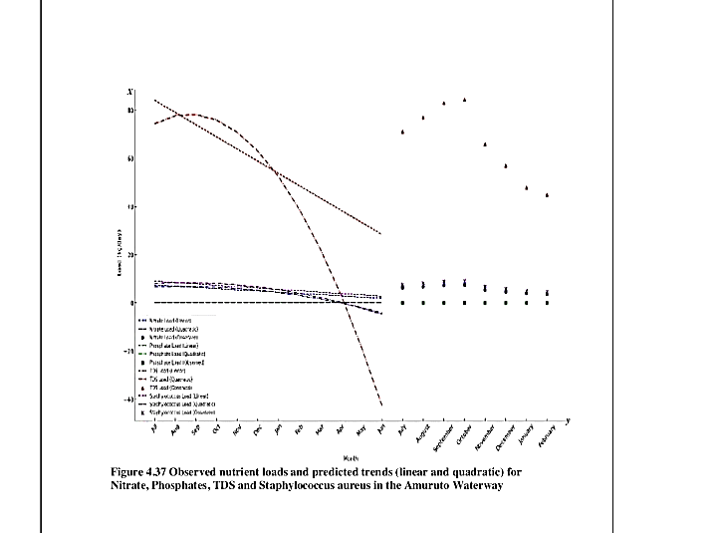

**Figure 3.19 Observed nutrient loads and predicted trends (linear and quadratic) for Nitrate, Phosphates, TDS and Staphylococcus aureus in Amuruto River**

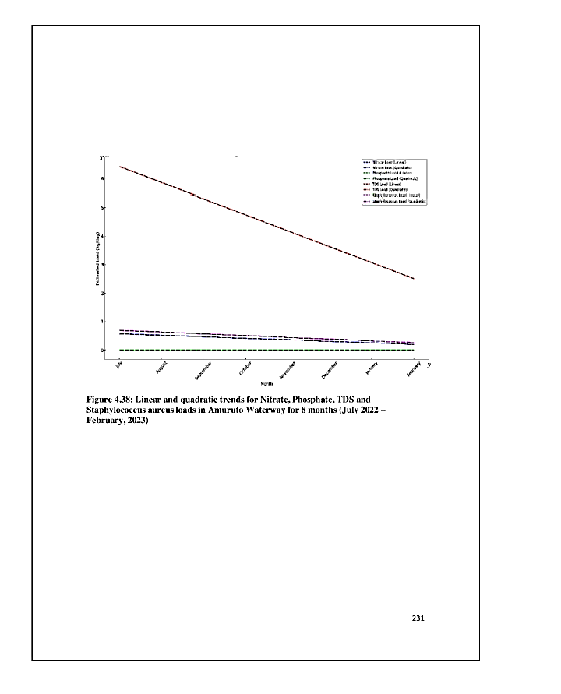

**Figure 3.20: Linear and quadratic trends for Nitrate, Phosphate, TDS and Staphylococcus Aureus Loads in Amuruto River for July 2022 – February, 2023**

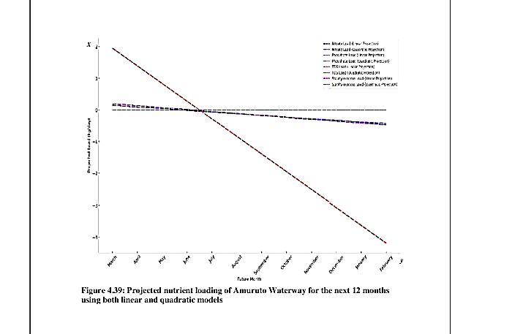

**Figure 3.21: Projected Nutrient Loading of Amuruto River for Next 12 Months Using both Linear and Quadratic Models**

**Table 3.1: Features of Quadratic and Linear Models**

|  |  |  |
| --- | --- | --- |
| **Feature** | **Quadratic Model** | **Linear Model** |
| Nature of Relationship | Non-linear (parabolic trends) | Linear or non-linear (statistical relationships) |
| Best Use Case | Seasonal analysis (wet vs. dry season) | Long-term predictions & trend analysis |
| Handles Multiple Parameters | No, focuses on key nutrient trends | Yes, integrates multiple environmental factors |
| Flexibility | Less flexible (fixed curve shape) | More flexible (can be adjusted to data) |
| Predictive Power | Limited to observed seasonal variations | Strong predictive capabilities |
| Data Requirement | Can work with small datasets | Requires large datasets for accuracy |
| Application | Understanding short-term nutrient spikes & declines | Policy planning, long-term monitoring |

**3.3.1 Correlation Analysis of Nutrient Parameters with other Water Quality Parameters**

Each nutrient concentration was modeled using the independent variables that show significant correlation (Table 3.2). Based on the correlations interpretation (Table 3.5), EC, BOD, and COD are likely to be strong predictors of nutrient concentrations. Nitrates correlated with EC (0.81), TDS (0.65), TSS (0.62), BOD (0.88) and Staphylococcus (0.66). Phosphates correlated with TDS (0.98), DO (0.78), BOD (0.92), and Staphylococcus (0.72). TDS correlated with EC (0.63), DO (0.73), Phosphates (0.98), BOD (0.69) and COD (0.90). Temperature correlated with DO (Dissolved Oxygen): 0.70, TSS: 0.83, Color: 0.97, THC: -0.95. pH correlated with EC: -0.74, BOD: -0.66. EC correlated with TDS: 0.63, DO: 0.70, TSS: 0.70, Nitrate: 0.81, BOD: 0.98, COD: 0.73, Staphylococcus: 0.74. TDS correlated with DO: 0.73, Nitrate: 0.65, Phosphates: 0.98, BOD: 0.69, COD: 0.90, Staphylococcus: 0.71. DO correlated with TSD: 0.73, Phosphates: 0.78, BOD: 0.71, COD: 0.93, Color: 0.74, Staphylococcus: 0.81. TSS correlated with Nitrate: 0.62, BOD: 0.78, Alkalinity: 0.74, Color: 0.75, THC: -0.78, Staphylococcus: 0.61. Nitrate correlated with BOD: 0.88, Staphylococcus: 0.66. Phosphates correlations: BOD: 0.92, Staphylococcus: 0.72. BOD correlations: COD: 0.75, Staphylococcus: 0.78. COD correlated with Staphylococcus: 0.85 and Color correlated with THC: -0.89.

3.4 Observed Impact of Natural and Human Activities on Nutrient Pollution on Amuruto River

Flooding in the wet season was observed to increase nitrate and phosphate runoff, leading to higher nutrient pollution (see Table 3.3). Silting and sand mining alter sediment composition, influencing nutrient retention and release. Cassava and palm oil processing (see Plates 2 & 3) along the river bank discharge organic waste and increased phosphate levels. Open defecation (see Plate 5) and domestic waste contribute to elevated nitrate and phosphate levels (see Table 4.2) in both seasons. Excess nutrients in the wet season could lead to eutrophication, while high nutrient concentration in the dry season increased toxicity risks and promote growth of exotic aquatic weeds (see plate 3 in Appendix 2).

**Table 3.2: Correlation Matrix of Parameters Used for Model Formulation**

|  |  |  |  |  |  |  |  |  |  |  |  |  |  |  |  |
| --- | --- | --- | --- | --- | --- | --- | --- | --- | --- | --- | --- | --- | --- | --- | --- |
|  | Temp (oC) | pH (Nil) | EC (µS/cm) | TDS (Mg/l) (ppm) | DO (Mg/l) | Turbidity (NTU) | TSS (Mg/l) | Nitrate (Mg/l) | Phosphates (Mg/l) | BOD (Mg/l) | COD (Mg/l) | Alkalinity (Mg/l) | Colour (TCU) | THC (Mg/l) | Staphylococcus Aureus (cfu/ml) |
| Temperature (oC) | 1 |  |  |  |  |  |  |  |  |  |  |  |  |  |  |
| pH (Nil) | -0.50 | 1.00 |  |  |  |  |  |  |  |  |  |  |  |  |  |
| Electrical Conductivity (µS/cm) | 0.38 | -0.74 | 1.00 |  |  |  |  |  |  |  |  |  |  |  |  |
| Total dissolved solids (Mg/l) (ppm) | 0.18 | -0.50 | 0.63 | 1.00 |  |  |  |  |  |  |  |  |  |  |  |
| Dissolved oxygen (Mg/l) | 0.70 | -0.57 | 0.70 | 0.73 | 1.00 |  |  |  |  |  |  |  |  |  |  |
| Turbidity (NTU) | -0.46 | -0.02 | 0.44 | 0.59 | 0.29 | 1.00 |  |  |  |  |  |  |  |  |  |
| Total suspended solids (Mg/l) | 0.83 | -0.49 | 0.70 | 0.41 | 0.73 | -0.12 | 1.00 |  |  |  |  |  |  |  |  |
| Nitrate (Mg/l) | 0.13 | -0.45 | 0.81 | 0.65 | 0.42 | 0.44 | 0.62 | 1.00 |  |  |  |  |  |  |  |
| Phosphates (Mg/l) | 0.23 | -0.42 | 0.52 | 0.98 | 0.78 | 0.56 | 0.37 | 0.51 | 1.00 |  |  |  |  |  |  |
| Biochemical oxygen demand (Mg/l) | 0.41 | -0.66 | 0.98 | 0.69 | 0.71 | 0.42 | 0.78 | 0.88 | 0.58 | 1.00 |  |  |  |  |  |
| Chemical oxygen demand (Mg/l) | 0.42 | -0.56 | 0.73 | 0.90 | 0.93 | 0.56 | 0.56 | 0.53 | 0.92 | 0.75 | 1.00 |  |  |  |  |
| Alkalinity ((Mg/l) | 0.57 | 0.06 | 0.32 | -0.13 | 0.31 | -0.19 | 0.74 | 0.34 | -0.13 | 0.40 | 0.08 | 1.00 |  |  |  |
| Colour (TCU) | 0.97 | -0.53 | 0.35 | 0.25 | 0.74 | -0.42 | 0.75 | 0.04 | 0.31 | 0.37 | 0.49 | 0.41 | 1.00 |  |  |
| Total hydrocarbon content (Mg/l) | -0.95 | 0.51 | -0.34 | 0.05 | -0.49 | 0.62 | -0.78 | -0.10 | 0.04 | -0.35 | -0.18 | -0.59 | -0.89 | 1.00 |  |
| Staphylococcus Aureus (cfu/ml) | 0.34 | -0.35 | 0.74 | 0.71 | 0.81 | 0.64 | 0.61 | 0.66 | 0.72 | 0.78 | 0.85 | 0.44 | 0.30 | -0.14 | 1.00 |

**Table 4.3: Observed Potential Influences in Water Quality Parameter Changes in Amuruto River**

|  |  |  |  |  |  |
| --- | --- | --- | --- | --- | --- |
| **Parameter** | **Wet Season Mean** | **Dry Season Mean** | **Percentage Change (%)** | **Observed Potential Influences** | |
| **Anthropogenic** | **Natural** |
| Color | 29.025 | 46.383 | +59.80% | Industrial effluents, palm oil and cassava processing. | Reduced water volume in dry season concentrates pollutants. |
| Dissolved Oxygen (DO) | 7.79 | 8.57 | +10.01% | Reduced organic matter degradation due to lower runoff. | Increased atmospheric oxygen diffusion in dry season. |
| Temperature | 25.71 | 27.37 | +6.48% | Deforestation, sand mining (less shade). | Higher solar intensity during dry season. |
| Alkalinity | 268.74 | 283.52 | +5.50% | Agricultural runoff, soap and detergent use. | Mineral leaching from riverbanks, reduced dilution. |
| COD | 519.86 | 547.61 | +5.34% | Industrial discharge, cassava and palm oil waste. | Lower water flow, less pollutant dispersion. |
| Phosphates | 0.45 | 0.46 | +3.53% | Agricultural fertilizer runoff, domestic waste. | Phosphate release from sediments during low flow. |
| BOD | 12.21 | 12.46 | +2.02% | Organic waste from food processing, faecal contamination. | Reduced microbial activity due to lower flow in dry season. |
| Electrical Conductivity (EC) | 1029.21 | 1042.23 | +1.26% | Industrial and domestic wastewater. | Higher evaporation concentrating ions in dry season. |
| TDS | 686.26 | 694.06 | +1.14% | Industrial waste, leachates from cassava and palm oil processing. | Sediment and mineral dissolution. |
| pH | 6.28 | 6.21 | -1.08% | Acidic effluents from palm oil processing. | Decomposition of organic matter, rainfall acidity. |
| Staphylococcus aureus | 74.00 | 72.83 | -1.58% | Human and livestock activity near water. | Bacterial die-off due to higher temperatures. |
| Nitrate | 61.09 | 57.50 | -5.88% | Agricultural runoff, fertilizer leaching. | Plant uptake and reduced soil flushing in dry season. |
| Escherichia coli | 185.83 | 170.17 | -8.43% | Open defecation, livestock activities. | Reduced runoff carrying fecal matter. |
| Turbidity | 10.48 | 8.36 | -20.27% | Sand mining, domestic washing. | Lower rainfall leading to reduced sediment suspension. |
| Total Hydrocarbon Content (THC) | 266.83 | 175.33 | -34.29% | Oil spills, petroleum waste. | Reduced surface water mixing. |
| Total Coliform Bacteria | 377.50 | 35.35 | -90.64% | Open defecation, wastewater discharge. | Lower runoff, bacterial die-off in dry season. |

# 4. DISCUSSIONS CONCLUSIONS & RECOMMENDATIONS

4.1 Discussions

The results of assessment of water quality parameters and modeling of nutrients loading of Amuruto river from July, 2022 (wet season) – February, 2023) was analyzed in accordance to regulatory standard methods, weighted arithmetic water quality index rating of the water was determined for both seasons, quadratic and linear regression nutrient loading models were formulated, seasonal correlation of parameters determined, spatial variation maps of parameters were developed and direct observation and questionnaire utilized to authenticated the outcome of this research. It is clear from the plot that the route of the actual value was the one that the projected value nearly exactly followed, therefore R2 value was 0.922, and while R2 adjusted value was 0.727. The fact that these values were found to be considerably different from zero indicated that the model is trusted as the model for phosphate also showed the same pattern were R2 was value 0.964 and R2adj 0.916. The R2 value that was obtained from the model for TDS was 0.966 and R2adj value was 0.921. For each of the models. The consistently high R2adj values indicated that the models were fit. The models showed that Nitrate and Total Dissolved Solids (TDS) had a stronger correlation in the wet season and weaker correlation in the dry season. Phosphate and TDS had a weak correlation since phosphate sources (organic pollution) and TDS sources (dissolved minerals) behave differently. Nitrate and Staphylococcus aureus had a moderate correlation, both seasons were linked to wastewater contamination. Phosphate and Staphylococcus aureus had a moderate positive correlation, with both parameters influenced by wastewater and organic pollution in both seasons. The results from the various laboratory and statistical analysis of selected water quality parameters of Amuruto River for the wet season and dry season indicate warmer temperature levels as potentially enhance biological activity for wet season and cooler in dry season, but slowed biological processes, lightly acidic pH influenced in wet season due to anthropogenic activities and runoffs but more stable than in wet in dry season. Electrical conductivity (EC) is lower compared to the dry season, with less ion concentration. The EC value and the strong positive correlation between TDS and EC results affirms the presence of dissolved solids in the water samples. Total dissolved solids (TDS) higher values, indicate increased dissolved substances from runoff but Stable in dry season with concentration reflecting reduced dilution. Generally high dissolved oxygen (DO) suggest good oxygenation in wet season and lower in dry season, may potentially stress aquatic life. Moderate turbidity, indicates sediment transport and potential pollution in wet season but indicates increased sediment and higher pollution potential in dry season. Higher levels of total suspended solids (TSS) in wet season is a reflection of increased sediment load than dry season. Higher nitrate levels, indicates nutrient pollution for both seasons and may have influenced aquatic weeds invasion of the Amuruto River. Higher biochemical oxygen demand (BOD) is a reflection of increased organic pollution in both seasons. The stable chemical oxygen demand (COD) levels, shows consistent pollution levels for both seasons. Higher alkalinity levels for wet and dry seasons provides a better buffering capacity of the Amuruto River. The moderately variable color in both seasons indicate water discoloration from sediment and organic matter. The high total hydrocarbon content (THC) shows degree of pollution sources for both season, mostly the dry season. Conclusively the overall water quality index of Amuruto River water for wet season and dry season is not suitable for drinking and even bathing without treatment as there is a strong positive correlations between pH and TDS, pH and Phosphate, TDS with BOD, Phosphate with TDS, Phosphate with BOD, Phosphate with Temperature and Nitrate with THC as in Uyi et al., (2022) but contradicts Fubara et al., (2022) report that WQI of Orashi River which empties into Amuruto River is within national and international standards, good and suitable for drinking, domestic use and other agricultural use.

4.4 Conclusion

Results of the parameters monitored in all the locations of Amuruto River exceeded the WHO, 2017 standard limits for drinking water, except electrical conductivity value for dry season; therefore agrees with earlier report that such water quality was being seriously impaired. Nitrate was higher (61.09mg/L) than in the dry season (57.50mg/L), likely due to increased nutrient loading runoff from agricultural lands and anthropogenic activities. Phosphate levels are slightly higher in the dry season (0.4618mg/L), suggesting wastewater discharge from marine transport activities and reduced dilution effects. Total dissolved solids (TDS) was higher in dry season (694.06mg/L) due to reduced water volumes, increases pollutants from anthropogenic activities and increased evaporation. Staphylococcus aureus levels remains relatively across seasons, indicating consistent contamination sources likely from open defecation in water. There was significant seasonal variations in nutrient pollution in the Amuruto River as Nitrate and TDS show a strong positive correlation in the wet season but weaken in the dry season due to reduced dilution. Meanwhile, phosphate and microbial contamination maintain a moderate correlation, indicating continuous pollution from domestic and industrial activities. Nutrient loading in Amuruto River was higher in the dry season, exacerbated by reduced river flow and evaporation as there is strong correlations between nutrients and organic pollution indicators (BOD, COD, THC) suggested eutrophication risks. The wet season faces greater microbiological pollution due to runoff, while the dry season had more chemical pollution due to concentration effects. The findings emphasized the need for season-specific pollution control strategies. The quadratic and linear models for predicted nutrient loading for Amuruto River during the wet and dry seasons provided significant insights into the river's health and the potential impacts of nutrient loading and contamination and can be validated on more extensive water quality databases as it constitutes a useful tool to further explore the effects on the rapid changes of human activity in any water body. The quadratic and linear models proved that Nitrate and TDS loads were highest during the wet season (peak in October) in Amuruto River due to increased flow rates, Phosphate loads remain relatively stable, reflecting lower concentration variability, Staphylococcus aureus load decreases sharply in the dry season, likely due to reduced human and animal activity near the river. Dissolved Oxygen (DO) negatively correlated with Biochemical Oxygen Demand (BOD) and Chemical Oxygen Demand (COD) because higher organic pollution leads to more oxygen consumption. The higher Turbidity (suspended particles) correlated positively with Total Dissolved Solids (TDS) and Electrical Conductivity (EC) due to increased mineral content. These nutrients contributed to eutrophication, often positively correlated with BOD and COD as they fuel microbial activity. High bacterial counts positively correlated with Turbidity and negatively correlated with DO. During the wet season, more nutrients, sediment and microbial contaminants entered the river due to surface runoff and other anthropogenic sources. This led to short-term degradation of water quality but also increased dilution of certain pollutants. During the dry season, lower dilution capacity led to higher pollutant concentrations, particularly for parameters like COD, BOD, THC, and Alkalinity. Amuruto River exhibited seasonal fluctuations in pollution, with higher microbial and nutrient contamination in the wet season and higher TDS, conductivity, and organic pollution in the dry season. Nitrate and TDS showed a strong positive correlation in the wet season but weaken in the dry season due to reduced dilution. Meanwhile, phosphate and microbial contamination maintain a moderate correlation, indicating continuous pollution from domestic and industrial activities. The correlation analysis showed a strong relationship between nutrient concentrations and Biological Oxygen Demand (BOD), Chemical Oxygen Demand (COD), and Total Hydrocarbon Content (THC), emphasizing the impact of nutrient pollution on river health. The strong correlations between nutrients and organic pollution indicators (BOD, COD, THC) suggested eutrophication risks, excessive algae growth and invasive aquatic exotic weeds proliferation. Water from Amuruto River and any other freshwater river in the Niger Delta should be properly treated before consumption as the water is of low quality and constitute a danger to public health (Ewulonu,et al., 2019). Therefore, continuous monitoring of water quality of rivers and water bodies in the Niger Delta is essential to the sustenance of aquatic biodiversity, the environment and public health (Enetimi et al., 2016). Based on the study outcome, recommendations are made to improve the water quality management of the Amuruto River.

4.3 Recommendations

The under listed recommendations are possibilities to manage and reduce nutrient loading in the Amuruto River and ensuring better water quality and ecosystem health.

1. Regular monitoring of water quality parameters: temperature, pH, EC, DO, turbidity, TSS, nitrate, phosphate, BOD, COD, alkalinity, color, THC, TCB, and Staphylococcus aureus.
2. Develop and enforce local and national regulations on harmful anthropogenic activities along the river banks and wastewater discharge to minimize nutrient loading into the river.
3. Periodically reevaluate and update the nutrient models to incorporate new data and reflect changes in environmental conditions.
4. Implement measures to manage runoff and reduce pollution sources, especially during the wet season to lower contaminant levels and TCB.
5. Establish or restore riparian buffers along the riverbanks to reduce sediment and nutrient runoff into the river.
6. Develop and enforce local and national regulations on harmful anthropogenic activities along the river banks and wastewater discharge to minimize nutrient loading into the river.
7. Encourage further research on tissue study of aquatic organism from Amuruto River to determine the absorption level of contaminants in river resources consumed by residents.
8. Promote sanitation programs to reduce open defecation and microbial contamination.
9. Implement continuous water quality monitoring programs to track changes in nutrients, TDS, and microbial loads.
10. Develop seasonal intervention plans to mitigate pollution spikes in both wet and dry seasons.

**Disclaimer (Artificial intelligence)**

Option 1:

Author(s) hereby declare that NO generative AI technologies such as Large Language Models (ChatGPT, COPILOT, etc.) and text-to-image generators have been used during the writing or editing of this manuscript.

References

Adams, J. B., Taljaard, S., Niekerk, L. V. & Lemley, D. A. (2020). Nutrient enrichment as a threat to the ecological resilience and health of South African microtidal estuaries Nutrient enrichment as a threat to the ecological resilience and health of. African Journal of Aquatic Science, 45(1–2), 23–40. <https://doi.org/10.2989/16085914.2019.1677212>

Adams, J. B., Taljaard, S., Niekerk, L. V. & Lemley, D. A. (2020). Nutrient enrichment as a threat to the ecological resilience and health of South African microtidal estuaries Nutrient enrichment as a threat to the ecological resilience and health of. African Journal of Aquatic Science, 45(1–2), 23–40. <https://doi.org/10.2989/16085914.2019.1677212>

American Public Health Association (APHA, 2012). Standard methods for the examination of water and wastewater, 22nd edn. American Public Health Association, Washington, DC.

Beusen, A. H. W., Van – Beek, L. P. H., Bouwman, A. F. , Mogollón, J. M. & Middelburg J. J. (2015). Coupling global models for hydrology and nutrient loading to simulate nitrogen and phosphorus retention in surface water – description of IMAGE-GNM and analysis of performance. Geosci. Model Dev. Discuss., 8, 7477–7539. doi:10.5194/gmdd-8-7477.

Beusen, A. H. W., Van – Beek, L. P. H., Bouwman, A. F. , Mogollón, J. M. & Middelburg J. J. (2015). Coupling global models for hydrology and nutrient loading to simulate nitrogen and phosphorus retention in surface water – description of IMAGE-GNM and analysis of performance. Geosci. Model Dev. Discuss., 8, 7477–7539. doi:10.5194/gmdd-8-7477.

Bhateria R. & Jain D. (2016). Water quality assessment of lake: a review. Sustain Water Resour Manag 2:161–173.

Bijay-Singh & Craswell E. (2021). Fertilizers and nitrate pollution of surface and ground water: an increasingly pervasive global problem. SN Appl; 3: 518. https://doi.org/10.1007/s42452-021-04521-8.

Cloern, J. E., Schraga, T. S., Nejad, E. & Martin, C. (2020). Nutrient status of San Francisco bay and its management implications. Estuaries and Coasts, 43, 1299–1317.

Cloern, J. E., Schraga, T. S., Nejad, E. & Martin, C. (2020). Nutrient status of San Francisco bay and its management implications. Estuaries and Coasts, 43, 1299–1317.

Connor, R. (2015). The United Nations world water development report 2015: water for a sustainable world (Vol. 1). UNESCO publishing.

Cornel, A.O., Reuben, O., Daniel, O., Hezron, D. O. (2023). Assessment of the currentstatus of water quality and nutrients enrichment of rivers Kisat and Auji and Nyalenda wastewater sedimentation ponds using multivariate technique. Research Article: Fisheries and Aquatic Ecology: Volume 02(03).

CPCB Ministry of Environment and Forest (2017). Guidelines of water quality monitoring CPCB Guidelines, 2017, 1-16.

Del-Porto, D. & Steinfeld, C., (1999). The Composting Toilet System Book, Center for Ecological Pollution Prevention. Ecological sanitation: Proceedings from Sida Sanitation Workshop, Balingsholm, Sweden.

Enetimi, I. S. & Sylvester, C. I. (2017). Review of Impact of Anthropogenic Activities in Surface Water Resources in the Niger Delta Region of Nigeria: A Case of Bayelsa State. International Journal of Ecotoxicology and Ecobiology. 2 (2), 61-73.

Enetimi, I. S., Sylvester, C. I. & Solomon, O. (2016). Assessment of Water quality from Sagbama Creek, Niger Delta, Nigeria. Biotechnol Res. 3(1), 20-24.

Ewim, D. R. E., Orikpete, O. F., Scott, T. O., Onyebuchi, C.N., Onukogu, A. O., Uzougbo, C. G. & Onunka, C. (2023). Survey of wastewater issues due to oil spills and pollution in the Niger Delta area of Nigeria: a secondary data analysis. Bulletin of the National Research Centre. 2023; 47: 116. <https://doi.org/10.1186/s42269-023-01090-1>

Ewulonu, C. C., Obire, O. & Akani, N. P. (2019). Microbiological and Physiochemical Quality of Freshwater in Isiokpo Community, Rivers State, Nigeria. South Asian Journal of Research in Microbiology 3(1): 1-8.

Fubara, R. I., Wokeh, O. K. & Okey-Wokeh, C. G. (2022). Physicochemical Characterisation and Water Quality Status of the Lower Orashi River, Niger Delta, Nigeria. West African Journal of Applied Ecology, vol. 30(2): pp 24 – 31.

Garnier, J., Billen, G., Hannon, E., Fonbonne, S., Videnina, Y. & Soulie, M. (2002). Modelling the Transfer and Retention of Nutrients in the Drainage Network of the Danube River. Estuarine, Coastal and Shelf Science: 54, pp. 285–308. doi:10.1006/ecss.2000.0648, available online at http://www.idealibrary.com

Garnier, J., Billen, G., Hannon, E., Fonbonne, S., Videnina, Y. & Soulie, M. (2002). Modelling the Transfer and Retention of Nutrients in the Drainage Network of the Danube River. Estuarine, Coastal and Shelf Science: 54, pp. 285–308. doi:10.1006/ecss.2000.0648, available online at http://www.idealibrary.com

Jabbar, F. K., & Grote, K. (2019). Statistical assessment of nonpoint source pollution in agricultural watersheds in the Lower Grand River watershed, MO, USA. Environmental Science and Pollution Research, 26(2), 1487-1506.

Kari, L. V. & Juliann, E. A. (2011). A comparison of tools for modeling freshwater ecosystem services: Journal of Environmental Management 92 (2011) 2403e2409. [www.elsevier.com/locate/jenvman](http://www.elsevier.com/locate/jenvman)

Karo-Emebeyo, O. E., Duke, O. & Diejomaoh C. L. (2023). Profile of Surface Water Quality at Sapele Section of Ethiope River, Delta State, Nigeria. International Journal of Innovative Research and Advanced Studies (IJIRAS) Volume 10(9).

Ogamba, E. N., Ebere N. & Izah S.C. (2017). Heavy Metal Concentration in Water, Sediment and Tissues of Eichhornia crassipes from Kolo Creek, Niger Delta. Greener J. Environ. Manage. Public Safety; 6 (1): pp. 001-005.

Okoro, D. & Diejomaoh, L. C. (2022). Profiling the surface water around Odeama Community of the Niger Delta area of Nigeria. Journal of Environmental Chemistry and Ecotoxicology; vol. 14(1): pp. 9-25. https://doi.org/10.5897/JECE2021.0485

Olubukola, A. A. R., Edet, E. E., & Godwin, O. E. (2021). Application of Water Quality Index for the Assessment of Water from Different Sources in Nigeria. Intech Open.

Roberta, J. (2020). Nutrients in lakes and streams - river, oceans, effects, important, system, plants, source, oxygen, human. Retrieved 24 June 2020, from http://www.waterencyclopedia. com/Mi-Oc/Nutrients-in-Lakes-and-Streams.html

Singh, P. K., Panigrahy, B. K., Verma, P. & Kumar B. (2018). Evaluation of the surface water quality index of Jharia coal mining region and its Management of Surface Water Resources. In: VP Singh et al (eds) Environmental Pollution, Water Science and Technology Library 77, <https://doi.org/10.1007/978-981-10-5792-2_34>.

Sravani, P., Manoj, K. K. & Saritha, V. (2020). A Review on Impacts of Agricultural Runoff on Freshwater Resources. International Journal on Emerging Technologies 11(2): 829-833.

Uruh, U. & Yusuf, M. (2022). Open Defecation and Eutrophication in the Niger Delta Region of Nigeria. International Journal of Novel Research in Engineering and Science Vol. 9, Issue 1, pp: (31-45): [www.noveltyjournals.com](http://www.noveltyjournals.com)

Uyi, H., Sabina, A. N. & Nanee, S. D. (2022). Wet and dry season water quality parameters of the middle reaches of Orashi River, Niger Delta. Ijbcoe journals Vol.1 (1): <https://ijbcoejournals.com>

WHO (2017). Guidelines for Drinking-Water Quality: Fourth Edition. World Health Organization.

WHO, Report on Chemical contaminants of water and Health Consequences, (2017)

Definitions, Acronyms, Abbreviations

µS/cm microsiemens per centimeter

AbsStdRes Absolute Standard Residual

APHA American Public Health Association

BOD Biochemical Oxygen Demand

*CNO*3 Predictive Nitrate

COD Chemical Oxygen Demand

COHSE Centre for Occupational Health, Safety and Environment

CPCB Central Pollution Control Board

*CPO4* Predictive Phosphate

DO Dissolved Oxygen

ds Dry Season

DWS Downstream water sample

E. coli Escherichia Coli

EC Electrical Conductivity

*F* Frequency

FC Fecal Coliforms

GIS Geographic Information System

GNM Global Nutrient Model

GPS Global Positioning System

kg kilogram

Kg/day kilogram per day

LNO3 Linear Nitrate model 3

LPO4) Linear Phosphate model 4

*LTDS*5 Linear Total Dissolved Solids model 5

m³/s meters cube per second

Mg/L Milligrams per liter

MWS Midstream Water Sample

NAOC Nigeria Agip Oil Company

NO3 Nitrate

NTU Nephelomatric Turbidity Unit

pH Alkalinity

PO₄³⁻ Phosphate

*P*-values Probability value

R2 Coefficient of determination

Radj. Residual Adjusted

Shell B.P Shell British Petroleum

SPSS Statistical Package for the Social Science

SS Sample Station

Std. Res Standard Residual

TCU True Color Units

*TDA* Topological Data Analysis

TDS Total Dissolved Solids

THC Total Hydrocarbon Content

THC Total Hydrocarbon Content

TSS Total Suspended Solids

TSS Total Suspended Solids

*Turb* Turbidity

U Upstream

uws Upstream water Sample

vs Versus

WHO World Health Organization

ws Wet Season

ϵ Error Term

𝑋1, 𝑋2, ⋯, 𝑋𝑛 Independent Variables

𝑌 Dependent Variable

𝛽0 Intercept

𝛽1, 𝛽2, ⋯, 𝛽𝑛  Regression coefficients

APPENDIX

**APPENDIX 1: STATISTICAL ANALYSIS TABLES**

|  |  |  |  |  |  |  |  |  |  |  |  |  |  |  |  |  |  |
| --- | --- | --- | --- | --- | --- | --- | --- | --- | --- | --- | --- | --- | --- | --- | --- | --- | --- |
| **Months** | **Temperature (oC)** | **pH (Nil)** | **Electrical Conductivity (µS/cm)** | **Total dissolved solids (Mg/l)** | **Dissolved oxygen (Mg/l)** | **Turbidity (NTU)** | **Total suspended solids (Mg/l)** | **Nitrate (Mg/l)** | **Phosphates (Mg/l)** | **Biochemical oxygen demand(Mg/l)** | **Chemical oxygen demand(Mg/l)** | **Alkalinity (Mg/l)** | **Colour (TCU)** | **Total hydrocarbon content (Mg/l)** | **Total coliform bacteria(cfu/ml)** | **Escherichia coli (cfu/ml)** | **Staphylococcus Aureus (cfu/ml)** |
| July | 25.56 | 6.42 | 808.8633 | 485.3133 | 6.263333 | 7.8 | 66.61667 | 56.09667 | 0.303333 | 9.15 | 382.9767 | 336.37 | 23.5 | 245.8733 | 356 | 161 | 60.33333 |
| August | 25.65 | 6.123333 | 1288.443 | 773.06 | 7.88 | 10.76667 | 78.71 | 74.26 | 0.473667 | 16.19667 | 545.57 | 244 | 27.8 | 246.73 | 262.6667 | 140 | 73.33333 |
| September | 25.66 | 6.253333 | 1189.32 | 713.59 | 8.786667 | 13.46667 | 67.3 | 59.56333 | 0.475667 | 13.94667 | 593.68 | 280.7233 | 29.8 | 287.2567 | 495.3333 | 260 | 92.66667 |
| October | 25.95 | 6.306667 | 830.2267 | 773.06 | 8.216667 | 9.893333 | 60.66667 | 54.45333 | 0.531667 | 9.55 | 557.1967 | 213.87 | 35 | 287.4633 | 396 | 182.3333 | 69.66667 |
| Wet Season Mean Values | 25.705 | 6.275833 | 1029.213 | 686.2558 | 7.786667 | 10.48167 | 68.32334 | 61.09333 | 0.446084 | 12.21084 | 519.8559 | 268.7408 | 29.025 | 266.8308 | 377.5 | 185.8333 | 74 |

**Monthly mean values of water quality parameters of Amuruto River for wet season (ws)**

**Monthly mean values of water quality parameters of Amuruto River for dry season (ds)**

|  |  |  |  |  |  |  |  |  |  |  |  |  |  |  |  |  |  |
| --- | --- | --- | --- | --- | --- | --- | --- | --- | --- | --- | --- | --- | --- | --- | --- | --- | --- |
| **Parameters/**  **Months** | **Temperature (oC)** | **pH (Nil)** | **Electrical Conductivity (µS/cm)** | **Total dissolved solids (Mg/l)** | **Dissolved oxygen (Mg/l)** | **Turbidity (NTU)** | **Total suspended solids (Mg/l)** | **Nitrate (Mg/l)** | **Phosphates (Mg/l)** | **Biochemical oxygen demand (Mg/l)** | **Chemical oxygen demand (Mg/l)** | **Alkalinity (Mg/l)** | **Colour (TCU)** | **Total hydrocarbon content (Mg/l)** | **Total coliform bacteria (cfu/m)** | **Escherichia coli (cfu/ml)** | **Staphylococcus Aureus (cfu/ml)** |
| November | 26.57333 | 6.206667 | 904.22 | 542.5267 | 7.206667 | 6.766667 | 59.86667 | 45.51 | 0.348333 | 9.21 | 450.97 | 225.9867 | 41.16667 | 190.7767 | 252 | 106.3333 | 49.33333 |
| December | 25.95 | 6.306667 | 830.2267 | 773.06 | 8.216667 | 9.893333 | 60.66667 | 54.45333 | 0.531667 | 9.55 | 557.1967 | 213.87 | 35 | 287.4633 | 396 | 182.3333 | 69.66667 |
| January | 28.32667 | 6.113333 | 1169.087 | 701.4467 | 9.026667 | 7.966667 | 94.31333 | 62.92667 | 0.467333 | 14.30667 | 565.97 | 333.56 | 51.86667 | 114.39 | 374 | 185 | 82.66667 |
| February | 28.63667 | 6.206667 | 1265.367 | 759.2167 | 9.813333 | 8.8 | 111.0667 | 67.11333 | 0.5 | 16.76333 | 616.3167 | 360.67 | 57.5 | 108.69 | 392 | 207 | 89.66667 |
| Dry Season Mean Values | 27.37167 | 6.208334 | 1042.225 | 694.0625 | 8.565834 | 8.356667 | 81.47834 | 57.50083 | 0.461833 | 12.4575 | 547.6134 | 283.5217 | 46.38334 | 175.33 | 353.5 | 170.1667 | 72.83334 |

**Wet season and dry seasonal mean values of water quality parameters of Amuruto River**

|  |  |  |  |  |  |  |  |  |  |  |  |  |  |  |  |  |  |
| --- | --- | --- | --- | --- | --- | --- | --- | --- | --- | --- | --- | --- | --- | --- | --- | --- | --- |
| **Season** | **Temperature (oC)** | **pH (Nil)** | **Electrical Conductivity (µS/cm)** | **Total dissolved solids (Mg/l)** | **Dissolved oxygen (Mg/l)** | **Turbidity (NTU)** | **Total suspended solids (Mg/l)** | **Nitrate (Mg/l)** | **Phosphates (Mg/l)** | **Biochemical oxygen demand (Mg/l)** | **Chemical oxygen demand(Mg/l)** | **Alkalinity (Mg/l)** | **Colour (TCU)ws** | **Total hydrocarbon content(Mg/l)** | **Total coliform bacteria(cfu/ml)** | **Escherichia coli (cfu/ml)** | **Staphylococcus Aureus (cfu/ml)** |
| Wet Season | 25.705 | 6.275833 | 1029.213 | 686.2558 | 7.786667 | 10.48167 | 68.32334 | 61.09333 | 0.446084 | 12.21084 | 519.8559 | 268.7408 | 29.025 | 266.8308 | 377.5 | 185.8333 | 74 |
| Dry Season | 27.37167 | 6.208334 | 1042.225 | 694.0625 | 8.565834 | 8.356667 | 81.47834 | 57.50083 | 0.461833 | 12.4575 | 547.6134 | 283.5217 | 46.38334 | 175.33 | 353.5 | 170.1667 | 72.83334 |

**Statistical mean values of parameters for upstream, midstream and downstream sections of Amuruto River**

|  |  |  |  |  |  |  |
| --- | --- | --- | --- | --- | --- | --- |
| **Parameters** | **Up-stream** | | **Mid-Stream** | | **Down-stream** | |
| Wet Season | Dry Season | Wet Season | Dry Season | Wet  Season | Dry Season |
| Temperature (oC) | 25.53 ± 0.06 | 27.53 ±0.98 | 25.85 ± 0.25 | 27.89 ± 0.87 | 25.74 ± 0.22 | 27.90 ± 0.93 |
| pH (Nil) | 6.40 ± 0.12 | 6.28 ±0.06 | 6.25 ± 0.13 | 6.18 ± 0.05 | 6.19 ± 0.13 | 6.09 ± 0.06 |
| Electrical Conductivity (µS/cm) | 777.54 ± 172.25 | 889.33 ± 117.88 | 1094.36 ± 249.56 | 1055.91 ± 173.54 | 1215.74 ± 319.52 | 1333.34 ± 190.52 |
| Total dissolved solids (Mg/l) (ppm) | 518.13 ± 100.17 | 533.59 ± 70.72 | 728.45 ± 140.43 | 633.54 ± 104.13 | 812.20 ± 173.54 | 800.00 ± 114.31 |
| Dissolved oxygen (Mg/l) | 6.16 ± 1.36 | 7.73 ± 1.37 | 7.85 ± 1.35 | 8.80 ± 0.92 | 9.36 ± 0.88 | 9.45 ± 1.02 |
| Turbidity (NTU) | 11.33 ± 4.40 | 6.90 ± 1.32 | 9.17 ± 1.81 | 7.85 ± 0.60 | 10.95 ± 3.13 | 8.68 ± 0.63 |
| Total suspended solids (Mg/l) | 51.73 ± 4.32 | 67.71 ± 15.66 | 64.32 ± 7.98 | 90.13 ± 22.94 | 88.93 ± 16.09 | 101.22 ± 26.75 |
| Nitrate (Mg/l) | 51.36 ± 0.29 | 49.13 ± 8.66 | 58.75 ± 12.38 | 57.54 ± 8.29 | 73.18 ± 6.97 | 66.18 ± 11.79 |
| Phosphates (Mg/l) | 0.64 ± 0.16 | 0.33 ± 0.07 | 0.39 ± 0.13 | 0.46 ± 0.06 | 0.31 ± 0.22 | 0.51 ± 0.08 |
| Biochemical oxygen demand (Mg/l) | 9.54 ± 2.62 | 12.02 ± 3.39 | 11.80 ± 3.12 | 12.87 ± 3.33 | 15.30 ± 4.61 | 14.06 ± 3.10 |
| Chemical oxygen demand (Mg/l) | 412.85 ± 102.47 | 446.84 ± 94.09 | 547.65 ± 102.95 | 539.91 ± 64.49 | 599.07 ± 83.63 | 626.03 ± 55.20 |
| Alkalinity (Mg/l) | 210.50 ± 45.29 | 248.30 ± 41.36 | 263.16 ± 51.13 | 311.32 ± 63.38 | 332.56 ± 62.75 | 346.22 ± 72.48 |
| Colour (TCU) | 22.65 ± 4.54 | 40.28 ± 7.60 | 29.88 ± 5.58 | 50.00 ± 5.64 | 34.55 ± 4.52 | 56.98 ± 8.32 |
| Total hydrocarbon content (Mg/l) | 273.34 ± 37.34 | 145.69 ± 42.56 | 257.02 ± 23.86 | 134.56 ± 38.16 | 270.13 ± 22.32 | 132.26 ± 31.51 |
| Total coliform bacteria (MPN/100ml) | 186.50 ± 56.60 | 227.25 ± 45.15 | 391.25 ± 140.38 | 367.50 ± 46.60 | 554.75 ± 119.87 | 415.25 ± 97.40 |
| Escherichia coli (MPN/100ml) | 111.75 ± 7.54 | 108.25 ± 34.84 | 180.50 ± 72.20 | 164.50 ± 38.68 | 265.25 ± 90.27 | 224.00 ± 56.86 |
| Staphylococcus Aureus (MPN/100ml) | 56.50 ± 17.18 | 57.00 ± 14.31 | 73.00 ± 15.30 | 76.25 ± 21.36 | 92.50 ± 10.25 | 85.75 ± 17.61 |

Values are expressed as Means ± Standard Deviation (SD) Note: Different superscript indicates a statistically significant difference between the means at p-value < 0.05 while similar superscript or none indicates that there is no statistically significant difference between the means.

**Multiple comparison of mean difference (I-J), Std. Error, Sig., 95% confidence interval (lower boundary) and (upper boundary) between water quality parameters for upstream, midstream and downstream of Amuruto River**

|  |  |  |  |  |  |  |  |  |  |  |  |  |  |  |  |
| --- | --- | --- | --- | --- | --- | --- | --- | --- | --- | --- | --- | --- | --- | --- | --- |
| **Multiple Comparisons LSD** | | | | | | | | | | | | | | | |
| **Independent Variables** | **Mean Difference (I-J)** | | | **Std. Error** | | | **Sig.** | | | **95% Confidence Interval** | | | | | |
| **Lower Bound** | | | **Upper Bound** | | |
| us | ms | ds | us | ms | ds | us | ms | ds | us | ms | ds | us | ms | ds |
| Temp. | -2.01 | -2.04 | -2.16 | 36.88 | 50.95 | 59.32 | .957 | .968 | .971 | -75.1616 | -103.1105 | -119.8120 | 71.1516 | 99.0255 | 115.4920 |
| pH | 0.11 | 0.07 | 0.10 | 36.88 | 50.95 | 59.32 | .998 | .999 | .999 | -73.0441 | -101.0030 | -117.5495 | 73.2691 | 101.1330 | 117.7545 |
| EC | **-**111**.**78750 | 38.45 | -117.60 | 36.88 | 50.95 | 59.32 | .003 | .452 | .050 | -184.9441 | -62.6205 | -235.2520 | -38.6309 | 139.5155 | .0520 |
| TDS | -15.47 | 94.91 | 12.19 | 36.88 | 50.95 | 59.32 | .676 | .065 | .838 | -88.6241 | -6.1630 | -105.4570 | 57.6891 | 195.9730 | 129.8470 |
| DO | -1.58 | -0.96 | -0.10 | 36.88 | 50.95 | 59.32 | .966 | .985 | .999 | -74.7316 | -102.0230 | -117.7470 | 71.5816 | 100.1130 | 117.5570 |
| Turbidity | 4.43 | 1.32 | 2.28 | 36.88 | 50.95 | 59.32 | .905 | .979 | .969 | -68.7291 | -99.7505 | -115.3770 | 77.5841 | 102.3855 | 119.9270 |
| TSS | -15.99 | -25.81 | -12.30 | 36.88 | 50.95 | 59.32 | .666 | .614 | .836 | -89.1416 | -126.8730 | -129.9495 | 57.1716 | 75.2630 | 105.3545 |
| Nitrate | 2.22 | 1.21 | 7.00 | 36.88 | 50.95 | 59.32 | .952 | .981 | .906 | -70.9341 | -99.8605 | -110.6520 | 75.3791 | 102.2755 | 124.6520 |
| Phosphates | 0.31 | -0.07 | -0.19 | 36.88 | 50.95 | 59.32 | .993 | .999 | .997 | -72.8496 | -101.1365 | -117.8440 | 73.4636 | 100.9995 | 117.4600 |
| BOD | -2.48 | -1.07 | 1.24 | 36.88 | 50.95 | 59.32 | .946 | .983 | .983 | -75.6391 | -102.1405 | -116.4095 | 70.6741 | 99.9955 | 118.8945 |
| COD | -33.99 | 7.75 | -26.96 | 36.88 | 50.95 | 59.32 | .359 | .879 | .650 | -107.1491 | -93.3205 | -144.6145 | 39.1641 | 108.8155 | 90.6895 |
| Alkalinity | -37.80 | -48.16 | -13.66 | 36.88 | 50.95 | 59.32 | .308 | .347 | .818 | -110.9566 | -149.2230 | -131.3095 | 35.3566 | 52.9130 | 103.9945 |
| Colour | -17.63 | -20.13 | -22.43 | 36.88 | 50.95 | 59.32 | .634 | .694 | .706 | -90.7816 | -121.1930 | -140.0770 | 55.5316 | 80.9430 | 95.2270 |
| THC | **127.65250** | **122.46250** | **137.87500** | 36.88 | 50.95 | 59.32 | .001 | .018 | .022 | 54.4959 | 21.3945 | 20.2230 | 200.8091 | 223.5305 | 255.5270 |
| TCB | -40.75 | 23.75 | **139.50000** | 36.88 | 50.95 | 59.32 | .272 | .642 | .021 | -113.9066 | -77.3180 | 21.8480 | 32.4066 | 124.8180 | 257.1520 |
| E. coli | 3.50 | 16.00 | 41.25 | 36.88 | 50.95 | 59.32 | .925 | .754 | .488 | -69.6566 | -85.0680 | -76.4020 | 76.6566 | 117.0680 | 158.9020 |
| S. Aureus | -0.50 | -3.25 | 6.75 | 36.88 | 50.95 | 59.32 | .989 | .949 | .910 | -73.6566 | -104.3180 | -110.9020 | 72.6566 | 97.8180 | 124.4020 |

* The mean difference is significant at the 0.05 level

* us – upstream, ms – midstream and ds – downstream

**APPENDIX 2: LINEAR REGRESSION MODEL TABLES**

|  |  |  |  |  |  |  |  |
| --- | --- | --- | --- | --- | --- | --- | --- |
| **R-Squared** | **Adj.R-Sqr.** | **Std.Err.Reg.** | **Std.Dep.Var.** | **# Fitted** | **# Missing** | **Critical t** | **Confidence** |
| 0.922 | 0.727 | 4.596 | 8.793 | 8 | 0 | 4.303 | 95.0% |

**Linear model 3 for nitrates**

|  |  |  |  |  |  |  |  |  |  |  |
| --- | --- | --- | --- | --- | --- | --- | --- | --- | --- | --- |
| **Model:** | Model 3 |  |  |  |  |  |  |  |  |  |
| **Dependent Variable:** | | Nitrate Mgl | |  |  |  |  |  |  |  |
| **Independent Variables:** | |  |  |  |  |  |  |  |  |
| Biochemical oxygen demand Mgl, Electrical Conductivity µScm, Staphylococcus Aureus cfuml, Total dissolved solids Mglppm, Total suspended solids Mgl | | | | | | | | | | |
| **Equation:** |  |  |  |  |  |  |  |  |  |  |
| Predicted Nitrate Mgl = 70.414 + 10.229.  Biochemical oxygen demand Mgl 0.099.  Electrical Conductivity µS cm - 0.054.  Staphylococcus Aureus cfuml - 0.014.  Total dissolved solids Mgl ppm - 0.279,  Total suspended solids Mgl | | | | | | | | | | |

|  |  |  |  |  |  |  |  |  |
| --- | --- | --- | --- | --- | --- | --- | --- | --- |
|  |  |  |  |  |  |  |  |  |
|  | **R-Squared** | **Adj.R-Sqr.** | **Std.Err.Reg.** | **Std.Dep.Var.** | **# Fitted** | **# Missing** | **Critical t** | **Confidence** |
|  | 0.922 | 0.727 | 4.596 | 8.793 | 8 | 0 | 4.303 | 95.0% |
|  |  |  |  |  |  |  |  |  |
| **Variable** | **Coefficient** | **Std.Err.** | **t-Statistic** | **P-value** | **Lower95%** | **Upper95%** | **VIF** | **Std. Coeff.** |
| Constant | 70.414 | 25.890 | 2.720 | 0.113 | -40.983 | 181.811 | 0.000 | 0.000 |
| Biochemical oxygen demand Mgl | 10.229 | 4.238 | 2.414 | 0.137 | -8.005 | 28.464 | 58.333 | 3.642 |
| Electrical Conductivity µScm | -0.099 | 0.054 | -1.835 | 0.208 | -0.331 | 0.133 | 36.435 | -2.189 |
| Staphylococcus Aureus cfuml | -0.054 | 0.234 | -0.230 | 0.839 | -1.060 | 0.953 | 3.041 | -0.079 |
| Total dissolved solids Mglppm | -0.014 | 0.028 | -0.502 | 0.666 | -0.132 | 0.105 | 3.045 | -0.173 |
| Total suspended solids Mgl | -0.279 | 0.202 | -1.383 | 0.301 | -1.148 | 0.589 | 4.312 | -0.567 |

|  |  |  |  |  |  |  |  |  |
| --- | --- | --- | --- | --- | --- | --- | --- | --- |
|  |  |  |  |  |  |  |  |  |
| **Source** | **Deg. Freedom** | **Sum Squares** | **Mean Square** | **F-Statistic** | **P-value** |  |  |  |
| Regression | 5 | 498.931 | 99.786 | 4.724 | 0.184 |  |  |  |
| Residual | 2 | 42.246 | 21.123 |  |  |  |  |  |
| Total | 7 | 541.177 |  |  |  |  |  |  |
|  | Mean Error | RMSE | MAE | Minimum | Maximum | MAPE | A-D* stat | MASE lag 1 |
| Fitted (n=8) | 0.000 | 2.298 | 2.058 | -3.346 | 2.508 | 3.5% | 0.55 (P=0.161) | 0.210 |

|  |  |  |  |  |  |  |  |  |
| --- | --- | --- | --- | --- | --- | --- | --- | --- |
|  |  |  |  |  |  |  |  |  |
| **Lag** | **1** |  |  |  |  |  |  |  |
| Autocorrelation | -0.291 |  |  |  |  |  |  |  |
| StdErrorsFromZero | -0.769 |  |  |  |  |  |  |  |
| Durbin-Watson | 2.301 |  |  |  |  |  |  |  |
|  |  |  |  |  |  |  |  |  |

|  |  |  |  |  |  |  |
| --- | --- | --- | --- | --- | --- | --- |
| Variable | Constant |  |  |  |  |  |
| Constant | 1.000 | Biochemical Oxygen demand Mgl |  |  |  |  |
| Biochemical oxygen demand Mgl | 0.897 | 1.000 | Electrical Conductivity µScm |  |  |  |
| Electrical Conductivity µScm | -0.874 | **-0.957** | 1.000 | Staphylococcus Aureus cfuml |  |  |
| Staphylococcus Aureus cfuml | -0.085 | -0.054 | -0.045 | 1.000 | Total dissolved Solids Mglppm |  |
| Total dissolved solids Mglppm | -0.625 | **-0.523** | 0.432 | -0.391 | 1.000 | Total suspended  Solids Mgl |
| Total suspended solids Mgl | -0.680 | **-0.718** | **0.588** | -0.132 | 0.480 | 1.000 |

|  |  |  |  |  |  |  |  |  |  |  |  |  |
| --- | --- | --- | --- | --- | --- | --- | --- | --- | --- | --- | --- | --- |
| **Obs#** | **Forecast** | **StErrFcst** | **Lower95%F** | **Upper95%F** | **StErrMean** | **Lower95%M** | **Upper95%M** | **Biochemical Oxygen demand**  **Mgl** | **Electrical**  **Conductivity**  **µScm** | **Staphylococcus**  **Aureus cfuml** | **Total_dissolved_**  **solids___Mg_l___ppm** | **Total_suspended**  **_solids___Mg_l** |
|  |  |  |  |  |  |  |  |  |  |  |  |  |

**Linear Model 4 for Phosphates**

|  |  |  |  |  |  |  |  |  |  |  |  |  |  |  |  |  |  |  |  |  |
| --- | --- | --- | --- | --- | --- | --- | --- | --- | --- | --- | --- | --- | --- | --- | --- | --- | --- | --- | --- | --- |
| **Model:** | | **Model 4** | |  |  | |  |  | |  |  |  | |  |  | |  | White | No Font | NoHeaders |
| **Dependent Variable:** | | | | Phosphates Mgl | | |  |  | |  |  |  | |  |  | |  |  |  |  |
| **Independent Variables:** | | | |  |  | |  |  | |  |  |  | |  |  | |  |  |  |  |
| Chemical oxygen demand Mgl,  Dissolved oxygen Mgl,  Staphylococcus Aureus cfuml,  Total dissolved solids Mglppm | | | | | | | | | | | | | |  |  | |  |  |  |  |
| **Equation:** | |  | |  |  | |  |  | |  |  |  | |  |  | |  |  |  |  |
| Predicted Phosphates Mgl = -0.055 + 0.000228  *Chemical oxygen demand Mgl + 0.002372  *Dissolved oxygen Mgl - 0.00038  *Staphylococcus Aureus cfu ml + 0.000567  *Total dissolved solids Mglppm | | | | | | | | | | | | | | | | | | | | |
|  | | **R-Squared** | | **Adj.RSqr** | **Std.Err.Reg.** | | **Std.Dep.Var.** | **# Fitted** | | **# Missing** | **Critical t** | **Confidence** | |  |  | |  |  |  |  |
|  | | 0.964 | | 0.916 | 0.023 | | 0.079 | 8 | | 0 | 3.182 | 95.0% | |  |  | |  |  |  |  |
| **Variable** | | **Coefficient** | | **Std.Err.** | **t-Statistic** | | **P-value** | **Lower95%** | | **Upper95%** | **VIF** | **Std. Coeff.** | |  |  | |  |  |  |  |
| Constant | | -0.055 | | 0.068 | -0.809 | | 0.478 | -0.272 | | 0.162 | 0.000 | 0.000 | |  |  | |  |  |  |  |
| Chemical oxygen demand Mgl | | 0.000228 | | 0.000764 | 0.299 | | 0.785 | -0.002204 | | 0.002661 | 46.929 | 0.224 | |  |  | |  |  |  |  |
| Dissolved oxygen Mgl | | 0.002372 | | 0.031 | 0.077 | | 0.944 | -0.096 | | 0.101 | 15.925 | 0.033 | |  |  | |  |  |  |  |
| Staphylococcus Aureus cfuml | | -0.000380 | | 0.001287 | -0.295 | | 0.787 | -0.004477 | | 0.003717 | 3.738 | -0.063 | |  |  | |  |  |  |  |
| Total dissolved solids Mglppm | | 0.000567 | | 0.000269 | 2.109 | | 0.126 | -0.000289 | | 0.001424 | 11.828 | 0.795 | |  |  | |  |  |  |  |
|  | | **Mean Error** | | **RMSE** | **MAE** | | **Minimum** | **Maximum** | | **MAPE** | **A-D* stat** | **MASE lag 1** | |  |  | |  |  |  |  |
| Fitted (n=8) | | 0.000 | | 0.014 | 0.010 | | -0.025 | 0.028 | | 2.1% | 0.43 (P=0.304) | 0.124 | |  |  | |  |  |  |  |
|  |  | |  | | |  | | |  | | | |  | | |
| **Lag** | | **1** | |  |  | |  |  | |  |  |  | |  |  | |  |  |  |  |
| Autocorrelation | | -0.182 | |  |  | |  |  | |  |  |  | |  |  | |  |  |  |  |
| StdErrorsFromZero | | -0.482 | |  |  | |  |  | |  |  |  | |  |  | |  |  |  |  |
| Durbin-Watson | | 2.317 | |  |  | |  |  | |  |  |  | |  |  | |  |  |  |  |

**Std.Res., AbsStdRes, Leverage and Cook's D values for Actual, Predicted and Residual model 4 for Phosphates ­­MgI (4 variables, n=8)**

|  |  |  |  |  |  |  |  |
| --- | --- | --- | --- | --- | --- | --- | --- |
| **Observation #** | **Actual** | **Predicted** | **Residual** | **Std.Res.** | **AbsStdRes** | **Leverage** | **Cook's D** |
| 1 | 0.303 | 0.300 | 0.003756 | 0.485 | 0.485 | 0.885 | 0.361 |
| 2 | 0.474 | 0.499 | -0.025 | -1.677 | 1.677 | 0.566 | 0.734 |
| 3 | 0.476 | 0.473 | 0.002998 | 0.678 | 0.678 | 0.962 | 2.356 |
| 4 | 0.532 | 0.504 | 0.028 | 1.704 | 1.704 | 0.482 | 0.540 |
| 5 | 0.348 | 0.354 | -0.005646 | -0.804 | 0.804 | 0.905 | 1.237 |
| 6 | 0.407 | 0.408 | -0.001497 | -0.084 | 0.084 | 0.392 | 0.001 |
| 7 | 0.467 | 0.462 | 0.005285 | 0.283 | 0.283 | 0.328 | 0.008 |
| 8 | 0.500 | 0.508 | -0.007679 | -0.467 | 0.467 | 0.479 | 0.040 |

**Linear Model 5 for Total Dissolved Solids (TDS)**

|  |  |  |  |  |  |  |  |  |  |
| --- | --- | --- | --- | --- | --- | --- | --- | --- | --- |
| **Model:** | **Model 5** |  |  |  |  |  |  |  |  |
| **Dependent Variable:** | | Total dissolved solids Mg lppm | | |  |  |  |  |  |
| **Independent Variables:** | |  |  |  |  |  |  |  |  |
| Chemical oxygen demand Mgl,  Dissolved oxygen Mgl,  Phosphates Mgl,  Staphylococcus Aureus cfuml | | | | | | | |  |  |
| **Equation:** |  |  |  |  |  |  |  |  |  |
| Predicted Total dissolved solids Mglppm = 90.218 + 0.782  Chemical oxygen demand Mgl - 35.637  Dissolved oxygen Mg l + 1052  Phosphates Mgl - 0.016  Staphylococcus Aureus cfuml | | | | | | | | | |
|  | **R-Squared** | **Adj.R-Sqr.** | **Std.Err.Reg.** | **Std.Dep.Var.** | **# Fitted** | **# Missing** | **Critical t** | **Confidence** |  |
|  | 0.966 | 0.921 | 31.062 | 110.179 | 8 | 0 | 3.182 | 95.0% |  |
|  |  |  |  |  |  |  |  |  |  |
| **Variable** | **Coefficient** | **Std.Err.** | **t-Statistic** | **P-value** | **Lower95%** | **Upper95%** | **VIF** | **Std. Coeff.** |  |
| Constant | 90.218 | 88.233 | 1.022 | 0.382 | -190.579 | 371.015 | 0.000 | 0.000 |  |
| Chemical oxygen demand Mgl | 0.782 | 0.955 | 0.820 | 0.472 | -2.256 | 3.821 | 39.484 | 0.549 |  |
| Dissolved oxygen Mgl | -35.637 | 36.899 | -0.966 | 0.405 | -153.065 | 81.792 | 12.172 | -0.359 |  |
| Phosphates Mgl | 1,052 | 499.091 | 2.109 | 0.126 | -535.953 | 2,641 | 11.185 | 0.751 |  |
| Staphylococcus Aureus cfuml | -0.016 | 1.778 | -0.009 | 0.993 | -5.676 | 5.644 | 3.846 | -0.001897 |  |
|  |  |  |  |  |  |  |  |  |  |
|  | **Mean Error** | **RMSE** | **MAE** | **Minimum** | **Maximum** | **MAPE** | **A-D* stat** | **MASE lag 1** |  |
| Fitted (n=8) | 0.000 | 19.022 | 13.977 | -27.210 | 39.463 | 1.9% | 0.29 (P=0.612) | 0.115 |  |
|  |  |  |  |  |  |  |  |  |  |
| **Lag** | **1** |  |  |  |  |  |  |  |  |
| Autocorrelation | -0.145 |  |  |  |  |  |  |  |  |
| StdErrorsFromZero | -0.384 |  |  |  |  |  |  |  |  |
| Durbin-Watson | 2.243 |  |  |  |  |  |  |  |  |

**APPENDIX 2: FIELD PLATES SHOWING SOME ANTHROPOGENIC ACTIVITIES ALONG AMURUTO RIVER**

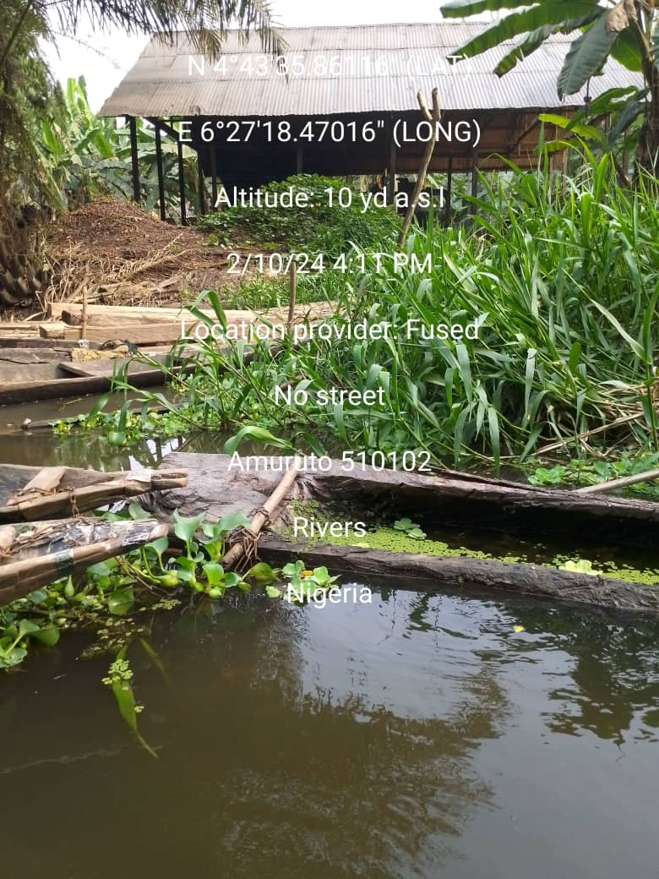 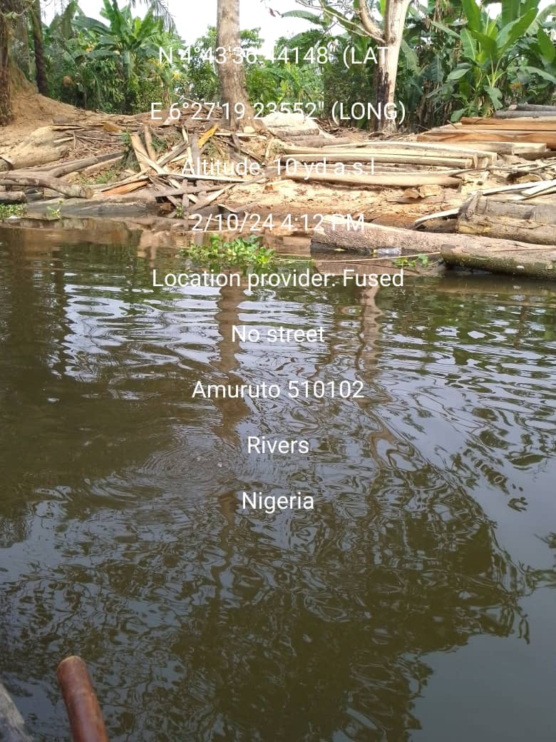

**Plate 2: Palm oil processing at Amuruto River Plate 3: Timber/wood sawing activities at Amuruto River**

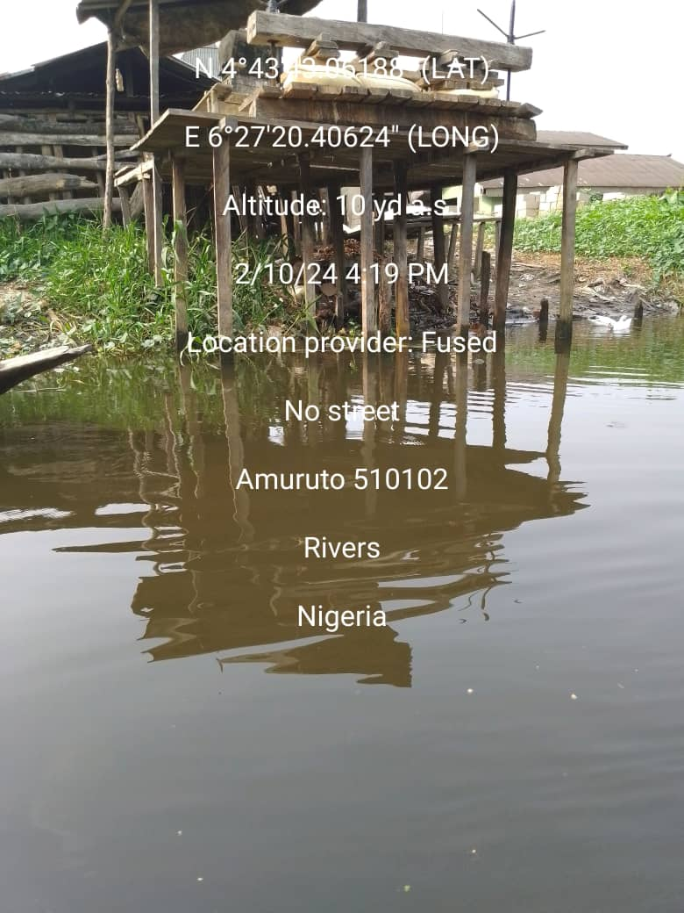 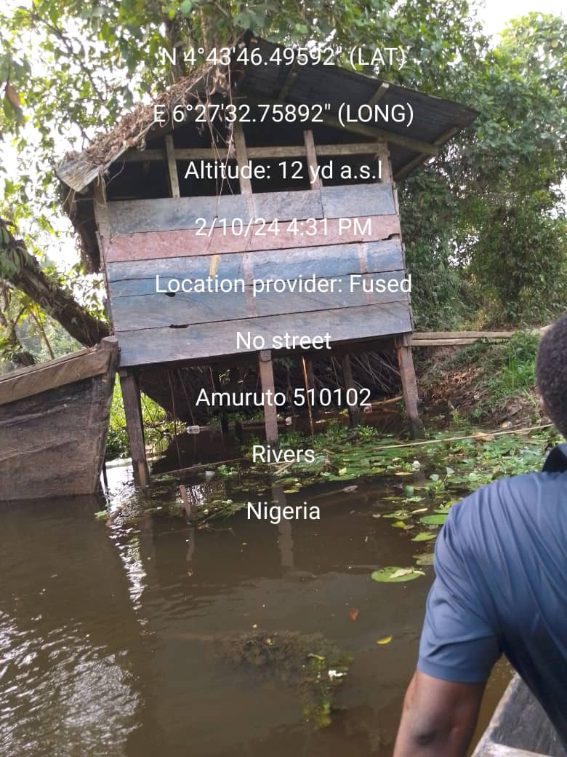

**Plate 4: Cassava processing activities at Amuruto River & Plate 5: Open defecation system along Amuruto River**

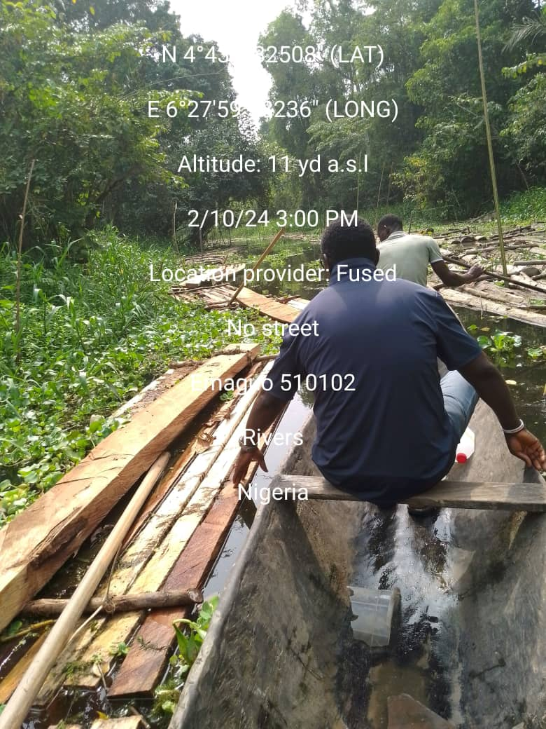 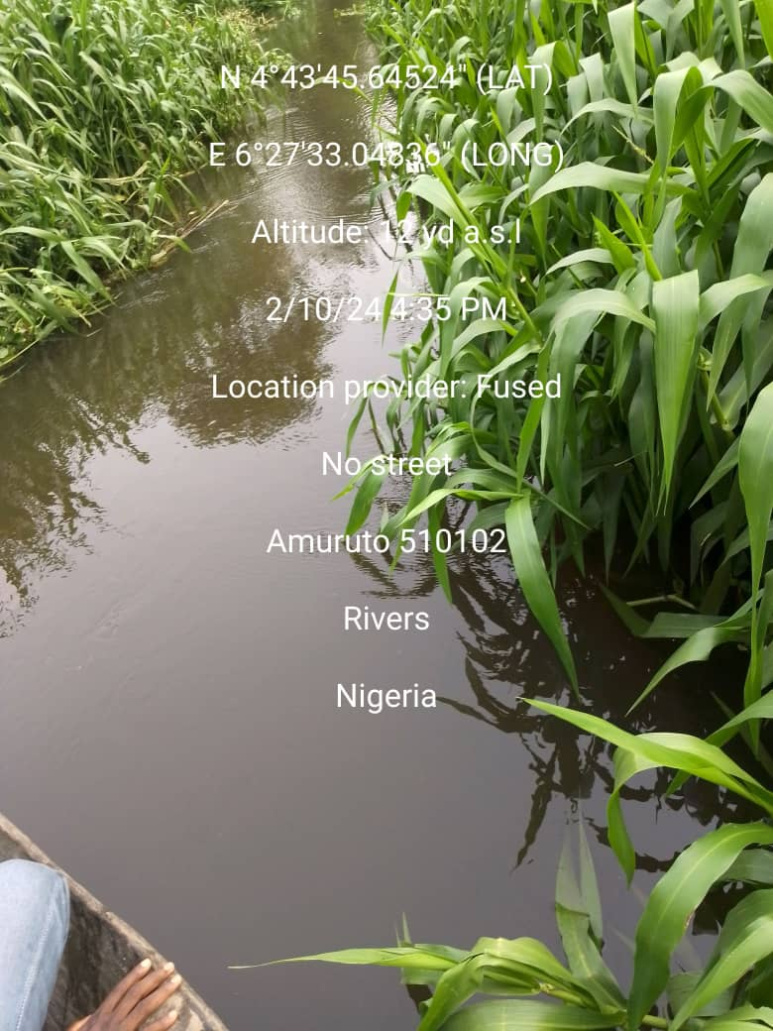

**Plate 6: Evidence of Lumbering activities along Amuruto River Plate 7: Exotic aquatic weed (*Hymenachne spp) infestation* on Amuruto River**