# Assessment of Precipitation and Temperature trends in Kilosa district, Morogoro, Tanzania

**ABSTRACT**

|  |
| --- |
| .  Global climate change presents challenges in characterizing regional impacts, particularly on rainfall patterns, crucial for socio-economic activities like agriculture in vulnerable regions such as Africa. Sub-Saharan Africa, with its erratic rainfall, limited data, and reliance on agriculture, faces significant climate-related challenges, particularly drought. Understanding rainfall characteristics is vital for water resources management particularly agriculture, prompting the study of precipitation and temperature trends in Kilosa District, Tanzania. Using CHIRPS precipitation data and ERA 5 Ag-9.6 km temperature data from 1981 to 2005, this study analyzed annual and seasonal trends. The Mann-Kendall test was employed to assess statistical significance. The findings show an increasing trend in annual precipitation, with wet years exceeding 900 mm/year and dry years dropping below 400 mm/year. While the dry season exhibits mixed trends, the wet season consistently shows increasing trends, albeit with variations across grids. Spatial analysis indicates a clear spatial distribution of precipitation patterns. Temperature trends reveal a consistent upward trajectory in mean, maximum, and minimum temperatures. Annual mean temperatures rise by 0.017°C per year, with December recording the highest (17.94°C) and July the lowest (13.43°C) temperatures. All grids/stations exhibit significant increases in both wet and dry season temperatures. Spatially, areas near urban centers experience the most significant temperature rise, while higher elevations witness slight decreases. These findings underscore the importance of comprehending local climate variations for effective water resource and agricultural management. Future research should focus on the impacts of these trends on surface irrigation, water availability, agricultural productivity, and ecosystem health, especially in the context of growing urbanization and environmental degradation. Efforts to mitigate climate change impacts should prioritize sustainable land use and water management practices in vulnerable district areas like Kilosa. |

**Key words:** Rainfall Variability, Rainfall characteristics, Trend analysis, Water resources management.

1. INTRODUCTION

Global climate change is a visible and identifiable phenomenon, but its presence at regional and local scales, especially in precipitation records, is difficult to characterize because of the high variability (IPCC, 2007b). The fourth Intergovernmental Panel on Climate Change (IPCC) assessment report provides compelling evidence that the global climate has changed significantly over the last century (Solomon et al., 2007). Africa is considered to be particularly vulnerable to climate change, mainly due to its dependence on climate, and in particular rainfall, for various socio-economic activities, particularly agriculture (FAO, 2004). Several studies have been conducted worldwide and in Sub-Saharan Africa, specifically Tanzania (Kulyakwave et al., 2023; Kimaro, 2019; Adhikari et al., 2017). The majority of investigations, however, have focused on a general perspective rather than local scale leading to more generalized results. So, for this study, it scaled down to district level as a smallest unit.

Interpretation of variations in meteorological analysis, usually expressed as monthly or seasonal averages, is crucial to understanding the impact on agriculture (Silungwe et al., 2019a). Understanding changes in rainfall patterns, particularly those affecting planting dates and the growth cycle of crops, is essential for the agricultural sector, which is the main source of income for most regions and local populations (Silungwe et al., 2019b). Precipitation and temperature are among the most important climatic variables in hydrology, water management and climate, due to their significant influence on the timing and geography of water availability (Raneesh, 2014). Precipitation is key to the relationship between rainfall and runoff, mitigation strategies and the assessment of floods and droughts, while temperature is important for water availability, respiration and evaporation (Qiu et al., 2021). Long-term variations in rainfall and temperature are essential to understand the impacts of climate change (Jones & Briffa, 2001). Valuable information on past and future changes in climate regimes can be obtained from the assessment of meteorological indicators such as precipitation and temperature (Tošić et al., 2015).

Although the trend towards global warming is clear, precipitation varies from place to place because of its higher geographical and seasonal variability relative to the increase in temperature (Dore, 2005). In hydrological studies, precipitation is an important factor in agriculture, disaster preparedness and water management and plays a key role in resource planning and management (Sivakumar, 2011). Recent emphasis in climate change research has been on regional and temporal precipitation distribution (Trenberth, 2011).

Acquisition of data from rain gauges faces challenges in many areas because of issues related to administration and technology (Silungwe et al., 2019a). Limited rain gauges in many river basins with limited data records make the distribution of observed precipitation for regional and temporal being imprecise (Tapiador et al., 2017). To address these challenges, alternative datasets have been developed in the previous two decades, including GPCP, TMPA, APHRODITE, CSFR, PERSIANN-CDR, ERA5 Ag and CHIRPS (Solomon et al., 2017). Several research efforts have compared these datasets to ground observations to assess their relevance in hydrological researches (Musuuza et al., 2023). The results of comprehensive assessment of several climate data sources for East Africa were used to guide this study on the use of the gridded satellite datasets with higher spatial and temporal resolutions (Gebrechorkos et al., 2018).

The policy of the Government of Tanzania is to shift from rain-fed to irrigated agriculture to improve food security (Patel et al., 2014). The objective is to increase irrigated land from 0.2 million ha in 2004 to 1.0 million ha in 2035 (NIMP, 2018). For effective development planning, understanding long-term trends in climatic factors, especially precipitation and temperature, over the last 25 years is essential. Focusing on the district level, taking 1981-2005 as a reference period will help to simplify the planning strategies up to 2035 as foreseen in the NIMP-2018.

Kilosa district is confronted with environmental challenges that pose significant implications for the well-being of its residents (Liwenga & Silangwa, 2020). Deforestation, soil erosion, inadequate water management practices and depletion of natural resources have raised concerns about the sustainability of the district (Mugasha & Katani, 2016). The consequences of these challenges extend beyond the environment, affecting the well-being of the local population and the overall socio-economic fabric of the district. The district experienced variability in seasonal rainfall, resulting in an unreliable water supply for paddy crops. This unreliability stems from a reduction in both rainfall and river water, affecting the effectiveness of surface irrigation systems. Additionally, urbanization in the district has contributed to a rise in temperature (Sumari et al., 2022). Consequently, it is essential to understand the historical climatic trends, particularly those related to precipitation and temperature for the future review of National Irrigation Master Plan (NIMP). Therefore, the goal of the study was to assesses precipitation and temperature trends in Kilosa district. The specific objectives of the study included (1) To validate the climatic datasets (2) To generate gridded climatic data and (3) To analyze precipitation and temperature trends.

2. Materials and Methods

2.1 Description of the study Area

The study was conducted in Kilosa district due to its potential in paddy cultivation among several districts in Tanzania and its prone to climate change impact. The district is located in Morogoro region in Eastern Tanzania between 36°30'E and 37°30'E easting, and 6°00'S and 7°00'S northing (Figure 1). The altitudes are ranging 300 and 600 meters above sea level and is about 138 kilometers from Morogoro Municipality (Boku, 2014). The main crops grown is paddy by surface irrigation and rain-fed methods.

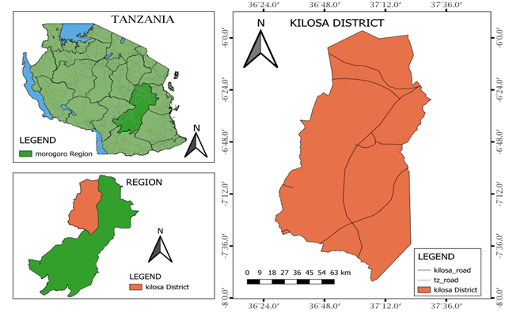

Figure 1: Location of the study area.

The district is one among the six districts of Morogoro Region in Tanzania, covers 14,918 square kilometers and is known for its significance in agriculture, contributing significantly to Tanzania's food production (Boku, 2014). It is characterized by strategic location offering a mix of plains and hills, favoring diverse ecosystems (Kilosa, 2015). The district is categorized by a dry season spanning from May to October with little or no rains while wet season is from November to April, which describe the rainfall regime as unimodal (Wilson & Ouedraogo, 2017). The surface irrigation is enforced by the presence of several Rivers such as Wami, Mkondoa, Ruaha and Mkata, supplementing precipitation to meet the crop water requirements (Kisoza, 2007). The local economy is primarily driven by agriculture, with a substantial portion of the population involved in farming activities (Luanda, 2020), this is due to its potential in fertile soil and favorable climate which both donate to the cultivation of several crops, consequently making Kilosa District a vital hub for food production in the region (Ntumva, 2020).

2.2 Validation of climatic datasets

The precipitation data used in this research comes from CHIRPS (1981-2005), which is a satellite-based rainfall estimation system (Paredes et al., 2017). It integrates daily infrared cold cloud duration (CCD) observations with ground data to provide accurate measurements (Sulugodu & Deka, 2019). CHIRPS offer gridded rainfall data at a spatial resolution of 0.05 degrees (around 4.8 kilometers) and covers the period from 1981 to date (Ntawukuriryayo, 2022). CHIRPS dataset is primarily utilized to evaluate long-term climate variability and trends, serving as a substitute for observed data (Wiwoho et al., 2021). For temperature data, including maximum, minimum, and mean temperatures, the study relied on ERA5 Ag (1981-2005) as an alternative to observed data (Velikou et al., 2022). ERA5 Ag offers high spatial resolution with grid cells of 0.1 degrees (approximately 9.6 km) (He et al., 2023). Research using ERA5 Ag has effectively investigated temperature anomalies and extremes, offering valuable insights into regional climate variability (Huang et al., 2021).

In this study, the methodology which involves point-to-area grid cell averaging to assess the accuracy of two specific products which are CHIRPS and ERA 5 Ag was used due to its efficiency in yielding accurate results compared to other methods (Kimani et al., 2017). Consequently, the comparison was conducted by matching the station averages with the area grid cell averages of these products, utilizing various statistical techniques (Dembélé & Zwart, 2016).

The validation area is Ukaguru forest meteorological station owned by Ruvu basin Tanzania, positioned at Latitude -6.333 and Longitude 36.95 within Kilosa district (Ido, 2008). The observed rainfall data, as well as minimum and maximum temperatures from 1981 to 2005 from the ground station (Ukaguru), were compared with gridded data of rainfall using CHIRPS and temperature using ERA5 Ag with the same period of length (Frank et al.,2022).

This study utilized statistical methods, comprises of Pearson correlation coefficient (CC), Mean Absolute Error (MAE) and Root Mean Squared Error (RMSE) (Shabani et al., 2020) for comparative analysis with the help of statistical package RStudio (Sarmento & Costa, 2017). Additionally, the findings have been compared with prior research on the assessment of several climate data sources used for management of environmental resources in East Africa (Solomon et al., 2017).

$CC=\frac{\sum_{i=1}^{N}{\left(P_{i}-P\right).(O_{i}-O)}}{\sqrt{\sum_{i=1}^{N}{{(P_{i}-P)}^{2}}}.\sqrt{\sum_{i=1}^{N}{(O_{I}-O)^{2}}}}$................................................................i

$MAE=\frac{\sum_{i=1}^{N}{\left[O_{i}-P_{i}\right]}}{N}$...................................................................................ii

$RMSE=\sqrt{\frac{\sum_{I=1}^{N}{(O_{i}-P_{i})^{2}}}{N}}$...........................................................................iii

2.3 Generation of gridded climatic data

The analysis of annual and seasonal precipitation trends covers a vast area of Kilosa district, spanning 14,918 square kilometers. This comprehensive study involves 35 grids, each covering an area of 500 square kilometers due to standard rain gauge sparse density (Frei & Schär, 1998). The choice of such a large number of grids is driven by the geographical significance of precipitation trends, which vary spatially each year and season across the district (New, 2001). In contrast, the analysis of temperature trends adopts only nine grids for this aspect of the study. This decision is informed by the understanding that temperature trends are influenced by global factors rather than localized geography (Easterling, 1997).

The grids which are representative of stations executed using the developed shape file of Kilosa district border, collected from Tanzania Agricultural Research Institution (TARI)-Mlingano with the help of Q-GIS software (Mbwambo et al., 2024). Precipitation and temperature data of 25 years for historical period (1981-2005) were gathered from the generated grids (Serbin & Kucharik, 2009).

2.4 The Analyses of precipitation and temperature trends within a baseline period (1981-2005)

Various statistical approaches can be employed for trend detection (Kundzewicz & Radziejewski, 2006). In this study, the nonparametric Mann–Kendall test was utilized for this purpose (Alashan, 2024). It is non-parametric tools which assumes observations are dependent (Karpouzos, 2010), not normally distributed, and effectively identifying the presence of trends. Based on this test, the null hypothesis H0 assumes no trend in the data (i.e., it is independent and randomly ordered) and tests this assumption in relation to the alternative hypothesis H1, which assumes that there is a trend (Tabari et al., 2011). Evaluation was conducted at a 95 percent confidence level, considering serial autocorrelation (Bence, 1995). Mann-Kendall test is presented by equation (iv):

$S=\sum_{k=1}^{n-1}{\sum_{j=k+1}^{n}{sign(x_{j}+x_{k})}}$..........................................................iv

Where, S = Mann-Kendall test value

Xj and Xk = Sequential data values

J, k and n = Length of the data

The presence of a statistically signiﬁcant trend is assessed using the Z value, as defined by the equation (v):

$Z=\left\{\begin{aligned}S-1/{\sqrt{VAR(S)}} if S>0 \\ 0 if S=0 \\ S+1/{VAR(S)} if S<0\end{aligned}\right.$.......................................................v

Where, Z = Normalized test statistics

S = Mann-Kendall statistical value

VAR(S) = Mann-Kendall variance.

A positive and negative values of Z indicate an upward and downward trend respectively (Kabanda, 2018). To test whether there is either an upward or downward monotone trend (a two-tailed test) at α signiﬁcance level, H0 is rejected if |Z| > Z1-α/2, H0 is rejected if the p value is less than the significance level α (alpha) = 0.05 (Limbu, & Makula, 2023). Rejecting H0 shows that there is a trend in the time series, while acceptance of H0 shows no trend was detected. When rejecting the null hypothesis, the result is said to be statistically significant (Kavishe & Limbu, 2020). The analysis was executed by using a statistical package of RStudio.

3. Results

3.1 Validation of the climatic data sets

The statistical evaluation of the CHIRPS and ERA5 Ag datasets, as presented in Table 1, highlights their predictive accuracy and reliability for climatic data.

The Mean Absolute Error (MAE), 0.81 and 0.71 suggests a high level of precision, indicating minimal average error in predictions. Similarly, the Root Mean Squared Error (RMSE), 1.16 and 1.14 implies a moderate degree of error. The unbiased RMSE (ubRMSE) values, 1.11 1nd 1.10 shows a slight improvement over RMSE, suggesting minor adjustments to reduce bias in the data. Additionally, the Pearson Correlation Coefficient (CC) for both datasets which is 1.00, confirm the almost perfect linear relationship between observed and predicted values, underscoring the dataset’s reliability.

Overall, both of the datasets provide accurate and dependable representations of climatic variables with higher correlation, lower errors and minor biases in the validation area. These findings align closely with validation studies conducted in Ethiopia, Kenya, and Tanzania, as documented by Gebrechorkos et al. (2018). In these countries, the CHIRPS dataset for precipitation and the ERA5 Ag dataset for temperature have consistently shown stronger correlations and lower biases with station data than other satellite sources. This validation highlights their reliability in representing the stations data within the study area.

The analysis of physical land features, environmental factors, and climatic data trends in Kilosa district reveals intricate interactions influenced by geographical and climatic variability. Kilosa's landscape is characterized by contrasting terrains, with the mountainous southern region receiving higher annual precipitation (up to 1313.15 mm) compared to the moderately flat northern region, which receives as little as 573.62 mm.

**Table 1:** Validation of the climatic data sets

|  |  |  |
| --- | --- | --- |
| Statistic test | CHIRPS | ERA 5 Ag |
| MAE | 0.81 | 0.71 |
| RMSE | 1.16 | 1.14 |
| ubRMSE | 1.11 | 1.10 |
| CC | 1.00 | 1.00 |

3.2 Generation of gridded climatic data

Using Q-GIS package, 35 grided point were generated each with a 500 square kilometer as a maximum coverage area for an area with flat area the same as Kilosa district (Figure 2).

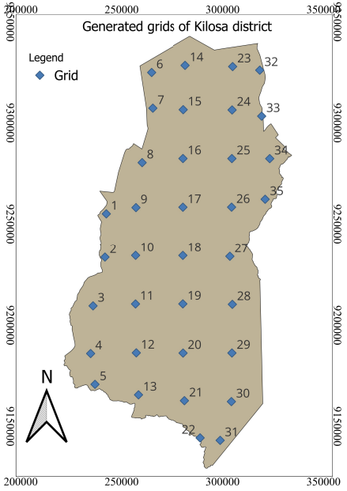

**Figure 2:** Maps showing generated grids with approximately coverage area of 500 km2

3.3 Distribution and Trends Analysis

**3.3.1 Precipitation**

Generally, the average annual precipitation in Kilosa district is between 573.62 mm in the moderately flat north to 1313.15 mm in the mountainous south (Figure 3). The wet season lasts from November to a third week of April, whereas the remaining months are dry. The peak rainfall occurs in March, while the lowest occurs in June (Fig. 4 and Table 2). More than 90% of whole precipitation occurs in the wet season (November-April). IDW (Inverse Distance Weighting) interpolation analysis was used to execute the spatial analysis of precipitation from generated point data (Chen et al.,2012).

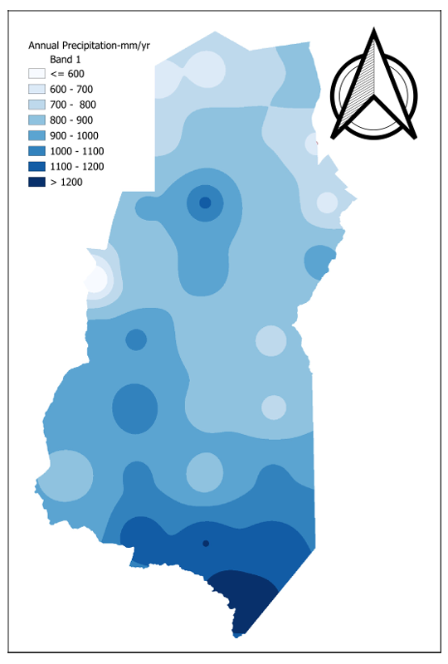

Figure 3: The spatial distribution of Kilosa District Precipitation

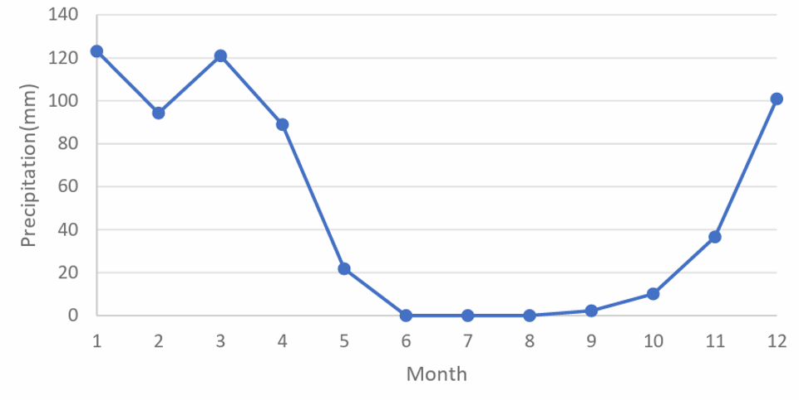

Figure 4: Graph of Monthly average of Kilosa district Precipitation

Table 2: Monthly Average rainfall in Kilosa District

|  |  |  |  |  |  |  |  |  |  |  |  |  |
| --- | --- | --- | --- | --- | --- | --- | --- | --- | --- | --- | --- | --- |
| Month | Jan | Feb | Mar | Apr | May | Jun | Jul | Aug | Sept | Oct | Nov | Dec |
| Temp | 123.11 | 94.30 | 120.98 | 88.94 | 21.78 | 0.04 | 0.04 | 0.02 | 2.28 | 10.14 | 36.59 | 100.95 |

The annual precipitation in Kilosa district from 1981 to 2005 indicates decreasing trend with a magnitude of -6.810 (Figure 5). Dry years occurred in 2005 with precipitation not exceeding 600 mm/year. In contrast, wet years appeared in 1989 with annual precipitation exceeding 1200 mm/year.

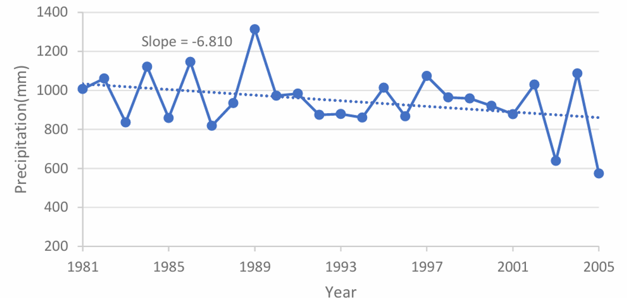

Figure 5: Variation of Annual Precipitation for Kilosa district

The MK test was applied to assess the annual precipitation time series through RStudio statistical package, which showed that 14.29% (5 grids) had a positive trend while 85.71% (30 grids) with a negative trend (Gupta & Chavan, 2021). The Z value revealed that, four (4) grids with an insignificant increase (I) while one grid with significant increase (SI), twenty-six (26) with an insignificant decrease (D) while four (4) grids with significant decrease (SD) (Table 3 & 4), The magnitude of the trend varies from -16.87 mm/year to 5.38 mm/year. (Figure 6a). This aligns with the findings of Luganda et al., (2019), who observed a significant shift in rainfall patterns across several areas in Kilosa from 1972 to 2004, resulting in an increased distance to grazing lands.

Table 3: MK Trend Analysis of 17 grids for precipitation in Kilosa District

|  |  |  |  |  |  |  |  |  |  |
| --- | --- | --- | --- | --- | --- | --- | --- | --- | --- |
| Grid |  | Wet |  |  | Dry |  |  | Annual |  |
| Z | Slope | Trend | Z | Slope | Trend | Z | Slope | Trend |
| 1 | 0.58 | 2.28 | I | -2.45 | -0.59 | SD | 2.32 | 2.40 | SI |
| 2 | -0.63 | -2.89 | D | -2.50 | -1.83 | SD | -0.63 | -3.95 | D |
| 3 | -1.00 | -6.60 | D | -1.99 | -1.13 | SD | -1.10 | -6.84 | D |
| 4 | -0.86 | 4.57 | D | -2.41 | -1.04 | SD | -1.14 | 5.38 | D |
| 5 | -1.05 | -5.32 | D | -2.45 | -0.74 | SD | 0.12 | 1.41 | I |
| 6 | 0.21 | 1.62 | I | -1.94 | 0.24 | SD | 1.86 | 4.00 | I |
| 7 | 0.16 | 0.58 | I | -2.79 | -1.11 | SD | 0.00 | -0.08 | D |
| 8 | 0.58 | 2.23 | I | -2.45 | -1.55 | SD | 0.26 | 1.28 | I |
| 9 | 0.35 | 1.76 | I | -2.97 | -1.67 | SD | -0.02 | -0.11 | D |
| 10 | -0.12 | -0.55 | D | -2.69 | -2.36 | SD | -0.44 | -4.47 | D |
| 11 | -0.49 | -2.67 | D | -3.06 | -2.58 | SD | -0.86 | -10.18 | D |
| 12 | -1.42 | -8.53 | D | -3.62 | -2.54 | SD | -1.80 | 1.45 | I |
| 13 | -1.05 | -7.41 | D | -3.01 | -1.96 | SD | -1.52 | -9.07 | D |
| 14 | 0.12 | 0.58 | I | -1.80 | -0.94 | D | -0.26 | -0.78 | D |
| 15 | -0.30 | -1.18 | D | -2.64 | -2.17 | SD | -0.35 | -1.47 | D |
| 16 | -0.30 | -2.14 | D | -2.73 | -2.84 | SD | -0.82 | -5.30 | D |
| 17 | 0.35 | 0.89 | I | -3.11 | -2.24 | SD | -0.16 | -1.14 | D |

Table 4. MK Trend Analysis of 18 grids for precipitation in Kilosa District

|  |  |  |  |  |  |  |  |  |  |
| --- | --- | --- | --- | --- | --- | --- | --- | --- | --- |
| Grid |  | Wet |  |  | Dry |  |  | Annual |  |
| Z | Slope | Trend | Z | Slope | Trend | Z | Slope | Trend |
| 18 | -0.21 | -0.84 | D | -2.55 | -1.89 | SD | -0.68 | -3.21 | D |
| 19 | -0.72 | -2.18 | D | -3.62 | -2.57 | SD | 1.19 | -5.44 | D |
| 20 | -1.28 | -6.05 | D | -3.06 | -1.84 | SD | -1.66 | -8.88 | D |
| 21 | -1.38 | -9.14 | D | -3.67 | -3.64 | SD | -1.99 | -13.98 | SD |
| 22 | -1.52 | -10.91 | D | -4.41 | -4.51 | SD | -2.13 | -16.87 | SD |
| 23 | -0.16 | -0.26 | D | 0.00 | 0.004 | I | -0.58 | -2.09 | D |
| 24 | -0.44 | -2.64 | D | -2.50 | -2.08 | SD | -1.19 | -4.02 | D |
| 25 | 0.00 | -0.01 | D | -3.34 | -2.80 | SD | -0.58 | -2.29 | D |
| 26 | -0.68 | -1.66 | D | -3.62 | -2.67 | SD | -0.96 | -5.18 | D |
| 27 | -1.10 | -2.43 | D | -2.92 | -2.13 | SD | -1.47 | -4.70 | D |
| 28 | -0.40 | -2.83 | D | -4.23 | -2.27 | SD | -1.10 | -5.40 | D |
| 29 | -1.42 | -8.53 | D | -3.62 | -2.54 | SD | -1.80 | -10.18 | D |
| 30 | -1.61 | -8.22 | D | -3.76 | -3.82 | SD | -2.13 | -13.85 | SD |
| 31 | -1.80 | -10.77 | D | -4.27 | -4.33 | SD | -2.45 | -15.87 | SD |
| 32 | -0.54 | -2.33 | D | -1.94 | -2.01 | SD | -0.77 | -3.30 | D |
| 33 | -0.86 | -3.22 | D | -2.78 | -1.80 | SD | -1.52 | -4.36 | D |
| 34 | -0.54 | -1.86 | D | -2.97 | -2.13 | SD | -1.28 | -4.78 | D |
| 35 | 0.35 | 0.89 | I | -3.11 | -2.24 | SD | -0.16 | -1.14 | D |

Despite the annual trend, in dry season the MK trend found that 22.86 % (1 grid) with a positive trend while 77.14 % (34 grids) with a negative trend. The Z value revealed that, thirty-three grids (33) with significant decrease (SD), one grid with an insignificant decrease (D), and one grid with insignificant increase (I) (Table 3 & 4), The magnitude of trends varies from -4.51 mm/year to 0.24 mm/year, with a small part of the southern area of the district showing the maximum decreasing trend while the northern part showing the highest increasing trend (Figure 6c).

Again, in the wet season, the MK test found 22.86 percent of grids (8) with a positive trend while 77.14 percent with a negative trend (27 grids). The Z value showed that, eight (8) grids and twenty-seven (27) grids, with insignificant increase (SI) and decrease (SD) respectively (Table 3 & 4). The magnitude of trends varies from -10.91 mm/year to 4.57 mm/year, with the northern part showing the increasing trend while southern part of the district showing the maximum decreasing trend (Figure 6b).

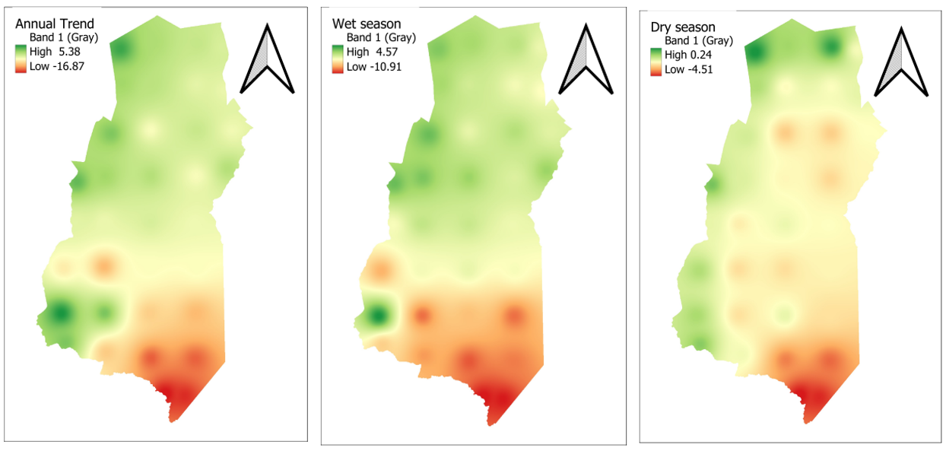

c

b

a

Figure 6: a, b, c. The Annual and Seasonal Spatial trend of Precipitation in Kilosa district

**3.3.2 Temperature**

Based on the analysis from 1981 to 2005, the mean temperature of Kilosa district has shown variability ranging from 18.33°C to 22.71°C across nine (9) monitoring grids. On monthly bases, December recorded the highest temperature at 17.77°C, whereas July marked the lowest at 13.29°C (Figure 7 and Table 5). Based on the spatial distribution map of mean annual temperature from 1981 to 2005, the eastern part which is fairly flat experiences the highest temperatures, peaking at 24.83°C, while the western part, characterized by higher elevations, records the lowest temperatures, averaging at 16.15°C (Figure 8).

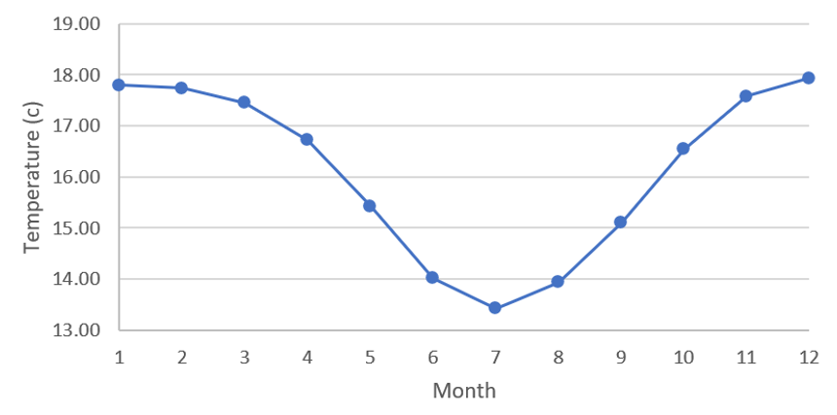

Figure 7: Graph of the monthly average temperature of Kilosa district

Table 5: Monthly Average Temperature in Kilosa District

|  |  |  |  |  |  |  |  |  |  |  |  |  |
| --- | --- | --- | --- | --- | --- | --- | --- | --- | --- | --- | --- | --- |
| Month | Jan | Feb | Mar | Apr | May | Jun | Jul | Aug | Sept | Oct | Nov | Dec |
| Temp | 22.59 | 22.56 | 21.96 | 20.93 | 19.88 | 18.72 | 18.33 | 18.94 | 20.19 | 21.40 | 22.34 | 22.71 |

The findings obtained for seasonal and annual data of minimum, maximum, and mean temperatures are presented in Table 6, 7 and 8 respectively. In annual minimum temperature, the analysis reveals decreasing trend from 1981 to 2005. This trend is quantified by a magnitude of -0.0059°C (Figure 8). The lowest minimum temperature was recorded in 1996 at 12.53°C, while the highest occurred in 1982 at 13.20°C. The results indicate that 100 percent of grids (9) had a positive trend in wet season in which 2 of the grids are significant (SI), while in dry season 100 percent are insignificant negative trend (D). In annual trends 66.67% of the grids (6) had insignificant positive trend (I) and 33.33% of the grids (3) had insignificant negative trend (D). The Z value reveals a notable increase across all grids during the wet season in which 2 grids with significant increase (SI). and insignificant decrease (D) across all grids during the dry season. Furthermore, it signifies annual insignificant increase (I) across 6 grids and annual insignificant decease (D) across the remaining 3 grids.

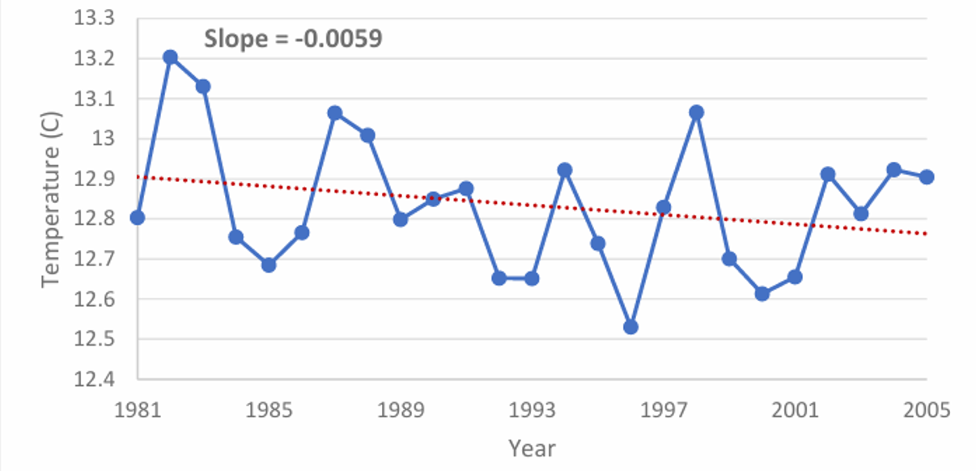

Figure 8: Minimum temperature trend of Kilosa district

Table 6: MK Trend Analysis of minimum temperature in Kilosa district

|  |  |  |  |  |  |  |  |  |  |
| --- | --- | --- | --- | --- | --- | --- | --- | --- | --- |
| Grid |  | Wet |  |  | Dry |  |  | Annual |  |
| Z | Slope | Trend | Z | Slope | Trend | Z | Slope | Trend |
| 6 | 0.257 | 0.001 | I | 1.658 | -0.014 | D | -0.817 | -0.005 | D |
| 10 | 0.958 | 0.005 | I | -1.191 | -0.009 | D | 0.000 | 0.00001 | I |
| 12 | 0.911 | 0.005 | I | -1.238 | 0.008 | D | -0.117 | -0.0004 | D |
| 14 | 1.705 | 0.012 | I | -1.004 | 0.006 | D | 0.631 | 0.005 | I |
| 16 | 1.798 | 0.014 | I | -0.072 | 0.001 | D | 0.631 | 0.006 | I |
| 28 | 1.425 | 0.007 | I | -1.238 | 0.011 | D | -0.304 | 0.002 | D |
| 30 | 1.752 | 0.007 | I | -0.911 | -0.005 | D | 0.210 | 0.001 | I |
| 32 | 2.265 | 0.013 | SI | -0.235 | -0.210 | D | 0.724 | 0.006 | I |
| 34 | 2.125 | 0.010 | SI | -0.490 | -0.004 | D | 0.584 | 0.003 | I |

The annual maximum temperature has shown a consistent upward trend from 1981 to 2005, with an increase of 0.0199°C (Figure 9). The lowest recorded maximum temperature was in 1989 at 18.80°C, while the highest was observed in 1998 at 19.78°C. The findings reveal that all grids display rising trends in both wet and dry seasons, as well as annually. Moreover, statistical analysis indicates that these trends are significant (SI) at a 95% confidence level for all grids (Table 7).

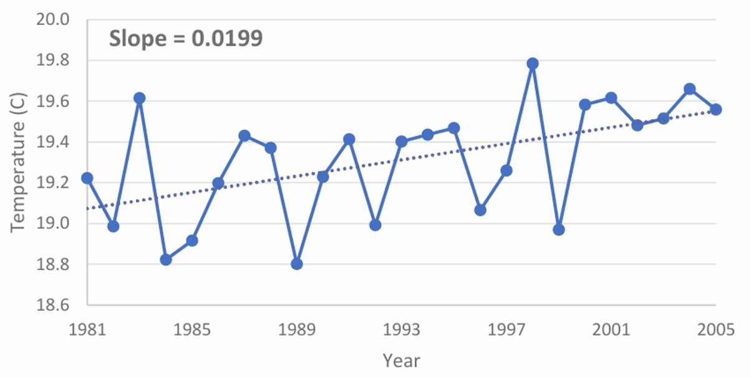

Figure 9: Maximum temperature trend of Kilosa district

Table 7. MK Trend Analysis of maximum temperature in Kilosa district

|  |  |  |  |  |  |  |  |  |  |
| --- | --- | --- | --- | --- | --- | --- | --- | --- | --- |
| Grid |  | Wet |  |  | Dry |  |  | Annual |  |
| Z | Slope | Trend | Z | Slope | Trend | Z | Slope | Trend |
| 6 | 4.036 | 0.012 | SI | 4.865 | 0.017 | SI | 4.602 | 0.014 | SI |
| 10 | 3.307 | 0.017 | SI | 4.602 | 0.021 | SI | 4.359 | 0.019 | SI |
| 12 | 4.157 | 0.017 | SI | 4.622 | 0.020 | SI | 4.926 | 0.018 | SI |
| 14 | 3.631 | 0.021 | SI | 4.258 | 0.023 | SI | 4.460 | 0.022 | SI |
| 16 | 4.036 | 0.019 | SI | 4.562 | 0.019 | SI | 4.784 | 0.018 | SI |
| 28 | 4.076 | 0.025 | SI | 4.683 | 0.025 | SI | 4.683 | 0.023 | SI |
| 30 | 3.934 | 0.031 | SI | 4.703 | 0.034 | SI | 4.804 | 0.029 | SI |
| 32 | 2.357 | 0.019 | SI | 3.752 | 0.019 | SI | 3.125 | 0.017 | SI |
| 34 | 3.226 | 0.023 | SI | 4.642 | 0.020 | SI | 4.056 | 0.020 | SI |

The annual mean temperature in Kilosa district exhibited a consistent upward trend from 1981 to 2005 (Figure 10). The magnitude of increase was measured at 0.0112°C. The lowest mean temperature was 15.61°C found in 1984, while the highest mean temperature of 16.37°C was observed in 2005. The findings reveal that all grids displayed increase in both wet and dry season temperatures, as well as annually. Additionally, statistical analysis indicates that all grids exhibited a significant upward trend (SI) at a confidence level of 95% for both wet and dry seasons, as well as annually (Table 8).

Table 8. MK Trend Analysis of mean temperature in Kilosa district

|  |  |  |  |  |  |  |  |  |  |
| --- | --- | --- | --- | --- | --- | --- | --- | --- | --- |
| Grid |  | Wet |  |  | Dry |  |  | Annual |  |
| Z | Slope | Trend | Z | Slope | Trend | Z | Slope | Trend |
| 6 | 5.836 | 0.018 | SI | 4.946 | 0.015 | SI | 5.836 | 0.017 | SI |
| 10 | 6.000 | 0.020 | SI | 5.650 | 0.020 | SI | 5.730 | 0.020 | SI |
| 12 | 5.800 | 3.650 | SI | 5.760 | 0.020 | SI | 6.020 | 0.020 | SI |
| 14 | 5.270 | 0.030 | SI | 5.290 | 0.020 | SI | 5.610 | 0.020 | SI |
| 16 | 5.650 | 0.030 | SI | 5.390 | 0.020 | SI | 5.730 | 0.020 | SI |
| 28 | 5.710 | 0.020 | SI | 5.610 | 0.020 | SI | 5.920 | 0.020 | SI |
| 30 | 5.530 | 0.030 | SI | 5.920 | 0.030 | SI | 5.920 | 0.030 | SI |
| 32 | 4.600 | 0.030 | SI | 5.290 | 0.030 | SI | 5.190 | 0.030 | SI |
| 34 | 5.050 | 0.030 | SI | 5.610 | 0.020 | SI | 5.450 | 0.030 | SI |

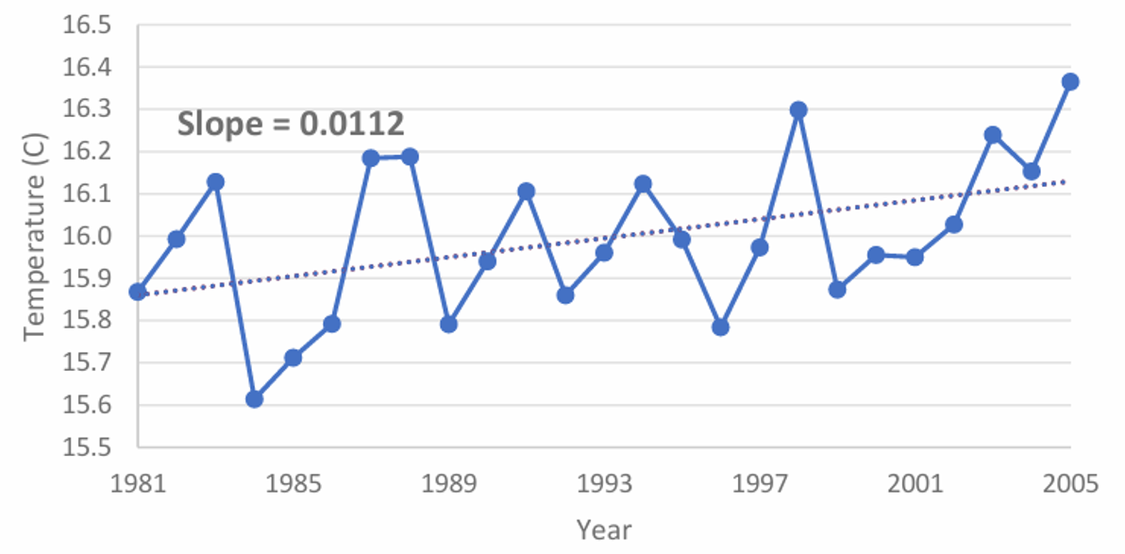

Figure 10: Mean temperature trend of Kilosa district.

The Inverse Distance Weighted (IDW) interpolation method is utilized to spatial interpolation of confidence levels and slopes of trend tests, ultimately producing a raster surface.

4. Discussion

The key findings of this study highlight significant climatic trends in Kilosa district. The CHIRPS and ERA5 Ag datasets were statistically evaluated as highly predictive as they were found to have strong correlation coefficient and very low bias. However, it can be observed that the precipitation trends as a whole are declining, with a geographic impact from geographical features such as mountains and flatlands. It is found that 85.71% of the grids have a negative trend in the annual precipitation as per the Mann-Kendall (MK) test results, where the largest magnitude of decreases was recorded in the southern region. Temperature trends show a pattern of a large warming with annual maximum temperature increased by 0.0199 °C and the mean annual temperature increased by 0.0112 °C between 1981 and 2005. Highest temperatures were recorded in the eastern, flatter areas, and the cool, elevated western areas were left behind. Such findings reinforce the important roles of geographical and human intervention in the formation of the climatic processes in the region.

An unexpected finding is the degree of warming observed across all temperature metrics. We expected general increases in temperature, and indeed observed that, but across all grids, there was a consistent increase in both the wet and dry seasons, and large increases in maximum temperatures. This implies a major role for land use (including urbanization and deforestation) on top of natural variability in the acceleration of warming. These results are of great concern for its implication on agricultural productivity and water resource management in the district.

The findings of this study are consistent with the existing work related to climate trends in East Africa. This is in line with Luganda *et al.* (2019) findings who also reported similar rainfall changes in Kilosa district. Validation studies also show that these datasets are reliable as they have strong correlations of CHIRPS and ERA5 Ag datasets with station data in Ethiopia, Kenya and Tanzania (Gebrechorkos *et al.,* 2018). Adding to what is commonly known in the existing literature, this study presents a finer spatial analysis of precipitation and temperature trends based on Kilosa consideration. Combining statistical and geospatial techniques helps in the improvement of understanding of climate variability in this district. Despite, some discrepancies, this study generally agrees with previous results. Unlike other regional studies reporting localized precipitation rises (Gudoshava *et al.,* 2020; Endris *et al.,* 2019; Liebmann *et al.,* 2014), this study found a general decline in the district. These dissimilarities may result from the distinct geographic peculiarity of the district that is characterized by the influence of deforestation in Rubeho and Ukaguru mountain ranges on local hydrological cycles. In addition, the contributions of urban heat islands in enhancing temperature rise were more pronounced in this study than in the previous research like the one conducted by Oke, (1982), perhaps as a result of the continued expansion of the settlements in the district.

These findings are of high importance for water resource management, agriculture, and climate adaptation strategies. Complementary to the water scarcity risk analysis, the forthcoming trends in declining precipitation and increasing temperatures likely increase the risks of water scarcity associated with rising temperatures and the degradation of soils and agricultural yields, especially the yields associated with rain fed farming systems. The impacts of these mechanisms can only be mitigated by conserving forest reserves and improving water management strategies, namely, adoption of irrigation systems. The study also laid the emphasis on the urgent act of adopting urban planning policies on green infrastructure to neutralize the urban heat island effect.

Beyond their scientific implications, these findings provide information to policies on land use planning, conservation and measures associated with climate adaptation, in practical applications. Such data is useful to the local governments and environment agencies for designing reforestation programs that can regenerate the hydrological balance in the district. They can also be used by agriculture stakeholders to create adaptive farming practices such as Agro-forestry and water efficient irrigation.

There are potential objections to this study based on the accuracy of gridded datasets relative to ground based meteorological station data. Although satellite-derived climate data may have inherent uncertainties, as indicated by results of the validation study presented in this paper, they are reliable. Moreover, the study period (1981-2005) might not include the most recent trends of climate and some may even argue against, but this historical analysis delineates the baseline for reading the long-term changes which could be extended by future research with more recent data.

The study period should be extended to cover more recent climatic data so that more recent trends can emerge. For a more holistic understanding of climate change driver, integrating socio-economic and land use/cover data will also provide other researchers to have a better look of climate change problem, while advanced modelling techniques like machine learning and remote sensing can improve the predictive accuracy. Additional broader concepts for the implications of regional climate dynamics for resource management can be drawn from comparative studies with other districts or regions in the country.

While this study has limitations, such as relying on gridded datasets and a historical study period, it successfully mitigates these challenges by testing data accuracy and using robust statistical and spatial analysis method. Its strengths are in bringing together multiple analytical approaches such that the climatic trends are assessed comprehensively. The findings have important applications in sustainable resources management, in conservation, and in urban planning. For future research, including the real time climate data and decision based on policy driven adaptation strategies, the expansion would be critical to enhance climate resilience in Kilosa district and other regions as well.

5. Conclusions

Inconclusion, it was shown that there were major trends in precipitation and temperature, with the district, in general experiencing a decline in precipitation and an upward temperature trend. The largest decrease in precipitation was shown in the southern part of the district, while the northern part gave a slight increase. Temperature trends were seen to increase consistently and maximum temperatures showed the most significant increase of which consequently gives concerns for water resources, agriculture and climate adaptation.

However, there are significant gaps of knowledge regarding climatic changes in the district, especially the effect by geographical influence on precipitation and temperature patterns. This emphasizes the necessity for the implementation of water and land management strategies, including enhancement of irrigation systems, reforestation initiatives and urban planning ecosystem that aims to combat the urban heat island effect. Its necessary to mitigate the effect of the negative impacts of the observed climatic trends, especially when rain fed agriculture and water resources are used in the district.

Further researches are recommended for the study period extension, to include the recent data, socio-economic and land use factors in determining the drivers of climate change. Additionally, future studies should apply sophisticated modelling methods towards providing better forecasting accuracy and for developing more judicious climate adaptation strategies for the district. These efforts will help create the long-term climate resilience in Kilosa district and similar areas.

**ACKNOWLEDGMENTS**

The research was funded by Tanzania National Irrigation Commission (NIRC) in the program of capacity building for internal staffs under the Division of Design and Research (DDR).

**AUTHOR CONTRIBUTIONS**

Said Hamisi Kambi comprehended, planned, and enrolled the paper, Boniface Peter Mbilinyi revised the plan of the paper and gave supplement literature, Festo Richard Silungwe revised the paper and subsidized to its writing.

**DISCLAIMER (ARTIFICIAL INTELLIGENCE)**

Author(s) hereby declares that NO generative AI technologies such as Large Language Models (ChatGPT, COPILOT, etc.) and text-to-image generators have been used during the writing or editing of this manuscript.

REFERENCES

1. Adhikari, U., Nejadhashemi, A. P., Herman, M. R., & Messina, J. P. (2017). Multiscale assessment of the impacts of climate change on water resources in Tanzania. Journal of Hydrologic Engineering, 22(2), 05016034.
2. Bence, J. R. (1995). Analysis of short time series: Correcting for autocorrelation. Ecology, 76(2), 628-639.
3. Boku, E. J. (2014). Climate change, migration and conflict: a case study of Kilosa district, Tanzania (Master's thesis, Universitetet i Agder; University of Agder).
4. Chen, Y., Guo, H., & Chen, Z. (2012). Trend analysis of temperature and precipitation in the Yellow River Basin from 1951 to 2009. Stochastic Environmental Research and Risk Assessment, 26, 1059-1072.
5. Dembélé, M., & Zwart, S. J. (2016). Evaluation and comparison of satellite-based rainfall products in Burkina Faso, West Africa. International Journal of Remote Sensing, 37(17), 3995-4014.
6. Dembélé, M., Schaefli, B., Van De Giesen, N., & Mariéthoz, G. (2020). Suitability of 17 rainfall and temperature gridded datasets for largescale hydrological modelling in West Africa. Hydrology and Earth System Sciences Discussions, 2020, 1-39.
7. Dore, M. H. (2005). Climate change and changes in global precipitation patterns: what do we know? Environment International, 31(8), 1167-1181.
8. Easterling, W. E. (1997). Why regional studies are needed in the development of full-scale integrated assessment modelling of global change processes. Global Environmental Change, 7(4), 337-356.
9. Endris, H. S., Lennard, C., Hewitson, B., Dosio, A., Nikulin, G., & Artan, G. A. (2019). Future changes in rainfall associated with ENSO, IOD and changes in the mean state over Eastern Africa. Climate dynamics, 52, 2029-2053.
10. FAO (2004). Drought impact mitigation and prevention in the Limpopo River Basin: A situation analysis. Food and Agriculture Organization of the United Nations.
11. Frei, C., & Schär, C. (1998). A precipitation climatology of the Alps from high resolution rain‐gauge observations. International Journal of Climatology: A Journal of the Royal Meteorological Society, 18(8), 873-900.
12. Gebrechorkos, S. H., Hülsmann, S., & Bernhofer, C. (2018). Regional climate projections for impact assessment studies in East Africa. Environmental Research Letters, 13(5), 055013.
13. Gudoshava, M., Misiani, H. O., Segele, Z. T., Jain, S., Ouma, J. O., Otieno, G., ... & Atheru, Z. (2020). Projected effects of 1.5 C and 2 C global warming levels on the intra-seasonal rainfall characteristics over the Greater Horn of Africa. Environmental Research Letters, 15(3), 034037.
14. He, L., Fang, G., Wang, Y., Sun, Z., Zhang, X., & Xu, X. (2023). Evaluating the performance of reanalysis and satellite-based precipitation products in the Luanhe River Basin, North China. Atmospheric Research, 282, 106399.
15. Huang, J., Yu, H., Dai, A., Wei, Y., & Kang, L. (2021). Drylands face potential threat under 2°C global warming target. Nature Climate Change, 7, 417-422.
16. IPCC (2007b). Climate Change 2007: The Physical Science Basis. Contribution of Working Group I to the Fourth Assessment Report of the Intergovernmental Panel on Climate Change.
17. Jones, P. D., Osborn, T. J., & Briffa, K. R. (2001). The evolution of climate over the last millennium. Science, 292(5517), 662-667.
18. Kabanda, T. (2018). Long-term rainfall trends over the Tanzania coast. Atmosphere, 9(4), 155.
19. Karpouzos, D. K., Kavalieratou, S., & Babajimopoulos, C. (2010). Trend analysis of precipitation data in Pieria Region (Greece). European Water, 30, 31-40.
20. Kavishe, G. M., & Limbu, P. T. S. (2020). Variation of October to December rainfall in Tanzania and its association with sea surface temperature. Arabian Journal of Geosciences, 13(13), 534.
21. Kimani, M. W., Forkuor, G., & Lautenbach, S. (2017). Mapping precipitation distribution in data-scarce regions: Comparison of multiple precipitation products over East Africa. International Journal of Climatology, 37(6), 3389-3401.
22. Kimaro, J. (2019). A review on managing agroecosystems for improved water use efficiency in the face of changing climate in Tanzania. Advances in Meteorology, 2019(1), 9178136.
23. Kulyakwave, P. D., Wen, Y., & Shiwei, X. (2023). Overcoming climate change challenges: The role of irrigation in enhancing rice yield in Tanzania. Economics, Management and Sustainability, 8(1), 58-71.
24. Liebmann, B., Hoerling, M. P., Funk, C., Bladé, I., Dole, R. M., Allured, D., ... & Eischeid, J. K. (2014). Understanding recent eastern Horn of Africa rainfall variability and change. Journal of Climate, 27(23), 8630-8645.
25. Liwenga, E. T., & Silangwa, E. L. (2020). The role of indigenous knowledge in climate change adaptation: Insights from rural Tanzania. Climate and Development, 12(4), 1-10.
26. Luanda, P. (2020). Climate change and agricultural practices in Kilosa district, Tanzania. Journal of Agricultural and Environmental Sciences, 9(2), 45-56.
27. Mbwambo, L., Moshi, N., & Msanya, B. (2024). Soil characterization for agricultural suitability in Kilosa District, Tanzania. Soil Science Society of America Journal, 88(1), 125-136.
28. Mugasha, A. G., & Katani, J. Z. (2016). Addressing environmental challenges in Kilosa district through community-based approaches. International Journal of Environmental Studies, 73(5), 678-694.
29. New, M., Todd, M., Hulme, M., & Jones, P. (2001). Precipitation measurements and trends in the twentieth century. International Journal of Climatology. A Journal of the Royal Meteorological Society, 21(15), 1889-1922.
30. NIMP (2018). National Irrigation Master Plan. Dar es Salaam: Ministry of Agriculture.
31. Ntawukuriryayo, E. (2022). Applicability of satellite-based rainfall estimates and inundation extent for flood modeling in the Sebeya catchment, Rwanda (Master's thesis, University of Twente).
32. Oke, T. R. (1982). The energetic basis of the urban heat island. Quarterly Journal of the Royal Meteorological Society, 108(455), 1-24.
33. Paredes-Trejo, F. J., Barbosa, H. A., & Kumar, T. L. (2017). Validating CHIRPS-based satellite precipitation estimates in Northeast Brazil. Journal of arid environments, 139, 26-40.
34. Patel, S., Vedeld, P., & Tarimo, A. (2014). Irrigation management, institutions and local livelihood adaptation on Usangu plains, Tanzania.
35. Qiu, J., Shen, Z., Leng, G., & Wei, G. (2021). Synergistic effect of drought and rainfall events of different patterns on watershed systems. Scientific reports, 11(1), 18957.
36. Raneesh, K. Y. (2014). Impact of climate change on water resources. Journal of Earth Science & Climatic Change, 5(3), 1.
37. Sarmento, R., & Costa, V. (Eds.). (2017). Comparative approaches to using R and Python for statistical data analysis. IGI Global.
38. Serbin, S. P., & Kucharik, C. J. (2009). Spatiotemporal mapping of temperature and precipitation for the development of a multidecadal climatic dataset for Wisconsin. Journal of Applied Meteorology and Climatology, 48(4), 742-757.
39. Shabani, F., & Kumar, L. (2020). Investigating the trend and variability of drought using SPI and SPEI: Case study in Iran. Theoretical and Applied Climatology, 139, 1711-1730.
40. Silungwe, F.R, Graef, F, Bellingrat-Kimura, S. D. Tumbo, S.D. Kahimba, F.C, and Lana, M.A. (2019b). The management strategies of pearl millet farmers to cope with seasonal rainfall variability in a semi-arid agroclimate. Agronomy 9, 400.
41. Silungwe, F.R, Graef, F, Bellingrat-Kimura, S. D. Tumbo, S.D. Kahimba, F.C, and Lana, M.A. (2019a). Analysis of Intra and Interseasonal Rainfall Variability and Its Effects on Pearly Millet Yield in a Semiarid Agroclimate; Significance of Scattered Fields and Tied Ridges. Water 11, 578.
42. Sivakumar, B. (2011). Global climate change and its impacts on water resources planning and management: assessment and challenges. Stochastic Environmental Research and Risk Assessment, 25, 583-600.
43. Solomon, H. S., Tekleab, S., & Araya, T. (2017). Evaluation of satellite rainfall estimates and rainfall products for hydrological applications in East Africa. Hydrology and Earth System Sciences, 21(6), 3661-3680.
44. Solomon, S., Qin, D., Manning, M., Chen, Z., Marquis, M., Averyt, K., & Miller, H. (2007). IPCC fourth assessment report (AR4). Climate Change, 374.
45. Sulugodu, B., & Deka, P. C. (2019). Evaluating the performance of CHIRPS satellite rainfall data for streamflow forecasting. Water Resources Management, 33, 3913-3927.
46. Sumari, N. S., Mandela, P. J., & Swai, C. S. (2022). Impact of urban expansion on land surface temperature in Dodoma and Morogoro metropolises, Tanzania. Tanzania Journal of Agricultural Sciences, 21(1), 263-276.
47. Tabari, H., Marofi, S., & Talaee, P. H. (2011). Detection of aridity trend in arid and semi-arid regions of Iran. Water Resources Management, 25(5), 1327-1348.
48. Tošić, I., Unkašević, M., & Trajkovic, S. (2015). Analysis of precipitation and temperature time series in Serbia. Global and Planetary Change, 122, 10-19.
49. Trenberth, K. E. (2011). Changes in precipitation with climate change. Climate Research, 47(1-2), 123-138.
50. Velikou, K., Lazoglou, G., Tolika, K., & Anagnostopoulou, C. (2022). Reliability of the ERA5 in replicating mean and extreme temperatures across Europe. Water, 14(4), 543.
51. Wilson, R. T., & Ouedraogo, M. (2017). Rainfall and agriculture in sub-Saharan Africa: Growing season, seasonal rainfall, and annual rainfall variability. Journal of Applied Meteorology and Climatology, 56(7), 1953-1963.
52. Wiwoho, B. S., Astuti, I. S., Alfarizi, I. A. G., & Sucahyo, H. R. (2021). Validation of three daily satellite rainfall products in a humid tropic watershed, Brantas, Indonesia: implications to land characteristics and hydrological modelling. Hydrology, 8(4), 154.