**Evaluation of groundwater potentials using vertical electrical sounding method in zamfara hostel, university of ilorin, kwara state, Nigeria**

.

ABSTRACT

|  |
| --- |
| Groundwater is a vital natural resource, especially in regions with limited surface water availability. This study assessed the groundwater potential of Zamfara Hostel, University of Ilorin, Nigeria, using the Vertical Electrical Sounding (VES) method. The study area is underlain by crystalline rocks of the Basement Complex, which are primarily high-grade metamorphic rocks, gneisses, and migmatites. These rocks typically have low porosity and permeability, but weathering and fracturing processes can enhance their groundwater storage capacity. Five VES points were established to evaluate the subsurface lithology and identify potential aquifer zones. The resistivity data were interpreted using IPI2Win and WinResist software, revealing a four-layer geo-electric sequence characterized by a resistive topsoil layer, a less resistive weathered basement, and a highly resistive fresh basement. The topsoil layer, with resistivity values ranging from 242.2 to 1021.8 Ωm, serves as the overburden, while the lateritic soil layer, with higher resistivity values (446.5 to 4132.2 Ωm), is less permeable. The weathered basement, with resistivity values ranging from 50.4 to 120.5 Ωm, was identified as the primary aquifer unit, with thicknesses varying from 6.4 to 34.2 meters. The fresh basement, with resistivity values exceeding 337.0 Ωm, was found to be impermeable. The study concluded that the area has medium groundwater potential, with the weathered and fractured zones serving as the main aquifer units. These zones are capable of storing and transmitting groundwater, making them suitable for borehole drilling. The findings provide valuable insights for groundwater management in the study area, particularly in addressing the water supply challenges faced by the growing population of the university community. This research highlights the importance of geophysical methods in groundwater exploration and contributes to the sustainable management of water resources in Basement Complex terrains. |

***Keywords****: Groundwater Potential, Vertical Electrical Sounding (VES), Weathered Basement Aquifer, Basement Complex Terrain, Resistivity Survey*

1. INTRODUCTION

Groundwater is a critical resource for human consumption, agriculture, and industrial activities, especially in regions with limited surface water availability (Mukherjee et al., 2015; Priyan, 2021; Scanlon et al., 2023). In Nigeria, groundwater is increasingly relied upon due to the seasonal variability of surface water sources and the growing demand for water (Danert et al., 2021; Olalekan et al., 2022; Ayejoto et al., 2023). The University of Ilorin, located in Kwara State, Nigeria, faces significant water supply challenges due to its expanding population and the seasonal drying of River Oyun, the primary surface water source within the campus. Consequently, groundwater exploration has become essential to meet the water needs of the university community.

Several studies have highlighted the importance of groundwater exploration in Basement Complex terrains, where surface water sources are often unreliable. According to Akinwumiju and Olorunfemi (2019), the Basement Complex rocks in Nigeria are characterized by low primary porosity, but secondary porosity due to weathering and fracturing can significantly enhance groundwater storage. Kouassi et al. (2024) further emphasized that the weathered and fractured zones in these terrains serve as the primary aquifers, providing a reliable source of groundwater for communities.

The use of geophysical methods, particularly the VES technique, has been widely adopted for groundwater exploration in such terrains. Gaikwad et al. (2021) demonstrated that the VES method is effective in delineating subsurface layers and identifying potential aquifer zones. Similarly, Akintorinwa et al. (2020) applied the VES method to evaluate groundwater potential in the central Basement Complex of Nigeria, identifying weathered and fractured zones as the main aquifers. Their findings underscored the importance of geophysical surveys in groundwater exploration, particularly in areas with limited hydrological data.

In the context of the University of Ilorin, previous studies have also highlighted the challenges of water supply due to the seasonal drying of River Oyun and its tributaries. Adetona et al. (2024) conducted a resistivity survey in the university’s senior staff quarters, identifying fractured basement rocks as the primary aquifers. Their study revealed that the thickness of the weathered layer and the presence of fractures are critical factors in determining groundwater potential in the area. These findings align with the broader understanding of groundwater dynamics in Basement Complex terrains, where the interplay between geology and hydrology dictates the availability of groundwater resources. The primary objectives of this study were to evaluate the groundwater potential, determine the overburden thickness, identify the basement depth, delineate fracture zones (aquifer zones), and recommend suitable borehole drilling locations in the Zamfara Hostel area using the Vertical Electrical Sounding (VES) method, contributing to sustainable groundwater management in the University of Ilorin and similar Basement Complex terrains while addressing water supply challenges and advancing knowledge on groundwater exploration in regions with limited surface water availability.

**1.1 Location and Geomorphology of the Study Area**

The study area, Zamfara Hostel, is located between Latitude 8° 28’ 42” N to 8° 28’ 48” N and Longitude 4° 40’ 7” E to 4° 40’ 9” E. It is underlain by crystalline rocks of the Basement Complex, which are predominantly high-grade metamorphic rocks, gneisses, and migmatites (Figure 1 and 2). These rocks typically have low porosity and permeability, but weathering and fracturing can enhance their groundwater storage capacity (Olawumi, 2022). The Vertical Electrical Sounding (VES) method, a geophysical technique, was employed to assess the groundwater potential of the area. This method is cost-effective and provides valuable information on the vertical succession of subsurface materials, including their resistivity, thickness, and depth (Shishaye and Abdi, 2016; Kilfoil et al., 2018).

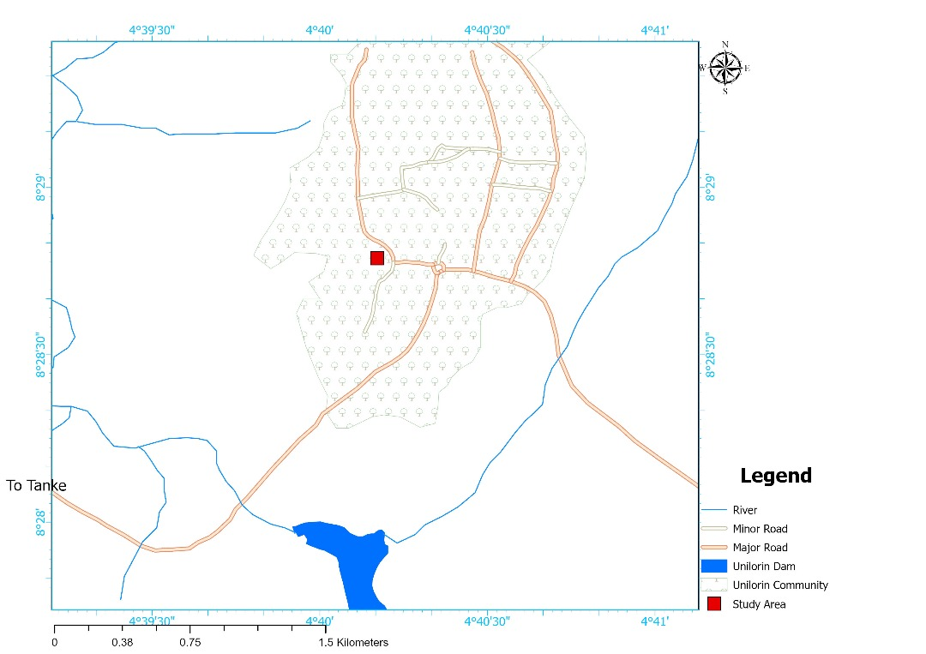

**Figure 1: A digitized map of University of Ilorin**

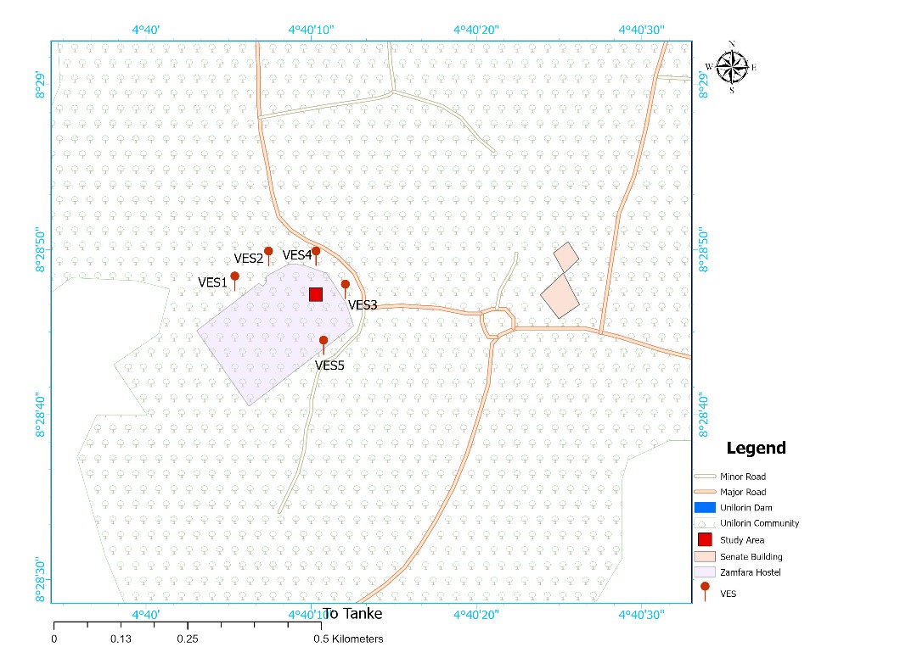

**Figure 2: The schematic sketch of the study area.**

2. METHODOLOGY

The study employed the Vertical Electrical Sounding (VES) method, which is widely used for groundwater exploration in Basement Complex terrains. The Schlumberger array configuration was utilized for data acquisition, with current electrode spacings (AB/2) ranging from 1 to 100 meters. A total of five VES points were established within the study area, and resistivity data were collected using an ABEM Terrameter (SAS 300). The data were processed and interpreted using IPI2Win and WinResist software to determine the resistivity, thickness, and depth of the subsurface layers.

The interpretation of the VES data involved curve matching and computer iteration techniques. The resistivity curves were classified into different types (H-type and KH-type) based on the sequence of resistivity values. The geo-electric sections were delineated into four layers: topsoil, lateritic soil, weathered basement, and fresh basement. The weathered and fractured zones were identified as the primary aquifers, with their thicknesses and resistivities calculated for each VES point. Field precautions were taken to ensure accurate data collection, including proper electrode placement, avoidance of leakage currents, and regular equipment checks. The limitations of the VES method, such as its sensitivity to near-surface resistivity variations and the ambiguity in interpreting complex subsurface structures, were also considered during the study.

3. RESULTS AND DISCUSSION

The Vertical Electrical Soundings were carried out at the selected areas. A total of five VES points were surveyed. The coordinates, i.e., Easting and Northing, of the sounding points were obtained with the help of a GARMIN II GPS receiver. The Vertical Electrical soundings were made using the following equipment: IBEM (IP) Earth Resistivity Meter, which is powered by a rechargeable battery, wires & reels, stainless steel electrodes and accessories such as alligator clips and hammer. The Schlumberger electrode configuration with maximum half-current electrode separation (AB/2) of 120 to 150 m was used for the sounding survey. Current is injected into the ground using two current electrodes, A and B, placed at a distance AB/2 apart; and the potential drop that occurs between two other electrodes, M and N, placed near the center of the current electrodes is measured. The current electrode separation, AB/2, is progressively increased in steps so as to increase the depth of investigation, and at each step the measured current and potential readings are used to obtain the apparent resistivity of the ground. The VES data acquired from each VES points were recorded and presented in a table.

**3.1 Presentation and Analysis of Field Data**

The Apparent Resistivity values for the different electrode spacing for the VES locations are presented below (Table 1). Plots of Apparent Resistivity Versus Current Electrode Separation (AB/2) were generated. The VES curves showing the field resistivity, calculated resistivity and thickness of the subsurface layers in the area are presented below:

**Table 1: Field data for VES 1, VES 2, VES 3 and VES 4**

|  |  |  |  |  |  |  |  |  |  |  |  |  |
| --- | --- | --- | --- | --- | --- | --- | --- | --- | --- | --- | --- | --- |
| SCHLUMBERGER ARRAY CONFIGURATION | | | | | | | | | | | | |
| VES 1 | | | | VES 2 | | | VES 3 | | | VES 4 | | |
| S/N | AB/2 (M) | MN/2 (M) | RES. (ΩM) | AB/2 (M) | MN/2 (M) | RES. (ΩM) | AB/2 (M) | MN/2 (M) | RES. (ΩM) | AB/2 (M) | MN/2 (M) |  |
| 1 | 1.00 | 0.2 | 304.00 | 1.00 | 0.2 | 266.00 | 1.00 | 0.2 | 529.80 | 1.00 | 0.2 | 727 |
| 2 | 2.00 | 0.2 | 303.40 | 2.00 | 0.2 | 264.40 | 2.00 | 0.2 | 1315.80 | 2.00 | 0.2 | 1557.00 |
| 3 | 3.00 | 0.2 | 310.00 | 3.00 | 0.2 | 315.00 | 3.00 | 0.2 | 1056.00 | 3.00 | 0.2 | 1242.60 |
| 4 | 5.00 | 0.2 | 320.70 | 5.00 | 0.2 | 329.00 | 5.00 | 0.2 | 929.30 | 5.00 | 0.2 | 1034.40 |
| 5 | 7.00 | 0.2 | 263.00 | 7.00 | 0.2 | 233.00 | 7.00 | 0.2 | 454.00 | 7.00 | 0.2 | 536.90 |
| 8 | 10.00 | 1.0 | 156.30 | 10.00 | 1.0 | 153.00 | 10.00 | 1.0 | 219.20 | 10.00 | 1.0 | 303.10 |
| 9 | 10.00 | 1.0 | 194.60 | 10.00 | 1.0 | 162.00 | 10.00 | 1.0 | 129.00 | 10.00 | 1.0 | 126.30 |
| 10 | 15.00 | 1.0 | 125.00 | 15.00 | 1.0 | 78.50 | 15.00 | 1.0 | 150.00 | 15.00 | 1.0 | 141.00 |
| 11 | 20.00 | 1.0 | 95.50 | 20.00 | 1.0 | 90.00 | 20.00 | 1.0 | 112.00 | 20.00 | 1.0 | 114.00 |
| 12 | 20.00 | 1.0 | 121.00 | 20.00 | 1.0 | 79.40 | 20.00 | 1.0 | 121.00 | 20.00 | 1.0 | 137.00 |
| 13 | 25.00 | 1.0 | 141.00 | 25.00 | 1.0 | 100.00 | 25.00 | 1.0 | 132.00 | 25.00 | 1.0 | 134.00 |
| 14 | 25.00 | 1.0 | 140.00 | 25.00 | 1.0 | 95.00 | 25.00 | 1.0 | 116.60 | 25.00 | 1.0 | 156.00 |
| 15 | 30.00 | 5.0 | 140.00 | 30.00 | 5.0 | 109.00 | 30.00 | 5.0 | 138.00 | 30.00 | 5.0 | 162.00 |
| 16 | 35.00 | 5.0 | 162.00 | 35.00 | 5.0 | 92.00 | 35.00 | 5.0 | 137.20 | 35.00 | 5.0 | 191.70 |
| 17 | 40.00 | 7.0 | 180.00 | 40.00 | 7.0 | 95.20 | 40.00 | 7.0 | 164.00 | 40.00 | 7.0 | 197.50 |
| 18 | 45.00 | 7.0 | 200.00 | 45.00 | 7.0 | 58.00 | 45.00 | 7.0 | 241.00 | 45.00 | 7.0 | 248.00 |
| 19 | 50.00 | 7.0 | 228.40 | 50.00 | 7.0 | 116.10 | 50.00 | 7.0 | 256.50 | 50.00 | 7.0 | 269.10 |
| 20 | 60.00 | 7.0 | 180.00 | 60.00 | 7.0 | 136.00 | 60.00 | 7.0 | 302.00 | 60.00 | 7.0 | 303.00 |
| 21 | 70 | 7.0 | 165.00 | 70 | 7.0 | 147.70 | 70 | 7.0 | 350.00 | 70 | 7.0 | 298.30 |
| 22 | 80 | 9.0 | 233.20 | 80 | 9.0 | 147.00 | 80 | 9.0 | 480.00 | 80 | 9.0 | 306.90 |
| 23 | 90 | 9.0 | 247.60 | 90 | 9.0 | 187.30 | 90 | 9.0 | 600 | 90 | 9.0 | 418.80 |
| 24 | 100 | 9.0 | 309.00 | 100 | 9.0 | 200.00 | 1.00 | 0.2 | 529.80 | 100 | 9.0 | 460.00 |

* 1. **Data Processing and Presentation**

The VES data collected in the field was first processed and plotted manually on a resistivity log-log graph to reduce and remove the errors (noise) as seen in figure 3, 4, 5, 6 and 7 respectively. After the removal of error, the data were then interpreted using IPI2 window-based resistivity software just to get the layer parameters. The layer parameters so obtained have been used as starting models in an iterative least squares inversion program, and then the software automatically displays the layer resistivity, thickness and depth of the layers from the ground surface.

The Root mean Square Errors for the analysis were found to be very low with an average of 5.52%. This underscores the reliability of the analysis tool for this type of work.

**LOCATION: VES 1 RMS ERROR: 4.7% CURVE TYPE: H**

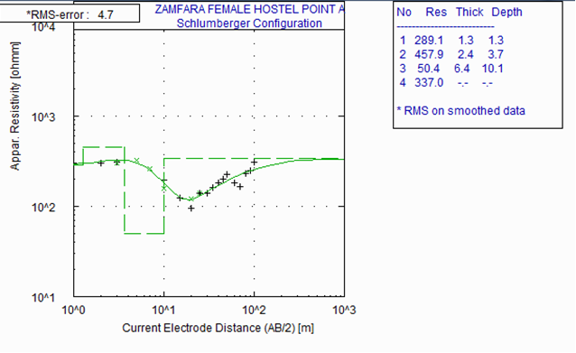

**Figure 3: Typical depth sounding curve showing synthetic curve VES 1**

**LOCATION: VES 2 RMS ERROR: 7.0% CURVE TYPE: KH**

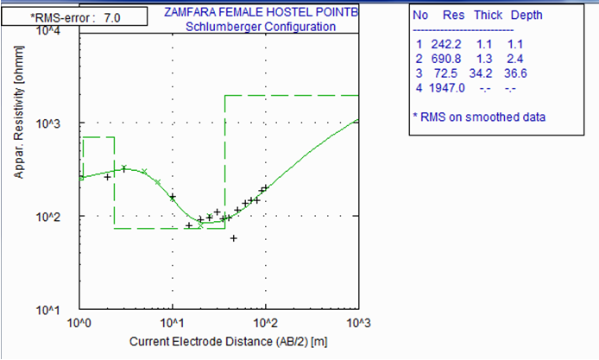

**Figure 4: Typical depth sounding curve showing synthetic curve VES 2**

**LOCATION: VES 3 RMS ERROR: 6.9% CURVE TYPE: KH**

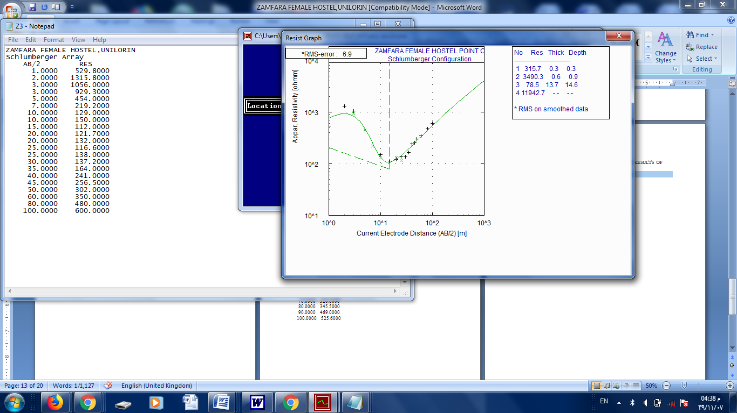

**Figure 5: Typical depth sounding curve showing synthetic curve VES 3**

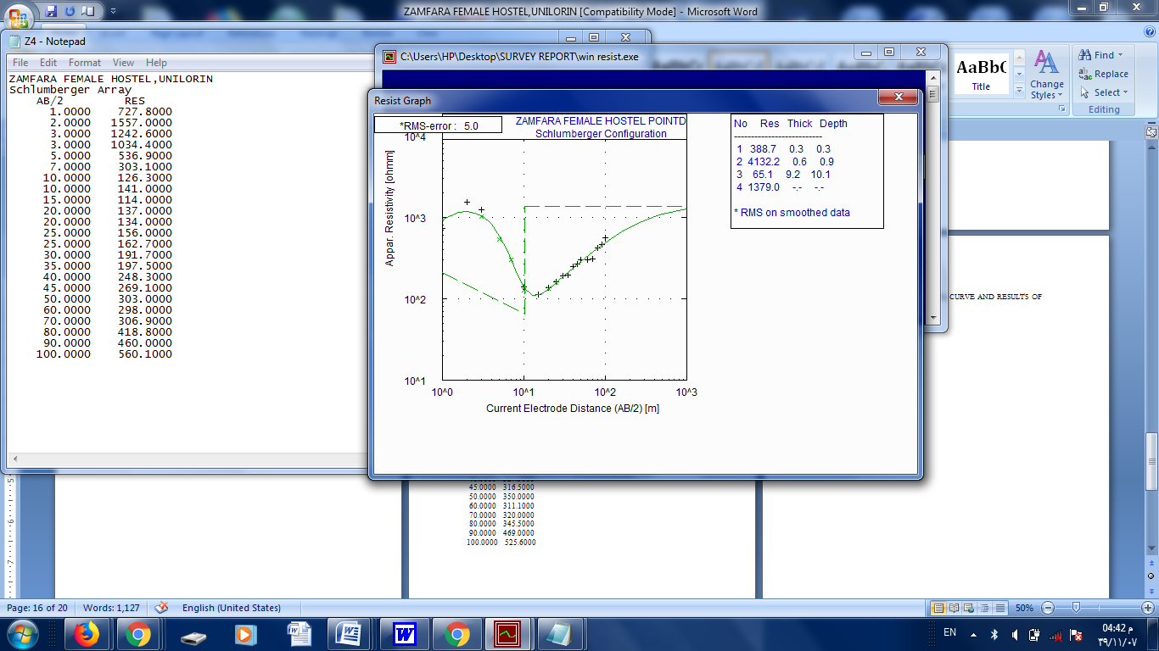**LOCATION: VES 4 RMS ERROR: 5.0% CURVE TYPE: KH**

**Figure 6: Typical depth sounding curve showing synthetic curve VES 4**

**LOCATION: VES 5 RMS ERROR: 4.0% CURVE TYPE: H**

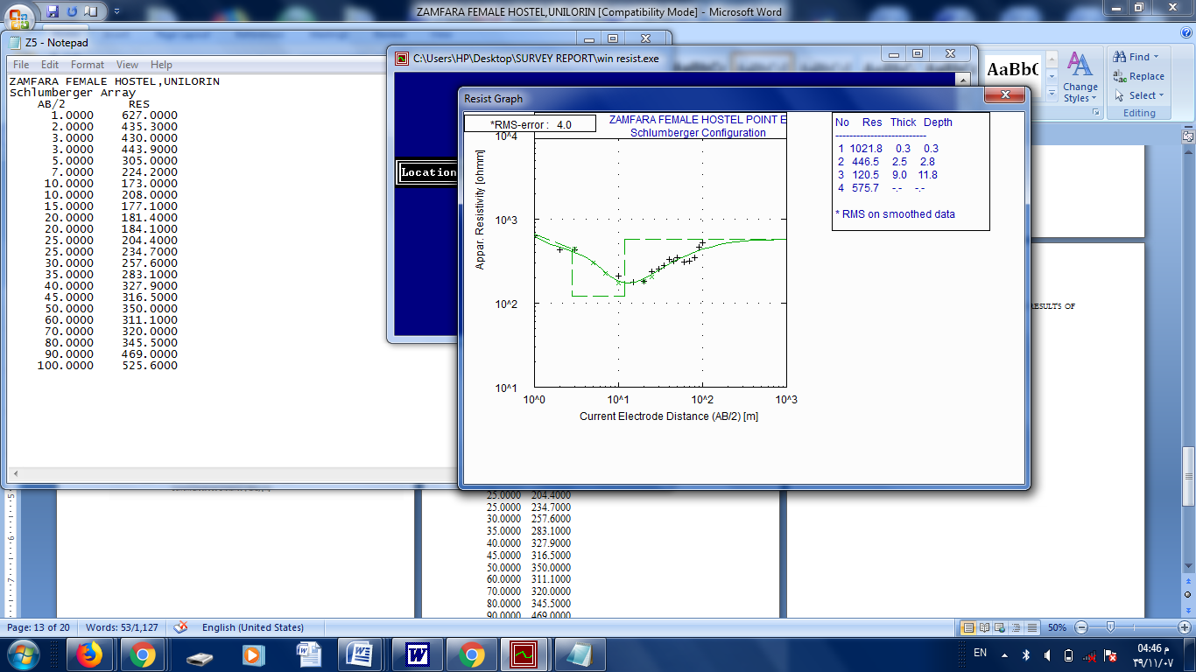

**Figure 7: Typical depth sounding curve showing synthetic curve VES 5**

**Table 2: Summary of Ves Data Acquired from Zamfara Hostel**

|  |  |  |  |  |  |  |
| --- | --- | --- | --- | --- | --- | --- |
| S/N | VES NO | RESISTIVY  (ΩM) | THICKESS (M) | DEPTH (M) | LITHOLOGIES | CURVE TYPES |
| 1 | 1 | 289.1  457.9  50.4  337.0 | 1.3  2.4  6.4  ∞ | 1.3  3.7  10.1 | Topsoil  Lateritic Soil  Weathered Basement  Fresh basement | H |
| 2 | 2 | 242.2  690.8  72.5  1947.0 | 1.1  1.3  34.2  ∞ | 1.1  2.4  36.6 | Topsoil  Lateritic Soil  Weathered Basement  Fresh basement | KH |
| 3 | 3 | 315.7  3490.3  78.5  11942.7 | 0.3  0.3  13.7  ∞ | 0.3  0.9  14.6  ∞ | Topsoil  Lateritic Soil  Weathered Basement  Fresh basement | KH |
| 4 | 4 | 388.7  4132.2  65.1  1379.0 | 0.3  0.6  9.2  ∞ | 0.3  0.9  10.1  ∞ | Topsoil  Lateritic Soil  Weathered Basement  Fresh basement | KH |
| 5 | 5 | 1021.8  446.5  120.5  575.7 | 0.3  2.5  9.0  ∞ | 0.3  2.8  11.8  ∞ | Topsoil  Lateritic Soil  Weathered Basement  Fresh basement | H |

**3.3 Pseudo Sections for the Correlated VES Points**

The geo-electric pseudosection reflects the apparent resistivity distributions versus electrode spacing (AB/2). Five VES data were sounded along a profile in the W-E direction and were presented in the form of a pseudosection (Figure 8 and 9). The electrode spreads are arranged in parallel, 3D pseudosections were determined and combined into correlated model. The pseudosection for correlated VES point 1,2 and 3 (Figure 8) shows that the area is underlain by four geo-electric layers. The first layer is Topsoil with resistivity range of 289.1 Ωm – 315.7 Ωm as seen in table 2. This is identified as Overburden. The second layer is Lateritic layer with resistivity ranges of 457.9 Ωm – 3490.3 Ωm. The third geo-electric layer is the weathered layer which composed of Sandy soil and probably aquiferous unit with resistivity ranges between 50.4 Ωm – 65.1 Ωm. The fourth layer is Fresh basement with resistivity greater than 1000 Ωm.

The pseudosections computed indicate the distribution of apparent resistivity of soundings of VES points along the same profile. The correlated VES soundings reveal the following:

1. The apparent resistivity increases with increase in depth of investigation
2. Absence of aquiferous unit in the geo-electric layers with high resistivity values.

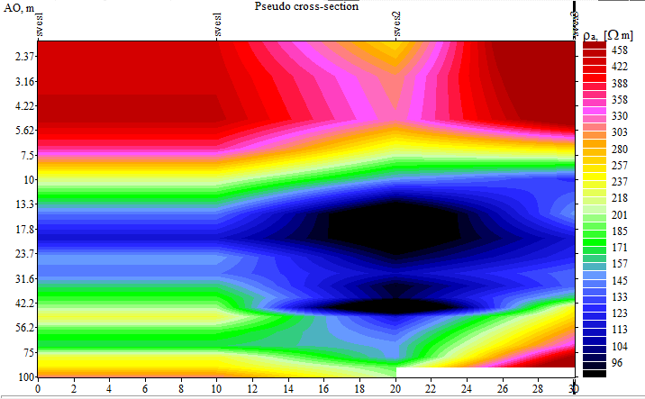

**Figure 8: The computed apparent resistivity pseudo-section for VES point 1, 2, and 3 profile.**

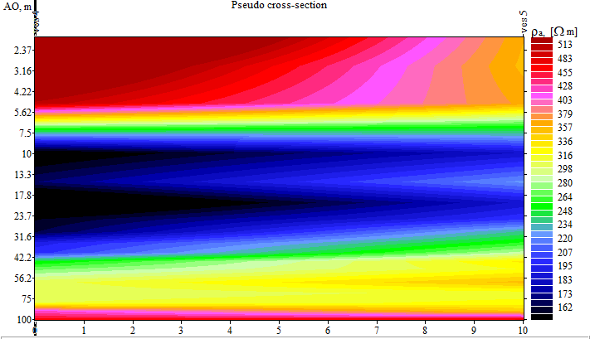

**Figure 9: The computed apparent resistivity pseudo-section for VES point 4 and 5 profile.**

4.0 **Discussion of Results**

**4.1 Qualitative Interpretation of Results**

In quantitative interpretation of VES data, the aim is to determine the number of layers represented by the curves individual layer resistivity and thickness. The quantitative methods adopted in this research are manual plotting which involve the plotting of field data, curve matching for comparison between the field curve and master curve to generate resistivity and thickness of each layer and using computer iteration technique. The computer iteration program software used is IPI2 WIN. The five VES soundings obtained in the study area reveal different resistivity curves and geo-electric layers as discussed below:

**VES SOUNDING 1**

Four geo-electric layers were delineated in this location. The resistivity curve identified is H-type. The first layer is Top soil with resistivity value of 289.1Ωm, a thickness of 1.3m at a depth of 1.3m. The second geo-electric layer is Lateritic soil with resistivity value of 457.9 Ωm, thickness of 2.4 m at a depth of 3.7 m. The third layer is a Weathered Basement with resistivity value of 50.4 Ωm, a thickness of 6.4m at a depth of 10.1m. The fourth layer is a Fresh Basement with resistivity value of 337.0 Ωm at an undefined thickness and depth (Figure 8)

**VES SOUNDING 2**

Four geo-electric layers were also delineated in this location. The resistivity curve interpreted is KH-type. The first layer is Top soil with resistivity value of 242.2 Ωm, a thickness of 1.1 m at a depth of 1.1m. The second layer is Lateritic soil with resistivity value of 690.8 Ωm, thickness of 1.3 m at a depth of 2.4 m. The third geo–electric layer is a Weathered Basement with resistivity value of 72.5 Ωm, a thickness of 34.2 m at a depth of 36.6m. The fourth layer is a Fresh Basement with resistivity value of 1947.0 Ωm at an undefined thickness and depth (Figure 9).

**VES SOUNDING 3**

The geo-electric section delineated four subsurface layers. The first subsurface layer is a Topsoil with a resistivity value of 315.7 Ωm having a thickness of 0.3m occurring a depth of 0.3m (shown in Figure 9). The second subsurface layer is a Lateritic soil having a resistivity of 3490.3 Ωm, a thickness of 0.6m and a depth of 0.9m. The third subsurface layer is a weathered horizon having a resistivity of 78.5 Ωm, a thickness of 13.7m and a depth of 14.6m. The fourth subsurface layer is a Fresh Basement with a resistivity value of 11942.7 Ωm, undefined thickness and depth.

**VES SOUNDING 4**

The geo-electric section delineated in this location revealed four subsurface layers. The resistivity curve interpreted is KH-type. The first subsurface layer is a Top soil with resistivity value of 388.7 Ωm, thickness of 0.3m and depth of 0.3m. The second subsurface is Lateritic soil with a resistivity value of 4132.2Ωm, thickness of 0.6m and depth of 0.9m. The third subsurface layer is a Weathered Basement having a resistivity of 65.1 Ωm, a thickness of 9.2m and a depth of 10.1m. The fourth subsurface layer is a Fresh Basement with a resistivity value of 1379.0 Ωm, undefined thickness and depth.

**VES SOUNDING 5**

The modeled resistivity curve obtained in this location is H-type. Four geo-electric subsurface layers were delineated (Figure 9). The first geo-electric layer is a Topsoil with a resistivity value of 1021.8 Ωm, a thickness of 0.3m, and a depth of 0.3m. The second geo-electric layer is a Lateritic layer having a resistivity of 446.5.00 Ωm, a thickness of 2.5m and a depth of 2.8m. The third geo-electric layer is a Weathered Basement having a resistivity of 120.5 Ωm, a thickness of 9.0m and a depth of 11.8m. The fourth subsurface layer is a Fresh Basement with a resistivity value of 575.7 Ωm, undefined thickness and depth.

**4.2 Assessment of Groundwater Prospect and Aquifer Delineation**

The interpretation of the five (5) VES soundings conducted in the study area reveals presence of four geo-electric layers. For four (4) layered geo-electric sequence, the weathered zone with thickness ranges between 6.4 – 34.2 m could serve as the probable aquiferous unit. In some geo-electric sections where there are layers that are made up of sand, especially the third layer, with high resistivity values can be said to contain good quality ground water. This accommodates a fresh water aquifer from which portable water in commercial quantity can be derived. Since this will likely give a very productive aquifer the overburden serves as a protective cover (aquiclude) to conserve these ground water resources.

**5.0 CONCLUSION**

The study has demonstrated the usefulness of the VES method in the exploration of groundwater in the Basement Complex Terrain of West Central Nigeria using Zamfara female hostel, University of Ilorin as a case study. The VES curves obtained exhibited a four-layer (H type and KH type) characteristic, showing a resistive first layer, followed by a less resistive weathered basement and finally, the highly resistive fresh basement.

Groundwater potential aquifers producing zones have been delineated through investigation conducted by the electrical resistivity survey method. Weathered and fractured horizons have been identified in the study area underlying VES points, and all of these constitute the aquifer zones. This research has provided information on the depth to the groundwater and the thickness of the aquifer unit in the study area. This information is going to be relevant to the development of an effective water scheme for the University of Ilorin campus. Based on the interpretation of the VES data, the thickness and resistivity of the aquifers at these VES points indicate medium potential for groundwater.

**Disclaimer (Artificial intelligence)**

Authors hereby declare that NO generative AI technologies such as Large Language Models (ChatGPT, COPILOT, etc.) and text-to-image generators have been used during the writing or editing of this manuscript**.**

REFERENCES

1. Adetona AA, Aliyu SB, Kwaghhua FI, Damidami LM. Groundwater investigation within the basement complex, North Central Nigeria, using magnetic and resistivity method. Arabian Journal of Geosciences. 2024 Jan;17(1):6.
2. Akintorinwa OJ, Atitebi MO, Akinlalu AA. Hydrogeophysical and aquifer vulnerability zonation of a typical basement complex terrain: A case study of Odode Idanre southwestern Nigeria. Heliyon. 2020 Aug 1;6(8).
3. Akinwumiju AS, Olorunfemi MO. Development of a conceptual groundwater model for a complex basement aquifer system: The case OF OSUN drainage basin in southwestern Nigeria. Journal of African Earth Sciences. 2019 Nov 1;159:103574.
4. Ayejoto DA, Egbueri JC, Agbasi JC, Omeka ME, Unigwe CO, Nwazelibe VE, Ighalo JO, Pande CB. Influence of seasonal changes on the quality of water resources in southwestern Nigeria: a review. Climate change impacts on Nigeria: environment and sustainable development. 2023 Apr 20:423-47.
5. Danert K, Healy A. Monitoring groundwater use as a domestic water source by urban households: analysis of data from Lagos State, Nigeria and Sub-Saharan Africa with implications for policy and practice. Water. 2021 Feb 23;13(4):568.
6. Gaikwad S, Pawar NJ, Bedse P, Wagh V, Kadam A. Delineation of groundwater potential zones using vertical electrical sounding (VES) in a complex bedrock geological setting of the West Coast of India. Modeling Earth Systems and Environment. 2021:1-5.
7. Kilfoil G, Blagdon A, Leitch A, Campbell H, Irvine M, Batterson M, Roberts G, Baker B. The Application and Testing of Two Geophysical Methods (Direct-Current Resistivity and Ground-Penetrating Radar) as part of the Coastal Monitoring Program to Assess Terrain Stability. Current Research, Newfoundland and Labrador Department of Natural Resources Geological Survey, Report 18-1, 31. 2018;57:28.
8. Kouassi KJ, Lachassagne P, Mangoua OM, Sombo AP, Dibi B. Identifying the origin of springs in weathered-fractured crystalline aquifers using a hydrogeophysical approach. Scientific Reports. 2024 Jun 5;14(1):12977.
9. Mukherjee A, Saha D, Harvey CF, Taylor RG, Ahmed KM, Bhanja SN. Groundwater systems of the Indian sub-continent. Journal of Hydrology: Regional Studies. 2015 Sep 1; 4:1-4.
10. Olalekan AS, Adewoye SO, Henry SO, Olaniyi OA, Raimi MO. Comprehensive understanding of hydrogeochemical evaluation of seasonal variability in groundwater quality dynamics in the gold mining areas of Osun state, Nigeria. medRxiv. 2022 Nov 13:2022-11.
11. Olawumi HB. Stability Assessment of Selected Earth Dams in Part of the Migmatite-Gneiss Complex Around Ilorin, Sheets 201 and 223, Southwestern Nigeria [Doctoral dissertation]. Kwara State University (Nigeria); 2022.
12. Priyan K. Issues and challenges of groundwater and surface water management in semi-arid regions. Groundwater resources development and planning in the semi-arid region. 2021 May 28:1-7.
13. Scanlon BR, Fakhreddine S, Rateb A, de Graaf I, Famiglietti J, Gleeson T, Grafton RQ, Jobbagy E, Kebede S, Kolusu SR, Konikow LF. Global water resources and the role of groundwater in a resilient water future. Nature Reviews Earth & Environment. 2023 Feb;4(2):87-101.
14. Shishaye HA, Abdi S. Groundwater exploration for water well site locations using geophysical survey methods. Hydrol. Curr. Res. 2016 Aug 17;7(1).