**Automating Financial Decision-Making in Renewable Energy: Leveraging AI and Credit Risk Models for Sustainable Investment**

**ABSTRACT**

|  |
| --- |
| **Aim:** This study investigates the impact of financial automation, artificial intelligence (AI) credit risk models, and predictive analytics on renewable energy investment choice in the United States. It investigates how automation optimizes capital allocation, mitigates investment risk, and enhances financing structures for clean energy projects.  **Study Design:** A systematic peer review of the literature from 2019-2025 on the application of AI in financial decision-making, credit risk modeling, and renewable energy investments, including blockchain technology. Case studies from financial institutions and renewable energy firms using AI-driven risk assessments are included.  **Methodology:** The research gathers articles from academic databases such as Google Scholar, Scopus, SSRN, and Business Source Complete. Some of the selected articles focus on AI in financial automation, credit risk evaluation in renewable energy, and investment patterns in clean energy ventures.  **Results:** The review references various studies demonstrating how financial automation using AI enhances risk evaluation, reduces rates of project failure, and enhances access to sustainable capital for investment. AI-based credit risk models ease the distribution of capital, allowing small and medium-sized businesses (SMEs) to access financing for clean energy initiatives. Predictive analytics in financial decision-making considerably enhances risk evaluation and portfolio diversification. Blockchain application further strengthens transactional transparency and reduces fraud risks in renewable energy financing.  **Conclusions:** AI and financial automation present transformative opportunities for sustainable energy financing through improved investment efficiency and diminished credit risks. However, data reliability and algorithmic biases are challenges that must be addressed to realize their maximum potential. Future research should examine regulatory frameworks and ethical considerations to ensure responsible implementation of AI-driven financial automation. |

.

***Keywords:*** *Sustainable Investment, Artificial Intelligence (AI), Credit Risk Modeling, Financial Automation, Renewable Energy, Predictive Analytics.*

**1. INTRODUCTION**

The growing urgency of global warming and the transition to renewable energy have accelerated the need for innovative financial solutions for financing sustainable investments. The renewable energy sector presents unique financial challenges, including high upfront capital costs, long payback periods, and volatile markets [1, 2]. Traditional financial decision-making models have been found to struggle to adequately assess risks in clean energy ventures, thus inhibiting investment flows, especially for small and medium enterprises (SMEs) [38]. To bypass such challenges, financial automation and artificial intelligence (AI)-powered credit risk models are increasingly being utilized to obtain investments, optimize the deployment of capital, and inform prudent financial decisions in the renewable energy sector [3].

Artificial intelligence and machine learning (ML) have revolutionized financial decision-making by increasing the efficiency and accuracy of credit risk assessment and investment forecasting [3, 4]. Investors and financial institutions are increasingly relying on AI-driven algorithms to process big datasets of structured and unstructured data for real-time risk assessment and predictive analytics in renewable energy finance [5]. These technologies enable lenders and investors to take into account historical energy generation data, market trends, and policy trends in determining the project's viability [5, 39].

Credit risk modeling is one of the most important uses of AI in renewable energy finance. Traditional credit assessment methods rely primarily on historical financials and credit scores, which were unable to capture the potential of clean energy projects [6]. AI credit risk models, however, utilize non-traditional data sources such as energy production forecasts, green ratings, and regulatory compliance with regulations [7, 8]. These models enable financial institutions' enhanced ability to assess the creditworthiness of borrowers and restrict default risks for renewable energy investments.

AI predictive analytics also are tasked with making the most suitable investment of capital. By examining macroeconomic performance metrics, changes in energy market conditions, and policy regimes, AI models assist investors in identifying highly promising renewable energy projects [9]. This improves total efficiency in allocating financial resources and increases return on investment [5]. Moreover, AI-based risk assessment tools lead to the reduction of information asymmetry in the financing of renewable energy, permitting investors to make evidence-based decisions aligned with long-term sustainability targets [10].

SMEs are vital in transitioning towards renewable energy but generally have a problem acquiring funding due to the perception of them as being high-risk players with few credit records [11]. Credit risk models that apply AI present an open funding avenue through incorporating additional data sources such as energy efficiency ratings, operational performance metrics, and smart meter readings [12, 13]. This facilitates financial institutions and banks to give tailor-made funding options to SMEs, allowing increased participation in the clean energy transition.

Blockchain technology, when used in conjunction with AI, also enhances the transparency and security of renewable energy finance. Smart contracts and decentralized financial systems enable the monitoring of financial transactions in real-time, reducing the risks of fraud and mismanagement [14, 15]. AI-powered platforms also facilitate peer-to-peer lending structures for renewable energy projects so that SMEs are financed by international investors without relying on traditional banking systems [16].

Despite the many benefits of AI-powered financial automation, there are some challenges that need to be addressed in using it in renewable energy finance. The most critical is data reliability and availability. AI models require high-quality real-time data in order to give accurate financial estimates. But inconsistencies in energy production data and requirements for reporting in the rules could negatively influence model performance [17].

Algorithmic bias is yet another significant concern for AI-driven financial decision-making. AI algorithms learning from past financial information might reinforce biases in credit risk scores and produce discriminatory lending decisions [9]. Financial institutions should therefore use transparent and interpretable AI models that focus on fairness and responsibility.

Regulatory uncertainty is another significant impediment to the utilization of AI for financial decision-making in investments in renewable energy. Existing finance regulations may not be entirely compatible with AI-facilitated credit risk models, and this raises compliance concerns for financial institutions. Policymakers must issue clear policy guidelines for embedding AI in financial automation towards regulatory compatibility and investor confidence [18, 19].

Although earlier research identifies the benefits of AI-driven financial automation in funding renewable energy, empirical examination of its long-term impacts on investment sustainability and economic stability is limited. In addition, regulatory and ethical challenges of AI-driven credit risk modeling are not as well examined. Future research must establish standardized frameworks to ensure greater transparency, minimize algorithmic bias, and optimize financial automation for clean energy investments.

**2. METHODOLOGY**

The research method employed in this study involved a systematic literature peer review to explore the application of artificial intelligence (AI) to automate financial decision-making in the renewable energy sector. This technique was employed to achieve a systematic and unbiased integration of existing studies in line with established guidelines for conducting high-quality literature reviews.

An extensive literature search was conducted on different academic databases, including Google Scholar, Scopus, SSRN, and Business Source Complete. These databases were selected because they cover comprehensively academic journals on AI, finance, and renewable energy. The keywords included were combined in different ways, e.g., "artificial intelligence," "financial automation," "credit risk modeling," and "renewable energy financing." To capture the latest developments, the search was limited to articles between 2019 and 2025.

The initial search yielded 265 records: 90 in Google Scholar, 75 in Scopus, 50 in SSRN, and 50 in Business Source Complete. After eliminating the duplicates, 190 unique records were left. Their abstracts and titles were scanned for relevance to eliminate 145 studies. Exclusion criteria were non-financial applications of AI, sectors outside renewable energy, articles prior to 2019, and not original work such as reviews or opinion pieces. The remaining 45 articles underwent full-text review and led to 30 further excluded studies for reasons such as not specifically focusing on credit risk modeling in the context of AI in renewable energy financing, emphasis on universal uses of AI without an instantaneous financial automation relevance, insufficient substantial debate regarding sustainable investment forms or credit risk analysis, and journal publishing in other than English journals. Overall, 15 studies met all inclusion criteria and were subjected to qualitative analysis.

Despite a systematic approach, there are certain limitations that should be noted. The use of specific databases could have led to exclusion of pertinent studies that were not indexed in these databases. Limiting the search to English-language publications could exclude useful research published in other languages, introducing language bias. Also, the practice of releasing studies with significant or positive results more frequently than negative or inconclusive results might bias the literature that is available. Also, considering how fast AI technologies are evolving, some of the recent advances may yet to be recorded in academic literature, so there could be a lag in being able to report the most recent trends. Despite these limitations, the methodology adopted in this work provides a rigorous and replicable way of reviewing the current situation of AI application in renewable energy financing. The findings of this review are helpful to researchers, practitioners, and policymakers interested in the intersection of AI and sustainable finance.

**3. RESULTS AND DISCUSSION**

The integration of artificial intelligence (AI) in financial automation is transforming investment decision-making in the renewable energy sector. This section examines AI’s role in credit risk modeling, capital allocation, investment optimization, and blockchain-enhanced financial security. While AI-powered models improve efficiency, transparency, and accessibility to funding, challenges such as data reliability, algorithmic bias, and regulatory compliance persist.

**3.1. AI-Driven Financial Automation in Renewable Energy Investments**

The peer review revealed significant advancements in AI-driven financial automation for renewable energy investment in the United States. AI tools have been broadly applied in credit rating, investment forecasting, and risk assessment, leading to evidence-based and effective decision-making [1, 20, 38].

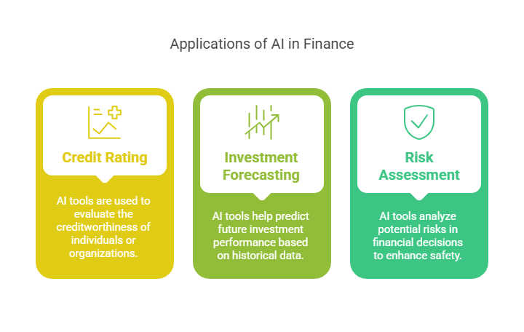

***Figure 1: Applications of AI in Finance***

A number of studies indicate that financial models based on artificial intelligence (AI) improve capital allocation by analyzing big datasets, reducing human bias, and live financial decision-making. By integrating AI into financial automation, U.S.-based investment firms such as BlackRock's Aladdin platform and Goldman Sachs' AI-powered risk modeling have optimized renewable energy project evaluations, reducing uncertainty and increasing funding accessibility for clean energy projects.

Among the important findings is the use of AI to automate financial transactions, particularly through machine learning (ML) algorithms that scan macroeconomic indicators, market indicators, and energy sector performance indicators [21]. AI-facilitated systems allow for auto-approval of loans, approval of project finance, and assessment of investment risk, thus facilitating the flow of finances to renewable energy companies [22]. For instance, the Bank of America's AI-driven green loan underwriting model has been instrumental in the sanctioning of funding for projects based on solar and wind power via real-time financial as well as environmental impact analysis.

However, as financial decision-making by AI expands investment opportunities, it creates transparency and regulatory compliance problems. Experts identify the need for explainable AI (XAI) models that ensure finance decisions remain interpretable and accountable to investors and regulators [14, 23]. The United States Securities and Exchange Commission (SEC) has strengthened the surveillance of AI-driven investment decisions recently, concentrating on investment algorithms' transparency.

**3.2. Credit Risk Modeling for Renewable Energy Financing**

AI-driven credit risk modeling is one of the most critical parts of financial automation, and it can more effectively identify the creditworthiness of borrowers and investment risks for renewable energy projects [7, 24, 39]. AI-driven models take an array of datasets, unlike the conventional credit scoring models that consider primarily historical finance data, and incorporate energy output projections, environmental impact analysis, and regulatory compliance history. These advancements have significantly improved the rate of loan approval for small and medium-sized enterprises (SMEs) engaged in renewable energy projects [25].

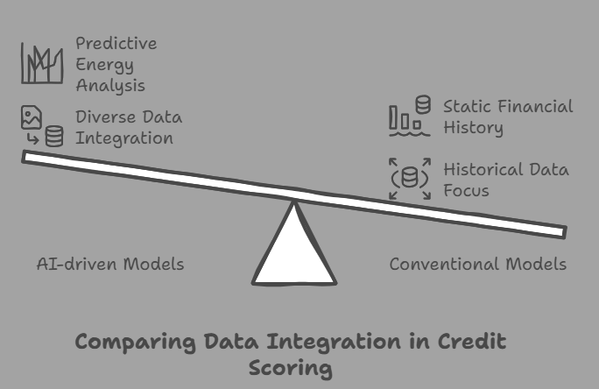

***Figure 2: Comparing Data Integration in Credit Scoring***

In the United States, JPMorgan Chase's AI-powered loan risk assessment system has enhanced the creditworthiness of renewable energy firms by integrating alternative data sources, such as satellite imagery of solar farms and wind turbine efficiency metrics [7, 26]. These practices enhance the accuracy of risk predictions, allowing financial institutions to offer individualized funding solutions with lower default rates.

Besides, AI-based credit risk models have also played a crucial role in reducing information asymmetry among investors and renewable energy organizations. They lower uncertainty via the application of real-time financial data as well as performance indicators, thereby improving investment confidence [27, 28]. However, there are concerns about potential biases in credit decisions by algorithms. For example, studies indicate that discriminatory lending that arises from biased training data can disproportionately affect smaller underrepresented businesses in the renewable industry [24, 29, 30]. The U.S. Consumer Financial Protection Bureau (CFPB) recently launched initiatives to track fairness in AI-based lending models.

**3.3. Predictive Analytics in Capital Allocation and Investment Optimization**

Predictive analytics emerged as a transformative tool in optimizing capital investment for renewable energy. AI-driven predictive models enable investors to calculate the financial viability of clean energy projects from historical trends to future market projections [12, 31, 38]. Studies identify that predictive analytics optimizes portfolio diversification through the identification of low-risk, high-reward renewable energy investments.

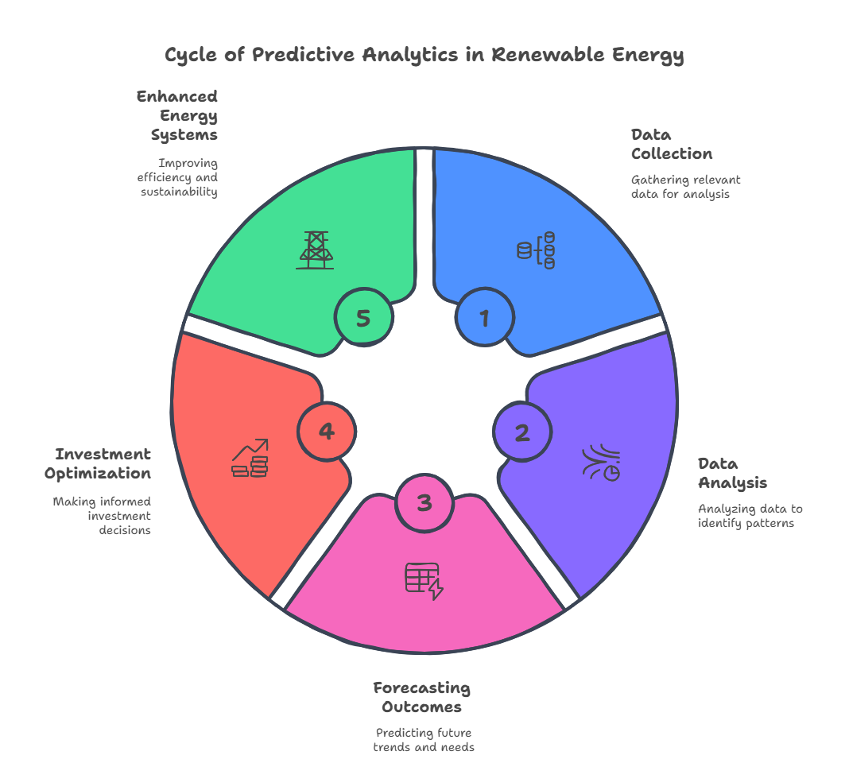

***Figure 3: Cycle of Predictive Analytics in Renewable Energy***

AI-driven forecasting models integrate economic indicators, energy consumption trends, and climate change projections to guide investment decisions. For instance, the U.S. Department of Energy's AI-driven Renewable Energy Investment Simulator (REIS) utilizes reinforcement learning algorithms to predict solar panel effectiveness and wind energy production, making it possible for financial institutions to adjust investment plans accordingly. These advancements have significantly improved the accuracy of investment risk assessment and return-on-investment (ROI) predictions [12, 32].

However, the success of predictive analytics depends significantly on the availability and dependability of environmental and financial information. Disparities in reporting and gathering data across various U.S. states make it challenging for AI models to provide investment insights [33] Resolving these issues involves finance reporting standardization and improved data-sharing mechanisms among U.S. renewable energy players.

**3.4. The Role of Blockchain in Enhancing Financial Security and Transparency**

The application of blockchain technology together with AI has further improved financial security and transparency in renewable energy investment. Smart contracts on blockchain technology enable real-time tracking of financial transactions, eliminating the possibility of fraud and enhancing accountability in investment processes [14, 15, 34]. These decentralized finance (DeFi) platforms enable peer-to-peer lending facilities, which offer SMEs access to international investors' capital without requiring conventional banking arrangements.

Current research indicates that blockchain enhances the integrity of AI-based credit risk assessment data by providing immutable evidence of financial transactions and energy production data [15]. The combination of AI and blockchain has proven very successful in green bond financing, where AI-driven smart contracts automatically guarantee compliance with sustainability guidelines and regulatory requirements [26, 35]. For example, the World Bank's green bond issuance platform based on AI has made financing renewable energy infrastructure possible by employing blockchain technology for smooth and transparent transactions.

Despite such advantages, factors such as higher energy usage for blockchain mining and regulatory ambiguity regarding DeFi adoption remain significant barriers [36]. Future research should explore energy-efficient blockchain technology as well as develop well-defined regulations to support AI-driven financial automation in the renewable energy sector.

**3.5. Challenges and Future Directions**

Although AI-driven financial automation has revolutionized investment in renewable energy, there are still issues to be addressed if its full potential is to be achieved. Data reliability continues to be a problem, as AI models require high-quality datasets upon which to base reliable financial estimates [1, 24, 39]. Standardization of data and combination of multiple datasets can enhance the effectiveness of AI-driven investment models. However, algorithmic bias is a prevalent issue within AI-based financial decision-making. Recommendations include applying fairness-aware machine learning techniques and open model validation frameworks to diminish discriminatory biases within credit risk assessments [37]. In addition, regulatory uncertainty for AI-driven automated finance calls for the formulation of comprehensive compliance policy and investor protection policies.

Future research should also focus on empirical evaluations of AI-models of investment, particularly the implications on long-term financial viability and economic stability. Investigating the ethical considerations of applying AI to finance decision-making and exploring hybrid AI-blockchain frameworks are likely to continue enhancing efficiency of renewable energy finance.

**4. CONCLUSION**

This review highlights the paradigm shift caused by AI-driven financial automation of investments in renewable energy. AI-driven frameworks optimize credit risk assessment, investment forecasting, and capital allocation, coupled with increased financial safety and transparency through the use of blockchain. However, challenges such as data inconsistency, algorithmic bias, and regulatory uncertainties must be addressed. Standardized financial reporting guidelines and ethical AI principles will play a critical role in ensuring responsible AI adoption. Hybrid AI-blockchain frameworks and bias-mitigation techniques must be explored further in an effort to enhance scalability, fairness, and long-term viability of AI-driven financial automation.

**Disclaimer (Artificial intelligence)**

Author(s) hereby declare that NO generative AI technologies such as Large Language Models (ChatGPT, COPILOT, etc.) and text-to-image generators have been used during the writing or editing of this manuscript.

**REFERENCES**

1. Olubusola O, Mhlongo NZ, Daraojimba DO, Ajayi-Nifise AO, Falaiye T. Machine learning in financial forecasting: A US review: Exploring the advancements, challenges, and implications of AI-driven predictions in financial markets. World Journal of Advanced Research and Reviews. 2024;21(2):1969-84.

2. Onabowale O. Energy policy and sustainable finance: Navigating the future of renewable energy and energy markets. World Journal of Advanced Research and Reviews. 2024;25:2235-52.

3. Vashishth TK, Sharma V, Kaushik V, Bagar VK, Sharma R, Kumar R. Importance of Using AI and ML in the Financial Sector for Risk Prevention and Management. InUtilizing AI and Machine Learning in Financial Analysis 2025 (pp. 509-530). IGI Global Scientific Publishing.

4. Ibrahim A, Almasria NA, Alhatabat ZA, Ershaid DJ, Aldboush HH. Transforming Financial Services With Artificial Intelligence and Machine Learning: Insights Into Opportunities and Emerging Trends. Utilizing AI and Machine Learning in Financial Analysis. 2025:129-48.

5. Pillai V. Integrating AI-Driven Techniques in Big Data Analytics: Enhancing Decision-Making in Financial Markets. International Journal of Engineering and Computer Science. 2023;12(07):10-8535.

6. Brown D, Sorrell S, Kivimaa P. Worth the risk? An evaluation of alternative finance mechanisms for residential retrofit. Energy policy. 2019;128:418-30.

7. Shittu AK. Advances in AI-driven credit risk models for financial services optimization. International Journal of Multidisciplinary Research and Growth Evaluation. 2022;3(1):660-76.

8. Wang Z, Huang D. A New Perspective on Financial Risk Prediction in a Carbon-Neutral Environment: A Comprehensive Comparative Study Based on the SSA-LSTM Model. Sustainability. 2023;15(19):14649.

9. Yao F, Qin Z, Wang X, Chen M, Noor A, Sharma S, et al. The evolution of renewable energy environments utilizing artificial intelligence to enhance energy efficiency and finance. Heliyon. 2023;9(5):e16160. doi: 10.1016/j.heliyon.2023.e16160. PMID: 37234613; PMCID: PMC10208837.

10. Zekos GI. AI Risk Management. Economics and Law of Artificial Intelligence: Finance, Economic Impacts, Risk Management and Governance. 2021:233-88.

11. Kus A, Grego-Planer D. A model of innovation activity in small enterprises in the context of selected financial factors: The example of the renewable energy sector. Energies. 2021;14(10):2926.

12. Ukoba K, Olatunji KO, Adeoye E, Jen TC, Madyira DM. Optimizing renewable energy systems through artificial intelligence: Review and future prospects. Energy & Environment. 2024;35(7):3833-79.

13. Ahmad T, Madonski R, Zhang D, Huang C, Mujeeb A. Data-driven probabilistic machine learning in sustainable smart energy/smart energy systems: Key developments, challenges, and future research opportunities in the context of smart grid paradigm. Renewable and Sustainable Energy Reviews. 2022;160:112128.

14. Rane N, Choudhary S, Rane J. Blockchain and Artificial Intelligence (AI) integration for revolutionizing security and transparency in finance. Available at SSRN 4644253. 2023. doi.org/10.2139/ssrn.4644253

15. Bello HO, Idemudia C, Iyelolu TV. Integrating machine learning and blockchain: Conceptual frameworks for real-time fraud detection and prevention. World Journal of Advanced Research and Reviews. 2024;23(1):056-68.

16. Tanchangya T, Islam N, Naher K, Mia MR, Chowdhury S, Sarker SR, Rashid F. Financial Technology-Enabled Sustainable Finance for Small-and Medium-Sized Enterprises. Environment, Innovation and Management. 2025;1:2550006.

17. Yusof ZB. The Role of High-Quality Data in Risk Assessment: Strategies for Ensuring Accuracy, Completeness, and Timeliness in Financial Predictive Analytics. International Journal of Advanced Computational Methodologies and Emerging Technologies. 2025;15(2):8-16.

18. Pancholi K, Shukla P. Harnessing AI for Sustainability: Innovations, Policies, and Investment Paradigms. InDiversity, AI, and Sustainability for Financial Growth 2025 (pp. 97-124). IGI Global Scientific Publishing.

19. Ekundayo F. Economic implications of AI-driven financial markets: Challenges and opportunities in big data integration. International Journal of Science and Research Archive. 2024;13:1500-15.

20. Wu M, Subramaniam G, Li Z, Gao X. Using AI Technology to Enhance Data‐Driven Decision‐Making in the Financial Sector. Artificial Intelligence‐Enabled Businesses: How to Develop Strategies for Innovation. 2025:187-207.

21. Alonso-Robisco A, Bas J, Carbo JM, de Juan A, Marques JM. Where and how machine learning plays a role in climate finance research. Journal of Sustainable Finance & Investment. 2024 Jun 28:1-42.

22. Waykar YA, Yambal S. AI and the Evolution of Green Finance: Transforming Banking for a Greener World. InConvergence of AI, Education, and Business for Sustainability 2025 (pp. 285-306). IGI Global Scientific Publishing.

23. Anang AN, Ajewumi OE, Sonubi T, Nwafor KC, Arogundade JB, Akinbi IJ. Explainable AI in financial technologies: Balancing innovation with regulatory compliance. International Journal of Science and Research Archive. 2024;13(1):1793-806.

24. Faheem MA. AI-Driven Risk Assessment Models: Revolutionizing Credit Scoring and Default Prediction. Iconic Research And Engineering Journals. 2021 Sep;5(3):177-86.

25. Ogunyemi FM, Ishola AO. Encouraging investment in renewable energy through data-driven analytics and financial solutions for SMEs. Renewable Energy Economics Journal. 2024;06(02),058–069.

26. Elias O, Awotunde OJ, Oladepo OI, Azuikpe PF, Samson OA, Oladele OR, Ogunruku OO. The evolution of green fintech: Leveraging AI and IoT for sustainable financial services and smart contract implementation. World Journal of Advanced Research and Reviews. 2024;23(1):2710-23.

27. Shen Q. AI-driven financial risk management systems: Enhancing predictive capabilities and operational efficiency. Applied and Computational Engineering. 2024;69:134-139.

28. Edunjobi TE, Odejide OA. Theoretical frameworks in AI for credit risk assessment: Towards banking efficiency and accuracy. International Journal of Scientific Research Updates. 2024;7(01):092-102.

29. Siddique S, Haque MA, George R, Gupta KD, Gupta D, Faruk MJ. Survey on machine learning biases and mitigation techniques. Digital. 2023;4(1):1-68.

30. Milton T. Exploring the Synergy of Artificial Intelligence and Financial Management in the Hotel Industry: A Critical Review of Innovations, Challenges, and Strategic Implications for Enhancing Operational Efficiency and Competitive Advantage. nternational Journal for Multidimensional Research Perspectives. 2024;2(2):79-95.

31. Anagnostopoulos T, Kyriakopoulos GL, Ntanos S, Gkika E, Asonitou S. Intelligent predictive analytics for sustainable business investment in renewable energy sources. Sustainability. 2020;12(7):2817.

32. Onwusinkwue S, Osasona F, Ahmad IA, Anyanwu AC, Dawodu SO, Obi OC, Hamdan A. Artificial intelligence (AI) in renewable energy: A review of predictive maintenance and energy optimization. World Journal of Advanced Research and Reviews. 2024;21(1):2487-99.

33. Ionescu SA, Diaconita V. Transforming financial decision-making: the interplay of AI, cloud computing and advanced data management technologies. International Journal of Computers Communications & Control. 2023;18(6). doi.org/10.15837/ijccc.2023.6.5735

34. Kokogho E, Onwuzulike OC, Omowole BM, Ewim CP, Adeyanju MO. Blockchain technology and real-time auditing: Transforming financial transparency and fraud detection in the Fintech industry. Gulf Journal of Advance Business Research. 2025;3(2):348-79.

35. Eyo-Udo NL, Agho MO, Onukwulu EC, Sule AK, Azubuike C. Advances in green finance solutions for combating climate change and ensuring sustainability. Gulf Journal of Advance Business Research. 2024 Dec 28;2(6):338-75.

36. Uzougbo NS, Ikegwu CG, Adewusi AO. Regulatory frameworks for decentralized finance (DEFI): challenges and opportunities. GSC Advanced Research and Reviews. 2024;19(02):116-29.

37. Wang Z. Artificial Intelligence and Machine Learning in Credit Risk Assessment: Enhancing Accuracy and Ensuring Fairness. Open Journal of Social Sciences. 2024;12(11):19-34.

38. Zhao C, Dong K, Wang K, Nepal R. How does artificial intelligence promote renewable energy development? The role of climate finance. Energy Economics. 2024 May 1;133:107493.

39. Soltani A. Exploring the interplay of foreign direct investment, digitalization, and green finance in renewable energy: advanced analytical methods and machine learning insights. Energy Conversion and Management: X. 2024 Oct 1;24:100802.