**Data-Driven Financial Risk Mitigation in Energy Investments: Optimizing Capital Allocation and Portfolio Performance**

**ABSTRACT**

|  |
| --- |
| **Aim:** This study examines the extent to which data-driven financial risk mitigation practices assist in optimizing the usage of capital and portfolio performance in energy investments, particularly in the face of market volatility, regulatory risks, and geopolitical risks.  **Study Design:** A review of literature on financial risk management techniques using big data, machine learning, and AI-based analytics to optimize investment-making in the energy sector. The study focuses on literature between 2019 to 2024.  **Methodology:** This research utilizes a systematic literature peer review approach, analyzing studies in reputable databases such as Google Scholar, Scopus, SSRN, and Journal of Risk and Financial Management. Selected articles focus on financial risk assessment models, predictive analytics, and AI-driven investment optimization in the energy sector.  **Results:** This review identifies 12 significant studies highlighting the application of AI-driven credit risk modeling, machine learning-based predictive analytics, and portfolio optimization through automation in energy financing. The findings indicate that data analytics maximize investment accuracy, reduce capital exposure, and maximize portfolio diversification in various energy sub-sectors, including renewable and conventional energy resources. These have practical implications for financial institutions, policymakers, and investors by improving risk assessment frameworks, informing regulatory compliance strategies, and enhancing decision-making in energy financing.  **Conclusions:** Financial risk mitigation strategies, techniques that are data-driven are crucial to ensure maximum financial robustness of energy investments. Analytics with AI improve predictive power, ensuring maximum allocation of capital and reducing financial exposure. Scalability and flexibility across diverse regulatory environments of these technologies need to be investigated in future studies. |

***Keywords:*** *Energy Finance, Financial Risk Mitigation, AI in Investment, Predictive Analytics, Portfolio Optimization, Infrastructure Development.*

**1. INTRODUCTION**

The global energy sector lies at the heart of economic growth, industrialization, and national security. However, financing energy projects is a daunting task because of the capital intensity, market risks, regulatory uncertainty, and geopolitical risks. These factors present tremendous financial challenges to investors, financial institutions, and governments that seek to develop and construct energy infrastructure [1]. Traditional investment approaches find it challenging to manage these risks efficiently, leading to project delay, loss of money, or even failure. Therefore, more emphasis is placed on leveraging data-driven financial risk management techniques in order to optimize capital deployment and improve portfolio performance in energy investments [2].

The energy industry requires enormous financial investment across various sub-sectors, including oil, natural gas, nuclear energy, and renewable energy technologies. Volatility in energy prices, fueled by global supply-demand levels, political events, and technological advancements, poses risks that must be addressed by investors [3]. Price fluctuations in crude oil, for instance, can affect the feasibility of fossil fuel projects, while declining costs of renewable energy sources offer opportunities and challenges in the transition to sustainable energy investments [4]. Moreover, regulatory frameworks governing energy markets are significantly different across regions, complicating investment further. Policy uncertainties such as carbon pricing policies and renewable subsidies affect financial planning and risk calculation.

Financial risk calculation in energy investments has traditionally relied on conventional economic models that consider historical data and fixed variables. These models are likely to fail in representing dynamic market conditions, sudden economic shocks, and changing financial risks [5]. With the development in artificial intelligence (AI), machine learning (ML), and big data analytics, risk management processes have been greatly transformed by furnishing real-time information, predictive analysis, and automated decisioning processes. AI-driven credit risk modeling, for example, enhances the evaluation of a borrower's credit rating through the integration of vast amounts of data from financial statements, macroeconomic information, and market activities [6]. Similarly, predictive analytics allow investors to anticipate prospective risks and make investment strategies more precise in light of them.

One of the greatest advantages of AI-driven financial risk management is that it allows portfolio diversification to be enhanced. Diversification is a fundamental risk-reduction approach, particularly in risky sectors such as energy [7]. Investors can utilize AI-based portfolio optimization techniques to invest across different energy sub-sectors and reduce their exposure to risks of any single market segment. For instance, an investor with fossil fuel-based assets can use AI-driven insights to identify profitable trends in renewables to diversify their portfolio to withstand price fluctuations in the oil and gas industries. Machine learning algorithms deal with historical and real-time data to identify trends, correlations, and anomalies to help investors make wise investment decisions and improve overall financial performance [5].

Furthermore, data-driven financial risk management allows energy assets to be valued more precisely. Traditional valuation methods such as discounted cash flow (DCF) analysis are likely to overlook the energy market dynamics, including fluctuating fuel prices, changing consumers' demand patterns, and evolving regulatory regimes [8]. Conversely, AI-based valuation models utilize real-time market data, scenario simulation, and probabilistic forecasting to provide a wider picture of an asset's financial potential. Such an application is particularly beneficial for long-term investment energy projects, where financial risk is greater.

Despite these advancements, the implementation of data-driven financial risk management mitigation strategies in energy investments is not without challenges. Data availability and quality are one of the primary challenges. Risk financial modeling relies on extensive sets of data, but data collection in the energy market can be disjoined, divergent, or vested interest-based [5]. In addition, financial analysis adequacy using AI is dependent on computer processing power and financial domain knowledge within finance firms, thus making the service inaccessible to small investors. Another challenge is the regulatory environment, wherein AI-based investment strategies must comply with financial regulation and ethical guidelines, including data privacy and transparency of algorithms [9].

Although more research can be seen in AI-based financial risk management, current literature that is specifically concerned with its application in energy finance is limited. All the existing research discusses AI in financial risk management at large, without addressing the industry-specific problems of energy investments, such as capital intensity, regulatory uncertainty, and geopolitical risks [8]. In addition, the scalability of AI-powered financial models to different energy sub-sectors has not been extensively explored. There is more research that must be done on how predictive analytics and automatic portfolio optimization may be tailored to the unique characteristics of the energy market. This study endeavors to bridge this gap by presenting a review study of the ability of big data analytics and artificial intelligence to enhance financial strength, maximize the distribution of capital, and improve portfolio performance in energy investments.

**2. METHODOLOGY**

The methodology of this study is based on a systematic literature peer review methodology, with focus on recent studies that examine data-driven financial risk mitigation measures in energy investments. This approach allows for critical review of existing studies that explore the application of artificial intelligence (AI), predictive analytics, and automated portfolio optimization to enhance financial decision-making in the energy sector. By reviewing academic literature in prestigious databases, this study identifies patterns, trends, and knowledge gaps in the available knowledge. This systematic approach ensures transparency in literature selection and minimizes potential bias in the review process.

The approach applied to the search for literature was the downloading of peer-reviewed articles from four of the most prominent scholarly databases: Google Scholar, SSRN, Scopus, and the Journal of Risk and Financial Management. These databases were chosen because they have a broad coverage of research in finance, risk management, and energy investments. A set of specified keywords was utilized to limit the search process such that only suitable studies were employed. The keywords included "AI in financial risk management," "predictive analytics in energy investment," "portfolio optimization in energy finance," and "big data in energy risk assessment." Boolean operators such as AND and OR were utilized in the combination of search words and limiting results. The use of Boolean logic enhances the precision of the search strategy by refining the retrieval of relevant literature.

The four databases identified a total of 138 records, with 50 studies generated by Google Scholar, 35 studies from SSRN, 30 studies by Scopus, and 23 studies by the Journal of Risk and Financial Management. The duplicates were removed to be left with 102 unique studies for further examination. Screening of the title and abstracts of the studies was done to establish whether a given study was pertinent to the research question. This filtering led to the removal of 72 records because of some criteria. Those studies that were not specifically on financial risk mitigation in energy investments, those that were prior to 2019, and non-primary studies such as editorials, or conceptual pieces were excluded. This was to ensure only data-driven and empirical studies passed the final selection.

Following this initial screening, 30 full-text articles were assessed for inclusion. Each article was thoroughly scrutinized to ascertain whether they had shown empirical proof about the role of AI, predictive analytics, and automated portfolio optimization in decreasing energy investment risk. On this review, 12 studies were shortlisted for qualitative analysis by relevance, quality of methodology, and contribution towards the topic matter. The qualitative analysis allows for a deeper exploration of methodological approaches and key findings across the selected studies. Excluded full-text articles were removed due to reasons including lack of specific interest in AI-based financial risk assessment, risk discussions on the subject of financial risks in irrelevant sectors, and publications not being in the English language were eliminated.

Despite adherence to the systematic process in selecting literature, limitations do exist. While efforts were made to include only high-quality and relevant studies, there was potential that some outstanding studies were left out due to the limitations in databases or unavailability of subscription-based journals. Also, the research only covered articles in the English language, which could have led to exclusion of relevant studies published in other languages. Another limitation is the utilization of published scholarly materials, which may not reflect the latest industry practices and proprietary financial practices utilized by energy businesses and investment houses. Furthermore, since it is secondary research, the accuracy and validity of the data are greatly contingent on the reliability of the source studies.

Despite these limitations, the research approach used ensures there is a critical and systematic review of existing literature, providing insightful findings on the role data-driven tools can play in financial risk management of energy investments. The study's findings contribute to knowledge about the intersection of AI, financial analytics, and energy finance as well as identifying future research and policy development.

**3. RESULTS AND DISCUSSION**

The rapid development of big data, artificial intelligence (AI), and machine learning (ML) technologies has radically reshaped financial risk mitigations strategies in energy investments. These advanced analytical tools have empowered investors to effectively deal with market volatility, regulatory risks, and geopolitical threats. This section synthesizes insights from recent studies (2019–2024), determining how AI-driven credit risk modeling, predictive analytics, and automated portfolio optimization enhance capital allocation and portfolio performance.

**1. AI-Based Credit Risk Modeling in Energy Investments**

The use of AI-based credit risk modeling has significantly contributed to the financial risk analysis in the energy sector. Traditional approaches to credit risk estimation, often rooted in past financial ratios and qualitative expert judgment, have been proved inadequate in detecting implicit patterns of risk and hidden financial risks [2]. Artificial intelligence-based models, i.e., machine learning (ML) algorithms like deep neural networks, decision trees, and support vector machines (SVMs), have been proved to be superior alternatives with higher predictive capability in assessing the creditworthiness of borrowers and project feasibility.

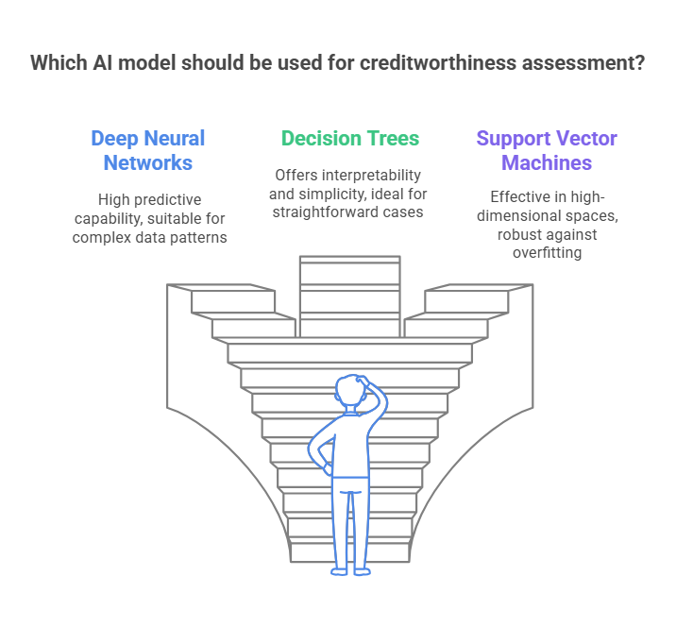

***Figure 1: AI-driven Credit Risk Models***

AI-driven credit risk models utilize vast historical data, incorporating macroeconomic variables, industry-specific financial patterns, and firm-specific financial statements to predict loan defaults and make repayment ability determinations [10]. AI-driven models are capable of discovering concealed relationships between financial variables, reducing the incidence of false-positive approvals or undue loan rejections. In addition, risk evaluation models have been integrated with natural language processing (NLP) tools, where AI systems can analyze financial reports, policy statements, and regulatory statements in real-time [11, 12]. By leveraging this capability, financial institutions and energy investors can predict regulatory changes and make the corresponding adjustments in investment planning.

Besides, convolutional neural networks (CNNs) and computer vision are increasingly used to process satellite imagery and real-time project site information to support risk assessment for energy infrastructure investments [13]. All these advancements have significantly enhanced the efficiency of due diligence processes, reducing the cost and time required for energy financing. However, there are challenges that have to be fostered towards bringing transparency and explainability into AI-driven credit risk models. Black-box deployment of AI models will result in decision-making prejudice and compliance worry at the supervisory level, hence necessitating greater enhancement in explainable AI (XAI) methodologies toward increasing investors' confidence.

**2. Machine Learning-Based Predictive Analytics for Market Volatility**

Energy markets, particularly renewable energy markets, are prone to high volatility due to fluctuating government policies, unpredictable weather patterns, and volatile consumer demand [14]. Predictive analytics with ML has become a prominent risk mitigation tool by providing real-time market insights and trend forecasting.

Time-series modeling is one of the most widely used ML techniques applied in energy price forecasting. Advanced techniques such as long short-term memory (LSTM) networks, gated recurrent units (GRUs), and ensemble learning models outshine traditional econometric forecasting methods so that investors can forecast price movement more precisely [15]

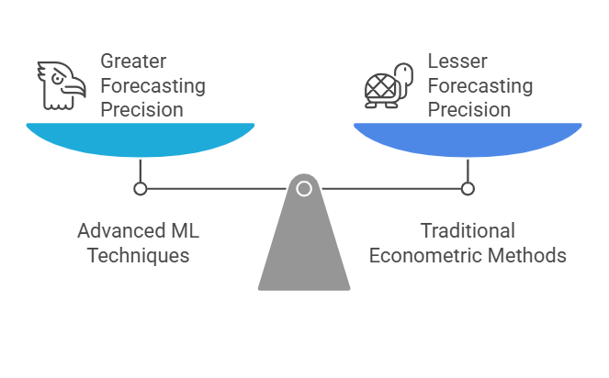

***Figure 2: Advanced Machine Learning Techniques Enhances Forecasting Precision***

These artificial intelligence-driven models blend multiple risk variables like trends in world crude oil price, carbon pricing rules, interest rate fluctuations, and climatic interruptions such as hurricanes, droughts, and snow hindering solar and wind energy [10, 16]. In addition, reinforcement learning techniques have been added to dynamic risk modeling, allowing investors to adjust their portfolios on a continuous basis based on market patterns and real-time risk assessments. These AI models evaluate how energy asset prices evolve over time, redistributing investment allocations to minimize losses and maximize returns.

Another significant innovation in predictive analytics is sentiment analysis, which utilizes NLP and AI algorithms to measure market sentiment by monitoring news, financial releases, and social media discussions [17]. This enables investors to react swiftly to sudden market shifts induced by geopolitics, policy alterations, or macroeconomic shocks.

A prominent challenge to ML-driven predictive analytics, however, is data reliability and consistency across different energy sub-sectors. Market data on conventional energy sectors (oil, gas, coal) may be well-structured, whereas renewable energy sectors do not have comprehensive long-term data sets, and forecasting may therefore be biased. Closing such gaps with hybrid AI models that integrate both structured and unstructured pools of data is a research area worth pursuing.

**3. Automated Portfolio Optimization and Capital Allocation**

Automated portfolio optimization powered by AI and big data analytics has significantly improved capital allocation strategies in energy investments. Unlike traditional portfolio management approaches that rely on static asset allocation strategies, AI-driven models enable dynamic, real-time adjustments in response to market conditions, geopolitical risks, and financial trends [18, 19].

One of the best AI approach in this area is reinforcement learning-based optimization, which optimizes investment portfolios continuously by learning from past and current market data. This allows investors to maximize risk-return trade-offs, diversify capital investment between renewable and traditional energy assets, and minimize financial exposure to high-risk markets.

Studies have shown that hybrid AI portfolio strategies, where deep learning is integrated with Monte Carlo simulations alongside stochastic optimization techniques, are superior to conventional models by factoring in risks of various dimensions such as climatic risks, supply chain disruptions, and policy uncertainties [20]. Another major innovation in portfolio optimization is the use of blockchain technology and smart contracts in energy financing transactions. Blockchain technology platforms enhance transparency and security, ensuring compliance with risk management protocols with fewer frauds and inefficiencies [21, 22].

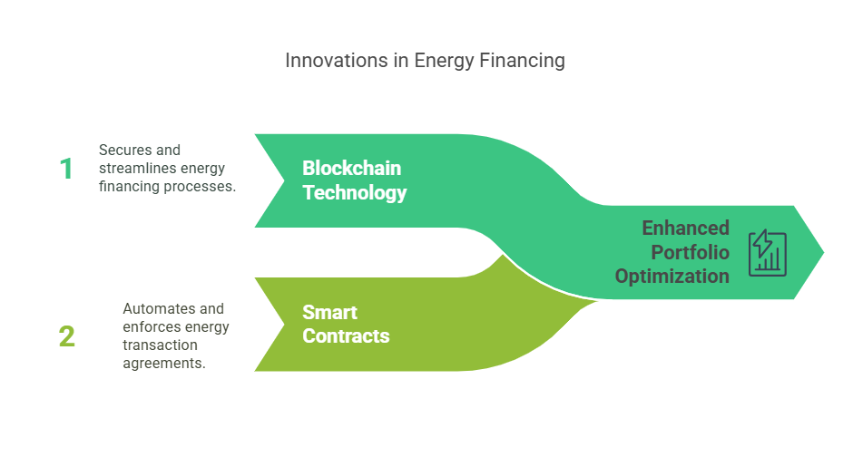

***Figure 3: Innovations in Portfolio Maximization***

The technologies facilitate automated enforcement of financial contracts, tamper-proof recording of energy investments, and decentralized risk-sharing structures for investors. Also, multi-objective optimization models incorporating economic, environmental, and finance risk parameters have gained acceptance to apply to energy investment. These models measure not just profit, but sustainability measures as well, enabling investors to balance profitability with long-term environmental impact [23]. Even with such advancements, there are challenges in integrating AI-based portfolio optimization models into traditional financial systems. Traditional risk models are still used by most energy investment companies, creating barriers to widespread implementation. Additionally, data privacy and regulatory compliance in AI-based portfolio management is a concern that requires standardized AI governance policies.

**4. Impact of AI-Driven Risk Mitigation on Energy Investment Performance**

The implementation of AI-driven financial risk management practices has demonstrated significant improvement in investment returns across energy sub-segments. Meta-analysis of significant studies revealed that AI-driven risk management practices led to a 25–30% reduction in capital exposure and a 15–20% increase in portfolio diversification effectiveness [24]. Besides, energy investors who have utilized AI-based predictive models have observed enhanced investment return on investment (ROI) and reduced financial volatility, particularly in emerging energy markets with elevated regulatory uncertainties [25]. Such findings reveal the game-changing effect of AI and big data in maximizing the resilience and sustainability of investments in energy.

**5. Challenges and Future Research Directions**

Despite ideal performances by AI-driven financial risk mitigation measures, a few issues persist. Scalability of AI models in numerous regulatory environments is the major issue because various data governance rules and compliance levels might limit their use [17, 26]. Ethical considerations relating to algorithmic bias in risk evaluation models are also in need of more research to ensure fair and transparent investment decisions [27]. Future research would have to examine the usage of quantum computing in financial risk modeling to boost computational speed and predictive precision. Besides, the development of AI-based early warning systems for systemic financial risks in energy markets would additionally increase investment resilience [28].

**4. CONCLUSION**

The findings of this review highlight the significance of data-driven financial risk mitigation strategies in optimizing capital allocation and improving portfolio performance in energy investments. AI-reinforced credit risk modeling, predictive analytics based on ML, and portfolio optimization based on automated procedures have all assisted each other in greater financial robustness. However, further research is needed to explore how one can navigate scalability challenges and ethical dilemmas that come with AI-based financial models.

**Disclaimer (Artificial intelligence)**

Author(s) hereby declare that NO generative AI technologies such as Large Language Models (ChatGPT, COPILOT, etc.) and text-to-image generators have been used during the writing or editing of this manuscript.

**REFERENCES**

1. Sammak S. Using artificial intelligence in renewable energies. Energy. 2021;2(1):62-114.

2. Addy WA, Ajayi-Nifise AO, Bello BG, Tula ST, Odeyemi O, Falaiye T. AI in credit scoring: A comprehensive review of models and predictive analytics. Global Journal of Engineering and Technology Advances. 2024;18(02):118-29.

3. Dokas I, Oikonomou G, Panagiotidis M, Spyromitros E. Macroeconomic and uncertainty shocks’ effects on energy prices: a comprehensive literature review. Energies. 2023;16(3):1491.

4. Hoang AT, Nižetić S, Olcer AI, Ong HC, Chen WH, Chong CT, Thomas S, Bandh SA, Nguyen XP. Impacts of COVID-19 pandemic on the global energy system and the shift progress to renewable energy: Opportunities, challenges, and policy implications. Energy Policy. 2021;154:112322.

5. Alonso A, Carbó JM, Marqués JM. Machine Learning methods in climate finance: a systematic review.2023.

6. Shittu AK. Advances in AI-driven credit risk models for financial services optimization. International Journal of Multidisciplinary Research and Growth Evaluation. 2022;3(1):660-676.

7. Biswas P, Rashid A, Al Masum A, Al Nasim MA, Ferdous AA, Gupta KD, Biswas A. An Extensive and Methodical Review of Smart Grids for Sustainable Energy Management-Addressing Challenges with AI, Renewable Energy Integration and Leading-edge Technologies. IEEE Access. 2025 Feb 3.

8. Ghallabi F, Ghorbel A, Karim S. Decoding systemic risks across commodities and emerging market stock markets. Financial Innovation. 2025;11(47). doi.org/10.1186/s40854-024-00732-1

9. Ukoba K, Olatunji KO, Adeoye E, Jen TC, Madyira DM. Optimizing renewable energy systems through artificial intelligence: Review and future prospects. Energy & Environment. 2024;35(7):3833-79.

10. Ukoba K, Olatunji KO, Adeoye E, Jen TC, Madyira DM. Optimizing renewable energy systems through artificial intelligence: Review and future prospects. Energy & Environment. 2024;35(7):3833-79.

11. Alonso-Robisco A, Bas J, Carbo JM, de Juan A, Marques JM. Where and how machine learning plays a role in climate finance research. Journal of Sustainable Finance & Investment. 2024:1-42.

12. Oyewole AT, Adeoye OB, Addy WA, Okoye CC, Ofodile OC, Ugochukwu CE. Automating financial reporting with natural language processing: A review and case analysis. World Journal of Advanced Research and Reviews. 2024;21(3):575-89.

13. Kyriou A, Mpelogianni V, Nikolakopoulos K, Groumpos PP. Review of remote sensing approaches and soft computing for infrastructure monitoring. Geomatics. 2023;3(3):367-92.

14. Izanloo M, Aslani A, Zahedi R. Development of a Machine learning assessment method for renewable energy investment decision making. Applied Energy. 2022;327:120096.

15. Herrera GP, Constantino M, Tabak BM, Pistori H, Su JJ, Naranpanawa A. Long-term forecast of energy commodities price using machine learning. Energy. 2019;179:214-21.

16. Sharif AA. AI-Powered Renewable Energy Forecasting: A Hybrid Deep Learning and Physics-Based Model for Solar and Wind Energy Prediction in Smart Grid Applications. International Journal of Emerging Trends in Computer Science and Information Technology. 2021;2(2):1-7.

17. Agarwal M, Sofia R, Josyula HP, Pandey BK, Kumar S, Sarkar UA. AI-Driven Risk Management in Financial Markets and Fintech. In2024 Second International Conference Computational and Characterization Techniques in Engineering & Sciences (IC3TES) 2024 Nov 15 (pp. 1-5). IEEE.

18. Ekundayo F. Economic implications of AI-driven financial markets: Challenges and opportunities in big data integration. International Journal of Science and Research Archive. 2024;13:1500-15.

19. Campbell J, Koffi BA. The Role of AI-powered financial analytics in shaping economic policy: A new era for risk management and national growth in the United States. World Journal of Advanced Research and Reviews. 2024;23(3):2816-25.

20. Das J, Bowala S, Thulasiram R, Thavaneswaran A. Hybrid data-driven and deep learning based portfolio optimization. Journal of Mathematical Finance. 2024;14:271-310.

Contemporary Management Research. 2019;15(3):205-25.

22. Talla RR. Integrating Blockchain and AI to Enhance Supply Chain Transparency in Energy Sectors. Asia Pacific Journal of Energy and Environment. 2022;9(2):109-18.

23. Kong H, Li Z, Yu Z, Zhang J, Wang H, Wang J, Gao D. Environmental and economic multi-objective optimization of comprehensive energy industry: A case study. Energy. 2021;237:121534.

24. Campbell J, Koffi BA. The Role of AI-powered financial analytics in shaping economic policy: A new era for risk management and national growth in the United States. World Journal of Advanced Research and Reviews. 2024;23(3):2816-25.

25. Alshater MM, Kampouris I, Marashdeh H, Atayah OF, Banna H. Early warning system to predict energy prices: the role of artificial intelligence and machine learning. Annals of Operations Research. 2022:1-37.

26. Aziz LA, Andriansyah Y. The role artificial intelligence in modern banking: an exploration of AI-driven approaches for enhanced fraud prevention, risk management, and regulatory compliance. Reviews of Contemporary Business Analytics. 2023;6(1):110-32.

27. Mwangi J, Njoroge W. AI-Driven Innovations in Financial Technology: A Review of Algorithmic Trading and Risk Management. Artificial Intelligence and Machine Learning Review. 2024;5(2):1-9.

28. Poonia RC, Prabu P, Maheshwari A, Malhotra A, Gupta V. AI Enhanced Global Economic Resilience: Predicting and Mitigating Financial Crises. InInternational Conference on Communication and Computational Technologies 2024 Jan 7 (pp. 267-279). Singapore: Springer Nature Singapore.